Name of Journal: World Journal of Gastrointestinal Endoscopy

Manuscript NO: 38818

Manuscript type: MINIREVIEWS

Proposed approach to the challenging management of progressive gastroesophageal reflux disease

Labenz J et al. Management of progressive GERD

Joachim Labenz, Parakrama T Chandrasoma, Laura J Knapp, Tom R DeMeester

Joachim Labenz, Internal Medicine, Diakonie Klinikum, Jung-Stilling Hospital, Siegen 57074, Germany

Parakrama T Chandrasoma, Tom R DeMeester, Keck School of Medicine, University of Southern California, Los Angeles, CA 91108, United States

Laura J Knapp, PharmaGenesis London, London SW1A 2DD, United Kingdom

ORCID number: Joachim Labenz (0000-0002-6010-7841); Parakrama T Chandrasoma (0000-0002-2168-9287); Laura J Knapp (0000-0001-8811-8051); Tom R DeMeester (0000-0002-2018-5773).

Author contributions: Labenz J, Chandrasoma PT, Knapp LJ and DeMeester TR designed the research, performed the research and wrote the paper.

Conflict-of-interest statement: Joachim Labenz has served as a consultant to EndoStim and Reckitt Benckiser, and has received honoraria for scientific presentations from AstraZeneca, EndoStim, Reckitt Benckiser, and Torax Medical Inc. Parakrama Chandrasoma has no conflict of interest. Laura Knapp is an employee of PharmaGenesis London, which received funding from EndoStim. Tom R DeMeester is currently a consultant to Torax Medical Inc. and has received honoraria for consultation and scientific presentation from EndoStim.

Open-Access: This article is an open-access article which was selected by an in-house editor and fully peer-reviewed by external reviewers. It is distributed in accordance with the Creative Commons Attribution Non Commercial (CC BY-NC 4.0) license, which permits others to distribute, remix, adapt, build upon this work non-commercially, and license their derivative works on different terms, provided the original work is properly cited and the use is non-commercial. See: http://creativecommons.org/licenses/by-nc/4.0/

Manuscript source: Unsolicited manuscript

Correspondence to: Joachim Labenz, MD, Doctor, Professor, Internal Medicine Diakonie Klinikum, Jung-Stilling Hospital, 40 Wichernstraße, Siegen 57074, Germany. joachim.labenz@diakonie-sw.de
Telephone: +49-27-13334243
Fax: +49-27-13334242

Received: March 17, 2018

Peer-review started: March 17, 2018

First decision: April 11, 2018
Revised: May 22, 2018

Accepted: June 13, 2018

Article in press:

Published online:

Abstract
The progression of gastroesophageal reflux disease (GERD) in patients who are taking proton pump inhibitors (PPIs) has been reported by several investigators, leading to concerns that PPI therapy does not address all aspects of the disease. Patients who are at risk of progression need to be identified early in the course of their disease in order to receive preventive treatment. A review of the literature on GERD progression to Barrett’s esophagus and the associated physiological and pathological changes was performed and risk factors for progression were identified. In addition, a potential approach to the prevention of progression is discussed. Current evidence shows that GERD can progress; however, patients at risk of progression may not be identified early enough for it to be prevented. Biopsies of the squamocolumnar junction that show microscopic intestinalization of metaplastic cardiac mucosa in endoscopically normal patients are predictive of future visible Barrett’s esophagus, and an indicator of GERD progression. Such changes can be identified only through biopsy, which is not currently recommended for endoscopically normal patients. GERD treatment should aim to prevent progression. We propose that endoscopically normal patients who partially respond or do not respond to PPI therapy undergo routine biopsies at the squamocolumnar junction to identify histological changes that may predict future progression. This will allow earlier intervention, aimed at preventing Barrett’s esophagus.
Key words: Barrett’s esophagus; Gastroesophageal reflux disease; Endoscopy; Progression; Treatment

© The Author(s) 2018. Published by Baishideng Publishing Group Inc. All rights reserved.
Core tip: A review of the literature on gastroesophageal reflux disease (GERD) progression and the associated physiological and pathological changes was performed. Current evidence shows that GERD can progress; however, patients at risk of progression may not be identified early enough for it to be prevented. We propose that endoscopically normal patients who partially respond or do not respond to PPI therapy undergo routine biopsies at the squamocolumnar junction to identify histological changes that may predict future progression. This will allow earlier intervention, aimed at preventing Barrett’s esophagus.

Labenz J, Chandrasoma PT, Knapp LJ, DeMeester TR. Proposed approach to the challenging management of progressive gastroesophageal reflux disease. World J Gastrointest Endosc 2018; In press

INTRODUCTION
Gastroesophageal reflux disease (GERD) has been defined as a condition that develops when the reflux of stomach contents into the esophagus causes troublesome symptoms such as heartburn and/or regurgitation^{[1]}. This primarily symptomatic definition is not a precise guide to the objective presence of disease. There is not always a clear correlation between reflux symptoms and objective evidence of the disease such as esophagitis or increased esophageal acid exposure on 24-h pH monitoring. Patients may have typical reflux symptoms in the absence of endoscopic esophagitis [referred to as non-erosive reflux disease (NERD)]^{[1]}, or endoscopic esophagitis in the absence of typical reflux symptoms^{[2,3]}. In both situations, a 24-h esophageal pH monitoring study is required to confirm the presence of the disease.
In practice, it is common for primary care physicians to initiate treatment with a trial of proton pump inhibitors (PPIs) in patients with symptoms of GERD. If symptoms are relieved, the diagnosis of GERD is confirmed. However, studies have shown that the PPI trial has a limited ability to identify GERD, particularly if the patient presents with atypical symptoms^{[4,5]}. In the absence of a complete response to PPI treatment, the PPI dose is usually doubled^{[6]}. If this does not lead to symptom resolution, a 24-h pH study, with or without impedance, should be performed in the absence of PPI treatment to determine whether or not the patient has GERD. Further increase in PPI dose or prescription of an alternative PPI is recommended in the event of a positive GERD diagnosis following pH monitoring^{[6]}. This approach to the diagnosis and treatment of GERD has popularized the notion that patients whose symptoms persist under PPI therapy have not received a sufficiently high dose. The possibility of progression of GERD under PPI therapy is not commonly considered by physicians. Despite this, progression of GERD under therapy has been demonstrated by several clinical investigators^{[7-10]}, and has raised concern that PPI treatment may not address all aspects of the disease. The pathology of early disease is not fully understood because endoscopy is indicated only when PPI treatment is ineffective, and biopsy is not recommended in patients who appear endoscopically normal^{[6,11]}. This may prevent early identification of endoscopic risk factors for visible Barrett’s esophagus (BE), the pre-malignant lesion of esophageal adenocarcinoma^{[12]}. Furthermore, the structure and functional status of the lower esophageal sphincter (LES) in patients who have an incomplete response to PPI therapy is rarely evaluated, despite its important role in the disease^{[7]}.

GERD PROGRESSION
Two scenarios have been proposed regarding the natural history of GERD. The first is that GERD can be categorized as either NERD or erosive reflux disease (ERD), and that patients remain in their diagnosed category^{[13,14]}. The second is that GERD is a spectrum disorder, with NERD at one end of the spectrum, and BE and esophageal adenocarcinoma at the other, with the possibility of disease progression over time^{[9,15]}. Current evidence appears to support the hypothesis that GERD is progressive, with several studies showing progression in cohorts of patients with different initial disease categorizations^{[8,10,15,16]}.
One of the largest studies of GERD progression (the ProGERD study) involved 2721 patients from Germany, Switzerland, and Austria^{[8]}. Patients were categorized endoscopically as having NERD or ERD, and those with ERD were further categorized based on Los Angeles (LA) classification grades (A-D) at baseline; patients with evidence of BE were excluded from the analysis of progression. Patients underwent an initial endoscopy followed by 4-8 wk of esomeprazole therapy. Maintenance therapy was then provided by each patient’s primary care physician; patients were followed for 5 years during which they underwent repeat endoscopies. Progression to BE (confirmed by endoscopy and biopsy) was observed in 5.9% of patients with NERD, 12.1% of patients with mild-to-moderate ERD (LA grade A/B) and 19.7% of patients with severe ERD (LA grade C/D). Overall, 10% of patients had progressed to BE by the end of the 5-year follow-up period, clearly demonstrating disease progression in a proportion of patients receiving PPI therapy. This study also established that although the treatment of GERD with PPIs can improve symptoms and heal erosive esophagitis, it does not appear to prevent progression to BE.
Pace et al^{[15]} reported data from a study of 33 patients with NERD who were referred to a gastrointestinal clinic in Milan, Italy and followed for 10 years. Patients were endoscopically normal but had an abnormal 24-h esophageal pH at baseline (acid exposure > 5%). Within 5 years of a GERD diagnosis, 17 of the 18 patients (94.4%) who underwent endoscopy had esophagitis. All of the patients were taking PPIs, either at the recommended dose (11/18) or at half the recommended dose (7/18). When active therapy was discontinued during follow-up, symptoms of GERD returned in 96.6% of available patients [median follow-up time 10 years (range 7-14 years)]. This study demonstrated that NERD is a chronic disease that can progress in severity over time in patients taking PPIs, and therefore requires protracted medical therapy. It further demonstrated that the absence of endoscopic esophagitis at presentation is not a positive prognostic factor.
GERD progression in patients undergoing PPI therapy has been shown to be related to a defective LES. In a study of 40 Swedish patients with GERD (confirmed by increased esophageal acid exposure on 24-hour pH monitoring) who were treated with PPIs and followed up for 21 years, progression to BE occurred in 45% of patients (18/40)^{[7]}. Manometric evaluation of the LES was performed at the beginning of the study and at the end of the follow-up period. Progression was associated with a significant reduction in mean intra-abdominal LES length on manometry (P = 0.01) and significantly greater esophageal acid exposure on pH monitoring (P = 0.004) than was observed in patients who did not experience disease progression. Furthermore, a trend towards increased use of PPIs and an increase in the number of patients who developed erosive esophagitis was observed over the 21-year period. These results implied that patients with a long duration of GERD were at risk of progression despite PPI treatment and that this was likely to be due to deterioration of the LES during the course of therapy. This study was the first to introduce this concept, which has since led to the prospective examination of LES function prior to PPI therapy in patients with GERD.
The concept that PPI efficacy decreases with increased damage to the LES, and with increased compromise in esophageal body function, has been corroborated in a prospective study of patients with GERD^{[17]}. In this study, a defective LES was defined as LES pressure of less than 8 mmHg and/or abdominal length of less than 1.2 cm. If more than 20% of peristaltic contractions were ineffective, the esophageal body was regarded as being compromised. PPI failure, shown by the recurrence of symptoms or esophagitis, was reported in 7.7% of patients (2/26) with a normal LES and normal esophageal body, 38.1% of patients (24/63) with a defective LES and normal esophageal body, and 79.5% of patients (31/39) with a defective LES and a compromised esophageal body. These results strongly indicated that PPI therapy is less effective in patients with a defective LES than in those with a normal LES, and that a compromised esophageal body contributes further to PPI inefficacy.
In an effort to further understand the mechanical factors implicated in GERD progression, Lord et al^{[18]} investigated the effects of distorted hiatal anatomy, the manometric condition of the LES, and esophageal exposure to acid and bile, on GERD severity. The study population comprised 39 patients with NERD, 42 patients with mild ERD (esophagitis that was healed with PPI therapy), 35 patients with severe ERD (esophagitis that persisted despite PPI therapy), and 44 patients with BE. All patients were taking PPIs prior to subsequent surgical treatment. Patients with severe ERD or BE had a significantly higher prevalence of distorted hiatal anatomy, a defective LES, and esophageal acid exposure. Esophageal bile exposure was significantly higher in patients with BE than those with NERD, mild ERD or severe ERD. The significant anatomical and physiological differences between patients with mild ERD and those with severe ERD are indicative of differences in the mechanical properties of the antireflux barrier. Variability in PPI dose is therefore not the only contributing factor to GERD severity, and treatment with PPIs is unlikely to prevent progression in patients with advanced abnormalities in hiatal anatomy and LES function; major antireflux surgery is usually required in such patients. Where PPIs are ineffective, early intervention with an LES augmentation procedure may prevent progression to severe ERD, and obviate the requirement for major antireflux surgery.
The most important information gained from the aforementioned studies is that treatment with PPIs does not prevent progression to BE in a proportion of patients, and that damage to the LES is significantly more prevalent in these patients compared with those whose disease does not progress. These findings encourage the identification of individuals at risk of GERD progression through manometric evaluation of LES function and 24-h esophageal pH monitoring. These patients may be candidates for a surgical procedure to improve LES function that may, consequently, improve PPI efficacy^{[18]}.

MEDICAL TOOLS FOR THE EVALUATION OF GERD PROGRESSION
Upper endoscopy is recommended in patients with atypical symptoms who do not respond to PPI therapy^{[6]}. Narrow band imaging (NBI), which enhances the contrast between the esophageal mucosa and the gastric mucosa, has improved visualization of the morphology of squamo-columnar junction (SCJ) (Figure 1) and been demonstrated to improve the endoscopic diagnosis of GERD. In a study of 107 patients with NERD (n = 36), ERD (n = 41) or no disease (n = 30), which compared conventional endoscopy with NBI, micro-erosions, increased vascularity, and pit patterns at the SCJ were clearly visible using NBI, but were not visible using conventional endoscopy^{[19]}. Furthermore, NBI proved useful in distinguishing patients with NERD from healthy individuals. NBI is not expected to replace conventional endoscopy in the diagnosis of GERD; however, it can be useful for differentiating patients with NERD from patients with ERD, and for grading patients with ERD, and can therefore help to identify patients with severe disease who may be at risk of progression.
Ambulatory reflux monitoring can confirm the presence of GERD in patients with normal endoscopy and atypical symptoms^{[20,21]}. The primary outcome of a 24-h pH monitoring study is the acid exposure time. Wireless pH monitoring allows the extension of the study time beyond 24 h, which has been demonstrated to increase the diagnostic yield^{[22]}; however, wireless monitoring is expensive and therefore not widely available^{[21]}. An alternative is pH-impedance monitoring, which is considered the gold standard^{[21]}. This method detects all reflux (liquid, gas or mixed) regardless of acidity, and defines the direction of flow. A recent study investigated the potential of pH-impedance monitoring to predict symptomatic outcome over a 5-year period in 94 patients with GERD who were not taking PPIs. The investigators reported that phenotyping of GERD according to the strength of evidence of reflux from pH-impedance testing efficiently stratified symptomatic outcome, and could be useful in planning disease management^{[23]}. In a study of GERD progression, patients with progressive disease had significantly increased esophageal acid exposure than those whose disease did not progress^{[7]}. pH-impedance monitoring may therefore be useful in the identification of patients who may be at risk of progression.
Conventional water-perfused manometry and, more recently, high resolution manometry (HRM) are used to evaluate LES and esophageal body function in patients with GERD. The technical advantages of HRM include its high density of recording sites, advanced solid-state sensor technology, and sophisticated plotting algorithms, as well as its superior speed and ease of performance compared with conventional manometry^{[21,24]}. However, a recent study comparing conventional manometry with HRM in the assessment of the LES in 55 patients with foregut symptoms, reported no difference between the two techniques in their measurement of resting LES pressure^{[25]}. Furthermore, LES overall and abdominal length were consistently overestimated by HRM compared with conventional manometry. Consequently, HRM could limit the detection of LES abnormalities, leading to difficulties in the identification of LES abnormalities as a cause for PPI inefficacy.

PATHOLOGY OF GERD PROGRESSION
The identification of factors associated with progression to BE and the need for surgical intervention, are key to managing those patients whose disease is progressive. This requires an understanding of the pathophysiology and pathology of GERD. Physiological and pathological studies have introduced the concept that GERD begins at the SCJ. In the absence of squamous epithelial injury, the SCJ and the gastroesophageal junction are concordant^{[11,26]}. As squamous epithelial injury occurs, metaplastic cardiac epithelium forms and the SCJ separates from the gastroesophageal junction and moves upwards into the esophagus. This process causes damage to the LES, resulting in greater esophageal exposure to acid and bile.
A normal LES occupies the entire abdominal esophagus and a small portion of the thoracic esophagus, and is lined with squamous epithelium. Gastric distension or postprandial non-pressurized gastric dilation causes transient effacement of the distal LES into the stomach (Figure 2)^{[26]}. Effacement results in the uptake of the distal portion of the LES by the expanding fundus of the distended stomach. This results in loss of abdominal LES length and exposure of the squamous epithelium to acidic gastric juice in the acid pocket^{[27]}. The subsequent inflammatory injury to the unprotected squamous epithelium results in metaplasia of the squamous epithelium to cardiac epithelium (Figure 1)^{[26,28]}. Indeed, biopsies of the SCJ from 714 symptomatic patients with GERD who were endoscopically normal showed that in an acidic environment, the acid-damaged squamous epithelium heals by forming cardiac epithelium^{[11]}. In an additional study of 334 patients with GERD symptoms and no visible evidence of BE, biopsies of the SCJ showed cardiac epithelium in 246 patients (73.7%)^{[28]}. When present, cardiac epithelium was significantly associated with increased esophageal acid exposure, a structurally defective LES, and erosive esophagitis (Table 1). Strikingly, inflammation in the form of carditis was present in 237/246 patients (96%) and was associated with a significantly shorter LES, significantly lower LES pressure, and a significantly higher prevalence of a structurally defective LES than no carditis (Table 2)^{[28]}. Individuals who had both carditis and esophagitis had a significantly greater prevalence of a structurally defective LES and greater esophageal acid exposure than individuals with carditis alone (Table 3)^{[28]}.
The presence of metaplastic cardiac mucosa at the SCJ results in the formation of a squamo-oxyntic gap between the oxyntic gastric mucosa in the proximal stomach and the remaining squamous esophageal mucosa within the LES (Figure 3)^{[29]}. The length of the squamo-oxyntic gap has been shown to be directly proportional to the prevalence of intestinal metaplasia (IM) of the cardiac epithelium (i.e., the formation of goblet cells). In a study of 1655 patients with GERD, IM was observed in: 24.3% of patients with a gap shorter than 1 cm; 83.5% of patients with a gap of 1-5 cm; and 100% of those with a gap longer than 5 cm^{[29]}. The authors proposed that the length of the squamo-oxyntic gap could be used as a cellular criterion to diagnose GERD. Furthermore, the length of the gap provides an accurate assessment of GERD severity, and IM of the cardiac epithelium within the gap is the most accurate indicator of disease progression and the risk of esophageal adenocarcinoma.
These findings strongly support the concept that GERD starts at the SCJ with acid-induced cardiac metaplasia of the injured and inflamed effaced squamous epithelium of the most distal portion of the LES. This process can result in LES damage. These initial changes are subtle and microscopic, and a patient with early GERD is likely to appear endoscopically normal. A manometric assessment of the LES, measurement of esophageal acid exposure, and biopsies at and below the SCJ are therefore required for these changes to be identified.

IDENTIFICATION OF PATIENTS AT RISK OF PROGRESSION TO BARRETT’S ESOPHAGUS
In the ProGERD study, 171 patients who were endoscopically normal had microscopic IM on biopsy of the SCJ before any therapy^{[30]}. After the 4-8-wk PPI treatment phase of the study, 128 of these patients had a follow-up endoscopy and biopsy of the SCJ; all had persistent microscopic IM. With continued PPI therapy, and endoscopy and biopsy at 2 and 5 years of follow-up, endoscopically visible BE was seen in 25.8% (33/128) of patients^{[30]}. The implication of this finding is that a biopsy showing microscopic IM at the SCJ in a patient who is endoscopically normal indicates a high risk of progression to visible BE, a precursor to esophageal cancer.
An additional population-based study in Sweden assessed the risk of esophageal cancer in 796492 adults taking maintenance PPIs for different indications in 2005-2012. Of 201744 individuals taking PPIs for GERD, 316 developed esophageal cancer. The reported standardized incidence ratio (SIR) of esophageal cancer in patients with GERD who were taking PPIs was 6.87 (95%CI: 6.13-7.67). Furthermore, the SIRs of esophageal cancer were also increased among individuals without GERD, who used PPIs for indications not associated with any increased risk of esophageal cancer (e.g., individuals taking PPIs due to maintenance treatment with non-steroidal anti-inflammatory drugs and aspirin). The authors concluded that the long-term use of PPIs is associated with increased risk of esophageal cancer in the absence of other risk factors^{[31]}.
Of concern is that the American College of Gastroenterology guidelines for the diagnosis and management of GERD recommend endoscopic examination only for patients who have an incomplete response to PPI treatment, and recommend routine biopsy only for those with visible evidence of a columnar-lined esophagus of more than 1 cm in length^{[6]}. The histological and pathological features of early disease have therefore not been investigated. Contrary to these guidelines, we propose that patients who are undergoing endoscopy to investigate an incomplete response to PPI therapy, and who have no visible evidence of a columnar-lined esophagus, undergo a routine biopsy of the SCJ. We hypothesize that in a significant minority of such patients, biopsies of the SCJ will reveal the presence of microscopic IM. Based on the findings of the ProGERD study, these patients are at risk of progression to visible BE and are candidates for early preventive treatment^{[30]}. Our hypothesis will need to be tested in the clinical setting to determine whether potentially progressive disease can be identified through routine biopsy of the SCJ in this subgroup of patients, and whether progression can be prevented through earlier intervention. In addition, the number of biopsies required, the cost-effectiveness, and the associated risk of bleeding^{[25]} must be considered before acceptance of this proposed approach in clinical practice.

PREVENTION OF PROGRESSION
Acid suppression therapy is notably effective in patients who have a normal LES but less so in those who have a structurally defective LES^{[17]}. Permanent structural alterations to the LES resulting from repeated effacement and chronic inflammation are difficult to correct without surgical intervention. The likelihood of symptom control and prevention of disease progression in patients with persistent symptoms on PPI therapy is greater if surgical correction of a compromised LES is carried out earlier rather than later. Nissen fundoplication has been demonstrated to prevent BE if performed before it develops, and if the fundoplication remains competent^{[32,33]}. A study of 15 patients with microscopic IM at the SCJ in the absence of endoscopically visible BE showed complete regression of microscopic IM in 73.7% of patients (11/15) following early fundoplication^{[34]}. In a separate control group of 45 patients with endoscopically visible BE, only 4.4% of individuals (2/45) showed regression of BE following fundoplication^{[34]}. Despite the ability of the fundoplication procedure to induce significant regression of microscopic IM and prevent development of visible BE, the associated complications (including, dysphagia, bloating, and the inability to burp or vomit^{[35]}) have discouraged the early use of this approach to prevent progressive disease.
Over the past decade, minimally invasive outpatient LES augmentation procedures have been developed^{[36-39]}. Examples include the implantation of a collar of magnetic beads around the inferior border of the LES to prevent its effacement into the stomach^{[38]}; the delivery of radiofrequency to the LES to reduce LES compliance^{[36]}; neuromodulation of the LES through electrical stimulation to increase LES resting pressure^{[37]}; and incisionless partial fundoplication performed using a flexible endoscope introduced to the stomach via the mouth^{[39]}. Clinical studies have demonstrated the efficacy of LES augmentation in eliminating reflux symptoms and healing esophagitis in patients with GERD who have an incomplete response to PPI therapy^{[36,37,39,40]}. These procedures avoid the complications associated with Nissen fundoplication, are reversible if required, and may therefore be appropriate for early surgical intervention with the goal of preventing disease progression. The effectiveness of these procedures to induce regression of microscopic IM at the SCJ and prevent progression to endoscopically visible BE and subsequent adenocarcinoma should be investigated in future clinical studies.
A proposed treatment algorithm that features early use of LES augmentation procedures to prevent GERD progression is shown in Figure 4. The algorithm emphasizes the use of endoscopy, manometry, and esophageal pH monitoring to assess patients with an incomplete response to PPI therapy. Following endoscopy, individuals are stratified into four groups: (1) patients with visible BE; (2) those with persistent esophagitis; (3) those who are endoscopically normal but have microscopic IM of the SCJ (identified by biopsy); and (4) patients who are endoscopically normal but have metaplastic cardiac mucosa with a squamo-oxyntic mucosal gap (identified by biopsy of the SCJ). LES augmentation is recommended for patients in groups (2) and (3) following a manometric evaluation of LES function. LES augmentation for patients in group (4) is only recommended if manometric evaluation reveals a permanently damaged LES. Nissen fundoplication should be considered for patients with extensive damage to the LES after a thorough discussion of the associated complications.

CONCLUSION
It is important that patients with GERD who are at risk of progression are identified early in the course of their disease in order to prevent the development of BE or other complications. This requires the early use of endoscopy, manometry and esophageal pH monitoring in those with an incomplete response to PPI therapy. In contrast to current management guidelines, we propose routine biopsy of the SCJ in such patients if their esophageal endoscopic evaluation is normal. If microscopic IM is identified, an LES augmentation procedure should be considered with the aim of preventing disease progression to endoscopically visible BE. This proposed approach must first be tested in the clinical research setting to confirm that the encouraging results obtained with the Nissen fundoplication procedure can be reproduced with an LES augmentation procedure.

REFERENCES
1 Vakil N, van Zanten SV, Kahrilas P, Dent J, Jones R; Global Consensus Group. The Montreal definition and classification of gastroesophageal reflux disease: a global evidence-based consensus. Am J Gastroenterol 2006; 101: 1900-1920; quiz 1943 [PMID: 16928254 DOI: 10.1111/j.1572-0241.2006.00630.x]
2 DeMeester TR, Peters JH, Bremner CG, Chandrasoma P. Biology of gastroesophageal reflux disease: pathophysiology relating to medical and surgical treatment. Annu Rev Med 1999; 50: 469-506 [PMID: 10073290 DOI: 10.1146/annurev.med.50.1.469]
3 Ronkainen J, Aro P, Storskrubb T, Johansson SE, Lind T, Bolling-Sternevald E, Graffner H, Vieth M, Stolte M, Engstrand L, Talley NJ, Agréus L. High prevalence of gastroesophageal reflux symptoms and esophagitis with or without symptoms in the general adult Swedish population: a Kalixanda study report. Scand J Gastroenterol 2005; 40: 275-285 [PMID: 15932168 DOI: 10.1080/00365520510011579]
4 Bytzer P, Jones R, Vakil N, Junghard O, Lind T, Wernersson B, Dent J. Limited ability of the proton-pump inhibitor test to identify patients with gastroesophageal reflux disease. Clin Gastroenterol Hepatol 2012; 10: 1360-1366 [PMID: 22813439 DOI: 10.1016/j.cgh.2012.06.030]
5 Vakil N. Review article: how valuable are proton-pump inhibitors in establishing a diagnosis of gastro-oesophageal reflux disease? Aliment Pharmacol Ther 2005; 22 Suppl 1: 64-69 [PMID: 16042661 DOI: 10.1111/j.1365-2036.2005.02612.x]
6 Katz PO, Gerson LB, Vela MF. Guidelines for the diagnosis and management of gastroesophageal reflux disease. Am J Gastroenterol 2013; 108: 308-328; quiz 329 [PMID: 23419381 DOI: 10.1038/ajg.2012.444]
7 Falkenback D, Oberg S, Johnsson F, Johansson J. Is the course of gastroesophageal reflux disease progressive? A 21-year follow-up. Scand J Gastroenterol 2009; 44: 1277-1287 [PMID: 19891578 DOI: 10.3109/00365520903314157]
8 Malfertheiner P, Nocon M, Vieth M, Stolte M, Jaspersen D, Koelz HR, Labenz J, Leodolter A, Lind T, Richter K, Willich SN. Evolution of gastro-oesophageal reflux disease over 5 years under routine medical care-the ProGERD study. Aliment Pharmacol Ther 2012; 35: 154-164 [PMID: 22070159 DOI: 10.1111/j.1365-2036.2011.04901.x]
9 Pace F, Bianchi Porro G. Gastroesophageal reflux disease: a typical spectrum disease (a new conceptual framework is not needed). Am J Gastroenterol 2004; 99: 946-949 [PMID: 15128365 DOI: 10.1111/j.1572-0241.2004.04164.x]
10 Ronkainen J, Talley NJ, Storskrubb T, Johansson SE, Lind T, Vieth M, Agréus L, Aro P. Erosive esophagitis is a risk factor for Barrett's esophagus: a community-based endoscopic follow-up study. Am J Gastroenterol 2011; 106: 1946-1952 [PMID: 21946284 DOI: 10.1038/ajg.2011.326]
11 Chandrasoma P, Wijetunge S, Ma Y, Demeester S, Hagen J, Demeester T. The dilated distal esophagus: a new entity that is the pathologic basis of early gastroesophageal reflux disease. Am J Surg Pathol 2011; 35: 1873-1881 [PMID: 21989338 DOI: 10.1097/PAS.0b013e31822b78e8]
12 Campos GM, DeMeester SR, Peters JH, Oberg S, Crookes PF, Hagen JA, Bremner CG, Sillin LF 3rd, Mason RJ, DeMeester TR. Predictive factors of Barrett esophagus: multivariate analysis of 502 patients with gastroesophageal reflux disease. Arch Surg 2001; 136: 1267-1273 [PMID: 11695971 DOI: 10.1001/archsurg.136.11.1267]
13 Agrawal A, Castell D. GERD is chronic but not progressive. J Clin Gastroenterol 2006; 40: 374-375 [PMID: 16721215 DOI: 10.1097/00004836-200605000-00002]
14 Fass R, Ofman JJ. Gastroesophageal reflux disease--should we adopt a new conceptual framework? Am J Gastroenterol 2002; 97: 1901-1909 [PMID: 12190152 DOI: 10.1111/j.1572-0241.2002.05912.x]
15 Pace F, Bollani S, Molteni P, Bianchi Porro G. Natural history of gastro-oesophageal reflux disease without oesophagitis (NERD)--a reappraisal 10 years on. Dig Liver Dis 2004; 36: 111-115 [PMID: 15002817 DOI: 10.1016/j.dld.2003.10.012]
16 Labenz J, Nocon M, Lind T, Leodolter A, Jaspersen D, Meyer-Sabellek W, Stolte M, Vieth M, Willich SN, Malfertheiner P. Prospective follow-up data from the ProGERD study suggest that GERD is not a categorial disease. Am J Gastroenterol 2006; 101: 2457-2462 [PMID: 17029609 DOI: 10.1111/j.1572-0241.2006.00829.x]
17 Klaus A, Gadenstaetter M, Mühlmann G, Kirchmayr W, Profanter C, Achem SR, Wetscher GJ. Selection of patients with gastroesophageal reflux disease for antireflux surgery based on esophageal manometry. Dig Dis Sci 2003; 48: 1719-1722 [PMID: 14560990 DOI: 10.1023/A:1025434726161]
18 Lord RV, DeMeester SR, Peters JH, Hagen JA, Elyssnia D, Sheth CT, DeMeester TR. Hiatal hernia, lower esophageal sphincter incompetence, and effectiveness of Nissen fundoplication in the spectrum of gastroesophageal reflux disease. J Gastrointest Surg 2009; 13: 602-610 [PMID: 19050984 DOI: 10.1007/s11605-008-0754-x]
19 Fock KM, Teo EK, Ang TL, Tan JY, Law NM. The utility of narrow band imaging in improving the endoscopic diagnosis of gastroesophageal reflux disease. Clin Gastroenterol Hepatol 2009; 7: 54-59 [PMID: 18852068 DOI: 10.1016/j.cgh.2008.08.030]
20 Malhotra A, Freston JW, Aziz K. Use of pH-impedance testing to evaluate patients with suspected extraesophageal manifestations of gastroesophageal reflux disease. J Clin Gastroenterol 2008; 42: 271-278 [PMID: 18223497 DOI: 10.1097/MCG.0b013e31802b64f3]
21 Gyawali CP, Kahrilas PJ, Savarino E, Zerbib F, Mion F, Smout AJPM, Vaezi M, Sifrim D, Fox MR, Vela MF, Tutuian R, Tack J, Bredenoord AJ, Pandolfino J, Roman S. Modern diagnosis of GERD: the Lyon Consensus. Gut 2018; 67: 1351-1362 [PMID: 29437910 DOI: 10.1136/gutjnl-2017-314722]
22 Sweis R, Fox M, Anggiansah A, Wong T. Prolonged, wireless pH-studies have a high diagnostic yield in patients with reflux symptoms and negative 24-h catheter-based pH-studies. Neurogastroenterol Motil 2011; 23: 419-426 [PMID: 21235685 DOI: 10.1111/j.1365-2982.2010.01663.x]
23 Patel A, Sayuk GS, Kushnir VM, Chan WW, Gyawali CP. GERD phenotypes from pH-impedance monitoring predict symptomatic outcomes on prospective evaluation. Neurogastroenterol Motil 2016; 28: 513-521 [PMID: 26686239 DOI: 10.1111/nmo.12745]
24 Ayazi S, Hagen JA, Zehetner J, Ross O, Wu C, Oezcelik A, Abate E, Sohn HJ, Banki F, Lipham JC, DeMeester SR, Demeester TR. The value of high-resolution manometry in the assessment of the resting characteristics of the lower esophageal sphincter. J Gastrointest Surg 2009; 13: 2113-2120 [PMID: 19779945 DOI: 10.1007/s11605-009-1042-0]
25 ASGE Standards of Practice Committee., Ben-Menachem T, Decker GA, Early DS, Evans J, Fanelli RD, Fisher DA, Fisher L, Fukami N, Hwang JH, Ikenberry SO, Jain R, Jue TL, Khan KM, Krinsky ML, Malpas PM, Maple JT, Sharaf RN, Dominitz JA, Cash BD. Adverse events of upper GI endoscopy. Gastrointest Endosc 2012; 76: 707-718 [PMID: 22985638 DOI: 10.1016/j.gie.2012.03.252]
26 Ayazi S, Tamhankar A, DeMeester SR, Zehetner J, Wu C, Lipham JC, Hagen JA, DeMeester TR. The impact of gastric distension on the lower esophageal sphincter and its exposure to acid gastric juice. Ann Surg 2010; 252: 57-62 [PMID: 20562610 DOI: 10.1097/SLA.0b013e3181e3e411]
27 Rohof WO, Bennink RJ, Boeckxstaens GE. Proton pump inhibitors reduce the size and acidity of the acid pocket in the stomach. Clin Gastroenterol Hepatol 2014; 12: 1101-1107.e1 [PMID: 24726906 DOI: 10.1016/j.cgh.2014.04.003]
28 Oberg S, Peters JH, DeMeester TR, Chandrasoma P, Hagen JA, Ireland AP, Ritter MP, Mason RJ, Crookes P, Bremner CG. Inflammation and specialized intestinal metaplasia of cardiac mucosa is a manifestation of gastroesophageal reflux disease. Ann Surg 1997; 226: 522-530; discussion 530-532 [PMID: 9351720 DOI: 10.1097/00000658-199710000-00013]
29 Chandrasoma P, Wijetunge S, Demeester SR, Hagen J, Demeester TR. The histologic squamo-oxyntic gap: an accurate and reproducible diagnostic marker of gastroesophageal reflux disease. Am J Surg Pathol 2010; 34: 1574-1581 [PMID: 20871393 DOI: 10.1097/PAS.0b013e3181f06990]
30 Leodolter A, Nocon M, Vieth M, Lind T, Jaspersen D, Richter K, Willich S, Stolte M, Malfertheiner P, Labenz J. Progression of specialized intestinal metaplasia at the cardia to macroscopically evident Barrett's esophagus: an entity of concern in the ProGERD study. Scand J Gastroenterol 2012; 47: 1429-1435 [PMID: 23110405 DOI: 10.3109/00365521.2012.733952]
31 Brusselaers N, Engstrand L, Lagergren J. Maintenance proton pump inhibition therapy and risk of oesophageal cancer. Cancer Epidemiol 2018; 53: 172-177 [PMID: 29477057 DOI: 10.1016/j.canep.2018.02.004]
32 Nissen R. Gastropexy and "fundoplication" in surgical treatment of hiatal hernia. Am J Dig Dis 1961; 6: 954-961 [PMID: 14480031 DOI: 10.1007/BF02231426]
33 Gutschow CA, Schröder W, Prenzel K, Bollschweiler E, Romagnoli R, Collard JM, Hölscher AH. Impact of antireflux surgery on Barrett's esophagus. Langenbecks Arch Surg 2002; 387: 138-145 [PMID: 12172858 DOI: 10.1007/s00423-002-0303-0]
34 DeMeester SR, Campos GM, DeMeester TR, Bremner CG, Hagen JA, Peters JH, Crookes PF. The impact of an antireflux procedure on intestinal metaplasia of the cardia. Ann Surg 1998; 228: 547-556 [PMID: 9790344 DOI: 10.1097/00000658-199810000-00011]
35 Kellokumpu I, Voutilainen M, Haglund C, Färkkilä M, Roberts PJ, Kautiainen H. Quality of life following laparoscopic Nissen fundoplication: assessing short-term and long-term outcomes. World J Gastroenterol 2013; 19: 3810-3818 [PMID: 23840119 DOI: 10.3748/wjg.v19.i24.3810]
36 Noar M, Squires P, Noar E, Lee M. Long-term maintenance effect of radiofrequency energy delivery for refractory GERD: a decade later. Surg Endosc 2014; 28: 2323-2333 [PMID: 24562599 DOI: 10.1007/s00464-014-3461-6]
37 Rodríguez L, Rodriguez PA, Gómez B, Netto MG, Crowell MD, Soffer E. Electrical stimulation therapy of the lower esophageal sphincter is successful in treating GERD: long-term 3-year results. Surg Endosc 2016; 30: 2666-2672 [PMID: 26487200 DOI: 10.1007/s00464-015-4539-5]
38 Bonavina L, Saino G, Lipham JC, Demeester TR. LINX(®) Reflux Management System in chronic gastroesophageal reflux: a novel effective technology for restoring the natural barrier to reflux. Therap Adv Gastroenterol 2013; 6: 261-268 [PMID: 23814607 DOI: 10.1177/1756283X13486311]
39 Trad KS, Barnes WE, Simoni G, Shughoury AB, Mavrelis PG, Raza M, Heise JA, Turgeon DG, Fox MA. Transoral incisionless fundoplication effective in eliminating GERD symptoms in partial responders to proton pump inhibitor therapy at 6 months: the TEMPO Randomized Clinical Trial. Surg Innov 2015; 22: 26-40 [PMID: 24756976 DOI: 10.1177/1553350614526788]
40 Ganz RA, Peters JH, Horgan S, Bemelman WA, Dunst CM, Edmundowicz SA, Lipham JC, Luketich JD, Melvin WS, Oelschlager BK, Schlack-Haerer SC, Smith CD, Smith CC, Dunn D, Taiganides PA. Esophageal sphincter device for gastroesophageal reflux disease. N Engl J Med 2013; 368: 719-727 [PMID: 23425164 DOI: 10.1056/NEJMoa1205544]

P-Reviewer: Lorenzo-Zúñiga V, Tseng PH S-Editor: Ji FF L-Editor: E-Editor:

Specialty type: Gastroenterology and hepatology

Country of origin: Germany

Peer-review report classification

Grade A (Excellent): 0
Grade B (Very good): 0
Grade C (Good): C, C
Grade D (Fair): 0

Grade E (Poor): 0

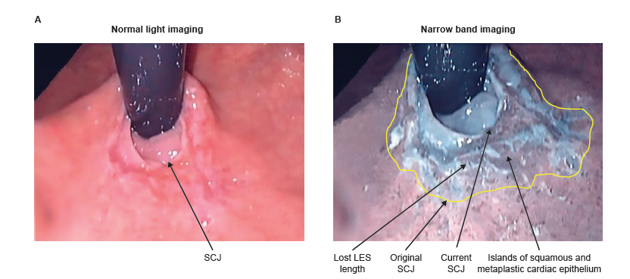
Figure 1 Retroflex endoscopic view of the squamocolumnar junction in advanced gastroesophageal reflux disease. A: Normal white light image displays a slightly irregular SCJ with normal squamous epithelium extending up the esophagus; B: Narrow band image shows multiple islands of squamous epithelium below the SCJ, surrounded by newly formed metaplastic cardiac epithelium. The splayed out original SCJ (indicated by the yellow line), and damaged portion of the LES between the original SCJ and the current SCJ, take on the appearance of stomach. Loss of esophageal muscle due to inflammation results in a reduction in the abdominal length of the LES and loss of the LES barrier function. Images used with permission from Dr. Peters, Case Western University, Cleveland, OH, United States. GERD: Gastroesophageal reflux disease; LES: Lower esophageal sphincter; SCJ: Squamocolumnar junction.

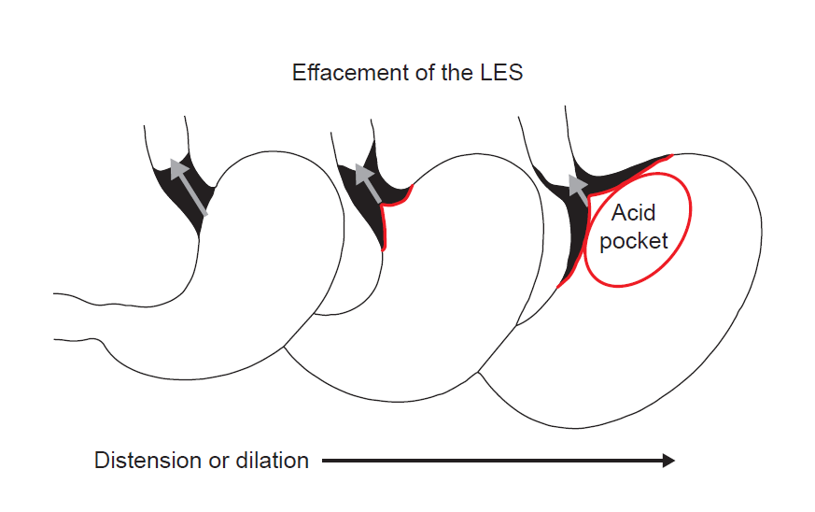
Figure 2 Effacement of the lower esophageal sphincter as a result of gastric distension or dilation. Exposure of the squamous mucosa covering the effaced portion of the lower esophageal sphincter (LES) to gastric juice results in inflammation, the formation of metaplastic cardiac mucosa, and progressive loss of LES length. The red line represents the squamous epithelial covering of the effaced portion of the LES (in black) as it is taken up by the expanding gastric fundus. LES: Lower esophageal sphincter.

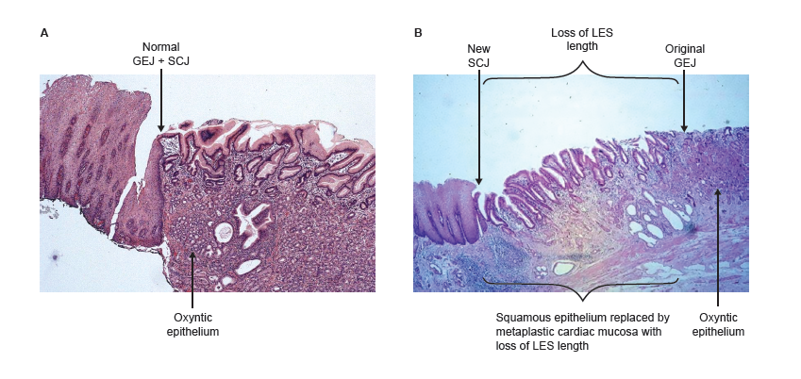
Figure 3 The histology of the squamo-oxyntic gap. A: The normal junction of the esophagus and stomach is the abutment of the proximal limit of the gastric oxyntic epithelium and the distal limit of the squamous epithelium; B: Squamo-oxyntic gap: Squamous epithelium is replaced by metaplastic cardiac mucosa resulting in loss of LES length, as shown by manometry. Images provided by Dr. Parakrama Chandrasoma. GEJ: Gastroesophageal junction; GERD: Gastroesophageal reflux disease; LES: Lower esophageal sphincter; SCJ: Squamocolumnar junction.
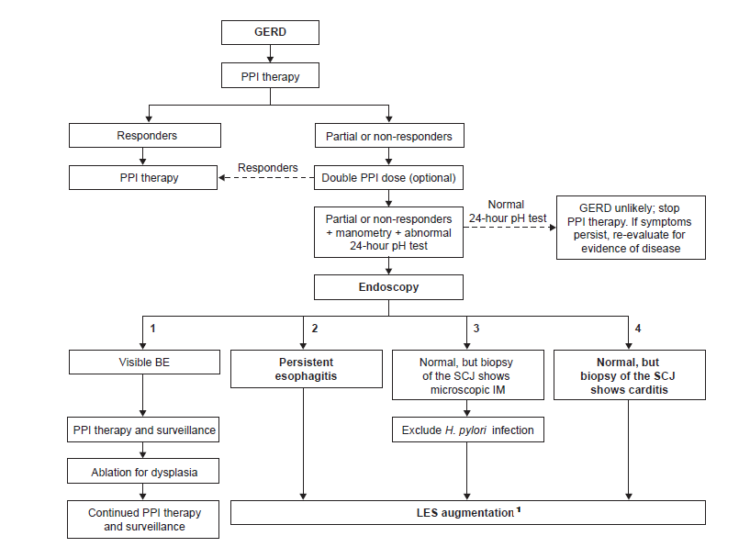

Figure 4 Proposed algorithm for the treatment of patients with progressive gastroesophageal reflux disease. Patients who do not respond to PPI therapy and who have an abnormal 24-h esophageal pH should undergo endoscopy. Patients can be stratified into four groups following endoscopy: (1) patients with visible BE; (2) patients with persistent esophagitis; (3) patients with a normal endoscopy who have microscopic IM of the SCJ; and (4) patients with a normal endoscopy who have carditis at the SCJ. Patients in groups (2), (3) and (4) should undergo manometric assessment of LES function; those with a defective LES may be candidates for LES augmentation. ¹If fewer than 2 defective LES components consider Nissen fundoplication. Only recommended for group 4 if damage to the LES is permanent. BE: Barrett’s esophagus; GERD: Gastroesophageal reflux disease; LES: Lower esophageal sphincter; IM: Intestinal metaplasia; PPI: Proton pump inhibitor; SCJ: Squamocolumnar junction.

Table 1 Hallmarks of gastroesophageal reflux disease in patients with and without cardiac mucosa on biopsies of the gastroesophageal junction
 | Findings on multiple biopsies of the GEJ
 | No cardiac epithelium  (n = 88) | Cardiac epithelium  (n = 246) | P
% time pH < 4 | 1.1 ± 4.6 | 6.0 ± 7.4 | < 0.01
% hiatal hernia | 25.0 | 55.1 | < 0.01
LES pressure (mmHg) | 13.2 ± 12.8 | 8.0 ± 8.0 | < 0.01
LES abdominal length (mm) | 1.6 ± 1.1 | 1.0 ± 1.2 | < 0.01
LES overall length (mm) | 3.0 ± 1.2 | 2.2 ± 1.6 | < 0.01
% defective LES | 27.2 | 62.3 | < 0.01
% esophagitis | 11.2 | 33.2 | < 0.01
Values are medians ± interquartile range unless otherwise stated. Data are from Oberg et al^{[28]}. GEJ: Gastroesophageal junction; GERD: Gastroesophageal reflux disease; LES: Lower esophageal sphincter.

Table 2 Hallmarks of gastroesophageal reflux disease in patients with and without carditis on biopsies of the gastroesophageal junction
 | Findings on multiple biopsies of the GEJ
 | No carditis (n = 9) | Carditis (n = 237) | P
% time pH < 4 | 3.1 ± 4.5 | 6.1 ± 7.2 | 0.14
LES pressure (mmHg) | 10.6 ± 12.4 | 7.8 ± 8.2 | 0.03
LES abdominal length (mm) | 1.4 ± 0.4 | 1.0 ± 1.2 | 0.10
LES overall length (mm) | 3.3 ± 0.7 | 2.2 ± 1.6 | 0.02
% defective LES | 11.1 | 63.7 | < 0.01
Values are medians ± interquartile range unless otherwise stated. Data are from Oberg et al^{[28]}. GEJ: Gastroesophageal junction; GERD: Gastroesophageal reflux disease; LES: Lower esophageal sphincter.

Table 3 Hallmarks of gastroesophageal reflux disease in patients with carditis in the presence or absence of erosive esophagitis
 | Carditis
 | No erosive esophagitis  (n = 155) | Erosive esophagitis  (n = 82) | P
% time pH < 4 | 4.1 ± 6.5 | 9.2 ± 7.0 | < 0.01
% hiatal hernia | 44.2 | 78.0 | < 0.01
LES pressure (mmHg) | 10.0 ± 8.8 | 5.6 ± 5.0 | < 0.01
LES abdominal length (mm) | 1.0 ± 1.2 | 0.6 ± 0.8 | < 0.01
LES overall length (mm) | 2.4 ± 1.4 | 2.1 ± 1.6 | < 0.06
% defective LES | 54.2 | 81.7 | < 0.01
% intestinal metaplasia | 8.3 | 19.5 | 0.02
Values are medians ± interquartile range unless otherwise stated. Data are from Oberg et al^{[28]}. GERD: Gastroesophageal reflux disease; LES: Lower esophageal sphincter.

