Name of Journal: World Journal of Gastrointestinal Endoscopy
ESPS Manuscript NO: 28832
Manuscript Type: Original Article

Retrospective Study

Endoscopic submucosal dissection for small submucosal tumors of the rectum compared with endoscopic submucosal resection with a ligation device

Harada H et al. ESD vs ESMR-L for small rectal SMTs

Hideaki Harada, Satoshi Suehiro, Daisuke Murakami, Ryoutarou Nakahara, Takanori Shimizu, Yasushi Katsuyama, Yasunaga Miyama, Kenji Hayasaka, Shigetaka Tounou

Hideaki Harada, Satoshi Suehiro, Daisuke Murakami, Ryoutarou Nakahara, Takanori Shimizu, Yasushi Katsuyama, Kenji Hayasaka, Department of Gastroenterology, New Tokyo Hospital, Chiba 270-2232, Japan

Yasunaga Miyama, Department of Health Service Center, Tokyo Medical and Dental University, Tokyo 113-0034, Japan

Shigetaka Tounou, Second Division of Internal Medicine, Teikyo University Chiba Medical Center, Chiba 3426-3, Japan

Author contributions: Harada H wrote the manuscript and analyzed the data; Suehiro S, Murakami D, Nakahara R, Shimizu T, Katsuyama Y, Miyama Y, Hayasaka K and Tounou S collected the data.

Supported by New-Tokyo Hospital, Chiba, Japan.

Institutional review board statement: This study was reviewed and approved by the New Tokyo Hospital Institutional Review Committee.

Informed consent statement: The procedure participant provided informed written consent.

Conflict-of-interest statement: No potential conflicts of interest relevant to this article were reported.

Data sharing statement: No additional data are available.

Open-Access: This is an open–access article that was selected by an in-house editor and fully peer-reviewed by external reviewers. It is distributed in accordance with the Creative Commons Attribution Non Commercial (CC BY-NC 4.0) license, which permits others to distribute, remix, adapt, build upon this work non-commercially, and license their derivative works on different terms, provided the original work is properly cited and the use is non-commercial. See: http://creativecommons.org/licenses/by-nc/4.0/

Manuscript source: Invited manuscript

Correspondence to: Hideaki Harada, MD, Director, Department of Gastroenterology, New Tokyo Hospital, 1271 Wanagaya, Matsudo Chiba 270-2232, Japan. nerimaendo@hotmail.co.jp
Telephone: +81-47-7118700
Fax: +81-47-3928718

Received: July 17, 2016
Peer-review started: July 20, 2016
First decision: September 7, 2016
Revised: September 28, 2016
Accepted: November 1, 2016
Article in press:
Published online:

Abstract
AIM
To evaluate the efficacy and safety of endoscopic submucosal dissection (ESD) for small rectal submucosal tumors (SMTs).

METHODS
Between August 2008 and March 2016, 39 patients were treated with endoscopic submucosal resection with a ligation device (ESMR-L) (n = 21) or ESD (n = 18) for small rectal SMTs in this study. Twenty-five lesions were confirmed by histological evaluation of endoscopic biopsy prior to the procedure, and 14 lesions were not evaluated by endoscopic biopsy. The results for the ESMR-L group and the ESD group were retrospectively compared, including baseline characteristics and therapeutic outcomes.

RESULTS
The rate of en bloc resection was 100% in both groups. Although the rate of complete endoscopic resection was higher in the ESD group than in the ESMR-L group (100% vs 95.2%), there were no significant differences between the two groups (P = 0.462). In one patient in the ESMR-L group with a previously biopsied tumor, histological complete resection with a vertical margin involvement of carcinoid tumor could not be achieved, whereas there was no incomplete resection in the ESD group. The mean length of the procedure was significantly greater in the ESD group than in the ESMR-L group (14.7 ± 6.4 min vs 5.4 ± 1.7 min, P < 0.05). The mean period of the hospitalization was also significantly longer in the ESD group than in the ESMR-L group (3.7 ± 0.9 d vs 2.8 ± 1.5 d, P < 0.05). Postoperative bleeding was occurred in one patient in the ESMR-L group.

CONCLUSION
Both ESMR-L and ESD were effective for treatment of small rectal SMTs. ESMR-L was simpler to perform than ESD and took less time.

Key words: Submucosal tumor; Carcinoid tumor; Leiomyoma; Lipoma; Rectum; Endoscopic submucosal resection with a ligation device; Endoscopic submucosal dissection

© The Author(s) 2016. Published by Baishideng Publishing Group Inc. All rights reserved.

Core tip: This was a retrospective study to evaluate the efficacy and safety of endoscopic submucosal dissection (ESD) compared with endoscopic submucosal resection with a ligation device (ESMR-L) for small rectal submucosal tumors (SMTs). A total of 39 patients were treated with endoscopic resection for small rectal SMTs; 21 were treated with ESMR-L and 18 were treated with ESD. The results show that both ESMR-L and ESD were effective for treatment of small rectal SMTs. ESMR-L was simpler to perform than ESD and took less time.

Harada H, Suehiro S, Murakami D, Nakahara R, Shimizu T, Katsuyama Y, Miyama Y, Hayasaka K, Tounou S. Endoscopic submucosal dissection for small submucosal tumors of the rectum compared with endoscopic submucosal resection with a ligation device. World J Gastrointest Endosc 2016; In press

INTRODUCTION
Submucosal tumors (SMTs) consist of neoplastic lesions covered by normal overlying mucosa. SMTs with an intramural origin include carcinoid tumors, leiomyoma, lipoma, lymphoma, and gastrointestinal stromal tumors (GISTs). Rectal SMTs are relatively rare and are occasionally detected by screening colonoscopy without any symptoms. Rectal carcinoid tumors smaller than 10 mm in diameter are candidates for local excision (e.g., by endoscopic resection or transanal endoscopic microsurgery). As previous studies of endoscopic resection for rectal carcinoid tumors have reported, conventional endoscopic resection, such as polypectomy or endoscopic mucosal resection (EMR), is associated with involvement of the resection margin that necessitates further intervention^{[1–3]}. On the other hand, endoscopic submucosal resection with a ligation device (ESMR-L) or endoscopic submucosal dissection (ESD) achieves a high rate of complete resection for rectal carcinoid tumors without involvement of the resection margin^{[4–12]}. Complete resection rates have been reported as ranging from 93.3% to 100% for ESMR-L^{[4–9]} and from 80.6% to 100% for ESD^{[8–16]}. Although both endoscopic procedures are excellent treatments for carcinoid tumors, ESD takes longer to perform and has a longer hospitalization period^{[8–10]}. However, an advantage of ESD is that the submucosal layer beneath the tumors can be directly visualized during submucosal dissection^{[17]}.
Although some cases have been reported of ESD for other rectal SMTs, such as leiomyoma and GISTs, there have been few reports comparing the two procedures for treatment of small rectal SMTs. The aim of this study was to evaluate the efficacy and feasibility of ESD for small rectal SMTs compared with ESMR-L.

MATERIALS AND METHODS
Patients
A total of 39 patients were treated with endoscopic resection for small rectal SMTs (35 with carcinoid tumors, three with leiomyoma, and one with lipoma) at the New Tokyo Hospital between August 2008 and March 2016. Twenty-one patients were treated with ESMR-L and 18 patients were treated with ESD.
All lesions were incidentally found by screening colonoscopy and none of the patients had any symptoms, such as carcinoid syndrome or hematochezia. Twenty-five lesions were confirmed by histological evaluation of endoscopic biopsy prior to the procedure, and 14 lesions were not evaluated by endoscopic biopsy. All patients were evaluated by endoscopic ultrasonography (EUS) before endoscopic treatment and also by computed tomography (CT) to rule out metastases. The indications for endoscopic treatment were a tumor less than 10 mm in diameter and confined to the submucosal layer, and no lymph node involvement or distant metastases.
All patients provided written informed consent before the treatment. Their clinical records were retrospectively reviewed after approval had been obtained from the institutional review board of the New Tokyo Hospital.

ESMR-L procedure
The ESMR-L procedure was performed with the use of a single-channel endoscope (GIF-Q260J; Olympus, Tokyo, Japan) with an attached a band-ligation device (pneumo-activate EVL device; Sumitomo Bakelite, Tokyo, Japan). The procedure was performed as follows (Figure 1). First, submucosal injection with a solution containing glycerin was performed to lift the submucosa off from the muscular layer. After the submucosa was lifted, the lesion was aspirated into a ligation device, followed by deployment of the elastic band. The shape of the lesion was changed to that of a pseudopolyp that was suitable for snare resection. Snare resection was then performed beneath the elastic band in an Endocut Q current (effect 3, cut duration 1, cut interval 6), which was generated with a VIO300D (ERBE, Türbingen, Germany). Finally, endoscopic plication was performed with the use of metal endoclips.

ESD procedure
The ESD procedure was performed with the use of a single-channel endoscope (GIF-Q240; Olympus, Tokyo, Japan). The procedure was performed as follows (Figure 2). After submucosal injection with sodium hyaluronate was performed, a hemicircumferential mucosal incision was made from the anal side with the use of a FlushKnife BT (DK2618JB; Fujifilm, Tokyo, Japan). Next, a pocket of the submucosa was created to allow the endoscope to enter the submucosal layer while the submucosa was being dissected. In order to keep sufficient margin between the bottom of the tumor and the cutting margin, the submucosal dissection was performed just above the muscular layer using an Endocut I current (effect 2, cut duration 3, cut interval 2), which was generated by using a VIO300D. During the submucosal dissection, precoagulation was performed on visible vessels by using hemostatic forceps (FD-230U or FD-410LR; Olympus, Tokyo, Japan). After the submucosal dissection was performed beyond the tumor, the intact mucosa was cut by the electrosurgical knife. Finally, endoscopic plication was performed with the use of metal endoclips. For both of ESMR-L and ESD, the procedure time was defined as the time from the submucosal injection to the completion of endoscopic resection.

Histological evaluation
The resected specimens were carefully examined for histological evaluation by experienced pathologists. The resected specimens were evaluated microscopically for pathological type, depth of invasion, lateral and vertical margin involvement, and lymphovascular invasion. En bloc resection was defined as one-piece resection endoscopically. Endoscopic complete resection was defined as en bloc resection endoscopically without tumor involvement to the lateral and the vertical margins of the resected specimens.

Complications
Postoperative bleeding was defined as hematochezia after endoscopic resection that required simultaneous endoscopic hemostasis. Perforation was defined as a defect of the muscular layer during endoscopic resection or recognized free air on CT after endoscopic resection.

Follow-up
All patients were periodically followed up by colonoscopy between approximately 6 and 12 mo after endoscopic resection. If recurrent or remnant tumor was suspected, biopsy from the resected scar was performed. CT was performed annually to exclude lymph node metastases and distant metastases.

Statistical analysis
Continuous variables were expressed as the means and standard deviations (SD). The chi-squared test or Fisher’s exact test was used to analyze categorical variables. A P value < 0.05 was considered to indicate statistical significance. Data analyses were performed with Stat View software Version 5.0 for Windows (SAS, Cary, NC, United States).

RESULTS
A total of 39 patients with small rectal SMTs were treated with endoscopic resection. The clinical findings and characteristics of these patients are shown in Table 1. No significant differences were observed between the ESMR-L group and the ESD group other than history of previous biopsy.
The clinical outcomes in the ESMR-L and the ESD groups are shown in Table 2. Three types of pathological findings were observed: carcinoid tumors, leiomyoma, and lipoma. There were 20 lesions of carcinoid tumors and one lesion of lipoma in the ESMR-L group, and 15 lesions of carcinoid tumors and three lesions of leiomyoma in the ESD group.
The rate of en bloc resection was 100% in both groups. The rate of endoscopic complete resection was 95.2% (20/21) in the ESMR-L group and 100% (18/18) in the ESD group. There were no significant differences between the two groups (P = 0.462). Vertical margin involvement occurred in one carcinoid tumor in the ESMR-L group.
Lymphovascular invasion occurred in one carcinoid tumor in the ESD group. The tumor was 6 mm in diameter, located at Rb, and was an neuroendocrine tumor G2 with Ki-67 expression between 3% and 20%. The patient underwent additional surgical resection with lymphadenectomy. However, no remnant tumor or lymph node metastases were found.
The mean length of the procedure was significantly greater in the ESD group than in the ESMR-L group (14.7 ± 6.4 min vs 5.4 ± 1.7 min, P < 0.05). The mean length of the hospitalization was also significantly greater in the ESD group than in the ESMR-L group (3.7 ± 0.9 d vs 2.8 ± 1.5 d, P < 0.05). Postoperative bleeding occurred in one patient with carcinoid tumor in the ESMR-L group after discharge from the hospital. The bleeding was successfully managed with emergency endoscopic hemostasis. There were no complications in the ESD group.
The average follow-up period after the treatment was 31.6 ± 21.9 mo in the ESMR-L group and 9.1 ± 5.8 mo in the ESD group. One patient in the ESMR-L group whose carcinoid tumor could not be resected completely was provided with careful follow-up by colonoscopy with biopsy and CT. There were no local recurrences or distant metastases during the follow-up period.

DISCUSSION
This study investigated the outcomes of endoscopic resection for small SMTs of the rectum. Although the rate of complete endoscopic resection was higher in the ESD group than in the ESMR-L group (100% vs 95.2%, P = 0.462), there were no significant differences in outcome between the two groups. Our results are similar to those of previous studies comparing ESD and ESMR-L for treatment of carcinoid tumors^{[7,9,10]}. Previous studies reported that the length of the procedure and the period of hospitalization were greater in the ESD group than in the ESMR-L group. Although our study included other rectal SMTs, such as leiomyoma and lipoma, our results were also consistent with those of the previous studies of carcinoid tumors. In terms of procedure time and length of hospitalization, the ESMR-L procedure is a more favorable treatment than the ESD procedure.
One patient in the ESMR-L group had postoperative bleeding 3 d after undergoing ESMR-L. The patient received dual antiplatelet therapy (DAPT; low-dose aspirin plus clopidogrel) for cardiovascular disease to prevent thrombosis after percutaneous coronary intervention. Since the patient was treated with ESMR-L for carcinoid tumor with continuous use of low-dose aspirin after clopidogrel was discontinued for 5 d before the treatment, the antiplatelet therapy probably contributed to the postoperative bleeding. The postoperative bleeding was successfully managed with endoscopic hemostasis with the use of metal endoclips.
One patient in the ESMR-L group had vertical margin involvement of the carcinoid tumor. Although the patient received no additional interventions, no local recurrence or distant metastases have occurred so far (24 mo after the resection). The patient had a diagnostic biopsy prior to ESMR-L. Im et al^{[18]} reported that previously biopsied tumors remained independent significant predictors of histological incomplete resection of rectal carcinoid tumors. Previous endoscopic biopsy is likely to produce fibrosis around the lesion. The authors reported that ESMR-L for previously biopsied tumors had a significantly higher rate of complete resection than EMR. However, two patients in their study who were treated with ESMR-L for previously biopsied tumors had histological incomplete resection. The fibrosis caused by the previous biopsy probably contributed to the incomplete resection in the ESMR-L procedure. In our study, one patient in the ESMR-L group had histological incomplete resection of a previously biopsied tumor, whereas there were no incomplete resections in the ESD group. An advantage of ESD is that the surgeon can directly observe the submucosal layer during ESD and perform the submucosal dissection regardless of the fibrosis. We believe that this advantage contributed to the complete resection of the SMTs. However, since only seven of our patients underwent ESD for a previously biopsied tumor, no statistically significant conclusion can be drawn from these results.
The most importance of the endoscopic resection for SMTs, such as carcinoid tumors, is to achieve the complete resection of the deeper margins without involvement of the tumor. The submucosal dissection facilitates the complete resection of the SMTs by cutting just above the muscular layer. However, the rate of perforation with colorectal ESD is comparatively high because of the thin wall, sharp bends, and narrow lumen of the colorectum. To remedy with this situation, Hayashi et al^{[17]} described the pocket-creation method (PCM). The authors reported that the PCM technique allows safe en bloc ESD and complete resection of tumors even in the presence of severe submucosal fibrosis, because creation of a submucosal pocket helps the endoscope to enter and stretch the submucosal layer and enables visualization of the line of dissection. We applied this method to the treatment of the rectal SMTs (Figure 2D).
The submucosal dissection is favorable to perform just above the muscular layer using an endocut mode rather than a coagulation mode, because it is likely to be the risk of a vertical margin involvement of the tumor caused by a burning effect during the submucosal dissection. Although the rate of perforation can be increased in the setting of an endocut mode during the submucosal dissection, an endocut mode would decrease the risk of the burning effect for the vertical margin of the tumor. On the other hand, using a coagulation mode would increase the risk of the burning effect for the vertical margin of the tumor. The PCM technique facilitated the submucosal dissection with the use of an endocut mode by preventing leakage of the submucosal injection and maintaining a thick submucosal layer owing to PCM technique. The creation of a submucosal pocket also facilitated the submucosal dissection of the rectal SMTs, regardless of the previous biopsy in this study. There was no vertical margin involvement in any of the specimens in the ESD group.
This study has some limitations. It was a retrospective study conducted in a single institution with a small sample size. A prospective study with a larger number of subjects will be expected.
In conclusion, both ESMR-L and ESD were effective for treatment of small rectal SMTs. ESMR-L was simpler to perform than ESD and took less time. However, the submucosal dissection using ESD could be effective for treatment of previously biopsied tumors.

COMMENTS
Background
Submucosal tumors (SMTs) consist of neoplastic lesions covered by normal overlying mucosa. SMTs with an intramural origin include carcinoid tumors, leiomyoma, lipoma, lymphoma, and gastrointestinal stromal tumors (GISTs). Rectal SMTs are relatively rare and are occasionally detected by screening colonoscopy (CS) without any symptoms. Rectal carcinoid tumors smaller than 10 mm in diameter are candidates for local excision (e.g., by endoscopic resection or transanal endoscopic microsurgery). Endoscopic submucosal resection with a ligation device (ESMR-L) or endoscopic submucosal dissection (ESD) achieves a high rate of complete resection for rectal carcinoid tumors without involvement of the resection margin. In this study, we evaluated the efficacy and feasibility of ESD for small rectal SMTs compared with ESMR-L.

Research frontiers
Although ESMR-L and ESD are excellent treatments for carcinoid tumors, ESD takes longer to perform and has a longer hospitalization period.

Innovations and breakthroughs
Previous endoscopic biopsy is likely to produce fibrosis around the lesion. Fibrosis caused by the previous biopsy probably contributed to the incomplete resection. An advantage of ESD is that the surgeon can directly observe the submucosal layer during ESD and perform the submucosal dissection regardless of the fibrosis.

Applications
The submucosal dissection using ESD could be effective for treatment of previously biopsied tumors in patients with SMTs

Terminology
ESMR-L is endoscopic submucosal resection with a ligation device. PCM is pocket-creation method that the technique helps the endoscope to enter and stretch the submucosal layer and enables visualization of the line of dissection.

Peer-review
The study is original and timely. Although the study consist of relatively low number of patients the findings of this study will make contribution to the literature. The findings of this study are relevant to the focus of this journal and will be of interest to its readers.

REFERENCES
1 Shirouzu K, Isomoto H, Kakegawa T, Morimatsu M. Treatment of rectal carcinoid tumors. Am J Surg 1990; 160: 262-265 [PMID: 2393053 DOI: 10.1016/S0002-9610(06)80019-X]
2 Matsumoto T, Iida M, Suekane H, Tominaga M, Yao T, Fujishima M. Endoscopic ultrasonography in rectal carcinoid tumors: contribution to selection of therapy. Gastrointest Endosc 1991; 37: 539-542 [PMID: 1936832 DOI: 10.1016/S0016-5107(91)70824-9]
3 Matsui K, Iwase T, Kitagawa M. Small, polypoid-appearing carcinoid tumors of the rectum: clinicopathologic study of 16 cases and effectiveness of endoscopic treatment. Am J Gastroenterol 1993; 88: 1949-1953 [PMID: 8237948]
4 Mashimo Y, Matsuda T, Uraoka T, Saito Y, Sano Y, Fu K, Kozu T, Ono A, Fujii T, Saito D. Endoscopic submucosal resection with a ligation device is an effective and safe treatment for carcinoid tumors in the lower rectum. J Gastroenterol Hepatol 2008; 23: 218-221 [PMID: 18289355 DOI: 10.1111/j.1440-1746.2008.05313.x]
5 Kim HH, Park SJ, Lee SH, Park HU, Song CS, Park MI, Moon W. Efficacy of endoscopic submucosal resection with a ligation device for removing small rectal carcinoid tumor compared with endoscopic mucosal resection: analysis of 100 cases. Dig Endosc 2012; 24: 159-163 [PMID: 22507089 DOI: 10.1111/j.1443-1661.2011.01190.x]
6 Kim KM, Eo SJ, Shim SG, Choi JH, Min BH, Lee JH, Chang DK, Kim YH, Rhee PL, Kim JJ, Rhee JC, Kim JY. Treatment outcomes according to endoscopic treatment modalities for rectal carcinoid tumors. Clin Res Hepatol Gastroenterol 2013; 37: 275-282 [PMID: 22959100 DOI: 10.1016/j.clinre.2012.07.007]
7 Lee SH, Park SJ, Kim HH, Ok KS, Kim JH, Jee SR, Seol SY, Kim BM. Endoscopic resection for rectal carcinoid tumors: comparison of polypectomy and endoscopic submucosal resection with band ligation. Clin Endosc 2012; 45: 89-94 [PMID: 22741138 DOI: 10.5946/ce.2012.45.1.89]
8 Niimi K, Goto O, Fujishiro M, Kodashima S, Ono S, Mochizuki S, Asada-Hirayama I, Konno-Shimizu M, Mikami-Matsuda R, Minatsuki C, Yamamichi N, Koike K. Endoscopic mucosal resection with a ligation device or endoscopic submucosal dissection for rectal carcinoid tumors: an analysis of 24 consecutive cases. Dig Endosc 2012; 24: 443-447 [PMID: 23078437 DOI: 10.1111/j.1443-1661.2012.01303.x]
9 Choi CW, Kang DH, Kim HW, Park SB, Jo WS, Song GA, Cho M. Comparison of endoscopic resection therapies for rectal carcinoid tumor: endoscopic submucosal dissection versus endoscopic mucosal resection using band ligation. J Clin Gastroenterol 2013; 47: 432-436 [PMID: 23188074 DOI: 10.1097/MCG.0b013e31826faf2b]
10 Lee DS, Jeon SW, Park SY, Jung MK, Cho CM, Tak WY, Kweon YO, Kim SK. The feasibility of endoscopic submucosal dissection for rectal carcinoid tumors: comparison with endoscopic mucosal resection. Endoscopy 2010; 42: 647-651 [PMID: 20669076 DOI: 10.1055/s-0030-1255591]
11 Onozato Y, Kakizaki S, Iizuka H, Sohara N, Mori M, Itoh H. Endoscopic treatment of rectal carcinoid tumors. Dis Colon Rectum 2010; 53: 169-176 [PMID: 20087092 DOI: 10.1007/DCR.0b013e318b9db7b]
12 Park HW, Byeon JS, Park YS, Yang DH, Yoon SM, Kim KJ, Ye BD, Myung SJ, Yang SK, Kim JH. Endoscopic submucosal dissection for treatment of rectal carcinoid tumors. Gastrointest Endosc 2010; 72: 143-149 [PMID: 20381798 DOI: 10.1016/j.gie.2010.01.040]
13 Sung HY, Kim SW, Kang WK, Kim SY, Jung CK, Cho YK, Park JM, Lee IS, Choi MG, Chung IS. Long-term prognosis of an endoscopically treated rectal neuroendocrine tumor: 10-year experience in a single institution. Eur J Gastroenterol Hepatol 2012; 24: 978-983 [PMID: 22647741 DOI: 10.1097/MEG.0b013e3283551e0b]
14 Zhao ZF, Zhang N, Ma SR, Yang Z, Han X, Zhao YF, Gao F, Gong ZJ, Yang L. A comparative study on endoscopy treatment in rectal carcinoid tumors. Surg Laparosc Endosc Percutan Tech 2012; 22: 260-263 [PMID: 22678324 DOI: 10.1097/SLE.0b013e3182512e0f]
15 Zhou PH, Yao LQ, Qin XY, Xu MD, Zhong YS, Chen WF, Ma LL, Zhang YQ, Qin WZ, Cai MY, Ji Y. Advantages of endoscopic submucosal dissection with needle-knife over endoscopic mucosal resection for small rectal carcinoid tumors: a retrospective study. Surg Endosc 2010; 24: 2607-2612 [PMID: 20361212 DOI: 10.1007/s00464-010-1016-z]
16 Suzuki S, Ishii N, Uemura M, Deshpande GA, Matsuda M, Iizuka Y, Fukuda K, Suzuki K, Fujita Y. Endoscopic submucosal dissection (ESD) for gastrointestinal carcinoid tumors. Surg Endosc 2012; 26: 759-763 [PMID: 21993939 DOI: 10.1007/s00464-011-1948-y]
17 Hayashi Y, Miura Y, Yamamoto H. Pocket-creation method for the safe, reliable, and efficient endoscopic submucosal dissection of colorectal lateral spreading tumors. Dig Endosc 2015; 27: 534-535 [PMID: 25708068 DOI: 10.1111/den.12465]
18 Im YC, Jung SW, Cha HJ, Yang SS, Kim GY, Yi YA, Park JH, Kim BG, Jeong ID. The effectiveness of endoscopic submucosal resection with a ligation device for small rectal carcinoid tumors: focused on previously biopsied tumors. Surg Laparosc Endosc Percutan Tech 2014; 24: 264-269 [PMID: 24710234 DOI: 10.1097/SLE.0b013e3182901176]

P-Reviewer: Demir Y, Pavlidis TE, Turati L S-Editor: Qi Y L-Editor: E-Editor:

Table 1 Clinical findings and characteristics between endoscopic submucosal resection with a ligation device and endoscopic submucosal dissection n (%)
 | ESMR-L (n = 21) | ESD (n = 18) | P value
Age (yr, mean ± SD) | 65.7 ± 14.2 | 61.2 ± 12.9 | 0.306
Sex (male/femal) | 14/7 | 8/10 | 0.206
Tumor size (mm, mean ± SD) | 4.9 ± 1.7 | 5.1 ± 2.1 | 0.681
Macroscopic type  Sessile  Semipedunculated | 21 (100)  0 (0) | 17 (94.4)  1 (5.6) | 0.462
Location  Rb  Ra | 18 (85.7)  3 (14.3) | 17 (94.4)  1 (5.6) | 0.609
History of previous biopsy | 18 (85.7) | 7 (38.9) | 0.003
ESMR-L: Endoscopic submucosal resection with a ligation device; ESD: Endoscopic submucosal dissection.

Table 2 Clinical outcomes between endoscopic submucosal resection with a ligation device and endoscopic submucosal dissection n (%)
 | ESMR-L (n = 21) | ESD (n = 18) | P value
En bloc resection | 21 (100) | 18 (100)
Endoscopic complete resection | 20 (95.2) | 18 (100) | 0.462
Histological evaluation  Vertical margin involvement  Lymphovascular invasion | 1 (4.8)  0 (0) | 0 (0)  1 (5.6) | 0.717
Pathological findings  Carcinoid  Others | 20 (95.2)  1 (4.8) | 15 (83.3)  3 (16.7) | 0.318
Complication  Post-operative bleeding | 1 (4.8) | 0 (0) | 0.462
Procedure time (min, mean ± SD) | 5.4 ± 1.7 | 14.7 ± 6.4 | < 0.001
Hospitalization (d, mean ± SD) | 2.8 ± 1.5 | 3.7 ± 0.9 | 0.024
Local recurrence | 0 (0) | 0 (0)
Distant recurrence | 0 (0) | 0 (0)
ESMR-L: Endoscopic submucosal resection with a ligation device; ESD: Endoscopic submucosal dissection.

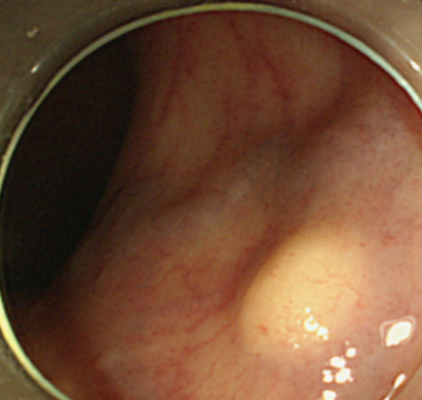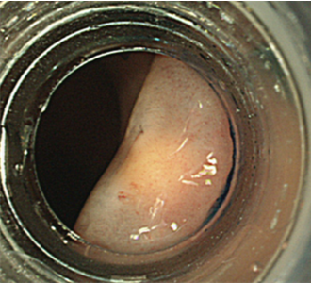
B
A
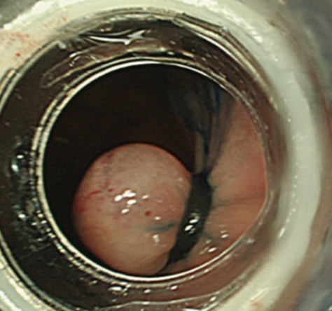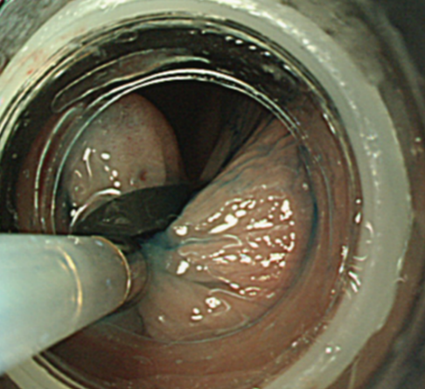
D
C
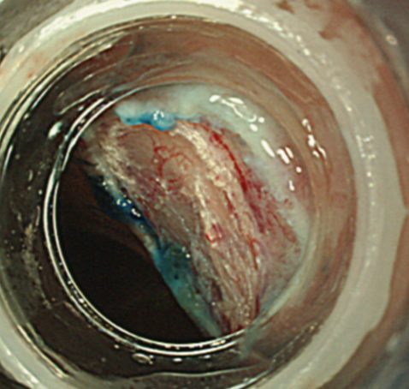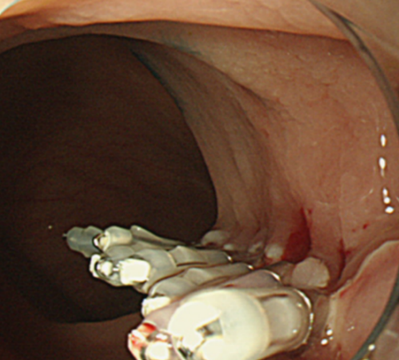
F
G
E
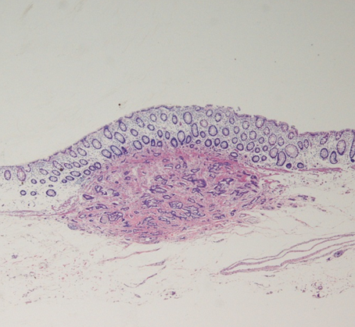
Figure 1 Endoscopic submucosal resection with a ligation device. A: Endoscopic view of a carcinoid tumor in the rectum; B: Submucosal injection beneath the tumor with glycerin solution; C: An elastic band was deployed, and then pseudopolyp was created; D: Snare resection was performed beneath the elastic band; E: An artificial ulcer was observed; F: Endoscopic plication was performed with the use of metal endoclips; G: Histopathological examination showed en bloc resection of the carcinoid tumor.

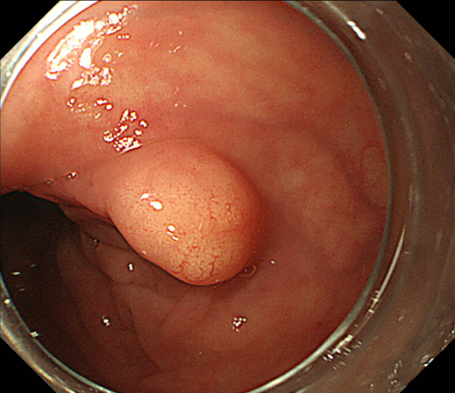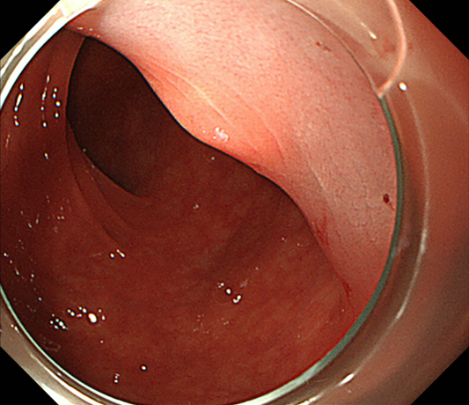
A
D
B
C
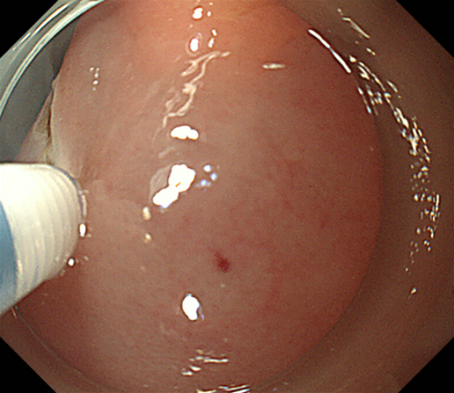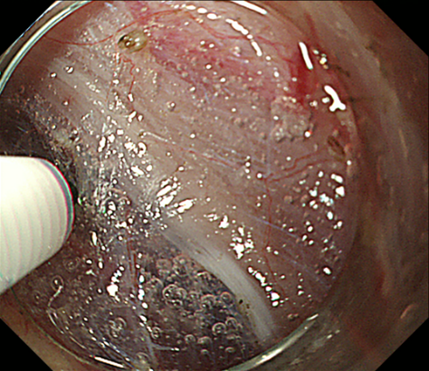
E
F
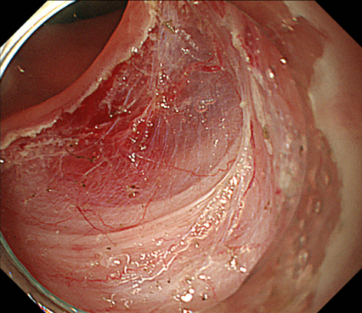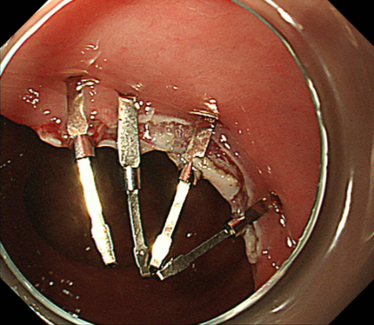
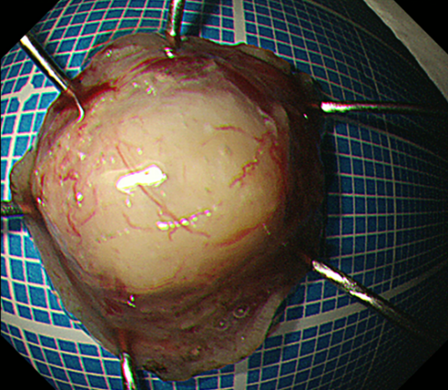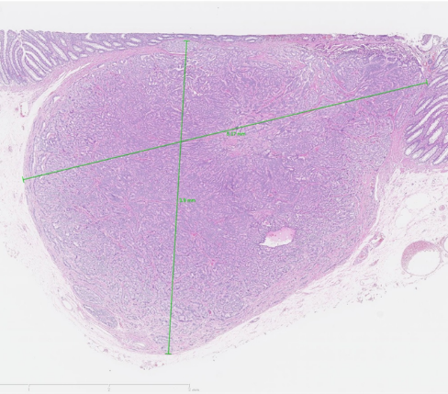
H
G
Figure 2 Endoscopic submucosal dissection. A: Endoscopic view of a carcinoid tumor in the rectum; B: Submucosal injection beneath the tumor with sodium hyaluronate; C: A hemicircumferential incision was performed with the use of the electrosurgical knife; D: A submucosal pocket was created during ESD. Submucosal dissection was performed just above the muscular layer; E: An artificial ulcer was observed; F: Endoscopic plication was performed with the use of metal endoclips; G: The specimen resected by ESD; H: Histopathological examination showed en bloc resection of the carcinoid tumor.

