Name of Journal: World Journal of Clinical Cases
Manuscript NO: 76915
Manuscript Type: CASE REPORT

ST-segment elevation myocardial infarction in Kawasaki disease: A case report and review of literature

Lee et al. Kawasaki disease presenting with STEMI

Joonpyo Lee, Jeongduk Seo, Yong Hoon Shin, Albert Youngwoo Jang, Soon Yong Suh

Joonpyo Lee, Jeongduk Seo, Yong Hoon Shin, Albert Youngwoo Jang, Soon Yong Suh, Division of Cardiology, Department of Internal Medicine, Gachon University, Gil Medical Center, Incheon 21565, South Korea

Author contributions: Lee J, Jang Y, and Suh SY contributed to conceptualization and design and methodology and visualization; Lee J, Seo J, Shin YH, Jang Y, and Suh SY are responsible for validation; Lee J, Jang Y, and Suh SY participated in original draft preparation; Lee J, Jang Y, and Suh SY reviewed and edited manuscript; Suh SY contributed to supervision and project administration; all authors issued their final approval for the version to be submitted.

Corresponding author: Soon Yong Suh, PhD, Associate Professor, Division of Cardiology, Department of Internal Medicine, Gachon University, Gil Medical Center, 1198 Guwol-dong, Namdong-gu, Incheon 21565, South Korea. ssy@gilhospital.com

Received: April 13, 2022
Revised: May 24, 2022
Accepted: August 5, 2022
Published online:

Abstract
BACKGROUND
Kawasaki disease (KD) is an acute self-limiting febrile vasculitis that occurs during childhood and can cause coronary artery aneurysm (CAA). CAAs are associated with a high rate of adverse cardiovascular events.

CASE SUMMARY
A Korean 35-year-old man with a 30-year history of KD presented to the emergency room with chest pain. Emergent coronary angiography was performed as ST-segment elevation in the inferior leads was observed on the electrocardiogram. An aneurysm of the left circumflex (LCX) coronary artery was found with massive thrombi within. A drug-eluting 4.5 mm× 23 mm-sized stent was inserted into the occluded area without complications. The maximal diameter of the LCX was 6.0 mm with a Z score of 4.7, suggestive of a small aneurysm considering his age, sex, and body surface area. We further present a case series of 19 patients with KD, including the current patient, presenting with acute coronary syndrome (ACS). Notably, none of the cases showed Z scores; only five patients (26%) had been regularly followed up by a physician, and only one patient (5.3%) was being treated with antithrombotic therapy before ACS occurred.

CONCLUSION
For KD presenting with ACS, regular follow up and medical therapy may be crucial for improved outcomes.

Key Words: Kawasaki disease; Acute coronary syndrome; ST elevation myocardial infarction; Coronary angiography; Percutaneous coronary intervention; Case report

Lee J, Seo J, Shin YH, Jang AY, Suh SY. ST-segment elevation myocardial infarction in Kawasaki disease: A case report and review of literature. World J Clin Cases 2022; In press

Core Tip: Kawasaki disease can lead to coronary artery aneurysms. The presence of a coronary artery aneurysm increases the risk of developing acute coronary syndrome. However, we found that proper long-term medical care or regular examination had not been provided to the 19 previously reported patients in this case series. Thus, based on the Z scores, our data highlight the importance of meticulous care by a cardiac specialist.

INTRODUCTION
Kawasaki disease (KD) is one of the most common causes of acute self-limited febrile illnesses resulting in vasculitis during childhood^{[1]}. The incidence of KD is the highest in boys under 5 years of age and in East Asia^{[2,3]}. In an Asian nationwide cohort, the annual risk of coronary complications was 2.4% during 2000-2010, and the incidence of acute myocardial infarction (MI) was 1.52%^{[4]}. KD can cause multiple complications throughout the body^{[5]}. Cardiac complications, such as coronary artery aneurysm, heart failure, MI, and arrhythmia, lead to significant morbidity and mortality^{[6]}. KD-related vasculitis destroys medium-sized arteries, among which coronary arteries are commonly influenced. Coronary arteries affected by KD have been reported to develop coronary artery aneurysm (CAA) in up to 25% of untreated patients^{[6-9]}, whereas the incidence drops to approximately 4% when treated with intravenous immunoglobulin (IVIG)^{[10,11]}. Such aneurysms are also known to be associated with coronary artery diseases^{[12]}. Moreover, as the size of the aneurysm increases, the prevalence of MI also increases^{[6]}. At four United States hospitals in San Diego, 5% of patients under 40 years of age with suspected MI who underwent coronary angiography had a history of KD^{[11]}. Herein, we present a case of a male Korean patient with a history of KD presenting with MI; we also discuss a case series of 19 patients with KD who were subsequently diagnosed with acute coronary syndrome (ACS).

CASE PRESENTATION
Chief complaints
A 35-year-old man visited the emergency room (ER) complaining of chest pain.

History of present illness
His symptoms were intermittent once a day before. His chest pain (numeric rating scale of 7) worsened 2 h before visiting the ER.

History of past illness
He had no significant medical history except for the diagnosis of KD at 2 years of age.

Personal and family history
He was currently not under any medications. His coronary risk factor was a 5-year smoking history. The patient had quit smoking at the time of visiting the emergency room.

Physical examination
His physical examination was normal, with a blood pressure of 121/72 mmHg, pulse rate of 72 beats per minute, body temperature of 36.8 °C, and a respiratory rate of 18 breaths per minute.

Laboratory examinations
The electrocardiogram (ECG) demonstrated a sinus rhythm with ST-segment elevation in leads II, III, aVF, and V4-V6 (Figure 1A). Initial blood tests reported that creatine kinase myocardial band (CK-MB), troponin-I, high-density lipoprotein cholesterol, and low-density lipoprotein cholesterol values were 4.970 ng/mL, 236.95 pg/mL, 42 mg/dL, and 204 mg/dL, respectively.

Imaging examinations
The initial echocardiogram revealed akinesia of the posterolateral wall from the base to the mid-left ventricle and hypokinesia of the anterolateral wall from the base to the mid-left ventricle without thinning, leading to moderately reduced left ventricular systolic function [left ventricular ejection fraction (LVEF): 47%]. Emergent coronary angiography (CAG) showed aneurysmal dilatation of the proximal segment of the right coronary artery (RCA) and total occlusion of the distal left circumflex (LCX) and obtuse marginal (OM) arteries with sluggish flow (Figure 1A and B).

FINAL DIAGNOSIS
The final diagnosis of the presented case was ST elevation myocardial infarction due to CAA after KD.

TREATMENT
Thrombosuction was performed on the LCX lesion, although the coronary blood flow was not improved. Further, subsequent extensive balloon angioplasty using a 2.5 mm × 15 mm balloon to the distal LCX and OM did not restore the blood flow. Intravascular ultrasound (IVUS, TVC imaging system™, Infraredx, Inc, Bedford, MA) showed a diameter of 6.0 mm CAA in the distal LCX with a hazy material, suggestive of thrombosis (Figure 2A). Based on these findings, the patient’s Z score was 4.7 (height 167 cm and body weight 73.5 kg), classified as being within a small aneurysm range^{[13]}. We were not able to further advance the IVUS catheter into the OM owing to resistance and angulation (Figure 2D). However, after IVUS examination, fluoroscopy showed the thrombolysis in myocardial infarction 2 flow to the distal LCX with massive thrombi (Figure 2B). A drug-eluting stent (GenossTM 4.5 mm × 23 mm, Genoss, Suwon, Korea) was successfully inserted (nominal pressure: 10 atm, inflated up to 10 atm) into the culprit lesion without a no-reflow phenomenon (Figure 2C). We decided to insert a drug-eluting stent instead of a bare metal stent because anticoagulation was not considered unless the presence of a giant aneurysm of a Z score > 10 was determined^{[14]}.

OUTCOME AND FOLLOW-UP
After the procedure, dual antiplatelets (100 mg aspirin and 90 mg ticagrelor twice daily) and statins (10 mg rosuvastatin) administration was initiated. Owing to the high thromboburden, the patient was treated with intravenous heparin for 48 h post- percutaneous coronary intervention (PCI). ST-segment elevation disappeared in the ECG performed 8 h after the procedure. Cardiac markers were observed to peak at 12 h (CK-MB > 300 ng/mL and troponin-I > 25000 pg/mL) post-PCI. The patient was discharged after 3 d without any additional events and was prescribed dual-antiplatelet therapy, nicorandil, and a statin. He is being followed up regularly in the outpatient department. However, the follow-up echocardiogram 6 mo after the initial PCI showed no interval change in LVEF and regional wall motion abnormality. Coronary computed tomography (CT) performed one year later showed good patency at the LCX stent area and ectatic aneurysm in all coronary arteries (Figure 2D and E). The patient is currently being followed up in the outpatient clinic without any events since 2 years while under dual-antiplatelet therapy.

DISCUSSION
Diagnosis of coronary artery abnormalities and Z score for primary prevention of coronary artery disease
Large CAAs are associated with a high risk of adverse cardiovascular (CV) events^{[15,16]}. Thus, the identification of a potential CAA is crucial for patients diagnosed with KD. Coronary artery abnormalities arising from KD in children can be identified in most cases by echocardiogram^{[17]}. However, visualizing the distal segment of coronary arteries can be challenging. Other imaging modalities can be legitimate options, such as cardiac CT angiography, cardiac magnetic resonance imaging, or CAG. Statistical Z scores have been devised to objectively assess the size of the CAA based on the patient’s age, sex, and body surface area^{[14]}. Thromboprophylaxis is determined by the Z scores according to the recent guidelines^{[14]}. The classification of Z scores of CAA and their corresponding thromboprophylaxis recommendations are summarized in Table 1 and Figure 3^{[14]}.

Long-term management of KD-related CAA and primary prevention for coronary artery thrombosis
The primary treatments for KD include IVIG and aspirin^{[18]}. A meta-analysis showed that the use of high-dose IVIG reduced the progression to CAA^{[19]}. In patients with IVIG-resistant KD, corticosteroids and infliximab can be used for the prevention of CAA. Once a CAA is formed, the goal is the primary prevention of coronary thrombosis. Although there is no study comparing the outcome in those with or without appropriate follow up and imaging surveillance to date, it is recommended by expert consensus^{[14]}. Further studies are required to demonstrate the usefulness of imaging surveillance. Additionally, despite the limited evidence on the benefit of the use of antiplatelets, it is recommended by expert consensus as well^{[14]}. The benefit of additional anticoagulation in patients with Z score-based giant aneurysms was, however, demonstrated by a previous study^{[20]}. Anticoagulation is recommended in such patients^{[14]}. For small CAAs (2.5 ≤ Z score < 5), low-dose aspirin is recommended^{[14]}, whereas a combination of aspirin and warfarin is recommended for those with giant aneurysms (Z score > 10) (Table 1 and Figure 3)^{[21]}. Additionally, it is recommended to set the international normalized ratio (INR) value of 2-3 with a daily INR check until the target INR is reached when the patient is first diagnosed with a giant aneurysm. Monthly INR testing is to be followed unless the patient is sick or undergoes a change in their medication or diet^{[14]}.

Case review of patients with KD presenting with MI
We reviewed the papers published regarding KD patients presenting with ACS. We first searched the PubMed database (search last updated in December 2021). The keywords were Kawasaki disease and acute coronary syndrome and case report. Among the 337 studies that were found, we excluded cases with patients under the age of 18 years and papers written in languages other than English. Among the 30 cases with these conditions, we further selected 18 cases from 14 publications with definite diagnoses (19 cases from 15 publications, including our own) (Table 2)^{[22-35]}.
In this case series, the average age of initial KD diagnosis was 3.2 ± 2.2 years. MI occurred at 28.5 ± 6.3 years of age, and the mean maximal diameter of the CAA was 11.7 mm ± 6.8 mm. Among a total of 19 patients, 4 (21.1%) patients underwent coronary stenting (1 Korea and 3 Japanese patients). After the diagnosis of KD, regular follow-up until adulthood was only performed in 5 of 19 cases (26.3%). Although a regular follow-up is recommended by expert consensus, there is limited evidence as to whether it translates to improved outcomes. However, a more concerted effort in this arena appears to be crucial, as patients diagnosed with KD are often neglected or lost to follow-up even in specialized centers. In a survey of 104 United States pediatric hospitals of patients with KD, only 10% of patients were referred to a cardiologist, and the majority of patients (79%) did not undergo a third echocardiographic evaluation, suggesting that such patients were lost to follow-up^{[36]}. Moreover, only 4% of patients were managed according to the guidelines in a United States tertiary hospital^{[36]}. A Japanese survey of KD experts in 2014 showed that 90% of the respondents considered it necessary for patients with KD to consult a cardiologist regularly in adulthood if there was a coronary artery lesion^{[37]}. More than 40% of patients did not undergo regular examinations during adulthood.
In patients with CAA, if the Z score is greater than 2.5, a transition to adult cardiac follow-up is required at the age of 16 to 18 years^{[9]}. Notably, none except for the current patient among the 19 patients presented with Z scores (Table 2). The maximal diameter was measured in only 12 patients, including the current patient, out of 19 patients (63%). However, considering that the mean maximal diameter (11.7 mm ± 6.8 mm) of the 12 patients was above 10 mm, the CAAs were giant aneurysms by definition and were indicated for both anticoagulation and antiplatelet therapy. This suggests once more that physicians worldwide may be relatively unaware of the Z score or the importance of maximal diameter in relation to long-term outcomes^{[36]}. Our patient also had a Z score of 4.7 in his LCX; however, the patient was not evaluated until MI occurred and was not being treated with antithrombotic therapy.
Additionally, most KD patients may not be under thromboprophylaxis treatment despite it being indicated. Although there is limited information regarding the percentage of patients under antithrombotic therapy in the literature, our study of the case series suggests that a very low percentage of patients (1 out of 19 patients, 5.3%) underwent thromboprophylaxis (Table 2). Since the disease is rare, it appears that physicians are commonly unaware of the long-term evaluation and management of KD, such that governmental initiatives may be necessary to educate and promote physicians and caregivers for both primary and secondary prevention.

The use of IVUS in ACS patients with KD
The use of IVUS is recommended during PCI in KD patients with ACS by expert consensus^{[14]}. PCI with IVUS can confirm the exact vascular pathology and diameter of vessel^{[38]}. The IVUS helps stent deployment during coronary intervention and anticoagulation after procedure^{[14]}. In our patient, we used IVUS during the procedure because we did not have a good visual on distal OM and to confirm the underlying pathophysiology.

CONCLUSION
From the current case and the case series of 19 KD patients who presented with ACS, we found that proper long-term medical care had not been provided, including regular examination and medical therapy. For KD presenting with ACS, regular follow up and medical therapy may be crucial for improved outcomes.

REFERENCES
1 Burns JC, Glodé MP. Kawasaki syndrome. Lancet 2004; 364: 533-544 [PMID: 15302199 DOI: 10.1016/s0140-6736(04)16814-1]
2 Nakamura Y. Kawasaki disease: epidemiology and the lessons from it. Int J Rheum Dis 2018; 21: 16-19 [PMID: 29115029 DOI: 10.1111/1756-185X.13211]
3 Kim GB, Park S, Eun LY, Han JW, Lee SY, Yoon KL, Yu JJ, Choi JW, Lee KY. Epidemiology and Clinical Features of Kawasaki Disease in South Korea, 2012-2014. Pediatr Infect Dis J 2017; 36: 482-485 [PMID: 27997519 DOI: 10.1097/INF.0000000000001474]
4 Wu MH, Chen HC, Yeh SJ, Lin MT, Huang SC, Huang SK. Prevalence and the long-term coronary risks of patients with Kawasaki disease in a general population <40 years: a national database study. Circ Cardiovasc Qual Outcomes 2012; 5: 566-570 [PMID: 22589296 DOI: 10.1161/CIRCOUTCOMES.112.965194]
5 Abrams JY, Belay ED, Uehara R, Maddox RA, Schonberger LB, Nakamura Y. Cardiac Complications, Earlier Treatment, and Initial Disease Severity in Kawasaki Disease. J Pediatr 2017; 188: 64-69 [PMID: 28619520 DOI: 10.1016/j.jpeds.2017.05.034]
6 Fukazawa R, Kobayashi J, Ayusawa M, Hamada H, Miura M, Mitani Y, Tsuda E, Nakajima H, Matsuura H, Ikeda K, Nishigaki K, Suzuki H, Takahashi K, Suda K, Kamiyama H, Onouchi Y, Kobayashi T, Yokoi H, Sakamoto K, Ochi M, Kitamura S, Hamaoka K, Senzaki H, Kimura T; Japanese Circulation Society Joint Working Group. JCS/JSCS 2020 Guideline on Diagnosis and Management of Cardiovascular Sequelae in Kawasaki Disease. Circ J 2020; 84: 1348-1407 [PMID: 32641591 DOI: 10.1253/circj.CJ-19-1094]
7 Sundel RP. Kawasaki disease. Rheum Dis Clin North Am 2015; 41: 63-73, viii [PMID: 25399940 DOI: 10.1016/j.rdc.2014.09.010]
8 Senzaki H. The pathophysiology of coronary artery aneurysms in Kawasaki disease: role of matrix metalloproteinases. Arch Dis Child 2006; 91: 847-851 [PMID: 16990356 DOI: 10.1136/adc.2005.087437]
9 Brogan P, Burns JC, Cornish J, Diwakar V, Eleftheriou D, Gordon JB, Gray HH, Johnson TW, Levin M, Malik I, MacCarthy P, McCormack R, Miller O, Tulloh RMR; Kawasaki Disease Writing Group, on behalf of the Royal College of Paediatrics and Child Health, and the British Cardiovascular Society. Lifetime cardiovascular management of patients with previous Kawasaki disease. Heart 2020; 106: 411-420 [PMID: 31843876 DOI: 10.1136/heartjnl-2019-315925]
10 Burns JC, Shike H, Gordon JB, Malhotra A, Schoenwetter M, Kawasaki T. Sequelae of Kawasaki disease in adolescents and young adults. J Am Coll Cardiol 1996; 28: 253-257 [PMID: 8752822 DOI: 10.1016/0735-1097(96)00099-x]
11 Daniels LB, Tjajadi MS, Walford HH, Jimenez-Fernandez S, Trofimenko V, Fick DB Jr, Phan HA, Linz PE, Nayak K, Kahn AM, Burns JC, Gordon JB. Prevalence of Kawasaki disease in young adults with suspected myocardial ischemia. Circulation 2012; 125: 2447-2453 [PMID: 22595319 DOI: 10.1161/CIRCULATIONAHA.111.082107]
12 Kavey RE, Allada V, Daniels SR, Hayman LL, McCrindle BW, Newburger JW, Parekh RS, Steinberger J; American Heart Association Expert Panel on Population and Prevention Science; American Heart Association Council on Cardiovascular Disease in the Young; American Heart Association Council on Epidemiology and Prevention; American Heart Association Council on Nutrition, Physical Activity and Metabolism; American Heart Association Council on High Blood Pressure Research; American Heart Association Council on Cardiovascular Nursing; American Heart Association Council on the Kidney in Heart Disease; Interdisciplinary Working Group on Quality of Care and Outcomes Research. Cardiovascular risk reduction in high-risk pediatric patients: a scientific statement from the American Heart Association Expert Panel on Population and Prevention Science; the Councils on Cardiovascular Disease in the Young, Epidemiology and Prevention, Nutrition, Physical Activity and Metabolism, High Blood Pressure Research, Cardiovascular Nursing, and the Kidney in Heart Disease; and the Interdisciplinary Working Group on Quality of Care and Outcomes Research: endorsed by the American Academy of Pediatrics. Circulation 2006; 114: 2710-2738 [PMID: 17130340 DOI: 10.1161/circulationaha.106.179568]
13 Kobayashi T, Fuse S, Sakamoto N, Mikami M, Ogawa S, Hamaoka K, Arakaki Y, Nakamura T, Nagasawa H, Kato T, Jibiki T, Iwashima S, Yamakawa M, Ohkubo T, Shimoyama S, Aso K, Sato S, Saji T; Z Score Project Investigators. A New Z Score Curve of the Coronary Arterial Internal Diameter Using the Lambda-Mu-Sigma Method in a Pediatric Population. J Am Soc Echocardiogr 2016; 29: 794-801.e29 [PMID: 27288089 DOI: 10.1016/j.echo.2016.03.017]
14 McCrindle BW, Rowley AH, Newburger JW, Burns JC, Bolger AF, Gewitz M, Baker AL, Jackson MA, Takahashi M, Shah PB, Kobayashi T, Wu MH, Saji TT, Pahl E; American Heart Association Rheumatic Fever, Endocarditis, and Kawasaki Disease Committee of the Council on Cardiovascular Disease in the Young; Council on Cardiovascular and Stroke Nursing; Council on Cardiovascular Surgery and Anesthesia; and Council on Epidemiology and Prevention. Diagnosis, Treatment, and Long-Term Management of Kawasaki Disease: A Scientific Statement for Health Professionals From the American Heart Association. Circulation 2017; 135: e927-e999 [PMID: 28356445 DOI: 10.1161/CIR.0000000000000484]
15 Friedman KG, Gauvreau K, Hamaoka-Okamoto A, Tang A, Berry E, Tremoulet AH, Mahavadi VS, Baker A, deFerranti SD, Fulton DR, Burns JC, Newburger JW. Coronary Artery Aneurysms in Kawasaki Disease: Risk Factors for Progressive Disease and Adverse Cardiac Events in the US Population. J Am Heart Assoc 2016; 5 [PMID: 27633390 DOI: 10.1161/jaha.116.003289]
16 Miura M, Kobayashi T, Kaneko T, Ayusawa M, Fukazawa R, Fukushima N, Fuse S, Hamaoka K, Hirono K, Kato T, Mitani Y, Sato S, Shimoyama S, Shiono J, Suda K, Suzuki H, Maeda J, Waki K; The Z-score Project 2nd Stage Study Group, Kato H, Saji T, Yamagishi H, Ozeki A, Tomotsune M, Yoshida M, Akazawa Y, Aso K, Doi S, Fukasawa Y, Furuno K, Hayabuchi Y, Hayashi M, Honda T, Horita N, Ikeda K, Ishii M, Iwashima S, Kamada M, Kaneko M, Katyama H, Kawamura Y, Kitagawa A, Komori A, Kuraishi K, Masuda H, Matsuda S, Matsuzaki S, Mii S, Miyamoto T, Moritou Y, Motoki N, Nagumo K, Nakamura T, Nishihara E, Nomura Y, Ogata S, Ohashi H, Okumura K, Omori D, Sano T, Suganuma E, Takahashi T, Takatsuki S, Takeda A, Terai M, Toyono M, Watanabe K, Watanabe M, Yamamoto M, Yamamura K. Association of Severity of Coronary Artery Aneurysms in Patients With Kawasaki Disease and Risk of Later Coronary Events. JAMA Pediatr 2018; 172: e180030 [PMID: 29507955 DOI: 10.1001/jamapediatrics.2018.0030]
17 Dominguez SR, Anderson MS, El-Adawy M, Glodé MP. Preventing coronary artery abnormalities: a need for earlier diagnosis and treatment of Kawasaki disease. Pediatr Infect Dis J 2012; 31: 1217-1220 [PMID: 22760536 DOI: 10.1097/INF.0b013e318266bcf9]
18 Rife E, Gedalia A. Kawasaki Disease: an Update. Curr Rheumatol Rep 2020; 22: 75 [PMID: 32924089 DOI: 10.1007/s11926-020-00941-4]
19 Mori M, Miyamae T, Imagawa T, Katakura S, Kimura K, Yokota S. Meta-analysis of the results of intravenous gamma globulin treatment of coronary artery lesions in Kawasaki disease. Mod Rheumatol 2004; 14: 361-366 [PMID: 17143694 DOI: 10.1007/s10165-004-0324-3]
20 Manlhiot C, Newburger JW, Low T, Dahdah N, Mackie AS, Raghuveer G, Giglia TM, Dallaire F, Mathew M, Runeckles K, Pahl E, Harahsheh AS, Norozi K, de Ferranti SD, Friedman K, Yetman AT, Kutty S, Mondal T, McCrindle BW; International Kawasaki Disease Registry. Low-Molecular-Weight Heparin vs Warfarin for Thromboprophylaxis in Children With Coronary Artery Aneurysms After Kawasaki Disease: A Pragmatic Registry Trial. Can J Cardiol 2020; 36: 1598-1607 [PMID: 32621885 DOI: 10.1016/j.cjca.2020.01.016]
21 Sugahara Y, Ishii M, Muta H, Iemura M, Matsuishi T, Kato H. Warfarin therapy for giant aneurysm prevents myocardial infarction in Kawasaki disease. Pediatr Cardiol 2008; 29: 398-401 [PMID: 18027010 DOI: 10.1007/s00246-007-9132-9]
22 Jiang X, Li J, Zhang X, Chen H. Acute coronary syndrome in a young woman with a giant coronary aneurysm and mitral valve prolapse: a case report and literature review. J Int Med Res 2021; 49: 300060521999525 [PMID: 33752500 DOI: 10.1177/0300060521999525]
23 Rozo JC, Jefferies JL, Eidem BW, Cook PJ. Kawasaki disease in the adult: a case report and review of the literature. Tex Heart Inst J 2004; 31: 160-164 [PMID: 15212128]
24 Negoro N, Nariyama J, Nakagawa A, Katayama H, Okabe T, Hazui H, Yokota N, Kojima S, Hoshiga M, Morita H, Ishihara T, Hanafusa T. Successful catheter interventional therapy for acute coronary syndrome secondary to kawasaki disease in young adults. Circ J 2003; 67: 362-365 [PMID: 12655171 DOI: 10.1253/circj.67.362]
25 Shaukat N, Ashraf S, Mebewu A, Freemont A, Keenan D. Myocardial infarction in a young adult due to Kawasaki disease. A case report and review of the late cardiological sequelae of Kawasaki disease. Int J Cardiol 1993; 39: 222-226 [PMID: 8335415 DOI: 10.1016/0167-5273(93)90044-h]
26 Ariyoshi M, Shiraishi J, Kimura M, Matsui A, Takeda M, Arihara M, Hyogo M, Shima T, Okada T, Kohno Y, Sawada T, Matsubara H. Primary percutaneous coronary intervention for acute myocardial infarction due to possible sequelae of Kawasaki disease in young adults: a case series. Heart Vessels 2011; 26: 117-124 [PMID: 21063878 DOI: 10.1007/s00380-010-0051-y]
27 Tsuda E, Hanatani A, Kurosaki K, Naito H, Echigo S. Two young adults who had acute coronary syndrome after regression of coronary aneurysms caused by Kawasaki disease in infancy. Pediatr Cardiol 2006; 27: 372-375 [PMID: 16565902 DOI: 10.1007/s00246-005-1233-8]
28 Kodama K, Okayama H, Tamura A, Suetsugu M, Honda T, Doiuchi J, Hamada N, Nomoto R, Akamatsu A, Jo T. Kawasaki disease complicated by acute myocardial infarction due to thrombotic occlusion of coronary aneurysms 19 years after onset. Intern Med 1992; 31: 774-777 [PMID: 1392180 DOI: 10.2169/internalmedicine.31.774]
29 Kawai H, Takakuwa Y, Naruse H, Sarai M, Motoyama S, Ito H, Iwase M, Ozaki Y. Two cases with past Kawasaki disease developing acute myocardial infarction in their thirties, despite being regarded as at low risk for coronary events. Heart Vessels 2015; 30: 549-553 [PMID: 24985931 DOI: 10.1007/s00380-014-0541-4]
30 Shiraishi J, Harada Y, Komatsu S, Suzaki Y, Hosomi Y, Hirano S, Sawada T, Tatsumi T, Azuma A, Nakagawa M, Matsubara H. Usefulness of transthoracic echocardiography to detect coronary aneurysm in young adult: two cases of acute myocardial infarction due to Kawasaki disease. Echocardiography 2004; 21: 165-169 [PMID: 14961797 DOI: 10.1111/j.0742-2822.2004.02151.x]
31 Vijayvergiya R, Bhattad S, Varma S, Singhal M, Gordon J, Singh S. Presentation of missed childhood Kawasaki disease in adults: Experience from a tertiary care center in north India. Int J Rheum Dis 2017; 20: 1023-1027 [PMID: 28378434 DOI: 10.1111/1756-185X.13073]
32 Sato T, Isomura T, Hayashida N, Aoyagi S. Coronary artery revascularization in an adult with coronary aneurysms probably secondary to childhood Kawasaki disease. Eur J Cardiothorac Surg 1997; 12: 312-314 [PMID: 9288524 DOI: 10.1016/s1010-7940(97)01199-8]
33 Kitamura A, Mukohara N, Ozaki N, Yoshida M, Shida T. Two adult cases of coronary artery aneurysms secondary to Kawasaki disease. Thorac Cardiovasc Surg 2008; 56: 57-59 [PMID: 18200472 DOI: 10.1055/s-2007-965056]
34 Potter EL, Meredith IT, Psaltis PJ. ST-elevation myocardial infarction in a young adult secondary to giant coronary aneurysm thrombosis: an important sequela of Kawasaki disease and a management challenge. BMJ Case Rep 2016; 2016 [PMID: 26791126 DOI: 10.1136/bcr-2015-213622]
35 Motozawa Y, Uozumi H, Maemura S, Nakata R, Yamamoto K, Takizawa M, Kumagai H, Ikeda Y, Komuro I, Ikenouchi H. Acute Myocardial Infarction That Resulted From Poor Adherence to Medical Treatment for Giant Coronary Aneurysm. Int Heart J 2015; 56: 551-554 [PMID: 26155999 DOI: 10.1536/ihj.15-155]
36 Lowry AW, Knudson JD, Myones BL, Moodie DS, Han YS. Variability in delivery of care and echocardiogram surveillance of Kawasaki disease. Congenit Heart Dis 2012; 7: 336-343 [PMID: 22613458 DOI: 10.1111/j.1747-0803.2012.00670.x]
37 Kamiyama H, Ayusawa M, Ogawa S, Saji T, Hamaoka K. Health-care transition after Kawasaki disease in patients with coronary artery lesion. Pediatr Int 2018; 60: 232-239 [PMID: 29290099 DOI: 10.1111/ped.13500]
38 Gordon JB, Daniels LB, Kahn AM, Jimenez-Fernandez S, Vejar M, Numano F, Burns JC. The Spectrum of Cardiovascular Lesions Requiring Intervention in Adults After Kawasaki Disease. JACC Cardiovasc Interv 2016; 9: 687-696 [PMID: 27056307 DOI: 10.1016/j.jcin.2015.12.011]

Footnotes
Informed consent statement: A written informed consent was obtained from the patient for publication of this case report.

Conflict-of-interest statement: The authors have nothing to disclose.

CARE Checklist (2016) statement: The authors have read the CARE Checklist (2016), and the manuscript was prepared and revised according to the CARE Checklist (2016).

Open-Access: This article is an open-access article that was selected by an in-house editor and fully peer-reviewed by external reviewers. It is distributed in accordance with the Creative Commons Attribution NonCommercial (CC BY-NC 4.0) license, which permits others to distribute, remix, adapt, build upon this work non-commercially, and license their derivative works on different terms, provided the original work is properly cited and the use is non-commercial. See: https://creativecommons.org/Licenses/by-nc/4.0/

Provenance and peer review: Unsolicited article; Externally peer reviewed.
Peer-review model: Single blind

Peer-review started: April 13, 2022
First decision: May 12, 2022
Article in press:

Specialty type: Cardiac and cardiovascular systems
Country/Territory of origin: South Korea
Peer-review report’s scientific quality classification
Grade A (Excellent): A, A
Grade B (Very good): B
Grade C (Good): 0
Grade D (Fair): D, D
Grade E (Poor): 0

P-Reviewer: Dauyey K, Kazakhstan; Hu F, China; Ito S, Japan; Li Y, China S-Editor: Wang DM L-Editor: A P-Editor: Wang DM

Figure Legends
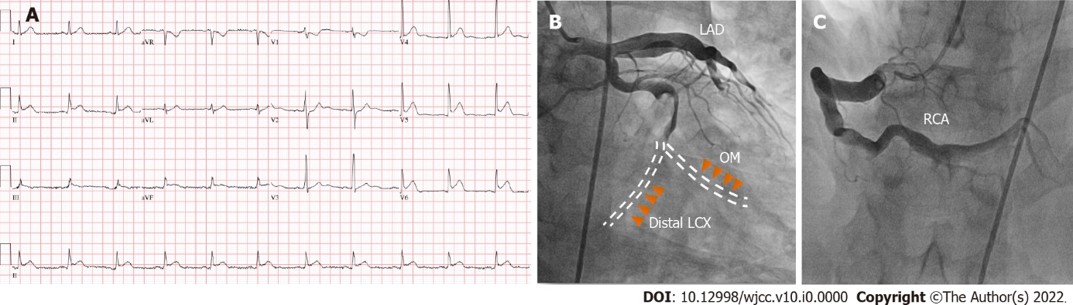
Figure 1 Electrocardiogram and coronary angiography. A: Initial electrocardiogram in the emergency room. Sinus rhythm with ST-segment elevation in leads II, III and aVF; B: Coronary angiography revealed total occlusion of the distal left circumflex, shown as red arrowheads, and the obtuse marginal arteries with severely enlarged vessels and sluggish flow in the 15° right anterior oblique and 25° caudal projection, presented as yellow arrowheads; C: Aneurysmal dilatation in the proximal segment of the right coronary artery was observed in the 30° left anterior oblique projection. LAD: Left anterior descending; RCA: Right coronary artery; OM: Obtuse marginal; LCX: Left circumflex.

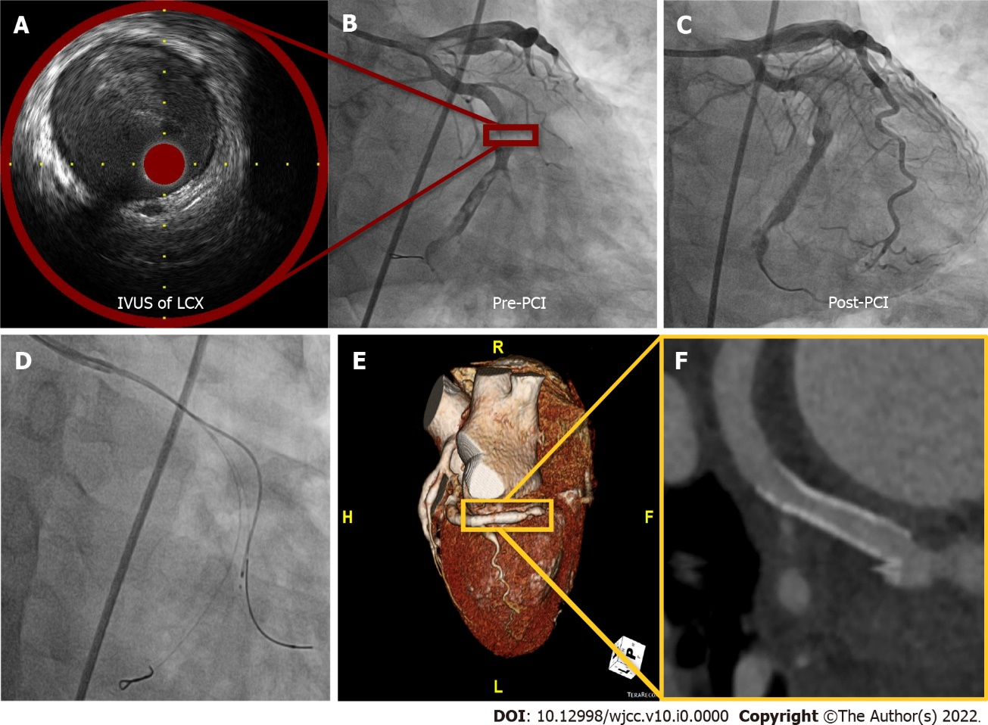
Figure 2 Coronary angiographic images and Intravascular ultrasound during percutaneous coronary intervention and follow-up coronary computerized tomography. A: Images and Intravascular ultrasound (IVUS) showed a diameter of 6.0 mm with hazy material filling the distal left circumflex (LCX), suggestive of thrombosis; B: Fluoroscopy showed a thrombolysis in myocardial infarction 2 flow to the distal LCX with massive thrombi; C: A drug-eluting stent was successfully inserted into the culprit lesion without a no-reflow phenomenon; D: We were not able to further advance the IVUS catheter into the obtuse marginal due to resistance and/or angulation; E and F: Coronary computerized tomography performed one year later showed good patency at the LCX stent area and ectatic aneurysm in all coronary arteries. IVUS: Images and Intravascular ultrasound; LCX: Left circumflex; PCI: Percutaneous coronary intervention.

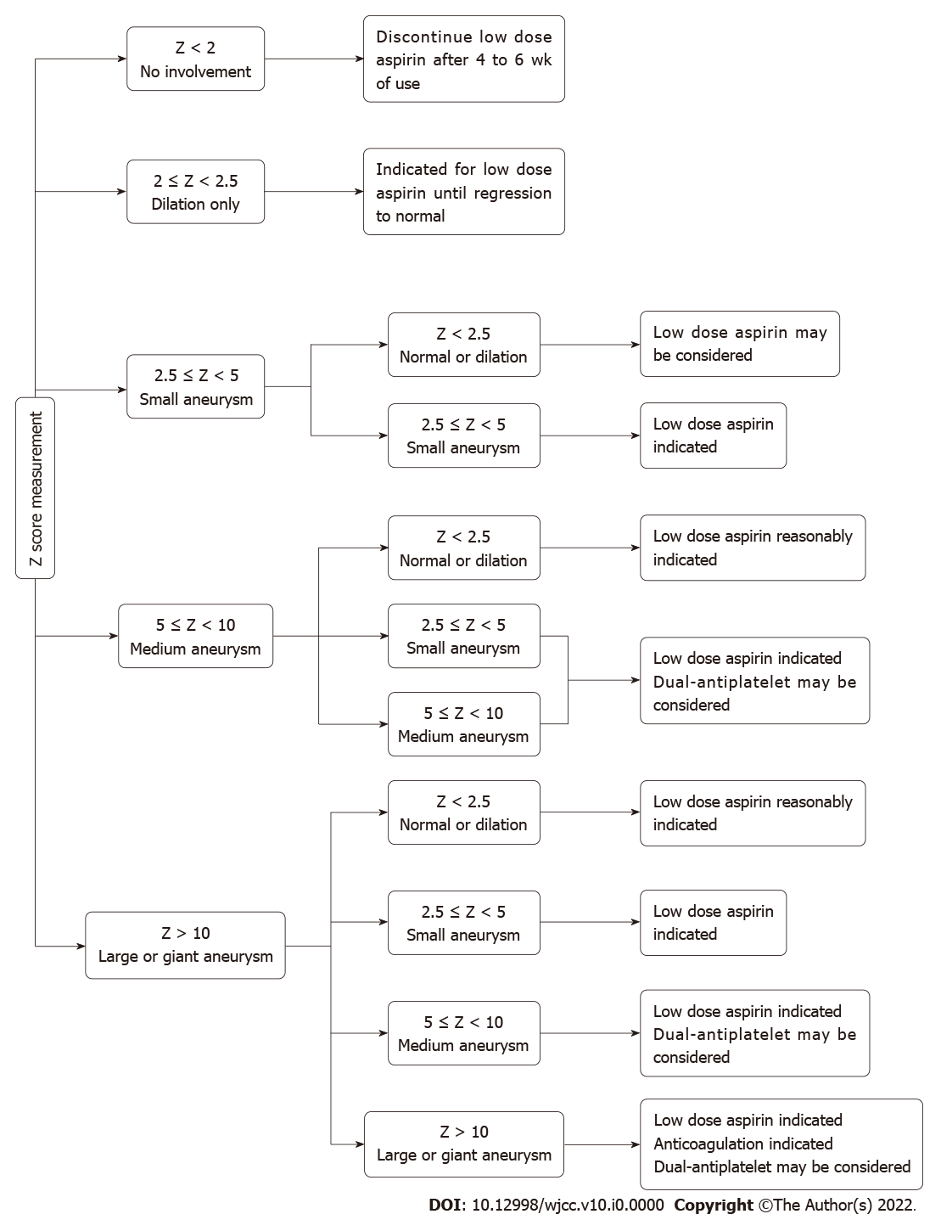
Figure 3 A summary of expert consensus of Kawasaki disease imaging surveillance and management.

Table 1 Antithrombotic therapy in the primary prevention settings of Kawasaki disease
Agent | Indication | Dose | Monitoring | Mechanism of action
Aspirin | Initial therapy for prevention of thrombosis.  (Z score ≥ 2.5) | 3-5 mg/kg/day | - | Cyclooxygenase-1 inhibitor
Clopidogrel | Resistance to aspirin or aspirin allergy. Dual-antiplatelet therapy for thromboprophylaxis | 0.2-1.0 mg/kg/day | - | P2Y12 inhibitor
Prasugrel/ticagrelor | NA | NA | NA | P2Y12 inhibitor
Warfarin | Thromboprophylaxis for large or giant aneurysm. (Z score > 10) |  | INR 2-3 | Vitamin K antagonist
LMWH | Thromboprophylaxis for large or giant aneurysm.  (Z score > 10) | Dosage varies according to age and agent | - | Active antithrombin III
NA: Not applicable; INR: International normalized ratio; LMWH: Low molecular weight heparin.
Table 2 Summary of case reports of patients in whom myocardial infarction was present during adulthood who were diagnosed with Kawasaki disease in childhood
Ref. | Age/Sex/Age of KD diagnosis | CV risk factor | Thromboprophylaxis | Follow up | Coronary angiography | Maximal diameter | Treatment
Current case | 35/M/2 | - | - | - | Aneurysm in the LCX, RCA. Stenosis in the LCX | 6.0 mm | PCI
Jiang et al^{[22]} | 21/F/2 | - | - | - | Aneurysm in the mid-RCA. Thrombosis in the RCA | - | Medication
Rozo et al^{[23]} | 36/M/4 | DL | - | - | Aneurysm in the left main and proximal LAD. Stenosis in the proximal LAD | - | CABG
Negoro et al^{[24]} | 27/M/1 | - | - | - | Aneurysm in all coronary arteries. Total occlusion in the mid-RCA | - | Thrombectomy and balloon angioplasty
Negoro et al^{[24]} | 32/M/2 | Smoker | - | + | Aneurysm in all coronary arteries. Stenosis in proximal the LCX and occlusion in the mid-RCA | - | Directional coronary atherectomy and balloon angioplasty
Shaukat et al^{[25]} | 24/M/6 | - | - | - | Aneurysm in the RCA and LCX. Occlusion in the proximal LAD, distal LCX and mid RCA | 17.0 mm | Thrombolysis
Ariyoshi et al^{[26]} | 26/M/3 | Smoker | - | - | Aneurysm in the proximal LAD. Total occlusion in the proximal LAD | 9.0 mm | PCI
Tsuda et al^{[27]} | 26/M/0 | Smoker | - | - | Aneurysm in the RCA, LAD and LCX. Total occlusion in the left main | 8.1 mm | Thrombolysis
Tsuda et al^{[27]} | 24/M/1 | - | - | + | Aneurysm in the bifurcation of the left coronary artery and proximal LAD. No significant stenosis | - | Medication
Kodama et al^{[28]} | 25/M/7 | Smoker | - | - | Aneurysm in the LAD and LCX. Occlusion in the LAD and LCX | - | Thrombolysis
Kawai et al^{[29]} | 32/M/4 | Smoker | - | - | Aneurysm in the LAD. Total occlusion in the proximal LAD | 5.8 mm | PCI
Kawai et al^{[29]} | 34/M/3 | - | - | - | Aneurysm in the LAD. Total occlusion in the proximal LAD | - | PCI
Shiraishi et al^{[30]} | 26/M/3 | - | - | - | Aneurysm in the proximal LAD. Total occlusion in the proximal LAD | 8.0 mm | Balloon angioplasty
Vijayvergiya et al^{[31]} | 20/M/9 | - | - | - | Aneurysm in the proximal LAD. There was no stenosis in the coronary artery | 13.0 mm | CABG
Sato et al^{[32]} | 44/M/3 | - | - | - | Aneurysm in the proximal LAD. Occlusion in the LM | 8.0 mm | PCI
Kitamura et al^{[33]} | 20/M/3 | - | - | + | Aneurysm in the LAD. Stenosis in the LAD and RCA | 19.0 mm | CABG
Kitamura et al^{[33]} | 30/M/0 | - | - | + | Aneurysm in the RCA. Stenosis in the RCA | 30.0 mm | CABG
Potter et al^{[34]} | 36/F/4 | - | - | - | Aneurysm in the proximal LAD, RCA. Occlusion in the RCA | 8.0 mm | CABG
Motozawa et al^{[35]} | 24/M/4 | - | Aspirin and ticlopidine | + | Aneurysm in the LAD. Stenosis in the LAD | 9.0 mm | Thrombectomy
KD: Kawasaki disease; CV: Cardiovascular; LCX: Left circumflex; RCA: Right coronary artery; PCI: Percutaneous coronary intervention; LAD: Left anterior descending; CABG: Coronary artery bypass graft; LM: Left main; DL: dyslipidemia.

