Name of Journal: World Journal of Gastrointestinal Endoscopy
Manuscript NO: 58445
Manuscript Type: CASE REPORT

Curling ulcer in the setting of severe sunburn: A case report

Schosheim A et al. Curling ulcer secondary to severe sunburn

Alexander Schosheim, Michelle Tobin, Anupama Chawla

Alexander Schosheim, Michelle Tobin, Anupama Chawla, Department of Pediatric Gastroenterology , Stony Brook University Hospital , Stony Brook, NY 11794, United States

Author contributions: Schosheim A, Tobin M and Chawla A contributed equally to this work. Schosheim A, Tobin M, and Chawla A conceptualized and drafted the initial manuscript, and reviewed and revised the manuscript along with also critically reviewing the manuscript for important intellectual content. All authors approved the final manuscript as submitted and agree to be accountable for all aspects of the work.

Corresponding author: Alexander Schosheim, MD, Pediatric Gastroenterology Fellow, Department of Pediatric Gastroenterology, Stony Brook University Hospital, 101 Nicolls Road, Stony Brook, NY 11794, United States. aschosheim@gmail.com

Received: August 3, 2020
Revised: September 30, 2020
Accepted: October 20, 2020
Published online: November 16, 2020

Abstract
BACKGROUND
While sunburns are very common, especially in pediatrics, curling ulcers secondary to sunburns are a very rare entity that has not been noted in the literature in over fifty years. This case is the first addition to the literature since the originally documented case.

CASE SUMMARY
A previously healthy 17 year old male presents to the emergency room with lethargy, shortness of breath on exertion, dark stools and nausea. His fatigue started to become significantly worse four days prior to admission. Approximately two weeks prior to admission, the patient was on a beach vacation with his family at which time he suffered severe sunburns. He had developed crampy epigastric abdominal pain, which was followed by dark, loose stools. On exam, he is non-toxic appearing, but with pallor and peeling skin on his face and chest with epigastric tenderness. Infectious stool studies were all negative including Helicobacter pylori. He denies use of any non-steroidal anti-inflammatory drugs and also denies alcohol or recreational drug use. While admitted he is found to be significantly anemic with his hemoglobin as low as 6.3 requiring two units of packed red blood cells. Endoscopy revealed several severe and deep ulcerations in the antrum and body of the stomach indicative of stress or curling ulcers.

CONCLUSION
While the incidence of stress ulcers is not known, it is most common with severe acute illness, most commonly presenting as upper gastrointestinal (GI) bleeding. It is essential to be aware of the risk of curling ulcers secondary to severe sunburns as patients with stress ulcer GI bleeding have increased morbidity and mortality compared to those who do not have GI bleed.

Key Words: Curling ulcer; Sunburn; Stress ulcer; Pediatrics; Gastroenterology; Gastrointestinal bleed; Case report

Citation: Schosheim A, Tobin M, Chawla A. Curling ulcer in the setting of severe sunburn: A case report. World J Gastrointest Endosc 2020; 12(11): 500-503
URL: https://www.wjgnet.com/1948-5190/full/v12/i11/500.htm
DOI: https://dx.doi.org/10.4253/wjge.v12.i11.500

Core Tip: While sunburns are very common, especially in pediatrics, curling ulcers secondary to sunburns are a very rare entity that has not been noted in the literature in over fifty years. Although a very rare consequence of sunburn, it is essential to be aware of the risk of curling ulcers secondary to severe sunburns as patients with stress ulcer gastrointestinal bleeding have increased morbidity and mortality compared to those who do not have gastrointestinal bleed.

INTRODUCTION
Stress ulcers are a well-known clinical entity with various findings ranging from asymptomatic superficial lesions and occult gastrointestinal (GI) bleed to overt clinically significant GI bleeding. It is thought that this is typically due to gastric and sometimes esophageal or duodenal mucosal barrier is disruption^{[1]}. When the etiology of the stress ulcer is a burn, they are characterized as curling ulcers. Most cases of curling ulcers in the current literature are secondary to severe systemic burns and although rare, there was one previous case report of curling ulcer secondary to sunburn^{[2]}.

CASE PRESENTATION
Chief complaints
A previously healthy 17 year old male presented to Stony Brook University Hospital from an outside hospital with lethargy, shortness of breath on exertion, dark stools and nausea.

History of present illness
The patient's fatigue had become significantly worse for four days prior to admission. Approximately two weeks prior to admission, the patient was on a beach vacation with his family at which time he suffered severe sunburns. He had developed crampy epigastric abdominal pain that was followed by dark, loose stools.

History of past illness
He has no significant past medical history.

Personal and family history
He and his family have no significant history.

Physical examination
On physical exam, he was pale and tired-appearing with epigastric tenderness.

Laboratory examinations
Infectious stool studies were all negative including Helicobacter pylori. His complete blood count revealed that he was significantly anemic with a hemoglobin of 6.3 and his complete metabolic panel was within normal limits.

Imaging examinations
No imaging was performed.

Further hospital course
Endoscopy was performed and revealed severe, deep ulcerations in the antrum and body of the stomach (Figure 1).

FINAL DIAGNOSIS
Curling ulcers in the antrum.

TREATMENT
The patient was treated with high dose proton-pump inhibitor and carafate along with iron and folate supplementation.

OUTCOME AND FOLLOW-UP
With time, the patient’s symptoms and blood work improved. Five months after his original admission, endoscopy was performed and all previous areas of ulceration had completely resolved.

DISCUSSION
While the incidence of stress ulcers is not known, it typically occurs with severe acute illness, most commonly presenting as upper GI bleeding. Although stress ulcers can lead to perforation, it is very rare with less than 1% incidence^{[3]}. An impaired mucosal barrier where the mucosal glycoprotein breaks down due to increased concentrations of refluxed bile salts or uremic toxins in the setting of critical illness may be the possible pathologic changes that lead to ulceration. Increased secretion of gastric acid secondary to higher secretion of gastrin during stress is likely as well^{[4]}.

CONCLUSION
Curling ulcers secondary to sunburns are a previously described phenomenon, but it is a rare entity that has not been noted in the literature in over fifty years^{[2]}. It is essential to be aware of the risk of curling ulcers secondary to severe sunburns as patients with stress ulcer GI bleeding have increased morbidity and mortality when compared to those without GI bleed.

REFERENCES
1 Nordström H, Nettelblad H. Curling's ulcer--a serious complication of the burned patient. Scand J Gastroenterol Suppl 1984; 105: 14-18 [PMID: 6597965]
2 JAFFE NB. Gastric ulcer caused by sunburn. Miss Valley Med J 1953; 75: 150-152 [PMID: 13086893]
3 Siddiqui F, Ahmed M, Abbasi S, Avula A, Siddiqui AH, Philipose J, Khan HM, Khan TMA, Deeb L, Chalhoub M. Gastrointestinal Bleeding in Patients With Acute Respiratory Distress Syndrome: A National Database Analysis. J Clin Med Res 2019; 11: 42-48 [PMID: 30627277 DOI: 10.14740/jocmr3660]
4 Cheung LY. Thomas G Orr Memorial Lecture. Pathogenesis, prophylaxis, and treatment of stress gastritis. Am J Surg 1988; 156: 437-440 [PMID: 3059833 DOI: 10.1016/s0002-9610(88)80522-1]

Footnotes
Informed consent statement: Informed verbal consent was obtained from the patient for publication of this report and any accompanying images.

Conflict-of-interest statement: There are no conflicts of interest.

CARE Checklist (2016) statement: The authors have read the CARE Checklist (2016), and the manuscript was prepared and revised according to the CARE Checklist (2016).

Open-Access: This article is an open-access article that was selected by an in-house editor and fully peer-reviewed by external reviewers. It is distributed in accordance with the creative commons attribution noncommercial (CC BY-NC 4.0) license, which permits others to distribute, remix, adapt, build upon this work non-commercially, and license their derivative works on different terms, provided the original work is properly cited and the use is non-commercial. See: http://creativecommons.org/Licenses/by-nc/4.0/

Manuscript source: Unsolicited manuscript

Peer-review started: August 3, 2020
First decision: September 17, 2020
Article in press: October 20, 2020

Specialty type: Gastroenterology and hepatology
Country/Territory of origin: United States
Peer-review report’s scientific quality classification
Grade A (Excellent): 0
Grade B (Very good): 0
Grade C (Good): C, C
Grade D (Fair): 0
Grade E (Poor): 0

P-Reviewer: Armellini E, Toka B S-Editor: Zhang L L-Editor: A P-Editor: Wang LL

Figure Legends
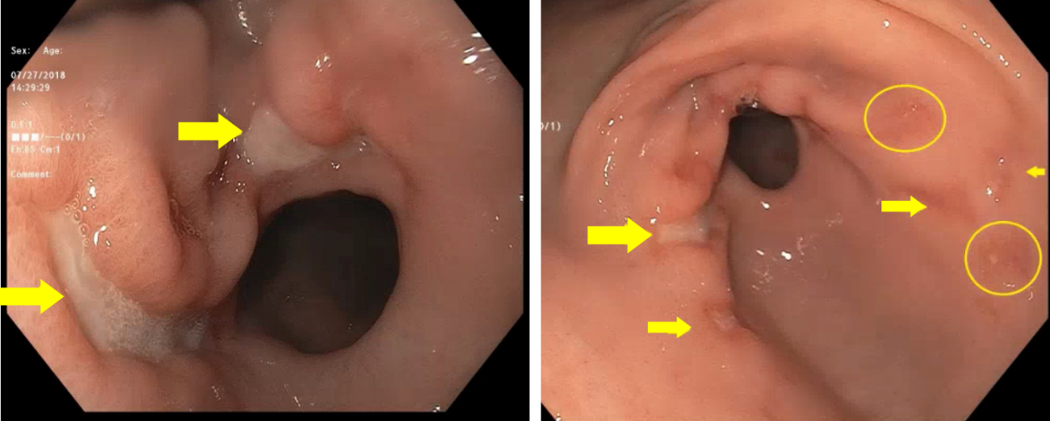
Figure 1 Deep ulcerations in the antrum of the stomach.

