Informed consent statement：

Serum ceruloplasmin levels are negatively associated with liver fibrosis: a promising novel non-invasive model to predict liver fibrosis in chronic hepatitis B virus patients with normal or minimally raised ALT
Zeng DW et al, 2016

Patients were not required to give informed consent to the study because the analysis used anonymous clinical data that were obtained after each patient agreed to treatment by verbal consent. Individuals can’t be identified according to the data presented.

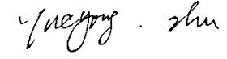
29 Jun 2016

