Name of Journal: World Journal of Gastroenterology
Manuscript NO: 75215
Manuscript Type: SCIENTOMETRICS

Mapping the global research landscape on nutrition and the gut microbiota: Visualization and bibliometric analysis

Zyoud SH et al. Nutrition and the gut microbiota

Sa'ed H Zyoud, Muna Shakhshir, Amani S Abushanab, Samah W Al-Jabi, Amer Koni, Moyad Shahwan, Ammar Abdulrahman Jairoun, Adham Abu Taha

Sa'ed H Zyoud, Amani S Abushanab, Samah W Al-Jabi, Amer Koni, Department of Clinical and Community Pharmacy, College of Medicine and Health Sciences, An-Najah National University, Nablus 44839, Palestine

Sa'ed H Zyoud, Poison Control and Drug Information Center, College of Medicine and Health Sciences, An-Najah National University, Nablus 44839, Palestine

Sa'ed H Zyoud, Clinical Research Centre, An-Najah National University Hospital, Nablus 44839, Palestine

Muna Shakhshir, Department of Nutrition, An-Najah National University Hospital, Nablus 44839, Palestine

Amer Koni, Division of Clinical Pharmacy, Hematology and Oncology Pharmacy Department, An-Najah National University Hospital, Nablus 44839, Palestine

Moyad Shahwan, Department of Pharmacy, Ajman University, Ajman 346, United Arab Emirates

Moyad Shahwan, Centre of Medical and Bio-allied Health Sciences Research, Ajman University, Ajman 346, United Arab Emirates

Ammar Abdulrahman Jairoun, Department of Health and Safety, Dubai Municipality, Dubai 67, United Arab Emirates

Adham Abu Taha, Department of Biomedical Sciences, College of Medicine and Health Sciences, An-Najah National University, Nablus 44839, Palestine

Adham Abu Taha, Department of Medicine, College of Medicine and Health Sciences, An-Najah National University, Nablus 44839, Palestine

Author contributions: Zyoud SH designed the study, collected the data, analyzed the data, made major contributions to the manuscript’s existing literature search and interpretation, and drafted the manuscript; Shakhshir M, Abushanab AS, Al-Jabi SW, Jairoun AA, Shahwan M, Koni A and Abu Taha A were involved in the interpretation of the data, and made revisions to the initial draft; all authors provided a critical review and approved the final manuscript before submission.

Corresponding author: Sa'ed H Zyoud, PhD, Associate Professor, Department of Clinical and Community Pharmacy, College of Medicine and Health Sciences, An-Najah National University, Academic Street, Nablus 44839, Palestine. saedzyoud@yahoo.com

Received: January 18, 2022
Revised: April 30, 2022
Accepted: May 28, 2022
Published online:

Abstract
BACKGROUND
Nutrition is a significant modifiable element that influences the composition of the gastrointestinal microbiota, implying the possibility of therapeutic diet methods that manipulate the composition and diversity of the microbial.

AIM
To overview research papers on nutrition and gut microbiota and determines the hotspots in this field at the global level.

METHODS
Scopus and Reference Citation Analysis were used to construct a bibliometric technique. It was decided to create bibliometric indicators and mapping as in most previous studies. 2012 through 2021 served as the study's timeframe.

RESULTS
A total of 5378 documents from the Scopus database were selected for analysis. Of all retrieved studies, 78.52% were research papers (n = 4223), followed by reviews (n = 820; 15.25%). China ranked first with a total number of articles of 1634 (30.38%), followed by the United States in second place with a total number of articles of 1307 (24.3%). In the last decade, emerging hotspots for gut microbiota and nutrition research included "gut microbiota metabolism and interaction with dietary components", "connection between the gut microbiota and weight gain", and "the influence of high-fat diet and gut microbiota on metabolic disorders".

CONCLUSION
This is the first thorough bibliometric analysis of nutrition and gut microbiota publications conducted on a global level. Investigation of the association between nutrition/diet and the gut microbiota is still in its infancy and will be expanded in the future. However, according to recent trends, the “effect of gut microbiota and high-fat diet on metabolic disorders" will be an increasing concern in the future.

Key Words: Gut microbiota; Microbiome; Nutrition; Diet; Bibliometric; Scopus; VOSviewer

Zyoud SH, Shakhshir M, Abushanab AS, Al-Jabi SW, Koni A, Shahwan M, Jairoun AA, Abu Taha A. Mapping the global research landscape on nutrition and the gut microbiota: Visualization and bibliometric analysis. World J Gastroenterol 2022; In press

Core Tip: The number of publications on the gut microbiota has progressively expanded as the potential clinical implications of the gut microbiota have become better known, and this has become an emerging research subject. Therefore, this comprehensive bibliometric study intends to provide an overview of the current state of worldwide nutrition and gut microbiota research and to stay ahead of emerging trends and important turns in the field's evolution. Investigation on the association between nutrition/diet and the gut microbiota is still in its infancy and will be expanded in the future. However, according to recent trends, the “effect of gut microbiota and high-fat diet on metabolic disorders" will be a bigger worry in the future.

INTRODUCTION
The microbiome is a term that refers to the collective genomes of microorganisms living in a certain habitat, and the gut microbiota is a complex collection of microorganisms that includes archaea, bacteria, fungus, viruses, and protozoa, among others^{[1]}. These communities interact with each other and their host, with the majority of them being bacteria that reside mainly in the colon of the gastrointestinal tract and interact with them. The human genome has thousands of genes; however, the microbiome contains millions of genes that produce a large number of metabolites that alter host activities, resulting in a substantial impact on the host at the physiological level^{[2]}. Different levels of evidence show that functional or compositional changes in the microbiota present in the human gut contribute to human disease and health, including metabolic, immunological and neuro-behavioral traits that support the role of the microbiota in human health^{[3,4]}.
The composition of the gut microbiota varies greatly between individuals. Several studies have found that dietary variations between people are one of the external variables that influence and define the gut microbiota structure^{[5-8]}. Studies in recent years have shown that diet or food as the main source of energy for gut microbes can greatly affect the diversity and components of the gut microbiota, which affects host health^{[9-12]}. In addition to diet, the gut microbiota is affected by different external variables, such as lifestyle and medication (e.g., antibiotics), which mainly affect the microbiota. There are also intrinsic factors that can affect the gut microbiota, such as host genetics, immune and metabolic regulations^{[13]}. Dietary modifications can account for more than 50% of the changes in the gut microbiota changes; however, host genes account for only 10%^{[14]}.
Research showed that disturbances in the interaction between nutrients in food and the microbiome affect its structure, which has been shown to be linked to the development of a variety of diseases^{[15,16]}. Long-term or, to a lesser extent, short-term dietary intake modifications could determine each human's stable microbiota profile. For example, regardless of the stage of life, the intake of protein, fat, fermentable or non-fermentable carbs, probiotic, and polyphenol effectively modulates the host's gut microbiota, metabolic, and immunological parameters. Compared to high animal protein consumption and low carbohydrate intake, high consumption increases the risk of various health conditions, such as diabetes, cancer, cardiovascular disease, and irritable bowel syndrome^{[7,10]}. Another evidence on the diversity of bacterial content in the gastrointestinal tract of humans revealed that lower bacterial diversity has been found in individuals with various diseases such as arthritis, inflammatory bowel disease, type 1 and type 2 diabetes, eczema, and obesity than in healthy individuals who support the role of the microbiota in human health and diseases^{[17-21]}. Accordingly, diversity appears as a positive indicator of a healthy gastrointestinal tract^{[22,23]}.
The results have been applied to numerous domains connected to the gut microbiota over the last years^{[24-28]}. However, there are no bibliometric analyses of nutrition/diet and gut microbiota publications. As a result, the objective of the present study was to carefully review publications related to nutrition and gut microbiota to assess the current state and hotspots in this field. Therefore, this comprehensive bibliometric study intends to provide an overview of the current state of worldwide nutrition and gut microbiota research and to stay ahead of emerging trends and important turns in the field's evolution.

MATERIALS AND METHODS
Data sources
We performed this bibliometric analysis using the Scopus bibliographic database, which Elsevier B.V. owns. In bibliometric research, only one database is used because bibliometric indicators and literature mapping are difficult to execute on documents acquired from several databases. Furthermore, the grey literature cannot be included in the data retrieved^{[29,30]}. The current analysis was conducted using the SciVerse Scopus database for numerous reasons. First, Scopus has a much larger number and diversity of indexed publications compared to other databases like PubMed or Web of Science. Scopus has nearly the same number of journals indexed as PubMed and Web of Science combined^{[31]}. Second, because all articles listed in PubMed are simultaneously indexed in Scopus, PubMed is completely comprehensive in Scopus. As a result, Scopus is considered to be comprehensive, as it includes papers from both PubMed and Web of Science^{[29,30]}. Third, Scopus publishes publications in a wide range of disciplines, including science, technology, medicine, social science, and the arts and humanities. Fourth, Scopus enables academics to create sophisticated and extensive search queries by combining various Boolean operators. Finally, Scopus enables the researcher to export and examine the data that have been retrieved. This comprises mapping and statistical analysis. Due to the rapid update of the database, the literature retrieval was carried out on a single day (January 7, 2022). Therefore, it was decided that the publication period for this study would be between 2012 and 2021.

Goal definition
The primary goal of this study is to assess the current state and hotspots in the field of nutrition and gut microbiota by examining the scientific production data set related to nutrition and gut microbiota with the goal of characterisation and understanding it in terms of scientometric indices. Based on bibliometric and/or scientometric indicators, the mapping and analysis of scientific knowledge allow the identification of the dynamics and/or expansion of a specific field of study and the support of strategic decisions related to various research institutions^{[32]}.

Search strategy
We used the key terms “microbiome or microbiota” and “nutrition or diet” and its synonyms because we are interested in nutrition and gut microbiota per se as a novel concept in scientific research rather than related subjects. The current study focuses on research papers containing “nutrt* or nutrient* or diet* or eat* or feeding” and “microbiome or microbiota or *flora” to recognize items based on their search in the fields topic and the time was ten years between 2012 and 2021. The asterisk (*) was used in search query to retrieve documents with keywords such as diet or dietary.

Validation of the search strategy
The search query was repeatedly fine-tuned in the current study until the top 100 cited publications in the retrieved literature were free of false-positive results. Furthermore, the search query was checked for missing data (false-negative) using a previously published method that depends on the association between the retrieved research output and the actual research output in this field^{[29,30]}. Instead of a title/abstract search, keywords were used in the title search. As a result, the title search will produce the fewest false positive documents, making it a reliable method^{[29,33-35]}. However, a title/abstract search will show many false positives in which the main focus is not on nutrition and the microbiota per se.

Bibliometric analysis
The Scopus advanced search tool was used to implement the method. Using the "analyze" function, the retrieved documents were examined. The abstained findings were saved as.csv files in Microsoft Excel. Annual growth, document types, journal names with impact factor (IF), funding agencies, country names, institution names, and document citations were all included in the exported findings. This data was displayed as a linear graph of the annual growth of publication and tables for the core of (top 10 active) journals, funding agencies, countries, institutions, and cited documents in the results section.
The Impact Index Per Article for the top 10 high-cited papers collected from Reference Citation Analysis (RCA) is presented. RCA is an open multidisciplinary citation analysis database owned by Baishideng Publishing Group Inc. (Pleasanton, CA 94566, United States)^{[36]}.

Visualized analysis
Data on terms in titles and abstracts and cross-country collaboration were visualized using the free Web tool VOSviewer 1.6.17 to determine a worldwide scientific cooperation network across countries/regions and examine hotspots and research trends. Nodes in VOSviewer maps are colored and sized differently. The size is related to the number of times it occurs. The node's color shows its relationship to other nodes with similar colors^{[37]}.

RESULTS
Number of publications and evolution over time
A total of 5378 documents from the Scopus database were selected for analysis. The documents retrieved were of 11 types, mainly research articles (n = 4223; 78.52%), followed by reviews (n = 820; 15.25%). Our findings revealed that the scientific advancement of articles on nutrition and gut microbiota has grown in the past ten years. For example, we found 1295 documents in 2021, compared to only 120 documents in 2012 (Figure 1). Of the 5378 documents retrieved, 89 were clinical trials. Fifteen publications on nutrition and gut microbiota were case reports or case series.

Contributions of countries to global publications
Table 1 Lists the contributions of the top 10 countries in publications related to nutrition and gut microbiota from 2012 to 2021. Topping the list was China, with 1634 items (30.38% of the total), followed by the United States, with 1307 items (second place) (24.3%). Italy (n = 346, 6.43%) and Spain (n = 313, 5.82%) ranked third and fourth positions, respectively. An examination of countries with more than 20 publications on nutrition and gut microbiota was conducted. Using data from 44 eligible nations, five VOSviewer clusters were used to examine their centrality and connections to other countries (Figure 2). The United States and China had the highest number of publications in the clusters (green cluster). There is a direct correlation between the number and width of the lines on this map with the degree of interaction and strength between countries.

Analysis of affiliations
As shown in Table 2, the top ten affiliations with the highest number of publications relevant to nutritional science and the gut microbiota were identified. The country with the highest number of affiliations was China. The Chinese Academy of Sciences had the highest number of publications (n = 138; 2.57%), followed by the China Agricultural University (n = 111; 2.06%), the Chinese Academy of Agricultural Sciences (n = 95; 1.77%), and the University College Cork (n = 81; 1.51%).

Analysis of funding agencies
Of the documents retrieved 3271 (60.82%) were publications that were part of funded projects. Again, Chinese funding agencies were the most active in this field, the National Natural Science Foundation of China (n = 711; 13.22%) being the most active, followed by the National Institutes of Health (n = 327; 6.08%), and the National Institute of Diabetes and Digestive and Kidney Diseases (n = 190; 3.53%) (Table 3).

Journal analysis
As presented in Table 4, Nutrients (n = 271 publications, IF: 5.717) published the most papers on nutrition and the gut microbiota, followed by Frontiers in Microbiology (n = 167 publications, IF: 5.64), and Scientific Reports (n = 136 publications, IF: 4.379). The top ten academic journals published approximately 22.3% of the publications.

Analysis of research hotspots
To detect trends and topics in most articles on nutrition and gut microbiota, we used VOSviewer software to look at the distribution of cooccurrence terms in the titles and abstracts of 5378 papers. By mapping terms in titles and abstracts with a minimum frequency of 100 occurrences, three major clusters emerged, highlighting three remarkable research themes. For example, in Figure 3, of the 85327 terms, 293 terms appeared at least 100 times, distributed in three clusters. Cluster 1, indicated by red frames, includes those terms commonly seen in publications related to interaction of the gut microbiota with dietary components; Cluster 2, shown by green frames, contains terms commonly seen in publications related tothe correlation between weight gain and the gut microbiota; and Cluster 3, marked by green frames, includes terms commonly observed in studies related to the effect of the gut microbiota and a high-fat diet and on metabolic syndromes. Figure 4 illustrates an overlay visualization in which the VOSviewer was used to color the terms based on their publication year. The blue and green colors indicate that the terminology appeared first, while the yellow colors indicate that they appeared later. Most studies before 2019 focused on the “connection between the gut microbiota and weight gain” and the “interaction of the gut microbiota with dietary components”. However, according to recent trends, the “effect of high-fat diet and the gut microbiota on metabolic syndromes” will be a bigger concern in the future.

Analysis of citations
According to citation analysis, the retrieved articles garnered 146101 citations, averaging 27.17 per document, and an h-index of 154. Citations ranged from 0 to 4588. Two thousand four hundred forty-two items were indexed with ten or more citations, while 852 were indexed without citations. Table 5 lists the top ten articles with the highest number of articles on research related to nutrition and gut microbiota from 2012 to 2021. The 10 highest citations ranged from 4588 to 796. The impact index per article of the 10 most cited articles ranged from 96.3 to 506.2 (Table 5).

DISCUSSION
This study has developed research techniques to thoroughly analyze the current status and direction of development of studies related to nutrition and the gut microbiota from 2012 to 2021 using a bibliometric and visualization analysis. The number of publications on the gut microbiota has progressively expanded as the potential clinical implications of the gut microbiota have become better known, and this has become an emerging research subject. Our review of research on global nutrition and gut microbiota found that relevant publications have expanded in the last ten years. A possible explanation for this finding might be that our understanding of the role of the gut microbiota has advanced significantly due to the advancement of scientific tools.
The examination of collaboration networks can provide rich data for evaluating research collaborations and characterizing essential collaborators. China and the United States had a clear advantage in this field, possibly due to their superior economics and investment in the scientific field; for example, in 2013, a notable research project from the United States was launched on the intestinal microbiota-brain axis^{[38]}, which resulted in a positive impact on the quality and productivity. In addition, Chinese scientists have made significant advances in the field of gut microbiota^{[39]}. Fecal microbiota transplantation (FMT) has attracted remarkable interest in the treatment of extraintestinal health problems. China registered 84 (24%) of the 367 clinical investigations employing FMT^{[40]}. This is a significant contribution by Chinese researchers to this field and the clinical transformation of studies on the gut microbiota. In addition to FMT research, Chinese researchers are also interested in the development and clinical application of probiotics^{[41]}. Furthermore, one possible reason for the increase in Chinese publication numbers, the National Natural Science Foundation of China launched a fund for the role and mechanism of the ‘Gut-Liver Axis’ in gastrointestinal diseases (H03)^{[42]}. This research should focus on the gut microbiota and metabolites, nutrition, neurotransmitters, gastrointestinal hormones, and bile acid, particularly their interactions with the gastrointestinal tract or liver-localized immune cells/factors to mediate a variety of functional roles. Expand on the "gut-liver axis" and its role in the mechanisms of gastrointestinal disease mechanisms to develop novel diagnostic and therapeutic strategies^{[42]}.
Furthermore, the increase in publications on the microbiota and nutrition can be attributed to the fact that numerous hot topics were published during this period of time, exposing new theories and establishing new research fields such as the “interaction of the gut microbiota with dietary components”, “connection between the gut microbiota and weight gain”, and “the impact of a high-fat diet and the gut microbiota on metabolic syndrome”. The effect of diet on the gut microbiota and, consequently, on human health suggests new therapeutic and diagnostic concepts and guides to develop probiotic and prebiotic strategies and functional nutrition^{[43-47]}.
The ‘effect of a high-fat diet and the gut microbiota on metabolic syndromes’ as a theme was among the main hot topics in the current study. Most publications on nutrition and gut microbiota before 2019 used words such as “connection between the gut microbiota and weight gain" and “interaction of the gut microbiota with dietary components". This was in the early stages of this research area. The “effect of a high-fat diet and gut microbiota on metabolic syndrome” as a theme was one of the main hot topics in this work and was considered the current trend after 2019. As a result, the evidence that emerges proposes that the gut microbiota may play a role in maintaining body weight and energy balance. It is assumed to be fueled, at least in part, by changes in gut microbiota composition caused by high-fat diets (HFDs); HFDs have been correlated with changes in gut microbial profile as well as decreased diversity^{[48,49]}. Furthermore, metabolic syndrome and its associated disorders have been linked to increasing evidence suggesting that the gut microbiota in the digestive tract plays a significant role. Numerous studies in animals and humans have shown that high-fat and high-sugar (fructose) diets are responsible for the three hallmarks of metabolic syndrome: Obesity, dyslipidemia, and insulin resistance by altering the composition and diversity of the gut microbiota^{[50-53]}. Furthermore, there is evidence that HFD is associated with cardiovascular disease^{[54]} because the intestinal microbiota converts dietary choline to trimethylamine, which is absorbed in the gut and converted to trimethylamine N-oxygen. This metabolite causes atherosclerosis in the liver^{[55]}.

Strengths and limitations
This is the first thorough bibliometric analysis of nutrition and gut microbiota research conducted on a global level. Research on the relationship between nutrition/diet and gut microbiota is still in its infancy and will expand in the future. The aforementioned growing hotspots serve as a foundation and guide for the development of new projects by scientific researchers, physicians, and medical educators.
Our study has several limitations. First, although Scopus is indeed the largest database available, the search for studies was carried out only from the Scopus database, which could have limited the generalizability of the findings due to the loss of certain documents published in unindexed journals. Second, the accuracy and comprehensiveness of the keywords have a significant impact on the reliability of the data retrieved in our study. As a result, some important and influential articles may be omitted from a representative list due to the use of other terms in their titles. Third, the current study only looked for terms such as “nutrition”, "gut microbiota" and other related terms in the title search only. Papers with these terms in the abstract or text may have been missed in this study. Furthermore, while most publications were published and indexed in 2021, the amount of scientific research productivity this year could be higher because new journal issues are still being published and indexed.

CONCLUSION
To our knowledge, this is the first bibliometric study of trends in publications on microbiota and nutrition. We are entering an era in which we can more easily alter our health through diet and track results using our microbiota or their metabolites. Over the last decade, there has been an increase in the number of publications on the microbiota and nutrition. The top three contributors to microbiota and nutrition research were China, the United States, and Italy. China is the leading country in this area of study, achieving some significant research findings and playing a key role in the progress of the field. “Connection between the gut microbiota and weight gain’, ‘interaction with dietary components” and “the effect of a high-fat diet and the gut microbiota on metabolic syndromes’ were hotspots for gut microbiota and nutrition research in the last 10 years. As a result, our timely examination and analysis of hotspots and research trends may aid in the growth of this discipline. Furthermore, these findings offer a fresh perspective on the study of the microbiota and nutrition/diet, which could help with future etiological research, diagnosis, and treatment of metabolic syndromes.

ARTICLE HIGHLIGHTS
Research background
Dietary composition is crucial in regulating the gut microbiota and, as a result, in the prevention, management, and treatment of diseases including diabetes and cancer.

Research motivation
According to a growing body of evidence, the gut microbiota appears to considerably impact human health. Intestinal homeostasis, physiology, gut microbiome, immune system, and host metabolic pathways are all affected by changes in the gut microbiota. However, there are no bibliometric analyses of nutrition/diet and gut microbiota publications.

Research objectives
The current study gives an overview of research publications on nutrition and gut microbiota and identifies global hotspots on this topic.

Research methods
A comprehensive, validated search query was used to find relevant publications on nutrition and gut microbiota. SciVerse Scopus was the database used.

Research results
This is the first bibliometric analysis of trends in microbiota and nutrition publications. The number of publications on microbiota and nutrition has increased over the last decade. China, the United States, and Italy were the top three contributors to microbiota and nutrition research.

Research conclusions
In conclusion with our timely examination and analysis of hotspots and research trends, we believe that this discipline will grow. Furthermore, these findings shed new light on the study of the microbiota and nutrition/diet, which could aid in future etiological research, diagnosis, and treatment of metabolic syndromes.

Research perspectives
This comprehensive bibliometric study aims to provide an overview of the current state of global nutrition and gut microbiota research and stay ahead of emerging trends and critical turns in the field's evolution.

REFERENCES
1 Berg G, Rybakova D, Fischer D, Cernava T, Vergès MC, Charles T, Chen X, Cocolin L, Eversole K, Corral GH, Kazou M, Kinkel L, Lange L, Lima N, Loy A, Macklin JA, Maguin E, Mauchline T, McClure R, Mitter B, Ryan M, Sarand I, Smidt H, Schelkle B, Roume H, Kiran GS, Selvin J, Souza RSC, van Overbeek L, Singh BK, Wagner M, Walsh A, Sessitsch A, Schloter M. Microbiome definition re-visited: old concepts and new challenges. Microbiome 2020; 8: 103 [PMID: 32605663 DOI: 10.1186/s40168-020-00875-0]
2 Rath CM, Dorrestein PC. The bacterial chemical repertoire mediates metabolic exchange within gut microbiomes. Curr Opin Microbiol 2012; 15: 147-154 [PMID: 22209085 DOI: 10.1016/j.mib.2011.12.009]
3 Jackson MA, Verdi S, Maxan ME, Shin CM, Zierer J, Bowyer RCE, Martin T, Williams FMK, Menni C, Bell JT, Spector TD, Steves CJ. Gut microbiota associations with common diseases and prescription medications in a population-based cohort. Nat Commun 2018; 9: 2655 [PMID: 29985401 DOI: 10.1038/s41467-018-05184-7]
4 Valdes AM, Walter J, Segal E, Spector TD. Role of the gut microbiota in nutrition and health. BMJ 2018; 361: k2179 [PMID: 29899036 DOI: 10.1136/bmj.k2179]
5 Zhang C, Zhang M, Wang S, Han R, Cao Y, Hua W, Mao Y, Zhang X, Pang X, Wei C, Zhao G, Chen Y, Zhao L. Interactions between gut microbiota, host genetics and diet relevant to development of metabolic syndromes in mice. ISME J 2010; 4: 232-241 [PMID: 19865183 DOI: 10.1038/ismej.2009.112]
6 Kolodziejczyk AA, Zheng D, Elinav E. Diet-microbiota interactions and personalized nutrition. Nat Rev Microbiol 2019; 17: 742-753 [PMID: 31541197 DOI: 10.1038/s41579-019-0256-8]
7 Mills S, Stanton C, Lane JA, Smith GJ, Ross RP. Precision Nutrition and the Microbiome, Part I: Current State of the Science. Nutrients 2019; 11 [PMID: 31022973 DOI: 10.3390/nu11040923]
8 Donovan SM. Introduction to the special focus issue on the impact of diet on gut microbiota composition and function and future opportunities for nutritional modulation of the gut microbiome to improve human health. Gut Microbes 2017; 8: 75-81 [PMID: 28282253 DOI: 10.1080/19490976.2017.1299309]
9 McKenney PT, Pamer EG. From Hype to Hope: The Gut Microbiota in Enteric Infectious Disease. Cell 2015; 163: 1326-1332 [PMID: 26638069 DOI: 10.1016/j.cell.2015.11.032]
10 Singh RK, Chang HW, Yan D, Lee KM, Ucmak D, Wong K, Abrouk M, Farahnik B, Nakamura M, Zhu TH, Bhutani T, Liao W. Influence of diet on the gut microbiome and implications for human health. J Transl Med 2017; 15: 73 [PMID: 28388917 DOI: 10.1186/s12967-017-1175-y]
11 Conlon MA, Bird AR. The impact of diet and lifestyle on gut microbiota and human health. Nutrients 2014; 7: 17-44 [PMID: 25545101 DOI: 10.3390/nu7010017]
12 Li YD, Liu BN, Zhao SH, Zhou YL, Bai L, Liu EQ. Changes in gut microbiota composition and diversity associated with post-cholecystectomy diarrhea. World J Gastroenterol 2021; 27: 391-403 [PMID: 33584071 DOI: 10.3748/wjg.v27.i5.391]
13 Rothschild D, Weissbrod O, Barkan E, Kurilshikov A, Korem T, Zeevi D, Costea PI, Godneva A, Kalka IN, Bar N, Shilo S, Lador D, Vila AV, Zmora N, Pevsner-Fischer M, Israeli D, Kosower N, Malka G, Wolf BC, Avnit-Sagi T, Lotan-Pompan M, Weinberger A, Halpern Z, Carmi S, Fu J, Wijmenga C, Zhernakova A, Elinav E, Segal E. Environment dominates over host genetics in shaping human gut microbiota. Nature 2018; 555: 210-215 [PMID: 29489753 DOI: 10.1038/nature25973]
14 Clark A, Mach N. Exercise-induced stress behavior, gut-microbiota-brain axis and diet: a systematic review for athletes. J Int Soc Sports Nutr 2016; 13: 43 [PMID: 27924137 DOI: 10.1186/s12970-016-0155-6]
15 Sommer F, Bäckhed F. The gut microbiota--masters of host development and physiology. Nat Rev Microbiol 2013; 11: 227-238 [PMID: 23435359 DOI: 10.1038/nrmicro2974]
16 Garn H, Neves JF, Blumberg RS, Renz H. Effect of barrier microbes on organ-based inflammation. J Allergy Clin Immunol 2013; 131: 1465-1478 [PMID: 23726530 DOI: 10.1016/j.jaci.2013.04.031]
17 Vijay A, Valdes AM. Role of the gut microbiome in chronic diseases: a narrative review. Eur J Clin Nutr 2022; 76: 489-501 [PMID: 34584224 DOI: 10.1038/s41430-021-00991-6]
18 Zheng L, Wen XL. Gut microbiota and inflammatory bowel disease: The current status and perspectives. World J Clin Cases 2021; 9: 321-333 [PMID: 33521100 DOI: 10.12998/wjcc.v9.i2.321]
19 Xia F, Wen LP, Ge BC, Li YX, Li FP, Zhou BJ. Gut microbiota as a target for prevention and treatment of type 2 diabetes: Mechanisms and dietary natural products. World J Diabetes 2021; 12: 1146-1163 [PMID: 34512884 DOI: 10.4239/wjd.v12.i8.1146]
20 Li WZ, Stirling K, Yang JJ, Zhang L. Gut microbiota and diabetes: From correlation to causality and mechanism. World J Diabetes 2020; 11: 293-308 [PMID: 32843932 DOI: 10.4239/wjd.v11.i7.293]
21 LaCourse KD, Johnston CD, Bullman S. The relationship between gastrointestinal cancers and the microbiota. Lancet Gastroenterol Hepatol 2021; 6: 498-509 [PMID: 33743198 DOI: 10.1016/S2468-1253(20)30362-9]
22 Dogra SK, Doré J, Damak S. Gut Microbiota Resilience: Definition, Link to Health and Strategies for Intervention. Front Microbiol 2020; 11: 572921 [PMID: 33042082 DOI: 10.3389/fmicb.2020.572921]
23 Voigt RM, Bishehsari F. The intestinal microbiota: determinants of resiliency? Lancet Healthy Longev 2021; 2: e2-e3 [DOI: 10.1016/s2666-7568(20)30048-9]
24 Yuan X, Chang C, Chen X, Li K. Emerging trends and focus of human gastrointestinal microbiome research from 2010-2021: a visualized study. J Transl Med 2021; 19: 327 [PMID: 34332587 DOI: 10.1186/s12967-021-03009-8]
25 Zhu X, Hu J, Deng S, Tan Y, Qiu C, Zhang M, Ni X, Lu H, Wang Z, Li L, Luo Y, Huang S, Xiao T, Liu S, Li X, Shang D, Wen Y. Comprehensive Bibliometric Analysis of the Kynurenine Pathway in Mood Disorders: Focus on Gut Microbiota Research. Front Pharmacol 2021; 12: 687757 [PMID: 34239441 DOI: 10.3389/fphar.2021.687757]
26 Xavier-Santos D, Padilha M, Fabiano GA, Vinderola G, Gomes Cruz A, Sivieri K, Costa Antunes AE. Evidences and perspectives of the use of probiotics, prebiotics, synbiotics, and postbiotics as adjuvants for prevention and treatment of COVID-19: A bibliometric analysis and systematic review. Trends Food Sci Technol 2022; 120: 174-192 [PMID: 35002079 DOI: 10.1016/j.tifs.2021.12.033]
27 Yue YY, Fan XY, Zhang Q, Lu YP, Wu S, Wang S, Yu M, Cui CW, Sun ZR. Bibliometric analysis of subject trends and knowledge structures of gut microbiota. World J Clin Cases 2020; 8: 2817-2832 [PMID: 32742991 DOI: 10.12998/wjcc.v8.i13.2817]
28 Zyoud SH, Smale S, Waring WS, Sweileh W, Al-Jabi SW. Global research trends in the microbiome related to irritable bowel syndrome: A bibliometric and visualized study. World J Gastroenterol 2021; 27: 1341-1353 [PMID: 33833487 DOI: 10.3748/wjg.v27.i13.1341]
29 Sweileh WM. Bibliometric analysis of peer-reviewed literature on antimicrobial stewardship from 1990 to 2019. Global Health 2021; 17: 1 [PMID: 33397377 DOI: 10.1186/s12992-020-00651-7]
30 Sweileh WM. Bibliometric analysis of global scientific literature on vaccine hesitancy in peer-reviewed journals (1990-2019). BMC Public Health 2020; 20: 1252 [PMID: 32807154 DOI: 10.1186/s12889-020-09368-z]
31 Falagas ME, Pitsouni EI, Malietzis GA, Pappas G. Comparison of PubMed, Scopus, Web of Science, and Google Scholar: strengths and weaknesses. FASEB J 2008; 22: 338-342 [PMID: 17884971 DOI: 10.1096/fj.07-9492LSF]
32 Santos BS, Silva I, Lima L, Endo PT, Alves G, Ribeiro-Dantas MDC. Discovering temporal scientometric knowledge in COVID-19 scholarly production. Scientometrics 2022; 127: 1609-1642 [PMID: 35068619 DOI: 10.1007/s11192-021-04260-y]
33 Sweileh WM. Global research activity on antimicrobial resistance in food-producing animals. Arch Public Health 2021; 79: 49 [PMID: 33849636 DOI: 10.1186/s13690-021-00572-w]
34 Sweileh WM. Global research publications on systemic use of off-label and unlicensed drugs: A bibliometric analysis (1990-2020). Int J Risk Saf Med 2022; 33: 77-89 [PMID: 34275912 DOI: 10.3233/JRS-210012]
35 Sweileh WM. Global Research Activity on Elder Abuse: A Bibliometric Analysis (1950-2017). J Immigr Minor Health 2021; 23: 79-87 [PMID: 32488667 DOI: 10.1007/s10903-020-01034-1]
36 Baishideng Publishing Group Inc. Reference Citation Analysis. 2022. [cited 29 April 2022]. Available from: https://www.referencecitationanalysis.com/
37 van Eck NJ, Waltman L. Software survey: VOSviewer, a computer program for bibliometric mapping. Scientometrics 2010; 84: 523-538 [PMID: 20585380 DOI: 10.1007/s11192-009-0146-3]
38 Schmidt C. Mental health: thinking from the gut. Nature 2015; 518: S12-S15 [PMID: 25715275 DOI: 10.1038/518S13a]
39 Wang H, Yang X. China’s contribution to gut microbiota research. Arch Community Med Public Health 2020; 6: 049-052
40 Olesen SW, Panchal P, Chen J, Budree S, Osman M. Global disparities in faecal microbiota transplantation research. Lancet Gastroenterol Hepatol 2020; 5: 241 [PMID: 32061326 DOI: 10.1016/S2468-1253(19)30452-2]
41 Zhang B, Wang Y, Tan Z, Li Z, Jiao Z, Huang Q. Screening of Probiotic Activities of Lactobacilli Strains Isolated from Traditional Tibetan Qula, A Raw Yak Milk Cheese. Asian-Australas J Anim Sci 2016; 29: 1490-1499 [PMID: 26954218 DOI: 10.5713/ajas.15.0849]
42 National Natural Science Foundation of China. National Natural Science Fund Guide to Programs 2020. [cited 15 January 2022]. Available from: https://www.nsfc.gov.cn/english/site_1/pdf/NationalNaturalScienceFundGuidetoPrograms2020.pdf
43 Rowland I, Gibson G, Heinken A, Scott K, Swann J, Thiele I, Tuohy K. Gut microbiota functions: metabolism of nutrients and other food components. Eur J Nutr 2018; 57: 1-24 [PMID: 28393285 DOI: 10.1007/s00394-017-1445-8]
44 Kim KA, Gu W, Lee IA, Joh EH, Kim DH. High fat diet-induced gut microbiota exacerbates inflammation and obesity in mice via the TLR4 signaling pathway. PLoS One 2012; 7: e47713 [PMID: 23091640 DOI: 10.1371/journal.pone.0047713]
45 Makki K, Deehan EC, Walter J, Bäckhed F. The Impact of Dietary Fiber on Gut Microbiota in Host Health and Disease. Cell Host Microbe 2018; 23: 705-715 [PMID: 29902436 DOI: 10.1016/j.chom.2018.05.012]
46 Rinninella E, Raoul P, Cintoni M, Franceschi F, Miggiano GAD, Gasbarrini A, Mele MC. What is the Healthy Gut Microbiota Composition? A Changing Ecosystem across Age, Environment, Diet, and Diseases. Microorganisms 2019; 7 [PMID: 30634578 DOI: 10.3390/microorganisms7010014]
47 Wu WC, Inui A, Chen CY. Weight loss induced by whole grain-rich diet is through a gut microbiota-independent mechanism. World J Diabetes 2020; 11: 26-32 [PMID: 32064033 DOI: 10.4239/wjd.v11.i2.26]
48 Murphy EA, Velazquez KT, Herbert KM. Influence of high-fat diet on gut microbiota: a driving force for chronic disease risk. Curr Opin Clin Nutr Metab Care 2015; 18: 515-520 [PMID: 26154278 DOI: 10.1097/MCO.0000000000000209]
49 He C, Cheng D, Peng C, Li Y, Zhu Y, Lu N. High-Fat Diet Induces Dysbiosis of Gastric Microbiota Prior to Gut Microbiota in Association With Metabolic Disorders in Mice. Front Microbiol 2018; 9: 639 [PMID: 29686654 DOI: 10.3389/fmicb.2018.00639]
50 O'Donovan AN, Herisson FM, Fouhy F, Ryan PM, Whelan D, Johnson CN, Cluzel G, Ross RP, Stanton C, Caplice NM. Gut microbiome of a porcine model of metabolic syndrome and HF-pEF. Am J Physiol Heart Circ Physiol 2020; 318: H590-H603 [PMID: 32031871 DOI: 10.1152/ajpheart.00512.2019]
51 Velasquez MT. Altered Gut Microbiota: A Link Between Diet and the Metabolic Syndrome. Metab Syndr Relat Disord 2018; 16: 321-328 [PMID: 29957105 DOI: 10.1089/met.2017.0163]
52 Guevara-Cruz M, Flores-López AG, Aguilar-López M, Sánchez-Tapia M, Medina-Vera I, Díaz D, Tovar AR, Torres N. Improvement of Lipoprotein Profile and Metabolic Endotoxemia by a Lifestyle Intervention That Modifies the Gut Microbiota in Subjects With Metabolic Syndrome. J Am Heart Assoc 2019; 8: e012401 [PMID: 31451009 DOI: 10.1161/JAHA.119.012401]
53 Cândido FG, Valente FX, Grześkowiak ŁM, Moreira APB, Rocha DMUP, Alfenas RCG. Impact of dietary fat on gut microbiota and low-grade systemic inflammation: mechanisms and clinical implications on obesity. Int J Food Sci Nutr 2018; 69: 125-143 [PMID: 28675945 DOI: 10.1080/09637486.2017.1343286]
54 Novakovic M, Rout A, Kingsley T, Kirchoff R, Singh A, Verma V, Kant R, Chaudhary R. Role of gut microbiota in cardiovascular diseases. World J Cardiol 2020; 12: 110-122 [PMID: 32431782 DOI: 10.4330/wjc.v12.i4.110]
55 Yoo W, Zieba JK, Foegeding NJ, Torres TP, Shelton CD, Shealy NG, Byndloss AJ, Cevallos SA, Gertz E, Tiffany CR, Thomas JD, Litvak Y, Nguyen H, Olsan EE, Bennett BJ, Rathmell JC, Major AS, Bäumler AJ, Byndloss MX. High-fat diet-induced colonocyte dysfunction escalates microbiota-derived trimethylamine N-oxide. Science 2021; 373: 813-818 [PMID: 34385401 DOI: 10.1126/science.aba3683]
56 David LA, Maurice CF, Carmody RN, Gootenberg DB, Button JE, Wolfe BE, Ling AV, Devlin AS, Varma Y, Fischbach MA, Biddinger SB, Dutton RJ, Turnbaugh PJ. Diet rapidly and reproducibly alters the human gut microbiome. Nature 2014; 505: 559-563 [PMID: 24336217 DOI: 10.1038/nature12820]
57 Koeth RA, Wang Z, Levison BS, Buffa JA, Org E, Sheehy BT, Britt EB, Fu X, Wu Y, Li L, Smith JD, DiDonato JA, Chen J, Li H, Wu GD, Lewis JD, Warrier M, Brown JM, Krauss RM, Tang WH, Bushman FD, Lusis AJ, Hazen SL. Intestinal microbiota metabolism of L-carnitine, a nutrient in red meat, promotes atherosclerosis. Nat Med 2013; 19: 576-585 [PMID: 23563705 DOI: 10.1038/nm.3145]
58 den Besten G, van Eunen K, Groen AK, Venema K, Reijngoud DJ, Bakker BM. The role of short-chain fatty acids in the interplay between diet, gut microbiota, and host energy metabolism. J Lipid Res 2013; 54: 2325-2340 [PMID: 23821742 DOI: 10.1194/jlr.R036012]
59 Claesson MJ, Jeffery IB, Conde S, Power SE, O'Connor EM, Cusack S, Harris HM, Coakley M, Lakshminarayanan B, O'Sullivan O, Fitzgerald GF, Deane J, O'Connor M, Harnedy N, O'Connor K, O'Mahony D, van Sinderen D, Wallace M, Brennan L, Stanton C, Marchesi JR, Fitzgerald AP, Shanahan F, Hill C, Ross RP, O'Toole PW. Gut microbiota composition correlates with diet and health in the elderly. Nature 2012; 488: 178-184 [PMID: 22797518 DOI: 10.1038/nature11319]
60 Trompette A, Gollwitzer ES, Yadava K, Sichelstiel AK, Sprenger N, Ngom-Bru C, Blanchard C, Junt T, Nicod LP, Harris NL, Marsland BJ. Gut microbiota metabolism of dietary fiber influences allergic airway disease and hematopoiesis. Nat Med 2014; 20: 159-166 [PMID: 24390308 DOI: 10.1038/nm.3444]
61 Flint HJ, Scott KP, Louis P, Duncan SH. The role of the gut microbiota in nutrition and health. Nat Rev Gastroenterol Hepatol 2012; 9: 577-589 [PMID: 22945443 DOI: 10.1038/nrgastro.2012.156]
62 Desai MS, Seekatz AM, Koropatkin NM, Kamada N, Hickey CA, Wolter M, Pudlo NA, Kitamoto S, Terrapon N, Muller A, Young VB, Henrissat B, Wilmes P, Stappenbeck TS, Núñez G, Martens EC. A Dietary Fiber-Deprived Gut Microbiota Degrades the Colonic Mucus Barrier and Enhances Pathogen Susceptibility. Cell 2016; 167: 1339-1353.e21 [PMID: 27863247 DOI: 10.1016/j.cell.2016.10.043]
63 Sonnenburg JL, Bäckhed F. Diet-microbiota interactions as moderators of human metabolism. Nature 2016; 535: 56-64 [PMID: 27383980 DOI: 10.1038/nature18846]
64 Chassaing B, Koren O, Goodrich JK, Poole AC, Srinivasan S, Ley RE, Gewirtz AT. Dietary emulsifiers impact the mouse gut microbiota promoting colitis and metabolic syndrome. Nature 2015; 519: 92-96 [PMID: 25731162 DOI: 10.1038/nature14232]
65 Dao MC, Everard A, Aron-Wisnewsky J, Sokolovska N, Prifti E, Verger EO, Kayser BD, Levenez F, Chilloux J, Hoyles L; MICRO-Obes Consortium, Dumas ME, Rizkalla SW, Doré J, Cani PD, Clément K. Akkermansia muciniphila and improved metabolic health during a dietary intervention in obesity: relationship with gut microbiome richness and ecology. Gut 2016; 65: 426-436 [PMID: 26100928 DOI: 10.1136/gutjnl-2014-308778]

Footnotes
Conflict-of-interest statement: All the authors report no relevant conflicts of interest for this article.

PRISMA 2009 Checklist statement: The authors have read the PRISMA 2009 Checklist, and the manuscript was prepared and revised according to the PRISMA 2009 Checklist.

Open-Access: This article is an open-access article that was selected by an in-house editor and fully peer-reviewed by external reviewers. It is distributed in accordance with the Creative Commons Attribution NonCommercial (CC BY-NC 4.0) license, which permits others to distribute, remix, adapt, build upon this work non-commercially, and license their derivative works on different terms, provided the original work is properly cited and the use is non-commercial. See: https://creativecommons.org/Licenses/by-nc/4.0/

Provenance and peer review: Invited article; Externally peer reviewed.

Peer-review model: Single blind

Peer-review started:January 18, 2022
First decision: April 11, 2022
Article in press:

Specialty type: Gastroenterology and hepatology
Country/Territory of origin: Palestine
Peer-review report’s scientific quality classification
Grade A (Excellent): 0
Grade B (Very good): 0
Grade C (Good): C, C, C
Grade D (Fair): 0
Grade E (Poor): 0

P-Reviewer: Sato H, Japan; Wang JH, South Korea; Yang M, United States A-Editor: Liu (Online Science Editor) X, China S-Editor: Fan JR L-Editor: A P-Editor: Fan JR

Figure Legends
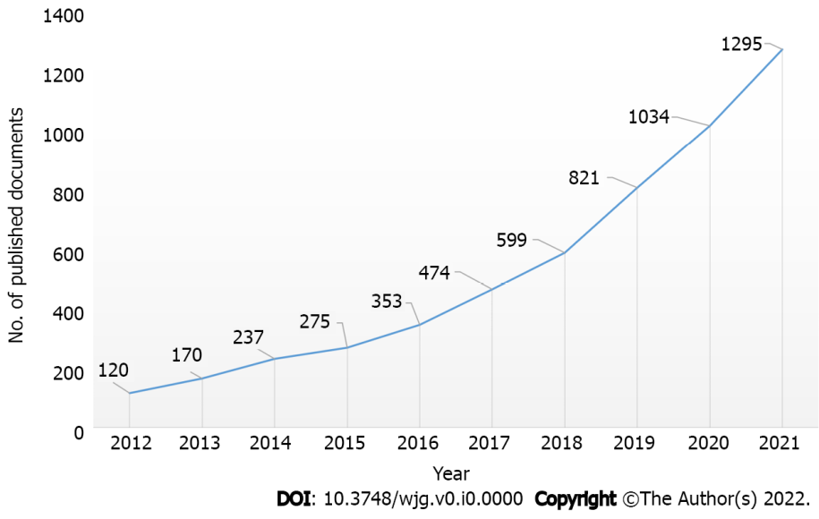
Figure 1 Growth trends of publications on the nutrition and the gut microbiota from 2012 to 2021.

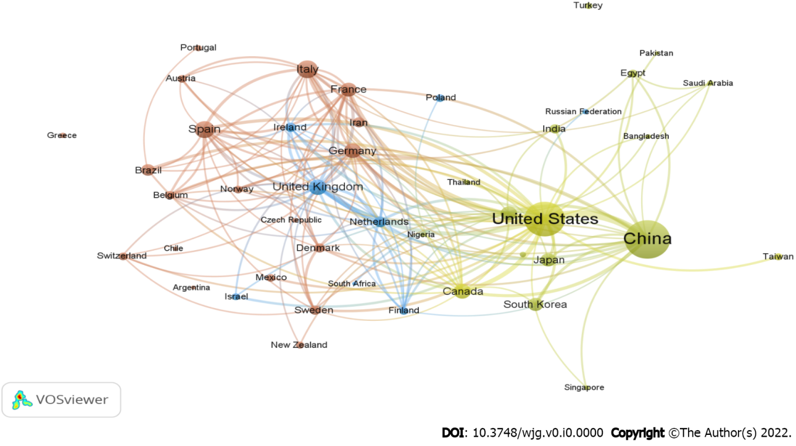
Figure 2 A network visualization map depicting international collaboration in nutrition and gut microbiota research during 2012-2021. This visualized map of collaborations was created after each country had at least 20 publications. Of 154 countries active in this field, 44 countries meet this threshold. The node's size indicates the number of publications for that country.

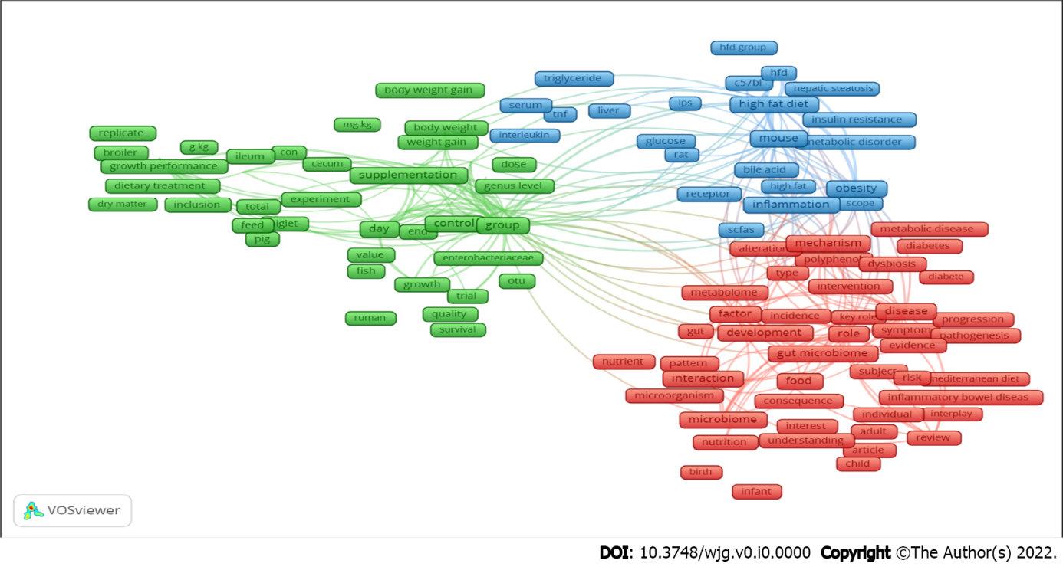
Figure 3 Network visualization map of terms in the title/abstract fields of publications relevant to nutrition and gut microbiota research from 2012 to 2021. When the minimum-term occurrences were put 100 times, this graphical map of terms was created. Of the 85327 terms in this field, 293 achieve this threshold, which were grouped into three clusters and colored differently. The size of the frame shows the number of publications that contain that term.

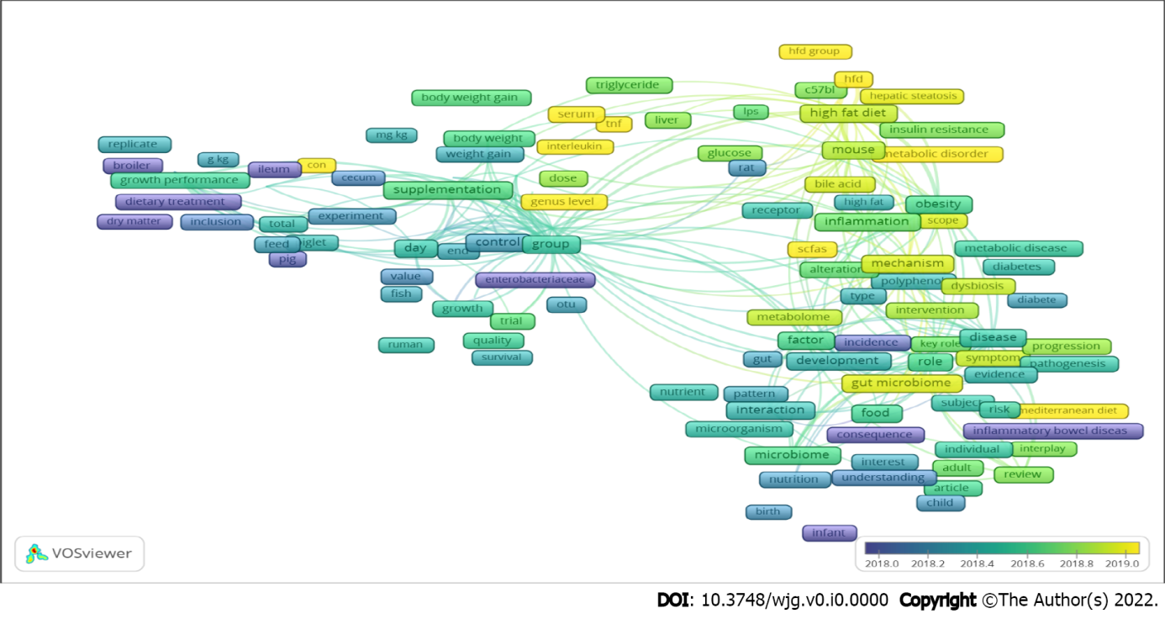
Figure 4 Network visualization map of terms in the title/abstract and their frequency of appearance of keywords is distributed according to the mean frequency of appearance. Blue-colored and green-colored terms first showed, and then yellow terms appeared later.

Table 1 List of the top ten countries publishing research on nutrition and the gut microbiota from 2012 to 2021
Ranking | Country | Number of documents | %
1st | China | 1634 | 30.38
2nd | United States | 1307 | 24.30
3rd | Italy | 346 | 6.43
4th | Spain | 313 | 5.82
5th | United Kingdom | 259 | 4.82
6th | Canada | 246 | 4.57
7th | Germany | 240 | 4.46
8th | Australia | 227 | 4.22
9th | France | 216 | 4.02
10th | South Korea | 204 | 3.79

Table 2 The top 10 productive affiliations publishing research on nutrition and the gut microbiota from 2012 to 2021
Ranking | Institute | Country | n | %
1st | Chinese Academy of Sciences | China | 138 | 2.57
2nd | China Agricultural University | China | 111 | 2.06
3rd | Chinese Academy of Agricultural Sciences | China | 95 | 1.77
4th | University College Cork | Ireland | 81 | 1.51
5th | APC Microbiome Ireland | Ireland | 80 | 1.49
6th | Nanjing Agricultural University | China | 74 | 1.38
7th | Københavns Universitet | Denmark | 73 | 1.36
8th | Wageningen University & Research | Netherlands | 62 | 1.15
9th | Consejo Superior de Investigaciones Científicas | Spain | 55 | 1.02
10th | Dankook University | South Korea | 54 | 1.00

Table 3 The top ten funding agencies having the most publications on nutrition and the gut microbiota from 2012 to 2021
Ranking | Funding agencies | Country | No. of publication | %
1st | National Natural Science Foundation of China | China | 711 | 13.22
2nd | National Institutes of Health | United States | 327 | 6.08
3rd | National Institute of Diabetes and Digestive and Kidney Diseases | United States | 190 | 3.53
4th | National Key Research and Development Program of China | China | 184 | 3.42
5th | European Commission | European Union | 102 | 1.90
6th | Ministry of Science and Technology of the People's Republic of China | China | 86 | 1.60
6th | National Institute of General Medical Sciences | China | 86 | 1.60
8th | European Regional Development Fund | European Union | 80 | 1.49
9th | National Institute of Allergy and Infectious Diseases | United States | 75 | 1.39
10th | Horizon 2020 Framework Programme | European Union | 74 | 1.38

Table 4 The top 10 most active journals publishing research on nutrition and the gut microbiota from 2012 to 2021
Ranking | Journal | n | % | IF¹
1st | Nutrients | 271 | 5.04 | 5.717
2nd | Frontiers in Microbiology | 167 | 3.11 | 5.64
3rd | Scientific Reports | 136 | 2.53 | 4.379
4th | Plos One | 124 | 2.31 | 3.24
5th | Food and Function | 116 | 2.16 | 5.396
6th | Journal of Functional Foods | 87 | 1.62 | 4.451
7th | Molecular Nutrition and Food Research | 82 | 1.52 | 5.914
8th | Poultry Science | 78 | 1.45 | 3.352
9th | Animals | 70 | 1.30 | 2.752
10th | Journal of Agricultural and Food Chemistry | 68 | 1.26 | 5.279
¹Impact factor (IF) was extracted from Journal Citation Reports (Source Clarivate, 2021).

Table 5 The top 10 high cited papers on research related to nutrition and the gut microbiota from 2012 to 2021
Ranking | Ref. | Year | Source title | IF¹ | Impact index per article² | Cited by
1st | David et al^{[56]} | 2014 | Nature | 49.962 | 506.2 | 4588
2nd | Koeth et al^{[57]} | 2013 | Nature Medicine | 53.44 | 242.8 | 2294
3rd | Den Besten et al^{[58]} | 2013 | Journal of Lipid Research | 5.922 | 202.2 | 1921
4th | Claesson et al^{[59]} | 2012 | Nature | 49.962 | 168.0 | 1793
5th | Trompette et al^{[60]} | 2014 | Nature Medicine | 53.44 | 165.6 | 1368
6th | Flint et al^{[61]} | 2012 | Nature Reviews Gastroenterology and Hepatology | 46.802 | 96.3 | 1011
7th | Desai et al^{[62]} | 2016 | Cell | 41.582 | 182.0 | 948
8th | Sonnenburg and Bäckhed^{[63]} | 2016 | Nature | 49.962 | 150.3 | 914
9th | Chassaing et al^{[64]} | 2015 | Nature | 49.962 | 122.1 | 889
10th | Dao et al^{[65]} | 2016 | Gut | 23.059 | 111.3 | 796
10th | Singh et al^{[10]} | 2017 | Journal of Translational Medicine | 5.531 | 148.0 | 796
¹Impact factor (IF) was extracted from Journal Citation Reports (Source Clarivate, 2021).
²The impact index per article is presented based on Reference Citation Analysis [Source: Baishideng Publishing Group Inc. (Pleasanton, CA 94566, United States)].

