Name of Journal: World Journal of Hepatology
ESPS Manuscript NO: 24494
Manuscript Type: Case Report

Host factors are dominant in the development of post-liver transplant non-alcoholic steatohepatitis

Boga S et al. NASH following split liver transplant

Salih Boga, Armando Salim Munoz-Abraham, Manuel I Rodriguez-Davalos, Sukru H Emre, Dhanpat Jain, Michael L Schilsky

Salih Boga, Michael L Schilsky, Division of Digestive Diseases, Department of Medicine and Surgery, Section of Transplantation and Immunology, Yale University School of Medicine, New Haven, CT 06520, United States

Armando Salim Munoz-Abraham, Manuel I Rodriguez-Davalos, Sukru H Emre, Department of Surgery, Section of Transplantation and Immunology, Yale-New Haven Transplantation Center, Yale University School of Medicine, New Haven, CT 06520, United States

Dhanpat Jain, Department of Pathology, Yale University School of Medicine, New Haven, CT 06520, United States

Author contributions: Boga S and Munoz-Abraham AS collected the data from patients’ file, reviewed literature and drafted manuscript; Jain D evaluated the biopsy specimens from pathologic points of view, prepared demonstrative pathology pictures; Rodriguez-Davalos MI, Emre SH and Schilsky ML supervised in designing and drafting the manuscript, revised the manuscript critically for important intellectual content; Emre SH and Schilsky ML presented patients’ clinical data, constituted the final form of manuscript; all authors read and approved the final manuscript.

Institutional review board statement: This case report was exempt from the Institutional Review Board standards at Yale University.

Informed consent statement: The patients involved in this report gave their written informed consents authorizing use and disclosure of their protected health information.

Conflict-of-interest statement: All the authors have no conflicts of interests to declare.

Open-Access: This article is an open-access article which was selected by an in-house editor and fully peer-reviewed by external reviewers. It is distributed in accordance with the Creative Commons Attribution Non Commercial (CC BY-NC 4.0) license, which permits others to distribute, remix, adapt, build upon this work non-commercially, and license their derivative works on different terms, provided the original work is properly cited and the use is non-commercial. See: http://creativecommons.org/licenses/by-nc/4.0/

Manuscript source: Invited manuscript

Correspondence to: Salih Boga, MD, Postdoctoral Fellow, Division of Digestive Diseases, Section of Transplantation and Immunology, Department of Medicine and Surgery, Yale University School of Medicine, 333 Cedar Street, LMP 1080, New Haven, CT 06520, United States. salihboga@yahoo.com
Telephone: +1-203-7371592
Fax: +1-203-7856645

Received: January 25, 2016
Peer-review started: January 25, 2016
First decision: February 29, 2016
Revised: March 30, 2016
Accepted: May 7, 2016
Article in press:
Published online:

Abstract
Non-alcoholic fatty liver disease (NAFLD) is a recognized problem in patients after orthotopic liver transplantation and may lead to recurrent graft injury. As the increased demand for liver allografts fail to match the available supply of donor organs, split liver transplantation (SLT) has emerged as an important technique to increase the supply of liver grafts. SLT allows two transplants to occur from one donor organ,and provides a unique model for observing the pathogenesis of NAFLD with respect to the role of recipient environmental and genetic factors. Here we report on two recipients of a SLT from the same deceased donor where only one developed nonalcoholic steatohepatitis (NASH), suggesting that host factors are critical for the development of NASH.

Key words: Liver; Transplant; Split graft; Steatohepatitis; Host factors

© The Author(s) 2016. Published by Baishideng Publishing Group Inc. All rights reserved.

Core tip: Split liver transplantation provides a unique model of the pathogenesis of non-alcoholic fatty liver disease with respect to the role of recipient environmental risk factors and genetic background because the same donor graft is shared by two distinct recipients. Here we present two recipients of a split liver transplantation from same deceased donor, with one developing nonalcoholic steatohepatitis and the other without any evidence of hepatic steatosis three years after they were transplanted. These cases provide a unique natural experiment to explore host factors that contributed to the development of nonalcoholic steatohepatitis after liver transplantation.

Boga S, Munoz-Abraham AS, Rodriguez-Davalos MI, Emre SH, Jain D, Schilsky ML. Host factors are dominant in the development of post-liver transplant non-alcoholic steatohepatitis. World J Hepatol 2016; In press

INTRODUCTION
Non-alcoholic fatty liver disease (NAFLD) affects around one third of the western population with an incidence that continues to grow in other parts of the world^{[1]}. Histopathological findings of NAFLD in the liver range from simple steatosis to non-alcoholic steatohepatitis (NASH), and can eventually progress to cirrhosis and liver cancer^{[2]}. NAFLD is recognized as a potential complication following LT and studies are being conducted to determine the prevalence and risk factors for development of NAFLD in LT recipients^{[3,4]}.
Split liver transplantation (SLT) has emerged as an important strategy to increase the supply of liver grafts by allowing two transplants to occur from one donor organ, and provide a unique opportunity to observe the role of host factors in the development of NAFLD. The technique of SLT is continuously evolving with reduced ischemia times and reduced vascular and biliary complications,and when performed in situ, SLT has yielded excellent outcomes^{[5]}. However, SLT still involves significant complexity and short and long term complications of the split grafts need to be continually analyzed. Here we present data on the clinical course and outcomes of two recipients of a SLT from the same deceased donor where only one developed NASH, suggesting that extrahepatic host factors are critical for the development of NASH.

CASE REPORT
Case 1
A female infant with a diagnosis of Crigler Najjar syndrome underwent a SLT at age 15 mo old, receiving a left lateral liver segment from a deceased donor who was exitus because of head trauma at age 16 years without any history of obesity, diabetes, hyperlipidemia or hypertension. The explanted liver did not reveal any significant histopathological abnormality and the donor pre-reperfusion biopsy was also negative for any significant pathologic findings, including inflammation, fibrosis, necrosis and steatosis (Figure 1). During the first year following transplantation, several episodes of liver test elevations were noted. Histology of the liver biopsy performed 19 mo post-SLT was not consistent with acute cellular rejection but showed minimal lobular inflammation, mild periportal edema and mild fibrosis (stage 1-2/4) without significant ductular reaction. No steatosis was present. A second biopsy performed 25 mo post-transplant due tocontinued liver test abnormalities revealed no histologic evidence of steatosis or progression of fibrosis (Figure 2). At this time the liver biopsy showed minimal portal fibrosis and no evidence of rejection, duct injury or duct loss. Subsequently magnetic resonance cholangiopancreatography was performed and an anatomic biliary stricture and dilated intrahepatic biliary ducts were identified. The patient underwent biliary reconstruction and a Roux-en-Y hepatojejunostomy and biliary stenting with internal-external drain placement at age 4 years. Three years following transplantation and two months after the biliary repair, liver tests improved [alanine aminotransferase (ALT): 29 U/L, aspartate aminotransferase (AST): 39 U/L, T/D Bil: 0.34/0.10 mg/dL, ınternational normalized ratio (INR): 0.93]. Growth was in the normal range with a body mass index (BMI): 17.58 kg/m². She was maintained on tacrolimus, mycophenolate mofetil and ursodeoxycholic acid treatment with routine biliary drain checks and close follow-up.

Case 2
A 69-year-old male patient with a history of heterozygocity for genetic hemochromatosis (single copy of C282Y for the HFE gene) and alcoholic cirrhosis complicated by development of hepatocellular carcinoma (HCC) within Milan criteria (a 2.6 cm in segment III, and 1.5 and 1.1 cm lesions in segment VI). He wastreated with chemoembolization and 8 mo later underwent an extended right lobe LT (Segments I-IV-VIII) from the same deceased donor. The explanted liver revealed cirrhosis with residual viable nodules of moderately differentiated hepatocellular carcinoma without any vascular invasion, mild steatosis with steatohepatitis and increased hepatocellular siderosis. His past medical history was remarkable for hypertension, hyperlipidemia and diabetes mellitus. Initial immunosuppression was with steroid and tacrolimus, and he was changed to sirolimus and a lower dosage of tacrolimus at eight weeks post-transplant to try to reduce the risk of recurrent HCC. Although his postoperative course was uncomplicated but he remained on insulin for glycemic control. Twenty-four months after SLT, he had HCC recurrence with a solitary 1.5 cm nodule in segment VIII found on surveillance imaging. The tumor was treated by selective chemoembolization and he is without recurrence on follow up magnetic resonance images; the most recent being 34 mo post-transplant. Three years after transplantation, his liver function tests were found to be elevated on routine testing, and increased cholesterol and triglyceride levels were noted (ALT: 154 U/L, AST: 125 U/L, T/D Bil: 0.85/0.20 mg/dL, INR: 1.1, total cholesterol: 218 mg/dL, HDL cholesterol: 34 mg/dL, triglyceride: 501 mg/dL). At the same time, his weight had increased by 12% (had BMI increased from 30.5 kg/m² to 34 kg/m²). He denied drinking alcohol. A liver biopsy was performed and showed no evidence of acute or chronic cellular rejection but was notable for marked macrovesicular steatosis involving about 70% of liver parenchyma, steatohepatitis and perisinusoidal fibrosis (grade 1 of 3, stage 1 of 4, Brunt system) (Figure 3).

DISCUSSION
LT is the accepted treatment of end-stage liver disease. The establishment of standard transplantation techniques, development of better immunosuppressive medications and accumulated experience in their safe use, improvement of intensive care and anesthesia all have played a major role in improving current 1-year survival after LT to 90%. Long-term outcomes, however, are still compromised by recurrent liver disease, increased risk of cancer, adverse effects of immunosuppressive drugs and possible metabolic complications^{[6,7]}. One of the possible metabolic complications is the development of NASH/NAFLD.
SLT has developed as an alternative to increase the donor pool of organ for LT. The concept of splitting a liver allograft between two recipients was reported almost simultaneously by Pichlmayr et al^{[8]} and Bismuth et al^{[9]}. Recipients of SLT in the mid 1990s^{[10,11]} were primarily one child who received the left-lateral segments and one adult who received the extended right lobe. SLT provides a unique model of the pathogenesis of NAFLD with respect to the role of recipient environmental risk factors and genetic backgroundbecause the same donor graft is shared by two distinct recipients. Here we present two recipients of a SLT from same deceased donor, with one developing NASH and the other without any evidence of hepatic steatosis three years after they were transplanted. These cases provide a unique natural experiment to explore host factors that contributed to the development of NASH after LT.
LT recipients have several risk factors that put them at risk for NAFLD. Age and rapid weight gain causing obesity and long-term exposure to immunosuppressive medications can in part be responsible for NAFLD. Hyperlipidemia ocurrs frequently following solid-organ transplantation. Between 16% and 43% of adult LT recipients can have increased plasma cholesterol levels^{[7,12,13]}. Furthermore corticosteroids and calcineurin inhibitors promote hypertension and hyper-cholesterolemia, prednisone, tacrolimus, and cyclosporine A are diabetogenic, and sirolimus induces hyperlipidemia. Although both of our recipientswere placed on tacrolimus, the older patient was also treated with sirolimus. In our adult recipient, use of tacrolimus and the aberrant gain in weight likely increased his already present insulin resistance and contributed to further deterioration of glucose regulation, causing an increase in hepatic fatty infiltration and inflammation that ended with steatohepatitis.
In the first few months after liver LT, weight gain may be regarded as one of the positive effects of transplantation, especially in patients with advanced liver disease and pre-transplant cachexia. However, within two years of transplantation, an excess body weight is recorded in up to 60% to 70% of patients and 20% of previously non-obese transplant recipients become obese^{[14,15]}. The recipient with steatohepatitis showed an increase in BMI from 30.5 kg/m² at time of transplant to 34 kg/m², corresponding to a 12% increase in weight over 3 years time. NAFLD is strongly linked to obesity, (BMI > 30 kg/m²) with a reported prevalence as high as 80% in obese patients and only 16% in individuals with a normal BMI^{[16]}. Although the exact mechanisms leading to excessive weight gain in post-LT patients are uncertain, a major role is attributed to the development of post-LT insulin resistance, diabetes mellitus, arterial hypertension, hyperlipidemia and the metabolic effects of immunosuppressive medications (corticosteroids, mTOR inhibitors and calcineurin inhibitors).
There are other factors in our steatohepatitic recipient that may have increased hepatic fatty infiltration. The patient had a history of alcoholic cirrhosis, and some patients transplanted for alcoholic disease have a significantly higher risk of post-LT NAFLD even in the absence of recurrent alcoholic intoxication. Kim et al^{[4]}, reported that even though in 156 patients who had stopped drinking or had a limited amount of alcohol after LT, pre-LT alcoholic liver cirrhosis was a significant factor for their development of post-LT NAFLD. Similarly Dumortier et al^{[17]} suggested that many patients with post-LT NAFLD have an unrecognized combination of alcoholic and non-alcoholic steatohepatitis that put them at risk of secondary liver failure because of persistent metabolic abnormalities. Recently Hejlova et al^{[18]} examined 2360 post-transplant biopsies of 548 LT recipients to identify risk factors for the development of significant steatosis and found alcohol induced cirrhosis as a pre-transplant factor that is associated with significant post-transplant steatosis. It is likely patients with this combination of alcoholic and non-alcoholic steatohepatitis pre-transplanthave an increased risk of persistence of metabolic abnormalities post-LT due to newly de-novo or aggravated insulin resistance.
Though the adult recipient had a pre-transplant diagnosis of iron overload disorder, genetic hemochromatosis is cured by liver transplantation^{[19]}. There are instances where recipients received organs from patients with hemochromatosis and iron accumulation has occured^{[20]}. In the adult recipient, we did not find iron accumulation in his liver biopsy, suggesting iron did not play any additional role in the genesis of his steatohepatitis. Of the factors mentioned above; age, genetic background and even pretransplant history of alcoholic cirrhosis may be considered as unchangeable host factors where as post-transplant life sytle changes, diet, glycemic control by anti-diabetic medications, control of weight gain, hyperlipidemia therapy and immunesuppressive medications are changeable host factors that can affect the presence and progression of post-LT NASH.
In conclusion, this SLT provided a unique opportunity to observe the pathogenesis of NAFLD in the post-transplant setting. Although we can not exclude an interaction of donor and host factors, our data suggest host factors may be dominant for the development of post-LT NASH.
Because we can not change the genetic background of the donor organ, careful attention to potentially alterable host factors or treatments like diet, life sytle changes, hyperlipidemia therapy and immunesuppressive medications can result in improved long term outcomes for recipients.

COMMENTS
Case characteristics
A female infant with a diagnosis of Crigler Najjar syndrome and a 69-year-old male patient with cirrhosis complicated by development of hepatocellular carcinoma underwent split liver transplantation (SLT).

Clinical diagnosis
Infant had jaundice and the elderly patient had signs of cirrhosis such as jaundice, ascites and spider angioma.

Differential diagnosis
Inherited disorders of bilirubin metabolism for the first patient and primary and metastatic malignities of the liver for the second patient.

Laboratory diagnosis
The first patient had elevated bilirubin levels (total bilirubin: 21 mg/dL, direct bilirubin: 0.25 mg/dL) and the second patient had an alpha fetoprotein of 109 ng/mL.

Imaging diagnosis
The adult patient had a 2.6 cm hepatocellular carcinoma (HCC) lesion in segment III, and 1.5 and 1.1 cm HCC lesions in segment VI on magnetic resonance scan.

Pathological diagnosis
While the explanted liver did not reveal any significant histopathological abnormality in the first patient and revealed cirrhosis with residual viable nodules of HCC in the second patient; post-transplant liver biopsies showed minimal portal fibrosis and no histologic evidence of steatosis in the first patient and showed macrovesicular steatosis, steatohepatitis and perisinusoidal fibrosis in the second patient.

Treatment
First patient underwent biliary reconstruction, a Roux-en-Y hepatojejunostomy and biliary stenting with internal-external drain placement and was maintained on tacrolimus, mycophenolate mofetil and ursodeoxycholic acid treatment and the second patient had an initial immunosuppression with steroid and tacrolimus, and then was changed to sirolimus and a lower dosage of tacrolimus at eight weeks post-transplant and had selective chemoembolization for recurrent HCC.

Related reports
Even though emerging literature puts non-alcoholic fatty liver disease (NAFLD) forward as a potential complication following liver transplantation, SLT presented in this report provided a unique model of the pathogenesis of NAFLD with respect to the role of recipient environmental risk factors and genetic background because the same donor graft was shared by two distinct recipients.

Term explanation
Crigler-Najjar syndrome is a rare hereditary disorder of bilirubin metabolism characterized by unconjugated hyperbilirubinemia due to deficiency of the enzymaticactivity of glucuronosyltransferase.

Experiences and lessons
This SLT provided a unique opportunity to observe the pathogenesis of NAFLD in the post-transplant setting. The data suggest host factors may be dominant for the development of post-LT NASH. The authors recommend paying careful attention to potentially alterable host factors or treatments like diet, life sytle changes, hyperlipidemia therapy and immunesuppressive medications to improve the long term outcomes for recipients.

Peer-review
This is an interesting case report about post transplant NASH comparing two different scenarios (two different hosts) for a unique donor from a split liver transplant.

REFERENCES
1 Milić S, Stimac D. Nonalcoholic fatty liver disease/steatohepatitis: epidemiology, pathogenesis, clinical presentation and treatment. Dig Dis 2012; 30: 158-162 [PMID: 22722431 DOI: 10.1159/000336669]
2 Bugianesi E, Leone N, Vanni E, Marchesini G, Brunello F, Carucci P, Musso A, De Paolis P, Capussotti L, Salizzoni M, Rizzetto M. Expanding the natural history of nonalcoholic steatohepatitis: from cryptogenic cirrhosis to hepatocellular carcinoma. Gastroenterology 2002; 123: 134-140 [PMID: 12105842]
3 Seo S, Maganti K, Khehra M, Ramsamooj R, Tsodikov A, Bowlus C, McVicar J, Zern M, Torok N. De novo nonalcoholic fatty liver disease after liver transplantation. Liver Transpl 2007; 13: 844-847 [PMID: 17029282 DOI: 10.1002/lt.20932]
4 Kim H, Lee K, Lee KW, Yi NJ, Lee HW, Hong G, Choi Y, You T, Suh SW, Jang JJ, Suh KS. Histologically proven non-alcoholic fatty liver disease and clinically related factors in recipients after liver transplantation. Clin Transplant 2014; 28: 521-529 [PMID: 24579874 DOI: 10.1111/ctr.12343]
5 Emre S, Umman V. Split liver transplantation: an overview. Transplant Proc 2011; 43: 884-887 [PMID: 21486620 DOI: 10.1016/j.transproceed.2013.02.063]
6 Reuben A. Long-term management of the liver transplant patient: diabetes, hyperlipidemia, and obesity. Liver Transpl 2001; 7: S13-S21 [PMID: 11689772 DOI: 10.1053/jits.2001.29167]
7 Sheiner PA, Magliocca JF, Bodian CA, Kim-Schluger L, Altaca G, Guarrera JV, Emre S, Fishbein TM, Guy SR, Schwartz ME, Miller CM. Long-term medical complications in patients surviving & gt; or = 5 years after liver transplant. Transplantation 2000; 69: 781-789 [PMID: 10755526 DOI: 10.1097/00007890-200003150-00018]
8 Pichlmayr R, Ringe B, Gubernatis G, Hauss J, Bunzendahl H. [Transplantation of a donor liver to 2 recipients (splitting transplantation)--a new method in the further development of segmental liver transplantation]. Langenbecks Arch Chir 1988; 373: 127-130 [PMID: 3287073]
9 Bismuth H, Morino M, Castaing D, Gillon MC, Descorps Declere A, Saliba F, Samuel D. Emergency orthotopic liver transplantation in two patients using one donor liver. Br J Surg 1989; 76: 722-724 [PMID: 2670054 DOI: 10.1002/bjs.1800760723]
10 Azoulay D, Astarcioglu I, Bismuth H, Castaing D, Majno P, Adam R, Johann M. Split-liver transplantation. The Paul Brousse policy. Ann Surg 1996; 224: 737-746; discussion 746-748 [PMID: 8968228]
11 Rogiers X, Malagó M, Gawad K, Jauch KW, Olausson M, Knoefel WT, Gundlach M, Bassas A, Fischer L, Sterneck M, Burdelski M, Broelsch CE. In situ splitting of cadaveric livers. The ultimate expansion of a limited donor pool. Ann Surg 1996; 224: 331-339; discussion 339-341 [PMID: 8813261]
12 Imagawa DK, Dawson S, Holt CD, Kirk PS, Kaldas FM, Shackleton CR, Seu P, Rudich SM, Kinkhabwala MM, Martin P, Goldstein LI, Murray NG, Terasaki PI, Busuttil RW. Hyperlipidemia after liver transplantation: natural history and treatment with the hydroxy-methylglutaryl-coenzyme A reductase inhibitor pravastatin. Transplantation 1996; 62: 934-942 [PMID: 8878387 DOI: 10.1097/00007890-199610150-00011]
13 Gisbert C, Prieto M, Berenguer M, Bretó M, Carrasco D, de Juan M, Mir J, Berenguer J. Hyperlipidemia in liver transplant recipients: prevalence and risk factors. Liver Transpl Surg 1997; 3: 416-422 [PMID: 9346772 DOI: 10.1002/lt.500030409]
14 Everhart JE, Lombardero M, Lake JR, Wiesner RH, Zetterman RK, Hoofnagle JH. Weight change and obesity after liver transplantation: incidence and risk factors. Liver Transpl Surg 1998; 4: 285-296 [PMID: 9649642 DOI: 10.1002/lt.500040402]
15 Palmer M, Schaffner F, Thung SN. Excessive weight gain after liver transplantation. Transplantation 1991; 51: 797-800 [PMID: 2014532 DOI: 10.1097/00007890-199104000-00012]
16 Williams CD, Stengel J, Asike MI, Torres DM, Shaw J, Contreras M, Landt CL, Harrison SA. Prevalence of nonalcoholic fatty liver disease and nonalcoholic steatohepatitis among a largely middle-aged population utilizing ultrasound and liver biopsy: a prospective study. Gastroenterology 2011; 140: 124-131 [PMID: 20858492 DOI: 10.1053/j.gastro.2010.09.038]
17 Dumortier J, Giostra E, Belbouab S, Morard I, Guillaud O, Spahr L, Boillot O, Rubbia-Brandt L, Scoazec JY, Hadengue A. Non-alcoholic fatty liver disease in liver transplant recipients: another story of "seed and soil". Am J Gastroenterol 2010; 105: 613-620 [PMID: 20040915 DOI: 10.1038/ajg.2009.717]
18 Hejlova I, Honsova E, Sticova E, Lanska V, Hucl T, Spicak J, Jirsa M, Trunecka P. Prevalence and Risk Factors of Steatosis After Liver Transplantation and Patient Outcomes. Liver Transpl 2015 Dec 28; Epub ahead of print [PMID: 26707008 DOI: 10.1002/lt.24393]
19 Moini M, Mistry P, Schilsky ML. Liver transplantation for inherited metabolic disorders of the liver. Curr Opin Organ Transplant 2010; 15: 269-276 [PMID: 20489626 DOI: 10.1097/MOT.0b013e3283399dbd]
20 Dwyer JP, Sarwar S, Egan B, Nolan N, Hegarty J. Hepatic iron overload following liver transplantation of a C282y homozygous allograft: a case report and literature review. Liver Int 2011; 31: 1589-1592 [PMID: 22093334 DOI: 10.1111/j.1478-3231.2011.02606.x]

P- Reviewer: Inoue K, Ikura Y, Komatsu H, Villela-Nogueira CA
S- Editor: Gong XM L- Editor: E- Editor:

A

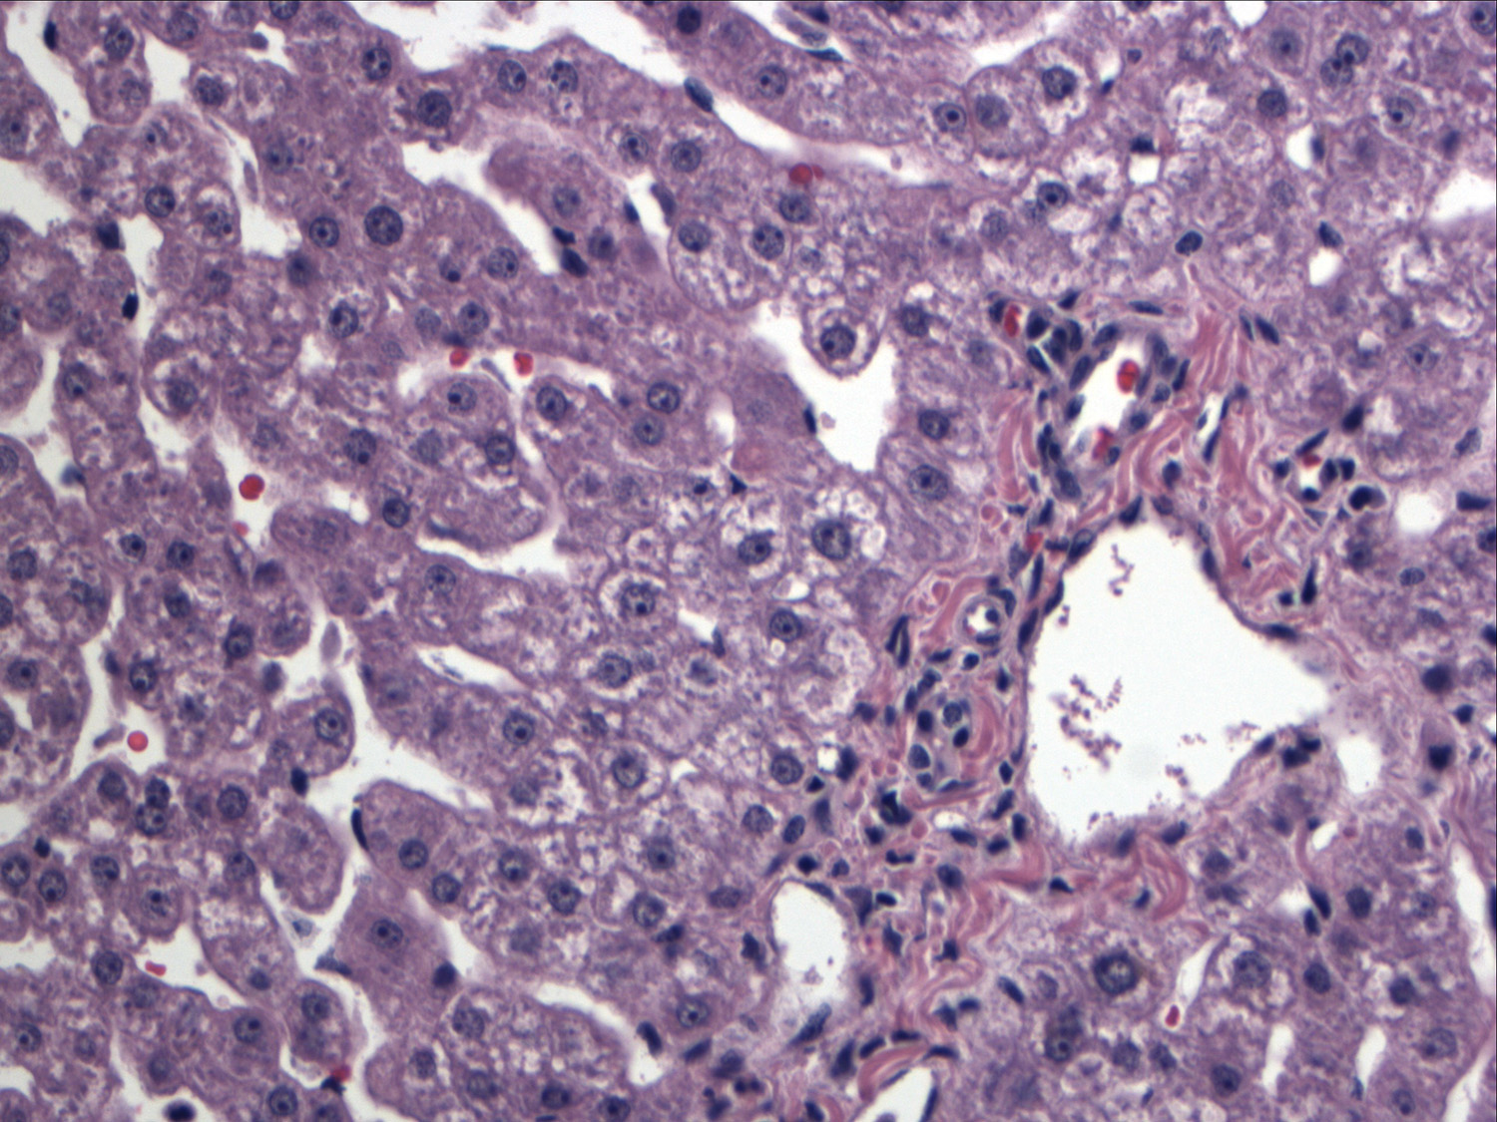
B
Figure 1 Biopsy of the donor liver showing a lack of obvious pathologic changes. Specifically there is no steatosis, fibrosis or inflammation (H and E stain). A: Low magnification (× 100); B: Higher magnification (× 200) of the biopsy.

A
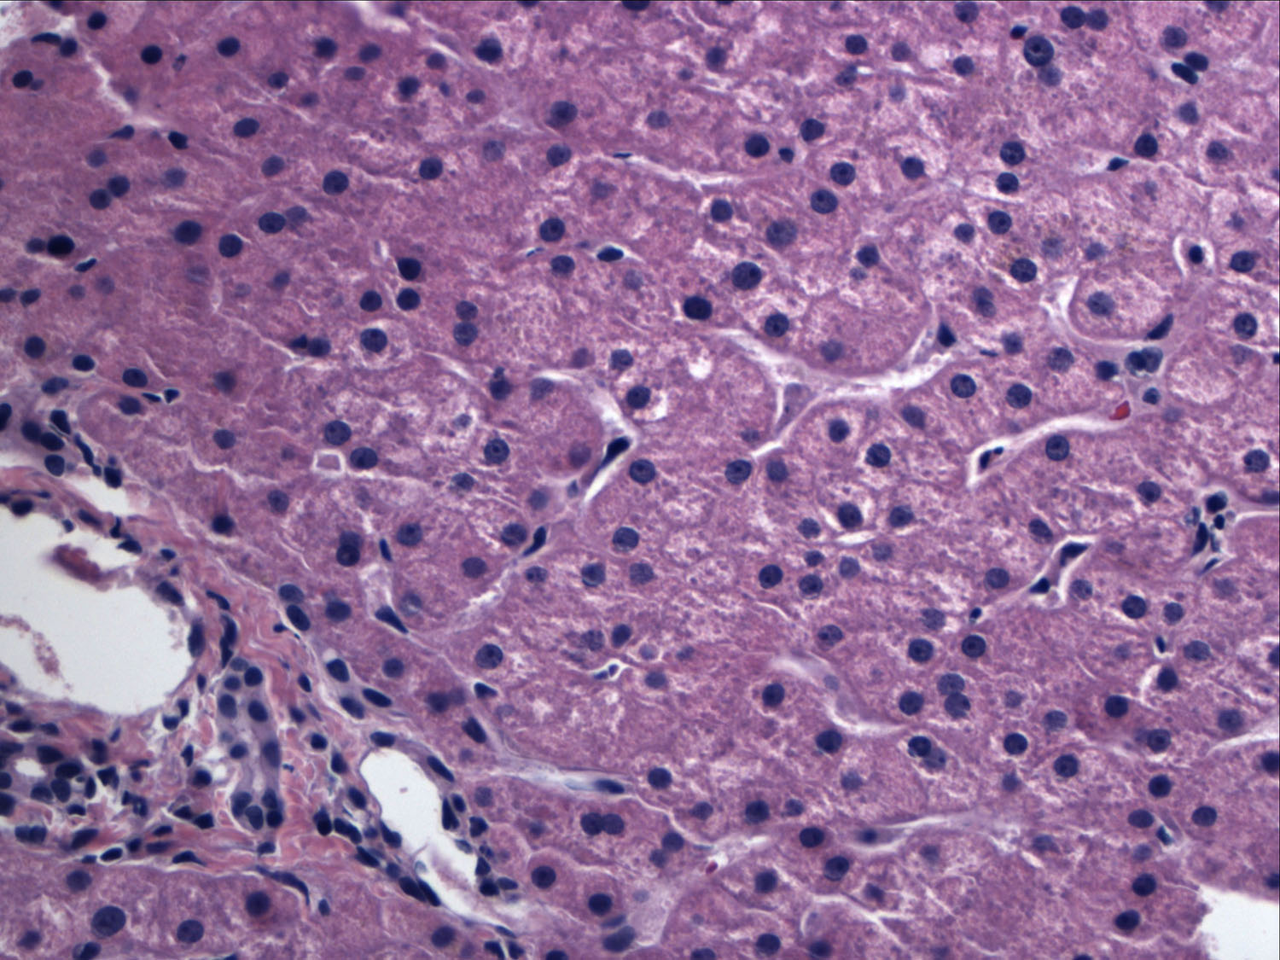
B
Figure 2 Biopsy ofliver graft fromcase 1 performed 25 mo later showing a lack of significant pathologic changes. Specifically, no steatosis is noted (H and E stain). A: Low magnification (× 100); B: Higher magnification (× 200) of the biopsy.

A
B
Figure 3 Biopsy of the liver graft from case 2 about 3 years post split liver transplantation showing marked macrovesicular steatosis (H and E stain). A: Low magnification (× 100); B: Higher magnification showingrare Mallory Denk bodies (arrow), ballooned hepatocytes and mild lobular inflammation (× 200). Trichrome stain revealed mild sinusoidal fibrosis (not shown here).

