Name of Journal: World Journal of Gastroenterology
Manuscript NO: 53401
Manuscript Type: ORIGINAL ARTICLE

Retrospective Cohort Study
Lifestyle factors and long-term survival of gastric cancer patients: A large bidirectional cohort study from China

Zhao LL et al. Lifestyle factors and survival of gastric cancer

Lu-Lu Zhao, Huang Huang, Yang Wang, Tong-Bo Wang, Hong Zhou, Fu-Hai Ma, Hu Ren, Peng-Hui Niu, Dong-Bing Zhao, Ying-Tai Chen

Lu-Lu Zhao, Yang Wang, Tong-Bo Wang, Hong Zhou, Fu-Hai Ma, Hu Ren, Peng-Hui Niu, Dong-Bing Zhao, Ying-Tai Chen, National Cancer Center/National Clinical Research Center for Cancer/Cancer Hospital, Chinese Academy of Medical Sciences and Peking Union Medical College, Beijing 100021, China

Huang Huang, Department of Environmental Health Sciences, Yale University School of Public Health, New Haven, CT 06520, United States

Yang Wang, Department of General Surgery, Beijing Di Tan Hospital, Capital Medical University, Beijing 100015, China

Author contributions: Zhao LL, Huang H and Wang Y contributed equally to this work; All authors made substantial contributions to the intellectual content of this paper.

Supported by National Key R&D Program of China, No. 2017YFC0908300.

Corresponding author: Ying-Tai Chen, MD, Professor, National Cancer Center/National Clinical Research Center for Cancer/Cancer Hospital, Chinese Academy of Medical Sciences and Peking Union Medical College, 17 Panjiayuan Nanli, Beijing 100021, China. yingtaichen@126.com

Received: December 18, 2019
Revised: March 5, 2020
Accepted: March 19, 2020
Published online: April 14, 2020

Abstract
BACKGROUND
Lifestyle factors such as body mass index (BMI), alcohol drinking, and cigarette smoking, are likely to impact the prognosis of gastric cancer, but the evidence has been inconsistent.

AIM
To investigate the association of lifestyle factors and long-term prognosis of gastric cancer patients in the China National Cancer Center.

METHODS
Patients with gastric cancer were identified from the China National Cancer Center Gastric Cancer Database 1998-2018. Survival analysis was performed via Kaplan-Meier estimates and Cox proportional hazards models.

RESULTS
In this study, we reviewed 18441 cases of gastric cancer. Individuals who were overweight or obese were associated with a positive smoking and drinking history (P = 0.002 and P < 0.001, respectively). Current smokers were more likely to be current alcohol drinkers (61.3% vs 10.1% vs 43.2% for current, never, and former smokers, respectively, P < 0.001). Multivariable results indicated that BMI at diagnosis had no significant effect on prognosis. In gastrectomy patients, factors independently associated with poor survival included older age (HR = 1.20, 95%CI: 1.05-1.38, P = 0.001), any weight loss (P < 0.001), smoking history of more than 30 years (HR = 1.14, 95%CI: 1.04-1.24, P = 0.004), and increasing pTNM stage (P < 0.001).

CONCLUSION
In conclusion, our results contribute to a better understanding of lifestyle factors on the overall burden of gastric cancer and long-term prognosis. In these patients, weight loss (both in the 0 to 10% and > 10% groups) but not BMI at diagnosis was related to survival outcomes. With regard to other factors, smoking history of more than 30 years conferred a worse prognosis only in patients who underwent gastrectomy. Extensive efforts are needed to elucidate mechanisms targeting the complex effects of lifestyle factors.

Key words: Gastric cancer; Lifestyle factors; Prognosis; Cohort study; Body mass index; Cigarette smoking

Zhao LL, Huang H, Wang Y, Wang TB, Zhou H, Ma FH, Ren H, Niu PH, Zhao DB, Chen YT. Lifestyle factors and long-term survival of gastric cancer patients: A large bidirectional cohort study from China. World J Gastroenterol 2020; 26(14): 1613-1627
URL: https://www.wjgnet.com/1007-9327/full/v26/i14/1613.htm
DOI: https://dx.doi.org/10.3748/wjg.v26.i14.1613

Core tip: Lifestyle factors are likely to impact the prognosis of gastric cancer, but the evidence has been inconsistent. We conducted a single-center, large-scale bidirectional cohort study to investigate the association of lifestyle factors with long-term prognosis in patients with gastric cancer in China. Among these patients, weight loss but not body mass index at diagnosis, was related to survival outcomes. With regard to other factors, smoking history of more than 30 years conferred a worse prognosis only in patients who underwent gastrectomy.
INTRODUCTION
Gastric cancer is the third leading cause of cancer-related mortality and the sixth most common cancer globally^{[1]}. More than 70% of new cases occur in developing countries, and half of the world’s total cases occur in Eastern Asia, mainly in China^{[2]}. As the patient population grows, factors contributing to improved or adverse survival are becoming a focus of increasing interest.
Obesity defined as high body mass index (BMI) results from the expansion of white adipose tissue, commonly referred to as fat. To date, evidence for the association between BMI and prognosis in gastric cancer patients has been inconsistent. Some studies^{[3-8]} have reported that being overweight was associated with improved long-term survival for gastric cancer patients who underwent gastrectomy, whereas other results^{[9-16]} showed that BMI was not a prognostic factor. Three studies^{[17-19]} even demonstrated poor survival of gastric cancer patients with higher BMI. However, some previous studies have used coarse categories, such as BMI < 25.0 and ≥ 25^{[8,15,20,21]}. Furthermore, these results may not apply to the Chinese population due to the different BMI categorization criteria for Asians; therefore, the association between BMI and prognosis is unclear in China.
Similarly, the prognostic effects of alcohol drinking and smoking status at diagnosis of gastric cancer are also contradictory, although cigarette smoking is known to be associated with stomach cancer risk^{[22,23]}. Alcohol drinking at diagnosis was reported to decrease survival in patients with gastric cancer in some studies^{[24,25]}, while several other studies^{[26,27]} did not confirm this finding. Some studies^{[28-31]} have shown a positive association between smoking and overall survival (OS) in gastric cancer, while other studies^{[24,26,32]} have found that smoking status was not statistically related to prognosis. There is a deficiency in most published studies, especially prospective studies, which have not adjusted for potentially significant covariates such as gastrectomy.
Thus, we conducted a single-center, large-scale bidirectional cohort study in the China National Cancer Center to investigate the three major lifestyle factors mentioned above - BMI, alcohol drinking, and smoking - and attempted to clarify the association of these factors with the OS of patients with gastric cancer.

MATERIALS AND METHODS
Population
All patient records were abstracted from the China National Cancer Center Gastric Cancer Database. The China National Cancer Center Gastric Cancer Database is a clinical gastric cancer database based on a huge bidirectional cohort, which was sourced from the China National Cancer Center, a single but large-volume institution with patients from all over China from 1998 to 2018. After the diagnosis of gastric cancer was confirmed by pathology, 18441 patients were included in this study. The AJCC 8th edition was used for TNM staging. The median follow-up of gastric cancer patients was 62.7 ± 3.5 mo until December 2018. 1818 patients were lost during the follow-up period with a loss rate of 9.86%. The geographical locations of these gastric cancer patients are shown in Figure 1.
After the analyses of all included gastric cancer patients irrespective of surgery, we further analyzed three detailed subgroups: consisting of gastrectomy patients, no surgery patients, and only gastric cancer patients with curative gastrectomy. Gastrectomy was defined as surgery with or without D2 lymphadenectomy, while curative gastrectomy was defined as patients who underwent surgery with D2 lymphadenectomy and had negative margins.

Statistical analysis
BMI at diagnosis was calculated as weight at diagnosis (kg) of gastric cancer divided by the square of height (m²). For the analysis of BMI according to the Asian criteria, patients were stratified according to the following BMI categories: underweight (< 18.5 kg/m²), healthy weight (≥ 18.5 to < 23 kg/m²), overweight (≥ 23 to < 27.5.0 kg/m²) and obese (≥ 27.5 kg/m²).
Other lifestyle variables related to cigarette smoking included smoking status (never, current, and former smokers), time since quitting smoking (1-9 and ≥ 10 years), number of cigarettes per day (≤ 20, 21-39, and ≥ 40), and duration of smoking (1-29 and ≥ 30 years). For alcohol drinking, drinking status (never, current, and former drinkers) and amount of alcohol consumed per day (light drinkers, < 15.0 g; moderate drinkers, ≥ 15.0 g to < 53.5 g; and heavy drinkers, ≥ 53.5 g) was included. Subjects who quit smoking or drinking within one year before the present admission were regarded as current smokers or drinkers, respectively.
Categorical variables were compared using the χ² test, and continuous variables were analyzed by the Student’s t-test. Survival curves were plotted for total patients, no-surgery, gastrectomy and only curative gastrectomy groups, respectively, using the Kaplan-Meier method and compared using the log-rank test. Hazard ratios (HRs) and 95% confidence intervals (CIs) were used to estimate the risk of death by employing the multivariate Cox proportional hazards models with adjustment for gender, age, pTNM stage, adjuvant therapies, and gastrectomy. The group with healthy weight (≥ 18.5 to < 23 kg/m²) was the reference group. A two-sided P-value less than 0.05 was considered statistically significant. All the statistical analyses were performed using SAS software v9.4 (SAS Institute, Inc., Cary, NC, USA).

RESULTS
Clinical characteristics
In this study, we included 18441 gastric cancer patients diagnosed between 1998 and 2018 (Table 1). Of these subjects, more than half were males (13533, 73.4%) with a median age of 58.5 years. Of the total subjects, 84.5% experienced weight loss at diagnosis when compared with their usual weight, 40.5% had a smoking history, and 33.2% had a drinking history. During the follow-up period, 4717 (25.6%) deaths were recorded in our database.
Compared to those with a healthy BMI at diagnosis, overweight and obese patients had more weight loss (0% to 10%) than patients with healthy weight (81.6% vs 81.9% vs 75.9%, P < 0.001). Underweight patients were more likely to be diagnosed at a later stage than other groups (pTNM IV, 17.0% vs 13.7% vs 10.6% vs 9.6%, P < 0.001).
Current drinkers tended to be at a later pTNM stage (stage IV, 44.2% vs 12.6% vs 11.9%, P < 0.001) with a proximal location in the stomach (47.0% vs 33.4% vs 34.5%) than never or former drinkers. In terms of cigarette smoking, former smokers were older (aged ≥ 66 years, 37.9% vs 30.0 vs 23.0%, P < 0.001) than never or current smokers. Current smokers were also more likely to be current alcohol drinkers (61.3% vs 10.1% vs 43.2%, P < 0.001) as compared to never or former smokers.

Survival outcomes in univariate analysis
Figure 2 shows the Kaplan-Meier curves for OS of different BMIs at diagnosis in total gastric cancer patients, no surgery, gastrectomy, and only curative gastrectomy patients. The median OS of total patients for each BMI category was as follows: underweight, 12.5 years; healthy weight, 13.0 years; overweight, 13.6 years; and obese, 13.6 years (P < 0.001). For no surgery patients, the results were as follows: underweight, 5.7 years; healthy weight, 5.0 years; overweight, 5.9 years; and obese, 6.1 years (P = 0.26). For the gastrectomy group, survival status was as follows: underweight, 14.0 years; healthy weight, 14.0 years; overweight, 14.2 years; and obese, 14.4 years (P < 0.001). For the only curative gastrectomy group, survival status was as follows: underweight, 14.1 years; healthy weight, 14.3 years; overweight, 14.3 years; and obese, 14.5 years (P = 0.002). The 3- and 5-year OS for different gastrectomy groups are presented in Supplementary Table 1.
Kaplan-Meier survival comparisons (Supplementary Figure 1 and Supplementary Table 2) showed no association between smoking status and the OS of gastric cancer patients, even stratified in the only curative gastrectomy group. With regard to alcohol drinking, there was a significant difference between drinking status among no surgery patients (P = 0.009), but not in the other groups (Supplementary Figure 2 and Supplementary Table 3). Survival of those with both smoking and alcohol drinking status was also analyzed (Figure 3 and Supplementary Table 4), and significant differences were observed in the total and gastrectomy groups.
Univariate analysis (Supplementary Table 5) showed that overweight and obese patients had better survival than those with normal weight (HR = 0.92, 95%CI: 0.88-0.96, P < 0.001 and HR = 0.89, 95%CI: 0.83-0.96, P = 0.001, respectively), while the discrepancy in survival rate was attenuated in the gastrectomy group (HR = 0.95, 95%CI: 0.90-1.00, P = 0.04 and HR = 0.91, 95%CI: 0.84-0.99, P = 0.03, respectively). However, for curative gastrectomy patients, only the overweight group showed an improved survival (HR = 0.94, 95%CI: 0.89-1.00, P = 0.049). Weight loss of > 10% of the usual weight was a significant risk factor for mortality in the four groups (P < 0.001). As shown in Table 2, smoking history of more than 30 years was a prognostic factor of poor survival for total patients and gastrectomy patients (P < 0.001). However, drinking status, even heavy drinking, was not a negative prognostic indicator.

Survival outcomes in multivariable analysis
The J-shaped relationship between BMI at diagnosis and survival in patients after multivariate-adjusted analysis of different gastrectomy groups is shown in Figure 4. The HR for total gastric cancer patients was the lowest (HR = 0.90; 95%CI: 0.86-0.94) at a BMI of 25.96, followed by a BMI of 28.20 for no surgery patients, 25.47 for gastrectomy patients, and 25.50 for only curative gastrectomy patients. However, the multivariable results (Table 2) indicated that BMI at diagnosis did not affect prognosis.
For total gastric cancer patients, any weight loss (P < 0.001), advanced pTNM stage (P < 0.001), and gastrectomy status (HR = 1.51, 95%CI: 1.40-1.63, P < 0.001) were independently associated with mortality. In the surgery group, factors independently associated with poor survival included older age (≥ 66 years) (HR = 1.20, 95%CI: 1.05-1.38, P = 0.001), any weight loss (0 to 10%, HR = 1.13, 95%CI: 1.05-1.20, P < 0.001 and > 10%, HR = 1.25, 95%CI: 1.14-1.38, P < 0.001), smoking history more than 30 years (HR = 1.14, 95%CI: 1.04-1.24, P = 0.004), and advanced pTNM stage (P < 0.001). An additional mortality-related factor for the only curative gastrectomy group was middle age (36-65 years) (HR = 1.15, 95%CI: 1.00-1.33, P = 0.047).

DISCUSSION
This retrospective study investigated how lifestyle factors in gastric cancer patients were associated with prognosis, including BMI at diagnosis, smoking, and drinking status. A primary finding of this study was that BMI at diagnosis was not independently associated with long-term survival after adjusting for risk factors, although weight loss of both 0 to 10% and > 10% of their usual weight were adverse prognostic factors in gastric cancer patients.
We included 18441 patients in this study, a larger cohort than most previous studies, and followed them for more than ten years. Four subgroups, total patients, no surgery, gastrectomy, and only curative gastrectomy, were analyzed to eliminate the effect of gastrectomy which may affect the survival outcomes. After controlling confounding variables, it was found that percentage weight loss of the usual weight was associated with an increased risk of mortality in gastric cancer patients compared to those without weight loss. It is possible that human adipose tissue may have the function of preserving nutrients and increase the chance of survival when the human body suffers stress, such as anti-cancer treatment^{[6,33,34]}. Weight loss may be due to gastric cancer-induced dysphagia, odynophagia, anorexia or cancer cachexia, thus it has a negative effect on survival^{[35]}.
Weight management strategies for gastric cancer patients have attracted a lot of attention; however, the relationship between obesity and cancer prognosis is complex. Many previous retrospective studies have also evaluated the association between BMI and the prognosis of gastric cancer in the general population; however, most of these studies only analyzed patients with gastrectomy. A recent study^{[6]} from Korea, which included a cohort of 7765 patients in a single institution, noted that patients who were overweight or mild-to-moderately obese (BMI 23 to < 30 kg/m²) preoperatively had better OS than those with healthy weights. This result was similar to that in another study carried out in Japan, which included 7925 patients^{[8]}. The reasons for the above outcomes may be due to the following: primarily, it is more likely that obese patients who have suffered gastric cancer have less aggressive tumors^{[36,37]}, which is consistent with the features in our study, i.e. the occurrence of pTNM IV tumors was more common in underweight patients. Furthermore, patients who were overweight or obese could achieve an ideal BMI after gastrectomy, thus acquiring better long-term prognosis^{[37]}. Also, a prospective study^{[38]} involving 1033 patients showed that among patients of 60 and older that lower BMI was associated with all-cause death, displaying a J-shaped pattern (HR= 2.28 for BMI < 18.5; HR = 1.61 for 25 vs 23.0 to < 25.0 kg/m²). Conversely, higher BMI was also reported to promote the peritoneal dissemination of gastric cancer and had a worse survival rate^{[17]}. In summary, the clinical analysis mainly concluded that obesity was associated with improved survival of patients with gastric cancer. McQuade et al^{[39]} indicated that high BMI cancer patients had improved response and survival following treatment with targeted therapy and checkpoint blockade immunotherapy, although a mechanistic link was not elucidated^{[39,40]}.
Research targeting the tumor microenvironment also investigated the impact of obesity on immune responses during cancer progression and therapy^{[41-43]}. Trevellin et al^{[44]} reported that esophageal peritumoral adipose tissue and its secretion of tumor-promoting factors are directly correlated with increased tumor growth. One study cultured periprostatic and subcutaneous adipose tissue with prostate cancer cells and concluded that periprostatic adipose tissue in obese individuals provided a favorable environment for prostate cancer progression^{[45]}. Adipocytes undergoing lipolysis were recognized as a source of lipids for cancer cells^{[46]}. Furthermore, a recent study published in Nature Medicine demonstrated that obesity (BMI ≥ 30 kg/m²) resulted in immune aging, tumor progression and PD-1-mediated T cell dysfunction across multiple species and tumor models^{[43]}. However, in our clinical study, BMI at diagnosis was not independently associated with long-term survival in multivariable analyses, even in the stratified gastrectomy group. Further investigations are needed to clarify the paradoxical effects of obesity between clinical and basic research in future studies.
Evidence on the prognostic effect of drinking has been inconsistent. A meta-analysis of 6856 cases from 7 countries showed that drinkers had a lower survival rate, although there was significant heterogeneity among the seven studies included^{[47]}. Our study revealed no significant association between drinking status and long-term prognosis, even in the subgroup of heavy drinkers (≥ 53.5 g/d). These differences may be partly attributed to the genetic distinction of populations with different race and from different regions.
It was found that cigarette smoking was related to gastric cancer risk^{[22,23,48]}, and may also have effects on prognosis. It has been demonstrated in most studies that smoking has a null or inverse influence on OS^{[25-27,49]}. Minami et al^{[24]} reported a clear association between starting smoking at an earlier age and prognosis. A possible explanation for this is that smoking increases serum estrogen metabolites, which have been postulated to induce a more aggressive tumor at a younger age. Moreover, it has been reported in two published studies^{[24,31]} that the risk of death caused by cancer increases if the patients undergoing curative gastrectomy have a smoking history. This was comparable with our research. In our multivariable analysis, we found that smoking history of more than 30 years conferred a worse prognosis in both the gastrectomy and curative gastrectomy groups. This may indicate that long-term cigarette smoking has a significant effect on the risk of mortality in patients who underwent gastrectomy. Although the cause of this association is unclear, it is possible that smoking has an adverse effect on the pulmonary, circulatory, and immunologic systems, and on wound healing^{[32,50]}. The cumulative chronic toxic effects of long-term smoking may delay the recovery of gastrectomy patients with reduced body condition and cause poor survival outcomes.
Several limitations need to be considered in this study. Firstly, we do not have data on changes in lifestyle factors during treatment, or in the post-treatment phase. These measures collected systematically would allow for a better understanding of whether change following diagnosis is associated with cancer prognosis. Secondly, BMI has been used as the most common measure of indicating obesity due to its simplicity of measurement and availability. However, waist circumference and actual body composition, particularly fat and muscle percentages, may be more reflective of the degree of obesity. Thirdly, the study was conducted in a single institution; therefore, the results might not be used as a reference for the whole Chinese population. However, the results may provide a reference value as the number of gastric cancer patients was large, and the patients were from Northern and Eastern areas in China. The strength of this study is that the groups analyzed included total patients, no surgery, gastrectomy and curative gastrectomy groups.
In conclusion, our results contribute to a better understanding of lifestyle factors on the overall burden of gastric cancer with regard to long-term prognosis. Among the total patients, weight loss (both the 0 to 10% and > 10% groups) but not BMI at diagnosis was related to survival outcomes. Other factors, such as smoking history of more than 30 years conferred a worse prognosis only in patients who underwent gastrectomy. Extensive efforts are needed to elucidate mechanisms targeting the complex effects of lifestyle factors.

ARTICLE HIGHLIGHTS
Research background
As the gastric cancer patient population grows, lifestyle factors contributing to improved or adverse survival are becoming a focus of increasing interest.

Research motivation
Lifestyle factors such as body mass index (BMI), alcohol drinking, and cigarette smoking, are likely to impact the prognosis of gastric cancer.

Research objectives
To investigate the three major lifestyle factors mentioned above - BMI, alcohol drinking, and smoking - and to clarify the association between these factors and the overall survival of patients with gastric cancer.

Research methods
Patients with gastric cancer were identified from the China National Cancer Center Gastric Cancer Database 1998-2018. Survival analysis was performed via Kaplan-Meier estimates and Cox proportional hazards models.

Research results
Patients who were overweight or obese were associated with a positive smoking and drinking history (P = 0.002 and P < 0.001, respectively). Current smokers were more likely to be current alcohol drinkers (61.3% vs 10.1% vs 43.2% for current, never, and former smokers, respectively, P < 0.001). Multivariable analysis indicated that BMI at diagnosis had no significant effect on prognosis. In gastrectomy patients, factors independently associated with poor survival included older age (HR = 1.20, 95%CI: 1.05-1.38, P = 0.001), any weight loss (P < 0.001), smoking history of more than 30 years (HR = 1.14, 95%CI: 1.04-1.24, P = 0.004), and increasing pTNM stage (P < 0.001).

Research conclusions
Among the total patients, weight loss (both in the 0 to 10% and > 10% groups) but not BMI at diagnosis was related to survival. With regard to other factors, smoking history of more than 30 years conferred a worse prognosis only in gastrectomy patients.

Research perspectives
Factors independently associated with poor survival included older age, any weight loss, smoking history of more than 30 years, and increasing pTNM stage. Extensive efforts are needed to elucidate mechanisms targeting the complex effects of lifestyle factors.

REFERENCES
1 Ferlay J, Colombet M, Soerjomataram I, Mathers C, Parkin DM, Piñeros M, Znaor A, Bray F. Estimating the global cancer incidence and mortality in 2018: GLOBOCAN sources and methods. Int J Cancer 2019; 144: 1941-1953 [PMID: 30350310 DOI: 10.1002/ijc.31937]
2 Ferlay J, Soerjomataram I, Dikshit R, Eser S, Mathers C, Rebelo M, Parkin DM, Forman D, Bray F. Cancer incidence and mortality worldwide: sources, methods and major patterns in GLOBOCAN 2012. Int J Cancer 2015; 136: E359-E386 [PMID: 25220842 DOI: 10.1002/ijc.29210]
3 Chen HN, Chen XZ, Zhang WH, Yang K, Chen XL, Zhang B, Chen ZX, Chen JP, Zhou ZG, Hu JK. The Impact of Body Mass Index on the Surgical Outcomes of Patients With Gastric Cancer: A 10-Year, Single-Institution Cohort Study. Medicine (Baltimore) 2015; 94: e1769 [PMID: 26496304 DOI: 10.1097/MD.0000000000001769]
4 Eroglu C, Orhan O, Karaca H, Unal D, Dikilitas M, Ozkan M, Kaplan B. The effect of being overweight on survival in patients with gastric cancer undergoing adjuvant chemoradiotherapy. Eur J Cancer Care (Engl) 2013; 22: 133-140 [PMID: 22989187 DOI: 10.1111/ecc.12010]
5 Jun DH, Kim BJ, Park JH, Kim JG, Chi KC, Park JM, Kim MK, Kang H. Preoperative Body Mass Index May Determine the Prognosis of Advanced Gastric Cancer. Nutr Cancer 2016; 68: 1295-1300 [PMID: 27715329 DOI: 10.1080]
6 Lee JH, Park B, Joo J, Kook MC, Kim YI, Lee JY, Kim CG, Choi IJ, Eom BW, Yoon HM, Ryu KW, Kim YW, Cho SJ. Body mass index and mortality in patients with gastric cancer: a large cohort study. Gastric Cancer 2018; 21: 913-924 [PMID: 29651648 DOI: 10.1007/s10120-018-0818-x]
7 Park YS, Park DJ, Lee Y, Park KB, Min SH, Ahn SH, Kim HH. Prognostic Roles of Perioperative Body Mass Index and Weight Loss in the Long-Term Survival of Gastric Cancer Patients. Cancer Epidemiol Biomarkers Prev 2018; 27: 955-962 [PMID: 29784729 DOI: 10.1158/1055-9965.EPI-18-0122]
8 Tokunaga M, Hiki N, Fukunaga T, Ohyama S, Yamaguchi T, Nakajima T. Better 5-year survival rate following curative gastrectomy in overweight patients. Ann Surg Oncol 2009; 16: 3245-3251 [PMID: 19636624 DOI: 10.1245/s10434-009-0645-8]
9 Barry JD, Blackshaw GR, Edwards P, Lewis WG, Murphy P, Hodzovic I, Thompson IW, Allison MC. Western body mass indices need not compromise outcomes after modified D2 gastrectomy for carcinoma. Gastric Cancer 2003; 6: 80-85 [PMID: 12861398 DOI: 10.1007/s10120-002-0212-5]
10 Bickenbach KA, Denton B, Gonen M, Brennan MF, Coit DG, Strong VE. Impact of obesity on perioperative complications and long-term survival of patients with gastric cancer. Ann Surg Oncol 2013; 20: 780-787 [PMID: 22976377 DOI: 10.1245/s10434-012-2653-3]
11 Ejaz A, Spolverato G, Kim Y, Poultsides GA, Fields RC, Bloomston M, Cho CS, Votanopoulos K, Maithel SK, Pawlik TM. Impact of body mass index on perioperative outcomes and survival after resection for gastric cancer. J Surg Res 2015; 195: 74-82 [PMID: 25619462 DOI: 10.1016/j.jss.2014.12.048]
12 Lee HH, Park JM, Song KY, Choi MG, Park CH. Survival impact of postoperative body mass index in gastric cancer patients undergoing gastrectomy. Eur J Cancer 2016; 52: 129-137 [PMID: 26686912 DOI: 10.1016/j.ejca.2015.10.061]
13 Kocoglu H, Dogan H, Oguz B, Ocak Serin S, Okuturlar Y, Gunaldi M, Erismis B, Ozdemir B, Tural D, Hursitoglu M, Harmankaya O, Kumbasar A. Comparison of Survival Rates, Tumor Stages, and Localization in between Obese and Nonobese Patients with Gastric Cancer. Gastroenterol Res Pract 2016; 2016: 9382750 [PMID: 27418926 DOI: 10.1155/2016/9382750]
14 Migita K, Takayama T, Matsumoto S, Wakatsuki K, Tanaka T, Ito M, Kunishige T, Nakade H, Nakajima Y. Impact of being underweight on the long-term outcomes of patients with gastric cancer. Gastric Cancer 2016; 19: 735-743 [PMID: 26298184 DOI: 10.1007/s10120-015-0531-y]
15 Oh SJ, Hyung WJ, Li C, Song J, Rha SY, Chung HC, Choi SH, Noh SH. Effect of being overweight on postoperative morbidity and long-term surgical outcomes in proximal gastric carcinoma. J Gastroenterol Hepatol 2009; 24: 475-479 [PMID: 19054266 DOI: 10.1111/j.1440-1746.2008.05704.x]
16 Wong J, Rahman S, Saeed N, Lin HY, Almhanna K, Shridhar R, Hoffe S, Meredith KL. Effect of body mass index in patients undergoing resection for gastric cancer: a single center US experience. J Gastrointest Surg 2014; 18: 505-511 [PMID: 24443204 DOI: 10.1007/s11605-014-2455-y]
17 Chen S, Nie RC, OuYang LY, Li YF, Xiang J, Zhou ZW, Chen Y, Peng J. Body mass index (BMI) may be a prognostic factor for gastric cancer with peritoneal dissemination. World J Surg Oncol 2017; 15: 52 [PMID: 28228146 DOI: 10.1186/s12957-016-1076-1]
18 Lianos GD, Bali CD, Glantzounis GK, Katsios C, Roukos DH. BMI and lymph node ratio may predict clinical outcomes of gastric cancer. Future Oncol 2014; 10: 249-255 [PMID: 24490611 DOI: 10.2217/fon.13.188]
19 Shimada S, Sawada N, Ishiyama Y, Nakahara K, Maeda C, Mukai S, Hidaka E, Ishida F, Kudo SE. Impact of obesity on short- and long-term outcomes of laparoscopy assisted distal gastrectomy for gastric cancer. Surg Endosc 2018; 32: 358-366 [PMID: 28656334 DOI: 10.1007/s00464-017-5684-9]
20 Kulig J, Sierzega M, Kolodziejczyk P, Dadan J, Drews M, Fraczek M, Jeziorski A, Krawczyk M, Starzynska T, Wallner G; Polish Gastric Cancer Study Group. Implications of overweight in gastric cancer: A multicenter study in a Western patient population. Eur J Surg Oncol 2010; 36: 969-976 [PMID: 20727706 DOI: 10.1016/j.ejso.2010.07.007]
21 Ojima T, Iwahashi M, Nakamori M, Nakamura M, Naka T, Ishida K, Ueda K, Katsuda M, Iida T, Tsuji T, Yamaue H. Influence of overweight on patients with gastric cancer after undergoing curative gastrectomy: an analysis of 689 consecutive cases managed by a single center. Arch Surg 2009; 144: 351-8; discussion 358 [PMID: 19380649 DOI: 10.1001/archsurg.2009.20]
22 Minami Y, Tateno H. Associations between cigarette smoking and the risk of four leading cancers in Miyagi Prefecture, Japan: a multi-site case-control study. Cancer Sci 2003; 94: 540-547 [PMID: 14529588 DOI: 10.1111/j.1349-7006.2003.tb01480.x]
23 Nishino Y, Inoue M, Tsuji I, Wakai K, Nagata C, Mizoue T, Tanaka K, Tsugane S; Research Group for the Development and Evaluation of Cancer Prevention Strategies in Japan. Tobacco smoking and gastric cancer risk: an evaluation based on a systematic review of epidemiologic evidence among the Japanese population. Jpn J Clin Oncol 2006; 36: 800-807 [PMID: 17210611 DOI: 10.1093/jjco/hyl112]
24 Minami Y, Kanemura S, Oikawa T, Suzuki S, Hasegawa Y, Miura K, Nishino Y, Kakugawa Y, Fujiya T. Associations of cigarette smoking and alcohol drinking with stomach cancer survival: A prospective patient cohort study in Japan. Int J Cancer 2018; 143: 1072-1085 [PMID: 29603213 DOI: 10.1002/ijc.31408]
25 Rota M, Pelucchi C, Bertuccio P, Matsuo K, Zhang ZF, Ito H, Hu J, Johnson KC, Palli D, Ferraroni M, Yu GP, Muscat J, Lunet N, Peleteiro B, Ye W, Song H, Zaridze D, Maximovitch D, Guevara M, Fernández-Villa T, Vioque J, Navarrete-Muñoz EM, Wolk A, Orsini N, Bellavia A, Håkansson N, Mu L, Persiani R, Kurtz RC, Lagiou A, Lagiou P, Galeone C, Bonzi R, Boffetta P, Boccia S, Negri E, La Vecchia C. Alcohol consumption and gastric cancer risk-A pooled analysis within the StoP project consortium. Int J Cancer 2017; 141: 1950-1962 [PMID: 28718913 DOI: 10.1002/ijc.30891]
26 Ferronha I, Castro C, Carreira H, Bento MJ, Carvalho I, Peleteiro B, Lunet N. Prediagnosis lifestyle exposures and survival of gastric cancer patients: a cohort study from Portugal. Br J Cancer 2012; 107: 537-543 [PMID: 22699821 DOI: 10.1038/bjc.2012.258]
27 Jayalekshmi PA, Hassani S, Nandakumar A, Koriyama C, Sebastian P, Akiba S. Gastric cancer risk in relation to tobacco use and alcohol drinking in Kerala, India--Karunagappally cohort study. World J Gastroenterol 2015; 21: 12676-12685 [PMID: 26640345 DOI: 10.3748/wjg.v21.i44.12676]
28 Han MA, Kim YW, Choi IJ, Oh MG, Kim CG, Lee JY, Cho SJ, Eom BW, Yoon HM, Ryu KW. Association of smoking history with cancer recurrence and survival in stage III-IV male gastric cancer patients. Cancer Epidemiol Biomarkers Prev 2013; 22: 1805-1812 [PMID: 23904463 DOI: 10.1158/1055-9965.EPI-13-0385]
29 Huang XE, Tajima K, Hamajima N, Kodera Y, Yamamura Y, Xiang J, Tominaga S, Tokudome S. Effects of dietary, drinking, and smoking habits on the prognosis of gastric cancer. Nutr Cancer 2000; 38: 30-36 [PMID: 11341041 DOI: 10.1207/S15327914NC381_5]
30 Chao A, Thun MJ, Henley SJ, Jacobs EJ, McCullough ML, Calle EE. Cigarette smoking, use of other tobacco products and stomach cancer mortality in US adults: The Cancer Prevention Study II. Int J Cancer 2002; 101: 380-389 [PMID: 12209964 DOI: 10.1002/ijc.10614]
31 Smyth EC, Capanu M, Janjigian YY, Kelsen DK, Coit D, Strong VE, Shah MA. Tobacco use is associated with increased recurrence and death from gastric cancer. Ann Surg Oncol 2012; 19: 2088-2094 [PMID: 22395977 DOI: 10.1245/s10434-012-2230-9]
32 Jung KH, Kim SM, Choi MG, Lee JH, Noh JH, Sohn TS, Bae JM, Kim S. Preoperative smoking cessation can reduce postoperative complications in gastric cancer surgery. Gastric Cancer 2015; 18: 683-690 [PMID: 25139298 DOI: 10.1007/s10120-014-0415-6]
33 Gonzalez MC, Pastore CA, Orlandi SP, Heymsfield SB. Obesity paradox in cancer: new insights provided by body composition. Am J Clin Nutr 2014; 99: 999-1005 [PMID: 24572565 DOI: 10.3945/ajcn.113.071399]
34 Ock CY, Oh DY, Lee J, Kim TY, Lee KH, Han SW, Im SA, Kim TY, Bang YJ. Weight loss at the first month of palliative chemotherapy predicts survival outcomes in patients with advanced gastric cancer. Gastric Cancer 2016; 19: 597-606 [PMID: 25749718 DOI: 10.1007/s10120-015-0481-4]
35 Genton L, Pichard C. Do obese patients have specific nutrition goals in cases of cancer? JPEN J Parenter Enteral Nutr 2009; 33: 442-443 [PMID: 19520800 DOI: 10.1177/0148607108328655]
36 Brown JC, Meyerhardt JA. Obesity and Energy Balance in GI Cancer. J Clin Oncol 2016; 34: 4217-4224 [PMID: 27903148 DOI: 10.1200/JCO.2016.66.8699]
37 Kong F, Li H, Fan Y, Zhang X, Cao S, Yu J, Ren X, Hao X. Overweight patients achieve ideal body weight following curative gastrectomy resulting in better long-term prognosis. Obes Surg 2013; 23: 650-656 [PMID: 23371777 DOI: 10.1007/s11695-012-0847-1]
38 Minami Y, Kawai M, Fujiya T, Suzuki M, Noguchi T, Yamanami H, Kakugawa Y, Nishino Y. Family history, body mass index and survival in Japanese patients with stomach cancer: a prospective study. Int J Cancer 2015; 136: 411-424 [PMID: 24890283 DOI: 10.1002/ijc.29001]
39 McQuade JL, Daniel CR, Hess KR, Mak C, Wang DY, Rai RR, Park JJ, Haydu LE, Spencer C, Wongchenko M, Lane S, Lee DY, Kaper M, McKean M, Beckermann KE, Rubinstein SM, Rooney I, Musib L, Budha N, Hsu J, Nowicki TS, Avila A, Haas T, Puligandla M, Lee S, Fang S, Wargo JA, Gershenwald JE, Lee JE, Hwu P, Chapman PB, Sosman JA, Schadendorf D, Grob JJ, Flaherty KT, Walker D, Yan Y, McKenna E, Legos JJ, Carlino MS, Ribas A, Kirkwood JM, Long GV, Johnson DB, Menzies AM, Davies MA. Association of body-mass index and outcomes in patients with metastatic melanoma treated with targeted therapy, immunotherapy, or chemotherapy: a retrospective, multicohort analysis. Lancet Oncol 2018; 19: 310-322 [PMID: 29449192 DOI: 10.1016/S1470-2045(18)30078-0]
40 Albiges L, Hakimi AA, Xie W, McKay RR, Simantov R, Lin X, Lee JL, Rini BI, Srinivas S, Bjarnason GA, Ernst S, Wood LA, Vaishamayan UN, Rha SY, Agarwal N, Yuasa T, Pal SK, Bamias A, Zabor EC, Skanderup AJ, Furberg H, Fay AP, de Velasco G, Preston MA, Wilson KM, Cho E, McDermott DF, Signoretti S, Heng DYC, Choueiri TK. Body Mass Index and Metastatic Renal Cell Carcinoma: Clinical and Biological Correlations. J Clin Oncol 2016; 34: 3655-3663 [PMID: 27601543 DOI: 10.1200/JCO.2016.66.7311]
41 Himbert C, Delphan M, Scherer D, Bowers LW, Hursting S, Ulrich CM. Signals from the Adipose Microenvironment and the Obesity-Cancer Link-A Systematic Review. Cancer Prev Res (Phila) 2017; 10: 494-506 [PMID: 28864539 DOI: 10.1158/1940-6207.CAPR-16-0322]
42 Lengyel E, Makowski L, DiGiovanni J, Kolonin MG. Cancer as a Matter of Fat: The Crosstalk between Adipose Tissue and Tumors. Trends Cancer 2018; 4: 374-384 [PMID: 29709261 DOI: 10.1016/j.trecan.2018.03.004]
43 Wang Z, Aguilar EG, Luna JI, Dunai C, Khuat LT, Le CT, Mirsoian A, Minnar CM, Stoffel KM, Sturgill IR, Grossenbacher SK, Withers SS, Rebhun RB, Hartigan-O'Connor DJ, Méndez-Lagares G, Tarantal AF, Isseroff RR, Griffith TS, Schalper KA, Merleev A, Saha A, Maverakis E, Kelly K, Aljumaily R, Ibrahimi S, Mukherjee S, Machiorlatti M, Vesely SK, Longo DL, Blazar BR, Canter RJ, Murphy WJ, Monjazeb AM. Paradoxical effects of obesity on T cell function during tumor progression and PD-1 checkpoint blockade. Nat Med 2019; 25: 141-151 [PMID: 30420753 DOI: 10.1038/s41591-018-0221-5]
44 Trevellin E, Scarpa M, Carraro A, Lunardi F, Kotsafti A, Porzionato A, Saadeh L, Cagol M, Alfieri R, Tedeschi U, Calabrese F, Castoro C, Vettor R. Esophageal adenocarcinoma and obesity: peritumoral adipose tissue plays a role in lymph node invasion. Oncotarget 2015; 6: 11203-11215 [PMID: 25857300 DOI: 10.18632/oncotarget.3587]
45 Venkatasubramanian PN, Brendler CB, Plunkett BA, Crawford SE, Fitchev PS, Morgan G, Cornwell ML, McGuire MS, Wyrwicz AM, Doll JA. Periprostatic adipose tissue from obese prostate cancer patients promotes tumor and endothelial cell proliferation: a functional and MR imaging pilot study. Prostate 2014; 74: 326-335 [PMID: 24571013 DOI: 10.1002/pros.22756]
46 Ye H, Adane B, Khan N, Sullivan T, Minhajuddin M, Gasparetto M, Stevens B, Pei S, Balys M, Ashton JM, Klemm DJ, Woolthuis CM, Stranahan AW, Park CY, Jordan CT. Leukemic Stem Cells Evade Chemotherapy by Metabolic Adaptation to an Adipose Tissue Niche. Cell Stem Cell 2016; 19: 23-37 [PMID: 27374788 DOI: 10.1016/j.stem.2016.06.001]
47 Ferronha I, Bastos A, Lunet N. Prediagnosis lifestyle exposures and survival of patients with gastric cancer: systematic review and meta-analysis. Eur J Cancer Prev 2012; 21: 449-452 [PMID: 22495254 DOI: 10.1097/CEJ.0b013e32834fdb1b]
48 Torre LA, Bray F, Siegel RL, Ferlay J, Lortet-Tieulent J, Jemal A. Global cancer statistics, 2012. CA Cancer J Clin 2015; 65: 87-108 [PMID: 25651787 DOI: 10.3322/caac.21262]
49 Posteraro B, Persiani R, Dall'Armi V, Biondi A, Arzani D, Sicoli F, Bonassi S, D'Ugo D, Ricciardi W, Boccia S. Prognostic factors and outcomes in Italian patients undergoing curative gastric cancer surgery. Eur J Surg Oncol 2014; 40: 345-351 [PMID: 24268760 DOI: 10.1016/j.ejso.2013.11.002]
50 Gajdos C, Hawn MT, Campagna EJ, Henderson WG, Singh JA, Houston T. Adverse effects of smoking on postoperative outcomes in cancer patients. Ann Surg Oncol 2012; 19: 1430-1438 [PMID: 22065194 DOI: 10.1245/s10434-011-2128-y]

Footnotes
Institutional review board statement: The study was reviewed and approved by the Ethics Committee of National Cancer Center/Cancer Hospital, Chinese Academy of Medical Science and Peking Union Medical College.

Informed consent statement: Patients were not required to give informed consent to the study as the analysis used anonymous data that were obtained after each patient agreed to treatment by written consent.

Conflict-of-interest statement: All authors have no conflict of interest related to the manuscript.

Data sharing statement: The original anonymous dataset is available on request from the corresponding author at yingtaichen@126.com.

STROBE statement: The authors have read the STROBE Statement-checklist of items, and the manuscript was prepared and revised according to the STROBE Statement-checklist of items.

Open-Access: This article is an open-access article that was selected by an in-house editor and fully peer-reviewed by external reviewers. It is distributed in accordance with the Creative Commons Attribution NonCommercial (CC BY-NC 4.0) license, which permits others to distribute, remix, adapt, build upon this work non-commercially, and license their derivative works on different terms, provided the original work is properly cited and the use is non-commercial. See: http://creativecommons.org/licenses/by-nc/4.0/

Manuscript source: Unsolicited manuscript

Peer-review started: December 18, 2019
First decision: January 12, 2020
Article in press: March 19, 2020

Specialty type: Gastroenterology and hepatology
Country/Territory of origin: China
Peer-review report’s scientific quality classification
Grade A (Excellent): 0
Grade B (Very good): B
Grade C (Good): C
Grade D (Fair): 0
Grade E (Poor): 0

P-Reviewer: Milone M, Ilhan E S-Editor: Dou Y L-Editor: Webster JR E-Editor: Zhang YL

Figure Legends
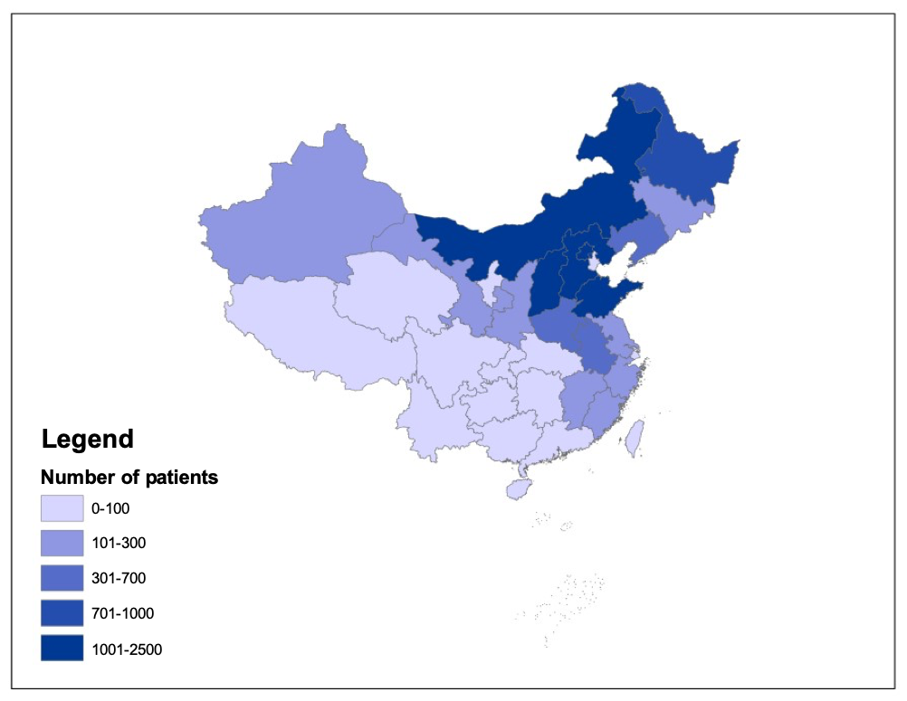
Figure 1 The geographical locations of gastric cancer patients in the China National Cancer Center Gastric Cancer Database, 1998–2018.
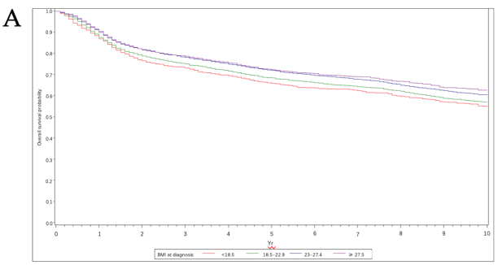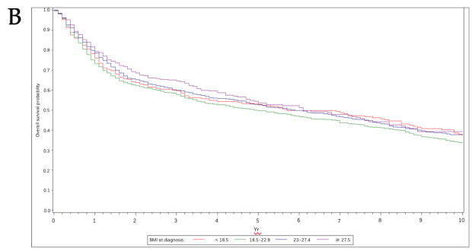
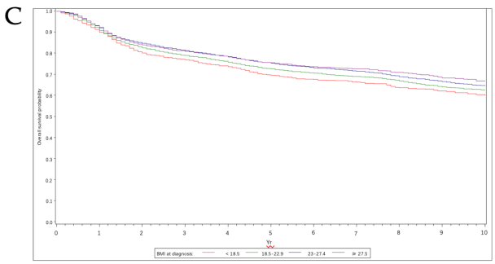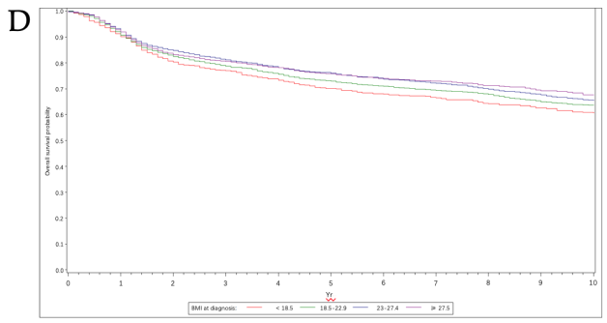
Figure 2 Kaplan-Meier survival curves for overall survival of patients with a different body mass index at diagnosis. A: Total gastric cancer patients; B: No surgery patients; C: Gastrectomy patients; D: Only curative gastrectomy patients. BMI: Body mass index.

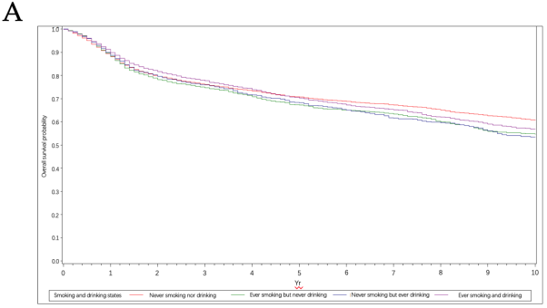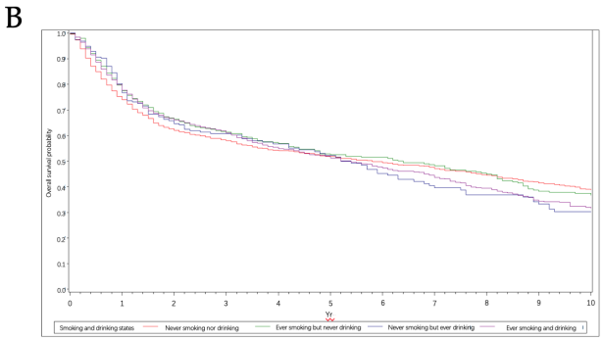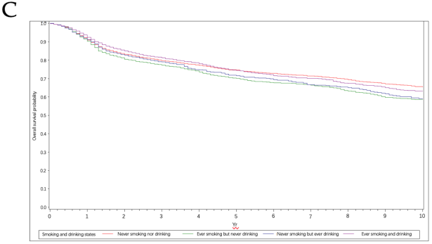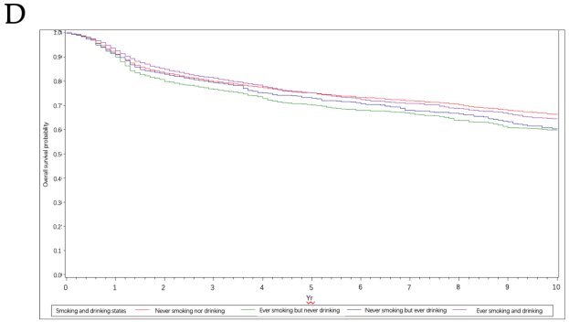
Figure 3 Kaplan-Meier survival curves for overall survival of patients with a history of both smoking and drinking. A: Total gastric cancer patients; B: No surgery patients; C: Gastrectomy patients; D: Only curative gastrectomy patients.

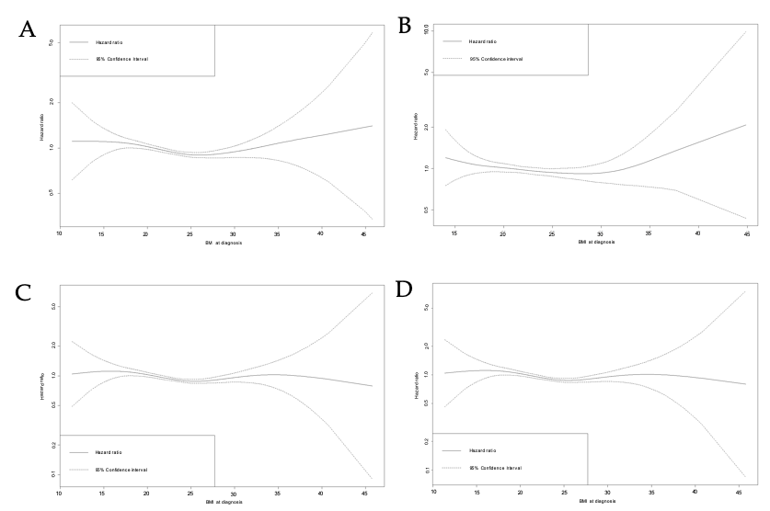
Figure 4 Body mass index at diagnosis and overall survival in multivariate-adjusted analysis. A: Total gastric cancer patients; B: No surgery patients; C: Gastrectomy patients; D: Only curative gastrectomy patients. BMI: Body mass index.

Table 1 Comparison of 18441 gastric cancer patients' characteristics
Characteristics, n (%) | No. of Patients | BMI at diagnosis |  |  |  | P value | Drinkers |  |  | P value | Smokers |  |  | P value
 |  | < 18.5 | 18.5-22.9 | 23-27.4 | ≥ 27.5 |  | Never | Yes |  |  | Never | Yes
 |  |  |  |  |  |  |  | Ex-drinkers | Current-drinkers |  |  | Ex-smokers | Current-smokers
No. of patients | 18441 (100) | 1193 (6.5) | 6872 (37.3) | 7310 (39.6) | 2196 (11.9) | - | 11578 (62.8) | 922 (5.0) | 5202 (28.2) | - | 10244 (55.6) | 2315 (12.6) | 5156 (28.0) | -
Gender
Male | 13533 (73.4) | 758 (63.5) | 4893 (71.2) | 5682 (77.7) | 1667 (75.9) |  | 6992 (62.0) | 874 (95.8) | 4948 (96.6) |  | 5903 (57.6) | 2220 (95.5) | 4974 (96.5)
Female | 4819 (26.1) | 435 (36.5) | 1979 (28.8) | 1628 (22.3) | 529 (24.1) | < 0.001 | 4286 (28.0) | 38 (4.2) | 174 (3.4) | < 0.001 | 4341 (42.4) | 95 (4.1) | 182 (3.5) | < 0.001
Age at diagnosis (yr)
mean (SD) | 58.5 | 56.7 | 58.2 | 59.0 | 58.5 | < 0.001 | 58.6 | 60.1 | 58.2 | < 0.001 | 58.0 | 62.1 | 58.1 | < 0.001
Younger (≤ 35) | 653 (3.5) | 127 (10.7) | 289 (4.2) | 152 (2.1) | 61 (2.8) |  | 530 (4.6) | 13 (1.4) | 91 (1.8) |  | 520 (5.1) | 22 (1.0) | 93 (1.8)
Middle-aged (36-65) | 12119 (65.7) | 682 (57.2) | 4604 (67.0) | 5063 (69.3) | 1524 (69.4) |  | 7373 (63.7) | 657 (71.3) | 3887 (74.7) |  | 6640 (64.8) | 1415 (61.1) | 3872 (75.1)
Older (≥ 66) | 5235 (28.4) | 383 (32.1) | 1976 (28.8) | 2090 (28.6) | 609 (27.7) | < 0.001 | 3667 (31.7) | 252 (27.3) | 1220 (23.5) | < 0.001 | 3077 (30.0) | 877 (37.9) | 1188 (23.0) | < 0.001
Weight loss as % of usual weight
None | 2858 (15.5) | 164 (13.8) | 821 (12.0) | 813 (11.1) | 276 (12.6) |  | 1629 (14.1) | 53 (5.8) | 642 (12.3) |  | 1437 (14.0) | 261 (11.3) | 625 (12.1)
0-10 | 13814 (74.9) | 766 (64.2) | 5217 (75.9) | 5964 (81.6) | 1798 (81.9) |  | 8830 (76.3) | 766 (83.1) | 4030 (77.5) |  | 7825 (76.4) | 1835 (79.3) | 3980 (77.2)
≥ 10 | 1769 (9.6) | 263 (22.1) | 834 (12.1) | 533 (7.3) | 122 (5.6) | < 0.001 | 1119 (9.7) | 103 (11.2) | 530 (10.2) | < 0.001 | 982 (9.6) | 219 (9.5) | 551 (10.7) | 0.0001
Smoking status
Never smokers | 10244 (55.6) | 737 (61.8) | 3895 (56.7) | 4084 (55.9) | 1252 (57.0) |  | 9.081 (78.4) | 124 (13.5) | 1037 (19.9) |  | - | - | -
Smokers | 7471 (40.5) | 435 (36.5) | 2875 (41.8) | 3128 (42.8) | 922 (42.0) | 0.002 | 2488 (21.5) | 795 (86.2) | 4159 (80.0) | < 0.001 | - | - | - | -
Current smokers | 5156 (28.0) | 339 (28.4) | 2076 (30.2) | 2059 (28.2) | 604 (27.5) |  | 1733 (15.0) | 250 (27.1) | 3158 (60.7) |  | - | - | -
Ex-smokers | 2315 (12.6) | 96 (8.1) | 799 (11.6) | 1069 (14.6) | 318 (14.5) | < 0.001 | 755 (6.5) | 545 (59.1) | 1001 (19.2) | < 0.001 | - | - | - | -
Time since quitting smoking
Short-term (1-9 yr) | 1505 (8.2) | 75 (6.3) | 535 (7.8) | 678 (9.3) | 197 (9.0) |  | 474 (4.1) | 422 (45.8) | 597 (11.5) |  | 0 (0.0) | 1505 (65.0) | 0 (0.0)
Long-term (≥ 10 yr) | 810 (4.4) | 21 (1.8) | 264 (3.8) | 391 (5.4) | 121 (5.5) | < 0.001 | 281 (2.4) | 123 (13.3) | 404 (7.8) | < 0.001 | 0 (0.0) | 810 (35.0) | 0 (0.0) | < 0.001
No. of cigarettes (per day)
≤ 20 (1 pack) | 5568 (30.2) | 338 (28.3) | 2190 (31.9) | 2318 (31.7) | 642 (29.2) |  | 1919 (16.6) | 602 (65.3) | 3030 (58.3) |  | 0 (0.0) | 1770 (76.5) | 3798 (73.7)
21-39 | 457 (2.5) | 22 (1.8) | 164 (2.4) | 198 (2.7) | 62 (2.8) |  | 144 (1.2) | 36 (3.9) | 276 (5.3) |  | 0 (0.0) | 115 (5.0) | 342 (6.6)
≥ 40 (≥ 2 packs) | 708 (3.8) | 32 (2.7) | 250 (3.6) | 302 (4.1) | 113 (5.2) | < 0.001 | 228 (2.0) | 76 (8.2) | 400 (7.7) | < 0.001 | 0 (0.0) | 208 (9.0) | 500 (9.7) | < 0.001
Duration of smoking (yr)
1-29 | 2805 (15.2) | 131 (11.0) | 999 (14.5) | 1258 (17.2) | 383 (17.4) |  | 927 (8.0) | 372 (40.4) | 1497 (28.8) |  | 0 (0.0) | 1230 (53.1) | 1575 (30.6)
≥ 30 | 4037 (21.9) | 267 (22.4) | 1652 (24.0) | 1604 (21.9) | 449 (20.5) | < 0.001 | 1411 (12.2) | 359 (38.9) | 2252 (43.3) | < 0.001 | 0 (0.0) | 940 (40.6) | 3097 (60.1) | < 0.001
Alcohol consumption
Never drinkers | 11578 (62.8) | 862 (72.3) | 4520 (65.8) | 4549 (62.2) | 1347 (61.3) |  | - | - | - |  | 9081 (88.7) | 755 (32.6) | 1733 (33.6)
Drinkers | 6124 (33.2) | 311 (26.1) | 2247 (32.7) | 2655 (36.3) | 821 (37.4) | < 0.001 | - | - | - | - | 1161 (11.3) | 1546 (66.8) | 3408 (66.1) | < 0.001
Current drinkers | 5202 (28.2) | 272 (22.8) | 1909 (27.8) | 2249 (30.8) | 692 (31.5) |  | - | - | - |  | 1037 (10.1) | 1001 (43.2) | 3158 (61.3)
Ex-drinkers | 922 (5.0) | 39 (3.3) | 338 (4.9) | 406 (5.6) | 129 (5.9) | < 0.001 | - | - | - | - | 124 (1.2) | 545 (23.5) | 250 (4.9) | < 0.001
Amount of alcohol consumption
Light drinkers (< 15.6 g/d) | 102 (0.6) | 3 (0.3) | 40 (0.6) | 48 (0.7) | 11 (0.5) |  | 0 (0.0) | 15 (1.6) | 87 (1.7) |  | 15 (0.2) | 42 (1.8) | 45 (0.9)
Moderate drinkers (≥ 15.6 g/d to < 53.5 g/d) | 660 (3.6) | 30 (2.5) | 246 (3.6) | 311 (4.3) | 62 (2.8) |  | 0 (0.0) | 77 (8.4) | 583 (11.2) |  | 127 (1.2) | 201 (8.7) | 329 (6.4)
Heavy drinkers (≥ 53.5 g/d) | 3480 (18.9) | 167 (14.0) | 1277 (18.6) | 1488 (20.4) | 501 (22.8) | < 0.001 | 0 (0.0) | 593 (64.3) | 2887 (55.5) | < 0.001 | 620 (6.1) | 894 (38.6) | 1962 (38.1) | < 0.001
H. pylori
No | 1506 (8.2) | 67 (5.6) | 561 (8.2) | 668 (9.1) | 193 (8.8) |  | 837 (7.2) | 152 (16.5) | 489 (9.4) |  | 734 (7.2) | 272 (11.8) | 474 (9.2)
Yes | 1167 (6.3) | 56 (4.7) | 457 (6.7) | 503 (6.9) | 134 (6.1) | < 0.001 | 692 (6.0) | 74 (8.0) | 386 (7.4) | < 0.001 | 590 (5.8) | 169 (7.3) | 393 (7.6) | < 0.001
Histologic type
Well | 351 (1.9) | 27 (2.3) | 107 (1.6) | 165 (2.3) | 48 (2.2) |  | 214 (1.9) | 24 (2.6) | 107 (2.1) |  | 185 (1.8) | 45 (1.9) | 115 (2.2)
Moderately | 5514 (29.9) | 257 (21.5) | 2004 (29.2) | 2390 (32.7) | 758 (34.5) |  | 2300 (28.5) | 288 (31.2) | 1829 (36.2) |  | 2789 (27.2) | 844 (36.5) | 1787 (34.7)
Poorly | 5824 (31.6) | 374 (31.4) | 2236 (32.5) | 2398 (32.8) | 730 (33.2) |  | 3922 (33.9) | 233 (25.3) | 1567 (30.1) |  | 3643 (35.6) | 612 (26.4) | 1475 (28.6)
Undifferentiated, anaplastic | 3 (0.0) | 0 (0.0) | 1 (0.0) | 2 (0.0) | 0 (0.0) | < 0.001 | 1 (0.0) | 0 (0.0) | 2 (0.0) | < 0.001 | 3 (0.0) | 0 (0.0) | 0 (0.0) | < 0.001
pathologicT
p0 | 61 (0.3) | 2 (0.2) | 22 (0.3) | 27 (0.4) | 10 (0.5) |  | 41 (0.4) | 3 (0.3) | 17 (0.3) |  | 35 (0.3) | 7 (0.3) | 19 (0.4)
p1 | 2778 (15.1) | 131 (11.0) | 966 (14.1) | 1242 (17.0) | 412 (18.8) |  | 1810 (15.6) | 206 (22.3) | 721 (13.9) |  | 1663 (16.2) | 347 (15.0) | 729 (14.1)
p2 | 1524 (8.3) | 83 (7.0) | 528 (7.7) | 647 (8.9) | 243 (11.1) |  | 955 (8.3) | 75 (8.1) | 462 (8.9) |  | 834 (8.1) | 192 (8.3) | 467 (9.1)
p3 | 3340 (18.1) | 169 (14.2) | 1233 (17.9) | 1459 (20.0) | 443 (20.2) |  | 2051 (17.7) | 176 (19.1) | 1093 (21.0) |  | 1702 (16.6) | 497 (21.5) | 1120 (21.7)
p4 | 6545 (35.5) | 465 (39.0) | 2605 (37.9) | 2640 (36.1) | 708 (32.2) | < 0.001 | 4308 (37.2) | 266 (28.9) | 1882 (36.2) | < 0.001 | 3888 (38.0) | 812 (35.1) | 1765 (34.2) | < 0.001
pathologicN
p0 | 4964 (26.9) | 274 (23.0) | 1758 (25.6) | 2184 (29.9) | 685 (31.2) |  | 3149 (27.2) | 304 (33.0) | 1436 (27.6) |  | 2785 (27.2) | 670 (28.9) | 1434 (27.8)
p1 | 2426 (13.2) | 161 (13.5) | 905 (13.2) | 1008 (13.8) | 313 (14.3) |  | 1577 (13.6) | 116 (12.6) | 709 (13.6) |  | 1357 (13.3) | 301 (13.0) | 744 (14.4)
p2 | 2549 (13.8) | 170 (14.3) | 1018 (14.8) | 997 (13.6) | 327 (14.9) |  | 1639 (14.2) | 116 (12.6) | 758 (14.6) |  | 1448 (14.1) | 316 (13.7) | 753 (14.6)
p3 | 4045 (21.9) | 226 (18.9) | 1570 (22.9) | 1717 (23.5) | 464 (21.1) | < 0.001 | 2633 (22.7) | 175 (19.0) | 1193 (22.9) | 0.007 | 2384 (23.3) | 545 (23.5) | 1079 (20.9) | 0.018
pathologicM
p0 | 14785 (80.2) | 899 (75.4) | 5563 (81.0) | 6176 (84.5) | 1889 (86.0) |  | 9438 (81.5) | 770 (83.5) | 4373 (84.1) |  | 8348 (81.5) | 1971 (85.1) | 4273 (82.9)
p1 | 2233 (12.1) | 203 (17.0) | 943 (13.7) | 776 (10.6) | 211 (9.6) | < 0.001 | 1460 (12.6) | 110 (11.9) | 620 (11.9) | < 0.001 | 1332 (13.0) | 231 (10.0) | 628 (12.2) | < 0.001
pTNM
I | 3340 (18.1) | 157 (13.2) | 1155 (16.8) | 1490 (20.4) | 500 (22.8) |  | 2139 (18.5) | 221 (24.0) | 16 (0.3) |  | 1928 (18.8) | 435 (18.8) | 922 (17.9)
II | 2334 (12.7) | 137 (11.5) | 843 (12.3) | 1012 (13.8) | 320 (14.6) |  | 1443 (12.5) | 147 (15.9) | 922 (17.7) |  | 1210 (11.8) | 317 (13.7) | 782 (15.2)
III | 7712 (41.8) | 481 (40.3) | 3005 (43.7) | 3180 (43.5) | 917 (41.8) |  | 5009 (43.3) | 312 (33.8) | 724 (13.9) |  | 4456 (43.5) | 1012 (43.7) | 2165 (42.0)
IV | 2233 (12.1) | 203 (17.0) | 943 (13.7) | 776 (10.6) | 211 (9.6) | < 0.001 | 1460 (12.6) | 110 (11.9) | 2301 (44.2) | < 0.001 | 1332 (13.0) | 231 (10.0) | 628 (12.2) | < 0.001
Lauren classification
Intestinal | 2838 (15.4) | 126 (10.6) | 988 (14.4) | 1304 (17.8) | 388 (17.7) |  | 1549 (13.4) | 250 (27.1) | 995 (19.1) |  | 1279 (12.5) | 554 (23.9) | 962 (18.7)
Diffuse | 2610 (14.2) | 154 (12.9) | 1017 (14.8) | 1095 (15.0) | 318 (14.5) |  | 1660 (14.3) | 181 (19.6) | 726 (14.0) |  | 1547 (15.1) | 342 (14.8) | 680 (13.2)
Mixed | 1799 (9.8) | 68 (5.7) | 646 (9.4) | 795 (10.9) | 271 (12.3) | < 0.001 | 1010 (8.7) | 146 (15.8) | 621 (11.9) | < 0.001 | 897 (8.8) | 295 (12.7) | 583 (11.3) | < 0.001
Linitis plastica
No | 17321 (93.9) | 1132 (94.9) | 6611 (96.2) | 7059 (96.6) | 2115 (96.3) |  | 11149 (96.3) | 892 (96.8) | 5011 (96.3) |  | 9844 (96.1) | 2244 (96.9) | 4978 (96.6)
Yes | 181 (1.0) | 23 (1.9) | 80 (1.2) | 59 (0.8) | 16 (0.7) | 0.005 | 125 (1.1) | 9 (1.0) | 44 (0.9) | 0.55 | 117 (1.1) | 18 (0.8) | 43 (0.8) | 0.17
Location
Proximal GC | 6704 (36.4) | 386 (32.4) | 2409 (35.1) | 2856 (39.1) | 913 (41.6) |  | 3870 (33.4) | 318 (34.5) | 2447 (47.0) |  | 3147 (30.7) | 1193 (51.5) | 2298 (44.6)
Distal GC | 9.992 (54.2) | 704 (59.0) | 3966 (57.7) | 3948 (54.0) | 1141 (52.0) |  | 6884 (59.5) | 517 (56.1) | 2417 (46.5) |  | 6354 (62.0) | 933 (40.3) | 2545 (49.4)
Total GC | 894 (4.9) | 56 (4.7) | 353 (5.1) | 355 (4.9) | 104 (4.7) | < 0.001 | 558 (4.8) | 55 (6.0) | 263 (5.1) | < 0.001 | 507 (5.0) | 127 (5.5) | 240 (4.7) | < 0.001
Type of gastrectomy
Gastrectomy | 15204 (82.5) | 930 (78.0) | 5623 (81.8) | 6248 (85.5) | 1885 (85.8) |  | 9662 (83.5) | 773 (83.8) | 4278 (82.2) |  | 8533 (83.3) | 1961 (84.7) | 4230 (82.0)
No surgery | 3146 (17.1) | 263 (22.1) | 1246 (18.1) | 1061 (14.5) | 311 (14.2) | < 0.001 | 1916 (16.6) | 148 (16.1) | 924 (17.8) | 0.019 | 1711 (16.7) | 353 (15.3) | 926 (18.0) | 0.005
Surgical margin
Negative | 13370 (72.5) | 791 (66.3) | 5012 (72.9) | 5650 (77.3) | 1730 (78.8) |  | 8623 (74.5) | 684 (74.2) | 3899 (75.0) |  | 7622 (74.4) | 1755 (75.8) | 3841 (74.5)
Positive | 443 (2.4) | 36 (3.0) | 163 (2.4) | 195 (2.7) | 41 (1.9) | < 0.001 | 297 (2.6) | 21 (2.3) | 120 (2.3) | 0.83 | 263 (2.6) | 67 (2.9) | 108 (2.1) | 0.067
Additional therapy
No neo/adjuvant | 1564 (8.5) | 82 (6.9) | 520 (7.6) | 701 (9.6) | 241 (11.0) |  | 925 (8.0) | 128 (13.9) | 484 (9.3) |  | 840 (8.2) | 242 (10.5) | 456 (8.8)
Neoadjuvant | 354 (1.9) | 25 (2.1) | 158 (2.3) | 134 (1.8) | 33 (1.5) |  | 192 (1.7) | 43 (4.7) | 113 (2.2) |  | 171 (1.7) | 81 (3.5) | 97 (1.9)
Adjuvant | 4713 (25.6) | 244 (20.5) | 1743 (25.4) | 2044 (28.0) | 621 (28.3) |  | 3057 (26.4) | 198 (21.5) | 1383 (26.6) |  | 2782 (27.2) | 503 (21.7) | 1354 (26.3)
Neo + adjuvant | 613 (3.3) | 37 (3.1) | 222 (3.2) | 272 (3.7) | 77 (3.5) | < 0.001 | 353 (3.1) | 63 (6.8) | 190 (3.7) | < 0.001 | 319 (3.1) | 136 (5.9) | 154 (3.0) | < 0.001
H. pylori: Helicobacter pylori; GC: gastric cancer.

Table 2 Multivariate survival analysis
Prognostic factors | Total (n = 18322)¹ |  |  |  | No surgery (n = 3142)² |  |  |  | Gastrectomy (n = 15180)³ |  |  |  | Only curative gastrectomy (n = 13695)⁴
 | HR | 95%CI |  | P value | HR | 95%CI |  | P value | HR | 95%CI |  | P value | HR | 95%CI |  | P value
 |  | Lower | Upper |  |  | Lower | Upper |  |  | Lower | Upper |  |  | Lower | Upper
Gender
Male | 1.00 |  |  |  | 1.00 |  |  |  | 1.00 |  |  |  | 1.00
Female | 1.05 | 1.00 | 1.11 | 0.06 | 1.07 | 0.97 | 1.19 | 0.19 | 1.05 | 0.99 | 1.11 | 0.13 | 1.04 | 0.97 | 1.11 | 0.25
Age at diagnosis (yr)
Younger (≤ 35) | 1.00 |  |  |  | 1.00 |  |  |  | 1.00 |  |  |  | 1.00
Middle-aged (36-65) | 1.07 | 0.95 | 1.19 | 0.26 | 0.94 | 0.76 | 1.15 | 0.54 | 1.14 | 0.99 | 1.30 | 0.06 | 1.15 | 1.00 | 1.33 | 0.05
Older (≥ 66) | 1.10 | 0.98 | 1.23 | 0.12 | 0.89 | 0.72 | 1.11 | 0.30 | 1.20 | 1.05 | 1.38 | 0.01 | 1.21 | 1.05 | 1.40 | 0.01
BMI (kg/m²) at diagnosis
< 18.5 | 1.00 | 0.92 | 1.09 | 0.99 | 1.01 | 0.87 | 1.18 | 0.90 | 1.00 | 0.90 | 1.10 | 0.93 | 1.02 | 0.92 | 1.14 | 0.72
18.5-22.9 | 1.00 |  |  |  | 1.00 |  |  |  | 1.00 |  |  |  | 1.00
23-27.4 | 0.97 | 0.93 | 1.02 | 0.22 | 0.92 | 0.84 | 1.02 | 0.11 | 0.99 | 0.94 | 1.05 | 0.73 | 0.99 | 0.94 | 1.05 | 0.74
≥ 27.5 | 0.99 | 0.92 | 1.06 | 0.72 | 0.95 | 0.82 | 1.10 | 0.48 | 1.01 | 0.93 | 1.10 | 0.85 | 1.02 | 0.93 | 1.11 | 0.74
Weight loss as % of usual weight
None | 1.00 |  |  |  | 1.00 |  |  |  | 1.00 |  |  |  | 1.00
0-10 | 1.14 | 1.07 | 1.20 | < 0.001 | 1.16 | 1.04 | 1.30 | 0.01 | 1.13 | 1.05 | 1.20 | 0 | 1.11 | 1.04 | 1.19 | 0
≥ 10 | 1.24 | 1.15 | 1.34 | < 0.001 | 1.22 | 1.06 | 1.40 | 0.01 | 1.25 | 1.14 | 1.38 | < 0.001 | 1.22 | 1.10 | 1.34 | 0
Smoking status
Never smokers | 1.00 |  |  |  | 1.00 |  |  |  | 1.00 |  |  |  | 1.00
Current smokers | 1.02 | 0.94 | 1.10 | 0.66 | 1.05 | 0.89 | 1.23 | 0.57 | 1.01 | 0.92 | 1.11 | 0.78 | 1.03 | 0.93 | 1.14 | 0.58
Ex-smokers | 0.93 | 0.84 | 1.03 | 0.17 | 0.95 | 0.76 | 1.19 | 0.66 | 0.93 | 0.82 | 1.04 | 0.20 | 0.91 | 0.81 | 1.03 | 0.15
Time since quitting smoking
Short-term (1–9 yr) | 1.00 |  |  |  | 1.00 |  |  |  | 1.00 |  |  |  | 1.00
Long-term (≥ 10 yr) | 1.04 | 0.91 | 1.19 | 0.55 | 1.02 | 0.78 | 1.34 | 0.87 | 1.05 | 0.90 | 1.22 | 0.51 | 1.07 | 0.91 | 1.25 | 0.42
No. of cigarettes (per day)
≤ 20 (1 pack) | 1.00 |  |  |  | 1.00 |  |  |  | 1.00 |  |  |  | 1.00
21-39 | 1.07 | 0.93 | 1.22 | 0.36 | 1.29 | 1.00 | 1.66 | 0.05 | 0.98 | 0.84 | 1.16 | 0.84 | 0.99 | 0.83 | 1.17 | 0.87
≥ 40 (≥ 2 packs) | 1.03 | 0.92 | 1.16 | 0.59 | 0.91 | 0.72 | 1.15 | 0.43 | 1.09 | 0.95 | 1.24 | 0.22 | 1.08 | 0.94 | 1.24 | 0.30
Duration of smoking (yr)
1-29 | 1.00 |  |  |  | 1.00 |  |  |  | 1.00 |  |  |  | 1.00
≥ 30 | 1.08 | 1.00 | 1.16 | 0.05 | 0.94 | 0.81 | 1.09 | 0.40 | 1.14 | 1.04 | 1.24 | 0 | 1.13 | 1.04 | 1.24 | 0.01
Alcohol consumption
Never drinkers | 1.00 |  |  |  | 1.00 |  |  |  | 1.00 |  |  |  | 1.00
Current drinkers | 0.82 | 0.58 | 1.18 | 0.29 | 1.54 | 0.71 | 3.37 | 0.28 | 0.75 | 0.50 | 1.12 | 0.16 | 0.88 | 0.59 | 1.32 | 0.54
Ex-drinkers | 0.86 | 0.59 | 1.24 | 0.42 | 1.33 | 0.63 | 2.80 | 0.46 | 0.75 | 0.49 | 1.16 | 0.19 | 0.86 | 0.56 | 1.32 | 0.48
Amount of alcohol consumption
Light drinkers (< 15.6 g/d) | 1.00 |  |  |  | 1.00 |  |  |  | 1.00 |  |  |  | 1.00
Moderate drinkers (≥ 15.6 g/d to < 53.5 g/d) | 1.25 | 0.86 | 1.81 | 0.25 | 0.97 | 0.45 | 2.13 | 0.95 | 1.27 | 0.83 | 1.94 | 0.28 | 1.07 | 0.70 | 1.64 | 0.75
Heavy drinkers (≥ 53.5 g/d) | 1.25 | 0.88 | 1.79 | 0.21 | 0.78 | 0.37 | 1.66 | 0.52 | 1.37 | 0.91 | 2.06 | 0.13 | 1.15 | 0.77 | 1.73 | 0.50
pTNM
I | 1.00 |  |  |  | 1.00 |  |  |  | 1.00 |  |  |  | 1.00
II | 1.48 | 1.33 | 1.66 | < 0.001 | 3.65 | 0.45 | 29.50 | 0.23 | 1.48 | 1.32 | 1.65 | < 0.001 | 1.38 | 1.23 | 1.56 | < 0.001
III | 2.31 | 2.12 | 2.52 | < 0.001 | 4.07 | 0.56 | 29.79 | 0.17 | 2.29 | 2.10 | 2.49 | < 0.001 | 2.19 | 2.00 | 2.39 | < 0.001
IV | 3.19 | 2.86 | 3.55 | < 0.001 | 4.41 | 0.62 | 31.18 | 0.14 | 3.42 | 3.04 | 3.86 | < 0.001 | 3.16 | 2.79 | 3.58 | < 0.001
Type of gastrectomy
Gastrectomy | 1.00 |  |  |  | - |  |  |  | - |  |  |  | -
No surgery | 1.51 | 1.40 | 1.63 | < 0.001 | - | - | - | - | - | - | - | - | - | - | - | -
¹Adjust for gender, age, pTNM stage, adjuvant therapies, gastrectomy. ²Adjust for gender, age, pTNM stage. ³Adjust for gender, age, pTNM stage, adjuvant therapies. ⁴Adjust for gender, age, pTNM stage, adjuvant therapies.

