Name of Journal: World Journal of Clinical Cases
Manuscript NO: 70857
Manuscript Type: CASE REPORT

Cryoballoon pulmonary vein isolation and left atrial appendage occlusion prior to atrial septal defect closure: A case report

Wu YC et al. Cryoballoon PVI, LAA and ASD occlusion

Yu-Cheng Wu, Mei-Xiang Wang, Ge-Cai Chen, Zhong-Bao Ruan, Qing-Qing Zhang

Yu-Cheng Wu, Mei-Xiang Wang, Ge-Cai Chen, Zhong-Bao Ruan, Department of Cardiology, Taizhou People’s Hospital, Taizhou 225300, Jiangsu Province, China

Qing-Qing Zhang, Department of Endocrinology, Taizhou People’s Hospital, Taizhou 225300, Jiangsu Province, China

Author contributions: Wu YC and Wang MX contributed to data collection, original draft preparation and writing; Chen GC and Ruan ZB contributed to operations and monitoring; Zhang QQ contributed to conceptualization, writing, reviewing and editing.

Supported by Taizhou People’s Hospital Scientific Research Start-Up Fund Project, No. QDJJ202113.

Corresponding author: Qing-Qing Zhang, MD, Doctor, Department of Endocrinology, Taizhou People’s Hospital, No. 366 Taihu Road, Taizhou 225300, Jiangsu Province, China. 2567181759@qq.com

Received: August 17, 2021
Revised: January 6, 2022
Accepted: March 6, 2022
Published online:

Abstract
BACKGROUND
In patients who suffer from both atrial fibrillation (AF) and atrial septal defect (ASD), cryoballoon pulmonary vein isolation (PVI), sequential left atrial appendage (LAA) occlusion and ASD closure could be a strategy for effective prevention of stroke and right heart failure.

CASE SUMMARY
A 65-year-old man was admitted to our institution due to recurrent episodes of palpitations and shortness of breath for 2 years, which had been worsening over the last 48 h. He had a history of AF, ASD, coronary heart disease with stent implantation and diabetes. Physical and laboratory examinations showed no abnormalities. The score of CHA2DS2VASc was 3, and HAS-BLED was 1. Echocardiography revealed a 25-mm secundum ASD. Pulmonary vein (PV) and LAA anatomy were assessed by cardiac computed tomography. PV mapping with 10-pole Lasso catheter was performed following ablation of all four PVs with complete PVI. Following the cryoballoon PVI, the patient underwent LAA occlusion under transesophageal echocardiographic monitoring. Lastly, a 34-mm JIYI ASD occlude device was implanted. A follow-up transesophageal echocardiography at 3 mo showed proper position of both devices and neither thrombi nor leakage was found.

CONCLUSION
Sequential cryoballoon PVI and LAA occlusion prior to ASD closure can be performed safely in AF patients with ASD.

Key Words: Atrial fibrillation; Atrial septal defect; Cryoballoon; Pulmonary vein isolation; Left atrial appendage occlusion; Case report

Wu YC, Wang MX, Chen GC, Ruan ZB, Zhang QQ. Cryoballoon pulmonary vein isolation and left atrial appendage occlusion prior to atrial septal defect closure: A case report. World J Clin Cases 2022; In press

Core Tip: Patients who suffer from atrial septal defect (ASD) with atrial fibrillation are prone to right heart dysfunction and embolism. We report the first case treated with a 3-in-1 procedure (cryoballoon pulmonary vein isolation and left atrial appendage occlusion prior to ASD closure), which may not be performed routinely. However, for ASD patients complicated with poorly controlled atrial fibrillation and unable to tolerate long-term oral anticoagulants, this 3-in-1 procedure can be considered.

INTRODUCTION
Pulmonary vein isolation (PVI) has been established as a treatment for patients with atrial fibrillation (AF)^{[1]}. Cryoballoon PVI has become a relatively simple alternative for radiofrequency ablation^{[2]}. Left atrial appendage (LAA) occlusion is performed as an alternative treatment to oral anticoagulation in patients with non-valvular AF^{[3]}. Atrial septal defect (ASD), as the most common congenital heart disease, may lead to right heart dysfunction and paradoxical embolism^{[4]}. In patients who suffer from both AF and ASD, cryoballoon PVI combined with ASD closure and the LAA occlusion combined with ASD closure have been reported^{[5-7]}. However, there has been no report on the 3-in-1 procedure (cryoballoon PVI, LAA occlusion and ASD closure), which may be effective for preventing stroke and right heart failure. Here, we report a patient who underwent sequential cryoballoon PVI, LAA occlusion and ASD closure during the same operation.

CASE PRESENTATION
Chief complaints
A 65-year-old man was admitted to our hospital due to recurrent episodes of palpitations and shortness of breath for 2 years.

History of present illness
His symptoms started 2 years ago with recurrent episodes of palpitations and shortness of breath, which had worsened over the last 48 h.

History of past illness
His past illness included AF, ASD, coronary heart disease with stent implantation and diabetes.

Personal and family history
None.

Physical examination
The patient’s temperature was 36.6 °C, heart rate was 74 bpm, respiratory rate was 16 breaths per minute, blood pressure was 120/70 mmHg and oxygen saturation in room air was 98%. There was no filling of jugular vein; cardiac auscultation showed arrhythmia and no cardiac murmur in each valve area; and no edema was found in both lower limbs.

Laboratory examinations
On admission, his blood tests including routine blood test, renal function, liver function, thyroid function and coagulation function showed no abnormalities.

Imaging examinations
Pulmonary vein (PV) anatomy was assessed in detail by cardiac computed tomography (CT) (Figure 1A). Reconstruction and measurement of LAA and selection of suitable implantation angle and position were also completed by cardiac CT (Figure 1B-C). Electrocardiography showed AF with a ventricular rate of 76 bpm. Echocardiography showed normal left ventricular ejection fraction, moderate dilatation of the left atrium (50 mm), severe enlarged right atrium and right ventricle and moderate tricuspid regurgitation (estimated pulmonary arterial systolic pressure was 47 mmHg). Abnormal flow from the left to right atrium through the interatrial septum was found by color Doppler image. Echocardiography revealed a 25-mm secundum ASD with adequate margins for ASD closure. There were no obvious abnormalities on chest CT and abdominal color Doppler ultrasound.

Further diagnostic work-up: AF embolism and bleeding score
CHA2DS2VASc score was 3 (diabetes mellitus, vascular disease, age 65 years to 74 years) and HAS-BLED was 1 (age ≥ 65 years). He refused a long-term anti-coagulation treatment.

FINAL DIAGNOSIS
AF, ASD, coronary heart disease and diabetes.

TREATMENT
Cryoballoon PVI
The patient had recurrent AF, which was poorly controlled with antiarrhythmic drugs, so PVI was attempted. Under general anesthesia, a 12F FlexCath steerable sheath (Medtronic Inc., Minneapolis, MN, United States) was advanced into the left atrium without transseptal puncture. A cryoballoon catheter (Medtronic Inc.) was introduced inside the 12F sheath. Following good balloon occlusion, we applied two ablation freezes for 120-180 s (Figure 2A-D). PV mapping was performed following ablation of all four PVs with a 10-pole Lasso catheter (Biosense-Webster Inc., Diamond Bar, CA, United States). We used bidirectional conduction block between the left atrium and PVs^{[8]} to conform the complete elimination of PV electrical activity. Preoperative and postoperative electrocardiograms are shown in Figure 2E-F.

LAA occlusion
Anticoagulant therapy was recommended, but the patient refused to take long-term oral anticoagulants, so LAA occlusion was selected. Following the cryoballoon PVI, the patient underwent LAA occlusion under transesophageal echocardiographic (TEE) monitoring^{[9]}. A special sheathing canal was placed to perform LAA angiography, and a pigtail angiographic catheter was directed to the LAA with the following positions: Right anterior oblique 30° + cranial 20° and right anterior oblique 30° + caudal 20°. Suitable LAA occluder (Watchman, 3.0 cm) was selected following measurement of LAA orifice width and depth. The LAA occluder was introduced into the LAA along the sheathing canal. The position of the occluder was monitored by TEE. A pull test was conducted to determine the stability of the occluder. After suitable position of the occluder and good plugging effect were confirmed, the occluder was released (Figure 1D).

ASD closure
The indications and benefits of atrial septal occlusion are clear. Figure 3A shows a secundum ASD by echocardiography. After cryoballoon PVI and LAA occlusion, the diameter of the interatrial defect was measured on TEE images in various planes, and a 34-mm JIYI ASD occluder device (Shanghai Shape Memory Co., Ltd, Shanghai, China) was implanted^{[10]}. Secured and stable positioning of the occluder was confirmed through a push-pull test (Figure 3B). After unscrewing the occluder from the cable, good positioning of the device was demonstrated by a final TEE examination.

OUTCOME AND FOLLOW-UP
The patient was subsequently treated with propafenone 150 mg three times a day for 3 mo. Antiplatelet and anticoagulation therapy (clopidogrel and rivaroxaban) was administered following the doctor's advice. Before discharge, correct device positions were confirmed by echocardiography (Figure 3C). A follow-up TEE was performed to confirm proper seating of the devices and to identify thrombi or residual leak at 3 mo (Figure 3D). Both devices were located in proper position, and neither thrombi nor leakage was present. Subsequently, the patient discontinued rivaroxaban and changed to aspirin and clopidogrel.

DISCUSSION
We report an ASD patient with AF who underwent the cryoballoon PVI and LAA occlusion prior to ASD closure, which indicates that this 3-in-1 operation is feasible, but it is not recommended as a routine procedure. For patients with ASD complicated with poorly controlled AF and unable to tolerate long-term oral anticoagulants, this 3-in-1 procedure can be considered.
AF is the most common cardiac arrhythmia, which occurs in 1%-2% of the general population^{[11]}. Since PVs were demonstrated as major sources of ectopic beats, PVI has been considered as the cornerstone for AF procedures^{[12]}. Cryoballoon AF ablation has been established as a useful and safe method in treating paroxysmal and persistent AF, providing an alternative approach to radiofrequency ablation^{[13]}. The incidence of AF is strikingly high in patients with ASD, even after surgical closure^{[14]}. Furthermore, compared with the general population, patients with ASD suffer earlier from atrial arrhythmia^{[15]}. Closure of the ASD could decrease the volume overload and reverse remodeling of the atrium^{[16]}. In the present case, we performed cryoballoon ablation followed by closure of LAA and ASD, which we thought could maintain sinus rhythm, reverse atrium remodeling and prevent embolism.
Koermendy et al^{[17]} reported that LAA occlusion through ASD or patent foramen ovale was a feasible access. Cardiac tamponade and perforation of adjacent organs could be obviated by avoiding a transseptal puncture^{[18]}. Another advantage is not to create an iatrogenic septal defect. It is not easy to perform LAA occlusion after ASD occlusion, as the ASD occluder makes it difficult to transseptal puncture^{[19]}. Thus, before ASD occlusion, it is necessary to evaluate the indication for LAA occlusion carefully. According to the reported guidelines, a CHA2DS2VASc score of ≥ 2 point is considered as an indication for LAA occlusion^{[20]}. Our case strictly followed this standard, and as this patient refused to take long-term anti-coagulants, LAA occlusion was conducted before ASD closure.
Invasive and surgical procedures are becoming less frequent because of the improvement in percutaneous techniques, especially in cardiac interventions^{[21]}. The present case report indicates that cryoballoon PVI and LAA occlusion prior to percutaneous ASD closure can be performed safely and can prevent several difficulties and complications. In addition, this 3-in-1 procedure was beneficial simultaneously to maintain sinus rhythm, reverse atrium remodeling and prevent embolism.

CONCLUSION
Cryoballoon PVI and LAA occlusion prior to ASD closure can be performed sequentially in ASD patients with AF, which may not be performed routinely. However, for ASD patients complicated with poorly controlled AF and unable to tolerate long-term oral anticoagulants, this 3-in-1 procedure can be considered.

ACKNOWLEDGEMENTS
The authors thank Zhang B and Wu DH for their assistance in cardiac CT analysis.

REFERENCES
1 Reissmann B, Metzner A, Kuck KH. Cryoballoon ablation versus radiofrequency ablation for atrial fibrillation. Trends Cardiovasc Med 2017; 27: 271-277 [PMID: 28089202 DOI: 10.1016/j.tcm.2016.12.002]
2 Kuck KH, Fürnkranz A. Cryoballoon ablation of atrial fibrillation. J Cardiovasc Electrophysiol 2010; 21: 1427-1431 [PMID: 21091966 DOI: 10.1111/j.1540-8167.2010.01944.x]
3 Piayda K, Afzal S, Nielsen-Kudsk JE, Schmidt B, Mazzone P, Berti S, Fischer S, Lund J, Montorfano M, Hildick-Smith D, Gage R, Zhao H, Zeus T. Length of stay following percutaneous left atrial appendage occlusion: Data from the prospective, multicenter Amplatzer Amulet Occluder Observational Study. PLoS One 2021; 16: e0255721 [PMID: 34375347 DOI: 10.1371/journal.pone.0255721]
4 Hatipoglu S, Almogheer B, Mahon C, Houshmand G, Uygur B, Giblin GT, Krupickova S, Baksi AJ, Alpendurada F, Prasad SK, Babu-Narayan SV, Gatzoulis MA, Mohiaddin RH, Pennell DJ, Izgi C. Clinical significance of partial anomalous pulmonary venous connections (isolated and atrial septal defect associated) determined by cardiovascular magnetic resonance. Circ Cardiovasc Imaging 2021; 14: e012371 [PMID: 34384233 DOI: 10.1161/CIRCIMAGING.120.012371]
5 Aytemir K, Sunman H, Canpolat U, Oto A. Cryoballoon pulmonary vein isolation prior to percutaneous atrial septal defect closure: a case report. Turk Kardiyol Dern Ars 2013; 41: 728-731 [DOI: 10.5543/tkda.2013.94910]
6 Song S, Lee OH, Kim JS, Cho IJ, Shim CY, Hong GR, Pak HN, Jang Y. Simultaneous closure of a left atrial appendage through an atrial septal defect and the atrial septal defect. Yonsei Med J 2017; 58: 1237-1240 [PMID: 29047250 DOI: 10.3349/ymj.2017.58.6.1237]
7 Paulo M, García E, Hernández-Antolín RA, Almería C. [Simultaneous percutaneous closure of patent foramen ovale and left atrial appendage]. Rev Esp Cardiol 2011; 64: 1215-1216 [PMID: 21601977 DOI: 10.1016/j.recesp.2010.12.008]
8 Rottner L, Fink T, Kuck KH. Cryoballoon ablation beyond paroxysmal atrial fibrillation. Curr Opin Cardiol 2019; 34: 23-28 [PMID: 30444759 DOI: 10.1097/HCO.0000000000000573]
9 Cimmino G, Loffredo FS, Gallinoro E, Prozzo D, Fabiani D, Cante L, Salerno G, Cappelli Bigazzi M, Golino P. Percutaneous Left Atrial Appendage Occlusion: An Emerging Option in Patients with Atrial Fibrillation at High Risk of Bleeding. Medicina (Kaunas) 2021; 57 [PMID: 34063719 DOI: 10.3390/medicina57050444]
10 Cruz-González I, Rama-Merchan JC, Rodríguez-Collado J, Martín-Moreiras J, Diego-Nieto A, Barreiro-Pérez M, Martín-García A, Sanchez PL. Simultaneous Percutaneous Closure of Left Atrial Appendage and Atrial Septal Defect After Mitral Valve Replacement. JACC Cardiovasc Interv 2016; 9: e129-e130 [PMID: 27318843 DOI: 10.1016/j.jcin.2016.04.025]
11 De Marchis GM, Sposato LA, Kühne M, Dittrich TD, Bonati LH, Fischer U, Chaturvedi S. New avenues for optimal treatment of atrial fibrillation and stroke prevention. Stroke 2021; 52: 1490-1499 [PMID: 33626906 DOI: 10.1161/STROKEAHA.120.032060]
12 Chun KR, Fürnkranz A, Schmidt B, Metzner A, Tilz R, Zerm T, Köster I, Koektuerk B, Konstantinidou M, Ouyang F, Kuck KH. Right ventricular rapid pacing in catheter ablation of atrial fibrillation: a novel application for cryoballoon pulmonary vein isolation. Clin Res Cardiol 2009; 98: 493-500 [PMID: 19513775 DOI: 10.1007/s00392-009-0031-3]
13 Hoffmann E, Straube F, Wegscheider K, Kuniss M, Andresen D, Wu LQ, Tebbenjohanns J, Noelker G, Tilz RR, Chun JKR, Franke A, Stellbrink C, Garcia-Alberola A, Dorwarth U, Metzner A, Ouarrak T, Brachmann J, Kuck KH, Senges J; FREEZE Cohort Study Investigators. Outcomes of cryoballoon or radiofrequency ablation in symptomatic paroxysmal or persistent atrial fibrillation. Europace 2019; 21: 1313-1324 [PMID: 31199860 DOI: 10.1093/europace/euz155]
14 Deveci OS, Aytemir K, Okutucu S, Tulumen E, Aksoy H, Kaya EB, Evranos B, Kabakci G, Tokgozoglu L, Oto A, Ozkutlu H. Evaluation of the relationship between atrial septal aneurysm and cardiac arrhythmias via P-wave dispersion and signal-averaged P-wave duration. Ann Noninvasive Electrocardiol 2010; 15: 157-164 [PMID: 20522057 DOI: 10.1111/j.1542-474X.2010.00357.x]
15 Guray U, Guray Y, Yýlmaz MB, Mecit B, Sasmaz H, Korknaz S, Kutuk E. Evaluation of P wave duration and P wave dispersion in adult patients with secundum atrial septal defect during normal sinus rhythm. Int J Cardiol 2003; 91: 75-79 [PMID: 12957732 DOI: 10.1016/s0167-5273(02)00598-3]
16 Dolgner SJ, Steinberg ZL, Jones TK, Reisman M, Buber J. Stroke in patients with secundum atrial septal defect and sequelae after transcatheter closure. Heart 2021; 107: 1850-1851 [DOI: 10.1136/heartjnl-2021-319050]
17 Koermendy D, Nietlispach F, Shakir S, Gloekler S, Wenaweser P, Windecker S, Khattab AA, Meier B. Amplatzer left atrial appendage occlusion through a patent foramen ovale. Catheter Cardiovasc Interv 2014; 84: 1190-1196 [PMID: 24399612 DOI: 10.1002/ccd.25354]
18 Tzeis S, Andrikopoulos G, Deisenhofer I, Ho SY, Theodorakis G. Transseptal catheterization: considerations and caveats. Pacing Clin Electrophysiol 2010; 33: 231-242 [PMID: 19889183 DOI: 10.1111/j.1540-8159.2009.02598.x]
19 He L, Du YJ, Cheng GS, Zhang YS. Device-related thrombosis on atrial septal defect occluder after simultaneous closure of left atrial appendage and atrial septal defect: a case report. J Geriatr Cardiol 2019; 16: 490-494 [PMID: 31308842 DOI: 10.11909/j.issn.1671-5411.2019.06.009]
20 Glikson M, Wolff R, Hindricks G, Mandrola J, Camm AJ, Lip GYH, Fauchier L, Betts TR, Lewalter T, Saw J, Tzikas A, Sternik L, Nietlispach F, Berti S, Sievert H, Bertog S, Meier B; ESC Scientific Document Group. EHRA/EAPCI expert consensus statement on catheter-based left atrial appendage occlusion - an update. Europace 2019 [PMID: 31504441 DOI: 10.1093/europace/euz258]
21 Kądziela J, Kochman J, Grygier M, Michałowska I, Tomaniak M, Wojakowski W, Araszkiewicz A, Dąbrowski M, Hawranek M, Huczek Z, Kralisz P, Kusa J, Roleder T, Januszewicz A, Witkowski A, Adlam D, Bartuś S. The diagnosis and management of spontaneous coronary artery dissection - expert opinion of the Association of Cardiovascular Interventions (ACVI) of Polish Cardiac Society. Kardiol Pol 2021; 79: 930-943 [PMID: 34292564 DOI: 10.33963/KP.a2021.0068]

Footnotes
Informed consent statement: All study participants, or their legal guardian, provided informed written consent prior to study enrollment.

Conflict-of-interest statement: The authors declared no potential conflicts of interest with respect to the research, authorship, and/or publication of this article.

CARE Checklist (2016) statement: The authors have read the CARE Checklist (2016), and the manuscript was prepared and revised according to the CARE Checklist (2016).

Open-Access: This article is an open-access article that was selected by an in-house editor and fully peer-reviewed by external reviewers. It is distributed in accordance with the Creative Commons Attribution NonCommercial (CC BY-NC 4.0) license, which permits others to distribute, remix, adapt, build upon this work non-commercially, and license their derivative works on different terms, provided the original work is properly cited and the use is non-commercial. See: https://creativecommons.org/Licenses/by-nc/4.0/

Provenance and peer review: Unsolicited article; Externally peer reviewed.
Peer-review model: Single blind

Peer-review started: August 17, 2021
First decision: December 17, 2021
Article in press:

Specialty type: Cardiac and cardiovascular systems
Country/Territory of origin: China
Peer-review report’s scientific quality classification
Grade A (Excellent): 0
Grade B (Very good): 0
Grade C (Good): C, C
Grade D (Fair): 0
Grade E (Poor): 0

P-Reviewer: Lal A, United States; Tumminello G, Italy S-Editor: Li X L-Editor: Filipodia P-Editor: Li X

Figure Legends
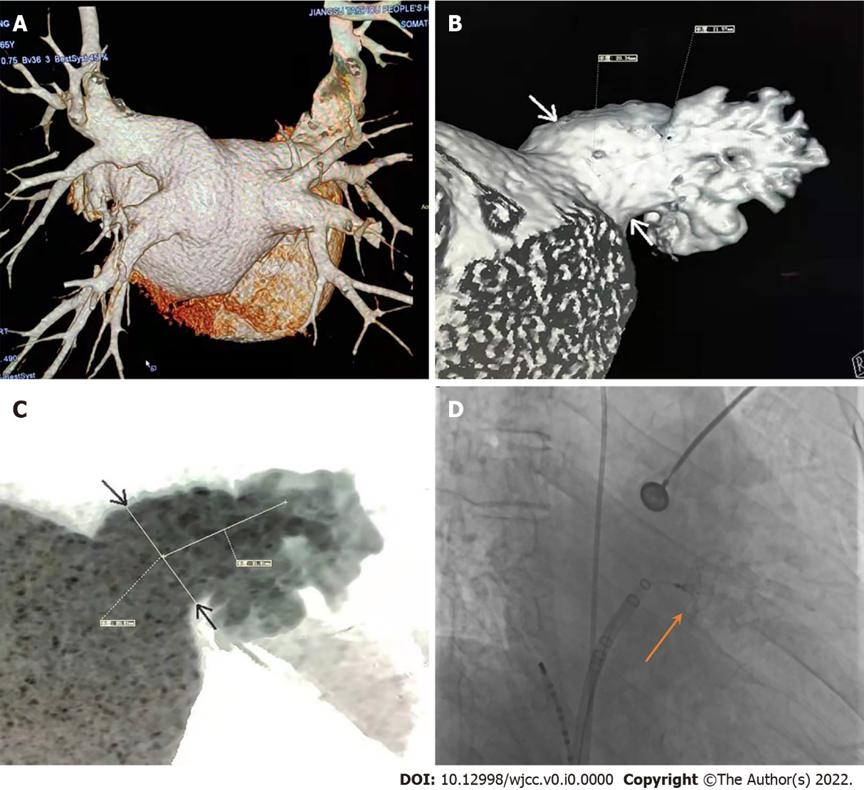
Figure 1 Reconstruction of pulmonary vein and left atrial appendage by cardiac computed tomography. A: Reconstruction of pulmonary vein; B-C: Reconstruction and measurement of left atrial appendage (LAA); D: LAA occluder was released. Orange arrow shows LAA occluder.

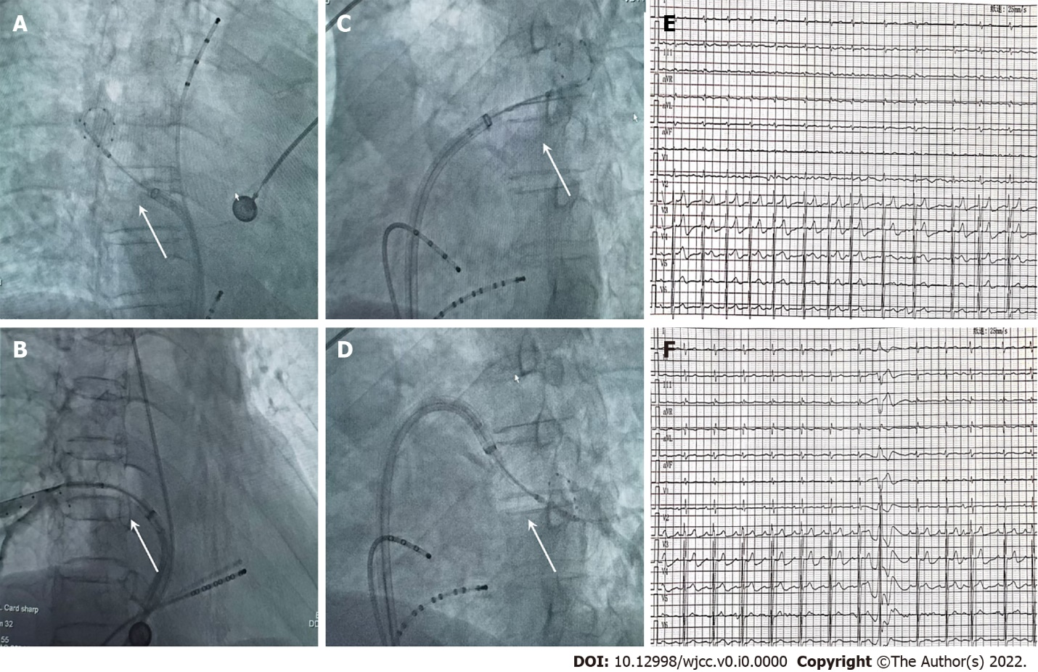
Figure 2 Cryoballoon ablation. A-D: Cryoballoon ablation of all four pulmonary veins with good balloon occlusion; E-F: Preoperative and postoperative electrocardiogram. White arrows show balloon occlusion.

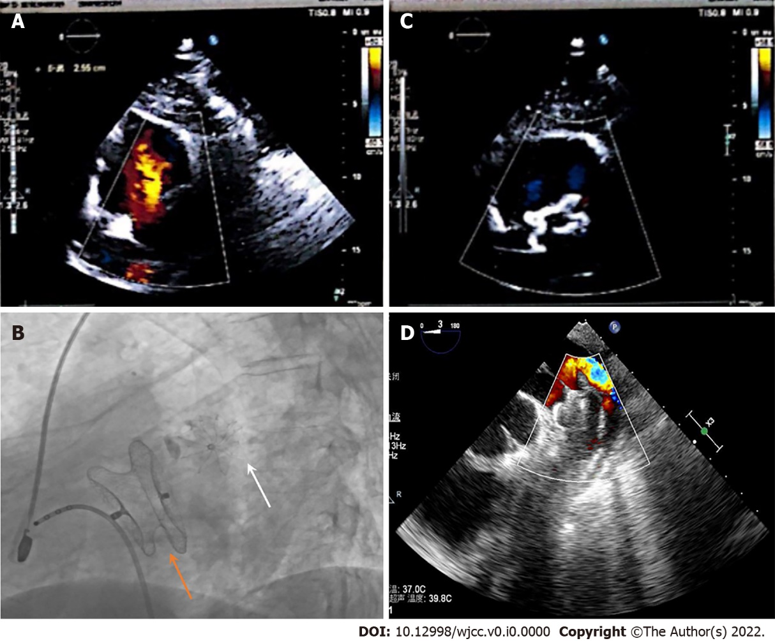
Figure 3 Outcome and follow-up. A: Preoperative echocardiography for atrial septal defect (ASD); B: Final X-ray image after left atrial appendage occlusion and ASD occlusion; C: Postoperative echocardiography for ASD; D: Follow-up at 3 mo by transesophageal echocardiography. Orange arrow shows ASD occluder; white arrow shows left atrial appendage occluder.

