Name of Journal: World Journal of Cardiology
Manuscript NO: 76933
Manuscript Type: ORIGINAL ARTICLE

Observational Study
National trend of heart failure and other cardiovascular diseases in people living with human immunodeficiency virus

Park DY et al. Trend of heart failure in HIV patients

Dae Yong Park, Seokyung An, Maria Emilia Romero, Mukunthan Murthi, Ramtej Atluri

Dae Yong Park, Department of Medicine, Cook County Health, Chicago, IL 60612, United States

Seokyung An, Department of Biomedical Science, Seoul National University Graduate School, Seoul 03080, South Korea

Maria Emilia Romero, Mukunthan Murthi, Ramtej Atluri, Department of Medicine, John H. Stroger, Jr. Hospital of Cook County, Chicago, IL 60612, United States

Author contributions: Park DY and An SK designed the research; Park DY and An SK performed the research; Park DY and An SK contributed analytic tools; Park DY and An SK analyzed the data; Park DY, An SK, Romero ME, Murthi M, and Atluri R wrote the paper, validated the results, and reviewed and edited the drafts.

Corresponding author: Dae Yong Park, MD, Doctor, Department of Medicine, Cook County Health, 1969 W Ogden Avenue, Chicago, IL 60612, United States. daeyongp@gmail.com

Received: April 7, 2022
Revised: May 13, 2022
Accepted: June 17, 2022
Published online: July 26, 2022

Abstract
BACKGROUND
As people living with human immunodeficiency virus (HIV) (PLWH) enjoy longer life expectancy with highly effective antiretroviral therapy, they are encountering challenging cardiovascular health risks.

AIM
To retrospectively examine the increasing burden of cardiovascular diseases in PLWH over the past decade.

METHODS
All hospitalizations for heart failure (HF), ischemic heart disease (IHD), and cerebrovascular disease (CeVD) in PLWH were identified using the International Classification of Diseases, Ninth Revision, Clinical Modification (ICD-9-CM) and ICD-10-CM codes in the National Inpatient Sample from 2008 to 2018. Outcomes included number of hospitalizations, in-hospital mortality, length of stay, and total hospital charge. Trend of the outcomes from 2008 to 2018 were analyzed using Cochran-Armitage trend test and simple linear regression.

RESULTS
The number of hospitalizations for HF in PLWH increased from 4212 in 2008 to 6700 in 2018 (P_{trend} < 0.01). Similar increasing trend was seen with those for IHD and CeVD over the decade (P_{trend} < 0.01). A decreasing trend of in-hospital mortality was observed in all hospitalizations of PLWH (P_{trend} < 0.01) and CeVD in PLWH (P_{trend} < 0.01), but not in those for HF (P_{trend} = 0.67) and IHD (P_{trend} = 0.13). The trend of length of stay was decreasing in all hospitalizations of PLWH (P_{trend} < 0.01), but increasing in those for HF in PLWH (P_{trend} < 0.01). An increasing trend of total hospital charge was observed in hospitalizations for HF, IHD, and CeVD (P_{trend} < 0.01).

CONCLUSION
The burden of cardiovascular diseases has significantly increased in hospitalizations of PLWH from 2008 to 2018. Continued efforts are needed to address the additional cardiovascular risks in this vulnerable population.

Key Words: Cardiovascular; Heart failure; Trend; Human immunodeficiency virus; People living with human immunodeficiency virus

©The Author(s) 2022. Published by Baishideng Publishing Group Inc. All rights reserved.

Citation: Park DY, An S, Romero ME, Murthi M, Atluri R. National trend of heart failure and other cardiovascular diseases in people living with human immunodeficiency virus. World J Cardiol 2022; 14(7): 427-437
URL: https://www.wjgnet.com/1949-8462/full/v14/i7/427.htm
DOI: https://dx.doi.org/10.4330/wjc.v14.i7.427

Core Tip: People living with human immunodeficiency virus (HIV) are at risk of developing cardiovascular diseases, including heart failure, but recent trends in the number of hospitalizations for various cardiovascular causes have not been examined on a national level. This study sought to analyze the trend in the number of hospitalizations for different cardiovascular diseases in people living with HIV to highlight the rising importance of cardiovascular diseases in this vulnerable population. More studies are needed to address the additional cardiovascular risks in people living with HIV, and tailored approach may be beneficial when managing and treating this population.

INTRODUCTION
As of the year 2020, human immunodeficiency virus (HIV) affected 37.7 million people worldwide with 1.5 million new diagnoses and 680000 deaths due to illnesses associated with acquired immunodeficiency syndrome (AIDS)^{[1]}. HIV infection used to be a debilitating disease leading to fatal infectious diseases, but with the advent of highly effective antiretroviral therapy, life expectancy for people living with HIV (PLWH) has increased by up to 10 years, approaching near-normal life expectancy especially in compliant patients^{[2,3]}. As a result, the importance of cardiovascular diseases (CVDs) in PLWH is continually increasing, especially with new studies suggesting that inflammation and immune activation associated with HIV infection are contributing to additional cardiovascular risk^{[4]}.
Many previous studies have indicated that HIV infection is an independent risk factor for CVDs and cerebrovascular diseases (CeVDs), including heart failure (HF), myocardial infarction, and stroke^{[5-7]}. However, studies on yearly dynamic changes brought about by CVDs in PLWH are lacking. Given the increasing burden of CVDs in PLWH, this study serves to elucidate the yearly trend of CVDs in PLWH by examining associated hospitalizations and in-hospital mortality from 2008 to 2018. Heart failure, along with ischemic heart disease (IHD) and CeVD, was used to represent the burden of CVDs in PLWH changing over the years^{[8]}.

MATERIALS AND METHODS
Data source
All data used in this study are openly available in the public website of Healthcare Cost and Utilization Project (HCUP) at https://www.hcup-us.ahrq.gov/nisoverview.jsp. The National Inpatient Sample (NIS), a retrospective cohort study developed for the HCUP, is the largest publicly available inpatient database that covers more than 97% of the U.S. population stratified by hospital region and type of insurance^{[9]}. The NIS consists of demographic and hospital characteristics at discharge, which are searchable using the International Classification of Diseases, Ninth Revision, Clinical Modification (ICD-9-CM) and ICD-10-CM codes^{[10]}. As the NIS is fully de-identified and public, ethics committee approval was not required in this study. The datasets used and analyzed during this study are available at https://www.hcup-us.ahrq.gov/databases.jsp^{[9]}.

Study population
Total number of hospitalizations of PLWH was calculated as the sum of all hospitalizations with primary or secondary diagnosis of HIV: ICD-9-CM codes 042 and V08, or ICD-10-CM codes B20-24, R75, and Z21. Primary discharge diagnoses of CVDs were defined as follows: HF (ICD-9-CM codes 398.91, 402.01, 402.11, 402.91, 404.01, 404.03, 404.11, 404.13, 404.91, 404.93, 428; ICD-10-CM codes I11.0, I13.0, I13.2, I09.81, I50), IHD (ICD-9-CM codes 410-411; ICD-10-CM codes I20-I25), and CeVD (ICD-9-CM codes 430-438; ICD-10-CM codes I60-I70). HF was chosen as the main CVD of interest as it comprised the largest proportion among the three. Other CVDs, including IHD and CeVD, were also included. The proportion of each CVD among all hospitalizations of PLWH was then calculated for each year. Only patients above 18 years were included, and hospitalizations with missing information on age, sex, and mortality status were excluded (Figure 1).

Outcome measures
The primary outcome of this study was the in-hospital mortality of hospitalizations due to each of the selected CVDs in PLWH. Secondary outcomes included length of hospital stay and total hospital charges.

Statistical analysis
To calculate estimates that represent total nationwide numbers, survey analysis methods were used based on the weights of hospital-level discharge provided by the NIS. The baseline demographic and hospital characteristics including sex, age, race, comorbidities, Charlson comorbidity index, hospital region, hospital bed size, and location were summarized as percentages for categorical variables and as means with standardized error for continuous variables. The crude mortality rate was calculated by each year and linear trends were examined using the Cochran-Armitage trend test. The trends in continuous outcomes were tested based on simple linear regression. A P value of less than or equal to 0.05 was considered statistically significant. All analyses were conducted using SAS, version 9.4 (SAS Institute, Cary, NC).

RESULTS
From 2008 to 2018, 54987 hospitalizations of adults (> 18 years) with a primary diagnosis of heart failure and secondary diagnosis of HIV were examined. Hospitalization with a primary diagnosis of HF and secondary diagnosis of HIV steadily increased from 4212 in 2008 to 6,700 in 2018 (P_{trend} < 0.001). The yearly demographics and comorbidities are shown in Table 1. About two-thirds of the population were male (65.5% in 2008 and 69.6% in 2018). In the year 2008, age less than 50 years was the largest group, but with progression of time, age group spanning from 50 to 59 years became the largest group. Majority of the population consisted of black race, which decreased over the years from 74.6% in 2008 to 71.5% in 2018 (P_{trend} < 0.001). Comorbidities of hypertension, diabetes mellitus, chronic kidney disease, obesity, and chronic obstructive pulmonary disease all significantly increased from 2008 to 2018 (P_{trend} < 0.001). Of note, hypertension and obesity markedly increased from 65.9% and 7.3% in 2008 to 91.2% and 17.1% in 2018, respectively. Such phenomenon was redemonstrated in the significantly increasing trend of Charlson comorbidity index over the years (P_{trend} < 0.001). These findings are shown in Table 1.
A total of 2,483,868 hospitalizations of PLWH with either primary or secondary diagnosis of HIV were reported from 2008 to 2018. Hospitalizations due to HF in PLWH increased from 4212 in 2008 to 6700 in 2018 (P_{trend} < 0.001). IHD (3921 in 2008 and 4,350 in 2018) and CeVD (2927 in 2008 and 3960 in 2018) followed the same pattern (both P_{trend} < 0.001). However, the overall hospitalizations of PLWH decreased from 236,809 in 2008 to 215,410 in 2018 (P_{trend} < 0.001). At the same time, the proportion of HF, IHD, and CeVD over all hospitalizations of PLWH increased from 4.7% in 2008 to 7.0% in 2018 (all P_{trend} < 0.001). These findings are illustrated in Figure 2.
There was a statistically significant decline in the in-hospital mortality of all hospitalizations of PLWH (P_{trend} < 0.001) from 3.40% in 2008 to 2.28% in 2018. A similar decline was observed in the in-hospital mortality of CeVD in PLWH (P_{trend} < 0.001) from 7.14% in 2008 to 3.67% in 2018. On the other hand, no significant difference was found in the trend of in-hospital mortality rate in hospitalizations due to HF or IHD in PLWH. In-hospital mortality rate was 1.84% in 2008 and 1.49% in 2018 for heart failure (P_{trend} = 0.672), and 1.61% in 2008 and 2.87% in 2018 for IHD (P_{trend} = 0.13). Figure 3 illustrates these findings.
Average length of hospital stay in all hospitalizations of PLWH decreased from 6.74 days in 2008 to 6.18 days in 2018 (P_{trend} < 0.001). However, that of HF in PLWH increased from 4.85 days in 2008 to 5.32 days in 2018 (P_{trend} < 0.001). No significant trend was found with IHD (P_{trend} = 0.294) and CeVD (P_{trend} = 0.341). These trends are illustrated in Figure 4.
Statistically significant increase in average total hospital charge was observed in all hospitalizations of PLWH from 2008 to 2018. Similar trend was seen in hospitalizations for HF, IHD, and CeVD in PLWH (Figure 5). In absolute terms, IHD showed the greatest increase by $53,500 from $57,324 in 2008 to $110,824. In relative terms, HF increased by 123% from $28,503 in 2008 to $63,566 in 2018. The order of total hospital charge was IHD, CeVD, and HF from highest to lowest.

DISCUSSION
PLWH have increased risks of CVDs, including myocardial infarction, HF, sudden cardiac death, peripheral artery disease, and CeVD^{[11,12]}. The mechanism of this increased risk has been explained by a combination of factors in HIV tropism in cardiac myocytes and effects related to the immunologic response triggered by HIV^{[13,14]}. In addition, traditional cardiovascular risk factors, such as dyslipidemia, diabetes, smoking, and HTN are more prevalent in PLWH^{[15]}. Genetic factors and the association of antiretroviral and metabolic abnormalities may also be playing a role in increasing cardiovascular risks in PLWH^{[16,17,18]}. On the other hand, immune activation and chronic inflammation mediated by HIV contribute to the progression of CVD. Ongoing viral replication and release of inflammatory markers, such as hsCRP, IL-6, and D-Dimer, trigger subclinical atherosclerosis and increase CV events^{[4]}. HIV-associated atherosclerosis is known to have its own features, such as non-calcified plaques, given this chronic inflammation^{[11,19]}. Even with HIV suppression with antiretroviral therapy, chronic inflammation persists, putting PLWH at risk of more cardiovascular events^{[4]}.
According to the trends described in the present study, hospitalizations due to HF, IHD, and CeVD in PLWH increased while overall hospitalizations of PLWH decreased. This is likely related to the impact of highly effective antiretroviral therapy, which allowed PLWH to have near-normal life expectancy and resulted in a rise in morbidity and mortality associated with age-related causes^{[20,21]}. The dramatic changes brought about by antiretroviral therapy is shown by how the annual mortality of PLWH exceeded 20% prior to 1996 but declined to less than 2% only after a decade later^{[22]}. With improvement in life expectancy, reduction of infectious burden, and changes in lifestyle, the prevalence of CVD is also expected to increase^{[23]}. Increase in the prevalence of comorbidities among PLWH was also noted in the present study (Table 1).
Interestingly, a precipitous reduction in hospitalizations of PLWH from 2010 to 2012 was observed. This may be due to the National HIV/AIDS Strategy implemented in 2010, intensifying HIV prevention efforts, facilitating access to care for PLWH, and creating a coordinated national response to the HIV epidemic^{[24,25]}. The President’s Emergency Plan for AIDS Relief in the U.S., whereby the government supported high active antiretroviral therapy (HAART) for more than 3.9 million people and provided care for nearly 13 million people, was also expanded in the year 2011^{[26]}. With these national efforts to combat HIV, hospitalizations of PLWH have been subdued since 2012 and has been remaining relatively stable.
The trend analysis from this present study coincides with those seen in previous studies. According to a population-based cohort study from 1999 to 2018, diagnosis and mortality rate of HIV infection underwent annual decrease of 5% and 8%, respectively^{[27]}. Earlier diagnosis, lower probability of AIDS-associated infections, and antiretroviral therapy factored into this decline^{[27]}. The decline of in-hospital mortality of CeVD in PLWH seen in this study may be due to the reduced severity of stroke among PLHW explained by the effectiveness of HAART and better tools for stroke diagnosis and treatment^{[28]}. This study did not show significant changes in the in-hospital mortality of HF and IHD in PLWH despite other epidemiological studies showing a decrease in the general population^{[29,30]}. From such finding, one can hypothesize that additional cardiovascular risk factors are present in PLWH, which are not being sufficiently addressed.
The decrease in average length of hospital stay in PLWH over time has also been reported by a retrospective study of more than 700,000 admissions in three hospitals in New York City^{[31]}. Rowell-Cunsolo et al^{[31]} reported decreases in length of stay from 2006 to 2014, but noted that the length of stay was greater in PLWH than the general population. Other studies have also produced comparable results, including Berry et al^{[32]} who reported decline in hospitalizations due to AIDS-defining illnesses from 6.7 to 2.7 per 100 person-years from 2001 to 2008 and Heslin et al^{[33]} who reported 10% decrease in length stay from 2006 to 2013^{[32,33]}.
To the best of authors’ knowledge, the present study was the first to use the largest inpatient database in the U.S. to examine the trend in the number of hospitalizations, stratified to cardiovascular causes, in people living with HIV. In addition, trends in the in-hospital mortality, length of hospital stay, and total hospital charge were also uniquely examined. By analyzing the yearly trend of CVDs in PLWH, the objective of this study is to increase the awareness of burden of CVD in this more vulnerable population. Hospitalizations due to CVD has increased in PLWH, highlighting the importance of evaluating and managing cardiovascular risks factors imparted by HIV. Meanwhile, more research investigating the underlying mechanisms that link HIV and CVD must continue to provide potential solutions to this problem of additional risk. Mechanisms whereby antiretrovirals may contribute to this risk should also be studied. With better understanding of the association between HIV infection and CVD, tailored approaches may be warranted in managing cardiovascular risk factors in PLWH.
This study contains several limitations. Administrative data was used for clinical outcomes by using NIS in analyzing yearly trends for CVDs in PLWH. NIS data can have varying degrees of accuracy since cardiovascular events can be coded differently, leading to underestimation of event rates and misclassification^{[34]}. As this study relied on NIS data, there was no control in either exposure or outcome. Not all cardiovascular diseases were included in the analysis. Age-standardized in-hospital mortality could not be calculated due to the skewed distribution of mortalities in different age groups. Prospective cohort studies should be implemented to better examine the burden of CVD in PLWH.

CONCLUSION
The present study used a national representative sample of U.S. hospital admissions from 2008 to 2018 to reach the following conclusions. First, hospitalizations due to HF, IHD, and CeVD in PLWH increased while total hospitalizations of PLWH decreased. Second, hospitalizations due to HF in PLWH steadily increased over 11 years along with the concomitant increase in the prevalence of comorbidities. Third, declining trends in the in-hospital mortality rate of overall hospitalizations in PLWH and those due to CeVD in PLWH were observed, whereas no change in trend was present with HF and IHD. Fourth, while the length of hospital stay in all hospitalizations of PLWH decreased, that due to HF increased. Finally, the healthcare costs increased for all admissions for all HF, IHD, and CeVD in PLWH. The results from this study demonstrate the increasing burden of CVD in PLWH as demonstrated by increasing hospitalizations, lack of improvement in in-hospital mortality, and increased length of hospital stay in those with HF.

ARTICLE HIGHLIGHTS
Research background
Recent studies have reported a strong association between human immunodeficiency virus (HIV) infection and cardiovascular diseases. However, studies examining the trend of cardiovascular diseases in people living with HIV on a national level have been lacking.

Research motivation
The trends of cardiovascular diseases in people living with HIV have not been sufficiently examined using nationally representative database.

Research objectives
To demonstrate that the burden of cardiovascular disease in people living with HIV has been increasing in the recent decade, emphasizing the need for continual efforts to address the excess cardiovascular risks in this vulnerable population.

Research methods
We retrospectively examined the National Inpatient Sample from 2008 to 2018 to analyze the trends in the hospitalizations for various cardiovascular diseases in people living with HIV. In addition, we looked at the trends of in-hospital mortality, length of hospital stay, and total hospital charge. Cochran-Armitage test and simple linear regression were used to examine the trends of categorical and continuous variables, respectively.

Research results
Hospitalizations for heart failure, ischemic heart disease, and cerebrovascular disease in people living with HIV showed an increasing trend, while the total number of hospitalizations in people with living HIV showed a decreasing trend from 2008 to 2018. The trend of in-hospital mortality and length of stay were variable in contrast to total hospital charge, which demonstrated a substantially increasing trend over the decade.

Research conclusions
Nationally representative data showed that the burden of cardiovascular diseases in people living with HIV has been significantly

Research perspectives
Further studies and preventative measures are needed to mitigate the additional cardiovascular burden in people living with HIV.

REFERENCES
1 UNAIDS Report on the Global AIDS Epidemic. [cited 20 April 2022]. Available from: https://www.unaids.org/
2 Antiretroviral Therapy Cohort Collaboration.. Survival of HIV-positive patients starting antiretroviral therapy between 1996 and 2013: a collaborative analysis of cohort studies. Lancet HIV 2017; 4: e349-e356 [PMID: 28501495 DOI: 10.1016/S2352-3018(17)30066-8]
3 Rodger AJ, Lodwick R, Schechter M, Deeks S, Amin J, Gilson R, Paredes R, Bakowska E, Engsig FN, Phillips A; INSIGHT SMART, ESPRIT Study Groups. Mortality in well controlled HIV in the continuous antiretroviral therapy arms of the SMART and ESPRIT trials compared with the general population. AIDS 2013; 27: 973-979 [PMID: 23698063 DOI: 10.1097/QAD.0b013e32835cae9c]
4 Triant VA. Cardiovascular disease and HIV infection. Curr HIV/AIDS Rep 2013; 10: 199-206 [PMID: 23793823 DOI: 10.1007/s11904-013-0168-6]
5 Chow FC, Regan S, Feske S, Meigs JB, Grinspoon SK, Triant VA. Comparison of ischemic stroke incidence in HIV-infected and non-HIV-infected patients in a US health care system. J Acquir Immune Defic Syndr 2012; 60: 351-358 [PMID: 22580566 DOI: 10.1097/qai.0b013e31825c7f24]
6 Freiberg MS, Chang CC, Kuller LH, Skanderson M, Lowy E, Kraemer KL, Butt AA, Bidwell Goetz M, Leaf D, Oursler KA, Rimland D, Rodriguez Barradas M, Brown S, Gibert C, McGinnis K, Crothers K, Sico J, Crane H, Warner A, Gottlieb S, Gottdiener J, Tracy RP, Budoff M, Watson C, Armah KA, Doebler D, Bryant K, Justice AC. HIV infection and the risk of acute myocardial infarction. JAMA Intern Med 2013; 173: 614-622 [PMID: 23459863 DOI: 10.1001/jamainternmed.2013.3728]
7 Remick J, Georgiopoulou V, Marti C, Ofotokun I, Kalogeropoulos A, Lewis W, Butler J. Heart failure in patients with human immunodeficiency virus infection: epidemiology, pathophysiology, treatment, and future research. Circulation 2014; 129: 1781-1789 [PMID: 24778120 DOI: 10.1161/CIRCULATIONAHA.113.004574]
8 Olvera Lopez E, Ballard BD, Jan A. Cardiovascular Disease. 2021 Aug 11. In: StatPearls [Internet]. Treasure Island (FL): StatPearls Publishing; 2022 Jan- [PMID: 30571040]
9 Healthcare Cost and Utilization Project (HCUP). Rockville, MD: Agency for Healthcare Research and Quality. [cited 20 April 2022]. Available from: www.hcup-us.ahrq.gov/db/nation/nis/nisarchive.jsp
10 Mohan S, Thirumalai C and Rababah A. Classification of Heart Disease Using Cluster Based DT Learning. Journal of Computer Science 2020; 16: 50-55 [DOI: 10.3844/jcssp.2020.50.55]
11 Hsue PY, Waters DD. Time to Recognize HIV Infection as a Major Cardiovascular Risk Factor. Circulation 2018; 138: 1113-1115 [PMID: 30354392 DOI: 10.1161/CIRCULATIONAHA.118.036211]
12 Delabays B, Cavassini M, Damas J, Beuret H, Calmy A, Hasse B, Bucher HC, Frischknecht M, Müller O, Méan M, Vollenweider P, Marques-Vidal P, Vaucher J. Cardiovascular risk assessment in people living with HIV compared to the general population. Eur J Prev Cardiol 2022; 29: 689-699 [PMID: 34893801 DOI: 10.1093/eurheartj/ehab724.2490]
13 Prendergast BD. HIV and cardiovascular medicine. Heart 2003; 89: 793-800 [PMID: 12807864 DOI: 10.1136/heart.89.7.793]
14 McGettrick P, Mallon PWG. Biomarkers to predict cardiovascular disease in people living with HIV. Curr Opin Infect Dis 2022; 35: 15-20 [PMID: 34873078 DOI: 10.1097/QCO.0000000000000802]
15 So-Armah K, Freiberg MS. HIV and Cardiovascular Disease: Update on Clinical Events, Special Populations, and Novel Biomarkers. Curr HIV/AIDS Rep 2018; 15: 233-244 [PMID: 29752699 DOI: 10.1007/s11904-018-0400-5]
16 Blanco F, San Román J, Vispo E, López M, Salto A, Abad V, Soriano V. Management of metabolic complications and cardiovascular risk in HIV-infected patients. AIDS Rev 2010; 12: 231-241 [PMID: 21179187]
17 Carr A, Samaras K, Burton S, Law M, Freund J, Chisholm DJ, Cooper DA. A syndrome of peripheral lipodystrophy, hyperlipidaemia and insulin resistance in patients receiving HIV protease inhibitors. AIDS 1998; 12: F51-F58 [PMID: 9619798 DOI: 10.1097/00002030-199807000-00003]
18 Mohan S, Thirumalai C and Srivastava G. Effective Heart Disease Prediction Using Hybrid Machine Learning Techniques. IEEE Access 2019; 7: 81542-81554 [DOI: 10.1109/access.2019.2923707]
19 Poznyak AV, Bezsonov EE, Borisov EE, Grechko AV, Kartuesov AG, Orekhov AN. Atherosclerosis in HIV Patients: What Do We Know so Far? Int J Mol Sci 2022; 23 [PMID: 35269645 DOI: 10.3390/ijms23052504]
20 Alonso A, Barnes AE, Guest JL, Shah A, Shao IY, Marconi V. HIV Infection and Incidence of Cardiovascular Diseases: An Analysis of a Large Healthcare Database. J Am Heart Assoc 2019; 8: e012241 [PMID: 31266386 DOI: 10.1161/JAHA.119.012241]
21 An S, Ahn C, Moon S, Sim EJ, Park SK. Individualized Biological Age as a Predictor of Disease: Korean Genome and Epidemiology Study (KoGES) Cohort. J Pers Med 2022; 12 [PMID: 35330504 DOI: 10.3390/jpm12030505]
22 May MT, Sterne JA, Costagliola D, Sabin CA, Phillips AN, Justice AC, Dabis F, Gill J, Lundgren J, Hogg RS, de Wolf F, Fätkenheuer G, Staszewski S, d'Arminio Monforte A, Egger M; Antiretroviral Therapy (ART) Cohort Collaboration. HIV treatment response and prognosis in Europe and North America in the first decade of highly active antiretroviral therapy: a collaborative analysis. Lancet 2006; 368: 451-458 [PMID: 16890831 DOI: 10.1016/S0140-6736(06)69152-6]
23 Kreatsoulas C, Anand SS. The impact of social determinants on cardiovascular disease. Can J Cardiol 2010; 26 Suppl C: 8C-13C [PMID: 20847985 DOI: 10.1016/s0828-282x(10)71075-8]
24 30 Years of AIDS. Honoring the Past, Looking Toward the Future [web site], 2011. [cited 20 April 2022]. Available from: https://hab.hrsa.gov/livinghistory/2011
25 Prior National HIV/AIDS Strategies (2010-2021). [cited 20 April 2022]. Available from: https://www.hiv.gov/federal-response/national-hiv-aids-strategy/national-hiv-aids-strategies-2010-2021
26 FACT SHEET: The Beginning of the End of AIDS. [cited 20 April 2022]. Available from: https://obamawhitehouse.archives.gov/the-press-office/2011/12/01/fact-sheet-beginning-end-aids
27 Fontela C, Aguinaga A, Moreno-Iribas C, Repáraz J, Rivero M, Gracia M, Floristán Y, Fresán U, Miguel RS, Ezpeleta C, Castilla J. Trends and causes of mortality in a population-based cohort of HIV-infected adults in Spain: comparison with the general population. Sci Rep 2020; 10: 8922 [PMID: 32488053 DOI: 10.1038/s41598-020-65841-0]
28 Lin HL, Muo CH, Lin CY, Chen HJ, Chen PC. Incidence of stroke in patients with HIV infection: A population-based study in Taiwan. PLoS One 2019; 14: e0217147 [PMID: 31116762 DOI: 10.1371/journal.pone.0217147]
29 Bytyçi I, Bajraktari G. Mortality in heart failure patients. Anatol J Cardiol 2015; 15: 63-68 [PMID: 25550250 DOI: 10.5152/akd.2014.5731]
30 Nowbar AN, Gitto M, Howard JP, Francis DP, Al-Lamee R. Mortality From Ischemic Heart Disease. Circ Cardiovasc Qual Outcomes 2019; 12: e005375 [PMID: 31163980 DOI: 10.1161/CIRCOUTCOMES.118.005375]
31 Rowell-Cunsolo TL, Liu J, Shen Y, Britton A, Larson E. The impact of HIV diagnosis on length of hospital stay in New York City, NY, USA. AIDS Care 2018; 30: 591-595 [PMID: 29338331 DOI: 10.1080/09540121.2018.1425362]
32 Berry SA, Fleishman JA, Moore RD, Gebo KA; HIV Research Network. Trends in reasons for hospitalization in a multisite United States cohort of persons living with HIV, 2001-2008. J Acquir Immune Defic Syndr 2012; 59: 368-375 [PMID: 22240460 DOI: 10.1097/qai.0b013e318246b862]
33 Heslin KC, Elixhauser A. HIV Hospital Stays in the United States, 2006–2013: Statistical Brief #206. In: Healthcare Cost and Utilization Project (HCUP) Statistical Briefs [Internet]. Rockville (MD): Agency for Healthcare Research and Quality (US), 2006 [PMID: 27559565]
34 Psaty BM, Delaney JA, Arnold AM, Curtis LH, Fitzpatrick AL, Heckbert SR, McKnight B, Ives D, Gottdiener JS, Kuller LH, Longstreth WT Jr. Study of Cardiovascular Health Outcomes in the Era of Claims Data: The Cardiovascular Health Study. Circulation 2016; 133: 156-164 [PMID: 26538580 DOI: 10.1161/CIRCULATIONAHA.115.018610]

Footnotes
Institutional review board statement: This study was exempt from institutional review board as it solely used deidentified data openly and readily available in a public database.

Informed consent statement: All study participants, or their legal guardian, provided informed written consent prior to study enrollment.

Conflict-of-interest statement: All the authors declare that they have no conflict of interest relevant to this study.

Data sharing statement: All data used in this study are openly available in the public website of Healthcare Cost and Utilization Project (HCUP) at https://www.hcup-us.ahrq.gov/nisoverview.jsp.

STROBE statement: The authors have read the STROBE Statement—checklist of items, and the manuscript was prepared and revised according to the STROBE Statement—checklist of items.

Open-Access: This article is an open-access article that was selected by an in-house editor and fully peer-reviewed by external reviewers. It is distributed in accordance with the Creative Commons Attribution NonCommercial (CC BY-NC 4.0) license, which permits others to distribute, remix, adapt, build upon this work non-commercially, and license their derivative works on different terms, provided the original work is properly cited and the use is non-commercial. See: https://creativecommons.org/Licenses/by-nc/4.0/

Provenance and peer review: Unsolicited article; Externally peer reviewed.
Peer-review model: Single blind

Peer-review started: April 7, 2022
First decision: May 12, 2022
Article in press: June 17, 2022

Specialty type: Cardiac and cardiovascular systems
Country/Territory of origin: United States
Peer-review report’s scientific quality classification
Grade A (Excellent): 0
Grade B (Very good): 0
Grade C (Good): C, C
Grade D (Fair): 0
Grade E (Poor): 0

P-Reviewer: Mohan S, India; Wierzbicka A, Poland S-Editor: Wang LL L-Editor: A P-Editor: Wang LL

Figure Legends
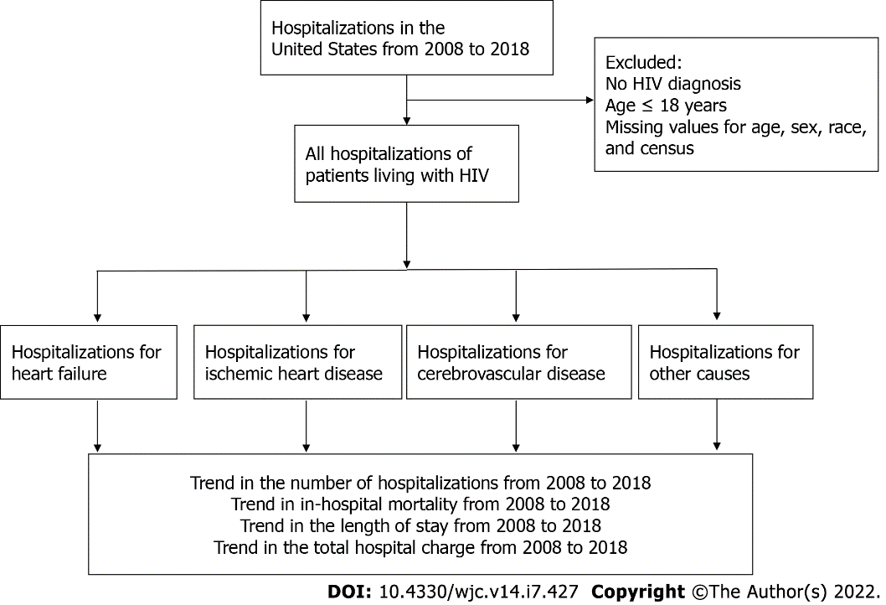
Figure 1 Flow chart of this study. The flow chart illustrates the underlying design of the present study. HIV: Human immunodeficiency virus.

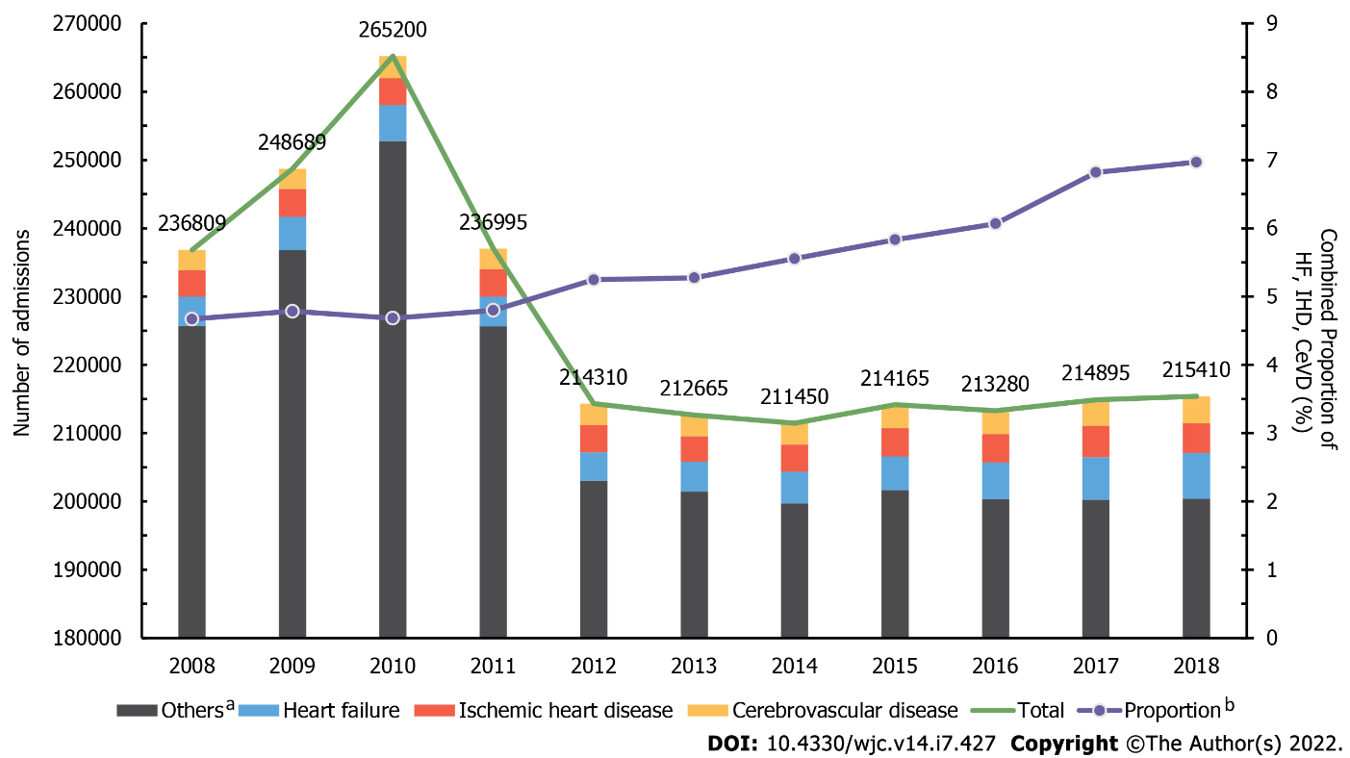Figure 2 Yearly trend of heart failure and other cardiovascular diseases in all admissions of people living with human immunodeficiency virus. Bar graph shows the yearly trend in the admissions of heart failure (HF) (blue), ischemic heart disease (IHD) (red), and cerebrovascular disease (CeVD) (yellow) in people living with human immunodeficiency virus (HIV). Gray bars show the number of all admissions of people living with human immunodeficiency virus (PLWH) for reasons other than HF, IHD, and CeVD. Violet line represents the combined proportion of HF, IHD, and CeVD among all hospitalizations of PLWH. Green line shows the total number of hospitalizations occurring in PLWH. ª“Others” refer to all admissions of PLWH for reasons other than HF, IHF, and CeVD. ^{b}“Proportion” refers to the combined proportion of HF, IHD, and CeVD among all hospitalizations of PLWH. CeVD: Cerebrovascular disease; HF: Heart failure; IHD: Ischemic heart disease; PLWH: People living with human immunodeficiency virus.

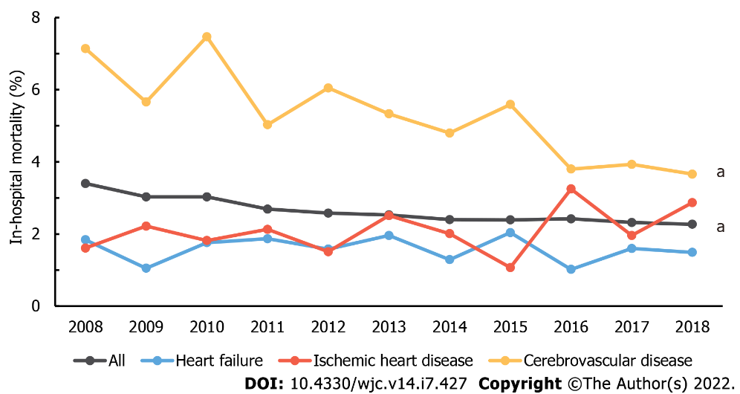
Figure 3 Yearly trend of average in-hospital mortality rate in admissions due to heart failure and other cardiovascular diseases in people living with human immunodeficiency virus. Line graphs illustrate the trend of in-hospital mortality in all admissions due to heart failure (blue), ischemic heart disease (red), and cerebrovascular disease (yellow). Gray line shows the in-hospital mortality of all admissions occurring in people living with human immunodeficiency virus. Significant P_{trend} < 0.05 is marked with an asterisk (a) at the end of the linear graph.

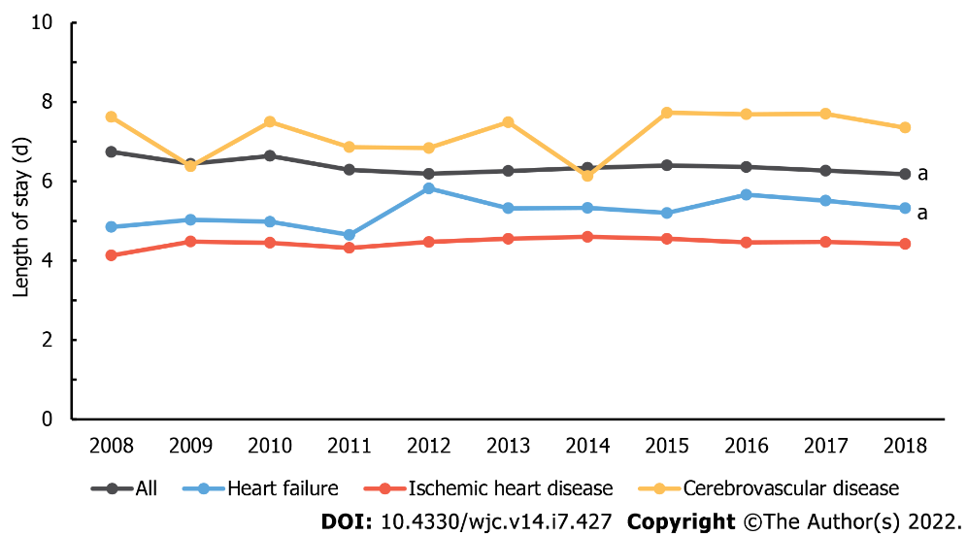
Figure 4 Yearly trend of average length of hospital stay in admissions due to heart failure and other cardiovascular diseases in people living with human immunodeficiency virus. Line graphs illustrate the trend of length of hospital stay in all admissions due to heart failure (blue), ischemic heart disease (red), and cerebrovascular disease (yellow). Gray line shows the length of hospital stay in all admissions occurring in PLWH. Significant P_{trend} < 0.05 is marked with an asterisk (a) at the end of the linear graph.

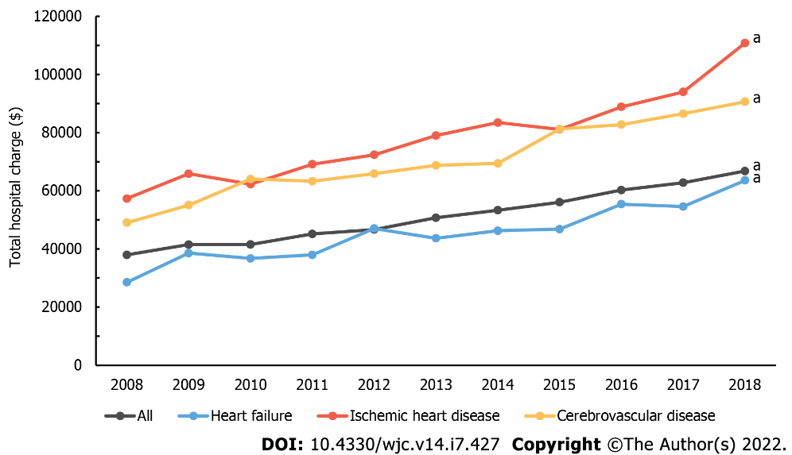
Figure 5 Yearly trend of average total hospital charge in admissions due to heart failure and other cardiovascular diseases in people living with human immunodeficiency virus. Line graphs illustrate the trend of total hospital charge in all admissions due to heart failure (blue), ischemic heart disease (red), and cerebrovascular disease (yellow). Gray line shows the total hospital charge in all admissions occurring in PLWH. Significant P-trend < 0.05 is marked with an asterisk (a) at the end of the linear graph.

Table 1 Baseline characteristics of hospitalizations due to heart failure in people living with human immunodeficiency virus from 2008 to 2018
 | 2008 | 2009 | 2010 | 2011 | 2012 | 2013 | 2014 | 2015 | 2016 | 2017 | 2018 | P_{trend}
n (sample) | 869 | 954 | 1021 | 910 | 825 | 868 | 928 | 979 | 1074 | 1248 | 1340 | < 0.001
n (weighted) | 4212 | 4878 | 5225 | 4362 | 4125 | 4340 | 4640 | 4895 | 5370 | 6240 | 6700 | < 0.001
Sex (%)
Male | 65.5 | 67.1 | 68.5 | 64.8 | 69.0 | 68.4 | 65.7 | 67.4 | 68.0 | 67.2 | 69.6 | < 0.001
Female | 34.5 | 32.9 | 31.5 | 35.2 | 31.0 | 31.6 | 34.3 | 32.6 | 32.0 | 32.8 | 30.4 | < 0.001
Age (%)
< 50 | 41.8 | 38.8 | 41.2 | 36.7 | 29.7 | 27.2 | 29.1 | 27.4 | 28.1 | 25.0 | 24.9 | < 0.001
50-59 | 35.2 | 38.5 | 36.2 | 41.3 | 41.1 | 42.5 | 42.0 | 39.6 | 37.9 | 37.3 | 35.1 | < 0.001
60-69 | 16.7 | 16.7 | 16.5 | 16.5 | 20.8 | 22.8 | 22.2 | 24.8 | 26.9 | 28.8 | 29.0 | < 0.001
≥ 70 | 6.3 | 6.0 | 6.1 | 5.5 | 8.4 | 7.5 | 6.7 | 8.2 | 7.1 | 8.9 | 10.0 | < 0.001
Race (%)
White | 11.8 | 12.0 | 12.8 | 13.6 | 16.9 | 15.5 | 18.1 | 16.9 | 17.3 | 17.6 | 15.9 | < 0.001
Black | 74.6 | 74.5 | 76.2 | 76.4 | 71.7 | 72.1 | 70.2 | 73.8 | 71.5 | 69.2 | 71.5 | 0.002
Hispanic | 10.9 | 8.9 | 8.3 | 6.2 | 6.6 | 7.9 | 8.5 | 5.6 | 7.7 | 8.8 | 9.5 | 0.203
Asian | 0.6 | 0.1 | 0.3 | 0.3 | 0.5 | 0.5 | 0.2 | 0.3 | 0.7 | 1.1 | 0.7 | < 0.001
AI/AN | 0.1 | 0.0 | 0.1 | 0.0 | 0.1 | 0.4 | 0.2 | 0.2 | 0.0 | 0.1 | 0.3 | < 0.001
Other | 2.0 | 4.5 | 2.3 | 3.5 | 4.2 | 3.6 | 2.8 | 3.2 | 2.7 | 3.2 | 2.1 | < 0.001
Comorbidities (%)
Hypertension | 65.9 | 67.9 | 64.7 | 67.5 | 81.8 | 80.1 | 68.4 | 69.7 | 86.6 | 73.4 | 91.2 | < 0.001
Diabetes mellitus | 33.4 | 33.2 | 31.3 | 32.5 | 34.4 | 35.1 | 37.8 | 37.4 | 38.0 | 37.9 | 36.7 | < 0.001
CKD | 53.1 | 50.4 | 50.4 | 49.2 | 53.9 | 56.9 | 54.5 | 58.1 | 60.6 | 62.6 | 61.0 | < 0.001
Obesity | 7.3 | 7.9 | 11.8 | 11.3 | 10.1 | 12.4 | 14.4 | 18.8 | 16.3 | 16.3 | 17.1 | < 0.001
COPD | 31.2 | 32.7 | 33.0 | 38.1 | 43.8 | 47.1 | 39.4 | 42.2 | 41.4 | 42.6 | 43.4 | < 0.001
Charlson comorbidity index
Mean (SD) | NR | NR | 6.18 (0.10) | 6.17 (0.11) | 6.11 (0.12) | 6.28 (0.11) | 6.27 (0.11) | 5.37 (0.11) | 6.86 (0.10) | 7.19 (0.09) | 6.99 (0.09) | < 0.001
Hospital characteristics
Hospital region (%)
Northwest | 25.4 | 35.3 | 35.9 | 30.9 | 32.1 | 31.8 | 28.0 | 274 | 24.8 | 25.8 | 26.3 | < 0.001
Midwest | 11.5 | 11.1 | 13.1 | 11.4 | 11.6 | 9.7 | 13.6 | 11.7 | 10.4 | 9.3 | 11.6 | < 0.001
South | 58.6 | 48.9 | 44.7 | 52.5 | 46.1 | 49.8 | 50.7 | 54.4 | 54.5 | 54.3 | 53.7 | < 0.001
West | 4.5 | 4.7 | 6.4 | 5.2 | 10.2 | 8.8 | 7.7 | 6.4 | 10.3 | 10.7 | 8.4 | < 0.001
Hospital bed size (%)
Small | 8.1 | 9.5 | 9.6 | 6.0 | 11.5 | 10.3 | 16.8 | 13.3 | 14.4 | 17.0 | 17.8 | < 0.001
Medium | 21.7 | 25.0 | 24.6 | 23.5 | 30.3 | 28.8 | 26.4 | 30.6 | 29.9 | 27.0 | 27.6 | < 0.001
Large | 70.2 | 65.5 | 65.8 | 70.5 | 58.2 | 60.9 | 56.8 | 56.1 | 55.7 | 56.0 | 54.6 | < 0.001
Urban location (%)
Rural | 5.5 | 3.8 | 2.9 | 3.4 | 2.9 | 3.6 | 2.6 | 3.4 | 3.1 | 3.8 | 4.0 | < 0.001
Urban nonteaching | 28.0 | 28.7 | 29.2 | 33.3 | 26.4 | 24.3 | 16.9 | 18.0 | 18.0 | 13.9 | 14.1 | < 0.001
Urban teaching | 66.5 | 67.5 | 68.0 | 63.3 | 70.7 | 72.1 | 80.5 | 78.6 | 78.9 | 82.2 | 81.9 | < 0.001
AI/AN: American Indian/Alaska Native; CKD: Chronic kidney disease; COPD: Chronic obstructive pulmonary disease; HIV: Human immunodeficiency virus; NR: Not reported; SD: Standard deviation.

Published by Baishideng Publishing Group Inc
7041 Koll Center Parkway, Suite 160, Pleasanton, CA 94566, USA
Telephone: +1-925-3991568
E-mail: bpgoffice@wjgnet.com
Help Desk: https://www.f6publishing.com/helpdesk
https://www.wjgnet.com

© 2022 Baishideng Publishing Group Inc. All rights reserved.

