Name of Journal: World Journal of Clinical Cases
Manuscript No: 51405
Manuscript type: CASE REPORT

Acute appendicitis in a patient after a uterus transplant: A case report

Kristek J et al. Acute appendicitis and uterus transplantation

Jakub Kristek, Michal Kudla, Jaroslav Chlupac, Robert Novotny, Tomas Mirejovsky, Libor Janousek, Jiri Fronek

Jakub Kristek, Michal Kudla, Jaroslav Chlupac, Robert Novotny, Libor Janousek, Jiri Fronek, Department of Transplant Surgery, Institute for Clinical and Experimental Medicine, Prague 140 21, Czech Republic

Jakub Kristek, Jaroslav Chlupac, Jiri Fronek, Department of Anatomy, Second Faculty of Medicine, Charles University, Prague 150 06, Czech Republic

Tomas Mirejovsky, Department of Clinical and Transplant Pathology, Institute for Clinical and Experimental Medicine, Prague 140 21, Czech Republic

Libor Janousek, First Faculty of Medicine, Charles University, Prague 121 08, Czech Republic

Jaroslav Chlupac, Jiri Fronek, Second Faculty of Medicine, Charles University, Prague 140 21, Czech Republic

ORCID number: Jakub Kristek (0000-0002-3758-2273); Michal Kudla (0000-0001-9018-1738); Jaroslav Chlupac (0000-0003-1482-6105); Robert Novotny (0000-0002-5876-2951); Tomas Mirejovsky (0000-0002-4616-4321); Libor Janousek (0000-0001-7572-8416); Jiri Fronek (0000-0003-2379-3886).

Author contributions: Kristek J wrote the manuscript and analyzed the data. Kudla M operated on the patient. Chlupac J and Novotny R co-analyzed the data and provided consultations regarding the risk of thrombosis. Mirejovsky T provided the histological image. Janousek L and Fronek J designed and ran the uterus transplantation trial and provided consultations regarding this case.

Conflict-of-interest statement: The authors declare that they have no conflict of interest.

CARE Checklist (2016) statement: The manuscript was prepared and revised according to the CARE Checklist (2016).

Open-Access: This article is an open-access article which was selected by an in-house editor and fully peer-reviewed by external reviewers. It is distributed in accordance with the Creative Commons Attribution Non Commercial (CC BY-NC 4.0) license, which permits others to distribute, remix, adapt, build upon this work non-commercially, and license their derivative works on different terms, provided the original work is properly cited and the use is non-commercial. See: http://creativecommons.org/licenses/by-nc/4.0/

Manuscript source: Unsolicited manuscript

Corresponding author: Jakub Kristek, MD, Department of Anatomy, Second Faculty of Medicine, Charles University, V Uvalu 84, Prague 150 06, Czech Republic. krsj@ikem.cz

Telephone: +420-23-6054105
Fax: +420-23-6052822

Received: September 20, 2019
Peer-review started: September 20, 2019
First decision: October 20, 2019
Revised: November 7, 2019
Accepted: November 15, 2019
Article in press: November 15, 2019
Published online: December 26, 2019

Abstract
BACKGROUND
Acute appendicitis in a solid organ transplant recipient is a rare occurrence, and experience remains limited. Appendicitis in uterine transplant recipients has never been reported. Immunocompromised patients with acute abdomen often present late and with attenuated symptoms. The differential diagnosis in a transplanted patient is broad and challenging due to possible existing complications associated with the graft, effects of immunosuppression, and altered anatomical relations.

CASE SUMMARY
A 26-year-old woman suffering from absolute uterine factor infertility received a uterus transplant. In the post-transplant period, she suffered from leukopenia and recurrent acute cellular rejection. Her compliance was suboptimal. She travelled to an exotic destination despite the physician’s recommendation not to do so. Following her vacation, she presented with abdominal discomfort, nausea and diarrhoea. There was no sign of acute abdomen; the abdominal ultrasound was negative on day 0. Clostridium difficile colitis was verified and treated with perorally administered vancomycin. On day 4, the discomfort changed to pain; the ultrasound scan revealed a finding suggestive of appendicitis. Surgical exploration revealed perforated appendicitis, and appendectomy was performed. From a surgical point of view, the patient’s follow-up was uneventful. The patient underwent a successful embryo transfer 6 months after the appendectomy. The patient gave birth to a healthy boy at the 35th week of gestation.

CONCLUSION
A high index of suspicion of an atypical course and symptomatology of acute abdomen should be maintained in immunosuppressed patients.

Key words: Uterus; Organ transplantation; Noncompliance; Acute abdomen; Colitis; Differential diagnosis; Case report

© The Author(s) 2019. Published by Baishideng Publishing Group Inc. All rights reserved.

Core tip: Herein, we present a unique report of a woman with a viable transplanted uterus graft who was suffering from concurrent Clostridium difficile colitis and acute appendicitis. The differential diagnosis in an immunosuppressed patient may be complex, and a high index of suspicion of an atypical course of acute abdomen should be maintained in immunosuppressed patients. Sometimes, more than one synchronous pathological condition may be present. This case highlights the ultimate importance of focusing on the achievement of successful embryo transfer in the uterus transplantation recipients as soon as possible since they are vulnerable to a multitude of possible complications.

Citation: Kristek J, Kudla M, Chlupac J, Novotny R, Mirejovsky T, Janousek L, Fronek J. Acute appendicitis in a patient after a uterus transplant: A case report. World J Clin Cases 2019; 7(24): 4270-4276
URL: https://www.wjgnet.com/2307-8960/full/v7/i24/4270.htm
DOI: https://dx.doi.org/10.12998/wjcc.v7.i24.4270

INTRODUCTION
Uterus transplantation (UTx) is an experimental treatment method for women with uterine factor infertility (UFI). It is a novel, challenging procedure performed in only a few centres around the world; hence, experience with acute abdomen in UTx recipients is rare. The lifetime risk of acute appendicitis (AA) in a normal population has been estimated to be 8.6% and 6.7% for males and females, respectively^{[1]}. AA in solid organ transplant recipients is rare, yet a few small case series have been reported^{[2,3]}. This article presents the first case of a woman with a history of UTx who suffered from AA.

CASE PRESENTATION
History of past illness
A 26-year-old Caucasian woman suffering from congenital absolute UFI underwent a deceased donor UTx. In the first year of the post-transplant period, 4 episodes of mild acute cellular rejection were diagnosed by cervical biopsy. They were treated with pulses of glucocorticoids and the addition of azathioprine to a maintenance immunosuppressive regimen of tacrolimus. In the further course, the patient developed secondary neutropenia, which was addressed by withdrawal of azathioprine and administration of several pulses of granulocyte colony-stimulating factor.

Personal and family history
Apart from congenital uterine agenesis which was treated with UTx, the patient was healthy with no history of further operations. Family history was negative for inherent diseases.

History of present illness
Five months after the UTx, the patient’s compliance was suboptimal. She decided to go on vacation to Egypt despite clear physician recommendation not to do so considering the high risk of acquisition of infectious gastroenteritis.

Chief complaints
After her return from Egypt, the patient presented with nausea, abdominal discomfort, and diarrhoea. She was hospitalized to receive rehydration therapy and to run necessary tests.

Physical examination upon admission
Upon admission, there were no signs of acute abdomen. The abdomen was mildly tender in all quadrants; there were no signs of peritoneal inflammation.

Imaging examinations
Upon admission, her abdominal ultrasound (US) was normal, although the appendix was not differentiated on baseline US. There was no suspicion of acute abdomen, and thrombosis of the uterine graft was excluded using Doppler ultrasound (Figure 1).

Laboratory examinations
C-reactive protein was 27 mg/L on day 0; the level of leukocytes was within the normal range. However, tests proved to be positive for Clostridium difficile colitis. Due to lack of signs of acute abdomen and verified colitis, we felt it was not necessary to run computed tomography (CT) of the abdomen. A therapy of perorally administered vancomycin 125 mg 4 times a day was started. Viral and parasitic colitis were excluded. Additionally, cytomegalovirus (CMV) polymerase chain reaction was negative. In the course of the next few days, there was a steady progressive elevation of the level of C-reactive protein up to 83 mg/L on day 4. Although the differential blood count showed a normal level of leukocytes, it was considered pathologic because the patient had been leukopenic chronically and there was a new finding of neutrophilia. On day 4, the abdominal discomfort changed to pain and became localized to the right hypogastrium.

FINAL DIAGNOSIS
A subsequent US scan revealed a nonhomogeneous tubular structure located behind the uterus, i.e., a finding suggestive of AA (Figure 2A and B). The final diagnosis of the presented case is concurrent Clostridium difficile colitis and acute perforated appendicitis.

TREATMENT
The patient underwent an uncomplicated conversion lap-to-open appendectomy. A gangrenous perforated appendix with localized peritonitis was found dorsal to the uterus (Figures 3 and 4). The patient was treated with metronidazole and amoxicillin with clavulanic acid; the tacrolimus immunosuppressive regimen was not discontinued because she was not septic. Subsequently, the tacrolimus levels increased to toxic levels, probably due to diarrhoea and consequently impaired resorption. The medication was changed, and probiotics were administered.

OUTCOME AND FOLLOW-UP
Apart from long-lasting diarrhoea and pancytopenia of complex aetiology, the patient’s follow-up was uneventful. The interval between transplant and appendectomy was 502 days. The patient underwent a successful embryo transfer 6 months after the appendectomy. Apart from pregnancy-induced diabetes, the pregnancy was uneventful. The patient gave birth to a healthy boy at week 35 of gestation.

DISCUSSION
Although AA has been rarely observed and described in recipients of solid organ transplants, this is the first reported case of AA in a uterus transplant recipient. According to the official transplant terminology, uterus transplant is not considered a solid organ transplant but a vascularized composite allograft, as are other non-vital transplantable organs, including the face, extremities, abdominal wall, and larynx^{[4]}. The prevalence of AA is reported as 0.35%, 0.49%, and 0.21% in kidney transplant recipients (n = 2880), liver transplant recipients (n = 817), and liver, heart, kidney, pancreas-kidney and heart-kidney transplant recipients (n = 8000), respectively^{[2,3,5]}.
Generally, immunocompromised patients tend to present late and with minimal symptoms; the symptoms of acute abdomen tend to be weakened by the attenuated immune response. Classic signs of peritonitis, e.g., rebound tenderness and fever, may be feeble or even absent in immunocompromised hosts. Furthermore, nonspecific signs such as tachycardia, hypotension, and confusion may present the only warning of existing abdominal catastrophe^{[6]}. Savar et al^{[2]} came to slightly different conclusions, at least with regard to AA. In their cohort of 15 transplant recipients suffering from AA, the physical findings were similar to the findings in the non-transplant population, i.e., abdominal/right hypogastrium pain (present in 94% of cases) and nausea and vomiting (present in 88% of cases)^{[2]}. Generally, after solid organ transplants that are typically placed in the right iliac fossa/retroperitoneum (kidney or pancreas), AA may be misdiagnosed as a graft-related complication, e.g., infection, acute urine outflow obstruction, or acute rejection of the graft. In UTx recipients, thrombosis of the graft remains the most feared complication. Thrombosis of the vascular pedicles of the uterine graft has been repeatedly presented as a cause of loss of the graft in both animal as well as human studies^{[7,8]}. Since diarrhoea may lead to dehydration and the association between dehydration and a higher risk of venous thrombosis is presumed, graft thrombosis was immediately suspected and subsequently excluded using Doppler US in our case^{[9]}. A possible cause of AA after kidney transplantation is CMV infection. Invasive CMV infection must always be excluded by definitive histopathological evaluation. If the test for CMV is positive, effective antiviral treatment must be instituted^{[10]}.
The risk of perforation of an inflamed appendix escalates over time. Perforation is present in approximately 10% of patients by 24 h and in up to 50% of patients by 48 h in the non-transplanted paediatric population^{[11]}. Although the diagnosis of AA is often based on clinical and laboratory findings, the use of either US or CT is recommended if AA is suspected; the sensitivity and specificity of CT are up to 98.5% and up to 98%, respectively^{[12]}. According to a meta-analysis, the rate of a negative appendectomy was 8.7% with the use of preoperative abdominal CT compared to 16.7% based on clinical evaluation alone^{[13]}. However, US may be almost as sensitive as CT in diagnosing AA when performed by well-trained radiologists, with the advantage of no radiation exposure^{[14]}.
In our case, if CT was used upon admission, it may have led to timely diagnosis and appendectomy of inflamed yet non-perforated appendix. However, we have suspicion that Clostridium difficile colitis may have been the very cause of the appendicitis. In other words, it may be a case of Clostridium difficile colitis and subsequent acute appendicitis.
UTx is primarily considered a temporary transplant. It cannot be emphasized enough that UTx recipients should preferentially focus on achieving successful embryo transfer. Since UTx recipients are prone to a variety of complications and the side effects of immunosuppression, it is advisable to obviate any risky activities that might compromise achieving the primary aim.

CONCLUSION
In this paper, we present a unique report of a woman with a viable transplanted uterus graft suffering from Clostridium difficile colitis and AA. The differential diagnosis in an immunosuppressed patient may be complex, and a high index of suspicion of atypical course and indefinite symptomatology of acute abdomen should be maintained in immunosuppressed patients. Sometimes, more than one synchronous pathological condition may be present. In transplanted patients, thrombosis of the vascular pedicles must always be excluded if pain or alteration to the graft’s function occurs. UTx recipients should preferentially focus on achieving successful embryo transfer because they are prone to a variety of complications.

ACKNOWLEDGEMENT
The author would like to thank Dr. Kornelia Chrapkova, PG Dip, for her invaluable help with review of the literature.

REFERENCES
1 Addiss DG, Shaffer N, Fowler BS, Tauxe RV. The epidemiology of appendicitis and appendectomy in the United States. Am J Epidemiol 1990; 132: 910-925 [PMID: 2239906 DOI: 10.1093/oxfordjournals.aje.a115734]
2 Savar A, Hiatt JR, Busuttil RW. Acute appendicitis after solid organ transplantation. Clin Transplant 2006; 20: 78-80 [PMID: 16556158 DOI: 10.1111/j.1399-0012.2005.00444.x]
3 Kwon SH, Park SH, Lee HY, Ko EJ, Ban TH, Chung BH, Yang CW. Clinical Characteristics of Acute Appendicitis in Kidney Transplant Recipients. Ann Transplant 2019; 24: 168-173 [PMID: 30910996 DOI: 10.12659/AOT.914134]
4 Samuel U. Regulatory aspects of VCA in Eurotransplant. Transpl Int 2016; 29: 686-693 [PMID: 26824440 DOI: 10.1111/tri.12753]
5 Wu L, Zhang J, Guo Z, Tai Q, He X, Ju W, Wang D, Zhu X. Diagnosis and treatment of acute appendicitis after orthotopic liver transplant in adults. Exp Clin Transplant 2011; 9: 113-117 [PMID: 21453228]
6 Scott-Conner CE, Fabrega AJ. Gastrointestinal problems in the immunocompromised host. A review for surgeons. Surg Endosc 1996; 10: 959-964 [PMID: 8864085 DOI: 10.1007/s004649900214]
7 Brännström M, Wranning CA, Altchek A. Experimental uterus transplantation. Hum Reprod Update 2010; 16: 329-345 [PMID: 19897849 DOI: 10.1093/humupd/dmp049]
8 Fageeh W, Raffa H, Jabbad H, Marzouki A. Transplantation of the human uterus. Int J Gynaecol Obstet 2002; 76: 245-251 [PMID: 11880127 DOI: 10.1016/s0020-7292(01)00597-5]
9 Verhaeghe R, Vermylen J, Verstraete M. Thrombosis in particular organ veins. Herz 1989; 14: 298-307 [PMID: 2680853]
10 Posen A, Renckens I, Sagaert X, Kuypers D. Subacute cytomegalovirus appendicitis in a renal transplant recipient. Transpl Infect Dis 2013; 15: 96-97 [PMID: 23075276 DOI: 10.1111/tid.12021]
11 Chan MK, Wilcox DT, Trompeter RS. Acute appendicitis in children after renal transplantation. Arch Dis Child 1999; 81: 372 [PMID: 10577360 DOI: 10.1136/adc.81.4.e372]
12 Pickhardt PJ, Lawrence EM, Pooler BD, Bruce RJ. Diagnostic performance of multidetector computed tomography for suspected acute appendicitis. Ann Intern Med 2011; 154: 789-796, W-291 [PMID: 21690593 DOI: 10.7326/0003-4819-154-12-201106210-00006]
13 Krajewski S, Brown J, Phang PT, Raval M, Brown CJ. Impact of computed tomography of the abdomen on clinical outcomes in patients with acute right lower quadrant pain: a meta-analysis. Can J Surg 2011; 54: 43-53 [PMID: 21251432 DOI: 10.1503/cjs.023509]
14 Doria AS, Moineddin R, Kellenberger CJ, Epelman M, Beyene J, Schuh S, Babyn PS, Dick PT. US or CT for Diagnosis of Appendicitis in Children and Adults? A Meta-Analysis. Radiology 2006; 241: 83-94 [PMID: 16928974 DOI: 10.1148/radiol.2411050913]
P-Reviewer: Hefny AF S-Editor: Zhang L L-Editor: A E-Editor: Qi LL

Specialty type: Medicine, Research and Experimental
Country of origin: Czech Republic
Peer-review report classification
Grade A (Excellent): 0
Grade B (Very good): B
Grade C (Good): 0
Grade D (Fair): 0
Grade E (Poor): 0

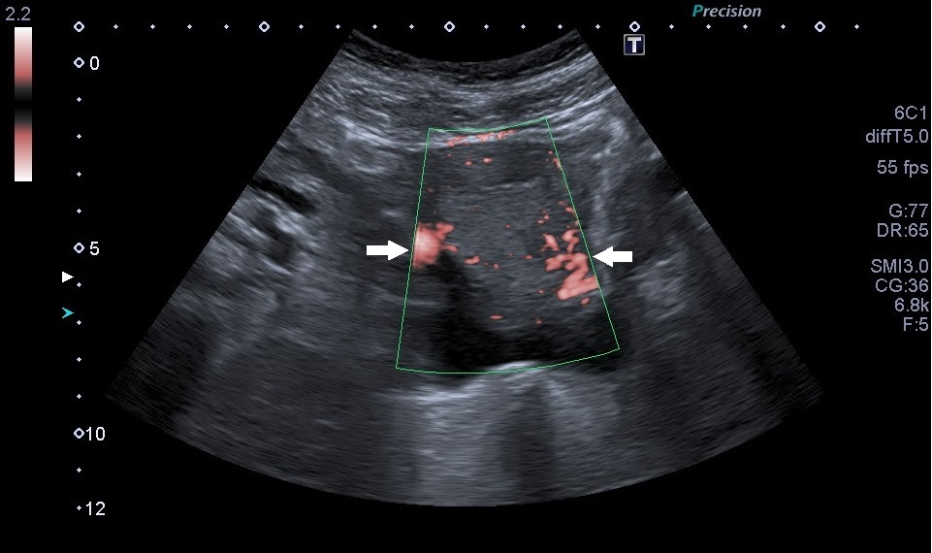
Figure 1 Doppler ultrasound scan of the uterine graft showing perfusion present on both sides of the graft. Uterine arteries (white arrows).

A
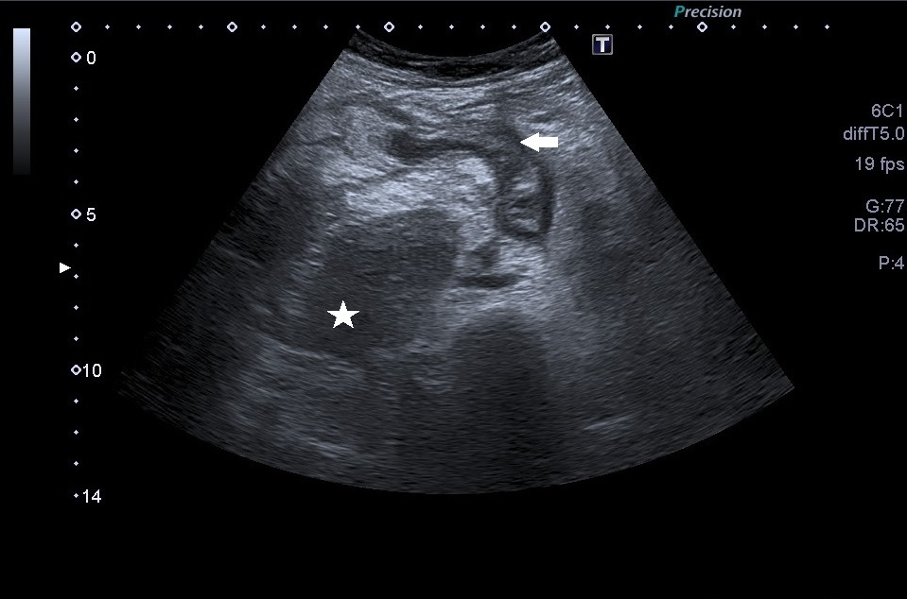

B
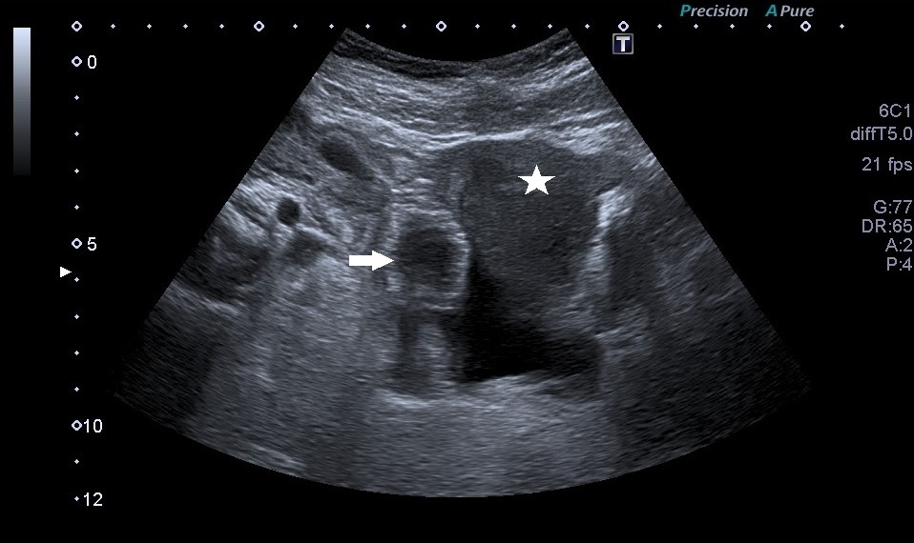
Figure 2 Ultrasound scan. A: A suspected inflamed appendix next to the uterine graft. Suspected inflamed appendix in a longitudinal view (arrow); the uterine graft (star); B: A suspected inflamed appendix next to the uterine graft. Suspected appendicitis in a transversal view (arrow); the uterine graft (star).

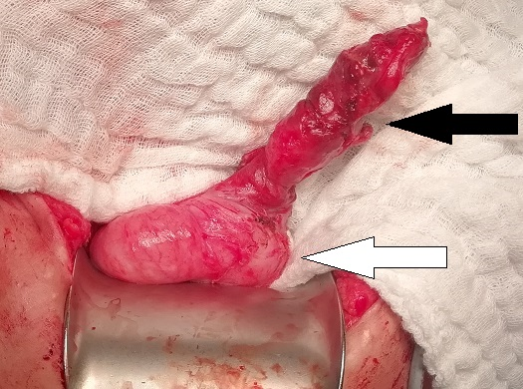
Figure 3 A photo of the appendix. A perforation of the appendix (black arrow); the base of the caecum (white arrow).
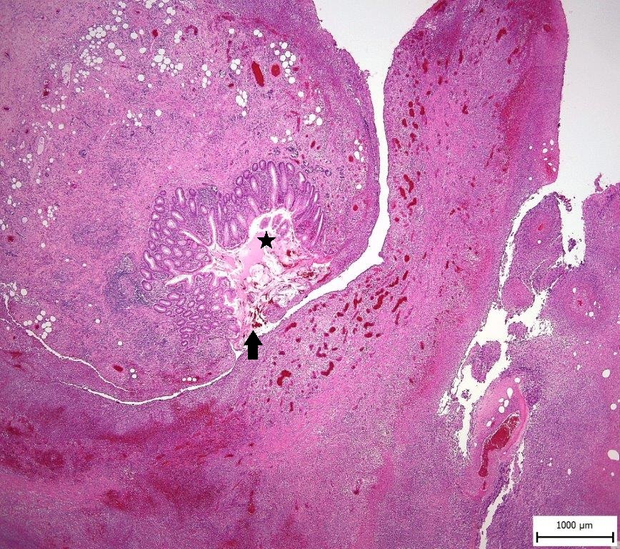
Figure 4 A histological section of the appendix; acute gangrenous appendicitis with perforation of its wall, purulent fibrinous periappendicitis. (Hematoxylin eosin, magnitude 20 ×). A perforation of the appendix (arrow); the lumen of the appendix (star).

