Name of Journal: World Journal of Gastroenterology
Manuscript NO: 60026
Manuscript Type: CASE REPORT

Vedolizumab in Crohn’s disease with rectal fistulas and presacral abscess: A case report

Yeh H et al. Vedolizumab fistulizing CD presacral abscess

Heng Yeh, Chia-Jung Kuo, Ren-Chin Wu, Chien-Ming Chen, Wen-Sy Tsai, Ming-Yao Su, Cheng-Tang Chiu, Puo-Hsien Le

Heng Yeh, School of Medicine, Chang Gung University, Taoyuan City 333323, Taiwan

Chia-Jung Kuo, Cheng-Tang Chiu, Puo-Hsien Le, Department of Gastroenterology and Hepatology, Chang Gung Memorial Hospital, Linkou Branch, Taoyuan 333, Taiwan

Chia-Jung Kuo, Ming-Yao Su, Cheng-Tang Chiu, Puo-Hsien Le, Taiwan Association of the Study of Small Intestine Disease, Taoyuan 333, Taiwan

Ren-Chin Wu, Department of Pathology, Chang Gung Memorial Hospital, Linkou Branch, Taoyuan 333, Taiwan

Chien-Ming Chen, Department of Medical Imaging and Intervention, Chang Gung Memorial Hospital, Linkou Branch, Taoyuan 333, Taiwan

Wen-Sy Tsai, Department of Colon and Rectal Surgery, Chang Gung Memorial Hospital, Linkou Branch, Taoyuan 333, Taiwan

Ming-Yao Su, Department of Gastroenterology and Hepatology, Chang Gung Memorial Hospital, Tucheng Branch, New Taipei City 236017, Taiwan

Puo-Hsien Le, Liver Research Center, Chang Gung Memorial Hospital, Linkou Branch, Taoyuan 333, Taiwan

Author contributions: Yeh H wrote up the first draft, revise the drafts, and a major contributor in writing the manuscript; Kuo CJ contributed acquisition and analyze the data; Wu RC contributed interpret the histological examination of the biopsy samples; Chen CM contributed acquisition and analyze the images; Tsai WS, Su MY and Chiu CT contributed acquisition and analyze the data; Le PH contributed study design, interpretation of the data, revised the drafts of the paper and a major contributor in writing the manuscript.

Corresponding author: Puo-Hsien Le, MD, Assistant Professor, Department of Gastroenterology and Hepatology, Chang Gung Memorial Hospital, Linkou Branch, No. 5 Fuxing Street, Guishan District, Taoyuan 333, Taiwan. puohsien@gmail.com

Received: October 12, 2020
Revised: December 8, 2020
Accepted: January 6, 2021
Published online:

Abstract
BACKGROUND
Fistula and intraabdominal fistula are common complications of Crohn’s disease (CD), but complex rectal fistula with abscess formation is rare. Tumor necrosis factor antagonists combined with percutaneous drainage or surgical intervention is optimal treatment for fistulizing CD with intraabdominal abscess. There is no study show the efficacy of vedolizumab in such complicated condition.

CASE SUMMARY
A 47-year-old man has decompensated liver cirrhosis, child B. He suffered from abdominal pain, bloody diarrhea, fever, and body weight loss. CD with rectoprostatic fistula, rectopresacral fistula, pre-sacral abscess and cytomegalovirus (CMV) infection were noted. He received antibiotics, anti-viral therapy, transverse colostomy and vedolizumab treatment. Six months later, he had deep remission and complete fistula tracts closure.

CONCLUSION
Early vedolizumab and stool diversion are effective and safe in treating CD with complex rectal fistula with abscess formation.

Key Words: Vedolizumab; Crohn's disease; Rectoprostatic fistula; Rectal pre-sacral fistula; Pre-sacral abscess; Case report

Yeh H, Kuo CJ, Wu RC, Chen CM, Tsai WS, Su MY, Chiu CT, Le PH. Vedolizumab in Crohn’s disease with rectal fistulas and presacral abscess: A case report. World J Gastroenterol 2021; In press

Core Tip: Fistulas and intraabdominal fistulas are common complications of Crohn’s disease (CD) and tumor necrosis factor antagonists combined with percutaneous drainage or surgical intervention is the optimal treatment for fistulizing CD with intraabdominal abscess. However, no previous study has reported the efficacy of vedolizumab in this complicated situation. This 47-year-old male presented with CD with complex fistulas and pre-sacral abscess. He received vedolizumab with transverse colostomy and the follow-up sigmoidoscopy 6 mo later showed mucosal healing without any visible fistula tracts. We think early vedolizumab treatment with stool diversion are effective and safe in treating CD with complex fistulas and abscess formation.
INTRODUCTION
Fistula affects up to 50% Crohn’s disease (CD) patients within 20 years of initial diagnosis^{[1,2]}. It includes perianal, rectovaginal, enterocutaneous and internal fistula, but no rectoprostatic fistula or rectopresacral fistula were reported. The treatment of fistula usually requires a combination of medical and surgical approach^{[3]}. As far as medical treatment is concerned, tumor necrosis factor (TNF) antagonists are most effective to treat fistulizing CD^{[4]}. However, some studies also noted the beneficial effect of vedolizumab for fistulizing CD^{[5,6]}. We presented the patient of CD, complicated with rectoprostatic fistula, rectopresacral fistula and presacral abscess. He had complete fistula closure and deep remission after transverse colostomy and vedolizumab treatment for six months.

CASE PRESENTATION
Chief complaints
Low abdominal pain and intermittent bloody stool for 6 mo.

History of present illness
A 47-year-old man has decompensated liver cirrhosis, child B, hepatitis C virus (HCV) and alcoholism related, complicated with hypoalbuminemia, hyperbilirubinemia, coagulopathy, thrombocytopenia, splenomegaly and esophageal varices, Form 1. He complained low abdominal pain and intermittent bloody stool for 6 mo. Appendicitis was diagnosed in local hospital, and he received appendectomy on 16th November 2019. However, he suffered from progressive low abdominal pain, bloody stool, dizziness, and intermittent fever up to 38 °C for four days. He also mentioned body weight loss 20 kg within one year. He was brought to our emergent department.

History of past illness
Decompensated liver cirrhosis, child B, hepatitis C virus infection and alcoholism.

Personal and family history
Appendicitis was diagnosed in local hospital, and he received appendectomy on 16th November 2019.

Laboratory examinations
Lab data revealed hemoglobin 10.1 g/dL, platelet 66000/μL, white blood cell 7700/μL, segment 68.7%, lymphocyte 23.7%, international normalized ratio (INR) 1.5, aspartate aminotransferase (AST) 55 U/L, alanine aminotransferase (ALT) 95 U/L, total bilirubin 2.1 mg/dL, albumin 2.38 g/dL and CRP 22.81 mg/L. Cytomegalovirus (CMV) immunoglobulin (Ig) M, CMV DNA, Epstein-Barr virus (EBV)-VCA IgM, EBV DNA, human immunodeficiency virus (HIV) antibody (Ab), amebic Ab, Clostridium difficile toxin, culture for Salmonella, Shigella and Campylobacter were all negative. Positive CMV IgG, EBV-VCA IgG, stool pus stool and occult blood were noted.

Imaging examinations
Colonoscopy showed terminal ileal shallow ulcer (Figure 1A) and multiple complex rectal fistula tracts (Figure 1B and C) on 10th December 2019. Magnetic resonance imaging (MRI) noted decompensated liver cirrhosis with ascites (Figure 2A), rectoprostatic fistula (Figure 2B), rectopresacral fistula (Figure 2C) and pre-sacral abscess (Figure 2D) on 21th December 2019. Pathology revealed acute on chronic inflammation with granulation tissue, compactable with CD (Figure 3A). Besides, there was positive result of CMV immunohistochemistry (IHC) staining (Figure 3B), which was performed with a monoclonal antibody directed against the CMV pp65 antigen (Novocastra™ lyophilized mouse monoclonal antibody; Leica Microsystems, Wetzlar, Germany).

FINAL DIAGNOSIS
He was diagnosed to have CD and CMV colitis by endoscopy and pathological findings. The CD activity index (CDAI) was 526 points and Harvey-Bradshaw index (HBI) was 22 points. He also had rectoprostatic fistula, rectopresacral fistula and pre-sacral abscess diagnosed by MRI findings.

TREATMENT
He refused percutaneous abscess fine needle aspiration, and we kept Tazocin for abscess treatment for 27 d. Because of positive CMV IHC staining result, he also received intravenous ganciclovir for 17 d and then valganciclovir po treatment for two months. Transverse colostomy was performed for stool diversion on 25th December 2019. He couldn’t tolerant azathioprine due to pancytopenia and vedolizumab (300 mg 8 wk) was prescript since 22th January 2020.

OUTCOME AND FOLLOW-UP
Follow-up sigmoidoscopy showed mucosal healing without any fistula tract (Figure 1D) on 9th July 2020. The pathologist reported minimal inflammatory activity (Figure 3C). Lower gastrointestinal series mentioned no more fistula tract (Figure 4) on 21th July 2020. There was no more rectoprostatic or rectopresacral fistula (Figure 5A) and pre-sacral abscess (Figure 5B) in MRI. After vedolizumab treatment for 6 mo, the CDAI was 42 points and HBI score was 0 point. His body weight body also increased 20 kg, back to the same level before the episode.

DISCUSSION
Fistulizing CD results in not only high morbidity but also impaired health-related quality of life^{[4]}. Biologics combined with surgical intervention seems to be the best resolution. Although Infliximab has strongest evidence in fistulizing CD treatment^{[7,8]}, vedolizumab also showed its efficacy in some studies^{[5,6]}. However, vedolizumab has better safety profiles (less severe adverse events and infections) in real world studies^{[9,10]}.
Intra-abdominal abscess occurs in up to 20% of patients with CD^{[11,12]}. Adequate percutaneous drainage combined with early adalimumab treatment achieves up to 74% successful rate^{[13]}. In this case, it was difficult to drain the presacral abscess and patient refused, too. Therefore, we chose vedolizumab with transverse colostomy in treating the complex rectal fistula and presacral abscess without abscess drainage.
This patient received vedolizumab treatment one month after confirmed the diagnosis. Earlier initiation of biological treatment shortly after diagnosis (less than one year) in patients with moderately to severely active CD leads to improved long-term clinical outcomes^{[14]}. Besides, early stool diversion with transverse colectomy and early anti-viral treatment for CMV infection were crucial to achieve the good outcome in this case.

CONCLUSION
Vedolizumab with loop transverse colostomy was effective in treating CD with complex rectal fistulas with pre-sacral abscess. Besides, early biological and anti-CMV treatments might also lead to the favorable outcome.

REFERENCES
1 Siegmund B, Feakins RM, Barmias G, Ludvig JC, Teixeira FV, Rogler G, Scharl M. Results of the Fifth Scientific Workshop of the ECCO (II): Pathophysiology of Perianal Fistulizing Disease. J Crohns Colitis 2016; 10: 377-386 [PMID: 26681764 DOI: 10.1093/ecco-jcc/jjv228]
2 Schwartz DA, Loftus EV Jr, Tremaine WJ, Panaccione R, Harmsen WS, Zinsmeister AR, Sandborn WJ. The natural history of fistulizing Crohn's disease in Olmsted County, Minnesota. Gastroenterology 2002; 122: 875-880 [PMID: 11910338 DOI: 10.1053/gast.2002.32362]
3 Gecse KB, Bemelman W, Kamm MA, Stoker J, Khanna R, Ng SC, Panés J, van Assche G, Liu Z, Hart A, Levesque BG, D'Haens G; World Gastroenterology Organization, International Organisation for Inflammatory Bowel Diseases IOIBD, European Society of Coloproctology and Robarts Clinical Trials; World Gastroenterology Organization International Organisation for Inflammatory Bowel Diseases IOIBD European Society of Coloproctology and Robarts Clinical Trials. A global consensus on the classification, diagnosis and multidisciplinary treatment of perianal fistulising Crohn's disease. Gut 2014; 63: 1381-1392 [PMID: 24951257 DOI: 10.1136/gutjnl-2013-306709]
4 Vavricka SR, Rogler G. Fistula treatment: The unresolved challenge. Dig Dis 2010; 28: 556-564 [PMID: 20926886 DOI: 10.1159/000320416]
5 Schwartz D, Peyrin-Biroulet L, Lasch K, Adsul S, Danese S. P476 Efficacy and safety of 2 vedolizumab IV regimens in patients with perianal fistulising Crohn’s disease: results of the ENTERPRISE study. J Crohns Colitis 2020; 14: S418-S419 [DOI: 10.1093/ecco-jcc/jjz203.605]
6 Feagan BG, Schwartz D, Danese S, Rubin DT, Lissoos TW, Xu J, Lasch K. Efficacy of Vedolizumab in Fistulising Crohn's Disease: Exploratory Analyses of Data from GEMINI 2. J Crohns Colitis 2018; 12: 621-626 [PMID: 29471381 DOI: 10.1093/ecco-jcc/jjy019]
7 Present DH, Rutgeerts P, Targan S, Hanauer SB, Mayer L, van Hogezand RA, Podolsky DK, Sands BE, Braakman T, DeWoody KL, Schaible TF, van Deventer SJ. Infliximab for the treatment of fistulas in patients with Crohn's disease. N Engl J Med 1999; 340: 1398-1405 [PMID: 10228190 DOI: 10.1056/nejm199905063401804]
8 Sands BE, Anderson FH, Bernstein CN, Chey WY, Feagan BG, Fedorak RN, Kamm MA, Korzenik JR, Lashner BA, Onken JE, Rachmilewitz D, Rutgeerts P, Wild G, Wolf DC, Marsters PA, Travers SB, Blank MA, van Deventer SJ. Infliximab maintenance therapy for fistulizing Crohn's disease. N Engl J Med 2004; 350: 876-885 [PMID: 14985485 DOI: 10.1056/NEJMoa030815]
9 Yarur A, Mantzaris G, Silverberg M, Walshe M, Zezos P, Stein D, Bassel M, Lissoos T, Lopez C, Natsios A, Radulescu G, Patel H, Demuth D, Bressler B. P573 Real-world effectiveness and safety of vedolizumab and anti-TNF in biologic-naive ulcerative colitis patients: Results from the EVOLVE study. J Crohns Colitis 2019; 13: S400-S401 [DOI: 10.1093/ecco-jcc/jjy222.697]
10 Helwig U, Mross M, Schubert S, Hartmann H, Brandes A, Stein D, Kempf C, Knop J, Campbell-Hill S, Ehehalt R. Real-world clinical effectiveness and safety of vedolizumab and anti-tumor necrosis factor alpha treatment in ulcerative colitis and Crohn's disease patients: a German retrospective chart review. BMC Gastroenterol 2020; 20: 211 [PMID: 32640990 DOI: 10.1186/s12876-020-01332-w]
11 Hurst RD, Molinari M, Chung TP, Rubin M, Michelassi F. Prospective study of the features, indications, and surgical treatment in 513 consecutive patients affected by Crohn's disease. Surgery 1997; 122: 661-7; discussion 667-8 [PMID: 9347840 DOI: 10.1016/s0039-6060(97)90071-4]
12 Yamaguchi A, Matsui T, Sakurai T, Ueki T, Nakabayashi S, Yao T, Futami K, Arima S, Ono H. The clinical characteristics and outcome of intraabdominal abscess in Crohn's disease. J Gastroenterol 2004; 39: 441-448 [PMID: 15175942 DOI: 10.1007/s00535-003-1317-2]
13 Pineton de Chambrun G, Pariente B, Seksik P, Altwegg R, Vuitton L, Stefasnescu C, Nancey S, Aubourg A, Serrero M, Peyrin-Biroulet L, Filippi J, Viennot S, Abitbol V, Boualit M, Boureille A, Moreau J, Buisson A, Roblin X, Nachury M, Zappa M, Lambert J, Bouhnik Y; GETAID-MICA study group. Adalimumab for patients with Crohn's disease complicated by intra-abdominal abscess: a multicentre, prospective, observational cohort study. J Crohns Colitis 2019; 13: S616 [PMID: 30794285 DOI: 10.1093/ecco-jcc/jjz045]
14 Panaccione R, Löfberg R, Rutgeerts P, Sandborn WJ, Schreiber S, Berg S, Maa JF, Petersson J, Robinson AM, Colombel JF. Efficacy and Safety of Adalimumab by Disease Duration: Analysis of Pooled Data From Crohn's Disease Studies. J Crohns Colitis 2019; 13: 725-734 [PMID: 30753371 DOI: 10.1093/ecco-jcc/jjy223]

Footnotes
Informed consent statement: The study participant provided informed written consent prior to study enrollment.

Conflict-of-interest statement: The authors have no conflict of interest to declare.

CARE Checklist (2016) statement: The authors have read the CARE Checklist (2016), and the manuscript was prepared and revised according to the CARE Checklist (2016).

Open-Access: This article is an open-access article that was selected by an in-house editor and fully peer-reviewed by external reviewers. It is distributed in accordance with the Creative Commons Attribution NonCommercial (CC BY-NC 4.0) license, which permits others to distribute, remix, adapt, build upon this work non-commercially, and license their derivative works on different terms, provided the original work is properly cited and the use is non-commercial. See: http://creativecommons.org/Licenses/by-nc/4.0/

Manuscript source: Unsolicited manuscript

Corresponding Author's Membership in Professional Societies: Taiwan Association of the Study of Small Intestinal Disease.

Peer-review started: October 12, 2020
First decision: November 23, 2020
Article in press:

Specialty type: Gastroenterology and hepatology
Country/Territory of origin: Taiwan
Peer-review report’s scientific quality classification
Grade A (Excellent): 0
Grade B (Very good): B, B
Grade C (Good): 0
Grade D (Fair): 0
Grade E (Poor): 0

P-Reviewer: Funel N, Makhlouf NA S-Editor: Gao CC L-Editor: P-Editor:
Figure Legends
A
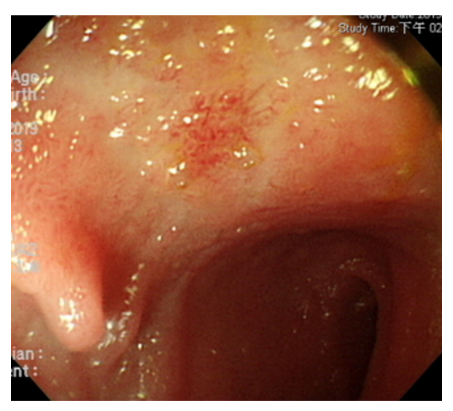
B
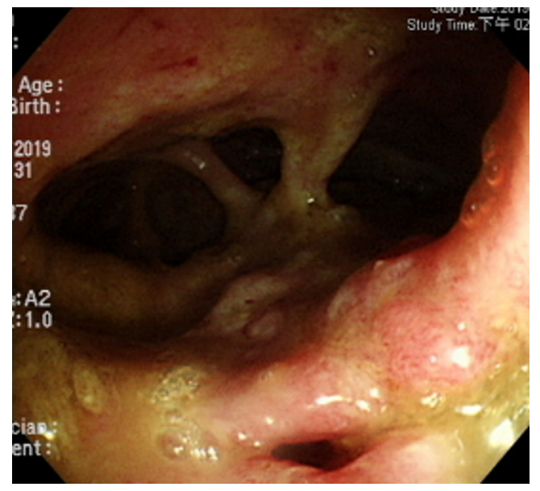
C
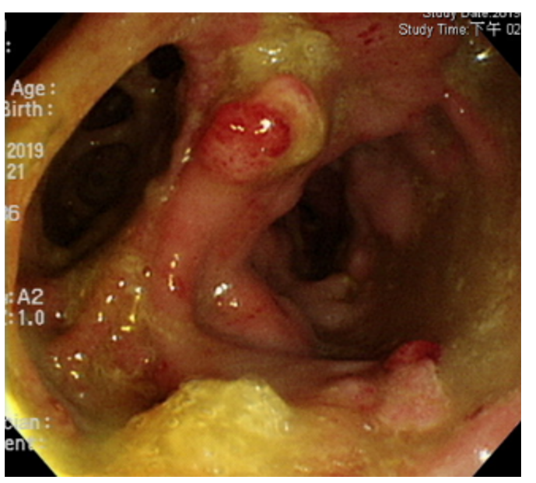
D
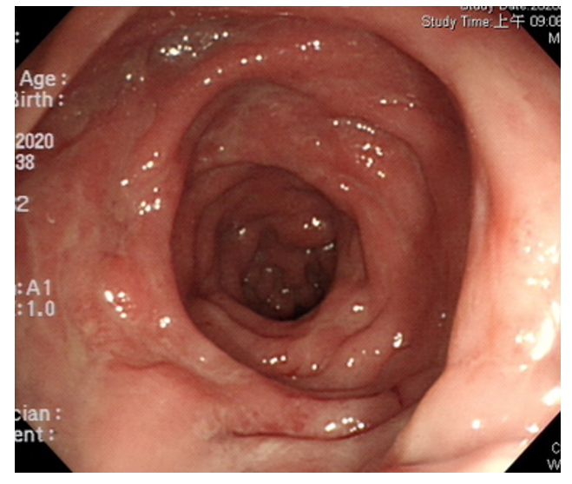
Figure 1 Endoscopic findings. A: Terminal ileal shallow ulcer at diagnosis; B and C: Multiple rectal fistula tracts with inflammation; D: Mucosal healing without fistula tracts six months after vedolizumab treatment, severe months after diagnosis.
A
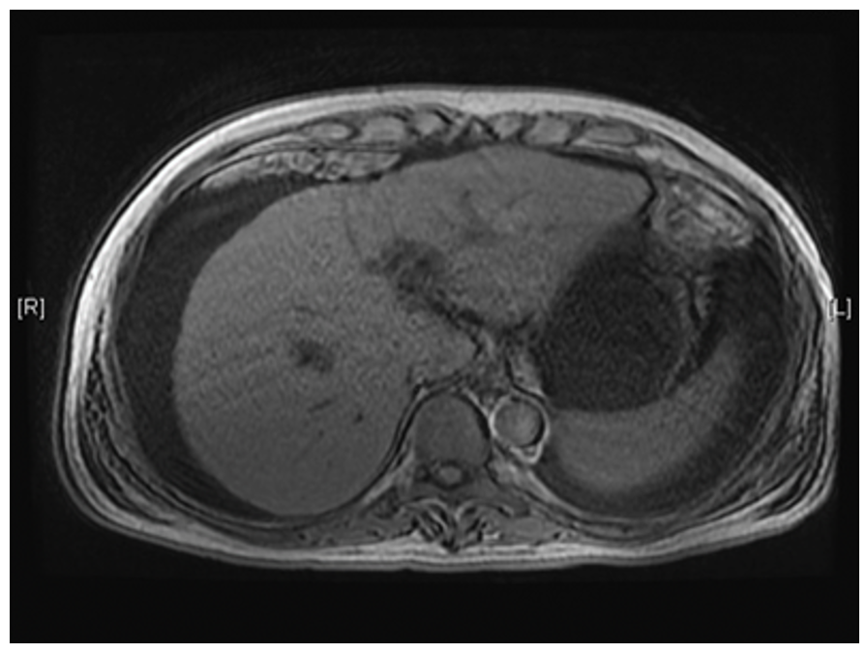
B
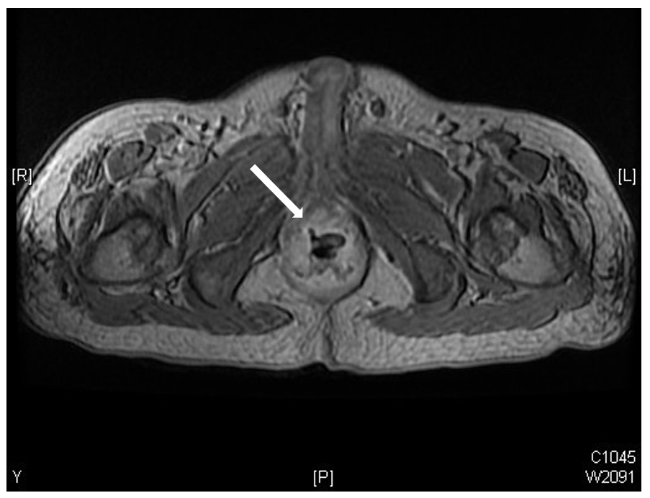
C
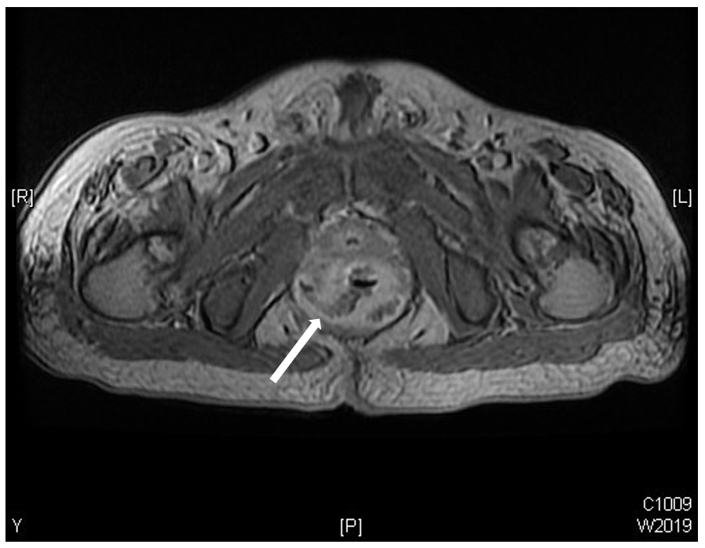
D
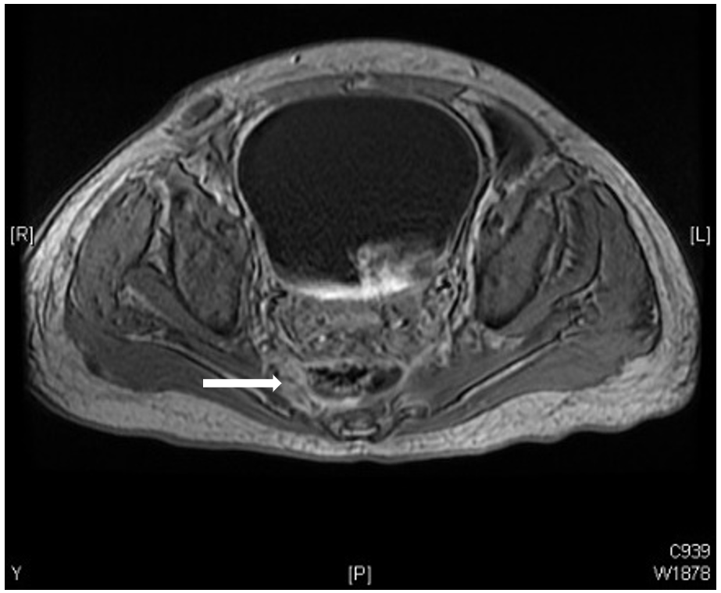
Figure 2 Magnetic resonance imaging at diagnosis. A-D: Liver cirrhosis (A) with ascites rectoprostaticfistula (B) rectopresacral fistula (C) with abscess pre-sacral abscess(D).
A
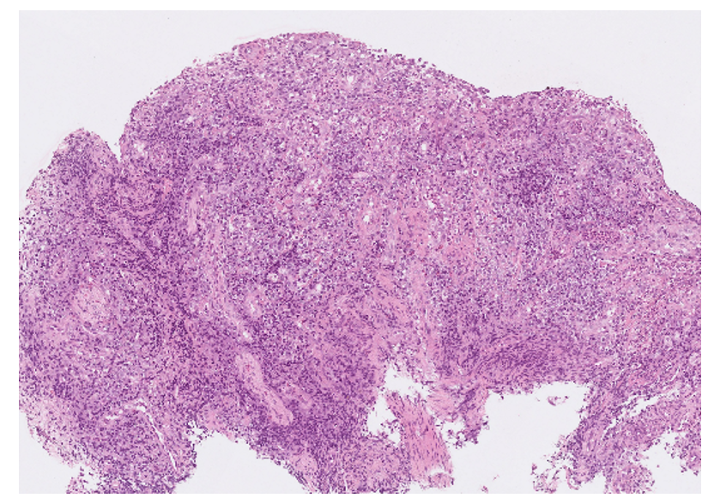
B
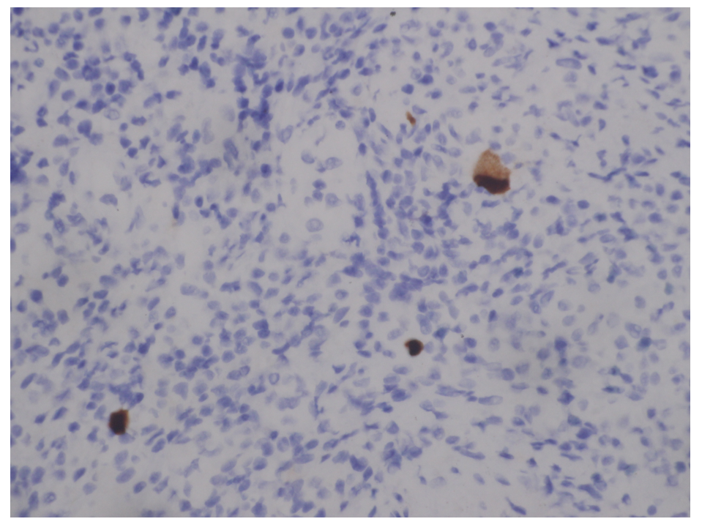
C
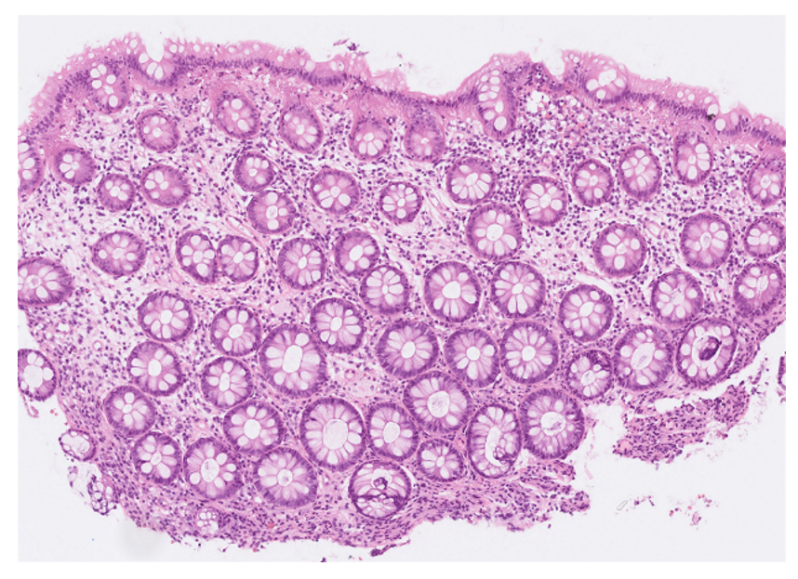
Figure 3 Patholog. A: Ulcer with acute on chronic inflammation and granulation tissue at diagnosis; B: Pathological presentations of cytomegalovirus (CMV) infection, immunohistochemistry stain (20 × objective) was performed with 1:200 diluted Novocastra™ lyophilized mouse monoclonal antibody against CMV pp65 antigen and showed strong focal CMV immunoreactivity with brownish areas; C: Minimal inflammatory cells infiltration six months after vedolizumab treatment, severe months after diagnosis.
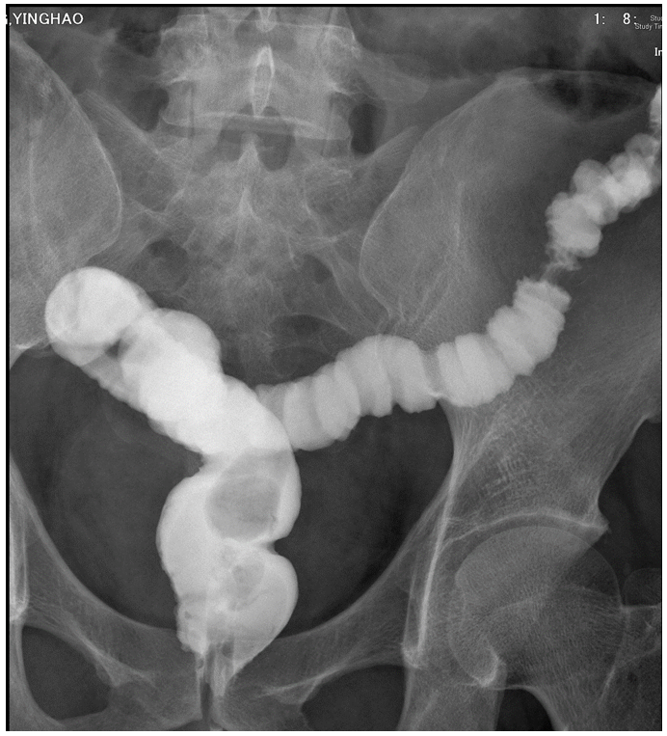
Figure 4 Lower gastrointestinal series showed no more rectal fistula tract.
A
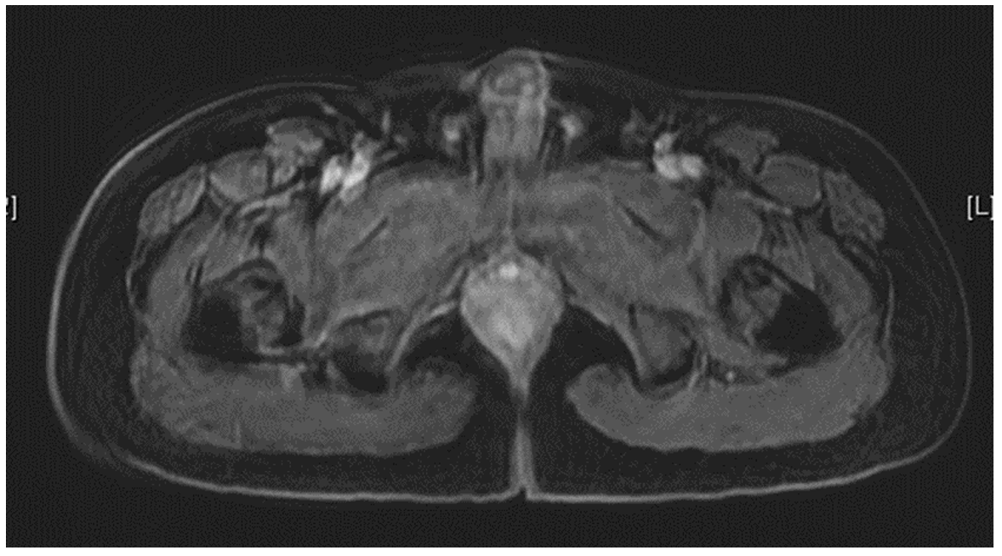
B
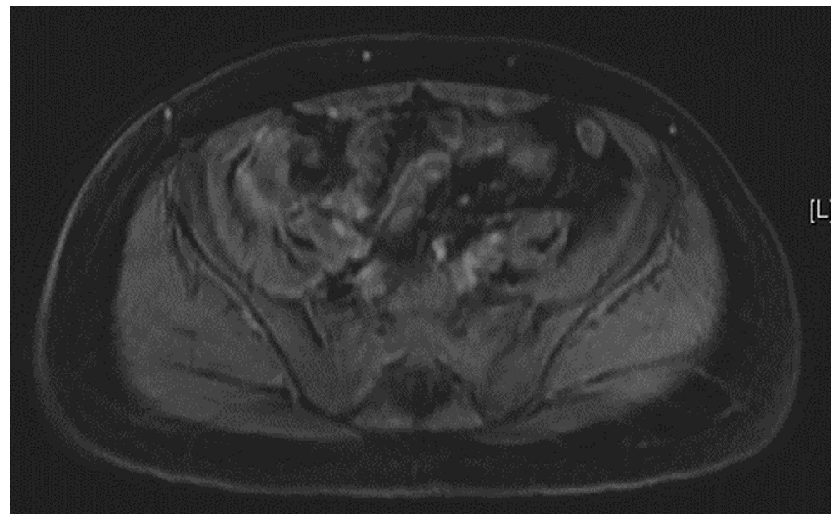
Figure 5 Magnetic resonance imaging seven months after diagnosis. A: No more rectal fistula tract; B: No more pre-sacral abscess.

