Name of Journal: World Journal of Hepatology
Manuscript NO: 56310
Manuscript Type: ORIGINAL ARTICLE

Observational Study
Novel markers of endothelial dysfunction in hepatitis C virus-related cirrhosis: More than a mere prediction of esophageal varices

Hanafy AS et al. Endothelial dysfunction in liver cirrhosis

Amr ShaabanHanafy, Mohamed Abdel KhalikBasha, Fady Maher Wadea

Amr ShaabanHanafy, Fady Maher Wadea, Department of Internal Medicine, Gastroenterology and Hepatology Division, Zagazig University Hospital, Zagazig 44519, Egypt

Mohamed Abdel KhalikBasha, Department of Diagnostic Radiology, Zagazig University, Zagazig 44519, Egypt

Author contributions: Hanafy AS was the guarantor; Hanafy AS, and Wadea FM were involved in the study concept and design; Hanafy AS, Basha MAK, and Wadea FM participated in the acquisition, analysis, and interpretation of the data, and drafted the initial manuscript; Hanafy AS performed the statistical analysis; Basha MAK was responsible for radiological investigations; all authors revised the article critically for important intellectual content.

Corresponding author: Amr ShaabanHanafy, MD, Assistant Professor, Department of Internal Medicine, Gastroenterology and Hepatology Division, Zagazig University Hospital, 40- Elzohour treet,Zagazig 44519,Egypt. amrhanafy@zu.edu.eg

Received: April 29, 2020
Revised: July 15, 2020
Accepted: August 24, 2020
Published online:

Abstract
BACKGROUND
Hepatitis C virus (HCV) infection may affect lipid metabolism by enhancing the circulating levels of inflammatory cytokines, together with its impact on endothelial function.

AIM
To evaluate the potential correlation of changes in lipid profile, carotid intima-media thickness (CIMT), and ankle-brachial index with the severity of fibrosis, grades of esophageal varices (EVs), and fibrosis indices.

METHODS
The study included 240 subjects who were divided into 3 groups; group 1 (n = 90, HCV-related cirrhotic patients with EVs), group 2 (n = 90, HCV-related cirrhotic patients without EVs), and group 3 (n = 60, served as the healthy control group). All patients underwent routine laboratory tests, including a lipid profile assay. Low-density lipoproteins (LDL)/platelet count and platelet/splenic diameter ratios were calculated. Abdominal ultrasonography, CIMT by carotid Doppler, bedside ankle-brachial index (ABI), liver stiffness measurement, and upper gastrointestinal endoscopy were performed.

RESULTS
Multivariate logistic regression revealed that very-low-density lipoprotein (VLDL) (β=0.988, odds ratio 2.5, P=0.001), LDL/platelet count ratio (β = 1.178, odds ratio 3.24, P=0.001), CIMT (β=1.37, odds ratio 3.9, P=0.001), and ABI (β=2.3, odds ratio 5.9, P=0.001) were the key variables associated with significant fibrosis, EVs and endothelial dysfunction. CIMT and LDL/platelet count ratio were predictive of advanced fibrosis and EVs at cutoff values of 1.1 mm and 1 mm, respectively, with an area under the curve (AUC) of 0.966 and 0.960 (P=0.001), while VLDL and ABI at a cutoff of 16.5 mg/dL and 0.94 were predictive of advanced fibrosis and EVs with an AUC of 0.891 and 0.823, respectively (P=0.001).

CONCLUSION
CIMT, ABI, VLDL, LDL/platelet count ratio are good non-invasive predictors of advanced fibrosis, presence of EVs, and endothelial dysfunction in liver cirrhosis.

Key words: Lipid profile; Liver cirrhosis; Esophageal varices; Carotid-intima media thickness; Ankle-brachial index

Hanafy AS, Basha MAK, Wadea FM. Novel markers of endothelial dysfunction in hepatitis C virus-related cirrhosis: More than a mere prediction of esophageal varices. World J Hepatol 2020; In press

Core tip: Hepatitis C virus (HCV) infection may affect lipid metabolism by enhancing the circulating levels of inflammatory cytokines. HCV may induce endothelial dysfunction. Carotid intima-media thickness, low-density lipoproteins (LDL)/platelet count ratio, ankle-brachial index, and very LDL were predictive of advanced fibrosis, esophageal varices, and endothelial dysfunction at cutoff values of 1.1 mm, 1, 0.94, and 16.5 mg/dL, respectively. Novel markers provide information beyond the previous traditional markers such as platelet count, FIB-4, and platelet/splenic diameter ratio with additional data regarding endothelial dysfunction and subclinical atherosclerosis.

INTRODUCTION
Hepatitis C virus (HCV) infection represents a major public health burden with an estimated global prevalence of 2.8% resulting in more than 185 million infected patients^{[1]}. Prompt recognition of vascular changes in patients with significant liver fibrosis is required for directing therapy and follow-up against both cardiovascular disease and esophageal varices (EVs).
Chronic HCV infection is associated with a chronic inflammatory state leading to a disproportion of pro-inflammatory/anti-inflammatory cytokines ratio. Also, lipid abnormalities, insulin resistance (IR), and increased risk of atherosclerosis have been described in chronic HCV^{[2,3]}.
HCV may trigger atherosclerosis through the production of intracellular adhesion molecules, anti-endothelial antibodies, oxidative stress generation, and IR^{[4,5]}. Increased carotid intima-media thickness (CIMT) represents an initial ultrasonographic sign of atherosclerosis that can be easily evaluated at the bedside. Previously, HCV RNA was isolated from carotid plaques from patients infected with HCV^{[6,7]}.
HCV is a hybrid molecule composed of viral and lipoprotein components (lipoviroparticles); the latter resemble very low-density lipoproteins (VLDLs) and low-density lipoproteins (LDLs)^{[8]}, and conjugate with cell surface receptors mainly scavenger receptor class B member 1 protein and the LDL receptor^{[9]}, the latter binds to either the lipoprotein component of the viral particle or the hyper-variable region 1 of glycoprotein E2^{[10]}.
HCV infection causes a defect in intrahepatic cholesterol synthesis due to its employment in viral replication, with a later decrease in the available cholesterol for peripheral delivery via VLDL and this stimulates more expression of LDL receptors and an increase in LDL uptake by the liver accounting for the decreased serum LDL; therefore, sustained virological response (SVR) may cause a rebound increase in lipid levels^{[11]}. VLDL level may be low in advanced liver diseases due to decreased synthesis and therefore it can be used as a marker of advanced fibrosis^{[12,13]}.
In addition to predicting EVs and fibrosis severity, the objective of this study was to determine predictive markers of vascular changes and endothelial dysfunction in HCV-related cirrhosis.

MATERIALS AND METHODS
Study aim
Evaluation of the association of changes in lipid profile, CIMT and ankle-brachial index (ABI) with the severity of fibrosis, grades of EVs, and fibrosis indices.

Study design
This cross-sectional case-control study was conducted in the Gastroenterology and Hepatology Clinic, Department of Internal Medicine, Faculty of Medicine, Zagazig University Hospitals during the period from November 2018 to December 2019. The research protocol (IRB-255-2018) was accepted by the Zagazig Faculty of Medicine Ethical Committee.
All procedures were carried out under the Zagazig University's ethical principles and in compliance with the Helsinki declaration and its more recent modifications. Informed consent was obtained from each patient who participated in the study.

Patient population
The study included chronic HCV infected patients (n=180) and 60 healthy subjects as a control group, all were matched for age, sex, and body mass index.Diagnosis of liver cirrhosis was based on clinical, laboratory, ultrasonographic, and FibroScan features. Eligible patients obtained a diagnosis of liver cirrhosis secondary to HCV infection proven by a positive anti-HCV test and HCV-RNA in serum, and were divided into 2 groups: Group 1 which included 90 cirrhotic patients complicated with EVs and group 2 which included 90 cirrhotic patients without EVs. Group 3 included the control subjects.

Exclusion criteria
Smoking, obesity, patients with other diseases that may alter serum lipid levels such as diabetes, non-alcoholic fatty liver disease or chronic alcohol consumption, any patients who had previously received anti-viral therapy for HCV or had been cured of HCV which may induce a rebound increase in serum lipids, lipid-lowering medications, recipients of solid organ transplantation and patients who had refused to participate in the study.

Laboratory analysis
Routine laboratory tests were performed including liver and kidney function tests, full blood count, and coagulation profile. LDL-C was calculated using the Friedewald formula: LDL-C (mg/dL) = Total cholesterol–(HDL-C)–(triglycerides/5)^{[14]}. The LDL/platelet count ratio was also calculated. VLDL cholesterol was estimated by dividing the TGs/5if the TGs were lower than 450 mg/dL^{[15]}.

Abdominal ultrasonography
The ultrasonographic features of liver cirrhosis or the presence of ascites were documented. Criteria for portal hypertension were defined as portal vein diameter greater than 13 mm, splenic bipolar diameter greater than 130 mm or the presence of portal venous collaterals^{[16]}.

Carotid artery intima-media thickness
Common carotid arteries were evaluated on both sides by an experienced radiologist who was blinded to clinical data using B-mode duplex ultrasound with a 7.5MHz linear probe (Siemens G60®). CIMT was measured from the intima lumen interface to the media adventitia interface; with a value > 0.9 mm considered abnormal. Three measures were obtained on either side; the mean CIMT was defined as the mean right and left CIMT^{[17]}.

Non-invasive documentation of liver fibrosis
Liver stiffness measurement: Liver stiffness measurement was performed by an experienced physician who was blinded to the clinical data of the patients using FibroScan®. Fibrosis stages F0-1; F2; F3 and F4 or cirrhosis were defined by the spectrum of liver stiffness values 2.5-7, 7-9.5, 9.5-12.5 and>12.5 kPa, respectively^{[18]}.

Traditional non-invasive tools
Fibrosis index-4: This was calculated by the following equation using 4 factors: [age (year)×aspartate aminotransferase (U/L)]/[platelet count (PLT) (10⁹/L)]×[alanine aminotransferase (U/L)]. A fibrosis index-4 (FIB-4) score < 1.45 displayed a negative predictive value of 90% for advanced fibrosis, however, a FIB-4 > 3.25 had a 97% specificity and a positive predictive value of 65% for advanced fibrosis^{[19]}.

PLT/splenic diameter ratio: The PLT/splenic diameter (PLT/SD) ratio was calculated by dividing the number of platelets (μL) by the maximum bipolar diameter of the spleen in millimeters, detected by abdominal ultrasound.

Upper gastrointestinalendoscopy
EVs were diagnosed and graded from grade I to grade IV, using the Paquet grading system^{[20]}.

Assessment of endothelial dysfunction
Endothelial dysfunction can be evaluated by flow-mediated dilatation in the brachial artery using high-resolution ultrasound or simply by bedside ABI which is considered an easy and cost-effective method for assessing endothelial dysfunction^{[21]}.The patient remained in the supine position for 5 min and the blood pressure cuff was applied to the arm and lower calf, then the stethoscope was used to measure the systolic pressure in the brachial and dorsalis pedis arteries of both sides. ABI was calculated by dividing the highest value of pressure in the dorsalis pedis arteries by the highest brachial pressure. The normal ABI is over 1 and the cutoff value to diagnose peripheral arterial disease is ≤ 0.90 at rest with a sensitivity of 95% and specificity of 100%, values > 1.40 suggest arteriosclerosis mainly seen in diabetes or chronic renal failure^{[22]}.

Statistical analysis
All data were statistically analyzed using SPSS 20 for Windows (SPSS Inc., Chicago, IL, United States). Quantitative data were expressed as the mean±SD. Qualitative data were expressed as absolute frequencies (number) and (percentage). The F test was performed to compare between more than two groups of normally distributed variables. LSD with Bonferroni correction was applied to detect the difference between groups.
Spearman’s correlation coefficient (r) was performed for ordinal variables and Pearson correlation for continuous variables. Logistic regression analysis was performed by forwarding selection to identify variables independently associated with advanced fibrosis and endothelial dysfunction. All variables with P<0.05 were considered statistically significant.
Receiver operating characteristic curves were plotted and the area under the curve (AUC) was calculated, the performance of the cutoff value was judged by calculation of Youden’s J value; values near 1 indicated good performance (J = sensitivity + specificity – 1). Sensitivity/specificity and positive/negative predictive values for the non-invasive diagnosis of fibrosis, EVs, and endothelial dysfunction were assessed considering liver stiffness as the reference for stages of fibrosis.

RESULTS
Basic demographic, clinical, laboratory and endoscopic findings
The current study included 240 subjects, and the baseline demographic, laboratory, and endoscopic findings of all subjects are summarized in Table 1. A highly significant statistical difference regarding serum transaminases and platelet count was found among the groups with the key significant difference between group 1 (cirrhosis with EVs) and group 2 (cirrhosis without EVs), and group 1 (cirrhosis with EVs) and group 3 (control group) (P= 0.001 and 0.001, respectively).
The total cholesterol and LDL levels were significantly lower in group 1 with a significant difference between groups 1 & 2, and 1 & 3 (P= 0.001 and 0.001, respectively).
VLDL was significantly lower in group 1 with a significant difference between groups 1 & 2, and 1 & 3 (P= 0.001 and 0.001, respectively) and between group 2 & 3 (P= 0.001). Also, the LDL/platelet count ratio was significantly higher in group 1 with a significant difference between groups 1 & 2, and 1 & 3 (P= 0.001 and 0.001, respectively).
FIB-4 values were significantly higher in group 1 with a significant difference between group 1 & 2, and 1 & 3 (P= 0.001 and 0.001, respectively) as presented in Table 1. In addition, ABI was significantly lower in group 1 when compared with group 2 and 3 (Table 1).

Radiological findings
Carotid-intima media thickness was significantly higher in group 1 when compared with group 2 and 3. These results are presented in Figure 1 and Table 2. SD and FibroScan readings (kPa) were significantly higher in cirrhotic patients with EVs with a significant difference between group 1 & 2, and 1 & 3 (P= 0.001 and 0.001), however, the PLT/SD ratio was significantly lower in the same group as presented in Table 2. The cutoff value of the PLT/SD ratio associated with advanced fibrosis and presence of EVs was 872 with a sensitivity of 100%, specificity of 94%, AUC of 0.991, P=0.001, and Youden's J value of 0.94.
Liver stiffness significantly correlated with platelet count (r= -0.615, P=0.001), VLDL (r= -0.619, P=0.001), SD (r=0.534, P=0.001), FIB-4 (r=0.588, P=0.001), CIMT (0.712, P=0.001), LDL/PLT ratio (r=0.677, P= 0.001), and ABI (r = -0.546, P=0.001).

Correlation of the new non-invasive markers to traditional tools
An increasingly significant direct correlation was detected between the LDL/PLT ratio, LS (r=0.677, P=0.001) and FIB4 (r=0.763, P=0.001). On the other hand, a high significant negative correlation was detected between VLDL and LS (r=-0.769, P=0.001) as well as FIB4 (r= -0.533, P=0.001) as shown in Figure 2 and Supplementary Figure 1.

Cutoff values of the new non-invasive markers for diagnostic performance for fibrosis severity, EVs and endothelial dysfunction in cirrhotic patients
Multivariate logistic regression was carried out to identify variables independently associated with fibrosis severity, EVs and endothelial dysfunction and revealed that VLDL (β=0.988, odds ratio 2.5, P=0.001), LDL/PLT ratio (β = 1.178, odds ratio 3.24, P=0.001), CIMT (β=1.37, odds ratio 3.9, P=0.001), and ABI (β=2.3, odds ratio 5.9, P=0.001) were independently associated with fibrosis severity.
CIMT and LDL/PLT ratio were predictive of advanced fibrosis, EVs and endothelial dysfunction at cutoff values 1.1 mm and 1, respectively, with an AUC of 0.966 and 0.960, 95%CI(0.913-1 and 0.916-1), sensitivity of 86.9% and 94%, specificity of 95% and 82% as presented in Figure 3, and Youden’s J value =0.819 and 0.76, respectively.
VLDL and ABI cutoff values predictive of advanced fibrosis, EVs and endothelial dysfunction were 16.5 mg/dL and 0.94 with an AUC of 0.891 and 0.823, sensitivity of 74.1% and 90.5%, and specificity of 100% and 92%, and corresponding to Youden’s J value = 0.741 and 0.82, respectively, as presented in Figure 4.
When patients were categorized based on the determined cutoff values of VLDL, CIMT, ABI, and the LDL/platelet ratio; they displayed an extremely significant discriminating ability for lipid profile, platelet count, SD, FIB-4 and the PLT/SD ratio as presented in Table 3.
CIMT > 1.1 mm, LDL/PLT ratio > 1, and VLDL< 16.5 were associated with lower ABI values and in this way endothelial dysfunction (P=0.001) when compared with other non-invasive tools. Also, CIMT >1.1 mm, LDL/PLT ratio >1, ABI <0.94 and VLDL< 16.5 showed comparable results for liver stiffness and were more efficient in identifying EVs (P = 0.001) and equally large EVs (P = 0.048) when compared with traditional tools such as FIB-4 and the platelets/SD ratio as shown in Table 4.

DISCUSSION
Compensated cirrhosis may be difficult to differentiate from chronic hepatitis^{[23,24]}. Accurate assessment of the fibrosis stage requires screening for complications mainly EVs to commence appropriate treatment^{[25]}.
Tools to estimate the extent and severity of liver fibrosis may be invasive such as liver biopsy, or non-invasive such as serological tests and imaging^{[26]}. Liver biopsy is the best available standard modality of reference, but it has some limits and it is refused by most patients^{[27,28]}.
Could endothelial dysfunction be linked to histological severity and EVs development in HCV-related cirrhosis? This was the research question in the current study, which revealed that cirrhotic patients with and without EVs experienced significantly more reduced levels of total cholesterol, triglycerides, LDL, VLDL and several studies determined the changes in the lipid profile of patients with chronic liver disease and correlated them with the severity of liver disease. Abbasi et al^{[29]} stated that serum cholesterol and triglycerides levels were inversely proportional to the histological severity. Ghadir et al^{[30]} and Boemekeet al^{[31]} observed a significant decrease in LDL, triglyceride, VLDL, and total cholesterol in cirrhotic patients compared with controls.
In advanced cirrhosis, IR is more common and associated with dyslipidemia with enhanced systemic inflammation^{[32,33]}. There are no available reports that link lipid profile changes, CIMT, and ABI as non-invasive tools to the presence and size of EVs.
The current study is the first to describe the capability of predicting the presence and grading of EVs using lipid profile, CIMT, and ABI and to link the emergence of EVs with underlying endothelial dysfunction that may increase morbidity through an added cardiovascular risk.
In a study which enrolled patients with HCV and liver cirrhosis, the CIMT and epicardial fat thickness were significantly increased in the cirrhotic and non-cirrhotic HCV groups when compared with the control group, and CIMT and epicardial fat thickness were significantly increased with the progression of Child's class, spleen span, portal vein diameter and negatively associated with PLT^{[34]}.
Another study showed that CIMT was significantly higher in HCV-positive patients (1.04) than in HCV-negative patients (0.71) with more frequent plaque formation and therefore chronic HCV was an independent risk factor for stroke^{[35]}. Patients with chronic liver disease and cirrhosis have more elevated risks of acute coronary syndrome and peripheral arterial disease than those without chronic liver disease and cirrhosis^{[36,37]} .
In another study conducted in patients with HCV-related liver cirrhosis without a previous history of cerebrovascular disease, cardiac and peripheral vascular diseases, a decrease in the brachial-ankle pulse wave velocity was reported to be directly in proportion to the severity of cirrhosis (F = 4.90, P< 0.05)^{[38]}.
Due to the proven lipid changes in cirrhotic patients and thrombocytopenia as a well-known non-invasive predictor of liver cirrhosis and EVs; a new promising non-invasive predictor (LDL/PLT ratio) was calculated, and our results confirmed that this ratio was significantly higher in cirrhotic patients complicated with EVs (P<0.001).
Using multivariate logistic regression to detect variables independently associated with significant fibrosis, EVs, and endothelial dysfunction; CIMT, VLDL, LDL/PLT ratio, and ABI were the most significant variables.
CIMT > 1.1 mm, LDL/PLT ratio > 1,VLDL < 16.5 mg/d, and ABI<0.94 were significantly associated with higher liver stiffness values, FIB4, SD and increased incidence of larger varices (P<0.001) with a significant discriminating ability for the degree of liver stiffness and grades of EVs with the advantage of providing information on endothelial dysfunction assessed by ABI when they were compared with the traditional non-invasive tools such as FIB-4 and PLT/SD ratio.
The limitation of the current study is that it was conducted in a single center and specific cardiac investigations should be performed to diagnose cardiovascular disease risk such as electrocardiography, echocardiography and coronary CT angiography which need to be conducted in high risk cirrhotic patients in future studies.

CONCLUSION
In conclusion, based on the current results, this may offer the chance for these markers to serve as non-invasive predictors of cirrhosis, EVs and endothelial dysfunction in this category of patients. The study raised an issue worthy of research, as patients with advanced fibrosis and larger varices had higher CIMT and lower ABI; therefore, placing these patients at an increased cardiovascular risk added to the risk of variceal bleeding; thus, prevention and treatment should be discussed in other studies.

ARTICLE HIGHLIGHTS
Research background
Hepatitis C virus (HCV) infection may affect lipid metabolism by enhancing the circulating levels of inflammatory cytokines. HCV may induce endothelial dysfunction.

Research motivation
We believe that there is a potential correlation between the changes in lipid profile, carotid intima-media thickness (CIMT) and ankle-brachial index with the severity of fibrosis, grades of esophageal varices (EVs), and fibrosis indices.

Research objectives
To identify predictive markers of vascular changes and endothelial dysfunction in HCV-related cirrhosis

Research methods
HCV infected cirrhotic patients with and without EVs were evaluated by routine laboratory tests, including lipid profile assay, abdominal ultrasonography, carotid intima-media thickness (CIMT) by carotid Doppler, bedside ankle-brachial index (ABI), liver stiffness measurement, and upper gastrointestinal endoscopy and compared to the healthy control group. Logistic regression analysis was performed to identify variables independently associated with advanced fibrosis and endothelial dysfunction.

Research results
CIMT, low-density lipoproteins (LDL)/platelet ratio, ABI, and very LDL (VLDL) were predictive of advanced fibrosis, EVs and endothelial dysfunction. They were effective at cutoff values of 1.1 mm, 1, 0.94, and 16.5 mg/dL, respectively.

Research conclusions
CIMT, ABI, VLDL, and LDL/platelet count ratio are good non-invasive predictors of advanced fibrosis, presence of EVs, and endothelial dysfunction in liver cirrhosis.

Research perspectives
The proposed markers serve as non-invasive predictors of cirrhosis, EVs and endothelial dysfunction, and patients with advanced fibrosis and larger varices had higher CIMT and lower ABI consequently, they bear an increased cardiovascular risk added to the risk of variceal bleeding. The study was designed and validated in a single-center. External, prospective validation is required to determine the widespread applicability and utility of this model.

ACKNOWLEDGEMENTS
Special thanks to Zagazig University's main Lab and Diagnostic Radiology Department for their help in this research.

REFERENCES
1 MohdHanafiah K, Groeger J, Flaxman AD, Wiersma ST. Global epidemiology of hepatitis C virus infection: new estimates of age-specific antibody to HCV seroprevalence. Hepatology 2013; 57: 1333-1342 [PMID: 23172780 DOI: 10.1002/hep.26141]
2 Negro F, Forton D, Craxì A, Sulkowski MS, Feld JJ, Manns MP. Extrahepatic morbidity and mortality of chronic hepatitis C. Gastroenterology 2015; 149: 1345-1360 [PMID: 26319013 DOI: 10.1053/j.gastro.2015.08.035]
3 Lauer GM, Walker BD. Hepatitis C virus infection.N Engl J Med 2001; 345: 41-52 [PMID: 11439948 DOI: 10.1056/NEJM200107053450107]
4 Lindenbach BD. Measuring HCV infectivity produced in cell culture and in vivo. Methods MolBiol 2009; 510: 329-336 [PMID: 19009272 DOI: 10.1007/978-1-59745-394-3_24]
5 Jacobson Brown PM, Neuman MG. Immunopathogenesis of hepatitis C viral infection: Th1/Th2 responses and the role of cytokines. ClinBiochem 2001; 34: 167-171 [PMID: 11408013 DOI: 10.1016/s0009-9120(01)00210-7]
6 Boddi M, Abbate R, Chellini B, Giusti B, Giannini C, Pratesi G, Rossi L, Pratesi C, Gensini GF, Paperetti L, Zignego AL. Hepatitis C virus RNA localization in human carotid plaques. J ClinVirol 2010; 47: 72-75 [PMID: 19896417 DOI: 10.1016/j.jcv.2009.10.005]
7 Barone M, Viggiani MT, Amoruso A, Schiraldi S, Zito A, Devito F, Cortese F, Gesualdo M, Brunetti N, Di Leo A, Scicchitano P, Ciccone MM. Endothelial dysfunction correlates with liver fibrosis in chronic HCV infection. Gastroenterol Res Pract 2015; 2015: 682174 [PMID: 26000012 DOI: 10.1155/2015/682174]
8 Ploss A, Dubuisson J. New advances in the molecular biology of hepatitis C virus infection: towards the identification of new treatment targets. Gut 2012; 61 Suppl 1: i25-i35 [PMID: 22504917 DOI: 10.1136/gutjnl-2012-302048]
9 Bartosch B, Verney G, Dreux M, Donot P, Morice Y, Penin F, Pawlotsky JM, Lavillette D, Cosset FL. An interplay between hypervariable region 1 of the hepatitis C virus E2 glycoprotein, the scavenger receptor BI, and high-density lipoprotein promotes both enhancement of infection and protection against neutralizing antibodies. J Virol 2005; 79: 8217-8229 [PMID: 15956567 DOI: 10.1128/JVI.79.13.8217-8229.2005]
10 Petit JM, Benichou M, Duvillard L, Jooste V, Bour JB, Minello A, Verges B, Brun JM, Gambert P, Hillon P. Hepatitis C virus-associated hypobetalipoproteinemia is correlated with plasma viral load, steatosis, and liver fibrosis. Am J Gastroenterol 2003; 98: 1150-1154 [PMID: 12809841 DOI: 10.1111/j.1572-0241.2003.07402.x]
11 Syed GH, Tang H, Khan M, Hassanein T, Liu J, Siddiqui A. Hepatitis C virus stimulates low-density lipoprotein receptor expression to facilitate viral propagation. J Virol 2014; 88: 2519-2529 [PMID: 24352472 DOI: 10.1128/JVI.02727-13]
12 Chrostek L, Supronowicz L, Panasiuk A, Cylwik B, Gruszewska E, Flisiak R. The effect of the severity of liver cirrhosis on the level of lipids and lipoproteins.ClinExp Med 2014; 14: 417-421 [PMID: 24122348 DOI: 10.1007/s10238-013-0262-5]
13 Duseja A, Singh SP, Saraswat VA, Acharya SK, Chawla YK, Chowdhury S, Dhiman RK, Jayakumar RV, Madan K, Misra SP, Mishra H, Modi SK, Muruganathan A, Saboo B, Sahay R, Upadhyay R. Non-alcoholic Fatty Liver Disease and Metabolic Syndrome-Position Paper of the Indian National Association for the Study of the Liver, Endocrine Society of India, Indian College of Cardiology and Indian Society of Gastroenterology. J ClinExpHepatol 2015; 5: 51-68 [PMID: 25941433 DOI: 10.1016/j.jceh.2015.02.006]
14 Friedewald WT, Levy RI, Fredrickson DS.Estimation of the concentration of low-density lipoprotein cholesterol in plasma, without use of the preparative ultracentrifuge.ClinChem 1972; 18: 499-502 [PMID: 4337382 DOI: 10.1093/clinchem/18.6.499]
15 Nanda SK, Bharathy M, Dinakaran A, Ray L, Ravichandran K. Correlation of Friedewald's calculated low-density lipoprotein cholesterol levels with direct low-density lipoprotein cholesterol levels in a tertiary care hospital. Int J Appl Basic Med Res 2017; 7: 57-62 [PMID: 28251110 DOI: 10.4103/2229-516X.198525]
16 González-Ojeda A, Cervantes-Guevara G, Chávez-Sánchez M, Dávalos-Cobián C, Ornelas-Cázares S, Macías-Amezcua MD, Chávez-Tostado M, Ramírez-Campos KM, Ramírez-Arce Adel R, Fuentes-Orozco C. Platelet count/spleen diameter ratio to predict esophageal varices in Mexican patients with hepatic cirrhosis. World J Gastroenterol 2014; 20: 2079-2084 [PMID: 24616574 DOI: 10.3748/wjg.v20.i8.2079]
17 Finn AV, Kolodgie FD, Virmani R. Correlation between carotid intimal/medial thickness and atherosclerosis: a point of view from pathology. ArteriosclerThrombVascBiol 2010; 30: 177-181 [PMID: 19679833 DOI: 10.1161/ATVBAHA.108.173609]
18 Wong VW, Vergniol J, Wong GL, Foucher J, Chan HL, Le Bail B, Choi PC, Kowo M, Chan AW, Merrouche W, Sung JJ, de Lédinghen V. Diagnosis of fibrosis and cirrhosis using liver stiffness measurement in nonalcoholic fatty liver disease. Hepatology 2010; 51: 454-462 [PMID: 20101745 DOI: 10.1002/hep.23312]
19 Sterling RK, Lissen E, Clumeck N, Sola R, Correa MC, Montaner J, S Sulkowski M, Torriani FJ, Dieterich DT, Thomas DL, Messinger D, Nelson M; APRICOT Clinical Investigators. Development of a simple noninvasive index to predict significant fibrosis in patients with HIV/HCV coinfection.Hepatology 2006; 43: 1317-1325 [PMID: 16729309 DOI: 10.1002/hep.21178]
20 Paquet KJ. Prophylactic endoscopic sclerosing treatment of the esophageal wall in varices -- a prospective controlled randomized trial. Endoscopy 1982; 14: 4-5 [PMID: 7035153 DOI: 10.1055/s-2007-1021560]
21 Kajikawa M, Maruhashi T, Iwamoto Y, Iwamoto A, Matsumoto T, Hidaka T, Kihara Y, Chayama K, Nakashima A, Goto C, Noma K, Higashi Y. Borderline ankle-brachial index value of 0.91-0.99 is associated with endothelial dysfunction. Circ J 2014; 78: 1740-1745 [PMID: 24813179 DOI: 10.1253/circj.cj-14-0165]
22 Carmo GA, Mandil A, Nascimento BR, Arantes BD, Bittencourt JC, Falqueto EB, Ribeiro AL. Can we measure the ankle-brachial index using only a stethoscope? A pilot study.Fam Pract 2009; 26: 22-26 [PMID: 19022870 DOI: 10.1093/fampra/cmn086]
23 Garcia-Tsao G, Lim JK; Members of Veterans Affairs Hepatitis C Resource Center Program. Management and treatment of patients with cirrhosis and portal hypertension: recommendations from the Department of Veterans Affairs Hepatitis C Resource Center Program and the National Hepatitis C Program. Am J Gastroenterol 2009; 104: 1802-1829 [PMID: 19455106 DOI: 10.1038/ajg.2009.191]
24 Garcia-Tsao G, Friedman S, Iredale J, Pinzani M. Now there are many (stages) where before there was one: In search of a pathophysiological classification of cirrhosis. Hepatology 2010; 51: 1445-1449 [PMID: 20077563 DOI: 10.1002/hep.23478]
25 de Franchis R. Evolving consensus in portal hypertension. Report of the Baveno IV consensus workshop on methodology of diagnosis and therapy in portal hypertension.J Hepatol 2005; 43: 167-176 [PMID: 15925423 DOI: 10.1016/j.jhep.2005.05.009]
26 Soresi M, Giannitrapani L, Cervello M, Licata A, Montalto G. Non invasive tools for the diagnosis of liver cirrhosis. World J Gastroenterol 2014; 20: 18131-18150 [PMID: 25561782 DOI: 10.3748/wjg.v20.i48.18131]
27 Maharaj B, Maharaj RJ, Leary WP, Cooppan RM, Naran AD, Pirie D, Pudifin DJ. Sampling variability and its influence on the diagnostic yield of percutaneous needle biopsy of the liver.Lancet 1986; 1: 523-525 [PMID: 2869260 DOI: 10.1016/s0140-6736(86)90883-4]
28 Regev A, Berho M, Jeffers LJ, Milikowski C, Molina EG, Pyrsopoulos NT, Feng ZZ, Reddy KR, Schiff ER. Sampling error and intraobserver variation in liver biopsy in patients with chronic HCV infection.Am J Gastroenterol 2002; 97: 2614-2618 [PMID: 12385448 DOI: 10.1111/j.1572-0241.2002.06038.x]
29 Abbasi A, Bhutto AR, Butt N, Lal K, Munir SM. Serum cholesterol: could it be a sixth parameter of Child-Pugh scoring system in cirrhotics due to viral hepatitis? J Coll Physicians Surg Pak 2012; 22: 484-487 [PMID: 22868011]
30 Ghadir MR, Riahin AA, Havaspour A, Nooranipour M, Habibinejad AA. The relationship between lipid profile and severity of liver damage in cirrhotic patients.Hepat Mon 2010; 10: 285-288 [PMID: 22312394 DOI: 10.1111/j.1523-5378.2010.00780.x]
31 Boemeke L, Bassani L, Marroni CA, Gottschall CB. Lipid profile in cirrhotic patients and its relation to clinical outcome.Arq Bras Cir Dig 2015; 28: 132-135 [PMID: 26176252 DOI: 10.1590/S0102-67202015000200012]
32 Leavens KF, Easton RM, Shulman GI, Previs SF, Birnbaum MJ. Akt2 is required for hepatic lipid accumulation in models of insulin resistance. Cell Metab 2009; 10: 405-418 [PMID: 19883618 DOI: 10.1016/j.cmet.2009.10.004]
33 Marchesini G, Brizi M, Bianchi G, Tomassetti S, Bugianesi E, Lenzi M, McCullough AJ, Natale S, Forlani G, Melchionda N. Nonalcoholic fatty liver disease: a feature of the metabolic syndrome. Diabetes 2001; 50: 1844-1850 [PMID: 11473047 DOI: 10.2337/diabetes.50.8.1844]
34 Barakat AAE, Nasr FM, Metwaly AA, Morsy S, Eldamarawy M. Atherosclerosis in chronic hepatitis C virus patients with and without liver cirrhosis. Egypt Heart J 2017; 69: 139-147 [PMID: 29622968 DOI: 10.1016/j.ehj.2016.10.004]
35 Osama A,Ashour Y, Abd El-Razek R, Monir D. Assessment of carotid intima-media thickness and carotid plaque formation among patients with ischemic stroke and hepatitis C virus infection. Egy J NeurolPsyNeurosurg2019; 55: 1-6 [DOI: 10.1186/s41983-019-0054-2]
36 Lin SY, Lin CL, Lin CC, Wang IK, Hsu WH, Kao CH. Risk of acute coronary syndrome and peripheral arterial disease in chronic liver disease and cirrhosis: A nationwide population-based study. Atherosclerosis 2018; 270: 154-159 [PMID: 29425961 DOI: 10.1016/j.atherosclerosis.2018.01.047]
37 Patel SS, Nabi E, Guzman L, Abbate A, Bhati C, Stravitz RT, Reichman T, Matherly SC, Driscoll C, Lee H, Luketic VA, Sterling RK, Sanyal AJ, Patel V, Levy M, Siddiqui MS. Coronary artery disease in decompensated patients undergoing liver transplantation evaluation. Liver Transpl 2018; 24: 333-342 [PMID: 29328556 DOI: 10.1002/lt.25012]
38 Kawakami M, Koda M, Murawaki Y. The prevalence of atherosclerosis in cirrhotic patients: assessment of two aspects of atherosis and sclerosis. Hepatol Res 2007; 37: 152-157 [PMID: 17300711 DOI: 10.1111/j.1872-034X.2007.00023.x]

Footnotes
Institutional review board statement: The study was reviewed and approved by Zagazig Faculty of Medicine Ethical Committee.

Informed consent statement: All study participants, or their legal guardian, provided written informed consent before study enrollment.

Conflict-of-interest statement: There are no conflicts of interest to report.

Data sharing statement: No additional data are available.

STROBE statement: The authors have read the STROBE Statement—a checklist of items, and the manuscript was prepared and revised according to the STROBE Statement—a checklist of items.

Open-Access: This article is an open-access article that was selected by an in-house editor and fully peer-reviewed by external reviewers. It is distributed in accordance with the Creative Commons Attribution NonCommercial (CC BY-NC 4.0) license, which permits others to distribute, remix, adapt, build upon this work non-commercially, and license their derivative works on different terms, provided the original work is properly cited and the use is non-commercial. See: http://creativecommons.org/licenses/by-nc/4.0/

Manuscript source: Invited manuscript
Peer-review started: April 29, 2020
First decision: July 5, 2020
Article in press:

Specialty type: Gastroenterology and hepatology
Country/Territory of origin: Egypt
Peer-review report’s scientific quality classification
Grade A (Excellent): 0
Grade B (Very good): 0
Grade C (Good): C, C
Grade D (Fair): 0
Grade E (Poor): 0

P-Reviewer: Poturoglu S, Yao DF S-Editor: Yan JP L-Editor: Webster JR P-Editor:

Figure Legends
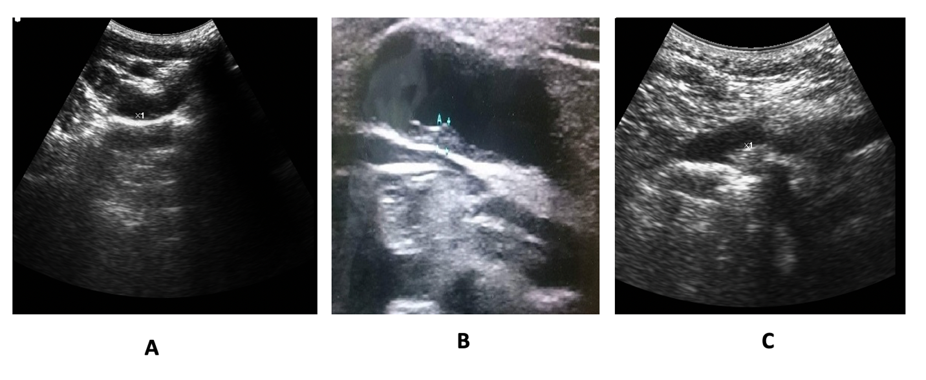
Figure 1 Carotid intima-media thickness in the study groups. A: Carotid-intima media thickness (CIMT) in a cirrhotic patient without esophageal varices (EVs) (0.72 mm); B: CIMT in a cirrhotic patient with EVs (1.42 mm); C: CIMT in a healthy control subject (0.6 mm).
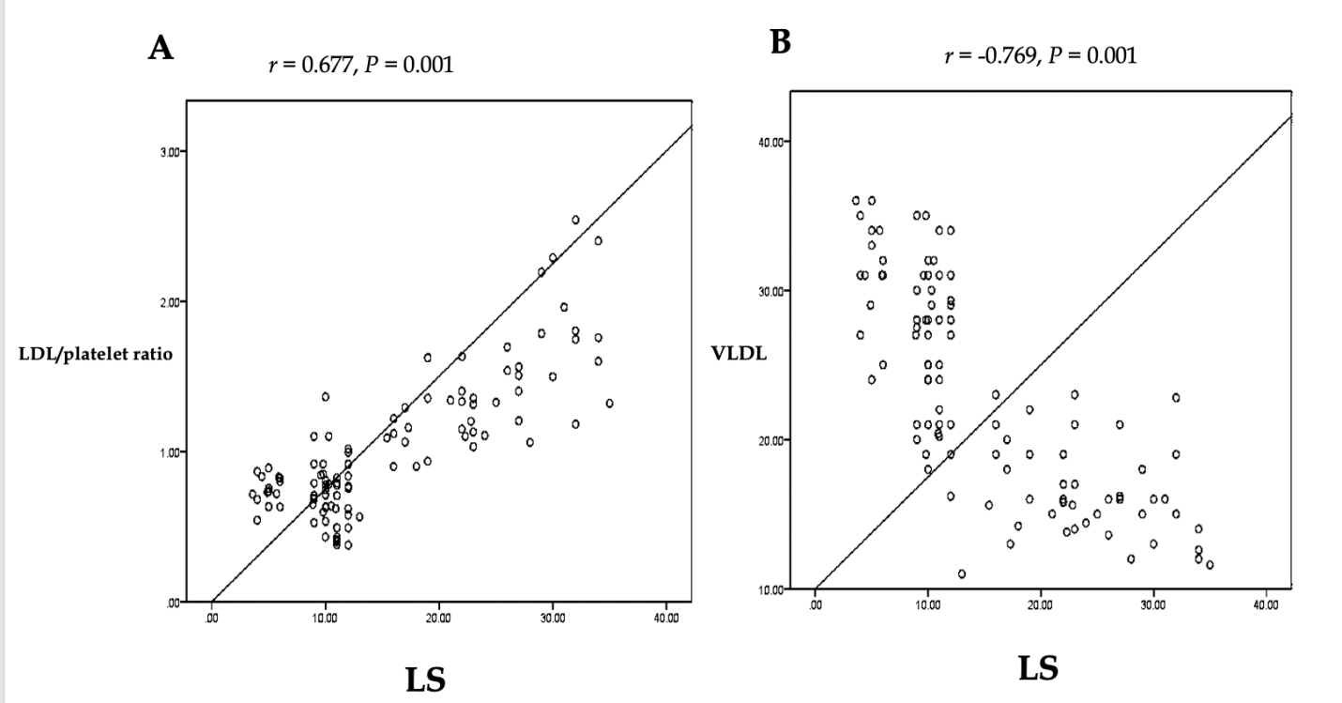
Figure 2 Correlation of liver stiffness with low-density lipoproteins/platelet count ratio (A) and very low-density lipoproteins (B).LS: Liver stiffness; LDL: Low-density lipoproteins; VLDL: Very low-density lipoproteins.

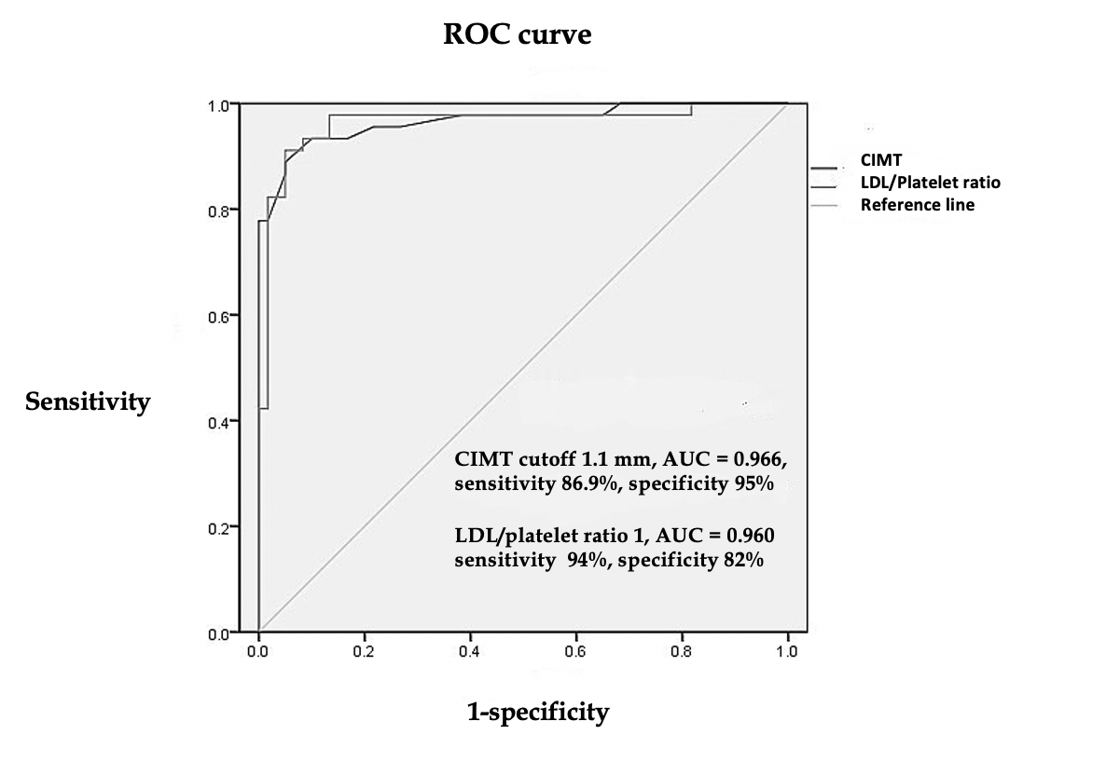
Figure 3 Receiver operating characteristic curve to detect cutoff values of carotid-intima media thickness and low-density lipoproteins/platelet count ratio. LDL: Low-density lipoproteins; CIMT: Carotid-intima media thickness; AUC: Area under the curve; ROC: Receiver operating characteristic.

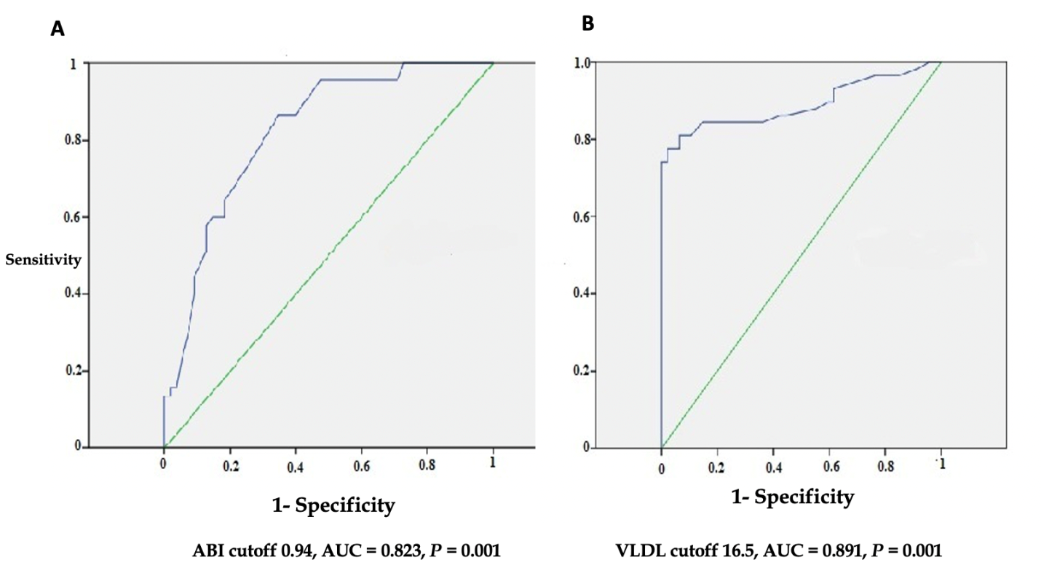
Figure 4 Receiver operating characteristic curve to detect cutoff value of ankle-brachial index (A) and very low-density lipoprotein (B). ABI: Ankle-brachial index; VLDL: Very low-density lipoprotein; AUC: Area under the curve.

Table 1 Baseline laboratory and endoscopic findings of the enrolled patients
Variable | Liver cirrhosis with EVs | Liver cirrhosis without EVs | Control group | P value¹
n | 90 | 90 | 60 | -
Sex (M/F) | 62/28 | 60/30 | 40/20 | 0.4
Age (yr) | 49.6 ± 8.4 | 47.7 ± 9.7 | 46 ±6.7 | 0.32
BMI (kg/m²) | 26.3 ± 2.1 | 25.8 ± 1.3 | 26.6 ± 0.9 | 0.21
ABI | 0.94 ± 0.09 | 1.08 ± 0.13 | 1.16 ± 0.11 | 0.001
AST (IU/L) | 53.7 ± 10.2 | 43.7 ± 5.6 | 31.1 ± 10.8 | 0.001
ALT (IU/L) | 47.2 ± 7.8 | 36.2 ± 8.5 | 30.6 ± 7.7 | 0.001
Platelet count × 10³ | 79.2 ± 21.2 | 189.3± 43.2 | 197.7 ± 18.7 | 0.001
Total cholesterol (mg/dL) | 177.6 ± 18.8 | 199.2 ± 27.4 | 210.4 ± 12.6 | 0.01
HDL (mg/dL) | 39.5 ± 4.3 | 44.6 ± 7.1 | 35.4 ± 5.3 | 0.004
TGs (mg/dL) | 135.7 ± 14.4 | 168.8 ± 12.8 | 180.8 ± 8.4 | 0.01
VLDL (mg/dL) | 16.6 ± 4.3 | 26.5 ± 5.3 | 25 ±5.7 | 0.001
LDL (mg/dL) | 105.8 ±14.5 | 128.9 ± 20.6 | 138.9 ± 16.5 | 0.03
FIB-4 | 4.97 ± 1.8 | 1.54 ± 0.47 | 1.51 ± 0.3 | 0.001
Platelets/SD ratio | 449 ± 167 | 1375 ± 380 | 1702 ± 238 | 0.001
LDL/platelet count ratio | 1.41 ± 0.4 | 0.71 ± 0.21 | 0.75 ± 0.09 | 0.001
Child-Pugh class (n) | A (26), B (46), C (18) | A (88), B (2) | Non-cirrhotic | -
Endoscopy | - | - | - | -
EVs | - | - | - | -
Grade I-II, n (%) | 32 (35.5) | - | - | -
Grade III, n (%) | 42 (46.7) | - | - | -
Grade IV, n (%) | 16 (17.8) | - | - | -
²Fundal varix, n (%) | 12 (13.3) | - | - | -
¹P value less than 0.05 is considered significant; ²Fundal varices were not isolated but associated with G I esophageal varices (EV) (n=2), G II EV (n=6), G III-IV EV (n=4). BMI: Body mass index; ABI: Ankle-brachial index; LDL: Low-density lipoproteins; HDL: High-density lipoproteins; VLDL: Very low-density lipoproteins; TGs: Triglycerides; EVs: Esophageal varices; AST: Aspartate aminotransferase; ALT: Alanine aminotransferase; SD: Splenic diameter; FIB-4: Fibrosis index-4.

Table 2 Ultrasonographic and liver stiffness values of the enrolled patients
Variable | Liver cirrhosis with EVs | Liver cirrhosis without EVs | Control group | P value
Splenic diameter | 182.9±21.4 | 141±12.8 | 111.2±9.7 | 0.003
Platelets/SD ratio | 449±166 | 1374.9±380 | 1701±239 | 0.001
FibroScan (kPa) | 24.4 ± 6.02 | 14.8±1.9 | 5.2 ± 0.82 | 0.001
CIMT (mm) | 1.2± 0.13 | 0.69± 0.14 | 0.62± 0.11 | 0.001
CIMT: Carotid-intima media thickness; EVs: Esophageal varices; SD: Splenic diameter.

Table 3 Discriminating ability of the novel markers in the studied groups
Variable | VLDL |  |  | CIMT |  |  | LDL/platelet ratio |  |  | ABI
Cutoff value | Below 16.5 | Above 16.5 | P value | Below 1.1 | Above 1.1 | P value | Below 1 | Above 1 | P value | Below 0.94 | Above 0.94 | P value
n | 76 | 164 | - | 96 | 144 | - | 98 | 142 | - | 70 | 170 | -
Sex (M/F) | 56/20 | 106/58 | 0.2 | 64/32 | 98/46 | 0.86 | 66/32 | 96/46 | 0.83 | 47/23 | 115/55 | 0.45
Age (yr) | 50.3 ± 10 | 48.5 ± 8.3 | 0.3 | 49.6 ± 8.6 | 48.7 ± 9 | 0.56 | 49.8 ± 8.8 | 48 ± 9 | 0.78 | 51.5 ± 8.9 | 48.2 ± 7.4 | 0.2
AST (IU/L) | 46 ± 11.6 | 38.4 ± 12.1 | 0.01 | 47.5 ± 11.8 | 34.9 ± 8.4 | 0.01 | 52 ± 11 | 35 ± 9 | 0.001 | 49 ± 12 | 38 ± 11 | 0.03
ALT (IU/L) | 45 ± 8.4 | 37.5 ± 8.5 | 0.03 | 46 ± 8 | 35.4 ± 7 | 0.03 | 45 ± 7.8 | 34 ± 5.6 | 0.02 | 43 ± 8 | 32 ± 8 | 0.047
Platelet count × 10³ | 83.6 ± 47 | 165.5 ± 62.2 | 0.001 | 82.5 ± 41.4 | 182 ± 40 | 0.001 | 81 ± 26 | 188 ± 41 | 0.001 | 87 ± 23 | 160 ± 61 | 0.001
Total cholesterol | 166 ± 21 | 198 ± 24 | 0.02 | 170 ± 18 | 200.5 ± 26 | 0.034 | 168 ± 26 | 197 ± 28 | 0.04 | 173 ± 27 | 196 ± 25 | 0.023
Triglycerides (mg/dL) | 135.7 ± 15 | 164 ± 19 | 0.03 | 137 ± 15 | 168 ± 15 | 0.032 | 140 ± 19 | 168 ± 16 | 0.045 | 143 ± 18 | 162 ± 24 | 0.01
VLDL (mg/dL) | 14.6 ± 1.5 | 26.2 ± 5.6 | 0.001 | 17 ± 4.9 | 28 ± 7 | 0.001 | 15 ± 4 | 32 ± 6 | 0.001 | 17 ± 5 | 25 ± 12 | 0.03
LDL (mg/dL) | 106 ± 15 | 126 ± 21 | 0.001 | 102 ± 13 | 130 ± 20 | 0.023 | 110 ± 17 | 122 ± 20 | 0.06 | 109 ± 19 | 129 ± 22 | 0.021
HDL (mg/dL) | 40 ± 4 | 43 ± 8 | 0.89 | 39 ± 5 | 42 ± 8.2 | 0.45 | 40 ± 5 | 42 ± 8 | 0.82 | 39 ± 4 | 42 ± 8 | 0.34
FIB-4 | 5.03 ± 1.8 | 2.2 ± 1.6 | 0.001 | 5 ± 2 | 1.7 ± 0.6 | 0.001 | 4.9 ± 1.9 | 1.6 ± 0.5 | 0.001 | 4.2 ± 2 | 2.4 ± 1.9 | 0.01
LDL/platelet count ratio | 1.5 ± 0.48 | 0.84 ± 0.3 | 0.001 | 1.4 ± 0.4 | 0.75 ± 0.21 | 0.001 | 1.5 ± 0.3 | 0.7 ± 0.15 | 0.001 | 1.24 ± 0.21 | 0.91 ± 0.34 | 0.001S
Splenic diameter (mm) | 186.3 ± 25.4 | 141.5 ± 24 | 0.001 | 185.4 ± 20 | 133 ± 17 | 0.001 | 181 ± 24 | 122 ± 11 | 0.001 | 171 ± 29 | 136 ± 13 | 0.001
Platelets/SD | 492.6 ± 76.2 | 1237.7 ± 502 | 0.001 | 463.3 ± 43 | 1400 ± 410 | 0.001 | 471 ± 213 | 1440 ± 402 | 0.001 | 678 ± 298 | 1173 ± 554 | 0.001
ABI: Ankle-brachial index; LDL: Low-density lipoproteins; HDL: High-density lipoproteins; VLDL: Very low-density lipoproteins; CIMT: Carotid-intima media thickness; SD: Splenic diameter; AST: Aspartate aminotransferase; ALT: Alanine aminotransferase; FIB-4: Fibrosis index-4.

Table 4 Performance of the novel markers when compared to the traditional tools
Cutoff value | PLT/SD ratio above 872 | FIB-4 above 3.25 | ABI below 0.94 | LDL/PLT ratio above 1 | CIMT above 1.1 | VLDL below 16.5 | P value
n | 90 | 90 | 70 | 98 | 96 | 76
LS (kPa) | 24.4 ± 6.2 | 26. 5 ± 5.2 | 22 ± 8.2 | 23 ± 7 | 24.6 ± 6.7 | 25.3 ± 6.3 | F = 1.87,P = 0.117
ABI | 1.08 ± 0.09 | 1.09 ± 0.1 | 0.887 ± 0.04 | 0.93 ± 0.1 | 0.88 ± 0.1 | 0.96 ± 0.08 | F = 30, P = 0.001
Endoscopy | - | - | - | - | - | - | -
EVs, n (%) | 82/90 (91.1) | 56/90 (62.2) | 65/70 (92.9) | 92/98 (94) | 90/96 (93.8) | 68/76 (89.5) | P = 0.001
Grade I-II, n (%) | 26/32 (81.3) | 14/32 (35) | 20/32 (62.5) | 24/32 (75) | 24/32 (75) | 10/32 (31.3) | χ² =13.3, P=0.009
Grade III, n (%) | 32/42 (76.2) | 30/42 (71.4) | 30/42 (71.4) | 42/42 (100) | 40/42 (95) | 34/42 (81) | χ²= 7.67, P =0.104
Grade IV, n (%) | 14/16 (87.5) | 6/16 (37.5) | 9/16 (56.3) | 16/16 (100) | 16/16 (100) | 12/16 (75) | χ²=9.55, P=0.048
Fundal varix, n (%) | 10/12 (83.3) | 6/12 (50) | 6/12 (50) | 10/12 (83) | 10/12 (83) | 12/12 (100) | χ²=3.47,P=0.48
LS: Liver stiffness; ABI: Ankle-brachial index; LDL: Low-density lipoproteins; VLDL: Very low-density lipoproteins; EVs: Esophageal varices; CIMT: Carotid-intima media thickness; PLT: Platelets; SD: Splenic diameter; FIB-4: Fibrosis index-4.

