Name of Journal: World Journal of Gastroenterology
Manuscript NO: 67267
Manuscript Type: ORIGINAL ARTICLE

Basic Study
Liver injury changes the biological characters of serum small extracellular vesicles and reprograms hepatic macrophages in mice

Lv XF et al. Liver injury changes mouse serum sEVs

Xiu-Fang Lv, An-Qi Zhang, Wei-Qi Liu, Min Zhao, Jing Li, Li He, Li Cheng, Yu-Feng Sun, Gang Qin, Peng Lu, Yu-Hua Ji, Ju-Ling Ji

Xiu-Fang Lv, An-Qi Zhang, Wei-Qi Liu, Min Zhao, Jing Li, Li He, Li Cheng, Yu-Feng Sun, Peng Lu, Ju-Ling Ji, Department of Pathology, Medical School of Nantong University, Nantong 226001, Jiangsu Province, China

Xiu-Fang Lv, An-Qi Zhang, Wei-Qi Liu, Min Zhao, Yu-Feng Sun, Peng Lu, Ju-Ling Ji, Key Laboratory of Microenvironment and Translational Cancer Research, Science and Technology Bureau of Nantong City, Nantong 226001, Jiangsu Province, China

Jing Li, Department of Pathology, National Cancer Center/National Clinical Research Center for Cancer/Cancer Hospital, Chinese Academy of Medical Sciences and Peking Union Medical College, Beijing 100021, China

Li He, Department of Pathology, Nanjing Jinling Hospital, Nanjing University School of Medicine, Nanjing 210093, Jiangsu Province, China

Li Cheng, Department of Pathology, Affiliated Jiangyin Hospital of Southeast University Medical College, Jiangyin 214400, Jiangsu Province, China

Gang Qin, Nantong Institute of Liver Diseases, Nantong Third People’s Hospital, Nantong University, Nantong 226006, Jiangsu Province, China

Yu-Hua Ji, Key Laboratory of Neuroregeneration of Jiangsu and Ministry of Education, Nantong University, Nantong 226001, Jiangsu Province, China

Yu-Hua Ji, Institute of Immunology, College of Life Science and Technology, Jinan University, Guangzhou 510632, Guangdong Province, China

Author contributions: Ji JL and Ji YH conceived the study and interpreted the data; Lv XF performed a systematic review and statistical analysis; Zhang AQ performed the Western blot analysis; Liu WQ performed qRT-PCR; Zhao M isolated the serum sEVs and performed the characterization; Li J, He L and Lu P performed the mouse model experiments; Cheng L performed the mouse model and the primary mouse hepatic macrophage-related experiments; Sun YF performed the histopathologic examination and the sEV characterization; Qin G performed the liver function test; Ji JL and Lv XF prepared the figures and drafted the manuscript; All authors read and approved the final version of the manuscript.

Supported by National Natural Science Foundation of China, No. 81761128018, No. 81572871 and No. 81272027; Natural Science Foundation of Jiangsu Province, No. BK20151277; and Science and Technology Project of Nantong City, No. MS12020010.

Corresponding author: Ju-Ling Ji, MD, PhD, Director, Professor, Department of Pathology, Medical School of Nantong University, No. 19 Qixiu Road, Nantong 226001, Jiangsu Province, China. jijuling@ntu.edu.cn

Received: April 21, 2021
Revised: July 21, 2021
Accepted: September 14, 2021
Published online: November 21, 2021

Abstract
BACKGROUND
Serum small extracellular vesicles (sEVs) and their small RNA (sRNA) cargoes could be promising biomarkers for the diagnosis of liver injury. However, the dynamic changes in serum sEVs and their sRNA components during liver injury have not been well characterized. Given that hepatic macrophages can quickly clear intravenously injected sEVs, the effect of liver injury-related serum sEVs on hepatic macrophages deserves to be explored.

AIM
To identify the characteristics of serum sEVs and the sRNAs during liver injury and explore their effects on hepatic macrophages.

METHODS
To identify serum sEV biomarkers for liver injury, we established a CCL₄-induced mouse liver injury model in C57BL/6 mice to simulate acute liver injury (ALI), chronic liver injury (CLI) and recovery. Serum sEVs were obtained and characterized by transmission electron microscopy and nanoparticle tracking analysis. Serum sEV sRNAs were profiled by sRNA sequencing. Differentially expressed microRNAs (miRNAs) were compared to mouse liver-enriched miRNAs and previously reported circulating miRNAs related to human liver diseases. The biological significance was evaluated by Ingenuity Pathway Analysis of altered sEV miRNAs and conditioned cultures of ALI serum sEVs with primary hepatic macrophages.

RESULTS
We found that both ALI and CLI changed the concentration and morphology of serum sEVs. The proportion of serum sEV miRNAs increased upon liver injury, with the liver as the primary contributor. The altered serum sEV miRNAs based on mouse studies were consistent with human liver disease-related circulating miRNAs. We established serum sEV miRNA signatures for ALI and CLI and a panel of miRNAs (miR-122-5p, miR-192-5p, and miR-22-3p) as a common marker for liver injury. The differential serum sEV miRNAs in ALI contributed mainly to liver steatosis and inflammation, while those in CLI contributed primarily to hepatocellular carcinoma and hyperplasia. ALI serum sEVs decreased both CD86 and CD206 expression in monocyte-derived macrophages but increased CD206 expression in resident macrophages in vitro.

CONCLUSION
Serum sEVs acquired different concentrations, sizes, morphologies and sRNA contents upon liver injury and could change the phenotype of liver macrophages. Serum sEVs therefore have good diagnostic and therapeutic potential for liver injury.

Key Words: MicroRNA; Small RNA sequencing; Biomarker; Monocyte-derived macrophage; Resident macrophage

©The Author(s) 2021. Published by Baishideng Publishing Group Inc. All rights reserved.

Citation: Lv XF, Zhang AQ, Liu WQ, Zhao M, Li J, He L, Cheng L, Sun YF, Qin G, Lu P, Ji YH, Ji JL. Liver injury changes the biological characters of serum small extracellular vesicles and reprograms hepatic macrophages in mice. World J Gastroenterol 2021; 27(43): 7509-7529
URL: https://www.wjgnet.com/1007-9327/full/v27/i43/7509.htm
DOI: https://dx.doi.org/10.3748/wjg.v27.i43.7509

Core Tip: The liver injury changed the concentration, morphology and small RNA contents of serum small extracellular vesicles (sEVs). Altered serum sEV microRNAs (miRNAs) based on mouse studies were highly consistent with the circulating miRNAs reported in human liver diseases. Serum sEV miRNA signatures for acute liver injury and chronic liver injury and a panel of miRNAs that can be used as a common marker for liver injury were established. Acute liver injury serum sEVs depolarized monocyte-derived macrophages and educated resident liver macrophages to transform into M2-like cells. Serum sEVs have good diagnostic and therapeutic potential for liver injury.

INTRODUCTION
Because of its strategic location and biological functions, the liver is particularly susceptible to various pathogenic factors, including drugs, alcohol and viruses. The initial insult induces acute liver injury (ALI) or even liver failure. Repeated or persistent insults will cause chronic liver injury (CLI), resulting in liver fibrosis and finally fatal cirrhosis^{[1,2]}. Therefore, it is important to identify individuals with liver injury. However, liver injury does not always cause noticeable signs and symptoms. Aside from the widely used blood liver function tests on serum alanine aminotransferase (ALT) and aspartate aminotransferase (AST), which are not always restricted to liver injury^{[3]}, there is still a need to explore specific and sensitive biomarkers. With the rapid progress in medical research, it is now possible and necessary to search for new biomarkers from serum small extracellular vesicles (sEVs).
Recently, serum sEVs have attracted tremendous interest due to their essential roles in intercellular communication and to their diagnostic and therapeutic potential^{[4]}. The term sEVs refers to extracellular vesicles released by cells that are of relatively small size (< 200 nm) and were previously regarded as exosomes^{[5]}. The cargoes carried by sEVs represent a snapshot of the parental cells at the time of release and change depending on the physiological and pathological states^{[6,7]}. In the liver, sEVs are released from both hepatocytes and nonparenchymal cells into the extracellular space and circulation. Several studies have reported that circulating sEV RNAs or proteins are abnormally expressed in the contexts of drug-induced liver injury (DILI), steatohepatitis, viral hepatitis and hepatocellular carcinoma (HCC)^{[6,8]}.
MicroRNAs (miRNAs) are 22-24 nt small noncoding RNAs involved in posttranscriptional regulation and various biological processes^{[9]}. Tissue-specific distribution is a key feature of miRNAs, making miRNAs good candidates as biomarkers or therapeutic targets for particular types of tissue injury^{[10-12]}. Serum miRNAs have been studied in a variety of liver diseases^{[13]}. However, compared to serum miRNAs, serum sEV miRNAs are well protected from RNA enzymes. Thus, serum sEV can serve as a more reliable miRNA pool^{[14]}. We hypothesized that serum sEVs and their miRNA cargoes might reflect liver damage upon injury and could be promising biomarkers.
In the present study, we tried to determine the effects of liver injury on serum sEVs and the small RNAs (sRNAs) they transport; we were also interested in determining if there is any difference between acute and chronic injury. A study in this regard will aid in identification of potential serum sEV miRNA biomarkers. The dynamic changes in the number and morphology of serum sEVs and the sRNA components of serum sEVs were examined. The profiles of deregulated serum sEV miRNAs were obtained and compared to those of mouse liver enriched miRNAs and previously reported circulating miRNAs related to human liver diseases (HLD). To further evaluate the biological significance of serum sEVs upon liver injury, conditioned cultures of ALI serum sEVs and primary hepatic macrophages were carried out.

MATERIALS AND METHODS
Animal studies
Male C57BL/6 mice (8 wk old) were purchased from the Shanghai Medical Laboratory Animal Center (Shanghai, China) and housed in the animal facility of Nantong University with temperature 25 ± 2 °C and 12 h light/dark cycle controls. All experimental protocols were approved by the Animal Ethics Committee of Nantong University. The animal care and experiments were performed in accordance with the relevant guidelines and regulations. For ALI, mice were treated with a single dose of CCL₄ (0.5 mL/kg intraperitoneal injection) dissolved in olive oil (1:9). The mice were sacrificed at 2 d or 7 d. For CLI, mice were treated with CCL₄ (0.5 mL/kg) or vehicle twice a week for 8 wk^{[15]}. The mice were sacrificed 48 h after the last injection at 8 wk or at 12 wk (Figure 1A). Mice treated with the same volume of olive oil served as the controls for the ALI and CLI models, and 10-12 mice were used in each group. Blood or livers were collected from each group for further analyses.

Liver function test and histopathologic examination
Blood was collected by left ventricular puncture from mice and was left undisturbed for 1 h at 37 °C and 2 h at 4 °C. Afterward, the samples were centrifuged at 1000 × g for 10 min at 4 °C; the clear upper fractions were aliquoted and stored at -80 °C. Serum ALT and AST levels were measured on an ADVIA 1800 autoanalyzer (Siemens Healthcare Diagnostics, Deerfield, IL, United States). The livers were preserved in 4% paraformaldehyde, paraffin-embedded and sectioned. The liver tissue sections were stained with hematoxylin and eosin (Beyotime Biotechnology, Shanghai, China) for routine histology and 0.1% Sirius Red (Sigma-Aldrich, St. Louis, MO, United States) for collagen evaluation.

Mouse serum sEV isolation and characterization
Exosome-enriched serum sEV fractions were precipitated using ultracentrifugation and an ExoQuick precipitation kit (System Biosciences Inc., Mountain View, CA, United States)^{[16]}. The sizes and particle concentrations of the isolated serum sEVs were measured by nanoparticle tracking analysis (NTA, NanoSight NS300, Malvern, United Kingdom). Serum sEVs were visualized using transmission electron microscopy (TEM, HT7700, Hitachi Ltd., Tokyo, Japan). The expression of exosomal protein markers was determined by Western blot analysis. The details are provided in the Supplementary material, Supporting Information.

sRNA library construction and deep sequencing
Serum sEV sRNA sequencing (RNA-seq) was conducted by BMK Biotech Co., Ltd. (Beijing, China) with biological replicates for each group.

Sequencing data analysis and bioinformatic analysis
The raw data were processed as described previously^{[16]}. The trimmed sequencing reads were deposited in the European Nucleotide Archive (https://www.ebi.ac.uk/arrayexpress/experiments/E-MTAB-9462). Bioinformatic analysis of the differentially expressed serum sEV miRNAs was performed using Ingenuity Pathways Analysis (Qiagen, Valencia, CA, United States). The significance of enrichment for genes with particular biologically relevant functions was determined with a one-sided Fisher’s exact test.

Systematic review of abnormally expressed circulating miRNAs in HLDs
The detailed procedure is provided in the Supplementary material, Supporting Information.

Isolation and culture of mouse hepatic macrophages
Primary mouse hepatic macrophages were isolated from male C57BL/6 mouse livers by Percoll (GE Healthcare, Princeton, NJ, United States) density gradient centrifugation. Incubation of liver macrophages with mouse serum sEVs and subsequent multiple-color flow cytometric analysis were carried out. The details are provided in the Supplementary material, Supporting Information.

Statistical analysis
Statistical analyses were performed with GraphPad Prism 7.0 software (GraphPad Software, Inc., La Jolla, CA, United States). Quantitative data were reported as the mean ± standard deviation. Comparisons between groups were made by Student’s t-test or one-way analysis of variance. All P values were two-sided, and statistical significance was accepted for a value less than 0.05. Except for the data from sRNA-seq experiments, which included two biological replicates for each group, the data provided in the present study were from three or more independent experiments.
Additional methods and details are provided in the Supplementary material, Supporting Information.

RESULTS
Establishment and validation of CCL₄-induced ALI and CLI in mice
The mouse CCL₄-induced ALI and recovery model and the mouse CCL₄-induced CLI and recovery model were established and validated (Figure 1).
In acutely injured mice (at 2 d; 2D group), serum ALT and AST levels were increased, and hepatocyte necrosis and inflammatory cell infiltration were observed around the lobular central vein. After 5 d of recovery (at 7 d; 7D group), the elevated ALT and AST levels had returned to the baseline of the ALI control group, and the histological changes were also reversed (Figure 1B and C). For CLI, repeated CCL₄ treatment induced a slight elevation in serum ALT (at 8 wk; 8W group), but the level returned to the baseline of the CLI control (CC) group by 4 wk after cessation of CCL₄ treatment (at 12 wk; 12W group) (Figure 1D). Although the ALT level change in CLI at 8W was not as prominent as those in ALI at 2D, the change was comparable to the ALT level changes reported by other study groups using the same mice CLI model^{[17,18]}. Damaged hepatocytes and centrilobular contracture were observed in the livers of the CLI mice (8W), with mild inflammatory cell infiltration. Sirius Red staining showed obvious collagen deposition and pseudolobule formation in 8W CLI mice. These morphological changes were alleviated in recovered mice (12W) (Figure 1E).

Identification and characterization of serum sEVs from ALI and CLI mice
The isolated particles were spherical or cup-shaped, as observed by TEM (Figure 2A). Exosomal protein markers, including CD63, CD81 and CD9, were all highly expressed (Figure 2B), as determined by Western blot analysis.
NTA showed that the mean diameter of the particles ranged from 90.2 nm to 127.8 nm. The number of particles was higher in the 2D group but lower in the 7D group than in the control group, and the particle diameters were smaller in the 2D group but larger in the 7D group than in the control group. We also noticed that the size distribution of sEVs widened and that multiple peaks were present in the 7D group (Figure 2C). For CLI mice, the particle concentrations in the 8W and 12W groups tended to be lower than those in the control group, although there were no significant differences. The size distribution of sEVs was expanded with multiple peaks in both the 8W and 12W groups, and the particle diameters were larger in both the 8W and 12W groups (Figure 2D). TEM examination revealed that the multiple peaks reflected the aggregation or fusion of mouse serum sEVs present in 7D, 8W and 12W samples (Figure 2C and D).
These findings suggested that both ALI and CLI changed the number and morphology of mouse serum sEVs, and even when the visible histological changes of the liver had recovered in the 7D and 12W groups, the changes in particle number and morphology of serum sEVs persisted.

Comparison of the sRNA components in serum sEVs from ALI and CLI mice
Dramatic increases in both total RNA and sRNA levels in serum sEVs were observed upon ALI (2D) (Figure 3A and B). For CLI, there was no significant difference in either sEV RNA or sRNA content among the groups. RNA-seq and annotation revealed that each pair of biological repeats had at least 94.97% common sequences in clean reads (Supplementary Figure 1). In the control groups (ALI control and CC), tRNA was the dominant sRNA species in serum sEVs, followed by rRNA and miRNA (Figure 3C). The most remarkable change in serum sEV sRNAs was the increase in miRNA proportion in both ALI and CLI mice. Compared to the control condition, ALI increased the proportion of miRNAs by more than four-fold, but the proportion returned to baseline by 7 d; the proportion of miRNAs increased by almost three-fold in CLI mice but was partially restored by 12 wk. With the increase in miRNA, the proportion of tRNA decreased (Figure 3D).

miRNA expression profiles of serum sEVs from ALI and CLI mice
For the ALI and CLI groups, 467 and 488 detectable sEVs (transcripts per million reads ≥ 5.0) miRNAs were obtained, respectively. The biological replications were highly correlated in each group (Figure 4A). The RNA-seq data were further validated by quantitative real-time polymerase chain reaction. Differentially expressed miRNAs with different abundances were selected for validation (Figure 4B).
In total, 91 miRNAs were upregulated and 85 miRNAs were downregulated (fold change ≥ 2.0, P < 0.05) in the 2D group compared with the ALI control group (Figure 4C and Supplementary Table 1). The levels of most of these miRNAs had recovered to baseline levels in the 7D group, in which only 8 upregulated miRNAs and 11 downregulated miRNAs were detected (fold change ≥ 2.0, P < 0.05) (Figure 4C and Supplementary Table 2). The cumulative distribution frequency was calculated by adding each proportion of miRNAs from most to least abundant. The plot showed that the top five upregulated miRNAs (miR-148a-3p, miR-122-5p, miR-192-5p, miR-22-3p and miR-21a-5p) in the 2D group accounted for up to 84.27% of all detectable miRNAs (Figure 4C).
Only 13 miRNAs were upregulated and six miRNAs were downregulated (fold change ≥ 2.0, P < 0.05) in the 8W group compared with the CC group (Figure 4D and Supplementary Table 3); in addition, 8 miRNAs were upregulated and 3 miRNAs were downregulated (fold change ≥ 2.0, P < 0.05) in the 12W group compared with the CC group (Figure 4D and Supplementary Table 4). The cumulative distribution frequency analysis showed that the top three upregulated miRNAs (miR-122-5p, miR-192-5p, and miR-22-3p) in the 8W group constituted up to 43.48% of all detectable miRNAs (Supplementary Figure 2). These findings suggested that both ALI and CLI induced changes in serum sEV miRNA composition. The changes were caused by the differential expression of a small number of miRNAs with high abundance.
The biological significance of these differentially expressed serum sEV miRNAs in liver injury was explored by Ingenuity Pathway Analysis (www.qiagen.com/ingenuity). For the 176 differentially expressed serum sEV miRNAs upon ALI, hepatic steatosis was the most significant hepatotoxic effect, followed by liver inflammation. For the 19 differentially expressed serum sEV miRNAs upon CLI, HCC was the most significant, followed by liver hyperplasia (Figure 4E).

The liver is the main contributor to the differentially expressed serum sEV miRNAs during ALI and CLI
We were interested in determining the contribution of liver cells to the changes in serum sEV miRNAs upon ALI and CLI. First, the liver miRNA expression profile for wild-type male C57BL/6 mice was established using BRB-Array Tool v4.6.0 (https://brb.nci.nih.gov) based on the RNA-seq data from GSE78792 (https://www.ncbi.nlm.nih.gov/geo/query/acc.cgi?acc=GSE78792)^{[19]} (Supplementary Table 5). Differentially expressed serum sEV miRNAs from ALI and CLI mice were compared to the liver miRNA expression profile. Among the top ten most abundant liver miRNAs, seven were also among the top ten increased miRNAs in serum sEVs upon ALI (Table 1) and constituted up to 84.70% of the increased serum sEV miRNAs. For CLI, the levels of three were raised in serum sEVs. These three miRNAs were the top three miRNAs that increased upon CLI (Table 1) and constituted up to 60.56% of the total increased serum sEV miRNAs. These findings suggested the liver as the primary contributor to the upregulated serum sEV miRNAs during ALI and CLI and confirmed that the serum sEV miRNA test could be a reliable and sensitive way to monitor either ALI or CLI.

ALI and CLI signatures based on serum sEV miRNA profiling
To identify serum sEV miRNA signatures for liver injury, we compared the differentially expressed serum sEV miRNAs in various stages of ALI and CLI. Compared to the levels in the vehicle control samples, eight miRNAs were upregulated and two miRNAs were downregulated significantly during the acute injury stage, and these changes were sustained through the chronic phase (fold change ≥ 2.0, P < 0.05); thus, they can serve as common liver injury signatures (Figure 5A). In addition, the levels of 166 miRNAs changed significantly during acute injury, while those of nine miRNAs changed dramatically during chronic injury. These miRNAs with high abundance (transcripts per million reads _mean > 1000) have the potential to be ALI or CLI signatures. The complete lists of these potential ALI and CLI serum sEV miRNA signatures are provided in Supplementary Table 6. According to their abundance, up to the top 20 miRNAs are listed in Figure 5. For the recovery stage, 18 miRNAs were changed significantly in the ALI group, and 11 miRNAs were changed significantly in the CLI group (Figure 5B). Some of these miRNAs overlapped with differentially expressed serum sEV miRNAs in corresponding acute or chronic injury stages.

Comparison of the potential ALI and CLI serum sEV miRNA signatures to HLD-related circulating miRNAs
To explore the biological significance of the ALI and CLI serum sEV miRNA signatures in HLDs, we performed a systematic review of abnormally expressed circulating miRNAs reported in various HLDs. In total, 299 and 257 studies were identified from PubMed (https://pubmed.ncbi.nlm.nih.gov) and Web of Science (http://apps.webofknowledge.com/) databases, respectively (Figure 6A). Data were retrieved from 14 studies, including drug-induced liver injury^{[20]}, chronic hepatitis B^{[21-25]}, chronic hepatitis C^{[21,25-27]}, nonalcoholic fatty liver disease^{[28]}, nonalcoholic steatohepatitis^{[23]}, liver cirrhosis^{[24,29,30]} and HCC^{[21-24,28-33]} studies. Details on the 14 articles are summarized in Supplementary Table 7.
In total, 269 nonredundant abnormally expressed circulating miRNAs related to HLDs were extracted, and those that appeared ≥ four times were defined as high-frequency miRNAs (Figure 6A). Of the 30 high-frequency miRNAs (Supplementary Table 7), 23 miRNAs were detected in ALI and CLI serum sEVs (Figure 6B), 14 miRNAs overlapped with ALI and CLI serum sEV signatures, and 12 miRNAs showed the same expression trend. Of the 12 miRNAs, three miRNAs (miR-122-5p, miR-192-5p, and miR-22-3p) were identified as being increased in both ALI and CLI mice and thus have the potential to serve as common signatures for either ALI or CLI. The other 9 miRNAs were identified as ALI signatures (miR-21a-5p, miR-92a-3p, miR-194-5p, miR-17-5p and miR-19b-3p were increased; miR-451a, miR-27a-3p, miR-26a-5p, and miR-223-3p were decreased) and may reflect acute or active liver injury (Figure 6C). In addition, it was noteworthy that the four high-frequency circulating miRNAs reported in HLDs with decreased levels all exhibited decreased levels in serum sEVs upon ALI.

Serum sEVs from liver injury mice induced hepatic macrophage reprogramming
Primary mouse hepatic macrophages were isolated, purified and incubated with SYTO-labeled serum sEVs. After 24 h, green fluorescence was observed in most macrophages in both the control and ALI (2D) serum sEV incubation groups (Figure 7A). These observations indicated that serum sEVs could be taken up by hepatic macrophages. Serum sEVs from ALI mice (2D) accelerated the adhesion of hepatic macrophages (Figure 7B). As determined by quantitative real-time polymerase chain reaction, normal serum sEVs increased M1-like gene (IL-1B and TNFA) expression and decreased the expression of some M2-like genes (IL-10RB, CD163, ARG1 and CD206); ALI serum sEVs showed similar effects. However, compared to normal serum sEVs, ALI serum sEVs tended to decrease M1-like IL-1B but increase M2-like CD163 gene expression (Figure 7C).
In order to further dissect the effects of ALI serum sEVs on monocyte-derived and resident hepatic macrophage subgroups, multiple-color flow cytometric analyses were performed to assess the expression of M1-like CD86 and M2-like CD206 in CD11b⁺F4/80^{Low} monocyte-derived and CD11b⁺F4/80^{High} resident macrophages (Tacke and Zimmermann^{[34]} and our unpublished data). ALI serum sEVs decreased both CD86 and CD206 expression in the CD11b⁺F4/80^{Low} subgroup but increased CD206 expression in the CD11b⁺F4/80^{High} subgroup (Figure 7D and E). These findings indicated that ALI serum sEVs might induce depolarization of CD11b⁺F4/80^{Low} monocyte-derived macrophages but M2 differentiation of CD11b⁺F4/80^{High} resident macrophages.

DISCUSSION
A growing number of studies have suggested the diagnostic value of serum sEV content for liver injury, especially miRNAs^{[6,8]}. To explore potential serum sEV miRNA biomarkers for liver injury, we simulated the complex processes of liver injury and recovery in CCL₄-induced ALI and CLI mouse models. The 2D group and 8W group represented ALI and CLI, respectively, while the 7D group and 12W group represented the recovery stage of ALI and CLI, respectively. The ALT and AST levels elevated in the 2D group and 8W group and returned to the baseline of the control groups (Figure 1B and D). Moreover, the histological changes also reversed in the 7D and 12W recovery groups (Figure 1C and E), which indicated that the ALI and CLI and recovery models were well established.
Unexpectedly, aside from differentially expressed miRNAs, we found that the concentration, size and morphology of serum sEVs might be essential features in liver injury (Figure 2). The number of serum sEVs increased upon ALI, which has been reported in human alcoholic hepatitis and alcoholic liver injury mouse models^{[35-37]}. Furthermore, we found sustained decreases in serum sEV number during the chronic injury stage and the recovery stage for both ALI and CLI. Moreover, serum sEVs became smaller upon ALI but enlarged during ALI recovery and the CLI stage, and the increased size persisted through the CLI recovery stage, at which time there were multiple peaks, as observed by NTA. Interestingly, aggregation of serum sEV particles was observed in samples from the ALI recovery stage, CLI stage and CLI recovery stage by TEM, which explained the multiple peaks and increased particle size found by NTA. We propose that the aggregation of sEVs might reflect membrane damage of extracellular vesicles following liver injury. Thus, changes in serum sEV concentration, size, and morphology are well connected to a particular stage of liver injury and could provide diagnostic clues. In addition, the changes in serum sEVs persisted even when liver function and visible histopathological changes were restored; thus, they could be useful to trace recent liver injury.
Then, we showed that ALI and CLI altered the sRNA levels and components in serum sEVs. For ALI, both the total RNA and sRNA levels of serum sEVs increased significantly, and the proportion of miRNAs in sRNA also increased. Although there were no significant increases in RNA or sRNA levels for CLI, the proportion of miRNAs increased significantly. Compared to CLI, ALI significantly changed more miRNA species (176 vs 19, fold change ≥ 2.0, P < 0.05). The increased proportion of miRNAs upon liver injury was mainly attributable to a few highly abundant miRNAs. To traceback the primary source of the increased serum sEV miRNAs, the highly abundant miRNAs detected in serum sEVs from ALI and CLI mice were evaluated in the livers of normal male C57BL/6 mice. The miRNAs with the highest abundance were all liver-enriched miRNAs (Table 1). We propose that the liver is the main contributor to the elevations in miRNAs in serum sEVs for both ALI and CLI. Thus, serum sEVs carry the miRNA messages released from the injured liver, and examining the serum sEV miRNAs could be a reliable way to monitor either ALI or CLI.
By comparing the expression profiles of serum sEV miRNAs in various stages of ALI and CLI, we obtained a list of miRNAs that can be used as common liver injury signatures as well as the miRNA signatures for ALI, CLI and the recovery stages. However, these signatures were obtained from mouse models and need to be validated in human patients. Hence, we carried out a systematic review of previously published studies and obtained 30 miRNAs that were highly correlated with HLD, including drug-induced liver injury, chronic hepatitis B, chronic hepatitis C, nonalcoholic fatty liver disease, nonalcoholic steatohepatitis and liver cirrhosis (Figure 6). Of these 30 miRNAs, 3 miRNAs (miR-122-5p, miR-192-5p and miR-22-3p) were identified as common injury signatures that were increased in both ALI and CLI mice. Although these three miRNAs have been studied separately^{[24,36,38,39]}, here, for the first time, they were combined as a universal signature for either ALI or CLI. Nine miRNAs were identified as ALI signatures. Along with the five increased miRNAs (miR-21a-5p, miR-92a-3p, miR-194-5p, miR-17-5p and miR-19b-3p), four miRNAs were decreased (miR-451a, miR-27a-3p, miR-26a-5p and miR-223-3p): the same four miRNAs that are frequently reported to be decreased in HLD (Figure 6). Although the human data were mostly from patients with CLI, the overlapping ALI signatures might reflect active lesions. Based on serum sEV miRNAs, we established common signatures for liver injury and specific signatures for acute/active liver injury.
The biological significance of the alterations in sEV miRNAs upon liver injury was explored by Ingenuity Pathway Analysis. The top hepatotoxicity-related functions of the altered serum sEV miRNAs in ALI were hepatic steatosis and liver inflammation, while the altered miRNAs carried by serum sEVs from CLI were linked primarily to HCC, followed by liver hyperplasia. These findings are consistent with the clinical findings that ALI mainly causes inflammation and that sustained damage increases the risk of carcinoma^{[40,41]}. Hepatic steatosis reflects fatty degeneration that is typically caused by CCL₄^{[42]}. These findings reveal the pathological importance of serum sEVs during the processes of ALI and CLI.
It has been reported that hepatic macrophages can take up serum sEVs and play essential roles in the clearance of intravenously injected sEVs from the systemic circulation^{[43,44]}. We were interested in determining the effects of liver injury-related serum sEVs on hepatic macrophages and whether these effects could aggravate liver damage or play a protective role. We found that in vitro, ALI serum sEVs could be taken up by hepatic macrophages and promote macrophage adhesion. Furthermore, ALI serum sEVs tended to decrease M1-like gene expression, such as IL-1B and TNFA expression, and increase M2-like gene expression, including CD163 expression. However, the trends were not consistent. Considering that hepatic macrophages are heterogeneous populations composed of two subgroups, including resident macrophages and circulating monocyte-derived macrophages^{[34]}, we propose that macrophages of different origins might react inconsistently to ALI serum sEVs. The expression of M1 (CD86) and M2 (CD206) polarization signatures on the two subgroups of hepatic macrophages was examined by flow cytometry. ALI serum sEVs induced depolarization of CD11b⁺F4/80^{Low} monocyte-derived macrophages but induced M2 differentiation of CD11b⁺F4/80^{High} resident macrophages. We propose that the changes in serum sEVs upon ALI might alleviate liver damage by depolarizing monocyte-derived macrophages and educating resident hepatic macrophages to transform into M2-like cells.

CONCLUSION
In conclusion, we found that the concentration, size and morphology of serum sEV particles were essential features for liver injury. We established specific serum sEV miRNA signatures for different liver injury stages and created a list of miRNAs that can be used as common liver injury biomarkers. The altered ALI and CLI serum sEV miRNAs were connected to diverse liver pathological processes. ALI serum sEVs reprogrammed hepatic macrophage subgroups differently. Serum sEVs not only have good diagnostic potential but also could be used to ameliorate liver injury. However, the diagnostic and therapeutic potential of these altered serum sEVs upon liver injury deserves further study.

ARTICLE HIGHLIGHTS
Research background
Both acute liver injury (ALI) and chronic liver injury (CLI) do not always cause noticeable signs and symptoms. Serum small extracellular vesicles (sEVs) have attracted tremendous interest due to their essential roles in intercellular communication and their diagnostic and therapeutic potential. The cargoes carried by sEVs represent a snapshot of the parental cells and change depending on the physiological and pathological states.

Research motivation
Serum sEVs and their small RNA (sRNA) cargoes could be promising biomarkers for the diagnosis of liver injury.

Research objectives
The present study aimed to characterize the dynamic changes of serum sEVs and their sRNA components during liver injury and to explore the effect of liver injury-related serum sEVs on hepatic macrophages.

Research methods
Male C57BL/6 mice were treated with CCL₄ to establish a mouse liver injury model for simulating ALI, CLI and recovery. Serum sEVs were obtained and characterized by transmission electron microscopy and nanoparticle tracking analysis. Serum sEV sRNAs were profiled by sRNA sequencing. Differentially expressed microRNAs (miRNAs) were compared to mouse liver-enriched miRNAs and previously reported circulating miRNAs related to human liver diseases. The biological significance was evaluated by Ingenuity Pathway Analysis of the altered sEV miRNAs and conditioned cultures of ALI serum sEVs with primary hepatic macrophages.

Research results
Both ALI and CLI changed the concentration and morphology of serum sEVs. The proportion of serum sEV miRNAs increased upon liver injury, with the liver as the primary contributor. The altered serum sEV miRNAs based on mouse study were consistent with human liver disease-related circulating miRNAs. We established serum sEV miRNA signatures for ALI and CLI and a panel of miRNAs (miR-122-5p, miR-192-5p, and miR-22-3p) as a common marker for liver injury. ALI serum sEVs decreased both CD86 and CD206 expression in monocyte-derived macrophages but increased CD206 expression in resident macrophages in vitro.

Research conclusions
Serum sEVs acquired different concentrations, sizes, morphologies and sRNA contents upon diverse liver injured pathological processes. ALI serum sEVs reprogrammed hepatic macrophage subgroups differently.

Research perspectives
Serum sEVs have good diagnostic and therapeutic potential for liver injury.

ACKNOWLEDGEMENTS
The authors would like to acknowledge Shen Y for the statistical review.

REFERENCES
1 Reuben A, Koch DG, Lee WM; Acute Liver Failure Study Group. Drug-induced acute liver failure: results of a U.S. multicenter, prospective study. Hepatology 2010; 52: 2065-2076 [PMID: 20949552 DOI: 10.1002/hep.23937]
2 Kullak-Ublick GA, Andrade RJ, Merz M, End P, Benesic A, Gerbes AL, Aithal GP. Drug-induced liver injury: recent advances in diagnosis and risk assessment. Gut 2017; 66: 1154-1164 [PMID: 28341748 DOI: 10.1136/gutjnl-2016-313369]
3 Nathwani RA, Pais S, Reynolds TB, Kaplowitz N. Serum alanine aminotransferase in skeletal muscle diseases. Hepatology 2005; 41: 380-382 [PMID: 15660433 DOI: 10.1002/hep.20548]
4 Hubbell CL, Mankes RF, Reid LD. A small dose of morphine leads rats to drink more alcohol and achieve higher blood alcohol concentrations. Alcohol Clin Exp Res 1993; 17: 1040-1043 [PMID: 8279664 DOI: 10.1111/j.1530-0277.1993.tb05661.x]
5 Théry C, Witwer KW, Aikawa E, Alcaraz MJ, Anderson JD, Andriantsitohaina R, Antoniou A, Arab T, Archer F, Atkin-Smith GK, Ayre DC, Bach JM, Bachurski D, Baharvand H, Balaj L, Baldacchino S, Bauer NN, Baxter AA, Bebawy M, Beckham C, Bedina Zavec A, Benmoussa A, Berardi AC, Bergese P, Bielska E, Blenkiron C, Bobis-Wozowicz S, Boilard E, Boireau W, Bongiovanni A, Borràs FE, Bosch S, Boulanger CM, Breakefield X, Breglio AM, Brennan MÁ, Brigstock DR, Brisson A, Broekman ML, Bromberg JF, Bryl-Górecka P, Buch S, Buck AH, Burger D, Busatto S, Buschmann D, Bussolati B, Buzás EI, Byrd JB, Camussi G, Carter DR, Caruso S, Chamley LW, Chang YT, Chen C, Chen S, Cheng L, Chin AR, Clayton A, Clerici SP, Cocks A, Cocucci E, Coffey RJ, Cordeiro-da-Silva A, Couch Y, Coumans FA, Coyle B, Crescitelli R, Criado MF, D'Souza-Schorey C, Das S, Datta Chaudhuri A, de Candia P, De Santana EF, De Wever O, Del Portillo HA, Demaret T, Deville S, Devitt A, Dhondt B, Di Vizio D, Dieterich LC, Dolo V, Dominguez Rubio AP, Dominici M, Dourado MR, Driedonks TA, Duarte FV, Duncan HM, Eichenberger RM, Ekström K, El Andaloussi S, Elie-Caille C, Erdbrügger U, Falcón-Pérez JM, Fatima F, Fish JE, Flores-Bellver M, Försönits A, Frelet-Barrand A, Fricke F, Fuhrmann G, Gabrielsson S, Gámez-Valero A, Gardiner C, Gärtner K, Gaudin R, Gho YS, Giebel B, Gilbert C, Gimona M, Giusti I, Goberdhan DC, Görgens A, Gorski SM, Greening DW, Gross JC, Gualerzi A, Gupta GN, Gustafson D, Handberg A, Haraszti RA, Harrison P, Hegyesi H, Hendrix A, Hill AF, Hochberg FH, Hoffmann KF, Holder B, Holthofer H, Hosseinkhani B, Hu G, Huang Y, Huber V, Hunt S, Ibrahim AG, Ikezu T, Inal JM, Isin M, Ivanova A, Jackson HK, Jacobsen S, Jay SM, Jayachandran M, Jenster G, Jiang L, Johnson SM, Jones JC, Jong A, Jovanovic-Talisman T, Jung S, Kalluri R, Kano SI, Kaur S, Kawamura Y, Keller ET, Khamari D, Khomyakova E, Khvorova A, Kierulf P, Kim KP, Kislinger T, Klingeborn M, Klinke DJ 2nd, Kornek M, Kosanović MM, Kovács ÁF, Krämer-Albers EM, Krasemann S, Krause M, Kurochkin IV, Kusuma GD, Kuypers S, Laitinen S, Langevin SM, Languino LR, Lannigan J, Lässer C, Laurent LC, Lavieu G, Lázaro-Ibáñez E, Le Lay S, Lee MS, Lee YXF, Lemos DS, Lenassi M, Leszczynska A, Li IT, Liao K, Libregts SF, Ligeti E, Lim R, Lim SK, Linē A, Linnemannstöns K, Llorente A, Lombard CA, Lorenowicz MJ, Lörincz ÁM, Lötvall J, Lovett J, Lowry MC, Loyer X, Lu Q, Lukomska B, Lunavat TR, Maas SL, Malhi H, Marcilla A, Mariani J, Mariscal J, Martens-Uzunova ES, Martin-Jaular L, Martinez MC, Martins VR, Mathieu M, Mathivanan S, Maugeri M, McGinnis LK, McVey MJ, Meckes DG Jr, Meehan KL, Mertens I, Minciacchi VR, Möller A, Møller Jørgensen M, Morales-Kastresana A, Morhayim J, Mullier F, Muraca M, Musante L, Mussack V, Muth DC, Myburgh KH, Najrana T, Nawaz M, Nazarenko I, Nejsum P, Neri C, Neri T, Nieuwland R, Nimrichter L, Nolan JP, Nolte-'t Hoen EN, Noren Hooten N, O'Driscoll L, O'Grady T, O'Loghlen A, Ochiya T, Olivier M, Ortiz A, Ortiz LA, Osteikoetxea X, Østergaard O, Ostrowski M, Park J, Pegtel DM, Peinado H, Perut F, Pfaffl MW, Phinney DG, Pieters BC, Pink RC, Pisetsky DS, Pogge von Strandmann E, Polakovicova I, Poon IK, Powell BH, Prada I, Pulliam L, Quesenberry P, Radeghieri A, Raffai RL, Raimondo S, Rak J, Ramirez MI, Raposo G, Rayyan MS, Regev-Rudzki N, Ricklefs FL, Robbins PD, Roberts DD, Rodrigues SC, Rohde E, Rome S, Rouschop KM, Rughetti A, Russell AE, Saá P, Sahoo S, Salas-Huenuleo E, Sánchez C, Saugstad JA, Saul MJ, Schiffelers RM, Schneider R, Schøyen TH, Scott A, Shahaj E, Sharma S, Shatnyeva O, Shekari F, Shelke GV, Shetty AK, Shiba K, Siljander PR, Silva AM, Skowronek A, Snyder OL 2nd, Soares RP, Sódar BW, Soekmadji C, Sotillo J, Stahl PD, Stoorvogel W, Stott SL, Strasser EF, Swift S, Tahara H, Tewari M, Timms K, Tiwari S, Tixeira R, Tkach M, Toh WS, Tomasini R, Torrecilhas AC, Tosar JP, Toxavidis V, Urbanelli L, Vader P, van Balkom BW, van der Grein SG, Van Deun J, van Herwijnen MJ, Van Keuren-Jensen K, van Niel G, van Royen ME, van Wijnen AJ, Vasconcelos MH, Vechetti IJ Jr, Veit TD, Vella LJ, Velot É, Verweij FJ, Vestad B, Viñas JL, Visnovitz T, Vukman KV, Wahlgren J, Watson DC, Wauben MH, Weaver A, Webber JP, Weber V, Wehman AM, Weiss DJ, Welsh JA, Wendt S, Wheelock AM, Wiener Z, Witte L, Wolfram J, Xagorari A, Xander P, Xu J, Yan X, Yáñez-Mó M, Yin H, Yuana Y, Zappulli V, Zarubova J, Žėkas V, Zhang JY, Zhao Z, Zheng L, Zheutlin AR, Zickler AM, Zimmermann P, Zivkovic AM, Zocco D, Zuba-Surma EK. Minimal information for studies of extracellular vesicles 2018 (MISEV2018): a position statement of the International Society for Extracellular Vesicles and update of the MISEV2014 guidelines. J Extracell Vesicles 2018; 7: 1535750 [PMID: 30637094 DOI: 10.1080/20013078.2018.1535750]
6 Szabo G, Momen-Heravi F. Extracellular vesicles in liver disease and potential as biomarkers and therapeutic targets. Nat Rev Gastroenterol Hepatol 2017; 14: 455-466 [PMID: 28634412 DOI: 10.1038/nrgastro.2017.71]
7 Valadi H, Ekström K, Bossios A, Sjöstrand M, Lee JJ, Lötvall JO. Exosome-mediated transfer of mRNAs and microRNAs is a novel mechanism of genetic exchange between cells. Nat Cell Biol 2007; 9: 654-659 [PMID: 17486113 DOI: 10.1038/ncb1596]
8 Urban SK, Mocan T, Sänger H, Lukacs-Kornek V, Kornek M. Extracellular Vesicles in Liver Diseases: Diagnostic, Prognostic, and Therapeutic Application. Semin Liver Dis 2019; 39: 70-77 [PMID: 30654391 DOI: 10.1055/s-0038-1676122]
9 Bartel DP. MicroRNAs: genomics, biogenesis, mechanism, and function. Cell 2004; 116: 281-297 [PMID: 14744438 DOI: 10.1016/s0092-8674(04)00045-5]
10 Erdos Z, Barnum JE, Wang E, DeMaula C, Dey PM, Forest T, Bailey WJ, Glaab WE. Evaluation of the Relative Performance of Pancreas-Specific MicroRNAs in Rat Plasma as Biomarkers of Pancreas Injury. Toxicol Sci 2020; 173: 5-18 [PMID: 31504967 DOI: 10.1093/toxsci/kfz184]
11 Laterza OF, Lim L, Garrett-Engele PW, Vlasakova K, Muniappa N, Tanaka WK, Johnson JM, Sina JF, Fare TL, Sistare FD, Glaab WE. Plasma MicroRNAs as sensitive and specific biomarkers of tissue injury. Clin Chem 2009; 55: 1977-1983 [PMID: 19745058 DOI: 10.1373/clinchem.2009.131797]
12 Sun P, Liu DZ, Jickling GC, Sharp FR, Yin KJ. MicroRNA-based therapeutics in central nervous system injuries. J Cereb Blood Flow Metab 2018; 38: 1125-1148 [PMID: 29708005 DOI: 10.1177/0271678X18773871]
13 Wang XW, Heegaard NH, Orum H. MicroRNAs in liver disease. Gastroenterology 2012; 142: 1431-1443 [PMID: 22504185 DOI: 10.1053/j.gastro.2012.04.007]
14 Cheng L, Sharples RA, Scicluna BJ, Hill AF. Exosomes provide a protective and enriched source of miRNA for biomarker profiling compared to intracellular and cell-free blood. J Extracell Vesicles 2014; 3 [PMID: 24683445 DOI: 10.3402/jev.v3.23743]
15 Gu L, Deng WS, Sun XF, Zhou H, Xu Q. Rapamycin ameliorates CCl4-induced liver fibrosis in mice through reciprocal regulation of the Th17/Treg cell balance. Mol Med Rep 2016; 14: 1153-1161 [PMID: 27315465 DOI: 10.3892/mmr.2016.5392]
16 Zhao F, Cheng L, Shao Q, Chen Z, Lv X, Li J, He L, Sun Y, Ji Q, Lu P, Ji Y, Ji J. Characterization of serum small extracellular vesicles and their small RNA contents across humans, rats, and mice. Sci Rep 2020; 10: 4197 [PMID: 32144372 DOI: 10.1038/s41598-020-61098-9]
17 Kwon HJ, Won YS, Park O, Chang B, Duryee MJ, Thiele GE, Matsumoto A, Singh S, Abdelmegeed MA, Song BJ, Kawamoto T, Vasiliou V, Thiele GM, Gao B. Aldehyde dehydrogenase 2 deficiency ameliorates alcoholic fatty liver but worsens liver inflammation and fibrosis in mice. Hepatology 2014; 60: 146-157 [PMID: 24492981 DOI: 10.1002/hep.27036]
18 Ma X, Luo Q, Zhu H, Liu X, Dong Z, Zhang K, Zou Y, Wu J, Ge J, Sun A. Aldehyde dehydrogenase 2 activation ameliorates CCl₄ -induced chronic liver fibrosis in mice by up-regulating Nrf2/HO-1 antioxidant pathway. J Cell Mol Med 2018 [PMID: 29799157 DOI: 10.1111/jcmm.13677]
19 Langfelder P, Gao F, Wang N, Howland D, Kwak S, Vogt TF, Aaronson JS, Rosinski J, Coppola G, Horvath S, Yang XW. MicroRNA signatures of endogenous Huntingtin CAG repeat expansion in mice. PLoS One 2018; 13: e0190550 [PMID: 29324753 DOI: 10.1371/journal.pone.0190550]
20 Russo MW, Steuerwald N, Norton HJ, Anderson WE, Foureau D, Chalasani N, Fontana RJ, Watkins PB, Serrano J, Bonkovsky HL. Profiles of miRNAs in serum in severe acute drug induced liver injury and their prognostic significance. Liver Int 2017; 37: 757-764 [PMID: 27860186 DOI: 10.1111/liv.13312]
21 Li LM, Hu ZB, Zhou ZX, Chen X, Liu FY, Zhang JF, Shen HB, Zhang CY, Zen K. Serum microRNA profiles serve as novel biomarkers for HBV infection and diagnosis of HBV-positive hepatocarcinoma. Cancer Res 2010; 70: 9798-9807 [PMID: 21098710 DOI: 10.1158/0008-5472.CAN-10-1001]
22 Wang Y, Gao Y, Shi W, Zhai D, Rao Q, Jia X, Liu J, Jiao X, Du Z. Profiles of differential expression of circulating microRNAs in hepatitis B virus-positive small hepatocellular carcinoma. Cancer Biomark 2015; 15: 171-180 [PMID: 25519019 DOI: 10.3233/CBM-140451]
23 Sohn W, Kim J, Kang SH, Yang SR, Cho JY, Cho HC, Shim SG, Paik YH. Serum exosomal microRNAs as novel biomarkers for hepatocellular carcinoma. Exp Mol Med 2015; 47: e184 [PMID: 26380927 DOI: 10.1038/emm.2015.68]
24 Zhou J, Yu L, Gao X, Hu J, Wang J, Dai Z, Wang JF, Zhang Z, Lu S, Huang X, Wang Z, Qiu S, Wang X, Yang G, Sun H, Tang Z, Wu Y, Zhu H, Fan J. Plasma microRNA panel to diagnose hepatitis B virus-related hepatocellular carcinoma. J Clin Oncol 2011; 29: 4781-4788 [PMID: 22105822 DOI: 10.1200/JCO.2011.38.2697]
25 Murakami Y, Toyoda H, Tanahashi T, Tanaka J, Kumada T, Yoshioka Y, Kosaka N, Ochiya T, Taguchi YH. Comprehensive miRNA expression analysis in peripheral blood can diagnose liver disease. PLoS One 2012; 7: e48366 [PMID: 23152743 DOI: 10.1371/journal.pone.0048366]
26 Murakami Y, Tanahashi T. Analysis of circulating microRNA by microarray in liver disease. Methods Mol Biol 2013; 1024: 173-182 [PMID: 23719950 DOI: 10.1007/978-1-62703-453-1_13]
27 Santangelo L, Bordoni V, Montaldo C, Cimini E, Zingoni A, Battistelli C, D'Offizi G, Capobianchi MR, Santoni A, Tripodi M, Agrati C. Hepatitis C virus direct-acting antivirals therapy impacts on extracellular vesicles microRNAs content and on their immunomodulating properties. Liver Int 2018; 38: 1741-1750 [PMID: 29359389 DOI: 10.1111/liv.13700]
28 Tan Y, Ge G, Pan T, Wen D, Gan J. A pilot study of serum microRNAs panel as potential biomarkers for diagnosis of nonalcoholic fatty liver disease. PLoS One 2014; 9: e105192 [PMID: 25141008 DOI: 10.1371/journal.pone.0105192]
29 Gui J, Tian Y, Wen X, Zhang W, Zhang P, Gao J, Run W, Tian L, Jia X, Gao Y. Serum microRNA characterization identifies miR-885-5p as a potential marker for detecting liver pathologies. Clin Sci (Lond) 2011; 120: 183-193 [PMID: 20815808 DOI: 10.1042/CS20100297]
30 Fornari F, Ferracin M, Trerè D, Milazzo M, Marinelli S, Galassi M, Venerandi L, Pollutri D, Patrizi C, Borghi A, Foschi FG, Stefanini GF, Negrini M, Bolondi L, Gramantieri L. Circulating microRNAs, miR-939, miR-595, miR-519d and miR-494, Identify Cirrhotic Patients with HCC. PLoS One 2015; 10: e0141448 [PMID: 26509672 DOI: 10.1371/journal.pone.0141448]
31 Chiu LY, Kishnani PS, Chuang TP, Tang CY, Liu CY, Bali D, Koeberl D, Austin S, Boyette K, Weinstein DA, Murphy E, Yao A, Chen YT, Li LH. Identification of differentially expressed microRNAs in human hepatocellular adenoma associated with type I glycogen storage disease: a potential utility as biomarkers. J Gastroenterol 2014; 49: 1274-1284 [PMID: 24129885 DOI: 10.1007/s00535-013-0890-2]
32 Lu L, Guo D, Chen X, Xiong W, Jie S, Li H. Abnormal miRNAs Targeting Chromosome Open Reading Frame Genes were Enriched in Microvesicles Derived from the Circulation of HCC. Biochem Genet 2016; 54: 120-133 [PMID: 26615601 DOI: 10.1007/s10528-015-9705-x]
33 Xue X, Zhao Y, Wang X, Qin L, Hu R. Development and validation of serum exosomal microRNAs as diagnostic and prognostic biomarkers for hepatocellular carcinoma. J Cell Biochem 2019; 120: 135-142 [PMID: 30238497 DOI: 10.1002/jcb.27165]
34 Tacke F, Zimmermann HW. Macrophage heterogeneity in liver injury and fibrosis. J Hepatol 2014; 60: 1090-1096 [PMID: 24412603 DOI: 10.1016/j.jhep.2013.12.025]
35 Momen-Heravi F, Saha B, Kodys K, Catalano D, Satishchandran A, Szabo G. Increased number of circulating exosomes and their microRNA cargos are potential novel biomarkers in alcoholic hepatitis. J Transl Med 2015; 13: 261 [PMID: 26264599 DOI: 10.1186/s12967-015-0623-9]
36 Momen-Heravi F, Bala S, Kodys K, Szabo G. Exosomes derived from alcohol-treated hepatocytes horizontally transfer liver specific miRNA-122 and sensitize monocytes to LPS. Sci Rep 2015; 5: 9991 [PMID: 25973575 DOI: 10.1038/srep09991]
37 Eguchi A, Lazaro RG, Wang J, Kim J, Povero D, Willliams B, Ho SB, Stärkel P, Schnabl B, Ohno-Machado L, Tsukamoto H, Feldstein AE. Extracellular vesicles released by hepatocytes from gastric infusion model of alcoholic liver disease contain a MicroRNA barcode that can be detected in blood. Hepatology 2017; 65: 475-490 [PMID: 27639178 DOI: 10.1002/hep.28838]
38 Motawi TK, Mohamed MR, Shahin NN, Ali MAM, Azzam MA. Time-course expression profile and diagnostic potential of a miRNA panel in exosomes and total serum in acute liver injury. Int J Biochem Cell Biol 2018; 100: 11-21 [PMID: 29738828 DOI: 10.1016/j.biocel.2018.05.002]
39 Arataki K, Hayes CN, Akamatsu S, Akiyama R, Abe H, Tsuge M, Miki D, Ochi H, Hiraga N, Imamura M, Takahashi S, Aikata H, Kawaoka T, Kawakami Y, Ohishi W, Chayama K. Circulating microRNA-22 correlates with microRNA-122 and represents viral replication and liver injury in patients with chronic hepatitis B. J Med Virol 2013; 85: 789-798 [PMID: 23508904 DOI: 10.1002/jmv.23540]
40 Michelotti GA, Machado MV, Diehl AM. NAFLD, NASH and liver cancer. Nat Rev Gastroenterol Hepatol 2013; 10: 656-665 [PMID: 24080776 DOI: 10.1038/nrgastro.2013.183]
41 Nguyen VT, Law MG, Dore GJ. Hepatitis B-related hepatocellular carcinoma: epidemiological characteristics and disease burden. J Viral Hepat 2009; 16: 453-463 [PMID: 19302335 DOI: 10.1111/j.1365-2893.2009.01117.x]
42 Recknagel RO, Glende EA Jr, Dolak JA, Waller RL. Mechanisms of carbon tetrachloride toxicity. Pharmacol Ther 1989; 43: 139-154 [PMID: 2675128 DOI: 10.1016/0163-7258(89)90050-8]
43 Imai T, Takahashi Y, Nishikawa M, Kato K, Morishita M, Yamashita T, Matsumoto A, Charoenviriyakul C, Takakura Y. Macrophage-dependent clearance of systemically administered B16BL6-derived exosomes from the blood circulation in mice. J Extracell Vesicles 2015; 4: 26238 [PMID: 25669322 DOI: 10.3402/jev.v4.26238]
44 Matsumoto A, Takahashi Y, Chang HY, Wu YW, Yamamoto A, Ishihama Y, Takakura Y. Blood concentrations of small extracellular vesicles are determined by a balance between abundant secretion and rapid clearance. J Extracell Vesicles 2020; 9: 1696517 [PMID: 31807238 DOI: 10.1080/20013078.2019.1696517]

Footnotes
Institutional review board statement: This study was reviewed and approved by the Nantong University Medical School Ethics Committee (License No. NTUMEC2017-20).

Institutional animal care and use committee statement: All experimental protocols were approved by the Animal Ethics Committee of Nantong University (License No. S20170102-011). The animal care and experiments were performed in accordance with the relevant guidelines and regulations.

Conflict-of-interest statement: The authors declare no competing interests.

Data sharing statement: All data used for the present study are presented in the main manuscript and its supplementary information files.

ARRIVE guidelines statement: The authors have read the ARRIVE guidelines, and the manuscript was prepared and revised according to the ARRIVE guidelines.

Open-Access: This article is an open-access article that was selected by an in-house editor and fully peer-reviewed by external reviewers. It is distributed in accordance with the Creative Commons Attribution NonCommercial (CC BY-NC 4.0) license, which permits others to distribute, remix, adapt, build upon this work non-commercially, and license their derivative works on different terms, provided the original work is properly cited and the use is non-commercial. See: http://creativecommons.org/Licenses/by-nc/4.0/

Provenance and peer review: Unsolicited article; Externally peer reviewed.

Peer-review started: April 21, 2021
First decision: July 14, 2021
Article in press: September 14, 2021

Specialty type: Gastroenterology and hepatology
Country/Territory of origin: China
Peer-review report’s scientific quality classification
Grade A (Excellent): 0
Grade B (Very good): B
Grade C (Good): 0
Grade D (Fair): 0
Grade E (Poor): 0

P-Reviewer: Li WJ S-Editor: Gao CC L-Editor: Filipodia P-Editor: Li JH

Figure Legends
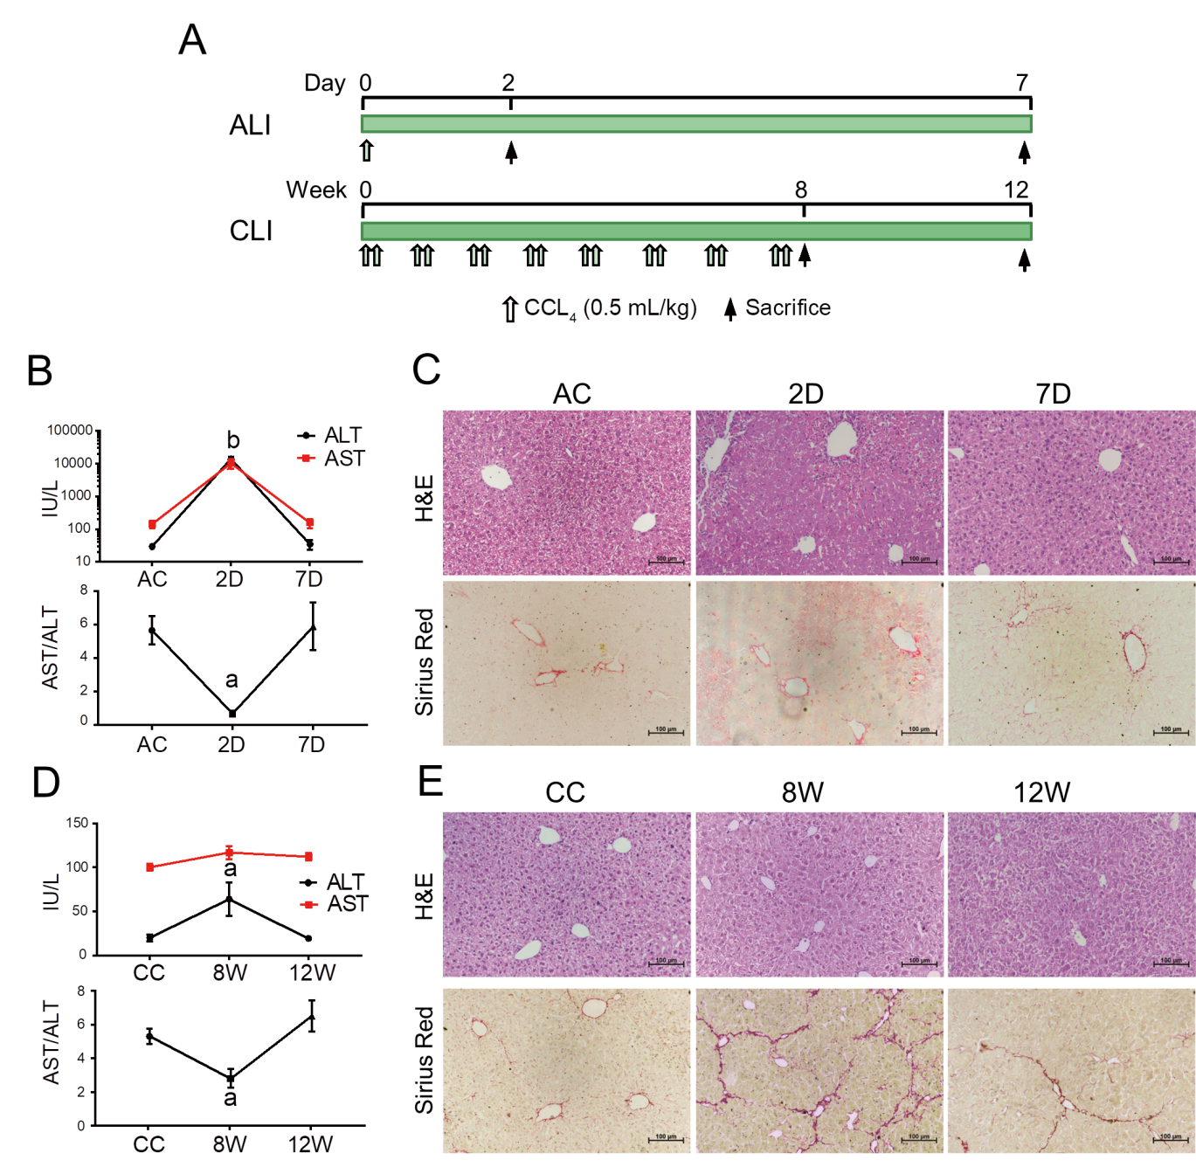
Figure 1 Establishment and validation of CCL₄-induced acute liver injury and chronic liver injury in mice. A: Workflow for the establishment of the acute liver injury (ALI) and chronic liver injury (CLI) mouse models; B: Serum alanine aminotransferase (ALT) and aspartate aminotransferase (AST) levels in ALI mice. Compared with the ALI control (AC) group, ªP < 0.05, ^{b}P < 0.01; C: Hematoxylin-eosin (H&E) and Sirius Red staining of liver sections from AC, 2 d and 7 d mice; D: Serum ALT and AST levels in CLI mice. Compared with the CC group, ªP < 0.05; E: H&E and Sirius Red staining of liver sections from CLI control (CC), 8 wk and 12 wk mice. Scale bar = 100 μm. D: Day; W: Week.
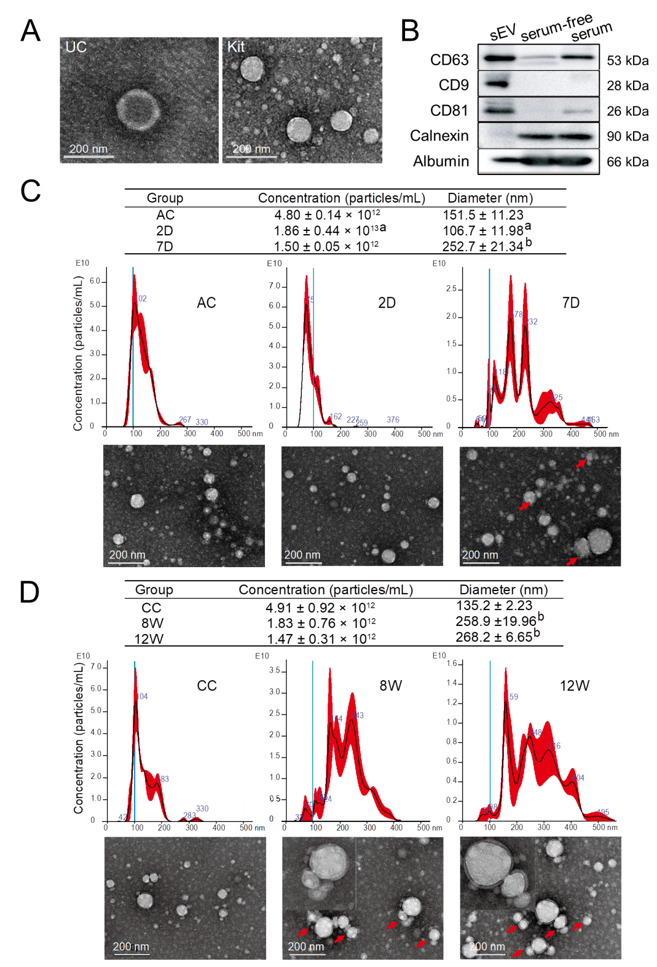
Figure 2 Characterization of isolated mouse serum small extracellular vesicles. A: Transmission electron microscopy (TEM) images of the particles isolated using ultracentrifugation and an ExoQuick precipitation kit; B: Representative Western blotting bands for CD63, CD81, CD9, calnexin and albumin; C: Nanoparticle tracking analysis (NTA) plots for the size distribution and concentration of the isolated particles in each group from ALI mice and the corresponding TEM images. Compared with the ALI control group, ªP < 0.05, ^{b}P < 0.01; D: NTA plots for the size distribution and concentration of the isolated particles in each group from CLI mice and the corresponding TEM images. Compared with the CLI control group, ^{b}P < 0.01. The red arrow indicates aggregated particles; representative particles were amplified and were exemplified in the top left corner. Scale bar = 200 nm. UC: Ultracentrifuge; D: Day; W: Week; AC: Acute liver injury control; CC: Chronic liver injury control; sEVs: Small extracellular vesicles.
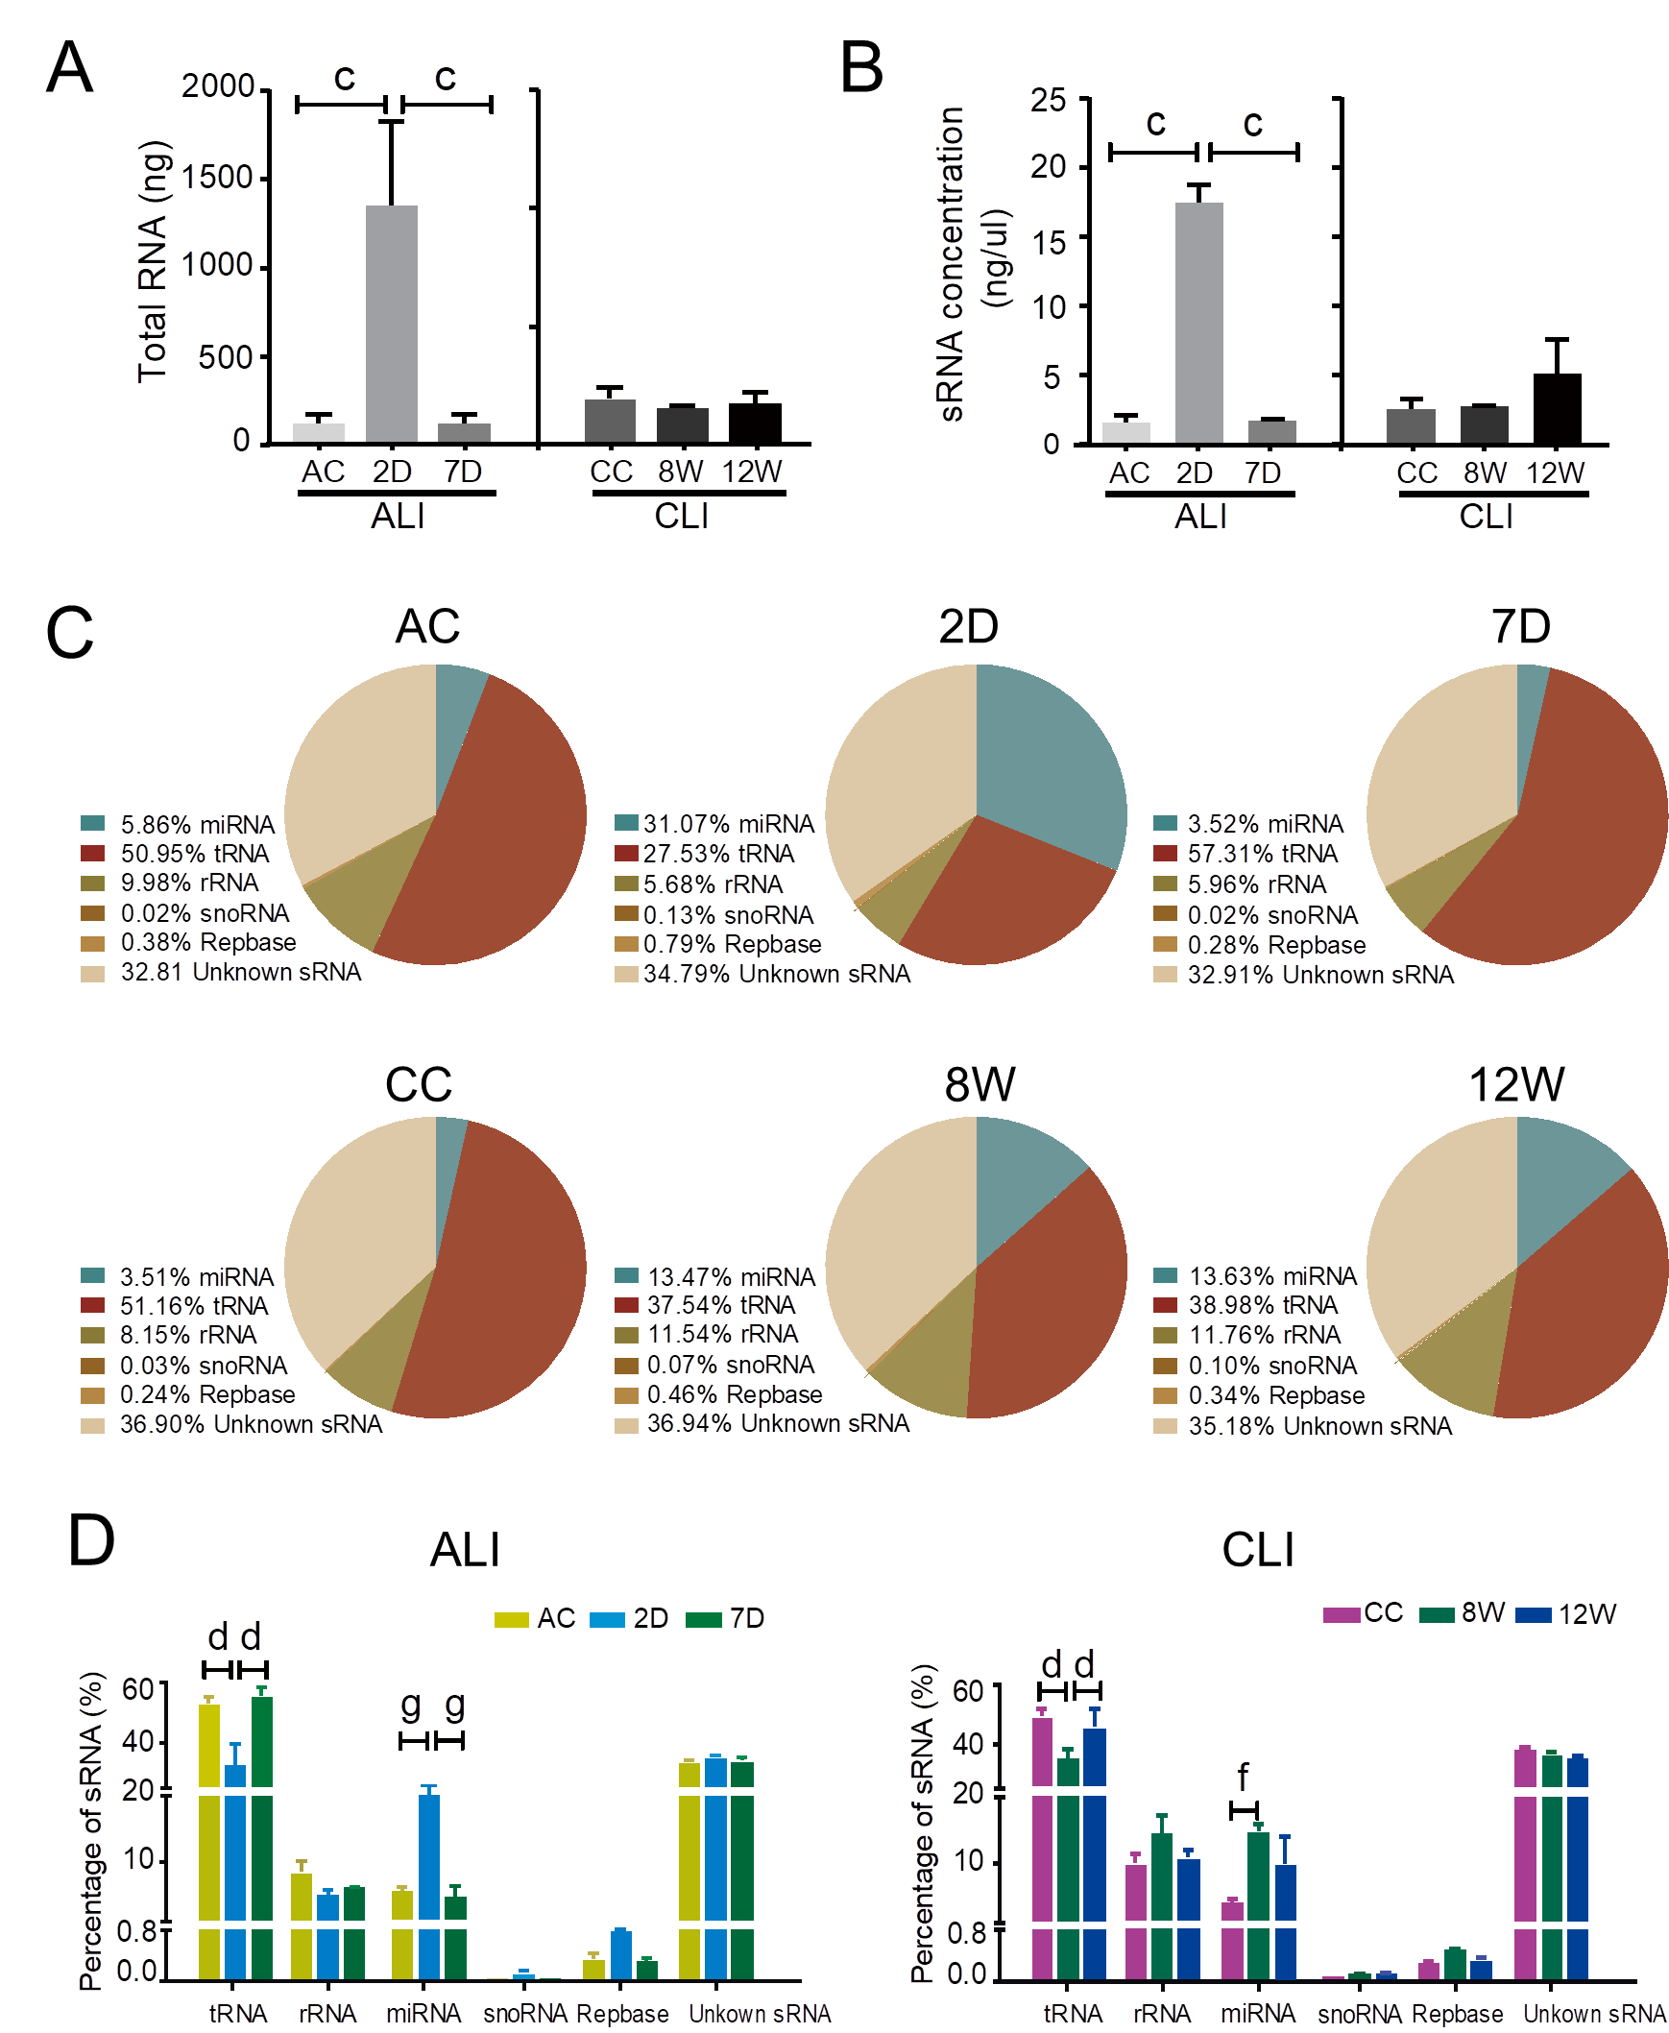
Figure 3 Annotations of small RNA in serum small extracellular vesicles from acute liver injury and chronic liver injury mice. A: Total RNA in serum small extracellular vesicles (sEVs) compared with the 2D group, ^{c}P < 0.001; B: Small RNA (sRNA) concentrations in serum sEVs compared with the 2 d group, ^{c}P < 0.001; C: Representative pie charts depicting the annotated sRNA species and their proportions in the different groups; D: Statistical analysis of sRNA species in sEVs. Compared with the 2 d group, ^{d}P < 0.0001; compared with the 8 wk group, ^{f}P < 0.01, ^{g}P < 0.0001. D: Day; W: Week; AC: Acute liver injury control; CC: Chronic liver injury control; ALI: Acute liver injury; CLI: Chronic liver injury; miRNA: MicroRNA; snoRNA: Small nucleolar RNA.
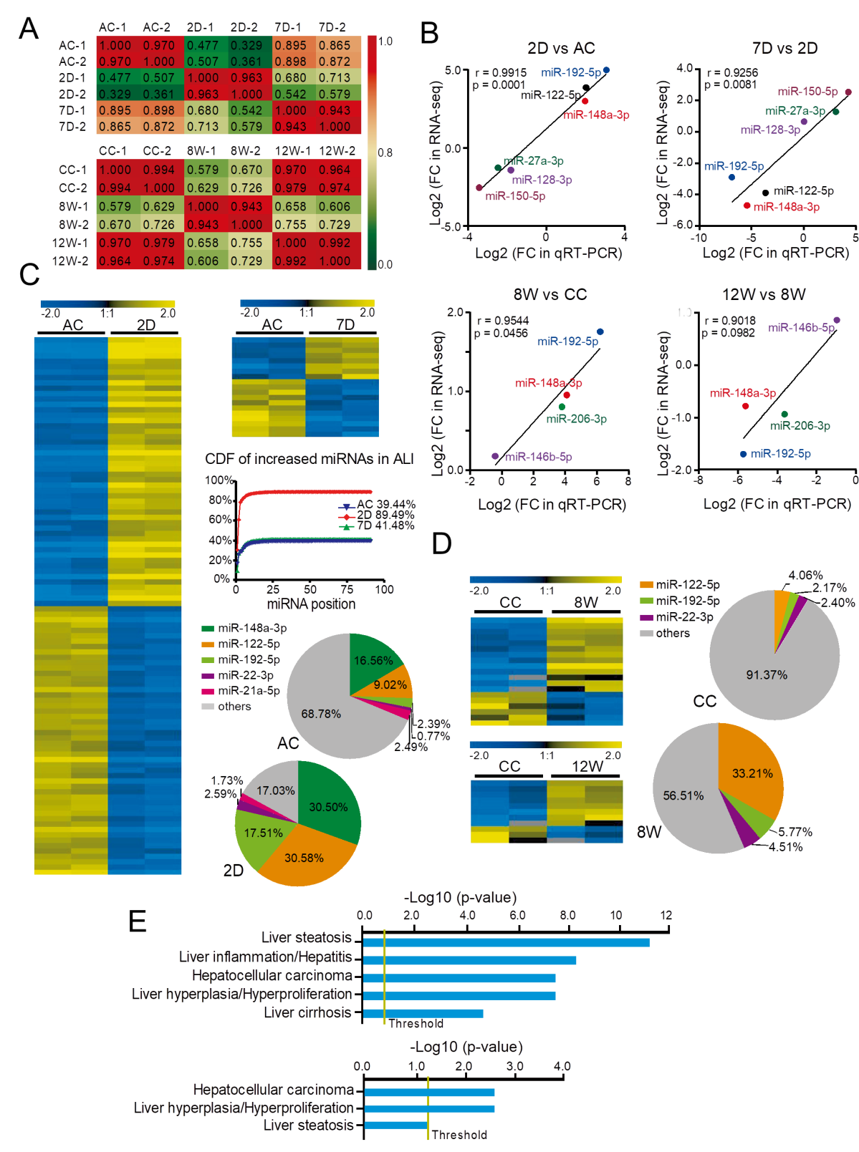
Figure 4 Differentially expressed microRNAs in serum small extracellular vesicles from acute liver injury and chronic liver injury mice and their biological significance. A: Pearson correlation coefficients between samples from acute liver injury (ALI) and chronic liver injury (CLI). The correlation coefficient values are labeled in the heat map; red or green represents high or low correlation, respectively; B: Validation of RNA sequencing data by quantitative real-time polymerase chain reaction for microRNAs (miRNAs) from ALI and CLI; C: Heatmap for the differentially expressed miRNAs in the ALI injury stage (2 d vs ALI control) and recovery stage (7 d vs ALI control), a cumulative distribution frequency plot for the increased miRNAs in ALI, and pie charts illustrating the proportions of the top five upregulated miRNAs in the ALI control and 2 d groups; D: Heatmap for the differentially expressed miRNAs in the CLI injury stage (8 wk vs CLI control) and recovery stage (12 wk vs CLI control). The pie charts illustrate the proportions of the top three upregulated miRNAs in the CLI control and 8 wk groups; E: The top hepatotoxicity processes related to the differentially expressed serum sEV miRNAs in ALI (top) and the differentially expressed serum sEV miRNAs in CLI (bottom) cataloged by Ingenuity Pathway Analysis-Tox function analysis. D: Day; W: Week; AC: Acute liver injury control; CC: Chronic liver injury control; ALI: Acute liver injury; CDF: Cumulative distribution frequency; qRT-PCR: Quantitative real-time polymerase chain reaction; FC: Fold change; RNA-seq: RNA sequencing; miRNA: MicroRNA.
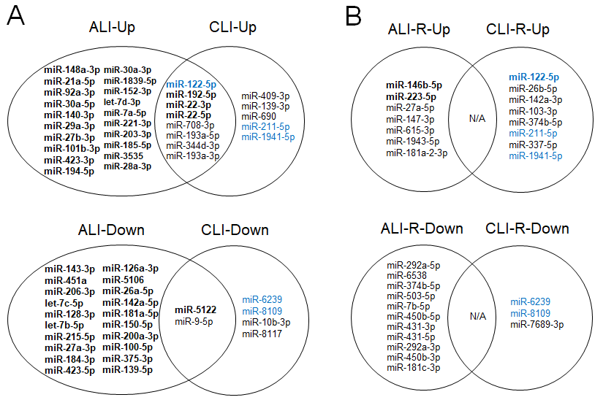
Figure 5 Common and specific microRNAs for acute and chronic liver injury and recovery in mouse models. A: Common and specific microRNAs (miRNAs) for acute and chronic liver injury; B: Common and specific miRNAs for the recovery stages of acute and chronic liver injury. Bold font: Transcripts per million reads Mean > 1000; Blue font: Overlapping microRNAs in injury and recovery; n: Not applicable; ALI: Acute liver injury; CLI: Chronic liver injury; ALI-R: Acute liver injury recovery; CLI-R: Chronic liver injury recovery.
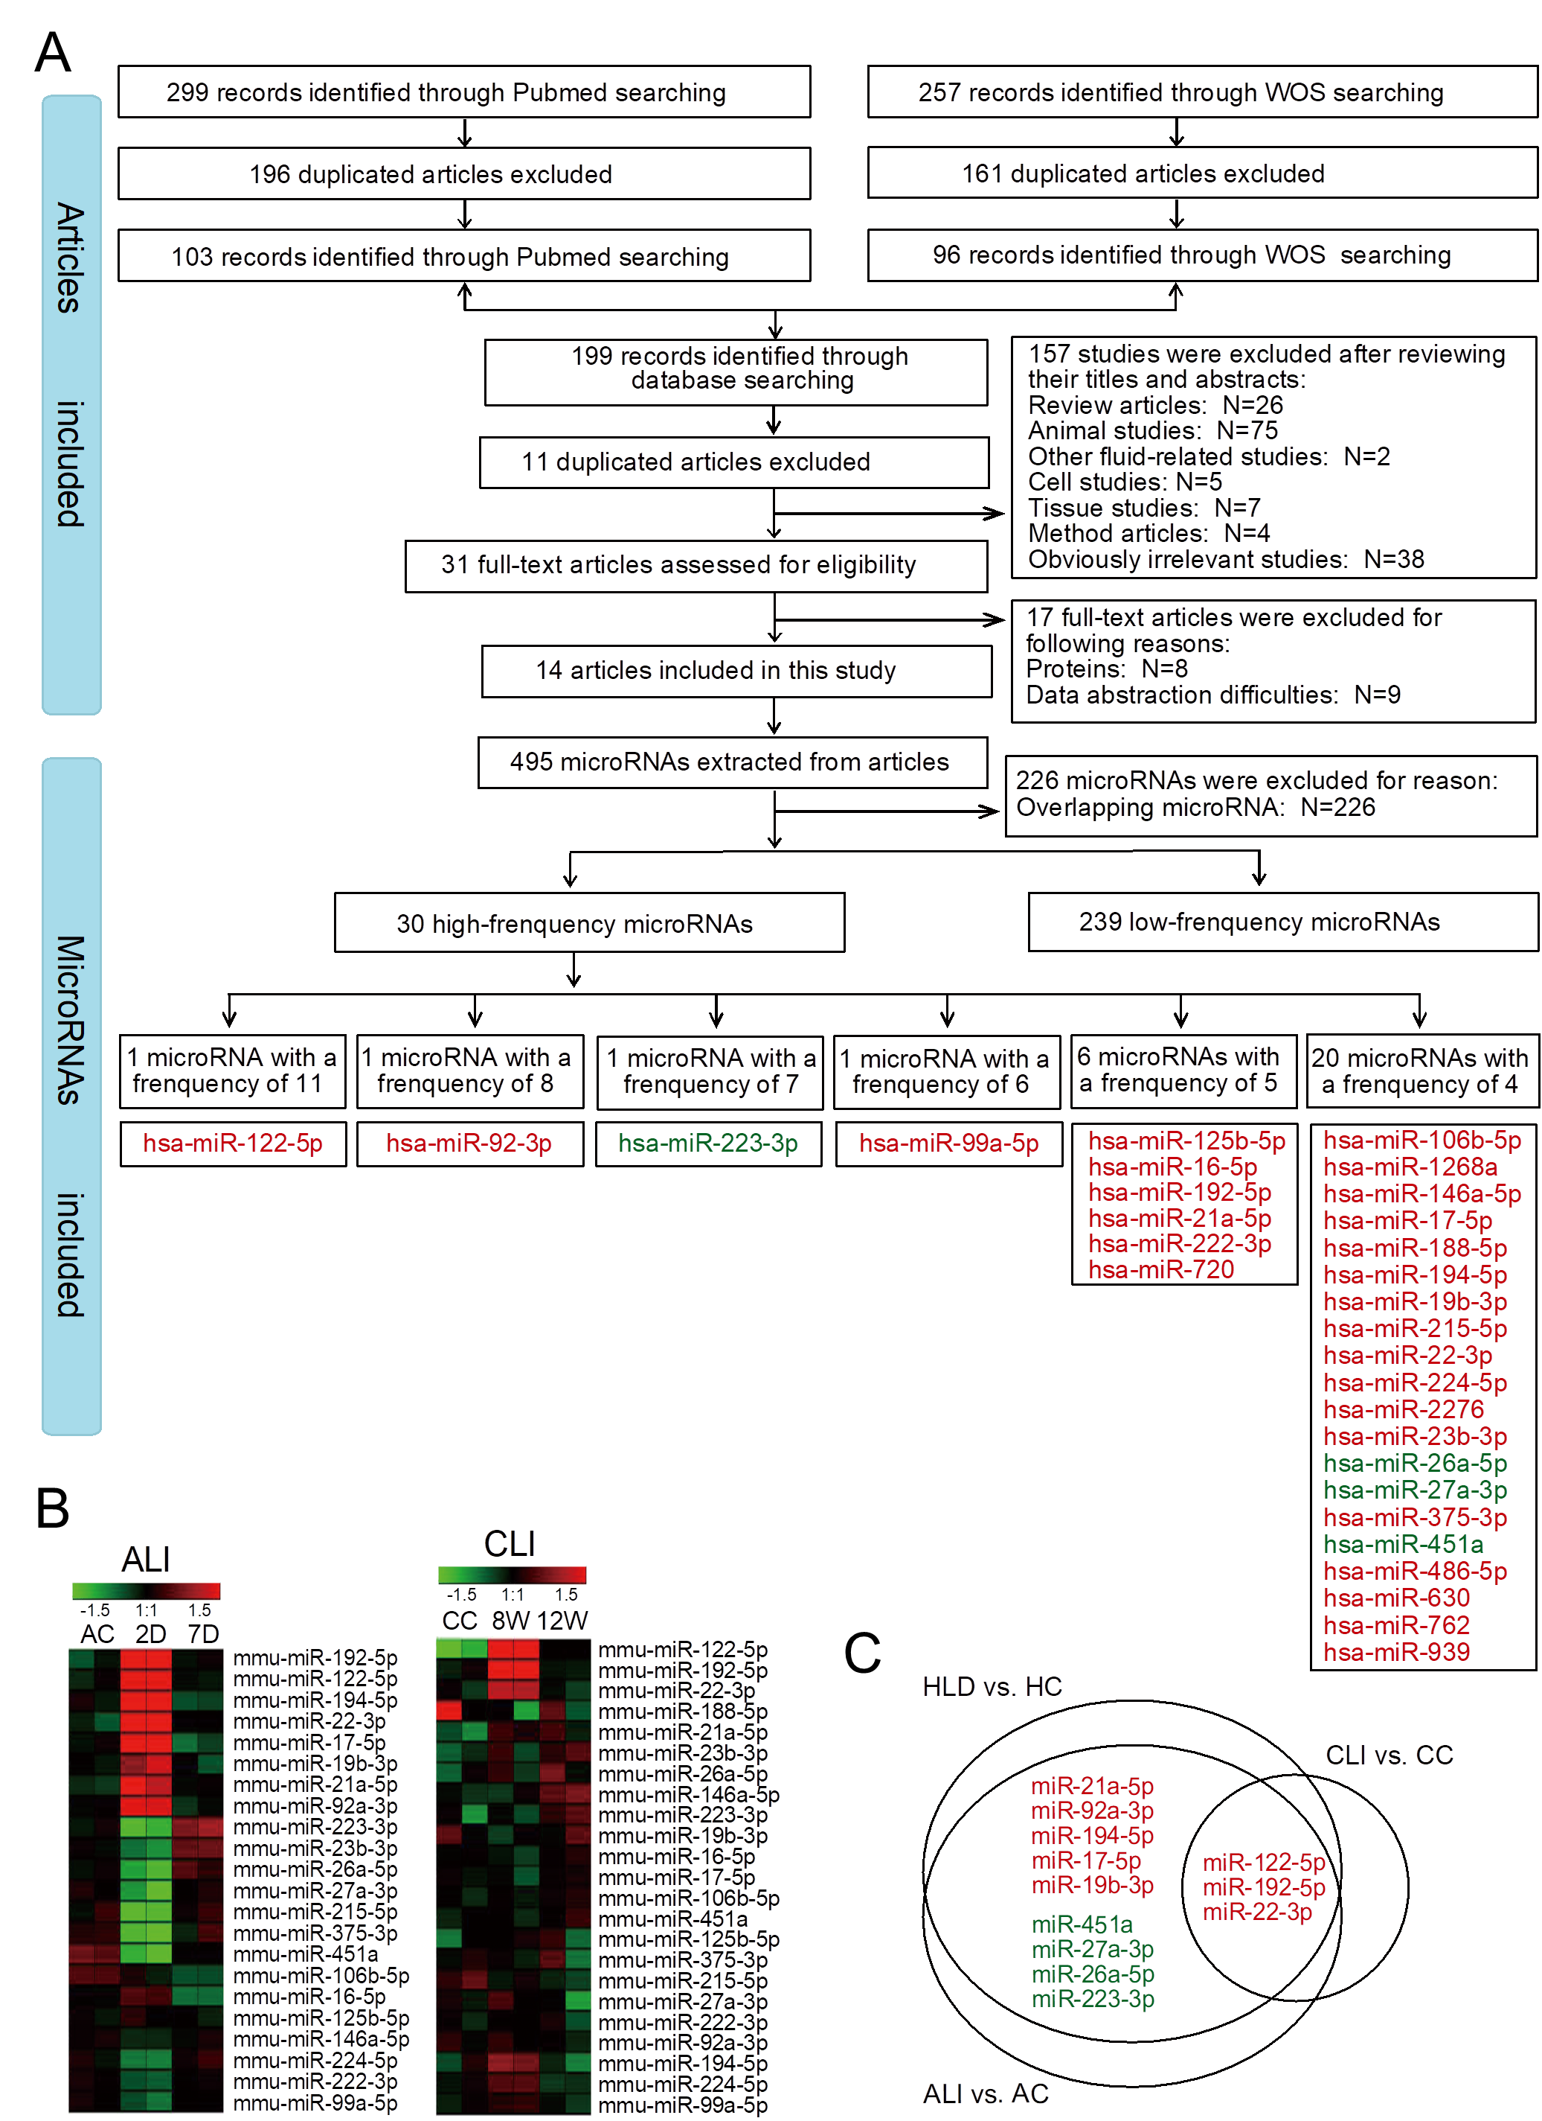
Figure 6 Differentially expressed circulating microRNAs in human liver disease and common microRNAs in mice. A: Flow chart of study selection and microRNA (miRNA) screening; B: Heatmap for the expression of high-frequency human liver disease (HLD)-related circulating miRNAs in acute liver injury (ALI) and chronic liver injury (CLI) serum small extracellular vesicles (sEVs); C: Common miRNAs in the serum sEVs from mice with ALI and CLI and in the circulation in the context of HLDs. Red font: Upregulated miRNAs; Green font: Downregulated miRNAs; HC: Healthy control; AC: Acute liver injury control; CC: Chronic liver injury control; WOS: Web of Science; D: Day; W: Week.
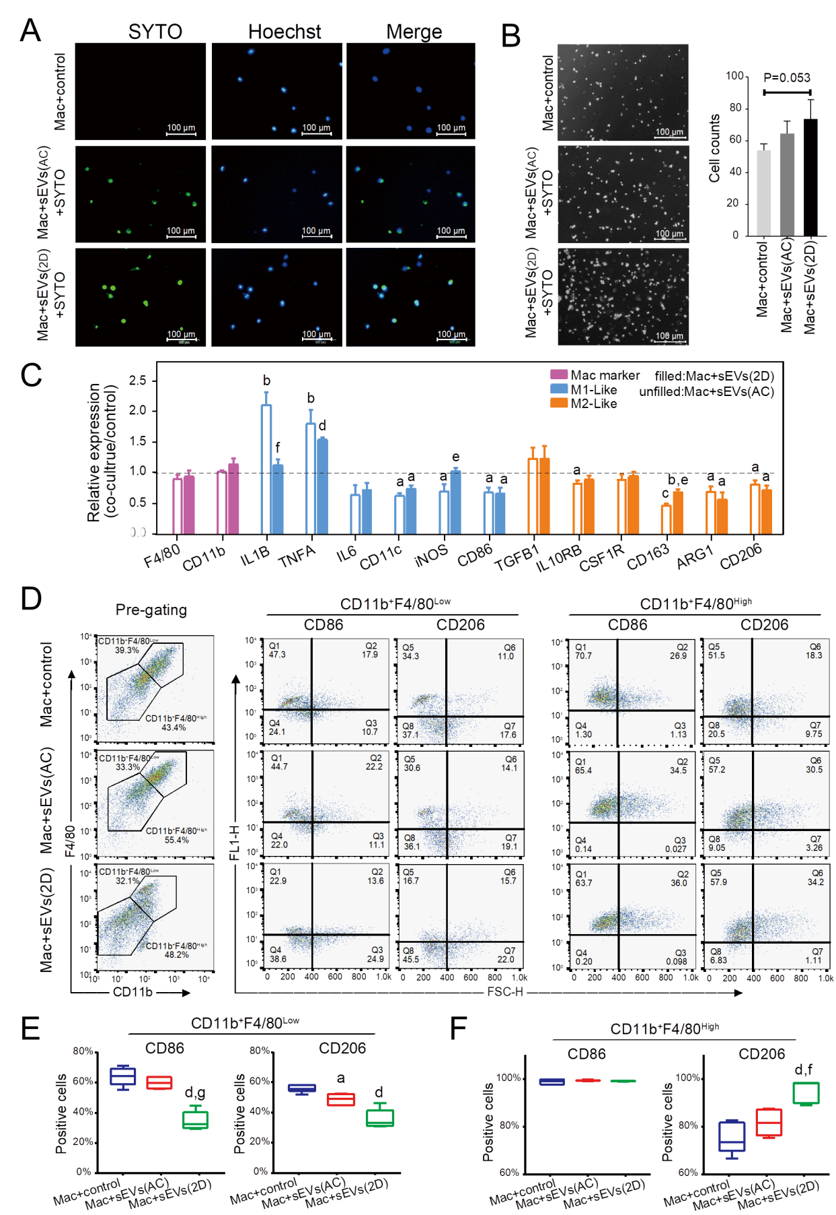
Figure 7 Uptake of serum small extracellular vesicles by hepatic macrophages and subsequent reprogramming. A: Uptake of SYTO-labeled serum small extracellular vesicles (sEVs) from normal (AC) or acute liver injury (ALI) (2D) mice by primary hepatic macrophages; B: Hepatic macrophages were incubated with AC or 2D serum sEVs for 24 h. The number of attached cells per 200 × field is shown; C: Expression of M1- and M2-like cell surface markers and cytokines in hepatic macrophages incubated with mice serum sEVs. The unfilled column represents macrophages incubated with AC sEVs, and the filled column represents macrophages incubated with 2D sEVs. Compared with the untreated control group, ªP < 0.05, ^{b}P < 0.01, ^{c}P < 0.001, ^{d}P < 0.0001; compared with the AC sEV treatment group, ^{e}P < 0.05, ^{f}P < 0.01; D: Macrophages were defined as CD11b⁺F4/80^{Low} and CD11b⁺F4/80^{High} subgroups. The representative images show the percentage of CD86-and CD206-positive cells in each subgroup subjected to the control, AC sEV and 2D sEV treatments; E: CD86- and CD206-positive cells in each subgroup. Compared with the control group, ªP < 0.05, ^{d}P < 0.0001; compared with the AC sEV treatment group, ^{f}P < 0.01, ^{g}P < 0.0001. Scale bar = 100 μm. Mac: Macrophage; D: Day; AC: Acute liver injury control; sEVs: Small extracellular vesicles.
Table 1 Liver-enriched microRNAs ranked highly among serum small extracellular vesicle microRNAs from acute liver injury and chronic liver injury model mice
GSE78792 liver | Rank | ALI | ALI rank | CLI | CLI rank
miR-192 | 1 | miR-192-5p | 3 | miR-192-5p | 2
miR-22 | 2 | miR-22-3p | 4 | miR-22-3p | 3
miR-30a | 3 | miR-30a-5p | 7 | N/A | N/A
miR-148a | 4 | miR-148a-3p | 1 | N/A | N/A
miR-21a | 5 | miR-21a-5p | 5 | N/A | N/A
miR-26a-2 | 6 | miR-26a-5p | 105 | N/A | N/A
miR-122 | 7 | miR-122-5p | 2 | miR-122-5p | 1
miR-10a | 8 | N/A | N/A | N/A | N/A
miR-143 | 9 | miR-143-3p | 92 | N/A | N/A
miR-27b | 10 | miR-27b-3p | 10 | N/A | N/A
N/A: Not applicable; ALI: Acute liver injury; CLI: Chronic liver injury.

Published by Baishideng Publishing Group Inc
7041 Koll Center Parkway, Suite 160, Pleasanton, CA 94566, USA
Telephone: +1-925-3991568
E-mail: bpgoffice@wjgnet.com
Help Desk: https://www.f6publishing.com/helpdesk
https://www.wjgnet.com

© 2021 Baishideng Publishing Group Inc. All rights reserved.

