Name of Journal: World Journal of Gastroenterology
ESPS Manuscript NO: 31752

Manuscript Type: ORIGINAL ARTICLE

Clinical Trials Study

Urinarymetabolomics analysis identifies key biomarkers of different stages of nonalcoholic fatty liver disease

Dong s et al. Biomarkers of stages in NAFLD

Shu Dong, Zong-Ying Zhan, Hong-yan Cao, Chao Wu, Yan-qin Bian, Jian-yuan Li, Gen-hong Cheng,Ping Liu, Ming-Yu Sun

Shu Dong, Zong-Ying Zhan, Hong-yan Cao, Chao Wu, Yan-qin Bian, Jian-yuan Li, Ping Liu, Ming-Yu Sun, Key Laboratory of Liver and Kidney Diseases, Institute of Liver Diseases, Shuguang Hospital Affiliated to Shanghai University of Traditional Chinese Medicine, Shanghai 201203, China

Shu Dong, Zong-Ying Zhan, Hong-yan Cao, Chao Wu, Yan-qin Bian, Jian-yuan Li, Ping Liu, Ming-Yu Sun, Shanghai University of Traditional Chinese Medicine, Shanghai 201203, China

Gen-hong Cheng, Department of Microbiology, Immunology and Molecular Genetics, David Geffen School of Medicine,University of California, Los Angeles, CA 90095, United States

Author contributions: Sun MY, Dong S, Zhan ZY and Liu P conceived and designed the experiments; Sun MY and Dong S wrote the paper; Dong S, Zhan ZY, Cao HY, Wu C, Bian YQ and Li JY collected samples; Sun MY and Cheng GH critically revised the paper for important intellectual content; Sun MY gave final approval for publication of the paper.

Supported by the Major Project of Shanghai Municipal S&T Commission, No. 15DZ1900104; National Natural Science Foundation, No. 81273729.

Institutional review board statement: The study protocol was approved by the ethics review committee of the Faculty of Medicine, Shuguang Hospital, China, and was conducted in accordance with the principles of the Declaration of Helsinki and Good Clinical Practice Guidelines.

Clinical trial registration statement: This study has been registered on ClinicalTrials.gov. Identifier No. NCT02077283.

Conflict-of-interest statement: The authors declare that there are no conflicts of interest regarding the publication of this paper.

Data sharing statement: The study protocol was approved by the ethics review committee of the Faculty of Medicine, Shuguang Hospital, China, and was conducted in accordance with the principles of the Declaration of Helsinki and Good Clinical Practice Guidelines. This study has been registered on ClinicalTrials.gov. Identifier No. NCT02077283. Readers could get the information of the study and the original data by contact the author Shu Dong at lisadongshu@163.com.

Open-Access: This article is an open-access article which was selected by an in-house editor and fully peer-reviewed by external reviewers. It is distributed in accordance with the Creative Commons Attribution Non Commercial (CC BY-NC 4.0) license, which permits others to distribute, remix, adapt, build upon this work non-commercially, and license their derivative works on different terms, provided the original work is properly cited and the use is non-commercial. See: http://creativecommons.org/licenses/by-nc/4.0/

Manuscript source: Unsolicited manuscript

Correspondence to: Ming-yu Sun, MD, PhD, Key Laboratory of Liver and Kidney Diseases, Institute of Liver Diseases, Shuguang Hospital Affiliated to Shanghai University of Traditional Chinese Medicine, 528 Zhangheng Road, Pudong New District, Shanghai 201203, China. mysun248@hotmail.com
Telephone: +86-21-20256526

Received: December 5, 2016
Peer-review started: December 6, 2016
First decision: December 29, 2016
Revised: January 13, 2017
Accepted: February 16, 2017
Article in press:
Published online:

Abstract
AIM
To find out a panel of biomarkers which can distinguish between non-alcoholic fatty liver disease (NAFLD) and non-alcoholic steatohepatitis (NASH) and explore molecular mechanism involved in the process of development of NASH from NAFLD.

METHODS
Biomarkers may differ during stages of with NAFLD. Urine and blood were obtained from non-diabetic subjects with NAFLD and steatosis, with normal liver function (n = 33) and NASH, with abnormal liver function (n = 45) and from healthy age- and sex-matched controls (n = 30). Samples were subjected to metabolomic analysis to identify potential non-invasive biomarkers. Differences in urinary metabolic profiles were analyzed by liquid chromatography tandem mass spectrometry with principal component analysis and partial least squares-discriminate analysis.

RESULTS
Compared with NAFLD patients, patients with NASH had abnormal liver function and high serum lipid concentrations. Urinary metabonomics found differences in 31 metabolites in these two groups, including differences in nucleic acids and amino acids. Pathway analysis based on overlapping metabolites showed that pathways of energy and amino acid metabolism, as well as the pentose phosphate pathway, were closely associated with pathological processes in NAFLD and NASH.

CONCLUSION
These findings suggest that a panel of biomarkers can distinguish between NAFLD and NASH and can help determine the molecular mechanism involved in the process of development of NASH from NAFLD. Urinary biomarkers may be diagnostic in these patients and may be used to assess responses to therapeutic interventions.

Key words: Nonalcoholic fatty liver disease; Steatohepatitis; Urinary metabonomics

© The Author(s) 2017. Published byBaishideng Publishing Group Inc.All rights reserved.

Core tip: To find out biomarkers which can distinguish between nonalcoholic fatty liver disease (NAFLD) and nonalcoholic steatohepatitis (NASH), urine and blood were obtained from NAFLD (n = 33), NASH (n = 45) and healthy controls (n = 30). Urinary metabonomics found differences in 31 metabolites between NAFLD and NASH, including nucleic acids and amino acids. Pathway analysis showed that pathways of energy and amino acid metabolism, as well as the pentose phosphate pathway, were closely associated with pathological processes in NAFLD and NASH. These biomarkers can distinguish between NAFLD and NASH and can help determine the mechanism involved in the development of NASH from NAFLD.

Dong S, Zhan ZY, Cao H, Wu C, Bian YQ, Li JY, Cheng GH, Liu P, Sun MY. Urinary metabolomics analysis identifies key biomarkers of different stages of nonalcoholic fatty liver disease. World J Gastroenterol 2017; In press

INTRODUCTION
Nonalcoholic fatty liver disease (NAFLD) comprises a spectrum of pathologic conditions, including simple steatosis, nonalcoholic steatohepatitis (NASH) and cirrhosis. NAFLD has been estimated to affect approximately 15%–30% of the general population and its prevalence is increasing worldwide^{[1,2]}. The rate of NAFLD is strongly linked to obesity, insulin resistance and a cluster of metabolic disorders, including hypertriglyceridemia and hyperuricemia^{[3]}, that seriously impair health^{[4]}.
No standard treatment currently exists for managing NAFLD, oreven NASH,in western medicine^{[5]}. Weight loss regimens, including restricted calorie diets, bariatric surgery and drug-induced fat malabsorption, only improve the condition to some degree^{[6–8]}. Identification of metabolic differences among stages of NAFLD may result in the development of more effective and specific treatments for NAFLD and NASH.
Urine metabonomics^{[9]} is a good method of assessing metabolic differences among different stages of NAFLD. Although urinary metabolomics data have been obtained in patients with NAFLD, NASH and liver cirrhosis^{[10]}, few studies to date have used this method to compare patterns in patients at different stages of NAFLD. This study was designed to investigate correlations between disease stages and urine metabonomics in patients with NAFLD, specifically to determine whether urine metabonomics can be used todistinguish NAFLD from NASH.In addition, this study sought to determine the molecular mechanisms involved in the development of NASH from NAFLD.

MATERIALS AND METHODS

Population, information and sample collection
The randomized clinical trial evaluated patients seen at the NAFLD outpatient clinic of Shuguang Hospital Affiliated to Shanghai University of Traditional Chinese Medicine fromJanuary 2013 to May 2014. Healthy volunteer controls were enrolled from employees of the medical center. Figure 1 provides an overview of the study.A total of 108 subjects were recruited, 33 in the NAFLD group, which included patients with steatosis and normal liver function; 45 in the NASH group, which included patients with steatohepatitis and abnormal liver function; and 30 healthy controls.All subjects provided written informed consent.
General information recorded at each participant’s first visit to a doctor included age, gender, and medical history. Results of laboratory tests and ultrasound were also recorded. Urine samples for metabolic profile were collected from participants at their second visit.

Diagnostic criteria for NAFLD and NASH
The diagnostic criteria for NAFLD included (1) a history of no or limited daily alcohol intake (< 20 g for women and < 30 g for men); (2) the presence of hepatic steatosis by imaging or histology; and (3) the exclusion of all other liver diseases^{[11]}. The diagnostic criteria for NASH included (1) a diagnosis of NAFLD, as above; and (2) a significant increase in ALT activity or other liver function parameters.

Inclusion criteria
Both males and females aged 18–60 years without medication were eligible following a screening test to confirm the presence of NAFLD. Based on their symptoms and the results of liver function test, NAFLD patients weredivided into NAFLD and NASH groups, consisting of patients with normal and abnormal liver function, respectively.

Exclusion criteria
Patients were excluded if they: (1) had a history of diabetes mellitus or any metabolic disease; (2) consumed > 20 g alcohol per day; (3) had acute diseases or other untreated illness requiring treatment; (4) had impaired hepatic or renal functions; (5) were female of childbearing age who were pregnant, lactating, or unwilling to use an effective form of birth control; (6) had medication or other treatment before or (7) had a history or presence of any condition that, in the investigator’s opinion, would endanger the individual’s safety or affect the study results.

Urine sample collection and handling
Urine samples were collected from each participant during mid-morning and centrifuged at 4 °C for 15 min at 1509.3×g. The supernatantswere frozen and stored at −80 °C until analysis. If required, urine samples were transported using Drikold.

LC/MS analysis
Pretreatment: 100 ul urine and 300 ul acetonitrile were vortexed for 3 min and then centrifuged at 12000 r/min, 4 ℃ for 10 min. Supernate were kept as prepared samples for further performance.
LC separation was performed on an Agilent 1200 series LC system. Aliquots of 2 µl of prepared samples were injected into a Waters Shield C18 column (3.5 µm, 2.1 mm×150 mm) maintained at 20 °C and eluted with a mobile phase of 0.01% formic acid in water-acetonitrile (90:10) at a flow rate of 0.3 ml/min. MS detection was performed on an API 4000 triple quadrupole mass spectrometer (Sciex Applied Biosystems), using positive electronic spray ionization in multiple reaction monitoring mode at a source temperature of 700 °C and a voltage of 5500 V. The dwell time for the multiple reaction monitoring mode was 0.08 s. Nitrogen was used as the curtain, nebulizer and collision gas at pressures of 50, 60 and 70 psi, respectively. Certain ion transitions for amino acids and their internal standards were monitored and peak area ratios of amino acids to internal standardswere calculated after correcting for transition overlaps of natural leucine and isoleucine^{[12]}.

Metabolite identification
Compounds were identified by comparison with library entries of purified standards and recurrent unknown entities. Known chemical entities were identified based on comparisons with metabolomic library entries of more than 2362 commercially available purified standards and online database (http://metlin.scripps.edu/), and addition, presently unknown entities,were identified by their recurrent nature^{[13]}.

Statistical analysis
Data were analyzed by parametric and nonparametric statistical tests using SPSS (version 16) and Simca-P (version 11.0). Continuous data were compared by one-way ANOVA. Differences in metabolic profileson LC/MS were determined by principal component analysis and partial least squares discriminant analysis.
To validate the importance of metabolites, and to furthergauge theirability todistinguish among patients with NASHand NAFLD and healthy controls, their potential predictive utility for the process of NAFLDwas assessed by ROC curve analysis. ROC analysis was performedusingMS peak areas corresponding to metaboliteconcentrations in each of the three subjects groups. Areas under the ROC curve were calculated using RORC package.

Quality control
The actual measurements from each patient’s laboratory test results were entered into an Excel spreadsheet, followed by re-checking of all data to ensure accuracy.

Results
Characteristics of study participants
There were no significant difference among the three groups in patient number, age and height. Weight and BMI were significantly higher in the NAFLD and NASH groups than in the control group (Table 1).
Compared with healthy group, patients with NAFLD and NASH had much higher concentrations of glycosylated hemoglobin (HbA1c), low-density lipoprotein-cholesterol (LDL), triglycerides (TG), total cholesterol (TC), alanine aminotransferase (ALT), aspartate aminotransferase (AST), gamma-glutamyl transferase (GGT) and total bilirubin (TBiL). Compared with the NAFLD group, patients with NASH had much higher ALT, AST, and GGT concentrations and significantly different results on NASH group ultrasound examinations(Table 2, Figure 2).

Urine metabonomics
Principal component analysis (PCA) was performed using samples from the three groups of subjects. S-plots showed obvious metabolic differences among these three groups (Figure 3).

NAFLD group vs control group: This was followed by pairwide comparisons. Urinary metabonomics were used to assess differences between the NAFLD and control groups. Principal component analysis (PCA) showed a spectral separation between these two groups, indicating significant metabolic differences.This was further supported by PLS-DA and OPLS-DA(Figure 4). After filtering out interference signals, 53 different metabolites were detected;mainly nucleic acids and amino acids (Table 3). Concentrations of the nucleic acid metabolites hypoxanthine, xanthine and carnitine were lower in the urine of patients with NAFLD than in control subjects. In addition, concentrations of the amino acid metabolites, citrulline, arginine, valine,and indole acetic acid, as well as glucose and gluconic acid, were higher in patients with NAFLD than in controls. ROC analysis, performed to identify the key metabolites that could distinguish NAFLD patients from healthy individuals found that 7-methylxanthine, 2-methylguanosine, gluconic acid and indoxylsulfuric acid were markers for NAFLD (Figure 5).

NASH group vs control group: Urinary metabonomics were also used to assess differences between the NASH and control groups. Analysis by PCA showed obvious spectral separation between the two groups, indicative of significant metabolic differences between NASH patients and healthy controls. This was further supported by PLS-DA and OPLS-DA (Figure 6). After filtering out the interference signals, 88 different metabolites (Table 4) were detected, consisting mainly of amino acids and their metabolic intermediates. Compared with healthy controls, patients with NASH had much higher urinary levels of lysine, valine, citrulline, arginine, threonine, tyrosine, leucine, hippuric acid and 3-indoleacetic acid and lower levels of derivatives of indole acetic acid such as 5-hydroxy indole acetic acid and indole-3-formic acid. In addition, cortisol levels decreased significantly. ROC analysis showed that 2-methylguanosine, gluconic acid, indoxylsulfuric acid, cAMP, indolelactic acid and acetyl-DL-leucine could distinguish patients with NASH from healthy individuals (Figure 7).

NAFLD group vs NASH group: Metabolic PCA analysis of urine samples from patients with NAFLDand NASHshowed spectral separation between the two groups of samples, indicating significant metabolic differences. PLS-DA was performedto better assess these differences (Figure 8). After filtering out interference signals, 31 different metabolites (Table 5) were detected, mainly nucleic acids and amino acids. Compared with the NAFLD group, patients with NASH had much higher concentrations of methyl xanthine, tryptophan, 3-indole acetic acid, and gluconic acid and a lower level of proline.ROC analysis showed that 3-indoleacetic acid, L-carnitine, pyroglutamic acid and indolelactic acid could distinguish NASH from NAFLD (Figure 9).

Key differential metabolites among the NALFD, NASH, and control groups: The differentially expressedmetabolites in the three pairwise comparisons were combined to determine themetabolitesthat overlapped in the three groups. Seven metabolites were screened through Venn analysis: L-carnitine, acetylcarnitine, gluconic acid, deoxycorticosterone, 2-keto-D-gluconic acid, pyroglutamic acid, and indolelactic acid (Figure 10). KEGG pathway analysis showed that these seven metabolites were enriched in seven pathways:metabolic pathways, the pentose phosphate pathway, antibiotic biosynthesis pathways antibiotics, steroid hormone biosynthesis, bile secretion, carbon metabolism and glutathione metabolism. Three of these pathways, the pentose phosphate,carbon metabolism and glutathione metabolism pathways, maybe closely related to the pathological processes of NAFLD and NASH.

DISCUSSION
Obesity, insulin resistance and associated metabolic perturbations are frequently observed in patients with NAFLD^{[14,15]}. NASH is a type of NAFLD with serious abnormalities in liver function^{[16]}. NAFLD has a great impact on health, affecting many bodilysystems^{[17]}. To determine the exact progress of NAFLD, we investigated metabolic changes involved in NAFLD and NASH.Urinary metabolomicsmay provide better understanding of the pathogenesis of NAFLD and may reveal key markers that can differentiate between NAFLD from NASH.
In NAFLD and the control group, the gender ratio has no difference. While in NASH group, there were more male than female which may due to that more female came to doctor earlier than male so they would not develop to NASH according to the doctor's experience. Age and heightwere similar in the NAFLD, NASH, and control groups, whereas body weight and BMI were significantly higher in the NASH than in the NAFLD and control groups. These findings suggest a link betweenobesity andNASH.Parameters of liver function and blood lipidsdiffered in patientswith NASH and NAFLD, indicating that metabolic changes occurred during the progression of NAFLD to NASH.One of the overlappingdifferentiallyexpressed metabolites, pyroglutamic acid,is involved in glutathione metabolism, a finding consistent with abnormal liver function. Another metabolite, L-carnitine, is involved in bile secretion, perhaps explaining the difference in blood lipid levelsbetween the NAFLD and NASH groups.
Animal experiments have shown metabolic changes in mice with NAFLD or NASH^{[18]}. For examples, concentrations of triglycerides, cholesterol and intermediates of the methionine cycle were reported altered^{[19]} and phospholipid and bile acid metabolism disrupted^{[20]} in mouse models of NASH.
Metabolic changes have also been detected in clinical trials. Serum glucose, lactate, glutamate/glutamine, and taurine concentrations have been reported to differ in patients with NAFLD and healthy controls^{[21]}. Bile acids and markers of glutathione, lipid and amino acid metabolism differ in NAFLD patients and controls^{[22]}. This study found differences in metabolites of amino acids and nucleic acids in NAFLD patients and controls, with the concentration of hypoxanthine being especially lower in patients with NAFLD. NAFLD is characterized by disordersin hypoxanthine and xanthinemetabolism, with these aberrations leadingto lipid peroxidation and oxidative stress, producing increased amounts of free radicals^{[23]}. Hypoxanthine and xanthine concentrations can be used to estimate the degree of injuryto hepatocytes^{[24]}.
This study also showed that the concentration of carnitine in urine was much lower in NAFLD patients than in healthy controls. Carnitine not only supplies energy for the oxidation of fatty acids^{[25]} but eliminates free radicals that can destabilizecell membranes^{[26]}. Low carnitineconcentrations can result in cell oxidative damage, fatty acid synthesis and energy metabolism disorders^{[27–29]}, ultimately resulting in NAFLD.
The concentrations of amino acids and their metabolic intermediates were generally higher in patients with NASH patientsthan in healthy individuals. Most amino acids are synthesized and degraded in the liver; thus, injury to the liver can result in abnormalities in the metabolism of amino acids and the release of amino acids from hepatocytes^{[30]}. Thus, amino acid levelswill be higher in the urine of NASH patients than in healthy controls.We also found that cortisol concentrations were significantly lower in the urine of NASH patients than in controls, indicatingpossible neuroendocrine changes in NASH patients. Cortisol concentrations have been reported to correlate with the severity of NAFLD^{[31]}.
Comparisons in the groups of patients with NAFLD and NASH showed that most ofthe differentially expressed metabolites were nucleic acids and amino acids. The level of cholinesterase was significantly lower in patients with NASH than with NAFLD. A low content of cholinesterase will have negative effects on the synthesis and secretion of very low-density lipoprotein (VLDL). This can result in the inability to transport triglycerides (TG) out of hepatocytes, which can result in liver steatosis^{[32,33]}. Deposits of excess fatcan cause lipid peroxidation and damage to the antioxidant barrier^{[25,26]}, an important step by which NASH develops from NAFLD^{[34]}. Interestingly, we also found that the level of indoleacetic acid was much higher in the NASH than in the NAFLD group. This was consistent with findings showing that indoleacetic acid concentration correlates with liver damage^{[35]}.
The alterations observed in the NAFLD and NASH groups mainly affect energy^{[19]}. Differential levels of hormones, cytokines, and neurotransmitters may result in abnormal energy metabolism in patients with NAFLD^{[36]}, findings consistent with our results. Alterations in hepatic mitochondrial function in NAFLD patients may influence lipid metabolism and promote oxidative stress^{[37]}, and may eventually result in changes in metabolites. Pathway analysis of the overlapping metabolites indicated thatamino acid metabolism andpentose phosphate pathways may be involved in the progression of NAFLD to NASH. Alterations in amino acid metabolites represent adaptive physiological responses to hepatic stress in patients with NASH^{[38]}. Glycometabolism, including the pentose phosphate pathway, may be altered, inasmuch asinsulin resistance is one of the primary causes of NAFLD^{[39]}. Many of these compoundsmay be associated with biochemical perturbations associated with liver dysfunctionand inflammation^{[40]}. The alterations in metabonomics we observed were consistent with previously reported changes in biochemical parameters.
Statistical analysis identified a panel of biomarkers involved in energy metabolism, amino acid metabolism and glycometabolism that may provide clues to the potential mechanism involved in the progress from NAFLD to NASH.These biomarkers may be used to effectively distinguish between NAFLD from NASH. These biomarkers may be diagnostic for NASH and may act as indicators of the efficacy of therapeutic interventions.

comments
Background
Nonalcoholic fatty liver disease (NAFLD) comprises a spectrum of pathologic conditions, including simple steatosis, nonalcoholic steatohepatitis (NASH) and cirrhosis. The rate of NAFLD is strongly linked to obesity, insulin resistance and a cluster of metabolic disorders, including hypertriglyceridemia and hyperuricemia, that seriously impair health. No standard treatment currently exists for managing NAFLD, or even NASH. Identification of metabolic differences among stages of NAFLD may result in the development of more effective and specific treatments for NAFLD and NASH. This study was designed to investigate correlations between disease stages and urine metabonomics in patients with NAFLD, specifically to determine whether urine metabonomics can be used to distinguish NAFLD from NASH, which would shed a light in dignosis and treatment of NAFLD.

Research frontiers
A panel of biomarkers can distinguish between NAFLD and NASH and can help determine the molecular mechanism involved in the process of development of NASH from NAFLD. Urinary biomarkers may be diagnostic in these patients and may be used to assess responses to therapeutic interventions.

Innovations and breakthroughs
Metabolic changes have been detected in clinical trials. Serum glucose, lactate, glutamate/glutamine, taurine concentrations, bile acids, markers of glutathione, lipid and amino acid metabolism have been reported to differ in patients with NAFLD and healthy controls. Among those findings, low carnitine concentrations can result in cell oxidative damage, fatty acid synthesis and energy metabolism disorders, ultimately resulting in NAFLD; Cortisol concentrations have been reported to correlate with the severity of NAFLD; Indoleacetic acid concentration correlates with liver damage; Differential levels of hormones, cytokines, and neurotransmitters may result in abnormal energy metabolism in patients with NAFLD.

Applications
Urinary biomarkers found in this study may be diagnostic in these patients and may be used to for diagnosis and evaluate the treatment of NAFLD.

Terminology
NAFLD, Nonalcoholic fatty liver disease. In our study, patients with NAFLD mean those patients which were dignosed with B ultrasound and their liver function were normal; NASH, nonalcoholic steatohepatitis. In our study, patients with NASH mean those patients which were dignosed with B ultrasound and their liver function were abnormal; PCA, Principal component analysis. PLS-DA, partial least squares-discriminate analysis. OPLS-DA, orthogonal projections to latent structures discriminant analysis. All these analysis were used to distinguish different groups.

Peer-review
This article investigated the urinary biomarkers to distinguish NAFLD from NASH which can help determine the molecular mechanism involved in the process of development of NASH from NAFLD and shed a light in diagnosis and treatment for NAFLD. Not only the results but also the methods will be attractive for readers.

REFERENCES
1 Vernon G, Baranova A, Younossi ZM. Systematic review: the epidemiology and natural history of non-alcoholic fatty liver disease and non-alcoholic steatohepatitis in adults. Aliment Pharmacol Ther 2011; 34: 274-285 [PMID: 21623852 DOI: 10.1111/j.1365-2036.2011.04724.x]
2 Forbes S, Taylor-Robinson SD, Patel N, Allan P, Walker BR, Johnston DG. Increased prevalence of non-alcoholic fatty liver disease in European women with a history of gestational diabetes. Diabetologia 2011; 54: 641-647 [PMID: 21153530 DOI: 10.1007/s00125-010-2009-0]
3 Choi SS, Diehl AM. Hepatic triglyceride synthesis and nonalcoholic fatty liver disease. Curr Opin Lipidol 2008; 19: 295-300 [PMID: 18460922 DOI: 10.1097/MOL.0b013e3282ff5e55]
4 de Wit NJ, Afman LA, Mensink M, Müller M. Phenotyping the effect of diet on non-alcoholic fatty liver disease. J Hepatol 2012; 57: 1370-1373 [PMID: 22796155 DOI: 10.1016/j.jhep.2012.07.003]
5 Schwenger KJ, Allard JP. Clinical approaches to non-alcoholic fatty liver disease. World J Gastroenterol 2014; 20: 1712-1723 [PMID: 24587650 DOI: 10.3748/wjg.v20.i7.1712]
6 Farrell GC, Larter CZ. Nonalcoholic fatty liver disease: from steatosis to cirrhosis. Hepatology 2006; 43: S99-S112 [PMID: 16447287 DOI: 10.1002/hep.20973]
7 Dixon JB, Bhathal PS, Hughes NR, O'Brien PE. Nonalcoholic fatty liver disease: Improvement in liver histological analysis with weight loss. Hepatology 2004; 39: 1647-1654 [PMID: 15185306 DOI: 10.1002/hep.20251]
8 Klein S, Mittendorfer B, Eagon JC, Patterson B, Grant L, Feirt N, Seki E, Brenner D, Korenblat K, McCrea J. Gastric bypass surgery improves metabolic and hepatic abnormalities associated with nonalcoholic fatty liver disease. Gastroenterology 2006; 130: 1564-1572 [PMID: 16697719 DOI: 10.1053/j.gastro.2006.01.042]
9 van Ginneken V, Verhey E, Poelmann R, Ramakers R, van Dijk KW, Ham L, Voshol P, Havekes L, Van Eck M, van der Greef J. Metabolomics (liver and blood profiling) in a mouse model in response to fasting: a study of hepatic steatosis. Biochim Biophys Acta 2007; 1771: 1263-1270 [PMID: 17904417 DOI: 10.1016/j.bbalip.2007.07.007]
10 Beyoğlu D, Idle JR. The metabolomic window into hepatobiliary disease. J Hepatol 2013; 59: 842-858 [PMID: 23714158 DOI: 10.1016/j.jhep.2013.05.030]
11 Hashimoto E, Tokushige K, Ludwig J. Diagnosis and classification of non-alcoholic fatty liver disease and non-alcoholic steatohepatitis: Current concepts and remaining challenges. Hepatol Res 2015; 45: 20-28 [PMID: 24661406 DOI: 10.1111/hepr.12333]
12 Yang R, Dong J, Guo H, Li H, Wang S, Zhao H, Zhou W, Yu S, Wang M, Chen W. Rapid and precise measurement of serum branched-chain and aromatic amino acids by isotope dilution liquid chromatography tandem mass spectrometry. PLoS One 2013; 8: e81144 [PMID: 24339906 DOI: 10.1371/journal.pone.0081144]
13 Cheng J, Joyce A, Yates K, Aouizerat B, Sanyal AJ. Metabolomic profiling to identify predictors of response to vitamin E for non-alcoholic steatohepatitis (NASH). PLoS One 2012; 7: e44106 [PMID: 23028489 DOI: 10.1371/journal.pone.0044106]
14 Preiss D, Sattar N. Non-alcoholic fatty liver disease: an overview of prevalence, diagnosis, pathogenesis and treatment considerations. Clin Sci (Lond) 2008; 115: 141-150 [PMID: 18662168 DOI: 10.1042/CS20070402]
15 Angulo P. Nonalcoholic fatty liver disease. N Engl J Med 2002; 346: 1221-1231 [PMID: 11961152 DOI: 10.1056/NEJMra011775]
16 Nguyen TA, Sanyal AJ. Pathophysiology guided treatment of nonalcoholic steatohepatitis. J Gastroenterol Hepatol 2012; 27 Suppl 2: 58-64 [PMID: 22320918 DOI: 10.1111/j.1440-1746.2011.07018.x]
17 Caballería L, Auladell MA, Torán P, Miranda D, Aznar J, Pera G, Gil D, Muñoz L, Planas J, Canut S, Bernad J, Aubà J, Pizarro G, Aizpurua MM, Altaba A, Tibau A. Prevalence and factors associated with the presence of non alcoholic fatty liver disease in an apparently healthy adult population in primary care units. BMC Gastroenterol 2007; 7: 41 [PMID: 17983472 DOI: 10.1186/1471-230X-7-41]
18 Shi X, Wahlang B, Wei X, Yin X, Falkner KC, Prough RA, Kim SH, Mueller EG, McClain CJ, Cave M, Zhang X. Metabolomic analysis of the effects of polychlorinated biphenyls in nonalcoholic fatty liver disease. J Proteome Res 2012; 11: 3805-3815 [PMID: 22686559 DOI: 10.1021/pr300297z]
19 Thomas A, Stevens AP, Klein MS, Hellerbrand C, Dettmer K, Gronwald W, Oefner PJ, Reinders J. Early changes in the liver-soluble proteome from mice fed a nonalcoholic steatohepatitis inducing diet. Proteomics 2012; 12: 1437-1451 [PMID: 22589191 DOI: 10.1002/pmic.201100628]
20 Tanaka N, Matsubara T, Krausz KW, Patterson AD, Gonzalez FJ. Disruption of phospholipid and bile acid homeostasis in mice with nonalcoholic steatohepatitis. Hepatology 2012; 56: 118-129 [PMID: 22290395 DOI: 10.1002/hep.25630]
21 Li H, Wang L, Yan X, Liu Q, Yu C, Wei H, Li Y, Zhang X, He F, Jiang Y. A proton nuclear magnetic resonance metabonomics approach for biomarker discovery in nonalcoholic fatty liver disease. J Proteome Res 2011; 10: 2797-2806 [PMID: 21563774 DOI: 10.1021/pr200047c]
22 Kalhan SC, Guo L, Edmison J, Dasarathy S, McCullough AJ, Hanson RW, Milburn M. Plasma metabolomic profile in nonalcoholic fatty liver disease. Metabolism 2011; 60: 404-413 [PMID: 20423748 DOI: 10.1016/j.metabol.2010.03.006]
23 Morita M, Ishida N, Uchiyama K, Yamaguchi K, Itoh Y, Shichiri M, Yoshida Y, Hagihara Y, Naito Y, Yoshikawa T, Niki E. Fatty liver induced by free radicals and lipid peroxidation. Free Radic Res 2012; 46: 758-765 [PMID: 22468959 DOI: 10.3109/10715762.2012.677840]
24 Vincent MF, Van den Berghe G, Hers HG. Metabolism of hypoxanthine in isolated rat hepatocytes. Biochem J 1984; 222: 145-155 [PMID: 6206848]
25 Matera M, Bellinghieri G, Costantino G, Santoro D, Calvani M, Savica V. History of L-carnitine: implications for renal disease. J Ren Nutr 2003; 13: 2-14 [PMID: 12563618]
26 Dubinina EE. [The role of reactive oxygen species as signal molecules in tissue metabolism in oxidative stress]. Vopr Med Khim 2001; 47: 561-581 [PMID: 11925746]
27 Jia W, Liu XS, Zhu Y, Li Q, Han WN, Zhang Y, Zhang JS, Yang K, Zhang XH, Jin BQ. Preparation and characterization of mabs against different epitopes of CD226 (PTA1). Hybridoma 2000; 19: 489-494 [PMID: 11152401 DOI: 10.1089/027245700750053986]
28 Ishikawa H, Takaki A, Tsuzaki R, Yasunaka T, Koike K, Shimomura Y, Seki H, Matsushita H, Miyake Y, Ikeda F, Shiraha H, Nouso K, Yamamoto K. L-carnitine prevents progression of non-alcoholic steatohepatitis in a mouse model with upregulation of mitochondrial pathway. PLoS One 2014; 9: e100627 [PMID: 24983359 DOI: 10.1371/journal.pone.0100627]
29 Jun DW, Cho WK, Jun JH, Kwon HJ, Jang KS, Kim HJ, Jeon HJ, Lee KN, Lee HL, Lee OY, Yoon BC, Choi HS, Hahm JS, Lee MH. Prevention of free fatty acid-induced hepatic lipotoxicity by carnitine via reversal of mitochondrial dysfunction. Liver Int 2011; 31: 1315-1324 [PMID: 22093454 DOI: 10.1111/j.1478-3231.2011.02602.x]
30 Munro HN, Fernstrom JD, Wurtman RJ. Insulin, plasma aminoacid imbalance, and hepatic coma. Lancet 1975; 1: 722-724 [PMID: 47485]
31 Arabi YM, Aljumah A, Dabbagh O, Tamim HM, Rishu AH, Al-Abdulkareem A, Knawy BA, Hajeer AH, Tamimi W, Cherfan A. Low-dose hydrocortisone in patients with cirrhosis and septic shock: a randomized controlled trial. CMAJ 2010; 182: 1971-1977 [PMID: 21059778 DOI: 10.1503/cmaj.090707]
32 Vance JE, Vance DE. The role of phosphatidylcholine biosynthesis in the secretion of lipoproteins from hepatocytes. Can J Biochem Cell Biol 1985; 63: 870-881 [PMID: 3904950 DOI: 10.1139/o85-108]
33 Yao ZM, Vance DE. The active synthesis of phosphatidylcholine is required for very low density lipoprotein secretion from rat hepatocytes. J Biol Chem 1988; 263: 2998-3004 [PMID: 3343237]
34 Reid AE. Nonalcoholic steatohepatitis. Gastroenterology 2001; 121: 710-723 [PMID: 11522755]
35 Tarantino G, Savastano S, Colao A, Polichetti G, Capone D. Urinary excretion of 5-hydroxy-3-indoleacetic acid in dystimic/depressed, adult obese women: what correlations to hepatic steatosis? Int J Immunopathol Pharmacol 2011; 24: 769-779 [PMID: 21978708]
36 Mehta R, Birerdinc A, Wang L, Younoszai Z, Moazzez A, Elariny H, Goodman Z, Chandhoke V, Baranova A, Younossi ZM. Expression of energy metabolism related genes in the gastric tissue of obese individuals with non-alcoholic fatty liver disease. BMC Gastroenterol 2014; 14: 72 [PMID: 24716593 DOI: 10.1186/1471-230X-14-72]
37 Koliaki C, Roden M. Hepatic energy metabolism in human diabetes mellitus, obesity and non-alcoholic fatty liver disease. Mol Cell Endocrinol 2013; 379: 35-42 [PMID: 23770462 DOI: 10.1016/j.mce.2013.06.002]
38 Lake AD, Novak P, Shipkova P, Aranibar N, Robertson DG, Reily MD, Lehman-McKeeman LD, Vaillancourt RR, Cherrington NJ. Branched chain amino acid metabolism profiles in progressive human nonalcoholic fatty liver disease. Amino Acids 2015; 47: 603-615 [PMID: 25534430 DOI: 10.1007/s00726-014-1894-9]
39 Su AP, Cao SS, Le Tian B, Da Zhang Z, Hu WM, Zhang Y, Wang ZL, Babu SR, Hu T. Effect of transjugular intrahepatic portosystemic shunt on glycometabolism in cirrhosis patients. Clin Res Hepatol Gastroenterol 2012; 36: 53-59 [PMID: 22099870 DOI: 10.1016/j.clinre.2011.09.011]
40 Barr J, Vázquez-Chantada M, Alonso C, Pérez-Cormenzana M, Mayo R, Galán A, Caballería J, Martín-Duce A, Tran A, Wagner C, Luka Z, Lu SC, Castro A, Le Marchand-Brustel Y, Martínez-Chantar ML, Veyrie N, Clément K, Tordjman J, Gual P, Mato JM. Liquid chromatography-mass spectrometry-based parallel metabolic profiling of human and mouse model serum reveals putative biomarkers associated with the progression of nonalcoholic fatty liver disease. J Proteome Res 2010; 9: 4501-4512 [PMID: 20684516 DOI: 10.1021/pr1002593]

P-Reviewer: S-Editor: Ma YJ L-Editor: E-Editor:

Specialty type: Gastroenterology and hepatology
Country of origin: China
Peer-review report classification
Grade A (Excellent): 0
Grade B (Very good): B, b
Grade C (Good): 0
Grade D (Fair): 0
Grade E (Poor): 0

Table 1 Demographic and clinical characteristics of study participants (mean ± SD)
Group | NASH | NAFLD | Healthy group
Number | 45 | 33 | 30
Age (yr) | 39 ± 10 | 44 ± 14 | 39 ± 4
Gender | Male(38)female(7) | Male(19)female(14) | Male(21)female(9)
Height (cm) | 169 ± 8 | 170 ± 6 | 168 ± 6
Weight (kg) | 76 ± 13^{b} | 78 ± 11^{b} | 68 ± 9
BMI (kg/m²) | 26.40 ± 3.49^{b} | 26.81 ± 3.43^{b} | 23.73 ± 1.95
^{b}P < 0.01 vs the healthy group. NASH: Non-alcoholic steatohepatitis; NAFLD: Non-alcoholic fatty liver disease; BMI: Body mass index.

Table 2 Laboratory test results in the three groups of study of participants (mean ± SD)
Group | NASH | NAFLD | Healthy group
HbA1C(%) | 5.51 ± 0.58^{b} | 5.8 ± 0.62 ^{b} | 4.83 ± 0.47
FBG(mmpl/L) | 5.31 ± 0.69 | 5.4 ± 1.05 | 5.25 ± 0.33
HDL(mmpl/L) | 1.2 ± 0.36 | 1.28 ± 0.3 | 1.33 ± 0.37
LDL(mmpl/L) | 3.57 ± 0.88 ^{b} | 3.53 ± 0.77 ^{b} | 1.64 ± 0.95
TG(mmpl/L) | 2.62 ± 1.4 ^{b} | 2.39 ± 1.64 ^{b} | 1.32 ± 0.41
TC(mmpl/L) | 5.37 ± 0.98 ^{b} | 5.3 ± 0.77 ^{b} | 4.32 ± 0.83
FFA(mmpl/L) | 0.58 ± 0.25 | 0.5 ± 0.24 | 0.44 ± 0.05
ALT(μ/L) | 100.66 ± 48.4^{bd} | 28.9 ± 10.76 | 27.36 ± 9.76
AST(u/L) | 49.68 ± 23.1 ^{bd} | 27.17 ± 12.74 | 26.41 ± 13.05
GGT(u/L) | 75.26 ± 53.1 ^{bd} | 40.25 ± 23.66 | 27.39 ± 12.04
ALP(u/L) | 78.5 ± 33.31 | 73.43 ± 17.05 | 79.1 ± 16.02
TBil(umol/L) | 16.42 ± 6.24 ^{b} | 16.63 ± 7.04 ^{b} | 8.99 ± 1.92
DBil(umol/L) | 4.07 ± 2.18 | 3.7 ± 1.72 | 3.05 ± 1.34
B ultrasound examination | 2.51 ± 0.55^{ac} | 1.67 ± 0.48ª | 0 ± 0
ªP < 0.05, ^{b}P < 0.01 vs the healthy group; ^{c}P < 0.05, ^{d}P < 0.01 vs the NAFLD group. NASH: Non-alcoholic steatohepatitis; NAFLD: Non-alcoholic fatty liver disease; HbA1c: glycosylated hemoglobin; FBG: fasting blood glucose; HDL: high-density lipoprotein; LDL: low-density lipoprotein; TG: Triglycerides; TC: Total cholesterol; ALT: Alanine aminotransferase; AST: Aspartate aminotransferase; GGT: Gamma-glutamyl transferase; Tbil: Total bilirubin; Dbil: Direct bilirubin.

NAFLD patients
Collection of clinical information

NASH
(patients
withabnormal transaminase)
(n = 45)
NAFLD
(patients
with normal transaminase)（n = 33）
Collection of basic information collection
Healthy
Controls
(n = 30)

Urine
samples
Ultrasound
Laboratory
results
Metabonomics
analysis

Illustrate the differences in metabonomics between NAFLD and NASH patients

Figure 1 Flow diagram of the study protocol. NASH: Non-alcoholic steatohepatitis; NAFLD: Non-alcoholic fatty liver disease.

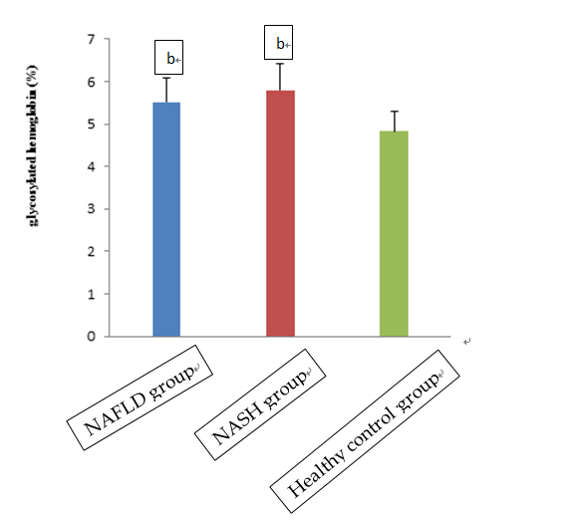
A

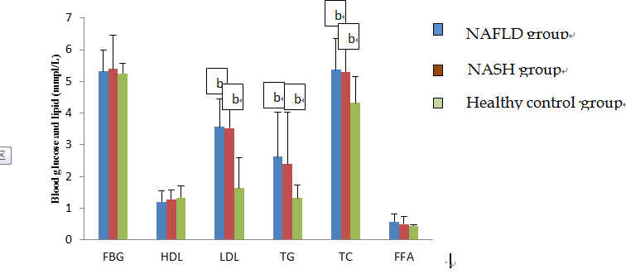
B

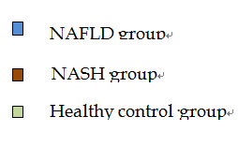
c
D
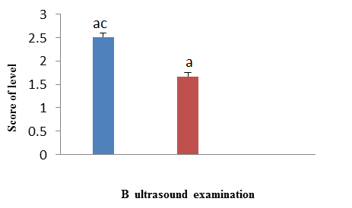
healthy control group
NASH group
NAFLD group

NASH group
E
NASH group
NASH group
Figure 2 Characteristics of study participants. Mean concentrations of (a) glycosylated hemoglobin (HbA1c); (b) fasting blood glucose (FBG), high-density lipoprotein cholesterol (HDL-C), low-density lipoprotein cholesterol (LDL-C), triglycerides (TG), total cholesterol (TC); (c) alanine aminotransferase (ALT), and aspartate aminotransferase (AST), gamma-glutamyl transferase (GGT), and alfa-fetoprotein (AFP); and (d) total bilirubin (TBil) and direct bilirubin (DBil) in the non-alcoholic fatty liver disease (NAFLD), non-alcoholic steatohepatitis (NASH) and healthy control groups. (e) Results of NASH group ultrasound examination in the three groups. Significant differences among the three groups were assessed by one-way ANOVA in (a)–(d)) and by t-tests in (e). ªP < 0.05, ^{b}P < 0.01 vs the control group; ^{c}P < 0.05, ^{d}P < 0.01 vs the NAFLD group.

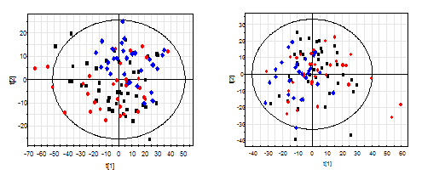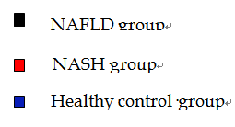
A B

Figure 3 S-plots of PCA analysis (a) with electrospray ionization (ESI+) and (b) without electrospray ionization (ESI-) in the NASH, NAFLD and control groups. PCA: Principal component analysis; NASH: Non-alcoholic steatohepatitis; NAFLD: Non-alcoholic fatty liver disease.

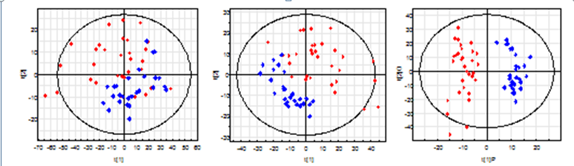

A1 B1 C1
A2 B2 C2
Figure 4 S-plots following (a) PCA, (b) PLS, and (c) OPLS analyses with (a1, b1, c1) electrospray ionization (ESI+) and without (a2, b2, c2) electrospray ionization (ESI-) in the NAFLD and control groups. PCA: Principal component analysis; NASH: Non-alcoholic steatohepatitis; NAFLD: Non-alcoholic fatty liver disease.

Table 3 List of urinary metabolites differentially expressed in NAFLD patients and healthy controls
No. | Metabolites | VIP-value  (OPLS-DA) |  | P-value  (t-test) | Fold change
ESI+  1 | L-Carnitine |  | 1.488 | 0.002 | 1.531
2 | Creatinine |  | 1.195 | 0.015 | 0.257
3 | L-Valine/betaine |  | 1.195 | 0.015 | −0.544
4 | Acetylcarnitine |  | 1.658 | 0.001 | 1.669
5 | Nα-Acetyl-L-arginine |  | 1.297 | 0.008 | −0.350
6 | Hypoxanthine |  | 1.883 | 0.000 | 0.968
7 | 1-Methylguanine |  | 1.376 | 0.005 | 0.483
8 | Adipic acid |  | 1.534 | 0.001 | −0.627
9 | Xanthosine |  | 1.467 | 0.002 | 0.389
10 | Guanosine |  | 1.448 | 0.003 | 0.273
11 | 7-Methylxanthine |  | 1.489 | 0.002 | 1.922
12 | 2-Methylguanosine |  | 1.654 | 0.001 | 0.475
13 | Butyryl-L-carnitine |  | 1.499 | 0.002 | 0.560
14 | Gluconic acid |  | 1.391 | 0.004 | −0.733
15 | Xanthurenic acid |  | 1.351 | 0.006 | 0.485
16 | Kynurenic acid |  | 1.590 | 0.001 | 0.560
17 | Indole-3-carboxylic acid |  | 1.189 | 0.015 | 0.496
18 | 6β-hydroxytestosterone |  | 2.203 | 0.000 | 1.251
19 | Androstenedione |  | 1.500 | 0.002 | 0.779
20 | PGA2 methyl ester |  | 1.709 | 0.000 | 0.676
21 | Cortisol |  | 1.340 | 0.006 | 0.641
22 | Deoxycorticosterone |  | 1.770 | 0.000 | 0.841
23 | corticosterone |  | 1.568 | 0.001 | 0.766
24 | Cortisone |  | 1.383 | 0.004 | 0.661
25 | Testosterone glucuronide |  | 1.838 | 0.000 | 0.844
26 | EPA |  | 1.208 | 0.014 | 0.714
27 | Decanoyl-L-carnitine |  | 1.592 | 0.001 | 1.101
28 | Androsterone |  | 2.276 | 0.000 | 0.918
29 | Eicosapentaenoic  Acid ethyl ester |  | 1.282 | 0.009 | −0.417
30 | Ursodeoxycholic acid |  | 1.599 | 0.001 | 0.474
ESI-  31 | Shikimate-3-phosphate |  | 1.195 | 0.020 | −0.344
32 | 2-keto-D-gluconic acid |  | 1.902 | 0.000 | −0.426
33 | α-D-glucose |  | 1.647 | 0.001 | −0.484
34 | Pyroglutamic acid |  | 1.545 | 0.002 | 0.334
35 | (S)-2-hydroxyglutarate |  | 1.299 | 0.011 | −0.579
36 | 2-Deoxy-D-ribose |  | 1.264 | 0.014 | −0.455
37 | 1-Methyluric acid |  | 1.181 | 0.022 | 0.870
38 | Salicyluric acid |  | 1.455 | 0.004 | −0.723
39 | Salicylic acid |  | 1.170 | 0.023 | −0.494
40 | Indoxylsulfuric acid |  | 1.829 | 0.000 | 0.646
41 | Ferulic acid 4-O-glucuronide |  | 2.046 | 0.000 | −2.303
42 | Caffeic acid 3-sulfate |  | 1.320 | 0.010 | −2.214
43 | 2,3-Dihydroxybenzoic acid |  | 1.857 | 0.000 | −1.004
44 | 3,3-Dimethylglutaric acid |  | 1.635 | 0.001 | −1.225
45 | Ferulic acid 4-sulfate |  | 1.695 | 0.001 | −1.779
46 | Deoxyinosine |  | 1.315 | 0.010 | −1.049
47 | Indolelactic acid |  | 1.251 | 0.015 | −0.868
48 | 3-Methylsuberic acid |  | 1.577 | 0.002 | −1.825
49 | L-Homocitrulline |  | 1.619 | 0.001 | −1.883
50 | Glycocholic acid |  | 1.187 | 0.021 | 0.408
51 | Glycoursodeoxycholic acid |  | 1.392 | 0.006 | 0.932
52 | L-homotyrosine |  | 1.475 | 0.004 | −0.625
53 | Ethisterone |  | 1.702 | 0.001 | −0.659

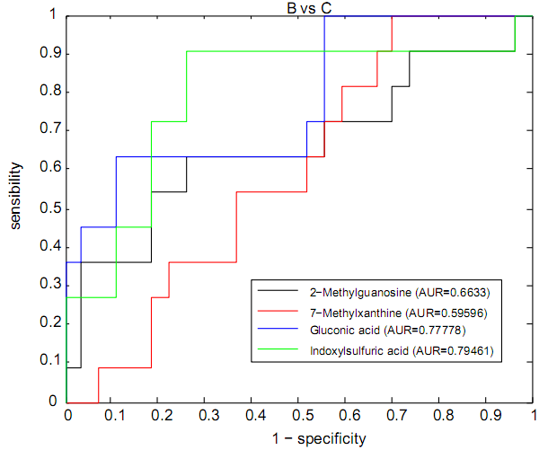

Figure 5 ROC curves for 2-methylguanosine, 7-methylxanthine, gluconic acid, and indoxylsulfuric acid in the NAFLD and control groups. NAFLD: Non-alcoholic fatty liver disease.

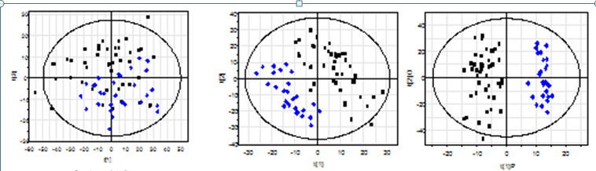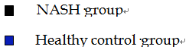

A1 B1 C1
A2 B2 C2

Figure 6 S-plots following (a) PCA, (b) PLS, and (c) OPLS analyses with (a1, b1, c1) electrospray ionization (ESI+) and without (a2, b2, c2) electrospray ionization (ESI-) in the NASH and control groups. PCA: Principal component analysis; NASH: Non-alcoholic steatohepatitis.

Table 4 List of urinary metabolites differentially expressed in NASH patients and healthy controls
No. | Metabolites | VIP-value  (OPLS-DA) | P-value  (t-test) | Fold change
E
ESI+  1 | L-Lysine | 1.291 | 0.007 | −0.747
2 | Suberic acid | 1.037 | 0.032 | −0.370
3 | L-Carnitine | 1.015 | 0.036 | 0.804
4 | Creatinine | 1.052 | 0.030 | 0.206
5 | L-Valine/betaine | 1.668 | 0.000 | −0.852
6 | Citrulline | 1.539 | 0.001 | −0.451
7 | L-Dopa | 1.249 | 0.009 | −0.322
8 | Acetylcarnitine | 1.213 | 0.012 | 0.971
9 | Nα-Acetyl-L-arginine | 1.128 | 0.019 | −0.658
10 | L-Threonine | 1.009 | 0.037 | −0.300
11 | L-Tyrosine | 1.217 | 0.011 | −0.304
12 | Uridine | 1.106 | 0.022 | 0.114
13 | Hypoxanthine | 2.406 | 0.000 | 1.093
14 | 2'-O-Methyladenosine | 1.345 | 0.005 | 0.222
15 | 1-Methylguanine | 1.921 | 0.000 | 0.744
16 | 6-Hydroxynicotinic acid | 1.617 | 0.001 | −0.957
17 | Adipic acid | 1.635 | 0.001 | −0.808
18 | Glycerophosphocholine | 1.623 | 0.001 | 0.299
19 | cAMP | 2.233 | 0.000 | 0.417
20 | L-Proline | 1.046 | 0.031 | 0.397
21 | Dimethyl fumarate | 1.716 | 0.000 | −0.627
22 | 5-Hydroxy-L-tryptophan | 1.118 | 0.021 | 0.190
23 | Xanthosine | 1.467 | 0.002 | 0.318
24 | D-Ribose | 0.994 | 0.040 | 0.141
25 | 2-Methylguanosine | 2.145 | 0.000 | 0.528
26 | Butyryl-L-carnitine | 1.941 | 0.000 | 0.569
27 | α-Hydroxyhippuric acid | 1.134 | 0.019 | −0.540
28 | Gluconic acid | 1.098 | 0.023 | −0.537
29 | N-Acetylproline | 1.486 | 0.002 | 0.491
30 | Kynurenic acid | 1.543 | 0.001 | 0.465
31 | Indoxylsulfuric acid | 1.444 | 0.002 | 0.494
32 | Ferulic acid | 0.982 | 0.043 | −0.948
33 | 5-Hydroxyindoleacetic acid | 1.420 | 0.003 | 0.312
34 | Acetyl-DL-leucine | 1.419 | 0.003 | −0.522
35 | Indole-3-carboxylic acid | 0.969 | 0.046 | 0.359
36 | 3-Indoleacetic Acid | 1.055 | 0.029 | −0.458
37 | 6β-Hydroxytestosterone | 2.074 | 0.000 | 0.929
38 | Estrone glucuronide | 1.111 | 0.021 | −1.448
39 | PGA2 methyl ester | 1.305 | 0.006 | 0.389
40 | Cortisol | 1.864 | 0.000 | 0.658
41 | Tetrahydrocortisone | 1.173 | 0.015 | 0.412
42 | Corticosterone | 1.165 | 0.016 | 0.406
43 | Deoxycorticosterone | 1.502 | 0.002 | 0.551
44 | Cortisone | 1.444 | 0.002 | 0.633
45 | Ethisterone | 1.541 | 0.001 | 0.689
46 | EPA | 0.953 | 0.050 | 0.456
47 | Decanoyl-L-carnitine | 1.295 | 0.007 | 0.828
48 | Androsterone | 2.370 | 0.000 | 0.741
49 | Lauroylcarnitine | 1.455 | 0.002 | 0.700
50 | Palmitic amide | 1.277 | 0.008 | 0.674
51 | Stearamide | 1.655 | 0.000 | 1.008
52 | Ursodeoxycholic acid | 1.231 | 0.010 | 0.398
ESI-
53 | N-Acetylneuraminic Acid | 0.993 | 0.034 | −0.257
54 | 5-aminosalicyluric acid | 2.042 | 0.000 | −0.877
55 | Guanine | 1.082 | 0.021 | −0.369
56 | p-Coumaric acid | 1.315 | 0.004 | −0.852
57 | 2-Keto-glutaramic acid | 1.058 | 0.024 | 0.201
58 | L-2-Aminoadipic acid | 0.968 | 0.039 | 0.265
59 | N-Acetyl-L-glutamic acid | 1.046 | 0.026 | 0.248
60 | Pyroglutamic acid | 2.089 | 0.000 | 0.483
61 | 2-Deoxy-D-ribose | 1.040 | 0.026 | −0.672
62 | N-Acetylaspartylglutamic acid | 1.091 | 0.020 | 0.250
63 | (S)-2-Hydroxyglutarate | 1.512 | 0.001 | −0.754
64 | Vanillylmandelic acid | 1.065 | 0.023 | 0.269
65 | (S)-(-)-2-Hydroxyisocaproic acid | 1.449 | 0.002 | −0.487
66 | Salicyluric acid | 0.975 | 0.038 | −0.792
67 | 2-Phenylglycine | 0.943 | 0.045 | −0.829
68 | Succinylacetone | 0.973 | 0.038 | 0.405
69 | Veratric acid | 0.944 | 0.045 | −0.573
70 | Acetyl-DL-valine | 0.956 | 0.042 | 0.264
71 | Salicylic acid | 1.034 | 0.027 | −0.574
72 | Indoxylsulfuric acid | 1.573 | 0.001 | 0.542
73 | 2-Isopropylmalic acid | 0.934 | 0.047 | −0.817
74 | Caffeic acid 3-sulfate | 0.929 | 0.048 | −2.412
75 | Dihydroferulic acid 4-sulfate | 1.351 | 0.003 | −1.229
76 | Pyridoxal phosphate | 0.965 | 0.040 | −1.215
77 | 2,3-Dihydroxybenzoic acid | 1.702 | 0.000 | −1.477
78 | L-Glutamine | 1.070 | 0.022 | 0.288
79 | 3-Methyladipic acid | 1.838 | 0.000 | −1.158
80 | Ferulic acid 4-sulfate | 1.903 | 0.000 | −1.748
81 | Isoferulic acid 3-O-glucuronide | 1.438 | 0.002 | −2.353
82 | 2-Keto-D-gluconic acid | 1.594 | 0.000 | −0.890
83 | ( ± )-Propionylcarnitine | 1.639 | 0.000 | 0.816
84 | Indolelactic acid | 1.420 | 0.002 | 1.305
85 | 3-Methylsuberic acid | 1.460 | 0.001 | −1.358
86 | L-Homocitrulline | 1.484 | 0.001 | −1.419
87 | Androsterone sulfate | 1.735 | 0.000 | 0.680
88 | L-Homotyrosine | 1.384 | 0.003 | −0.464

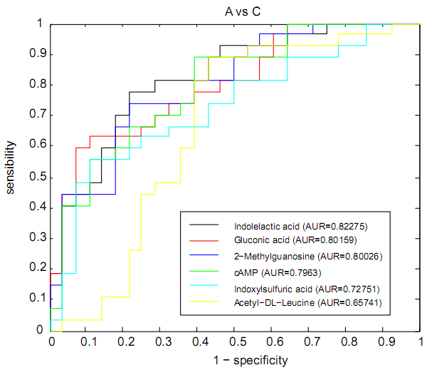

Figure 7 ROC curves for indoleacetic acid, gluconic acid, 2-methylguanosine, cAMP, indoxylsulfuric acid, and acetyl-DL-leucine in the NASH and control groups. NASH: Non-alcoholic steatohepatitis.

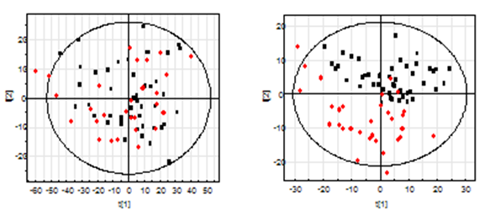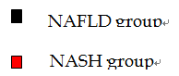
A1 B1
A2 B2
Figure 8 S-plots following (a) PCA and (b) PLS analyses with (a1, b1) electrospray ionization (ESI+) and without (a2, b2) electrospray ionization (ESI-) in the NASH and NAFLD groups. NAFLD: Non-alcoholic fatty liver disease; NASH: Non-alcoholic steatohepatitis.

Table 5 List of urinary metabolites differentially expressed in patients with NAFLD and NASH
No. | Metabolites | VIP-value  (OPLS-DA) | P-value  (t-test) | Fold change
ESI+
1 | L-Carnitine | 1.253 | 0.067 | −0.727
2 | L-Dopa | 0.952 | 0.092 | 0.234
3 | Acetylcarnitine | 1.181 | 0.094 | −0.698
4 | L-Histidine | 1.229 | 0.081 | −1.339
5 | Pyroglutamic acid | 1.541 | 0.021 | 0.143
6 | 3-Methylxanthine | 2.403 | 0.002 | −1.981
7 | α-D-Glucose | 1.739 | 0.013 | −1.376
8 | 5-Hydroxyferulate | 0.895 | 0.058 | −0.266
9 | 2-Oxosuberate | 0.850 | 0.073 | −0.315
10 | p-Hydroxyphenylacetic acid | 1.354 | 0.095 | 0.398
11 | 3-Indoleacetic Acid | 0.915 | 0.052 | −0.378
12 | β-Estradiol | 1.883 | 0.002 | −0.635
13 | Phosphorylcholine | 1.731 | 0.032 | 0.716
14 | 17α-Hydroxypregnenolone | 0.854 | 0.087 | −0.281
15 | Deoxycorticosterone | 0.865 | 0.093 | −0.312
16 | Progesterone | 0.866 | 0.084 | −0.301
ESI-
17 | 2-Keto-glutaramic acid | 1.653 | 0.027 | 0.210
18 | cAMP | 1.659 | 0.041 | 0.196
19 | 7-Methylxanthine | 1.595 | 0.036 | −0.925
20 | (S)-(-)-2-Hydroxyisocaproic acid | 1.344 | 0.089 | −0.250
21 | Gluconic acid | 1.638 | 0.025 | −1.111
22 | N-Acetylproline | 1.865 | 0.021 | 0.399
23 | Acetyl-DL-valine | 1.636 | 0.053 | 0.284
24 | Pyridoxal phosphate | 1.490 | 0.050 | −0.990
25 | N-Acetyl-DL-tryptophan | 1.440 | 0.059 | −0.951
26 | 2-Keto-D-gluconic acid | 1.258 | 0.088 | −0.340
27 | D-(+)-3-Phenyllactic acid | 2.021 | 0.017 | −1.621
28 | Indoleactic acid | 1.495 | 0.051 | 0.832
29 | 3-Hydroxy-sebacic acid | 1.270 | 0.092 | −0.292
30 | Sebacic acid | 1.847 | 0.024 | 0.420
31 | Deoxyguanosine | 1.548

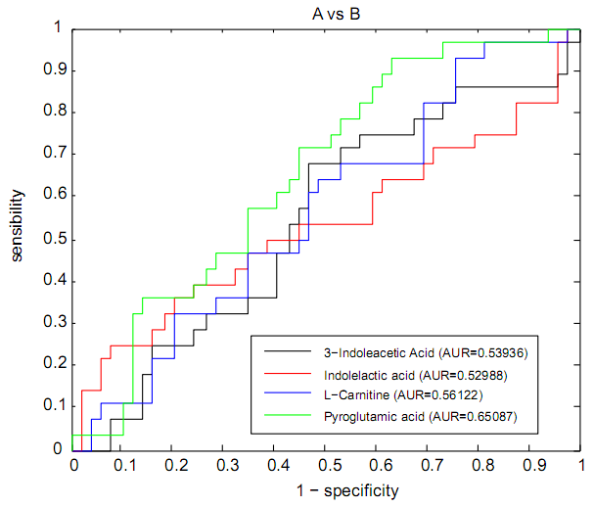
Figure 9 ROC curves for 3-indoleacetic acid, indoleacetic acid, L-carnitine, and pyroglutamic acid in the NASH and NAFLD groups. NAFLD: Non-alcoholic fatty liver disease; NASH: Non-alcoholic steatohepatitis.

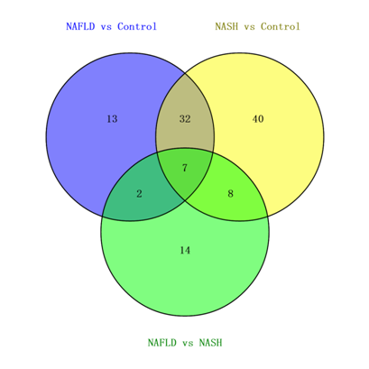

Figure 10 Venn diagram of metabolites differentially expressed in urinary samples of the NAFLD vs control, NASH vs control, and NAFLD vs NASH groups. NAFLD: Non-alcoholic fatty liver disease; NASH: Non-alcoholic steatohepatitis.

