Name of Journal: World Journal of Gastroenterology
Manuscript NO: 68368
Manuscript Type: ORIGINAL ARTICLE

Retrospective Cohort Study
Life prognosis of sentinel node navigation surgery for early-stage gastric cancer: Outcome of lymphatic basin dissection

Kinami S et al. Outcome of lymphatic basin dissection

Shinichi Kinami, Naohiko Nakamura, Tomoharu Miyashita, Hidekazu Kitakata, Sachio Fushida, Takashi Fujimura, Yasuo Iida, Noriyuki Inaki, Toru Ito, Hiroyuki Takamura

Shinichi Kinami, Naohiko Nakamura, Tomoharu Miyashita, Hiroyuki Takamura, Department of Surgical Oncology, Kanazawa Medical University, Kahoku 920-0293, Ishikawa, Japan

Hidekazu Kitakata, Toru Ito, Department of Gastroenterological Endoscopy, Kanazawa Medical University, Kahoku 920-0293, Ishikawa, Japan

Sachio Fushida, Noriyuki Inaki, Department of Gastrointestinal Surgery, Kanazawa University, Kanazawa 920-8641, Ishikawa, Japan

Takashi Fujimura, Department of Surgery, Toyama City Hospital, Toyama 939-8511, Toyama, Japan

Yasuo Iida, Department of Mathematics, Division of General Education, Kanazawa Medical University, Kahoku 920-0293, Ishikawa, Japan

Author contributions: Kinami S was responsible for the scientific conception of the study and writing of the manuscript; Kinami S, Nakamura N, Miyashita T, Kitakata H, Fushida S, Fujimura T, and Ito T contributed to the surgery and data collection; Iida Y was responsible for the statistical analysis; Takamura H and Inaki N contributed to the drafting, editing, and critical revision of the manuscript; and all authors contributed to the approval of the final version of the manuscript.

Corresponding author: Shinichi Kinami, MD, PhD, Professor, Department of Surgical Oncology, Kanazawa Medical University, 1-1 Daigaku, Uchinada-machi, Kahoku 920-0293, Ishikawa, Japan. kinami@kanazawa-med.ac.jp

Received: May 20, 2021
Revised: June 28, 2021
Accepted: November 29, 2021
Published online: December 14, 2021
Abstract
BACKGROUND
Lymphatic basin dissection is a sentinel node biopsy method that is specific for gastric cancer. In this method, the dyed lymphatic system is dissected en bloc, and sentinel nodes are identified at the back table (ex vivo). Even with lymphatic basin dissection, blood flow to the residual stomach can be preserved, and function-preserving curative gastrectomy can be performed. The oncological safety of function-preserving curative gastrectomy combined with lymphatic basin dissection has not yet been fully investigated. We hypothesized that the oncological safety of sentinel node navigation surgery (SNNS) is not inferior to that of the guidelines.

AIM
To investigate the life prognosis of SNNS for gastric cancer in comparison with guidelines surgery.

METHODS
This was a retrospective cohort study. Patients were selected from gastric cancer patients who underwent sentinel node biopsy from April 1999 to March 2016. Patients from April 1999 to August 2008 were from the Department of Surgery II, Kanazawa University Hospital, and patients from August 2009 to March 2016 were from the Department of Surgical Oncology, Kanazawa Medical University Hospital. Patients who were diagnosed with gastric cancer, which was preoperatively diagnosed as superficial type (type 0), 5 cm or less in length, clinical T1-2 and node negative, and underwent various gastrectomies guided by sentinel node navigation were retrospectively collected. The overall survival (OS) and relapse-free survival (RFS) of these patients (SNNS group) were investigated. Patients with gastric cancer of the same stage and who underwent guidelines gastrectomy with standard nodal dissection were also selected as the control group.

RESULTS
A total of 239 patients in the SNNS group and 423 patients in the control group were included. Pathological nodal metastasis was observed in 10.5% and 10.4% of the SNNS and control groups, respectively. The diagnostic abilities of sentinel node biopsy were 84% and 98.6% for sensitivity and accuracy, respectively. In the SNNS group, 81.6% of patients underwent modified gastrectomy or function-preserving curative gastrectomy with lymphatic basin dissection, in which the extent of nodal dissection was further reduced compared to the guidelines. The OS rate in the SNNS group was 96.8% at 5 years and was significantly better than 91.3% in the control group (P = 0.0014). The RFS rates were equal in both groups. After propensity score matching, there were 231 patients in both groups, and the cumulative recurrence rate was 0.43% at 5 years in the SNNS group and 1.30% in the control group, which was not statistically different.

CONCLUSION
The oncological safety of patients who undergo gastrectomy guided by sentinel node navigation is not inferior to that of the guidelines surgery.

Key Words: Early gastric cancer; Sentinel node biopsy; Function preserving surgery; Lymph node dissection; Gastrectomy; Lymphatic basin dissection
alcoholic steatohepatitis; Animal models; Insulin resistance; Oxidative stress

©The Author(s) 2021. Published by Baishideng Publishing Group Inc. All rights reserved.

Citation: Kinami S, Nakamura N, Miyashita T, Kitakata H, Fushida S, Fujimura T, Iida Y, Inaki N, Ito T, Takamura H. Life prognosis of sentinel node navigation surgery for early-stage gastric cancer: Outcome of lymphatic basin dissection. World J Gastroenterol 2021; 27(46): 8010-8030
URL: https://www.wjgnet.com/1007-9327/full/v27/i46/8010.htm
DOI: https://dx.doi.org/10.3748/wjg.v27.i46.8010

Core Tip: The oncological safety of 239 patients with early-stage gastric cancer who underwent sentinel node navigation surgery was investigated. In total, 81.6% of patients underwent modified gastrectomy or function-preserving curative gastrectomy with lymphatic basin dissection, and the extent of nodal dissection was reduced compared to the guidelines. The overall survival rate at 5 years was significantly better, and the cumulative recurrence rate was equal to that of the control group in original data sets and propensity score-matched comparisons. The oncological safety of patients undergoing gastrectomy guided by sentinel node navigation is not inferior to that of the guidelines surgery.

INTRODUCTION
The basic treatment for early gastric cancer not indicated for endoscopic submucosal dissection (ESD) is gastrectomy with lymph node dissection^{[1,2]}. The range of prophylactic lymphadenectomy is determined in the greatest common denominator based on past data of lymph node metastasis, because most metastases to regional lymph nodes in early gastric cancer cannot be determined without pathological specimens. The Japanese Gastric Cancer Treatment Guidelines^{[3]} recommends D1 + and D1 as the range of nodal dissection for cT1N0 cancer. D1 + requires sacrificial resection of most of the feeding arteries, resulting in the need for extensive gastrectomy. However, patients with nodal metastasis account for only approximately 20% of surgical patients with early gastric cancer. Excessive gastrectomy is performed in 80% of patients with early gastric cancer^{[4]}.
The preoperative diagnosis of lymph node metastasis is limited^{[5-11]}. If lymph node metastasis can be diagnosed intraoperatively and node-negative patients can be distinguished, excessive dissection and extensive gastrectomy can be avoided. Currently, the most effective method for diagnosing lymph node metastasis is sentinel lymph node biopsy^{[12-27]}.
The sentinel lymph nodes of gastric cancer can be identified by administering a tracer with lymph-palatability to the submucosa using a gastroscopic injection needle and regarding the tracer-taking lymph nodes as sentinel nodes^{[14,15,24-26]}. However, intraoperative pathological diagnosis of lymph node metastasis remains difficult^{[28]}. Genetic diagnosis^{[29-33]} is still in the research phase and, at present, we have to rely on intraoperative rapid frozen section diagnosis, but this method is accompanied by false negatives. Unlike breast cancer, reoperation for additional nodal dissection or additional radiation therapy is not acceptable in the case of gastric cancer. Therefore, a certain range of nodal dissection is necessary even in patients who are node negative by sentinel node biopsy. In view of these trends, Miwa^{[34]} proposed lymphatic basin dissection, which is a sentinel node biopsy method specific for gastric cancer. In dye-based sentinel node biopsy, the lymphatic system specific to gastric cancer is stained by a dye tracer that is administered to the stomach and drains into the lymphatic system. The lymphatic system is then dissected en bloc and sentinel nodes are identified at the back table (ex vivo) in this method. This method not only reduces the difficulty of sentinel node biopsy, but also serves to a certain extent as backup dissection to cover false negatives of rapid intraoperative diagnosis. Even with lymphatic basin dissection, blood flow to the residual stomach can be preserved and function-preserving curative gastrectomy can be performed instead of extensive gastrectomy (Figure 1)^{[4,35]}.
Lymphatic basin dissection has been evaluated as a certain sentinel lymph node biopsy for gastric cancer^{[4,15,36]}. However, the oncological safety of function-preserving curative gastrectomy combined with lymphatic basin dissection has not yet been fully investigated. In this study, we investigated the life prognosis of patients who underwent sentinel node navigation surgery (SNNS) for gastric cancer in comparison with standard surgery.
A prospective nation-wide study is currently undergoing in Japan to verify the oncological safety of the tailor-made surgical strategy guided by sentinel node navigation^{[37]}. However, it is not a comparative study, and a control group has not been set due to difficulty in clinical circumference. In contrast, standard surgery performed at our facility complies with the Japanese guidelines has been performed as the routine medical treatment simultaneously and in parallel with the clinical trial of SNNS by the first author, which made it possible for us to compare the prognoses retrospectively. Therefore, we conducted this retrospective comparative study on patients who underwent SNNS and those who underwent the standard surgery performed as per the guidelines. The sentinel node biopsy is a diagnostic method for lymph node metastasis, and its applicability is determined based on the preoperative findings. To reproduce the findings of the prospective study, we selected patients with preoperative findings that were the same as those with indications for SNNS, and verified them using propensity score matching.

MATERIALS AND METHODS
This was a retrospective cohort study. Patients were selected from gastric cancer patients who underwent sentinel node biopsy by the first author (SK) from April 1999 to March 2016. The inclusion criteria were as follows: Age between 20 and 85 years; American Society of Anesthesiologists physical status (ASA-PS) 1-2 and tolerance to general anesthesia and gastrectomy; superficial type (type 0); preoperative diagnosis of 5 cm or less in length; preoperative diagnosis of T1 or T2 (clinical T1-2); node-negative preoperative diagnosis by X-computed tomography (CT); preoperative confirmation of adenocarcinoma by endoscopic biopsy; and reliable medical records. Conversely, patients with synchronous multiple advanced cancers in other organs, with severe comorbidities, and those with an Eastern Cooperative Oncology Group Performance Status (ECOG PS) of 3 or higher were excluded. Patients from April 1999 to August 2008 were from the Department of Surgery II, Kanazawa University Hospital, and patients from August 2009 to March 2016 were from the Department of Surgical Oncology, Kanazawa Medical University Hospital.
For patients in the control group, early gastric cancer patients who underwent gastrectomy without sentinel node biopsy were extracted at the same time in the Department of Surgery II, Kanazawa University Hospital, and Department of Surgical Oncology, Kanazawa Medical University Hospital. The inclusion and exclusion criteria were the same as those of patients with sentinel node biopsy. In these patients, the standard surgeries in accordance with the Japanese guidelines^{[3]} were mainly applied without mapping. The choice between mapping and non-mapping patients was mainly determined by the surgeon in charge. However, at both Kanazawa University Hospital and Kanazawa Medical University Hospital, a limited number of surgeons with the same treatment strategies and the same surgical skills were in charge of the gastrectomies.
The sentinel node biopsy methods used at Kanazawa University Hospital were the blue dye method, RI colloid method, and the combination method of blue dye and RI colloid. The dye tracers were patent blue or Lymphazurin, and the RI colloid tracers were ^{99m}Tc-tin colloid or ^{99m}Tc-phytate, which were endoscopically administered into the submucosal layer at four points around the tumor. The RI colloid was administered at 0.5 mL per site the day before surgery, and the blue dye was administered intraoperatively at 0.2 mL per site. The lymphatic basins were defined as the lymphatic system that was stained within 20 min after dye injection. The blue nodes were defined as nodes stained blue, and hot nodes were defined as nodes with radioactivity of more than 10 counts per second by using the gamma probe (Navigator GPS, Tyco Health Care, Mansfield, United States), and these were regarded as the sentinel nodes^{[14,36]}.
The indocyanine green (ICG) fluorescence method was used in Kanazawa Medical University Hospital^{[26]}. ICG was adjusted to 50 μg/mL and endoscopically administered at 0.5 mL per site to the submucosal layer at four points around the tumor the day before surgery. Intraoperatively, ICG fluorescence was observed using a photodynamic eye (PDE, Hamamatsu Photonics, Shizuoka, Japan). The lymphatic basins were defined as the lymphatic system that was detected with fluorescent lymphatics, and the obvious fluorescent nodes were regarded as sentinel nodes. According to a previous report^{[36]}, lymphatic basins were integrated into the five lymphatic areas, except for the lymphatic flow to the left paracardial lymph node (No. 2 Lymph node, #2). Each of these is called the lymphatic compartment and is classified into five basins: The left gastric artery basin (l-GA); right gastric artery basin (r-GA); left gastroepiploic artery basin; right gastroepiploic artery basin; and the posterior gastric artery basin (p-GA) (Figure 2A). Classifying the lymphatic flow to #2 is challenging because of the multidirectional flow to l-GA and No. 19 ahead, and the lymphatic flow to p-GA nearby. Therefore, it was excluded from the lymphatic compartment classification and handled separately.
Patients who underwent sentinel node biopsy were divided into two groups: The feasibility phase group and the clinical application phase group. For patients in the former group, sentinel node biopsy was performed to evaluate the diagnostic ability of nodal metastasis; therefore, standard gastrectomy with nodal dissection was performed, and sentinel node identification was also performed postoperatively on the resected specimen. In contrast, in the clinical application phase, function-preserving curative gastrectomy was performed using sentinel node biopsy as a guide^{[4,26]}. First, sentinel node mapping was performed, followed by lymphatic basin dissection, ex vivo identification and biopsy of the sentinel nodes, and intraoperative rapid pathology. If the sentinel nodes were diagnosed as metastasis at rapid diagnosis, standard gastrectomy with nodal dissection up to D2 was performed; if the sentinel nodes were diagnosed as node negative, the extent of gastrectomy was reduced and function-preserving curative gastrectomy, such as local resection (LR), segmental gastrectomy (SG), or proximal gastrectomy (PG) was performed according to the preserved blood flow (Figure 2B)^{[4]}. This surgical strategy is generally called SNNS.
The patients were divided into two groups. Patients in the clinical application phase of sentinel node biopsy were designated as the study group (SNNS group). Patients who did not undergo sentinel node biopsy and those in the feasibility phase of sentinel node biopsy were defined as the control group. The control group consisted of patients who underwent guidelines gastrectomy, while the SNNS group consisted of patients who underwent tailor-made gastrectomy guided by sentinel node biopsy (Figure 3).
In this study, we examined and compared the prognosis of patients between the two groups. The prognosis of the patients at Kanazawa University Hospital was investigated in 2013, and that of Kanazawa Medical University Hospital was investigated in 2021. The prognosis was examined up to 10 years after initial gastrectomy, and the investigations included alive or dead, cause of death, presence or absence of recurrence, and the presence of newly detected metachronous multiple gastric cancer (MMGC) in the remnant stomach. Therefore, in this study, the prognosis up to 5 years was generally accurate, but some patients were censored because they did not reach 10 years after surgery at the time of investigation. The causes of death other than gastric cancer recurrence were divided into other cancer deaths (including MMGC) and non-cancer deaths from other diseases. The date of the confirmation of gastric cancer recurrence was also investigated. For cancers found in the remnant stomach, we distinguished between local recurrence and MMGC, and the latter was not judged as gastric cancer recurrence because of its favorable prognosis. In this study, overall survival (OS) treated all-cause mortality as an event, and relapse-free survival (RFS) treated gastric cancer recurrence as an event. All descriptions were described in accordance with the 15th edition of the Japanese classification of gastric carcinoma^{[38]}. In this article, distal gastrectomy (DG) and total gastrectomy (TG) were defined as standard gastrectomy, pylorus-preserving gastrectomy (PPG), and PG were defined as guidelines-modified gastrectomy, and mini-DG (MDG), mini-PG (MPG), SG, and LR were defined as function-preserving curative gastrectomy (Figure 1)^{[4]}. The diagnosis of lymph node metastases was determined by hematoxylin and eosin staining of the permanent slide at the maximum plane. The tumor cells were considered to be metastatic regardless of the size of metastatic foci, so both isolated tumor cells and micrometastases were also considered metastases. The results of immunohistochemical staining and genetic diagnosis were not considered in this study.
The chi-square test was used to compare the background factors of each group. Survival rates were compared by drawing survival curves using the Kaplan-Meier method and certified by using the log-rank test. Multivariate analysis of factors affecting survival was performed using Cox proportional hazards regression with a stepwise variable selection method. The Gray test was used to compare the cumulative incidence of recurrence, incidence of MMGC, other cancer-related deaths, and non-cancer deaths from other diseases, and Fine-Gray proportional hazards regression was used for multivariate analysis. In addition to these comparisons, propensity score matching was performed to adjust for differences in background factors between the two groups. Propensity scores were calculated for the two groups by logistic regression analysis using age, sex, location, circumference, long axis of tumor, macroscopic type, preoperative diagnosis of depth of invasion, and preoperative pathological diagnosis as variables. These variables were selected from among the factors that could affect the life prognosis and could be known preoperatively. To adjust for the covariates and estimate the causal effects, we used the nearest neighbor matching method with greedy matching and one-to-one matching with non-restorative extraction. The caliper of the propensity score was calculated by multiplying the standard deviation of the recommended propensity score estimated value by 0.2, after logit conversion. The balance between the groups was evaluated using the standardized difference score.
All statistical analyses were performed using EZR (Saitama Medical Center, Jichi Medical University, Saitama, Japan), which is a graphical user interface for R (The R Foundation for Statistical Computing, Vienna, Austria). EZR is a modified version of R Commander designed to add statistical functions that are frequently used in biostatistics^{[39]}. All statistical methods used in this study were reviewed by Yasuo Iida, Department of Mathematics, Division of General Education, Kanazawa Medical University.
This study was approved by the ethics committee of Kanazawa University Hospital and Kanazawa Medical University (Trial Number R093, M288) and registered with the University Hospital Medical Information Network Clinical Trials Registry (trial number UMIN000010154 and UMIN000023828). ICG mapping was approved by the ethics committee of Kanazawa Medical University (Trial Number M404 and jRCTs041180006 https://jrct.niph.go.jp/Latest-detail/iRCTs041180006).
This study was conducted in accordance with the Good Clinical Practice guidelines and the Declaration of Helsinki. All patients provided written informed consent for surgery and use of their data. Regarding data use in the retrospective study, the patients were allowed to opt out of the study at any time.

RESULTS
Characteristics of the patients
A total of 276 patients with sentinel node mapping and 386 patients who underwent surgery without mapping were collected. Of the sentinel lymph node mapping patients, 37 were in the feasibility phase and 239 were in the clinical application phase. Therefore, there were 239 patients in the SNNS group and 423 patients in the control group (Figure 3). The patient profiles are presented in Table 1. There were differences in age and histological type between the two groups. In the control group, 67.6% of the patients underwent standard surgery (TG, 5.4%; DG, 62.2%), and 26.7% of patients underwent guidelines-modified gastrectomy (PG, 12.1%; PPG, 14.6%). In contrast, only 18.4% of the patients in the SNNS group underwent standard surgery, 14.2% underwent modified gastrectomy, and 67.4% underwent function-preserving curative gastrectomy (SG, 35.1%; MDG, 13.8%; MPG, 2.5%; LR, 15.9%), in which the extent of resection was reduced further than that recommended by the guidelines.
All patients in this study were preoperatively diagnosed as node negative by X-CT, but pathological nodal metastasis was observed in 10.5% (25 patients) in the SNNS group and 10.4% in the control group. Table 2 lists the 25 patients in the SNNS group.

Recurrence of gastric cancer and results of sentinel node biopsy
Two patients in the control group died after surgery (hospital death); one was due to aspiration pneumonia and the other was due to peritonitis from idiopathic colon perforation. In contrast, no in-hospital deaths were observed in the SNNS group. Gastric cancer recurrence was observed in one patient in the SNNS group and eight patients in the control group. The recurrent patient in the SNNS group is displayed as No. 16 in Table 2. He was diagnosed as node-positive intraoperatively by sentinel node biopsy, and DG D2 was performed. Although postoperative adjuvant chemotherapy with S1 was administered, the patient died of lymph node metastasis 53.2 mo later. The type of recurrence in eight patients in the control group were four of lymph node recurrence, two of liver metastasis, one of lung metastasis, and one patient of local recurrence.
Of the 276 patients with sentinel node mapping, 37 patients in the feasibility phase had no lymph node metastasis. In contrast, of the 239 patients in the clinical application phase, 25 patients had lymph node metastasis (Table 2). Of these 25 patients, 21 (No. 1-21) were diagnosed as positive for metastasis intraoperatively by sentinel node biopsy, and 4 (No. 22-25) were false negative. The diagnostic ability of sentinel node biopsy in this study was calculated to be 84% (21/25) for sensitivity, 100% for specificity, 100% for positive predictive value, 98.4% (251/255) for negative predictive value, and 98.6% (272/276) for accuracy. The reasons for false negatives were misdiagnosis of frozen section diagnosis in three patients (No. 22-24) and macroscopic lymph node metastasis, which was not able to take up tracer in one patient (No. 25). The diagnosis of metastasis in the later patient was easy due to intraoperative findings. Twenty-one patients who were diagnosed as node-positive by sentinel node biopsy during surgery underwent standard gastrectomy with D1 + or D2. On the other hand, two of the false-negative patients with rapid diagnosis underwent SG but were followed up without additional dissection. One patient died of pancreatic cancer (No. 23), while the other survived for 5 years without recurrence (No. 22). As for the remaining two patients, DG D2 was performed because one had macroscopic lymph node metastasis (No. 25) and the other was suspected from intraoperative findings to be advanced gastric cancer with serosal exposure (No. 24). However, No. 24 was pathologically a mucosal cancer. These patients survived for five years without recurrence.
Therefore, there were no recurrences in the 218 patients diagnosed as node negative by sentinel node biopsy (214 true negative + four false negative). Of these 218 patients, only 11 underwent standard surgery (DG or TG with D1 + or D2). A total of 190 patients underwent modified gastrectomy or function-preserving curative gastrectomy with reduction of the resection area, and 17 underwent gastrectomy with reduction of the nodal dissection.
Of the 25 patients with nodal metastasis in the SNNS group, 11 had metastasis to only the sentinel nodes, 12 had non-sentinel metastatic nodes other than the sentinel nodes, but they remained within the lymphatic basin, and one was a false-negative patient with macroscopic metastasis as described above, with only one metastatic node. Only one patient had a metastatic node outside the lymphatic basin (No. 8). In this patient, macroscopic metastasis was found intraoperatively, and the final pathological diagnosis was fT2(MP)N3a (#4d, 6, 7). The patient was alive 6 years after surgery without any sign of recurrence.

MMGC of the remnant stomach
After surgery, the residual stomach was followed up with periodic endoscopic examinations, and MMGCs were found in 21 patients. Table 3 shows a list of interval times until the diagnosis of MMGC and treatment details. Of the 21 patients, 5 were in the SNNS group and 16 were in the control group. Four patients in the SNNS group (80%) and eight in the control group (50%) underwent ESD; therefore, their remnant stomachs were preserved. In contrast, five patients in the control group required TG, and one patient was unresectable. The cumulative incidence of MMGC is shown in Figure 4, and there was no difference in the incidence of MMGC between the two groups.

Life prognosis of patients in the SNNS group
The OS of all the patients in this study is shown in Figure 5A. The 5-year survival rates were 92.7% and the 10-year survival rate was 83.2%, respectively. The results of univariate and multivariate analyses for factors affecting OS are shown in Table 4, which shows that OS was affected by age, sex, macroscopic type, size, and pathological nodal status, as well as by the SNNS group. The OS of the SNNS group was significantly better than that of the control group (Figure 5B).
RFS in the SNNS group was 99.6% at both 5 and 10 years, and the RFS in the control group was 98.1% at both 5 and 10 years. Since there were a small number of recurrent patients and these recurrences competed with other cancer deaths and non-cancer deaths from other diseases, the evaluation of RFS was difficult and should be examined by cumulative incidence. Figure 6 shows a graph of the cumulative incidence, including other cancer deaths and non-cancer deaths from other diseases. The cumulative incidence of non-cancer deaths from other diseases was lower in the SNNS group than in the control group, and a significant difference was observed in the Gray test. Table 5 shows the results of the multivariate analysis using the Fine-Gray proportional hazard regression test. Age and the SNNS group were independent factors significantly affecting non-cancer deaths from other diseases, while age and macroscopic type were factors that significantly affected other cancer deaths, and pN was the only factor affecting gastric cancer recurrence.

Evaluation of life prognosis by propensity score matching
In the SNNS group, the gastric cancer recurrences might be comparable, and the number of non-cancer deaths from other diseases might be less than that in the control group. However, caution should be exercised when interpreting the results because of the significant difference in age distribution between the two groups. We re-examined the comparison of life prognosis using the propensity score matching method. Propensity score matching was performed for the two groups using the preoperatively recognizable items of age, sex, tumor location, macroscopic type, preoperative T factor, and pathological diagnosis. We added the long axis of the tumor to the items because size is an important factor affecting prognosis. The characteristics of the two groups after propensity score matching (m-SNNS and m-control groups) are shown in Table 6. There were 231 patients in both groups, and the backgrounds of the two groups became uniform. The distributions of the other factors were also examined after matching. There was no significant difference in pathological depth of invasion or pathological nodal status, although there was a natural difference in the distribution of sentinel node mapping and surgical techniques, and there were three cases of recurrence in the control group compared to one case in the SNNS group.
Figure 7 shows a graph of OS and the cumulative incidence of death or recurrence after matching. OS in the SNNS group was significantly better than that in the control group. The cumulative recurrence rate in the SNNS group was 0.43% at both 5 and 10 years, and in the control group was 1.30% at both 5 and 10 years, which was not statistically different. In contrast, the cumulative incidence of non-cancer deaths from other diseases was 2.6% at 5 years and 8.6% at 10 years in the SNNS group, and 5.7% at 5 years and 15.5% at 10 years in the control group. In the SNNS group, the cumulative incidence of non-cancer deaths from other diseases tended to be lower than that in the control group (P = 0.089).

Accuracy of preoperative diagnosis
Although all patients were preoperatively diagnosed with a long axis of 5 cm or less, 19 patients had a pathological diagnosis larger than 5 cm: Eight patients (3.3%) in the SNNS group and 11 (2.6%) in the control group. All 19 patients had a preoperative diagnosis of sN0, but four had pN1 and two had pN2. There were no recurrences in these 19 patients.

DISCUSSION
In both original data sets and propensity score-matched comparisons, the OS rate and RFS rate of patients who underwent gastrectomy guided by sentinel node navigation were not inferior to those of standard gastrectomy. In addition, there was no difference in the cumulative incidence of MMGC between the two groups.
Postgastrectomy syndrome (PGS) is a serious drawback after curative gastrectomy for gastric cancer^{[40-45]}, and occurs in a certain percentage of patients after standard gastrectomy. Currently, the most common approach for early gastric cancer is laparoscopic gastrectomy (D1 +) worldwide, especially in East Asian countries. Nevertheless, the occurrence rate of PGS and the quality of life (QoL) of patients after laparoscopic gastrectomy after 1 year is similar to that of patients after open gastrectomy^{[46-51]}. To alleviate this, SNNS is a promising treatment strategy for function-preserving curative gastrectomy^{[4,14-27]}. It has been reported that the PGS and QoL of function-preserving curative gastrectomy were less than those of standard gastrectomy^{[52-61]}. However, there are two concerns that must be addressed before SNNS can be applied in clinical practice. One is that reducing the extent of nodal dissection may compromise curability. Another concern is whether preserving a large portion of the stomach will have any disadvantages, especially for an increase in the number of MMGCs of the remnant stomach.
In this study, we investigated the treatment outcome of SNNS from the viewpoint of life prognosis in comparison with the guidelines surgical strategy. In both the original data sets and propensity score-matched comparisons, the OS and RFS of the SNNS group were not inferior to those of the control group. This result supports the hypothesis that the oncological safety of the SNNS group is not inferior to that of the guidelines. Since this is a retrospective study, it is difficult to judge whether the life prognosis of the SNNS group is equivalent to that of the control group based on our results. A prospective non-inferiority trial is needed to make this scientific judgment. A prospective study is currently ongoing by the Japanese Society for SNNS^{[37]}. In the protocol of this study, the expected 5-year recurrence-free survival rate was set at 98%, the non-inferiority margin was set at 10%, and the expected number of patients with sentinel node navigation was set to 225. The number of patients in the SNNS group in our study was 239 and, even after propensity score matching, 231 patients exceeded the number of patients in this prospective study. The result of life prognosis of the SNNS group in our study was one recurrent patient and 99.6% of RFS at both 5 and 10 years, comparable to conventional surgery. Extrapolating from these results, it seems that the curability of the SNNS could be proved to some extent. In addition, in the multivariate analysis, the only significant factor affecting gastric cancer recurrence was pN status, not SNNS grouping. In other words, the concern that reducing the extent of dissection may compromise curative outcomes would be unfounded.
The OS of the SNNS group was better than that of the control group in both comparisons of the original data sets and propensity score-matched groups. There was little difference in RFS between the two groups, and there was no significant difference in other cancer deaths. It was considered that the reason for this difference in OS would be the non-cancer deaths from other diseases. In multivariate analysis, the significant factors affecting non-cancer deaths were age and SNNS grouping. In the prospensity score-matched comparison, age was adjusted between the two groups, and a significantly better trend for non-cancer deaths was observed in the SNNS group. There is a possibility that keeping the gastrectomy area small leads to the maintenance of food volume, dietary habits, and nutritional status and has the effect of suppressing non-cancer death. However, this idea tends to be too advanced, and it may be reasonable to interpret that the survival outcome of patients with SNNS is not inferior to that of standard surgery.
In this study, we distinguished between MMGCs and local recurrence of gastric cancer. One patient with local recurrence of the oral stump was observed in the control group, whereas no local recurrence was observed in the SNNS group. This recurrent patient was unresectable, underwent chemoradiotherapy, and died due to distant metastasis. Meanwhile, MMGC in the remnant stomach was observed in six patients in the SNNS group and 15 in the control group. One of these patients was unresectable and died after 10 years. However, all other MMGC patients were curatively resectable by gastrectomy or ESD, and there were no recurrent deaths from MMGC during the study period. Although it is sometimes difficult to distinguish between local recurrence and MMGC, we distinguished these two situations because of the favorable outcome of MMGC. A randomized prospective clinical trial of SNNS for gastric cancer was conducted in South Korea^{[27,62-65]}, and an interim analysis was recently reported at the American Society of Clinical Oncology (ASCO) annual meeting^{[63]}. They reported that they failed to prove the non-inferiority of RFS in the SNNS group, but they did not strictly distinguish between MMGC and local recurrence. The MMGC and local recurrence should be clearly distinguished.
There was no difference in the cumulative incidence of MMGC^{[66-69]} between the two groups in this study. Therefore, it was speculated that there is not much concern for whether MMGCs increase as the area of the remnant gastric mucosa increases. However, we cannot conclude with this result that there is no need to worry about the increased risk of MMGC in SNNS. Yaguchi et al^{[70]} followed the prognosis of 50 SNNS cases and reported that MMGC occurred in 8% of cases. Kinami et al^{[71]} conducted a national questionnaire survey and reported that the risk of MMGC increases as the area of the remnant stomach increases. The reason for this discrepancy between the present study and previous reports is unclear. Considering the natural history of early gastric cancer, most MMGC cases may have been caused by misdiagnosis at the time of initial endoscopy. The patients in the SNNS group had more detailed endoscopy than those in the control group to exclude multiple gastric cancers, which may be related to selection bias. However, in the study by Kinami et al^{[71]}, many MMGCs in surgeries with a large remaining gastric mucosal area were resected by ESD, and it was concluded that there is no need to hesitate to perform function-preserving surgery because of the increased risk of MMGC. The results of the present study also suggest that there is no need to forgo the adoption of SNNS due to concerns about MMGC.
Through this study, the problems of SNNS became apparent, that is, the preoperative diagnostic ability. The precise diagnosis of early gastric cancer is difficult, not only in the depth of invasion but also in the lateral margin. All patients had a preoperative diagnosis of ≤ 5 cm along the long axis; however, 2.8% of the patients were found to have more than 5 cm in the postoperative specimens, including one patient of 87 mm. Six (31.6%) patients > 50 mm had lymph node metastasis. Misdiagnosis of size not only entails a positive margin, but also increases the possibility of lymph node metastasis. It was suggested that the accuracy of preoperative diagnosis, especially accurate extent diagnosis, must be ensured in order to safely perform SNNS.
Standard surgical treatment for early gastric cancer is standard gastrectomy D1 +^{[1-4]}. However, 72.8% of patients in the SNNS group had D0. All SNNS patients underwent lymphatic basin dissection. This result may be interpreted as follows: Early gastric cancer patients do not necessarily require nodal dissection up to D1 +; and in the patients who were node negative, the reduction of the dissection area to the lymphatic basin did not affect the prognosis. On the other hand, 96% (24/25) of nodal metastatic patients in the SNNS group had metastases only within the lymphatic basin; the patient who had nodal metastases that was spread outside the basin was the only one with advanced gastric cancer with macroscopic metastases that could be easily diagnosed intraoperatively. On the other hand, one patient in the SNNS group had nodal recurrence despite being judged to be positive for metastasis during surgery and changed to D2, and recurrence may not have been avoided even if standard treatment was applied initially. Considering these facts, it may be possible to reduce the extent of nodal dissection to only the lymphatic basin for all patients with cT1N0 less than 5 cm in the future.
This study has some limitations. This was a retrospective study. It is possible that there was a selection bias in the SNNS group. Another problem is that the study was conducted over a long period of time. The diagnostic and therapeutic techniques have advanced during this period, and this may have affected the prognosis of patients and the incidence of MMGC. In addition, there were no QoL data of the SNNS group in this study. A nationwide multicenter prospective study is essential to correctly determine the prognosis, rate of non-cancer deaths from other diseases, and QoL assessment data. The results of a Japanese study^{[37]} are awaited.

CONCLUSION
In both original data sets and propensity score-matched comparisons, OS and RFS of patients who underwent gastrectomy guided by sentinel node navigation were not inferior to those of standard gastrectomy. In addition, there was no difference in the cumulative incidence of MMGC between the two groups. The oncological safety of SNNS is not inferior to that of the guidelines. This study also indicates the possibility of reducing the extent of nodal dissection to only the lymphatic basin for all patients with cT1N0 less than 5 cm in the future.

ARTICLE HIGHLIGHTS
Research background
If early gastric cancer patients who are negative for lymph node metastasis can be diagnosed intraoperatively, excessive nodal dissection and extensive gastrectomy can be avoided. Currently, the most effective method for diagnosing lymph node metastasis is sentinel node biopsy. Lymphatic basin dissection is a sentinel node biopsy method that is specific for gastric cancer. The dyed lymphatic system was dissected en bloc and sentinel nodes were identified at the back table (ex vivo) using this method. This method not only reduces the difficulty of sentinel node biopsy, but also serves to a certain extent as backup dissection. Even with lymphatic basin dissection, blood flow to the residual stomach can be preserved and function-preserving curative gastrectomy can be performed, such as segmental gastrectomy and local resection.

Research motivation
The oncological safety of function-preserving curative gastrectomy combined with lymphatic basin dissection has not yet been fully investigated.

Research objectives
This study aimed to investigate the life prognosis of patients with early gastric cancer who underwent sentinel node navigation surgery (SNNS) in comparison with standard guideline surgery.

Research methods
Gastric cancer patients were retrospectively collected. The inclusion criteria were as follows: Superficial type (type 0); preoperative diagnosis of 5 cm or less in length; clinical T1-2; and node-negative on X-computed tomography. The patients underwent SNNS. First, sentinel node mapping was performed, followed by lymphatic basin dissection and rapid intraoperative pathology. If the sentinel nodes were diagnosed as metastasic at rapid diagnosis, standard gastrectomy with nodal dissection up to D2 was performed; if the sentinel nodes were diagnosed as node-negative, the extent of gastrectomy was reduced, and function-preserving curative gastrectomy was performed. The life prognosis and cumulative incidence of metachronous multiple gastric cancer (MMGC) were investigated. Patients with the same inclusion criteria and who underwent standard gastrectomy and guideline lymph node dissection with or without sentinel node biopsy were selected as the control group.

Research results
There were 239 patients in the SNNS group and 423 patients in the control group. All patients were diagnosed as node-negative preoperatively, but pathological nodal metastasis was observed in 10.5% of patients in the SNNS group and 10.4% in the control group. The diagnostic ability of sentinel node biopsy in this study was 84% and 98.6% for sensitivity and accuracy, respectively. In the SNNS group, 18.4% of patients underwent standard surgery, 14.2% had modified gastrectomy, and 67.4% had function-preserving curative gastrectomy, in which the extent of resection was further reduced than that recommended by the guidelines. The overall survival (OS) rate in the SNNS group was 96.8% at 5 years and was significantly better than 91.3% in the control group (P = 0.0014). The relapse-free survival (RFS) rate in the SNNS group was 99.6% at 5 years and 98.1% in the control group. After propensity score matching, there were 231 patients in both groups, and the OS in the SNNS group remained significantly better than that in the control group (P = 0.030). The cumulative recurrence rate in the SNNS group was 0.43% in 5 years and 1.30% in the control group, which was not statistically different. There was no difference in the incidence of MMGC between the SNNS group (1.7% at 5-years) and the control group (2.3% at 5-years).

Research conclusions
In both original data sets and propensity score-matched comparisons, the OS rate and RFS rate of patients who underwent gastrectomy guided by sentinel node navigation were not inferior to those of standard gastrectomy. In addition, there was no difference in the cumulative incidence of MMGC between the two groups.

Research perspectives
The oncological safety of sentinel node navigation surgery for early-stage gastric cancer is not inferior to that of the guideline. This study also indicates the possibility of reducing the extent of nodal dissection to only the lymphatic basin for all patients with cT1N0 less than 5 cm in the future.

ACKNOWLEDGEMENTS
The authors are most grateful to Dr. Koichi Miwa, an ex-professor at Kanazawa University. We would also like to thank Dr. Takeo Kosaka, an ex-professor at Kanazawa Medical University.

REFERENCES
1 Tanaka N, Katai H, Taniguchi H, Saka M, Morita S, Fukunaga T, Shimoda T. Surgical treatment for early gastric cancer (in Japanese with English abstract). Stomach Intest 2009; 44: 700-706
2 Kumagai K, and Sano T. Part III Lymph node metastasis: Clinical significance Gastric Cancer. In: Natsugoe S editor. Lymph Node Metastasis in Gastrointestinal Cancer. Singapore: Springer Nature; 2019: p267-282
3 Japanese Gastric Cancer Association. Japanese gastric cancer treatment guidelines 2018 (5th edition). Gastric Cancer 2021; 24: 1-21 [PMID: 32060757 DOI: 10.1007/s10120-020-01042-y]
4 Kinami S, Nakamura N, Tomita Y, Miyata T, Fujita H, Ueda N, Kosaka T. Precision surgical approach with lymph-node dissection in early gastric cancer. World J Gastroenterol 2019; 25: 1640-1652 [PMID: 31011251 DOI: 10.3748/wjg.v25.i14.1640]
5 Kwee RM, Kwee TC. Imaging in assessing lymph node status in gastric cancer. Gastric Cancer 2009; 12: 6-22 [PMID: 19390927 DOI: 10.1007/s10120-008-0492-5]
6 Noda N, Sasako M, Yamaguchi N, Nakanishi Y. Ignoring small lymph nodes can be a major cause of staging error in gastric cancer. Br J Surg 1998; 85: 831-834 [PMID: 9667718 DOI: 10.1046/j.1365-2168.1998.00691.x]
7 Luo M, Lv Y, Guo X, Song H, Su G, Chen B. Value and impact factors of multidetector computed tomography in diagnosis of preoperative lymph node metastasis in gastric cancer: A PRISMA-compliant systematic review and meta-analysis. Medicine (Baltimore) 2017; 96: e7769 [PMID: 28816957 DOI: 10.1097/MD.0000000000007769]
8 Kubota K, Suzuki A, Shiozaki H, Wada T, Kyosaka T, Kishida A. Accuracy of Multidetector-Row Computed Tomography in the Preoperative Diagnosis of Lymph Node Metastasis in Patients with Gastric Cancer. Gastrointest Tumors 2017; 3: 163-170 [PMID: 28611983 DOI: 10.1159/000454923]
9 Mocellin S, Marchet A, Nitti D. EUS for the staging of gastric cancer: a meta-analysis. Gastrointest Endosc 2011; 73: 1122-1134 [PMID: 21444080 DOI: 10.1016/j.gie.2011.01.030]
10 Mocellin S, Pasquali S. Diagnostic accuracy of endoscopic ultrasonography (EUS) for the preoperative locoregional staging of primary gastric cancer. Cochrane Database Syst Rev 2015: CD009944 [PMID: 25914908 DOI: 10.1002/14651858.CD009944.pub2]
11 Yang QM, Kawamura T, Itoh H, Bando E, Nemoto M, Akamoto S, Furukawa H, Yonemura Y. Is PET-CT suitable for predicting lymph node status for gastric cancer? Hepatogastroenterology 2008; 55: 782-785 [PMID: 18613454]
12 Morton DL, Wen DR, Wong JH, Economou JS, Cagle LA, Storm FK, Foshag LJ, Cochran AJ. Technical details of intraoperative lymphatic mapping for early stage melanoma. Arch Surg 1992; 127: 392-399 [PMID: 1558490 DOI: 10.1001/archsurg.1992.01420040034005]
13 Veronesi U, Paganelli G, Viale G, Luini A, Zurrida S, Galimberti V, Intra M, Veronesi P, Robertson C, Maisonneuve P, Renne G, De Cicco C, De Lucia F, Gennari R. A randomized comparison of sentinel-node biopsy with routine axillary dissection in breast cancer. N Engl J Med 2003; 349: 546-553 [PMID: 12904519 DOI: 10.1056/NEJMoa012782]
14 Miwa K, Kinami S, Taniguchi K, Fushida S, Fujimura T, Nonomura A. Mapping sentinel nodes in patients with early-stage gastric carcinoma. Br J Surg 2003; 90: 178-182 [PMID: 12555293 DOI: 10.1002/bjs.4031]
15 Kitagawa Y, Takeuchi H, Takagi Y, Natsugoe S, Terashima M, Murakami N, Fujimura T, Tsujimoto H, Hayashi H, Yoshimizu N, Takagane A, Mohri Y, Nabeshima K, Uenosono Y, Kinami S, Sakamoto J, Morita S, Aikou T, Miwa K, Kitajima M. Sentinel node mapping for gastric cancer: a prospective multicenter trial in Japan. J Clin Oncol 2013; 31: 3704-3710 [PMID: 24019550 DOI: 10.1200/JCO.2013.50.3789]
16 Hiratsuka M, Miyashiro I, Ishikawa O, Furukawa H, Motomura K, Ohigashi H, Kameyama M, Sasaki Y, Kabuto T, Ishiguro S, Imaoka S, Koyama H. Application of sentinel node biopsy to gastric cancer surgery. Surgery 2001; 129: 335-340 [PMID: 11231462 DOI: 10.1067/msy.2001.111699]
17 Ichikura T, Morita D, Uchida T, Okura E, Majima T, Ogawa T, Mochizuki H. Sentinel node concept in gastric carcinoma. World J Surg 2002; 26: 318-322 [PMID: 11865368 DOI: 10.1007/s00268-001-0226-x]
18 Carlini M, Carboni F, Petric M, Santoro R, Guadagni F, Marandino F, Castelli M, Santoro E. Sentinel node in gastric cancer surgery. J Exp Clin Cancer Res 2002; 21: 469-473 [PMID: 12636091]
19 Kitagawa Y, Fujii H, Mukai M, Kubota T, Otani Y, Kitajima M. Radio-guided sentinel node detection for gastric cancer. Br J Surg 2002; 89: 604-608 [PMID: 11972551 DOI: 10.1046/j.1365-2168.2002.02065.x]
20 Hayashi H, Ochiai T, Mori M, Karube T, Suzuki T, Gunji Y, Hori S, Akutsu N, Matsubara H, Shimada H. Sentinel lymph node mapping for gastric cancer using a dual procedure with dye- and gamma probe-guided techniques. J Am Coll Surg 2003; 196: 68-74 [PMID: 12517553 DOI: 10.1016/s1072-7515(02)01594-6]
21 Nimura H, Narimiya N, Mitsumori N, Yamazaki Y, Yanaga K, Urashima M. Infrared ray electronic endoscopy combined with indocyanine green injection for detection of sentinel nodes of patients with gastric cancer. Br J Surg 2004; 91: 575-579 [PMID: 15122608 DOI: 10.1002/bjs.4470]
22 Song X, Wang L, Chen W, Pan T, Zhu H, Xu J, Jin M, Finley RK 3rd, Wu J. Lymphatic mapping and sentinel node biopsy in gastric cancer. Am J Surg 2004; 187: 270-273 [PMID: 14769318 DOI: 10.1016/j.amjsurg.2003.11.013]
23 Ishizaki M, Kurita A, Kubo Y, Takashima S, Nishina T, Nishimura E. Evaluation of sentinel node identification with isosulfan blue in gastric cancer. Eur J Surg Oncol 2006; 32: 191-196 [PMID: 16412604 DOI: 10.1016/j.ejso.2005.11.013]
24 Kusano M, Tajima Y, Yamazaki K, Kato M, Watanabe M, Miwa M. Sentinel node mapping guided by indocyanine green fluorescence imaging: a new method for sentinel node navigation surgery in gastrointestinal cancer. Dig Surg 2008; 25: 103-108 [PMID: 18379188 DOI: 10.1159/000121905]
25 Yoshida M, Kubota K, Kuroda J, Ohta K, Nakamura T, Saito J, Kobayashi M, Sato T, Beck Y, Kitagawa Y, Kitajima M. Indocyanine green injection for detecting sentinel nodes using color fluorescence camera in the laparoscopy-assisted gastrectomy. J Gastroenterol Hepatol 2012; 27 Suppl 3: 29-33 [PMID: 22486868 DOI: 10.1111/j.1440-1746.2012.07067.x]
26 Kinami S, Oonishi T, Fujita J, Tomita Y, Funaki H, Fujita H, Nakano Y, Ueda N, Kosaka T. Optimal settings and accuracy of indocyanine green fluorescence imaging for sentinel node biopsy in early gastric cancer. Oncol Lett 2016; 11: 4055-4062 [PMID: 27313740 DOI: 10.3892/ol.2016.4492]
27 Park JY, Kim YW, Ryu KW, Nam BH, Lee YJ, Jeong SH, Park JH, Hur H, Han SU, Min JS, An JY, Hyung WJ, Cho GS, Jeong GA, Jeong O, Park YK, Jung MR, Yoon HM, Eom BW. Assessment of laparoscopic stomach preserving surgery with sentinel basin dissection versus standard gastrectomy with lymphadenectomy in early gastric cancer-A multicenter randomized phase III clinical trial (SENORITA trial) protocol. BMC Cancer 2016; 16: 340 [PMID: 27246120 DOI: 10.1186/s12885-016-2336-8]
28 Takeuchi H, Kitagawa Y. Sentinel node and mechanism of lymphatic metastasis. Ann Vasc Dis 2012; 5: 249-257 [PMID: 23555522 DOI: 10.3400/avd.ra.12.00033]
29 Takeuchi H, Ueda M, Oyama T, Shimizu Y, Kitagawa Y. Molecular diagnosis and translymphatic chemotherapy targeting sentinel lymph nodes of patients with early gastrointestinal cancers. Digestion 2010; 82: 187-191 [PMID: 20588032 DOI: 10.1159/000309464]
30 Yaguchi Y, Sugasawa H, Tsujimoto H, Takata H, Nakabayashi K, Ichikura T, Ono S, Hiraki S, Sakamoto N, Horio T, Kumano I, Otomo Y, Mochizuki H, Yamamoto J, Hase K. One-step nucleic acid amplification (OSNA) for the application of sentinel node concept in gastric cancer. Ann Surg Oncol 2011; 18: 2289-2296 [PMID: 21301968 DOI: 10.1245/s10434-011-1591-9]
31 Yanagita S, Natsugoe S, Uenosono Y, Kozono T, Ehi K, Arigami T, Arima H, Ishigami S, Aikou T. Sentinel node micrometastases have high proliferative potential in gastric cancer. J Surg Res 2008; 145: 238-243 [PMID: 17603078 DOI: 10.1016/j.jss.2007.04.037]
32 Arigami T, Uenosono Y, Yanagita S, Nakajo A, Ishigami S, Okumura H, Kijima Y, Ueno S, Natsugoe S. Clinical significance of lymph node micrometastasis in gastric cancer. Ann Surg Oncol 2013; 20: 515-521 [PMID: 22546997 DOI: 10.1245/s10434-012-2355-x]
33 Zhou Y, Zhang GJ, Wang J, Zheng KY, Fu W. Current status of lymph node micrometastasis in gastric cancer. Oncotarget 2017; 8: 51963-51969 [PMID: 28881703 DOI: 10.18632/oncotarget.17495]
34 Miwa K. [Sentinel node concept and its application for cancer surgery]. Nihon Geka Gakkai Zasshi 2000; 101: 307-310 [PMID: 10773998]
35 Hiki N, Nunobe S, Kubota T, Jiang X. Function-preserving gastrectomy for early gastric cancer. Ann Surg Oncol 2013; 20: 2683-2692 [PMID: 23504120 DOI: 10.1245/s10434-013-2931-8]
36 Kinami S, Fujimura T, Ojima E, Fushida S, Ojima T, Funaki H, Fujita H, Takamura H, Ninomiya I, Nishimura G, Kayahara M, Ohta T, Yoh Z. PTD classification: proposal for a new classification of gastric cancer location based on physiological lymphatic flow. Int J Clin Oncol 2008; 13: 320-329 [PMID: 18704632 DOI: 10.1007/s10147-007-0755-x]
37 Kamiya S, Takeuchi H, Fukuda K, Kawakubo H, Takahashi N, Mitsumori N, Terashima M, Tsujimoto H, Kinami S, Natsugoe S, Ohi M, Kadoya S, Fushida S, Hayashi H, Nabeshima K, Sakamoto J, Matsuda S, Mayanagi S, Irino T, Sato Y, Kitagawa Y. A multicenter non-randomized phase III study of sentinel node navigation surgery for early gastric cancer. Jpn J Clin Oncol 2021; 51: 305-309 [PMID: 33017014 DOI: 10.1093/jjco/hyaa179]
38 Japanese Gastric Cancer Association. Japanese classification of gastric carcinoma. 15th ed. Tokyo: Kanehara Shuppan 2018; 2017
39 Kanda Y. Investigation of the freely available easy-to-use software 'EZR' for medical statistics. Bone Marrow Transplant 2013; 48: 452-458 [PMID: 23208313 DOI: 10.1038/bmt.2012.244]
40 Bolton JS, Conway WC 2nd. Postgastrectomy syndromes. Surg Clin North Am 2011; 91: 1105-1122 [PMID: 21889032 DOI: 10.1016/j.suc.2011.07.001]
41 Carvajal SH, Mulvihill SJ. Postgastrectomy syndromes: dumping and diarrhea. Gastroenterol Clin North Am 1994; 23: 261-279 [PMID: 8070912]
42 Eagon JC, Miedema BW, Kelly KA. Postgastrectomy syndromes. Surg Clin North Am 1992; 72: 445-465 [PMID: 1549803 DOI: 10.1016/s0039-6109(16)45689-6]
43 Davis JL, Ripley RT. Postgastrectomy Syndromes and Nutritional Considerations Following Gastric Surgery. Surg Clin North Am 2017; 97: 277-293 [PMID: 28325187 DOI: 10.1016/j.suc.2016.11.005]
44 Sawyers JL. Management of postgastrectomy syndromes. Am J Surg 1990; 159: 8-14 [PMID: 2294803 DOI: 10.1016/s0002-9610(05)80600-2]
45 Cooperman AM. Postgastrectomy syndromes. Surg Annu 1981; 13: 139-161 [PMID: 7025276]
46 Terashima M, Tanabe K, Yoshida M, Kawahira H, Inada T, Okabe H, Urushihara T, Kawashima Y, Fukushima N, Nakada K. Postgastrectomy Syndrome Assessment Scale (PGSAS)-45 and changes in body weight are useful tools for evaluation of reconstruction methods following distal gastrectomy. Ann Surg Oncol 2014; 21 Suppl 3: S370-S378 [PMID: 24590434 DOI: 10.1245/s10434-014-3583-z]
47 Misawa K, Fujiwara M, Ando M, Ito S, Mochizuki Y, Ito Y, Onishi E, Ishigure K, Morioka Y, Takase T, Watanabe T, Yamamura Y, Morita S, Kodera Y. Long-term quality of life after laparoscopic distal gastrectomy for early gastric cancer: results of a prospective multi-institutional comparative trial. Gastric Cancer 2015; 18: 417-425 [PMID: 24801197 DOI: 10.1007/s10120-014-0374-y]
48 Ikenaga N, Nishihara K, Iwashita T, Suehara N, Mitsuyama S. Long-term quality of life after laparoscopically assisted distal gastrectomy for gastric cancer. J Laparoendosc Adv Surg Tech A 2006; 16: 119-123 [PMID: 16646700 DOI: 10.1089/lap.2006.16.119]
49 Yasuda K, Shiraishi N, Etoh T, Shiromizu A, Inomata M, Kitano S. Long-term quality of life after laparoscopy-assisted distal gastrectomy for gastric cancer. Surg Endosc 2007; 21: 2150-2153 [PMID: 17479329 DOI: 10.1007/s00464-007-9322-9]
50 Best LM, Mughal M, Gurusamy KS. Laparoscopic versus open gastrectomy for gastric cancer. Cochrane Database Syst Rev 2016; 3: CD011389 [PMID: 27030300 DOI: 10.1002/14651858.CD011389.pub2]
51 Kobayashi D, Kodera Y, Fujiwara M, Koike M, Nakayama G, Nakao A. Assessment of quality of life after gastrectomy using EORTC QLQ-C30 and STO22. World J Surg 2011; 35: 357-364 [PMID: 21104250 DOI: 10.1007/s00268-010-0860-2]
52 Isozaki H, Matsumoto S, Murakami S, Takama T, Sho T, Ishihara K, Sakai K, Takeda M, Nakada K, Fujiwara T. Diminished Gastric Resection Preserves Better Quality of Life in Patients with Early Gastric Cancer. Acta Med Okayama 2016; 70: 119-130 [PMID: 27094837 DOI: 10.18926/AMO/54191]
53 Okubo K, Arigami T, Matsushita D, Sasaki K, Kijima T, Noda M, Uenosono Y, Yanagita S, Ishigami S, Maemura K, Natsugoe S. Evaluation of postoperative quality of life by PGSAS-45 following local gastrectomy based on the sentinel lymph node concept in early gastric cancer. Gastric Cancer 2020; 23: 746-753 [PMID: 32086650 DOI: 10.1007/s10120-020-01047-7]
54 Katai H. Function-preserving surgery for gastric cancer. Int J Clin Oncol 2006; 11: 357-366 [PMID: 17058133 DOI: 10.1007/s10147-006-0613-2]
55 Nunobe S, Hiki N. Function-preserving surgery for gastric cancer: current status and future perspectives. Transl Gastroenterol Hepatol 2017; 2: 77 [PMID: 29034350 DOI: 10.21037/tgh.2017.09.07]
56 Seto Y, Yamaguchi H, Shimoyama S, Shimizu N, Aoki F, Kaminishi M. Results of local resection with regional lymphadenectomy for early gastric cancer. Am J Surg 2001; 182: 498-501 [PMID: 11754858 DOI: 10.1016/s0002-9610(01)00747-4]
57 Hosoda K, Yamashita K, Sakuramoto S, Katada N, Moriya H, Mieno H, Watanabe M. Postoperative quality of life after laparoscopy-assisted pylorus-preserving gastrectomy compared With laparoscopy-assisted distal gastrectomy: A cross-sectional postal questionnaire survey. Am J Surg 2017; 213: 763-770 [PMID: 27751530 DOI: 10.1016/j.amjsurg.2016.09.041]
58 Pu YW, Gong W, Wu YY, Chen Q, He TF, Xing CG. Proximal gastrectomy versus total gastrectomy for proximal gastric carcinoma. A meta-analysis on postoperative complications, 5-year survival, and recurrence rate. Saudi Med J 2013; 34: 1223-1228 [PMID: 24343461]
59 Huang C, Yu F, Zhao G, Xia X. Postoperative quality of life after laparoscopy-assisted pylorus-preserving gastrectomy compared with laparoscopy-assisted distal gastrectomy for early gastric cancer. J Gastroenterol Hepatol 2020; 35: 1712-1719 [PMID: 31945189 DOI: 10.1111/jgh.14985]
60 Isozaki H, Okajima K, Momura E, Ichinona T, Fujii K, Izumi N, Takeda Y. Postoperative evaluation of pylorus-preserving gastrectomy for early gastric cancer. Br J Surg 1996; 83: 266-269 [PMID: 8689185]
61 Xiao XM, Gaol C, Yin W, Yu WH, Qi F, Liu T. Pylorus-Preserving versus Distal Subtotal Gastrectomy for Surgical Treatment of Early Gastric Cancer: A Meta-Analysis. Hepatogastroenterology 2014; 61: 870-879 [PMID: 26176089]
62 An JY, Min JS, Hur H, Lee YJ, Cho GS, Park YK, Jung MR, Park JH, Hyung WJ, Jeong SH, Kim YW, Yoon HM, Eom BW, Kook MC, Han MR, Nam BH, Ryu KW; SEntinel Node ORIented Tailored Approach (SENORITA) Study Group. Laparoscopic sentinel node navigation surgery versus laparoscopic gastrectomy with lymph node dissection for early gastric cancer: short-term outcomes of a multicentre randomized controlled trial (SENORITA). Br J Surg 2020; 107: 1429-1439 [PMID: 32492186 DOI: 10.1002/bjs.11655]
63 Ryu KW, Kim YW, Min JS, An JY, Yoon HM, Eom BW, Hur H, Lee YJ, Cho GS, Park Y, Jung MR, Park JH, Hyung WJ, Jeong S-H, Han M, Nam BH. Laparoscopic sentinel node navigation surgery vs laparoscopic standard gastrectomy with lymph node dissection in early gastric cancer: Final three-year survival results of multicenter randomized controlled phase III trial (SENORITA trial). J Clin Oncol 2020; 38: 4510 [DOI: 10.1200/JCO.2020.38.15_suppl.4510]
64 An JY, Min JS, Lee YJ, Jeong SH, Hur H, Han SU, Hyung WJ, Cho GS, Jeong GA, Jeong O, Park YK, Jung MR, Park JY, Kim YW, Yoon HM, Eom BW, Ryu KW; Sentinel Node Oriented Tailored Approach (SENORITA) Study Group. Safety of Laparoscopic Sentinel Basin Dissection in Patients with Gastric Cancer: an Analysis from the SENORITA Prospective Multicenter Quality Control Trial. J Gastric Cancer 2018; 18: 30-36 [PMID: 29629218 DOI: 10.5230/jgc.2018.18.e6]
65 Park JY, Kook MC, Eom BW, Yoon HM, Kim SJ, Rho JY, Kim SK, Kim YI, Cho SJ, Lee JY, Kim CG, Choi IJ, Kim YW, Ryu KW. Practical intraoperative pathologic evaluation of sentinel lymph nodes during sentinel node navigation surgery in gastric cancer patients - Proposal of the pathologic protocol for the upcoming SENORITA trial. Surg Oncol 2016; 25: 139-146 [PMID: 27566014 DOI: 10.1016/j.suronc.2016.05.004]
66 Tanigawa N, Nomura E, Lee SW, Kaminishi M, Sugiyama M, Aikou T, Kitajima M; Society for the Study of Postoperative Morbidity after Gastrectomy. Current state of gastric stump carcinoma in Japan: based on the results of a nationwide survey. World J Surg 2010; 34: 1540-1547 [PMID: 20182716 DOI: 10.1007/s00268-010-0505-5]
67 Takeno S, Hashimoto T, Maki K, Shibata R, Shiwaku H, Yamana I, Yamashita R, Yamashita Y. Gastric cancer arising from the remnant stomach after distal gastrectomy: a review. World J Gastroenterol 2014; 20: 13734-13740 [PMID: 25320511 DOI: 10.3748/wjg.v20.i38.13734]
68 Ohira M, Toyokawa T, Sakurai K, Kubo N, Tanaka H, Muguruma K, Yashiro M, Onoda N, Hirakawa K. Current status in remnant gastric cancer after distal gastrectomy. World J Gastroenterol 2016; 22: 2424-2433 [PMID: 26937131 DOI: 10.3748/wjg.v22.i8.2424]
69 Hosokawa O, Kaizaki Y, Watanabe K, Hattori M, Douden K, Hayashi H, Maeda S. Endoscopic surveillance for gastric remnant cancer after early cancer surgery. Endoscopy 2002; 34: 469-473 [PMID: 12048630 DOI: 10.1055/s-2002-32007]
70 Yaguchi Y, Tsujimoto H, Hiraki S, Ito N, Nomura S, Horiguchi H, Kumano I, Einama T, Okamoto K, Noro T, Kajiwara Y, Shinto E, Aosasa S, Ichikura T, Ueno H. Long-term outcome following sentinel node navigation surgery for cT1 gastric cancer. Mol Clin Oncol 2019; 10: 615-618 [PMID: 31031977 DOI: 10.3892/mco.2019.1833]
71 Kinami S, Aizawa M, Yamashita H, Kumagai K, Kamiya S, Toda M, Takahata T, Fujisaki M, Miyamoto H, Kusanagi H, Kobayashi K, Washio M, Hosoda K, Kosaka T. The incidences of metachronous multiple gastric cancer after various types of gastrectomy: analysis of data from a nationwide Japanese survey. Gastric Cancer 2021; 24: 22-30 [PMID: 32780194 DOI: 10.1007/s10120-020-01104-1]

Footnotes
Institutional review board statement: This study was approved by the ethics committee of Kanazawa University Hospital and Kanazawa Medical University (Trial Number R093, M288). ICG mapping was approved by the ethics committee of Kanazawa Medical University (Trial Number M404).

Informed consent statement: All patients provided written informed consent for surgery and the use of their data. Regarding data use in the retrospective study, the patients were given the opportunity to opt out of the study at any time.

Conflict-of-interest statement: The authors declare no conflicts of interest related to the publication of this study.

Data sharing statement: No additional data are available.

STROBE statement: The authors have read the STROBE Statement checklist of items, and the manuscript was prepared and revised according to the STROBE Statement checklist of items.

Open-Access: This article is an open-access article that was selected by an in-house editor and fully peer-reviewed by external reviewers. It is distributed in accordance with the Creative Commons Attribution NonCommercial (CC BY-NC 4.0) license, which permits others to distribute, remix, adapt, build upon this work non-commercially, and license their derivative works on different terms, provided the original work is properly cited and the use is non-commercial. See: http://creativecommons.org/Licenses/by-nc/4.0/

Provenance and peer review: Invited article; Externally peer reviewed
Peer-review model: Single blind

Peer-review started: May 20, 2021
First decision: June 22, 2021
Article in press: November 29, 2021

Specialty type: Gastroenterology and hepatology
Country/Territory of origin: Japan
Peer-review report’s scientific quality classification
Grade A (Excellent): 0
Grade B (Very good): B
Grade C (Good): 0
Grade D (Fair): 0
Grade E (Poor): 0

P-Reviewer: Shi Y S-Editor: Wang JJ L-Editor: A P-Editor: Wang JJ
Figure Legends
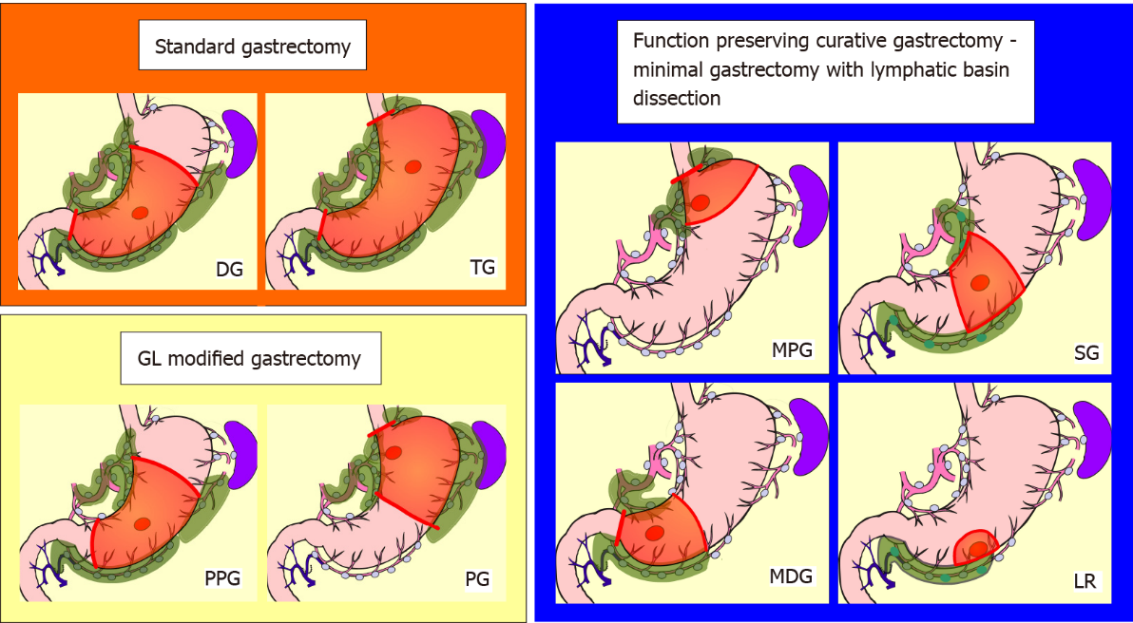
Figure 1 Schemas of standard gastrectomy, modified gastrectomy due to guidelines, and the function-preserving curative gastrectomy with lymphatic basin dissection. The red circle indicates the tumor, the green colored area indicates the extent of lymph node dissection, and the orange area indicates the extent of gastrectomy. The extent of nodal dissection in standard gastrectomy and modified gastrectomy according to the guidelines was D1 +. In contrast, the extent of nodal dissection in lymphatic basin dissection was defined as D0. GL: Japanese gastric cancer treatment guidelines; DG: Distal gastrectomy; TG: Total gastrectomy; PPG: Pylorus-preserving gastrectomy; PG: Proximal gastrectomy; MPG: Mini-proximal gastrectomy; SG: Segmental gastrectomy; MDG: Mini-distal gastrectomy; LR: Local resection.

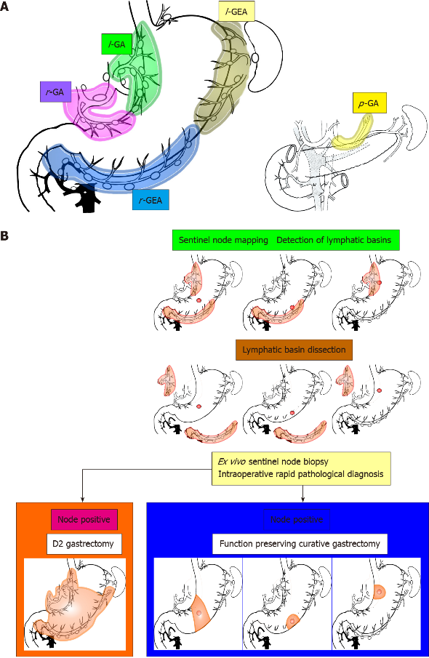
Figure 2 Lymphatic basins, lymphatic compartments, and the strategy of sentinel node navigation surgery. A: The lymphatic basins were defined as the lymphatic system that was detected with dyed or fluorescent lymphatics. The lymphatic basins were integrated into the five lymphatic areas. Each of these was called the lymphatic compartment and was classified into five basins; B: Algorithm for sentinel node navigation surgery for early gastric cancer. First, sentinel node mapping was performed, followed by lymphatic basin dissection, ex vivo identification and biopsy of the sentinel nodes, and intraoperative rapid pathology. If the sentinel nodes were diagnosed as metastasis at rapid diagnosis, standard gastrectomy with nodal dissection up to D2 was performed; if the sentinel nodes were diagnosed as node negative, the extent of gastrectomy was reduced and function-preserving curative gastrectomy, such as segmental gastrectomy or local resection, was applied. l-GA: Left gastric artery basin; r-GA: Right gastric artery basin; l-GEA: Left gastroepiploic artery basin; r-GEA: Right gastroepiploic artery basin; p-GA: Posterior gastric artery basin.

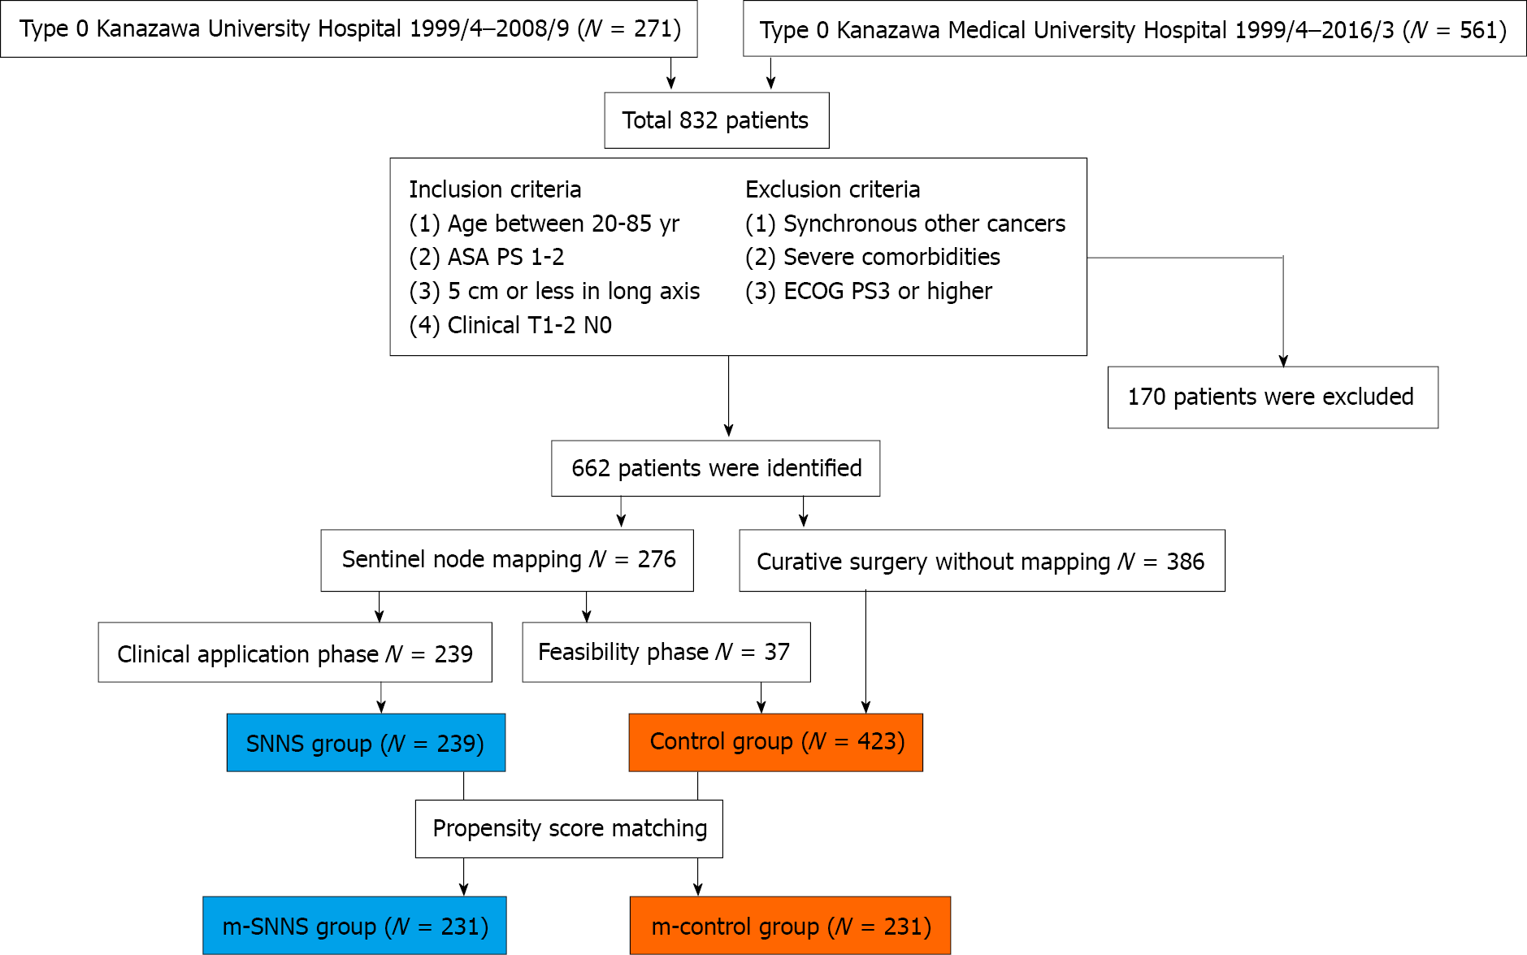
Figure 3 Summary of enrolled patients. The control group consisted of patients who underwent guidelines gastrectomy with standard lymph node dissection, while the sentinel node navigation surgery (SNNS) group consisted of patients who underwent tailor-made gastrectomy guided by sentinel node biopsy. SNNS: Sentinel node navigation surgery; m-SNNS: Propensity score-matched sentinel node navigation surgery; m-control: Propensity score-matched control; ECOG: Eastern Cooperative Oncology Group; ASA PS: American Society of Anesthesiologists physical status.

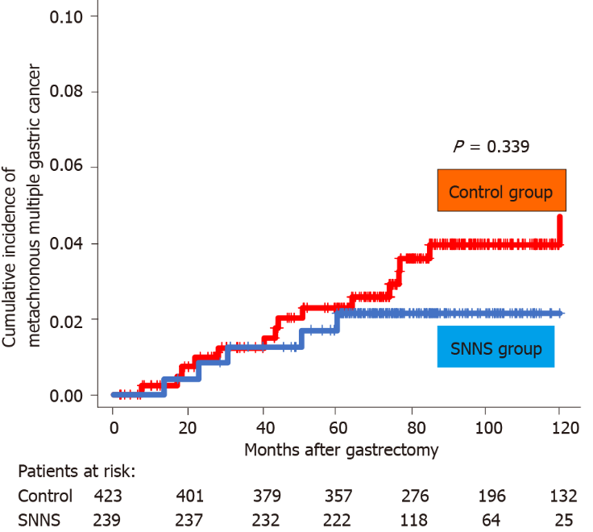
Figure 4 Cumulative incidence of metachronous multiple gastric cancer in the remnant stomach. There was no difference in the incidence of metachronous multiple gastric cancer between the SNNS and control groups. SNNS: sentinel node navigation surgery.

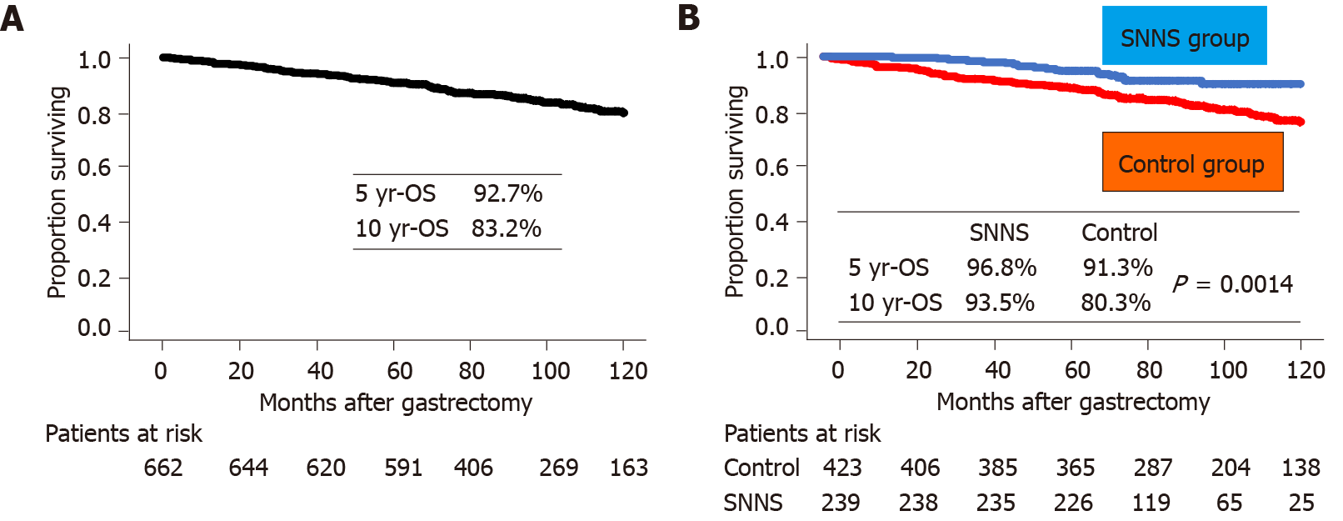
Figure 5 Overall survival curve. A: The overall survival of all patients; B: Comparison of overall survival between the sentinel node navigation surgery (SNNS) and control groups. The overall survival of the SNNS group was significantly better than the control group. SNNS: Sentinel node navigation surgery; OS: Overall survival.

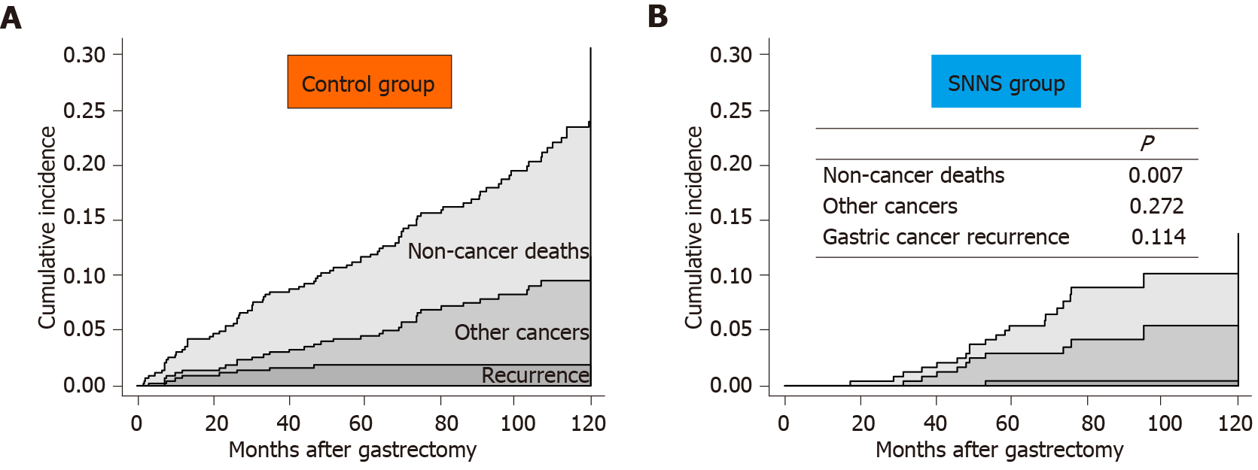
Figure 6 Cumulative incidence of gastric cancer recurrence or reason for death. A: Control group; B: Sentinel node navigation surgery (SNNS) group. The cumulative incidence of gastric cancer recurrence and other cancer-related deaths was almost equal between the two groups; in contrast, that of non-cancer deaths from other diseases was lower in the SNNS group than in the control group. SNNS: Sentinel node navigation surgery.

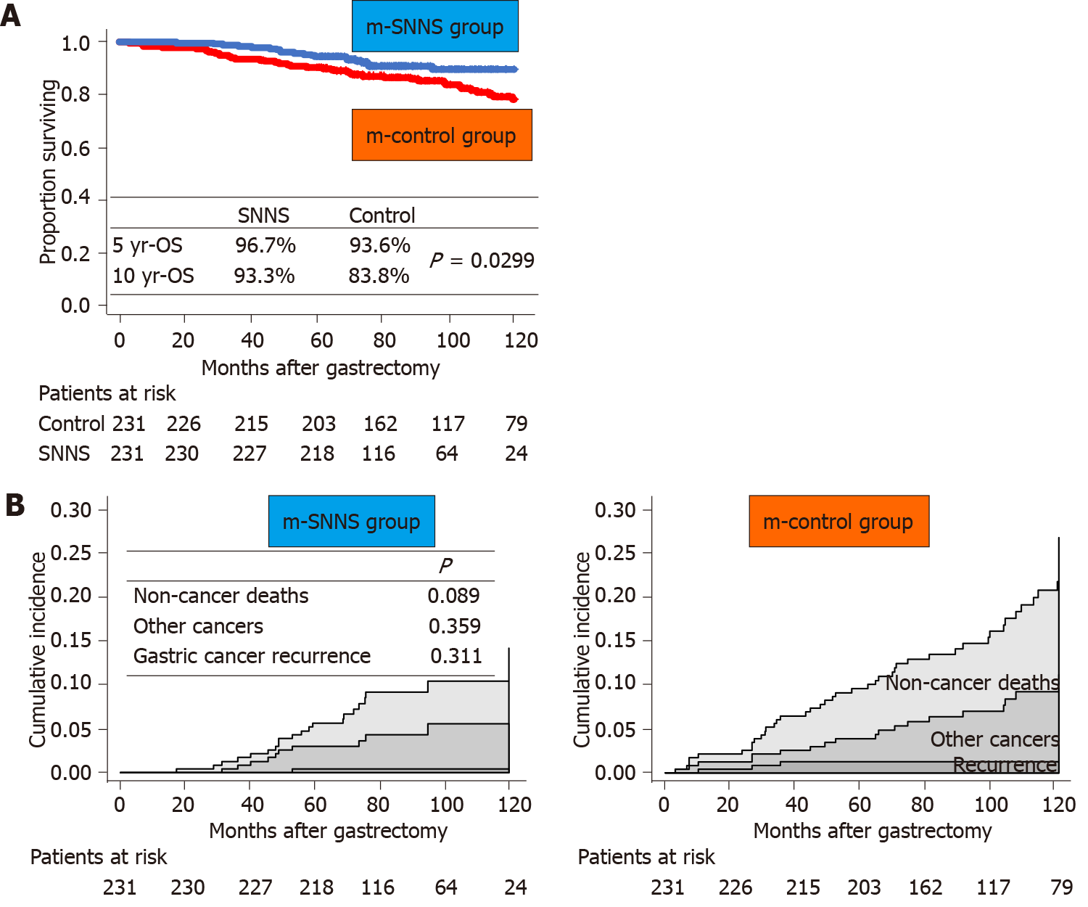
Figure 7 Comparisons of overall survival and cumulative incidence between the two groups after propensity score matching. A: Overall survival curves; B: Cumulative incidence curves of gastric cancer recurrence or the reason for death. The overall survival of the sentinel node navigation surgery (SNNS) group was significantly better than that of the control group. The cumulative recurrence of non-cancer deaths from other diseases in the SNNS group tended to be lower than that in the control group. SNNS: Sentinel node navigation surgery; m-SNNS: Propensity score-matched sentinel node navigation surgery; m-control: Propensity score-matched control; OS: Overall survival.

Table 1 Patient characteristics
 | n | SNNS n = 239 | Control n = 423 | P value
Age | Median (range) | 64 (28-85) | 67 (27-85) | 0.004
Sex | Male:Female | 157:82 | 289:134 | 0.491
Location | U:M:L | 35:130:74 | 78:195:150 | 0.116
Circumference | Less:Ant:Gre:Post | 107:37:48:47 | 201:78:72:72 | 0.492
Macroscopic type | Elevated:Depressed | 62:177 | 108:315 | 0.926
Clinical T status (cT) | 1a:1b:2 | 100:111:28 | 171:192:60 | 0.678
Clinical N status (cN) | 0:1:2-3 | 239:0:0 | 423:0:0 | 1.000
Pathological diagnosis | DF:UDF | 130:109 | 289:134 | < 0.001
Sentinel node mapping | BD:RI:CM:ICG:None | 39:6:135:59:0 | 2:1:13:21:386 | < 0.001
Surgical procedure | TG:DG:PG:PPG; SG:MDG:MPG:LR | 3:41:24:10; 84:33:6:38 | 23:263:51:62; 8:4:1:11 | < 0.001
Nodal dissection | D0:D1(1 +):D2 | 174:42:23 | 45:191:187 | < 0.001
Long axis (mm) | Median (range) | 22 (2-65) | 25 (4-87) | 0.265
Pathological T (pT) | 1a:1b:2:3-4 | 129:92:10:8 | 218:145:39:21 | 0.065
Pathological N (pN) | 0:1:2-3 | 214:13:12 | 379:34:10 | 0.072
Recurrent cases |  | 1 | 8
SNNS: Sentinel node navigation surgery group; DF: Differentiated type; UDF: Undifferentiated type; BD: Blue dye mapping; RI: Radioisotope colloid mapping; CM: Dye and RI combination mapping; ICG: Indocyanine green fluorescence mapping; TG: Total gastrectomy; DG: Distal gastrectomy; PG: Proximal gastrectomy; PPG: Pylorus-preserving gastrectomy; SG: Segmental gastrectomy; MDG: Mini-distal gastrectomy; MPG: Mini-proximal gastrectomy; LR: Local resection.

Table 2 List of 25 patients of lymph node metastasis in the sentinel node navigation surgery group
No. | LOC | MAC | LA | cT | cN | sN | MP | LB | INDSN | OP | D | PD | pT | MS | NS | MLB | MOB | NNS | MRSC | PROG¹
1 | M | 0 IIa + IIc | 20 | 1b | 0 | 0 | ICG | l-GA | TP | DG | 2 | tub2 | sm2 | #3 #7 | 4 | #7 | - | 1 | 82.3 | Alive
2 | M | 0 IIc | 25 | 1b | 0 | 0 | CM | l-GA | TP | DG | 2 | por1 | sm2 | #3 | 1 | - | - | 0 | 71.4 | Alive
3 | U | 0 IIc | 25 | 1b | 0 | 0 | ICG | l-GA | TP | PG | 1 + | tub2 | mp | #1 #3 | 2 | #1 | - | 1 | 56.1 | Trauma
4 | M | 0 IIa + IIc | 40 | 2 | 0 | 0 | ICG | l-GA | TP | DG | 2 | tub2 | ss | #3 | 1 | - | - | 0 | 63.7 | Alive
5 | M | 0 IIc + IIb | 40 | 1b | 0 | 0 | ICG | l-GA | TP | DG | 2 | tub2 | mp | #3 | 1 | - | - | 0 | 80.4 | Alive
6 | U | 0 IIc | 45 | 1b | 0 | 0 | CM | l-GA | TP | PG | 1 + | sig | m | #1 #7 | 2 | - | - | 0 | 69.2 | Alive
7 | L | 0 IIc + IIb | 45 | 2 | 0 | 1 | CM | l-GA | TP | DG | 2 | por2 | ss | #3 | 2 | #3 | - | 1 | 67.7 | Alive
8 | L | 0 IIc + III | 40 | 2 | 0 | 2 | ICG | r-GEA | TP | DG | 2 | tub2 | mp | #4d | 2 | #4d #6 | #7 | 5 | 72.1 | Alive
9 | L | 0 IIa | 55 | 2 | 0 | 1 | ICG | l-GA, r-GA | TP | DG | 1 + | tub1 | sm1 | #5 | 1 | - | - | 0 | 67.7 | Alive
10 | L | 0 IIa + IIc | 20 | 1b | 0 | 0 | ICG | l-GA, r-GEA | TP | DG | 2 | tub2 | sm2 | #3 #4d #6 | 4 | #6 | - | 1 | 62.0 | Alive
11 | M | 0 IIc + III | 25 | 2 | 0 | 0 | BD | l-GA, r-GEA | TP | DG | 2 | por2 | ss | #4d | 2 | - | - | 0 | 120.0 | Alive
12 | M | 0 IIa + IIc | 25 | 1b | 0 | 0 | ICG | l-GA, r-GEA | TP | DG | 1 + | tub2 | sm2 | #3 #7 #4d | 4 | - | - | 0 | 59.5 | CVD
13 | M | 0 I | 32 | 1b | 0 | 0 | CM | l-GA, r-GEA | TP | TG | 2 | tub2 | sm2 | #3 #4d | 5 | - | - | 0 | 64.7 | Alive
14 | M | 0 IIc + IIb | 37 | 1b | 0 | 0 | CM | l-GA, r-GEA | TP | DG | 2 | por2 | m | #3 | 3 | - | - | 0 | 61.9 | Alive
15 | M | 0 I | 55 | 1a | 0 | 0 | ICG | l-GA, r-GEA | TP | DG | 2 | por2 | mp | #4d | 1 | #3 #4d | - | 4 | 69.8 | Alive
16 | M | 0 IIc + III | 30 | 2 | 0 | 1 | BD | l-GA, r-GEA | TP | DG | 2 | por2 | se | #1 #3 #4d | 3 | #4d | - | 2 | 53.2 | LNR
17 | U | 0 IIa + IIc | 11 | 1a | 0 | 0 | CM | l-GA, l-GEA, p-GA | TP | PG | 1 + | por1 | sm2 | #11d | 1 | #7 | - | 1 | 84.3 | Alive
18 | U | 0 IIc | 33 | 1b | 0 | 0 | CM | l-GA, l-GEA, p-GA | TP | PG | 1 + | tub2 | mp | #1 | 1 | - | - | 0 | 62.9 | Alive
19 | U | 0 IIc | 55 | 2 | 0 | 0 | CM | l-GA, r-GEA, r-GEA | TP | TG | 2 | por2 | sm2 | #1 #3 #4d #10 | 4 | #1 | - | 1 | 65.2 | Alive
20 | M | 0 IIc | 40 | 2 | 0 | 0 | ICG | l-GA, r-GA, r-GEA | TP | DG | 1+ | tub2 | sm1 | #3 | 1 | - | - | 0 | 89.6 | Alive
21 | L | 0 IIa + IIc | 24 | 1b | 0 | 2 | CM | l-GA, r-GA, r-GEA | TP | DG | 2 | por1 | sm2 | #8a | 1 | #3 | - | 1 | 72.6 | Alive
22 | M | 0 IIc | 20 | 1b | 0 | 0 | ICG | l-GA, r-GEA | FN (FD) | SG | 0 | por2 | sm2 | (#4d) | 1 | #4d | - | 1 | 61.2 | Alive
23 | M | 0 IIc + III | 23 | 2 | 0 | 0 | CM | l-GA, r-GEA | FN (FD) | SG | 0 | tub2 | mp | (#3) | 1 | #3 | - | 2 | 75.8 | PK
24 | L | 0 IIc | 45 | 1b | 0 | 0 | RI | l-GA, r-GA, r-GEA | FN (FD) | DG | 2 | por2 | m | (#5) | 1 | - | - | 0 | 66.8 | Alive
25 | L | 0 I | 25 | 1b | 0 | 1 | CM | l-GA, r-GA, r-GEA | FN (LM) | DG | 2 | tub2 | sm2 | - | 0 | #4d | - | 1 | 63.6 | Alive
¹“PROG” column indicates whether the patients are alive at the time of recent survival confirmation, recurrent status of gastric cancer, or the cause of death.
SNNS: Sentinel node navigation surgery; LOC: Location; MAC: Macroscopic type; LA: Size of long axis (mm); cT: Clinical T status; cN: Clinical N status; sN: Surgical N status; MP; Mapping procedures; ICG: Indocyanine green fluorescence mapping; CM: Combination mapping; BD: Blue dye mapping; RI: Radioactive colloid mapping; LB: Distributions of lymphatic basins; l-GA: Left gastric artery basin; r-GA: Right gastric artery basin; r-GEA: Right gastroepiploic artery basin; l-GEA: Left gastroepiploic artery basin; p-GA: Posterior gastric artery basin; INDSN: Intraoperative nodal diagnosis by sentinel node biopsy; TP: True positive diagnosis for nodal metastasis; FN (FD): False-negative diagnosis because of frozen section diagnosis; FN (LM): False negative because of obvious macroscopic nodal metastasis; OP: Surgical procedures; DG: Distal gastrectomy; PG: Proximal gastrectomy; TG: Total gastrectomy; SG: Segmental gastrectomy; D: Degree of nodal dissection; PD: Dominant pathological diagnosis; pT: Pathological T status; MS: Metastastic stations of sentinel nodes; NS: Numerical numbers of metastatic sentinel nodes; MLB: Metastatic stations of not sentinel nodes inside the lymphatic basins; MOB: Metastatic stations of not sentinel nodes outside the basins; NNS: Numerical numbers of metastatic nodes of not sentinel nodes; MRSC: Months to recent survival confirmation; PROG: Prognosis, recurrent status or cause of death; CVD: Cerebrovascular disease; LNR: Lymph nodal recurrence; PK: Pancreas cancer.
Table 3 Profiles of metachronous multiple remnant gastric cancer patients
No. | Group | ISP | Treatment | MTMC | Curability¹ | MRSC | PROG²
1 | SNNS | SG | DG | 50.5 | Curative | 75.6 | Pneumonia
2 | SNNS | SG | ESD | 60.2 | Curative | 114.9 | Alive
3 | SNNS | SG | ESD | 22.9 | Curative | 79.9 | Alive
4 | SNNS | MPG | ESD | 13.6 | Curative | 76.3 | Alive
5 | SNNS | LR | ESD | 30.7 | Curative | 73.1 | Alive
6 | SNNS | DG | TG | 43.6 | Curative | 62.9 | Alive
7 | Control | DG | TG | 19.5 | Curative | 63.6 | Alive
8 | Control | DG | TG | 17.2 | Curative | 97.4 | Alive
9 | Control | DG | ESD | 44.3 | Curative | 55.5 | AID
10 | Control | DG | ESD | 220.4 | Curative | 240.0 | Alive
11 | Control | DG | ESD | 40.6 | Curative | 120.0 | Alive
12 | Control | PG | UR | 74.3 | UR | 120.0 | Alive
13 | Control | PG | TG | 76.8 | Curative | 120.0 | Alive
14 | Control | PG | ESD | 18.5 | Curative | 120.0 | Alive
15 | Control | PG | ESD | 28.2 | Curative | 120.0 | Alive
16 | Control | PPG | TG | 50.8 | Curative | 120.0 | Alive
17 | Control | PPG | DG | 85.0 | Curative | 116.2 | Alive
18 | Control | PPG | ESD | 77.1 | Curative | 118.5 | Alive
19 | Control | PPG | ESD | 22.0 | Curative | 98.2 | Alive
20 | Control | LR | DG | 7.6 | Cure | 42.8 | CVD
21 | Control | LR | ESD | 64.2 | Cure | 85.7 | Alive
¹“Curability” column indicates whether treatment for metachronous multiple remnant gastric cancers was curative or not. All but one unresectable patient could be resected radically, and there were no recurrences of metachronous gastric cancer. One unresectable patient was alive with metachronous cancer 10 years after the initial surgery.
²“PROG” column indicates whether the patients are alive at the time of recent survival confirmation, or the cause of death.
ISP: Initial surgical procedure; SG: Segmental gastrectomy; MPG: Mini-proximal gastrectomy; LR: Local resection; DG: Distal gastrectomy; PG: Proximal gastrectomy; PPG: Pylorus-preserving gastrectomy; ESD: Endoscopic submucosal dissection; TG: Total gastrectomy; UR: Unresectable; MTMC: Months to treat metachronous gastric cancer; MRSC: Months to recent survival confirmation; PROG: Prognosis or cause of death; AID: Autoimmune disease; CVD: Cerebrovascular disease; SNNS: Sentinel node navigation surgery.
Table 4 Univariate and multivariate analysis for the factors affected to the overall survival
Factors | vs | Univariate¹ (Log-rank P) | Multivariate²
 |  |  | Hazard ratio | 95% CI | P value
Age |  | < 0.0001 | 1.092 | 1.064-1.120 | < 0.0001
Sex | Male:Female | 0.0009 | 1.815 | 1.099-2.998 | 0.0199
Location |  | 0.0978
Circumference |  | 0.301
Macroscopic type | Elevated:Depressed | < 0.0001 | 1.678 | 1.131-2.490 | 0.0101
Clinical T status |  | 0.632
Pathological type | Diff.:Undiff. | 0.0001
Long axis (mm) |  | < 00001 | 0.9815 | 0.965-0.998 | 0.0287
Pathological N status |  | 0.0033 | 1.785 | 1.288-2.473 | 0.0005
SNNS | SNNS:Control | 0.0014 | 0.4892 | 0.298-0.802 | 0.0046
¹The log-rank test was used for the univariate analysis of overall survival.
²The Cox proportional hazards regression model was used for multivariate analysis of overall survival.
SNNS: Sentinel node navigation surgery; diff.: Differentiated; Undiff.: Undifferentiated; CI: Confidential interval.
Table 5 Multivariate analysis for the factors affected to the cumulative incidence of causes of death or recurrences
Factors | Non-cancer deaths |  |  | Other cancers |  |  | Gastric cancer recurrence
 | HR | 95% CI | P value | HR | 95% CI | P value | HR | 95% CI | P value
Age | 1.101 | 1.064-1.140 | < 0.0001 | 1.064 | 1.026-1.103 | 0.0008 | 0.992 | 0.894-1.101 | 0.88
Sex | 1.533 | 0.823-2.855 | 0.18 | 2.126 | 0.863-5.239 | 0.1 | 3.213 | 0.592-17.43 | 0.18
Location | 1.259 | 0.890-1.782 | 0.19 | 0.9636 | 0.637-1.457 | 0.86 | 1.472 | 0.482-4.502 | 0.5
Circumference | 1.037 | 0.798-1.349 | 0.78 | 1.184 | 0.875-1.602 | 0.27 | 1.943 | 0.732-5.158 | 0.18
Macroscopic type | 1.303 | 0.752-2.256 | 0.35 | 2.322 | 1.241-4.346 | 0.0084 | 1.083 | 0.136-8.636 | 0.94
Clinical T status | 0.9053 | 0.584-1.403 | 0.66 | 0.8587 | 0.481-1.535 | 0.61 | 1.542 | 0.662-3.595 | 0.32
Pathological type | 1.509 | 0.762-2.990 | 0.24 | 0.5908 | 0.211-1.657 | 0.32 | 1.27 | 0.165-9.786 | 0.82
Long axis | 0.9802 | 0.958-1.003 | 0.086 | 0.9874 | 0.958-1.017 | 0.4 | 0.9468 | 0.867-1.034 | 0.22
Pathological N status | 1.263 | 0.683-2.337 | 0.46 | 1.353 | 0.751-2.440 | 0.31 | 5.252 | 2.043-13.50 | 0.00058
SNNS | 0.4438 | 0.230-0.855 | 0.015 | 0.7224 | 0.338-1.542 | 0.4 | 0.1859 | 0.030-1.166 | 0.072
SNNS: Sentinel node navigation surgery; HR: Hazard ratio; CI: Confidence interval.

Table 6 Patient characteristics after propensity score matching
 | n | m-SNNS n = 231 | m-control n= 231 | P value
Age | Median (range) | 64 (29-85) | 64 (27-85) | 0.473
Sex | Male:Female | 152:79 | 147:84 | 0.697
Location | U:M:L | 34:125:72 | 37:119:75 | 0.843
Circumference | Less:Ant:Gre:Post | 106:37:45:43 | 103:40:46:42 | 0.980
Macroscopic type | Elevated:Depressed | 57:174 | 57:174 | 1.000
Clinical T status (cT) | 1a:1b:2 | 98:105:28 | 88:108:35 | 0.528
Clinical N status (cN) | 0:1:2-3 | 231:0:0 | 231:0:0 | 1.000
Pathological diagnosis | DF:UDF | 130:101 | 126:105 | 0.779
Long axis (mm) | Median (range) | 23 (2-65) | 25 (4-87) | 0.547
Sentinel node mapping | BD:RI:CM:ICG:None | 38:5:132:56:0 | 1:1:8:15:206 | < 0.001
Surgical procedure | TG:DG:PG:PPG; SG:MDG:MPG:LR | 3:40:23:10; 80:31:6:37 | 14:147:25:32; 4:4:0:5 | < 0.001
Nodal dissection | D0:D1(1+):D2 | 169:39:23 | 23:97:111 | < 0.001
Pathological T (pT) | 1a:1b:2:3-4 | 125:89:10:7 | 126:72:20:13 | 0.075
Pathological N (pN) | 0:1:2-3 | 206:13:12 | 213:13:5 | 0.251
Recurrent cases |  | 1 | 3
m-SNNS: Matched sentinel node navigation surgery group; m-control: Matched control group; DF: Differentiated type; UDF: Undifferentiated type; BD: Blue dye mapping; RI: Radioisotope colloid mapping; CM: Dye and RI combination mapping; ICG: Indocyanine green fluorescence mapping; TG: Total gastrectomy; DG: Distal gastrectomy; PG: Proximal gastrectomy; PPG: Pylorus-preserving gastrectomy; SG: Segmental gastrectomy; MDG: Mini-distal gastrectomy; MPG: Mini-proximal gastrectomy; LR: Local resection.

Published by Baishideng Publishing Group Inc
7041 Koll Center Parkway, Suite 160, Pleasanton, CA 94566, USA
Telephone: +1-925-3991568
E-mail: bpgoffice@wjgnet.com
Help Desk: https://www.f6publishing.com/helpdesk
https://www.wjgnet.com

© 2021 Baishideng Publishing Group Inc. All rights reserved.

