Name of Journal: World Journal of Psychiatry
Manuscript NO: 74395
Manuscript Type: OPINION REVIEW

Eco-crisis and mental health of children and young people: Do child mental health professionals have a role?

Gnanavel S. Eco-crisis and mental health of youth

Sundar Gnanavel

Sundar Gnanavel, Department of Child Psychiatry, CNTW NHS Foundation Trust, Newcastle NE33XT, United Kingdom

Author contributions: Gnanavel S conceptualised and drafted this manuscript.

Corresponding author: Sundar Gnanavel, MD, Doctor, Department of Child Psychiatry, CNTW NHS Foundation Trust, Alnwood, St Nicholas Hospital, Gosforth, Newcastle NE33XT, United Kingdom. sundar.gnanavel@cntw.nhs.uk

Received: December 22, 2021
Revised: March 27, 2022
Accepted: April 15, 2022
Published online: May 19, 2022

Abstract
Child mental health professionals have an extremely important role to play in their distinct roles as clinicians, therapists, researchers, policy makers, advocates, preventative public health professionals and service developers pertaining to eco-crisis in the child and adolescent populations. This article provides examples of how this can be done.

Key Words: Eco-crisis; Children; Mental; Mental health

©The Author(s) 2022. Published by Baishideng Publishing Group Inc. All rights reserved.

Citation: Gnanavel S. Eco-crisis and mental health of children and young people: Do child mental health professionals have a role? World J Psychiatry 2022; 12(5): 668-672
URL: https://www.wjgnet.com/2220-3206/full/v12/i5/668.htm
DOI: https://dx.doi.org/10.5498/wjp.v12.i5.668

Core Tip: Child mental health professionals can perform different and effective roles pertaining to eco-crisis and mental health of children and young people. They can be clinicians, researchers, preventative professionals, service builders and policy makers in this regard. I believe this would be a moral obligation and a professional duty to the population that we are privileged to serve.

INTRODUCTION
International experts widely accept that climate change is under way and it poses a critical threat to the future of mankind. The 2015 Paris Agreement acknowledges that climate change is an urgent and potentially irreversible threat to the planet (International Panel on Climate Change, 2018)^{[1]}. These changes can potentially affect food and water availability, agricultural productivity, natural ecosystems and result in a variety of health disorders (Intergovernmental Panel on Climate Change, 2014)^{[2]}.
There are emerging studies that demonstrate the physical health effects of climate change, but research is relatively scarce on the psychological effects. In particular, there is a lacuna in our understanding of psychological effects in children and adolescents who in fact might be disproportionately affected^{[3]}. Climate change could induce or precipitate psychiatric disorders and might worsen existing mental illnesses among children and adolescents experiencing climate anxiety.
Mental health professionals, policy makers and advocates need robust evidence to mitigate the effects of climate anxiety on the short-term and long-term mental health of young people. The role of child mental health professionals as an advocate, researcher, or policy maker is crucial. This review aims to demonstrate the multiple effective roles that they can play in this regard with examples to demonstrate in each of these roles (Figure 1).

As a clinician and a therapist
Empirical evidence demonstrates that both the acute and chronic mental health effects of climate change has risen sharply in the past decade. Several recent studies have explored the mental health effects of climate-related psychological disorders, including depression, anxiety, post-traumatic stress disorder, the exacerbation of psychotic symptoms, suicidal ideation and completed suicides, including in the child and adolescent population^{[4]}. Child mental health clinicians are appropriate professionals for conducting a detailed assessment in addition to developing and implementing appropriate assessment strategies.
In addition to diagnosable mental health disorders, experiences of ecological anxiety (i.e. apprehension about anticipated threats to salient ecosystems) and ecological grief (i.e. grief in relation to ecological loss) are commonly noted as psychological phenomena (though poorly understood) causing distress in children and adolescents. The grief phenomena associated with loss of the ecosystem is commonly categorised into: grief associated with physical ecological losses, grief associated with the loss of environmental knowledge and grief associated with anticipated future losses^{[5]}. It is to be noted that these phenomena which can be debilitating are not diagnosable as a psychiatric disorder in the current diagnostic & classificatory systems.
Enhanced and detailed clinical assessments are needed for this population. For some people suffering from ecological grief and anxiety, clinical support might be required, particularly if their personal safety or daily functioning are affected. It is important to discern this from reactive emotions which can be unpleasant and at times painful but do not impair daily functioning and rather may assist in making productive and positive changes, including in the implementation of climate change related solutions. Screening for psychiatric comorbidity including mood and anxiety disorders with subsequent management is also crucial for a holistic plan.
Existing individual and group therapy strategies could be adapted and improvised for children and adolescents experiencing co-anxiety. The role of child psychiatrists and psychologists would be crucial in this regard. For example, interpersonal group therapy would be one option to consider^{[6]}. There are some examples of networks that have been created to support climate-related mental wellbeing like the Good Grief Network.
Social prescribing and facilitating social connectedness would be an important part of the management plan. This would help in managing some of these psychological phenomena causing distress but with no diagnosable psychiatric disorder. The benefits would include avoiding over-pathologising and inappropriate management of these issues within a medical model^{[7]}. For example, prescribing spending time in nature, engaging in community-based work for increasing the number of trees in urban spaces, improving the infrastructure for active commuting and reducing air pollution through a shift to clean energy might be beneficial.
Child mental health professionals are well regarded for their systemic approach to managing mental health. In this case, helping the parents/family members acknowledge the challenge, encourage parental insight into children’s responses, encouraging empathetic communication with children and adolescents, validating their feelings of fear and disillusionment and mobilising hope through meaningful goal-directed activities would be appropriate measures^{[7]}.

As a researcher
As mentioned earlier, there is scarce research into the psychological effects of climate change in children and adolescents. The primary focus of the existing studies is assessing participants' knowledge, perceptions and attitudes about climate change. For example, a recent survey-based study of 10000 young people demonstrated significant respondents were worried about climate change (59% very or extremely worried, 84% at least moderately worried)^{[8]}. Existing literature suffers from several methodological challenges that limits the interpretation of study results. This includes the use of self-report instruments exclusively, extrapolating adult surveys to children, limited sample frame (lack of representativeness), use of closed form surveys, common methodological biases, such as social desirability, item ambiguity or demand characteristics that may result in measurement error and not taking developmental perspective (e.g., children vs adolescents) into consideration^{[9]}.
The need of the hour is to develop psychometric instruments that can accurately screen for and measure the severity of eco-anxiety in children and adolescents. This is important to quantify differences between subjects and across time-points. This is also important for accurately assessing the relationships between climate change distress/anxiety and other known constructs, such as environmental concern and general anxiety. Of course, this is also vital for measuring response to treatment that we provide as child mental health professionals^{[10]}. Prior to developing psychometric instruments, a clear conceptualization of the construct of eco-anxiety is imperative and a consensus needs to be reached on this. This is also important from the perspective of diagnostic and classificatory systems to explore if this could merit a primary psychiatric diagnosis on its own.
In addition to developing valid psychometric instruments, child mental health professionals are well positioned to explore a number of other poorly understood aspects including differences in perception of climate change according to age, differences in perception based on location (e.g., developing vs developed countries; rural vs urban population; low vs higher socio-economic group), prevalence of comorbid psychiatric disorders with eco-anxiety and effectiveness of different therapeutic interventions for the same.
Future high-quality research on this subject should employ a variety of methods both quantitative and qualitative, to elicit a broad understanding of factors in addition to knowledge. Different methodological biases should be carefully considered to devise the study as well as to interpret the study findings. This could be at the individual, collective, and situational levels as all these impact adolescents’ climate-related concepts^{[11]}. The use of open-ended questions would be invaluable in exploring the views of this group without limiting their responses. Also, using reverse coding rather than questions with negations would be a useful strategy to circumvent the cognitive limitations particularly in younger children.

As a preventative professional (public health)
Research on resilience and positive development identifies the characteristics that will be most valuable for the next generation to adapt successfully to climate change related difficulties. These can be grouped into individual skills and capacities, interpersonal skills and relationships and social/civic engagement^{[12]}.
Individual characteristics include emotional self-regulation (e.g., meaning-focused coping strategies), behavioural and attentional self-regulation, empathy and beliefs in social justice, adaptability and creativity. Interpersonal skills include negotiation, conflict-resolution skills and the capacity to work cooperatively. Social and civic engagement includes volunteering and joining community groups, and engaging in active citizenship (e.g., speaking out on issues of concern, communicating with policy makers)^{[13]}. Models of positive development indicate that these are desirable developmental outcomes.
Child mental health professionals play a valuable role in both researching on as well as implementing these resilience-based preventative public health strategies in both school and other community-based settings. They are obvious stakeholders who should be involved in developing, trialling and implementing the educational/curricular changes in this regard, possibly in conjunction with educational psychologists. Also, developing nature friendly schools projected along with educational professionals is likely to be helpful. Also, this approach is likely to be helpful in developing nature based positive behavioural support strategies for children and adolescents with intellectual disabilities.

As a policy maker and advocate
Child mental health professionals are extremely well placed to actively advocate for climate change mitigation and adaption. Through their membership in different professional and government committees, they could influence policy making as relevant to children and adolescents. For example, The Royal College of Psychiatry, United Kingdom is a member of the United Kingdom health alliance on climate change bringing together the voices of a multitude of health care professionals to advocate for action on climate change and study its psychological impact. The college also published a position paper on sustainability which highlights the need to develop carbon efficient mental health services as part of sustainable mental health^{[14]}.
There are several recently implemented programs at local, national and international levels that support actively engaging children and adolescents in increasing awareness of climate change, promoting renewable energy, developing environmentally sustainable practices and advocating for urgent action on the climate crisis^{[13]}. Child psychiatrists and other child mental health professionals have a lot to contribute to these crucial efforts. They can help in identifying the subset of children and adolescents most likely to benefit from these efforts and help in developing the program and in evaluating its effectiveness.

As a promoter of health equity (public health perspective) and as a service developer
Access to mental health care in relation to eco-crisis can be impeded by inadequate mental health-care infrastructure in certain areas, cultural practices and practitioner’s familiarity with climate-related anxiety and grief, existing burden on mental health care services and disparities in underlying determinants of health (e.g., socio-economic factors)^{[14,15]}. There is some evidence that those who experience the most acute forms of ecological anxiety are also those with relatively less access to mental health resources^{[5]}. Hence, the role of these professionals is crucial for ensuring fair access for all to the services and building a resilient service in this regard.
Also, looking at a global level, most of the world’s children (about 85%) live in low- and middle-income countries, which tend to be in geographic locations more vulnerable to the impacts of climate change. These developing nations also tend to have weaker mental health care infrastructure and fewer support services with which to prepare for and adapt to the impact of climate change^{[3]}. Hence, the role of clinicians serving children and adolescents in the developing world and those working with global agencies [e.g., the World Health Organization (WHO)] are even more crucial for ensuring health equity for children and adolescents globally, pertaining to eco-anxiety. Influencing decision-makers who are crucial for ensuring health equity for children and adolescents globally and pertaining to eco-anxiety is an important role that we could play. This would include local, regional or national leaders; WHO and charitable organizations.

CONCLUSION
As highlighted through numerous examples above, child mental health professionals have an extremely important role to play in their distinct roles as clinicians, therapists, researchers, policy makers, advocates, preventative public health professionals and service developers pertaining to eco-crisis in both the children and adolescent populations. This would be even more important in developing countries where the majority of the children live. These countries typically have weaker pre-existing mental health services which need to be strengthened. I believe this would be a moral obligation and a professional duty to the population we are privileged to serve.
REFERENCES
1 International Panel on Climate Change. Global warming of 1.5°C. An IPCC special report on the impacts of global warming of 1.5°C above pre-industrial levels and related global greenhouse gas emission pathways, in the context of strengthening the global response to the threat of climate change, sustainable development, and efforts to eradicate poverty. Geneva, Switzerland: World Meteorological Organization 2018
2 Intergovernmental Panel on Climate Change. Climate change 2014: Synthesis report. Contribution of working groups I, II and III to the fifth assessment report of the Intergovernmental Panel on Climate Change. Geneva, Switzerland. Available from: http://www.ipcc.ch/report/ar5/syr/2014
3 Sanson AV, Van Hoorn J, Burke SEL. Responding to the impacts of the climate crisis on children and youth. Child Dev Perspect 2019; 13: 201–207 [DOI: 10.1111/cdep.12342]
4 Davidson JR, McFarlane AC. The extent and impact of mental health problems after disaster. J Clin Psychiatry 2006; 67 Suppl 2: 9-14 [PMID: 16602810]
5 Cunsolo A, Ellis R. Ecological grief as a mental health response to climate change-related loss. Nature Clim Change 2018; 8: 275–281 [DOI: 10.1038/s41558-018-0092-2]
6 Clayton S. Mental health risk and resilience among climate scientists. Nat Clim Change 2018; 8: 260-261 [DOI: 10.1038/s41558-018-0123-z]
7 Clayton S, Maning C, Krygsman K, Speiser M. Mental health and our changing climate: impacts, implications, and guidance. American Psychological Association and Eco-America, Washington, DC 2017. Available from: http://ecoamerica.org/wp-content/uploads/2017/03/ea-apa-psych-report-web.pdf
8 Hickman C, Marks E, Pihkala P, Clayton S, Lewandowski RE, Mayall EE, Wray B, Mellor C, van Susteren L. Young People's Voices on Climate Anxiety, Government Betrayal and Moral Injury: A Global Phenomenon. SSRN 2021 [DOI: 10.2139/ssrn.3918955]
9 Lee K, Gjersoe N, O'Neill S, Barnett J. Youth perceptions of climate change: A narrative synthesis. WIREs Clim Change 2020; 11: e641 [DOI: 10.1002/wcc.641]
10 Leeuw E, Otter E. The reliability of children's responses to questionnaire items: Question eects in children's questionnaire data. In: Hox JJ, Meulen BF, Janssens JMAM, Laak JJF, Tavecchio LWC (Eds.), Advances in family research. Amsterdam, the Netherlands: Thesis Publishers. 1995: 251-258
11 Podsakoff PM, MacKenzie SB, Lee JY, Podsakoff NP. Common method biases in behavioral research: a critical review of the literature and recommended remedies. J Appl Psychol 2003; 88: 879-903 [PMID: 14516251 DOI: 10.1037/0021-9010.88.5.879]
12 Australian Psychological Society. Raising children to thrive in a climate changed world. Melbourne, VIC: Author. Available from: https://www.psychology.org.au/for-the-public/Psychologytopics/Climate-change-psychology/Talking-with-children-aboutthe-environment/Raising-children-to-thrive-in-a-climate-changedwo. 2018.
13 Sustainability in Psychiatry. RCPsych (Royal college of Psychiatry) occasional paper 97, March 2015
14 Wu J, Snell G, Samji H. Climate anxiety in young people: a call to action. Lancet Planet Health 2020; 4: e435-e436 [PMID: 32918865 DOI: 10.1016/S2542-5196(20)30223-0]
15 Cunsolo A, Harper SL, Minor K, Hayes K, Williams KG, Howard C. Ecological grief and anxiety: the start of a healthy response to climate change? Lancet Planet Health 2020; 4: e261-e263 [PMID: 32681892 DOI: 10.1016/S2542-5196(20)30144-3]

Footnotes
Conflict-of-interest statement: No conflicts of interest to declare.

Open-Access: This article is an open-access article that was selected by an in-house editor and fully peer-reviewed by external reviewers. It is distributed in accordance with the Creative Commons Attribution NonCommercial (CC BY-NC 4.0) license, which permits others to distribute, remix, adapt, build upon this work non-commercially, and license their derivative works on different terms, provided the original work is properly cited and the use is non-commercial. See: https://creativecommons.org/Licenses/by-nc/4.0/

Provenance and peer review: Invited article; Externally peer reviewed.
Peer-review model: Single blind

Peer-review started: December 27, 2021
First decision: March 13, 2022
Article in press: April 15, 2022

Specialty type: Psychiatry
Country/Territory of origin: United Kingdom
Peer-review report’s scientific quality classification
Grade A (Excellent): 0
Grade B (Very good): B
Grade C (Good): C, C
Grade D (Fair): 0
Grade E (Poor): 0

P-Reviewer: Ustun G, Turkey; Wierzbicka A, Poland S-Editor: Gong ZM L-Editor: Filipodia P-Editor: Gong ZM

Figure Legends
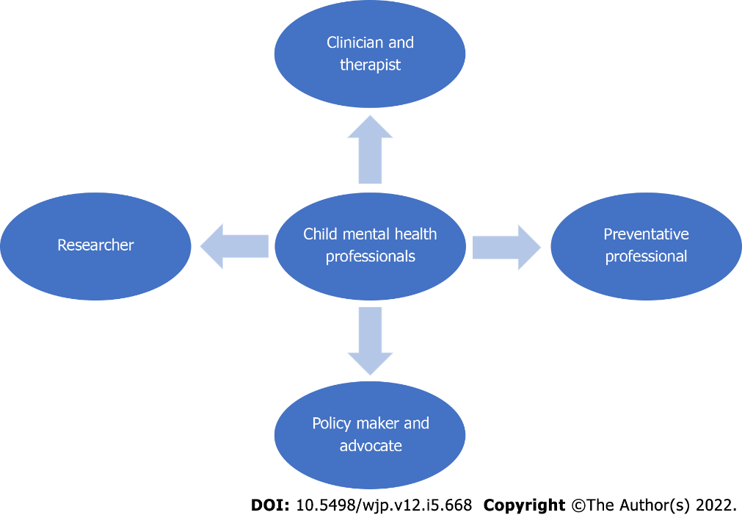
Figure 1 Roles of child mental health professionals in ecological crisis.

Published by Baishideng Publishing Group Inc
7041 Koll Center Parkway, Suite 160, Pleasanton, CA 94566, USA
Telephone: +1-925-3991568
E-mail: bpgoffice@wjgnet.com
Help Desk: https://www.f6publishing.com/helpdesk
https://www.wjgnet.com

© 2022 Baishideng Publishing Group Inc. All rights reserved.

