Name of Journal: World Journal of Radiology
Manuscript NO: 75136
Manuscript Type: ORIGINAL ARTICLE

Retrospective Study
Type 2 dynamic curves: a diagnostic dilemma

Karavas E et al. Histopathological outcomes of lesions with type 2 curves

Erdal Karavas, Bunyamin Ece, Sonay Aydın

Erdal Karavas, Sonay Aydın, Department of Radiology, Erzincan University, Erzincan 24142, Turkey

Bunyamin Ece, Department of Radiology, Kastamonu University, Kastamonu 37150, Turkey

Author contributions: Karavas E participated in design and oversight of the study, and drafted the manuscript; Ece B participated in design of the study and drafted the manuscript; and Aydin S participated in design of the study, drafted the manuscript, and performed statistical analysis.

Corresponding author: Bunyamin Ece, MD, Associate Professor, Doctor, Department of Radiology, Kastamonu University, Kuzeykent 57, Alay Street No. 4, Kastamonu 37150, Turkey. bunyaminece@hotmail.com

Received: February 19, 2022
Revised: April 16, 2022
Accepted: July 6, 2022
Published online:

Abstract
BACKGROUND
Magnetic resonance imaging (MRI) with multiparametric dynamic contrast plays a critical role in the assessment of breast lesions. Dynamic curves are a critical parameter in determining the benign or malignant nature of lesions. Dynamic curves of type 1 are known to represent benign masses, while dynamic curves of type 3 are known to identify malignant masses. Type 2 dynamic curves have a sensitivity of 42.6% and specificity of 75% for malignancy detection.

AIM
To investigate the pathological diagnosis of lesions with type 2 dynamic curves.

METHODS
We evaluated breast MRI examinations performed between 2020 and 2021 retrospectively and included lesions with type 2 dynamic curves. We included 38 lesions from 33 patients. The lesions were evaluated for their pathological diagnosis and morphological characteristics.

RESULTS
Twenty-six lesions were malignant, while twelve were benign. The most frequently encountered benign lesion (7/12, 58.3%) was sclerosing adenosis, while the most frequently encountered malignant diagnosis was invasive ductal cancer. The presence of a type 2 dynamic curve had a sensitivity of 40.2% and specificity of 73.4% for predicting malignancy. By combining type 2 curves and morphological features, the sensitivity and specificity were increased.

CONCLUSION
The high rates of malignancy detected histopathologically among patients with type 2 dynamic curves in our study are remarkable. Type 2 dynamic curves can be detected in benign breast masses, especially in sclerosing adenosis cases. Considering morphological features can increase the diagnostic accuracy in cases with type 2 dynamic curves.

Key Words: Type 2; dynamic curve; benign; malignant; breast; Magnetic resonance imaging

Karavas E, Ece B, Aydın S. Type 2 dynamic curves: a diagnostic dilemma. World J Radiol 2022; In press

Core Tip: Dynamic contrast-enhanced magnetic resonance imaging (MRI) plays a critical role in the evaluation of breast lesions. The sensitivity and specificity of dynamic curves acquired using MRI are variable. While type 1 curves indicate more benign pathologies and type 3 curves indicate more malignant pathologies, there is a significant overlap in type 2 dynamic curves. We examined the histopathological outcomes of lesions with type 2 curves retrospectively. The histopathology results of lesions with type 2 curves were malignant at a rate of 68.4%. The presence of a type 2 dynamic curve had a sensitivity of 40.2% and specificity of 73.4% for predicting malignancy. By combining type 2 curves and morphological features, the area under the curve, sensitivity, and specificity were increased.
INTRODUCTION
Breast magnetic resonance imaging (MRI) is a noninvasive technique that is highly sensitive for detecting breast cancer. Breast MRI can be used in situations where mammography is insufficient, in patients with dense breast structure, for preoperative planning in breast cancer, in multifocal and multicentric cases, for detecting contralateral malignancy, for evaluating response to neoadjuvant chemotherapy, and for postoperative control^{[1–5]}. Breast MRI provides morphological information about lesions as well as kinetic features such as perfusion and enhancement of the lesion. Additionally, breast MR imaging is less affected by dense breast tissue than other imaging modalities, allowing for a higher sensitivity in detecting lesions^{[6–10]}.
The most frequently used MRI technique for evaluating breast cancer is dynamic contrast-enhanced magnetic resonance imaging (DCE-MR). A low molecular weight contrast agent (gadolinium) is injected intravenously for DCE-MR imaging. Gadolinium uptake and washout, and thus the detection of signal changes on T1-weighted images and the differentiation of cancerous from normal breast tissue, are the foundations of DCE-MR imaging of breast cancer^{[11]}.
The enhancement properties are determined by examining changes in signal intensity across multiple images acquired by pre- and post-contrast repeat MRI scans. The time-signal intensity curve, also known as the kinetic curve, can be classified into three types: type 1 (persistence), type 2 (plateau), and type 3 (washout). Dynamic curve of type 1 (persistent) exhibits a persistent increase in signal intensity following contrast agent injection. Dynamic curve of type 2 (plateau) exhibits an initial slow or rapid increase followed by a flattening. Dynamic curve of type 3 (washout) involves an initial increase and subsequent decrease in signal intensity. Between benign and malignant lesions, there is considerable overlap in dynamic curves. Various noninvasive cancers may lack washout or plateau kinetics, but various benign entities, such as fibroadenomas, fibrocystic changes, scars, sclerosing adenosis, lobular carcinoma in situ, focal fibrosis, and atypical ductal hyperplasia, may show malignant curves^{[9,12,13]}. Therefore, dynamic curves should not be evaluated alone without considering lesion morphology.
The aim of this study was to examine the histopathological outcomes of lesions with type 2 dynamic curves, in which there is a high degree of overlap between benign and malignant entities in the kinetic analysis performed using dynamic contrast MR imaging.

MATERIALS AND METHODS
Between January 2020 and January 2021, dynamic contrast enhanced breast MRI scans were evaluated retrospectively. In the research conducted from the hospital information system, there were 560 patients who underwent dynamic contrast MR examinations between January 2020 and January 2021. In the results of these patients, type 2 dynamic curve was detected in 48 lesions of 41 patients. Ten lesions in eight patients were excluded from the study due to a history of radiotherapy within the previous 6 mo, previous surgery or tru-cut biopsy, lack of histopathological results, and imaging artifacts. As a result, 38 lesions in 33 patients were included in the study.
Dynamic contrast enhanced breast MR images of the lesions included in the study were reviewed retrospectively with a consensus formed by two radiology specialists. The evaluators had more than 8 years of experience in interpreting breast MRI images. The patients' anamnesis, previous mammography, and ultrasonography examinations were re-examined using the hospital information system. The radiologists who performed the retrospective evaluation were blinded to the lesions' histopathological findings. Enhancement dynamic curves were calculated using the region of interest (ROI) method. Evaluators checked for type 2 dynamic curves by reconstructing dynamic curves from high temporal resolution dynamic images of the included lesions. Additionally, the evaluators classified the lesions according to their morphological characteristics using the American College of Radiology (ACR)'s Breast Imaging Reporting and Data System (BI-RADS) classification^{[14]}, which ranges from 0 to 5. Additionally, the histopathological findings of the patients were retrieved and recorded retrospectively from the hospital information system.
The data used for this study were collected anonymously and local ethics committee approval was obtained for this study (ethics committee number: 34336249-604.01.02-E.30236). This study adhered to the Declaration of Helsinki. Because the study was retrospective, informed consent was not obtained.
The same device and protocol were used for dynamic contrast-enhanced breast MRI examinations. One 1.5-T whole-body MRI scanner was used for breast MRI with dynamic contrast (Magnetom Avanto; Siemens Healthineers). The vendor-supplied receive-only 4-channel circularly polarized breast array coil was used. A standard protocol includes a T2-weighted rapid (fast or turbo) spin-echo (TR: 4000 ms; TE: 90 ms; ≤ 4 mm thickness) acquisition and 3D T1-weighted GRE (20/4.5; flip angle, 30°–45°; ≤ 3 mm thickness) acquisitions before and after the administration of gadolinium, with the usual dose of 0.1 mmol/kg injected as a bolus and followed by a 10–20-mL saline flush. For sagittal plane, an image matrix of 256 × 192 can be used with zero-filled interpolation to 512 × 512, a small field of view (16–18 cm), and chemical fat suppression. For bilateral axial imaging, the field of view is increased to approximately 30 cm, and high-resolution matrices (between 256 and 512) are used.

Statistical analysis
The sample size was calculated using G power analysis (alpha error: 0.05; power: 80%); the minimum number of patients was thus defined as 31. The Statistical Package for Social Sciences (SPSS) for Windows 20 software was used to analyze the data (IBM SPSS Inc., Chicago, IL, United States). The Kolmogorov-Smirnov test was used to determine whether the age data conformed to a normal distribution. Age is represented as the mean ± SD and categorical variables as number (n) and percentage values (%). To define the diagnostic efficacy of type 2 dynamic curves alone and along with morphological characteristics, receiver operating characteristic analysis was used. The chi-square test was used to compare two groups of categorical variables. Statistical significance was defined as a two-tailed value of p < 0.050.

RESULTS
A total of 38 lesions in 33 patients were included in the study. The mean age of the patients was 53.7 ± 10.1 years (range, 43-87 years).
The 38 lesions included in the study showed a dynamic contrast enhancement curve of type 2 (plateau) on their dynamic contrast imaging (Figures 1 and 2). The histopathological diagnoses of these lesions are shown in Table 1. As a result, 12 lesions were determined to be benign, while 26 lesions were determined to be malignant. While sclerosing adenosis was the most frequently encountered benign pathology, invasive ductal carcinoma was the most frequently encountered malignant pathology (Table 1).
The morphological evaluation results obtained using the ACR BI-RADS classification system for the lesions are given in Table 2. Histopathological examinations of eight lesions classified as BI-RADS 3 revealed that the vast majority (5 of them) were sclerosing adenosis. One lesion in the BI-RADS 3 category was histopathologically diagnosed as invasive ductal carcinoma. The remaining two lesions were benign. Sixteen of the 18 BI-RADS 4 lesions with type 2 dynamic curve were malignant, while two were benign. All 12 lesions classified as BI-RADS 5 were found to be malignant on histopathology (Table 2).
The presence of a type 2 dynamic curve had a sensitivity of 40.2% and specificity of 73.4% for predicting malignancy. By combining type 2 curves and morphological features, the area under the curve, sensitivity, and specificity were increased (Table 3, Figure 3).

DISCUSSION
In our study, we investigated the histopathological results of type 2 dynamic curves obtained from dynamic contrast magnetic resonance imaging, which plays a critical role in the evaluation of breast lesions. We found that the type 2 dynamic curve had a sensitivity of 40.2% and specificity of 73.4% in predicting malignancy. Additionally, we found that combining type 2 dynamic curve with morphological findings increased the sensitivity and specificity.
The type 1 (persistent) dynamic curve obtained from breast MRI with dynamic contrast indicates a higher rate of benign pathologies, while the type 3 (washout) dynamic curve indicates a higher rate of malignant pathologies according to the literature^{[9,11]}. However, it has been reported in the literature that time-signal intensity curves have a high sensitivity but relatively low specificity for breast cancer diagnosis^{[15–20]}. It is critical to keep in mind when evaluating these kinetic images that there is considerable overlap between benign and malignant lesions^{[9,12,13,21]}. Schnall et al^{[20]} reported in a multicenter study of evaluating 995 breast lesions that a lesion with type 3 curve has a five times higher relative risk of cancer than a lesion with type 1 curve. According to the same study, 76% of lesions with type 3 curves were associated with malignancy. In other studies in the literature, a significant correlation was reported between malignancy and type 3 washout dynamic curve^{[15,16,22,23]}. Durhan et al^{[24]} in their study on young women under 40 years of age, stated that 25 of 27 malignant lesions had type 2 and type 3 dynamic curves. In contrary to the majority in the literature, Williams et al^{[25]} found no significant difference between dynamic curves and benign and malignant lesions in their study with 41 malignant and 113 benign lesions. They stated that the reason for lack of significant difference may be due to the lower temporal resolution in their study and the different MR imaging protocols compared to other studies. Macura et al^{[26]} stated in support of this in the literature that due to the low temporal resolution, washout may not be visible in the signal intensity-time curve because the first contrast images are acquired too late after peak formation. When these data in the literature are reviewed, it is understood that the results of dynamic curves, especially type 2 dynamic curves, may be contradictory. For this reason, we conducted a study investigating the histopathological results of type 2 curves. Our findings show that type 2 dynamic curve can be an important finding in demonstrating malignancy and supports other data in the literature in contrary to the study of Williams et al^{[25]}.
In our study, we evaluated lesions with a type 2 (plateau) dynamic curve and discovered that approximately 68% of these lesions were malignant. According to the literature, Kuhl et al^{[15]} in their study including 101 malignant and 165 benign cases, found that the type 1 dynamic curve was observed in 83% of benign lesions and 9% of malignant lesions, type 2 dynamic curve was observed in 13% of benign lesions and 34% of malignant lesions, and type 3 dynamic curve was observed in 6% of benign lesions and 57% of malignant lesions. Bluemke et al^{[16]} in their study including 404 malignant and 366 benign cases, found that the type 3 dynamic curve had a 20.5% sensitivity and 90.4% specificity, type 2 dynamic curve had a 42.6% sensitivity and 75% specificity, and type 1 dynamic curve had a 52.2% sensitivity and 71% specificity for detecting benignity. According to these results^{[15,16]}, our study's malignancy rate was higher than those reported in the literature, but the sensitivity and specificity rates were similar. As supported by our findings and the literature, the type 2 dynamic curve indicates an increased risk of malignant lesions. These results led us to believe that in the presence of a type 2 dynamic curve, we should exercise caution in terms of suspicion of malignancy.
Numerous studies have demonstrated that combining use of both morphological and enhancement kinetics improves the sensitivity and specificity of MRI^{[27–29]}. Lee et al^{[21]} stated in their study that as a reasonable strategy, the morphological features of the lesion should be evaluated before evaluating the enhancement kinetics, and in case of suspicious morphological features, further evaluation including histopathological diagnosis should be made. They also stated that if the lesion is morphologically benign or indeterminate, evaluation of the enhancement kinetics can help differentiate lesions that may require biopsy. Additionally, it should be emphasized at this point that the MR examination should be correlated with mammographic and sonographic findings to increase the accuracy of the result. According to these data, we also examined the sensitivity and specificity of type 2 dynamic curves for detecting malignancy both alone and in combination with the BI-RADS classification. Accordingly, while the sensitivity and specificity values of the type 2 dynamic curve increased significantly when combined with BI-RADS 4 and 5, no significant increase was observed when combined with BI-RADS 3. According to the ACR, radiological follow-up is recommended instead of histopathological correlation in BI-RADS 3 lesions^{[14]}. In our study, histopathological correlation was performed on eight lesions with type 2 dynamic curves in BI-RADS 3 lesions, and one of them was found to be malignant. At this point, although there is a possibility of unnecessary histopathological correlation to BI-RADS 3 lesions, the fact that even one malignancy was detected in our results suggests that histopathological correlation may provide additional benefit in the presence of type 2 dynamic curve in BI-RADS 3 lesions. There is a need for studies examining the type 2 dynamic curve and BI-RADS 3 classification in a larger patient population.
There are some limitations to our study. The most significant limitations are the study's retrospective design and small patient population. Additionally, when the ROI method is used to create a dynamic curve, inter-rater variability may occur. In our study, two radiologists evaluated the images retrospectively with a consensus and there was no assessment of interobserver variability. Finally, the study was designed to assess only the type 2 dynamic curve in contrast-enhanced dynamic series; lesions with type 1 or type 3 dynamic curves were not included and early phase (initial) enhancement was not assessed.

CONCLUSION
In conclusion, the high rates of malignancy detected histopathologically among patients with type 2 curves in our study are remarkable. However, it is possible to detect type 2 dynamic curves in benign lesions as well. Compared to the evaluation made with only the type 2 dynamic curve, the combined evaluation with the BI-RADS categories increases the sensitivity and specificity of the type 2 dynamic curve.

ARTICLE HIGHLIGHTS
Research background
Dynamic contrast-enhanced magnetic resonance imaging (MRI) is the most frequently used MRI technique for evaluating breast cancer. Changes in signal intensity across multiple images acquired by pre- and post-contrast repeat MRI scans are used to determine the enhancement patterns. The time-signal intensity curve, also known as the kinetic curve, can be classified into three types: type 1 (persistence), type 2 (plateau), and type 3 (washout). A higher rate of benign pathologies is indicated by the type 1 dynamic curve, while a higher rate of malignant pathologies is indicated by the type 3 dynamic curve. However, there is a dilemma with the type 2 curve. The aim of this study was to investigate the histopathological outcomes of lesions with type 2 dynamic curves, which have much overlap in the kinetic analysis between benign and malignant entities.

Research motivation
There have been several studies on type 3 and type 1 dynamic curves, but studies on type 2 dynamic curves are not sufficient. More research on type 2 dynamic curves, which have much overlap in kinetic analysis between benign and malignant entities, is needed.

Research objectives
The aim of this study was to examine the histopathological outcomes of lesions with type 2 dynamic curves, in which there is a high degree of overlap between benign and malignant entities in the kinetic analysis performed using dynamic contrast MRI.

Research methods
Two experienced radiologists retrospectively re-evaluated lesions with type 2 dynamic curves. The included lesions were re-examined for type 2 dynamic curves by the evaluators. Additionally, the evaluators classified the lesions according to their morphological characteristics using the American College of Radiology's Breast Imaging Reporting and Data System classification. The histopathological findings of the patients were retrieved and recorded retrospectively from the hospital information system. Receiver operating characteristic analysis was done to determine the diagnostic efficacy of type 2 dynamic curves alone and in combination with morphological characteristics.

Research results
Thirty-eight lesions in 33 patients were included in the study. As a result, 12 lesions were determined to be benign, while 26 lesions were determined to be malignant. While sclerosing adenosis was the most frequently encountered benign pathology, invasive ductal carcinoma was the most frequently encountered malignant pathology. The presence of a type 2 dynamic curve had a sensitivity of 40.2% and specificity of 73.4% for predicting malignancy. By combining type 2 curves and morphological features, the area under the curve, sensitivity, and specificity were increased.

Research conclusions
In our investigation, the significant rates of malignancy discovered histopathologically among patients with type 2 curves are remarkable. In the presence of a type 2 dynamic curve, we should exercise caution in terms of suspicion of malignancy.

Research perspectives
Studies with larger patient populations focusing on the histopathological results of lesions with type 2 dynamic curves are needed.

REFERENCES
1 Peters NH, Borel Rinkes IH, Zuithoff NP, Mali WP, Moons KG, Peeters PH. Meta-analysis of MR imaging in the diagnosis of breast lesions. Radiology 2008; 246: 116-124 [PMID: 18024435 DOI: 10.1148/radiol.2461061298]
2 Bedrosian I, Mick R, Orel SG, Schnall M, Reynolds C, Spitz FR, Callans LS, Buzby GP, Rosato EF, Fraker DL, Czerniecki BJ. Changes in the surgical management of patients with breast carcinoma based on preoperative magnetic resonance imaging. Cancer 2003; 98: 468-473 [PMID: 12879462 DOI: 10.1002/cncr.11490]
3 Fischer U, Kopka L, Grabbe E. Breast carcinoma: effect of preoperative contrast-enhanced MR imaging on the therapeutic approach. Radiology 1999; 213: 881-888 [PMID: 10580970 DOI: 10.1148/radiology.213.3.r99dc01881]
4 Liberman L, Morris EA, Kim CM, Kaplan JB, Abramson AF, Menell JH, Van Zee KJ, Dershaw DD. MR imaging findings in the contralateral breast of women with recently diagnosed breast cancer. AJR Am J Roentgenol 2003; 180: 333-341 [PMID: 12540428 DOI: 10.2214/ajr.180.2.1800333]
5 Lehman CD, Gatsonis C, Kuhl CK, Hendrick RE, Pisano ED, Hanna L, Peacock S, Smazal SF, Maki DD, Julian TB, DePeri ER, Bluemke DA, Schnall MD; ACRIN Trial 6667 Investigators Group. MRI evaluation of the contralateral breast in women with recently diagnosed breast cancer. N Engl J Med 2007; 356: 1295-1303 [PMID: 17392300 DOI: 10.1056/NEJMoa065447]
6 DeMartini W, Lehman C. A review of current evidence-based clinical applications for breast magnetic resonance imaging. Top Magn Reson Imaging 2008; 19: 143-150 [PMID: 18941394 DOI: 10.1097/RMR.0b013e31818a40a5]
7 Kriege M, Brekelmans CT, Boetes C, Besnard PE, Zonderland HM, Obdeijn IM, Manoliu RA, Kok T, Peterse H, Tilanus-Linthorst MM, Muller SH, Meijer S, Oosterwijk JC, Beex LV, Tollenaar RA, de Koning HJ, Rutgers EJ, Klijn JG; Magnetic Resonance Imaging Screening Study Group. Efficacy of MRI and mammography for breast-cancer screening in women with a familial or genetic predisposition. N Engl J Med 2004; 351: 427-437 [PMID: 15282350 DOI: 10.1056/NEJMoa031759]
8 Orel SG, Schnall MD. MR imaging of the breast for the detection, diagnosis, and staging of breast cancer. Radiology 2001; 220: 13-30 [PMID: 11425968 DOI: 10.1148/radiology.220.1.r01jl3113]
9 Kuhl C. The current status of breast MR imaging. Part I. Choice of technique, image interpretation, diagnostic accuracy, and transfer to clinical practice. Radiology 2007; 244: 356-378 [PMID: 17641361 DOI: 10.1148/radiol.2442051620]
10 Boetes C, Veltman J. Screening women at increased risk with MRI. Cancer Imaging 2005; 5 Spec No A: S10-S15 [PMID: 16361123 DOI: 10.1102/1470-7330.2005.0040]
11 Moon M, Cornfeld D, Weinreb J. Dynamic contrast-enhanced breast MR imaging. Magn Reson Imaging Clin N Am 2009; 17: 351-362 [PMID: 19406363 DOI: 10.1016/j.mric.2009.01.010]
12 Rausch DR, Hendrick RE. How to optimize clinical breast MR imaging practices and techniques on Your 1.5-T system. Radiographics 2006; 26: 1469-1484 [PMID: 16973776 DOI: 10.1148/rg.265055176]
13 Jansen SA, Fan X, Karczmar GS, Abe H, Schmidt RA, Newstead GM. Differentiation between benign and malignant breast lesions detected by bilateral dynamic contrast-enhanced MRI: a sensitivity and specificity study. Magn Reson Med 2008; 59: 747-754 [PMID: 18383287 DOI: 10.1002/mrm.21530]
14 D'Orsi C, Morris E, Mendelson E. ACR BI-RADS® Atlas, Breast Imaging Reporting and Data System. American College of Radiology; 2013. Available from: https://www.scienceopen.com/document?vid=ddb508dc-e150-4b1c-aad8-1be1c031edd8
15 Kuhl CK, Mielcareck P, Klaschik S, Leutner C, Wardelmann E, Gieseke J, Schild HH. Dynamic breast MR imaging: are signal intensity time course data useful for differential diagnosis of enhancing lesions? Radiology 1999; 211: 101-110 [PMID: 10189459 DOI: 10.1148/radiology.211.1.r99ap38101]
16 Bluemke DA, Gatsonis CA, Chen MH, DeAngelis GA, DeBruhl N, Harms S, Heywang-Köbrunner SH, Hylton N, Kuhl CK, Lehman C, Pisano ED, Causer P, Schnitt SJ, Smazal SF, Stelling CB, Weatherall PT, Schnall MD. Magnetic resonance imaging of the breast prior to biopsy. JAMA 2004; 292: 2735-2742 [PMID: 15585733 DOI: 10.1001/jama.292.22.2735]
17 Kinkel K, Helbich TH, Esserman LJ, Barclay J, Schwerin EH, Sickles EA, Hylton NM. Dynamic high-spatial-resolution MR imaging of suspicious breast lesions: diagnostic criteria and interobserver variability. AJR Am J Roentgenol 2000; 175: 35-43 [PMID: 10882243 DOI: 10.2214/ajr.175.1.1750035]
18 El Khouli RH, Macura KJ, Jacobs MA, Khalil TH, Kamel IR, Dwyer A, Bluemke DA. Dynamic contrast-enhanced MRI of the breast: quantitative method for kinetic curve type assessment. AJR Am J Roentgenol 2009; 193: W295-W300 [PMID: 19770298 DOI: 10.2214/AJR.09.2483]
19 Baltzer PA, Benndorf M, Dietzel M, Gajda M, Runnebaum IB, Kaiser WA. False-positive findings at contrast-enhanced breast MRI: a BI-RADS descriptor study. AJR Am J Roentgenol 2010; 194: 1658-1663 [PMID: 20489110 DOI: 10.2214/AJR.09.3486]
20 Schnall MD, Blume J, Bluemke DA, DeAngelis GA, DeBruhl N, Harms S, Heywang-Köbrunner SH, Hylton N, Kuhl CK, Pisano ED, Causer P, Schnitt SJ, Thickman D, Stelling CB, Weatherall PT, Lehman C, Gatsonis CA. Diagnostic architectural and dynamic features at breast MR imaging: multicenter study. Radiology 2006; 238: 42-53 [PMID: 16373758 DOI: 10.1148/radiol.2381042117]
21 Lee CH. Problem solving MR imaging of the breast. Radiol Clin North Am 2004; 42: 919-934, vii [PMID: 15337425 DOI: 10.1016/j.rcl.2004.05.001]
22 Chen W, Giger ML, Lan L, Bick U. Computerized interpretation of breast MRI: investigation of enhancement-variance dynamics. Med Phys 2004; 31: 1076-1082 [PMID: 15191295 DOI: 10.1118/1.1695652]
23 Gilhuijs KG, Deurloo EE, Muller SH, Peterse JL, Schultze Kool LJ. Breast MR imaging in women at increased lifetime risk of breast cancer: clinical system for computerized assessment of breast lesions initial results. Radiology 2002; 225: 907-916 [PMID: 12461278 DOI: 10.1148/radiol.2253011582]
24 Durhan G, Azizova A, Önder Ö, Kösemehmetoğlu K, Karakaya J, Akpınar MG, Demirkazık F, Üner A. Imaging Findings and Clinicopathological Correlation of Breast Cancer in Women under 40 Years Old. Eur J Breast Health 2019; 15: 147-152 [PMID: 31312789 DOI: 10.5152/ejbh.2019.4606]
25 Williams TC, DeMartini WB, Partridge SC, Peacock S, Lehman CD. Breast MR imaging: computer-aided evaluation program for discriminating benign from malignant lesions. Radiology 2007; 244: 94-103 [PMID: 17507720 DOI: 10.1148/radiol.2441060634]
26 Macura KJ, Ouwerkerk R, Jacobs MA, Bluemke DA. Patterns of enhancement on breast MR images: interpretation and imaging pitfalls. Radiographics 2006; 26: 1719-34; quiz 1719 [PMID: 17102046 DOI: 10.1148/rg.266065025]
27 Liu PF, Debatin JF, Caduff RF, Kacl G, Garzoli E, Krestin GP. Improved diagnostic accuracy in dynamic contrast enhanced MRI of the breast by combined quantitative and qualitative analysis. Br J Radiol 1998; 71: 501-509 [PMID: 9691895 DOI: 10.1259/bjr.71.845.9691895]
28 Schnall MD, Rosten S, Englander S, Orel SG, Nunes LW. A combined architectural and kinetic interpretation model for breast MR images. Acad Radiol 2001; 8: 591-597 [PMID: 11450959 DOI: 10.1016/S1076-6332(03)80683-9]
29 Szabó BK, Aspelin P, Wiberg MK, Boné B. Dynamic MR imaging of the breast. Analysis of kinetic and morphologic diagnostic criteria. Acta Radiol 2003; 44: 379-386 [PMID: 12846687 DOI: 10.1080/j.1600-0455.2003.00084.x]

Footnotes
Institutional review board statement: The study was reviewed and approved by the Erzincan University Institutional Review Board (ethics committee number: 34336249-604.01.02-E.30236)

Conflict-of-interest statement: All authors report no relevant conflicts of interest for this article.

Data sharing statement: Technical appendix, statistical code, and dataset available from the corresponding author at bunyaminece@hotmail.com. Informed consent was not obtained since the presented data are anonymized and risk of identification is low.

Open-Access: This article is an open-access article that was selected by an in-house editor and fully peer-reviewed by external reviewers. It is distributed in accordance with the Creative Commons Attribution NonCommercial (CC BY-NC 4.0) license, which permits others to distribute, remix, adapt, build upon this work non-commercially, and license their derivative works on different terms, provided the original work is properly cited and the use is non-commercial. See: https://creativecommons.org/Licenses/by-nc/4.0/

Provenance and peer review: Invited article; Externally peer reviewed.
Peer-review model: Single blind

Peer-review started: February 19, 2022
First decision: April 8, 2022
Article in press:

Specialty type: Radiology, nuclear medicine and medical imaging
Country/Territory of origin: Turkey
Peer-review report’s scientific quality classification
Grade A (Excellent): 0
Grade B (Very good): B
Grade C (Good): 0
Grade D (Fair): D
Grade E (Poor): 0

P-Reviewer: Chrcanovic BR, Sweden; Ma C, China S-Editor: Ma YJ L-Editor: Wang TQ P-Editor: Ma YJ

Figure Legends
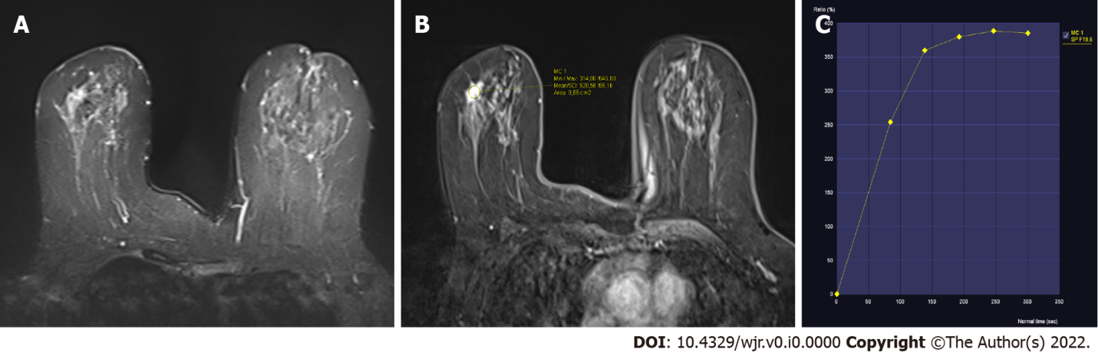
Figure 1 A 63-year-old patient. A: Hyperintense lesion on T2 weighted image (WI) in the right breast; B: The lesion is enhanced on post-contrast T1WI; C: The dynamic curve of the lesion is type 2. Pathological diagnosis is invasive ductal carcinoma.

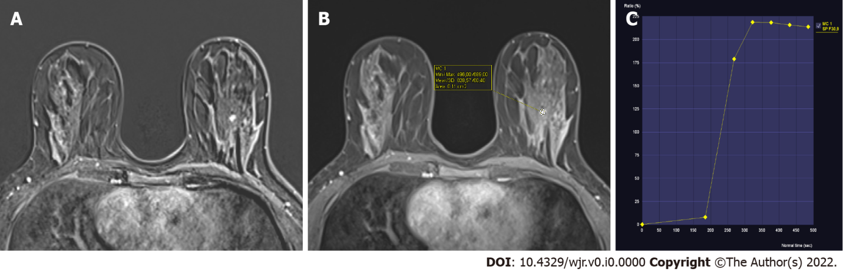
Figure 2 A 37-year-old patient. A: Hyperintense lesion on T2 weighted image (WI) in the right breast; B: The lesion is enhanced on post-contrast T1WI; C: The dynamic curve of the lesion is type 2. Pathological diagnosis is fibroadenoma.

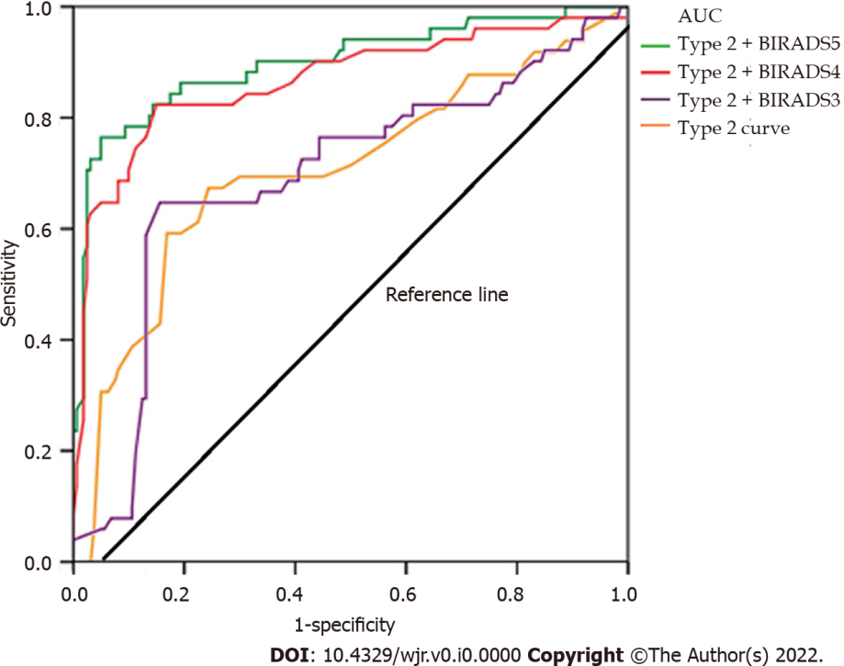
Figure 3 Receiver operating characteristic analysis graph by combining type 2 curves and morphological features for predicting malignancy. AUC: area under the curve.
Table 1 Histopathological results of lesions with type 2 curves
 | Histopathological diagnosis | n (%)
Benign 12/38 (31.6%) | Sclerosing adenosis | 7 (18.4)
 | Fibroadenoma | 3 (7.9)
 | Intraductal papilloma | 1 (2.6)
 | Usual ductal hyperplasia | 1 (2.6)
Malignant 26/38 (68.4%) | Ductal carcinoma in situ | 7 (18.4)
 | Invasive ductal carcinoma | 15 (39.5)
 | Invasive lobular carcinoma | 4 (10.5)
Total |  | 38 (100)

Table 2 Breast Imaging Reporting and Data System categories of lesions
BI-RADS category | n (%)
BI-RADS-0 | 0
BI-RADS-1 | 0
BI-RADS-2 | 0
BI-RADS-3 | 8 (21)
BI-RADS-4 | 18 (47.4)
BI-RADS-5 | 12 (31.6)
Total | 38 (100)
BI-RADS: Breast Imaging Reporting and Data System.

Table 3 Sensitivity and specificity values obtained by combining type 2 curves and morphological features for predicting malignancy
 | Sensitivity | Specificity
Type 2 dynamic curve | 40.2 | 73.4
Type 2 dynamic curve + BI-RADS 3 category | 41.9 | 75.8
Type 2 dynamic curve + BI-RADS 4 category | 95.3 | 97.7
Type 2 dynamic curve + BI-RADS 5 category | 100 | 100
BI-RADS: Breast Imaging Reporting and Data System.

