Name of Journal: World Journal of Gastroenterology
Manuscript NO: 91036
Manuscript Type: ORIGINAL ARTICLE

Basic Study
Taurine attenuates activation of hepatic stellate cells by inhibiting autophagy and inducing ferroptosis

Li S et al. Effect of taurine on HSCs

Sen Li, Qian-Jun Ren, Can-Hao Xie, Yang Cui, Li-Tao Xu, Yi-Dan Wang, Su Li, Xing-Qiu Liang, Bin Wen, Ming-Kun Liang, Xiao-Fang Zhao

Sen Li, Qian-Jun Ren, Can-Hao Xie, Yang Cui, Li-Tao Xu, Yi-Dan Wang, Su Li, Department of Basic Science, Guangxi University of Chinese Medicine, Nanning 541100, Guangxi Zhuang Autonomous Region, China

Xing-Qiu Liang, Bin Wen, Xiao-Fang Zhao, Department of Science and Technology, Ruikang Hospital Affiliated to Guangxi University of Chinese Medicine, Nanning 541100, Guangxi Zhuang Autonomous Region, China

Ming-Kun Liang, Traditional Chinese Medicine Specialty Office, Ruikang Hospital Affiliated to Guangxi University of Chinese Medicine, Nanning 541100, Guangxi Zhuang Autonomous Region, China

Co-first authors: Sen Li and Qian-Jun Ren.

Co-corresponding authors: Ming-Kun Liang and Xiao-Fang Zhao.

Author contributions: Li S drafted the manuscript and conducted the experiments of Western blotting, RT-PCR, and enzyme-linked immunosorbent assay; Ren QJ completed the cell culture and treatment, transmission electron microscopy observation, and visualization of this study; Xie CH, Cui Y, Xu LT, and Wang YD assisted with methodology and validation of this study; Li S and Wen B participated in the supervision of this manuscript; Liang XQ and Wen B contributed to the project administration and funding acquisition; Zhao XF supervised the experiments, corrected the data, revised the manuscript, and provided feedback on the whole manuscript text; Liang MK was responsible for collectively designing, performing, analyzing, and completing the study. All authors contributed to the article and approved the submitted version.

Supported by Guangxi Natural Science Foundation Program, No. 2020GXNSFAA297160 and No. 2018GXNSFBA050050; and Guipai Xinglin Youth Talent Project of Guangxi University of Chinese Medicine, No. 2022C042.

Corresponding author: Xiao-Fang Zhao, MA, Chief Doctor, Doctor, Department of Science and Technology, Ruikang Hospital Affiliated to Guangxi University of Chinese Medicine, No. 10 Huadong Road, Nanning 541100, Guangxi Zhuang Autonomous Region, China. 37940097@qq.com

Received: December 21, 2023
Revised: January 30, 2024
Accepted: March 21, 2024
Published online:

Abstract
BACKGROUND
Liver fibrosis is a compensatory response during the tissue repair process in chronic liver injury, and finally leads to liver cirrhosis or even hepatocellular carcinoma. The pathogenesis of hepatic fibrosis is associated with the progressive accumulation of activated hepatic stellate cells (HSCs), which can transdifferentiate into myofibroblasts to produce an excess of the extracellular matrix (ECM). Myofibroblasts are the main source of the excessive ECM responsible for hepatic fibrosis. Therefore, activated hepatic stellate cells (aHSCs), the principal ECM producing cells in the injured liver, are a promising therapeutic target for the treatment of hepatic fibrosis.

AIM
To explore the effect of taurine on aHSC proliferation and the mechanisms involved.

METHODS
Human HSCs (LX-2) were randomly divided into five groups: Normal control group, platelet-derived growth factor-BB (PDGF-BB) (20 ng/mL) treated group, and low, medium, and high dosage of taurine (10 mmol/L, 50 mmol/L, and 100 mmol/L, respectively) with PDGF-BB (20 ng/mL) treated group. Cell Counting Kit-8 method was performed to evaluate the effect of taurine on the viability of aHSCs. Enzyme-linked immunosorbent assay was used to estimate the effect of taurine on the levels of reactive oxygen species (ROS), malondialdehyde, glutathione, and iron concentration. Transmission electron microscopy was applied to observe the effect of taurine on the autophagosomes and ferroptosis features in aHSCs. Quantitative real-time polymerase chain reaction and Western blot analysis were performed to detect the effect of taurine on the expression of α-SMA, Collagen I, Fibronectin 1, LC3B, ATG5, Beclin 1, PTGS2, SLC7A11, and p62.

RESULTS
Taurine promoted the death of aHSCs and reduced the deposition of the ECM. Treatment with taurine could alleviate autophagy in HSCs to inhibit their activation, by decreasing autophagosome formation, downregulating LC3B and Beclin 1 protein expression, and upregulating p62 protein expression. Meanwhile, treatment with taurine triggered ferroptosis and ferritinophagy to eliminate aHSCs characterized by iron overload, lipid ROS accumulation, glutathione depletion, and lipid peroxidation. Furthermore, bioinformatics analysis demonstrated that taurine had a direct targeting effect on nuclear receptor coactivator 4, exhibiting the best average binding affinity of -20.99 kcal/mol.

CONCLUSION
Taurine exerts therapeutic effects on liver fibrosis via mechanisms that involve inhibition of autophagy and trigger of ferroptosis and ferritinophagy in HSCs to eliminate aHSCs.

Key Words: Hepatic stellate cells; Autophagy; Ferroptosis; Molecular docking; Taurine

Li S, Ren QJ, Xie CH, Cui Y, Xu LT, Wang YD, Li S, Liang XQ, Wen B, Liang MK, Zhao XF. Taurine attenuates activation of hepatic stellate cells by inhibiting autophagy and inducing ferroptosis. World J Gastroenterol 2024; In press

Core Tip: We have previously demonstrated that treatment of taurine could alleviate liver fibrosis by inhibiting hepatic stellate cell (HSC) activation and inhibiting activated HSC proliferation. Considering the important role of autophagy and ferroptosis in the process of liver fibrosis pathology, we used molecular biology tests and bioinformatic methods to identify the effect of taurine on autophagy and ferroptosis in HSCs in vitro. This study demonstrated for the first time that taurine could inhibit autophagy in HSCs to inhibit their activation while triggering ferroptosis and ferritinophagy to eliminate activated HSCs. Taurine has a direct targeting effect on nuclear receptor coactivator 4, exhibiting the best average binding affinity of -23.95 kcal/mol.

INTRODUCTION
Liver fibrosis is a compensatory response during the tissue repair process in chronic liver injury, finally leading to liver cirrhosis or even hepatocellular carcinoma. It is reported that liver fibrosis has a high incidence rate and mortality in the world^{[1,2]}. Liver fibrosis is a common pathological occurrence and is initiated as a result of chronic liver injury due to alcohol, viral hepatitis, drugs, toxins, nonalcoholic steatohepatitis, autoimmune liver disease, and so on. The pathogenesis of hepatic fibrosis is associated with the progressive accumulation of activated hepatic stellate cells (aHSCs), which can transdifferentiate into myofibroblasts to produce an excess of the extracellular matrix (ECM)^{[3]}. In the normal liver, HSCs are quiescent and contain retinoid (vitamin A) and numerous lipid droplets. However, in response to liver injury, HSCs transform into the highly activated, proliferative, motile, and contractile myofibroblast phenotype by receiving either autocrine or paracrine signaling from injured hepatocytes and immune cells. Myofibroblasts are the main source of the excessive ECM responsible for hepatic fibrosis^{[4]}. Since aHSCs are the principal ECM producing cells in the injured liver, they are a promising therapeutic target for the treatment of hepatic fibrosis.
Autophagy is a conservative way of cell self-degradation, which involves the process of lysosomes engulfing their own cytoplasm or organelles to achieve intracellular nutrition and energy reuse. Autophagy has been implicated in major liver pathologies, such as hepatitis C virus (HCV) infection and hepatocarcinoma. Several studies have shown that autophagy dysfunction can exacerbate liver diseases^{[5]}. For example, a decrease in the number of autophagosomes was found in liver tissue of alcoholic liver disease model rats, while an increased autophagosome number was observed in HCV-infected patients^{[6]}. Besides, in α-1 antitrypsin deficiency, which results in protein aggregates and chronic liver injury, autophagy stimulation reduces the hepatic load of aggregated protein and reverses fibrosis. Furthermore, studies have also showed that autophagy is an important process during HSC activation. Treatment of HSCs with the autophagy inhibitor bafilomycin A1, hydroxychloroquine, or 3-methyladenine hampered several characteristic features of the activated phenotype, such as proliferation and expression of ACTA2, PDGFR-β, and PROCOL1a1, in both mouse and human-derived HSCs^{[7,8]}. Bafilomycin A1-treated HSCs present a higher number of large lipid droplets when compared with control cells, further suggesting the important role of autophagy in HSC lipid droplet metabolism. The above-mentioned findings also indicate that autophagy may be a therapeutic target for liver fibrosis.
Taurine, a sulfur-containing amino acid, has a wide range of protective activities towards cytotoxicity and oxidative stress produced in hepatocytes or other tissues, especially antioxidation, anti-inflammatory, as well as anti-apoptotic activities^{[9,10]}. In the liver, taurine is an end product of sulfur amino acid catabolism and its biosynthetic ability is reduced in the case of liver diseases. Exogenous supplementation of taurine can prevent liver injury caused by different harmful substances and inhibit ECM deposition in the damaged liver to prevent liver fibrosis^{[11]}. Miyazaki et al^{[12]} reported that the anti-fibrogenesis effect of taurine in rats is associated with inhibiting the proliferation of aHSCs. Our previous studies have demonstrated that taurine can inhibit HSC proliferation and promote cell apoptosis significantly via mechanisms mainly involving the p38 mitogen-activated protein kinase-c-Jun NH2-terminal kinase-Caspase 9/8/3 pathway^{[13]}. Overall, these results show that taurine can serve as an effective anti-inflammatory agent to prevent liver disease.
To determine the mechanism by which treatment with taurine protects against hepatic fibrosis, the present study was performed to observe the effect of taurine on autophagy and ferroptosis to provide more data on taurine therapy of hepatic fibrosis.

MATERIALS AND METHODS
Materials
Human HSCs (LX-2) were purchased from XiangYa Central Experiment Laboratory, Central South University, Changsha, Hunan Province, China. Dulbecco's minimum essential medium (DMEM) was obtained from Hyclone (Logan, UT, United States). Fetal bovine serum (FBS) was purchased from Biochrom AG (Berlin, German). Streptomycin sulfate and penicillin were supplied by North China Pharmaceutical, China. Cell Counting Kit-8 (CCK8) was purchased from Beyotime Biotechnology (Shanghai, China). Taurine was purchased from Sigma-Aldrich (Merck KGaA, Darmstadt, Germany). Platelet-derived growth factor-BB (PDGF-BB) was provided by PeproTech (No. L1019).

Culture and treatment of HSCs
HSCs were cultured in DMEM supplemented with 10% FBS, 100 U/mL penicillin and 100 U/mL streptomycin in an incubator with 5% CO₂ at 37 °C. The culture medium was replaced every other day. When the cell density reached approximately 80% confluence, cells were trypsinized and resuspended in DMEM at a density of 1 × 10⁵/mL. For taurine-treated cells, the supernatant was discarded after centrifugation, and the cells were incubated for 48 h in DMEM containing 10, 50, and 100 mmol/L taurine and 20 ng/mL PDGF-BB, while cells in the control group were incubated in DMEM without taurine.

Cell viability assay
Cell viability was evaluated with a CCK8 kit (Beyotime Institute of Biotechnology, C0037) according to the manufacturer’s instructions. Briefly, HSCs were plated in a 96-well plates (Sigma, CLS9898) and exposed to various concentrations of the cytotoxic compounds for the indicated times. CCK8 reagent (10 μL) was added to each well and incubated at 37 °C in 5% CO₂ for 4 h, and then the plates were read at 450 nm using the Thermo MK3 Molecular Device (Morrisville, NC, United States).

Estimation of reactive oxygen species level by enzyme-linked immunosorbent assay
Intracellular reactive oxygen species (ROS) level was measured using the oxidation-sensitive fluorescent probe dichlorodihydrofluorescein diacetate (Solarbio, CA1410) according to the manufacturer’s instructions.

Estimation of malondialdehyde and glutathione levels by enzyme-linked immunosorbent assay
The relative malondialdehyde (MDA) and glutathione (GSH) concentrations in cell lysates were assessed using enzyme-linked immunosorbent assay (ELISA) kits (Nanjing Jiancheng Bioengineering institute, A003-1 and A006-2-1) according to the manufacturer’s instructions.

Estimation of iron concentration by ELISA
The relative iron concentration in cell lysates was assessed using an iron assay kit (Nanjing Jiancheng Bioengineering institute, A039) according to the manufacturer’s instructions.

Observation of autophagosomes and ferroptosis features by transmission electron microscopy
HSC-LX2 cells were seeded onto a 4-well chambered coverglass at a density of 2 × 10⁴ cells/mL (14000 cells/well). Images were acquired using a HIATACHI HT7700 transmission electron microscope.

RNA isolation and real-time polymerase chain reaction
Total RNA was isolated and quantitative polymerase chain reaction (PCR) was performed using the QuantiTect SYBR Green PCR Kit (Thermo, F-415XL) in accordance with the manufacturer’s instructions. Beta-actin levels were taken for normalization and fold change was calculated using 2-ddct. The sequence of primers used is showed in Table 1.

Western blot analysis
HSC cells were lysed using a mammalian lysis buffer (Beyotime, P0013B) and immunoblotting was performed according to the manufacturer’s guidelines (Bio/Rad, Hercules, CA, United States). Densitometry analysis was performed using the ImageJ software.

Statistical analysis
All the data are expressed as the mean ± SD and were analyzed with GraphPad Prism (GraphPad Software, San Diego, CA, United States). To compare the data of two groups, unpaired Student's t-test was used. One-way analysis of variance with the Bonferroni post hoc test was used for multiple group comparisons. P values were all two-sided and considered statistically significant when they were < 0.05.

RESULTS
Taurine suppresses PDGF-BB-induced HSC proliferation
The effect of taurine on aHSC viability was assessed by the CCK8 assay. There was no significant difference in aHSC viability among the groups at 0 and 24 h. The proliferation of HSCs (LX-2) was promoted by PDGF-BB (20 ng/mL) at 48 and 72 h (P < 0.01, Figure 1A). aHSC viability was significantly decreased in cells cultured with different concentrations of taurine for 48 h compared to those cultured without taurine but activated by PDGF-BB (Figure 1A). Therefore, we selected 48 h as the treatment duration and 50 mmol/L as the working concentration in subsequent experiments.

Taurine inhibits expression of α-SMA, Collagen I, and Fibronectin 1
The protein expression of α-SMA, Collagen I, and Fibronectin 1 in the PDGF-BB-induced groups was significantly higher than that in the control group. However, the upregulated expression of α-SMA, Collagen I, and Fibronectin 1 induced by PDGF-BB was significantly inhibited by taurine (P < 0.01, Figure 1B and C).

Taurine induces autophagy in HSCs
Western blot analysis showed that taurine significantly inhibited the expression of p62 and increased the expression of LC3B, ATG5, and Beclin 1 (Figure 2A). Transmission electron microscopy showed that typical ferroptosis features were present after taurine intervention: Vacuoles appeared in cells, the edge of nuclear membrane was depressed, and the number of autophagosomes was significantly increased (Figure 2B).

Taurine induces ferroptosis in HSCs
Western blot analysis showed that taurine significantly inhibited the expression of GPX4 protein, but significantly increased the expression of PTGS2 and SLC11A2 proteins (Figure 3A). When ferroptosis occurs, lipid peroxidation is enhanced. We found that taurine significantly increased the level of MDA but significantly decreased the level of GSH. Flow cytometry revealed that taurine significantly increased the levels of ROS (Figure 3B and C). Transmission electron microscopy showed that taurine-treated HSCs showed obvious ferroptotic cell morphological changes, including obvious reduction and shrinkage of mitochondria, disappearance of mitochondrial cristae, and significant mitochondrial shortening (Figure 3D). These results indicate that taurine can induce ferroptosis in HSCs. In addition, taurine significantly increased the deposition of iron ions in HSCs (Figure 3E).

Effect of taurine on ferritinophagy of HSCs
Bioinformatics showed that there is a direct interaction between nuclear receptor coactivator 4 (NCOA4) and ferritin heavy chain 1 (FTH1) (Figure 4), and taurine has a good docking effect with NCOA4 and FTH1, indicating that taurine may have a direct targeting effect on NCOA4 (Figure 4B).

DISCUSSION
It is well known that nearly half of the disease deaths in the developed countries are closely related to chronic fibroproliferative diseases, especially hepatic fibrosis^{[14–16]}. HSC activation is associated with the development of hepatic fibrosis and inhibiting activated HSC (aHSC) proliferation has been identified as an important way for prevention and treatment of hepatic fibrosis^{[17]}. Studies over the past decade have implicated the pivotal role of ferroptosis in the event of HSC activation^{[18,19]}. Although taurine could protect against hepatic fibrosis in rats by inhibiting aHSC proliferation^{[20,21]}, there are no in-depth reports focusing on the effect of taurine on HSC ferroptosis in hepatic fibrosis. Elucidation of the mechanisms governing the ferroptosis of aHSCs may provide a therapeutic approach for taurine to control liver fibrosis. In the current study, we initially demonstrated that taurine inhibited the proliferation of aHSCs in vitro, as manifested by the observation that cellular viability and the expression of ECM decreased significantly, respectively. Thus, it is conceivable that taurine can inhibit PDGF-BB-induced activation of HSCs and promote their death to play a role in anti-fibrosis.
In recent years, many studies have found that drugs can improve the pathological damage of liver fibrosis by regulating ferroptosis in HSCs. Recently, Zheng et al^{[2]} indicated that curcumol induced ferroptosis in HSCs by promoting autophagy and mediating the degradation of NCOA4 and FTH1 complexes to release iron ions^{[2]}. Moreover, Kuo et al reported that chrysophanol can impair HBx-induced activation of HSCs via endoplasmic reticulum stress and ferroptosis-dependent or GPX4-independent pathways^{[23]}. Furthermore, Zhang et al^{[22]} indicated that dihydroartemisinin could trigger ferroptosis to eliminate aHSCs by regulating iron overload, lipid ROS accumulation, glutathione depletion, and lipid peroxidation^{[22]}. In our study, we showed that taurine could inhibit aHSC proliferation in vitro. The induction of ferroptosis is required for taurine to inhibit HSC proliferation. Our findings together with previous reports indicated that taurine triggered ferroptotic events including iron overload, lipid ROS generation, GSH depletion, and lipid peroxidation product (MDA) accumulation. Furthermore, results also showed that taurine can upregulate the expression of PTGS2 and SLC11A2 proteins and downregulate the expression of GPX4 protein. Our above results are consistent with those reported in previous studies^{[2,15,22,24]}. According to our results, the expression of PTGS2 in PDGF-BB-induced aHSCs was significantly upregulated. PTGS2, also known as cyclooxygenase-2, is the key enzyme in prostaglandin biosynthesis, and acts as both a peroxidase and a dioxygenase^{[25,26]}. It is showed that PTGS2 is involved in the process of ferroptosis because it was significantly upregulated after treatment with Rsl3 and erastin in mice^{[15,27]}. As a matter of fact, PTGS2 was found to be significantly elevated in cells undergoing ferroptosis^{[28]}. Although the exact role of PTGS2 in the ferroptotic cell death cascade remains to be elucidated, targeting on PTGS2, as being associated with ferroptosis, is an effective way to promote cell death. Additionally, existing studies have elucidated that SLC11A2 activation or upregulation increases ferroptosis in hypoxia/reoxygenation treated myocardial cells^{[29]}, and SLC11A2 knockdown reduces iron deposition and lipid peroxidation and therefore alleviates ferroptosis in rats after subarachnoid hemorrhage^{[28]}. Otherwise, GPX4 is equipped with GSH to prevent cells from ferroptosis by reducing oxidized phospholipids, ROS production, and iron uptake. Here, we found that the expression of SLC11A2 was significantly upregulated in PDGF-BB-induced aHSCs after taurine treatment, while the expression of GPX4 was significantly downregulated. Altogether, these data indicate that taurine stimulates ferroptosis in aHSCs by increasing PTGS2 and SLC11A2 expression and decreasing GPX4 expression to promote cell death. Although much more research is needed to uncover the molecular mechanism of ferroptosis in aHSCs, taurine treatment by inducing ferroptosis has become a potential strategy for eliminating aHSCs.
Autophagy regulates the development of liver injury and fibrosis by affecting the secretion of many cytokines and signal pathways in the liver. The formation of essential autophagy consists of four molecular subunits, which included ATG6/Beclin 1, LC3, ATG9/VMP1, and ULK1 complex^{[29]}. Beclin 1 is a key protein involved in autophagy, and it is also one of the earliest autophagy proteins found in mammals. It plays a key role in the regulation of autophagy, and its up-regulation can stimulate the occurrence of autophagy^{[30,31]}. p62 is a common autophagy protein, its expression is negatively correlated with autophagy level, and it is an important bridge between LC3 and ubiquitin substrate to be degraded. When autophagy is activated, the protein polymer formed by p62 can be degraded by autophagosomes. p62 binds to autophagy membrane protein LC3, thus transporting the protein polymer containing p62 to autophagosomes^{[32]}. Interestingly, we observed that the number of autophagosomes increased in PDGF-BB-induced aHSCs, but it was decreased after treatment with taurine. Meanwhile, our data showed that taurine downregulated the expression of LC3B and Beclin 1 proteins, and upregulated the expression of p62 protein. Thus, it is suggested that taurine can inhibit HSC activation effectively by inhibiting autophagy. Thoen et al^{[33]} reported that increased autophagic flux was observed during HSC activation and autophagy can induce HSC activation^{[33]}. In previous studies, several pieces of research have demonstrated that autophagy promotes digestion of lipid droplets in quiescent HSCs, thereby facilitating HSC activation and promoting liver fibrosis. Besides, autophagy is regarded as a cytoprotective and anti-fibrotic mechanism in most liver cell types and is crucial for metabolic homeostasis of hepatocytes^{[34]}.
Several lines of evidence have indicated a vital relationship between ferroptosis and autophagy^{[27,35]}. Autophagy is identified as an upstream mechanism in the induction of ferroptosis by regulating cellular iron homeostasis and cellular ROS generation^{[36]}. Based on the relationship between autophagy and ferroptosis, Mancias et al^{[37]} proposed a new term named ferritinophagy in 2014^{[37]}. Ferritinophagy was regarded as a form of cell-selective autophagy mediated by NCOA4, and it is involved in iron metabolism related pathophysiologic process^{[16,37]}. We did not carry out the experimental verification of NCOA4 knockout and overexpression. Nevertheless, bioinformatics revealed that taurine has a good docking effect with NCOA4. NCOA4 is a key target for regulating the process of ferritin phagocytosis. Studies have showed that NCOA4 depletion inhibits the delivery of ferritin to the lysosome, and NCOA4-mediated ferritinophagy modulates susceptibility to ferroptosis^{[38]}. Besides, Cao et al^{[39]} reported that inhibiting autophagy would upregulate the expression of NCOA4 and promote degradation of FTH1, finally promoting ferroptosis in hepatocytes^{[39]}. It was further revealed that NCOA4 is a promising target for anti-hepatic fibrosis. Therefore, many investigators are looking for strategies to alter the expression of NCOA4 or to regulate HSC ferritinophagy to alleviate liver fibrosis. For example, Zheng et al^{[2]} reported that curcumol inhibited the activation of HSCs by increasing the expression of NCOA4 to mediate the migration of FTH1 for degradation in autophagolysosomes^{[2]}. Ma et al^{[16]} found that Schisandrin B could ameliorate hepatic fibrosis by inducing NCOA4-mediated ferritinophagy to promote aHSC senescence^{[16]}. Xiu et al^{[29]} showed that caryophyllene oxide regulated NCOA4, LC3B, and FTH1 to promote ferritinophagy^{[29]}. Our data provide further evidence for the notion that taurine inhibits HSC activation by regulating the expression of NCOA4 and mediating ferritinophagy.
Altogether, our data demonstrate that the anti-fibrosis mechanisms of taurine include inhibition of autophagy to inhibit HSC activation, and the induction of ferritinophagy and ferroptosis to promote aHSC death (Figure 5).

CONCLUSION
Taurine inhibits autophagy of HSCs and promotes their ferroptosis and ferritinophagy, thus inhibiting the activation of HSCs to alleviate hepatic fibrosis.

REFERENCES
1 Jophlin LL, Cao S, Shah VH. The Transcriptome of Hepatic Fibrosis Revealed by Single-Cell RNA Sequencing. Hepatology 2020; 71: 1865-1867 [PMID: 32017148 DOI: 10.1002/hep.31155]
2 Zheng Y, Zhao T, Wang J, Jiang R, Huang J, Li W, Wang J. Curcumol alleviates liver fibrosis through inducing autophagy and ferroptosis in hepatic stellate cells. FASEB J 2022; 36: e22665 [PMID: 36398583 DOI: 10.1096/fj.202200933RR]
3 Yang X, Li Q, Liu W, Zong C, Wei L, Shi Y, Han Z. Mesenchymal stromal cells in hepatic fibrosis/cirrhosis: from pathogenesis to treatment. Cell Mol Immunol 2023; 20: 583-599 [PMID: 36823236 DOI: 10.1038/s41423-023-00983-5]
4 Shao C, Xu H, Sun X, Huang Y, Guo W, He Y, Ye L, Wang Z, Huang J, Liang X, Zhang J. New Perspectives on Chinese Medicine in Treating Hepatic Fibrosis: Lipid Droplets in Hepatic Stellate Cells. Am J Chin Med 2023; 51: 1413-1429 [PMID: 37429706 DOI: 10.1142/S0192415X23500647]
5 Shu Y, Liu X, Huang H, Wen Q, Shu J. Research progress of natural compounds in anti-liver fibrosis by affecting autophagy of hepatic stellate cells. Mol Biol Rep 2021; 48: 1915-1924 [PMID: 33609264 DOI: 10.1007/s11033-021-06171-w]
6 Jones-Jamtgaard KN, Wozniak AL, Koga H, Ralston R, Weinman SA. Hepatitis C virus infection increases autophagosome stability by suppressing lysosomal fusion through an Arl8b-dependent mechanism. J Biol Chem 2019; 294: 14257-14266 [PMID: 31383738 DOI: 10.1074/jbc.RA119.008229]
7 Le TV, Phan-Thi HT, Huynh-Thi MX, Dang TM, Holterman AXL, Grassi G, Nguyen-Luu TU, Truong NH. Autophagy Inhibitor Chloroquine Downmodulates Hepatic Stellate Cell Activation and Liver Damage in Bile-Duct-Ligated Mice. Cells 2023; 12 [PMID: 37048098 DOI: 10.3390/cells12071025]
8 Yu K, Li N, Cheng Q, Zheng J, Zhu M, Bao S, Chen M, Shi G. miR-96-5p prevents hepatic stellate cell activation by inhibiting autophagy via ATG7. J Mol Med (Berl) 2018; 96: 65-74 [PMID: 29051972 DOI: 10.1007/s00109-017-1593-6]
9 Schaffer S, Kim HW. Effects and Mechanisms of Taurine as a Therapeutic Agent. Biomol Ther (Seoul) 2018; 26: 225-241 [PMID: 29631391 DOI: 10.4062/biomolther.2017.251]
10 Chaudhry S, Tandon B, Gupta A, Gupta S. Taurine: A potential mediator for periodontal therapy. Indian J Dent Res 2018; 29: 808-811 [PMID: 30589012 DOI: 10.4103/ijdr.IJDR_123_17]
11 Heidari R, Jamshidzadeh A, Niknahad H, Mardani E, Ommati MM, Azarpira N, Khodaei F, Zarei A, Ayarzadeh M, Mousavi S, Abdoli N, Yeganeh BS, Saeedi A, Najibi A. Effect of taurine on chronic and acute liver injury: Focus on blood and brain ammonia. Toxicol Rep 2016; 3: 870-879 [PMID: 28959615 DOI: 10.1016/j.toxrep.2016.04.002]
12 Miyazaki T, Karube M, Matsuzaki Y, Ikegami T, Doy M, Tanaka N, Bouscarel B. Taurine inhibits oxidative damage and prevents fibrosis in carbon tetrachloride-induced hepatic fibrosis. J Hepatol 2005; 43: 117-125 [PMID: 15893842 DOI: 10.1016/j.jhep.2005.01.033]
13 Liang XQ, Liang J, Zhao XF, Wang XY, Deng X. Integrated network analysis of transcriptomic and protein-protein interaction data in taurine-treated hepatic stellate cells. World J Gastroenterol 2019; 25: 1067-1079 [PMID: 30862995 DOI: 10.3748/wjg.v25.i9.1067]
14 Fang C, Jaffer OS, Yusuf GT, Konstantatou E, Quinlan DJ, Agarwal K, Quaglia A, Sidhu PS. Reducing the Number of Measurements in Liver Point Shear-Wave Elastography: Factors that Influence the Number and Reliability of Measurements in Assessment of Liver Fibrosis in Clinical Practice. Radiology 2018; 287: 844-852 [PMID: 29514018 DOI: 10.1148/radiol.2018172104]
15 Kong Z, Liu R, Cheng Y. Artesunate alleviates liver fibrosis by regulating ferroptosis signaling pathway. Biomed Pharmacother 2019; 109: 2043-2053 [PMID: 30551460 DOI: 10.1016/j.biopha.2018.11.030]
16 Ma M, Wei N, Yang J, Ding T, Song A, Chen L, Zheng S, Jin H. Schisandrin B promotes senescence of activated hepatic stellate cell via NCOA4-mediated ferritinophagy. Pharm Biol 2023; 61: 621-629 [PMID: 37010139 DOI: 10.1080/13880209.2023.2189908]
17 Zhang M, Serna-Salas S, Damba T, Borghesan M, Demaria M, Moshage H. Hepatic stellate cell senescence in liver fibrosis: Characteristics, mechanisms and perspectives. Mech Ageing Dev 2021; 199: 111572 [PMID: 34536446 DOI: 10.1016/j.mad.2021.111572]
18 Cho SS, Yang JH, Lee JH, Baek JS, Ku SK, Cho IJ, Kim KM, Ki SH. Ferroptosis contribute to hepatic stellate cell activation and liver fibrogenesis. Free Radic Biol Med 2022; 193: 620-637 [PMID: 36370962 DOI: 10.1016/j.freeradbiomed.2022.11.011]
19 Tang R, Luo J, Zhu X, Miao P, Tang H, Jian Y, Ruan S, Ling F, Tang M. Recent progress in the effect of ferroptosis of HSCs on the development of liver fibrosis. Front Mol Biosci 2023; 10: 1258870 [PMID: 37860583 DOI: 10.3389/fmolb.2023.1258870]
20 Deng X, Liang J, Li YZ, Huang B, Zhang XL. [Protective effect of natural taurine on mitochondria of hepatic fibrosis in rats]. Xian Jiaotong Daxue Xuebao (Yixueban) 2007; 28: 648-650,703
21 Zhang X, Zhao L, Ying K, Xu J, Huang Y, Zhu R, Ding Y, Cai W, Wu X, Miao D, Xu Q, Zeng Y, Yu F. TUG1 protects against ferroptosis of hepatic stellate cells by upregulating PDK4-mediated glycolysis. Chem Biol Interact 2023; 383: 110673 [PMID: 37582412 DOI: 10.1016/j.cbi.2023.110673]
22 Zhang Z, Wang X, Wang Z, Zhang Z, Cao Y, Wei Z, Shao J, Chen A, Zhang F, Zheng S. Dihydroartemisinin alleviates hepatic fibrosis through inducing ferroptosis in hepatic stellate cells. Biofactors 2021; 47: 801-818 [PMID: 34129254 DOI: 10.1002/biof.1764]
23 Kuo CY, Chiu V, Hsieh PC, Huang CY, Huang SJ, Tzeng IS, Tsai FM, Chen ML, Liu CT, Chen YR. Chrysophanol attenuates hepatitis B virus X protein-induced hepatic stellate cell fibrosis by regulating endoplasmic reticulum stress and ferroptosis. J Pharmacol Sci 2020; 144: 172-182 [PMID: 32811746 DOI: 10.1016/j.jphs.2020.07.014]
24 Kinowaki Y, Kurata M, Ishibashi S, Ikeda M, Tatsuzawa A, Yamamoto M, Miura O, Kitagawa M, Yamamoto K. Glutathione peroxidase 4 overexpression inhibits ROS-induced cell death in diffuse large B-cell lymphoma. Lab Invest 2018; 98: 609-619 [PMID: 29463878 DOI: 10.1038/s41374-017-0008-1]
25 Xiao X, Jiang Y, Liang W, Wang Y, Cao S, Yan H, Gao L, Zhang L. miR-212-5p attenuates ferroptotic neuronal death after traumatic brain injury by targeting Ptgs2. Mol Brain 2019; 12: 78 [PMID: 31533781 DOI: 10.1186/s13041-019-0501-0]
26 Amadio P, Tarantino E, Sandrini L, Tremoli E, Barbieri SS. Prostaglandin-endoperoxide synthase-2 deletion affects the natural trafficking of Annexin A2 in monocytes and favours venous thrombosis in mice. Thromb Haemost 2017; 117: 1486-1497 [PMID: 28536720 DOI: 10.1160/TH16-12-0968]
27 Zhang Z, Yao Z, Wang L, Ding H, Shao J, Chen A, Zhang F, Zheng S. Activation of ferritinophagy is required for the RNA-binding protein ELAVL1/HuR to regulate ferroptosis in hepatic stellate cells. Autophagy 2018; 14: 2083-2103 [PMID: 30081711 DOI: 10.1080/15548627.2018.1503146]
28 Hirschhorn T, Stockwell BR. The development of the concept of ferroptosis. Free Radic Biol Med 2019; 133: 130-143 [PMID: 30268886 DOI: 10.1016/j.freeradbiomed.2018.09.043]
29 Xiu Z, Zhu Y, Han J, Li Y, Yang X, Yang G, Song G, Li S, Li Y, Cheng C, Li Y, Fang J, Li X, Jin N. Caryophyllene Oxide Induces Ferritinophagy by Regulating the NCOA4/FTH1/LC3 Pathway in Hepatocellular Carcinoma. Front Pharmacol 2022; 13: 930958 [PMID: 35899120 DOI: 10.3389/fphar.2022.930958]
30 Shi B, Ma M, Zheng Y, Pan Y, Lin X. mTOR and Beclin1: Two key autophagy-related molecules and their roles in myocardial ischemia/reperfusion injury. J Cell Physiol 2019; 234: 12562-12568 [PMID: 30618070 DOI: 10.1002/jcp.28125]
31 Xu HD, Qin ZH. Beclin 1, Bcl-2 and Autophagy. Adv Exp Med Biol 2019; 1206: 109-126 [PMID: 31776982 DOI: 10.1007/978-981-15-0602-4_5]
32 Lamark T, Svenning S, Johansen T. Regulation of selective autophagy: the p62/SQSTM1 paradigm. Essays Biochem 2017; 61: 609-624 [PMID: 29233872 DOI: 10.1042/EBC20170035]
33 Thoen LF, Guimarães EL, Dollé L, Mannaerts I, Najimi M, Sokal E, van Grunsven LA. A role for autophagy during hepatic stellate cell activation. J Hepatol 2011; 55: 1353-1360 [PMID: 21803012 DOI: 10.1016/j.jhep.2011.07.010]
34 Khambu B, Yan S, Huda N, Liu G, Yin XM. Homeostatic Role of Autophagy in Hepatocytes. Semin Liver Dis 2018; 38: 308-319 [PMID: 30357768 DOI: 10.1055/s-0038-1669939]
35 Gao W, Wang X, Zhou Y, Wang X, Yu Y. Autophagy, ferroptosis, pyroptosis, and necroptosis in tumor immunotherapy. Signal Transduct Target Ther 2022; 7: 196 [PMID: 35725836 DOI: 10.1038/s41392-022-01046-3]
36 Hou W, Xie Y, Song X, Sun X, Lotze MT, Zeh HJ 3rd, Kang R, Tang D. Autophagy promotes ferroptosis by degradation of ferritin. Autophagy 2016; 12: 1425-1428 [PMID: 27245739 DOI: 10.1080/15548627.2016.1187366]
37 Mancias JD, Wang X, Gygi SP, Harper JW, Kimmelman AC. Quantitative proteomics identifies NCOA4 as the cargo receptor mediating ferritinophagy. Nature 2014; 509: 105-109 [PMID: 24695223 DOI: 10.1038/nature13148]
38 Gryzik M, Srivastava A, Longhi G, Bertuzzi M, Gianoncelli A, Carmona F, Poli M, Arosio P. Expression and characterization of the ferritin binding domain of Nuclear Receptor Coactivator-4 (NCOA4). Biochim Biophys Acta Gen Subj 2017; 1861: 2710-2716 [PMID: 28754384 DOI: 10.1016/j.bbagen.2017.07.015]
39 Cao YM. [Autophagy regulates FFA-induced ferroptosis in hepatocytes]. M.Sc. Thesis, Shanxi Medical University, 2023 [DOI: 10.27288/d.cnki.gsxyu.2023.000725]

Footnotes
Institutional review board statement: This study does not involve any human subjects.

Institutional animal care and use committee statement: This study does not involve any animal subjects.

Conflict-of-interest statement: All the authors report no relevant conflicts of interest for this article.

Data sharing statement: Technical appendix, statistical code, and dataset available from the corresponding author at 37940097@qq.com.

Open-Access: This article is an open-access article that was selected by an in-house editor and fully peer-reviewed by external reviewers. It is distributed in accordance with the Creative Commons Attribution NonCommercial (CC BY-NC 4.0) license, which permits others to distribute, remix, adapt, build upon this work non-commercially, and license their derivative works on different terms, provided the original work is properly cited and the use is non-commercial. See: https://creativecommons.org/Licenses/by-nc/4.0/

Provenance and peer review: Unsolicited article; Externally peer reviewed.

Peer-review model: Single blind

Peer-review started: December 21, 2023
First decision: January 16, 2024
Article in press:

Specialty type: Gastroenterology and hepatology
Country/Territory of origin: China
Peer-review report’s scientific quality classification
Grade A (Excellent): 0
Grade B (Very good): B
Grade C (Good): 0
Grade D (Fair): 0
Grade E (Poor): 0

P-Reviewer: Gupta S, Brazil S-Editor: Liu H L-Editor: Wang TQ P-Editor:

Figure Legends
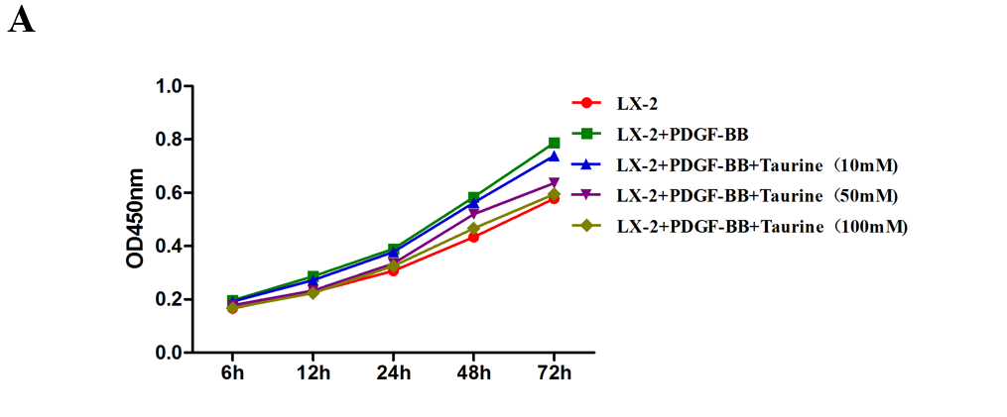
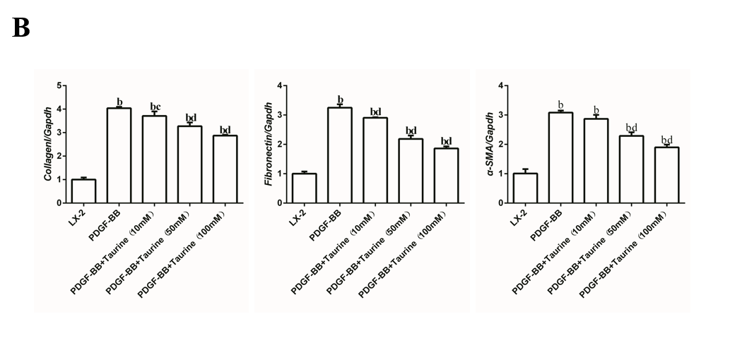

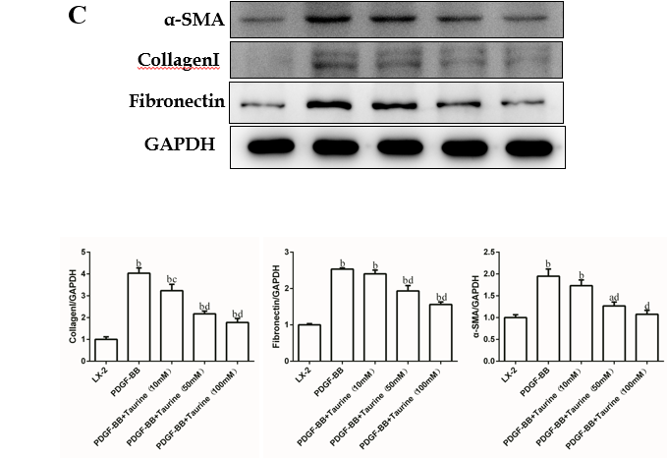
Figure 1 Effects of taurine on extracellular matrix. A: Detection of effect of taurine on the viability of hepatic stellate cells by Cell Counting Kit-8 method; B: Detection of the effect of taurine on mRNA expression of fibronectin 1, collagen I, and α-SMA by reverse transcription-polymerase chain reaction; C: Detection of effect of taurine on protein expression of fibronectin 1, collagen Ι, and α-SMA by Western blot. Data are expressed as the mean ± SD. ªP < 0.05 vs control, ^{b}P < 0.01 vs control, ^{c}P < 0.05 vs platelet-derived growth factor-BB (PDGF-BB), ^{d}P < 0.01 vs PDGF-BB. PDGF-BB: Platelet-derived growth factor-BB.

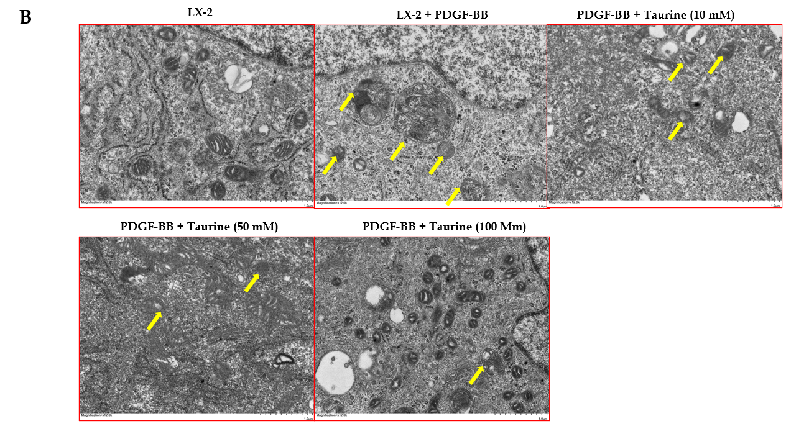
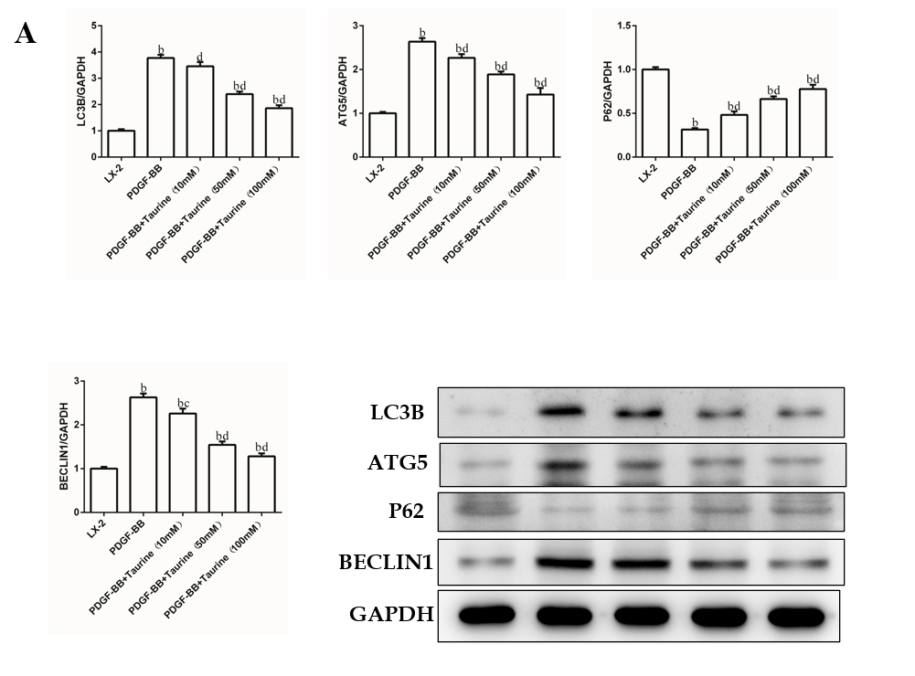

Figure 2 Taurine inhibits autophagy in hepatic stellate cells. A: Effect of taurine on expression of autophagy-related molecules; B: Taurine decreases the number of autophagosomes. Yellow arrows indicate monolayer or bilayer autophagosomes. Bar = 1 μm. Data are expressed as the mean ± SD. ªP < 0.05 vs control, ^{b}P < 0.01 vs control, ^{c}P < 0.05 vs platelet-derived growth factor-BB (PDGF-BB), ^{d}P < 0.01 vs PDGF-BB. PDGF-BB: Platelet-derived growth factor-BB.

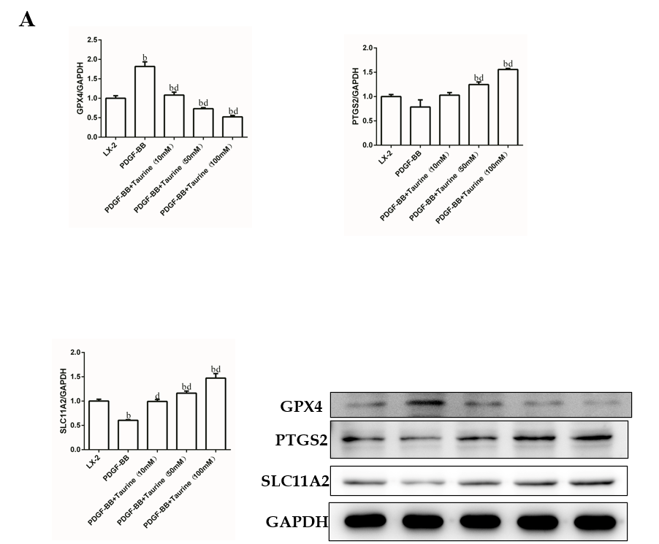

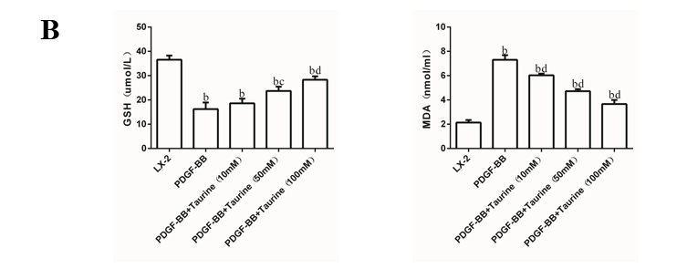

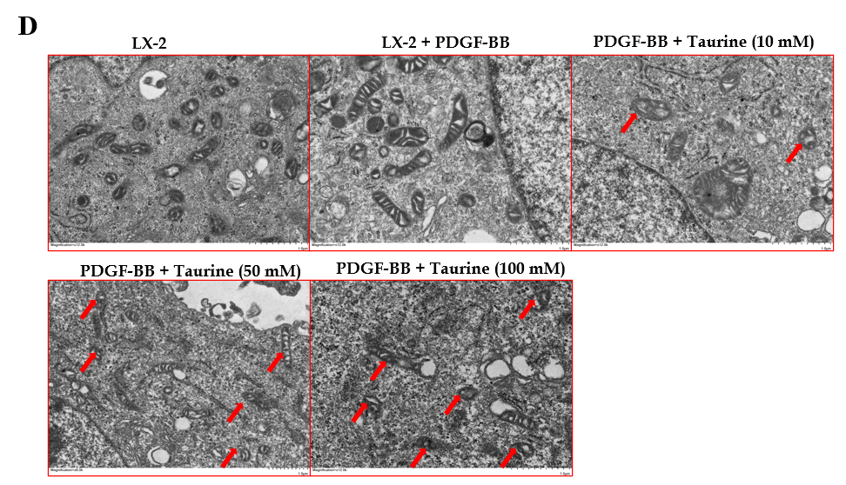
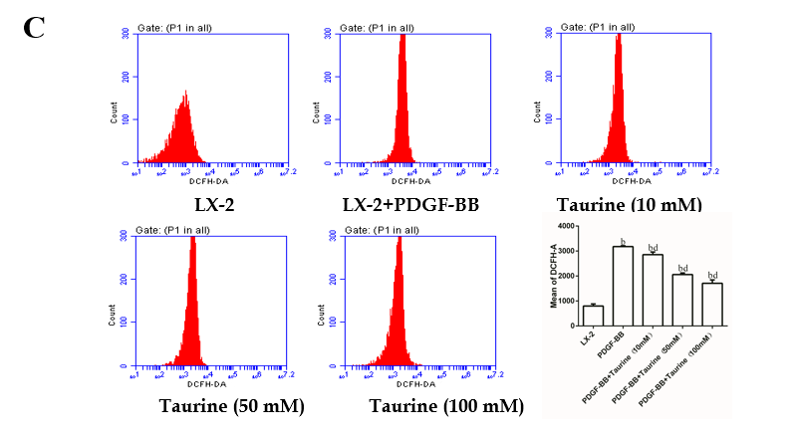

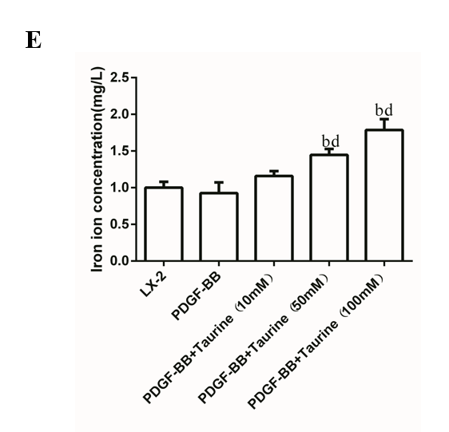
Figure 3 Taurine induces ferroptosis in hepatic stellate cells. A: Effect of taurine on expression of ferroptosis-related molecules; B: Effect of taurine on levels of glutathione and malondialdehyde; C: Effect of taurine on reactive oxygen species; D: Effect of taurine on mitochondrial structure of hepatic stellate cells. Red arrows indicate mitochondria. Bar = 1 μm; E: Taurine induces iron deposition in hepatic stellate cell. Data are expressed as the mean ± SD. ªP < 0.05 vs control, ^{b}P < 0.01 vs control, ^{c}P < 0.05 vs platelet-derived growth factor-BB (PDGF-BB), ^{d}P < 0.01 vs PDGF-BB. PDGF-BB: Platelet-derived growth factor-BB; GSH: Glutathione; MDA: Malondialdehyde.

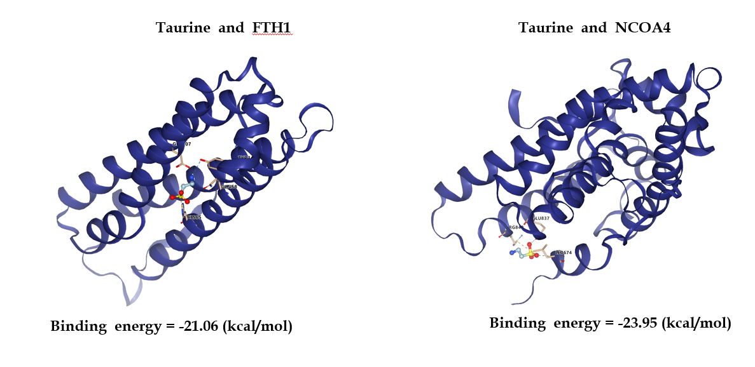
Figure 4 Molecular docking results of taurine and ferritin heavy chain 1 and nuclear receptor coactivator 4, respectively. FTH1: Ferritin heavy chain 1; NCOA4: Nuclear receptor coactivator 4.

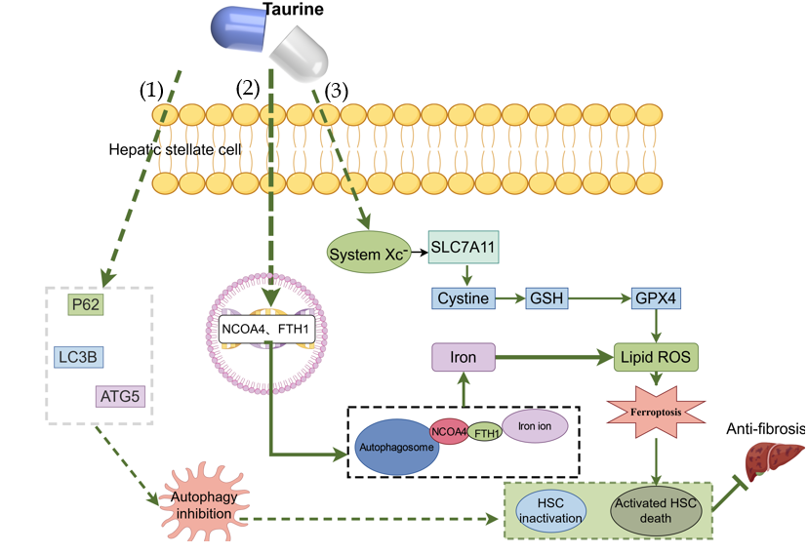
Figure 5 Mechanisms associated with taurine-mediated death and inactivation of hepatic stellate cells in liver fibrosis. (1) Inhibition of autophagy; (2) Activation of ferritinophagy; and (3) Induction of ferroptosis. FTH1: Ferritin heavy chain 1; NCOA4: Nuclear receptor coactivator 4; ROS: Reactive oxygen species; HSC: Hepatic stellate cell; GSH: Glutathione.

Table 1 Sequence of primers used
Gene | Forward | Reverse
LC3B | 5’-ACAAGGGTGAGAAGCA-3’ | 5’-ACCAGCAGGAAGAAGG-3’
ATG5 | 5’-CGAGATGTGTGGTTTGG-3’ | 5’-ATTTCAGTGGTGTGCCT-3’
Beclin1 | 5’-ATACCGACTTGTTCCTT-3’ | 5’-GTCTTCAATCTTGCCTT-3’
p62 | 5’-TACCTGCCCGAACTCA-3’ | 5’-AATCTTCCCCACAAAA-3’
CollagenI | 5’-GCCAATGTGGTTCGTG-3’ | 5’-TGGGCTGAGTGGGGTA-3’
Fibronectin1 | 5’-CTGGAGGAGACCACATGAGACTG-3’ | 5’-TCCTTGTGTCCTGATCGTTGCATC-3’
PTGS2 | 5’-AGGTGTATGTATGAGTGTG-3’ | 5’-AGTGGGTAAGTATGTAGTG-3’
SLC11A2 | 5’-GGAGCAGTGGCTGGATT-3’ | 5’-CGTGGGACCTTGGGATA-3’
GPX4 | 5’-CCGCTGTGGAAGTGGATG-3’ | 5’-CGCTGGATTTTCGGGTCT-3’
α-SMA | 5’-TGCTCCCAGGGCTGTTTT-3’ | 5’-TTGCTCTGTGCTTCGTCA-3’
GAPDH | 5’-AGAAGGCTGGGGCTCATTTG-3’ | 5’-AGGGGCCATCCACAGTCTTC-3’

