Name of Journal: World Journal of Clinical Cases
Manuscript NO: 70045
Manuscript Type: CASE REPORT

Mixed neuroendocrine-nonneuroendocrine neoplasm of the ampulla: Four case reports

Wang Y et al. Mixed neuroendocrine-nonneuroendocrine neoplasm of the ampulla

Yang Wang, Zhen Zhang, Cheng Wang, Shi-Hang Xi, Xiao-Ming Wang

Yang Wang, Zhen Zhang, Cheng Wang, Shi-Hang Xi, Xiao-Ming Wang, Department of Hepatobiliary Surgery, The First Affiliated Hospital of Wannan Medical College, Wuhu 241000, Anhui Province, China

Author contributions: Wang Y contribute to data analysis and writing; Zhang Z and Wang C contribute to data collection; Xi SH contribute to manuscript revision; Wang XM contribute to data and manuscript revision; all authors issued final approval for the version to be submitted.

Supported by Funded Project of "Mountain Climbing" Cultivation Project of Yijishan Hospital of Wannan Medical College, No. KPF2019011.

Corresponding author: Xiao-Ming Wang, MD, Chief Doctor, Professor, Department of Hepatobiliary Surgery, The First Affiliated Hospital of Wannan Medical College, No. 2 Zheshan West Road, Wuhu 241000, Anhui Province, China. wxm6901@aliyun.com

Received: July 20, 2021
Revised: October 27, 2021
Accepted: January 25, 2022
Published online:

Abstract
BACKGROUND
Mixed neuroendocrine-nonneuroendocrine neoplasm (MiNEN) is a rare tumor that occurs in the gastrointestinal tract and pancreas, usually composed of adenocarcinoma and neuroendocrine carcinoma. MiNEN occurring in ampulla is even rarer. We report 4 cases of MiNEN in ampulla, combined with literature review to summarize the clinical features and treatment of the disease, in order to improve the understanding of the disease.

CASE SUMMARY
A retrospective analysis was performed in 4 cases of MiNEN of the ampulla diagnosed by pathology from 2014 to 2021. The 4 patients were all male, aged 67-81 years (average 72.25 years). Among them, 2 patients had jaundice, 1 patient had abdominal pain, and 1 patient had jaundice with abdominal pain as the first symptom. All 4 patients underwent enhanced CT or MRI, which all indicated that the tumors were located in the ampulla. Two patients underwent duodenoscopy, and a biopsy revealed ampullary adenocarcinoma. All 4 patients underwent radical pancreaticoduodenectomy. Four cases were followed up: One patient developed severe complications after the operation, his condition deteriorated, and he survived for 1 mo. In the other 3 patients, tumor recurrence was observed during follow-up, and 2 of them survived for 29 mo and 22 mo respectively. One case survived and is still being followed up.

CONCLUSION
MiNEN of the ampulla are extremely rare, lacking typical clinical symptoms and imaging features, and are usually diagnosed after postoperative histopathological and immunohistochemical examinations. The main treatment is radical surgical resection, which can be combined with chemotherapy. The best method of diagnosis and treatment needs further research.

Key Words: Ampulla; Mixed neuroendocrine-nonneuroendocrine neoplasm; Pancreaticoduodenectomy; Chemotherapy; Case report

Wang Y, Zhang Z, Wang C, Xi SH, Wang XM. Mixed neuroendocrine-nonneuroendocrine neoplasm of the ampulla: Four case reports. World J Clin Cases 2022; In press

Core Tip: Mixed neuroendocrine-nonneuroendocrine neoplasm (MiNEN) is a rare tumor that occurs in the gastrointestinal tract and pancreas. MiNEN occurring in ampulla is extremely rare. We report 4 cases of MiNEN of the ampulla, summarizes these cases and reviews related literature.

INTRODUCTION
According to the latest World Health Organization (WHO) classification of gastrointestinal tumors in 2019, tumors with nonneuroendocrine and neuroendocrine components are named mixed neuroendocrine-nonneuroendocrine neoplasms (MiNENs), and each component must account for at least 30% of the neoplasm composition^{[1]}. A MiNEN of the digestive tract is a rare tumor that can be found in the pancreas, bile duct, stomach, colon and rectum, but a MiNEN that occurs in the ampulla is very rare^{[2]}. This article reports the clinical data of 4 cases of MiNEN in the ampulla, reviews the relevant literature, and summarizes the clinical characteristics and treatment of the disease to improve the understanding of MiNEN in the ampulla.

CASE PRESENTATION
Chief complaints
The 4 cases were all male, and the age of onset was 67-81 years old. Patients 1 and 2 developed jaundice, patient 3 had abdominal pain, and patient 4 had both jaundice and abdominal pain and was admitted to the hospital.

History of present illness
Three of the patients were treated at the local hospital, but they did not respond to therapy. Therefore, they were admitted to our hospital for further treatment. Patient 4 did not receive treatment before surgery.

History of past illness
Patients 1 and 2 had no significant medical history, and patient 3 had a history of an open fracture of the right lower limb. Patient 4 had a history of hypertension, diabetes, and hepatitis C.

Personal and family history
One patient had hypertension and diabetes. None of the patients had any family members that had similar diseases.

Physical examination
Patients 1, 2, and 4 developed jaundiced and varying degrees of anemia. Patients 1 and 4 developed epigastric tenderness. The rest of the examinations showed no obvious abnormalities.

Laboratory examinations
None of the 4 patients had an increase in white blood cells, except for patient 3, who had varying degrees of anemia and an increase in total bilirubin. All patients had increased transaminase and decreased albumin. There were no abnormalities in the tumor indicators, alpha fetal protein and carcinogenic embryonic antigen, in any of the patients, and the tumor markers, carbohydrate antigen 199, of patients 1 and 3 were increased.

Imaging examinations
Enhanced computed tomography (CT) and magnetic resonance imaging (MRI) of the abdomen showed that all patients had lesions in the ampulla, which caused a dilation of the bile ducts and pancreatic ducts in and out of the liver. No distant metastases were found in the preoperative imaging examinations of any of the patients. Patients 2 and 3 underwent further duodenoscopy. The lesions were found in the ampulla, and both pathological biopsies revealed adenocarcinoma. Table 1 and Figures 1 and 2 show the characteristics of these ampullary lesions.

FINAL DIAGNOSIS
All patients were diagnosed with MiNENs by postoperative pathology and immunohistochemistry. All sections were reread and diagnosed by pathologists, which further confirmed the histopathological diagnoses.

TREATMENT
Four patients were hospitalized for surgical treatment, and all underwent radical pancreaticoduodenectomy. Patient 1 developed complications of pancreatic leakage, intestinal anastomotic leakage, abdominal cavity and lung infections and was discharged after refusing further treatment. Patient 2 developed infection after the operation and was discharged after symptomatic treatment improved the patient’s condition. Patients 3 and 4 had no perioperative complications. Pathologically confirmed MiNEN of the ampulla (Figure 3), and immunohistochemistry is shown in Figure 4. Patient 1 did not receive chemotherapeutic treatment postoperatively; Patient 2 received a total of 14 cycles of chemotherapy after surgery: 1 cycle of oxaliplatin + 5-fluorouracil + leucovorin, 6 cycles of etoposide + nedaplatin, and 7 cycles of irinotecan + nedaplatin. Patient 3 received a total of 7 cycles of chemotherapy: Capecitabine + oxaliplatin regimen. Patient 4 received hepatic arterial chemoembolization with cisplatin + etoposide when he developed a liver metastasis postoperatively.

OUTCOME AND FOLLOW-UP
All patients were followed up postoperatively. Patient 1 died of postoperative complications in the 1st postoperative month; Patient 2 developed tumor liver metastasis in the 22nd postoperative month and eventually died of systemic metastases in the 29th month; Patient 3 developed tumor liver metastasis in the 4th postoperative month and eventually died of systemic metastasis in the 22nd month; and patient 4 developed tumor liver metastasis in the 4th postoperative month and is currently still alive Table 2.

DISCUSSION
In 2010, the WHO classification of gastrointestinal tumors defined tumors with exocrine and neuroendocrine components as mixed adenoneuroendocrine carcinoma (MANEC), and each component had to account for at least 30% of the tumor composition and being malignant. In 2017, the WHO classification of gastrointestinal tumors renamed MANEC in the pancreas to MiNEN. In the latest 2019 WHO classification of gastrointestinal tumors, the use of MiNEN has been expanded to all gastrointestinal and pancreatic tumors that meet the diagnostic criteria. Among them, the nonneuroendocrine component is mainly adenocarcinoma, and squamous cell carcinoma is rare. The neuroendocrine component is a neuroendocrine tumor or cancer, and each component must still account for at least 30% of the tumor^{[1,3]}. At present, the pathogenesis in MiNEN's biphasic morphology is not clear. There are three main theories: the first theory suggests that two components are produced independently from different precursor cells in a synchronous or different time; the second theory suggests that the two components are from common pluripotent stem cells or naive cells; and the third theory suggests that the neuroendocrine differentiation develops from the original nonneuroendocrine cells^{[4]}.
MiNEN is a rare tumor commonly found in the appendix and colorectum in the digestive tract, while MiNENs that occur in the ampulla are very rare. The literature search found only 16 cases,and most of them were case reports^{[1,2,5]}. Patients with a MiNEN of the ampulla usually present with nonspecific clinical symptoms, such as abdominal pain, jaundice, nausea, vomiting, and upper abdominal discomfort^{[6]}. Jaundice and pain are the most common. Although some tumors secrete hormones, endocrine symptoms are rare or mild^{[7]}. Auxiliary examinations such as CT, MRI, endoscopy and ultrasound can provide a certain value in the diagnosis, but the diagnosis mainly depends on postoperative histopathology and immunohistochemical examinations. Immunohistochemical examinations have showed that the neuroendocrine components CgA, Syn and CD56 were usually positive. To determine the neuroendocrine nature of the tumor, there must be two of the three commonly used neuroendocrine markers above^{[6,8]}. It is also difficult to diagnose by duodenoscope tissue biopsy before surgery. Currently, only 4 cases of MiNEN in the ampulla have been diagnosed by biopsy. One of the histopathological features of MiNEN is that the mucosa usually contains adenocarcinoma, so it is most likely to be diagnosed as adenocarcinoma before surgery^{[2]}. However, the use of fine needle aspiration for deep biopsy under ultrasound endoscopy combined with immunohistochemical examination can improve the accuracy of diagnosis^{[9]}.
At present, the best treatment for MiNEN is not clear^{[5]}. It has been reported that for MiNEN without distant metastases, radical surgery can be the first choice for treatment, and palliative chemotherapy can be selected when the patient has distant metastases^{[10]}. Regarding chemotherapy, the treatment target of MiNEN should be mainly toward the more aggressive tumor components. If the neuroendocrine components of MiNEN are well differentiated and the malignant behavior is benign or low-grade, then chemotherapy should focus on the more aggressive exocrine components. In contrast, in patients with neuroendocrine cancer, the neuroendocrine cancer will become the main target for treatment^{[11]}. Among the reported cases of MiNEN in the ampulla, most cases undergo surgical radical resection (pancreaticoduodenectomy). Postoperative chemotherapy regimens are different, such as oxaliplatin-based combination chemotherapy and S-1, and chemotherapy for NEC components is usually recommended^{[2,5]}.Among the 3 patients undergoing chemotherapy in this study, the regimen was different from the previously reported regimen. After the tumor recurrence was observed in these patients, they were treated with chemotherapeutic drugs, and the reduction of metastases was observed, suggesting that it may be effective. Regarding the regimen and efficacy of chemotherapy, further research is needed in the future. We report 4 cases of MiNEN in the ampulla, summarize the clinical features and treatment of these cases, help to better understand the disease, and provide references for further research on the disease.
Studies have shown that the prognosis of MiNEN in the digestive tract is generally poor, with a median survival time of only 13.2 mo. and its prognosis depends on the low-differentiated neuroendocrine components. The Ki67 index is the main prognostic factor of MiNEN, and a percentage that higher than 55% indicates a poor prognosis^{[12]}. Studies have also shown that the prognoses between MiNEN and pure NEC in the gastrointestinal tract are different and are related to the tumor site. Compared with pure NEC, MiNENs in the small intestine and appendix have a worse prognosis; however, there is no significant difference in survival rates between NEC and MiNEN in other parts of the gastrointestinal tract^{[13]}. In our case, the Ki-67 index of 2 patients was greater than 55%, and distant metastases appeared earlier after surgery, suggesting a poor prognosis. However, there are only a few cases of MiNEN of the ampulla in this review, and the treatment measures taken after the operation are not the same, which can create certain limitations in this study. The prognosis of these tumors needs further study.

CONCLUSION
MiNEN of the ampulla are extremely rare, lacking typical clinical symptoms and imaging features, and are usually diagnosed after postoperative histopathological and immunohistochemical examinations. The main treatment is radical surgical resection, which can be combined with chemotherapy. In order to obtain an accurate preoperative diagnosis and the best treatment, further research on the disease is needed.

REFERENCES
1 Frizziero M, Chakrabarty B, Nagy B, Lamarca A, Hubner RA, Valle JW, McNamara MG. Mixed Neuroendocrine Non-Neuroendocrine Neoplasms: A Systematic Review of a Controversial and Underestimated Diagnosis. J Clin Med 2020; 9 [PMID: 31963850 DOI: 10.3390/jcm9010273]
2 Yoshimachi S, Ohtsuka H, Aoki T, Miura T, Ariake K, Masuda K, Ishida M, Mizuma M, Hayashi H, Nakagawa K, Morikawa T, Motoi F, Kanno A, Masamune A, Fujishima F, Sasano H, Kamei T, Naitoh T, Unno M. Mixed adenoneuroendocrine carcinoma of the ampulla of Vater: a case report and literature review. Clin J Gastroenterol 2020; 13: 37-45 [PMID: 31342462 DOI: 10.1007/s12328-019-01009-2]
3 Huang YC, Yang NN, Chen HC, Huang YL, Yan WT, Yang RX, Li N, Zhang S, Yang PP, Feng ZZ. Clinicopathological features and prognostic factors associated with gastroenteropancreatic mixed neuroendocrine non-neuroendocrine neoplasms in Chinese patients. World J Gastroenterol 2021; 27: 624-640 [PMID: 33642833 DOI: 10.3748/wjg.v27.i7.624]
4 Bazerbachi F, Kermanshahi TR, Monteiro C. Early precursor of mixed endocrine-exocrine tumors of the gastrointestinal tract: histologic and molecular correlations. Ochsner J 2015; 15: 97-101 [PMID: 25829889]
5 Li X, Li D, Sun X, Lv G. Mixed adenoneuroendocrine carcinoma (MANEC) of the ampulla of Vater in a Chinese patient: A case report. J Int Med Res 2020; 48: 300060520947918 [PMID: 32833541 DOI: 10.1177/0300060520947918]
6 Huang Z, Xiao WD, Li Y, Huang S, Cai J, Ao J. Mixed adenoneuroendocrine carcinoma of the ampulla: two case reports. World J Gastroenterol 2015; 21: 2254-2259 [PMID: 25717267 DOI: 10.3748/wjg.v21.i7.2254]
7 Zhang L, DeMay RM. Cytological features of mixed adenoneuroendocrine carcinoma of the ampulla: two case reports with review of literature. Diagn Cytopathol 2014; 42: 1075-1084 [PMID: 24554593 DOI: 10.1002/dc.23107]
8 Brathwaite S, Rock J, Yearsley MM, Bekaii-Saab T, Wei L, Frankel WL, Hays J, Wu C, Abdel-Misih S. Mixed Adeno-neuroendocrine Carcinoma: An Aggressive Clinical Entity. Ann Surg Oncol 2016; 23: 2281-2286 [PMID: 26965701 DOI: 10.1245/s10434-016-5179-2]
9 Yoshioka S, Ebisu Y, Ishida M, Uemura Y, Yanagimoto H, Satoi S, Tsuta K. Cytological features of mixed adenoneuroendocrine carcinoma of the ampulla of Vater: A case report with immunocytochemical analyses. Diagn Cytopathol 2018; 46: 540-546 [PMID: 29341470 DOI: 10.1002/dc.23891]
10 Frizziero M, Wang X, Chakrabarty B, Childs A, Luong TV, Walter T, Khan MS, Morgan M, Christian A, Elshafie M, Shah T, Minicozzi A, Mansoor W, Meyer T, Lamarca A, Hubner RA, Valle JW, McNamara MG. Retrospective study on mixed neuroendocrine non-neuroendocrine neoplasms from five European centres. World J Gastroenterol 2019; 25: 5991-6005 [PMID: 31660035 DOI: 10.3748/wjg.v25.i39.5991]
11 Yamamoto M, Ozawa S, Koyanagi K, Oguma J, Kazuno A, Ninomiya Y, Yatabe K, Hatanaka K. Mixed adenoneuroendocrine carcinoma of the esophagogastric junction: a case report. Surg Case Rep 2018; 4: 56 [PMID: 29900476 DOI: 10.1186/s40792-018-0464-x]
12 Milione M, Maisonneuve P, Pellegrinelli A, Grillo F, Albarello L, Spaggiari P, Vanoli A, Tagliabue G, Pisa E, Messerini L, Centonze G, Inzani F, Scarpa A, Papotti M, Volante M, Sessa F, Fazio N, Pruneri G, Rindi G, Solcia E, La Rosa S, Capella C. Ki67 proliferative index of the neuroendocrine component drives MANEC prognosis. Endocr Relat Cancer 2018; 25: 583-593 [PMID: 29592868 DOI: 10.1530/ERC-17-0557]
13 Shi H, Qi C, Meng L, Yao H, Jiang C, Fan M, Pang S, Zhang Q, Lin R. Do neuroendocrine carcinomas and mixed neuroendocrine-non-neuroendocrine neoplasm of the gastrointestinal tract have the same prognosis? A SEER database analysis of 12,878 cases. Ther Adv Endocrinol Metab 2020; 11: 2042018820938304 [PMID: 32670540 DOI: 10.1177/2042018820938304]

Footnotes
Informed consent statement: Informed written consent was obtained from the patient for publication of this report and any accompanying images.

Conflict-of-interest statement: The authors declare that they have no conflict of interest.

CARE Checklist (2016) statement: The authors have read the CARE Checklist (2016), and the manuscript was prepared and revised according to the CARE
Checklist (2016).

Open-Access: This article is an open-access article that was selected by an in-house editor and fully peer-reviewed by external reviewers. It is distributed in accordance with the Creative Commons Attribution NonCommercial (CC BY-NC 4.0) license, which permits others to distribute, remix, adapt, build upon this work non-commercially, and license their derivative works on different terms, provided the original work is properly cited and the use is non-commercial. See: http://creativecommons.org/Licenses/by-nc/4.0/

Manuscript source: Unsolicited Manuscript

Peer-review started: July 21, 2021
First decision: October 16, 2021
Article in press:

Specialty type: Surgery
Country/Territory of origin: China
Peer-review report’s scientific quality classification
Grade A (Excellent): 0
Grade B (Very good): B, B
Grade C (Good): C
Grade D (Fair): 0
Grade E (Poor): 0

P-Reviewer: Ghimire R, Yamanaka K S-Editor: Liu JH L-Editor: A P-Editor:
Figure Legends
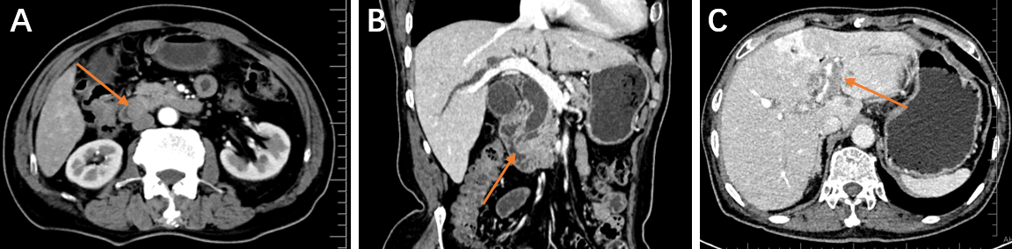
Figure 1 Enhanced computed tomography of the abdomen of patient 4. A: The ampullary mass shown by the orange arrow protrudes into the duodenal cavity, and the arterial phase shows uneven enhancement. B: The tumor caused significant dilation of the bile ducts and pancreatic ducts inside and outside the liver. C: Postoperative liver metastases indicated by orange arrows.

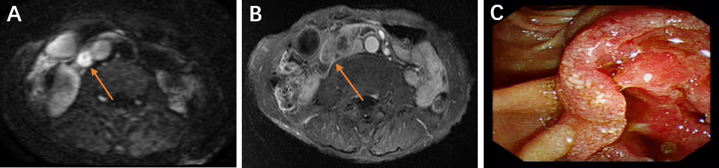
Figure 2 Enhanced magnetic resonance imaging of the abdomen and duodenoscopy of patient 3. A: The orange arrow shows an oval mass in the ampulla, which shows high signal intensity on diffusion weighted imaging and the boundary is still clear. B: After the mass is enhanced, it shows uneven ring enhancement. C: An irregular ulcer in the ampulla was seen under the endoscopy, with a crater-like bulge around it.
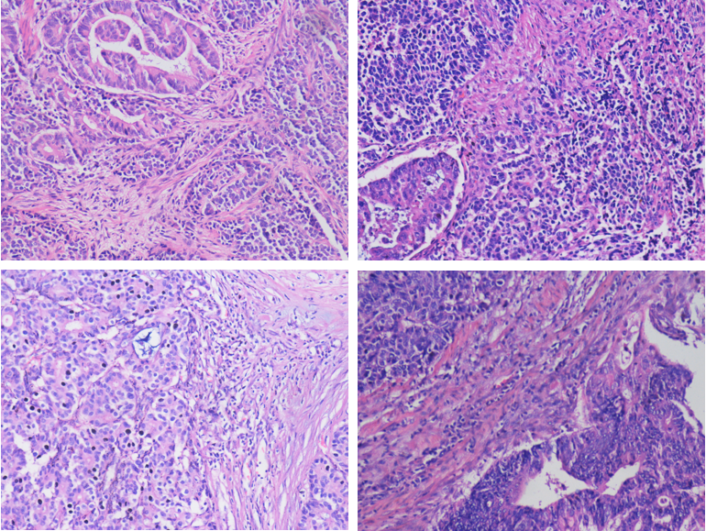
Figure 3 Light microscope images of hematoxylin-eosin stained lesion sections of 4 patients. Original magnification: × 200.

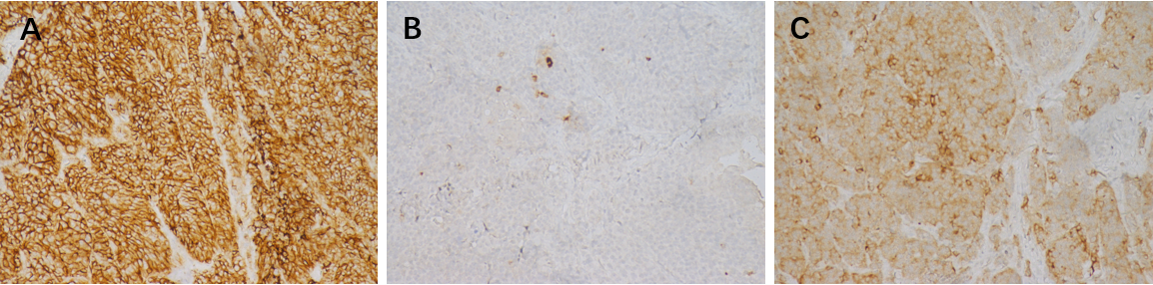
Figure 4 Light microscope image with immunohistochemical staining. A: CD56+; B: CgA+; C: Syn+. Original magnification: × 200.

Table 1 Imaging, duodenal endoscopy and biopsy, laboratory, pathological and immunohistochemical examinations of 4 patients.
Serial number | Image | Duodenal endoscopy and biopsy | Tumor markers | Ratio (%); ADC:NEN | Immunohisto-chemistry | Ki-67
Patient 1 | Enhanced CT | No | CA19-9 rise; CEA, AFP normal | 30:70 | Component (NEN): CgA(-), Syn(+), CD56(+) | 30%
Patient 2 | Enhanced MRI | Yes, ADC | CA19-9, CEA, AFP normal | 60:40 | Component (NEN): CgA(+), Syn(+), CD56(+) | 50%
Patient 3 | Enhanced MRI | Yes, ADC | CA19-9 rise; CEA, AFP normal | 60:40 | Component (NEN): CgA(+/-), Syn(+), CD56(+)） | 70%
Patient 4 | Enhanced CT | No | CA19-9, CEA, AFP normal | 40:60 | Component (NEN): CgA(-), Syn(+), CD56(+) | 70%
AFP: Alpha fetal protein; CT: Computed tomography; CA19-9: Carbohydrate antigen199; CEA: Carcinogenic embryonic antigen; MRI: Magnetic resonance imaging.

Table 2 Treatment and follow-up data of 4 patients
Serial number | Sex | Age | First symptoms | Treatment | Chemo-therapy | Follow-up | Postoperative overall survival (mo)
Patient 1 | Male | 81 | Jaundice | Pancreatico-duodenectomy | No | Death | 1
Patient 2 | Male | 69 | Jaundice | Pancreatico-duodenectomy | Yes | Death | 29
Patient 3 | Male | 67 | Abdominal pain | Pancreatico-duodenectomy | Yes | Death | 22
Patient 4 | Male | 72 | Jaundice;  Abdominal pain | Pancreatico-duodenectomy | Yes | Survival | -

