Name of Journal: World Journal of Gastrointestinal Surgery
Manuscript NO: 90508
Manuscript Type: ORIGINAL ARTICLE

Retrospective Study
Nomogram model including LATS2 expression was constructed to predict the prognosis of advanced gastric cancer after surgery

Sun N et al. LATS2-based prognostic model for gastric cancer

Nan Sun, Bi-Bo Tan, Yong Li

Nan Sun, Department of Blood Transfusion, The Fourth Hospital of Hebei Medical University, Shijiazhuang 050011, Hubei Province, China

Bi-Bo Tan, Yong Li, Third Department of General Surgery, the Fourth Hospital of Hebei Medical University, Shijiazhuang 050011, Hebei Province, China

Author contributions: Sun N designed the research study; Sun N, Tan BB and Li Y performed the research; Sun N and Tan BB contributed analytic tools; Sun N and Li Y analyzed the data and wrote the manuscript; all authors have read and approve the final manuscript.

Corresponding author: Yong Li, PhD, Chief Doctor, Professor, Third Department of General Surgery, The Fourth Hospital of Hebei Medical University, No. 12 Jiankang Road, Chang'an District, Shijiazhuang 050011, Hebei Province, China. liyong780728@163.com

Received: December 12, 2023
Revised: January 13, 2024
Accepted: January 24, 2024
Published online: February 27, 2024

Abstract
BACKGROUND
Gastric cancer is a leading cause of cancer-related deaths worldwide. Prognostic assessments are typically based on the tumor-node-metastasis (TNM) staging system, which does not account for the molecular heterogeneity of this disease. LATS2, a tumor suppressor gene involved in the Hippo signaling pathway, has been identified as a potential prognostic biomarker in gastric cancer.

AIM
To construct and validate a nomogram model that includes LATS2 expression to predict the survival prognosis of advanced gastric cancer patients following radical surgery, and compare its predictive performance with traditional TNM staging.

METHODS
A retrospective analysis of 245 advanced gastric cancer patients from the Fourth Hospital of Hebei Medical University was conducted. The patients were divided into a training group (171 patients) and a validation group (74 patients) to develop and test our prognostic model. The performance of the model was determined using C-indices, receiver operating characteristic curves, calibration plots, and decision curves.

RESULTS
The model demonstrated a high predictive accuracy with C-indices of 0.829 in the training set and 0.862 in the validation set. Area under the curve values for three-year and five-year survival prediction were significantly robust, suggesting an excellent discrimination ability. Calibration plots confirmed the high concordance between the predictions and actual survival outcomes.

CONCLUSION
We developed a nomogram model incorporating LATS2 expression, which significantly outperformed conventional TNM staging in predicting the prognosis of advanced gastric cancer patients postsurgery. This model may serve as a valuable tool for individualized patient management, allowing for more accurate stratification and improved clinical outcomes. Further validation in larger patient cohorts will be necessary to establish its generalizability and clinical utility.

Key Words: Gastric cancer; LATS2; Column line graph; Prognosis; Advanced gastric cancer survival; Molecular biomarkers; Predictive analytics in oncology; Survival analysis

©The Author(s) 2024. Published by Baishideng Publishing Group Inc. All rights reserved.

Citation: Sun N, Tan BB, Li Y. Nomogram model including LATS2 expression was constructed to predict the prognosis of advanced gastric cancer after surgery. World J Gastrointest Surg 2024; 16(2): 518-528
URL: https://www.wjgnet.com/1948-9366/full/v16/i2/518.htm
DOI: https://dx.doi.org/10.4240/wjgs.v16.i2.518

Core Tip: This study focuses on developing a prognostic model for patients with advanced gastric cancer postsurgery by integrating LATS2 expression and clinicopathological features into a nomogram. It highlights the significance of the LATS2 gene in improving prognostic predictions beyond traditional tumor-node-metastasis staging. Our model demonstrates excellent predictive accuracy and clinical utility, which indicates its potential for enhancing individualized patient care through better risk stratification. Future studies should focus on external validation to confirm the model’s applicability across diverse patient populations.

INTRODUCTION
Gastric cancer ranks fifth and fourth among all malignant tumors globally in terms of incidence and mortality, respectively^{[1]}, and poses a serious threat to human health. The prognosis of gastric cancer remains unsatisfactory because there are no specific and obvious symptoms during the early stages, thus most patients are at an advanced stage at the time of presentation^{[2]}. The poor prognosis of advanced gastric cancer may be related, in part, to the heterogeneous nature of gastric cancer, which involves various gene mutations and molecular signaling pathways, some of which may be exploited for prognosis and targeted drug therapy^{[3-6]}.
Nomograms have been used to predict the survival prognosis of cancer patients through the construction of multifactorial regression models. These models integrate multiple clinical factors based on the relative degree of contribution of each to the outcome variables, followed by visualization of the data^{[7]}. Nomograms have been used for colorectal cancer^{[8]}, lung adenocarcinoma^{[9]}, breast cancer^{[10]}, endometrial stromal sarcoma^{[11]}, and other tumors to accurately predict patient prognosis.
Large tumor suppressor kinase (LATS) was first discovered in Drosophila melanogaster in 1995. An ortholog was found to exist in humans in subsequent studies, which included LATS1 and LATS2^{[12]}. LATS is a core member of the Hippo signaling pathway and plays an important role in maintaining cellular homeostasis^{[13,14]}. LATS also has a role in the development of gastric cancer by inhibiting tumor cell proliferation and promoting apoptosis^{[15,16]}.
In this study, 245 gastric cancer patients were retrospectively analyzed to determine the clinical value of LATS2 expression on the survival prognosis of patients with advanced gastric cancer. LATS2 was incorporated into a prognostic prediction model of postoperative gastric cancer patients to generate a model that enables the prognostic assessment of patients with advanced gastric cancer. The results were visualized in the form of a nomogram and the predictive efficacy of the model was evaluated.

MATERIALS AND METHODS
Research subjects
A total of 245 patients with advanced gastric cancer who underwent surgery in the Department of Surgery at the Fourth Affiliated Hospital of Hebei Medical University from March 2015 to March 2017 were retrospectively selected. The patients were randomly divided into a training group and a validation group at a 7:3 ratio. The training group was used to screen variables and construct models, whereas the validation group was used to validate the models obtained from the training group. The tumor were surgically resected and analyzed for pathology and by immunohistochemical staining. The tumor-node-metastasis (TNM) stage was determined according to the AJCC 8th edition standard TNM staging system. The data in were obtained from the postoperative pathology reports and the patient clinical information was collected through the hospital’s independent information system. For immunohistochemistry, the intensity and extent of staining were assessed semi-quantitatively, with scores of 0-3 defined as low expression and scores of 4-9 defined as high expression. This was a retrospective study approved by the Ethics Committee of the Fourth Hospital of Hebei Medical University (Approval No. 2019ME0039).

Inclusion criteria: (1) Confirmed diagnosis of advanced gastric cancer along with radical gastrectomy (D2 lymph node dissection, R0 resection); (2) M0 patients without distant metastasis; (3) Diagnosis of primary gastric adenocarcinoma, which was clearly defined by postoperative pathology and immunohistochemical staining; (4) Complete medical records and immunohistochemistry analysis data; (5) No chemotherapy, radiotherapy, immunotherapy, or other tumor present; and (6) The depth of cancer cell invasion reached the muscle layer, serous layer, or extraserous layer (T stage ≥ T2).

Exclusion criteria: (1) Patients aged < 18 years old and survival time < 1 month; (2) Combination of severe anemia, infection, autoimmune disease, hematologic disease, or inflammation in the last month; (3) Combination of severe brain, heart, liver, kidney, or other vital organ disease; (4) Recurrence, combination of distant metastasis, or history of other malignant neoplasms; (5) Recent use of antibiotics, anti-inflammatory drugs; and (6) Incomplete pathological data or postoperative loss of patient contact.

Observation indicators
The collected clinical data included: gender, age, comorbidities (hypertension, diabetes mellitus, chronic lung disease), history of smoking, LATS2, history of alcohol consumption, tumor size, lymphatic invasion, T-stage, and N stage.

Survival follow-up
Follow-up data were obtained from inpatient medical records, outpatient medical records, and telephone consultations. Patients were monitored every three months during the first two years following surgery and every six months after two years. Overall survival (OS) was defined as the time from the start of treatment to death from any cause. For patients lacking study endpoints, we recorded the latest follow-up date, which was January 31, 2022, for the included patients. Local recurrence or distant metastasis was determined based on a computed tomography (CT)-enhanced scan, fiberoptic gastroscopy biopsy, bone scan, magnetic resonance imaging, or positron emission tomography/CT.

Statistical analysis
Categorical variables were expressed as numbers and percentages, and continuous variables were expressed as the median and interquartile range. Differences in the distribution of categorical variables between the training and validation groups were tested using a chi-square test or Fisher’s exact test. Differences in the distribution of continuous variables between the two groups were tested using a t-test. Hazard ratios and 95%CI for each risk factor were calculated using a one-way Cox regression. Significant effects from the unifactorial analysis were included in the multifactorial Cox regression based on Akaike information criteria. Significant clinical variables in the multifactorial analysis were independent predictors of overall survival and were used to construct nomogram plots to estimate three-year and five-year overall and progression-free survival rates as well as to generate Kaplan-Meier survival curves. The C-index and receiver operating characteristic (ROC) curves were plotted, which were used to assess the discriminatory ability of the nomogram charts. C-index and an area under curve (AUC) ≥ 0.7 indicated that the nomogram charts had good predictive discriminatory ability. Calibration plots were used to assess the gap between the predicted and actual results of the nomogram graphs. A decision curve analysis was used to assess the clinical benefit of the nomogram charts. P-values were used for all statistical analyses and P < 0.05 was considered statistically significant. Statistical analysis and plotting of the data were done using R 4.2.1 (http://www.R-projectct.org/) software and the RStudio environment.

RESULTS
Analysis of general clinical data
A total of 245 patients were randomly divided into a training group (171) and a validation group (74) in a 7:3 ratio. Among all patients, the majority were male (80.41%) and most of them were older than 65 years (60.00%) (Table 1). More than half of the patients did not have hypertension (64.90%), diabetes mellitus (90.61%), or chronic lung disease (96.33%), whereas a minority had no history of smoking (8.98%). Most of the patients exhibited lymphatic invasion (81.63%) and high LATS2 expression (66.90%). Approximately half of the patients had a history of alcohol consumption. Most patients had a tumor diameter greater than 5 cm (83.67%) and staged as T4 (72.24%) and N3 (30.61%).

Unifactorial and multifactorial Cox analysis
Based on a unifactorial Cox analysis, age, lymphatic invasion, LATS2 expression, tumor size, T stage, and N stage had predictive value (Table 2). In a multifactorial Cox analysis, all of the above factors had independent predictive value, except for age, which was included in the nomogram model. As shown in Figure 1, the survival rate of patients with high LATS2 expression was higher compared with that of low-expressing patients.

Establishment and validation of a nomogram
Based on the results of a multifactorial Cox analysis, lymphatic invasion, LATS2, tumor size, T, and N were included in the nomogram (Figure 2), and the consistency indices (C-index) of the three clinical prediction models, namely TN staging, TN staging combined with LATS2, and the nomogram model, were calculated, respectively, according to the results of the clinical data. After comparing the three clinical prediction models, we concluded that the nomogram model had accurate clinical prognostic prediction (Table 3). The C-indexes of the training and validation sets were 0.829 and 0.862, respectively, which were higher compared with those of the two models, TN staging, and TN staging combined with LATS2. The three-year and five-year AUC of TN staging combined with LATS2 in the training set were higher compared with those of the TN staging model, indicating that LATS2 has a positive significance for the prognosis of progressive gastric cancer. The three-year and five-year AUC of the training set of the nomogram graph model were 0.8723 and 0.8525, respectively, which were higher compared with those of the two models of TN staging and TN staging combined with LATS2, which suggests that our model has a good predictive performance (Figure 3). Similarly, the three-year and five-year AUC of the validation set nomogram model were 0.9129 and 0.8763, respectively (Figure 4), indicating that it had a good discriminatory ability. As shown in Figures 5 and 6, the prognosis predicted by the nomogram model was in high agreement with the actual real-world situation.

DISCUSSION
Accurate prediction of postoperative prognosis is important for optimizing treatment strategies and improving outcomes in patients with advanced gastric cancer. In this study, we developed and validated a prognostic model incorporating LATS2 expression and clinicopathological characteristics to predict overall survival at three and five years following radical surgery for advanced gastric cancer.
Several findings indicate that our nomogram model has significant clinical value for postoperative prognosis prediction. First, the model showed good discrimination, with C-indices of 0.829 and 0.862 in the training and validation sets, respectively. The AUCs at three and five years were also high, ranging from 0.8525 to 0.9129, further demonstrating the strong predictive accuracy. Calibration plots revealed a high level of agreement between the predicted and actual survival. In addition, a decision curve analysis showed that the predictions using our model resulted in a superior net benefit compared with predictions based on TNM staging alone or TNM combined with LATS2 across a wide range of threshold probabilities. Taken together, the results provide solid evidence that the model can accurately stratify patients by prognostic risk.
Of note, the incorporation of LATS2 expression data improved model performance over TNM staging alone. High LATS2 expression was associated with a significantly better prognosis, which is consistent with its known tumor suppressive function. As an important component of the Hippo signaling pathway, which regulates cell proliferation and apoptosis, dysregulation of LATS2 affects key oncogenic mechanisms in gastric cancer. Our findings indicate that LATS2 merits inclusion as a prognostic biomarker, lending additional risk stratification information beyond standard clinicopathological factors.
In clinical practice, TNM staging is primarily used to roughly predict prognosis; however, it lacks individualization and accuracy in predicting postoperative treatment and prognosis^{[17]}. The construction of effective prognostic tools is of great significance for the individualized treatment of patients, for whom the nomogram has attracted much attention in recent years because of its convenient and intuitive clinical application^{[18]}. Some models for predicting patient prognosis in gastric cancer have been reported, such as a gastric cancer prognosis model based on oxidative stress genes^{[19]}, and a model related to scorched death^{[20]}; however. there are many candidate genes involved and research is immature, so the clinical feasibility is not high. For example, age, race, marital status, TNM stage, surgery, chemotherapy, grade, and the number of positive regional nodes can be used to predict the survival of gastric cancer patients^{[21]}; however, the C-index and area under the ROC curve are low, thus the accuracy of prognosis for gastric cancer is not high. To more accurately predict the prognosis of patients with gastric cancer following surgery and for clinical application, it is significant to combine biomarkers that have an important role in gastric cancer with clinicopathological features.
The user-friendly visual format of the nomogram facilitates its application to clinical practice. By mapping the profiles of individual patients onto the diagram, physicians can readily estimate three- and five-year survival probabilities. This may facilitate important management decisions, such as selecting high-risk patients likely to benefit from adjuvant chemotherapy or more intensive follow-up. Dynamic risk assessment at successive time points may also help to determine if and when to modify treatment regimens.
By enabling more accurate risk stratification and prognosis prediction, this model has the potential to significantly improve clinical decision-making and outcomes for patients undergoing radical surgery for advanced gastric cancer. The next step will be an external validation of the model using patient cohorts from other centers. Broader validation will provide further support for its generalizability and clinical utility. The LATS gene family is a core component of the Hippo pathway and an important regulator of homeostasis in vivo, of which LATS2 expression is low in gastric cancer tissues^{[16]}. Previous studies have confirmed that in gastric cancer, LATS2 is involved in tumor cell growth, invasion, migration^{[22-24]}, and mesenchymal transformation^{[25]}. Previous studies have confirmed that LATS2 expression in gastric cancer is closely associated with clinicopathological factors^{[26]} and the survival rate of gastric cancer patients^{[27]}.
Some limitations should be acknowledged when interpreting our results. First, the sample size, though adequately powered for model development and internal validation, was relatively small and derived from a single center. Thus, large prospective studies are warranted to validate these findings. Second, data on certain potential prognostic variables, such as the Lauren classification and Borrmann classification, were not available for inclusion. Future models incorporating a more comprehensive set of clinical and molecular data may improve the prognostic accuracy. Finally, the current study lacked an external validation set. Validating the model using an independent patient population will also be essential to confirm its wider applicability.

CONCLUSION
In conclusion, we developed an internally validated, robust prognostic model for advanced gastric cancer after radical surgery, incorporating both tumor biomarkers and clinicopathological data. The results indicate that the model enables superior discrimination of low- vs high-risk patients compared with standard prognostic approaches. Following additional external validation, translation of this prognostic tool into clinical practice may significantly assist therapeutic decision-making and ultimately improve patient outcomes. The next steps will be to expand validation of the model across multiple centers as well as investigator-initiated trials to evaluate its impact on clinical management and survival.

ARTICLE HIGHLIGHTS
Research background
Gastric cancer is a significant global health concern, ranking fifth in incidence and fourth in mortality among all cancers. The prognosis is often poor due to late-stage diagnosis. Molecular signaling pathways and gene mutations, like those involving the LATS gene, play a crucial role in the pathogenesis of gastric cancer, affecting prognosis and treatment options.

Research motivation
There is a need for more accurate prognostic models for advanced gastric cancer that can incorporate molecular biomarkers like LATS2 expression. This would improve individual prognosis assessments and aid in personalizing treatment strategies.

Research objectives
The objective of this research is to construct a nomogram model based on LATS2 expression and evaluate its predictive accuracy for the survival prognosis of patients with advanced gastric cancer post-surgery.

Research methods
The study retrospectively analyzed clinical data of 245 advanced gastric cancer patients, dividing them into a training group and a validation group. Univariate and multivariate Cox regression analyses were used to assess the prognostic value of LATS2 expression. The model's performance was analyzed through various statistical methods including C-index, receiver operating characteristic curves, calibration curves, and decision curves.

Research results
The nomogram model demonstrated high C-indexes and area under curve values, indicating strong predictive accuracy. Calibration plots showed high agreement between predicted and actual survival, and decision curves indicated the model's superior net benefit over tumor-node-metastasis (TNM) staging alone.

Research conclusions
The nomogram model incorporating LATS2 expression provided significant clinical value in predicting the postoperative prognosis of advanced gastric cancer patients. It showed superior discrimination and net clinical benefit compared to TNM staging alone.

Research perspectives
The study suggests that the developed model can assist in clinical decision-making, but acknowledges limitations such as the small, single-center sample size. Future research should aim at external validation and include more comprehensive clinical and molecular data to optimize prognostic accuracy.

REFERENCES
1 Hirata Y, Noorani A, Song S, Wang L, Ajani JA. Early stage gastric adenocarcinoma: clinical and molecular landscapes. Nat Rev Clin Oncol 2023; 20: 453-469 [PMID: 37264184 DOI: 10.1038/s41571-023-00767-w]
2 Guan WL, He Y, Xu RH. Gastric cancer treatment: recent progress and future perspectives. J Hematol Oncol 2023; 16: 57 [PMID: 37245017 DOI: 10.1186/s13045-023-01451-3]
3 Gilhaus K, Cepok C, Kamm D, Surmann B, Nedvetsky PI, Emich J, Sundukova A, Saatkamp K, Nüsse H, Klingauf J, Wennmann DO, George B, Krahn MP, Pavenstädt HJ, Vollenbröker BA. Activation of Hippo Pathway Damages Slit Diaphragm by Deprivation of Ajuba Proteins. J Am Soc Nephrol 2023; 34: 1039-1055 [PMID: 36930055 DOI: 10.1681/ASN.0000000000000107]
4 Wang CH, Baskaran R, Ng SS, Wang TF, Li CC, Ho TJ, Hsieh DJ, Kuo CH, Chen MC, Huang CY. Platycodin D confers oxaliplatin Resistance in Colorectal Cancer by activating the LATS2/YAP1 axis of the hippo signaling pathway. J Cancer 2023; 14: 393-402 [PMID: 36860929 DOI: 10.7150/jca.77322]
5 Liberale L, Puspitasari YM, Ministrini S, Akhmedov A, Kraler S, Bonetti NR, Beer G, Vukolic A, Bongiovanni D, Han J, Kirmes K, Bernlochner I, Pelisek J, Beer JH, Jin ZG, Pedicino D, Liuzzo G, Stellos K, Montecucco F, Crea F, Lüscher TF, Camici GG. JCAD promotes arterial thrombosis through PI3K/Akt modulation: a translational study. Eur Heart J 2023; 44: 1818-1833 [PMID: 36469488 DOI: 10.1093/eurheartj/ehac641]
6 Zhang Y, He LJ, Huang LL, Yao S, Lin N, Li P, Xu HW, Wu XW, Xu JL, Lu Y, Li YJ, Zhu SL. Oncogenic PAX6 elicits CDK4/6 inhibitor resistance by epigenetically inactivating the LATS2-Hippo signaling pathway. Clin Transl Med 2021; 11: e503 [PMID: 34459131 DOI: 10.1002/ctm².503]
7 Kong P, Yang H, Tong Q, Dong X, Yi MA, Yan D. Expression of tumor-associated macrophages and PD-L1 in patients with hepatocellular carcinoma and construction of a prognostic model. J Cancer Res Clin Oncol 2023; 149: 10685-10700 [PMID: 37306737 DOI: 10.1007/s00432-023-04949-y]
8 Lv J, Liu YY, Jia YT, He JL, Dai GY, Guo P, Zhao ZL, Zhang YN, Li ZX. A nomogram model for predicting prognosis of obstructive colorectal cancer. World J Surg Oncol 2021; 19: 337 [PMID: 34857001 DOI: 10.1186/s12957-021-02445-6]
9 Jin C, Cao J, Cai Y, Wang L, Liu K, Shen W, Hu J. A nomogram for predicting the risk of invasive pulmonary adenocarcinoma for patients with solitary peripheral subsolid nodules. J Thorac Cardiovasc Surg 2017; 153: 462-469.e1 [PMID: 27838008 DOI: 10.1016/j.jtcvs.2016.10.019]
10 Zhu X, Li Y, Liu F, Zhang F, Li J, Cheng C, Shen Y, Jiang N, Du J, Zhou Y, Huo B. Construction of a Prognostic Nomogram Model for Patients with Mucinous Breast Cancer. J Healthc Eng 2022; 2022: 1230812 [PMID: 35368964 DOI: 10.1155/2022/1230812]
11 Wu J, Zhang H, Li L, Hu M, Chen L, Xu B, Song Q. A nomogram for predicting overall survival in patients with low-grade endometrial stromal sarcoma: A population-based analysis. Cancer Commun (Lond) 2020; 40: 301-312 [PMID: 32558385 DOI: 10.1002/cac2.12067]
12 Liang B, Wang H, Qiao Y, Wang X, Qian M, Song X, Zhou Y, Zhang Y, Shang R, Che L, Chen Y, Huang Z, Wu H, Monga SP, Zeng Y, Calvisi DF, Chen X, Chen X. Differential requirement of Hippo cascade during CTNNB1 or AXIN1 mutation-driven hepatocarcinogenesis. Hepatology 2023; 77: 1929-1942 [PMID: 35921500 DOI: 10.1002/hep.32693]
13 Jin D, Guo J, Wu Y, Yang L, Wang X, Du J, Dai J, Chen W, Gong K, Miao S, Li X, Sun H. Correction: m6A demethylase ALKBH5 inhibits tumor growth and metastasis by reducing YTHDFs-mediated YAP expression and inhibiting miR-107/LATS2-mediated YAP activity in NSCLC. Mol Cancer 2022; 21: 130 [PMID: 35692055 DOI: 10.1186/s12943-022-01593-x]
14 Qi S, Zhu Y, Liu X, Li P, Wang Y, Zeng Y, Yu A, Wang Y, Sha Z, Zhong Z, Zhu R, Yuan H, Ye D, Huang S, Ling C, Xu Y, Zhou D, Zhang L, Yu FX. WWC proteins mediate LATS1/2 activation by Hippo kinases and imply a tumor suppression strategy. Mol Cell 2022; 82: 1850-1864.e7 [PMID: 35429439 DOI: 10.1016/j.molcel.2022.03.027]
15 Jiang SF, Li RR. hsa_circ_0067514 suppresses gastric cancer progression and glycolysis via miR-654-3p/LATS2 axis. Neoplasma 2022; 69: 1079-1091 [PMID: 35818964 DOI: 10.4149/neo_2022_220225N209]
16 Wen Z, Li Y, Tan B, Chen Z, Zhao Q, Tan M, Zhao Y, Xia Y, FanΔ L. LINC01088 regulates the miR-95/LATS2 pathway through the ceRNA mechanism to inhibit the growth, invasion and migration of gastric cancer cells. Int J Immunopathol Pharmacol 2022; 36: 3946320221108271 [PMID: 35728587 DOI: 10.1177/03946320221108271]
17 Zhu Z, Gong Y, Xu H. Clinical and pathological staging of gastric cancer: Current perspectives and implications. Eur J Surg Oncol 2020; 46: e14-e19 [PMID: 32732091 DOI: 10.1016/j.ejso.2020.06.006]
18 Wang X, Lu J, Song Z, Zhou Y, Liu T, Zhang D. From past to future: Bibliometric analysis of global research productivity on nomogram (2000-2021). Front Public Health 2022; 10: 997713 [PMID: 36203677 DOI: 10.3389/fpubh.2022.997713]
19 Wu Z, Wang L, Wen Z, Yao J. Integrated analysis identifies oxidative stress genes associated with progression and prognosis in gastric cancer. Sci Rep 2021; 11: 3292 [PMID: 33558567 DOI: 10.1038/s41598-021-82976-w]
20 Liang C, Fan J, Liang C, Guo J. Identification and Validation of a Pyroptosis-Related Prognostic Model for Gastric Cancer. Front Genet 2021; 12: 699503 [PMID: 35280928 DOI: 10.3389/fgene.2021.699503]
21 Ji H, Wu H, Du Y, Xiao L, Zhang Y, Zhang Q, Wang X, Wang W. Development and External Validation of a Nomogram for Predicting Overall Survival in Stomach Cancer: A Population-Based Study. J Healthc Eng 2021; 2021: 8605869 [PMID: 34608415 DOI: 10.1155/2021/8605869]
22 Sun D, Wang Y, Wang H, Xin Y. The novel long non-coding RNA LATS2-AS1-001 inhibits gastric cancer progression by regulating the LATS2/YAP1 signaling pathway via binding to EZH2. Cancer Cell Int 2020; 20: 204 [PMID: 32514249 DOI: 10.1186/s12935-020-01285-w]
23 Wang YJ, Liu JZ, Lv P, Dang Y, Gao JY, Wang Y. Long non-coding RNA CCAT2 promotes gastric cancer proliferation and invasion by regulating the E-cadherin and LATS2. Am J Cancer Res 2016; 6: 2651-2660 [PMID: 27904778]
24 Hum M, Tan HJ, Yang Y, Srivastava S, Teh M, Lim YP. WBP2 promotes gastric cancer cell migration via novel targeting of LATS2 kinase in the Hippo tumor suppressor pathway. FASEB J 2021; 35: e21290 [PMID: 33475198 DOI: 10.1096/fj.202000393R]
25 Molina-Castro SE, Tiffon C, Giraud J, Boeuf H, Sifre E, Giese A, Belleannée G, Lehours P, Bessède E, Mégraud F, Dubus P, Staedel C, Varon C. The Hippo Kinase LATS2 Controls Helicobacter pylori-Induced Epithelial-Mesenchymal Transition and Intestinal Metaplasia in Gastric Mucosa. Cell Mol Gastroenterol Hepatol 2020; 9: 257-276 [PMID: 31669263 DOI: 10.1016/j.jcmgh.2019.10.007]
26 Kim E, Ahn B, Oh H, Lee YJ, Lee JH, Lee Y, Kim CH, Chae YS, Kim JY. High Yes-associated protein 1 with concomitant negative LATS1/2 expression is associated with poor prognosis of advanced gastric cancer. Pathology 2019; 51: 261-267 [PMID: 30819540 DOI: 10.1016/j.pathol.2019.01.001]
27 Son MW, Song GJ, Jang SH, Hong SA, Oh MH, Lee JH, Baek MJ, Lee MS. Clinicopathological Significance of Large Tumor Suppressor (LATS) Expression in Gastric Cancer. J Gastric Cancer 2017; 17: 363-373 [PMID: 29302376 DOI: 10.5230/jgc.2017.17.e41]

Footnotes
Institutional review board statement: This was a retrospective study approved by the Ethics Committee of the Fourth Hospital of Hebei Medical University (Approval No. 2019ME0039).

Informed consent statement: Patients were not required to give informed consent to the study because the analysis used anonymous clinical data that were obtained after each patient agreed to treatment by written consent.

Conflict-of-interest statement: All authors claim no conflicts of interest.

Data sharing statement: Raw data, statistical codes and datasets are available from the corresponding author.

Open-Access: This article is an open-access article that was selected by an in-house editor and fully peer-reviewed by external reviewers. It is distributed in accordance with the Creative Commons Attribution NonCommercial (CC BY-NC 4.0) license, which permits others to distribute, remix, adapt, build upon this work non-commercially, and license their derivative works on different terms, provided the original work is properly cited and the use is non-commercial. See: https://creativecommons.org/Licenses/by-nc/4.0/

Provenance and peer review: Unsolicited article; Externally peer reviewed.
Peer-review model: Single blind

Peer-review started: December 12, 2023
First decision: January 2, 2024
Article in press: January 24, 2024

Specialty type: Oncology
Country/Territory of origin: China
Peer-review report’s scientific quality classification
Grade A (Excellent): 0
Grade B (Very good): 0
Grade C (Good): C
Grade D (Fair): 0
Grade E (Poor): 0

P-Reviewer: Herrera-Pariente C, Spain S-Editor: Gong ZM L-Editor: A P-Editor: Xu ZH

Figure Legends
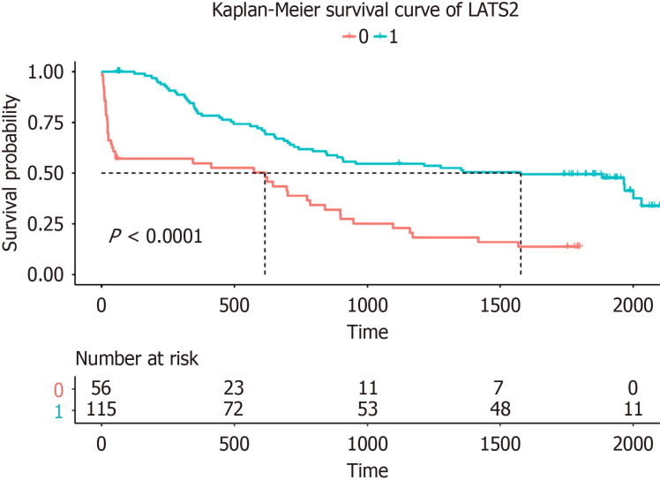
Figure 1 Kaplan-Meier survival curve for LATS2 expression.
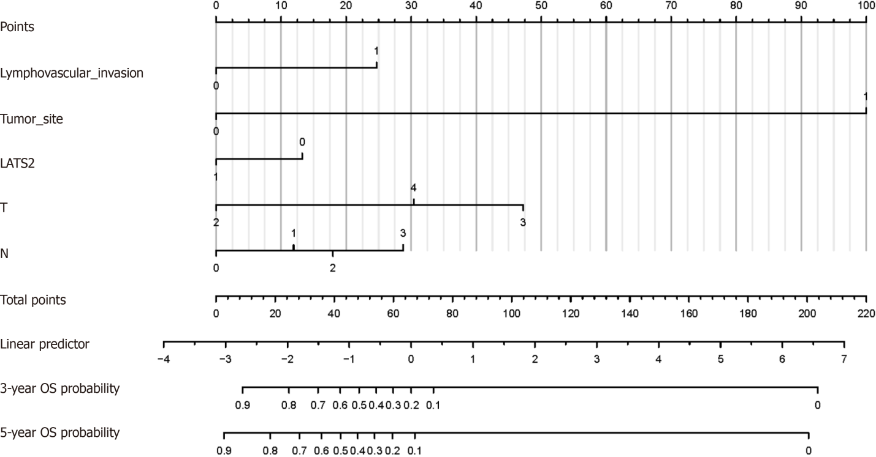
Figure 2 Nomogram consisting of lymphatic invasion, LATS2, tumor size, and T and N stages.
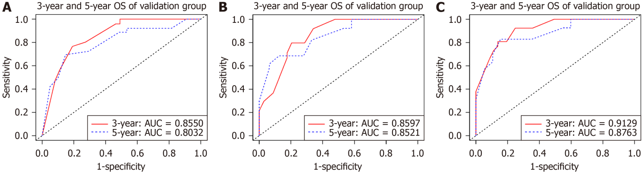
Figure 3 Receiver operating characteristic curve of training set. A: Receiver operating characteristic (ROC) curve of TN stage; B: ROC curve of TN stage + LATS2; C: ROC curve of the target model.
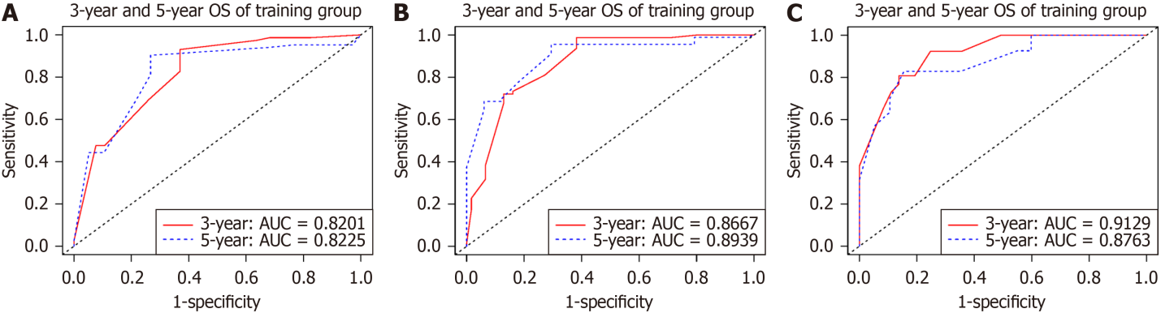
Figure 4 Receiver operating characteristic curve of validation set. A: Receiver operating characteristic (ROC) curve of TN stage; B: ROC curve of TN stage + LATS2; C: ROC curve of the target model.
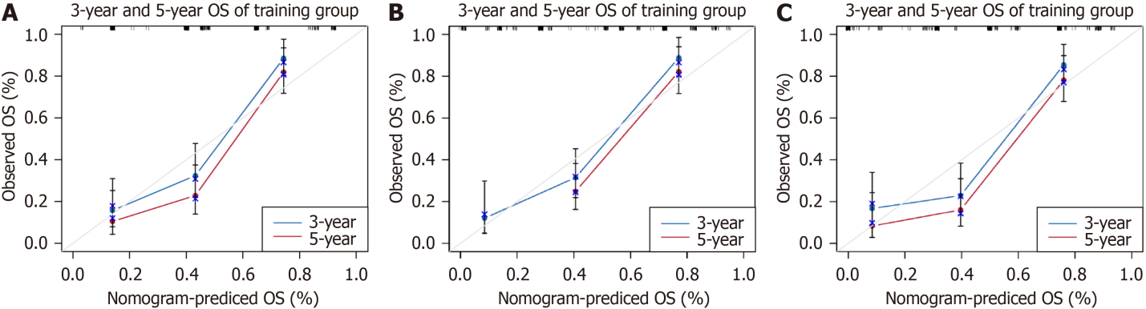
Figure 5 Calibration diagram of training set. A: Calibration diagram of TN stage; B: Calibration diagram of TN stage +LATS2; C: Calibration plot of the target model.
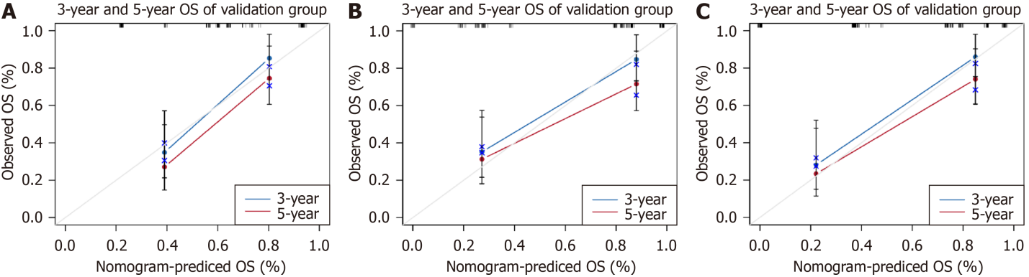
Figure 6 Calibration diagram of validation set. A: Calibration diagram of TN stage; B: Calibration diagram of TN stage +LATS2; C: Calibration plot of the target model.
Table 1 Clinical information, n (%)
Characteristics | All patients cases (%)/median (IQR) | Training group cases (%)/median (IQR) | Validation group cases (%)/median (IQR) | P value
Sex
Male | 197 (80.41) | 142 (83.04) | 55 (74.32) | 0.16
Female | 48 (19.59) | 29 (16.96) | 19 (25.68)
Age
< 65 | 98 (40.00) | 64 (37.43) | 34 (45.95) | 0.27
≥ 65 | 147 (60.00) | 107 (62.57) | 40 (54.05)
Hypertension
No | 159 (64.90) | 115 (67.25) | 44 (59.46) | 0.30
Yes | 86 (35.10) | 56 (32.75) | 30 (40.54)
Diabetes
Yes | 23 (9.39) | 13 (7.60) | 10 (13.51) | 0.22
No | 222 (90.61) | 158 (92.40) | 64 (86.49)
Chronic lung disease
Yes | 9 (3.67) | 6 (3.51) | 3 (4.05) | 1
No | 236 (96.33) | 165 (96.49) | 71 (95.95)
Smoking
Yes | 223 (91.02) | 154 (90.06) | 69 (93.24) | 0.58
No | 22 (8.98) | 17 (9.94) | 5 (6.76)
Lymphatic invasion
Yes | 200 (81.63) | 140 (81.87) | 60 (81.08) | 1
No | 45 (18.37) | 31 (18.13) | 14 (18.92)
LATS2
High | 164 (66.90) | 121 (70.70) | 43 (58.10) | 0.60
Low | 81 (33.10) | 50 (29.30) | 31 (41.80)
Alcohol consumption
Yes | 135 (55.10) | 93 (54.39) | 42 (56.76) | 0.84
No | 110 (44.90) | 78 (45.61) | 32 (43.24)
Tumor size
> 5 cm | 205 (83.67) | 145 (84.80) | 60 (81.08) | 0.59
≤ 5 cm | 40 (16.33) | 26 (15.20) | 14 (18.92)
T stage
2 | 45 (18.37) | 26 (15.20) | 19 (25.68) | 0.11
3 | 23 (9.39) | 15 (8.77) | 8 (10.81)
4 | 177 (72.24) | 130 (76.03) | 47 (63.51)
N stage
0 | 74 (30.20) | 54 (31.58) | 20 (27.03) | 0.62
1 | 45 (18.37) | 28 (16.37) | 17 (22.97)
2 | 51 (20.82) | 35 (20.47) | 16 (21.62)
3 | 75 (30.61) | 54 (31.58) | 21 (28.38)
IQR: Interquartile range.
Table 2 Unifactorial and multifactorial cox analysis
Characteristics | Univariate analysis |  |  |  | Multivariate analysis
 | HR | 95%CI | P value | HR |  | 95%CI | P value
Sex
Male | Reference
Female | 0.700 | 0.397-1.233 | 0.217
Age
< 65 | Reference |  |  | Reference |  |  | 0.199
≥ 65 | 6.632 | 4.026-10.926 | < 0.001 | 1.780 |  | 0.739-4.286
Hypertension
No | 1.202 | 0.800-1.812 | 0.378
Yes | Reference
Diabetes
Yes | 1.256 | 0.608-2.594 | 0.537
No | Reference
Chronic lung disease
Yes | 0.807 | 0.255-2.552 | 0.716
No | Reference
Smoking
Yes | 0.900 | 0.604-1.312 | 0.605
No | Reference
Lymphatic invasion
Yes | 13.121 | 7.840-21.959 | < 0.001 | 3.251 |  | 1.519-6.960 | 0.002
No | Reference |  |  | Reference
LATS2
High | 0.327 | 0.217-0.495 | < 0.001 | 0.522 |  | 0.307-0.887 | 0.016
Low | Reference |  |  | Reference
Alcohol consumption
Yes | 1.186 | 0.796-1.767 | 0.402
No | Reference
Tumor size
> 5 cm | Reference |  |  | Reference
≤ 5 cm | 319.955 | 42.319-2419.010 | < 0.001 | 79.564 |  | 8.657-731.251 | < 0.001
T stage
2 | Reference
3 | 6.691 | 2.407-18.598 | < 0.001 | 9.620 |  | 3.390-27.300 | < 0.001
4 | 5.452 | 2.372-12.536 | < 0.001 | 4.156 |  | 1.753-9.850 | < 0.001
N stage
0 | Reference
1 | 1.650 | 0.824-3.304 | 0.158 | 1.762 |  | 0.872-3.563 | 0.115
2 | 2.237 | 1.186-4.220 | 0.013 | 2.248 |  | 1.155-4.376 | 0.017
3 | 4.332 | 2.452-7.653 | < 0.001 | 3.874 |  | 2.127-7.056 | < 0.001
HR: Hazard ratio.
Table 3 Model consistency index (c-index)
Variables |  | Training group |  | Validation group
 |  | C-index | 95%CI | C-index | 95%CI
Overall survival | TN stage | 0.702 | 0.653-0.751 | 0.756 | 0.682-0.830
 | TN stage + LATS2 | 0.785 | 0.742-0.828 | 0.830 | 0.761-0.899
 | Nomogram | 0.829 | 0.788-0.870 | 0.862 | 0.805-0.919

Published by Baishideng Publishing Group Inc
7041 Koll Center Parkway, Suite 160, Pleasanton, CA 94566, USA
Telephone: +1-925-3991568
E-mail: office@baishideng.com
Help Desk: https://www.f6publishing.com/helpdesk
https://www.wjgnet.com

© 2024 Baishideng Publishing Group Inc. All rights reserved.

