Name of Journal: World Journal of Clinical Cases
Manuscript NO: 39903
Manuscript Type: CASE REPORT

Balo’s concentric sclerosis in a patient with spontaneous remission based on magnetic resonance imaging: A case report and review of literature

Ertuğrul Ö et al. Balo’s concentric sclerosis

Özgür Ertuğrul, Esra Çiçekçi, Mehmet Cudi Tuncer, Mehmet Ufuk Aluçlu

Özgür Ertuğrul, Department of Radiology, Memorial Hospital, Diyarbakır 21100, Turkey

Esra Çiçekçi, Department of Physiotherapy, University of Health Sciences, Gazi Yaşargil Education and Research Hospital, Diyarbakır 21100, Turkey

Mehmet Cudi Tuncer, Department of Anatomy, Faculty of Medicine, University of Dicle, Diyarbakır 21280, Turkey

Mehmet Ufuk Aluçlu, Department of Neurology, Faculty of Medicine, University of Dicle, Diyarbakır 21280, Turkey

ORCID number: Özgür Ertuğrul (0000-0002-7178-2164); Esra Çiçekçi (0000-0001-5506-5707); Mehmet Cudi Tuncer (0000-0001-7317-5467); Mehmet Ufuk Aluçlu (0000-0001-5876-8643).

Author contributions: Ertuğrul Ö, Aluçlu MU and Çiçekçi E examined patient and collected clinical data; Ertuğrul Ö performed and analyzed radiologic imaging data; Tuncer MC and Ertuğrul Ö wrote the paper; Tuncer MC, Aluçlu MU and Ertuğrul Ö edited the manuscript and had final approval.

Informed consent statement: Informed written consent was obtained from the patient prior to all procedures described in the report as well as for the use of the patient’s clinical information and images for published scientific works.

Conflict-of-interest statement: All of the authors report no relationships that could be construed as a conflict of interest.

CARE Checklist (2013) statement: The authors have read the CARE Checklist (2013), and the manuscript was prepared and revised according to the CARE Checklist (2013).

Open-Access: This article is an open-access article which was selected by an in-house editor and fully peer-reviewed by external reviewers. It is distributed in accordance with the Creative Commons Attribution Non Commercial (CC BY-NC 4.0) license, which permits others to distribute, remix, adapt, build upon this work non-commercially, and license their derivative works on different terms, provided the original work is properly cited and the use is non-commercial. See: http://creativecommons.org/licenses/by-nc/4.0/

Manuscript source: Unsolicited manuscript

Correspondence to: Mehmet Cudi Tuncer, PhD, Full Professor, Department of Anatomy, Faculty of Medicine, University of Dicle, Fabrika Mahallesi, 760. sokak, Sunrise 2 Evleri, E Blok, Kat: 3, No: 9, Diyarbakır 21280, Turkey. drcudi@hotmail.com
Telephone: +90-412-2488001
Fax: +90-532-2744926

Received: May 18, 2018
Peer-review started: May 19, 2018
First decision: July 8, 2018
Revised: July 30, 2018
Accepted: August 6, 2018
Article in press:
Published online:

Abstract
Balo’s concentric sclerosis (BCS) is a rare monophasic demyelinating disease known as multiple sclerosis subtype and seen as a round lesion with variable hyper and hypo-detoxification layers. Characteristic appearance can be seen as “bulb eye” or “onion bulb”. The initial terminology for this neurological disorder was leukoencephalitis periaxialis concentrica; this is defined as a disease in which the white matter of the brain is destroyed in concentric layers in such a way as to leave the axial cylinders intact. This report presents a case of BCS with spontaneous healing of the patient and a mass lesion with concentric rings adjacent to the left lateral ventricle and the posterior portion of the corpus callosum with peripheral vasogenic edema. The neurological lesion of the patient was similar to the magnetic resonance imaging and clinical findings of the BCS.

Key words: Balo’s concentric sclerosis; Demyelinating; Magnetic resonance imaging; Diffusion-weighted imaging; Multiple sclerosis

© The Author(s) 2018. Published by Baishideng Publishing Group Inc. All rights reserved.

Core tip: This case report demonstrates that Balo’s concentric sclerosis (BCS) a patient with a mass lesion containing concentric rings, BCS diagnosis was reported by magnetic resonance imaging. As supported in previously reported clinical trials, BCS is not always a fatal disease and supports the definition that it may be a self-limiting disease.

Ertuğrul Ö, Çiçekçi E, Tuncer MC, Aluçlu MU. Balo’s concentric sclerosis in a patient with spontaneous remission based on magnetic resonance imaging: A case report and review of literature. World J Clin Cases 2018; In press

Introduction
Balo’s concentric sclerosis (BCS) is characterized radiologically and pathologically by demyelinating lesions with a concentric ring appearance formed by areas of demyelination alternating with relatively preserved myelin^{[1]}. The lesions of BCS often occur in isolation or in association with clinically and radiologically more typical multiple sclerosis (MS). Historically, BCS was thought to be uniformly fatal and diagnosis was post-mortem, but in the magnetic resonance imaging (MRI) era, BCS can be detected intra vitam and, in many cases, has a favorable prognosis^{[2]}.
BCS was first described by Marburg in 1906, and in 1928, the Hungarian neuropathologist, Joseph Balo^{[3]} published a report of a student with right hemiparesis followed by optic neuritis, who upon autopsy had demyelinated lesions described as encephalitis periaxialis concentrica. Traditionally, BCS has been grouped under one of the atypical forms of MS, with Marburg’s disease, tumefactive demyelination, Schilder’s disease, and acute haemorrhagic leukoencephalitis, although the contemporary status and usefulness of these categorizations are questionable apart from tumefactive demyelinationis contentious. Tumefactive demyelinating lesions are more than 2 cm in size when viewed with MRI and may have an associated mass effect (45%) and/or edema (77%) with larger lesions generally having both more mass effect and edema^{[4]}. Most tumefactive demyelinating lesions are focal and supratentorial, with a predilection for the frontal and parietal lobes, but they can present in other areas of the cerebral hemispheres as well as in the deep gray matter, brainstem, cerebellum, and spinal cord^{[4-6]}.
BCS is clinically indicated in clinical trials that may occur in a manner similar to MS. It is known that it can affect young people and children with mild dementia. However, it may be associated with altered behavior and focal central nervous system (CNS) deficits. Clinical trials have reported that BCS exhibits characteristic radiographic findings that aid in ante-mortem diagnosis^{[7]}. BCS is clinically first reported to be a rapidly progressive and lethal condition^{[8]}, and subsequently reported clinical trials have demonstrated that anti-inflammatory corticosteroids are efficacious against BCS-associated neurological deficits. Because of this reason, it is known that MRI imaging allows early diagnosis and treatment by significantly affecting the course of the disease.
This acute idiopathic inflammatory demyelinating disease has a unique pathological and radiographic signature of concentric demyelination. The pattern can be quite striking upon MRI, with alternating concentric rings of T2 isointensity and hyperintensity related to advancing waves of demyelination. These may show gadolinium enhancement^{[9]}. Lesions may be small or occupy large sections of a cerebral hemisphere and tend to spare the cortical U-fibers. Pathologically, there are rings of demyelination corresponding to areas of T2 hyperintensity with MRI alternating with rings of normal myelination or partial remyelination corresponding to areas of T2 isointensity. This renders the lesions with an onion bulb appearance^{[10]}. Lesions can also be found in the basal ganglia, pons, cerebellum, and, very infrequently, the spinal cord and optic nerves^{[2]}. Patients with this diagnosis were thought to have a fulminant course that was invariably fatal within a year. However, with the advent of MRI, certain cases detected via MRI have had favorable outcomes^{[2,11]}. The concentric ring appearance is also not specific, with these types of lesions having also been described in the brainstem in a patient with neuromyelitis optica^{[12]} and another with MS^{[13]} as well as in patients with progressive multifocal leukoencephalopathy^{[14]}, cerebral autosomal dominant arteriopathy with subcortical infarcts and leukoencephalopathy^{[15]} and concomitant active hepatitis C and human herpes virus 6^{[16]}.
In this study, we reported a mass lesion with concentric rings adjacent to the left lateral ventricle and the posterior part of the corpus callosum with a peripheral vasogenic lesion in a patient with spontaneous remission with MRI imaging.

Case report
A 19-year-old woman complaining of night-raging nausea, blurred vision, and severe headache for seven days was seen in our clinic. Focal CNS deficiency was not detected in our patient. On cranial MRI, a mass with concentric circles and peripheral vesogenic edema located right lateral to the left lateral ventricle was seen in the posterior part of the corpus callosum (Figure 1). A significant increase was detected in the peripheries and central region of the lesion after contrast material injection (Figure 2). Diffusion-weighted imaging showed circular rings of hyperintensity, similar to the T2-weighted (T2W) images visible diffusion co-efficient maps showed a donut-shaped slow diffusion zone around a central nidus of facilitated diffusion (Figure 3). Single-voxel magnetic resonance spectroscopy was obtained from the left-enhancing centrum semiovale lesion. It indicated a decrease in the choline/N-acetyl aspartate ratio and mild lipid along with lactate peaks (Figure 4). No other lesions were seen. The patient underwent a fluorodeoxyglucose (FDG) positron emission tomography (PET)/computed tomography (CT) and there were no pathological findings in favor of malignancy. Characteristic MRI findings suggested the diagnosis of BCS but the patient refused the treatment. After nine months, she was admitted to a neurology clinic for a severe headache. Interestingly, there was only a T2W linear signal intensity on the MRI (Figure 5). This case is very interesting for its spontaneous remission. Cases between 1985-2018 related to BCS can be seen in Table 1.

Discussion
It was stated that the case reports presented about the BCS were seen more in women^{[2,17-26]}. However, it has been pointed out in scientific publications that BCS is more common in East Asian descent^{[17-20]}. According to these studies, genetic and environmental factors should be considered with BCS. Many signs of Balo’s disease are similar to MS symptoms. Headaches, seizures, muscle pain and spasms, muscle weakness, paralysis over time, difficulty speaking, different thinking or understanding, changes in behavior can be seen as clinical manifestations of BCS. And also, BCS symptoms show a similar clinical course, mostly with intracerebral mass lesions^{[11,17,18]}.
Preservation of cortical gray matter, cerebral white matter oligodendrocyte loss and demyelination are known pathological findings of BCS^{[3,20-24]}. In the pathology of BCS tissue lesions, the number of oligodendrocytes in the demyelinated areas of the substantia alba layer was reduced, and the lesions were defined as a variation of the immunopathological pattern III of MS^{[1,22]}.
The demyelinated ring appearance of BCS has been reported to include foamy macrophages, activated microglia, reactivated astrocytes and axonal loss areas, as is typically found in MS. It has been reported that hypoxia and demyelination of the edge of BCS lesions are related to the production of chemical mediators and cytokines by macrophages or microglia cells. This provides some protection against demyelination at the BCS lesion side, and as the lesion expands, the demyelination area appears to be a relatively preserved myelinated tissue^{[1]}.
Hypoxia-inducible factor 1α and heat-shock protein 70 are proteins that protect the myelin structure between the rings demyelinated in BCS lesions^{[25]}. BCS lesions are larger than MS lesions in appearance. Different ring appearances are seen with a shape called onion bulb. The formation of this shape is related to relative myelin preservation and the loss of axon structure^{[1,26]}. The myelin structure in BCS patients is rarely preserved. However, it is stated that this is actually a partial demyelination area^{[1,27]}. When the pathological results of BCS lesions are examined, lymphocytic infiltrates around the vessel and demyelination area at different stages are reported^{[28]}. Histological studies on MS lesions indicated that the areas of demyelination may closely resemble the appearance of BCS patients^{[22,29,30]}. Because of this close anatomical resemblance, some BCS cases have been described as MS cases. Some of the BCS lesions have been found to have lost myelin-associated glycoprotein^{[1,22]}.
In MRI studies, BCS lesions may typically be multiple, isolated, and mixed, such as in MS lesions^{[31]}. Concentric rings can be seen the most common alternative augment rings in the outer rings^{[32]}. In T1-weighted MR scans of BCS lesions, the lesions are generally seen as light or dark (isointense or hypointense) concentric rings. However, in the T2W MRI sequences, it was stated that the density of the lamellae appearance around the lesion increased. Apart from these, it has been reported that the images of BCS lesions may have different geometric shapes^{[33,34]}. The image intensity of MR sections on the outer margin of the BCS lesions was found to be higher^{[27,35]}. It has been stated that in the MR sections of the BCS lesions, the flow of the contras material may be in the peripheral direction. However, it was determined that the density of lesion layers increased in T2 weighted sections^{[7,21]}. BCS lesions are frequently seen in the white matter layer (substantia alba) of cerebrum. And, subcortical U-fibres usually initially spared. However, BCS lesions have been reported in rhombencephalon and the basal ganglia^{[13,36-38]}. In our case, T2 images revealed one adjacent hyperintense perioedematous concentric lesion at the left centrum semiovale and periventricular white matter spreading to the corpus callosum (Figure 1). Magnetic resonance spectroscopy of the patient indicated a decrease in the choline/N-acetyl aspartate ratio along with mild lipid and lactate peaks (Figure 4). Clinical studies on long-term follow-up of BCS lesions have shown that these lesions lost their ring appearance and turned into demyelinating areas. It has even been reported that the lesions may have a linear shape^{[7]}. Other studies have shown that the classic concentric view of the BCS lesion can retain its structure for a long time^{[9]}, or that BCS lesions may lose their anatomical shape and appear as a classic demyelinating plaque.
In conclusion, in a patient with a mass lesion containing concentric rings, BCS diagnosis was reported by MRI imaging. As supported in previously reported clinical trials, BCS is not always a fatal disease and supports the definition that it may be a self-limiting disease. Although BCS is usually known to possess a fulminant demyelinating course, there are cases in the literature with favorable prognoses and occasionally cases with spontaneous remission^{[21]}. The unexpected finding of spontaneous remission without any treatment was noted in this case. A mass lesion with concentric rings that we determined more than nine months later were seen with a linear signal intensity without any treatment during MRI (Figure 5).

ARTICLE HIGHLIGHTS
Case characteristics
In a 19-year-old woman complaining of night-raging nausea, blurred vision, and severe headache ongoing for a week was admitted in our clinic.

Clinical diagnosis
The patient underwent magnetic resonance imaging (MRI) examination at our hospital, which indicated a mass with concentric circles and peripheral vesogenic edema located right lateral to the left lateral ventricle was seen in the posterior part of the corpus callosum.

Differential diagnosis
The patient underwent a fluorodeoxyglucose positron emission tomography/computed tomography and there were no pathological findings in favor of malignancy.

Imaging diagnosis
MRI and single-voxel magnetic resonance spectroscopy were used in this case.
Treatment
The patient refused the treatment.

Related reports
Balo’s concentric sclerosis (BCS) was first described by Marburg in 1906, and in 1928, the Hungarian neuropathologist, Joseph Balo, published a report of a student. Cases related to BCS between 1985-2018 were presented in this case report together with clinical findings and results.

Term explanation
BCS is a rare monophasic demyelinating disease known as multiple sclerosis subtype. BCS may rapidly progress to become severe and fatal.

Experiences and lessons
The unexpected finding of spontaneous remission without any treatment was reported by MRI in this case. Clinicians should consider BCS is not always a fatal disease.

REFERENCES
1 Popescu BF, Lucchinetti CF. Pathology of demyelinating diseases. Annu Rev Pathol 2012; 7: 185-217 [PMID: 22313379 DOI: 10.1146/annurev-pathol-011811-132443]
2 Hardy TA, Miller DH. Baló's concentric sclerosis. Lancet Neurol 2014; 13: 740-746 [PMID: 24943346 DOI: 10.1016/S1474-4422(14)70052-3]
3 Balo J. Encephalitis periaxialis concentrica. Arch Neur Psych 1928; 19: 242-264 [DOI: 10.1001/archneurpsyc.1928.02210080044002]
4 Lucchinetti CF, Gavrilova RH, Metz I, Parisi JE, Scheithauer BW, Weigand S, Thomsen K, Mandrekar J, Altintas A, Erickson BJ, König F, Giannini C, Lassmann H, Linbo L, Pittock SJ, Brück W. Clinical and radiographic spectrum of pathologically confirmed tumefactive multiple sclerosis. Brain 2008; 131: 1759-1775 [PMID: 18535080 DOI: 10.1093/brain/awn098]
5 Altintas A, Petek B, Isik N, Terzi M, Bolukbasi F, Tavsanli M, Saip S, Boz C, Aydin T, Arici-Duz O, Ozer F, Siva A. Clinical and radiological characteristics of tumefactive demyelinating lesions: follow-up study. Mult Scler 2012; 18: 1448-1453 [PMID: 22419670 DOI: 10.1177/1352458512438237]
6 Wallner-Blazek M, Rovira A, Fillipp M, Rocca MA, Miller DH, Schmierer K, Frederiksen J, Gass A, Gama H, Tilbery CP, Rocha AJ, Flores J, Barkhof F, Seewann A, Palace J, Yousry T, Montalban X, Enzinger C, Fazekas F. Atypical idiopathic inflammatory demyelinating lesions: prognostic implications and relation to multiple sclerosis. J Neurol 2013; 260: 2016-2022 [PMID: 23620065 DOI: 10.1007/s00415-013-6918-y]
7 Chen CJ, Chu NS, Lu CS, Sung CY. Serial magnetic resonance imaging in patients with Balò's concentric sclerosis: natural history of lesion development. Ann Neurol 1999; 46: 651-656 [PMID: 10514104 DOI: 10.1002/1531-8249(199910)46:43.0.CO;2-Y]
8 Chen CJ, Ro LS, Wang LJ, Wong YC. Balò's concentric sclerosis: MRI. Neuroradiology 1996; 38: 322-324 [PMID: 8738087 DOI: 10.1007/BF00596578]
9 Ng SH, Ko SF, Cheung YC, Wong HF, Wan YL. MRI features of Balo's concentric sclerosis. Br J Radiol 1999; 72: 400-403 [PMID: 10474505 DOI: 10.1259/bjr.72.856.10474505]
10 Darke M, Bahador FM, Miller DC, Litofsky NS, Ahsan H. Baló's concentric sclerosis: imaging findings and pathological correlation. J Radiol Case Rep 2013; 7: 1-8 [PMID: 24421937 DOI: 10.3941/jrcr.v7i6.1251]
11 Karaarslan E, Altintas A, Senol U, Yeni N, Dincer A, Bayindir C, Karaagac N, Siva A. Baló's concentric sclerosis: clinical and radiologic features of five cases. AJNR Am J Neuroradiol 2001; 22: 1362-1367 [PMID: 11498428]
12 Graber JJ, Kister I, Geyer H, Khaund M, Herbert J. Neuromyelitis optica and concentric rings of Baló in the brainstem. Arch Neurol 2009; 66: 274-275 [PMID: 19204169 DOI: 10.1001/archneurol.2008.539]
13 Kishimoto R, Yabe I, Niino M, Sato K, Tsuji S, Kikuchi S, Sasaki H. Baló's concentric sclerosislike lesion in the brainstem of a multiple sclerosis patient. J Neurol 2008; 255: 760-761 [PMID: 18293025 DOI: 10.1007/s00415-008-0795-9]
14 Markiewicz D, Adamczewska-Goncerzewicz Z, Dymecki J, Goncerzewicz A. A case of primary form of progressive multifocal leukoencephalopathy with concentric demyelination of Baló type. Neuropatol Pol 1977; 15: 491-500 [PMID: 414153]
15 Chitnis T, Hollmann TJ. CADASIL mutation and Balo concentric sclerosis: a link between demyelination and ischemia? Neurology 2012; 78: 221-223 [PMID: 22218279 DOI: 10.1212/WNL.0b013e31823fcd3c]
16 Ferreira D, Castro S, Nadais G, Dias Costa JM, Fonseca JM. Demyelinating lesions with features of Balo's concentric sclerosis in a patient with active hepatitis C and human herpesvirus 6 infection. Eur J Neurol 2011; 18: e6-e7 [PMID: 20849439 DOI: 10.1111/j.1468-1331.2010.03201.x]
17 Chaodong Wang, Zhang KN, Wu XM, Gang Huang, Xie XF, Qu XH, Xiong YQ. Balo's disease showing benign clinical course and co-existence with multiple sclerosis-like lesions in Chinese. Mult Scler 2008; 14: 418-424 [PMID: 18208888 DOI: 10.1177/1352458507084036]
18 Tabira T. Concentric sclerosis (Balo's disease). In: Lisak RP, Truong DD, Carroll WM, Bhidayasiri R, editors. International neurology a clinical approach. Sussex: Blackwell Publishing, 2009: 389-390 [DOI: 10.1002/9781444317008.ch105]
19 Capello E, Mancardi GL. Marburg type and Balò's concentric sclerosis: rare and acute variants of multiple sclerosis. Neurol Sci 2004; 25 Suppl 4: S361-S363 [PMID: 15727234 DOI: 10.1007/s10072-004-0341-1]
20 Kira J. Astrocytopathy in Balo's disease. Mult Scler 2011; 17: 771-779 [PMID: 21459811 DOI: 10.1177/1352458511400475]
21 Kastrup O, Stude P, Limmroth V. Balo's concentric sclerosis. Evolution of active demyelination demonstrated by serial contrast-enhanced MRI. J Neurol 2002; 249: 811-814 [PMID: 12140661 DOI: 10.1007/s00415-002-0718-0]
22 Lucchinetti C, Brück W, Parisi J, Scheithauer B, Rodriguez M, Lassmann H. Heterogeneity of multiple sclerosis lesions: implications for the pathogenesis of demyelination. Ann Neurol 2000; 47: 707-717 [PMID: 10852536 DOI: 10.1002/1531-8249(200006)47:63.0.CO;2-Q]
23 Yao DL, Webster HD, Hudson LD, Brenner M, Liu DS, Escobar AI, Komoly S. Concentric sclerosis (Baló): morphometric and in situ hybridization study of lesions in six patients. Ann Neurol 1994; 35: 18-30 [PMID: 8285587 DOI: 10.1002/ana.410350105]
24 Weinshenker B, Miller D. "Multiple sclerosis: one disease or many?". In: Thompson AB, Siva A, Kesselring J, editors. Frontiers in multiple sclerosis. 2nd ed. London, Taylor Francis Group, 1998: 37-46
25 Stadelmann C, Ludwin S, Tabira T, Guseo A, Lucchinetti CF, Leel-Ossy L, Ordinario AT, Brück W, Lassmann H. Tissue preconditioning may explain concentric lesions in Baló's type of multiple sclerosis. Brain 2005; 128: 979-987 [PMID: 15774507 DOI: 10.1093/brain/awh457]
26 Hu W, Lucchinetti CF. The pathological spectrum of CNS inflammatory demyelinating diseases. Semin Immunopathol 2009; 31: 439-453 [PMID: 19779719 DOI: 10.1007/s00281-009-0178-z]
27 Wiendl H, Weissert R, Herrlinger U, Krapf H, Küker W. Diffusion abnormality in Balo's concentric sclerosis: clues for the pathogenesis. Eur Neurol 2005; 53: 42-44 [PMID: 15746544 DOI: 10.1159/000084264]
28 Garbern J, Spence AM, Alvord EC Jr. Balo's concentric demyelination diagnosed premortem. Neurology 1986; 36: 1610-1614 [PMID: 3785678 DOI: 10.1212/WNL.36.12.1610]
29 Barnett MH, Prineas JW. Relapsing and remitting multiple sclerosis: pathology of the newly forming lesion. Ann Neurol 2004; 55: 458-468 [PMID: 15048884 DOI: 10.1002/ana.20016]
30 Barnett MH, Henderson AP, Prineas JW. The macrophage in MS: just a scavenger after all? Pathology and pathogenesis of the acute MS lesion. Mult Scler 2006; 12: 121-132 [PMID: 16629415 DOI: 10.1191/135248506ms1304rr]
31 Charil A, Yousry TA, Rovaris M, Barkhof F, De Stefano N, Fazekas F, Miller DH, Montalban X, Simon JH, Polman C, Filippi M. MRI and the diagnosis of multiple sclerosis: expanding the concept of "no better explanation". Lancet Neurol 2006; 5: 841-852 [PMID: 16987731 DOI: 10.1016/S1474-4422(06)70572-5]
32 Gray F, Léger JM, Duyckaerts C, Bor Y. [Baló's concentric sclerosis: lesions restricted to the pons]. Rev Neurol (Paris) 1985; 141: 43-45 [PMID: 3983518]
33 Courville CB. Concentric sclerosis. In: Vinken P, Bruyn GW, editors. Handbook of clinical neurology. Amsterdam, North Holland, 1970: 437-451
34 Wang L, Liu YH. Balo's concentric sclerosis. Lancet 2010; 376: 189 [PMID: 20630582 DOI: 10.1016/S0140-6736(09)61876-6]
35 Kavanagh EC, Heran MK, Fenton DM, Lapointe JS, Nugent RA, Graeb DA. Diffusion-weighted imaging findings in Balo concentric sclerosis. Br J Radiol 2006; 79: e28-e31 [PMID: 16823051 DOI: 10.1259/bjr/36636301]
36 Itoyama Y, Tateishi J, Kuroiwa Y. Atypical multiple sclerosis with concentric or lamellar demyelinated lesions: two Japanese patients studied post mortem. Ann Neurol 1985; 17: 481-487 [PMID: 4004171 DOI: 10.1002/ana.410170511]
37 Kreft KL, Mellema SJ, Hintzen RQ. Spinal cord involvement in Balo's concentric sclerosis. J Neurol Sci 2009; 279: 114-117 [PMID: 19181346 DOI: 10.1016/j.jns.2008.12.030]
38 Moore GR, Neumann PE, Suzuki K, Lijtmaer HN, Traugott U, Raine CS. Balo's concentric sclerosis: new observations on lesion development. Ann Neurol 1985; 17: 604-611 [PMID: 4026231 DOI: 10.1002/ana.410170614]
39 Iannucci G, Mascalchi M, Salvi F, Filippi M. Vanishing Balò-like lesions in multiple sclerosis. J Neurol Neurosurg Psychiatry 2000; 69: 399-400 [PMID: 10945819 DOI: 10.1136/jnnp.69.3.399]
40 Nandini M, Gourie-Devi M, Shankar SK, Mustare VB, Ravi V. Balo's concentric sclerosis diagnosed intravitam on brain biopsy. Clin Neurol Neurosurg 1993; 95: 303-309 [PMID: 8299288 DOI: 10.1016/0303-8467(93)90106-Q]
41 Gharagozloo AM, Poe LB, Collins GH. Antemortem diagnosis of Baló concentric sclerosis: correlative MR imaging and pathologic features. Radiology 1994; 191: 817-819 [PMID: 8184071 DOI: 10.1148/radiology.191.3.8184071]
42 Sekijima Y, Tokuda T, Hashimoto T, Koh CS, Shoji S, Yanagisawa N. Serial magnetic resonance imaging (MRI) study of a patient with Balo's concentric sclerosis treated with immunoadsorption plasmapheresis. Mult Scler 1997; 2: 291-294 [PMID: 9065920 DOI: 10.1177/135245859700200605]
43 Kim MO, Lee SA, Choi CG, Huh JR, Lee MC. Balo's concentric sclerosis: a clinical case study of brain MRI, biopsy, and proton magnetic resonance spectroscopic findings. J Neurol Neurosurg Psychiatry 1997; 62: 655-658 [PMID: 9219760 DOI: 10.1136/jnnp.62.6.655]
44 Murakami Y, Matsuishi T, Shimizu T, Yamashita Y, Nagamitsu S, Kojima K, Kato H, Tabira T. Baló's concentric sclerosis in a 4-year-old Japanese infant. Brain Dev 1998; 20: 250-252 [PMID: 9661972 DOI: 10.1016/S0387-7604(98)00025-4]
45 Singh S, Kuruvilla A, Alexander M, Korah IP. Balo's concentric sclerosis: value of magnetic resonance imaging in diagnosis. Australas Radiol 1999; 43: 400-404 [PMID: 10901949 DOI: 10.1046/j.1440-1673.1999.433700.x]
46 Moore GR, Berry K, Oger JJ, Prout AJ, Graeb DA, Nugent RA. Baló's concentric sclerosis: surviving normal myelin in a patient with a relapsing-remitting dinical course. Mult Scler 2001; 7: 375-382 [PMID: 11795459 DOI: 10.1177/135245850100700606]
47 Caracciolo JT, Murtagh RD, Rojiani AM, Murtagh FR. Pathognomonic MR imaging findings in Balo concentric sclerosis. AJNR Am J Neuroradiol 2001; 22: 292-293 [PMID: 11156771]
48 Gu J, Wang R, Lin J, Fang S. Concentric sclerosis: imaging diagnosis and clinical analysis of 3 cases. Neurol India 2003; 51: 528-530 [PMID: 14742939]
49 Airas L, Kurki T, Erjanti H, Marttila RJ. Successful pregnancy of a patient with Balo's concentric sclerosis. Mult Scler 2005; 11: 346-348 [PMID: 15957519 DOI: 10.1191/1352458505ms1158oa]
50 Pohl D, Rostasy K, Krone B, Hanefeld F. Baló's concentric sclerosis associated with primary human herpesvirus 6 infection. J Neurol Neurosurg Psychiatry 2005; 76: 1723-1725 [PMID: 16291903 DOI: 10.1136/jnnp.2004.062331]
51 Ball T, Malik O, Roncaroli F, Quest RA, Aviv RI. Apparent diffusion coefficient changes and lesion evolution in Balo's type demyelination-correlation with histopathology. Clin Radiol 2007; 62: 498-503 [PMID: 17398278 DOI: 10.1016/j.crad.2006.11.020]
52 Mowry EM, Woo JH, Ances BM. Baló's concentric sclerosis presenting as a stroke-like syndrome. Nat Clin Pract Neurol 2007; 3: 349-354 [PMID: 17549061 DOI: 10.1038/ncpneuro0522]
53 Khiat A, Lesage J, Boulanger Y. Quantitative MRS study of Baló's concentric sclerosis lesions. Magn Reson Imaging 2007; 25: 1112-1115 [PMID: 17707174 DOI: 10.1016/j.mri.2006.11.005]
54 Lindquist S, Bodammer N, Kaufmann J, König F, Heinze HJ, Brück W, Sailer M. Histopathology and serial, multimodal magnetic resonance imaging in a multiple sclerosis variant. Mult Scler 2007; 13: 471-482 [PMID: 17463070 DOI: 10.1177/1352458506071329]
55 Dreha-Kulaczewski SF, Helms G, Dechent P, Hofer S, Gärtner J, Frahm J. Serial proton MR spectroscopy and diffusion tensor imaging in infantile Balo's concentric sclerosis. Neuroradiology 2009; 51: 113-121 [PMID: 18958461 DOI: 10.1007/s00234-008-0470-y]
56 Li Y, Xie P, Fan X, Tang H. Balò's concentric sclerosis presenting with benign clinical course and multiple sclerosis-like lesions on magnetic resonance images. Neurol India 2009; 57: 66-68 [PMID: 19305082 DOI: 10.4103/0028-3886.48815]
57 Matsuoka T, Suzuki SO, Iwaki T, Tabira T, Ordinario AT, Kira J. Aquaporin-4 astrocytopathy in Baló's disease. Acta Neuropathol 2010; 120: 651-660 [PMID: 20680636 DOI: 10.1007/s00401-010-0733-7]
58 Brown JW, Coles AJ, Jones JL. First use of alemtuzumab in Balo's concentric sclerosis: a case report. Mult Scler 2013; 19: 1673-1675 [PMID: 23886830 DOI: 10.1177/1352458513498129]
59 Purohit B, Ganewatte E, Schreiner B, Kollias S. Balo's Concentric Sclerosis with Acute Presentation and Co-Existing Multiple Sclerosis-Typical Lesions on MRI. Case Rep Neurol 2015; 7: 44-50 [PMID: 25873888 DOI: 10.1159/000380813]
60 Chen F, Liu T, Li J, Xing Z, Huang S, Wen G, Lu G. Eccentric development of Balo's concentric sclerosis: detected by magnetic resonance diffusion-weighted imaging and magnetic resonance spectroscopy. Int J Neurosci 2015; 125: 433-440 [PMID: 25051427 DOI: 10.3109/00207454.2014.946563]
61 Agarwal M, Ulmer JL, Klein AP, Mark LP. Why Is This Auntminnie a Diagnostic Conundrum?: A Knowledge-Based Approach to Balo's Concentric Sclerosis From Reports of 3 Cases and Pooled Data From 68 Other Patients in the Literature. Curr Probl Diagn Radiol 2018; pii: S0363-0188(17)30191-3 [PMID: 29428181 DOI: 10.1067/j.cpradiol.2017.12.008]
62 Sagduyu Kocaman A, Yalinay Dikmen P, Karaarslan E. Cocaine-induced multifocal leukoencephalopathy mimicking Balo's concentric sclerosis: A 2-year follow-up with serial imaging of a single patient. Mult Scler Relat Disord 2018; 19: 96-98 [PMID: 29182995 DOI: 10.1016/j.msard.2017.11.011]

P-Reviewer: Demonacos C, Lin GM, Ueda H S-Editor: Ji FF L-Editor: E-Editor:

Specialty type: Medicine, research and experimental
Country of origin: Turkey
Peer-review report classification
Grade A (Excellent): 0
Grade B (Very good): B, B
Grade C (Good): C
Grade D (Fair): 0
Grade E (Poor): 0

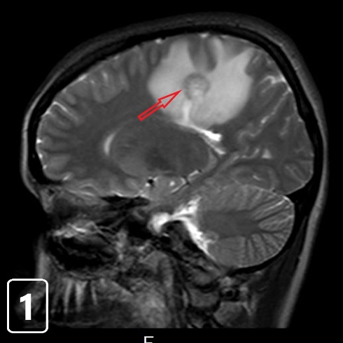
Figure 1 Sagittal T2-weighted magnetic resonance imaging showing a mass lesion with concentric rings located adjacent to the left lateral ventricle and posterior part of the corpus callosum with peripheral vasogenic edema.

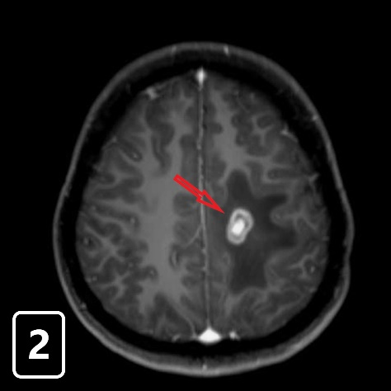
Figure 2 Axial T1-weighted image after administration of gadolinium-diethylenetriaminepentaacetic acid depicts prominent enhancement in the periphery and central area of the lesion.

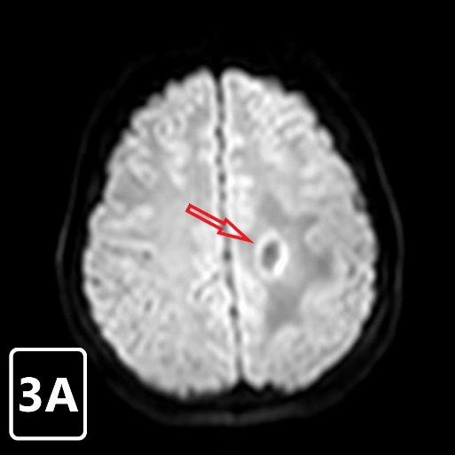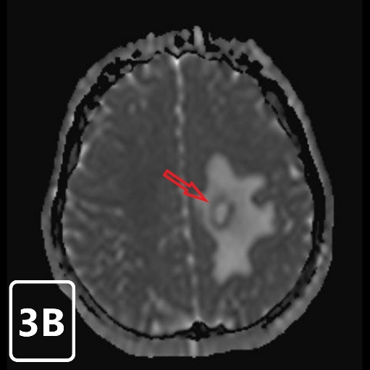
Figure 3 Apparent diffusion co-efficient maps portraying only a thin rim of restricted diffusion at the outer rim of the lesion, with facilitated diffusion centrally and at the outer edema. A: Diffusion weight images shows a thin rim of increased diffusion at the outer rim of the lesion; B: The outer rim is hypointense on the corresponding apparent diffusion coefficient map images, indicating true restriction.

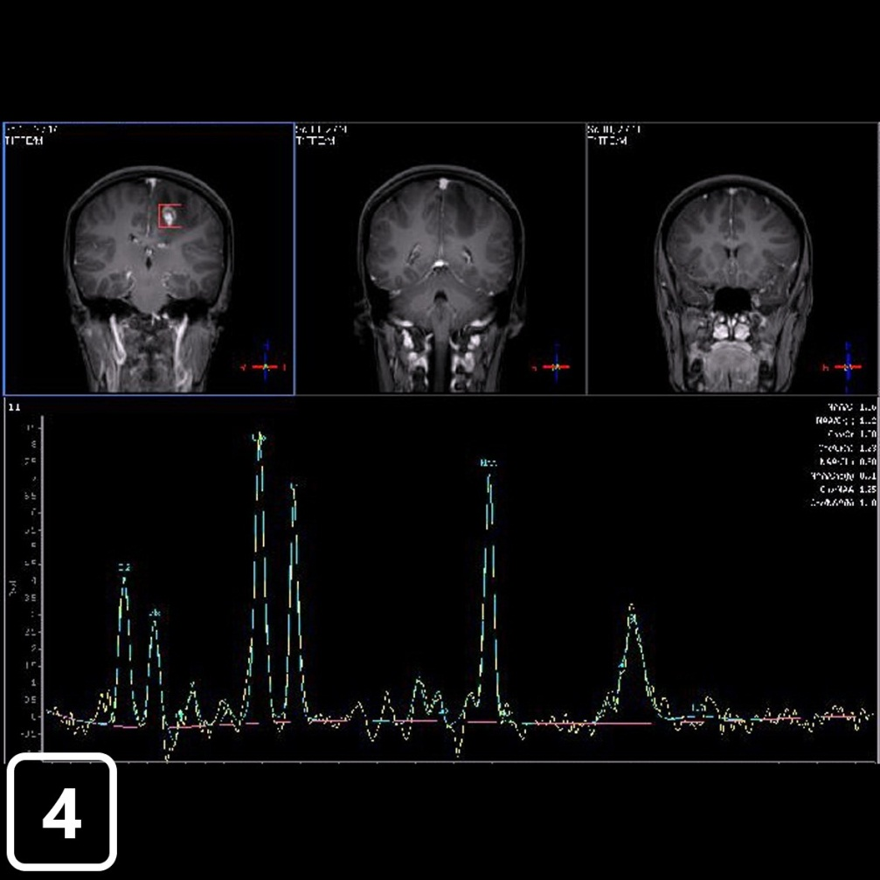
Figure 4 One hundred and forty-four millisecond single-voxel magnetic resonance spectroscopy was obtained from the left-enhancing centrum semiovale lesion. It showed a decrease in the choline/N-acetyl aspartate ratio along with mild lipid and lactate peaks.

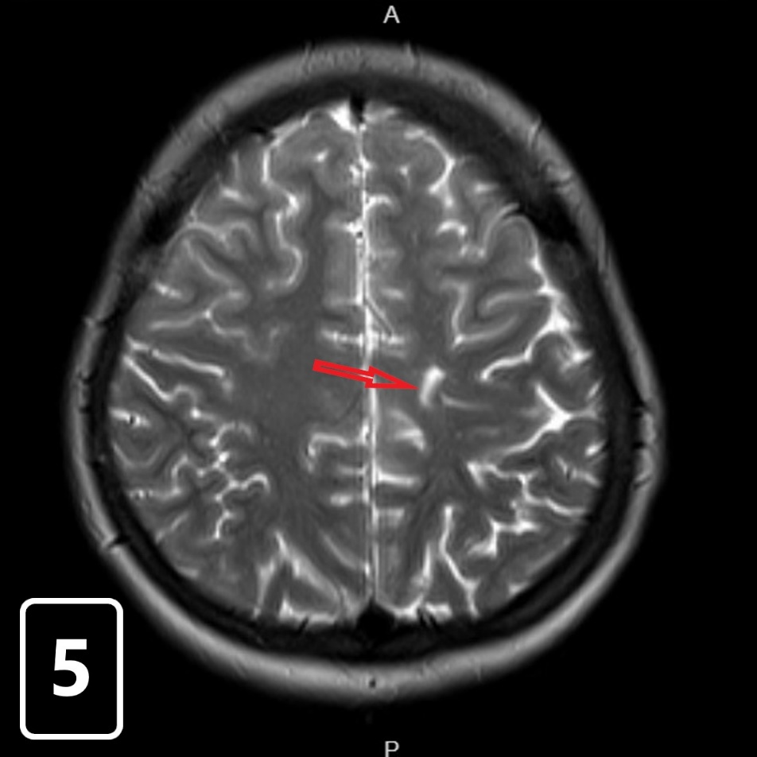
Figure 5 There was only a T2-weighted linear signal intensity with magnetic resonance imaging obtained after nine months.

Table 1 Cases related to Balo’s concentric sclerosis between 1985-2018
Reference | Case number | Gender/age | Clinical presentation | Oligoclonal bands | Coexistence with injuries | Histopathological  examination | Clinical progression
^{[38]} | 1 | F/54 | Progressive Primary | Positive | Y | Y | D
^{[40]} | 1 | M/28 | Relapsing-Remitting | Negative | NR | Y | D
^{[23]} | 1 | M/46 | Progressive Primary | NR | NR | Y | D
 | 2 | M/24 | Progressive Primary | NR | NR | Y | D
 | 3 | M/48 | Progressive Primary | NR | NR | Y | D
 | 4 | F/40 | Progressive Primary | NR | NR | Y | D
 | 5 | F/25 | Progressive Primary | NR | NR | Y | D
 | 6 | F/24 | Progressive Primary | NR | NR | Y | D
^{[41]} | 1 | F/32 | NR | NR | NR | NR | NR
^{[42]} | 1 | F/28 | NR | Negative | NR | N | NR
^{[43]} | 1 | F/52 | Monophase | Negative | N | Y | SH
^{[44]} | 1 | M/4 | Monophase | Negative | N | N | MH
^{[9]} | 1 | F/56 | Relapsing-Remitting | NR | N | Y | MH
^{[7]} | 1 | F/37 | Monophase | NR | NR | Y | SH
 | 2 | F/56 | Monophase | NR | NR | Y | SH
 | 3 | M/42 | Monophase | NR | NR | N | SH
 | 4 | F/33 | Monophase | NR | NR | N | SH
^{[45]} | 1 | F/45 | Progressive Primary | Negative | N | N | LH
 | 2 | M/36 | Progressive Primary | Negative | N | N | LH
^{[39]} | 1 | F/31 | Relapsing-Remitting | NR | Y | N | NR
^{[46]} | 1 | F/24 | Relapsing-Remitting | NR | Y | Y | D
^{[47]} | 1 | F/34 | Monophase | NR | N | Y | NR
^{[11]} | 1 | M/51 | Monophase | Negative | N | Y | SH
 | 2 | F/20 | Monophase | Negative | N | N | CH
 | 3 | M/48 | Monophase | Positive | Y | N | CH
 | 4 | M/38 | Monophase | Negative | N | N | CH
 | 5 | F/15 | Monophase | Negative | Y | N | SH
^{[21]} | 1 | M/43 | Relapsing-Remitting | Negative | Y | N | MH
^{[48]} | 1 | M/NR | Monophase | Negative | N | N | SH
 | 2 | F/38 | Progressive Primary | Positive | N | N | D
 | 3 | M/40 | Monophase | Negative | N | N | SH
^{[25]} | 1 | F/NR | NR | NR | Y | Y | D
 | 2 | F/NR | NR | NR | Y | Y | D
 | 3 | F/NR | NR | NR | Y | Y | D
 | 4 | F/NR | NR | NR | Y | Y | D
 | 5 | F/NR | NR | NR | Y | Y | D
 | 6 | F/NR | NR | NR | Y | Y | D
 | 7 | F/NR | NR | NR | Y | Y | D
 | 8 | F/NR | NR | NR | Y | Y | D
 | 9 | F/NR | NR | NR | Y | Y | D
 | 10 | M/NR | NR | NR | Y | Y | D
 | 11 | M/NR | NR | NR | Y | Y | D
 | 12 | M/NR | NR | NR | Y | Y | D
 | 13 | M/NR | NR | NR | Y | Y | D
 | 14 | M/NR | NR | NR | Y | Y | D
^{[49]} | 1 | F/23 | Relapsing-Remitting | Negative | Y | N | MH
^{[50]} | 1 | F/13 | Relapsing-Remitting | Positive | N | N | SH
^{[35]} | 1 | F/45 | Monophase | NR | N | N | SH
^{[51]} | 1 | F/27 | Relapsing-Remitting | Negative | N | Y | LH
^{[52]} | 1 | F/37 | Monophase | NR | NR | NR | MH
^{[53]} | 1 | F/31 | Monophase | NR | N | N | SH
 | 2 | F/58 | Monophase | NR | N | Y | LH
^{[54]} | 1 | M/26 | Progressive Primary | Positive | N | Y | LH
^{[17]} | 1 | F/52 | Monophase | NR | N | N | SH
 | 2 | M/31 | Monophase | NR | N | N | CH
 | 3 | F/40 | Relapsing-Remitting | NR | Y | N | SH
 | 4 | M/31 | Monophase | NR | N | N | CH
 | 5 | F/23 | Monophase | NR | Y | N | SH
 | 6 | F/44 | Relapsing-Remitting | NR | Y | N | SH
 | 7 | F/43 | Relapsing-Remitting | NR | Y | N | SH
^{[13]} | 1 | F/45 | Relapsing-Remitting | Negative | N | N | SH
^{[55]} | 1 | F/17 | Relapsing-Remitting | Positive | N | N | MH
^{[37]} | 1 | F/57 | Progressive Secondary | Negative | Y | N | NH
^{[12]} | 1 | F/29 | Relapsing-Remitting | NR | Y | N | MH
^{[56]} | 1 | M/37 | Monophase | Negative | Y | N | SH
^{[57]} | 1 | M/49 | Progressive Primary | NR | NR | Y | D
 | 2 | M/23 | Progressive Primary | NR | NR | Y | D
 | 3 | F/28 | Progressive Primary | NR | NR | Y | D
 | 4 | F/40 | Progressive Primary | NR | NR | Y | D
^{[34]} | 1 | F/32 | Monophase | NR | N | N | SH
^{[15]} | 1 | M/26 | Progressive Primary | NR | N | N | SH
^{[58]} | 1 | M/52 | Relapsing-Remitting | NR | N | N | D
^{[59]} | 1 | F/25 | Progressive Primary | NR | NR | N | SH
^{[60]} | 1 | F/21 | Relapsing-Remitting | NR | NR | N | SH
 | 2 | M/45 | Relapsing-Remitting | NR | NR | N | CH
 | 3 | M/35 | Relapsing-Remitting | NR | NR | N | SH
 | 4 | F/38 | Progressive Primary | NR | NR | N | D
 | 5 | M/43 | Progressive Primary | NR | NR | N | MH
 | 6 | F/33 | Progressive Primary | NR | NR | N | MH
^{[61]} | 1 | M/36 | Monophase | Negative | NR | N | MH
 | 2 | F/52 | Progressive Primary | Negative | NR | N | LH
 | 3 | M/56 | Progressive Primary | Positive | NR | N | NH
^{[62]} | 1 | M/24 | Progressive Primary | Negative | NR | N | SH

M: Male; F: Female; Y: Yes; N: No; D: Dead; NR: Not reported; CH: Complete healing; SH: Significant healing; MH: Modarate healing; LH: Little healing; NH: No healing.

