Name of Journal: World Journal of Clinical Cases
Manuscript NO: 64829
Manuscript Type: CASE REPORT

Reversible congestive heart failure associated with hypocalcemia: A case report

Wang C et al. Congestive heart failure induced by hypocalcemia

Chu Wang, Li-Wen Dou, Tian-Bing Wang, Yang Guo

Chu Wang, Tian-Bing Wang, Yang Guo, Trauma Rescue & Treatment Center, Peking University People's Hospital, Beijing 100044, China

Li-Wen Dou, Emergency Department, Peking University People's Hospital, Beijing 100044, China

Author contributions: Wang C and Dou LW contributed equal efforts to this work; Wang C contributed to manuscript drafting and editing; Dou LW was the attending doctor of the patient, reviewed the literature, and contributed to manuscript editing; Wang TB contributed to manuscript supervision; Guo Y was the chief physician of the patient and contributed to manuscript conception and supervision.

Supported by National Key R&D Program of China, No. 2018YFF0301103.

Corresponding author: Yang Guo, MD, Doctor, Trauma Rescue & Treatment Center, Peking University People's Hospital, No. 11 Xizhimen South Boulevard, Xicheng District, Beijing 100044, China. edguoyang@163.com

Received: February 26, 2021
Revised: May 17, 2021
Accepted: October 27, 2021
Published online:

Abstract
BACKGROUND
Hypoparathyroidism is a rare disease that may occur due to primary or secondary etiologies. The estimated incidence in the United States is 24–37/100000 person-years. Congestive heart failure associated with hypocalcemia due to hypoparathyroidism is an even rarer presentation.

CASE SUMMARY
Here, we present a 64-year-old woman with congestive heart failure following hypocalcemia. The patient was transferred to our emergency department with complaints of rapidly progressive dyspnea, shortness of breath and heaviness of the chest for 4 d. She had a history of undergoing thyroidectomy and partial tracheotomy 2 years prior due to a malignant thyroid tumor. Muscle spasms had been present 1 year ago, and cataracts were treated with intraocular lens replacement in both eyes. Most tests were within normal ranges, except serum calcium at 1.33 mmol/L (2.20–2.65 mmol/L), ionized calcium at 0.69 mmol/L (1.15–1.29 mmol/L), and parathyroid hormone at < 1.0 pg/mL (12–88 pg/mL). Echocardiography revealed an ejection fraction of 28.48%. Cardiac function was quickly reversed by restoring the serum calcium concentration. Significant improvements were noted with an ejection fraction of up to 48.50% at follow-up.

CONCLUSION
For patients with potential hypocalcemia, monitoring calcium levels and dealing with hypocalcemia in time to avoid serious complications are important.

Key Words: Hypoparathyroidism; Congestive heart failure; Cardiomyopathy; Parathyroid hormone; Calcium; Echocardiography; Case report

Wang C, Dou LW, Wang TB, Guo Y. Reversible congestive heart failure associated with hypocalcemia: A case report. World J Clin Cases 2021; In press

Core Tip: Hypoparathyroidism-related cardiomyopathy is rare but reversible. We present a rare case of congestive heart failure associated with hypocalcemia in an elderly female with a history of thyroidectomy. The heart failure was reversed rapidly by infusion of calcium gluconate. With the supplementation of calcium, the cardiac function was maintained very well. The patient also presented with a history of cataracts. This case highlights that, for patients with potential hypocalcemia, we need to supplement calcium and closely monitor calcium levels to manage the hypocalcemia in time to avoid serious complications, such as cardiac complications or cataracts.

INTRODUCTION
Hypoparathyroidism is a rare disease that may occur due to primary or secondary etiologies. The level of parathyroid hormone is low; therefore, serum concentrations of calcium and phosphorus cannot be maintained within a narrow normal range, resulting in hypocalcemia and hyperphosphatemia^{[1]}. Hypocalcemia has many manifestations, such as muscle spasms, hair loss, dry skin and brittle nails^{[2]}. Here, we present a case of chronic hypocalcemia-induced cardiomyopathy following hypoparathyroidism, manifesting as congestive heart failure (CHF), which was quickly reversed by restoring the serum calcium concentration (Table 1).

CASE PRESENTATION
Chief complaints
A 64-year-old woman was transferred to the emergency department on October 30, 2020 with complaints of insidious onset but rapidly progressive dyspnea, shortness of breath and heaviness of the chest for 4 d.

History of present illness
The patient had progressive dyspnea and shortness of breath without obvious cause on October 26, 2020. Symptoms were present during activity or at rest, which could last for about 1 h and then resolve spontaneously. There was no fever, cough, sputum, chest pain, hemoptysis, or lower limb edema. On October 29, 2020, she went to a local hospital for symptom aggravation, and congestive cardiac failure was diagnosed. Diuretic treatment was adopted. No effect was observed. Thereafter, she was transferred to our hospital for further evaluation and treatment.

History of past illness
She had a history of undergoing thyroidectomy and partial tracheotomy in 2018 due to a malignant thyroid tumor, followed by iodine-131 radiotherapy every 6 mo thereafter (3 times in total). Intraocular lens implantation was performed in both eyes in 2019 due to cataracts. Muscle spasms were also present in 2019. Diabetes mellitus was noted. She was taking levothyroxine (175 μg qd), calcium carbonate (0.5 g tid) and acarbose (100 mg qd) regularly.

Personal and family history
Personal and family history were unremarkable.

Physical examination
On general physical examination, the patient was conscious with a blood pressure of 140/80 mmHg, respiratory rate of 16 breaths/min, and pulse rate of 104 beats/min. Auscultation revealed reduced air entry in both lungs. Edema of the lower limbs was noted. No cyanosis, clubbing or lymphadenopathy were observed. Abdominal and central nervous system examinations were unremarkable.

Laboratory examinations
The following levels (normal range) were revealed. Routine blood test showed hemoglobin was 116 g/L (115–150 g/L). Biochemical tests revealed serum calcium was 1.33 mmol/L (2.20–2.65 mmol/L), ionized calcium was 0.69 mmol/L (1.15–1.29 mmol/L), phosphorus was 2.43 mmol/L (0.81–1.45 mmol/L), serum magnesium was 0.67 mmol/L (0.7–1.05 mmol/L), albumin was 38.8 g/L (40–55 g/L), total bilirubin was 9.3 µmol/L (3–21 µmol/L), and creatinine was 65 µmol/L (45–84 µmol/L). Infection related markers showed that C-reactive protein was 11.1 mg/L (0–10 mg/L), procalcitonin was 0.071 ng/mL (< 0.5 ng/mL). Cardiac-related markers showed that B-brain natriuretic peptide was 730 pg/mL (0–100 pg/mL). High-sensitivity troponin, myoglobin and creatine kinase MB were within normal ranges. Parathyroid hormone was < 1.0 pg/mL (12–88 pg/mL). The arterial blood gas level was within normal limits.

Imaging examinations
Electrocardiography on admission showed a prolonged corrected QT interval (0.560 s) (Figure 1). Chest computed tomography showed bilateral lung infection, mild enlargement of the left atrium and ventricle, and bilateral pleural and pericardial effusions (Figure 2). Head computed tomography showed bilateral symmetric calcification in the basal ganglia (Figure 3). Echocardiography revealed that the left heart was enlarged with reduced movement of the left ventricle and a small amount of pericardial effusion with an ejection fraction (EF) of 28.48% on admission (Figure 4).

FINAL DIAGNOSIS
The final diagnosis of the presented case was CHF associated with hypocalcemia and hypoparathyroidism. Myocardial infarction and pulmonary heart disease were excluded based on the history, electrocardiography, echocardiography and chest computed tomography.

TREATMENT
The patient was administered a 10% calcium gluconate 100 mL (930 mg of elemental calcium) infusion in 1000 mL of 5% dextrose at a rate of 50 mL/h. Within 2 d, the serum calcium level increased from 1.33 mmol/L to 2.14 mmol/L, ionized calcium level increased from 0.69 mmol/L to 1.11 mmol/L, and echocardiography showed an EF of 40.80% (Figure 5).

OUTCOME AND FOLLOW-UP
The symptoms of CHF were quickly alleviated. The patient was then discharged with oral calcium carbonate (0.75 g qid) and calcitriol (0.25 μg bid). At the 1-mo follow-up, the patient had no symptoms of CHF, and echocardiography showed an EF of 48.50% (Figure 6). At the 4-mo follow-up, the patient had no symptoms of CHF, and echocardiography showed left heart size and left ventricular systolic function returned to normal with no pericardial effusion. EF was 65.60% (Figure 7).

DISCUSSION
Hypoparathyroidism is a relatively uncommon disease. The estimated incidence in the United States is 24–37/100000 person-years^{[3]}. It is characterized by hypocalcemia due to absent or low parathyroid hormone levels. The major function of parathyroid hormone is to maintain the level of serum calcium by binding to cell surface receptors in the bone and kidneys, thereby modulating the calcium concentration in the blood. Approximately 75% of cases are due to neck surgery^{[3]}. Other etiologies include autoimmune diseases or hereditary hypoparathyroidism, such as DiGeorge syndrome, autosomally inherited hypoparathyroidism and autoimmune polyglandular syndrome type I.
Our patient had undergone extensive thyroid surgery 2 years prior and had developed symptoms of hypoparathyroidism for 1 year, even though she was taking calcium carbonate. With prolonged duration of hypocalcemia, dilated cardiomyopathy, a severe complication, developed, which was rapidly and easily reversed by calcium supplementation. Severe complications of hypocalcemia include confusion, muscle spasms, numbness in the hands, feet and face, depression, hallucinations, muscle cramps, brittle nails, and an increased risk of bone fractures. Dilated cardiomyopathy caused by hypocalcemia is very rare but reversible^{[4,5]}. Unfortunately, the reversibility might not be complete^{[4]}. Fortunately, cardiac function was fully restored after supplementation of calcium. Normal levels of calcium are critical for cardiac function and for the reduction in mortality^{[6]}.
The patient underwent surgery in both eyes for cataracts, which might also have been a manifestation of her prolonged hypocalcemia. The proposed mechanism of cataract formation from hypocalcemia is membrane damage due to low calcium levels in the aqueous humor and increased sodium levels in the lens^{[7]}. Sharp vigilance about the possibility of cataracts induced by hypocalcemia should be maintained, although diabetes mellitus may also contribute to cataract formation^{[8]}.
In conclusion, prolonged hypocalcemia should be avoided, especially in patients after thyroid surgery. For patients with hypoparathyroidism, serum calcium be monitored along with regular ophthalmic checks. CHF may develop following hypoparathyroidism and cataracts.

CONCLUSION
For patients with potential hypocalcemia, we need to supplement calcium and closely monitor serum calcium levels to manage hypocalcemia in time to avoid serious complications, such as cardiac complications or cataracts.

REFERENCES
1 Bilezikian JP. Hypoparathyroidism. J Clin Endocrinol Metab 2020; 105: 1722-1736 [PMID: 32322899 DOI: 10.1210/clinem/dgaa113]
2 Hakami Y, Khan A. Hypoparathyroidism. Front Horm Res 2019; 51: 109-126 [PMID: 30641528 DOI: 10.1159/000491042]
3 Abate EG, Clarke BL. Review of Hypoparathyroidism. Front Endocrinol (Lausanne) 2016; 7: 172 [PMID: 28138323 DOI: 10.3389/fendo.2016.00172]
4 Newman DB, Fidahussein SS, Kashiwagi DT, Kennel KA, Kashani KB, Wang Z, Altayar O, Murad MH. Reversible cardiac dysfunction associated with hypocalcemia: a systematic review and meta-analysis of individual patient data. Heart Fail Rev 2014; 19: 199-205 [PMID: 23355181 DOI: 10.1007/s10741-013-9371-1]
5 Saini N, Mishra S, Banerjee S, Rajput R. Hypocalcemic cardiomyopathy: a rare presenting manifestation of hypoparathyroidism. BMJ Case Rep 2019; 12: e229822 [PMID: 31519715 DOI: 10.1136/bcr-2019-229822]
6 Miura S, Yoshihisa A, Takiguchi M, Shimizu T, Nakamura Y, Yamauchi H, Iwaya S, Owada T, Miyata M, Abe S, Sato T, Suzuki S, Oikawa M, Yamaki T, Sugimoto K, Kunii H, Nakazato K, Suzuki H, Saitoh S, Takeishi Y. Association of Hypocalcemia With Mortality in Hospitalized Patients With Heart Failure and Chronic Kidney Disease. J Card Fail 2015; 21: 621-627 [PMID: 25982827 DOI: 10.1016/j.cardfail.2015.04.015]
7 Daba KT, Weldemichael DK, Mulugeta GA. Bilateral hypocalcemic cataract after total thyroidectomy in a young woman: case report. BMC Ophthalmol 2019; 19: 233 [PMID: 31752761 DOI: 10.1186/s12886-019-1224-9]
8 Ang MJ, Afshari NA. Cataract and systemic disease: A review. Clin Exp Ophthalmol 2021; 49: 118-127 [PMID: 33426783 DOI: 10.1111/ceo.13892]

Footnotes
Informed consent statement: Written consent was obtained from the patient.

Conflict-of-interest statement: The authors declare no conflicts of interest.

CARE Checklist (2016) statement: The authors have read the CARE Checklist (2016), and the manuscript was prepared and revised according to the CARE Checklist (2016).

Open-Access: This article is an open-access article that was selected by an in-house editor and fully peer-reviewed by external reviewers. It is distributed in accordance with the Creative Commons Attribution NonCommercial (CC BY-NC 4.0) license, which permits others to distribute, remix, adapt, build upon this work non-commercially, and license their derivative works on different terms, provided the original work is properly cited and the use is non-commercial. See: http://creativecommons.org/Licenses/by-nc/4.0/

Manuscript source: Unsolicited manuscript

Peer-review started: February 26, 2021
First decision: May 11, 2021
Article in press:

Specialty type: Cardiac and cardiovascular systems
Country/Territory of origin: China
Peer-review report’s scientific quality classification
Grade A (Excellent): 0
Grade B (Very good): 0
Grade C (Good): C
Grade D (Fair): D
Grade E (Poor): 0

P-Reviewer: Kharlamov AN S-Editor: Liu M L-Editor: A P-Editor: Liu M

Figure Legends
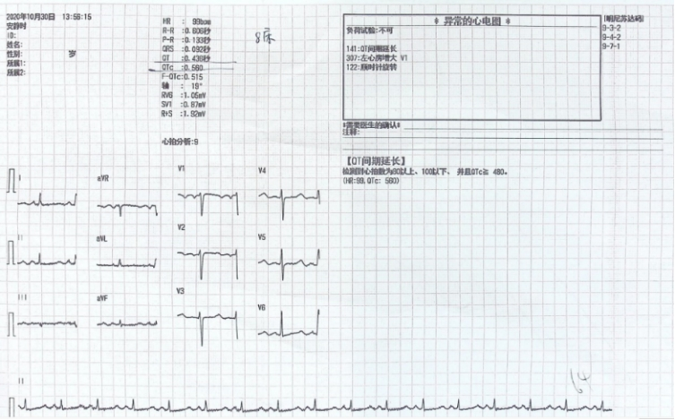
Figure 1 Electrocardiography on admission showed a prolonged QT interval corrected for heart rate. The QT interval corrected for heart rate equaled 0.560 s.
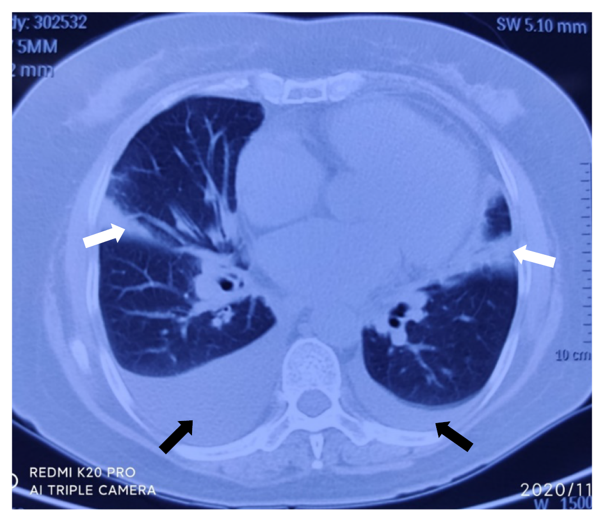
Figure 2 Chest computed tomography on admission showed bilateral lung infection and bilateral pleural effusions. Black arrows showed bilateral pleural effusion; White arrows showed bilateral lung infection.
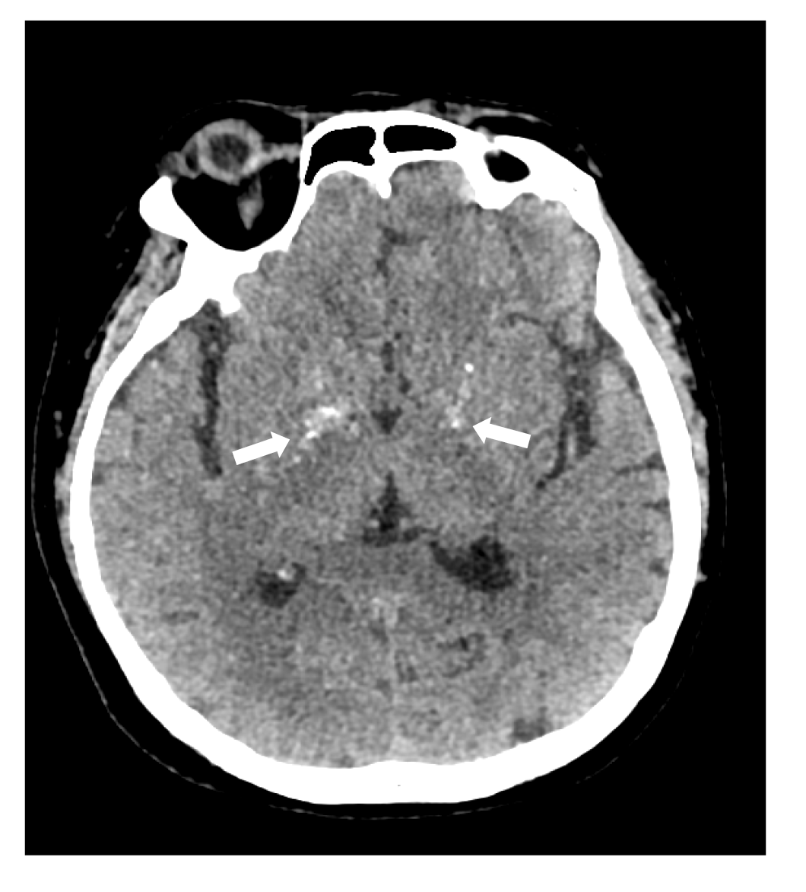
Figure 3 Head computed tomography on admission showed symmetric calcification in basal ganglia. No sign of infraction or hemorrhage was observed; White arrows: Calcification.

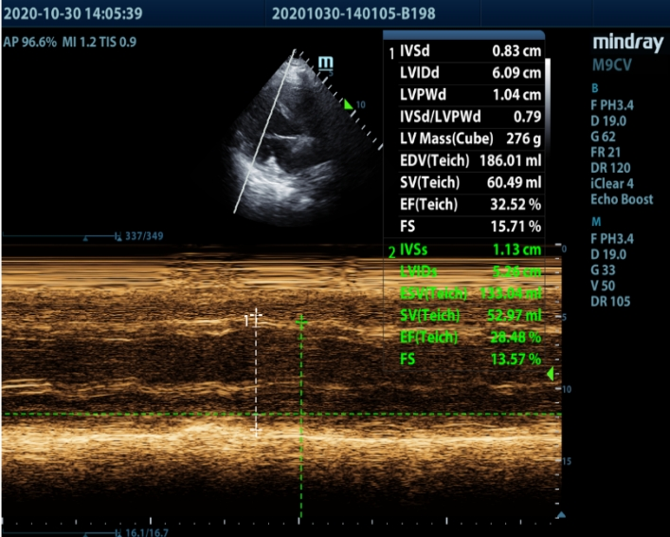
Figure 4 Echocardiography on admission. Left ventricular enlargement and left ventricular systolic function was significantly reduced. The ejection fraction was 28.48%.

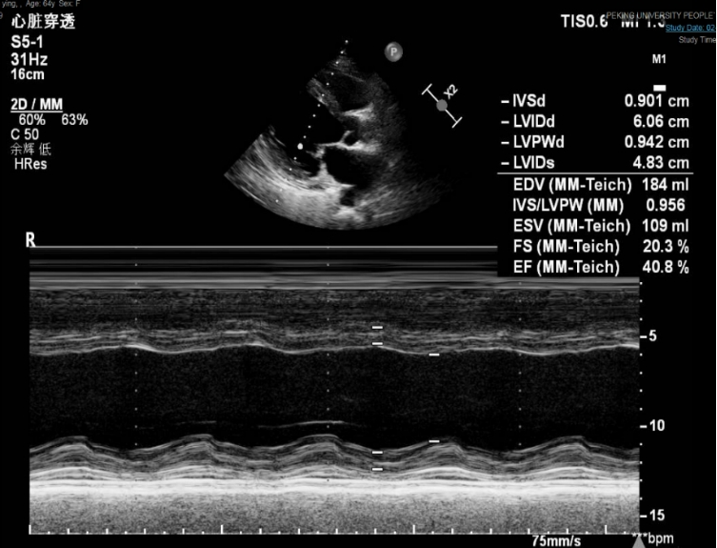
Figure 5 Echocardiography 2 d after admission. Left ventricular systolic function improved after calcium supplementation. The ejection fraction was 40.80%.

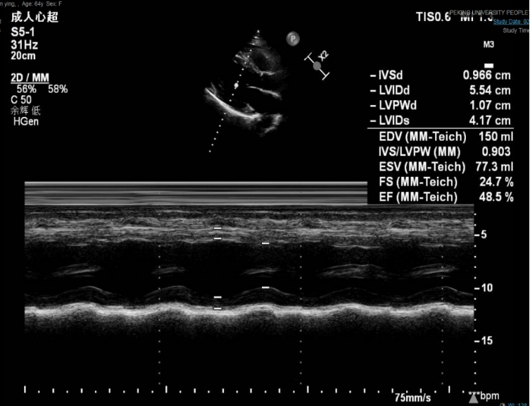
Figure 6 Echocardiography at the 1-mo follow-up. The size and systolic function of the left ventricle continued to recover. The ejection fraction was 48.50%.

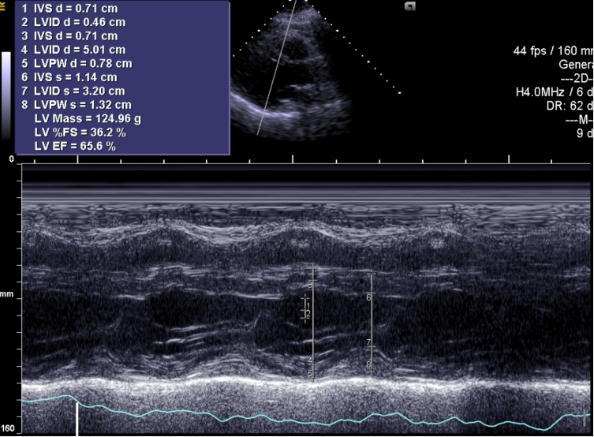
Figure 7 Echocardiography at the 4-mo follow-up. Left ventricular size and left ventricular systolic function returned to normal. The ejection fraction was 65.60%.
Table 1 Timeline of the case
Timeline | Events | Additional information
2018 | Thyroidectomy and partial tracheotomy | Iodine-131 radiotherapy every six months thereafter (3 times in total)
June 2019 | Muscle spasms | Intraocular lens implantation in both eyes due to cataracts
October 26, 2020 | Rapidly progressive dyspnea, shortness of breath | Treated for CHF at a local hospital without any effect
October 30, 2020 | Transferred to our ER department | -
November 1, 2020 | Symptoms resolved greatly | Administration of a 10% calcium gluconate
December 2, 2020 | Follow up 1 mo later | Oral calcium carbonate (0.75 g qid) and calcitriol (0.25 μg bid)
CHF: Congestive heart failure.

