Name of Journal: World Journal of Clinical Cases
Manuscript NO: 84346
Manuscript Type: CASE REPORT

Flared inflammatory episode transforms advanced myelodysplastic syndrome into aplastic pancytopenia: A case report and literature review

Ju B et al. Transformation of MDS into SAA feature

Bo Ju, Nuan-Nuan Xiu, Jia Xu, Xiao-Dong Yang, Xiao-Yun Sun, Xi-Chen Zhao

Bo Ju, Nuan-Nuan Xiu, Jia Xu, Xiao-Dong Yang, Xiao-Yun Sun, Xi-Chen Zhao, Department of Hematology, The Central Hospital of Qingdao West Coast New Area, Qingdao 266555, Shandong Province, China

Author contributions: Zhao XC developed the idea; Ju B and Xiu NN analyzed the data and drafted the manuscript; Ju B, Xiu NN, Xu J, and Yang XD participated in the treatment; Sun XY supervised the treatment; Zhao XC revised the final manuscript; All authors have read and approved the final version of the manuscript.

Supported by The Specialized Scientific Research Fund Projects of The Medical Group of Qingdao University, No. YLJT20201002.

Corresponding author: Xi-Chen Zhao, MD, Chief Physician, Department of Hematology, The Central Hospital of Qingdao West Coast New Area, No 9, Huangpujiang Road, Qingdao 266555, Shandong Province, China. zhaoxc7150@163.com

Received: March 10, 2023
Revised: April 21, 2023
Accepted: May 22, 2023
Published online:

Abstract
BACKGROUND
Myelodysplastic syndrome (MDS) is a hematological neoplasm, and an increase in myeloblasts is representative of leukemic hematopoiesis in advanced MDS. Low-risk MDS usually exhibits deranged autoimmunity resembling that of aplastic anemia (AA), whereas advanced MDS is characterized by a phenotype of immune exhaustion. MDS can be normo/hyperplastic or hypoplastic. Generally, bone marrow cellularity and myeloblasts increase with disease progression. Transformation from advanced MDS to AA-like syndrome with leukemic cell regression has not previously been reported.

CASE SUMMARY
A middle-aged Chinese woman had a 4-year history of leukocytopenia. Six months prior to admission, the patient developed gradually worsening fatigue and performance status. The leukocytopenia further progressed. She was diagnosed with MDS with excess blasts-2 based on increased bone marrow cellularity and an increased percentage of myeloblasts on marrow and blood smears, an increased percentage of cluster of differentiation (CD)34+CD33+ progenitors in immunotyping analysis, a normal karyotype in cytogenetic analysis, and the identification of somatic mutations in CBL, KMT2D and NF1 in molecular analysis. Initially, neutropenia was the predominant hematological abnormality, with mild anemia and thrombocytosis, and the degree of fatigue was far more severe than the degree of anemia. In the following months, the patient experienced several febrile episodes. Intravenous antibiotic treatments were able to control the febrile episodes, but the elevated inflammatory indices persisted. The hematological parameters dramatically fluctuated with the waxing and waning of the inflammatory episodes. With recurrent flares of the inflammatory condition, agranulocytosis and severe anemia developed, with mild thrombocytopenia. During the patient’s hospitalization, computed tomography (CT) scans revealed the presence of extensive inflammatory lesions involving the lungs, mediastinum, pleura, gastrointestinal tract, peritoneum and urinary tract, with imaging features suggestive of the reactivation of disseminated tuberculosis. Reevaluation of the bone marrow smears revealed that the cellularity became hypoplastic, and the leukemic cells regressed, suggesting that both normal and leukemic hematopoiesis had been heavily suppressed. Immunological analysis of the bone marrow samples revealed a decreased percentage of CD34+ cells and an immunological signature resembling that of severe AA (SAA), confirming the regression of the leukemic cells by autoimmune-mediated attacks. The patient demonstrated resistance to multiple drugs, including antituberculotics, recombinant human granulocyte colony-stimulating factor, broad-spectrum antibiotics, voriconazole, ganciclovir, immune suppressants, eltrombopag and intravenous immunoglobulin, which further worsened the hematological injury and patient’s performance status. The patient eventually died of overwhelming infection and multidrug resistance.

CONCLUSION
Advanced MDS can transform to aplastic cytopenia with leukemic cell regression and an immunological signature of SAA during inflammatory flare-ups.

Key Words: Myelodysplastic syndrome; Aplastic anemia; Inflammatory stress; Leukemic cell regression; Antileukemic; Case report

Ju B, Xiu NN, Xu J, Yang XD, Sun XY, Zhao XC. Flared inflammatory episode transforms advanced myelodysplastic syndrome into aplastic pancytopenia: A case report and literature review. World J Clin Cases 2023; In press

Core Tip: In patients with myelodysplastic syndrome, bone marrow cellularity and the percentage of myeloblasts generally increase with disease progression. Transformation from advanced myelodysplastic syndrome to aplastic cytopenia with leukemic cell regression has not previously been reported. Here, we report a case of this disease phenotypic transformation. The cause for the disease transformation was a disseminated inflammatory condition involving the lungs, mediastinum, pleura, gastrointestinal tract, peritoneum and urinary tract. This case study demonstrated that in myeloid neoplasms, disseminated inflammatory conditions can suppress both normal and leukemic hematopoiesis.

INTRODUCTION
Myelodysplastic syndrome (MDS) is a hematological clonal disease caused by somatic mutations in myeloid neoplasm-associated genes, resulting in malignant proliferation and ineffective hematopoiesis. Clinically, impaired blood cell production leads to peripheral cytopenia and resultant symptoms. Morphologically, MDS is characterized by one or more lineages of marrow dysplasia, and an increased percentage of myeloblasts and cluster of differentiation (CD)34+ cells is representative of leukemic hematopoiesis and the most significant dysplastic feature in the diagnosis and risk stratification. The identification of somatic mutations in myeloid neoplasm-associated genes is helpful in determining malignant hematopoiesis^{[1-3]}. Aplastic anemia (AA) is a disease of hematopoietic failure caused by cellular immune-mediated destructive impairment of hematopoietic progenitor cells. Decreased hematopoietic volume and deranged autoimmunity are the underlying pathophysiology in AA development and diagnosis^{[4-6]}. AA is generally considered a benign hematological disorder. By definition, AA and MDS are distinctive disease entities. However, studies using modern techniques have demonstrated that AA and MDS exhibit overlapping signatures and an intrinsic relationship with respect to laboratory abnormalities and prognostic outcomes^{[7]}. Patients with definitively diagnosed AA may have somatic mutations typically seen in MDS^{[8,9]}, and patients with low-risk MDS, particularly hypoplastic MDS, exhibit an immunological signature typically seen in AA^{[10-11]}, indicating that immune function may impact the disease phenotype.
MDS can be normo/hyperplastic or hypoplastic, and the bone marrow cellularity and percentage of leukemic cells generally increases with disease progression. The increased leukemic cells are usually ascribed to leukemic cell expansion via the acquisition of proliferative advantage or escape from immune-mediated attacks^{[8,9,12,13]}. Although disease phenotypic transformation from severe AA (SAA) to myeloid neoplasms following antithymocyte globulin (ATG) and cyclosporine-based immunosuppressive therapy (IST) is well recognized, phenotypic transformation from advanced MDS to aplastic cytopenia with regression of leukemic cells has not been reported. In this manuscript, we report a patient with definitively diagnosed MDS with excess blasts-2 (MDS-EB-2) who exhibited disease phenotypic transformation from advanced MDS into aplastic cytopenia with the development of deranged cellular immune-mediated responses and concomitant leukemic cell regression. Due to the slowly progressive infectious disorder, we were able to document the transformation process. Initially, the patient presented with neutropenia, mild anemia and thrombocytosis. During the following 6 mo, the patient experienced several febrile episodes; intravenous administration of antibiotics was able to control the febrile episodes, but the elevated inflammatory indices persisted. The hematological parameters fluctuated with the waxing and waning of the inflammatory condition. With recurrent flares of the inflammatory condition, aplastic pancytopenia developed, with cytological and immunological features resembling those of SAA. Computed tomography (CT) scans revealed extensive inflammatory lesions involving the lungs, mediastinum, pleura, gastrointestinal tract, peritoneum and urinary tract, with imaging features suggestive of the reactivation of disseminated tuberculosis. However, the patient exhibited multidrug resistance, which further worsened the hematological injury and patient’s performance status.

CASE PRESENTATION
Chief complaints
Worsening fatigue and progressive cytopenia for 6 mo.

History of present illness
Six months prior to admission to our hospital, a 46-year-old Chinese woman sought medical help at another hospital due to gradually worsening fatigue and leukocytopenia. The patient was diagnosed with MDS-EB-2 based on increased bone marrow cellularity and an increased percentage of myeloblasts (representing 13% of the total nucleated cells) on morphological evaluation of bone marrow smears (Figure 1A) and slices (Figure 1B). The diagnosis was further supported by an increased percentage of CD34+CD33+ hematopoietic progenitors (7.18%) on immunological analysis, a normal 46;XX karyotype on cytogenetic analysis, and the identification of somatic mutations in CBL [a variant allele fraction (VAF) of 3.5%], KMT2D (a VAF of 40.1%) and NF1 (a VAF of 44.5%) on molecular biological analysis. At the time of diagnosis, complete blood count (CBC) revealed the following results: white blood cells (WBCs), 1.74 × 10⁹/L; absolute neutrophil count, 0.38 × 10⁹/L; red blood cells (RBCs), 3.02 × 10¹²/L; hemoglobin level (Hb), 102 g/L; platelets (Plts), 356 × 10⁹/L; and absolute reticulocyte count (Ret), 64.26 × 10⁹/L. Neutropenia was the predominant hematological abnormality, with mild anemia and thrombocytosis. The degree of fatigue was far more severe than the degree of anemia. The patient was treated with Chinese herbs, which failed to achieve any hematological improvement and resulted in worsening cytopenia. During the following 6 mo, the patient experienced several febrile episodes. Intravenous antibiotics were able to control the febrile episodes, but the elevated inflammatory indices persisted, and the inflammatory disease lacked localized signs and symptoms. Various imaging modalities and laboratory tests failed to determine the location or etiology of the inflammatory condition. During the inflammatory episodes, neutropenia worsened, frequently accompanied by a dramatic reduction in platelet count. After the febrile episodes were controlled, the hematological parameters were significantly improved. With recurrent flares of the inflammatory condition, thrombocytopenia and severe anemia emerged, and neutropenia further worsened. Four hours prior to admission, a febrile episode recurred, with the highest body temperature being 39.2 °C. During this febrile episode, the patient was transferred to our hospital.

History of past illness
The patient had a 4-year history of leukocytopenia, which was found during physical check-ups. She denied any history of cardiovascular, endocrine, respiratory, gastrointestinal, urogenital or musculoskeletal diseases.

Personal and family history
No family history of inherited, hematological, autoimmune or neoplastic diseases was recorded.

Physical examination
The patient was 154 cm tall and weighed 42.5 kg. Upon admission, her vitals were as follows: Temperature 39.0 °C, respiratory rate 19 breaths per minute, heart rate 80 beats per minute, and blood pressure 133/78 mmHg. Physical examination revealed mild tenderness of the right iliac fossa. No significant abnormalities of the nervous, respiratory, cardiovascular, or musculoskeletal systems were found.

Laboratory examinations
Routine laboratory examinations: At the emergency department, CBC revealed the following: WBCs, 0.47 × 10⁹/L; ANC, 0.17 × 10⁹/L; RBC, 1.07 × 10¹²/L; Hb, 59 g/L; Plts, 94 × 10⁹/L; Ret, 12.2 × 10⁹/L; and C-reactive protein (CRP), 59.27 mg/L. The coagulation profile demonstrated an elevated plasma fibrinogen level (4.41 g/L), with a D-dimer of 0.92 mg/L. Uranalysis revealed an occult blood of 2+, protein of 1+, RBC of 186/μL and WBC of 45/μL. Feces examination revealed a mucopurulent bloody stool, with an occult blood of 3+, and With the exception of a slightly decreased serum albumin level and slightly increased serum levels of lactate dehydrogenase, hydroxybutyric dehydrogenase, and β2-microglobulin, no other obvious abnormalities were detected on biochemical tests. The immunological tests for hepatitis A, B, and C virus and human immunodeficiency virus were negative. Repeated blood cultures were negative for growth of both Gram-positive and Gram-negative microbes. Antinuclear antibodies and neoplastic biomarkers were also negative, but an antineutrophil cytoplasmic antibody was positive. A positive interferon-gamma (IFN-γ) release assay raised the suspicion of tuberculosis infection. However, acid-fast bacilli could not be identified upon repeated sputum examinations.

Specific laboratory examinations for blood diseases: After hospitalization, the patient’s neutropenia and anemia worsened further, and there was significant progression of thrombocytopenia. Coomb’ test reported a negative resort, which ruled out the peripheral antibody-mediated pathogenic process. Reevaluation of the bone marrow samples was performed. Cytological evaluation of the bone marrow smears (Figure 1C), and slices (Figure 1D) indicated that the cellularity became heavily hypoplastic and the hematopoietic volume was significantly reduced, with an increased percentage of various stages of nucleated erythrocytes (61%) and the absence of morphological dysplasia. Myeloblasts were rarely visualized, indicative of regression of the leukemic clones. Megakaryocytes were also rarely visualized, confirming the decreased platelet production. Immunological analysis revealed significantly decreased percentages of CD34+ cells (0.51%), CD19+ cells (5.43%), and CD4+ cells (7.01%) and significantly increased percentages of CD71+ cells (43.73%), CD8+ cells (18.25%), and CD5+CD7+ cells (7.64%), an immunological signature consistent with autoimmune hematopoietic failure. The elevated serum levels of interkin (IL)-6, IFN-γ and tumor necrosis factor (TNF)-α also suggested the development of dysregulated cellular immune responses. CD55 and CD59 expression was within the normal levels (97.25% and 96.63 on erythrocytes and 99.42% and 98.06% on granulocytes). Cytogenetic analysis revealed a normal 46,XX karyotype. Molecular analysis revealed the presence of somatic mutations in CBL (2.8%), KMT2D (37.6%) and NF1 (44.6%), consistent with the mutations detected when the patient was initially diagnosed with MDS-EB-2, but the VAFs were slightly decreased. These morphological, immunological, and cytogenetic analyses favored a diagnosis of SAA^{[4-6]}, but the presence of myeloid neoplasm-associated somatic mutations and the medical history suggested a diagnosis of hMDS^{[1,2,9,10]}.

Imaging examinations
Chest (Figure 2) and abdominal (Figure 3) CT scans revealed the presence of extensive inflammatory lesions involving the lungs, mediastinum, pleura, gastrointestinal tract, peritoneum and urinary tract. The imaging features were suggestive of the reactivation of disseminated tuberculosis^{[14,15]}. Endoscopic examination revealed the presence of successional inflammatory lesions extending from the terminal ileum to the sigmoid colon and a mixture of old and novel cicatricial tissues in the terminal ileum and cecum. The pathological examination reported mucositis. The inflammatory nature of the ileocecal lesions was corroborated using positron emission tomography (PET)/CT.

FINAL DIAGNOSIS
The patient was diagnosed with hMDS with suspected tuberculosis reactivation.

TREATMENT
In the following 6 mo of hospitalization, the patient was treated with the standard first-line antituberculotics (consisting of rifampicin, isoniazid, ethambutol and pyrazinamide) for suspected tuberculosis infection, recombinant human granulocyte colony-stimulating factor (rhG-CSF) for agranulocytosis, sequential administration of intravenous antibiotics (piperacillin-tazobactam, kanamycin, levofloxacin, vancomycin, voriconazole) for suspected bacterial infections due to agranulocytosis, ganciclovir for possible herpesvirus infections (because herpesvirus infections have been reported to be common microbes in the pathogenesis of immune-mediated hematopoietic failure), glucocorticoids and cyclosporine for immune-mediated pathophysiology, eltrombopag to promote autologous hematopoiesis, intravenous immunoglobulin for possible parvovirus B19 infection (because parvovirus B19 infection has been reported to be a common microbe in the pathogenesis of immune-mediated hematopoietic failure), and polyethylene glycol and electrolyte oral solution (a gut-cleansing preparation) to rapidly remove pathogenic bacteria and their endotoxins in the intestinal lumen.

OUTCOME AND FOLLOW-UP
The patient demonstrated resistance to these treatment modalities, and multidrug resistance resulted in the aggravation of the systemic and gut inflammatory condition, indicating that the gut inflammatory disease was likely complicated by other unknown and intractable causative agents. The patient’s hematopoietic injury and performance status further deteriorated, and she developed severe aplastic pancytopenia, cachexia, and platelet transfusion refractoriness. Because of the poor performance status and platelet transfusion refractoriness, surgical interventions were denied. The patient eventually died of systemic inflammatory response syndrome and cachexia.

DISCUSSION
In this case study, we described a patient with definitively diagnosed MDS-EB-2 who, following repeated flares of a disseminated inflammatory disease, developed severe aplastic cytopenia, with regression of the leukemic cells.
The definitive diagnosis of MDS-EB-2 was made at another hospital based primarily on the increased percentage of myeloblasts and CD34+ hematopoietic progenitors and the identification of myeloid neoplasm-associated somatic mutations in bone marrow samples, which are the most reliable markers for leukemic hematopoiesis and the most valuable parameters in MDS diagnosis and risk stratification^{[1,2,11]}. Initially, neutropenia was the predominant hematological abnormality, with concurrent mild anemia and thrombocytosis. The degree of fatigue was far more severe than the degree of anemia, strongly indicative of an active inflammatory condition leading to systemic inflammatory symptoms. In the following months, the inflammatory response worsened, her performance status deteriorated, and aplastic cytopenia developed. She experienced several febrile episodes. During the febrile episodes, neutropenia worsened, uniformly accompanied by a significant decrease in the platelet count. Upon resolution of each febrile episode, the hematopoietic parameters were significantly improved, strongly suggesting that the aggravated inflammatory reaction dramatically affected hematological function. Although intravenously administered antibiotics were able to control the febrile episodes, the elevated inflammatory indices persisted, indicating the presence of an active chronic inflammatory disease. The inflammatory disease and underlying etiology were not definitively diagnosed and effectively managed, resulting in persistent neutropenia. When sent to our hospital, the patient presented with a febrile episode. Pancytopenia emerged with agranulocytosis and severe anemia, but thrombocytopenia was mild. CT scans revealed the presence of extensive inflammatory lesions involving the lungs, mediastinum, pleura, gastrointestinal tract, peritoneum and urinary tract, with imaging features suggestive of the reactivation of disseminated tuberculosis. The IFN-γ release assay and endoscopic examination also supported the diagnosis of tuberculosis infection. The inflammatory nature of the ileocecal lesions was corroborated using PET/CT. However, the patient failed to respond to treatments with rhG-CSF, antituberculotics, broad-spectrum antibiotics, voriconazole, ganciclovir, intravenous immunoglobulin and gut-cleansing preparation (GCP).
After admission, the hematological profile rapidly deteriorated, and the patient developed severe pancytopenia. Reevaluation of the bone marrow smears was performed. Cytological evaluation demonstrated that the cellularity had become hypoplastic, and previously increased myeloblasts was no longer evident. Immunological analysis confirmed the decreased percentage of myeloblasts and cellular immune-mediated autoimmunity. These cytological and immunological features were similar to those of SAA. Based on the disease progression, it could be interpreted that the recurrent febrile episodes and the aggravated systemic inflammatory response were responsible for suppression of both normal and leukemic hematopoiesis, resulting in the disease phenotypic transformation from advanced MDS to SAA feature.
This case study revealed the following attractive points:
First, a severe inflammatory condition can heavily suppress hematopoietic function and reduce bone marrow cellularity in predisposed individuals, resulting in the development of autoimmune hematopoietic failure - whether it was called SAA or hMDS. It is not surprising in light of hematopoietic regulation mechanisms. Blood cells themselves are immune cells and are generated from the division and maturation of hematopoietic stem cells. Their production is regulated largely in response to pathogenic invasion and antigen stimulation. When confronting an acute and limited microbial infection, blood cell production switches the differentiation to replenish effector immune cells to fight the ongoing infection at the expense of self-renewal capacity of hematopoietic progenitors^{[16,17]}. After pathogenic antigens are cleared, the activated host immune system quickly returns to the homeostatic state, and blood cell production quickly returns to steady-state hematopoiesis. However, persistent and intensive antigen stimulation can perturb the immune regulatory mechanisms, thereby generating a large number of persistently activated immune cells and secreting a large amount of inflammatory mediators. Activated cytotoxic T lymphocytes (CTLs) and increased levels of inflammatory mediators result in the suppression of autologous hematopoiesis and the exhaustion of hematopoietic progenitors^{[18,19]}, especially in the setting of genetically damaged hematopoietic progenitors and a neoplastic molecule-initiated marrow immune-active environment^{[20-22]}. In neoplastic molecule-initiated bone marrow immune-active environment, the overexpressed human leukocyte antigen-DR (HLA-DR), Toll-like receptors (TLRs) and Fas molecules on hematopoietic progenitors enhance the immunological responses to exogenous antigen stimulation^{[20-24]}. However, the phenomenon observed in this case study has not previously been reported, because in most cases, the development of severe aplastic cytopenia in end-stage myeloid neoplasms progresses very quickly, and patients rapidly die of overwhelming infections and cytokine cascades. Another reason is likely because bone marrow reevaluations are seldom performed in these definitively diagnosed MDS patients.
Second, leukemic cells can regress during inflammatory flare-ups, suggesting that autoimmune-mediated hematopoietic failure likely functions as an inflammatory stress-fueled antileukemic mechanism. With recurrence of the febrile episodes and aggravation of the inflammatory condition, together with reduced bone marrow cellularity, the morphologically evidenced leukemic clones disappeared. Leukemic cell regression suggests the preferential suppression of malignant proliferation and represents an inflammatory stress-fueled antileukemic activity. In this stage, a deranged autoimmune signature resembling that seen in patients with SAA was observed^{[10-12]}. AA is generally considered a benign hematological disorder^{[4,5]}, whereas MDS is an unequivocal hematological neoplasm, especially when presenting with an increased percentage of myeloblasts^{[1-3]}. However, with the widespread application of next-generation sequencing techniques in the diagnosis and risk stratification of hematological diseases, patients with definitively diagnosed AA have been found to have somatic mutations that play well-known roles in neoplastic pathogenesis. Approximately 15% of AA patients have neoplastic cytogenetic abnormalities, and approximately 30% of AA patients have myeloid neoplasm-associated somatic mutations^{[8,9]}. The percentage of somatic mutations increases up to 60% after ATG and cyclosporine-based IST, along with an increase in the leukemic burden^{[25]}. Approximately 10%-15% of AA patients undergo leukemic transformation after ATG and cyclosporine-based IST, some of whom progress to myeloid neoplasms during IST or within 6 mo following IST^{[25-27]}, strongly suggesting that the leukemic clones preexisted but were concealed in the AA stage and rapidly expanded following IST. Furthermore, AA and low-risk MDS, especially hypoplastic MDS, share similar immunological features, that is, cellular immune-mediated responses^{[10-12]}. AA and low-risk MDS also share similar prognostic outcomes. Together, this evidence suggests that AA and MDS likely have an intrinsic relationship with respect to their pathogenesis and immunological signature. In organ-specific autoimmune diseases, the primary immune-active bone marrow environment is induced by CTL recognition of neoplastic antigens or by innate immune cell recognition of damage-associated molecules on hematopoietic progenitors, whereas active chronic inflammatory conditions fuel antileukemic activities^{[28,29]} in the setting of overexpression of HLA-DR, TLRs and Fas molecules on damaged hematopoietic progenitors^{[20,21,24]}. With successful treatment of the inflammatory condition, the leukemic clone undergoes expansion, and morphologically evidenced myeloid neoplasms emerge. The same effect can also be achieved by ATG-based IST. When the inflammatory conditions are aggravated, the leukemic clones are concealed, and the morphologically evidenced myeloid neoplasms disappeared.
Third, neutropenia can be the primary hematological abnormality in immune-mediated hematopoietic failure and myeloid neoplasms under active chronic inflammatory conditions. The patient in our case study had a 4-year history of leukocytopenia before she was diagnosed with MDS-EB-2. With aggravation of the inflammatory condition, a decrease in granulocytes was the earliest and most prominent hematological abnormality, with poor sensitivity to rhG-SCF, which was also indicative of the preferential suppressive activity on myelopoiesis and autoimmune responses to myeloid progenitors. Autoimmune neutropenia can be preexisting for many years before the development of a morphologically evidenced myeloid neoplasm, and in this stage, the leukemic clones are concealed. The bone marrow may exhibit hypocellularity, with cytological and immunological features resembling those of immune-mediated hematopoietic failure^{[30,31]}. Poor response to rhG-SCF treatment predicts an increased risk for transformation to myeloid neoplasms^{[31]}. In fact, a significant proportion of patients with myeloid neoplasms present with neutropenia upon initial diagnosis or during disease progression, and these patients frequently exhibit longer survival.
Finally, gastrointestinal involvement of inflammatory conditions may play a more important role in the repression of hematopoietic function. In this patient, the imaging features of the chest CT scan were typical for the reactivation of pulmonary tuberculosis^{[32,33]}, and the imaging features of the abdominal CT scans suggested a diagnosis of gastrointestinal tuberculosis with peritoneal involvement^{[14,15]}. Although immune-mediated hematopoietic failure has been reported to be associated with tuberculosis^{[34-38]} and Bacillus Calmette-Guerin (BCG) vaccination^{[39]}, the tuberculosis infection was disseminated rather than isolated pulmonary tuberculosis. Effective suppression of marrow hematopoiesis requires the engagement of sufficient activated immune cells and a large amount of proinflammatory cytokines. The gastrointestinal tract contains a large number of lymphatic tissues and a complex microbial community and therefore can provide sufficient activated immune cells and continuously supply intestine-derived pathogenic antigens^{[40,41]}. Not only pathogenic microbes but also commensal microbes and undigested food can become exogenous antigens to activate CTLs and stimulate the release of proinflammatory cytokines^{[42-44]}. Gut dysbiosis and inflammatory bowel diseases have been reported to be associated with immune-mediated hematopoietic failure^{[45-48]}. A gluten-free diet^{[46]}, resection of diseased intestinal segments^{[47]} or successful treatment of inflammatory bowel diseases^{[48]} can achieve hematological remission, confirming the role of dysbiotic gut microbiota and a compromised intestinal barrier in the pathogenesis of hematopoietic failure^{[49,50]}. In our retrospective study, all patients with SAA had imaging abnormalities that could reflect the presence of chronic inflammatory conditions and acute inflammatory damage. Five out of 17 recruited patients had imaging features suggestive of gastrointestinal involvement of tuberculosis infection^{[51]}.
The inflammatory stress-fueled antileukemic activities raise an interesting suggestion that patients with myeloid neoplasms who are either ineligible for intensive treatment or during maintenance therapy can be treated with immune-modulating agents such as recombinant inflammatory cytokines^{[52,53]}, immune checkpoint inhibitors^{[54]}, polyinosinic-polycytidilic acid (polyI:C)^{[55]}, and BCG vaccination^{[56]}. Although inflammatory stress-fueled antileukemic activities benefit patient survival, an overwhelming infection can also be fatal. How to tip the balance between antileukemic activities and systemic inflammatory responses in the treatment of myeloid neoplasms with immune activating agents is another intriguing topic.
This study had several limitations. First, the mechanisms underlying inflammatory stress-induced hematopoietic failure were not further explored due to our limited knowledge and laboratory techniques. Second, the extrapolation of inflammatory stress-fueled antileukemic activities requires additional laboratory investigations to substantiate the validity. Third, the inflammatory response in the chest and abdomen lacked etiopathological diagnosis due to the contraindications of surgical intervention.

CONCLUSION
Aggravated inflammatory stresses can induce severe aplastic cytopenia in advanced MDS, resulting in the disease phenotypic transformation from a morphologically evidenced myeloid neoplasm to immune-mediated hematopoietic failure. In this process, both normal and malignant hematopoiesis were heavily suppressed with the preferential suppression of leukemic cells, raising the possibility of an antileukemic mechanism. Patients with myeloid neoplasms who are ineligible for intensive treatment or during maintenance therapy can be treated with immune-modulating agents. However, the benefit and fatal adverse effects should be carefully weighed.

ACKNOWLEDGEMENTS
The authors would like to thank Fan-Jun Meng (Department of Hematology, The Affiliated Hospital of Qingdao University) for assistance in the analysis and writing of the manuscript.

REFERENCES
1 Li H, Hu F, Gale RP, Sekeres MA, Liang Y. Myelodysplastic syndromes. Nat Rev Dis Primers 2022; 8: 74 [PMID: 36396662 DOI: 10.1038/s41572-022-00402-5]
2 Cook MR, Karp JE, Lai C. The spectrum of genetic mutations in myelodysplastic syndrome: Should we update prognostication? EJHaem 2022; 3: 301-313 [PMID: 35846202 DOI: 10.1002/jha2.317]
3 Bouligny IM, Maher KR, Grant S. Mechanisms of myeloid leukemogenesis: Current perspectives and therapeutic objectives. Blood Rev 2023; 57: 100996 [PMID: 35989139 DOI: 10.1016/j.blre.2022.100996]
4 Giudice V, Selleri C. Aplastic anemia: Pathophysiology. Semin Hematol 2022; 59: 13-20 [PMID: 35491054 DOI: 10.1053/j.seminhematol.2021.12.002]
5 Shallis RM, Ahmad R, Zeidan AM. Aplastic anemia: Etiology, molecular pathogenesis, and emerging concepts. Eur J Haematol 2018; 101: 711-720 [PMID: 30055055 DOI: 10.1111/ejh.13153]
6 Solimando AG, Palumbo C, Pragnell MV, Bittrich M, Argentiero A, Krebs M. Aplastic Anemia as a Roadmap for Bone Marrow Failure: An Overview and a Clinical Workflow. Int J Mol Sci 2022; 23 [PMID: 36233062 DOI: 10.3390/ijms231911765]
7 Skibenes ST, Clausen I, Raaschou-Jensen K. Next-generation sequencing in hypoplastic bone marrow failure: What difference does it make? Eur J Haematol 2021; 106: 3-13 [PMID: 32888355 DOI: 10.1111/ejh.13513]
8 Mufti GJ, Marsh JCW. Somatic Mutations in Aplastic Anemia. Hematol Oncol Clin North Am 2018; 32: 595-607 [PMID: 30047413 DOI: 10.1016/j.hoc.2018.03.002]
9 Kulasekararaj AG, Jiang J, Smith AE, Mohamedali AM, Mian S, Gandhi S, Gaken J, Czepulkowski B, Marsh JC, Mufti GJ. Somatic mutations identify a subgroup of aplastic anemia patients who progress to myelodysplastic syndrome. Blood 2014; 124: 2698-2704 [PMID: 25139356 DOI: 10.1182/blood-2014-05-574889]
10 Patel BA, Giudice V, Young NS. Immunologic effects on the haematopoietic stem cell in marrow failure. Best Pract Res Clin Haematol 2021; 34: 101276 [PMID: 34404528 DOI: 10.1016/j.beha.2021.101276]
11 Votavova H, Belickova M. Hypoplastic myelodysplastic syndrome and acquired aplastic anemia: Immune-mediated bone marrow failure syndromes (Review). Int J Oncol 2022; 60 [PMID: 34958107 DOI: 10.3892/ijo.2021.5297]
12 Fattizzo B, Levati GV, Giannotta JA, Cassanello G, Cro LM, Zaninoni A, Barbieri M, Croci GA, Revelli N, Barcellini W. Low-Risk Myelodysplastic Syndrome Revisited: Morphological, Autoimmune, and Molecular Features as Predictors of Outcome in a Single Center Experience. Front Oncol 2022; 12: 795955 [PMID: 35392224 DOI: 10.3389/fonc.2022.795955]
13 Durrani J, Groarke EM. Clonality in immune aplastic anemia: Mechanisms of immune escape or malignant transformation. Semin Hematol 2022; 59: 137-142 [PMID: 36115690 DOI: 10.1053/j.seminhematol.2022.08.001]
14 Deshpande SS, Joshi AR, Deshpande SS, Phajlani SA. Computed tomographic features of abdominal tuberculosis: unmask the impersonator!. Abdom Radiol (NY) 2019; 44: 11-21 [PMID: 30027495 DOI: 10.1007/s00261-018-1700-3]
15 Gupta P, Kumar S, Sharma V, Mandavdhare H, Dhaka N, Sinha SK, Dutta U, Kochhar R. Common and uncommon imaging features of abdominal tuberculosis. J Med Imaging Radiat Oncol 2019; 63: 329-339 [PMID: 30932343 DOI: 10.1111/1754-9485.12874]
16 Barman PK, Goodridge HS. Microbial Sensing by Hematopoietic Stem and Progenitor Cells. Stem Cells 2022; 40: 14-21 [PMID: 35511863 DOI: 10.1093/stmcls/sxab007]
17 Collins A, Mitchell CA, Passegué E. Inflammatory signaling regulates hematopoietic stem and progenitor cell development and homeostasis. J Exp Med 2021; 218 [PMID: 34129018 DOI: 10.1084/jem.20201545]
18 Esplin BL, Shimazu T, Welner RS, Garrett KP, Nie L, Zhang Q, Humphrey MB, Yang Q, Borghesi LA, Kincade PW. Chronic exposure to a TLR ligand injures hematopoietic stem cells. J Immunol 2011; 186: 5367-5375 [PMID: 21441445 DOI: 10.4049/jimmunol.1003438]
19 MacNamara KC, Racine R, Chatterjee M, Borjesson D, Winslow GM. Diminished hematopoietic activity associated with alterations in innate and adaptive immunity in a mouse model of human monocytic ehrlichiosis. Infect Immun 2009; 77: 4061-4069 [PMID: 19451243 DOI: 10.1128/IAI.01550-08]
20 Xin J, Breslin P, Wei W, Li J, Gutierrez R, Cannova J, Ni A, Ng G, Schmidt R, Chen H, Parini V, Kuo PC, Kini AR, Stiff P, Zhu J, Zhang J. Necroptosis in spontaneously-mutated hematopoietic cells induces autoimmune bone marrow failure in mice. Haematologica 2017; 102: 295-307 [PMID: 27634200 DOI: 10.3324/haematol.2016.151514]
21 Maratheftis CI, Andreakos E, Moutsopoulos HM, Voulgarelis M. Toll-like receptor-4 is up-regulated in hematopoietic progenitor cells and contributes to increased apoptosis in myelodysplastic syndromes. Clin Cancer Res 2007; 13: 1154-1160 [PMID: 17317824 DOI: 10.1158/1078-0432.CCR-06-2108]
22 Paracatu LC, Schuettpelz LG. Contribution of Aberrant Toll Like Receptor Signaling to the Pathogenesis of Myelodysplastic Syndromes. Front Immunol 2020; 11: 1236 [PMID: 32625214 DOI: 10.3389/fimmu.2020.01236]
23 Chaturvedi CP, Tripathy NK, Minocha E, Sharma A, Rahman K, Nityanand S. Altered Expression of Hematopoiesis Regulatory Molecules in Lipopolysaccharide-Induced Bone Marrow Mesenchymal Stem Cells of Patients with Aplastic Anemia. Stem Cells Int 2018; 2018: 6901761 [PMID: 30416525 DOI: 10.1155/2018/6901761]
24 Giudice V, Feng X, Lin Z, Hu W, Zhang F, Qiao W, Ibanez MDPF, Rios O, Young NS. Deep sequencing and flow cytometric characterization of expanded effector memory CD8(+)CD57(+) T cells frequently reveals T-cell receptor Vβ oligoclonality and CDR3 homology in acquired aplastic anemia. Haematologica 2018; 103: 759-769 [PMID: 29419434 DOI: 10.3324/haematol.2017.176701]
25 Peffault de Latour R, Kulasekararaj A, Iacobelli S, Terwel SR, Cook R, Griffin M, Halkes CJM, Recher C, Barraco F, Forcade E, Vallejo JC, Drexler B, Mear JB, Smith AE, Angelucci E, Raymakers RAP, de Groot MR, Daguindau E, Nur E, Barcellini W, Russell NH, Terriou L, Iori AP, La Rocca U, Sureda A, Sánchez-Ortega I, Xicoy B, Jarque I, Cavenagh J, Sicre de Fontbrune F, Marotta S, Munir T, Tjon JML, Tavitian S, Praire A, Clement L, Rabian F, Marano L, Hill A, Palmisani E, Muus P, Cacace F, Frieri C, van Lint MT, Passweg JR, Marsh JCW, Socié G, Mufti GJ, Dufour C, Risitano AM; Severe Aplastic Anemia Working Party of the European Society for Blood and Marrow Transplantation. Eltrombopag Added to Immunosuppression in Severe Aplastic Anemia. N Engl J Med 2022; 386: 11-23 [PMID: 34986284 DOI: 10.1056/NEJMoa2109965]
26 Patel BA, Groarke EM, Lotter J, Shalhoub R, Gutierrez-Rodrigues F, Rios O, Quinones Raffo D, Wu CO, Young NS. Long-term outcomes in patients with severe aplastic anemia treated with immunosuppression and eltrombopag: a phase 2 study. Blood 2022; 139: 34-43 [PMID: 34525188 DOI: 10.1182/blood.2021012130]
27 Groarke EM, Patel BA, Shalhoub R, Gutierrez-Rodrigues F, Desai P, Leuva H, Zaimoku Y, Paton C, Spitofsky N, Lotter J, Rios O, Childs RW, Young DJ, Dulau-Florea A, Dunbar CE, Calvo KR, Wu CO, Young NS. Predictors of clonal evolution and myeloid neoplasia following immunosuppressive therapy in severe aplastic anemia. Leukemia 2022; 36: 2328-2337 [PMID: 35896822 DOI: 10.1038/s41375-022-01636-8]
28 Nissen C, Stern M. Acquired immune mediated aplastic anemia: is it antineoplastic? Autoimmun Rev 2009; 9: 11-16 [PMID: 19245859 DOI: 10.1016/j.autrev.2009.02.032]
29 Zhao XC, Sun XY, Ju B, Meng FJ, Zhao HG. Acquired aplastic anemia: Is bystander insult to autologous hematopoiesis driven by immune surveillance against malignant cells? World J Stem Cells 2020; 12: 1429-1438 [PMID: 33312408 DOI: 10.4252/wjsc.v12.i11.1429]
30 Rosenberg PS, Alter BP, Bolyard AA, Bonilla MA, Boxer LA, Cham B, Fier C, Freedman M, Kannourakis G, Kinsey S, Schwinzer B, Zeidler C, Welte K, Dale DC; Severe Chronic Neutropenia International Registry. The incidence of leukemia and mortality from sepsis in patients with severe congenital neutropenia receiving long-term G-CSF therapy. Blood 2006; 107: 4628-4635 [PMID: 16497969 DOI: 10.1182/blood-2005-11-4370]
31 Newburger PE, Dale DC. Evaluation and management of patients with isolated neutropenia. Semin Hematol 2013; 50: 198-206 [PMID: 23953336 DOI: 10.1053/j.seminhematol.2013.06.010]
32 Im JG, Itoh H, Han MC. CT of pulmonary tuberculosis. Semin Ultrasound CT MR 1995; 16: 420-434 [PMID: 8527173 DOI: 10.1016/0887-2171(95)90029-2]
33 Jeong YJ, Lee KS. Pulmonary tuberculosis: up-to-date imaging and management. AJR Am J Roentgenol 2008; 191: 834-844 [PMID: 18716117 DOI: 10.2214/AJR.07.3896]
34 Demiroğlu H, Ozcebe OI, Ozdemir L, Sungur A, Dündar S. Pancytopenia with hypocellular bone marrow due to miliary tuberculosis: an unusual presentation. Acta Haematol 1994; 91: 49-51 [PMID: 8171938 DOI: 10.1159/000204246]
35 Rutovitz JJ. Miliary tuberculosis causing pancytopenia. A report of 2 cases. S Afr Med J 1986; 69: 451-452 [PMID: 3961639]
36 Mangion PD, Schiller KF. Disseminated tuberculosis complicated by pancytopenia. Proc R Soc Med 1971; 64: 1000 [PMID: 5114273]
37 Zubair AB, Razzaq MT, Hashmi AW, Ali SMY, Israr MM, Sadiq SM, Khan MF, Haider Z, Sabir M, Kaneez M. Clinical Characteristics and Etiological Spectrum of Pancytopenia in Pediatric Age Group: A Cross-Sectional Outlook From a Developing Country. Cureus 2022; 14: e27842 [PMID: 36110464 DOI: 10.7759/cureus.27842]
38 Cameron SJ. Tuberculosis and the blood--a special relationship? Tubercle 1974; 55: 55-72 [PMID: 4534375 DOI: 10.1016/0041-3879(74)90067-1]
39 Long HJ. Aplastic anemia, a rare complication of disseminated BCG infection: case report. Mil Med 1982; 147: 1067-1070 [PMID: 6817203]
40 Shen L. Functional morphology of the gastrointestinal tract. Curr Top Microbiol Immunol 2009; 337: 1-35 [PMID: 19812978 DOI: 10.1007/978-3-642-01846-6_1]
41 Panda S, Guarner F, Manichanh C. Structure and functions of the gut microbiome. Endocr Metab Immune Disord Drug Targets 2014; 14: 290-299 [PMID: 25022563 DOI: 10.2174/1871530314666140714120744]
42 Maeda Y, Kurakawa T, Umemoto E, Motooka D, Ito Y, Gotoh K, Hirota K, Matsushita M, Furuta Y, Narazaki M, Sakaguchi N, Kayama H, Nakamura S, Iida T, Saeki Y, Kumanogoh A, Sakaguchi S, Takeda K. Dysbiosis Contributes to Arthritis Development via Activation of Autoreactive T Cells in the Intestine. Arthritis Rheumatol 2016; 68: 2646-2661 [PMID: 27333153 DOI: 10.1002/art.39783]
43 Rehaume LM, Mondot S, Aguirre de Cárcer D, Velasco J, Benham H, Hasnain SZ, Bowman J, Ruutu M, Hansbro PM, McGuckin MA, Morrison M, Thomas R. ZAP-70 genotype disrupts the relationship between microbiota and host, leading to spondyloarthritis and ileitis in SKG mice. Arthritis Rheumatol 2014; 66: 2780-2792 [PMID: 25048686 DOI: 10.1002/art.38773]
44 Berer K, Mues M, Koutrolos M, Rasbi ZA, Boziki M, Johner C, Wekerle H, Krishnamoorthy G. Commensal microbiota and myelin autoantigen cooperate to trigger autoimmune demyelination. Nature 2011; 479: 538-541 [PMID: 22031325 DOI: 10.1038/nature10554]
45 Zhao XC, Sun XY, Zhao L, Meng FJ. Gut inflammation in the pathogenesis of acquired aplastic anemia. Chin Med J (Engl) 2020; 133: 1878-1881 [PMID: 32568881 DOI: 10.1097/CM9.0000000000000772]
46 Salmeron G, Patey N, de Latour RP, Raffoux E, Gluckman E, Brousse N, Socié G, Robin M. Coeliac disease and aplastic anaemia: a specific entity? Br J Haematol 2009; 146: 122-124 [PMID: 19438483 DOI: 10.1111/j.1365-2141.2009.07719.x]
47 Tokar B, Aydoğdu S, Paşaoğlu O, Ilhan H, Kasapoğlu E. Neutropenic enterocolitis: is it possible to break vicious circle between neutropenia and the bowel wall inflammation by surgery? Int J Colorectal Dis 2003; 18: 455-458 [PMID: 12750931 DOI: 10.1007/s00384-003-0502-3]
48 Zhao XC, Zhao L, Sun XY, Xu ZS, Ju B, Meng FJ, Zhao HG. Excellent response of severe aplastic anemia to treatment of gut inflammation: A case report and review of the literature. World J Clin Cases 2020; 8: 425-435 [PMID: 32047795 DOI: 10.12998/wjcc.v8.i2.425]
49 Mu Q, Kirby J, Reilly CM, Luo XM. Leaky Gut As a Danger Signal for Autoimmune Diseases. Front Immunol 2017; 8: 598 [PMID: 28588585 DOI: 10.3389/fimmu.2017.00598]
50 Zhang H, Liu M, Zhong W, Zheng Y, Li Y, Guo L, Zhang Y, Ran Y, Zhao J, Zhou L, Wang B. Leaky Gut Driven by Dysbiosis Augments Activation and Accumulation of Liver Macrophages via RIP3 Signaling Pathway in Autoimmune Hepatitis. Front Immunol 2021; 12: 624360 [PMID: 33841405 DOI: 10.3389/fimmu.2021.624360]
51 Zhao XC, Xue CJ, Song H, Gao BH, Han FS, Xiao SX. Bowel inflammatory presentations on computed tomography in adult patients with severe aplastic anemia during flared inflammatory episodes. World J Clin Cases 2023; 11: 576-597 [PMID: 36793625 DOI: 10.12998/wjcc.v11.i3.576]
52 Karimdadi Sariani O, Eghbalpour S, Kazemi E, Rafiei Buzhani K, Zaker F. Pathogenic and therapeutic roles of cytokines in acute myeloid leukemia. Cytokine 2021; 142: 155508 [PMID: 33810945 DOI: 10.1016/j.cyto.2021.155508]
53 Kiladjian JJ, Giraudier S, Cassinat B. Interferon-alpha for the therapy of myeloproliferative neoplasms: targeting the malignant clone. Leukemia 2016; 30: 776-781 [PMID: 26601783 DOI: 10.1038/leu.2015.326]
54 Kroll MH, Rojas-Hernandez C, Yee C. Hematologic complications of immune checkpoint inhibitors. Blood 2022; 139: 3594-3604 [PMID: 34610113 DOI: 10.1182/blood.2020009016]
55 Bianchi F, Pretto S, Tagliabue E, Balsari A, Sfondrini L. Exploiting poly(I:C) to induce cancer cell apoptosis. Cancer Biol Ther 2017; 18: 747-756 [PMID: 28881163 DOI: 10.1080/15384047.2017.1373220]
56 Kennedy A, Sahu KK, Cerny J. Role of Immunomodulation of BCG Therapy on AML Remission. Int Med Case Rep J 2021; 14: 115-119 [PMID: 33658865 DOI: 10.2147/IMCRJ.S296387]

Footnotes
Informed consent statement: Informed written consent was obtained from the patient to publish this case report and any accompanying laboratory data.

Conflict-of-interest statement: All the authors report no relevant conflicts of interest for this article.

CARE Checklist (2016) statement: The authors have read CARE Checklist (2016), and the manuscript was prepared and revised according to CARE Checklist (2016).

Open-Access: This article is an open-access article that was selected by an in-house editor and fully peer-reviewed by external reviewers. It is distributed in accordance with the Creative Commons Attribution NonCommercial (CC BY-NC 4.0) license, which permits others to distribute, remix, adapt, build upon this work non-commercially, and license their derivative works on different terms, provided the original work is properly cited and the use is non-commercial. See: https://creativecommons.org/Licenses/by-nc/4.0/

Provenance and peer review: Unsolicited article; Externally peer reviewed.

Peer-review model: Single blind

Peer-review started: March 10, 2023
First decision: April 10, 2023
Article in press:

Specialty type: Medicine, research and experimental
Country/Territory of origin: China
Peer-review report’s scientific quality classification
Grade A (Excellent): 0
Grade B (Very good): B, B
Grade C (Good): 0
Grade D (Fair): D
Grade E (Poor): 0

P-Reviewer: Kheiralla OAM, Saudi Arabia; Nwabo Kamdje AH, Cameroon S-Editor: Li L L-Editor: A P-Editor: Li L

Figure Legends
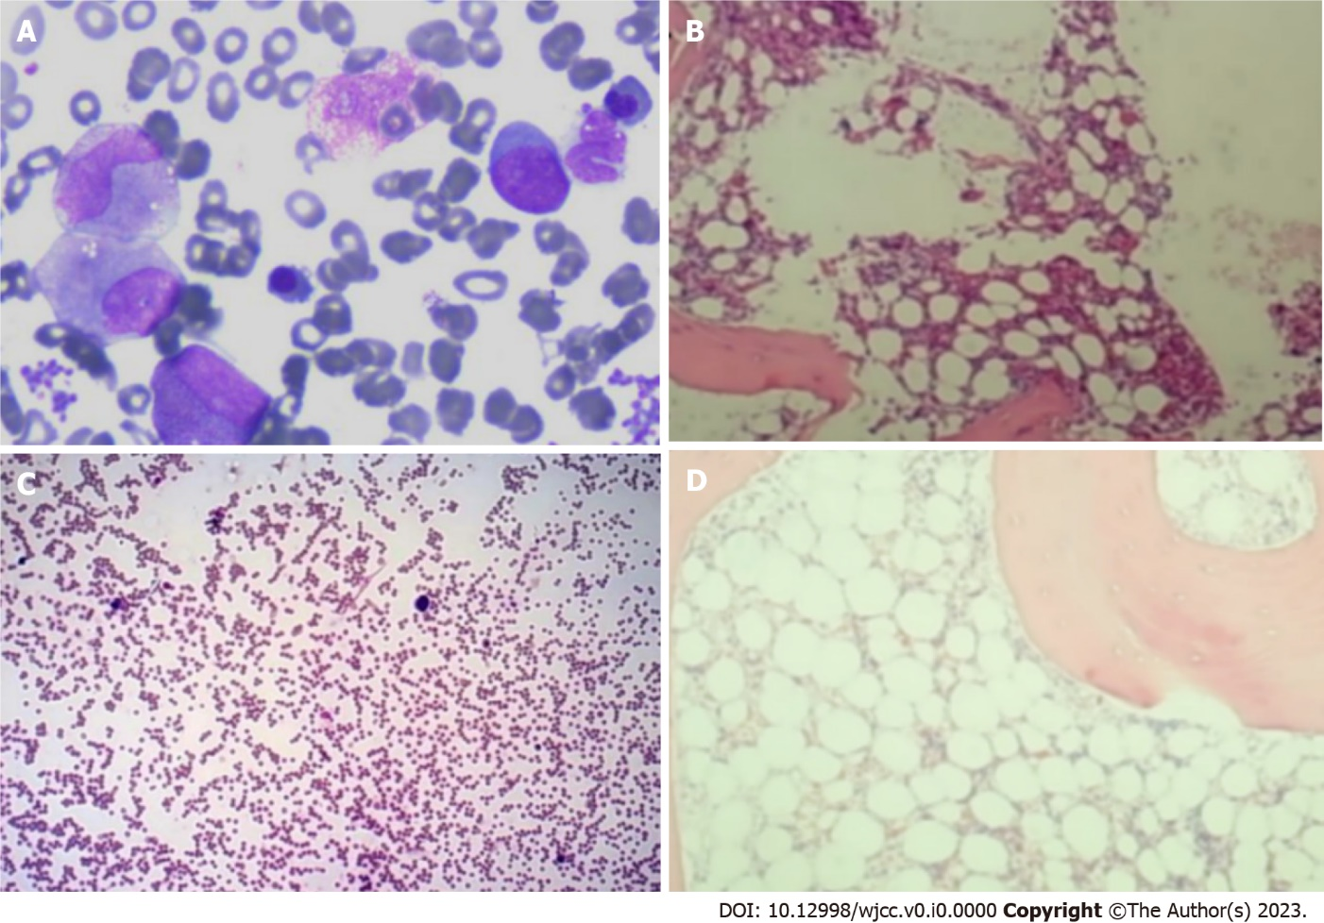
Figure 1 Morphological and pathological evaluation of the bone marrow at the time of initial diagnosis of myelodysplastic syndrome and in the flared inflammatory episode. A and B: Morphological (A) and pathological (B) evaluation of the bone marrow at the time of initial diagnosis of myelodysplastic syndrome showed significantly increased cellularity with an increased percentage of myeloblasts that accounted for 13% of the total nucleated cells; C and D: Morphological (C) and pathological (D) reevaluation of the bone marrow in the flared inflammatory episode with agranulocytosis and severe anemia showed heavily decreased cellularity with regression of the leukemic cells.
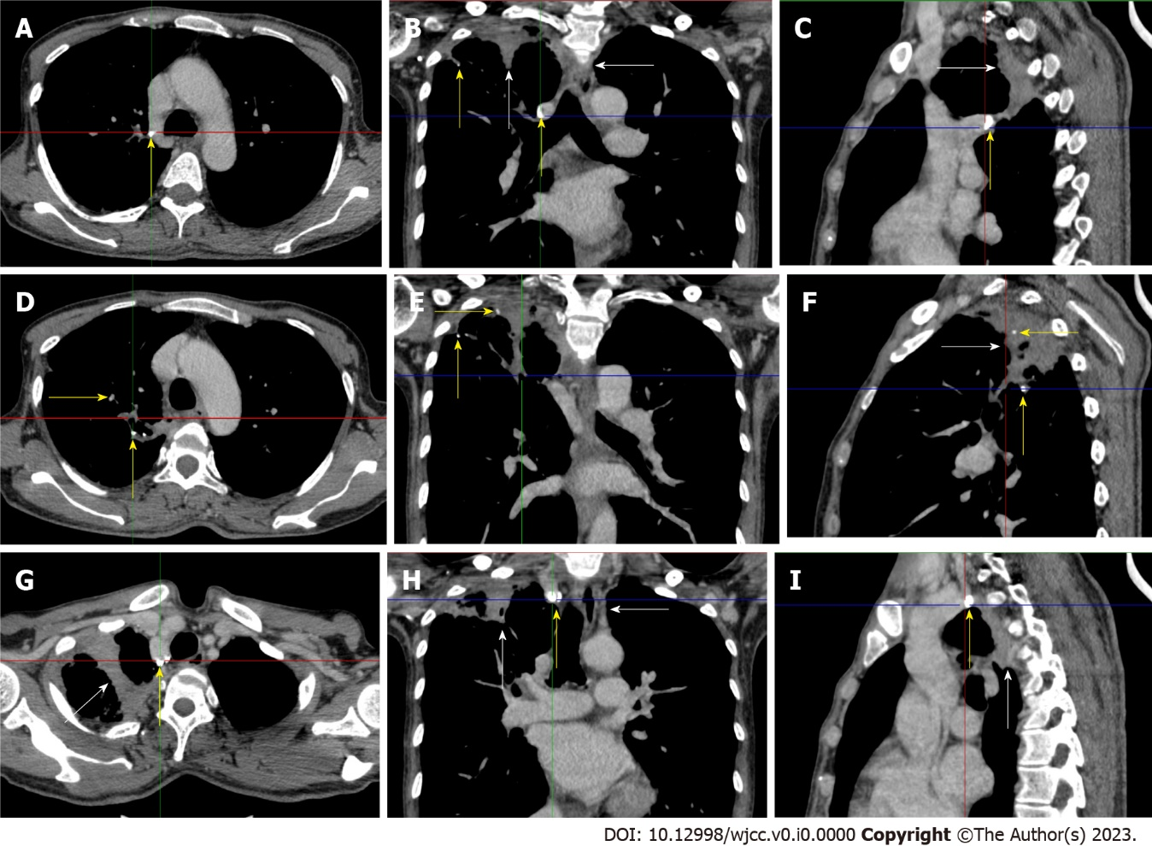
Figure 2 Chest computed tomography scan in the flared inflammatory episode. Multiple calcified lesions (yellow arrows) with adjacent exudative lesions (white arrows) were present in the right upper lung and mediastinal lymph nodes, indicating the presence of old tuberculosis infection. A-C: A large calcified lesion was present in the posterior mediastinum with adjacent exudative lesions; D-F: Successional exudative lesions on a background of calcified lesions formed a large fused exudative lesion present in the right upper lung abutting the pleura and mediastinum; G-I: A large calcified lesion was present in the top of the right upper lung with adjacent exudative lesions. This imaging feature is typical of the reactivation of an old tuberculosis infection.
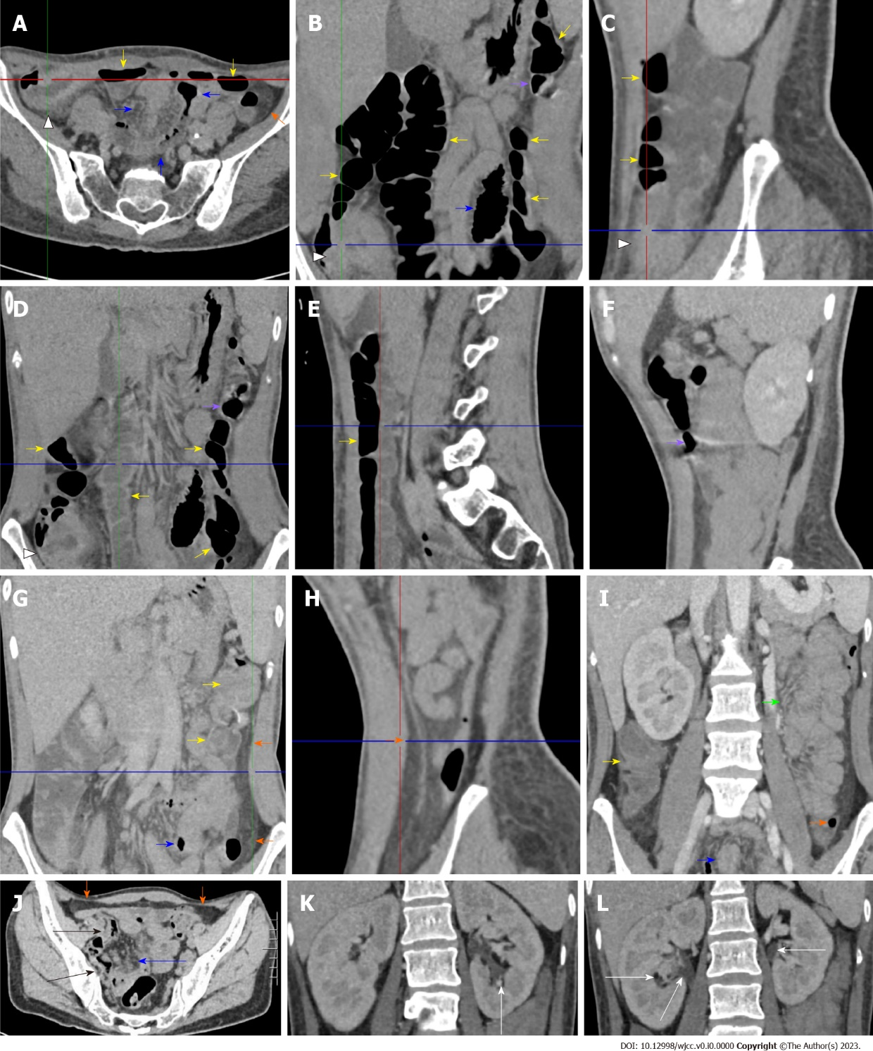
Figures 3 Enhanced abdominal computed tomography in the flared inflammatory episode. The computed tomography (CT) scan was performed after bowel preparation. A-C: Striking bowel wall thickening with mucosal hyperenhancement, mucosal hyperdensity and circumferentially distributed hypervascular fat stranding of the cecum in the right iliac fossa in the absence of mural stratification was readily visualized (head arrows). From the ascending colon to the splenic flexure, the mucosa was hyperenhanced and hyperdense, and the lumen was dilated with successional gas‒liquid levels (yellow arrows), suggesting the fibrotic thickening of the colonic wall and the presence of dynamic abnormalities. Noticeably, the location of the transverse colon was abnormally low, which may represent a visceral ectopia and may affect colonic function. However, the descending colon was collapsed following a segment of hypertrophic lesions in the splenic flexure, and in some segments, was emptied. In a short segment of the sigmoid colon (blue arrows), the mucosa was hypertrophic, and the lumen was dilated. Proximal and distal to the dilated segment of the sigmoid colon, the colonic wall was hypertrophic, and the lumen was collapsed; D and E: Successional gas‒liquid levels in the descending part of the transverse colon; F: A segment of hyperenhanced mucosa and hypertrophic wall with erosive lesions was present in the ascending part of the transverse colon (purple arrows). These hypertrophic lesions could also be seen in multiple colonic and enteric segments; G and H: A misty fat streak on both the visceral and parietal sides of the thickened peritoneum of the left abdominal wall (orange arrows) was visualized along the ascending part of the transverse colon, indicating the peritoneal involvement of inflammatory lesions. An inflamed diverticulum was present in the distal descending colon, and the fat streak was especially prominent adjacent to this colonic segment; I: A large segment of clustered and adhered bowel loop was present in the jejunum (green arrow), together with fibrotic thickening of the peritoneum forming a so-called “abdominal cocoon”. Clustered perienteric hypervascular fat stranding was adjacent to this adhesive jejunal loop. This clustered perienteric hypervascular fat stranding could also been visualized in other enteric segments (blue arrows); J: The fat streak was contiguous with the fat stranding of the right iliac fossa posterior to the anterior abdominal wall at the pelvic level (orange arrows). The wall of the distal ileum was hypertrophic, and the lumen was gas-filled (black arrows); K and L: Hydronephrosis was present in the bilateral pelvises (white arrows), and hypertrophic lesions could be visualized. These imaging features, together with the imaging presentation on chest CT, strongly suggested a diagnosis of tuberculosis reactivation involving the gastrointestinal tract, peritoneum and pelvises.

