Name of Journal: World Journal of Clinical Cases
Manuscript NO: 76332
Manuscript Type: CASE REPORT

X-linked recessive Kallmann syndrome: A case report

Zhang P et al. X-linked recessive Kallmann syndrome

Ping Zhang, Jing-Yun Fu

Ping Zhang, Jing-Yun Fu, Division of Endocrinology, The First Affiliated Hospital of Kunming Medical University, Kunming 650031, Yunnan Province, China

Author contributions: Fu JY contributed to the conception and design of the study; Zhang P organized the database; Zhang P wrote the first draft of the manuscript; all authors contributed to manuscript revision and read and approved the submitted version.

Supported by the National Natural Science Foundation of China, No. 81860265; and the Special Foundation for Discipline Leaders of High-level Health Technical Talents in Yunnan Province, No. D-2018035.

Corresponding author: Jing-Yun Fu, MD, Chief Doctor, Division of Endocrinology, The First Affiliated Hospital of Kunming Medical University, Xi Chang Road, Kunming 650031, Yunnan Province, China. fujy74@sina.com

Received: April 13, 2022
Revised: June 16, 2022
Accepted: July 27, 2022
Published online:

Abstract
BACKGROUND
Kallmann syndrome (KS), also known as hypogonadotropic hypogonadism (HH) or olfactory-gonadal dysplasia, is a genetic condition in which the primary symptom is a failure to begin puberty or a failure to fully complete it. It occurs in both males and females and has the additional symptoms of hypogonadism and almost invariably infertility. The condition has a low prevalence that is estimated to be 1 in 4000 for male HH cases overall and 1:50000 for KS. It is three to five times more common in males than females. Whether this is a true sex imbalance or a reflection of how difficult KS/HH is to diagnose correctly in males vs females has yet to be fully established.

CASE SUMMARY
This article reports a 26-year-old male presenting with delayed puberty. The synthetic decapeptide luteinizing hormone-releasing hormone stimulation test showed that the secretion levels of follicle-stimulating hormone and luteinizing hormone were delayed. The eigengenes commonly associated with idiopathic HH (IHH) were screened, and an X-linked recessive (KAL-1) mutation was found. His gonadotropin and testosterone levels increased significantly after pulsatile gonadotropin-releasing hormone (GnRH) subcutaneous therapy by pump. A relevant literature review on the recent advances in the diagnosis and treatment of KS and genetic counseling was conducted.

CONCLUSION
KS is caused by a KAL-1 mutation that follows an X-linked recessive inheritance pattern. Pulsatile GnRH subcutaneous therapy by pump was effective in this patient.

Key Words: X-linked recessive Kallmann syndrome; Gonadotropin-releasing hormone; Hormone replacement therapy; Diagnosis; Treatment; Case report

Zhang P, Fu JY. X-linked recessive Kallmann syndrome: A case report. World J Clin Cases 2022; In press

Core Tip: Kallmann syndrome (KS), also known as hypogonadotropic hypogonadism (HH) or olfactory-gonadal dysplasia, is a genetic condition in which the primary symptom is a failure to begin puberty or a failure to fully complete it. It occurs in both males and females and has the additional symptoms of hypogonadism and almost invariably infertility. The condition has a low prevalence. The prevalence is estimated to be 1 in 4000 for male HH cases overall and 1:50000 for KS. It is three to five times more common in males than females. Whether this is a true sex imbalance or a reflection of how difficult KS/HH is to diagnose correctly in males vs females has yet to be fully established. Our Department of Endocrinology admitted a case of adolescent dysplasia in 2017. The patient presented with no development of secondary sex characteristics, such as the growth of facial hair and deepening of the voice, and an unusually small penis (micropenis). These presentations indicate adolescent dysplasia. A mutation in the KAL-1 gene was detected by a family pedigree survey and gene molecular screening analysis.

INTRODUCTION
Kallmann syndrome (KS) is an inherited heterogeneous disorder that is characterized by hypogonadotropic hypogonadism (HH) and loss of smell. The disease is characterized by the association of an isolated defect in the secretion (or, less commonly, action) of gonadotropin-releasing hormone (GnRH). The initiation and maintenance of reproductive function in humans requires coordination between GnRH synthesis and pulsatile secretion^{[1]}. The diagnosis of KS is currently difficult, especially in early adolescence. Targeted genetic testing based on inheritance patterns is important in the diagnosis of this disease^{[2]}. Early diagnosis and treatment are critical, and fertility can be restored in most patients with pulsed GnRH therapy or gonadotropin therapy^{[3]}. Pulsed GnRH therapy is more effective than human chorionic gonadotropin (HCG) therapy^{[4]}.

CASE PRESENTATION
Chief complaints
A 26-year-old male patient was admitted to the hospital with no secondary sex characteristics, such as the growth of facial hair and deepening of the voice, and an unusually small penis (micropenis).

History of present illness
Nine years previously, the patient found that his penis and testicles were small. His weight and height increased normally each year, and there was no pubertal erection. The patient attended the Andrology Department of our hospital for treatment with intermittent intramuscular injection of hormone therapy (the specific drug name and dosage are unknown), but his condition did not improve.

History of past illness
The patient had no significant medical history.

Personal and family history
His parents are healthy, and their marriage is nonconsanguineous. He has a younger brother who is in good health.

Physical examination
Physical examination revealed the following: height 1.74 m, weight 58 kg, Body Mass Index 19.15 kg/m², waist-to-hip ratio of 0.78, sitting height 87 cm, and arm length 1.79 m. Evaluation of his sense of smell revealed anosmia. Tanner Stage was G1P2. The testicles and penis were of the infantile type. His left testicle was less than 2.5 cm in diameter, and his pubic hair was sparse, straight and light in color. The right testicle was not found in the scrotum. Cardiopulmonary, abdominal and nervous system examinations were normal.

Laboratory examinations
The patient was admitted to the hospital due to adolescent dysplasia and anosmia. After admission, an oral glucose tolerance test showed normal glucose tolerance, but peak insulin secretion was delayed. His pituitary hormone assessments (Table 1) suggested that follicle-stimulating hormone (FSH), luteinizing hormone (LH) and testosterone (T) levels were below the normal reference ranges. A synthetic decapeptide luteinizing hormone-releasing hormone (LHRH; gonadorelin) stimulation test (Table 2) suggested a delayed response (peak LH secretion was 3.72 mIU/mL at 90 min). The adrenocorticotropic hormone and cortisone rhythms were normal.
His sex chromosome karyotype analysis results were 46,XY. Eigengenes commonly associated with IHH were screened, and a KAL-1 mutation was found. His mother was found to be a carrier, and a diagnosis of X-linked recessive KS was made by performing genetic tests on three generations of direct relatives (Figure 1). The KS gene was subjected to high-throughput Sanger sequencing. The results indicated a mutation in the KAL-1 gene (p. Trp204*) located in the 5th exon at coding sequence 612. At position 612, G was converted to A (c.612G>A), causing a nonsense mutation (Table 3). The parents were screened for the disease-causing gene, and it was found that the patient’s mother carried the KAL-1 gene mutation (p. Trp204*), but the patient’s father did not carry the mutation (Table 4, Figure 2B and C).

Imaging examinations
Abdominal color Doppler ultrasound showed a small right kidney (3.3 cm × 1.5 cm) and compensatory left kidney enlargement (12.6 cm × 5.9 cm). Genital color Doppler ultrasound showed right cryptorchidism (2.0 cm × 0.9 cm) and a left testicle (2.0 cm × 0.8 cm). Pituitary MRI plain scan and enhancement (MRI) revealed no abnormalities.

FINAL DIAGNOSIS
The patient was diagnosed with KS after physical examination, auxiliary examination and KAL-1 gene (p. Trp204 ×) mutation screening.

TREATMENT
The patient was given pulsatile GnRH pump therapy. The GnRH pulse pump was set to pulse once every 90 min, with subcutaneous infusion of 10 μg each time, for a total of 16 pulses in 24 h.

OUTCOME AND FOLLOW-UP
The levels of FSH, LH (Figure 3A) and androgen (Figure 3B) were significantly increased after pulsatile treatment with the GnRH pump. Moreover, genital color Doppler ultrasound showed that the right cryptorchidism descended into the scrotum and that the testicle volume gradually increased (Figure 3C). A semen test indicated a sperm discharge ≥ 1.5 mL, pH ≥ 7.2, and a sperm activity rate ≥ 40%.

DISCUSSION
Etiology and pathogenesis
The pathogenesis of KS is the complete or incomplete loss of the ability to synthesize GnRH in the hypothalamus. In the case studied, the complaint of difficulty perceiving odors aided the clinical study. The disease was reported by the American anatomist Kallmann in 1944. It is a congenital genetic disease that can be caused by autosomal-dominant, autosomal-recessive or X-linked inheritance^{[5]}. It usually presents with genetic heterogeneity; thus, the patient’s clinical manifestations are polymorphic. Kallmann syndrome is genetically heterogeneous, and its pathogenic genes and specific mechanisms have not been thoroughly studied. At present, there are 18 pathogenic genes related to KS: KAL-1, FGFR1, PROKR2, PROK2, CHD7, FGF8, WDR11, NELF, HS6ST1, SEMA3A, HESX1, SOX10, IL17RD, FGF17, SPRY4, DUSP6, FLRT3 and AXL. However, the first six genes (KAL-1, FGFR1, PROKR2, PROK2, CHD7, and FGF8) are the most frequently mutated genes in this disease, and the mutations of these genes account for only approximately 30% of its pathogenic factors. Thus, approximately 70% of the pathogenic factors and mechanisms of this disease are still unknown^{[6]}.
Mutations in the KAL-1 gene and the X-linked recessive genotype account for approximately 12% of KS cases. The KS X-linked type is an important genetic mode of disease inheritance, and familial morbidity is more common for this type. The KAL-1 gene is located at Xp22.3 and has a full length of 210 kb. It consists of 14 exons encoding an extracellular matrix protein of 680 amino acids called anosmin^{[7]}. KAL-1 is distributed in the basement membrane and interstitial tissues in locations that include the respiratory tract, kidney, digestive tract, blood vessels, oculomotor nuclei, and developing Purkinje cells. During embryonic development, mature anosmin-1 binds to related neural adhesion molecules through its molecular structure. This process is mediated by GnRH neurons on the inner side of the olfactory substrate, and the olfactory nerves migrate to the hypothalamic process. Therefore, the mechanism of olfactory disturbance or deletion in KS patients is that GnRH neurons and olfactory neurons share a common embryonic origin (bromo substrate) and migration pathway. GnRH neurons migrate from the bromine substrate to the hypothalamus during the embryonic period via the KAL-1 gene. This protein regulates axon outgrowth and recognizes the target tissue or target cell. It also participates in the migration of GnRH-secreting neurons and olfactory neurons and KAL-1 gene mutations can occur. Moreover, the KAL adhesion protein cannot be synthesized, affecting the migration of GnRH nerve cells and the olfactory bulb. During the formation of olfactory bundles, insufficient secretion of GnRH in the hypothalamus causes different degrees of LH and FSH deficiency. In turn, this leads to decreased secretion of androgens (testosterone, T), causing hypogonadism and olfactory disorders^{[8-11]}. The testicular tissue of male patients or the ovarian tissue of female patients can remain immature in adulthood. Thus, these patients have not undergone secondary sexual development in adulthood and are infertile at reproductive age. There are three types of KAL-1 gene mutations: (1) missense or nonsense mutations; (2) mutations in the cleavage site; and (3) deletions within the gene or chromosomal deletions^{[12]}. In this case, we performed high-throughput sequencing of 18 genes commonly associated with congenital HH using genomic DNA extracted from the peripheral blood of the proband and his family members. The sequence variants were combined. Informatics analysis was performed to identify the pathogenic gene, and Sanger sequencing was performed to verify the gene mutation site. The results showed that the guanylate located at position 612 of the KAL-1 gene was mutated to adenylate. This resulted in a tryptophan mutation at amino acid 204 that created a termination codon. Thus, the KAL-1-encoded protein terminated prematurely. This missense mutation affects the migration of GnRH neurons and olfactory nerves and results in gonadal dysplasia and olfactory loss. The c.612G>A(p. Trp204Ter) mutation was found in the proband. While the father of the subject did not carry the KAL-1 ₋ ex5 c.612G>A (p. Trp204Ter) mutation, the mother of the subject was heterozygous for the KAL-1 ₋ ex5 c.612G>A (p. Trp204Ter) nonsense mutation (Figures 2-3). Similar to single renal hypoplasia, this is related to distribution of the KAL-1 gene. The structure, biological activity and related clinical aspects of KAL-1 and its encoded antagonist are still being studied. Patients can exhibit several malformations, such as congenital midline developmental malformations of the lips, cracks, hypospadias, short palm deformities, arched feet, single-kidney hypoplasia, and/or some neurological symptoms, such as intelligence, visual, olfactory, hearing, spatial orientation and motor abnormalities (joint movements), ataxia, and nystagmus, which are important for the diagnosis of KS^{[13]}. This mutation site has been reported in the literature^{[14]}.

Treatment
At present, hormone replacement therapy is mainly used for KS. GnRH pulse pump treatment simulates the pulsed mode of GnRH secretion in the human physiological state, and this treatment is called an artificial hypothalamus. It can promote the secretion of gonadotropin in the anterior pituitary and promote testicular growth, the secretion of T and sperm production. Studies have found that the use of pulsed subcutaneous injections of GnRH for male IHH produces sperm earlier than intramuscular injections of a HCG/HMG combination. In 92 male IHH patients, 50% (20/40) and 28.8% (15/52) of the GnRH-treated and HCG/HMG-treated groups, respectively, produced sperm. The GnRH-treated group produced sperm in 6.5 ± 3.1 mo, which was significantly shorter than that of the HCG/HMG-treated group (10.8 ± 3.7 mo). Another randomized controlled trial included 34 patients with low gonadotropin hypogonadism who were randomized into two groups. These groups included 12 patients in the GnRH-treated group and 22 patients in the HCG-treated group. The results showed improvements in penis length and the testes in the GnRH-treated group. The volume, LH, and FSH levels were higher than those in the HCG treatment group, and the difference was statistically significant. In this case, the testicular volume of the patient treated with the GnRH pulse pump was increased, the LH, FSH, and T levels were significantly increased, and sperm formation was present. Moreover, with the advancements in molecular biology techniques, the use of genetic diagnoses and development of gene therapy options may open up new avenues for the treatment of KS.

Genetic counseling
At present, there are still many difficulties in the field of KS research. Many blind spots remain to be elucidated, and genetic diagnoses will be an inevitable trend for KS diagnosis. Clear genetic analyses can effectively prevent and cure diseases. KS is caused by KAL-1 mutations and follows an X-linked recessive inheritance pattern. First, the risk of hereditary X-linked disease among family members needs to be assessed. Regarding the parents of the patient, if the patient is male, the father should be evaluated to determine if he is affected or a carrier of the disease. Furthermore, a family analysis can reveal if the patient is the only family member affected or if his mother is a carrier. If the patient has a genetic mutation that causes the disease to occur, the mother is not a carrier. However, if the family has more than one affected individual, the mother of the male patient must be a carrier of the disease. If a mother has more than two children and there is no mutated gene in her genetic analysis that causes the disease, the mother may have a germline chimera. For brothers and sisters of the first patient of the family, the incidence of the disease depends on the state of the mother (carrier). If the mother of the patient has a genetic mutation that causes the disease, the probability of inheritance among her offspring is 50%. If the patient is a sporadically affected male patient, the mother may not have a genetic mutation that caused the disease. Thus, the risk to his siblings is low. Among the offspring of the first affected individual in the family, male patients pass the gene to their daughters but not to their sons. Among other family members of the first patient of the family, the mother of the patient may be affected, and the mother’s sister may be a carrier.
Another problem that needs to be considered for X-linked recessive female KS is that prenatal diagnosis is a powerful screening tool for pregnant women carrying mutations in the KAL-1 gene. After sampling the villi of pregnant women at approximately 10 to 12 wk of pregnancy, amniocentesis can be performed for pregnant women at approximately 15 to 18 wk of gestation to obtain fetal cells. Then, chromosomal analysis can be performed to determine the sex of the fetus. If the karyotype is 46,XY, the fetal intracellular DNA can be diagnosed with a known KAL-1 mutation.

CONCLUSION
We report a rare case of X-linked recessive Kallmann syndrome. Subcutaneous therapy with pulsed GnRH resulted in elevated gonadotropin and testosterone levels, increased bilateral testicular volume, and the detection of sperm in semen.

REFERENCES
1 Boehm U, Bouloux PM, Dattani MT, de Roux N, Dodé C, Dunkel L, Dwyer AA, Giacobini P, Hardelin JP, Juul A, Maghnie M, Pitteloud N, Prevot V, Raivio T, Tena-Sempere M, Quinton R, Young J. Expert consensus document: European Consensus Statement on congenital hypogonadotropic hypogonadism--pathogenesis, diagnosis and treatment. Nat Rev Endocrinol 2015; 11: 547-564 [PMID: 26194704 DOI: 10.1038/nrendo.2015.112]
2 Layman LC. Clinical genetic testing for Kallmann syndrome. J Clin Endocrinol Metab 2013; 98: 1860-1862 [PMID: 23650337 DOI: 10.1210/jc.2013-1624]
3 Young J, Xu C, Papadakis GE, Acierno JS, Maione L, Hietamäki J, Raivio T, Pitteloud N. Clinical Management of Congenital Hypogonadotropic Hypogonadism. Endocr Rev 2019; 40: 669-710 [PMID: 30698671 DOI: 10.1210/er.2018-00116]
4 Gong C, Liu Y, Qin M, Wu D, Wang X. Pulsatile GnRH Is Superior to hCG in Therapeutic Efficacy in Adolescent Boys With Hypogonadotropic Hypogonadodism. J Clin Endocrinol Metab 2015; 100: 2793-2799 [PMID: 25978110 DOI: 10.1210/jc.2015-1343]
5 Layman LC. Genetics of human hypogonadotropic hypogonadism. Am J Med Genet 1999; 89: 240-248 [PMID: 10727999 DOI: 10.1002/(sici)1096-8628(19991229)89:4<240::aid-ajmg8>3.0.co;2-7]
6 Liu Meng ying, Wu Ling qian.(2014)Progress in genetics research of Kallmann syndrome[J].International Journal of Reproductive Health Planning,33(3),186-190.
7 Bhagavath B, Xu N, Ozata M, Rosenfield RL, Bick DP, Sherins RJ, Layman LC. KAL1 mutations are not a common cause of idiopathic hypogonadotrophic hypogonadism in humans. Mol Hum Reprod 2007; 13: 165-170.
8 Soussi-Yanicostas N, de Castro F, Julliard AK, Perfettini I, Chédotal A, Petit C. Anosmin-1, defective in the X-linked form of Kallmann syndrome, promotes axonal branch formation from olfactory bulb output neurons. Cell 2002; 109: 217-228 [PMID: 12007408 DOI: 10.1016/s0092-8674(02)00713-4]
9 Cariboni A, Pimpinelli F, Colamarino S, Zaninetti R, Piccolella M, Rumio C, Piva F, Rugarli EI, Maggi R. The product of X-linked Kallmann's syndrome gene (KAL1) affects the migratory activity of gonadotropin-releasing hormone (GnRH)-producing neurons. Hum Mol Genet 2004; 13: 2781-2791 [PMID: 15471890 DOI: 10.1093/hmg/ddh309]
10 Cariboni A, Maggi R. Kallmann's syndrome, a neuronal migration defect. Cell Mol Life Sci 2006; 63: 2512-2526 [PMID: 16952059 DOI: 10.1007/s00018-005-5604-3]
11 Izumi Y, Tatsumi K, Okamoto S, Ogawa T, Hosokawa A, Matsuo T, Kato Y, Fukui H, Amino N. Analysis of the KAL1 gene in 19 Japanese patients with Kallmann syndrome. Endocr J 2001; 48: 143-149 [PMID: 11456260 DOI: 10.1507/endocrj.48.143]
12 Tsai PS, Gill JC. Mechanisms of disease: Insights into X-linked and autosomal-dominant Kallmann syndrome. Nat Clin Pract Endocrinol Metab 2006; 2: 160-171 [PMID: 16932275 DOI: 10.1038/ncpendmet0119]
13 El Husny AS, Raiol-Moraes M, Fernandes-Caldato MC, Ribeiro-Dos-Santos A. A novel nonsense mutation of the KAL1 gene (p.Trp204 ×) in Kallmann syndrome. Appl Clin Genet 2014; 7: 177-182 [PMID: 25328414 DOI: 10.2147/TACG.S64280]
14 Corona G, Vignozzi L, Sforza A, Maggi M. Risks and benefits of late onset hypogonadism treatment: an expert opinion. World J Mens Health 2013; 31: 103-125 [PMID: 24044106 DOI: 10.5534/wjmh.2013.31.2.103]

Footnotes
Informed consent statement: Participants in this study provided informed written consent prior to study enrolment.

Conflict-of-interest statement: The authors declare that they have no conflicts of interest.

CARE Checklist (2016) statement: The authors have read the CARE Checklist (2016), and the manuscript was prepared and revised according to the CARE Checklist (2016).

Open-Access: This article is an open-access article that was selected by an in-house editor and fully peer-reviewed by external reviewers. It is distributed in accordance with the Creative Commons Attribution NonCommercial (CC BY-NC 4.0) license, which permits others to distribute, remix, adapt, build upon this work non-commercially, and license their derivative works on different terms, provided the original work is properly cited and the use is non-commercial. See: https://creativecommons.org/Licenses/by-nc/4.0/

Provenance and peer review: Unsolicited article; Externally peer reviewed.
Peer-review model: Single blind

Peer-review started: April 13, 2022
First decision: May 30, 2022
Article in press:

Specialty type: Endocrinology and Metabolism
Country/Territory of origin: China
Peer-review report’s scientific quality classification
Grade A (Excellent): 0
Grade B (Very good): 0
Grade C (Good): C
Grade D (Fair): D
Grade E (Poor): 0

P-Reviewer: de Melo FF, Brazil; Tuan Ismail TS, Malaysia S-Editor: Ma YJ L-Editor: Webster JR P-Editor: Ma YJ
Figure Legends
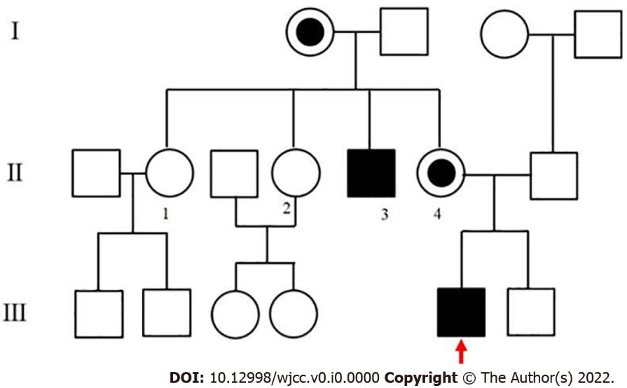
Figure 1 The family genetic map (mother and grandmother were found to be carriers, uncle was found to be a patient).
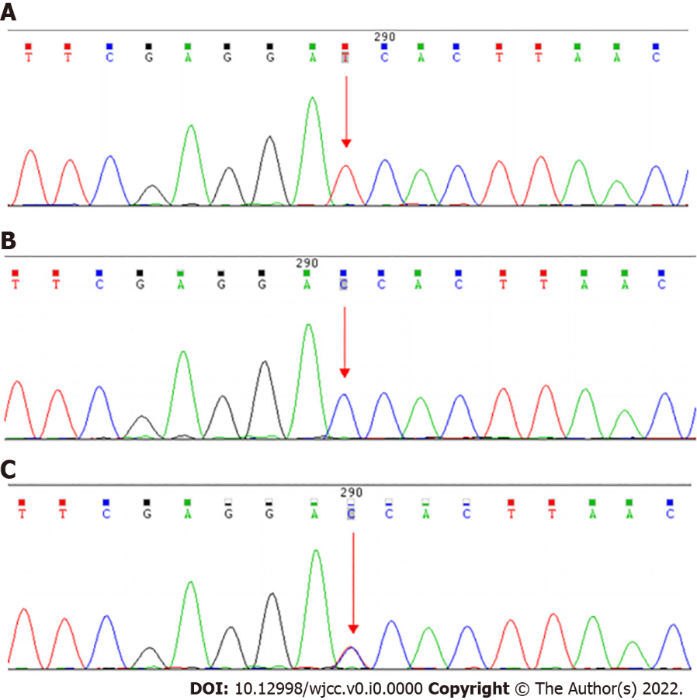
Figure 2 Sanger validation diagram (forward). A: Subject was detected to have KAL-1-ex5c612G>A(p.Trp204Ter); B: The mother of the subject was detected to have KAL-1- ex5c612G>A(p.Trp204Ter); C: The father of the subject did not have KAL-1-ex5c612G>A(p.Trp204Ter).
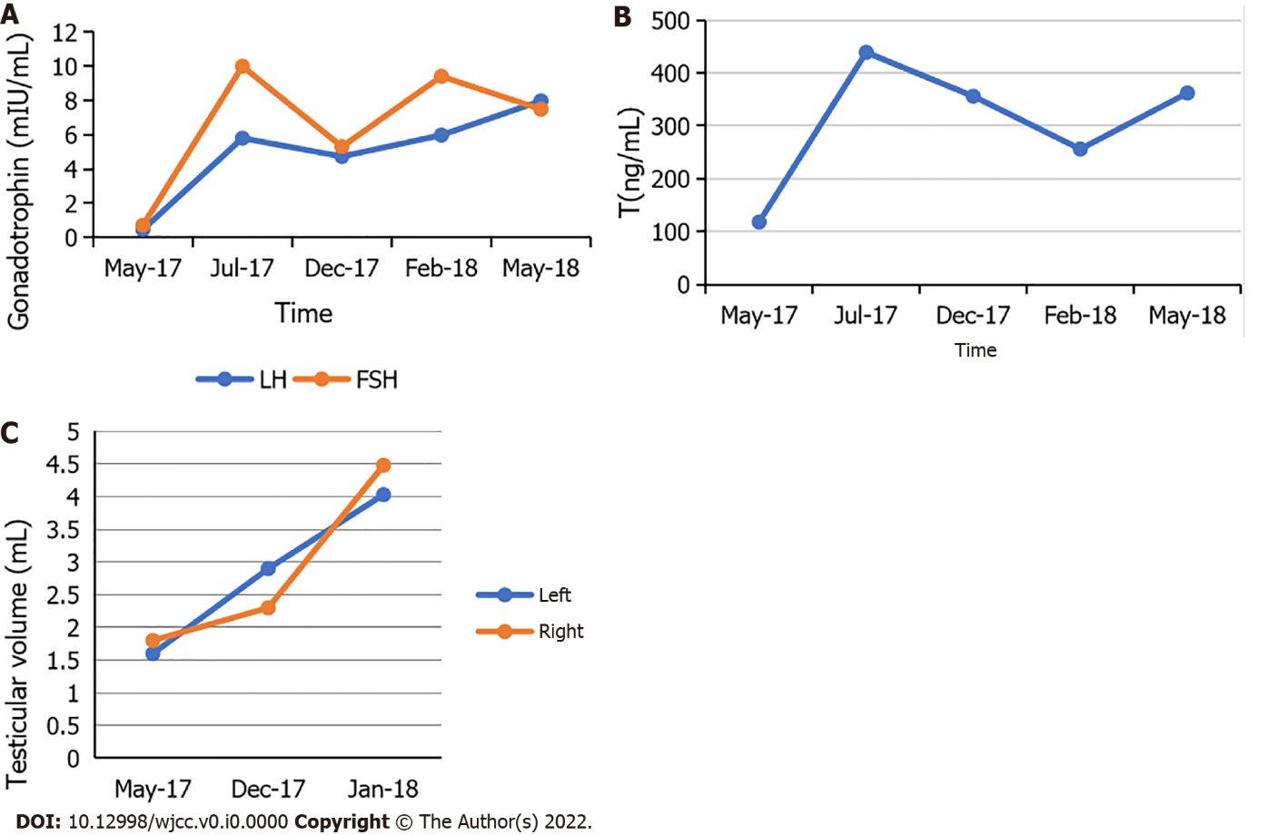
Figure 3 Changes in the levels of gonadotropin and androgen, with testicular volume before and after treatment of GnRH pump. A: Changes in luteinizing hormone and follicle-stimulating hormone levels before and after pulsed treatment of GnRH pump; B: Change in testosterone level before and after pulsed treatment of GnRH pump; and C: Change in testicular volume before and after pulsed treatment of GnRH pump.
Table 1 Pituitary and gonadal hormones
Project | Numerical value | Reference value (male)
Prol | 9.15 | 4.1-18.5
GH | 0.7 | 0.2-1.23
FSH | 0.71 | 1.3-11.8
LH | 0.46 | 2.8-6.8
E2 | 12.3 | 0-56
P | 0.33 | 0
Test | 118 | 210-1600
Prol: Prolactin; GH: Growth hormone; FSH: Follicle-stimulating hormone; LH: Luteinizing hormone; E2: Estradiol; P: Progesterone; Test: Testosterone.

Table 2 Luteinizing hormone-releasing hormone stimulation test
Index | 0 min | 25 min | 45 min | 90 min | 180 min
LH） | 0.25 | 1.96 | 3.21 | 3.72 | 1.76
FSH | 1.14 | 2.35 | 3.33 | 2.78 | 2.86
FSH: Follicle-stimulating hormone; LH: Luteinizing hormone.

Table 3 Patient’s genetic test results
Gene | Nucleotide variation | Amino acid variation | Functional change | Type of mutation | Genetic mode | Clinical significance | Related diseases
KAL-1-ex5 | c612G>A | P.Trp204Ter | Nonsense | Hemizygous | XLD | Pathogenic | Kallmann
NM-000216 |  |  | Mutation |  |  |  | Syndrome type 1
XLD: X-linked recessive inheritance.

Table 4 Patient’s parental genetic test results
Examination range | Test results | Test results
Known/suspected pathogenic site | Mother | Father
KAL-1-ex5c612G>A(p.Trp204Ter) | + | -
“+” represents present and “-” represents absent.

