Name of Journal: World Journal of Gastroenterology
ESPS Manuscript NO: 22638
Manuscript Type: CASE REPORT

Laparoscopic resection of adult colon duplication causing intussusception

Kyo K et al. Adult colon duplication

Kennoki Kyo, Masaki Azuma, Kazuya Okamoto, Motohiro Nishiyama, Takahiro Shimamura, Atsushi Maema, Motoaki Shirakawa, Toshio Nakamura, Kenji Koda, Hidetaro Yokoyama

Kennoki Kyo, Masaki Azuma, Kazuya Okamoto, Motohiro Nishiyama, Takahiro Shimamura, Atsushi Maema, Motoaki Shirakawa, Toshio Nakamura, Hidetaro Yokoyama, Department of Surgery, Fujieda Municipal General Hospital, Fujieda, Shizuoka 426-8677, Japan

Kenji Koda, Department of Pathology, Fujieda Municipal General Hospital, Fujieda, Shizuoka 426-8677, Japan

Author contributions: Kyo K served as an attending doctor for the patient, designed the report and wrote the manuscript; Kyo K and Azuma M performed the surgery; Azuma M, Okamato K, Nishiyama M, Shimamura T, Maema A, Shirakawa M, Nakamura T, Koda K and Yokoyama H were involved in editing the manuscript; Koda K performed the pathological examination.

Supported by Fujieda Municipal General Hospital, Surugadai, Fujieda, Shizuoka, Japan.

Institutional review board statement: This study was reviewed and approved by the Institutional Review Board of Fujieda Municipal General Hospital.

Informed consent statement: Written informed consent was obtained from the patient for publication of this case report and the accompanying images.

Conflict–of-interest statement: The authors declare that there are no conflicts of interest for this article.

Open-Access: This article is an open-access article which was selected by an in-house editor and fully peer-reviewed by external reviewers. It is distributed in accordance with the Creative Commons Attribution Non Commercial (CC BY-NC 4.0) license, which permits others to distribute, remix, adapt, build upon this work non-commercially, and license their derivative works on different terms, provided the original work is properly cited and the use is non-commercial. See: http://creativecommons.org/licenses/by-nc/4.0/

Correspondence to: Kennoki Kyo, MD, PhD, Department of Surgery, Fujieda Municipal General Hospital, 4-1-11 Surugadai, Fujieda, Shizuoka 426-8677, Japan. kkyo@vega.ocn.ne.jp
Telephone: +81-54-6461111
Fax: +81-54-6461122

Received: September 9, 2015
Peer-review started: September 16, 2015
First decision: October 14, 2015
Revised: November 3, 2015
Accepted: December 12, 2015
Article in press:
Published online:

Abstract
Gastrointestinal duplications are uncommon congenital malformations that can occur anywhere along the gastrointestinal tract. Most cases are recognized before the age of 2 years, and those encountered in adults are rare. We describe here a case of ascending colon duplication in a 20-year-old male that caused intussusception and was treated laparoscopically. Although computed tomography revealed a cystic mass filled with stool-like material, the preoperative diagnosis was a submucosal tumor of the ascending colon. We performed a laparoscopic right colectomy, and the postoperative pathological diagnosis was duplication of the ascending colon, both cystic and tubular components. We conclude that gastrointestinal duplications, although rare, should be considered in the differential diagnosis of all abdominal and submucosal cystic lesions and that laparoscopy is a preferred approach for the surgical treatment of gastrointestinal duplications.

Key words: Gastrointestinal duplication; Colonic duplication; Laparoscopy; Intussusception; Congenital abnormalities

© The Author(s) 2015. Published by Baishideng Publishing Group Inc. All rights reserved.

Core tip: Gastrointestinal duplications are uncommon congenital malformations and are rarely encountered in adults. We describe an adult case of ascending colon duplication resected by laparoscopic right colectomy. We conclude that gastrointestinal duplications should be included in the differential diagnosis of all abdominal and submucosal cystic lesions and that laparoscopy is a preferred approach for the surgical treatment of gastrointestinal duplications.

Kyo K, Azuma M, Okamoto K, Nishiyama M, Shimamura T, Maema A, Shirakawa M, Nakamura T, Koda K, Yokoyama H. Laparoscopic resection of adult colon duplication causing intussusception. World J Gastroenterol 2015; In press

INTRODUCTION
Gastrointestinal duplications are uncommon congenital malformations and are estimated to occur in 1 of 4500 births^{[1]}. These malformations can occur anywhere along the gastrointestinal tract from the mouth to the anus, but the ileum is the most common site (30%-35%) and colonic duplications are rare (7%-20%)^{[2,3]}. Most cases (67%-80%) are recognized before the age of 2 years as an acute abdomen or bowel obstruction, and thise condition is rarely encountered in adults^{[2,3]}. We describe here a case of adult colon duplication that caused intussusception and was treated by laparoscopic resection.

CASE REPORT
A 20-year-old otherwise healthy male was referred to our hospital because of a one-year history of intermittent right flank pain and a large submucosal mass in the ascending colon that had been observed by colonoscopy at a clinic. All laboratory tests performed resulted in values within the normal range. An abdominal computed tomography scan revealed intussusception of the right colon with a cystic mass 4 cm in diameter. Although stool-like material was observed within the mass, it did not lead to the diagnosis (Figure 1A and 1B). A barium enema showed a large submucosal mass in the ascending colon that originated near the ileocecal valve (Figure 2). Colonoscopy also revealed a large submucosal mass in the ascending colon, and two mucosal defects were observed on its surface (Figure 3). Histological examinations of biopsy specimens taken from one of the mucosal defects revealed only necrotic tissue. No other abnormalities were found in by either physical or radiologic examinations. A neoplastic submucosal tumor causing intussusception was suspected, and a laparoscopic right colectomy with ileocolic anastomosis was performed. Intraoperatively, a round mass was observed in the hepatic flexure of the colon that caused an invagination of the ileocecal region into the ascending colon (Figure 4). No other abnormalities such as Meckel’s diverticulum or malrotation were found. Careful inspection of the resected specimen revealed not only a cystic submucosal mass 4 cm in diameter but also a submucosal tubular bulge measuring 5 cm in length and extending from the mass to the ileocecal valve (Figure 5A). Both the cystic and tubular parts of the lesion were on the mesenteric side. Histopathologically, both the cystic and tubular parts of the lesion were lined by with normal colonic mucosa; the cystic part had its own muscular layer, whereas the tubular part shared the muscular layer with the native ascending colon, which led to the diagnosis of colon duplication (Figure 5B-D). Both of the mucosal defects on the cystic lesion were communication sites with the native bowel, and the cystic lesion contained fecal material and blood clots. No neoplastic lesion or ectopic mucosa was identified. The postoperative course was uneventful, and the patient was discharged on post-operative day 7.

DISCUSSION
In 1876, Suppinger reported the first case of this congenital malformation, and in 1937, Ladd described in detail the clinical and pathological aspects of the lesions and recommended using the term ‘duplications of the alimentary tract’^{[4]}. These lesions have 3 defined features: (1) well-formed smooth muscle layers; (2) an epithelial lining consisting of some portion of the alimentary tract; and (3) contiguity with a portion of the alimentary tract. There may or may not be communication with the gastrointestinal tract, and the dividing septum may be muscular or merely a double layer of epithelium^{[5]}. Additionally, these malformations may be found in the intermuscular, submucosal or subserosal layer of the intestinal wall and are typically located on the mesenteric side of the bowel^{[6]}. Duplications are divided into cystic (86%) and tubular types (14%), and the cystic lesion usually does not communicate with the lumen of the adjacent bowel and contains a sticky mucoid fluid that is chocolate or café au lait colored in some instances and almost colorless in others^{[2,4,7]}. Tubular lesions often have one or more direct communications with the adjacent bowel and can appear either as double-barreled or Y-shaped forms. Gross et al^{[7]} described four variations of the duplications: (1) a tubular structure that branches out from the intestine and extends for some distance between the mesenteric leaves; (2) a double-barreled structure communicating with the intestinal lumen at one or both ends; (3) a cystic structure lying free in the peritoneal cavity, attached only by a thin mesenteric stalk (this type is rare); and (4) most common, a spherical lesion contiguous with some part of the bowel, particularly along the ileum. Although both cystic and tubular parts were observed in the present case, we think it plausible that stool accumulation in the tubular duplication caused cystic dilatation that protruded into the intestinal lumen over the years; therefore, this case should be classified as a double-barreled tubular structure type. Similar cases were have been reported in which the end of a Y-shaped tubular colonic duplication had become a large cystic mass containing stool^{[8,9]}.
Signs and symptoms of the duplications are nonspecific and depend on their location; oral and esophageal lesions may cause dysphagia and respiratory difficulties, and other intra-abdominal types may cause an abdominal mass, pain, constipation, intestinal obstruction, volvulus, intussusception, hemorrhage or perforation^{[2,6,7,10]}. Hemorrhage often occurs from the ectopic ulcerating gastric mucosa in the duplication. Ectopic gastric mucosa was observed frequently in the duplications irrespective of their locations in the gastrointestinal tract (20%-50%) and was particularly common in esophageal duplications^{[2,3,6]}. The occurrence of carcinoma in a duplicated cyst has also been reported, and 67% of malignancies occurred in colonic duplication, although colonic duplications are relatively rare^{[11]}.
Although no other abnormalities were found in the present case, 80% of patients with tubular colonic duplication are have been reported to have associated anomalies; urogenital duplications are the most notable, and skeletal abnormalities, including malformations or duplications of the spine and sacrum, are also often observed^{[10,12]}. The etiology of intestinal duplications and the associated anomalies is poorly understood, although several theories have been proposed^{[10]}.
The treatment of choice for duplications is surgical excision. Although the treatment strategy for asymptomatic cases is not clearly established, surgical excision is generally recommended to prevent the complications described above and the occurrence of malignancies. However, complete excision may not be possible for a long tubular duplication. In such a case, selective mucosal excision with preservation of the seromuscular layer^{[6,10,13]} or distal internal drainage by excisionng of the common wall may be effective alternatives^{[2,3,10]}. Although some recent studies have recommended the use of laparoscopy for the diagnosis and surgical treatment of gastrointestinal duplications, few have reported its use in surgery for duplications^{[2,14]}. We believe that laparoscopic surgery, if possible, is a preferred approach because of its minimal invasiveness.
In conclusion, although gastrointestinal duplications, particularly adult cases are rare, they should be considered in the differential diagnosis of all abdominal and submucosal cystic lesions, and laparoscopy should be a preferred approach for the surgical treatment of gastrointestinal duplications. The differential diagnosis of other gastrointestinal cystic lesions can include heterotopic pancreas, lymphangiomas, cystic degeneration of solid tumors such as gastrointestinal stromal tumors and schwannomas, Brunner’s gland hyperplasia and gastritis cystica profunda^{[15-17]}. The majority of duplications reported in the literature were unsuspected before surgery, and the diagnoses were established during or after the surgery. It is difficult to make a correct diagnosis without knowledge of the disease, and practitioners should be familiar with the characteristics of this disease.

COMMENTS
Case characteristics
A 20-year-old male was referred to our hospital because of a one-year history of intermittent right flank pain and a large submucosal mass in the ascending colon which had been observed by colonoscopy at a clinic.

Clinical diagnosis
Intermittent right flank pain.

Differential diagnosis
A submucosal tumor of the ascending colon.

Laboratory diagnosis
All labs were within normal limits.

Imaging diagnosis
CT showed intussusception of the right colon with a cystic mass 4 cm in diameter.

Pathological diagnosis
Ascending colon duplication.

Treatment
Laparoscopic right colectomy.

Related reports
Gastrointestinal duplications are uncommon congenital malformations, and those encountered in adults are rare. There are only a few reports on laparoscopic surgery for theis condition.

Term explanation
Gastrointestinal duplications are uncommon congenital malformations that possess 3 defined features: (1) well-formed smooth muscle layers; (2) an epithelial lining consisting of some portion of the alimentary tract; and (3) contiguity with a portion of the alimentary tract.

Experiences and lessons
Although gastrointestinal duplications, particularly adult cases are rare, they should be included in the differential diagnosis of all abdominal and submucosal cystic lesions.

Peer-review
This article presents a rare case of adult colon duplication that was treated by laparoscopic resection.

REFERENCES
1 Schalamon J, Schleef J, Höllwarth ME. Experience with gastro-intestinal duplications in childhood. Langenbecks Arch Surg 2000; 385: 402-405 [PMID: 11127525 DOI: 10.1007/s004230000170]
2 Puligandla PS, Nguyen LT, St-Vil D, Flageole H, Bensoussan AL, Nguyen VH, Laberge JM. Gastrointestinal duplications. J Pediatr Surg 2003; 38: 740-744 [PMID: 12720184 DOI: 10.1016/jpsu.2003.50197]
3 Holcomb GW, Gheissari A, O'Neill JA, Shorter NA, Bishop HC. Surgical management of alimentary tract duplications. Ann Surg 1989; 209: 167-174 [PMID: 2916861 DOI: 10.1097/00000658-198902000-00006]
4 Ladd WE. Duplications of the alimentary tract. South Med J 1937; 30: 363-371 [DOI: 10.1097/00007611-193704000-00002]
5 Smith JR. Accessory enteric formations: a classification and nomenclature. Arch Dis Child 1960; 35: 87-89 [PMID: 13832044 DOI: 10.1136/adc.35.179.87]
6 Iyer CP, Mahour GH. Duplications of the alimentary tract in infants and children. J Pediatr Surg 1995; 30: 1267-1270 [PMID: 8523222 DOI: 10.1016/0022-3468(95)90482-4]
7 Gross RE, Holcomb GW, Farber S. Duplications of the alimentary tract. Pediatrics 1952; 9: 448-468 [PMID: 14920118]
8 Chaiyasate K, Bruch S. Colonic duplication associated with anterior spinal bar and left-sided inferior vena cava. Surgery 2007; 141: 823-825 [PMID: 17560260 DOI: 10.1016/j.surg.2006.06.024]
9 Ohno T, Shiogama T, Mochizuki S, Mizutani A, Tsurunaga Y, Fukui H, Aso N. Huge cystic communicating duplication of the right colon with perforated appendicitis. Surgery 2005; 137: 477-479 [PMID: 15800498 DOI: 10.1016/j.surg.2003.11.007]
10 Stern LE, Warner BW. Gastrointestinal duplications. Semin Pediatr Surg 2000; 9: 135-140 [PMID: 10949423 DOI: 10.1053/spsu.2000.7565]
11 Inoue Y, Nakamura H. Adenocarcinoma arising in colonic duplication cysts with calcification: CT findings of two cases. Abdom Imaging 1998; 23: 135-137 [PMID: 9516499 DOI: 10.1007/s002619900305]
12 Yousefzadeh DK, Bickers GH, Jackson JH, Benton C. Tubular colonic duplication--review of 1876-1981 literature. Pediatr Radiol 1983; 13: 65-71 [PMID: 6856378 DOI: 10.1007/BF02390103]
13 Ildstad ST, Tollerud DJ, Weiss RG, Ryan DP, McGowan MA, Martin LW. Duplications of the alimentary tract. Clinical characteristics, preferred treatment, and associated malformations. Ann Surg 1988; 208: 184-189 [PMID: 3401062 DOI: 10.1097/00000658-198808000-00009]
14 Kiu V, Liang JT. Laparoscopic resection of Y-shaped tubular duplication of the sigmoid colon: report of a case. Dis Colon Rectum 2010; 53: 949-952 [PMID: 20485011 DOI: 10.1007/DCR.0b013e3181d96e5d]
15 Lee J, Park CM, Kim KA, Lee CH, Choi JW, Shin BK, Lee SJ, Choi D, Jang KT. Cystic lesions of the gastrointestinal tract: multimodality imaging with pathologic correlations. Korean J Radiol 2010; 11: 457-468 [PMID: 20592930 DOI: 10.3348/kjr.2010.11.4.457]
16 Deesomsak M, Aswakul P, Junyangdikul P, Prachayakul V. Rare adult gastric duplication cyst mimicking a gastrointestinal stromal tumor. World J Gastroenterol 2013; 19: 8445-8448 [PMID: 24363539 DOI: 10.3748/wjg.v19.i45.8445]
17 Ikematsu Y, Nishiwaki Y, Kida H, Iwaoka Y, Nagashima S, Ozawa T, Hasegawa S, Okawada T, Waki S. Gastric outlet obstruction caused by a heterotopic pancreas in a pregnant woman: report of a case. Surg Today 2003; 33: 952-955 [PMID: 14669092 DOI: 10.1007/s00595-003-2614-3]
P-Reviewer: Kir G, Leao P, Leao P S-Editor: Yu J L-Editor: E-Editor:

A B
Figure 1 Coronal computed tomography of the abdomen. A: A cystic lesion 4 cm in diameter in the transverse colon (arrow). The lesion contained stool-like material and acted as a lead point for intussusception.; B: Intussusception of the right colon (arrow).

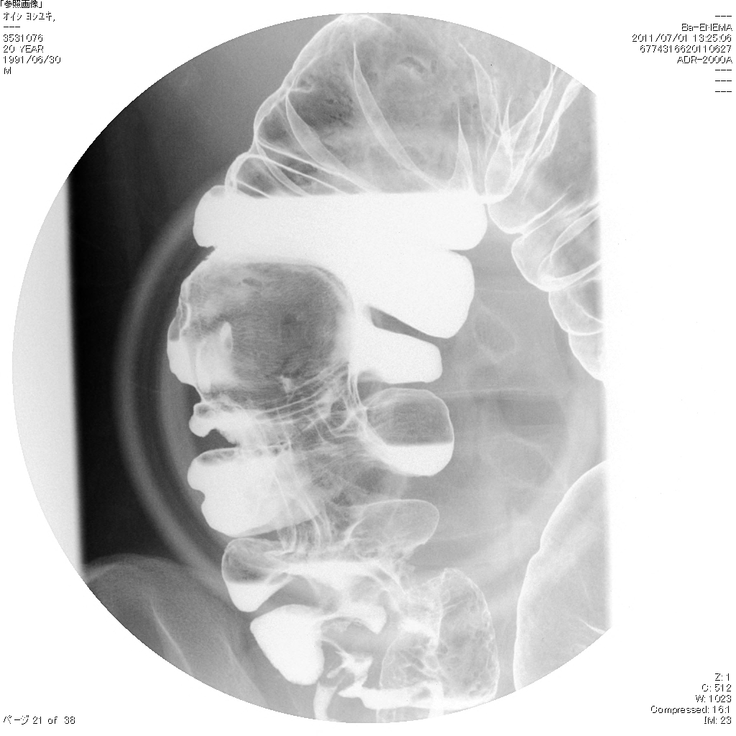
Figure 2 Barium enema. A large submucosal mass (arrow) in the ascending colon originating near the ileocecal valve.

Figure 3 Colonoscopy. A large submucosal mass in the ascending colon. Arrows indicate mucosal defects on the surface of the mass.

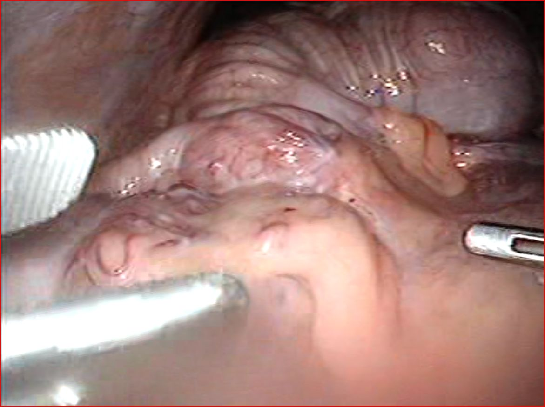

Figure 4 Intraoperative laparoscopic view. A round mass in the hepatic flexure of the colon (arrow) causing an invagination of the ileocecal region into the ascending colon (arrowhead).

A B
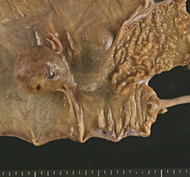
C D
Figure 5 Pathological analysis. A: A macroscopic view of the resected specimen. A round mass 4 cm in diameter is observed in the ascending colon. A submucosal tubular bulge measuring 5 cm in length extends from the round mass to the ileocecal valve (arrows); B and C: Magnified sectional views of the cystic lesion (loupe images; B: hematoxylin and eosin; C: desmin). The cystic lesion is lined by normal colonic mucosa and possesses its own muscular layer; D: A magnified sectional view of the tubular bulge (loupe image; hematoxylin and eosin). A blind-end tubular structure extends from the cystic lesion toward the proximal side to the ileocecal valve. This structure is lined by normal colonic mucosa and shares the muscular layer with the native ascending colon.

