Name of Journal: World Journal of Clinical Cases
Manuscript NO: 53185
Manuscript Type: CASE REPORT

Extrapleural solitary fibrous tumor of the thyroid gland: A case report and review of literature

Suh YJ et al. Extrapleural solitary fibrous tumor

Yong Joon Suh, Jung Ho Park, Jae Hyeon Jeon, Sanchir-Erdene Bilegsaikhan

Yong Joon Suh, Jung Ho Park, Department of Breast and Endocrine Surgery, Hallym University Sacred Heart Hospital, Gyeonggi-do 14068, South Korea

Jae Hyeon Jeon, Sanchir-Erdene Bilegsaikhan, Department of Biomedical Science, Hallym University, Chuncheon 24252, South Korea

Author contributions: Suh YJ designed the study; Bilegsaikhan SE collected the data; Suh YJ and Bilegsaikhan SE drafted the manuscript; Suh YJ revised the manuscript critically. All authors read and approved the final manuscript.

Supported by the National Research Foundation of Korea grant funded by the Korea government, No. 2019R1G1A1004679.

Corresponding Author: Yong Joon Suh, MD, PhD, Department of Breast and Endocrine Surgery, Hallym University Sacred Heart Hospital, No. 22 Gwanpyeong-ro 170 beon-gil, Dongan-gu, Anyang-si, Gyeonggi-do 14068, South Korea. nicizm@gmail.com

Received: December 9, 2019
Revised: January 13, 2020
Accepted: January 19, 2020
Published online: February 26, 2020

Abstract

BACKGROUND

Solitary fibrous tumor (SFT) is an uncommon mesenchymal neoplasm that arises from the pleura. A few SFTs have also been described in extrapleural sites. However, SFT of the thyroid gland is rare. Here, we report a case of extrapleural SFT on the thyroid gland, in addition to a literature review.

CASE SUMMARY
A 59-year-old man visited our hospital in July 2017 complaining of a large mass in his neck. His thyroid function test results, including antibody levels, were within the normal limits. Ultrasonography showed a 4.7 cm × 4.0 cm × 3.2 cm solitary mass of intermediate suspicion in the left thyroid lobe. A fine-needle aspiration biopsy was subsequently performed. The pathologist reported a benign follicular lesion. However, the size of this nodule increased to 5.5 cm × 5.0 cm × 3.4 cm by April 2018. After a multidisciplinary discussion, a left lobectomy was performed in May 2018. The specimen showed a well-demarcated, partly encapsulated, soft nodule of whitish and tan/brown color on the cut surface. Light microscopy revealed high cellularity with moderate cytologic atypia. The mitotic count was 5/10 high-power fields. There was no tumor necrosis or lymphovascular invasion. The tumor was CD34-positive and signal transducer and activator of transcription 6-positive. Neither thyroid transcription factor-1 nor cytokeratin expression was detected. The Ki-67 showed intermediate proliferative activity. The final diagnosis was extrapleural SFT of the thyroid gland with a clear resection margin. The patient was discharged without complication three days after the surgery.

CONCLUSION

In the literature, extrapleural SFT of the thyroid gland has been reported to behave indolently with the capacity for recurrence and rare metastasis, although surgical resection is the treatment of choice. Understanding this disease entity is important for accurate diagnosis and proper management.

Key words: Solitary fibrous tumor; Mesenchymal neoplasm; Thyroid gland; Surgery; Case report; Review

Citation: Suh YJ, Park JH, Jeon JH, Bilegsaikhan SE. Extrapleural solitary fibrous tumor of the thyroid gland: A case report and review of literature. World J Clin Cases 2020; 8(4): 782-789
URL: https://www.wjgnet.com/2307-8960/full/v8/i4/782.htm
DOI: https://dx.doi.org/10.12998/wjcc.v8.i4.782

Core tip: This report presents laboratory, radiologic, and pathologic findings about the extrapleural solitary fibrous tumor of the thyroid gland. Not much is known about its behavior or prognosis because of the rarity of these tumors. Therefore, a comprehensive literature review is also performed, which covers all the cases published in English.

INTRODUCTION
Solitary ﬁbrous tumor (SFT) is an uncommon spindle-cell neoplasm. In 1931, it was ﬁrst reported by Klemperer and Coleman^{[1]} as a pleural tumor. Since then, and for many years, as more cases of pleural SFT have been reported in the literature, such neoplasms have been thought to be conﬁned to the pleura as a type of localized ﬁbrous mesothelioma. It has subsequently been recognized in other organs of the body. Now, it is widely accepted that SFT is a rare neoplasm of mesenchymal origin^{[2]}. In 1993, SFT derived from the thyroid gland (SFT-T) was ﬁrst described in three patients presenting with nodular goiters^{[3]}. To the best of our knowledge, 37 cases have been reported to date, with an increased frequency in the past few years. Typically, patients presented with a slow-growing asymptomatic mass around the neck^{[4]}. Microscopically, the tumors are characterized by hypocellular and hypercellular areas, cytologically-bland spindle cells with patternless growth, ectatic branching blood vessels, and variable amounts of collagen^{[5,6]}. Well-defined immunohistochemical features and electron microscope ﬁndings support a fibroblastic, rather than mesothelial, differentiation of the tumor^{[7,8]}. Herein, we report a case of SFT originating from the thyroid gland, as well as a literature review. The patient provided informed consent for the publication of this report.

CASE PRESENTATION
Chief complaints
A 59-year-old man visited our hospital in July 2017 complaining of neck discomfort.

History of present illness
The patient had a history of an enlarged neck mass associated with dysphagia to solids.

Physical examination
At the physical examination, a neck mass with a homogeneous and tender consistency was palpated on the left side of the neck.

Laboratory examination
The patient’s thyroid function test results, including antibody levels, were within normal limits.

Imaging examination
Ultrasonography demonstrated a left-sided thyroid nodule with deviation of the trachea, showing a 4.7 cm × 4.0 cm × 3.2 cm solitary mass of intermediate suspicion in the left lobe (Figure 1). However, the size of the nodule was increased to 5.5 cm × 5.0 cm × 3.4 cm on a follow-up ultrasonography in April 2018. Computed tomography revealed a bulky and solid thyroid nodule in the transverse view (Figure 2).

Pathologic evaluation
A fine-needle aspiration biopsy was subsequently performed. The pathologist reported a benign follicular lesion.

FINAL DIAGNOSIS
The final diagnosis was extrapleural SFT-T with a clear resection margin. The specimen showed a well-demarcated and partly encapsulated soft nodule of whitish and tan/brown color on the cut surface (Figure 3A). Light microscopy examination of the surgical specimen revealed high cellularity with moderate cytologic atypia (Figure 3B). The mitotic count was 5/10 high-power fields. There was no tumor necrosis or lymphovascular invasion. Immunohistochemistry staining demonstrated that the tumor cells expressed CD34-positivity and signal transducer and activator of transcription 6 (STAT6)-positivity (Figure 3C and D). Neither cytokeratin nor thyroid transcription factor-1 expression was detected (Figure 3E and F). The Ki-67 showed intermediate proliferative activity.

TREATMENT
After a multidisciplinary discussion, the patient underwent a left lobectomy in May 2018. The recurrent laryngeal nerve, as well as the parathyroid glands, was preserved. No vocal cord dysfunction was found in the laryngoscopic evaluation performed after the surgery.

OUTCOME AND FOLLOW-UP
The patient was discharged without complication three days after the surgery. Follow-up examinations have been performed every six months, without any evidence of recurrence. The patient is doing well after 17 mo.

DISCUSSION
SFTs are rare ubiquitous neoplasms of mesenchymal origin^{[9]}. The etiology is unknown^{[10]}. They have been described as pleural-based lesions^{[1]}, but there have been subsequent reports of SFTs in other anatomic sites as well. Less than 0.1% of all tumors arise on the head and neck area^{[11]}. The first report of SFT-T was described in 1993^{[3]}. Since then, only 37 cases have been published in English articles. A review of this literature is summarized in Table 1. According to the accumulative data, the mean age for the appearance of SFT-T is 54.1 ± 13.0 years (ranging from 28 to 88 years), with no sex predilection (20 females and 18 males). The size of the tumors ranged from 1.5 to 13.8 cm, with a mean size of 5.6 ± 2.8 cm. Sixteen tumors were located on the left lobe, whereas 15 tumors were on the right lobe. Two tumors were found in intrathoracic locations. Among 25 patients with available follow-up data (mean 39.4 ± 34.0 mo), one patients experienced a local recurrence and distant metastasis^{[12]}. The clinical presentation of SFT-Ts is similar to regular thyroid neoplasms^{[13]}. The patient commonly refers to a painless slow-growing mass, but, there may be a rapid increase in volume occasionally^{[14,15]}.
SFT-T can only be diagnosed after the exclusion of other thyroid tumors that exhibit spindle-cell morphology^{[16]}. Possible differential diagnoses include anaplastic carcinomas, hemangiopericytomas, medullary carcinomas, sarcomas, leiomyomas, neurofibromas, schwannomas, Riedel’s thyroiditis, and lymphomas^{[17-20]}. The paucicellular variant of anaplastic thyroid carcinoma is featured by mildly atypical spindle cells in a sclerotic stromal background, which can morphologically resemble SFT-T^{[4]}. Even though fine-needle aspiration biopsy is a proper procedure for the evaluation of thyroid nodules, its efficacy in the diagnosis of SFT-T is limited^{[2,13]}. Although two reports presented a diagnosis of spindle-cell neoplasm using cytology combined with immunocytochemistry, a definitive confirmation of SFT-T was impossible using this method alone^{[7,18]}. Proper diagnosis can be only ensured by the combination of histopathological and immunohistochemical analysis. Microscopically, SFT-T shows a unique morphology, often referred to as a “patternless” pattern, with spindle cell proliferation, intermingled with hypocellular and hypercellular areas^{[2,15,21]}. Immunohistochemical analysis of the tumor cells has revealed positivity for progenitor cell marker (CD34), Ewing’s sarcoma cell marker (CD99), apoptotic marker (Bcl-2), and mesenchymal marker (vimentin). However, no immune reactions against epithelial marker (keratin), muscle cell marker (desmin), neuron-specific marker (S-100), and thyroid transcription factor-1 have been reported^{[19,22]}.
A gene fusion between NAB2 and STAT6 on chromosome 12q13 has been recently identified to be the pathognomonic molecular aberration in SFT^{[23]}. NAB2 is a repressor of Early growth response 1 (EGR1) target genes. EGR1 is a transcription factor that couples growth factor signaling with the induction of nuclear programs of cellular proliferation and differentiation. The NAB2 fusion gains an activation domain from STAT6, which converts NAB2 into a potent transcriptional activator of EGR1. This leads to constitutive activation of EGR-mediated transcription that drives neoplastic progression. The protein STAT6 detectable by immunohistochemistry, is shown to be a reliable indicator for the NAB2-STAT6 gene fusion^{[24,25]}. STAT6 immunohistochemistry is a highly sensitive and specific diagnostic marker for SFT^{[26,27]}. In our case, STAT6 immunohistochemistry showed the diffuse strong nuclear positivity. This testing can be considered as a valuable adjunct in the diagnosis of SFT.
SFT-Ts are mainly benign neoplasms and there are no distinct pathologic features to help differentiate benign from malignant lesions^{[2,9,13]}. In 1998, Vallat-Decouvelaere et al^{[28]} proposed some characteristics suggesting a more aggressive behavior. The histologic features of malignancy, as defined by the World Health Organization, include the presence of high cellularity, cytological atypia, a higher frequency of mitoses (> 4/10 HPF), and evidence of tumor necrosis or infiltrating margins^{[29]}. So far, there has only been one report of malignant SFT-T, which already presented with pulmonary metastasis when diagnosed^{[12]}. Even without distant metastasis, the tumor presented two of the above criteria for malignancy (high cellularity and cytological atypia) in the present case.
The primary management of SFT-T is surgical, which also provides a definitive diagnosis^{[10,13,30]}. A thyroid lobectomy may be sufficient, if there is no suspicion of malignancy, such as the invasion of surrounding structures. In the present case, there was no intraoperative finding of malignancy. Combined with the intraoperative finding of a normal right lobe, we chose to perform a left thyroid lobectomy. Thyroid-stimulating hormone suppression therapy with hormones has no rationale in the management of SFT-T, as the origin of the tumor cells is stromal^{[12]}. Indications for chemotherapy or external radiation therapy is controversial, even in malignant tumors^{[12,17]}. Specially in cases of malignancy, not much is known about its behavior or prognosis because of the rarity of these tumors. Close follow-up after surgical resection of the lesions seems to be the best management. A review of this literature is summarized in Table 1^{[31-36]}. This is the 38th case of SFT-T reported in English literature to date.

CONCLUSION
SFT-T has been reported to behave indolently with the capacity for potential recurrence and rare metastasis. The literature shows that surgical resection is the treatment of choice. Understanding this disease entity is important for accurate diagnosis and proper management.

REFERENCES
1 Klemperer P, Coleman BR. Primary neoplasms of the pleura. A report of five cases. Am J Ind Med 1992; 22: 1-31 [PMID: 1415270 DOI: 10.1002/ajim.4700220103]
2 Papi G, Corrado S, Uberti ED, Roti E. Solitary fibrous tumor of the thyroid gland. Thyroid 2007; 17: 119-126 [PMID: 17316113 DOI: 10.1089/thy.2005.0202]
3 Taccagni G, Sambade C, Nesland J, Terreni MR, Sobrinho-Simões M. Solitary fibrous tumour of the thyroid: clinicopathological, immunohistochemical and ultrastructural study of three cases. Virchows Arch A Pathol Anat Histopathol 1993; 422: 491-497 [PMID: 8333152 DOI: 10.1007/BF01606459]
4 Thompson LDR, Wei C, Rooper LM, Lau SK. Thyroid Gland Solitary Fibrous Tumor: Report of 3 Cases and a Comprehensive Review of the Literature. Head Neck Pathol 2019; 13: 597-605 [PMID: 30758754 DOI: 10.1007/s12105-019-01012-6]
5 Deshmukh NS, Mangham DC, Warfield AT, Watkinson JC. Solitary fibrous tumour of the thyroid gland. J Laryngol Otol 2001; 115: 940-942 [PMID: 11779319 DOI: 10.1258/0022215011909440]
6 Bohórquez CL, González-Cámpora R, Loscertales MC, Escudero AG, Mezquita JC. Solitary fibrous tumor of the thyroid with capsular invasion. Pathol Res Pract 2003; 199: 687-690 [PMID: 14666971 DOI: 10.1078/0344-0338-00481]
7 Kie JH, Kim JY, Park YN, Lee MK, Yang WI, Park JS. Solitary fibrous tumour of the thyroid. Histopathology 1997; 30: 365-368 [PMID: 9147086 DOI: 10.1046/j.1365-2559.1997.d01-618.x]
8 Cameselle-Teijeiro J, Varela-Duran J, Fonseca E, Villanueva JP, Sobrinho-Simoes M. Solitary fibrous tumor of the thyroid. Am J Clin Pathol 1994; 101: 535-538 [PMID: 8160648 DOI: 10.1093/ajcp/101.4.535]
9 Song Z, Yu C, Song X, Wei L, Liu A. Primary solitary fibrous tumor of the thyroid - report of a case and review of the literature. J Cancer 2011; 2: 206-209 [PMID: 21509151 DOI: 10.7150/jca.2.206]
10 Farrag TY, Micchelli S, Tufano RP. Solitary fibrous tumor of the thyroid gland. Laryngoscope 2009; 119: 2306-2308 [PMID: 19806654 DOI: 10.1002/lary.20295]
11 Larsen SR, Godballe C, Krogdahl A. Solitary fibrous tumor arising in an intrathoracic goiter. Thyroid 2010; 20: 435-437 [PMID: 20373988 DOI: 10.1089/thy.2009.0237]
12 Ning S, Song X, Xiang L, Chen Y, Cheng Y, Chen H. Malignant solitary fibrous tumor of the thyroid gland: report of a case and review of the literature. Diagn Cytopathol 2011; 39: 694-699 [PMID: 21837658 DOI: 10.1002/dc.21538]
13 Alves Filho W, Mahmoud RR, Ramos DM, Araujo-Filho VJ, Lima PP, Cernea CR, Brandão LG. Malignant solitary fibrous tumor of the thyroid: a case-report and review of the literature. Arq Bras Endocrinol Metabol 2014; 58: 402-406 [PMID: 24936737 DOI: 10.1590/0004-2730000003230]
14 Boonlorm N. Solitary Fibrous Tumor of Thyroid Gland: A Case Report. Bull Dep Med Serv 2014; 39: 133-141
15 Ghasemi-Rad M, Wang KY, Jain S, Lincoln CM. Solitary fibrous tumor of thyroid: a case report with review of literature. Clin Imaging 2019; 53: 105-107 [PMID: 30317135 DOI: 10.1016/j.clinimag.2018.09.011]
16 Tanahashi J, Kashima K, Daa T, Kondoh Y, Suzuki M, Kerakawauchi H, Yokoyama S. Solitary fibrous tumor of the thyroid gland: report of two cases and review of the literature. Pathol Int 2006; 56: 471-477 [PMID: 16872444 DOI: 10.1111/j.1440-1827.2006.01992.x]
17 Verdi D, Pennelli G, Pelizzo MR, Toniato A. Solitary fibrous tumor of the thyroid gland: a report of two cases with an analysis of their clinical and pathological features. Endocr Pathol 2011; 22: 165-169 [PMID: 21818669 DOI: 10.1007/s12022-011-9172-9]
18 Parwani AV, Galindo R, Steinberg DM, Zeiger MA, Westra WH, Ali SZ. Solitary fibrous tumor of the thyroid: cytopathologic findings and differential diagnosis. Diagn Cytopathol 2003; 28: 213-216 [PMID: 12672098 DOI: 10.1002/dc.10264]
19 Papi G, Corrado S, LiVolsi VA. Primary spindle cell lesions of the thyroid gland; an overview. Am J Clin Pathol 2006; 125 Suppl: S95-123 [PMID: 16830961 DOI: 10.1309/4DQW6RQX3C6KRX1J]
20 Baloch ZW, LiVolsi VA. Thyroid and Parathyroid. In: Mills SE, Greenson JK, Hornick JL, Longacre TA, Reuter VE. Sternberg's Diagnostic Surgical Pathology. 6th ed. Lippincott Williams and Wilkins, 2015: 533-594
21 Gold JS, Antonescu CR, Hajdu C, Ferrone CR, Hussain M, Lewis JJ, Brennan MF, Coit DG. Clinicopathologic correlates of solitary fibrous tumors. Cancer 2002; 94: 1057-1068 [PMID: 11920476 DOI: 10.1002/cncr.10328]
22 Santeusanio G, Schiaroli S, Ortenzi A, Mulè A, Perrone G, Fadda G. Solitary fibrous tumour of thyroid: report of two cases with immunohistochemical features and literature review. Head Neck Pathol 2008; 2: 231-235 [PMID: 20614321 DOI: 10.1007/s12105-008-0070-5]
23 Robinson DR, Wu YM, Kalyana-Sundaram S, Cao X, Lonigro RJ, Sung YS, Chen CL, Zhang L, Wang R, Su F, Iyer MK, Roychowdhury S, Siddiqui J, Pienta KJ, Kunju LP, Talpaz M, Mosquera JM, Singer S, Schuetze SM, Antonescu CR, Chinnaiyan AM. Identification of recurrent NAB2-STAT6 gene fusions in solitary fibrous tumor by integrative sequencing. Nat Genet 2013; 45: 180-185 [PMID: 23313952 DOI: 10.1038/ng.2509]
24 Doyle LA, Vivero M, Fletcher CD, Mertens F, Hornick JL. Nuclear expression of STAT6 distinguishes solitary fibrous tumor from histologic mimics. Mod Pathol 2014; 27: 390-395 [PMID: 24030747 DOI: 10.1038/modpathol.2013.164]
25 Barthelmeß S, Geddert H, Boltze C, Moskalev EA, Bieg M, Sirbu H, Brors B, Wiemann S, Hartmann A, Agaimy A, Haller F. Solitary fibrous tumors/hemangiopericytomas with different variants of the NAB2-STAT6 gene fusion are characterized by specific histomorphology and distinct clinicopathological features. Am J Pathol 2014; 184: 1209-1218 [PMID: 24513261 DOI: 10.1016/j.ajpath.2013.12.016]
26 Yoshida A, Tsuta K, Ohno M, Yoshida M, Narita Y, Kawai A, Asamura H, Kushima R. STAT6 immunohistochemistry is helpful in the diagnosis of solitary fibrous tumors. Am J Surg Pathol 2014; 38: 552-559 [PMID: 24625420 DOI: 10.1097/PAS.0000000000000137]
27 Cheah AL, Billings SD, Goldblum JR, Carver P, Tanas MZ, Rubin BP. STAT6 rabbit monoclonal antibody is a robust diagnostic tool for the distinction of solitary fibrous tumour from its mimics. Pathology 2014; 46: 389-395 [PMID: 24977739 DOI: 10.1097/PAT.0000000000000122]
28 Vallat-Decouvelaere AV, Dry SM, Fletcher CD. Atypical and malignant solitary fibrous tumors in extrathoracic locations: evidence of their comparability to intra-thoracic tumors. Am J Surg Pathol 1998; 22: 1501-1511 [PMID: 9850176 DOI: 10.1097/00000478-199812000-00007]
29 Fletcher CDM, Bridge JA, Lee, JC. Extrapleural solitary fibrous tumour. In: Fletcher CDM, Bridge JA, Hogendoorn, P, Mertens F. WHO Classification of Tumours of Soft Tissue and Bone. 4th ed. IARC, 2013: 80-82
30 Mizuuchi Y, Yamamoto H, Nakamura K, Shirahane K, Souzaki M, Tanaka M, Oda Y. Solitary fibrous tumor of the thyroid gland. Med Mol Morphol 2014; 47: 117-122 [PMID: 24013381 DOI: 10.1007/s00795-013-0056-6]
31 Brunnemann RB, Ro JY, Ordonez NG, Mooney J, El-Naggar AK, Ayala AG. Extrapleural solitary fibrous tumor: a clinicopathologic study of 24 cases. Mod Pathol 1999; 12: 1034-1042 [PMID: 10574600]
32 Rodriguez I, Ayala E, Caballero C, De Miguel C, Matias-Guiu X, Cubilla AL, Rosai J. Solitary fibrous tumor of the thyroid gland: report of seven cases. Am J Surg Pathol 2001; 25: 1424-1428 [PMID: 11684960 DOI: 10.1097/00000478-200111000-00011]
33 Babouk NL. Solitary fibrous tumor of the thyroid gland. Saudi Med J 2004; 25: 805-807
34 Papi G, Corrado S, Ruggiero C, Livolsi VA. Solitary fibrous tumor of the thyroid gland associated with papillary thyroid carcinoma. Thyroid 2006; 16: 319-320 [PMID: 16571098 DOI: 10.1089/thy.2006.16.319]
35 Cox DP, Daniels T, Jordan RC. Solitary fibrous tumor of the head and neck. Oral Surg Oral Med Oral Pathol Oral Radiol Endod 2010; 110: 79-84 [PMID: 20488732 DOI: 10.1016/j.tripleo.2010.01.023]
36 Lin MW, Wu CT, Lee YH, Chang YL. Intrathoracic thyroid solitary fibrous tumor presenting with respiratory failure. Ann Thorac Cardiovasc Surg 2014; 20 Suppl: 427-429 [PMID: 23445791 DOI: 10.5761/atcs.cr.12.02068]

Footnotes
Informed consent statement: Informed written consent was obtained from the patient for publication of this report and any accompanying images.

Conflict-of-interest statement: The authors declare that they have no conflict of interest.

CARE Checklist (2016) statement: The authors have read the CARE Checklist (2016), and the manuscript was prepared and revised according to the CARE Checklist (2016).

Open-Access: This article is an open-access article that was selected by an in-house editor and fully peer-reviewed by external reviewers. It is distributed in accordance with the Creative Commons Attribution Non Commercial (CC BY-NC 4.0) license, which permits others to distribute, remix, adapt, build upon this work non-commercially, and license their derivative works on different terms, provided the original work is properly cited and the use is non-commercial. See: http://creativecommons.org/licenses/by-nc/4.0/

Manuscript source: Unsolicited manuscript

Peer-review started: December 9, 2019
First decision: December 30, 2019
Article in press: January 19, 2020

Specialty type: Medicine, research and experimental
Country of origin: South Korea
Peer-review report classification
Grade A (Excellent): 0
Grade B (Very good): 0
Grade C (Good): C
Grade D (Fair): 0
Grade E (Poor): 0

P-Reviewer: Ishizawa K S-Editor: Zhang L L-Editor: A E-Editor: Qi LL

Figure legends
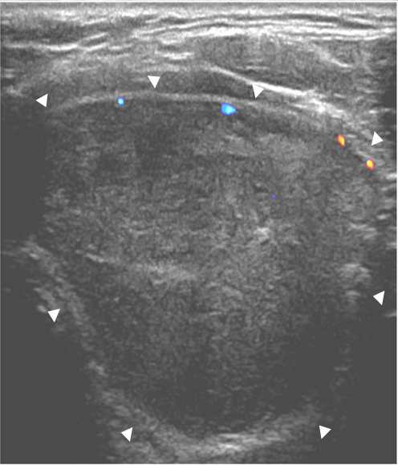
Figure 1 Ultrasonography shows a 4.7 cm × 4.0 cm × 3.2 cm heterogeneously enhancing solitary nodule arising from the left lobe of the thyroid gland (white arrow head).

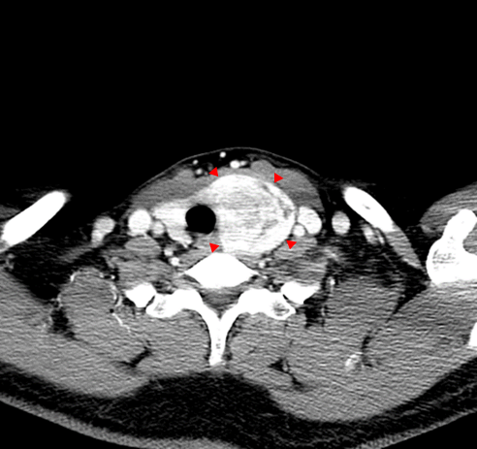
Figure 2 Computed tomography reveals a bulky and solid thyroid nodule at transverse view (red arrow head).

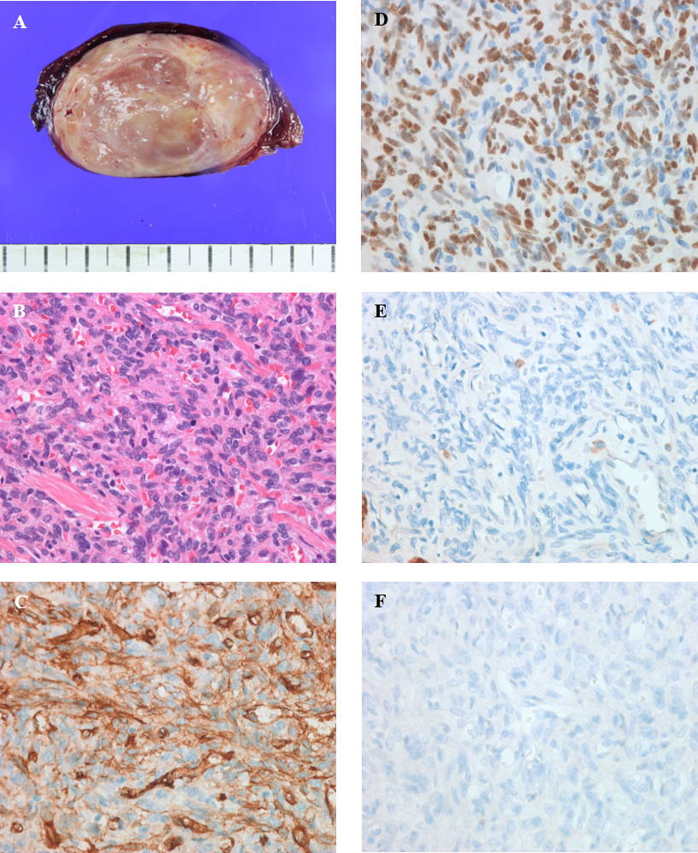
Figure 3 Histology of a surgical specimen examined under light microscope. A: Gross image; B: Hematoxylin and eosin staining (LM, × 40); C: CD34 (LM, × 400); D: Signal transducer and activator of transcription 6 (LM, × 400); E: CK (LM, × 400); F: TTF-1 (LM, × 400). LM: light microscope.
Table 1 A summary of the clinicopathological features in the reported cases of solitary fibrous tumor derived from the thyroid gland
Case | Year | Ref. | Age | Sex | Site | Size (cm) | Atypia | Mitosis¹ | Necrosis | STAT6 | Treatment | F/U (mo)
1 | 1993 | Taccagni et al^{[3]} | 44 | F | R | 6 | No | Rare | NA | NA | Lobectomy | NED (60)
2 | 1993 | Taccagni et al^{[3]} | 61 | M | L | 6 | No | No | NA | NA | Subtotal | NED (48)
3 | 1993 | Taccagni et al^{[3]} | 32 | F | R | 3.5 | Yes | Rare | NA | NA | Lobectomy | NED (60)
4 | 1994 | Cameselle-Teijeiro et al^{[8]} | 43 | F | L | 4 | No | No | No | NA | Subtotal | NED (160)
5 | 1997 | Kie et al^{[7]} | 48 | F | R | 8 | No | No | No | NA | Lobectomy | NA
6 | 1999 | Brunnemann et al^{[31]} | 28 | F | NA | 2.5 | NA | 4 | NA | NA | NA | NA
7 | 2001 | Rodriguez et al^{[32]} | 43 | F | L | 3.5 | No | 2 | No | NA | NA | NA
8 | 2001 | Rodriguez et al^{[32]} | 52 | M | L | 2.5 | No | No | No | NA | NA | NA
9 | 2001 | Rodriguez et al^{[32]} | 44 | M | L | 2 | Yes | 1 | No | NA | NA | NA
10 | 2001 | Rodriguez et al^{[32]} | 64 | F | R | 4. | No | 2 | No | NA | NA | NED (60)
11 | 2001 | Rodriguez et al^{[32]} | 53 | M | L | 6 | No | 1 | No | NA | NA | NED (60)
12 | 2001 | Rodriguez et al^{[32]} | 47 | F | R | 4.5 | No | No | No | NA | NA | NED (48)
13 | 2001 | Rodriguez et al^{[32]} | 64 | F | L | 3 | No | No | No | NA | NA | NA
14 | 2001 | Deshmukh et al^{[5]} | 56 | M | R | 8 | No | No | No | NA | Lobectomy | NED (12)
15 | 2003 | Bohórquez et al^{[6]} | 68 | M | L | 9.7 | No | No | No | NA | Lobectomy | NA
16 | 2003 | Parwani et al^{[18]} | 61 | M | L | 5 | No | No | No | NA | Subtotal | NA
17 | 2004 | Babouk^{[33]} | 45 | M | L | 5 | No | No | No | NA | Lobectomy | NA
18 | 2006 | Tanahashi et al^{[16]} | 64 | M | R | 5 | No | No | No | NA | Subtotal | NED (57)
19 | 2006 | Tanahashi et al^{[16]} | 41 | M | R | 3 | No | No | No | NA | Lobectomy | NED (45)
20 | 2006 | Papi et al^{[34]} | 70 | F | R | 1.5 | No | No | No | NA | Total | NED (6)
21 | 2008 | Santeusanio et al^{[22]} | 61 | M | R | 3.5 | No | No | No | NA | Subtotal | NED (60)
22 | 2008 | Santeusanio et al^{[22]} | 42 | F | R | 4.7 | No | No | No | NA | Lobectomy | NED (84)
23 | 2009 | Farrag et al^{[10]} | 51 | M | L | 7 | NA | NA | NA | NA | Lobectomy | NA
24 | 2010 | Ning et al^{[12]} | 76 | F | R | 4 | Yes | High | Yes | NA | Lobectomy | RC/ MT (5)
25 | 2010 | Larsen et al^{[11]} | 58 | M | IT | 8 | No | Low | No | NA | Lobectomy | NA
26 | 2010 | Cox et al^{[35]} | 69 | F | NA | 2.2 | NA | NA | NA | NA | NA | NA
27 | 2011 | Song et al^{[9]} | 37 | M | L | 4 | No | < 1 | No | NA | Subtotal | NED (12)
28 | 2011 | Verdi et al^{[17]} | 47 | F | L | 5.2 | NA | NA | No | NA | Lobectomy | NED (9)
29 | 2011 | Verdi et al^{[17]} | 59 | M | R | 7 | No | No | No | NA | Lobectomy | NED (31)
30 | 2013 | Lin et al^{[36]} | 88 | F | IT | 9 | NA | < 1 | Yes | NA | Subtotal | NED (36)
31 | 2013 | Mizuuchi et al^{[30]} | 78 | M | R | 3 | No | No | No | NA | Subtotal | NED (12)
32 | 2013 | Alves Filho et al^{[13]} | 60 | F | R | 13.8 | Yes | 6 | No | NA | Subtotal | NA
33 | 2014 | Boonlorm^{[14]} | 61 | F | L | 10.5 | No | No | No | NA | Subtotal | NED (19)
34 | 2019 | Ghasemi-rad et al^{[15]} | 41 | F | L | 11 | Yes | High | No | Yes | Total | NED (10)
35 | 2019 | Thompson et al^{[4]} | 44 | F | NA | 7 | NA | NA | NA | Yes | Lobectomy | NED (41)
36 | 2019 | Thompson et al^{[4]} | 45 | F | NA | 8.2 | NA | NA | NA | Yes | Lobectomy | NED (28)
37 | 2019 | Thompson et al^{[4]} | 52 | M | NA | 7 | NA | NA | NA | Yes | Lobectomy | NED (5)
38 | 2019 | Present case | 59 | M | L | 5.5 | Yes | 5 | No | Yes | Lobectomy | NED (17)
¹The mitosis is counted per 10 high power fields. M: Male; F: Female; R: Right lobe; L: Left lobe; IT: Intrathoracic; NA: Not available; NED: No evidence of disease; RC: Recurrence; MT: Metastasis.

