Name of Journal: World Journal of Gastroenterology
Manuscript NO: 90246
Manuscript Type: REVIEW

Optimizing nutrition in hepatic cirrhosis: A comprehensive assessment and care approach

Mendez-Guerrero O et al. Optimizing nutrition in cirrhosis

Osvely Mendez-Guerrero, Anaisa Carranza-Carrasco, Luis Alberto Chi-Cervera, Aldo Torre, Nalu Navarro-Alvarez

Osvely Mendez-Guerrero, Anaisa Carranza-Carrasco, Aldo Torre, Nalu Navarro-Alvarez, Department of Gastroenterology, Instituto Nacional de Ciencias Médicas y Nutrición Salvador Zubirán, Mexico City 14080, Mexico

Luis Alberto Chi-Cervera, Clínica de Especialidades Gastrointestinales y Hepáticas, Hospital Star Medica, Merida 97133, Yucatan, Mexico

Nalu Navarro-Alvarez, Molecular Biology, Universidad Panamericana School of Medicine, Campus México, Mexico City 03920, Mexico

Nalu Navarro-Alvarez, Department of Surgery, University of Colorado Anschutz Medical Campus, Denver, CO 80045, United States

Author contributions: Mendez-Guerrero O, Carranza-Carrasco A, Chi-Cervera LA, and Torre A performed the literature revision, collected the data, and wrote the manuscript; Navarro-Alvarez N wrote, reviewed, and edited the manuscript.

Corresponding author: Nalu Navarro-Alvarez, MD, PhD, Assistant Professor, Department of Gastroenterology, Instituto Nacional de Ciencias Médicas y Nutrición Salvador Zubirán, 15 Vasco de Quiroga, Mexico City 14080, Mexico. nalu.navarroa@incmnsz.mx

Received: November 28, 2023
Revised: January 23, 2024
Accepted: February 25, 2024
Published online: March 14, 2024

Abstract
Cirrhosis is considered a growing cause of morbidity and mortality, which represents a significant public health problem. Currently, there is no effective treatment to reverse cirrhosis. Treatment primarily centers on addressing the underlying liver condition, monitoring, and managing portal hypertension-related complications, and evaluating the potential for liver transplantation in cases of decompensated cirrhosis, marked by rapid progression and the emergence of complications like variceal bleeding, hepatic encephalopathy, ascites, malnutrition, and more. Malnutrition, a prevalent complication across all disease stages, is often underdiagnosed in cirrhosis due to the complexities of nutritional assessment in patients with fluid retention and/or obesity, despite its crucial impact on prognosis. Increasing emphasis has been placed on the collaboration of nutritionists within hepatology and Liver transplant teams to deliver comprehensive care, a practice that has shown to improve outcomes. This review covers appropriate screening and assessment methods for evaluating the nutritional status of this population, diagnostic approaches for malnutrition, and context-specific nutrition treatments. It also discusses evidence-based recommendations for supplementation and physical exercise, both essential elements of the standard care provided to cirrhotic patients.

Key Words: Cirrhosis; Nutritional diagnosis; Treatment; Diet; Guidelines

©The Author(s) 2024. Published by Baishideng Publishing Group Inc. All rights reserved.

Citation: Mendez-Guerrero O, Carranza-Carrasco A, Chi-Cervera LA, Torre A, Navarro-Alvarez N. Optimizing nutrition in hepatic cirrhosis: A comprehensive assessment and care approach. World J Gastroenterol 2024; 30(10): 1313-1328
URL: https://www.wjgnet.com/1007-9327/full/v30/i10/1313.htm
DOI: https://dx.doi.org/10.3748/wjg.v30.i10.1313

Core Tip: Currently, there is a wealth of information on the ideal nutritional treatment for cirrhosis. Yet, a critical gap persists: The absence of a concise clinical document encompassing the entire nutritional care process. The significance of nutritional management is increasing, given its profound influence on both patient prognosis and quality of life. We here strongly emphasize the need to offer a practical foundation for managing nutrition in cirrhosis, grounded in scientific evidence.
INTRODUCTION
Cirrhosis is a globally highly prevalent disease associated with significantly high morbidity and mortality. It is the 14th cause of death worldwide accounting for 1.03 million deaths/year^{[1]}. This chronic disease is a result of the progression of many forms of necro-inflammatory liver diseases leading to fibrosis, vascular remodeling, development of portal hypertension along with its complications, and ultimately liver failure^{[2]}. The disease’s natural progression involves an asymptomatic phase known as “compensated cirrhosis”, followed by “decompensated cirrhosis”, marked by rapid progression and the emergence of symptoms including portal hypertension, bleeding, hepatic encephalopathy (HE), ascites, malnutrition, among others^{[3]}.
Cirrhosis is a condition with a longstanding propensity for the development of malnutrition, sarcopenia, and fragility.
Malnutrition in this population is attributed to the interaction of different factors, including: Metabolic alterations^{[4]}, inadequate dietary intake, increased energy requirements as a result of hypermetabolism and systemic inflammation^{[5]}, deficiencies of micronutrients, and anorexia due to hormonal imbalances, among others^{[6]}. Malnutrition is not simply an accompanying condition but has a significant impact on the progression of the disease that further worsens the patient prognosis. Its direct impact on patient outcomes and complications is widely acknowledged^{[7]}.
Diagnosing malnutrition can be challenging due to its complex evaluation and the potential influence of factors like fluid overload, HE, and obesity, which can mask its effects^{[7-9]}.
As one of the few modifiable factors within cirrhosis, early diagnosis and timely treatment offer the potential to influence positively patient outcomes.
In this review we aim to describe the impact of malnutrition in cirrhosis, the adequate strategies for a thorough nutritional status assessment using validated screening tools. We also discuss evidence-based recommendations of nutritional and exercise intervention that can be used to improve outcomes for patients with liver cirrhosis.

DIAGNOSIS AND TREATMENT
The most useful scores to determine the severity of the disease include the Child-Pugh and model for end-stage liver disease (MELD) scores. The Child-Pugh score incorporates biochemical and clinical factors such as total bilirubin, albumin, international normalized ratio (INR), ascites, and HE. However, limitations arise due to the variability in assessing clinical variables like ascites and HE^{[10]}. Therefore, the MELD score was developed, offering a more objective approach. It relies on a mathematical model involving biochemical parameters like creatinine, total bilirubin, and INR. The MELD score is widely used as a measurement to evaluate and prioritize the organ allocation for transplantation, since it accurately predicts short-term survival (3 months). The cut-off value of 15 is widely used to prioritize candidates to receive a liver transplantation^{[11]}.
Currently, preventing cirrhosis lacks an effective treatment approach. As a result, the present emphasis is on managing liver diseases and their related complications. This involves meticulous assessment of individuals with decompensated disease for potential liver transplantation^{[12]}.
Despite liver transplantation being considered a curative treatment, is not always available to everyone, and in some cases, there is a high incidence of recurrence of the liver disease. In a retrospective cohort evaluating risk factors and outcomes associated with recurrent autoimmune hepatitis (AIH) after liver transplantation, AIH recurrence was found in 20% of patients after 5 years and 31% after 10 years. The authors concluded that AIH recurrence after transplantation is common and is associated with younger age at liver transplant (LT), post-LT use of mycophenolate mofetil, gender mismatch, and elevated pre-transplant IgG levels. They demonstrated an association between disease recurrence and graft impairment and overall survival in patients with AIH, highlighting the importance of continued efforts to better characterize, prevent, and treat recurrent AIH^{[12]}. The LT community continues to be challenged by limitations in organ supply, allocation, and quality. As the need for transplantation expands, innovations to safely use and potentially salvage all donor organs are being explored and tested. Many groups are attempting to overcome these obstacles by gradually developing novel techniques and using sound translational science^{[13]}.

IMPACT OF MALNUTRITION AND SARCOPENIA IN CIRRHOSIS
Malnutrition is defined as inadequate nutrient intake, nutrient imbalance, or altered utilization^{[14]}. The prevalence of malnutrition varies depending on the assessment method, disease etiology, and patient stage. It is higher (40%-70%) in decompensated cirrhosis often accompanied by disease-related complications such as HE, ascites, and esophageal varices (Child-Pugh B-C). In compensated or asymptomatic phases (Child-Pugh A), the prevalence ranges from 10% to 40%^{[14-16]}.
The pathophysiology of malnutrition and sarcopenia is complex and is attributed to the interaction of factors including metabolic alterations caused by a decrease in hepatic glycogen reserves, increased lipid catabolism, and increased proteolysis due to an increased gluconeogenesis^{[4,5]}. These metabolic changes lead to a 15%-30% increase in energy requirements^{[15]}, which if coupled with the insufficient dietary intake arising from cirrhosis-related complications such as ascites, HE, and dysgeusia, are a significant malnutrition-contributing factor.
Ascites in patients delays gastric emptying, resulting in postprandial satiety and reduced appetite^{[17]}. Cognitive impairment in HE leads to decreased food consumption^{[18]}. Protein intake is often restricted as part of routine clinical management, leading to reduced calorie intake, despite a lack of evidence supporting improvement in HE^{[19]}.
Cirrhotic patients often experience dysgeusia, which is linked to deficiency in micronutrients like zinc^{[20]} and other minerals that decrease due to both the drugs used for treating the disease and associated comorbidities, including diuretics^{[21]}, and a decreased consumption by the patients.
Following variceal gastrointestinal bleeding, patients may be kept fasting for prolonged periods. Additionally, endoscopic procedures like variceal ligation can induce temporary dysphagia, potentially leading to reduced protein and energy intake^{[14,15]}.
Sarcopenia, another facet of malnutrition, involves muscle mass and strength loss alongside reduced physical performance^{[14,22]}. This condition contributes to fragility, marked by reduced physiological reserve and increased stress factors^{[23]}.
Furthermore, there is a decline in muscle fiber formation which is attributed to satellite cell differentiation inhibition^{[24]} and an increased in mTOR signaling pathway activity^{[25]}, promoting proteolysis. This phenomenon is linked to elevated myostatin activity^{[26]}, a member of the TGF-β cytokine family, which is proven to be enhanced in cirrhosis and closely related to disease severity^{[27]}.
Sarcopenia, regardless of hepatic function, has been shown to be an important predictor of pre and posttransplant complications^{[28]}, including higher risk of infections^{[29]}, HE^{[30]}, longer hospital stay^{[31]}, low quality of life^{[32]} and survival (Figure 1)^{[33]}.
A weak correlation between muscle mass and liver function has prompted the consideration of sarcopenia as a significant addition to the MELD score. The presence of sarcopenia in a patient is equivalent to adding 10 points to the MELD score^{[33]}. Therefore, prioritizing these patients and implementing a controlled nutritional plan before transplantation becomes crucial to enhance post-transplant outcomes.

NUTRITIONAL CONTROL AND SCREENING
According to Global Leadership Initiative on Malnutrition criteria, a proper diagnosis requires combining etiological and phenotypic patient characteristics (Table 1)^{[34]}.
Implementing the nutritional control protocol outlined by Clinical Practice Guidelines is strongly advised as a fundamental aspect of standard cirrhosis patient management (Figure 2). This comprehensive plan encompasses nutritional assessment, nutritional diagnosis, a personalized nutritional intervention, and monitoring as recommended by the European Association for the Study of the Liver^{[35]} (Figure 3). Assessing nutritional status, interpreting parameters, and clinically evaluating patients with cirrhosis possesses challenges influenced by numerous non-nutritional factors, therefore, this should be a collaborative endeavor, where nutritionists and hepatologists work together to provide holistic treatment, ensuring optimal outcomes for the patients.
Nutritional screening evaluates characteristics related to nutritional concerns, pinpointing patients who need thorough nutritional status assessment. These screenings should occur within 24 h of hospitalization or within the initial 14 d of long-term care facility admission^{[36]}. The tools used must be easy to apply, reproducible, capable of detecting changes over time, and validated for the population in which they are being used^{[37]}.
In patients with cirrhosis, the validated screening tools are the Royal Free Hospital Global Assessment (RFH-GA) and the RFH-Nutritional Prioritizing Tool (RFH-NPT)^{[19]}.

RFH-GA
This tool evaluates mortality risk in mild/moderate and severe malnutrition stages. It considers objective and subjective factors, incorporating body mass index (BMI). For patients with fluid overload, it considers dry weight, often calculated from post-paracentesis weight or pre-fluid retention weight, or subtracts a percentage based on ascites severity (5% for mild, 10% for moderate, and 15% for severe), plus an extra 5% for bilateral edema^{[38]}. In this scheme, the corrected mid-arm muscle area (cAMA) is also used along with dietary intake details in a semi-structured algorithmic construction. The RFH-GA exhibits excellent intra- and inter-observer reproducibility and has been validated against a multicomponent model of body composition^{[39,40]}.

RFH-NPT
Currently there is international consensus to utilize this tool due to its demonstrated clinical correlation with disease severity and efficient application^{[41,42]}. Taking under 3 minutes to complete, this screening tool is suitable for non-specialized personnel. It boasts remarkable intra- and inter-observer reproducibility and substantial external validity when compared to RFH-GA^{[40]}.
The process involves three key steps: (1) Individuals with alcoholic hepatitis or on tube feeding are promptly identified as high risk without further steps; (2) those without alcoholic hepatitis and not on tube feeding are assessed for fluid overload’s effect on food intake and weight loss; and (3) individuals without fluid overload are evaluated for nutritional status (BMI, unplanned weight loss, daily dietary intake). Patients are categorized as low risk (score 0), moderate risk (score 1), or high risk (score 2 to 7)^{[42]}.

NUTRITIONAL STATUS ASSESSMENT
Body composition assessment methods vary in their characteristics, benefits, and drawbacks. Their diagnostic effectiveness hinges on the patient’s disease-related complications during assessment. Fluid retention can distort measurements due to physical changes in body compartments. The following outlines the key measurements for assessing body composition, including their respective advantages and disadvantages.

Anthropometry
Anthropometric assessment measures physical dimensions and body composition. It’s highly accessible but demands evaluator training and intra-observer evaluations for measurement consistency^{[43,44]}.
The most used anthropometric measures, in addition to weight and height, are mid-arm circumference (MAC) and triceps skinfold thickness (TSF). These measurements are taken as follows.

MAC: When measuring MAC, the subject should be standing upright with arms by their sides and palms facing inward. The measuring area should be uncovered. To find the midpoint of the arm, the person’s arm is flexed at a 90-degree angle with the palm upward. The person taking the measurement stands behind and locates the lateral tip of the acromion, palpating along the upper surface of the scapula’s spine. The distance between the acromion (end of the clavicle) and the olecranon (end of the humerus) is measured, marking the midpoint between them. After identifying the midpoint, the arm is relaxed, and the measurement is taken in centimeters (cm)^{[43]}.

TSF: To assess TSF, locate the skinfold site on the back of the arm, directly over the triceps muscle. For accurate measurement, have the subject’s arm hang to one side to establish the posterior midline. Mark the skinfold site along the posterior midline of the arm, aligning it with the MAC. The person performing the measurement should stand behind the subject, using their left hand to hold the skinfold 1 cm proximal to the marked site. Position the caliper tips 1 cm below the thumb and index finger, maintaining them perpendicular to the skinfold’s longitudinal axis. Take three measurements and record the average in millimeters (mm)^{[45,46]}.

cAMA: The cAMA is calculated using the values obtained from measurements of the MAC and TSF with the following formula:
Men cAMA: [MAC cm - ( × PCT cm)]²/4 - 10
Women cAMA: [MAC cm - ( × PCT cm)]²/4 - 6.5
cAMA measurements below the 5th percentile, as indicated by reference tables for sex and age by Frisancho, suggest malnutrition resulting from low muscle mass^{[45,46]}. However, these measurements have limitations in patients with fluid retention, as they can lead to overestimation during assessments and show reduced sensitivity to sudden changes. Consequently, their use is advised in the early stages of the disease^{[47]}.

Imaging methods
Radiological imaging analysis is now used to diagnose muscle mass in cirrhosis. These techniques have gained substantial attention primarily due to their diagnostic capability in determining muscle mass and its connection to disease prognosis. Imaging methods are considered objective and reproducible approaches to evaluate skeletal muscle mass, utilizing indices calculated from cross-sectional images obtained via computed tomography (CT) or magnetic resonance imaging (MRI)^{[16,48]}. These approaches are predominantly employed for hepatocellular carcinoma screening or during LT protocols. However, they are not specifically recommended for muscle mass assessment due to their high costs, exposure to radiation, and a shortage of trained personnel for image analysis.

CT: A tomographic scan is taken at the L3 lumbar vertebra level, and specialized software is employed to delineate tissues based on hounsfield unit thresholds. Muscles within the L3 region encompass the psoas, erector spinae, quadratus lumborum, transversus abdominis, external and internal obliques, and rectus abdominis. Cross-sectional areas (cm²) are automatically computed by summing tissue pixels and multiplying by pixel surface area^{[30,49]}.
The resulting muscle and adipose tissue cross-sectional areas are then adjusted for height (cm²/m²), yielding the L3 Skeletal Muscle Index (L3 SMI)^{[50]}.
Recent years have seen the development of specific cutoff values for cirrhosis. Presently, it is advised to utilize the cutoff values established by the North American expert consensus, which are validated and interpreted according to gender: L3 SMI < 39 cm²/m² for women and < 50 cm²/m² for men^{[51]}. This method offers the advantage of maintaining diagnostic accuracy even in the presence of ascites. However, its practical application is restricted due to factors such as radiation exposure, costs, and the necessity for standardized personnel to conduct measurements and interpretation.

MRI: This method utilizes an L3 vertebral level image, outlining areas expressed in pixels that are then converted into an area measurement (cm²). This measurement is adjusted for the patient’s height and shares the same interpretation as the L3 SMI since it uses the same cutoff points^{[51]}.
Similar to CT scans, it remains unaffected by ascites and offers the advantage of avoiding ionizing radiation, while also assisting in quantifying intrahepatic fat. However, limitations include its limited availability, cost, and the requirement for standardized personnel to analyze the images, rendering it less practical for routine monitoring.

Dual-energy X-ray absorptiometry: This method evaluates fat mass, lean mass, and bone mineral content. Using this data, muscle mass in the upper and lower limbs is calculated to eliminate the influence of ascites. After adjusting for height, the Appendicular SMI (ASMI) is derived^{[52]}. A value below two standard deviations from the mean indicates muscle mass loss. Limitations involve potential overestimation of lean mass and inaccuracies due to edema. Nonetheless, the method’s advantage is assessing bone mineral density, aiding in tailoring the dietary plan if osteopenia or osteoporosis is detected in the patient^{[49,53]}.

Other methods
Bioelectrical impedance analysis: Bioelectrical impedance analysis (BIA) is a common method for assessing body composition, including lean mass, fat mass, and body fluids. It works by measuring the resistance of body tissues to alternating current. However, the equations used in this method are derived from healthy populations and can be affected by fluid retention. Consequently, its use is not recommended due to its tendency to underestimate lean mass^{[39]}.

Vector analysis of bioelectrical impedance: This analysis was developed to enhance the diagnostic capabilities of conventional impedance. It utilizes direct data from BIA and standardizes them based on the patient’s height. The process involves using software created by Piccoli et al^{[54]}, which graphically represents the data as a vector. Unlike predicting body composition, this analysis visually represents it as a bivariate vector, assessing both body composition and hydration status. The correlations between these variables lead to an elliptical distribution known as the RXc graph. This graph’s normal distribution is derived from a healthy population, yielding three reference percentiles or tolerance ellipses at 50%, 75%, and 95%, specific to each gender. Values beyond the 95th percentile are considered abnormal. Hence, in clinical practice, the 50% and 75% ellipses are used as ranges of normality. Within the graph, there are quadrants with distinct values that offer qualitative insights. These values can be depicted as vectors and interpreted as follows: Hydration variations (edema or dehydration) without tissue structure changes align with the major axis of the tolerance ellipses. Changes in soft tissue quantity (lean and adipose) correspond to vector shifts along the minor axis of the ellipses. The method’s advantage lies in its ability to simultaneously assess fluid presence and malnutrition, facilitating nutritional monitoring and diuretic treatment evaluation. It also enables comparisons of a patient’s visits to the nutritionist and aims to position the patient within the ellipses of normality^{[55,56]}.

Phase angle: The phase angle (PA), derived from bioelectrical impedance measurements, relies on the body’s conductivity properties, specifically the resistance and reactance. This metric mirrors the integrity of cell membranes and their ability to resist impedance currents. It is considered a useful tool that indicates the balance between cellular hydration and body mass, ultimately translating into tissue homeostasis and nutritional status. Low levels of the PA have been associated with inflammation and loss of muscle and fat mass in patients with conditions like cancer^{[57]}, human immunodeficiency virus^{[58]} among others^{[59]}. It has been validated in patients with cirrhosis from the Mexican population, where a PA of ≤ 4.9 has been observed to be associated with worse clinical outcomes^{[60,61]}.

Dynamometry: Dynamometry is a nutritional assessment method that measures muscle function by measuring grip strength with a dynamometer, often using a hand dynamometer. This approach has been verified across diverse populations, as weak grip strength has been linked to functional constraints, diminished quality of life, and heightened morbidity and mortality^{[62-64]}. Grip strength reflects changes occurring in prominent muscle groups, even during the early phases of malnutrition, and likely isn’t directly influenced by liver disease. There are specific cutoff points for men and women in different populations^{[65]}, where measurements below the mean are indicative of malnutrition or reduced functionality^{[64,66]}. However, in individuals with cirrhosis, its reliability is hindered, particularly in patients with HE, even in mild forms, or those undergoing benzodiazepine therapy, due to cognitive and motor impairments that may skew the outcome^{[64]}.

Liver frailty index: To assess frailty, the Liver Frailty Index (LFI) is utilized, previously validated in the population with hepatic cirrhosis^{[23,67,68]}. This index takes into account the following assessments: (1) Grip strength: It considers the average of three measurements taken on the subject’s dominant hand using a hand dynamometer^{[65,66]}; (2) Timed chair stands: Measured as the number of seconds it takes to perform five chair stands with the subject’s arms crossed over their chest^{[23]}; and (3) Balance test: It is evaluated by counting the number of seconds the subject can balance in three positions (feet placed side by side, semi-tandem, and tandem) for a maximum of 10 s each^{[23]}.
The results of each test are incorporated into the following formula (calculator available at http://Liverfrailtyindex.ucsf.edu): (-0.330 × gender - adjusted grip strength) + (-2.529 × number of chair stands per second) + (-0.040 × balance time) + 6. A patient is considered frail when they score > 4.5.

BIOCHEMICAL MARKERS
Biochemical markers play a crucial role in the clinical assessment of cirrhosis, including parameters like prothrombin time (INR), albumin, creatinine, and more^{[69]}. However, the usefulness of these markers in nutritional evaluation is limited. The compromised hepatic synthesis in cirrhosis leads to reduced levels of serum albumin, prealbumin, transferrin, and prolonged INR, potentially leading to an overestimation of malnutrition prevalence. Moreover, creatinine, commonly used as a measure of malnutrition, can be inaccurate due to its sensitivity to renal function changes often present in these patients^{[70]}. Additionally, the lymphocyte count is influenced by the disease, with lymphopenia often caused by hypersplenism due to portal hypertension in cirrhosis, making it an unreliable indicator of the patient’s nutritional status.

CLINICAL EVALUATION
In the context of the nutritional care process, it is necessary to assess the presence of complications of cirrhosis, such as ascites and HE, as they can lead to deteriorated nutritional status. Timely identification of these complications allows for necessary adjustments in nutritional treatment.

Ascites
Ascites occurs due to disruptions in renal sodium excretion, resulting in a positive sodium balance, and subsequent fluid retention. This accumulation of fluids leads to an increase in extracellular volume. Decreased sodium excretion is primarily attributed to arterial vasodilation triggered by portal hypertension. This, in turn, activates the renin-angiotensin-aldosterone system and the sympathetic nervous system, causing renal vasoconstriction and sodium retention. Consequently, ascites and edema develop as a consequence of these physiological responses^{[71]}.
Ascites is classified into the following grades: Grade I: Mild, detectable only through ultrasound; Grade II: Moderate, evident by symmetrical abdominal distension; and Grade III: Severe and marked abdominal distension.
The cornerstone of ascites treatment is dietary sodium restriction in combination with loop diuretics and aldosterone antagonist diuretics, aiming to create a negative sodium balance that enhances urinary sodium excretion beyond dietary sodium intake^{[72]}. However, dietary sodium restriction is effective in only around 14% of patients due to the poor adherence associated with such diets.

HE
HE is a condition characterized by brain dysfunction due to hepatic insufficiency or portosystemic shunting. It manifests as a wide range of neurological and psychiatric abnormalities, spanning from subtle or minimal presentations to a coma state. The West Haven Criteria serve as the standard for categorizing HE. The overt form encompasses minimal HE and West Haven grade I, whereas West Haven grades II to IV fall under the overt or clinically evident HE category^{[73]}. In the minimal form of HE, observable signs and symptoms are absent, prompting the need for various psychometric and electrophysiological tests for diagnosis. These psychometric tests are straightforward to conduct, and a nutritionist with training in this domain can periodically administer them during consultations to identify the complication when it’s not readily apparent. This facilitates necessary adjustments in nutritional treatment. While inadequate diet, low muscle mass, dehydration, and constipation play roles in HE development, early detection is crucial. However, it’s important to note that many other unspecified nutritional factors can also contribute to the manifestation of this complication^{[74,75]}.

Other complications of cirrhosis
Additional important complications arise during the evaluation of patients with cirrhosis. Dysgeusia and/or dysphagia are frequently encountered in cirrhosis, influencing the patient’s dietary intake and demanding consideration during nutritional interventions. For cases of dysgeusia, investigating deficiencies in zinc and B complex vitamins, which could contribute to this issue, is crucial. If deficiencies are identified, supplementing these micronutrients is advisable. Moreover, assessing the diet’s palatability is essential, as stringent restrictions on seasonings and salt can affect consumption.
Following endoscopic variceal ligation, patients often experience recurring dysphagia. In such instances, a recommended approach involves softening, chopping, or pureeing solid foods to facilitate safe oral consumption while the patient recovers from dysphagia. Commercial thickeners can provide a valuable alternative by altering food texture and augmenting nutritional content, thus offering a solution for managing complex cases of dysphagia^{[76]}.

ASSESSING DIETARY INTAKE, FOR APPROPRIATE NUTRIONAL INTERVENTION
Assessing dietary intake is crucial for determining the quantity of energy and nutrients a patient regularly consumes, as well as for identifying early signs of inadequate intake. Properly identifying the specific needs of each patient and tailoring follow-up according to the disease stage will yield better outcomes. Various methods can be employed for dietary evaluation, including the use of 24-h recalls, food frequency questionnaires, or 3-d food diaries. The information gathered from these assessments serves to pinpoint potential obstacles to proper dietary consumption, personalize meal schedules, and implement strategies to ensure adherence to the prescribed diet plan. In general, opting for a 3-d food diary is preferred over a single 24-h recall or food frequency questionnaire, as it yields more comprehensive and less biased information that can be both quantitatively and qualitatively assessed. These tools allow for the estimation of the patient’s energy and protein intake, while also facilitating the monitoring of sodium, fluid, and micronutrient consumption^{[77]}.
Nutritional intervention must be individualized, addressing not only the primary liver disease but also any concurrent health issues (Figure 4). Patients with liver disease often have additional conditions like diabetes, chronic kidney disease, and dyslipidemia. Therefore, a comprehensive nutritional strategy should consider these factors. Following global guidelines and current scientific evidence for treating chronic hepatitis, the following recommendations are proposed:

Energy
The energy intake recommendations set forth by prominent international societies suggest a range of 30 to 40 kcal/kg/d^{[78]}. However, the importance of tailoring this intake to the specific clinical context cannot be overstated. For patients without malnutrition, an appropriate range is 30 to 35 kcal/kg/d, while malnourished individuals may require 35 to 40 kcal/kg/d. In critically ill patients, the preferred method for determining energy expenditure is indirect calorimetry. In cases where this is not feasible, a minimum intake of 35 kcal/kg/d is advised. In instances of obesity and liver cirrhosis, an energy deficit of 500 to 800 kcal/d has been linked to weight loss^{[72]}.
When calculating nutritional requirements, the current weight is used for patients not experiencing fluid retention. However, in the presence of ascites or edema, the ideal or dry weight is considered. The dry weight corresponds to the weight after paracentesis, or the weight documented before fluid retention occurred. In cases where this data is unavailable, a percentage of weight is subtracted based on the severity of ascites (mild, 5%; moderate, 10%; and severe, 15%). An additional 5% reduction is applied if bilateral lower limb edema is present^{[78]}.

Macronutrients
Protein: The controversy surrounding protein intake is prominent in macronutrient recommendations. Current evidence suggests that protein restriction is not necessary, even in the presence of HE. Protein intake is determined at 1.0 to 1.5 g/kg/d, varying based on the level of malnutrition. For mild malnutrition, the suggestion is 1.0 to 1.2 g/kg/d, 1.3 to 1.4 g/kg/d for moderate malnutrition, and 1.5 g/kg/d for severe malnutrition. To enhance tolerance, it is recommended that 60% to 70% of the protein comes from plant sources^{[78,79]}.

Carbohydrates y lipids: In terms of carbohydrate recommendations, it is advised that they make up 45% to 65% of daily caloric intake. The remaining calories are suggested to be supplied by lipids^{[78,79]}.

Micronutrients
Micronutrient deficiencies are prevalent in cirrhosis. Nevertheless, it’s advisable to provide vitamin and mineral supplementation solely to patients with either clinical suspicion or confirmed deficiency^{[21]}. The goal is to restore normal serum levels.

Sodium: Managing sodium intake is crucial for patients with ascites or edema. The recommended approach involves limiting sodium consumption to 2000 to 2600 mg/d, which corresponds to 5.0 to 6.5 g/d of sodium chloride (NaCl)^{[80]}. However, stricter limitations are not recommended due to the unpalatable nature of such diets, potentially leading to reduced calorie and protein intake and an increased risk of malnutrition^{[81]}. Reducing sodium intake can lead to a 10%-20% reduction in fluid retention, particularly in patients experiencing initial episodes of fluid overload with adequate sodium excretion^{[17]}. It’s important to exercise caution when using salt substitutes, as they are high in potassium and could result in hyperkalemia. Offering proper nutritional guidance to patients and their families, including information about salt-to-sodium equivalencies, is essential. Additionally, identifying and limiting the consumption of high-sodium foods is crucial for effective management^{[82]}.

Zinc: Zinc deficiency in patients with cirrhosis has been linked to the development of HE due to its role in ammonia detoxification within the urea cycle. Moreover, inadequate zinc levels have been linked to weakened immune responses during bacterial infections and sepsis episodes^{[6,83,84]}. Potential causes of zinc deficiency in cirrhosis include disrupted absorption in the digestive tract and heightened urinary excretion, often caused by diuretic usage that elevates urine output and lactulose contributing to gastrointestinal losses^{[85]}.

Vitamina D: Serum vitamin D levels decline with disease progression, and levels below 20 ng/mL are linked to an increased risk of hepatocellular carcinoma, disease decompensation, and increased mortality^{[86]}.
Therefore, regular monitoring of serum 25-hydroxyvitamin D levels is recommended. In cases of deficiency, supplementation is necessary to attain levels exceeding 30 ng/mL. For this purpose, a recommended dosage is 600 to 4000 IU/d of cholecalciferol (vitamin D3)^{[86]}. Patients with a T-score lower than -1.5 standard deviations are advised to begin supplementation with calcium (1000 to 1500 mg/d) and vitamin D (400 to 800 IU/d)^{[87]}.

Others: Strategies have been devised to counteract fasting periods, and one such strategy involves incorporating a snack into the diet^{[88]}. This approach not only enhances nutritional metabolism but also improves glucose tolerance and nutritional status^{[89]}. By reducing fasting periods and minimizing the extent of gluconeogenesis, this strategy enhances the utilization of substrates for energy production. One of the supplementation methods employed is the use of formulas containing branched-chain amino acids (BCAAs), which have demonstrated remarkable effectiveness in improving both nutritional status and the management of associated complications. While a unanimous agreement on dosage does not yet exist, tested doses for BCAAs typically range from 0.15 g to 0.25 g per kilogram of body weight, which corresponds to 8 g to 20 g per day^{[90]}.

Fiber
Due to its positive effects on microbiota and gastrointestinal motility, a daily fiber intake of 25 g to 45 g is recommended^{[19]}.

Fluids
Avoiding general water restriction for all cirrhosis patients is crucial. Fluid intake should only be restricted to 800 to 1000 mL/d in cases of severe hyponatremia, where sodium levels are below 125 mmol/L. Imposing fluid limitations on patients undergoing diuretic therapy can elevate the risk of dehydration^{[81]}.

Exercise
Physical exercise is a key component in clinical practice due to its widely recognized benefits in improving the prognosis of various chronic degenerative diseases. Initially, evidence discouraged exercise recommendation for cirrhotic patients due to its potential elevation of portal pressure. However, these findings were observed in a limited patient group and only during exercise routines; this effect normalized afterward, posing no elevated risk of complications linked to portal hypertension. Presently, clinical trials offer compelling evidence of exercise’s positive impact, showing a reduction in portal pressure of around -2.5 mmHg^{[91,92]}. Exercise guidelines for cirrhosis patients encompass a blend of aerobic and resistance training lasting 30 min to 60 min per session, at least thrice weekly^{[93]}. For frail individuals with sarcopenia, prioritizing balance and flexibility training is advisable, concentrating on bolstering postural muscles and expanding range of motion before delving into aerobic and resistance training^{[87]}. Physiotherapists, especially those specializing in geriatrics, should be integrated into multidisciplinary teams to ensure comprehensive care for this patient population.

ALCOHOL-RELATED LIVER DISEASE
Alcohol-related liver disease (ALD), or alcoholic liver disease, encompasses a range of conditions starting with fatty liver and progressing to alcoholic hepatitis and cirrhosis. Patients with ALD exhibit a higher incidence of malnutrition, reported in at least 50% of both outpatients and hospitalized patients^{[94]}. The compromised nutritional status can be attributed to various factors, including altered olfactory and taste perception^{[95]}, changes in appetite-related hormonal^{[96]}, lower absorption of nutrients^{[97]} and alterations in intestinal microbiota^{[98]}.
Moreover, individuals with ALD commonly experience malnutrition, characterized by protein-energy malnutrition and deficiencies in specific nutrients^{[99]}.
One of the key contributors to the development of protein-calorie malnutrition is accelerated catabolism, primarily induced by patients who reduce their energy intake from food while relying on the caloric value of alcohol to meet their basal metabolic expenditure, thereby limiting the contribution of essential macronutrients and micronutrients^{[100]}.
Another significant factor is the loss of appetite, linked to the upregulation of inflammatory cytokines (IL-1b, IL-6, and IL-8), tumor necrosis factor (TNF-α), and leptin levels. This upregulation leads to decreased appetite and early satiety, playing a crucial role in the cachexia observed in various acute and chronic diseases^{[95]}. TNF-α further influences metabolism by directly impacting the central nervous system, altering the release of neurotransmitters. This modulation slows intestinal motility and gastric emptying, influencing the patients’ food choices^{[101]}.
Alcohol interferes with the absorption, storage, metabolism, and activation of certain water-soluble vitamins (thiamine, riboflavin, pyridoxine, ascorbic acid, and folic acid)^{[102]}. Additionally, individuals with alcohol-related issues frequently exhibit zinc deficiency, a consistent biochemical/nutritional manifestation resulting from poor intestinal absorption^{[103]}. In alcohol-related cirrhosis, along with reduced enteric absorption and increased urinary excretion of zinc, patients often adhere to diets lacking in protein and zinc. Zinc deficiency is a common cause of dysgeusia^{[104]}.
The consequences of zinc deficiency can manifest as acrodermatitis, anorexia, hypogonadism, impaired immune function, poor wound healing, night vision problems, diarrhea, issues with mental function, and an increased incidence of HE^{[20,105]}.
Wernicke encephalopathy can develop in patients with depleted thiamine stores, and clinically, it presents as confusion, oculomotor dysfunction, and ataxia. If left untreated, patients may develop Korsakoff syndrome, which is permanent and results in marked memory deficits^{[106,107]}. Additionally, deficiencies in vitamin B12 and folic acid are prevalent and can lead to macrocytic anemia^{[108]}. Moreover, chronic alcohol consumption disrupts vitamin A metabolism as it relies on the same pathways as alcohol metabolism. This alteration in metabolism results in the depletion of retinoid-binding proteins and increased excretion of retinoids into the bile, ultimately causing vitamin A deficiency^{[109]}.
For the management of ALD patients, it is crucial to advise and provide guidance on lifestyle habits such as diet and the cessation of alcohol consumption^{[99]}. Routine nutritional assessments, dietitian involvement, and supplementation are recommended to enhance clinical outcomes in these patients^{[110]}. Additionally, vitamins and trace elements should be consumed at least in the recommended daily amounts. Nutritional support has been demonstrated to improve nutritional status and abnormal liver tests^{[111]}.
In summary, nutritional therapy plays a vital role in addressing the complex nutritional needs of individuals with alcoholic liver disease, with the goal of improving clinical outcomes and addressing the challenges associated with this condition.

CONCLUSION
Patients with cirrhosis are at high risk of malnutrition, these patients should have adequate and timely nutritional evaluation, diagnosis, intervention, and monitoring. Dietary management of liver cirrhosis is complex and may require a multipronged approach to address issues of protein-energy malnutrition, muscle wasting, complications of fluid retention, and HE along with other symptoms that can impact nutritional intake. Currently the limited data support patients with liver cirrhosis receiving early nutritional intervention that is high in energy, protein, and carbohydrates, and incorporation of frequent meals, particularly with an additional late evening nutrient-dense snack. Unnecessary dietary restrictions in these patients should be minimized as much as possible. In addition, nutritionist involvement earlier on in the treatment algorithm is an important step to provide aggressive nutritional intervention and ameliorating the high rates of malnutrition in this patient population. Finally, there is an urgent need to bridge the evidence gap between dietary intervention trials and clinical practice, with a bigger focus on the manipulation of whole diets.

REFERENCES
1 Liu YB, Chen MK. Epidemiology of liver cirrhosis and associated complications: Current knowledge and future directions. World J Gastroenterol 2022; 28: 5910-5930 [PMID: 36405106 DOI: 10.3748/wjg.v28.i41.5910]
2 Ginès P, Krag A, Abraldes JG, Solà E, Fabrellas N, Kamath PS. Liver cirrhosis. Lancet 2021; 398: 1359-1376 [PMID: 34543610 DOI: 10.1016/S0140-6736(21)01374-X]
3 D'Amico G, Garcia-Tsao G, Pagliaro L. Natural history and prognostic indicators of survival in cirrhosis: a systematic review of 118 studies. J Hepatol 2006; 44: 217-231 [PMID: 16298014 DOI: 10.1016/j.jhep.2005.10.013]
4 Glass C, Hipskind P, Tsien C, Malin SK, Kasumov T, Shah SN, Kirwan JP, Dasarathy S. Sarcopenia and a physiologically low respiratory quotient in patients with cirrhosis: a prospective controlled study. J Appl Physiol (1985) 2013; 114: 559-565 [PMID: 23288550 DOI: 10.1152/japplphysiol.01042.2012]
5 Müller MJ, Böttcher J, Selberg O, Weselmann S, Böker KH, Schwarze M, von zur Mühlen A, Manns MP. Hypermetabolism in clinically stable patients with liver cirrhosis. Am J Clin Nutr 1999; 69: 1194-1201 [PMID: 10357739 DOI: 10.1093/ajcn/69.6.1194]
6 Marchesini G, Fabbri A, Bianchi G, Brizi M, Zoli M. Zinc supplementation and amino acid-nitrogen metabolism in patients with advanced cirrhosis. Hepatology 1996; 23: 1084-1092 [PMID: 8621138 DOI: 10.1053/jhep.1996.v23.pm0008621138]
7 Tandon P, Montano-Loza AJ, Lai JC, Dasarathy S, Merli M. Sarcopenia and frailty in decompensated cirrhosis. J Hepatol 2021; 75 Suppl 1: S147-S162 [PMID: 34039486 DOI: 10.1016/j.jhep.2021.01.025]
8 Göktürk HS, Selçuk H. Importance of malnutrition in patients with cirrhosis. Turk J Gastroenterol 2015; 26: 291-296 [PMID: 26038997 DOI: 10.5152/tjg.2015.0224]
9 Maharshi S, Sharma BC, Srivastava S. Malnutrition in cirrhosis increases morbidity and mortality. J Gastroenterol Hepatol 2015; 30: 1507-1513 [PMID: 25974421 DOI: 10.1111/jgh.12999]
10 Papatheodoridis GV, Cholongitas E, Dimitriadou E, Touloumi G, Sevastianos V, Archimandritis AJ. MELD vs Child-Pugh and creatinine-modified Child-Pugh score for predicting survival in patients with decompensated cirrhosis. World J Gastroenterol 2005; 11: 3099-3104 [PMID: 15918197 DOI: 10.3748/wjg.v11.i20.3099]
11 Wiesner R, Edwards E, Freeman R, Harper A, Kim R, Kamath P, Kremers W, Lake J, Howard T, Merion RM, Wolfe RA, Krom R; United Network for Organ Sharing Liver Disease Severity Score Committee. Model for end-stage liver disease (MELD) and allocation of donor livers. Gastroenterology 2003; 124: 91-96 [PMID: 12512033 DOI: 10.1053/gast.2003.50016]
12 Montano-Loza AJ, Ronca V, Ebadi M, Hansen BE, Hirschfield G, Elwir S, Alsaed M, Milkiewicz P, Janik MK, Marschall HU, Burza MA, Efe C, Calışkan AR, Harputluoglu M, Kabaçam G, Terrabuio D, de Quadros Onofrio F, Selzner N, Bonder A, Parés A, Llovet L, Akyıldız M, Arikan C, Manns MP, Taubert R, Weber AL, Schiano TD, Haydel B, Czubkowski P, Socha P, Ołdak N, Akamatsu N, Tanaka A, Levy C, Martin EF, Goel A, Sedki M, Jankowska I, Ikegami T, Rodriguez M, Sterneck M, Weiler-Normann C, Schramm C, Donato MF, Lohse A, Andrade RJ, Patwardhan VR, van Hoek B, Biewenga M, Kremer AE, Ueda Y, Deneau M, Pedersen M, Mayo MJ, Floreani A, Burra P, Secchi MF, Beretta-Piccoli BT, Sciveres M, Maggiore G, Jafri SM, Debray D, Girard M, Lacaille F, Lytvyak E, Mason AL, Heneghan M, Oo YH; International Autoimmune Hepatitis Group (IAIHG). Risk factors and outcomes associated with recurrent autoimmune hepatitis following liver transplantation. J Hepatol 2022; 77: 84-97 [PMID: 35143897 DOI: 10.1016/j.jhep.2022.01.022]
13 Bodzin AS, Baker TB. Liver Transplantation Today: Where We Are Now and Where We Are Going. Liver Transpl 2018; 24: 1470-1475 [PMID: 30080954 DOI: 10.1002/lt.25320]
14 Lai JC, Tandon P, Bernal W, Tapper EB, Ekong U, Dasarathy S, Carey EJ. Malnutrition, Frailty, and Sarcopenia in Patients With Cirrhosis: 2021 Practice Guidance by the American Association for the Study of Liver Diseases. Hepatology 2021; 74: 1611-1644 [PMID: 34233031 DOI: 10.1002/hep.32049]
15 Periyalwar P, Dasarathy S. Malnutrition in cirrhosis: contribution and consequences of sarcopenia on metabolic and clinical responses. Clin Liver Dis 2012; 16: 95-131 [PMID: 22321468 DOI: 10.1016/j.cld.2011.12.009]
16 Montano-Loza AJ, Meza-Junco J, Prado CM, Lieffers JR, Baracos VE, Bain VG, Sawyer MB. Muscle wasting is associated with mortality in patients with cirrhosis. Clin Gastroenterol Hepatol 2012; 10: 166-173, 173.e1 [PMID: 21893129 DOI: 10.1016/j.cgh.2011.08.028]
17 Biggins SW, Angeli P, Garcia-Tsao G, Ginès P, Ling SC, Nadim MK, Wong F, Kim WR. Diagnosis, Evaluation, and Management of Ascites, Spontaneous Bacterial Peritonitis and Hepatorenal Syndrome: 2021 Practice Guidance by the American Association for the Study of Liver Diseases. Hepatology 2021; 74: 1014-1048 [PMID: 33942342 DOI: 10.1002/hep.31884]
18 Bajaj JS, O'Leary JG, Tandon P, Wong F, Garcia-Tsao G, Kamath PS, Maliakkal B, Biggins SW, Thuluvath PJ, Fallon MB, Subramanian RM, Vargas HE, Lai J, Thacker LR, Reddy KR. Hepatic Encephalopathy Is Associated With Mortality in Patients With Cirrhosis Independent of Other Extrahepatic Organ Failures. Clin Gastroenterol Hepatol 2017; 15: 565-574.e4 [PMID: 27720916 DOI: 10.1016/j.cgh.2016.09.157]
19 Amodio P, Bemeur C, Butterworth R, Cordoba J, Kato A, Montagnese S, Uribe M, Vilstrup H, Morgan MY. The nutritional management of hepatic encephalopathy in patients with cirrhosis: International Society for Hepatic Encephalopathy and Nitrogen Metabolism Consensus. Hepatology 2013; 58: 325-336 [PMID: 23471642 DOI: 10.1002/hep.26370]
20 Nishikawa H, Enomoto H, Yoh K, Iwata Y, Sakai Y, Kishino K, Ikeda N, Takashima T, Aizawa N, Takata R, Hasegawa K, Ishii N, Yuri Y, Nishimura T, Iijima H, Nishiguchi S. Serum Zinc Concentration and Sarcopenia: A Close Linkage in Chronic Liver Diseases. J Clin Med 2019; 8 [PMID: 30862022 DOI: 10.3390/jcm8030336]
21 Stirnimann J, Stirnimann G. Nutritional Challenges in Patients with Advanced Liver Cirrhosis. J Clin Med 2019; 8 [PMID: 31717529 DOI: 10.3390/jcm8111926]
22 Cruz-Jentoft AJ, Bahat G, Bauer J, Boirie Y, Bruyère O, Cederholm T, Cooper C, Landi F, Rolland Y, Sayer AA, Schneider SM, Sieber CC, Topinkova E, Vandewoude M, Visser M, Zamboni M; Writing Group for the European Working Group on Sarcopenia in Older People 2 (EWGSOP2), and the Extended Group for EWGSOP2. Sarcopenia: revised European consensus on definition and diagnosis. Age Ageing 2019; 48: 16-31 [PMID: 30312372 DOI: 10.1093/ageing/afy169]
23 Lai JC, Covinsky KE, Dodge JL, Boscardin WJ, Segev DL, Roberts JP, Feng S. Development of a novel frailty index to predict mortality in patients with end-stage liver disease. Hepatology 2017; 66: 564-574 [PMID: 28422306 DOI: 10.1002/hep.29219]
24 McPherron AC, Lawler AM, Lee SJ. Regulation of skeletal muscle mass in mice by a new TGF-beta superfamily member. Nature 1997; 387: 83-90 [PMID: 9139826 DOI: 10.1038/387083a0]
25 Nardelli S, Lattanzi B, Merli M, Farcomeni A, Gioia S, Ridola L, Riggio O. Muscle Alterations Are Associated With Minimal and Overt Hepatic Encephalopathy in Patients With Liver Cirrhosis. Hepatology 2019; 70: 1704-1713 [PMID: 31038758 DOI: 10.1002/hep.30692]
26 Wallner C, Wagner JM, Dittfeld S, Drysch M, Lehnhardt M, Behr B. Myostatin serum concentration as an indicator for deviated muscle metabolism in severe burn injuries. Scand J Surg 2019; 108: 297-304 [PMID: 30474468 DOI: 10.1177/1457496918812230]
27 Merli M. Nutrition in cirrhosis: Dos and Don'ts. J Hepatol 2020; 73: 1563-1565 [PMID: 32891430 DOI: 10.1016/j.jhep.2020.07.019]
28 Masuda T, Shirabe K, Ikegami T, Harimoto N, Yoshizumi T, Soejima Y, Uchiyama H, Ikeda T, Baba H, Maehara Y. Sarcopenia is a prognostic factor in living donor liver transplantation. Liver Transpl 2014; 20: 401-407 [PMID: 24357065 DOI: 10.1002/lt.23811]
29 Krell RW, Kaul DR, Martin AR, Englesbe MJ, Sonnenday CJ, Cai S, Malani PN. Association between sarcopenia and the risk of serious infection among adults undergoing liver transplantation. Liver Transpl 2013; 19: 1396-1402 [PMID: 24151041 DOI: 10.1002/lt.23752]
30 Bhanji RA, Moctezuma-Velazquez C, Duarte-Rojo A, Ebadi M, Ghosh S, Rose C, Montano-Loza AJ. Myosteatosis and sarcopenia are associated with hepatic encephalopathy in patients with cirrhosis. Hepatol Int 2018; 12: 377-386 [PMID: 29881992 DOI: 10.1007/s12072-018-9875-9]
31 Montano-Loza AJ, Meza-Junco J, Baracos VE, Prado CM, Ma M, Meeberg G, Beaumont C, Tandon P, Esfandiari N, Sawyer MB, Kneteman N. Severe muscle depletion predicts postoperative length of stay but is not associated with survival after liver transplantation. Liver Transpl 2014; 20: 640-648 [PMID: 24678005 DOI: 10.1002/lt.23863]
32 Norman K, Kirchner H, Lochs H, Pirlich M. Malnutrition affects quality of life in gastroenterology patients. World J Gastroenterol 2006; 12: 3380-3385 [PMID: 16733855 DOI: 10.3748/wjg.v12.i21.3385]
33 Montano-Loza AJ, Duarte-Rojo A, Meza-Junco J, Baracos VE, Sawyer MB, Pang JX, Beaumont C, Esfandiari N, Myers RP. Inclusion of Sarcopenia Within MELD (MELD-Sarcopenia) and the Prediction of Mortality in Patients With Cirrhosis. Clin Transl Gastroenterol 2015; 6: e102 [PMID: 26181291 DOI: 10.1038/ctg.2015.31]
34 Cederholm T, Jensen GL, Correia MITD, Gonzalez MC, Fukushima R, Higashiguchi T, Baptista G, Barazzoni R, Blaauw R, Coats A, Crivelli A, Evans DC, Gramlich L, Fuchs-Tarlovsky V, Keller H, Llido L, Malone A, Mogensen KM, Morley JE, Muscaritoli M, Nyulasi I, Pirlich M, Pisprasert V, de van der Schueren MAE, Siltharm S, Singer P, Tappenden K, Velasco N, Waitzberg D, Yamwong P, Yu J, Van Gossum A, Compher C; GLIM Core Leadership Committee; GLIM Working Group. GLIM criteria for the diagnosis of malnutrition - A consensus report from the global clinical nutrition community. Clin Nutr 2019; 38: 1-9 [PMID: 30181091 DOI: 10.1016/j.clnu.2018.08.002]
35 European Association for the Study of the Liver. EASL Clinical Practice Guidelines on nutrition in chronic liver disease. J Hepatol 2019; 70: 172-193 [PMID: 30144956 DOI: 10.1016/j.jhep.2018.06.024]
36 Charney P. Nutrition screening vs nutrition assessment: how do they differ? Nutr Clin Pract 2008; 23: 366-372 [PMID: 18682587 DOI: 10.1177/0884533608321131]
37 Skipper A, Ferguson M, Thompson K, Castellanos VH, Porcari J. Nutrition screening tools: an analysis of the evidence. JPEN J Parenter Enteral Nutr 2012; 36: 292-298 [PMID: 22045723 DOI: 10.1177/0148607111414023]
38 Morgan MY, Madden AM, Soulsby CT, Morris RW. Derivation and validation of a new global method for assessing nutritional status in patients with cirrhosis. Hepatology 2006; 44: 823-835 [PMID: 17006918 DOI: 10.1002/hep.21358]
39 Morgan MY, Madden AM, Jennings G, Elia M, Fuller NJ. Two-component models are of limited value for the assessment of body composition in patients with cirrhosis. Am J Clin Nutr 2006; 84: 1151-1162 [PMID: 17093169 DOI: 10.1093/ajcn/84.5.1151]
40 Georgiou A, Papatheodoridis GV, Alexopoulou A, Deutsch M, Vlachogiannakos I, Ioannidou P, Papageorgiou MV, Papadopoulos N, Tsibouris P, Prapa A, Yannakoulia M, Kontogianni MD. Evaluation of the effectiveness of eight screening tools in detecting risk of malnutrition in cirrhotic patients: the KIRRHOS study. Br J Nutr 2019; 122: 1368-1376 [PMID: 31735186 DOI: 10.1017/S0007114519002277]
41 Plauth M, Bernal W, Dasarathy S, Merli M, Plank LD, Schütz T, Bischoff SC. ESPEN guideline on clinical nutrition in liver disease. Clin Nutr 2019; 38: 485-521 [PMID: 30712783 DOI: 10.1016/j.clnu.2018.12.022]
42 Wu Y, Zhu Y, Feng Y, Wang R, Yao N, Zhang M, Liu X, Liu H, Shi L, Zhu L, Yang N, Chen H, Liu J, Zhao Y, Yang Y. Royal Free Hospital-Nutritional Prioritizing Tool improves the prediction of malnutrition risk outcomes in liver cirrhosis patients compared with Nutritional Risk Screening 2002. Br J Nutr 2020; 124: 1293-1302 [PMID: 32600494 DOI: 10.1017/S0007114520002366]
43 Grant JP, Custer PB, Thurlow J. Current techniques of nutritional assessment. Surg Clin North Am 1981; 61: 437-463 [PMID: 7020129 DOI: 10.1016/s0039-6109(16)42430-8]
44 Osuna I. Soporte Nutricional de Bolsillo. 2019. [cited 20 January 2024]. Available from: http://www.institutoisabellacatolica.com/materiales/Soporte%20nutricional%20de%20bolsillo.pdf
45 Frisancho AR. New norms of upper limb fat and muscle areas for assessment of nutritional status. Am J Clin Nutr 1981; 34: 2540-2545 [PMID: 6975564 DOI: 10.1093/ajcn/34.11.2540]
46 Frisancho AR. New standards of weight and body composition by frame size and height for assessment of nutritional status of adults and the elderly. Am J Clin Nutr 1984; 40: 808-819 [PMID: 6486088 DOI: 10.1093/ajcn/40.4.808]
47 Vieira PM, De-Souza DA, Oliveira LCM. Evaluación nutricional en cirrosis hepática; los parámetros clínicos, antropométricos, bioquímicos y hematológicos. Nutr Hosp 2013; 28: 1615-1621 [DOI: 10.3305/nh.2013.28.5.6563]
48 Heymsfield SB. Development of imaging methods to assess adiposity and metabolism. Int J Obes (Lond) 2008; 32 Suppl 7: S76-S82 [PMID: 19136995 DOI: 10.1038/ijo.2008.242]
49 Mourtzakis M, Prado CM, Lieffers JR, Reiman T, McCargar LJ, Baracos VE. A practical and precise approach to quantification of body composition in cancer patients using computed tomography images acquired during routine care. Appl Physiol Nutr Metab 2008; 33: 997-1006 [PMID: 18923576 DOI: 10.1139/H08-075]
50 Ebadi M, Wang CW, Lai JC, Dasarathy S, Kappus MR, Dunn MA, Carey EJ, Montano-Loza AJ; From the Fitness, Life Enhancement, and Exercise in Liver Transplantation (FLEXIT) Consortium. Poor performance of psoas muscle index for identification of patients with higher waitlist mortality risk in cirrhosis. J Cachexia Sarcopenia Muscle 2018; 9: 1053-1062 [PMID: 30269421 DOI: 10.1002/jcsm.12349]
51 Carey EJ, Lai JC, Sonnenday C, Tapper EB, Tandon P, Duarte-Rojo A, Dunn MA, Tsien C, Kallwitz ER, Ng V, Dasarathy S, Kappus M, Bashir MR, Montano-Loza AJ. A North American Expert Opinion Statement on Sarcopenia in Liver Transplantation. Hepatology 2019; 70: 1816-1829 [PMID: 31220351 DOI: 10.1002/hep.30828]
52 Belarmino G, Gonzalez MC, Sala P, Torrinhas RS, Andraus W, D'Albuquerque LAC, Pereira RMR, Caparbo VF, Ferrioli E, Pfrimer K, Damiani L, Heymsfield SB, Waitzberg DL. Diagnosing Sarcopenia in Male Patients With Cirrhosis by Dual-Energy X-Ray Absorptiometry Estimates of Appendicular Skeletal Muscle Mass. JPEN J Parenter Enteral Nutr 2018; 42: 24-36 [PMID: 28402708 DOI: 10.1177/0148607117701400]
53 Giusto M, Lattanzi B, Albanese C, Galtieri A, Farcomeni A, Giannelli V, Lucidi C, Di Martino M, Catalano C, Merli M. Sarcopenia in liver cirrhosis: the role of computed tomography scan for the assessment of muscle mass compared with dual-energy X-ray absorptiometry and anthropometry. Eur J Gastroenterol Hepatol 2015; 27: 328-334 [PMID: 25569567 DOI: 10.1097/MEG.0000000000000274]
54 Piccoli A, Rossi B, Pillon L, Bucciante G. A new method for monitoring body fluid variation by bioimpedance analysis: the RXc graph. Kidney Int 1994; 46: 534-539 [PMID: 7967368 DOI: 10.1038/ki.1994.305]
55 Espinosa-Cuevas MDLÁ, Rivas-Rodríguez L, González-Medina EC, Atilano-Carsi X, Miranda-Alatriste P, Correa-Rotter R. Vectores de impedancia bioeléctrica para la composición corporal en población mexicana. Rev Invest Clin 2007; 59: 15-24
56 Ruiz-Margáin A, Macías-Rodríguez RU, Duarte-Rojo A, Ríos-Torres SL, Espinosa-Cuevas Á, Torre A. Malnutrition assessed through phase angle and its relation to prognosis in patients with compensated liver cirrhosis: a prospective cohort study. Dig Liver Dis 2015; 47: 309-314 [PMID: 25618555 DOI: 10.1016/j.dld.2014.12.015]
57 Mohamed Sad L, Elsaka AM, Abdelmonem Zamzam Y, Gharib Khairallah F. Phase angle, body mass index and KRAS status of metastatic colorectal cancer in response to chemotherapy with and without target therapy: clinical impact and survival. J BUON 2020; 25: 914-926 [PMID: 32521886]
58 Llames L, Baldomero V, Iglesias ML, Rodota LP. Values of the phase angle by bioelectrical impedance: nutritional status and prognostic value. Nutr Hosp 2013; 28: 286-295 [DOI: 10.3305/nh.2013.28.2.6306]
59 Osuna-Padilla IA, Rodríguez-Moguel NC, Rodríguez-Llamazares S, Aguilar-Vargas A, Casas-Aparicio GA, Ríos-Ayala MA, Hernández-Cardenas CM. Low phase angle is associated with 60-day mortality in critically ill patients with COVID-19. JPEN J Parenter Enteral Nutr 2022; 46: 828-835 [PMID: 34291834 DOI: 10.1002/jpen.2236]
60 Ruiz-Margáin A, Macías-Rodríguez RU, Ampuero J, Cubero FJ, Chi-Cervera L, Ríos-Torres SL, Duarte-Rojo A, Espinosa-Cuevas Á, Romero-Gómez M, Torre A. Low phase angle is associated with the development of hepatic encephalopathy in patients with cirrhosis. World J Gastroenterol 2016; 22: 10064-10070 [PMID: 28018114 DOI: 10.3748/wjg.v22.i45.10064]
61 Barbosa-Silva MC, Barros AJ, Wang J, Heymsfield SB, Pierson RN Jr. Bioelectrical impedance analysis: population reference values for phase angle by age and sex. Am J Clin Nutr 2005; 82: 49-52 [PMID: 16002799 DOI: 10.1093/ajcn.82.1.49]
62 Luong R, Kim M, Lee A, Carey S. Assessing nutritional status in a cohort of liver cirrhosis outpatients: A prospective cross-sectional study. Nutr Health 2020; 26: 19-25 [PMID: 31779515 DOI: 10.1177/0260106019888362]
63 Hanai T, Shiraki M, Imai K, Suetsugu A, Takai K, Moriwaki H, Shimizu M. Reduced handgrip strength is predictive of poor survival among patients with liver cirrhosis: A sex-stratified analysis. Hepatol Res 2019; 49: 1414-1426 [PMID: 31408558 DOI: 10.1111/hepr.13420]
64 Alvares-da-Silva MR, Reverbel da Silveira T. Comparison between handgrip strength, subjective global assessment, and prognostic nutritional index in assessing malnutrition and predicting clinical outcome in cirrhotic outpatients. Nutrition 2005; 21: 113-117 [PMID: 15723736 DOI: 10.1016/j.nut.2004.02.002]
65 Rodríguez-García WD, García-Castañeda L, Orea-Tejeda A, Mendoza-Núñez V, González-Islas D, Santillán-Díaz C, Castillo-Martínez L. Handgrip strength: Reference values and its relationship with bioimpedance and anthropometric variables. Clin Nutr ESPEN 2017; 19: 54-58 [DOI: 10.1016/j.clnesp.2017.01.010]
66 Budziareck MB, Pureza Duarte RR, Barbosa-Silva MC. Reference values and determinants for handgrip strength in healthy subjects. Clin Nutr 2008; 27: 357-362 [PMID: 18455840 DOI: 10.1016/j.clnu.2008.03.008]
67 Lai JC, Dodge JL, Kappus MR, Dunn MA, Volk ML, Duarte-Rojo A, Ganger DR, Rahimi RS, McCulloch CE, Haugen CE, McAdams-DeMarco M, Ladner DP, Segev DL, Verna EC; Multi-Center Functional Assessment in Liver Transplantation (FrAILT) Study. Changes in frailty are associated with waitlist mortality in patients with cirrhosis. J Hepatol 2020; 73: 575-581 [PMID: 32240717 DOI: 10.1016/j.jhep.2020.03.029]
68 Lai JC, Rahimi RS, Verna EC, Kappus MR, Dunn MA, McAdams-DeMarco M, Haugen CE, Volk ML, Duarte-Rojo A, Ganger DR, O'Leary JG, Dodge JL, Ladner D, Segev DL. Frailty Associated With Waitlist Mortality Independent of Ascites and Hepatic Encephalopathy in a Multicenter Study. Gastroenterology 2019; 156: 1675-1682 [PMID: 30668935 DOI: 10.1053/j.gastro.2019.01.028]
69 Francoz C, Prié D, Abdelrazek W, Moreau R, Mandot A, Belghiti J, Valla D, Durand F. Inaccuracies of creatinine and creatinine-based equations in candidates for liver transplantation with low creatinine: impact on the model for end-stage liver disease score. Liver Transpl 2010; 16: 1169-1177 [PMID: 20879015 DOI: 10.1002/lt.22128]
70 Moore KP, Wong F, Gines P, Bernardi M, Ochs A, Salerno F, Angeli P, Porayko M, Moreau R, Garcia-Tsao G, Jimenez W, Planas R, Arroyo V. The management of ascites in cirrhosis: report on the consensus conference of the International Ascites Club. Hepatology 2003; 38: 258-266 [PMID: 12830009 DOI: 10.1053/jhep.2003.50315]
71 European Association for the Study of the Liver. EASL clinical practice guidelines on the management of ascites, spontaneous bacterial peritonitis, and hepatorenal syndrome in cirrhosis. J Hepatol 2010; 53: 397-417 [PMID: 20633946 DOI: 10.1016/j.jhep.2010.05.004]
72 European Association for the Study of the Liver. EASL Clinical Practice Guidelines for the management of patients with decompensated cirrhosis. J Hepatol 2018; 69: 406-460 [PMID: 29653741 DOI: 10.1016/j.jhep.2018.03.024]
73 Vilstrup H, Amodio P, Bajaj J, Cordoba J, Ferenci P, Mullen KD, Weissenborn K, Wong P. Hepatic encephalopathy in chronic liver disease: 2014 Practice Guideline by the American Association for the Study of Liver Diseases and the European Association for the Study of the Liver. Hepatology 2014; 60: 715-735 [PMID: 25042402 DOI: 10.1002/hep.27210]
74 Duarte-Rojo A, Estradas J, Hernández-Ramos R, Ponce-de-León S, Córdoba J, Torre A. Validation of the psychometric hepatic encephalopathy score (PHES) for identifying patients with minimal hepatic encephalopathy. Dig Dis Sci 2011; 56: 3014-3023 [PMID: 21461913 DOI: 10.1007/s10620-011-1684-0]
75 Luo M, Ma P, Li L, Cao WK. Advances in psychometric tests for screening minimal hepatic encephalopathy: From paper-and-pencil to computer-aided assessment. Turk J Gastroenterol 2019; 30: 398-407 [PMID: 31060994 DOI: 10.5152/tjg.2019.18226]
76 Rofes L, Arreola V, Almirall J, Cabré M, Campins L, García-Peris P, Speyer R, Clavé P. Diagnosis and management of oropharyngeal Dysphagia and its nutritional and respiratory complications in the elderly. Gastroenterol Res Pract 2011; 2011 [PMID: 20811545 DOI: 10.1155/2011/818979]
77 Dietary Reference Intakes for Vitamin A, Vitamin K, Arsenic, Boron, Chromium, Copper, Iodine, Iron, Manganese, Molybdenum, Nickel, Silicon, Vanadium, and Zinc. Washington (DC): National Academies Press (US); 2001– [PMID: 25057538 DOI: 10.17226/10026]
78 Bischoff SC, Bernal W, Dasarathy S, Merli M, Plank LD, Schütz T, Plauth M, Burgos Peláez R, Rivera Irigoin R. [ESPEN Practical Guideline: clinical nutrition in liver disease]. Nutr Hosp 2022; 39: 434-472 [PMID: 35014850 DOI: 10.20960/nh.03856]
79 Bischoff SC, Bernal W, Dasarathy S, Merli M, Plank LD, Schütz T, Plauth M. ESPEN practical guideline: Clinical nutrition in liver disease. Clin Nutr 2020; 39: 3533-3562 [PMID: 33213977 DOI: 10.1016/j.clnu.2020.09.001]
80 Kumar R, Marrapu S. Dietary salt in liver cirrhosis: With a pinch of salt!. World J Hepatol 2023; 15: 1084-1090 [PMID: 37970619 DOI: 10.4254/wjh.v15.i10.1084]
81 Runyon BA; AASLD. Introduction to the revised American Association for the Study of Liver Diseases Practice Guideline management of adult patients with ascites due to cirrhosis 2012. Hepatology 2013; 57: 1651-1653 [PMID: 23463403 DOI: 10.1002/hep.26359]
82 Wong F. Management of ascites in cirrhosis. J Gastroenterol Hepatol 2012; 27: 11-20 [PMID: 21916992 DOI: 10.1111/j.1440-1746.2011.06925.x]
83 Dhanda A, Atkinson S, Vergis N, Enki D, Fisher A, Clough R, Cramp M, Thursz M. Trace element deficiency is highly prevalent and associated with infection and mortality in patients with alcoholic hepatitis. Aliment Pharmacol Ther 2020; 52: 537-544 [PMID: 32573823 DOI: 10.1111/apt.15880]
84 Katayama K. Zinc and protein metabolism in chronic liver diseases. Nutr Res 2020; 74: 1-9 [PMID: 31891865 DOI: 10.1016/j.nutres.2019.11.009]
85 Reding P, Duchateau J, Bataille C. Oral zinc supplementation improves hepatic encephalopathy. Results of a randomised controlled trial. Lancet 1984; 2: 493-495 [PMID: 6147551 DOI: 10.1016/s0140-6736(84)92567-4]
86 Vieth R, Kimball S, Hu A, Walfish PG. Randomized comparison of the effects of the vitamin D3 adequate intake versus 100 mcg (4000 IU) per day on biochemical responses and the wellbeing of patients. Nutr J 2004; 3: 8 [PMID: 15260882 DOI: 10.1186/1475-2891-3-8]
87 Juakiem W, Torres DM, Harrison SA. Nutrition in cirrhosis and chronic liver disease. Clin Liver Dis 2014; 18: 179-190 [PMID: 24274873 DOI: 10.1016/j.cld.2013.09.004]
88 Hanai T, Shiraki M, Imai K, Suetsugu A, Takai K, Shimizu M. Late Evening Snack with Branched-Chain Amino Acids Supplementation Improves Survival in Patients with Cirrhosis. J Clin Med 2020; 9 [PMID: 32260139 DOI: 10.3390/jcm9041013]
89 Leoni L, Valoriani F, Barbieri R, Pambianco M, Vinciguerra M, Sicuro C, Colecchia A, Menozzi R, Ravaioli F. Unlocking the Power of Late-Evening Snacks: Practical Ready-to-Prescribe Chart Menu for Patients with Cirrhosis. Nutrients 2023; 15 [PMID: 37571408 DOI: 10.3390/nu15153471]
90 Ruiz-Margáin A, Macías-Rodríguez RU, Ríos-Torres SL, Román-Calleja BM, Méndez-Guerrero O, Rodríguez-Córdova P, Torre A. Effect of a high-protein, high-fiber diet plus supplementation with branched-chain amino acids on the nutritional status of patients with cirrhosis. Rev Gastroenterol Mex (Engl Ed) 2018; 83: 9-15 [PMID: 28408059 DOI: 10.1016/j.rgmx.2017.02.005]
91 Macías-Rodríguez RU, Ilarraza-Lomelí H, Ruiz-Margáin A, Ponce-de-León-Rosales S, Vargas-Vorácková F, García-Flores O, Torre A, Duarte-Rojo A. Changes in Hepatic Venous Pressure Gradient Induced by Physical Exercise in Cirrhosis: Results of a Pilot Randomized Open Clinical Trial. Clin Transl Gastroenterol 2016; 7: e180 [PMID: 27415618 DOI: 10.1038/ctg.2016.38]
92 Berzigotti A, Saran U, Dufour JF. Physical activity and liver diseases. Hepatology 2016; 63: 1026-1040 [PMID: 26313307 DOI: 10.1002/hep.28132]
93 Duarte-Rojo A, Ruiz-Margáin A, Montaño-Loza AJ, Macías-Rodríguez RU, Ferrando A, Kim WR. Exercise and physical activity for patients with end-stage liver disease: Improving functional status and sarcopenia while on the transplant waiting list. Liver Transpl 2018; 24: 122-139 [PMID: 29024353 DOI: 10.1002/lt.24958]
94 Singal AK, Charlton MR. Nutrition in alcoholic liver disease. Clin Liver Dis 2012; 16: 805-826 [PMID: 23101983 DOI: 10.1016/j.cld.2012.08.009]
95 Langhans W, Hrupka B. Interleukins and tumor necrosis factor as inhibitors of food intake. Neuropeptides 1999; 33: 415-424 [PMID: 10657519 DOI: 10.1054/npep.1999.0048]
96 Nicolás JM, Fernández-Solà J, Fatjó F, Casamitjana R, Bataller R, Sacanella E, Tobías E, Badía E, Estruch R. Increased circulating leptin levels in chronic alcoholism. Alcohol Clin Exp Res 2001; 25: 83-88 [PMID: 11198718]
97 Styskel B, Natarajan Y, Kanwal F. Nutrition in Alcoholic Liver Disease: An Update. Clin Liver Dis 2019; 23: 99-114 [PMID: 30454836 DOI: 10.1016/j.cld.2018.09.012]
98 Parlesak A, Schäfer C, Schütz T, Bode JC, Bode C. Increased intestinal permeability to macromolecules and endotoxemia in patients with chronic alcohol abuse in different stages of alcohol-induced liver disease. J Hepatol 2000; 32: 742-747 [PMID: 10845660 DOI: 10.1016/s0168-8278(00)80242-1]
99 Rossi RE, Conte D, Massironi S. Diagnosis and treatment of nutritional deficiencies in alcoholic liver disease: Overview of available evidence and open issues. Dig Liver Dis 2015; 47: 819-825 [PMID: 26164399 DOI: 10.1016/j.dld.2015.05.021]
100 Parker R, Neuberger JM. Alcohol, Diet and Drug Use Preceding Alcoholic Hepatitis. Dig Dis 2018; 36: 298-305 [PMID: 29852499 DOI: 10.1159/000487392]
101 Grossberg AJ, Scarlett JM, Marks DL. Hypothalamic mechanisms in cachexia. Physiol Behav 2010; 100: 478-489 [PMID: 20346963 DOI: 10.1016/j.physbeh.2010.03.011]
102 McClain CJ, Barve SS, Barve A, Marsano L. Alcoholic liver disease and malnutrition. Alcohol Clin Exp Res 2011; 35: 815-820 [PMID: 21284673 DOI: 10.1111/j.1530-0277.2010.01405.x]
103 Kang X, Zhong W, Liu J, Song Z, McClain CJ, Kang YJ, Zhou Z. Zinc supplementation reverses alcohol-induced steatosis in mice through reactivating hepatocyte nuclear factor-4alpha and peroxisome proliferator-activated receptor-alpha. Hepatology 2009; 50: 1241-1250 [PMID: 19637192 DOI: 10.1002/hep.23090]
104 Zhong W, McClain CJ, Cave M, Kang YJ, Zhou Z. The role of zinc deficiency in alcohol-induced intestinal barrier dysfunction. Am J Physiol Gastrointest Liver Physiol 2010; 298: G625-G633 [PMID: 20167873 DOI: 10.1152/ajpgi.00350.2009]
105 Prasad AS. Clinical manifestations of zinc deficiency. Annu Rev Nutr 1985; 5: 341-363 [PMID: 3896271 DOI: 10.1146/annurev.nu.05.070185.002013]
106 Ota Y, Capizzano AA, Moritani T, Naganawa S, Kurokawa R, Srinivasan A. Comprehensive review of Wernicke encephalopathy: pathophysiology, clinical symptoms and imaging findings. Jpn J Radiol 2020; 38: 809-820 [PMID: 32390125 DOI: 10.1007/s11604-020-00989-3]
107 Latt N, Dore G. Thiamine in the treatment of Wernicke encephalopathy in patients with alcohol use disorders. Intern Med J 2014; 44: 911-915 [PMID: 25201422 DOI: 10.1111/imj.12522]
108 Medici V, Halsted CH. Folate, alcohol, and liver disease. Mol Nutr Food Res 2013; 57: 596-606 [PMID: 23136133 DOI: 10.1002/mnfr.201200077]
109 Leo MA, Lieber CS. Hepatic vitamin A depletion in alcoholic liver injury. N Engl J Med 1982; 307: 597-601 [PMID: 7202119 DOI: 10.1056/NEJM198209023071006]
110 Bhavsar-Burke I, Jansson-Knodell CL, Gilmore AC, Crabb DW. Review article: the role of nutrition in alcohol-associated liver disease. Aliment Pharmacol Ther 2021; 53: 1268-1276 [PMID: 33896017 DOI: 10.1111/apt.16380]
111 Tome S, Lucey MR. Review article: current management of alcoholic liver disease. Aliment Pharmacol Ther 2004; 19: 707-714 [PMID: 15043511 DOI: 10.1111/j.1365-2036.2004.01881.x]
112 BioRender. [cited 2 February 2024]. Available from: https://www.biorender.com/

Footnotes
Conflict-of-interest statement: The authors declare that they have no conflict of interest.

Open-Access: This article is an open-access article that was selected by an in-house editor and fully peer-reviewed by external reviewers. It is distributed in accordance with the Creative Commons Attribution NonCommercial (CC BY-NC 4.0) license, which permits others to distribute, remix, adapt, build upon this work non-commercially, and license their derivative works on different terms, provided the original work is properly cited and the use is non-commercial. See: https://creativecommons.org/Licenses/by-nc/4.0/

Provenance and peer review: Invited article; Externally peer reviewed.
Peer-review model: Single blind

Peer-review started: November 28, 2023
First decision: January 5, 2024
Article in press: February 25, 2024

Specialty type: Gastroenterology and hepatology
Country/Territory of origin: Mexico
Peer-review report’s scientific quality classification
Grade A (Excellent): 0
Grade B (Very good): B, B
Grade C (Good): 0
Grade D (Fair): 0
Grade E (Poor): 0

P-Reviewer: Khayyat YM, Saudi Arabia; Malnick SDH, Israel S-Editor: Chen YL L-Editor: A P-Editor: Zheng XM
Figure Legends
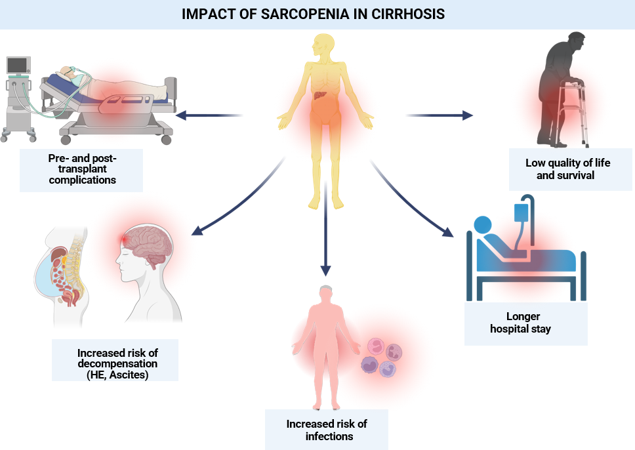
Figure 1 Impact of sarcopenia in cirrhosis. The presence of sarcopenia has been shown to be associated with reduced quality of life and survival. It is a predictor of pre and posttransplant complications, including higher risk of infections, ascites, hepatic encephalopathy, and longer hospital stay. HE: Hepatic encephalopathy. Citation: The authors have obtained the permission for figure using from the BioRender.com (Supplementary material)^{[112]}.

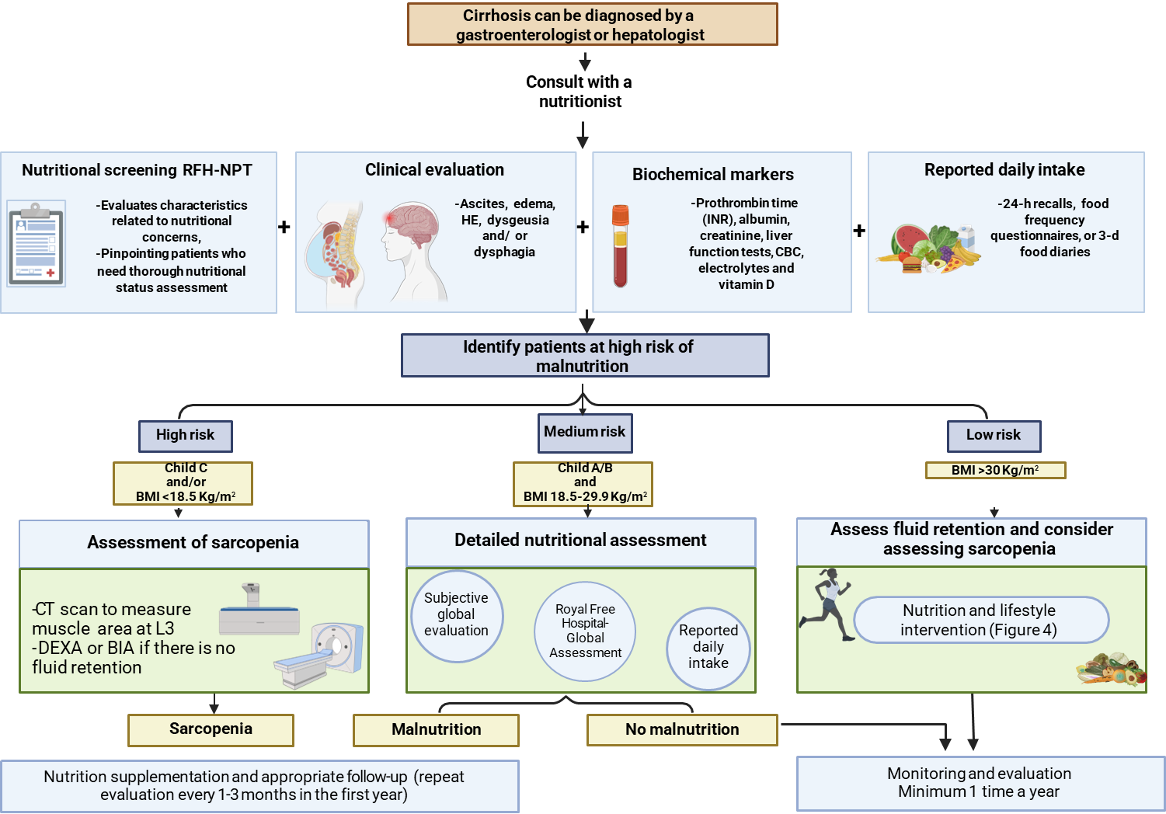
Figure 2 Assessment in patients with cirrhosis. Implementing the nutritional control protocol outlined by Clinical Practice Guidelines is strongly advised as a fundamental aspect of standard cirrhosis patient management. HE: Hepatic encephalopathy; INR: International normalized ratio; CBC: Complete blood count; CT: Computed tomography; DEXA: Dual energy X-ray absorptiometry; BIA: Bioelectrical impedance analysis; BMI: Body mass index; RFH-NPT: Royal Free Hospital Nutritional Prioritizing Tool. The consent was adapted by Clinical Practice Guidelines^{[41]}. Citation: The authors have obtained the permission for figure using from the BioRender.com (Supplementary material)^{[112]}.
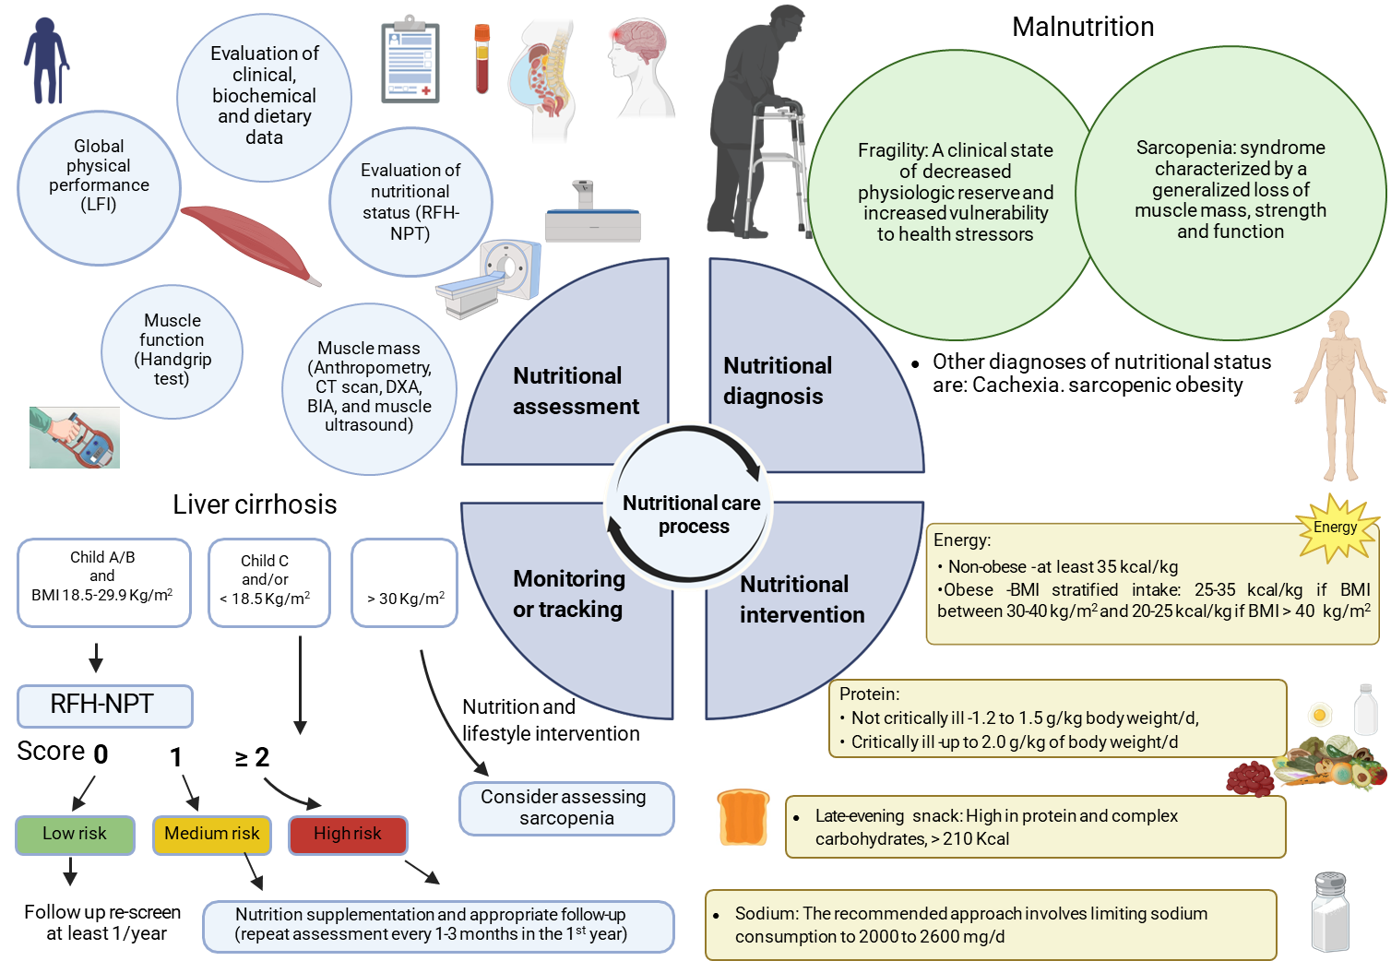
Figure 3 The nutritional care process includes the following steps. (1) Nutritional assessment; (2) nutritional diagnosis; (3) nutritional intervention; and (4) monitoring. LFI: Liver frailty index; RFH-NPT: Royal Free Hospital Nutritional Prioritizing Tool; CT: Computed tomography; DEXA: Dual energy X-ray absorptiometry; BIA: Bioelectrical impedance analysis; BMI: Body mass index. Citation: The authors have obtained the permission for figure using from the BioRender.com (Supplementary material)^{[112]}.
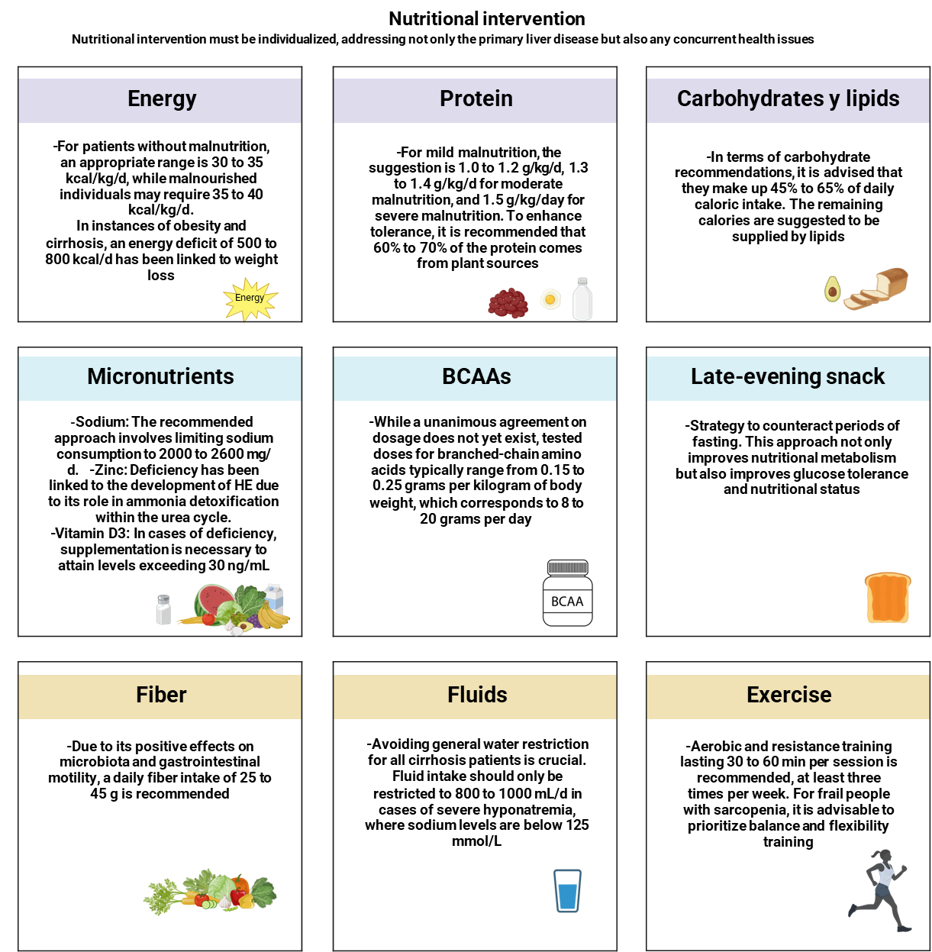
Figure 4 General recommendations for nutritional intervention in patients with cirrhosis. BCAAs: Branched-chain amino acids. Citation: The authors have obtained the permission for figure using from the BioRender.com (Supplementary material)^{[112]}.

Table 1 Global leadership initiative on malnutrition criteria for the diagnosis of malnutrition
Phenotypic criteria |  |  | Etiological criteria
Unintentional weight loss | Low body mass index | Reduction of muscle mass | Decreased intake or assimilation of foods | Inflammatory load
> 5% in the last 6 months or > 10% in more than 6 months | < 20 in < 70 yr or < 22 in > 70 yr | Evaluated by validated body composition techniques | ≤ 50% > 1 wk or ≤ 100% > 2 wk or any chronic condition that alters food assimilation | Acute injury/inflammation; chronic inflammatory pathology
Diagnosis requires at least 1 phenotypic criterion and 1 etiological criterion.

Published by Baishideng Publishing Group Inc
7041 Koll Center Parkway, Suite 160, Pleasanton, CA 94566, USA
Telephone: +1-925-3991568
E-mail: office@baishideng.com
Help Desk: https://www.f6publishing.com/helpdesk
https://www.wjgnet.com

© 2024 Baishideng Publishing Group Inc. All rights reserved.

