Name of Journal: World Journal of Clinical Cases
Manuscript NO: 71343
Manuscript Type: CASE REPORT

Langerhans cell histiocytosis presenting as an isolated brain tumour: A case report

Liang HX et al. LCH in the frontal lobe

Han-Xiang Liang, Yue-Long Yang, Qing Zhang, Zhi Xie, En-Tao Liu, Shu-Xia Wang

Han-Xiang Liang, Department of Nuclear Medicine, Maoming People's Hospital, Maoming 525000, Guangdong Province, China

Yue-Long Yang, Department of Radiology, Guangdong Provincial People's Hospital, Guangdong Academy of Medical Sciences, Guangzhou 510080, Guangdong Province, China

Qing Zhang, En-Tao Liu, Shu-Xia Wang, WeiLun PET Center, Department of Nuclear Medicine, Guangdong Provincial People's Hospital, Guangdong Academy of Medical Sciences, Guangzhou 510080, Guangdong Province, China

Zhi Xie, Guangdong Lung Cancer Institute, Guangdong Provincial Key Laboratory of Translational Medicine in Lung Cancer, Guangdong Provincial People's Hospital, Guangdong Academy of Medical Sciences, Guangzhou 510080, Guangdong Province, China

Author contributions: Liang HX and Yang YL contributed to the conception and design; Liang HX, Yang YL, and Zhang Q contributed to the interpretation of imaging; Yang YL, Zhang Q, and Xie Z contributed to the interpretation of history, treatments, and histopathology; Liang HX and Liu ET contributed to the drafting of the manuscript; Liu ET and Wang SX contributed to the revised the manuscript.

Supported by Guangdong Medical Research Fund to Han-Xiang Liang, No. B2021084; Traditional Chinese Medicine Bureau of Guangdong Province to En-Tao Liu, No. 20211005; and High-level Hospital Construction Research Project of Maoming People's Hospital to Han-Xiang Liang, No. ZX2020014.

Corresponding author: En-Tao Liu, MD, Doctor, WeiLun PET Center, Department of Nuclear Medicine, Guangdong Provincial People's Hospital, Guangdong Academy of Medical Sciences, Room 526, 5/F, Weilun Building of Guangdong Provincial People's Hospital, No. 106 Zhongshan Er Road, Guangzhou 510080, Guangdong Province, China. liuentao@gdph.org.cn

Received: September 5, 2021
Revised: November 3, 2021
Accepted: December 23, 2021
Published online:

Abstract
BACKGROUND
Langerhans cell histiocytosis (LCH) is a rare proliferative histiocyte disorder. It can affect any organ or system, especially the bone, skin, lung, and central nervous system (CNS). In the CNS, the hypothalamic-pituitary is predominantly affected, whereas the brain parenchyma is rarely affected. LCH occurring in the brain parenchyma can be easily confused with glioblastoma or brain metastases. Thus, multimodal imaging is useful for the differential diagnosis of these intracerebral lesions and detection of lesions in the other organs.

CASE SUMMARY
A 47-year-old man presented with a headache for one week and sudden syncope. Brain computed tomography (CT) and magnetic resonance imaging showed an irregularly shaped nodule with heterogeneous enhancement. On ¹⁸F-fluorodeoxyglucose (¹⁸F-FDG) positron emission tomography/CT, a nodule with ¹⁸F-FDG uptake and multiple cysts in the upper lobes of both lungs were noted, which was also confirmed by high-resolution CT. Thus, the patient underwent surgical resection of the brain lesion for further examination. Postoperative pathology confirmed LCH. The patient received chemotherapy after surgery. No recurrence was observed in the brain at the 12-mo follow-up.

CONCLUSION
Multimodal imaging is useful for evaluating the systemic condition of LCH, developing treatment plans, and designing post-treatment strategies.

Key Words: Langerhans cell histiocytosis; Brain neoplasms; Lung; Computed tomography; Magnetic resonance imaging; Positron emission tomography/computed tomography; Case report

Liang HX, Yang YL, Zhang Q, Xie Z, Liu ET, Wang SX. Langerhans cell histiocytosis presenting as an isolated brain tumour: A case report. World J Clin Cases 2021; In press

Core Tip: Langerhans cell histiocytosis (LCH) is a rare hematological disease characterized by a clonal proliferation of abnormal langerhans cells. It can affect any organ or system, especially the bone, skin, lung, and central nervous system (CNS). In the CNS, the hypothalamic-pituitary is predominantly affected, whereas the brain parenchyma is rarely affected. Cases of LCH involving the brain parenchyma and presenting as an isolated brain tumour have been reported, but all the reports lack complete multimodal imaging. In this manuscript, we have reported a case of LCH involving the brain parenchyma and bilateral lungs, which was assessed using computed tomography (CT), high-resolution CT, magnetic resonance imaging, and ¹⁸F-fluorodeoxyglucose positron emission tomography/CT. Furthermore, we have reviewed the relevant literature.

INTRODUCTION
Langerhans cell histiocytosis (LCH) is an uncommon disease characterized by clonal proliferation of myeloid precursors that differentiate into cluster of differentiation (CD)1a⁺/CD207⁺ (Langerin) cells in lesions^{[1,2]}. It mainly affects children, with a reported incidence of 4-5 cases per million children aged < 15 years per year, while its incidence in adults is uncertain^{[3]}. LCH may affect any organ or system, but it most frequently affects the bone, skin, pituitary, liver, spleen, hematopoietic system, lung, lymph nodes, and central nervous system (CNS)^{[4,5]}. Cases of LCH involving the brain parenchyma and presenting as an isolated brain tumour have been reported, but all the reports lack complete multimodal imaging. Herein, we have reported a case of LCH involving the brain parenchyma and bilateral lungs, which was assessed using computed tomography (CT), high-resolution CT (HRCT), magnetic resonance imaging (MRI), and ¹⁸F-fluorodeoxyglucose (¹⁸F-FDG) positron emission tomography (PET)/CT. Furthermore, we have reviewed the relevant literature.

CASE PRESENTATION
Chief complaints
A 47-year-old man was referred to our hospital with a headache for one week and sudden syncope in the morning.

History of present illness
A 47-year-old man was referred to our hospital with a headache for one week and sudden syncope in the morning.

History of past illness
The patient had no history of polyuria or polydipsia. No other illnesses were observed.

Personal and family history
The patient had no known comorbidities or family history, but had a 15-year smoking history.

Physical examination
No rash or positive neurological signs were found on physical examination.

Laboratory examinations
Laboratory tests results showed increased in carcinoembryonic antigen (CEA) levels (7.03 ng/mL, reference: 0-5 ng/mL), with no other abnormal findings.

Imaging examinations
Non-contrast brain CT showed irregularly shaped nodular foci with isodensity at the left frontal corticomedullary junction. Large patches of hypodense edema were noted in the adjacent white matter (Figure 1A and B represent the lateral ventricular and basal ganglia levels, respectively). Contrast-enhanced brain CT showed significant heterogeneous enhancement in the left frontal foci (Figure 1C and D, the same level as the Figure 1A and B). Coronal and sagittal views of contrast-enhanced CT images showed irregular morphology of the lesion and poor demarcation with the adjacent skull (Figure 1E and F). Bone window CT showed no abnormalities in the adjacent skull (Figure 1G and H, the same level as the Figure 1E and F). Subsequently, the patient underwent a brain MRI. Axial T1-weighted images (T1WI) showed heterogeneous hypointense lesions in the left frontal lobe (Figure 2A). Axial T2-weighted images (T2WI) showed a heterogeneously mixed hyperintensity signals with hypointense areas in the left frontal lobe lesion (Figure 2B). After administration of gadolinium, the lesion showed heterogeneous enhancement on axial (Figure 2C), coronal (Figure 2D), and sagittal T1WI (Figure 2E). No abnormalities were found on sagittal T1WI of the sellar region (Figure 2F).
Considering the elevated CEA levels and CT and MRI manifestations, further investigation was required to rule out brain metastases. Therefore, ¹⁸F-FDG PET/CT was performed. Maximum-intensity-projection imaging showed a focal increase in ¹⁸F-FDG uptake in the right maxillary sinus and multiple foci of increased ¹⁸F-FDG uptake in the bilateral lung fields (Figure 3A). Axial (Figure 3B-D) and coronal (Figure 3E-G) views of the selected PET, non-enhanced CT (NE-CT), and fused PET/CT images showed moderately increased ¹⁸F-FDG uptake in the left frontal nodule [the maximum standardized uptake value (SUVmax) of the lesions and surrounding tissues are shown in Supplementary Figure 1]. No abnormal ¹⁸F-FDG uptake was observed in the sellar region (Supplementary Figure 2). Axial (Figure 3H-J) views of the selected PET, NE-CT, and fused PET/CT images showed multiple cysts with peripheral exudation in the upper lobes of bilateral lungs, with slightly increased ¹⁸F-FDG uptake. HRCT was performed to further evaluate the pulmonary lesions. Axial (Figure 4A), coronal (Figure 4B), and sagittal (Figure 4C and D, left and right lungs, respectively) views of HRCT images showed multiple scattered small thick-walled irregular cysts and small nodules. Sinusitis was diagnosed in the right maxillary sinus. Bilateral lung manifestations should be differentiated from pulmonary LCH, but brain nodules are more difficult to diagnose and should be differentiated from gliomas.

Further diagnostic work-up
The patient underwent brain tumour resection. Gross examination showed that the specimen was a grey-brown solid tumour (Figure 5A) and the cut surface was grey-brown and grey-white (Figure 5B). Histopathological examination revealed mononucleated and multinucleated histocytes with abundant cytoplasm and slight staining (haematoxylin and eosin, magnification, × 200; Figure 5C). On immunohistochemistry, the specimen stained positive for S100, CD207 (Langerin), CD4, and CD1a, and negative for CD3 and CD20. Ki67 (MIB-1) index was slightly > 30%.

FINAL DIAGNOSIS
The final histological diagnosis was LCH.

TREATMENT
The patient received chemotherapy (vindesine and prednisone acetate) after surgery.

OUTCOME AND FOLLOW-UP
No recurrence was observed on brain MRI at the 12-mo follow-up (Supplementary Figure 3).

DISCUSSION
LCH involving the hypothalamic-pituitary or skull is not uncommon, but involvement of the brain parenchyma, such as the frontotemporal lobe, is rare. As of January 2019, fewer than 30 cases have been reported in the PubMed database (Table 1)^{[6–8]}. We reviewed the relevant PubMed literature from 1990 to May 2021 and found 16 cases of brain parenchymal LCH with imaging data. The mean age was 31 years (95% confidence interval: 21.5-41.2). The male-to-female ratio was 14:2, which is consistent with that reported in previous literature reviews of intracerebral LCH, but higher than that in children with LCH^{[3,9,10]}. The lesions were mostly located in the frontotemporal lobe (14 cases), particularly in the frontal lobe. The clinical presentation of LCH is non-characteristic and varies depending on the site. Most cases showed non-specific symptoms of mass effect such as headache, seizures, hemiparesis, and/or sensory disturbances. MRI findings without contrast were also largely non-specific. Nonetheless, MRI showed hypointensity on T1WI and hyperintensity on T2WI in most cases. After administration of gadolinium, most cases showed intense homogeneous or heterogeneous enhancement. Another characteristic feature is sulcal enhancement around the lesion^{[6,7]}. MRI images showed leptomeningeal involvement near the lesions in several cases, as reported by Kim et al^{[7]}. This may be a characteristic sign of brain parenchymal LCH, but it needs to be confirmed in more cases.
There are no previous reports of ¹⁸F-FDG PET/CT for assessing the metabolic activity of brain parenchymal LCH. To our knowledge, our case report is the first with a PET/CT description. The SUVmax of the brain lesion was approximately 9.5, which was similar to the SUVmax of LCH lesions involving other regions reported in the literature^{[11]}. Additional bilateral lung lesions were found, and pulmonary manifestations were decisive for diagnosis^{[12]}. As 30% patients with LCH present with multi-organ system involvement, it is important to detect involvement of other tissues (such as the bone, soft tissue, the CNS, or the lungs)^{[3,13]}. Single or isolated brain lesions have previously been reported based on only brain CT or MRI, without whole-body scans^{[6,7]}. Without whole-body evaluation, reports of isolated brain lesions may be non-rigorous or biased. More recent studies that performed whole-body evaluations have identified a higher rate of focal LCH lesions than that previously reported^{[14,15]}. Therefore, PET/CT or PET/MRI seems to be more appropriate for evaluating this disease^{[16]}. This is especially true for combined bone and lung lesions as some case without obvious symptoms are incidentally detected; they may be missed by relying solely on radiography or CT^{[8]}. Several studies have confirmed the diagnostic value of systemic scans, such as PET/CT or PET/MRI for LCH^{[14,15,17,18]}. The diagnostic evaluation of LCH plays a crucial role in treatment planning. PET/CT or PET/MRI can be used to assess multiple foci throughout the body, guide biopsy sites, and assist with post-treatment strategies.
Based on prospective trials, the combination of vinblastine plus prednisolone is the most commomly used induction chemotherapy regimen and is administered over six weeks^{[19]}.

CONCLUSION
As a systemic disease, LCH has the potential to involve the brain parenchyma, and its diagnosis is extremely challenging. The use of multimodal imaging or whole-body imaging, combined with the manifestation of lesions at other sites, can be helpful in the diagnosis of this disease. Moreover, multimodality imaging is useful for assessing the systemic status of LCH, developing treatment plans, and evaluating post-treatment strategies.

REFERENCES
1 Rodriguez-Galindo C, Allen CE. Langerhans cell histiocytosis. Blood 2020; 135: 1319-1331 [PMID: 32106306 DOI: 10.1182/blood.2019000934]
2 Allen CE, Beverley PCL, Collin M, Diamond EL, Egeler RM, Ginhoux F, Glass C, Minkov M, Rollins BJ, van Halteren A. The coming of age of Langerhans cell histiocytosis. Nat Immunol 2020; 21: 1-7 [PMID: 31831887 DOI: 10.1038/s41590-019-0558-z]
3 Krooks J, Minkov M, Weatherall AG. Langerhans cell histiocytosis in children: History, classification, pathobiology, clinical manifestations, and prognosis. J Am Acad Dermatol 2018; 78: 1035-1044 [PMID: 29754885 DOI: 10.1016/j.jaad.2017.05.059]
4 Grois N, Pötschger U, Prosch H, Minkov M, Arico M, Braier J, Henter JI, Janka-Schaub G, Ladisch S, Ritter J, Steiner M, Unger E, Gadner H; DALHX- and LCH I and II Study Committee. Risk factors for diabetes insipidus in langerhans cell histiocytosis. Pediatr Blood Cancer 2006; 46: 228-233 [PMID: 16047354 DOI: 10.1002/pbc.20425]
5 Haupt R, Minkov M, Astigarraga I, Schäfer E, Nanduri V, Jubran R, Egeler RM, Janka G, Micic D, Rodriguez-Galindo C, Van Gool S, Visser J, Weitzman S, Donadieu J; Euro Histio Network. Langerhans cell histiocytosis (LCH): guidelines for diagnosis, clinical work-up, and treatment for patients till the age of 18 years. Pediatr Blood Cancer 2013; 60: 175-184 [PMID: 23109216 DOI: 10.1002/pbc.24367]
6 Cai S, Zhang S, Liu X, Lin Y, Wu C, Chen Y, Hu J, Wang X. Solitary Langerhans cell histiocytosis of frontal lobe: a case report and literature review. Chin J Cancer Res 2014; 26: 211-214 [PMID: 24826063 DOI: 10.3978/j.issn.1000-9604.2014.02.12]
7 Kim JH, Jang WY, Jung TY, Moon KS, Jung S, Lee KH, Kim IY. Magnetic Resonance Imaging Features in Solitary Cerebral Langerhans Cell Histiocytosis: Case Report and Review of Literature. World Neurosurg 2018; 116: 333-336 [PMID: 29929024 DOI: 10.1016/j.wneu.2018.06.060]
8 Bärtschi P, Luna E, González-López P, Abarca J, Herrero J, Costa E, Paya A, Sales J, Moreno P. A Very Rare Case of Right Insular Lobe Langerhans Cell Histiocytosis (CD1a⁺) Mimicking Glioblastoma Multiforme in a Young Adult. World Neurosurg 2019; 121: 4-11 [PMID: 30261373 DOI: 10.1016/j.wneu.2018.09.093]
9 Cagli S, Oktar N, Demirtas E. Langerhans' cell histiocytosis of the temporal lobe and pons. Br J Neurosurg 2004; 18: 174-180 [PMID: 15176561 DOI: 10.1080/02688690410001681055]
10 Rodríguez-Pereira C, Borrás-Moreno JM, Pesudo-Martínez JV, Vera-Román JM. Cerebral solitary Langerhans cell histiocytosis: report of two cases and review of the literature. Br J Neurosurg 2005; 19: 192-197 [PMID: 16120527 DOI: 10.1080/02688690500145944]
11 Agarwal KK, Seth R, Behra A, Jana M, Kumar R. 18F-Fluorodeoxyglucose PET/CT in Langerhans cell histiocytosis: spectrum of manifestations. Jpn J Radiol 2016; 34: 267-276 [PMID: 26759026 DOI: 10.1007/s11604-016-0517-7]
12 Vassallo R, Harari S, Tazi A. Current understanding and management of pulmonary Langerhans cell histiocytosis. Thorax 2017; 72: 937-945 [PMID: 28689173 DOI: 10.1136/thoraxjnl-2017-210125]
13 Albano D, Bosio G, Giubbini R, Bertagna F. Role of ¹⁸F-FDG PET/CT in patients affected by Langerhans cell histiocytosis. Jpn J Radiol 2017; 35: 574-583 [PMID: 28748503 DOI: 10.1007/s11604-017-0668-1]
14 Ferrell J, Sharp S, Kumar A, Jordan M, Picarsic J, Nelson A. Discrepancies between F-18-FDG PET/CT findings and conventional imaging in Langerhans cell histiocytosis. Pediatr Blood Cancer 2021; 68: e28891 [PMID: 33442960 DOI: 10.1002/pbc.28891]
15 Huynh KN, Nguyen BD. Histiocytosis and Neoplasms of Macrophage-Dendritic Cell Lineages: Multimodality Imaging with Emphasis on PET/CT. Radiographics 2021; 41: 576-594 [PMID: 33606566 DOI: 10.1148/rg.2021200096]
16 Hashimoto K, Nishimura S, Sakata N, Inoue M, Sawada A, Akagi M. Treatment Outcomes of Langerhans Cell Histiocytosis: A Retrospective Study. Medicina (Kaunas) 2021; 57 [PMID: 33917120 DOI: 10.3390/medicina57040356]
17 Obert J, Vercellino L, Van Der Gucht A, de Margerie-Mellon C, Bugnet E, Chevret S, Lorillon G, Tazi A. ¹⁸F-fluorodeoxyglucose positron emission tomography-computed tomography in the management of adult multisystem Langerhans cell histiocytosis. Eur J Nucl Med Mol Imaging 2017; 44: 598-610 [PMID: 27645693 DOI: 10.1007/s00259-016-3521-3]
18 Sher AC, Orth R, McClain K, Allen C, Hayatghaibi S, Seghers V. PET/MR in the Assessment of Pediatric Histiocytoses: A Comparison to PET/CT. Clin Nucl Med 2017; 42: 582-588 [PMID: 28604476 DOI: 10.1097/RLU.0000000000001717]
19 Gadner H, Minkov M, Grois N, Pötschger U, Thiem E, Aricò M, Astigarraga I, Braier J, Donadieu J, Henter JI, Janka-Schaub G, McClain KL, Weitzman S, Windebank K, Ladisch S; Histiocyte Society. Therapy prolongation improves outcome in multisystem Langerhans cell histiocytosis. Blood 2013; 121: 5006-5014 [PMID: 23589673 DOI: 10.1182/blood-2012-09-455774]
20 Caresio JF, McMillan JH, Batnitzky S. Coexistent intra- and extracranial mass lesions: an unusual manifestations of histiocytosis X. AJNR Am J Neuroradiol 1991; 12: 82 [PMID: 1899525]
21 Itoh H, Waga S, Kojima T, Hoshino T. Solitary eosinophilic granuloma in the frontal lobe: case report. Neurosurgery 1992; 30: 295-298 [PMID: 1372112 DOI: 10.1227/00006123-199202000-00030]
22 Bogaert J, Verschakelen JA, d'Haen B, Dom R, Wilms G. Diagnosis of atypical intracerebral Langerhans cell histiocytosis suggested by concomitant lung abnormalities. A case report. Rofo 1994; 161: 369-371 [PMID: 7948986 DOI: 10.1055/s-2008-1032547]
23 Vital A, Loiseau H, Kantor G, Vital C, Cohadon F. Primary Langerhans' cell histiocytosis of the central nervous system with fatal outcome. Case report. J Neurosurg 1996; 85: 1156-1160 [PMID: 8929511 DOI: 10.3171/jns.1996.85.6.1156]
24 Grant GA, Kim DK, Shaw CM, Berger MS. Solitary eosinophilic granuloma of the temporal lobe: case report and review of the literature. Brain Tumor Pathol 1999; 16: 55-59 [PMID: 10532425 DOI: 10.1007/BF02478903]
25 Katati MJ, Martin JM, Pastor J, Arjona V. Isolated primary Langerhans' cell histiocytosis of central nervous system. Neurocirugia (Astur) 2002; 13: 477-478 [PMID: 12529777 DOI: 10.1016/s1130-1473(02)70575-7]
26 Yamaguchi S, Oki S, Kurisu K. Spontaneous regression of Langerhans cell histiocytosis: a case report. Surg Neurol 2004; 62: 136-40; discussion 140-1 [PMID: 15261507 DOI: 10.1016/j.surneu.2003.10.003]
27 Dieter S. Letter to the Editor Re: Zeidman LA, Stone J, Kondziella D. New revelations about Hans Berger, father of the electroencephalogram (EEG), and his ties to the Third Reich. J Child Neurol. 2014;29:1002-1010. J Child Neurol 2017; 32: 680-681 [PMID: 28511629 DOI: 10.1177/0883073817696813]
28 Dardis C, Aung T, Shapiro W, Fortune J, Coons S. Langerhans cell histiocytosis in an adult with involvement of the calvarium, cerebral cortex and brainstem: discussion of pathophysiology and rationale for the use of intravenous immune globulin. Case Rep Neurol 2015; 7: 30-38 [PMID: 25873887 DOI: 10.1159/000380760]

Footnotes
Informed consent statement: Publication consent has been obtained from the patient in a written form.

Conflict-of-interest statement: All authors have completed the ICMJE uniform disclosure form. The authors have no conflicts of interest to declare.

CARE Checklist (2016) statement: The authors have read the CARE Checklist (2016), and the manuscript was prepared and revised according to the CARE Checklist (2016).

Open-Access: This article is an open-access article that was selected by an in-house editor and fully peer-reviewed by external reviewers. It is distributed in accordance with the Creative Commons Attribution NonCommercial (CC BY-NC 4.0) license, which permits others to distribute, remix, adapt, build upon this work non-commercially, and license their derivative works on different terms, provided the original work is properly cited and the use is non-commercial. See: http://creativecommons.org/Licenses/by-nc/4.0/

Provenance and peer review: Unsolicited article; Externally peer reviewed.

Peer-review model: Single blind

Peer-review started: September 5, 2021
First decision: October 22, 2021
Article in press:

Specialty type: Medicine, research and experimental
Country/Territory of origin: China
Peer-review report’s scientific quality classification
Grade A (Excellent): 0
Grade B (Very good): B
Grade C (Good): C
Grade D (Fair): 0
Grade E (Poor): 0

P-Reviewer: Hashimoto K, Mukthinuthalapati VVPK S-Editor: Fan JR L-Editor: A P-Editor: Fan JR

Figure Legends
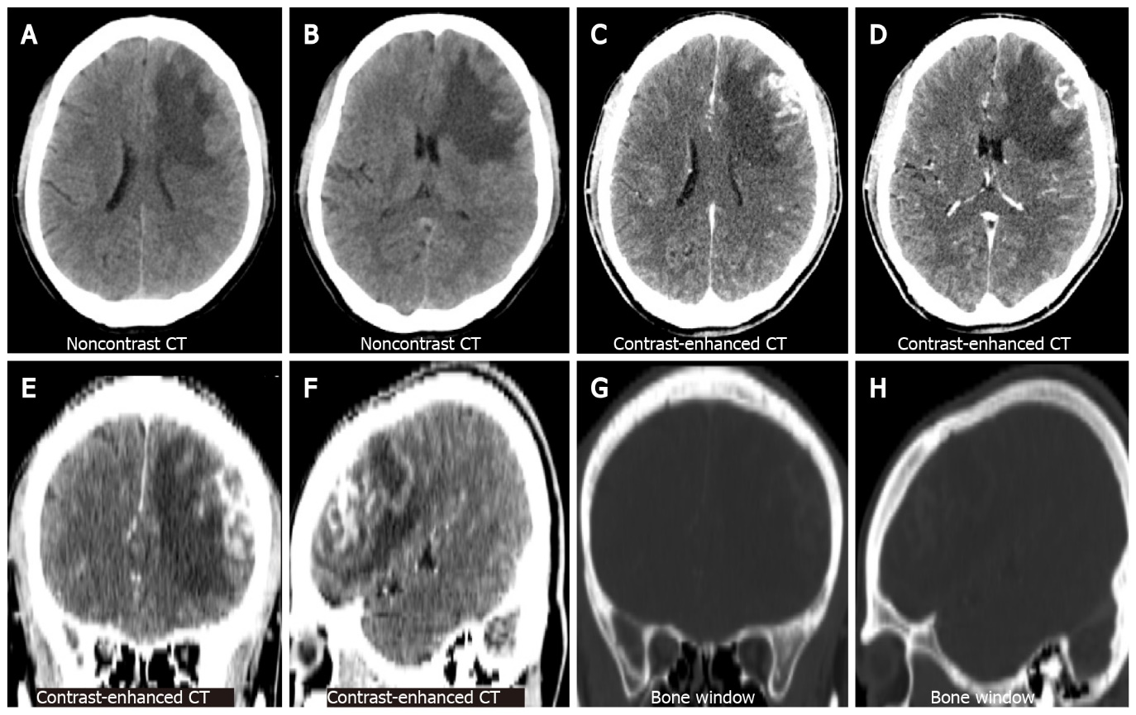
Figure 1 Brain computed tomography. A and B: Represent the lateral ventricular and basal ganglia levels on non-contrast computed tomography (CT), respectively. An irregularly shaped nodule is observed in the left frontal lobe with large perifocal low-density oedema; C and D: Represent the same level as the former on contrast-enhanced CT. The nodules are significantly enhanced heterogeneously; E and F: Represent the coronal and sagittal views of the contrast-enhanced CT; G and H: Represent the same level as the former, with no abnormalities in the adjacent skull. CT: Computed tomography.
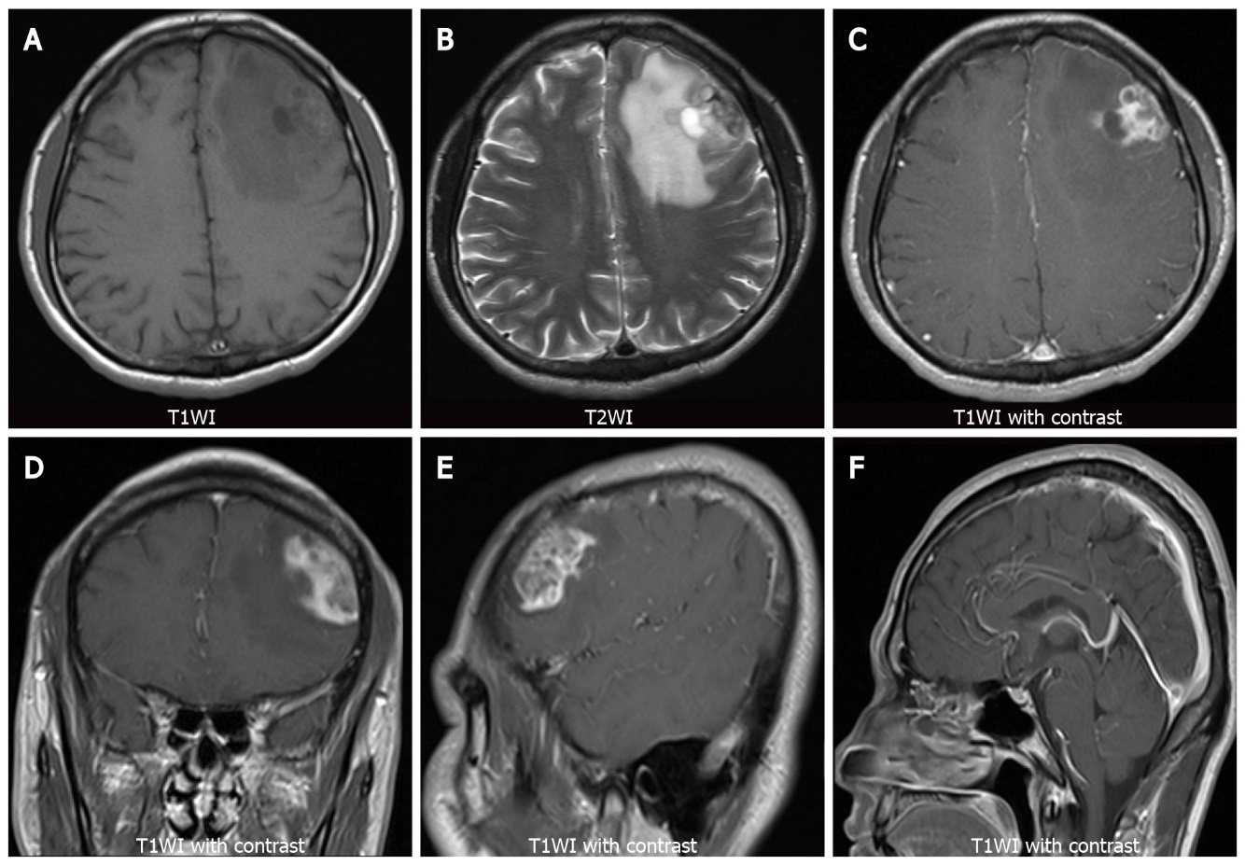
Figure 2 Brain magnetic resonance imaging. A: Axial T1-weighted images (T1WI) show heterogeneous hypo-intensity of the left frontal lobe lesion; B: Axial T2-weighted images (T2WI) show heterogeneously mixed signal of hyperintensity with hypointense areas of the left frontal lobe lesion; C-E: Axial, coronal, and sagittal views of T1WI with contrast agent administration show heterogeneous enhancement of the lesion; F: Sagittal T1WI show no abnormality in the sellar region. T1WI: T1-weighted images; T2WI: T2-weighted images.
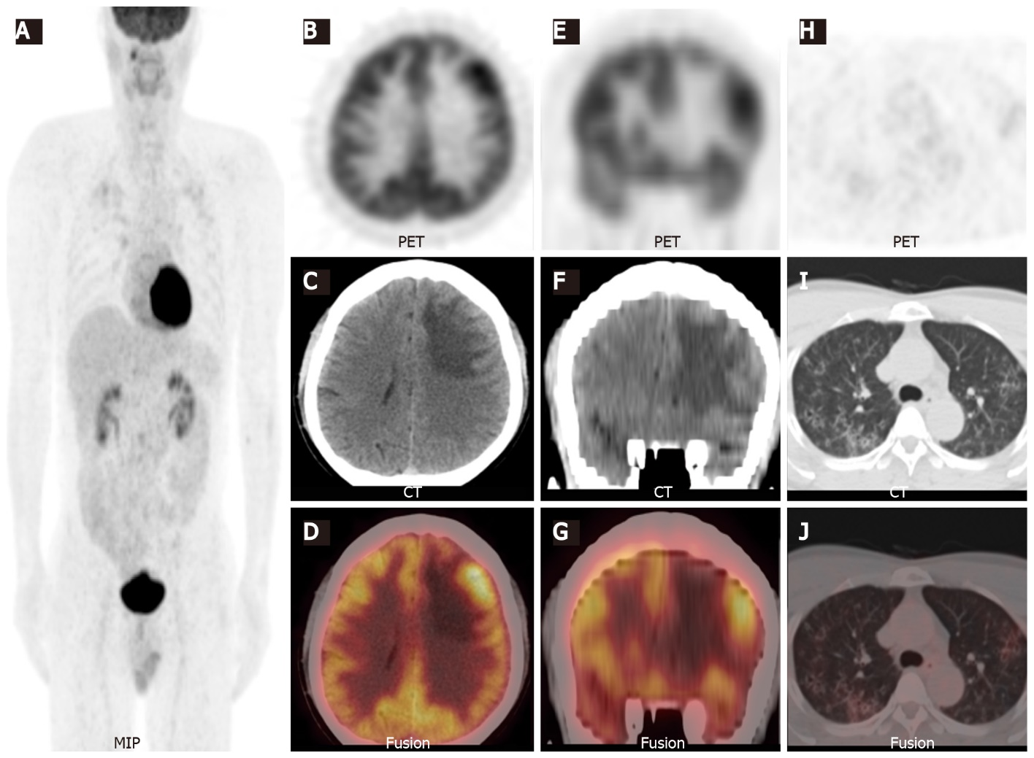
Figure 3 ¹⁸F-fluorodeoxyglucose positron emission tomography/computed tomography. A: Maximum-intensity-projection show a focal ¹⁸F-fluorodeoxyglucose (¹⁸F-FDG) uptake lesion in the right maxillary sinus and multiple foci with ¹⁸F-FDG uptake in the bilateral lung field; B-G: Axial and coronal views of the selected positron emission tomography (PET), non-enhanced computed tomography (NE-CT), and fused PET/CT images show the left frontal lesion with ¹⁸F-FDG uptake (SUVmax 9.5, arrowheads); H-J: Axial views of the selected PET, NE-CT, and fused PET/CT images show multiple cysts with peripheral exudation in the upper lobes of bilateral lungs, with slightly increased ¹⁸F-FDG uptake (SUVmax 3.2). MIP: Maximum-intensity-projection; PET: Positron emission tomography; CT: Computed tomography.
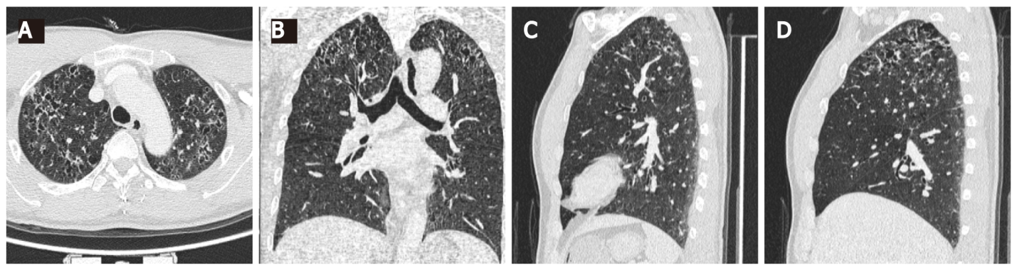
Figure 4 High-resolution computed tomography of the lung. Axial, coronal, and sagittal (the left and right lungs, respectively) views of high-resolution computed tomography images show multiple scattered small thick-walled irregular cysts as well as small nodules. A: Axial; B: Coronal; C: Left lungs; D: Right lungs.
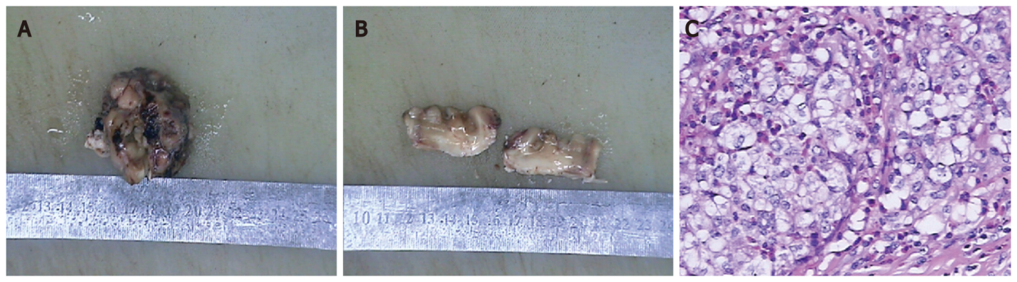
Figure 5 Histopathological images. A: The specimen is a greyish brown and greyish dark solid tumour; B: The cut surface is greyish brown and greyish white; C: Histopathological examination reveal mononucleated and multinucleated histocytes with abundant cytoplasm and light staining (haematoxylin and eosin, magnification, × 400).

Table 1 Summary of 16 cases with brain parenchymal langerhans cell histiocytosis with imaging data
Ref. | Age/sex | Diameter (cm)¹ | Location (Lobe) | MRI Finding |  |  | ¹⁸F-FDG PET/CT finding
 |  |  |  | T1WI | T2WI | T1WI with contrast
Caresio et al^{[20]}, 1991 | 29/Male | 3.0 | Right temporal lobe | Hypointense | Hyperintense | Ringlike enhancement | NA
Itoh et al^{[21]}, 1992 | 7/Male | NA | Right frontal lobe | Hypo-/iso-intense | Hyperintense | Intense enhancement | NA
Bogaert et al^{[22]}, 1994 | 40/Female | NA | Left parietal lobe | Hypointense | Hyperintense | Intense enhancement | NA
Vital et al^{[23]}, 1996 | 32/Female | NA | Right insula lobe | NA | Hyperintense | Intense enhancement | NA
Grant et al^{[24]}, 1999 | 20/Male | 3.5 | Right temporal lobe | NA | NA | Intense enhancement | NA
Katati et al^{[25]}, 2002 | 36/Male | NA | Left temporal lobe | Hypointense | NA | Intense enhancement | NA
Cagli et al^{[9]}, 2004 | 24/Male | 1.5 | Left temporal lobe | Hypointense | NA | Intense enhancement | NA
Yamaguchi et al^{[26]}, 2004 | 2/Male | NA | Multiple lesions/bilateral frontal and temporal lobes | NA | NA | Intense enhancement | NA
Rodríguez-Pereira et al^{[10]}, 2005 | 30/Male | 5.0 | Left frontal lobe | NA | NA | Gyral enhancement | NA
Rodríguez-Pereira et al^{[10]}, 2005 | 65/Male | 2.5 | Left parietal lobe | NA | NA | Peripheral enhancement | NA
Dieter^{[27]}, 2017 | 4/Male | 2.0¹ | Multiple lesions, right frontal, and parietal lobe | Iso-/hyper-intense | Hypointense | Uniform enhancement | NA
Cai et al^{[6]}, 2014 | 23/Male | 4.1 | Right frontal lobe | Hypo-/iso-intense | Iso-/hyper-intense | Moderate to intense homogeneous enhancement | NA
Dardis et al^{[28]}, 2015 | 64/Male | NA | Multiple lesions, left frontal and right temporal lobe, and brainstem | NA | Hyperintense | Patchy enhancement | NA
Kim et al^{[7]}, 2018 | 36/Male | 3.0 | Right frontal lobe | Isointense | Hyperintense | Heterogeneous enhancement | NA
Bärtschi et al^{[8]}, 2019 | 42/Male | NA | Right insular lobe | NA | Hyperintense | Intense enhancement | NA
Current case | 47/Male | 3.6 | Left frontal lobe | Hypointense | Hyperintensity with hypointense areas | Heterogeneous enhancement | Lesion SUVmax 9.5 and contralateral SUVmax 8.1
¹The largest lesion.
NA: Not available; PET: Positron emission tomography; CT: Computed tomography; T1WI: T1-weighted images; T2WI: T2-weighted images; MRI: Magnetic resonance imaging.

