Name of Journal: World Journal of Clinical Cases
Manuscript NO: 54076
Manuscript Type: CASE REPORT

Unusual presentation of congenital radioulnar synostosis with osteoporosis, fragility fracture and nonunion: A case report and review of literature

Yang ZY et al. Congenital radioulnar synostosis

Zhan-Yu Yang, Jiang-Dong Ni, Ze Long, Le-Tian Kuang, Shi-Bin Tao

Zhan-Yu Yang, Jiang-Dong Ni, Ze Long, Le-Tian Kuang, Shi-Bin Tao, Department of Orthopedics, The Second Xiangya Hospital, Central South University, Changsha 410000, Hunan Province, China

Author contributions: Ni JD contributed to manuscript drafting; Yang ZY reviewed the literature and contributed to manuscript drafting; Long Z and Kuang LT were responsible for the follow-up and data collection; Tao SB was responsible for the revision of the manuscript; all authors approved the final version to be submitted.

Corresponding author: Jiang-Dong Ni, MD, Professor, Department of Orthopedics, The Second Xiangya Hospital, Central South University, No. 139 Renmin Street, Changsha 410000, Hunan Province, China. nijiangdong001@csu.edu.cn

Received: January 8, 2020
Revised: March 26, 2020
Accepted: April 10, 2020
Published online:

Abstract
BACKGROUND
Congenital radioulnar synostosis (CRUS) is a rare deformity of the upper extremity. It is characterized by loss of rotation of the involved forearm and functional limitations in daily activities. No studies on CRUS with osteoporosis have been reported to date, and osteoporosis is usually recognized as an important dimension of genetic disorder in children. We discuss the possible relationship among this disorder, osteoporosis and fracture nonunion, investigate the strict surgical indications and recommended treatments.

CASE SUMMARY
A 14-year-old male patient with bilateral CRUS with osteoporosis, fragility fracture and nonunion of fractures in ulna and radius presented our institution for further treatment, complaining of limitation in rotation. The bone mineral density of the hip and lumbar spine was 0.687 g/cm² and 0.705 g/cm², respectively, and the Z-score for both was -2.1, which revealed osteoporosis and a high risk of fracture. Tow serum bone turnover markers indicated an imbalance of bone metabolism. Reoperation for ulna fracture with autogenous bone grafting and a postoperative physiotherapy program were adopted rather than the separation of pathological synostosis. Radiological examination, observational posture assessment and limb function scale were evaluated before and 1 year after surgery. At 1 year, the fracture nonunion had almost recovered, forearm movement function on the fracture side was restored, and function on the healthy side was significantly improved compared with that before rehabilitation.

CONCLUSION
Surgical indications for CRUS vary from person to person. Surgery should not be the first choice of treatment, and physiotherapy is not inferior to surgical treatment.

Key words: Congenital radioulnar synostosis; Surgical indication; Osteoporosis; Fragility fracture; Nonunion; Case report

Yang ZY, Ni JD, Long Z, Kuang LT, Tao SB. Unusual presentation of congenital radioulnar synostosis with osteoporosis, fragility fracture and nonunion: A case report and review of literature. World J Clin Cases 2020; In press

Core tip: Congenital radioulnar synostosis is a rare deformity of the upper extremity, which is characterized by loss of rotation and a variety of functional limitations. We present a rare case of bilateral congenital proximal radioulnar synostosis with osteoporosis, fragility fracture and nonunion. This case suggests that internal fixation plus bone grafting or stimulus of osteogenesis may result in a much better outcome than expected. In addition, this case highlights that surgery should not be the first choice except for those with severe daily activity limitations, and physiotherapy is not inferior to surgical treatment.

INTRODUCTION
Congenital radioulnar synostosis (CRUS), which is caused by fusion between the proximal end of the radius and ulna with the forearm fixed in some degrees of pronation, is a rare deformity of the upper extremity. It is common, however, in congenital elbow anomalies, and approximately 60%-80% of cases are bilateral^{[1-3]}. It is characterized by loss of rotation of the involved forearm and a variety of functional limitations in daily activities in severe cases, presumably as a result of an insult in utero at the time when the proximal ends of the radius and ulna were connected by a common perichondrium^{[4,5]}. The etiology has been reported to be genetic and multifactorial^{[1]}. Pain or restriction of elbow flexion-extension movements is absent in most patients with CRUS; their forearm is usually fixed in the pronation, and the function of supination is lost to varying degrees^{[1,6]}. In most cases, the evaluation of the malformation is based on the classification by Cleary and Omer^{[7,8]}. It is classified into four radiographic types, as shown in Table 1^{[9]}.
No studies on CRUS with osteoporosis have been reported to date, but osteoporosis is usually recognized as an important dimension of genetic disorder in children. Childhood osteoporosis is typically divided into primary and secondary causes, with osteogenesis imperfecta (OI) representing the prototypical primary osteoporosis of childhood, predisposing to bone fragility and fracture^{[10-13]}. Low-trauma non-vertebral fractures in children with osteoporosis are observed most frequently at the femur, tibia, forearm, humerus, feet and ankles^{[14-16]}.
We here report a 14-year-old male patient with bilateral CRUS with osteoporosis, fragility fracture and nonunion of fracture in ulna and radius. Informed consent was obtained from the patient and his guardians for using the data of this case to be submitted for publication.

CASE PRESENTATION
Chief complaints
A 14-year-old right-handed boy with CRUS of the bilateral forearm and a fragility fracture of both bones of the forearm in a fall presented to the Department of Orthopedics of our hospital.

History of present illness
In another hospital, open reduction and internal fixation were performed, while the ulna was fixed with a Kirschner wire, maintaining neutral forearm position in a plaster cast for 8 wk before rehabilitation was initiated. At 3 mo after surgery, since the location of the reduced ulna was lost and the fracture was nonunion, the patient came to our hospital and asked for further treatment.

History of past illness
The boy had two previous fractures, including one distal radius fracture and one tibiofibular fracture.

Personal and family history
There was a possible hereditary history in his family, where his mother and younger brother had a similar elbow deformity.

Physical examination upon admission
On physical examination, a hard but painless lump was found in the posterolateral region of the bilateral elbow, and it could not be reduced in flexion-extension or in pronation-supination. A deficiency in active motion was present at the left forearm (Figure 1). Right forearm function was slightly limited for the compensation of the ipsilateral shoulder, and the patient had no flexion and extension dysfunction on both sides of the forearm.

Laboratory examinations
Bone mineral density (BMD) was measured by Dual Energy X-ray Absorptiometry. BMD of the hip and lumbar spine was 0.687 g/cm² and 0.705 g/cm², respectively, and the Z-score for both was -2.1. The 2013 International Society for Clinical Densitometry recommended a BMD Z-score threshold (−2.0 or worse) in children to denote childhood osteoporosis, provided such children also have a clinically significant fracture history, defined as ≥ 2 long bone fractures by age 10 and ≥ 3 long bone fractures by age 18^{[17]}. According to the recommendation, the patient was identified as childhood osteoporosis with an increased fracture risk. Serum collagen type I cross-linked C-telopeptide (a marker of bone resorption) and serum procollagen I N-terminal propeptide (a marker of bone formation) of the patient were 1832 ng/mL and 347 ng/mL, respectively. These two bone turnover markers are recommended by the International Osteoporosis Foundation and the International Federation of Clinical Chemistry and Laboratory Medicine for the assessment of bone health^{[18]}.

Imaging examinations
Plain radiography showed a fracture of both bones of the left forearm and pathologic fusions between the proximal diaphysis of radius and ulna, with a small bone diameter (Figure 2).

FINAL DIAGNOSIS
Bilateral CRUS with osteoporosis, fragility fracture and nonunion of fractures in ulna and radius.

TREATMENT
Bilateral synostoses of this case were both classified as type II according to Cleary and Omer. Considering that the child’s forearm function of the dominant side was not significantly affected with the compensation of the ipsilateral limb and could ensure necessary living requirements, reoperation for ulna fracture with autogenous bone grafting and a postoperative physiotherapy program were adopted rather than the separation of pathological synostosis. Physiotherapy was performed by a professional rehabilitation physician, and all exercises were practiced bilaterally. These exercises consisted of actively stretching the muscle to the point of limitation of supination, followed by a passive supination movement, and then practicing compensatory movement of adjacent joints.

OUTCOME AND FOLLOW-UP
The patient was evaluated before and 1 year after surgery with radiological examination, observational posture assessment, the Activities of Daily Living Scale, the Liverpool Elbow Score, the Disabilities of the Arm, Shoulder, and Hand score and the Failla classification system. The Activities of Daily Living Scale was used to evaluate subjectively the degree of improvement in activities of daily living, including 11 that related to hygiene and self-care, eight that related to feeding, and seven that assessed environmental interaction on a 5-point scale. The Liverpool Elbow Score was first introduced in 2004 as an elbow-specific outcome score to be completed by both the clinicians and patients, combining a nine-item patient-answered questionnaire and a six-item clinical assessment score^{[19]}. The Disabilities of the Arm, Shoulder, and Hand score is a 30-item questionnaire that quantifies physical function and symptoms in persons with any or multiple musculoskeletal disorders of the upper limb^{[20]}. The Failla classification system is a grading system used by Failla et al^{[21]} to evaluate the functional ranges of rotation of the forearm. The evaluation results are given in Table 2. One year later, the fracture had almost recovered (Figure 3), and the range of motion was significantly improved (Figure 4).

DISCUSSION
The forearm complex functions to rotate the hand in space and allow for a redistribution of forces during functional tasks. Disruptions of any one of the components can potentially lead to limitations in forearm rotation and function^{[22]}. CRUS as a rare malformation is thought to be an anomaly of longitudinal segmentation that develops in the early fetal life. The elbow begins to appear at day 34-35 of fetal life, while the humerus, radial bone and ulna appear at day 37^{[7]}. The humerus, radius and ulna are continuous with each other and are joined by a common perichondrium within the first 60 d of embryologic development. The cartilaginous anlage between these bones is separated by condensation, while the forearm is in a neutral position. Deformity of the radial head may be closely related to complete proximal union caused by early interference with joint formation^{[23]} or unequal growth of the radius head caused by limited distal epiphyseal fusion^{[24]}.
CRUS is usually bilateral and subject to autosomal dominant inheritance^{[25]}. Moreover, CRUS is one of many components of malformation syndromes in children with chromosomal aberrations^{[8,26]}. A number of authors have claimed that there is a genetic basis for radioulnar synostosis. Evidence for this etiology, like in this case, includes familial occurrence and the close relation with other congenital syndromes such as acrocephalosyndactyly, microcephaly, Apert's syndrome, Carpenter's syndrome, arthrogryposis, Klinefelter syndrome, multiple exostoses, Holt-Oram syndrome, fetal alcohol syndrome, Ayme-Gripp syndrome, Saethre-Chotzen syndrome, mandibulofacial dysostosis with microcephaly and William's syndrome^{[2,27-30]}.
Because children can easily compensate for rotational limitations caused by joint deformities, the disease is usually not diagnosed early^{[31]}. Although the pronation and supination movements of forearm are limited, elbow flexion and extension exercises are generally unaffected. Most patients with CRUS can manage daily activities through the overuse and compensation of shoulder and wrist^{[6,32]}. Shoulder abduction compensates for inadequate pronation, and shoulder adduction compensates for inadequate supination^{[33]}.
Our patient had type II bilateral synostoses, according to the Cleary and Omer classification, and had an accessory bone in the proximal part of his bilateral forearm wedged between the radius and ulna. In addition, there was a fracture with slender long bones and thin cortex after a low-energy injury. Laboratory examination also revealed the presence of osteoporosis as compared with peers. The only available method to determine the pathogenesis with certainty is to measure directly bone formation and resorption on trabecular surfaces via transiliac bone biopsy. However, the patient refused this procedure because of the potential risks. We hypothesize that patients with CRUS may have OI or calcification disorder due to genetic defects. Therefore, for such patients with fractures, in addition to strong internal fixation, bone grafting or stimulation of osteogenesis may have more benefits than expected.
Many studies have examined different surgical methods for CRUS, such as derotational osteotomy of radial shaft, radial head excision and graft applications (see Table 3 for details). As CRUS is rare, it is difficult to conduct randomized-controlled trials, and there are generally only case reports or case series in the literature. Surgical techniques for treating radioulnar synostosis can be categorized into two groups: (1) operations that improve pro-supination through synostosis resection, with or without interposition of biological or synthetic materials; and (2) operations that improve the forearm’s fixed position^{[34]}. Surgery is performed with the intention of restoring normal anatomical alignment, thus preserving normal forearm biomechanics. However, some studies have shown a high incidence of postoperative complications^{[35-37]}. It is almost impossible to restore the complete rotation of the affected forearm, and although the initial results might be satisfactory, the range of motion would return to the preoperative status over time^{[37,38]}. Satisfactory results were usually achieved in patients with very severe preoperative disability^{[31,39-42]}.
Although an indication for operation in a patient with more than 60 degrees of fixed pronation was proposed, it must be individualized in patients with pronation between 15 and 60 degrees^{[43]}. The patients with > 60 degrees of pronation usually have restrictions in daily activities^{[44]}. Generally, the surgical protocol is dependent more on functional deficits than absolute forearm position. Studies have shown that physiotherapy is effective in the functional recovery of the upper extremities in patients with CRUS^{[45]}.
In the present case, forearm rotation function was compensated well through the adjusted movements of the adjacent joints, wrists and shoulders, and there was no obvious limitation in daily life. Therefore, we suggest that the choice of procedure should be individualized as not all the patients are eligible for surgery.

CONCLUSION
In summary, based on a review of all similar reported cases, we believe that patients with CRUS complicated with osteoporosis and fracture, due to the suspicious gene-induced OI or calcification disorder, may benefit not only from indispensable firm internal fixation but also bone grafting or stimulus of osteogenesis. In addition, surgical indications in such patients vary from person to person. Surgery should not be the first choice except for those with severe limitations in daily activities, and physiotherapy may be a new method of functional rehabilitation. However, these are just conjectures obtained from a common case, and more research is needed to confirm these predictions in the future.

REFERENCES
1 Siemianowicz A, Wawrzynek W, Besler K. Congenital radioulnar synostosis - case report. Pol J Radiol 2010; 75: 51-54 [PMID: 22802806]
2 Wurapa R. Radioulnar Synostosis. 2009. Available from: https://emedicine.medscape.com/article/1240467-overview-a6.html
3 Lescault E, Mulligan J, Williams G. Congenital radioulnar synostosis in an active duty soldier: case report and literature review. Mil Med 2000; 165: 425-428 [PMID: 10826394 DOI: 10.1093/milmed/165.5.425]
4 Sachar K, Akelman E, Ehrlich MG. Radioulnar synostosis. Hand Clin 1994; 10: 399-404 [PMID: 7962146]
5 Shoham Y, Gurfinkel R, Sagi A. Idiopathic distal radioulnar synostosis. J Plast Surg Hand Surg 2014; 48: 89-90 [PMID: 23789710 DOI: 10.3109/2000656X.2012.754626]
6 Kasten P, Rettig O, Loew M, Wolf S, Raiss P. Three-dimensional motion analysis of compensatory movements in patients with radioulnar synostosis performing activities of daily living. J Orthop Sci 2009; 14: 307-312 [PMID: 19499298 DOI: 10.1007/s00776-009-1332-0]
7 Elliott AM, Kibria L, Reed MH. The developmental spectrum of proximal radioulnar synostosis. Skeletal Radiol 2010; 39: 49-54 [PMID: 19669136 DOI: 10.1007/s00256-009-0762-2]
8 Cho YG, Kim DS, Lee HS, Cho SC, Choi SI. A case of 49,XXXXX in which the extra X chromosomes were maternal in origin. J Clin Pathol 2004; 57: 1004-1006 [PMID: 15333671 DOI: 10.1136/jcp.2004.017475]
9 Cleary JE, Omer GE Jr. Congenital proximal radio-ulnar synostosis. Natural history and functional assessment. J Bone Joint Surg Am 1985; 67: 539-545 [PMID: 3980498 DOI: 10.2106/00004623-198567040-00006]
10 Bachrach LK. Diagnosis and treatment of pediatric osteoporosis. Curr Opin Endocrinol Diabetes Obes 2014; 21: 454-460 [PMID: 25232753 DOI: 10.1097/MED.0000000000000106]
11 Mäkitie O. Causes, mechanisms and management of paediatric osteoporosis. Nat Rev Rheumatol 2013; 9: 465-475 [PMID: 23591487 DOI: 10.1038/nrrheum.2013.45]
12 Saraff V, Schneider J, Colleselli V, Ruepp M, Rauchenzauner M, Neururer S, Geiger R, Högler W. Sex-, age-, and height-specific reference curves for the 6-min walk test in healthy children and adolescents. Eur J Pediatr 2015; 174: 837-840 [PMID: 25491900 DOI: 10.1007/s00431-014-2454-8]
13 Bianchi ML, Leonard MB, Bechtold S, Högler W, Mughal MZ, Schönau E, Sylvester FA, Vogiatzi M, van den Heuvel-Eibrink MM, Ward L; International Society for Clinical Densitometry. Bone health in children and adolescents with chronic diseases that may affect the skeleton: the 2013 ISCD Pediatric Official Positions. J Clin Densitom 2014; 17: 281-294 [PMID: 24656723 DOI: 10.1016/j.jocd.2014.01.005]
14 King WM, Ruttencutter R, Nagaraja HN, Matkovic V, Landoll J, Hoyle C, Mendell JR, Kissel JT. Orthopedic outcomes of long-term daily corticosteroid treatment in Duchenne muscular dystrophy. Neurology 2007; 68: 1607-1613 [PMID: 17485648 DOI: 10.1212/01.wnl.0000260974.41514.83]
15 Högler W, Wehl G, van Staa T, Meister B, Klein-Franke A, Kropshofer G. Incidence of skeletal complications during treatment of childhood acute lymphoblastic leukemia: comparison of fracture risk with the General Practice Research Database. Pediatr Blood Cancer 2007; 48: 21-27 [PMID: 16317756 DOI: 10.1002/pbc.20701]
16 van Staa TP, Cooper C, Leufkens HG, Bishop N. Children and the risk of fractures caused by oral corticosteroids. J Bone Miner Res 2003; 18: 913-918 [PMID: 12733732 DOI: 10.1359/jbmr.2003.18.5.913]
17 Bishop N, Arundel P, Clark E, Dimitri P, Farr J, Jones G, Makitie O, Munns CF, Shaw N; International Society of Clinical Densitometry. Fracture prediction and the definition of osteoporosis in children and adolescents: the ISCD 2013 Pediatric Official Positions. J Clin Densitom 2014; 17: 275-280 [PMID: 24631254 DOI: 10.1016/j.jocd.2014.01.004]
18 Vasikaran S, Cooper C, Eastell R, Griesmacher A, Morris HA, Trenti T, Kanis JA. International Osteoporosis Foundation and International Federation of Clinical Chemistry and Laboratory Medicine position on bone marker standards in osteoporosis. Clin Chem Lab Med 2011; 49: 1271-1274 [PMID: 21605012 DOI: 10.1515/CCLM.2011.602]
19 Sathyamoorthy P, Kemp GJ, Rawal A, Rayner V, Frostick SP. Development and validation of an elbow score. Rheumatology (Oxford) 2004; 43: 1434-1440 [PMID: 15304676 DOI: 10.1093/rheumatology/keh367]
20 Hudak PL, Amadio PC, Bombardier C. Development of an upper extremity outcome measure: the DASH (disabilities of the arm, shoulder and hand) [corrected]. The Upper Extremity Collaborative Group (UECG) Am J Ind Med 1996; 29: 602-608 [PMID: 8773720 DOI: 10.1002/(sici)1097-0274(199606)29:6<602::aid-ajim4>3.0.co;2-l]
21 Failla JM, Amadio PC, Morrey BF. Post-traumatic proximal radio-ulnar synostosis. Results of surgical treatment. J Bone Joint Surg Am 1989; 71: 1208-1213 [PMID: 2777849 DOI: 10.2106/00004623-198971080-00014]
22 LaStayo PC, Lee MJ. The forearm complex: anatomy, biomechanics and clinical considerations. J Hand Ther 2006; 19: 137-144 [PMID: 16713861 DOI: 10.1197/j.jht.2006.02.002]
23 García-Mata S, Hidalgo-Ovejero AM. Developmental anterior dislocation of the radial head resulting from a congenital solitary osteochondroma of the proximal ulna in an infant. Bull NYU Hosp Jt Dis 2010; 68: 38-42 [PMID: 20345362]
24 Mital MA. Congenital radioulnar synostosis and congenital dislocation of the radial head. Orthop Clin North Am 1976; 7: 375-383 [PMID: 1264432]
25 Rizzo R, Pavone V, Corsello G, Sorge G, Neri G, Opitz JM. Autosomal dominant and sporadic radio-ulnar synostosis. Am J Med Genet 1997; 68: 127-134 [PMID: 9028445 DOI: 10.1002/(SICI)1096-8628(19970120)68:2<127::AID-AJMG2>3.0.CO;2-M]
26 Burgemeister AL, Daumiller E, du Bois G, Graul-Neumann LM, Köhler B, Knecht S, Burgemeister S, Gronwald S, Maurer MH, Zirn B. Clinical report of 8 patients with 49,XXXXY syndrome: Delineation of the facial gestalt and depiction of the clinical spectrum. Eur J Med Genet 2019; 62: 210-216 [PMID: 30031153 DOI: 10.1016/j.ejmg.2018.07.016]
27 Amudhavalli SM, Hanson R, Angle B, Bontempo K, Gripp KW. Further delineation of Aymé-Gripp syndrome and use of automated facial analysis tool. Am J Med Genet A 2018; 176: 1648-1656 [PMID: 30160832 DOI: 10.1002/ajmg.a.38832]
28 Gandomi SK, Parra M, Reeves D, Yap V, Gau CL. Array-CGH is an effective first-tier diagnostic test for EFTUD2-associated congenital mandibulofacial dysostosis with microcephaly. Clin Genet 2015; 87: 80-84 [PMID: 24266672 DOI: 10.1111/cge.12328]
29 Germeshausen M, Ancliff P, Estrada J, Metzler M, Ponstingl E, Rütschle H, Schwabe D, Scott RH, Unal S, Wawer A, Zeller B, Ballmaier M. MECOM-associated syndrome: a heterogeneous inherited bone marrow failure syndrome with amegakaryocytic thrombocytopenia. Blood Adv 2018; 2: 586-596 [PMID: 29540340 DOI: 10.1182/bloodadvances.2018016501]
30 Lord SV, Jimenez JE, Kroeger ZA, Patrick CS, Sanchez-Pena I, Ziga E, Bademci G, Tekin M. A MECOM variant in an African American child with radioulnar synostosis and thrombocytopenia. Clin Dysmorphol 2018; 27: 9-11 [PMID: 29200407 DOI: 10.1097/MCD.0000000000000200]
31 Simcock X, Shah AS, Waters PM, Bae DS. Safety and Efficacy of Derotational Osteotomy for Congenital Radioulnar Synostosis. J Pediatr Orthop 2015; 35: 838-843 [PMID: 26322649 DOI: 10.1097/BPO.0000000000000370]
32 Tuli S, Kelly M, Ryan K, Tuli S, Giordano BP. A 4-year-old child who could not supinate her forearm. J Pediatr Health Care 2014; 28: 357-360 [PMID: 24593870 DOI: 10.1016/j.pedhc.2013.12.007]
33 Kozin SH. Congenital differences about the elbow. Hand Clin 2009; 25: 277-291 [PMID: 19380066 DOI: 10.1016/j.hcl.2008.12.007]
34 Barrera-Ochoa S, Campillo-Recio D, Mir-Bullo X. Treating bilateral congenital radioulnar synostosis using the reverse Sauvé-Kapandji procedure. J Hand Surg Eur Vol 2019; 44: 430-432 [PMID: 30776944 DOI: 10.1177/1753193419827853]
35 VanHeest AE, Lin TE, Bohn D. Treatment of blocked elbow flexion in congenital radioulnar synostosis with radial head excision: a case series. J Pediatr Orthop 2013; 33: 540-543 [PMID: 23752153 DOI: 10.1097/BPO.0b013e318292c187]
36 Garg G, Gupta SP. Surgical outcome of delayed presentation of congenital proximal radioulnar synostosis. SICOT J 2015; 1: 33 [PMID: 27163088 DOI: 10.1051/sicotj/2015035]
37 Kanaya K, Iba K, Yamashita T. Long-term results after a free vascularized adipofascial graft for congenital proximal radioulnar synostosis with an average follow-up of 10 years: a series of four cases. J Shoulder Elbow Surg 2016; 25: 1258-1267 [PMID: 27422459 DOI: 10.1016/j.jse.2016.04.009]
38 Hwang JH, Kim HW, Lee DH, Chung JH, Park H. One-stage rotational osteotomy for congenital radioulnar synostosis. J Hand Surg Eur Vol 2015; 40: 855-861 [PMID: 25827142 DOI: 10.1177/1753193415580066]
39 Hung NN. Derotational osteotomy of the proximal radius and the distal ulna for congenital radioulnar synostosis. J Child Orthop 2008; 2: 481-489 [PMID: 19308546 DOI: 10.1007/s11832-008-0146-5]
40 Bishay SN. Minimally invasive single-session double-level rotational osteotomy of the forearm bones to correct fixed pronation deformity in congenital proximal radioulnar synostosis. J Child Orthop 2016; 10: 295-300 [PMID: 27312798 DOI: 10.1007/s11832-016-0750-8]
41 Horii E, Koh S, Hattori T, Otsuka J. Single osteotomy at the radial diaphysis for congenital radioulnar synostosis. J Hand Surg Am 2014; 39: 1553-1557 [PMID: 24996678 DOI: 10.1016/j.jhsa.2014.05.018]
42 Pei X, Han J. Efficacy and feasibility of proximal radioulnar derotational osteotomy and internal fixation for the treatment of congenital radioulnar synostosis. J Orthop Surg Res 2019; 14: 81 [PMID: 30894220 DOI: 10.1186/s13018-019-1130-0]
43 Simmons BP, Southmayd WW, Riseborough EJ. Congenital radioulnar synostosis. J Hand Surg Am 1983; 8: 829-838 [PMID: 6643957 DOI: 10.1016/S0363-5023(83)80078-1]
44 Ogino T, Hikino K. Congenital radio-ulnar synostosis: compensatory rotation around the wrist and rotation osteotomy. J Hand Surg Br 1987; 12: 173-178 [PMID: 3624970 DOI: 10.1016/0266-7681(87)90006-4]
45 Kepenek-Varol B, Hoşbay Z. Is short-term hand therapy effective in a child with congenital radioulnar synostosis? A case report. J Hand Ther 2019 [PMID: 30956071 DOI: 10.1016/j.jht.2019.03.009]
46 Shingade VU, Shingade RV, Ughade SN. Results of single-staged rotational osteotomy in a child with congenital proximal radioulnar synostosis: subjective and objective evaluation. J Pediatr Orthop 2014; 34: 63-69 [PMID: 23863412 DOI: 10.1097/BPO.0b013e3182a00890]
47 Satake H, Kanauchi Y, Kashiwa H, Ishigaki D, Takahara M, Takagi M. Long-term results after simple rotational osteotomy of the radius shaft for congenital radioulnar synostosis. J Shoulder Elbow Surg 2018; 27: 1373-1379 [PMID: 30016690 DOI: 10.1016/j.jse.2018.04.012]

Footnotes
Informed consent statement: Informed written consent was obtained from the guardians of the patient for publication of this report and any accompanying images.

Conflict-of-interest statement: The authors declare that they have no conflict of interest.

CARE Checklist (2016) statement: The authors have read the CARE Checklist (2016), and the manuscript was prepared and revised according to the CARE Checklist (2016).

Open-Access: This article is an open-access article that was selected by an in-house editor and fully peer-reviewed by external reviewers. It is distributed in accordance with the Creative Commons Attribution NonCommercial (CC BY-NC 4.0) license, which permits others to distribute, remix, adapt, build upon this work non-commercially, and license their derivative works on different terms, provided the original work is properly cited and the use is non-commercial. See: http://creativecommons.org/licenses/by-nc/4.0/

Manuscript source: Unsolicited manuscript

Peer-review started: January 8, 2020
First decision: March 18, 2020
Article in press:

Specialty type: Medicine, research and experimental
Country/Territory of origin: China
Peer-review report’s scientific quality classification
Grade A (Excellent): 0
Grade B (Very good): B
Grade C (Good): C
Grade D (Fair): 0
Grade E (Poor): 0

P-Reviewer: Gheita T, Ünver B S-Editor: Dou Y L-Editor: Filipodia E-Editor:

Figure Legends
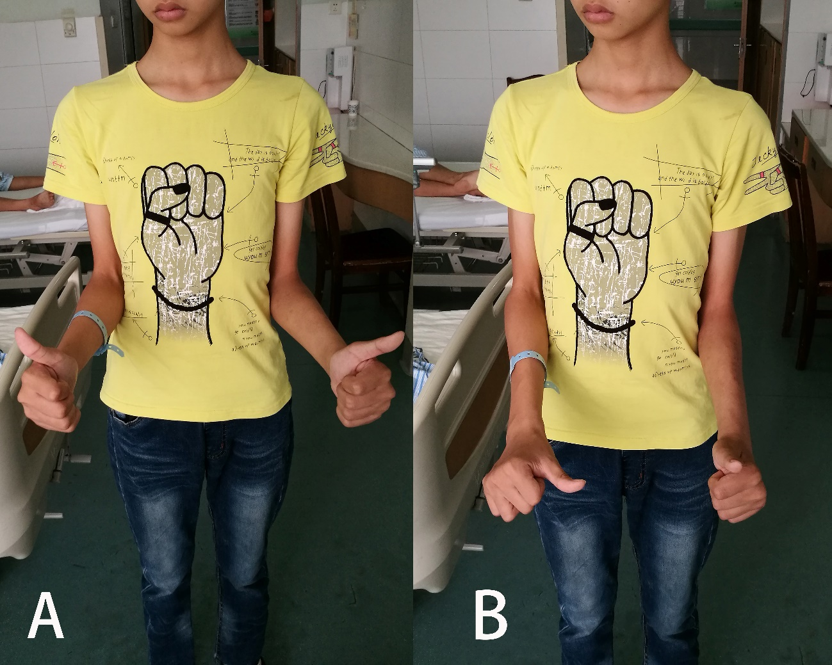
Figure 1 Active motion of the left forearm was limited. In order to reduce the rotation error caused by the compensation of elbow motion, the elbow joint was tightly attached to the waist. A: Supination; B: Pronation.
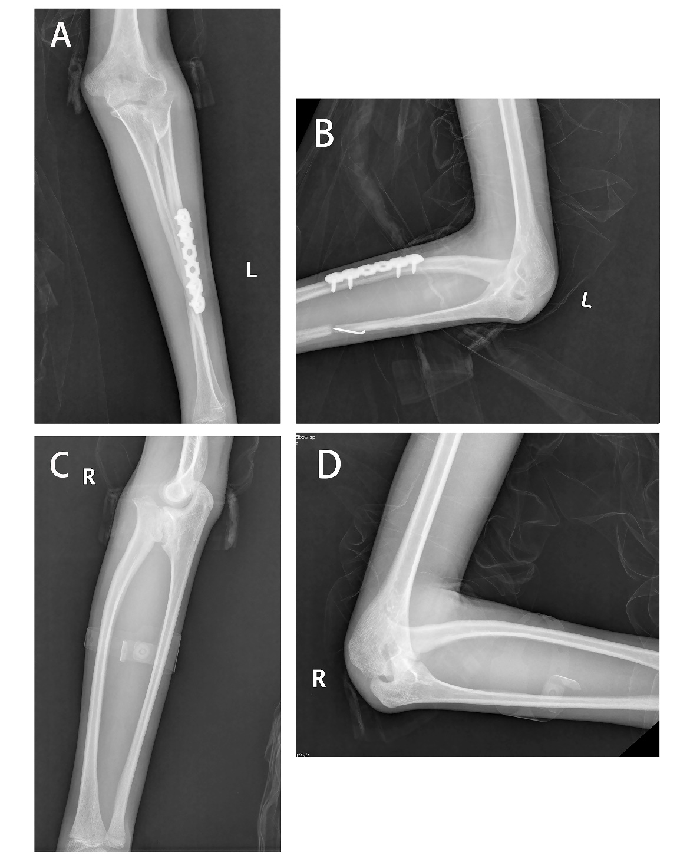
Figure 2 Plain radiographs of the bilateral forearm at 3 mo after surgery. A, B: Left side with loss of reduced location; C, D: Right side with the same deformity of radioulnar synostosis.

Figure 3 Plain radiographs showing the formation of callus, the disappearance of fracture line and the healing of fracture. A: At 2 mo after surgery; B: At 1 yr after surgery.

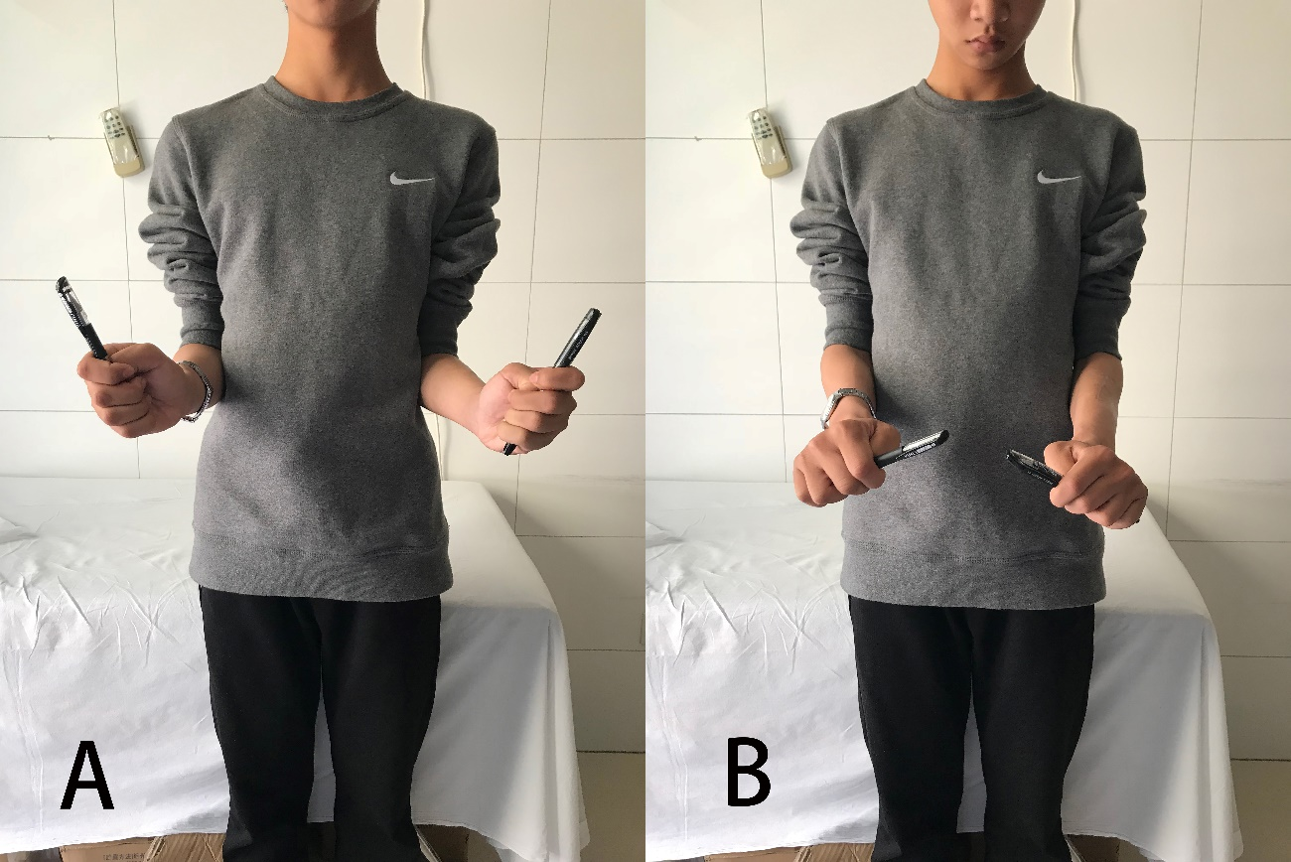
Figure 4 The range of motion of the left forearm was restored to the pre-injury state and was significantly improved after operation. A: Supination; B: Pronation.

Table 1 Cleary and Omer classification of congenital proximal radioulnar synostosis
Type (proportion) | Description
I (19%) | Fibrous synostosis with a reduced normal-appearing radial head
II (8%) | Visible bony synostosis with a reduced radial head
III (56%) | Visible bony synostosis with a hypoplastic and posteriorly dislocated radial head
IV (17%) | Short bony synostosis with an anteriorly dislocated mushroom-shaped radial head

Table 2 The evaluation results before and after surgery
Outcome assessment | Before surgery |  | At 1 yr after surgery
 | Nondominant, fractured side | Dominant, non-fractured side | Nondominant, fractured side | Dominant, non-fractured side
ROM of elbow E/F (°) | 0/140 | 0/140 | 0/140 | 0/140
ROM of forearm P/S (°) | 0/5 | -30/0 | -45/45 | -45/30
ADL¹
Hygiene and self-care items | 3.5 | 4.0 | 4.2 | 4.5
Feeding-related items | 3.3 | 4.6 | 4.5 | 4.9
Environmental interaction | 3.3 | 4.3 | 4.3 | 4.7
Average | 3.4 | 4.3 | 4.3 | 4.7
LES²
Clinical assessment | 12 | 15 | 17 | 17
Patient-answered questions | 11 | 30 | 31 | 34
Final scores | 4.4 | 8.2 | 8.7 | 9.2
DASH³
Function | 48 |  | 32
Symptoms | 14 |  | 7
DASH value | 26.7 |  | 7.5
Failla classification system | Fair | Good | Good | Excellent
¹Scores range from 1 to 5. The lower scores represent greater limitation on activities of daily living. ²Scores range from 0 to 10. The lower scores represent greater symptom and functional severity. ³Value ranges from 1 to 100. Greater scores indicate more extremely limited upper limb function. ROM: Range of motion; E/F: Extension/flexion; P/S: Pronation/supination; ADL: Assessment of activities of daily living; LES: Liverpool Elbow Score; DASH: Disabilities of the arm, shoulder and hand.

Table 3 Different surgical methods used in the treatment of congenital radioulnar synostosis
Ref. | Post-op follow-up in mo | Surgical methods | Preoperative ﬁxed forearm position (°)¹ | Final forearm position (°)⁴ | Complications
Simcock et al^{[31]}, 2015 | 46 (range, 6-148) | Derotational osteotomy | 85 (range, 60-100) | -8 (range, -30-0) | 12%
VanHeest et al^{[35]}, 2013 | 33 (range, 24-42)² | Radial head excision³ | 27.5 (range, 0-60) | Mainly improve elbow extension movement | 25% (one with transient radial nerve neuropraxia)
Shingade et al^{[46]}, 2014 | 54 (range, 36-84) | Radial osteotomy | 56.3 (range, 30-86) | 27.2 (range, 20-30) | Not available
Hung et al^{[39]}, 2008 | 64 (range, 30-129) | Derotational osteotomy | 78 (range, 65-85) | 8 (range, 0-30) | 0%
Bishay et al^{[40]}, 2016 | 30.4 (range, 24-36) | single-session double-level rotational osteotomy | 70.7 (range, 60-85) | -15.5 (range, -30-20) | 0%
Garg et al^{[36]}, 2015 | 32.1 (range, 16-65) | Radial head excision with a tensor fascia lata graft | 51.6 (range, 30-70) | 15 (range, 5-32) | 50% (superficial infection, posterior interosseous nerve palsy and a persistent extension lag)
Horii et al^{[41]}, 2014 | 60 (range, 12-156) | Derotational osteotomy | 72 (range, 40-100) | 0 | 0%
Pei et al^{[42]}, 2019 | 55.19 (range, 24-123) | Derotational osteotomy | 62.92 (55-80) | 7.94 (range, -10-20) | 9.7% (transient nerve palsies and compartment syndrome)
Satake et al^{[47]}, 2018 | 163.2 (range, 120-228) | Derotational osteotomy | 51.3 (range, 30-90) | 4 (range, -20-30) | 0%
Hwang et al^{[38]}, 2015 | 33 (range, 12-72) | Derotational osteotomy | 47 (range, 30-65) | 27 (range, 25-30) | 0%
Kanaya et al^{[37]}, 2016 | 120 (range, 96-144) | Radial osteotomy with a free vascularized adipofascial graft | 14.2 (range, 0-25) | 6.7 (range, 0-25) | 66.7% (flap congestion, transient radial nerve palsy, synovial fold and posterior or anterior radial head dislocation)
¹Degree of pronation. ²The fourth case without specific follow-up time. ³A method of only treating the anteriorly dislocated radial head in type IV radioulnar synostoses with radial head impingement. ⁴Degrees of supination: -8, 8° of pronation; -10, 10° of pronation; -15.5, 15.5° of pronation; -20, 20° of pronation; -30, 30° of pronation.

