Name of journal: World Journal of Gastroenterology
ESPS Manuscript NO: 23718
Manuscript Type: CASE REPORT

Gastric inverted hyperplastic polyp: A rare cause of iron deficiency anemia

Yun JK et al. Gastric inverted hyperplastic polyp with anemia

Jin Tak Yun, Seung Woo Lee, Dong Pil Kim, Seung Hwa Choi, Seok-Hwan Kim,
Jun Kyu Park, Sun Hee Jang, Yun Jung Park, Ye Gyu Sung, Hae Jung Sul

Jin Tak Yun, Seung Woo Lee, Dong Pil Kim, Seung Hwa Choi, Seok-Hwan Kim,
Jun Kyu Park, Sun Hee Jang, Yun Jung Park, Ye Gyu Sung, Division of Gastroenterology, Department of Internal Medicine, College of Medicine, Daejeon St. Mary’s Hospital, The Catholic University of Korea, Daejeon 301-723, South Korea

Hae Jung Sul, Department of Pathology, College of Medicine, Daejeon St. Mary`s Hospital, The Catholic University of Korea, Daejeon 301-723, South Korea

Author contributions: Yun JT and Lee SW designed the report; Kim DP, Choi SH and Kim SH collected the patient’s clinical data; Park JK, Jang SH, Park YJ and Sung YG contributed to revising the manuscript; Yun JT and Lee SW wrote the paper.

Supported by Division of Gastroenterology, Department of Internal Medicine, College of Medicine, Daejeon St. Mary`s Hospital, The Catholic University of Korea.

Institutional review board statement: The case has been discussed with the most senior member of staff in charge of the patient’s care who has given consent for this, and consent was obtained for use of accompanying pathologic images from the consultant pathologist. The study was reviewed and approved by the Daejeon St. Mary`s Hospital of the Catholic University of Korea Institutional Review Board.

Informed consent statement: All study participants, or their legal guardian, provided informed written consent prior to enrollment.

Conflict-of-interest statement: We declare that we have no financial or personal relationships with other individuals or organizations that would inappropriately influence our work. There is no professional or other personal interest of any nature in any product or service.

Open-Access: This article is an open-access article which was selected by an in-house editor and fully peer-reviewed by external reviewers. It is distributed in accordance with the Creative Commons Attribution Non Commercial (CC BY-NC 4.0) license, which permits others to distribute, remix, adapt, build upon this work non-commercially, and license their derivative works on different terms, provided the original work is properly cited and the use is non-commercial. See: http://creativecommons.org/licenses/by-nc/4.0/

Correspondence to: Seung Woo Lee, MD, PhD, Division of Gastroenterology, Department of Internal Medicine, College of Medicine, Daejeon St. Mary`s Hospital, The Catholic University of Korea, 64 Daeheung-ro, Jung-gu, Daejeon 301-723, South Korea. cutetak@hanmail.net
Telephone: +82-42-2209501
Fax: +82-42-2526808

Received: December 12, 2015
Peer-review started: December 13, 2015
First decision: December 21, 2015
Revised: December 25, 2015
Accepted: January 9, 2016
Article in press:
Published online:

Abstract
Gastric inverted hyperplastic polyp (IHP) is a rare gastric polyp characterized by the downward growth of hyperplastic mucosal components into the submucosal layer. Macroscopically, a gastric IHP resembles a subepithelial tumor (SET); as a result, accurately diagnosing gastric IHP is difficult. This issue has clinical significance because gastric IHP can be misdiagnosed as SET or as malignant neoplasm In addition, adenocarcinoma can accompany benign gastric IHP. Although in most cases, gastric IHPs are asymptomatic and are found incidentally, these polyps may cause anemia secondary to chronic bleeding. Here, we report one case involving gastric IHP accompanied by chronic iron deficiency anemia that was successfully managed using endoscopic submucosal dissection.

Key words: Stomach; Hyperplasia; Polyp; Anemia

© The Author(s) 2016. Published by Baishideng Publishing Group Inc. All rights reserved.

Core tip: Gastric inverted hyperplastic polyp (IHP) is a rare gastric polyp characterized by the downward growth of hyperplastic mucosal components into the submucosal layer. It is difficult to diagnose accurately without endoscopic resection and pathological investigation because of its inverted grown into the submucosal layer and the paucity of case reports. In most cases, gastric IHPs are asymptomatic and are found incidentally. Rarely, it may manifest as anemia secondary to chronic bleeding and can be ignored by inexperienced endoscopist. Importantly, it is reported to be related with dysplasia and adenocarcinoma. So, en bloc resection using endoscopic submucosal dissection was recommended for diagnosis and treatment.

Yun JT, Lee SW, Kim DP, Choi SH, Kim SH, Park JK, Jang SH, Park YJ, Sung YG, Sul HJ. Gastric inverted hyperplastic polyp: A rare cause of iron deficiency anemia. World J Gastroenterol 2016; In press

INTRODUCTION
Gastric inverted hyperplastic polyp (IHP) is a rare gastric polyp characterized by the downward growth of hyperplastic mucosal components into the submucosal layer^{[1]}. In 1993, Kamata et al^{[2]} first referred to this type of lesion as an IHP. This polyp has also been called a hamartomatous polyp and a solitary polypoid hamartoma^{[3]}. Macroscopically, a gastric IHP resembles a subepithelial tumor (SET); as a result, accurately diagnosing gastric IHP is difficult. This issue has clinical significance because gastric IHP can be misdiagnosed as SET or as malignant neoplasm. In addition, adenocarcinoma can accompany benign gastric IHP^{[1]}. Although most gastric IHPs are symptomatic and are identified incidentally, we encountered a case of gastric IHP that had the primary manifestation of chronic iron deficiency anemia (IDA) and was successfully managed using endoscopic submucosal dissection (ESD).

CASE REPORT
A 64-year-old woman presented with several year history of dizziness and general weakness that had recently become aggravated. Her medical history was otherwise unremarkable. Approximately 7 years prior to the events described here, the patient had been diagnosed with gastric SET (Figure 1A). A biopsy indicated the presence of chronic gastritis. Although the patient had undergone endoscopic examinations nearly every year, no treatment for her gastric SET had been considered.
At admission, a physical examination produced unremarkable findings. Complete blood count results indicated a white blood cell count, hemoglobin level, and platelet count of 5900/mm³, 6.5 g/dL, and 497000/mm³, respectively. The patient’s anemia was diagnosed as IDA and her stool was negative for occult blood. Blood chemistry results were unremarkable. An endoscopic examination revealed a 1.5 cm SET on the greater curvature (GC) side of the lower body. This tumor, which had increased in size since the previous examination, was covered with normal mucosa exhibited irregular, hypervascular changes and a central orifice at its surface (Figure 1B). Endoscopic forceps biopsy results indicated chronic gastritis with intestinal metaplasia. A colonoscopic examination produced unremarkable findings. Endoscopic ultrasonography (EUS) revealed a 13.2 mm × 11.2 mm heterogeneous hypoechoic tumor in the submucosal layer of the gastric wall (Figure 2A). Abdominal contrast-enhanced computed tomography (CT) indicated the presence of a 1.5 cm, oval-shaped enhancing mass in the stomach, on the GC side of the lower body (Figure 2B). Because this lesion could have been a cause of the patient’s IDA and because we wished to obtain an appropriate diagnosis, we decided to respect the mass in question using ESD. Grossly, the resected specimen measured 5.0 cm × 3.0 cm and included a well-circumscribed 1.5 cm polypoid lesion (Figure 2C). Histologically, the lesion mainly consisted of inverted proliferating columnar cells and was primarily composed of hyperplastic foveolar-type glands; focal cystic dilatation, inflammatory cells, and smooth muscle bundles in the stroma were observed (Figure 3). The pathologic diagnosis was consistent with gastric IHP. No architectural or cytological atypia were detected.
The patient was discharged following endoscopic treatment of gastric IHP; 5 months later, the patient’s hemoglobin had normalized to 12.4 g/dL, and anemic symptoms such as general weakness and dizziness had disappeared. A follow-up endoscopic examination revealed a post-ESD scar with a converging fold on the GC side of the lower body (Figure 2D).

DISCUSSION
Gastric polyps can be classified by morphology as either protruding or inverted. Most gastric polyps are protruding, whereas inverted gastric polyps are rare. Gastric IHP is characterized by the marked endophytic proliferation of foveolar-, pyloric-, or fundic-type glandular epithelium, which leads to a polypoid lesion^{[4]}. Although the pathogenesis of IHP is not well understood, studies have suggested that inflammation and subsequent healing may promote epithelial displacement^{[4]}.
The connection between the inflamed overlying mucosa and hyperplastic components in combination with the presence of the slit-shaped cavity in the polyp’s center suggested that repeated mucosal inflammation caused a break in the muscularis mucosae that allowed for the downward herniation and submucosal trapping of mucosal glands^{[4]}.
Our literature review discovered 19 reported cases of gastric IHP^{[1-11]}. Most of this gastric IHP were asymptomatic and were found incidentally. Rarely, gastric IHP may manifest as anemia secondary to chronic bleeding. Among the 19 previosly reported IHP cases, only 1 case presented with mild anemia. Thus, our IHP case is the first report of symptomatic, severe anemia as a symptom of gastric IHP.
Gastric IHP is difficult to diagnose accurately without endoscopic resection and pathological investigation because of the polyp’s inverted growth into the submucosal layer and the existence of extremely few case reports. Gastric IHP is diagnosed based on the tumor’s pathological characteristics, including fibroblast cells, smooth muscle proliferation, nerve components, vasoformative tissue, glandular hyperplasia, and cystic gland dilatation^{[1]}. The pathological finding of inverted ectopic gastric pseudopyloric glands in the submucosal layer is critical for diagnosing gastric IHP^{[1]}.
Gastric IHP is reportedly related to dysplasia and adenocarcinoma^{[3]}. Although gastric IHPs are benign tumors, dysplastic or cancerous areas are found within a large lesion in approximately 20% of gastric IHP cases ^{[5]}. Kono et al. suggested that p53 dysregulation may play an important role in the malignant transformation of gastric IHPs^{[6]}. In addition, multifocal adenocarcinomas may be present and randomly distributed across the superficial and deep regions of a gastric IHP. Therefore, a negative biopsy cannot reliably exclude the presence of dysplasia or adenocarcinoma. As a result, a patient with gastric IHP should be subjected to complete resection with a negative margin and a thorough histological examination should be performed^{[4]}. Several methods of diagnosing and treating gastric IHP have been used, including conventional polypectomy, endoscopic mucosal resection with piecemeal resection, ESD, and surgical approaches such as laparoscopic wedge resection. Recently, en bloc resection using ESD was recommended for the diagnosis and treatment of gastric IHP.
In conclusion, gastric IHP can cause symptoms such as anemia and can be ignored by an inexperienced endoscopist. Therefore, it is important to recognize the clinical significance of these lesions and consider treatment. We have reported a case of gastric IHP accompanied by chronic IDA that was successfully managed using ESD.

COMMENTS
Case characteristics
A 64-year-old woman presented with several year history of dizziness and general weakness that had recently become aggravated.

Clinical diagnosis
An endoscopic examination revealed a 1.5 cm SET on the greater curvature (GC) side of the lower body.

Differential diagnosis
Carcinoid, Ectopic pancreas, Granular cell tumor, Leiomyoma, Lymphoma.

Laboratory diagnosis
Hemoglobin level was 6.5 g/dL and all other labs were within normal limits.

Imaging diagnosis
Abdominal CT indicated the presence of a 1.5 cm, oval-shaped enhancing mass in the stomach, on the GC side of the lower body and EUS revealed a 13.2 mm × 11.2 mm heterogeneous hypoechoic tumor in the submucosal layer of the gastric wall.

Pathological diagnosis
Gastric inverted hyperplastic polyp (IHP).

Treatment
Endoscopic submucosal dissection (ESD).

Related reports
Gastric IHP is a rare gastric polyp characterized by the downward growth of hyperplastic mucosal components into the submucosal layer. It is difficult to diagnose accurately without endoscopic resection and pathological investigation. Rarely, it may manifest as anemia secondary to chronic bleeding and is related with dysplasia and adenocarcinoma.

Term explanation
ESD is a well-established technique of endoscopic resection that allows for en bloc removal of GI epithelial lesions.

Experiences and lessons
Gastric IHP can cause symptoms such as anemia and can be ignored by an inexperienced endoscopist. Therefore, it is important to recognize the clinical significance of these lesions and consider treatment.

Peer-review
The paper is well written.

REFERENCES
1 Mori H, Kobara H, Tsushimi T, Fujihara S, Nishiyama N, Matsunaga T, Ayaki M, Yachida T, Masaki T. Two rare gastric hamartomatous inverted polyp cases suggest the pathogenesis of growth. World J Gastroenterol 2014; 20: 5918-5923 [PMID: 24914354 DOI: 10.3748/wjg.v20.i19.5918]
2 Lee SJ, Park JK, Seo HI, Han KH, Kim YD, Jeong WJ, Cheon GJ, Eom DW. A case of gastric inverted hyperplastic polyp found with gastritis cystica profunda and early gastric cancer. Clin Endosc 2013; 46: 568-571 [PMID: 24143322 DOI: 10.5946/ce.2013.46.5.568]
3 Jung M, Min KW, Ryu YJ. Gastric inverted hyperplasic polyp composed only of pyloric glands: a rare case report and review of the literature. Int J Surg Pathol 2015; 23: 313-316 [PMID: 25097203 DOI: 10.1177/1066896914545395]
4 Kim HS, Hwang EJ, Jang JY, Lee J, Kim YW. Multifocal Adenocarcinomas Arising within a Gastric Inverted Hyperplastic Polyp. Korean J Pathol 2012; 46: 387-391 [PMID: 23110034 DOI: 10.4132/KoreanJPathol.2012.46.4.387]
5 Odashima M, Otaka M, Nanjo H, Jin M, Horikawa Y, Matsuhashi T, Ohba R, Koizumi S, Kinoshita N, Takahashi T, Shima H, Watanabe S. Hamartomatous inverted polyp successfully treated by endoscopic submucosal dissection. Intern Med 2008; 47: 259-262 [PMID: 18277026]
6 Kono T, Imai Y, Ichihara T, Miyagawa K, Kanemitsu K, Ajiki T, Kawasaki K, Kamigaki T, Ikuta H, Ohbayashi C, Yokozaki H, Fujimori T, Kuroda Y. Adenocarcinoma arising in gastric inverted hyperplastic polyp: a case report and review of the literature. Pathol Res Pract 2007; 203: 53-56 [PMID: 17097828 DOI: 10.1016/j.prp.2006.08.010]
7 Matsuoka J, Itaba S, Makihara Y, Murao H, Umeno N, Minoda Y, Kaku T, Kuniyoshi M, Hamada T, Nakamura K. [Three cases of pedunculated gastric hamartomatous inverted polyps resected endoscopically]. Nihon Shokakibyo Gakkai Zasshi 2015; 112: 1030-1036 [PMID: 26050726 DOI: 10.11405/nisshoshi.112.1030]
8 Aoki M, Yoshida M, Saikawa Y, Otani Y, Kubota T, Kumai K, Wakabayashi G, Omori T, Mukai M, Kitajima M. Diagnosis and treatment of a gastric hamartomatous inverted polyp: report of a case. Surg Today 2004; 34: 532-536 [PMID: 15170552 DOI: 10.1007/s00595-004-2761-1]
9 Yamashita M, Hirokawa M, Nakasono M, Kiyoku H, Sano N, Fujii M, Koyama T, Yoshida S, Sano T. Gastric inverted hyperplastic polyp. Report of four cases and relation to gastritis cystica profunda. APMIS 2002; 110: 717-723 [PMID: 12583438 DOI: 10.1034/j.1600-0463.2002.1101005]
10 Itoh K, Tsuchigame T, Matsukawa T, Takahashi M, Honma K, Ishimaru Y. Unusual gastric polyp showing submucosal proliferation of glands: case report and literature review. J Gastroenterol 1998; 33: 720-723 [PMID: 9773938 DOI: 10.1007/s005350050161]
11 Miyamoto Y, Muguruma N, Okamura S, Okada Y, Kitamura S, Okamoto K, Yoneda A, Kagawa N, Takayama T. A pedunculated submucosal lesion in the stomach with inverted downgrowth. Intern Med 2014; 53: 1625-1628 [PMID: 25088874 DOI: 10.2169/internalmedicine.53.2719]

P-Reviewer: Geraci G, Reinehr R S-Editor: Yuan Qi L-Editor: E-Editor:

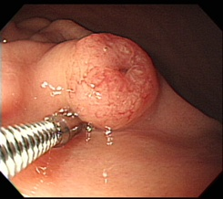
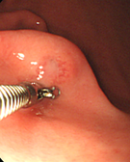
B
A

Figure 1 Gastric subepithelial tumor on the greater curvature side of the lower body. A: 7 years ago, gastric subepithelial tumor (SET) with hypervascular mucosal change was shown. When pushed the gastric SET by cold biopsy forcep, mucous secretion flowed from the lesion; B: At admission, gastric SET had shown the growth of size. Top of the gastric SET was shown slightly depressed, irregular and hypervascular change.

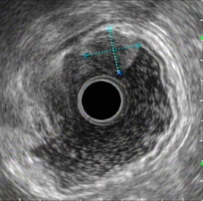
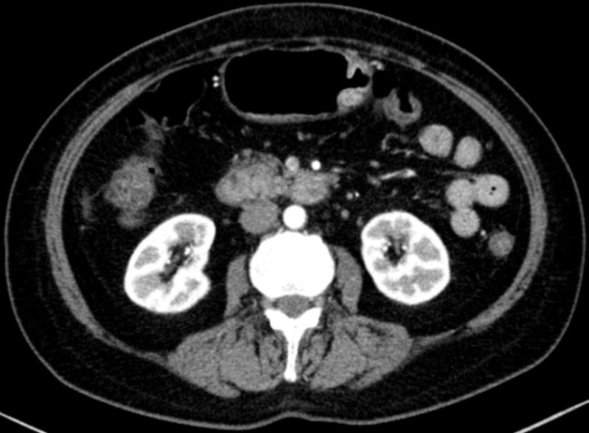
A

B

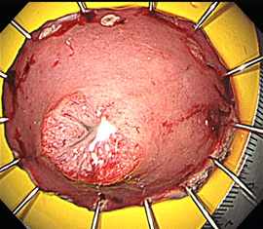
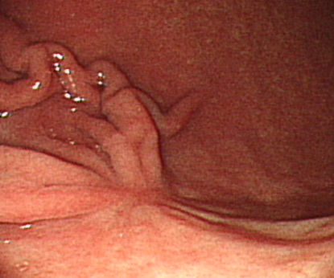
C
D

Figure 2 Colonoscopic examinations. A: Endoscopic ultrasonography (EUS) demonstrated a 13.2 mm × 11.2 mm-sized heterogeneous hypoechoic tumor (white arrow) in the submucosal layer of the gastric wall; B: Abdominal contrast-enhanced computed tomography (CT) demonstrated a 1.5 cm-sized, oval-shaped enhancing mass (white arrow) on the GC side of the lower body; C: ESD specimen measuring 5.0 cm × 3.0 cm showed a 1.5 cm-sized, well-circumscribed polypoid lesion; D: Follow-up endoscopic examination demonstrated a post ESD scar with converging fold on the GC side of the lower body.

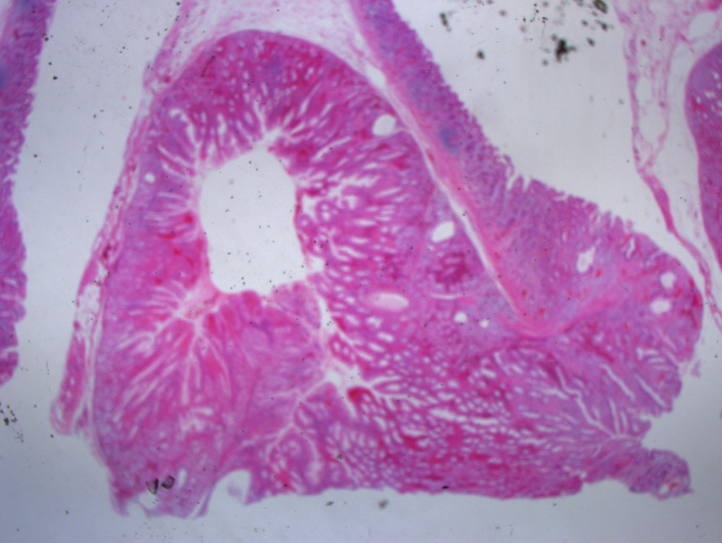
A

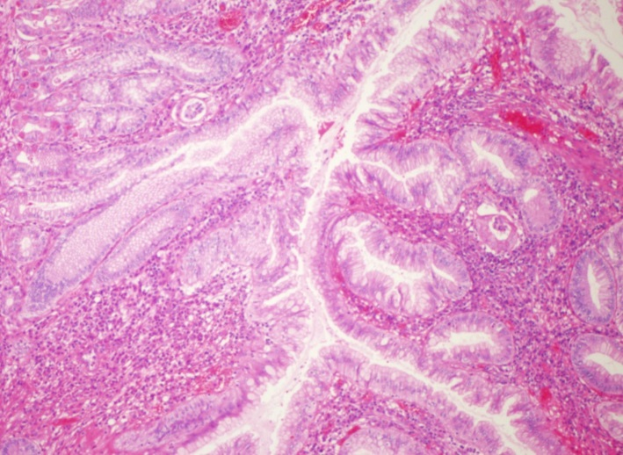
B

Figure 3 Microscopy of the endoscopic submucosal dissection specimen. A: Well-circumscribed inverted growth pattern into the submucosal layer was shown (HE staining, × 10); B: Endophytic proliferation of hyperplastic columnar cells and connected with inflamed surface epithelium was shown. No architectural or cytological atypia was found (HE staining, × 100).

