Name of journal: World Journal of Gastrointestinal Endoscopy
ESPS Manuscript NO: 17547
Manuscript Type: TOPIC HIGHLIGHT

2015 Advances in Gastrointestinal Endoscopy

Rare gastro-intestinal lymphomas: the endoscopic investigation

Vetro C et al. Endoscopy in rare GI lymphomas

Calogero Vetro, Giacomo Bonanno, Giorgio Giulietti, Alessandra Romano, Concetta Conticello, Annalisa Chiarenza, Paolo Spina, Francesco Coppolino, Rosario Cunsolo, Francesco Di Raimondo

Calogero Vetro, Alessandra Romano, Concetta Conticello, Annalisa Chiarenza, Paolo Spina, Francesco Di Raimondo, Division of Hematology, A.O. “Policlinico-Vittorio Emanuele”, University of Catania, 95124 Catania, Italy

Giacomo Bonanno, Division of Gastroenterology, A.O. “Policlinico-Vittorio Emanuele”, 95129 Catania, Italy

Giorgio Giulietti, Department of Diagnostic and Interventional Radiology, A.O. “Policlinico-Vittorio Emanuele”, 95124 Catania, Italy

Francesco Coppolino, Department of Radiology, University of Palermo, 90141 Palermo, Italy

Rosario Cunsolo, Health Direction, A.O. “Policlinico-Vittorio Emanuele”, 95129 Catania, Italy

Author contributions: Vetro C is the primary author of the study and was involved in literature search and data collection and wrote the paper; Giulietti G and Bonanno G provided figures, were content expert and involved in editing the manuscript; Vetro C, Romano A, Conticello C, Chiarenza A, Spina P, Coppolino F and Cunsolo R were content expert and involved in editing the manuscript; Vetro C and Di Raimondo F analyzed the data and were involved in editing the manuscript; Di Raimondo F was the principle investigator, content expert and involved in editing the manuscript.

Conflict-of-interest statement: no conflicts of interest.

Open-Access: This article is an open-access article which was selected by an in-house editor and fully peer-reviewed by external reviewers. It is distributed in accordance with the Creative Commons Attribution Non Commercial (CC BY-NC 4.0) license, which permits others to distribute, remix, adapt, build upon this work non-commercially, and license their derivative works on different terms, provided the original work is properly cited and the use is non-commercial. See: http://creativecommons.org/licenses/by-nc/4.0/

Correspondence to: Calogero Vetro, MD, Divisione Clinicizzata di Ematologia, Ospedale Ferrarotto, Via Citelli 6, 95124 Catania, Italy. gerovetro@gmail.com
Telephone: +39-95-7435916
Fax: +39-95-365174

Received: March 12, 2015
Peer-review started: March 13, 2015
First decision: April 23, 2015
Revised: June 1, 2015
Accepted: July 8, 2015
Article in press:
Published online:

Abstract
Gastrointestinal lymphomas represent up to 10% of gastrointestinal malignancies and about one third of non-Hodgkin lymphomas. Most prominent histologies are Mucosa-associated Lymphoid Tissue Lymphoma and Diffuse Large B-Cell Lymphoma. However, the gastrointestinal tract can be site of more rare lymphoma subtypes as primary or secondary localization. Due to their rarity and the multifaceted histology, an endoscopic classification has not been validated yet. This review aims to analyze the endoscopic presentation of rare gastro-intestinal lymphomas from disease diagnosis to follow-up, according to involved site and lymphoma subtype. Existing, new and emerging endoscopic technologies have been examined. In particular, we investigated the diagnostic and prognostic and follow-up endoscopic features of T-cell and NK lymphomas, Lymphomatous polyposis and Mantle Cell lymphoma, Follicular lymphoma, Plasma-cell related disease, gastrointestinal lymphomas in immunodeficiency and Hodgkin’s lymphoma of the gastrointestinal tract. Contrarily to more frequent gastrointestinal lymphomas, data about rare lymphomas are mostly extracted from case series and case reports. Due to data paucity, a synergism between gastroenterologists and hematologists is required in order to better manage the disease. Indeed, clinical and prognostic features are different from nodal and extranodal or bone marrow (in case of plasma-cell disease) counterpart. Therefore, the approach should be based on the knowledge of the peculiar behavior and natural history of disease.

Key words: Endoscopy; Lymphoma; Endosonography; Stomach; Intestine

© The Author(s) 2015. Published by Baishideng Publishing Group Inc. All rights reserved.

Core tip: Gastro-intestinal tract can be site of rare lymphomas as primary or secondary localization. Their endoscopic behavior has been scantly evaluated but is emerging as an useful tool with prognostic and therapeutic implications. T-cell lymphomas present mainly with ulcerative lesions, while B-cell lymphomas (follicular or mantle-cell lymphomas) present as duodenal mass or multiple polyposis. Plasmacell-related disorders localize to the gastrointestinal tract, either as neoplastic mass or as amyloid deposition. Immunodeficits (primary or secondary) can lead to gastrointestinal localization of rare, and seldom fatal, high-grade lymphomas. More rarely, Hodgkin’s Lymphoma localizes to the gastro-intestinal tract with uncertain impact on prognosis.

Vetro C, Bonanno G, Giulietti G, Romano A, Conticello C, Chiarenza A, Spina P, Coppolino F, Cunsolo R, Di Raimondo F. Rare gastro-intestinal lymphomas: the endoscopic investigation. World J Gastrointest Endosc 2015; In press

Introduction and main of the work
Gastro-intestinal (GI) lymphomas represent 5-10% of primary GI malignancies and almost two third of extra-nodal non-hodgkin lymphomas (NHL), that in turn account for 24%-49% of all NHL^{[1,2]}. Most common lymphomas are Mucosa-Associated Lymphoid Tissue (MALT) and Diffuse Large B-cell Lymphoma (DLBCL), accounting for 70%-95% of GI lymphomas^{[3, 4]}. Apart MALT and DLBCL, GI tract can be site of other lymphomas, either as primary or secondary localization^{[5]} and these lymphomas will be the object of this report. The knowledge of their clinical and echo-endoscopic features would help in addressing the clinical question^{[3,6-8]}, sparing inappropriate evaluations^{[9-13]}. Nonetheless, histology, together with immunohistochemistry and molecular biology, are mandatory for diagnosis^{[14]}.
While the endoscopic classification for MALT and DLBCL has been already validated^{[15,16]}, such an analysis on rare GI lymphomas is still under debate. In 2001 and 2003, the Taiwanese^{[17]} and the Korean group^{[18]} respectively published a 3/5-item classification of ileo-colonic GI lymphomas. Table 1 shows patterns analyzed in both classifications. Basically, the endoscopic appearance is classified according to the presence and depth of ulcerations and of fungating lesions. To date, these are the only attempts to classify rare GI lymphomas. After that, Kim et al^{[19]} investigated the endoscopic differences between B- and T- cell lymphomas of the colon, and they observed that B-cell lymphomas occur more often as fungating or ulcero-fungating lesions, while T-cell lymphomas have more frequently an ulcerative or ulcero-infiltrative pattern (Figure 1). Notwithstanding, a clear prognostic implication based on the endoscopic pattern has not been validated yet.
Newer techniques, i.e., capsule endoscopy (CE) and double-balloon enteroscopy (DBE), are emerging as useful tools in detecting small bowel tumors (15% of them represented by lymphomas)^{[3,20-22]}. Surely both techniques can augment the endoscopic diagnostic field (especially for follicular lymphomas^{[21]}). Moreover, spiral enteroscopy has been also evaluated as a tool for revealing GI lymphomas of the small intestine. Boudiaf et al^{[23]}, reported that 4 out of 14 patients affected by refractory celiac sprue developed a small bowel mass that was confirmed to be an enteropathy-associated T-cell lymphoma (EATL) by histological evaluation. Even if less spread, single balloon-enteroscopy has been used in the definition of small bowel lesions and recently it has been implemented with the water-exchange method in order to improve the visualization of the lumen to better define and sampling the lesion^{[24]}. However, such a deep diagnostic tools have not been validated for routine use in GI lymphoma staging and follow-up since they do not induce a treatment change. Thus, their application in gastric or colonic lymphomas has not fully validated^{[25]}. Differently, facing with T-cell lymphomas, with a jejunal tropism, DBE can lead to a definitive diagnosis coupling the endoscopic investigation with the bioptic evaluation^{[26,27]}. However, not many publications related to the usage of these techniques are available to date.
A particular consideration should be given to the role of endoscopic ultrasonography (EUS). Its role has gained more and more importance in MALT lymphomas since the loco-regional staging of the disease has a great impact on the treatment approach^{[6]}. Regarding DLBCL, the loco-regional extension has significant prognostic implications, even if its role in treatment definition is still under discussion^{[3]}. In contrast, few data are available in rare GI lymphomas. In particular, they are more frequently regarded as general diseases, so that the loco-regional extension is not always evaluated with some reports indicating just the EUS pattern without any clinical implication. Exceptional cases have indicated the role of EUS in defining the limited extension of the disease thus leading to an endoscopic resection of the mass (see the paragraph “Extramedullary Plasmacytoma and Plasma Cell-related Diseases”). That notwithstanding, EUS information are gathered only for describing the behavior of these lesions in most cases without any significant clinical impact.
Definitively, a proper staging for GI lymphomas will include^{[28]}: (1) physical examination: evaluation of superficial lymph-nodes and Waldeyer Ring inspection; abdomen palpation in order to detect liver enlargement, splenomegaly and abdominal masses; (2) endoscopic ultrasonography that represents the golden standard in defining the loco-regional GI involvement since it is able to distinguish the involvement of a specific layer and also of regional lymph nodes. However, as stated above, its role is under study and it is not strictly recommended in this setting; (3) computed Tomography of neck, chest and abdomen in order to detect involvement of nodes above and below the diaphragm and also other extra-nodal involvement not pertaining the GI tract. In some cases, Computed Tomography can be of great help in defining the extension of a large bulky mass departing from the GI tract but exteriorizing outside the GI tract (look at the paragraph “Plasma-cell related diseases”; (4) Positron Emission Tomography is not generally indicated as a staging procedure, especially in MALT lymphomas but it retains a role in defining the pre-treatment lymphomatous involvement and response to treatment; and (5) bone marrow biopsy: not withstanding low-grade, indolent, diseases tend to remain localized at the GI tract, bone marrow biopsy should be performed in order to exclude a marrow involvement that could influence treatment and follow-up management. However, the level of evidence on its utility is poor. A recent update of the staging recommendation in nodal lymphomas does not encourage the performance of bone marrow biopsy facing Diffuse-large B cell lymphoma and Hodgkin lymphoma, but this strategy has not been evaluated specifically for GI lymphomas^{[29]}.
However, these are general guidelines adopted from MALT lymphoma, since in more rare GI lymphomas, these guidelines have not been fully validated.
The aim of the present review is to highlight macroscopic features of rare GI lymphomas using endoscopy and related techniques. In particular we will focus on T-cell lymphomas, Lymphomatous polyposis (LP) and Mantle Cell lymphoma (MCL), Follicular lymphoma (FL), Plasma-cell related diseases, gastrointestinal lymphomas in immunodeficiency and Hodgkin’s Lymphoma (HL). An outline on the endoscopic presentation will be given for diagnostic aspect and follow-up assessment. As a whole, Table 2 summarizes the clinical and molecular characteristics and prognostic features of these lymphomas.

T-cell and NK lymphomas
GI T-cell lymphomas are rare, representing about 5% of GI lymphomas^{[14,30,31]}. However, incidence varies according to the geographic zones. European studies reported that 1.3% of primary GI lymphomas is of T-cell origin^{[32]}, while groups from Eastern Countries reported 7%-15%^{[33,34]} reaching the 41% in other series of intestinal lymphoma^{[35]}.
Ulcerated lesions are the main endoscopic features^{[30,36-38]}. The first definition of this disease was “ulcerative jejunitis” by Isaacson and Du, given the always present ulcerative pattern^{[14]}. Usually, symptoms are related to malabsorption^{[14]}, even if perforation^{[39]} or intestinal bleeding^{[40]} can occur. Incidentally, GI perforation or bleeding can occur in cases of nodal T-cell lymphomas independently from GI localization and recognize an infective etiology, reflecting the immune impairment that characterizes these lymphomas^{[41,42]}.
Guidelines suggest that diagnostic work-up and follow-up should be done in synergism between hematologists and gastroenterologists in order to better define the staging and the treatment needed and to ensure the best nutritional guidance (evidence level III grade B)^{[43]}.
In a study from the German group, the most frequent histotype of intestinal lymphoma was represented by T-cell lymphomas^{[44]}. The most common involved organs are duodenum and jejunum, followed by ileum and colon. Less frequent is the involvement of the stomach^{[45]} also as part of composite lymphoma^{[46]}, i.e., lymphoma with B- and T-cells origin. In a retrospective study by Matsumoto et al, it has been found that this type of lymphomas tends to have a small bowel localization more than other histotype. Regarding gastric involvement, in 30% of cases there is localization in the upper part of the stomach, in 20% the localization is in the middle part and diffuse in 40% of cases^{[47]}. Due to the fact that prognosis and treatment strategy depends on the lymphoma histotype, bioptic evaluation is a mandatory step. In addition, each subtype presents peculiar endoscopic behaviors that can drive diagnosis and treatment. GI T-cell lymphomas have typically a mature phenotype, while acute types of T-cell neoplasms do not classically involve GI tract^{[48]}.
According to 2008 WHO classification of hematological malignancies, most prevalent histotypes are^{[48,49]}: (1) enteropathy-associated T-cell lymphomas (EATL) (distinguished in type I and II); (2) peripheral T-cell lymphomas and Extranodal Natural Killer(NK)/T-Cell lymphoma; and (3) adult T-Cell Leukemia/Lymphoma (ATLL).
In addition, very rare cases have been reported (and represent mostly singular events) of colo-rectal T-cell prolymphocytic leukemia/lymphoma^{[50]} or anaplastic T-cell lymphoma (ALCL) ALK+^{[51]} or ALK-^{[52]}. Distinct entities, not described in the WHO classification are indolent T-cell/NK diseases that will be also taken into account.
Although EUS findings are not usually reported except peculiar cases, submucosal hypoechogeneic lesions destroying the involved layer would represent the main pattern^{[53]}. Another proof of the sub-mucosal origin of the tumor is given by narrow band imaging, able to show intact gastric pits elevated from the underlying mass^{[51]}. Very rare and unusual is the GI involvement in Sezary syndrome where, despite unremarkable gastric mucosa, EUS can show hyperechogeneic submucosa layer at giant fold level^{[54]}.

Enteropathy-associated T-cell lymphoma
EATL can be divided into two forms^{[14]}: the first variant is characterized by features of celiac disease with abdominal pain and small intestine obstruction/perforation. Usually there is a large mass with massive necrosis, while the neighboring mucosa shows villous atrophy and crypt hyperplasia as in typical enteropathy. Type II exhibits villous atrophy in the context of tumor mass with normal intestinal mucosa in uninvolved sites. Contrarily to type I EATL, type II EATL does not progress from undiagnosed or refractory celiac disease^{[14,55]}. Prognosis is poor with a median Overall Survival of 7-10 mo^{[56]}.
The exact incidence and lymphoma risk in celiac patients is still a debated issue^{[57]}. Some studies indicates a 200 fold increased risk to develop EATL compared to general population^{[58,59]}. According to other studies, the risk to develop non-Hodgkin lymphomas in Celiac patients appears to be 6-fold higher than in general population and this risk assumes a downward trend over years^{[60]}. Nonetheless, it appears clear that the occurrence of complications in celiac patients, even if infrequent, is an event that negatively impact on patient survival^{[61]}. In fact, the occurrence of intestinal perforation in a patient affected by celiac disease should lead to a suspicion of lymphoma.
Usually, EATL patients, tend to have a poorer Performance Status than B-Cell Lymphomas (even though tends to be localized), independently from the stage. Fever and diarrhea are the most frequent symptoms^{[44]}. Duodenum and jejunum represents the most involved sites with secondary involvement of the gross intestine in 14% of cases^{[44]}. The diagnosis of the disease in some cases is difficult since neoplastic lymphocytes can be present in a context of inflammatory background.
Endoscopic features are aspecific, with multiple erosions and ulcers^{[31]}. Nodularity and thickened folds can be seen at DBE^{[26,27]}. Strictures and masses are less common^{[62]}. In some cases, macroscopic findings together with the occurrence of an intense inflammatory reaction can lead to a mistaken diagnosis of Chron’s disease (CD)^{[31,63]}. However, even if it is not a general rule, CD ulcers are trasversal, while, in presence of T-cell lymphoma, ulcers are longitudinal^{[63]}.

Peripheral T-cell lymphomas and Extranodal Natural Killer/ T-Cell lymphoma
Peripheral T-Cell Lymphomas (PTCL) and natural killer (NK) lymphomas are more frequent in South America and Asia. These entities are distinct from other GI T-cell lymphomas by morphological and immunohistochemistry criteria^{[62]} and should be diagnosed when other more frequent T-cell lymphomas are excluded^{[48]}. Korean and Japanese series indicated that these are the most frequent GI T-cell lymphoma subtype accounting for 40% of primary T-cell GI lymphomas HTLV-1 negative^{[64]}. PTCL arises frequently in extranodal sites, especially at the skin. However, the involvement of the gastrointestinal tract represent a severe prognostic factor^{[65,66]}. Stomach an Duodenum accounts for 60% of GI localizations^{[52]}. Most frequent findings are ulcerative (46% of cases), infiltrative (9%), ulceroinfiltrative (18%), ulcerofungating (18%), erosive (9%)^{[52]}. Multiple polyposis can also be detected^{[67]}. In literature there are two reports indicating the involvement by T-cell lymphomas in the ileocolonic anastomosis for previously resected right colon, presenting with polypoid lesions^{[68]} or ulcerative lesions^{[69]}.
Extranodal NK/T-cell lymphoma usually arises in nasal cavities and rarely affect the GI tract. A strict relationship exists between ENKTCL and EBV infection with almost 70% of cases positive for Epstein–Barr virus-encoded small RNAs (EBER) detection^{[70]}. Small intestine is the most involved organ, while stomach is rarely involved^{[71]}. The endoscopic pattern in majority of cases is given by multifocal ulcers^{[72-75]} and infiltrative lesions^{[52]}. Sometimes the ulceration leads to intestine perforation and acute peritonitis (60% of the total complications)^{[52]}. Additionally, perforation is more frequent in the infiltrative pattern compared to the non-infiltrative. Fungating lesions are not usually reported^{[76]}. The most involved organ is small intestine^{[77,78]} and/or colon^{[72,76]} (depending on the case series), followed by small intestine, rectum and stomach^{[72]}. However, the location at GI tract does not seem to affect the prognosis^{[77]}. Interestingly, since the perforation leads usually to the development of peritonitis, the Lugano staging system has been applied, resulting the advanced stage of the disease a prognostic factor at multivariate analysis^{[72]}. Due to the high risk of perforation, many patients undergo surgery as pre-emptive or curative strategy, rarely for diagnosis^{[79]}. However, according to Kim et al^{[77]}, patients undergoing surgery followed by chemo/radio-therapy would show a better OS. However, as the authors themselves stated, this benefit would be ascribed to the fact that patients undergoing surgery had a better performance status and more limited disease and this would have affected the outcome. Similarly, as Hong et al^{[78]} reported, in a multivariate analysis, surgery ensures a better survival compared to chemotherapy. Therefore an appropriate loco-regional staging is also useful to tailor patients treatment.

Adult T-Cell Leukemia/Lymphoma
As for EATL, ATLL tends to present with ulcers with aggressive behavior. This is a specific variant of peripheral T-cell lymphoma that recognizes HTLV-1 virus as etiological agent^{[48]}. This variant is mainly found in endemic areas of Japan^{[64]}. In about one third of ATLL cases, GI involvement is secondary to a systemic disease^{[49]}. According to first data by Suzumiya, stomach is involved in 40% of cases and small and large intestine in 38% and 34% respectively^{[80]}. Even if four types of ATLL have been depicted (i.e., smoldering, chronic, lymphoma, acute) no endoscopic pattern has been related to a peculiar histotype. HTLV-1 infection has no role in determining the macroscopic features^{[47]}. Noteworthy, the detection of GI involvement has a prognostic impact^{[49]} representing the aggressiveness of the disease^{[43]}. In fact, smoldering or chronic ATLL subtypes do not show typically GI involvement^{[81]}. However, primary GI smoldering ATLL have been described and show long term disease-free survival after chemotherapy^{[82]}. Gastric involvement can be enhanced by Helicobacter pylori infection that creates an inflammatory state able to lead lymphocytes (also malignant) to migrate into gastric wall through the expression of specific adhesion molecules^{[83]}.
Ulcerative pattern is present in more than half cases of gastric involvement^{[47]}. Single or multiple yellow-whitish polyposis of the first or second loop are more frequent in the duodenum^{[49]} and multiple polyposis is the recurrent lesion in case of colon involvement^{[84]}. Even if a single or multiple polyps are the most frequent lesions, flat ulcerations/erosions can also be present^{[84]}. Red flat or elevated lesions in the rectum have been also documented^{[85,86]}. Rarely, there is the involvement of the ileum, where polyps are the main features^{[87]}. It should be underlined that GI lesions are not always monotone, but can be variegated. For examples, case reports indicate occurrence of protruding masses with normal or eroded mucosa at the stomach and occurrence of flat granular, friable and bled on contact mucosa at the colon^{[88]} or reddish irregular flat lesions at the esophagus^{[89]}.
Narrow-band imaging is able to document irregular microvascular architecture, dilated and destroyed gastric pits and dense aggregations between the pits with variegate irregular nuclei without interglandular infiltration (reflecting the absence of lympho-epithelioid lesions)^{[90]}.

Indolent lymph-proliferative diseases of the GI tract
A new category of T-cell GI lymph-proliferative disease, namely T-LPD (T-cell lymph-proliferative disease), has been recently introduced^{[91]}. The indolent course is the main clinical hallmark while this entity has been previously treated and managed as PTCL. Noteworthy, the etiology of the disease is unknown, even if many patients present a history of inflammatory bowel disease (IBD). Basically, the clinical picture is dyspepsia and mild diarrhea, while endoscopic feature can vary from unremarkable mucosa to erythema. Small intestine and colon are the most frequently involved sites, followed by oral cavity, stomach and esophagus. Usually gastric mucosa is normal despite a disease localization while duodenum can show thickened folds and irregular pattern. In the colon, occurrence of friable mucosa, erythematous mucosa and small polyps can be seen. Ulcerations are not described. At immunohistochemistry, lymphoid cells have a cytotoxic phenotype (CD8+; CD4-; TIA+), clonal T-cell receptor (TCR) gene rearrangements, do not form masses, do not invade the intestinal crypts and do not cover the full thickness of the bowel^{[91]}. Additionally, the lymphoid infiltrate is limited to the mucosa and sub-mucosa. The molecular study for TCR can show a monoclonal rearrangement of TCR-γ chain^{[91]}. The recognition of this disease have many therapeutic implications, since aggressive chemotherapy is excessive, being an immunosuppressive treatment virtually sufficient.
Indolent CD4+ T-cell lymphoma have also been described and show a good outcome and survival despite a persistence after immunomodulatory drug-based treatment^{[92]}. Rarely, gastric mucosa can show multiple nodularities^{[93]}. However, a clinical and endoscopic follow-up of these lesions is always advisable^{[93]}, also for the risk of progression in a long-run term^{[92]}.
Similarly to T-LPD, also NK cells can give raise to an indolent form of lymphoid infiltrate in the context of the GI tract, i.e., NK-cell enteropathy^{[94]}. Usually the symptoms are vague and the GI lesions can be present at stomach (more frequently), duodenum, small intestine, and colon. At endoscopy, these lesions exhibit superficial ulceration, flat elevations with central depression and are associated with edema and local hemorrhage. Usually these ulcers are 1cm in diameter and the surrounding mucosa is not abnormal. This disease is distinct from ENKTL since gastric involvement in the latter is really infrequent (and if present the localization is not limited to the stomach) and EBER is positive. In addition, in presence of NK-enteropathy, the epithelium can be invaded, showing a lymphoepithelial-like lesion^{[95]}. Moreover, contrarily to T-LPD, TCR rearrangement is polyclonal or oligoclonal^{[94]}.

Lymphomatous polyposis and Mantle Cell Lymphoma
The pioneer study by Corner et al^{[96]} in 1961 firstly reported the term “Lymphomatous polyposis”(LP). It is defined as the presence of diffuse proliferation of monotonous small-to-intermediate sized lymphocytes presenting as multiple polypoid tumors from 2 mm to several centimeters in different GI sites. Even if the preferred site is the small intestine^{[14]}, other sites can be involved alone or at the same time^{[97-104]}. Actually, LP is present in 4%-9% of all GI Lymphomas^{[14]} resulting more frequent in Western compared to Eastern Countries^{[105]}. B-cell lymphomas are more frequent than T-cell lymphomas and this is due to the fact that histologically these polyps originates from the mantle zone of the lymphoid follicle of the Mucosa-associated lymphoid tissue^{[106]}. Additionally, this fact justifies the augmented frequency in small intestine (rich in lymphatic tissue) compared to other GI tracts. Additionally, multiple tumors or different kind of lymphomas can be simultaneously present in a context of LP^{[107]}. Therefore, the biopsy of more than one polyp and of different types of lesions is always advisable^{[108,109]}. Additionally, it must be underlined that the occurrence of multiple polyposis in a patient with nodal lymphoma is not criterion to absolutely define the involvement of the GI tract, being the histological evaluation always mandatory^{[110]}.
Typical lymphoma presenting with LP is MCL^{[14,111]}, even if other tumors can show this feature^{[98-100,112-114]}. Among 37 case reports of LP since 2000^{[67,84,98-100,103,112-142]}, indeed MCL was the most frequent disease (more than 50% of cases) (Figure 2). The most involved site was the colon (Figure 3). In the case series by Saito et al., regarding patients affected by MALT lymphomas or MCL at the ileal site, it has been underlined that LP was the most frequent presentation of MCL and the least common lesion in MALT lymphomas (Figure 4)^{[143]}.
MCL can locate at the GI tract secondarily to the generalized disease^{[102]} and, even if only 25% of patients with nodal mantle cell lymphoma suffers GI symptoms, 77%-88% has a localization at the gross intestine and 43%-77% in the upper GI tract also in absence of macroscopic lesions^{[14]} (Figure 5). LP is the most frequent endoscopic pattern even if other endoscopic features can be present^{[144]}, for example granular pattern associated with polyps (Figure 6) or ulcerated polyps^{[145]} or masses^{[146]}. In addition, the endoscopic pattern varies according to the GI tract involved (Figure 7). EUS has been applied in this setting giving the possibility to identify submucosal lesions^{[115]}. MCL appears echopoor, usually departing from the second layer, remaining confined to the GI wall (Figure 8)^{[115,147,148]}. In some cases the diagnosis of MCL could be incidental during the endoscopic definition of gastric bleeding caused by gastric ulcers^{[149]}.
Contrarily to GI Follicular Lymphoma (discussed below), the GI tract involvement by MCL assumes a great prognostic implication and is useful to monitor patients after the treatment^{[14,101]}. Indeed, the occurrence of LP designate a median survival of 3-4 years^{[14,101]}. The fact that the small intestine can be also involved by the tumor, the performance of CE or DBE would be advisable in order to correctly stage the patient and assess the follow-up evaluations^{[116,117]}.
Even though the disease presentation has been well studied, there are no data about the management of LP during follow-up assessment. Our opinion is that the endoscopic evaluation with mapping biopsies should be performed in these patients since in some cases the presence of aspecific abnormalities during follow-up can lead to the finding of lymphoma reappearance^{[146]}, sometimes after many years from complete remission^{[103,119]}.

Follicular Lymphoma
GI FL is a rare entity, representing up to 3.6% of all GI NHL^{[150,151]}. Primary GI FL has been recognized as an histological variant of FL in the 2008 WHO classification of haematopoietic tumors^{[152]}. Sites most frequently involved are the duodenum (55.6% of cases)^{[101]}, in particular the second part^{[152]}, and the terminal ileum (33.3% of cases)^{[151,153]}. Since Positron Emission Tomography and Computed tomography have low sensitivity and specificity^{[154]} in catching small intestine involvement, CE and DBE have acquired more and more importance^{[155,156]}. Indeed, these techniques showed that small bowel can be involved in 70%-83% of cases^{[157,158]} even in cases of duodenal lymphoma^{[152]}.
To date, a clear endoscopic classification of GI-FL could not be done, as for GI MALT lymphomas. However, Yamamoto et al^{[151]}, reviewing 249 GI-FL cases, reported a reliable endoscopic classification of the disease. Whitish polyps usually up to 2 mm^{[151,153]} and/or white granules-nodular aggregates, with or without ulceration of the mucosa layer (Figure 9), represent the typical endoscopic pattern^{[150,159,160]}. This can be unifocal or multifocal and it is mainly present in intestinal FL. Large mass with or without ulceration is less frequent and in half of cases can be associated with multifocal whitish polyps. The latter is the most frequent endoscopic pattern of primary gastric FL. Multiple lymphomatous polyposis can also be found^{[30,101,150,158,161,162]}. Interestingly, in the series of 48 patients with GI FL reported by Yanai et al^{[163]} it has been found that the LP was the most frequent endoscopic feature (more than 50% of cases) followed by polypoid or ulcerative lesions (Figure 10).
Recently, high-definition endoscopy, as well as Magnifying Endoscopy (ME), has been used to describe the surface micro-structures of GI FL such as enlarged whitish villi and tiny whitish depositions and irregular microvascular pattern^{[164,165]}. This fact indicates that the tumor is of not-epithelial origin and usually reflects the formation of lymphoid follicles^{[164,166-169]}. EUS has not widely applied. Few reports have indicated that the echoendoscopic pattern is given by second and third layer thickening, dotted by hypoechogeneic nodules^{[170]}.
Capsule endoscopy and double-balloon enteroscopy are useful in the definition of small intestine involvement in an non-invasive way. The typical picture is a whitish submucosal elevation presenting as nodules or polyps^{[21]}, usually multifocal^{[171,172]}. However, the limitation is given by the inability to perform biopsy that is postponed to the execution of enteroscopy and the risk of retention in cases of stenosis (unusual in case of GI-FL).
Nodal spread is rare and GI FL tends to be localized in the gastrointestinal tract (stage IE according to Ann Arbor staging system)^{[173]} and to have an indolent course^{[152,174]}. However, transformation to aggressive lymphoma has been documented^{[175]}. Differently from other form of lymphomas, the GI involvement is not an adverse prognostic factor^{[176]}. Lymphoma grading is low in the majority of cases, while in the nodal counterpart grade I-II FL is documented in 1 case out of 10^{[173]}. Furthermore, in contrast to nodal FL, these cells do not acquire additional mutations and this justify the absence of grade 3 GI FL and the very low rate of transformation^{[173,175]}.
Treatment strategies are not uniform, even if GI FL are treated more frequently compared to nodal counterpart^{[177]}. Different case series have demonstrated that watch and wait approach is as useful as the pharmacological approach, except for relieving clinical symptoms^{[163,178-180]}. However, case series differ greatly in identifying the correct treatment approach to be applied. The surgical resection is not recommended while chemoimmunotherapy should be preferred^{[151,171]}. It must be considered also that the introduction of anti CD20 antibodies has augmented the survival rate and in some series localized/low-grade GI FL have been treated with anti CD20 monoclonal antibody alone, without chemotherapy^{[151]}.
It is debatable whether CE and/or DBE are truly useful. Indeed, no studies have demonstrated that the detection of small bowel involvement (especially if duodenal lymphoma is present) would have changed the treatment needed. Surely, these procedures would change the treatment strategy in case of radiation or surgical treatment and are needed in cases of obscure gastrointestinal bleeding^{[172,181]}. Apart these occurrences, the effectiveness of chemoimmunotherapy or immunotherapy alone would render these procedures not so practical in patient management. However, since no clear data exists regarding survival and quality of life in dependence of small bowel involvement, clinician choice is the only way to proceed.
That notwithstanding, the diagnostic suspect based on the endoscopic feature, together with the patient history, is fundamental in addressing the pathological diagnosis. Indeed, in almost 20% of cases, FL can be misdiagnosed by endoscopic biopsy evaluation^{[182]}. Therefore, multiple biopsies would be necessary. In particular, biopsies of the peripheral mucosa would be more informative than biopsies from the erosion/ulceration, since the probability to catch necrotic tissue decreases significantly.

Extramedullary Plasmacytoma and Plasma Cell-related Diseases
Extramedullary Plasmacytoma (EMP) belongs to a precise type of lymphoid malignancies, i.e., Plasma Cell Neoplasms, among whose represent 3%-4% of cases^{[183]}. It is important to distinguish this subtype from lymphomas with plasmacytic differentiation, particularly MALT lymphomas^{[48]}. The upper respiratory tract is the most involved organ (almost 80% of cases), while GI localization is rare^{[48]}. Among these cases, the stomach is the most involved site, followed by the liver, colon and the small intestine (duodenum, jejunum and ileum)^{[184]}.
Usually, gastric localization is secondary to a plasma cell myeloma (PCM) and often emerges through a clone selection process. Indeed, Multiple Myeloma treatment itself can select a particular chemo-resistant PC clone able to migrate at extra-nodal organs. In these cases, an accurate endoscopic investigation is critical for the diagnostic assessment and disease monitoring^{[185]}. Due to the strict relationship with plasma cell myeloma, the clinical course is poor. Most frequent endoscopic finding consists of an infiltrating mass or masses in the stomach and/or the duodenum^{[186,187]} or well-demarcated, flat, yellow-whitish mucosal changes^{[188]} or nodular lesion with central umbelication^{[189]}. Endoscopic appearance as diffusely thickened mucosal folds simulating linitis plastica is rare^{[190]}. Sometimes, large ulcerations can be seen^{[191,192]}. However, gastric mucosa can appear normal, while the extramural growth is incredibly vast (Figure 11). EUS could be of great help in defining the disease extension that appears as a large echo-poor mass infiltrating surrounding organs^{[186]}. However, sometimes, EUS can be useful to detect limited gastric wall involvement and in these cases an endoscopic resection of the mass can be performed resulting safe for the patient and effective for the treatment of the disease^{[188,193,194]}. Alternatively, patients with localized disease can be treated with radiation treatment^{[190,195]}.
Small intestine involvement is generally primary and have a benign course. These lesions can be explored by Enteroscopy and/or Capsule Endoscopy^{[196]} paying attentions to the cases in which obstructions or retention are expected. Differential diagnosis is with other cases of sub-mucosal masses in the small intestine, as reported by Lopes da Silva^{[196]}. Colon involvement appears more frequently as stricture^{[197,198]} in some cases difficult to differentiate from colon adenocarcinoma^{[199]}, returning in the differential diagnosis of sub-mucosal tumors^{[193]}. Rarely it can determine rectal bleeding^{[200]}. The localization at rectum appears as a mild granularity as well as a reddish, protruded lesion^{[201]}. Usually these lesions disappear after treatment and this is a confirmation of treatment efficacy^{[186]}, even if mucosal atrophy and non-specific inflammation can resituate^{[195]}.
Apart EMP, other Plasma Cell-related disorders can involve the GI tract. This is due to the production of amyloid protein in AL Amyloidosis (Light chain Amyloidosis)^{[187]}. The most involved organ is the small intestine. In some cases the amyloid deposition is synchronous with EMP^{[187,193,195]} or other GI lymphomas^{[202]}. Usually, the amyloid protein in AL amyloidosis involves the submucosa and the muscolaris mucosae, resulting in thickened folds and valvulae conniventes and polypoid lesions in GI tract. The typical deposition of AL amyloid protein justify pseudo-obstruction, constipation and mechanical obstruction as main symptoms^{[203]}. Intestinal bleeding can also occur^{[204]} and, if this event occurs in a patient with Multiple Myeloma, the occurrence of aspecific elevated lesions at the endoscopic evaluations should lead to the suspect of systemic Amyloidosis. More rarely, submucosal hematoma, ulcers and hemorrhagic bullous colitis can be seen^{[205]}. On the other hand, nodularity, fine granular appearance and mucosal friability are more frequent in another type of Amyloidosis, i.e., AA Amyloidosis (Amyloidosis secondary to systemic disorders). This is due to the deposit of amyloid proteins into the lamina propria with impaired absorption and subsequent diarrhea^{[203]}.

Immunodeficiency and GI lymphomas
Immunodeficiency is defined as a state of impaired function of the immune system that can be congenital, acquired or iatrogenic. The reduced immune-surveillance can determine an augmented rate of lymphomas. Two conditions mainly determine the arising of lymphomas: Human immunodeficiency virus (HIV) infection with the correlated Acquired Immuno Deficiency Syndrome (AIDS) and post-transplant immune-suppression. In both conditions, GI tract is the most involved site^{[206]}. Apart HIV and PTLD, Common variable immunodeficiency (CVID) has been related with the development of gastrointestinal NHL, even if this is a very rare finding^{[207,208]}.
In HIV patients, the rate of GI lymphomas was higher in pre-HAART era, before 1996^{[209]} and the risk of gastric NHL was 353 fold compared to normal subject, being aggressive lymphomas the most prevalent features^{[59]}. In cases of AIDS-related lymphoma, GI tract is involved in 20% up to 50% of cases^{[206,210]}. However, the decrease of GI lymphoma incidence has not been so high compared to Central Nervous System Lymphomas^{[209]}. A recent analysis on 243 HIV patients performed at University of Sao Paolo revealed an incidence of Gastric NHL of 2.5%^{[211]}. Co-infection with EBV and/or CMV would complicate the prognosis^{[212]}, even if the occurrence of viral infection is less pathogenetically important compared to PTLD^{[206]}. The main histologies are B-cell lymphomas (67%) (DLBCL, Burkitt lymphoma, MALT lymphoma)^{[213]} while T-cell lymphomas are less frequent (33%)^{[209]} and anecdotal are other types of hematologic malignancies^{[214,215]}. In 5%-10% of cases cMyc rearrangement is present and confers a poor prognosis^{[212]}. Additionally, the prompt recognition of this lymphoma subtype has a great impact in patient management since presenting symptoms are usually alarm symptom in about half of patients. However, in majority of patients, the lymphoma is diagnosed at stage III-IV AnnArbor^{[206]}. Most frequent endoscopic features are multifocal ulcerations, followed by polypoid or bulky mass together with bloody spots^{[206,212]}. The most involved sites are the stomach and the duodenum^{[216]} followed by small bowel and colon-rectum (Figure 12)^{[211]}. However, unusual presentations can be seen more commonly than in immunocompetent patients^{[206]}. At narrow-band, honeycomb-like pattern is present without irregularity in microvasculature^{[212]}. The localization can also be perirectal and in these cases, EUS-guided fine needle biopsy would be a valid tool to pone diagnosis given the high grade nature of this kind of lymphomas^{[217]}. Noteworthy, EUS appearance is of hypoechoic poorly defined mass^{[217]} and is important for the loco-regional staging^{[206]}. Prognosis is poor with a median survival of 6 months with a rate of complete remission less than 40%^{[211]}. Prognosis is also impaired by the occurrence of opportunistic infections^{[210]}. Extremely suggestive, is the development of EBV-related DLBCL in patients suffering other types of lymphomas that induce a state of immunosuppression, such as AITL^{[218]}. In these peculiar cases, the outcome is really poor and alarm symptoms and perforation can occur with fatal implications^{[218]}.
GI lymphomas are also more frequent in solid organ transplant recipients, particularly after renal and heart and small bowel transplantation, encompassing the spectrum of PTLD (Table 3). The pathogenetic events seem to be different compared to HIV-related lymphomas since in this kind of lymphomas Epstein-Barr Virus re-activation due to immunosuppressants plays a pivotal role^{[219]}. Apart negative EBV serology prior to transplantation, length of immunosuppression is an overt risk factor^{[220,221]}. EBV-positive lymphomas arise earlier than EBV-negative lymphomas^{[221]}. In adults, majority of cases arises beyond 12 mo from transplantation^{[222]}, at a median of 36 mo^{[223]}. A second peak is after 5-10 years^{[206]}. Median overall survival is 8 years and the principal histotype is B-cell lymphoma, even if lymphomas of T-cell origin can also be present. Noteworthy, the GI tract is involved in one third of cases. Endoscopy is of great help in establishing the diagnosis. Specially in small bowel transplantation, endoscopic follow-up has gained a pivotal role in defining the transplant-related complications, including the onset of PTLD^{[224]}. Typically, lesions are raised rubbery erythematous or ulcerated^{[222,225,226]}. Most involved organ is the colon, followed by small intestine and stomach^{[223]}. However, the recognition of symptoms together with the patient history is of great help in driving the diagnosis. Additionally, endoscopic procedures are essential in order to follow the course of disease^{[225]}, being valid also in long-run term^{[226]}. Interestingly, early stage PTLD can be safely removed endoscopically and this would be a valid approach in the treatment of localized PTLD^{[224]}.
Plasmablastic lymphoma (PBL) is a rare and aggressive type of lymphoma characterized, at histological valuation, by the presence of large immunoblasts with plasmacytic differentiation with an high replication index^{[227]}. Usually, this lymphoma arises in the oral cavity in HIV-infected patients and in literature there are few cases of GI localization (Table 4)^{[228-237]}. Stomach is the most involved site (about 50% of cases), followed by small intestine, anal region, cecum, colon and esophagus^{[237]}. Large masses and exophitic processes are the main endoscopic appearance in stomach and anal region. Intestinal localization is extremely rare and when present the endoscopic appearance is of multiple nodularity^{[227]}. Moreover, PBL can arises also in immunocompetent patients with ulcerated lesions at the stomach^{[236]}. These patients are normally older than HIV+ patients, tend to present GI localizations more that HIV+ patients and show a worse overall survival^{[236,237]}.
Additionally, CD has been also linked to the development of lymphomas of the gastrointestinal tract. Most of them are of B origin, comprising DLBCL and HL, even if also T-cell lymphomas can arise. In the recent report by Kappelman et al^{[238]} patients with CD showed a greater risk to develop haematological malignancies compared to general population. This study confirmed the previous report by Askling et al^{[239]}, showing also an augmented rate of haematological malignancies compared to general population and 10% of developed lymphomas where of T-type. Probably it would be related to the state of immunosuppression leading to infection of lymphotropic and oncogenic viruses, but the specific mechanism remains to be clarified. This predisposition seems to be unrelated to the immune-suppressive treatment. In this setting, anti-TNFα treatment have been related to development of hepatosplenic T-cell lymphoma^{[240]}. However, two years later, a metanalysis by Siegel et al^{[241]} indicated that the immunosuppressive treatment is not a risk factor for the development of NHL in CD patients. However, it is still a matter of discussion since the augmented incidence of GI lymphomas in these patients would be related to the more intensive examinations. Moreover, the histological evaluation is a crucial point since the inflammatory background can lead to a false positive result. That notwithstanding, anti-TNFα treatment seems to be safe regarding the incidence of NHL and should not be regarded as a risk factor. Therefore, more epidemiological studies will be needed in order to better define the link between CD and GI lymphomas.

Hodgkin’s Lymphoma
Lymphomatous GI involvement in HL appears as a stricture (Figure 13) or ulceration^{[242-245]}.The abundant lymphoid tissue, present at this site, renders it one of the most involved region^{[246]}. HL rarely present a colonic localization (almost 1%-3% of extra-nodal HL cases^{[247]} and less than 5% of gastrointestinal lymphomas^{[243]}) and the prognostic impact is still obscure. Mixed-cellularity subtype represents the most common feature^{[248]}. As for nodal counterpart, the inflammatory background represents a key feature of HL^{[249]}. In some cases, the endoscopic and histological presentation can resemble inflammatory bowel disease (IBD), that, in turn, can seldom be associated with colonic HL^{[244,250]}. Additionally, immunodeficiency represents a risk factor^{[251]}, even if this type of lymphoma can also arise in immune-competent patients^{[247]}.
Recently, a new entity has been proposed, i.e., ‘‘EBV Associated Mucocutaneous Ulcer” (EBVMCU)^{[252]}. This disease subtype would resemble HL, but there are peculiar clinical and histological differences from HL. Indeed, the presence of ‘‘plasmacytoid’’ apoptotic cells and the confinement to mucosa and sub-mucosal layers are the histological hallmark that can lead to a differential diagnosis from cHL. However, EBV infection is always present as in GI-HL.

CONCLUSION
Endoscopic features of GI lymphomas are variegated encompassing ulcers, erosions, polyps and so on. It represents a fascinating matter of study for both hematologists and gastroenterologists. As stated in guidelines, a synergism between these two figures is fundamental. This is due to the lack of data and the fact that information regarding rare GI lymphomas are extrapolated from case series or case reports. Actually, the scientific community is gaining more and more knowledges on the recognition and management of these lymphomas with the creation of proper guidelines for specific lymphoma subtypes. In this setting, the collection of different case series and their analysis will assume a pivotal role in drawing general guidance on disease characterization. Certainly, as emerged into the manuscript, the management of these lymphomas is different compared to nodal or medullary counterpart and a proper understanding of the endoscopic features together with clinical and histological characteristic is crucial in a better management of patients with the ultimate goal of improving clinical outcome and quality of life of patients.

References
1 Zullo A, Hassan C, Cristofari F, Perri F, Morini S. Gastric low-grade mucosal-associated lymphoid tissue-lymphoma: Helicobacter pylori and beyond. World J Gastrointest Oncol 2010; 2: 181-186 [PMID: 21160595 DOI: 10.4251/wjgo.v2.i4.181]
2 Vetro C, Romano A, Palumbo GA, Bonanno G, Di Raimondo F. Role of the endoscopic ultrasonography in the management of gastric lymphomas: our experience and review of literature. Russian Federation: Novosibirsk State technical University: InTech 2011: 235-258
3 Vetro C, Romano A, Amico I, Conticello C, Motta G, Figuera A, Chiarenza A, Di Raimondo C, Giulietti G, Bonanno G, Palumbo GA, Di Raimondo F. Endoscopic features of gastro-intestinal lymphomas: from diagnosis to follow-up. World J Gastroenterol 2014; 20: 12993-13005 [PMID: 25278693 DOI: 10.3748/wjg.v20.i36.12993]
4 Vetro C, Romano A, Donnarumma D, La Fauci A, Fiumara P, Chiarenza A, Figuera A, Palumbo G, Bonanno G, Di Raimondo F. Role of the endoscopic ultrasonography in the management of gastric lymphomas: metanalysis of literature. Haematologica 2011; 96: 567
5 Ferry JA. Extranodal Lymphomas. Publisher: Elsevier Health Sciences, 2011
6 Vetro C, Chiarenza A, Romano A, Amico I, Calafiore V, Di Raimondo C, Coppolino F, Di Raimondo F. Prognostic assessment and treatment of primary gastric lymphomas: how endoscopic ultrasonography can help in tailoring patient management. Clin Lymphoma Myeloma Leuk 2014; 14: 179-185 [PMID: 24369919 DOI: 10.1016/j.clml.2013.10.010]
7 Vetro C, Romano A, Chiarenza A, Conticello C, Donnarumma D, Gorgone A, Coppolino F, Palumbo GA, Bonanno G, Di Raimondo F. Endoscopic ultrasonography in gastric lymphomas: appraisal on reliability in long-term follow-up. Hematol Oncol 2012; 30: 180-185 [PMID: 22189677 DOI: 10.1002/hon.1022]
8 O'Malley DP, Goldstein NS, Banks PM. The recognition and classification of lymphoproliferative disorders of the gut. Hum Pathol 2014; 45: 899-916 [PMID: 24613566 DOI: 10.1016/j.humpath.2013.12.001]
9 Zullo A, Esposito G, Ridola L, Hassan C, Lahner E, Perri F, Bianco MA, De Francesco V, Buscarini E, Di Giulio E, Annibale B. Prevalence of lesions detected at upper endoscopy: An Italian survey. Eur J Intern Med 2014; 25: 772-776 [PMID: 25245606 DOI: 10.1016/j.ejim.2014.08.010]
10 Di Giulio E, Hassan C, Marmo R, Zullo A, Annibale B. Appropriateness of the indication for upper endoscopy: a meta-analysis. Dig Liver Dis 2010; 42: 122-126 [PMID: 19497799 DOI: 10.1016/j.dld.2009.04.019]
11 Faintuch JJ, Silva FM, Navarro-Rodriguez T, Barbuti RC, Hashimoto CL, Rossini AR, Diniz MA, Eisig JN. Endoscopic findings in uninvestigated dyspepsia. BMC Gastroenterol 2014; 14: 19 [PMID: 24499444 DOI: 10.1186/1471-230X-14-19]
12 Hassan C, Di Giulio E, Marmo R, Zullo A, Annibale B. Appropriateness of the indication for colonoscopy: systematic review and meta-analysis. J Gastrointestin Liver Dis 2011; 20: 279-286 [PMID: 21961096]
13 Buri L, Bersani G, Hassan C, Anti M, Bianco MA, Cipolletta L, Di Giulio E, Di Matteo G, Familiari L, Ficano L, Loriga P, Morini S, Pietropaolo V, Zambelli A, Grossi E, Intraligi M, Tessari F, Buscema M. How to predict a high rate of inappropriateness for upper endoscopy in an endoscopic centre? Dig Liver Dis 2010; 42: 624-628 [PMID: 20308024 DOI: 10.1016/j.dld.2010.02.012]
14 Burke JS. Lymphoproliferative disorders of the gastrointestinal tract: a review and pragmatic guide to diagnosis. Arch Pathol Lab Med 2011; 135: 1283-1297 [PMID: 21970484 DOI: 10.5858/arpa.2011-0145-RA]
15 Ahmad A, Govil Y, Frank BB. Gastric mucosa-associated lymphoid tissue lymphoma. Am J Gastroenterol 2003; 98: 975-986 [PMID: 12809817 DOI: 10.1111/j.1572-0241.2003.07424.x]
16 Zullo A, Hassan C, Andriani A, Cristofari F, Cardinale V, Spinelli GP, Tomao S, Morini S. Primary low-grade and high-grade gastric MALT-lymphoma presentation. J Clin Gastroenterol ; 44: 340-344 [PMID: 19745757 DOI: 10.1097/MCG.0b013e3181b4b1ab]
17 Myung SJ, Joo KR, Yang SK, Jung HY, Chang HS, Lee HJ, Hong WS, Kim JH, Min YI, Kim HC, Yu CS, Kim JC, Kim JS. Clinicopathologic features of ileocolonic malignant lymphoma: analysis according to colonoscopic classification. Gastrointest Endosc 2003; 57: 343-347 [PMID: 12612513 DOI: 10.1067/mge.2003.135]
18 Wang MH, Wong JM, Lien HC, Lin CW, Wang CY. Colonoscopic manifestations of primary colorectal lymphoma. Endoscopy 2001; 33: 605-609 [PMID: 11473333 DOI: 10.1055/s-2001-15320]
19 Kim YH, Lee JH, Yang SK, Kim TI, Kim JS, Kim HJ, Kim JI, Kim SW, Kim JO, Jung IK, Jung SA, Jung MK, Kim HS, Myung SJ, Kim WH, Rhee JC, Choi KY, Song IS, Hyun JH, Min YI. Primary colon lymphoma in Korea: a KASID (Korean Association for the Study of Intestinal Diseases) Study. Dig Dis Sci 2005; 50: 2243-2247 [PMID: 16416168 DOI: 10.1007/s10620-005-3041-7]
20 Chen WG, Shan GD, Zhang H, Li L, Yue M, Xiang Z, Cheng Y, Wu CJ, Fang Y, Chen LH. Double-balloon enteroscopy in small bowel tumors: a Chinese single-center study. World J Gastroenterol 2013; 19: 3665-3671 [PMID: 23801870 DOI: 10.3748/wjg.v19.i23.3665]
21 Egea-Valenzuela J, Castillo-Espinosa JM, Sánchez-Torres A, Alberca-de-las-Parras F, Carballo-Álvarez F. Diagnosis of follicular lymphoma of the small bowel by video capsule endoscopy. Rev Esp Enferm Dig 2014; 106: 51-52 [PMID: 24689716]
22 Nakamura M, Ohmiya N, Hirooka Y, Miyahara R, Ando T, Watanabe O, Itoh A, Kawashima H, Ohno E, Kinoshita T, Goto H. Endoscopic diagnosis of follicular lymphoma with small-bowel involvement using video capsule endoscopy and double-balloon endoscopy: a case series. Endoscopy 2013; 45: 67-70 [PMID: 23208779 DOI: 10.1055/s-0032-1325867]
23 Boudiaf M, Jaff A, Soyer P, Bouhnik Y, Hamzi L, Rymer R. Small-bowel diseases: prospective evaluation of multi-detector row helical CT enteroclysis in 107 consecutive patients. Radiology 2004; 233: 338-344 [PMID: 15459329 DOI: 10.1148/radiol.2332030308]
24 Liang S, Pan Y, Wang B, Luo H, Xue X, Qin J, Guo X, Wu K. Complete small-bowel examination by oral single-balloon enteroscopy using the water-exchange method. Endoscopy 2013; 45 Suppl 2 UCTN: E415-E417 [PMID: 24285078 DOI: 10.1055/s-0033-1358810]
25 Al-Taie O, Dietrich CG, Flieger D, Katzenberger T, Fischbach W. Is there a role for capsule endoscopy in the staging work-up of patients with gastric marginal zone B-cell lymphoma of MALT? Z Gastroenterol 2013; 51: 727-732 [PMID: 23955137 DOI: 10.1055/s-0033-1335077]
26 Yanai S, Matsumoto T, Nakamura S, Fujisawa K, Ueki T, Hirahashi M, Yao T, Iida M. Endoscopic findings of enteropathy-type T-cell lymphoma. Endoscopy 2007; 39 Suppl 1: E339-E340 [PMID: 18273786 DOI: 10.1055/s-2007-967063]
27 Matsumoto T, Nakamura S, Esaki M, Yada S, Moriyama T, Yanai S, Hirahashi M, Yao T, Iida M. Double-balloon endoscopy depicts diminutive small bowel lesions in gastrointestinal lymphoma. Dig Dis Sci 2010; 55: 158-165 [PMID: 19241169 DOI: 10.1007/s10620-009-0713-8]
28 Zucca E, Copie-Bergman C, Ricardi U, Thieblemont C, Raderer M, Ladetto M , Ladetto M; ESMO Guidelines Working Group. Gastric marginal zone lymphoma of MALT type: ESMO Clinical Practice Guidelines for diagnosis, treatment and follow-up. Ann Oncol 2013; 24 Suppl 6: vi144-vi148 [PMID: 24078657 DOI: 10.1093/annonc/mdt343]
29 Cheson BD, Fisher RI, Barrington SF, Cavalli F, Schwartz LH, Zucca E, Lister TA. Recommendations for initial evaluation, staging, and response assessment of Hodgkin and non-Hodgkin lymphoma: the Lugano classification. J Clin Oncol 2014; 32: 3059-3068 [PMID: 25113753 DOI: 10.1200/jco.2013.54.8800]
30 Terada T. Gastrointestinal malignant lymphoma: a pathologic study of 37 cases in a single Japanese institution. Am J Blood Res 2012; 2: 194-200 [PMID: 23119230]
31 Freeman HJ. Malignancy in adult celiac disease. World J Gastroenterol 2009; 15: 1581-1583 [PMID: 19340898]
32 Koch P, Probst A, Berdel WE, Willich NA, Reinartz G, Brockmann J, Liersch R, del Valle F, Clasen H, Hirt C, Breitsprecher R, Schmits R, Freund M, Fietkau R, Ketterer P, Freitag EM, Hinkelbein M, Heinecke A, Parwaresch R, Tiemann M. Treatment results in localized primary gastric lymphoma: data of patients registered within the German multicenter study (GIT NHL 02/96). J Clin Oncol 2005; 23: 7050-7059 [PMID: 16129843 DOI: 10.1200/jco.2005.04.031]
33 Park YH, Kim WS, Bang SM, Lee SI, Uhm JE, Kang HJ, Na II, Yang SH, Lee SS, Kim K, Jung CW, Park K, Ko YH, Ryoo BY. Prognostic factor analysis and proposed prognostic model for conventional treatment of high-grade primary gastric lymphoma. Eur J Haematol 2006; 77: 304-308 [PMID: 16879609 DOI: 10.1111/j.1600-0609.2006.00709.x]
34 Kohno S, Ohshima K, Yoneda S, Kodama T, Shirakusa T, Kikuchi M. Clinicopathological analysis of 143 primary malignant lymphomas in the small and large intestines based on the new WHO classification. Histopathology 2003; 43: 135-143 [PMID: 12877728]
35 Gou HF, Zang J, Jiang M, Yang Y, Cao D, Chen XC. Clinical prognostic analysis of 116 patients with primary intestinal non-Hodgkin lymphoma. Med Oncol 2012; 29: 227-234 [PMID: 21193968 DOI: 10.1007/s12032-010-9783-x]
36 Ho HC, Nagar AB, Hass DJ. Obscure gastrointestinal bleeding and video capsule retention due to enteropathy-associated T-cell lymphoma. Gastroenterol Hepatol (N Y) 2013; 9: 536-538 [PMID: 24719605]
37 Kawamoto K, Nakamura S, Iwashita A, Watanabe J, Oshiro Y, Nakayama Y, Nimura S, Kimura N, Aoyagi K, Yao T, Kuramochi S, Matsuyama A, Kurihara K, Ohshima K, Takeshita M. Clinicopathological characteristics of primary gastric T-cell lymphoma. Histopathology 2009; 55: 641-653 [PMID: 20002766 DOI: 10.1111/j.1365-2559.2009.03430.x]
38 Radersma M, Mulder CJ, Tushuizen ME. A rare cause of weight loss and night sweats. Gastroenterology 2014; 147: e11-e12 [PMID: 25173784 DOI: 10.1053/j.gastro.2014.05.032]
39 Dughayli MS, Baidoun F, Lupovitch A. Synchronous perforation of non-Hodgkin's lymphoma of the small intestine and colon: a case report. J Med Case Rep 2011; 5: 57 [PMID: 21310044 DOI: 10.1186/1752-1947-5-57]
40 Kinaci E, Gunes ME, Huq GE. An unusual presentation of EATL type 1: Emergency surgery due to life-threatening gastrointestinal bleeding. Int J Surg Case Rep 2013; 4: 961-964 [PMID: 24055918 DOI: 10.1016/j.ijscr.2013.08.007]
41 Saitoh T, Matsushima T, Matsuo A, Yokohama A, Irisawa H, Handa H, Tsukamoto N, Karasawa M, Nojima Y, Murakami H. Small-bowel perforation accompanied by Aspergillus endocarditis in a patient with angioimmunoblastic T-cell lymphoma. Ann Hematol 2007; 86: 71-73 [PMID: 17043778]
42 Keiser PB, Nutman TB. Strongyloides stercoralis in the Immunocompromised Population. Clin Microbiol Rev 2004; 17: 208-217 [PMID: 14726461]
43 Dearden CE, Johnson R, Pettengell R, Devereux S, Cwynarski K, Whittaker S, McMillan A. Guidelines for the management of mature T-cell and NK-cell neoplasms (excluding cutaneous T-cell lymphoma). Br J Haematol 2011; 153: 451-485 [PMID: 21480860 DOI: 10.1111/j.1365-2141.2011.08651.x]
44 Daum S, Ullrich R, Heise W, Dederke B, Foss HD, Stein H, Thiel E, Zeitz M, Riecken EO. Intestinal non-Hodgkin's lymphoma: a multicenter prospective clinical study from the German Study Group on Intestinal non-Hodgkin's Lymphoma. J Clin Oncol 2003; 21: 2740-2746 [PMID: 12860953 DOI: 10.1200/JCO.2003.06.026]
45 Sugita S, Iijima T, Furuya S, Kano J, Yanaka A, Ohta K, Kojima H, Noguchi M. Gastric T-cell lymphoma with cytotoxic phenotype. Pathol Int 2007; 57: 108-114 [PMID: 17300676 DOI: 10.1111/j.1440-1827.2006.02065.x]
46 Tachikawa Y, Shiratsuchi M, Sada E, Idutsu K, Kiyasu J, Karube K, Ohshima K, Nishimura J, Takayanagi R, Abe Y. Composite gastrointestinal lymphoma consisting of diffuse large B-cell lymphoma and peripheral T-cell lymphoma. Int J Hematol 2009; 90: 275-277 [PMID: 19588220 DOI: 10.1007/s12185-009-0371-9]
47 Hatano B, Ohshima K, Katoh A, Kanda M, Kawasaki C, Tsuchiya T, Shimazaki K, Haraoka S, Sugihara M, Suzumiya J, Kikuchi M. Non-HTLV-1-associated primary gastric T-cell lymphomas show cytotoxic activity: clinicopathological, immunohistochemical characteristics and TIA-1 expression in 31 cases. Histopathology 2002; 41: 421-436 [PMID: 12405910]
48 Swerdlow SHC, E.; Harris, N.L.; Jaffe, E.S.; Pileri, S.A.; Stein, H.; Thiele, J.; Vardimar, J.W. WHO classification of tumours of haematopoietic and lymphoid tissues: International Agency for Research on Cancer, 2008
49 Isomoto H, Ohnita K, Mizuta Y, Maeda T, Onizuka Y, Miyazaki M, Omagari K, Takeshima F, Murase K, Haraguchi M, Murata I, Kohno S. Clinical and endoscopic features of adult T-cell leukemia/lymphoma with duodenal involvement. J Clin Gastroenterol 2001; 33: 241-246 [PMID: 11500618]
50 Toyota S, Nakamura N, Dan K. T-cell prolymphocytic leukemia with hemorrhagic gastrointestinal involvement and a new chromosomal abnormality. Int J Hematol 2002; 75: 314-317 [PMID: 11999363]
51 Ishii H, Isomoto H, Taniguchi H, Kinoshita N, Matsushima K, Taguchi J, Miyazaki Y, Nakao K. Education and Imaging: Gastrointestinal: gastroduodenal involvement of ALK-positive anaplastic large cell lymphoma. J Gastroenterol Hepatol 2011; 26: 933 [PMID: 21488949 DOI: 10.1111/j.1440-1746.2011.06665.x]
52 Kim do H, Lee D, Kim JW, Huh J, Park SH, Ha HK, Suh C, Yoon SM, Kim KJ, Choi KD, Ye BD, Byeon JS, Song HJ, Jung HY, Yang SK, Kim JH, Myung SJ. Endoscopic and clinical analysis of primary T-cell lymphoma of the gastrointestinal tract according to pathological subtype. J Gastroenterol Hepatol 2014; 29: 934-943 [PMID: 24325295 DOI: 10.1111/jgh.12471]
53 Okada M, Maeda K, Suzumiya J, Hagimoto T, Wakamatsu S, Ohshima K, Kanda M, Sonoda T, Sakamoto A, Tamura K. Primary colorectal T-cell lymphoma. J Gastroenterol 2003; 38: 376-384 [PMID: 12743779 DOI: 10.1007/s005350300067]
54 Schuler MK, Kroschinsky F, Schaich M, Kalauch A, Stroszczynski C, Kellermann S, Ehninger G, Benter T. Sézary syndrome: infiltration of the gastric wall--does it matter? Ann Hematol 2012; 91: 1507-1509 [PMID: 22362119 DOI: 10.1007/s00277-012-1426-1]
55 Okumura K, Ikebe M, Shimokama T, Takeshita M, Kinjo N, Sugimachi K, Higashi H. An unusual enteropathy-associated T-cell lymphoma with MYC translocation arising in a Japanese patient: a case report. World J Gastroenterol 2012; 18: 2434-2437 [PMID: 22654438 DOI: 10.3748/wjg.v18.i19.2434]
56 Sieniawski MK, Lennard AL. Enteropathy-associated T-cell lymphoma: epidemiology, clinical features, and current treatment strategies. Curr Hematol Malig Rep 2011; 6: 231-240 [PMID: 21912848 DOI: 10.1007/s11899-011-0097-7]
57 Rostami Nejad M, Aldulaimi D, Ishaq S, Ehsani-Ardakani MJ, Zali MR, Malekzadeh R, Rostami K. Geographic trends and risk of gastrointestinal cancer among patients with celiac disease in Europe and Asian-Pacific region. Gastroenterol Hepatol Bed Bench 2013; 6: 170-177 [PMID: 24834268]
58 d'Amore F, Brincker H, Grønbaek K, Thorling K, Pedersen M, Jensen MK, Andersen E, Pedersen NT, Mortensen LS. Non-Hodgkin's lymphoma of the gastrointestinal tract: a population-based analysis of incidence, geographic distribution, clinicopathologic presentation features, and prognosis. Danish Lymphoma Study Group. J Clin Oncol 1994; 12: 1673-1684 [PMID: 8040680]
59 Chang ST, Menias CO. Imaging of primary gastrointestinal lymphoma. Semin Ultrasound CT MR 2013; 34: 558-565 [PMID: 24332207 DOI: 10.1053/j.sult.2013.05.008]
60 Askling J, Linet M, Gridley G, Halstensen TS, Ekström K, Ekbom A. Cancer incidence in a population-based cohort of individuals hospitalized with celiac disease or dermatitis herpetiformis. Gastroenterology 2002; 123: 1428-1435 [PMID: 12404215]
61 Biagi F, Gobbi P, Marchese A, Borsotti E, Zingone F, Ciacci C, Volta U, Caio G, Carroccio A, Ambrosiano G, Mansueto P, Corazza GR. Low incidence but poor prognosis of complicated coeliac disease: a retrospective multicentre study. Dig Liver Dis 2014; 46: 227-230 [PMID: 24268568 DOI: 10.1016/j.dld.2013.10.010]
62 Arps DP, Smith LB. Classic versus type II enteropathy-associated T-cell lymphoma: diagnostic considerations. Arch Pathol Lab Med 2013; 137: 1227-1231 [PMID: 23991736 DOI: 10.5858/arpa.2013-0242-CR]
63 Jiao G, Zheng Z, Jiang K, Zhang J, Wang B. Enteropathy-associated T-cell lymphoma presenting with gastrointestinal tract symptoms: A report of two cases and review of diagnostic challenges and clinicopathological correlation. Oncol Lett 2014; 8: 91-94 [PMID: 24959225 DOI: 10.3892/ol.2014.2105]
64 Park YH, Kim WS, Bang SM, Lee SI, Kang HJ, Na II, Yang SH, Lee SS, Uhm JE, Kwon JM, Kim K, Jung CW, Park K, Ko YH, Ryoo BY. Primary gastric lymphoma of T-cell origin: clinicopathologic features and treatment outcome. Leuk Res 2006; 30: 1253-1258 [PMID: 16529813 DOI: 10.1016/j.leukres.2006.01.018]
65 Bellei M, Chiattone CS, Luminari S, Pesce EA, Cabrera ME, de Souza CA, Gabús R, Zoppegno L, Zoppegno L, Milone J, Pavlovsky A, Connors JM, Foss FM, Horwitz SM, Liang R, Montoto S, Pileri SA, Polliack A, Vose JM, Zinzani PL, Zucca E, Federico M. T-cell lymphomas in South america and europe. Rev Bras Hematol Hemoter 2012; 34: 42-47 [PMID: 23049383 DOI: 10.5581/1516-8484.20120013]
66 Velagapudi P, Turagam M, Uzoaru I, Graham D. Small bowel obstruction due to mycosis fungoides: an unusual presentation. Am J Med Sci 2011; 341: 508-509 [PMID: 21613936 DOI: 10.1097/MAJ.0b013e31821389da]
67 Isomoto H, Maeda T, Akashi T, Tsuchiya T, Kawaguchi Y, Sawayama Y, Koida S, Ohnita K, Kohno S, Tomonaga M. Multiple lymphomatous polyposis of the colon originating from T-cells: a case report. Dig Liver Dis 2004; 36: 218-221 [PMID: 15046193 DOI: 10.1016/j.dld.2003.09.019]
68 Cooperberg MR, Fiedler PN. Ki-1 anaplastic large-cell lymphoma occurring at the site of ileocolonic anastomosis in a patient treated surgically for colonic adenocarcinoma: case report and review of the literature. Ann Diagn Pathol 2001; 5: 162-167 [PMID: 11436170 DOI: 10.1053/adpa.2001.25408]
69 Ikeda J, Yamauchi A, Hoshida Y, Okamura S, Hashimoto K, Aozasa K, Morii E. Peripheral T-cell lymphoma developing at ileocolonic anastomosis site after colectomy for adenocarcinoma. Pathol Res Pract 2010; 206: 376-378 [PMID: 19836149 DOI: 10.1016/j.prp.2009.08.001]
70 Jung CK, Lee KY, Kim Y, Han K, Shim SI, Kim BK, Kang CS. Epstein-Barr virus infection, drug resistance and prognosis in Korean T- and NK-cell lymphomas. Pathol Int 2001; 51: 355-363 [PMID: 11422793]
71 Zhang YC, Sha Zhao JB, Lei Shi MX, Zhang HY, Liu WP. Gastric involvement of extranodal NK/T-cell lymphoma, nasal type: a report of 3 cases with literature review. Int J Surg Pathol 2008; 16: 450-454 [PMID: 18492683 DOI: 10.1177/1066896908316068]
72 Jiang M, Chen X, Yi Z, Zhang X, Zhang B, Luo F, Jiang Y, Zou L. Prognostic characteristics of gastrointestinal tract NK/T-cell lymphoma: an analysis of 47 patients in China. J Clin Gastroenterol 2013; 47: e74-e79 [PMID: 23948755 DOI: 10.1097/MCG.0b013e31829e444f]
73 Wakabayashi S, Arai A, Oshikawa G, Araki A, Watanabe M, Uchida N, Taniguchi S, Miura O. Extranodal NK/T cell lymphoma, nasal type, of the small intestine diagnosed by double-balloon endoscopy. Int J Hematol 2009; 90: 605-610 [PMID: 19936878 DOI: 10.1007/s12185-009-0438-7]
74 Li JZ, Tao J, Ruan DY, Yang YD, Zhan YS, Wang X, Chen Y, Kuang SC, Shao CK, Wu B. Primary duodenal NK/T-cell lymphoma with massive bleeding: A case report. World J Clin Oncol 2012; 3: 92-97 [PMID: 22724088 DOI: 10.5306/wjco.v3.i6.92]
75 Kobold S, Merz H, Tiemann M, Mahuad C, Bokemeyer C, Koop I, Fiedler W. Primary NK/T cell lymphoma nasal type of the stomach with skin involvement: a case report. Rare Tumors 2009; 1: e58 [PMID: 21139937 DOI: 10.4081/rt.2009.e58]
76 Kim JH, Lee JH, Lee J, Oh SO, Chang DK, Rhee PL, Kim JJ, Rhee JC, Lee J, Kim WS, Ko YH. Primary NK-/T-cell lymphoma of the gastrointestinal tract: clinical characteristics and endoscopic findings. Endoscopy 2007; 39: 156-160 [PMID: 17657701 DOI: 10.1055/s-2006-945114]
77 Kim SJ, Jung HA, Chuang SS, Hong H, Guo CC, Cao J, Hong XN, Suzuki R, Kang HJ, Won JH, Chng WJ, Kwong YL, Suh C, Song YQ, Zhu J, Tay K, Lim ST, Suzumiya J, Lin TY, Kim WS. Extranodal natural killer/T-cell lymphoma involving the gastrointestinal tract: analysis of clinical features and outcomes from the Asia Lymphoma Study Group. J Hematol Oncol 2013; 6: 86 [PMID: 24238138 DOI: 10.1186/1756-8722-6-86]
78 Hong H, Liang C, Huang H, Guo C, Tian Y, Liu T, Zhang M, Li X, Wang Z, Fang X, Lin J, Lin T. Surgical resection followed by chemotherapy may be an effective treatment strategy for primary gastrointestinal natural killer/T-cell lymphoma: a single center experience. Leuk Lymphoma 2014; 55: 2649-2651 [PMID: 24506468 DOI: 10.3109/10428194.2014.889829]
79 Yang H, Wu M, Yin W, Sun W, Zhang G. Diagnosis and treatment of a patient with primary gastric extranodal natural killer/T-cell lymphoma, nasal type. Leuk Lymphoma 2010; 51: 2137-2140 [PMID: 20858103 DOI: 10.3109/10428194.2010.512964]
80 Suzumiya J, Marutsuka K, Nabeshima K, Nawa Y, Koono M, Tamura K, Kimura N, Hisano S, Tachibana N, Inoue S. Autopsy findings in 47 cases of adult T-cell leukemia/lymphoma in Miyazaki prefecture, Japan. Leuk Lymphoma 1993; 11: 281-286 [PMID: 8260899 DOI: 10.3109/10428199309087005]
81 Bazarbachi A, Suarez F, Fields P, Hermine O. How I treat adult T-cell leukemia/lymphoma. Blood 2011; 118: 1736-1745 [PMID: 21673346 DOI: 10.1182/blood-2011-03-345702]
82 Tanaka K, Nakamura S, Matsumoto T, Hirakawa K, Yanaru-Fujisawa R, Onoyama K, Sakata H, Ohshima K, Yao T, Iida M. Long-term remission of primary gastric T cell lymphoma associated with human T lymphotropic virus type 1: a report of two cases and review of the literature. Intern Med 2007; 46: 1783-1787 [PMID: 17978535]
83 Ohnita K, Isomoto H, Mizuta Y, Maeda T, Haraguchi M, Miyazaki M, Murase K, Murata I, Tomonaga M, Kohno S. Helicobacter pylori infection in patients with gastric involvement by adult T-cell leukemia/lymphoma. Cancer 2002; 94: 1507-1516 [PMID: 11920508]
84 Hokama A, Tomoyose T, Yamamoto Y, Watanabe T, Hirata T, Kinjo F, Kato S, Ohshima K, Uezato H, Takasu N, Fujita J. Adult T-cell leukemia/lymphoma presenting multiple lymphomatous polyposis. World J Gastroenterol 2008; 14: 6584-6588 [PMID: 19030219]
85 Asada Y, Isomoto H, Shikuwa S, Ito M, Momita S, Matsumura N, Ohba K, Ohnita K, Nakamura T, Mizuta Y, Ishibashi H, Kohno S. Adult T-cell leukemia with colorectal involvement. Gastrointest Endosc 2004; 60: 983-984 [PMID: 15605016]
86 Onishi T, Tamura S, Onishi S. A case of adult T-cell leukemia with colon involvement. Gastrointest Endosc 2007; 65: 712-713 [PMID: 17383471 DOI: 10.1016/j.gie.2006.06.076]
87 Ohnita K, Isomoto H, Maeda T, Jubashi T, Nakamura H, Misuta Y, Murase K, Tomonaga M, Kohno S. Two cases of adult T-cell leukemia/lymphoma involving the terminal ileum. Leuk Lymphoma 2003; 44: 973-976 [PMID: 12854896 DOI: 10.1080/1042819031000063499]
88 Isomoto H, Furusu H, Onizuka Y, Kawaguchi Y, Mizuta Y, Maeda T, Kohno S. Colonic involvement by adult T-cell leukemia/lymphoma mimicking ulcerative colitis. Gastrointest Endosc 2003; 58: 805-808 [PMID: 14997894]
89 Isomoto H, Ohnita K, Mizuta Y, Maeda T, Omagari K, Miyazaki M, Murase K, Hasui K, Murata I, Kohno S. Adult T-cell leukemia with an unusual esophageal lesion. Gastrointest Endosc 2001; 53: 673-675 [PMID: 11323605]
90 Isomoto H, Matsushima K, Hayashi T, Imaizumi Y, Shiota J, Ishii H, Minami H, Ohnita K, Takeshima F, Shikuwa S, Miyazaki Y, Nakao K. Endocytoscopic findings of lymphomas of the stomach. BMC Gastroenterol 2013; 13: 174 [PMID: 24369830 DOI: 10.1186/1471-230x-13-174]
91 Perry AM, Warnke RA, Hu Q, Gaulard P, Copie-Bergman C, Alkan S, Wang HY, Cheng JX, Bacon CM, Delabie J, Ranheim E, Kucuk C, Hu X, Weisenburger DD, Jaffe ES, Chan WC. Indolent T-cell lymphoproliferative disease of the gastrointestinal tract. Blood 2013; 122: 3599-3606 [PMID: 24009234 DOI: 10.1182/blood-2013-07-512830]
92 Margolskee E, Jobanputra V, Lewis SK, Alobeid B, Green PH, Bhagat G. Indolent small intestinal CD4+ T-cell lymphoma is a distinct entity with unique biologic and clinical features. PLoS One 2013; 8: e68343 [PMID: 23861889 DOI: 10.1371/journal.pone.0068343]
93 Leventaki V, Manning JT, Luthra R, Mehta P, Oki Y, Romaguera JE, Medeiros LJ, Vega F. Indolent peripheral T-cell lymphoma involving the gastrointestinal tract. Hum Pathol 2014; 45: 421-426 [PMID: 24439229 DOI: 10.1016/j.humpath.2013.08.003]
94 Mansoor A, Pittaluga S, Beck PL, Wilson WH, Ferry JA, Jaffe ES. NK-cell enteropathy: a benign NK-cell lymphoproliferative disease mimicking intestinal lymphoma: clinicopathologic features and follow-up in a unique case series. Blood 2011; 117: 1447-1452 [PMID: 20966166 DOI: 10.1182/blood-2010-08-302737]
95 Takeuchi K, Yokoyama M, Ishizawa S, Terui Y, Nomura K, Marutsuka K, Nunomura M, Fukushima N, Yagyuu T, Nakamine H, Akiyama F, Hoshi K, Matsue K, Hatake K, Oshimi K. Lymphomatoid gastropathy: a distinct clinicopathologic entity of self-limited pseudomalignant NK-cell proliferation. Blood 2010; 116: 5631-5637 [PMID: 20829373 DOI: 10.1182/blood-2010-06-290650]
96 Cornes JS. Multiple lymphomatous polyposis of the gastrointestinal tract. Cancer 1961; 14: 249-257 [PMID: 13695582]
97 Shen KH, Chen CJ, Yen HH. Multiple polyposis of the esophagus: mantle cell lymphoma. Clin Gastroenterol Hepatol 2012; 10: e65 [PMID: 22516172 DOI: 10.1016/j.cgh.2012.04.009]
98 Esteban JM, Gutiérrez del Olmo A, Baki W, Fernández S, Soria MT, Díaz Mediavilla J, Ramírez Armengol JA. Colonic mucosa-associated lymphoid tissue lymphoma presenting as multiple polyposis. Gastrointest Endosc 2005; 61: 928-930 [PMID: 15933708]
99 Isomoto H, Maeda T, Ohnita K, Nakayama T, Kohno S. Colonic lymphomatous polyposis. Gastrointest Endosc 2004; 59: 261 [PMID: 14745401]
100 Peters JH, Rondonotti E, Weijmer MC, Mulder CJ, Jacobs MA. Lymphomatous polyposis of the small intestine. Gastrointest Endosc 2008; 67: 763-765 [PMID: 18207144 DOI: 10.1016/j.gie.2007.09.035]
101 Ruskoné-Fourmestraux A, Audouin J. Primary gastrointestinal tract mantle cell lymphoma as multiple lymphomatous polyposis. Best Pract Res Clin Gastroenterol 2010; 24: 35-42 [PMID: 20206107 DOI: 10.1016/j.bpg.2009.12.001]
102 Moynihan MJ, Bast MA, Chan WC, Delabie Jan RS, Wu G, Weisenburger DD. Lymphomatous polyposis. A neoplasm of either follicular mantle or germinal center cell origin. Am J Surg Pathol 1996; 20: 442-452 [PMID: 8604811]
103 Saito M, Mori A, Irie T, Tanaka M, Morioka M, Ozasa M, Kobayashi T, Saga A, Miwa K, Tanaka S. Endoscopic follow-up of 3 cases with gastrointestinal tract involvement of mantle cell lymphoma. Intern Med 2010; 49: 231-235 [PMID: 20118601]
104 Chung R, Peters AC, Armanious H, Anand M, Gelebart P, Lai R. Biological and clinical significance of GSK-3beta in mantle cell lymphoma--an immunohistochemical study. Int J Clin Exp Pathol 2010; 3: 244-253 [PMID: 20224723]
105 Chuang SS, Chang ST, Liu H, Ye H, Sheu MJ, Chen MJ, Tsao CJ. Intramucosal follicular lymphoma in the terminal ileum with nodal involvement. Pathol Res Pract 2007; 203: 691-694 [PMID: 17643847 DOI: 10.1016/j.prp.2007.05.006]
106 Isaacson PG, MacLennan KA, Subbuswamy SG. Multiple lymphomatous polyposis of the gastrointestinal tract. Histopathology 1984; 8: 641-656 [PMID: 6479906]
107 Kanehira K, Braylan RC, Lauwers GY. Early phase of intestinal mantle cell lymphoma: a report of two cases associated with advanced colonic adenocarcinoma. Mod Pathol 2001; 14: 811-817 [PMID: 11504842 DOI: 10.1038/modpathol.3880395]
108 Chong Y, Shin JJ, Cho MY, Cui Y, Kim HY, Park KH. Synchronous primary gastric mantle cell lymphoma and early gastric carcinoma: a case report. Pathol Res Pract 2008; 204: 407-411 [PMID: 18282664 DOI: 10.1016/j.prp.2007.12.008]
109 Okazaki K. Multiple lymphomatous polyposis form is common but not specific for mantle cell lymphoma in the gastrointestinal tract. J Gastroenterol 2004; 39: 1023-1024 [PMID: 15549463 DOI: 10.1007/s00535-004-1459-x]
110 Au WY, Lo SH, Law WL, Khong PL, Shek TW, Lau WH, Chau EM. Concomitant Eber-positive lymphomatoid papulosis and malignant transformation of colonic polyposis in a heart transplant recipient. J Heart Lung Transplant 2008; 27: 575-576 [PMID: 18442728 DOI: 10.1016/j.healun.2008.01.024]
111 Lee JA, Taxier MS, Nicely CJ. Electronic clinical challenges and images in GI. Lymphomatous polyposis. Gastroenterology 2008; 135: e1-e3 [PMID: 18619969 DOI: 10.1053/j.gastro.2008.06.041]
112 Hirata N, Tominaga K, Ohta K, Kadouchi K, Okazaki H, Tanigawa T, Shiba M, Watanabe T, Fujiwara Y, Nakamura S, Oshitani N, Higuchi K, Arakawa T. A case of mucosa-associated lymphoid tissue lymphoma forming multiple lymphomatous polyposis in the small intestine. World J Gastroenterol 2007; 13: 1453-1457 [PMID: 17457982]
113 Bahari A, Jahantigh M, Mashhadi A, Bari Z, Bari A. Plasmablastic Lymphoma presenting as small intestinal polyposis: A case-report. Iran Red Crescent Med J 2012; 14: 669-675 [PMID: 23285420]
114 Khaled S, Gotlieb V, Schuster IP, Saif MW. Multiple lymphomatous polyposis associated with small lymphocytic lymphoma: a unique presentation. J Gastrointestin Liver Dis 2008; 17: 461-463 [PMID: 19104711]
115 Songür Y, Tezel A, Ensari A, Sahin B. EUS diagnosis of lymphomatous polyposis. Gastrointest Endosc 2000; 52: 685-687 [PMID: 11060202 DOI: 10.1067/mge.2000.107713]
116 Rodrigues S, Cardoso H, Macedo G. Mantle cell lymphoma presenting as multiple lymphomatous polyposis of the small bowel. Clin Gastroenterol Hepatol 2013; 11: e71 [PMID: 23466713 DOI: 10.1016/j.cgh.2013.02.018]
117 Hotta K, Oyama T, Kitamura Y, Tomori A, Miyata Y, Mitsuishi T. Mantle cell lymphoma presenting as multiple lymphomatous polyposis spreading widely to the small intestine and diagnosed by double-balloon endoscopy. Endoscopy 2007; 39 Suppl 1: E347-E348 [PMID: 18273791 DOI: 10.1055/s-2007-995331]
118 Han EJ, Yang SA, Sohn HS, Kim JI, Kang CS, Cho SG. Successful treatment with tandem consolidation using 90yttrium-ibritumomab tiuxetan (Zevalin) and high-dose therapy with autologous PBSCT in a patient with relapsed mantle cell lymphoma presenting as multiple lymphomatous polyposis. Bone Marrow Transplant 2012; 47: 877-879 [PMID: 21946384 DOI: 10.1038/bmt.2011.193]
119 Tanţău M, Tanţău A, Zaharia T, Cucuianu A. Gastrointestinal lymphomatous polyposis--clinical, endoscopical and evolution features. A case report. Rom J Gastroenterol 2005; 14: 273-278 [PMID: 16200239]
120 Chung HH, Kim YH, Kim JH, Cha SH, Kim BH, Kim TK, Kim AR, Cho SJ. Imaging findings of mantle cell lymphoma involving gastrointestinal tract. Yonsei Med J 2003; 44: 49-57 [PMID: 12619175]
121 Yu SC, Liu KL, Chang LC. Lymphomatous polyposis as primary manifestation of mantle cell lymphoma. Eur J Haematol 2012; 89: 185-186 [PMID: 22563740 DOI: 10.1111/j.1600-0609.2012.01791.x]
122 Christopoulos C, Stathakis S, Theodoropoulos I, Papavassiliou E, Savva S. Multiple lymphomatous polyposis. Br J Haematol 2004; 125: 544 [PMID: 15147367 DOI: 10.1111/j.1365-2141.2004.04915.x]
123 Chim CS, Shek TW, Chung LP, Liang R. Unusual abdominal tumors: case 3. Multiple lymphomatous polyposis in lymphoma of colon. J Clin Oncol 2003; 21: 953-955 [PMID: 12610202]
124 Watanabe T, Homma N, Ogata N, Saito H, Kanefuji T, Hasegawa K, Soga K, Shibasaki K, Endo T, Ajioka Y. Complete response in a patient with colonic mantle cell lymphoma with multiple lymphomatous polyposis treated with combination chemotherapy using anti-CD20 antibody and cladribine. Gut 2007; 56: 449-450 [PMID: 17339260 DOI: 10.1136/gut.2006.114207]
125 Meral M, Demirpençe M, Gönen C, Akarsu M, Kayahan H, Demirkan F, Kargi A, Akpinar H. Diffuse gastrointestinal involvement of mantle cell lymphoma. Turk J Gastroenterol 2008; 19: 117-120 [PMID: 19110668]
126 Alvarez-Martínez P, Pipa-Muñiz M, Ordieres-Díaz C, Fernández-Vega I, Palacio-Galán MA, Granero-Castro P, Suárez-González A. Multiple lymphomatous polyposis of intestine as presentation of mantle cell lymphoma. Rev Esp Enferm Dig 2012; 104: 491-492 [PMID: 23130858]
127 Kyung Shin B, Lee H, Choi J, Kim A, Kim H, Park J, Kim I. Primary marginal zone B-cell lymphoma of gastrointestinal tract presenting as multiple lymphomatoid polyposis. Int J Colorectal Dis 2007; 22: 991-992 [PMID: 16586077 DOI: 10.1007/s00384-006-0125-6]
128 Wolfsen HC, Achem SR. Diffuse colonic polyposis detected at screening colonoscopy: mantle-cell lymphoma. Endoscopy 2004; 36: 471 [PMID: 15100973 DOI: 10.1055/s-2004-814418]
129 Lam KC, Yeo W, Lee JF, Chow J, Mok TS. Unusual abdominal tumors: case 4. Multiple lymphomatous polyposis in mantle cell lymphoma. J Clin Oncol 2003; 21: 955-956 [PMID: 12610203]
130 Michopoulos S, Petraki K, Matsouka C, Kastritis E, Chrysanthopoulou H, Dimopoulos MA. Mantle-cell lymphoma (multiple lymphomatous polyposis) of the entire GI tract. J Clin Oncol 2008; 26: 1555-1557 [PMID: 18349408 DOI: 10.1200/JCO.2007.14.9856]
131 Xu XJ, Wu SM. Multiple lymphomatous polyposis of the gastrointestinal tract: report of three cases and literature review. J Dig Dis 2012; 13: 649-653 [PMID: 23134448 DOI: 10.1111/j.1751-2980.2012.00635.x]
132 Barut F, Kandemır NO, Karakaya K, Kökten N, Ozdamar SO. Primary intestinal diffuse large B-cell lymphoma forming multiple lymphomatous polyposis. Turk J Gastroenterol 2011; 22: 324-328 [PMID: 21805425]
133 Cestaro G, De Rosa M, Vitiello C, Galloro G, Gentile M. Multiple lymphomatous polyposis with diffuse involvement of the gastrointestinal tract. Case report. G Chir ; 34: 173-175 [PMID: 23837958]
134 Murase K, Matsunaga T, Sato T, Kuribayashi K, Kogawa K, Kawano Y, Okamoto T, Takayama T, Watanabe H, Niitsu Y, Hirayama Y. Allogeneic bone marrow transplantation in a patient with T-prolymphocytic leukemia with small-intestinal involvement. Int J Clin Oncol 2003; 8: 391-394 [PMID: 14663643 DOI: 10.1007/s10147-003-0349-1]
135 Chen CY, Wu CC, Hsiao CW, Lee TY, Jao SW. Colonic manifestation of mantle cell lymphoma with multiple lymphomatous polyposis. Int J Colorectal Dis 2009; 24: 729-730 [PMID: 19172280 DOI: 10.1007/s00384-009-0649-7]
136 Franco MI, Waisberg J, Lopes LS. Multiple lymphomatous polyposis of the gastrointestinal tract. Sao Paulo Med J 2004; 122: 131-133 [PMID: 15448813 DOI: /S1516-31802004000300011]
137 Kella VK, Constantine R, Parikh NS, Reed M, Cosgrove JM, Abo SM, King S. Mantle cell lymphoma of the gastrointestinal tract presenting with multiple intussusceptions--case report and review of literature. World J Surg Oncol 2009; 7: 60 [PMID: 19646237 DOI: 10.1186/1477-7819-7-60]
138 Remes-Troche JM, De-Anda J, Ochoa V, Barreto-Zuñiga R, Arista-Nasr J, Valdovinos MA. A rare case of multiple lymphomatous polyposis with widespread involvement of the gastrointestinal tract. Arch Pathol Lab Med 2003; 127: 1028-1030 [PMID: 12873180 DOI: 10.1043/1543-2165(2003)127<1028: ARCOML>2.0.CO; 2]
139 Mar N, Khaled S, Kencana F, Gergis U, Khattak F, Brodsky N, Gotlieb V. Multiple lymphomatous polyposis as a sole presentation of mantle cell lymphoma. J Clin Gastroenterol 2006; 40: 653-654 [PMID: 16917415]
140 Tomita S, Kojima M, Imura J, Hori H, Ueda Y, Koitabashi A, Suzuki Y, Nakamura T, Nakamura Y, Mitani K, Terano A, Ohkura Y, Kawamata H, Fujimori T. Extranodal diffuse follicular center lymphoma mimicking mantle cell lymphoma of the intestine. Am J Hematol 2003; 74: 287-289 [PMID: 14635213 DOI: 10.1002/ajh.10437]
141 Sciaudone G, Pellino G, Selvaggi F. Diagnostic pitfalls: cancerization in IBD versus mantle cell lymphoma presenting with multiple lymphomatous polyposis. Inflamm Bowel Dis 2011; 17: E28-E30 [PMID: 21287677 DOI: 10.1002/ibd.21642]
142 Yang SF, Liao YL, Kuo SY, Ye H, Lin SF, Chen FM, Chen CY, Chuang SS. Primary intestinal diffuse large B-cell lymphoma presenting as multiple lymphomatous polyposis. Leuk Lymphoma 2009; 50: 1219-1222 [PMID: 19557644 DOI: 10.1080/10428190902974247]
143 Saito T, Toyoda H, Yamaguchi M, Nakamura T, Nakamura S, Mukai K, Fuke H, Wakita Y, Iwata M, Adachi Y, Shiku H. Ileocolonic lymphomas: a series of 16 cases. Endoscopy 2005; 37: 466-469 [PMID: 15844027 DOI: 10.1055/s-2005-861093]
144 Iwamuro M, Okada H, Kawahara Y, Shinagawa K, Morito T, Yoshino T, Yamamoto K. Endoscopic features and prognoses of mantle cell lymphoma with gastrointestinal involvement. World J Gastroenterol 2010; 16: 4661-4669 [PMID: 20872966]
145 Yilmaz B, Posul E, Col C, Uyeturk U, Boran C, Aktas G, Kurt M. Diffuse gastric mantle cell lymphoma resembling gastrointestinal stromal tumors. Gastrointest Endosc 2014; 79: 375 [PMID: 24368075 DOI: 10.1016/j.gie.2013.11.008]
146 Kelkitli E, Atay H, Yıldız L, Bektaş A, Turgut M. Mantle cell lymphoma mimicking rectal carcinoma. Case Rep Hematol 2014; 2014: 621017 [PMID: 24822134 DOI: 10.1155/2014/621017]
147 Raderer M, Püspök A, Birkner T, Streubel B, Chott A. Primary gastric mantle cell lymphoma in a patient with long standing history of Crohn's disease. Leuk Lymphoma 2004; 45: 1459-1462 [PMID: 15359648 DOI: 10.1080/10428190310001645915]
148 Viana HL, Henrique RM, Ferreira ES, Correia AM, Silva RA, Dias LM, Viana RL. Endoscopic ultrasonography in multiple lymphomatous polyposis. J Clin Gastroenterol 2002; 34: 150-154 [PMID: 11782610]
149 Zheng W, Song Y, Lin N, Tu M, Liu W, Zhu J. Primary gastrointestinal mantle lymphoma with massive bleeding: a case report and literature review. Chin J Cancer Res 2013; 25: 250-253 [PMID: 23592907 DOI: 10.3978/j.issn.1000-9604.2012.12.05]
150 Yoshino T, Miyake K, Ichimura K, Mannami T, Ohara N, Hamazaki S, Akagi T. Increased incidence of follicular lymphoma in the duodenum. Am J Surg Pathol 2000; 24: 688-693 [PMID: 10800987]
151 Yamamoto S, Nakase H, Yamashita K, Matsuura M, Takada M, Kawanami C, Chiba T. Gastrointestinal follicular lymphoma: review of the literature. J Gastroenterol 2010; 45: 370-388 [PMID: 20084529 DOI: 10.1007/s00535-009-0182-z]
152 Takata K, Miyata-Takata T, Sato Y, Yoshino T. Pathology of follicular lymphoma. J Clin Exp Hematop 2014; 54: 3-9 [PMID: 24942941]
153 Shia J, Teruya-Feldstein J, Pan D, Hegde A, Klimstra DS, Chaganti RS, Qin J, Portlock CS, Filippa DA. Primary follicular lymphoma of the gastrointestinal tract: a clinical and pathologic study of 26 cases. Am J Surg Pathol 2002; 26: 216-224 [PMID: 11812943]
154 Iwamuro M, Okada H, Takata K, Shinagawa K, Fujiki S, Shiode J, Imagawa A, Araki M, Morito T, Nishimura M, Mizuno M, Inaba T, Suzuki S, Kawai Y, Yoshino T, Kawahara Y, Takaki A, Yamamoto K. Diagnostic role of 18F-fluorodeoxyglucose positron emission tomography for follicular lymphoma with gastrointestinal involvement. World J Gastroenterol 2012; 18: 6427-636; discussion p.6434 [PMID: 23197888 DOI: 10.3748/wjg.v18.i44.6427]
155 Higuchi N, Sumida Y, Nakamura K, Itaba S, Yoshinaga S, Mizutani T, Honda K, Taki K, Murao H, Ogino H, Kanayama K, Akiho H, Goto A, Segawa Y, Yao T, Takayanagi R. Impact of double-balloon endoscopy on the diagnosis of jejunoileal involvement in primary intestinal follicular lymphomas: a case series. Endoscopy 2009; 41: 175-178 [PMID: 19214900 DOI: 10.1055/s-0028-1119467]
156 Hoffmann M, Chott A, Püspök A, Jäger U, Kletter K, Raderer M. 18F-fluorodeoxyglucose positron emission tomography (18F-FDG-PET) does not visualize follicular lymphoma of the duodenum. Ann Hematol 2004; 83: 276-278 [PMID: 15060746 DOI: 10.1007/s00277-003-0827-6]
157 Chowdhury M, Endo M, Chiba T, Kudara N, Oana S, Sato K, Akasaka R, Tomita K, Fujiwara S, Mizutani T, Sugai T, Takikawa Y, Suzuki K. Characterization of follicular lymphoma in the small intestine using double-balloon endoscopy. Gastroenterol Res Pract 2009; 2009: 835258 [PMID: 19901998 DOI: 10.1155/2009/835258]
158 Wright DH. Pathology of extra-nodal non Hodgkin lymphomas. Clin Oncol (R Coll Radiol) 2012; 24: 319-328 [PMID: 22480571 DOI: 10.1016/j.clon.2012.02.004]
159 Matsumoto H, Haruma K, Akiyama T. An unusual case of multiple small ulcerations throughout the GI tract. Gastroenterology 2011; 141: e11-e12 [PMID: 21959077 DOI: 10.1053/j.gastro.2010.10.054]
160 Hayashi H, Onishi Y, Mitsuoka H, Ogura T, Maeda M, Nishigami T, Harada M. Regression of follicular lymphoma of the duodenum following eradication of H. pylori infection. Intern Med 2013; 52: 2611-2614 [PMID: 24292749]
161 Ruskoné-Fourmestraux A, Delmer A, Lavergne A, Molina T, Brousse N, Audouin J, Rambaud JC. Multiple lymphomatous polyposis of the gastrointestinal tract: prospective clinicopathologic study of 31 cases. Groupe D'étude des Lymphomes Digestifs. Gastroenterology 1997; 112: 7-16 [PMID: 8978336]
162 Matsuura M, Nakase H, Mochizuki N. Ileal polyposis caused by follicular lymphoma. Clin Gastroenterol Hepatol 2007; 5: e30 [PMID: 17625984 DOI: 10.1016/j.cgh.2007.05.005]
163 Yanai S, Nakamura S, Takeshita M, Fujita K, Hirahashi M, Kawasaki K, Kurahara K, Sakai Y, Matsumoto T. Translocation t(14; 18)/IGH-BCL2 in gastrointestinal follicular lymphoma: correlation with clinicopathologic features in 48 patients. Cancer 2011; 117: 2467-2477 [PMID: 24048795 DOI: 10.1002/cncr.25811]
164 Nakase H, Matsuura M, Mikami S, Chiba T. Magnified endoscopic view of primary follicular lymphoma at the duodenal papilla. Intern Med 2007; 46: 141-142 [PMID: 17268132]
165 Nakazuru S, Yoshio T, Suemura S, Iwasaki R, Hasegawa H, Sakakibara Y, Mita E, Ikeda H, Mori K, Mano M. Education and Imaging. Gastrointestinal: Unusual duodenal follicular lymphoma observed by magnifying endoscopy with narrow-band imaging. J Gastroenterol Hepatol 2013; 28: 1255 [PMID: 23875635 DOI: 10.1111/jgh.12297]
166 Iwamuro M, Kawai Y, Takata K, Kawano S, Yoshino T, Okada H, Yamamoto K. Primary intestinal follicular lymphoma: How to identify follicular lymphoma by routine endoscopy. World J Gastrointest Endosc 2013; 5: 34-38 [PMID: 23330052 DOI: 10.4253/wjge.v5.i1.34]
167 Iwamuro M, Okuda M, Yumoto E, Suzuki S, Shirakawa A, Takata K, Yoshino T, Okada H, Yamamoto K. Magnifying endoscopy for intestinal follicular lymphoma is helpful for prompt diagnosis. Gut Liver 2013; 7: 258-261 [PMID: 23560166 DOI: 10.5009/gnl.2013.7.2.258]
168 Inoue N, Isomoto H, Shikuwa S, Mizuta Y, Hayashi T, Kohno S. Magnifying endoscopic observation of primary follicular lymphoma of the duodenum by using the narrow-band imaging system. Gastrointest Endosc 2009; 69: 158-19; discussion 159 [PMID: 19111697 DOI: 10.1016/j.gie.2008.06.055]
169 Norimura D, Isomoto H, Imaizumi Y, Akazawa Y, Matsushima K, Inoue N, Yamaguchi N, Ohnita K, Shikuwa S, Arima T, Hayashi T, Takeshima F, Miyazaki Y, Nakao K. Case series of duodenal follicular lymphoma, observed by magnified endoscopy with narrow-band imaging. Gastrointest Endosc 2011; 74: 428-434 [PMID: 21620398 DOI: 10.1016/j.gie.2011.03.1237]
170 Higuchi K, Komatsu K, Wakamatsu H, Kawasaki H, Murata M, Miyazaki K, Oikawa K, Ohwada M, Nanjo H, Otaka M, Watanabe S, Komatsu K. Small intestinal follicular lymphoma with multiple tumor formations diagnosed by double-balloon enteroscopy. Intern Med 2007; 46: 705-709 [PMID: 17541220]
171 Akamatsu T, Kaneko Y, Ota H, Miyabayashi H, Arakura N, Tanaka E. Usefulness of double balloon enteroscopy and video capsule endoscopy for the diagnosis and management of primary follicular lymphoma of the gastrointestinal tract in its early stages. Dig Endosc 2010; 22: 33-38 [PMID: 20078662 DOI: 10.1111/j.1443-1661.2009.00915.x]
172 Nakamura M, Ohmiya N, Hirooka Y, Miyahara R, Ando T, Watanabe O, Itoh A, Kawashima H, Ohno E, Kinoshita T. Endoscopic diagnosis of follicular lymphoma with small-bowel involvement using video capsule endoscopy and double-balloon endoscopy: a case series. Endoscopy 2013; 45: 67-70
173 Schmatz AI, Streubel B, Kretschmer-Chott E, Püspök A, Jäger U, Mannhalter C, Tiemann M, Ott G, Fischbach W, Herzog P, Seitz G, Stolte M, Raderer M, Chott A. Primary follicular lymphoma of the duodenum is a distinct mucosal/submucosal variant of follicular lymphoma: a retrospective study of 63 cases. J Clin Oncol 2011; 29: 1445-1451 [PMID: 21383289 DOI: 10.1200/JCO.2010.32.9193]
174 Sagaert X, Tousseyn T, Yantiss RK. Gastrointestinal B-cell lymphomas: From understanding B-cell physiology to classification and molecular pathology. World J Gastrointest Oncol 2012; 4: 238-249 [PMID: 23443141 DOI: 10.4251/wjgo.v4.i12.238]
175 Miyata-Takata T, Takata K, Sato Y, Taniguchi K, Takahashi Y, Ohara N, Yoshino T. A case of diffuse large B-cell lymphoma transformed from primary duodenal follicular lymphoma. Pathol Int 2014; 64: 527-532 [PMID: 25186289 DOI: 10.1111/pin.12197]
176 Hawkes EA, Wotherspoon A, Cunningham D. Diagnosis and management of rare gastrointestinal lymphomas. Leuk Lymphoma 2012; 53: 2341-2350 [PMID: 22616672 DOI: 10.3109/10428194.2012.695780]
177 Watanabe T. Treatment strategies for nodal and gastrointestinal follicular lymphoma: current status and future development. World J Gastroenterol 2010; 16: 5543-5554 [PMID: 21105187]
178 Damaj G, Verkarre V, Delmer A, Solal-Celigny P, Yakoub-Agha I, Cellier C, Maurschhauser F, Bouabdallah R, Leblond V, Lefrère F, Bouscary D, Audouin J, Coiffier B, Varet B, Molina T, Brousse N, Hermine O. Primary follicular lymphoma of the gastrointestinal tract: a study of 25 cases and a literature review. Ann Oncol 2003; 14: 623-629 [PMID: 12649111]
179 Huang WT, Hsu YH, Yang SF, Chuang SS. Primary gastrointestinal follicular lymphoma: a clinicopathologic study of 13 cases from Taiwan. J Clin Gastroenterol 2008; 42: 997-1002 [PMID: 18719510 DOI: 10.1097/MCG.0b013e3180f62b12]
180 Mori M, Kobayashi Y, Maeshima AM, Gotoda T, Oda I, Kagami Y, Bennett S, Nomoto J, Azuma T, Yokoyama H, Maruyama D, Kim SW, Watanabe T, Matsuno Y, Tobinai K. The indolent course and high incidence of t(14; 18) in primary duodenal follicular lymphoma. Ann Oncol 2010; 21: 1500-1505 [PMID: 20022910 DOI: 10.1093/annonc/mdp557]
181 Rondonotti E, Pennazio M, Toth E, Menchen P, Riccioni ME, De Palma GD, Scotto F, De Looze D, Pachofsky T, Tacheci I, Havelund T, Couto G, Trifan A, Kofokotsios A, Cannizzaro R, Perez-Quadrado E, de Franchis R; European Capsule Endoscopy Group; Italian Club for Capsule Endoscopy (CICE); Iberian Group for Capsule Endoscopy. Small-bowel neoplasms in patients undergoing video capsule endoscopy: a multicenter European study. Endoscopy 2008; 40: 488-495 [PMID: 18464193 DOI: 10.1055/s-2007-995783]
182 Iwamuro M, Okada H, Takata K, Nose S, Miyatani K, Yoshino T, Yamamoto K. Diagnostic accuracy of endoscopic biopsies for the diagnosis of gastrointestinal follicular lymphoma: a clinicopathologic study of 48 patients. Ann Diagn Pathol 2014; 18: 99-103 [PMID: 24513028 DOI: 10.1016/j.anndiagpath.2013]
183 Nolan KD, Mone MC, Nelson EW. Plasma cell neoplasms. Review of disease progression and report of a new variant. Surg Oncol 2005; 14: 85-90 [PMID: 15993050 DOI: 10.1016/j.suronc.2005.05.001]
184 Hu K, Yahalom J. Radiotherapy in the management of plasma cell tumors. Oncology (Williston Park) 2000; 14: 101-18, 111; discussion 101-18, 115 [PMID: 10680152]
185 Terpos E, Rezvani K, Basu S, Milne AE, Rose PE, Scott GL, Rahemtulla A, Samson D, Apperley JF. Plasmacytoma relapses in the absence of systemic progression post-high-dose therapy for multiple myeloma. Eur J Haematol 2005; 75: 376-383 [PMID: 16191086 DOI: 10.1111/j.1600-0609.2005.00531.x]
186 Katodritou E, Kartsios C, Gastari V, Verrou E, Mihou D, Banti A, Lazaraki G, Lazaridou A, Kaloutsi V, Zervas K. Successful treatment of extramedullary gastric plasmacytoma with the combination of bortezomib and dexamethasone: first reported case. Leuk Res 2008; 32: 339-341 [PMID: 17560647 DOI: 10.1016/j.leukres.2007.04.016]
187 Carneiro FP, Sobreira MN, Maia LB, Sartorelli AC, Franceschi LE, Brandão MB, Calaça BW, Lustosa FS, Lopes JV. Extramedullary plasmocytoma associated with a massive deposit of amyloid in the duodenum. World J Gastroenterol 2009; 15: 3565-3568 [PMID: 19630116]
188 Park CH, Lee SM, Kim TO, Kim DU, Jung WJ, Kim GH, Song GA. Treatment of solitary extramedullary plasmacytoma of the stomach with endoscopic submucosal dissection. Gut Liver 2009; 3: 334-337 [PMID: 20431772 DOI: 10.5009/gnl.2009.3.4.334]
189 Krishnamoorthy N, Bal MM, Ramadwar M, Deodhar K, Mohandas KM. A rare case of primary gastric plasmacytoma: an unforeseen surprise. J Cancer Res Ther ; 6: 549-551 [PMID: 21358099 DOI: 10.4103/0973-1482.77067]
190 Chim CS, Wong WM, Nicholls J, Chung LP, Liang R. Extramedullary sites of involvement in hematologic malignancies: case 3. Hemorrhagic gastric plasmacytoma as the primary presentation in multiple myeloma. J Clin Oncol 2002; 20: 344-347 [PMID: 11773190]
191 Matsumoto Y, Matsumoto T, Nakamura S, Kawasaki A, Aso M, Aoyagi K, Sadoshima S, Onoyama K, Fujishima M. Primary ileal plasmacytoma arising in mixed low- and high-grade B-cell lymphoma of mucosa-associated lymphoid tissue type. Abdom Imaging ; 25: 139-141 [PMID: 10675454]
192 Ammar T, Kreisel F, Ciorba MA. Primary antral duodenal extramedullary plasmacytoma presenting with melena. Clin Gastroenterol Hepatol 2010; 8: A32 [PMID: 19286477 DOI: 10.1016/j.cgh.2009.03.005]
193 Kodani T, Osada T, Terai T, Ohkusa T, Shibuya T, Sakamoto N, Beppu K, Kato J, Nagahara A, Watanabe H, Watanabe S. Successful endoscopic mucosal resection of a solitary extramedullary plasmacytoma in the sigmoid colon. Endoscopy 2011; 43 Suppl 2 UCTN: E298-E299 [PMID: 21915836 DOI: 10.1055/s-0030-1256451]
194 Nakagawa Y, Nagai T, Okawara H, Nakashima H, Hisamatsu A, Syutou M, Yamauchi M, Kai S, Nakayama T, Yokoyama S, Murakami K, Fujioka T. Minute primary extramedullary plasmacytomas of the large intestine. Endoscopy 2011; 43 Suppl 2 UCTN: E105-E106 [PMID: 21424997 DOI: 10.1055/s-0030-1256138]
195 Tan J, Lade S, Harrison S, Opat S, Mac Manus MP. Complete remission of localised gastric plasmacytomas following definitive radiotherapy. J Med Imaging Radiat Oncol 2012; 56: 328-331 [PMID: 22697332 DOI: 10.1111/j.1754-9485.2012.02369.x]
196 Lopes da Silva R. Extramedullary plasmacytoma of the small intestine: clinical features, diagnosis and treatment. J Dig Dis 2012; 13: 10-18 [PMID: 22188911 DOI: 10.1111/j.1751-2980.2011.00544.x]
197 Lattuneddu A, Farneti F, Lucci E, Garcea D, Ronconi S, Saragoni L. A case of primary extramedullary plasmacytoma of the colon. Int J Colorectal Dis 2004; 19: 289-291 [PMID: 14689207 DOI: 10.1007/s00384-003-0560-6]
198 Doki T, Takeuchi O, Kaiho T, Tsuchiya S, Matsuzaki O, Miyazaki M. Primary isolated extramedullary plasmacytoma of the colon. Int J Colorectal Dis 2008; 23: 719-720 [PMID: 18239923 DOI: 10.1007/s00384-008-0439-7]
199 Makis W, Ciarallo A, Hickeson M, Lisbona R. Gastric recurrence of a primary colon plasmacytoma: staging and evaluating response to therapy with 18F-FDG PET/CT. Br J Radiol 2012; 85: e4-e9 [PMID: 22190759 DOI: 10.1259/bjr/37953406]
200 Pacheco DC, de Solórzano MM, Lázaro EQ, Alvarez CI, Torre LR. Extramedullary plasmacytoma of the colon: a rare cause of gastrointestinal bleeding. Endoscopy 2009; 41 Suppl 2: E306-E307 [PMID: 19921603 DOI: 10.1055/s-0029-1215225]
201 Hashiguchi K, Iwai A, Inoue T, Okudaira K, Miyazaki J, Matsuzaki K, Tsuzuki Y, Kawaguchi A, Nagao S, Itoh K, Sato K, Miura S. Extramedullary plasmacytoma of the rectum arising in ulcerative colitis: case report and review. Gastrointest Endosc 2004; 59: 304-307 [PMID: 14745413]
202 Yaita H, Nakamura S, Kurahara K, Nagasue T, Kochi S, Oshiro Y, Ohshima K, Ikeda Y, Fuchigami T. Primary small-bowel adult T-cell leukemia/lymphoma with gastric AL amyloidosis. Endoscopy 2014; 46 Suppl 1 UCTN: E613-614 [PMID: 25502266 DOI: 10.1055/s-0034-1390757]
203 Hokama A, Kishimoto K, Nakamoto M, Kobashigawa C, Hirata T, Kinjo N, Kinjo F, Kato S, Fujita J. Endoscopic and histopathological features of gastrointestinal amyloidosis. World J Gastrointest Endosc 2011; 3: 157-161 [PMID: 21954412 DOI: 10.4253/wjge.v3.i8.157]
204 Chang SS, Lu CL, Tsay SH, Chang FY, Lee SD. Amyloidosis-induced gastrointestinal bleeding in a patient with multiple myeloma. J Clin Gastroenterol 2001; 32: 161-163 [PMID: 11205655]
205 Sattianayagam PT, Hawkins PN, Gillmore JD. Systemic amyloidosis and the gastrointestinal tract. Nat Rev Gastroenterol Hepatol 2009; 6: 608-617 [PMID: 19724253 DOI: 10.1038/nrgastro.2009.147]
206 Heise W. GI-lymphomas in immunosuppressed patients (organ transplantation; HIV). Best Pract Res Clin Gastroenterol 2010; 24: 57-69 [PMID: 20206109 DOI: 10.1016/j.bpg.2010.01.001]
207 Delia M, Liso V, Capalbo S, Napoli A, Ricco R, Semenzato G, Liso A. Common variable immunodeficiency patient with large granular lymphocytosis developing extranodal diffuse large B-cell lymphoma: a case report. Haematologica 2006; 91: ECR61 [PMID: 17194667]
208 Castellano G, Moreno D, Galvao O, Ballestín C, Colina F, Mollejo M, Morillas JD, Solís Herruzo JA. Malignant lymphoma of jejunum with common variable hypogammaglobulinemia and diffuse nodular hyperplasia of the small intestine. A case study and literature review. J Clin Gastroenterol 1992; 15: 128-135 [PMID: 1401824]
209 Persson EC, Shiels MS, Dawsey SM, Bhatia K, Anderson LA, Engels EA. Increased risk of stomach and esophageal malignancies in people with AIDS. Gastroenterology 2012; 143: 943-950.e2 [PMID: 22796240 DOI: 10.1053/j.gastro.2012.07.013]
210 Gao GJ, Yang D, Lin KK, Xiao J, Li X, Liang HY, Liu L, Han N, Zhao HX. Clinical analysis of 10 AIDS patients with malignant lymphoma. Cancer Biol Med 2012; 9: 115-119 [PMID: 23691465 DOI: 10.3969/j.issn.2095-3941.2012.02.006]
211 Rezende RE, Mantelmacher M, Ferreira Sda C, Hyppólito EB, Machado AA, Ardengh JC, Módena JL. Clinical, endoscopic and prognostic aspects of primary gastric non-hodgkin's lymphoma associated with acquired immunodeficiency syndrome. Braz J Infect Dis 2009; 13: 2-4 [PMID: 19578621]
212 Tanaka S, Nagata N, Mine S, Igari T, Kobayashi T, Sugihara J, Honda H, Teruya K, Kikuchi Y, Oka S, Uemura N. Endoscopic appearance of AIDS-related gastrointestinal lymphoma with c-MYC rearrangements: case report and literature review. World J Gastroenterol 2013; 19: 4827-4831 [PMID: 23922484 DOI: 10.3748/wjg.v19.i29.4827
213 Kim Y, Leventaki V, Bhaijee F, Jackson CC, Medeiros LJ, Vega F. Extracavitary/solid variant of primary effusion lymphoma. Ann Diagn Pathol 2012; 16: 441-446 [PMID: 22497739 DOI: 10.1016/j.anndiagpath.2012.03.004]
214 Flanagan PK, Coupland SE, Arumainathan A, Probert CS. A rare cause of weight loss. Gut 2014; 63: 1024, 1027 [PMID: 24277727 DOI: 10.1136/gutjnl-2013-306299]
215 Manley K, Dunning J, Nelson M, Bower M. HIV-associated gastric natural killer/T-cell lymphoma. Int J STD AIDS 2012; 23: 66-67 [PMID: 22362696 DOI: 10.1258/ijsa.2009.009121]
216 Smith G, Crocker J, Nar P, Chesner I, Leyland MJ. Immunogold-silver technique applied to showing malignant B cell infiltration of gastrointestinal tract in patients with chronic lymphocytic leukaemia and non-Hodgkin's lymphoma. J Clin Pathol 1987; 40: 756-759 [PMID: 3114328]
217 Palakodeti S, Hoda K, Munroe CA. Perirectal Burkitt lymphoma presenting as an uncommon cause of lower gastrointestinal bleeding. Clin Gastroenterol Hepatol 2014; 12: A23-A24 [PMID: 24135467 DOI: 10.1016/j.cgh.2013.10.006]
218 Takahashi T, Maruyama R, Mishima S, Inoue M, Kawakami K, Onishi C, Miyake T, Tanaka J, Nabika T, Ishikura H. Small bowel perforation caused by Epstein-Barr virus-associated B cell lymphoma in a patient with angioimmunoblastic T-cell lymphoma. J Clin Exp Hematop 2010; 50: 59-63 [PMID: 20505277]
219 Ghobrial IM, Habermann TM, Maurer MJ, Geyer SM, Ristow KM, Larson TS, Walker RC, Ansell SM, Macon WR, Gores GG, Stegall MD, McGregor CG. Prognostic analysis for survival in adult solid organ transplant recipients with post-transplantation lymphoproliferative disorders. J Clin Oncol 2005; 23: 7574-7582 [PMID: 16186599 DOI: 10.1200/JCO.2005.01.0934]
220 Shroff R, Rees L. The post-transplant lymphoproliferative disorder-a literature review. Pediatr Nephrol 2004; 19: 369-377 [PMID: 14986084 DOI: 10.1007/s00467-003-1392-x]
221 Knight JS, Tsodikov A, Cibrik DM, Ross CW, Kaminski MS, Blayney DW. Lymphoma after solid organ transplantation: risk, response to therapy, and survival at a transplantation center. J Clin Oncol 2009; 27: 3354-3362 [PMID: 19451438 DOI: 10.1200/jco.2008.20.0857]
222 Haverkos BM, Oza VM, Johnson A, Walker J, Shana'ah A. Rare presentation of post-transplant lymphoproliferative disorder isolated to gastroesophageal junction. World J Gastrointest Oncol 2013; 5: 230-234 [PMID: 24363831 DOI: 10.4251/wjgo.v5.i12.230]
223 Shitrit D, Shitrit AB, Dickman R, Sahar G, Saute M, Kramer MR. Gastrointestinal involvement of posttransplant lymphoproliferative disorder in lung transplant recipients: report of a case. Dis Colon Rectum 2005; 48: 2144-2147 [PMID: 16086224 DOI: 10.1007/s10350-005-0116-7]
224 Lauro A, Di Simone M, Zanfi C, Pironi L, D'Errico A, Pinna AD. Operative endoscopy for treatment of native rectal post-transplantation lymphoproliferative disease after adult small bowel transplantation: a case report. Transplant Proc 2013; 45: 3442-3443 [PMID: 24182833 DOI: 10.1016/j.transproceed.2013.07.066]
225 Sharma S, Gurakar A, Camci C, Jabbour N. Avoiding pitfalls: what an endoscopist should know in liver transplantation--part II. Dig Dis Sci 2009; 54: 1386-1402 [PMID: 19085103 DOI: 10.1007/s10620-008-0520-7]
226 Lauro A, Pinna AD, Pellegrini S, Bagni A, Zanfi C, Dazzi A, Pironi L, Di Simone MP. Long-term endoscopic follow-up in small bowel transplant recipients: single-center series. Transplant Proc 2014; 46: 2325-2328 [PMID: 25242780 DOI: 10.1016/j.transproceed.2014.07.025]
227 Wang HW, Yang W, Sun JZ, Lu JY, Li M, Sun L. Plasmablastic lymphoma of the small intestine: case report and literature review. World J Gastroenterol 2012; 18: 6677-6681 [PMID: 23236245 DOI: 10.3748/wjg.v18.i45.6677]
228 Tavora F, Gonzalez-Cuyar LF, Sun CC, Burke A, Zhao XF. Extra-oral plasmablastic lymphoma: report of a case and review of literature. Hum Pathol 2006; 37: 1233-1236 [PMID: 16938530 DOI: 10.1016/j.humpath.2006.04.009]
229 Chapman-Fredricks J, Montague N, Akunyili I, Ikpatt O. Extraoral plasmablastic lymphoma with intravascular component and MYC translocation. Ann Diagn Pathol 2012; 16: 48-53 [PMID: 21239197 DOI: 10.1016/j.anndiagpath.2010.11.002]
230 Pruneri G, Graziadei G, Ermellino L, Baldini L, Neri A, Buffa R. Plasmablastic lymphoma of the stomach. A case report. Haematologica 1998; 83: 87-89 [PMID: 9542326]
231 Colomo L, Loong F, Rives S, Pittaluga S, Martínez A, López-Guillermo A, Ojanguren J, Romagosa V, Jaffe ES, Campo E. Diffuse large B-cell lymphomas with plasmablastic differentiation represent a heterogeneous group of disease entities. Am J Surg Pathol 2004; 28: 736-747 [PMID: 15166665]
232 Dong HY, Scadden DT, de Leval L, Tang Z, Isaacson PG, Harris NL. Plasmablastic lymphoma in HIV-positive patients: an aggressive Epstein-Barr virus-associated extramedullary plasmacytic neoplasm. Am J Surg Pathol 2005; 29: 1633-1641 [PMID: 16327436]
233 Taddesse-Heath L, Meloni-Ehrig A, Scheerle J, Kelly JC, Jaffe ES. Plasmablastic lymphoma with MYC translocation: evidence for a common pathway in the generation of plasmablastic features. Mod Pathol 2010; 23: 991-999 [PMID: 20348882 DOI: 10.1038/modpathol.2010.72]
234 Brahmania M, Sylwesterowic T, Leitch H. Plasmablastic lymphoma in the ano-rectal junction presenting in an immunocompetent man: a case report. J Med Case Rep 2011; 5: 168 [PMID: 21539737 DOI: 10.1186/1752-1947-5-168]
235 Mihaljevic BS, Todorovic MR, Andjelic BM, Antic DA, Perunicic Jovanovic MD. Unusual presentation of gastric plasmablastic lymphoma in HIV-negative patient. Med Oncol 2012; 29: 1186-1189 [PMID: 21476144 DOI: 10.1007/s12032-011-9930-z]
236 Hashimoto M, Inaguma S, Kasai K, Kuwabara K, Noda N, Hayakawa M, Fujino M, Ito M, Ikeda H. Plasmablastic lymphoma of the stomach in an HIV-negative patient. Pathol Int 2012; 62: 763-770 [PMID: 23121609 DOI: 10.1111/pin.12005]
237 Luria L, Nguyen J, Zhou J, Jaglal M, Sokol L, Messina JL, Coppola D, Zhang L. Manifestations of gastrointestinal plasmablastic lymphoma: a case series with literature review. World J Gastroenterol 2014; 20: 11894-11903 [PMID: 25206297 DOI: 10.3748/wjg.v20.i33.11894]
238 Kappelman MD, Farkas DK, Long MD, Erichsen R, Sandler RS, Sørensen HT, Baron JA. Risk of cancer in patients with inflammatory bowel diseases: a nationwide population-based cohort study with 30 years of follow-up evaluation. Clin Gastroenterol Hepatol 2014; 12: 265-73.e1 [PMID: 23602821 DOI: 10.1016/j.cgh.2013.03.034]
239 Askling J, Brandt L, Lapidus A, Karlén P, Björkholm M, Löfberg R, Ekbom A. Risk of haematopoietic cancer in patients with inflammatory bowel disease. Gut 2005; 54: 617-622 [PMID: 15831904 DOI: 10.1136/gut.2004.051771]
240 Mackey AC, Green L, Liang LC, Dinndorf P, Avigan M. Hepatosplenic T cell lymphoma associated with infliximab use in young patients treated for inflammatory bowel disease. J Pediatr Gastroenterol Nutr 2007; 44: 265-267 [PMID: 17255842 DOI: 10.1097/MPG.0b013e31802f6424]
241 Siegel CA, Marden SM, Persing SM, Larson RJ, Sands BE. Risk of lymphoma associated with combination anti-tumor necrosis factor and immunomodulator therapy for the treatment of Crohn's disease: a meta-analysis. Clin Gastroenterol Hepatol 2009; 7: 874-881 [PMID: 19558997 DOI: 10.1016/j.cgh.2009.01.004]
242 Venizelos I, Tamiolakis D, Bolioti S, Nikolaidou S, Lambropoulou M, Alexiadis G, Manavis J, Papadopoulos N. Primary gastric Hodgkin's lymphoma: a case report and review of the literature. Leuk Lymphoma 2005; 46: 147-150 [PMID: 15621794 DOI: 10.1080/10428190400012037]
243 Sharma S, Rana S, Kapur S, Jairajpuri ZS. Primary Intestinal Hodgkin's Lymphoma: An Uncommon Presentation. J Lab Physicians 2013; 5: 124-126 [PMID: 24701107 DOI: 10.4103/0974-2727.119866]
244 Kashi MR, Belayev L, Parker A. Primary extranodal Hodgkin lymphoma of the colon masquerading as new diagnosis of Crohn's disease. Clin Gastroenterol Hepatol 2010; 8: A20 [PMID: 20601139 DOI: 10.1016/j.cgh.2010.06.007]
245 Hossain FS, Koak Y, Khan FH. Primary gastric Hodgkin's lymphoma. World J Surg Oncol 2007; 5: 119 [PMID: 17949508 DOI: 10.1186/1477-7819-5-119]
246 Ghimire P, Wu GY, Zhu L. Primary gastrointestinal lymphoma. World J Gastroenterol 2011; 17: 697-707 [PMID: 21390139 DOI: 10.3748/wjg.v17.i6.697]
247 da Costa AA, Flora AC, Stroher M, Soares FA, de Lima VC. Primary Hodgkin's lymphoma of the rectum: an unusual presentation. J Clin Oncol 2011; 29: e268-e270 [PMID: 21220602 DOI: 10.1200/JCO.2010.32.2073]
248 Gupta D, Sharma A, Dwary A, Kark AK. Hodgkin lymphoma involving ascending colon and mesenteric lymphnodes: A rare entity. Indian J Cancer ; 46: 175-176 [PMID: 19346657]
249 Romano A, Vetro C, Caocci G, Greco M, Parrinello NL, Di Raimondo F, La Nasa G. Immunological deregulation in classic hodgkin lymphoma. Mediterr J Hematol Infect Dis 2014; 6: e2014039 [PMID: 24959336 DOI: 10.4084/MJHID.2014.039]
250 Bautista-Quach MA, Ake CD, Chen M, Wang J. Gastrointestinal lymphomas: Morphology, immunophenotype and molecular features. J Gastrointest Oncol 2012; 3: 209-225 [PMID: 22943012 DOI: 10.3978/j.issn.2078-6891.2012.024]
251 Vadmal MS, LaValle GP, DeYoung BR, Frankel WL, Marsh WL. Primary localized extranodal hodgkin disease of the transverse colon. Arch Pathol Lab Med 2000; 124: 1824-1827 [PMID: 11100066 DOI: 10.1043/0003-9985(2000)124<1824: PLEHDO>2.0.CO; 2]
252 Dojcinov SD, Venkataraman G, Raffeld M, Pittaluga S, Jaffe ES. EBV positive mucocutaneous ulcer—a study of 26 cases associated with various sources of immunosuppression. Am J Surg Pathol 2010; 34(3): 405-417 [PMID: 20154586 DOI: 10.1097/PAS.0b013e3181cf8622]

P-Reviewer: Boulay B, Braden B, Polistina F S-Editor: Ma YJ L-Editor: E-Editor:

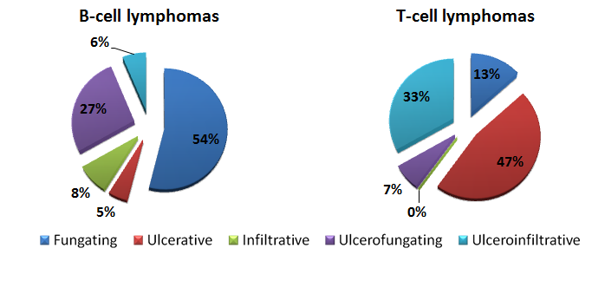
Figure 1 Differences in endoscopic pattern between B-cell and T-cell lymphomas of the gastro-intestinal tract. Data extrapolated from Kim et al^{[19]} 2005.

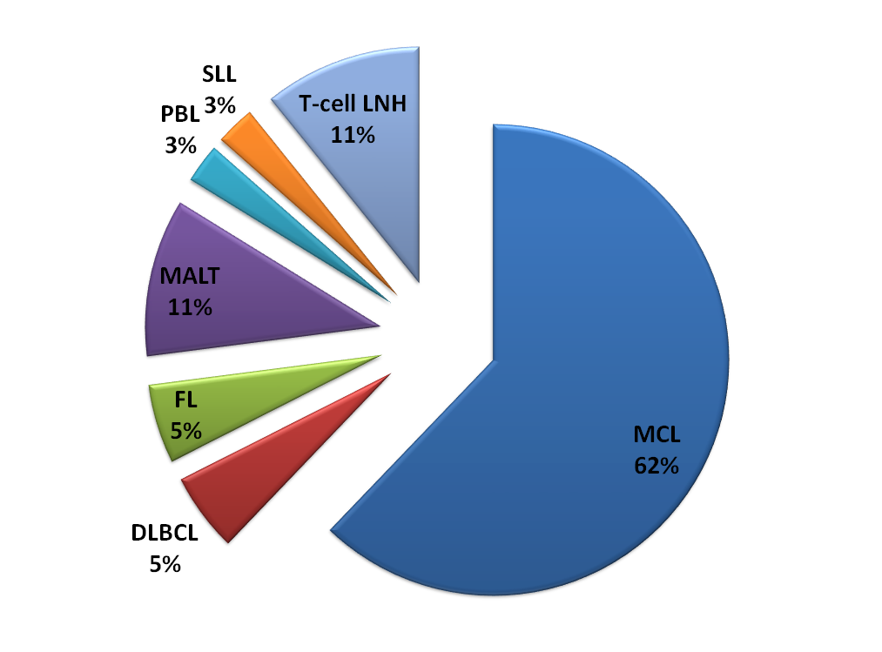
Figure 2 Pie chart describing the distribution of lymphomatous polyposis as a presenting gastro-intestinal feature in gastro-intestinal non-hodgkin lymphomas according to histotype.

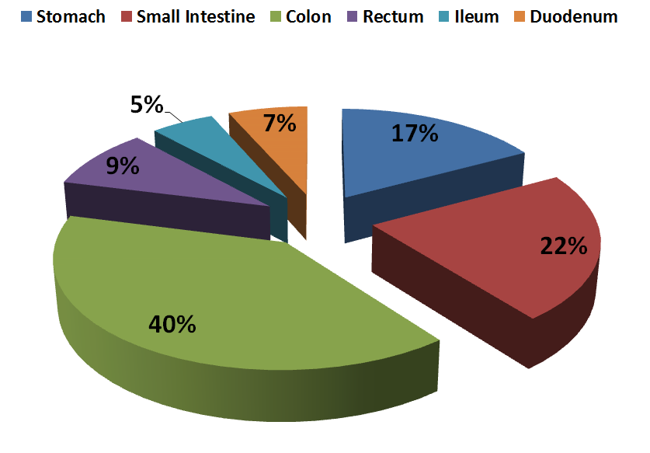
Figure 3 Pie chart describing the most involved gastro-intestinal site in lymphomatous polyposis.

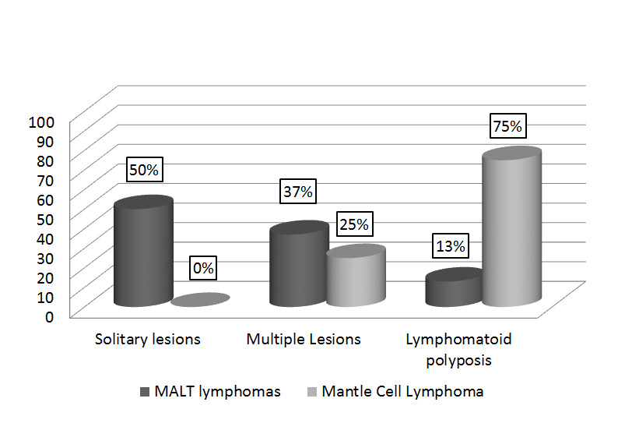
Figure 4 Frequency of lymphomatous polyposis at ileum in mucosa-associated lymphoid tissue lymphoma and mantle cell lymphoma. Adapted from Saito et al^{[143]}, 2005.

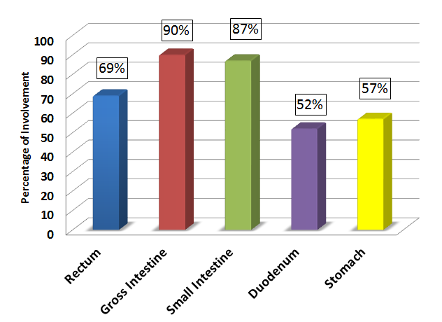
Figure 5 Frequency of the sites involved in mantle cell lymphoma. Adapted from Ruskone-Fourmestraux et al^{[101]}, 2010.

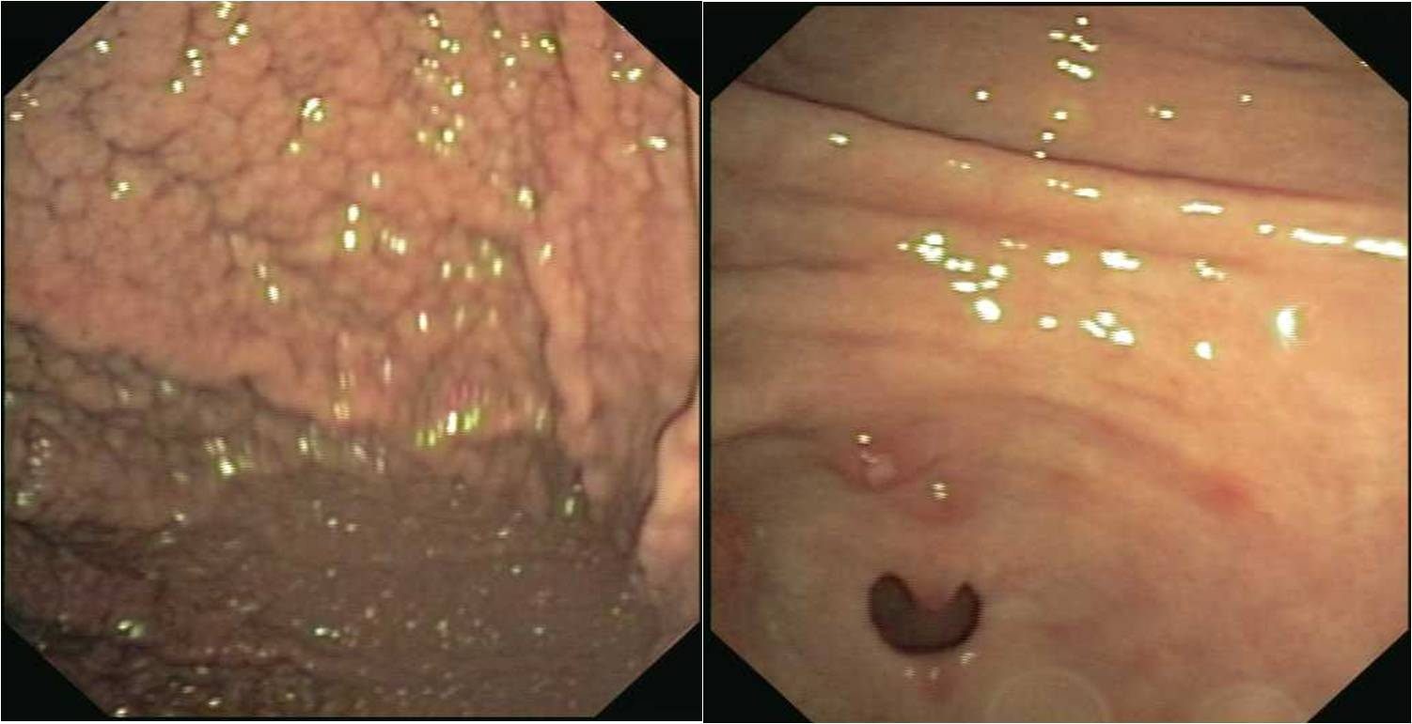
Figure 6 Endoscopy Stomach: granular pattern of the fundus and body of the stomach (left side of the figure) and polyps in the Antrum (right side of the figure).

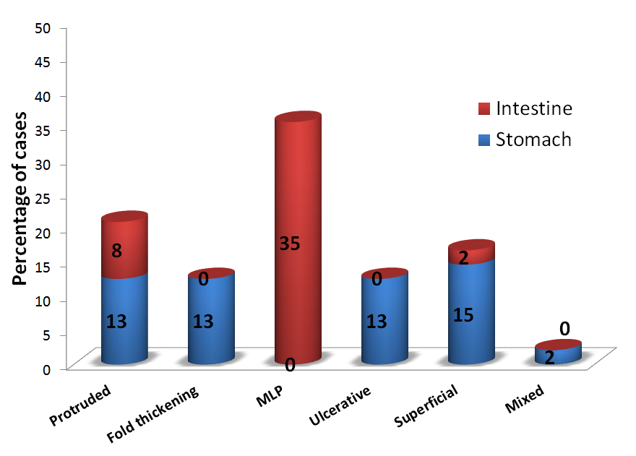
Figure 7 Endoscopic lesions in mantle cell lymphomas according to the gastric and intestinal localization. Adapted from Iwamuro et al^{[144]}, 2010.

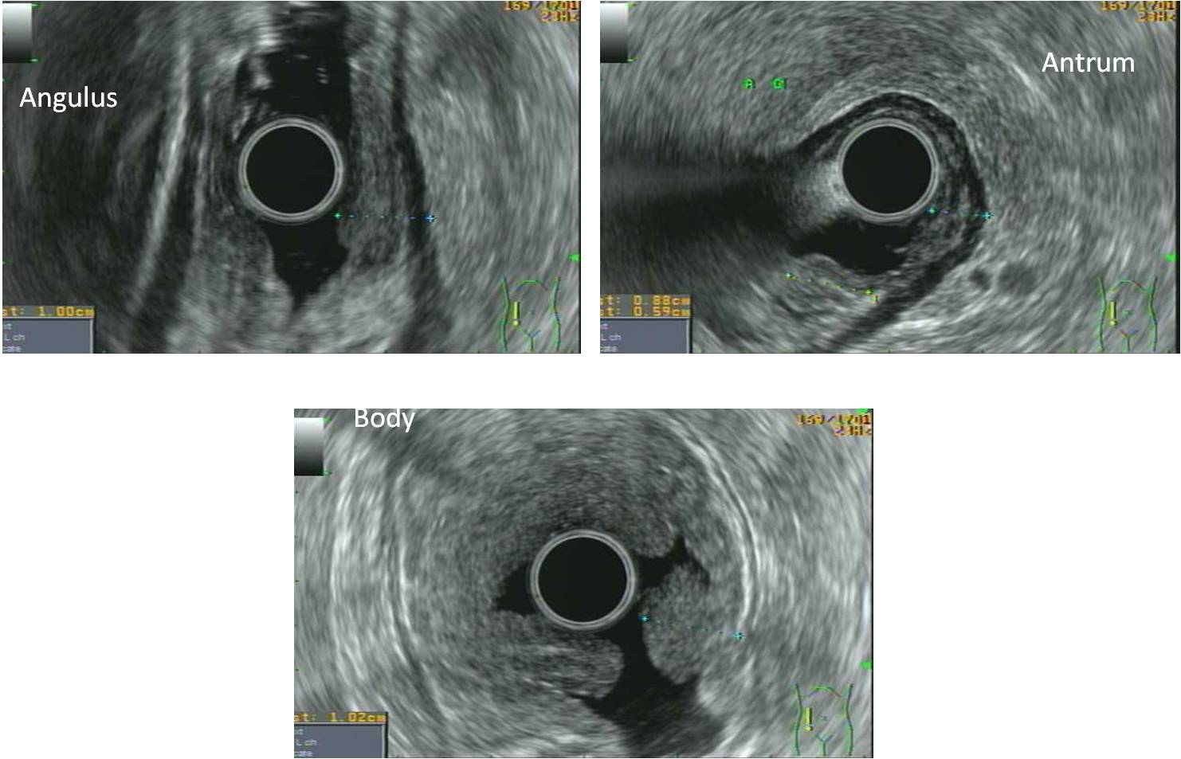
Figure 8 endoscopic ultrasonography (Radial Scanning): marked thickening of the muscolaris propria and increased wall thickness (12 mm) in the Angulus (up-left); Antrum (up-right); Body (bottom).

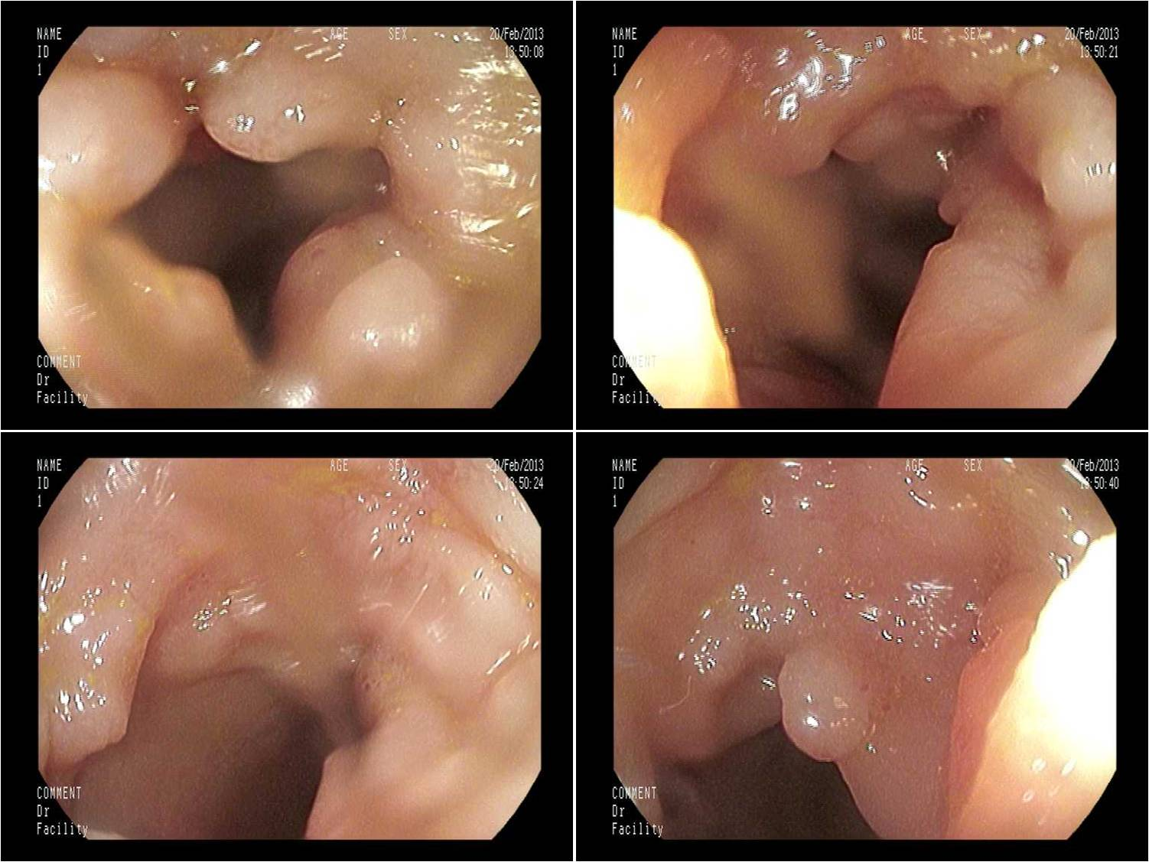
Figure 9 Ileoscopy revealing the presence of hyperemic mucosa with whitish polypoid nodularity. The subsequent diagnosis was a grade 2A Follicular Lymphoma.

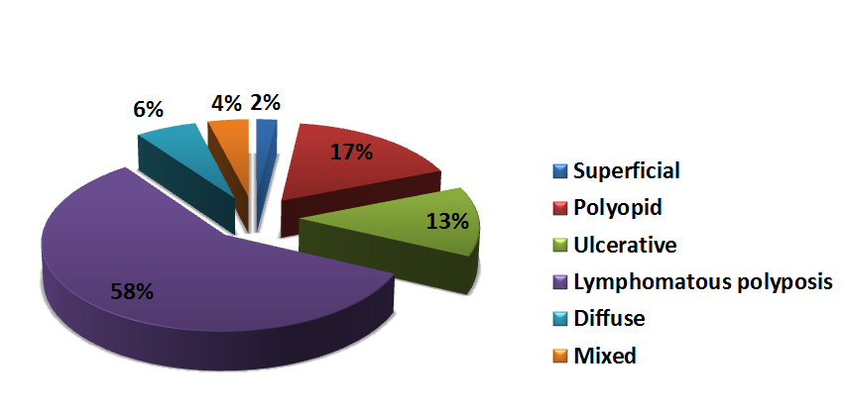
Figure 10 Endoscopic features of follicular gastrointestinal lymphomas. Adapted from Yanai et al^{[163]}, 2011.

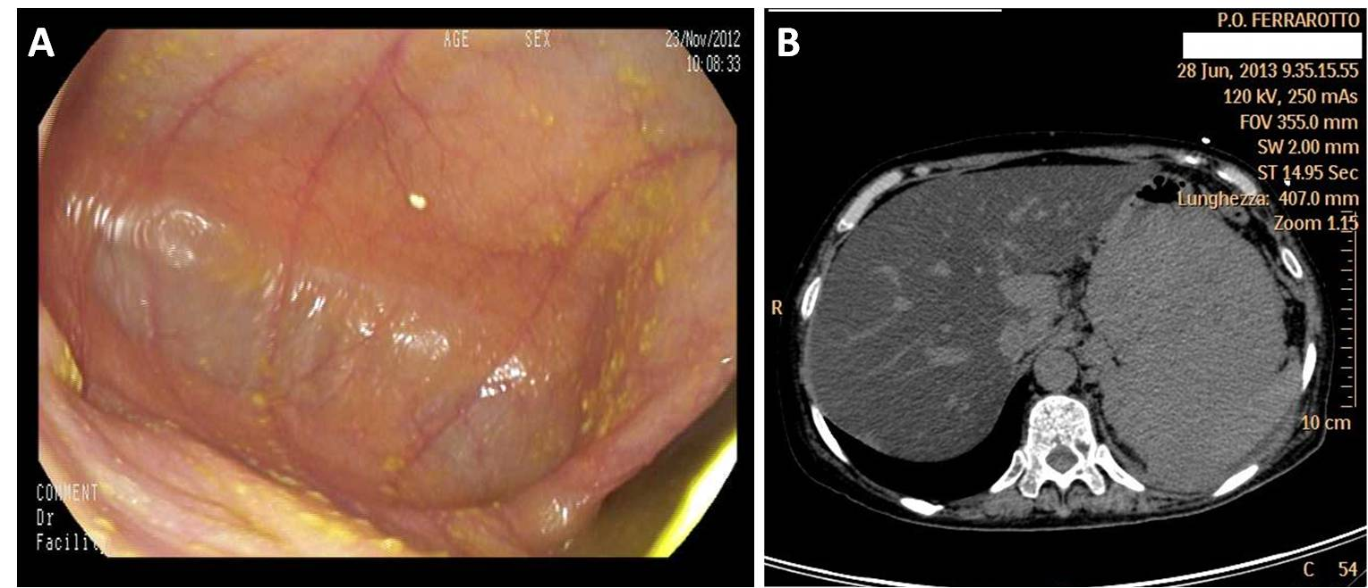
Figure 11 Extra-medullary Plasmacytoma with gastric localization arising after treatment for multiple myeloma. A: Gastroscopy resulted negative for tumor detection; B: CT scan analysis of the upper abdomen showing a bulky mass departing from the stomach.

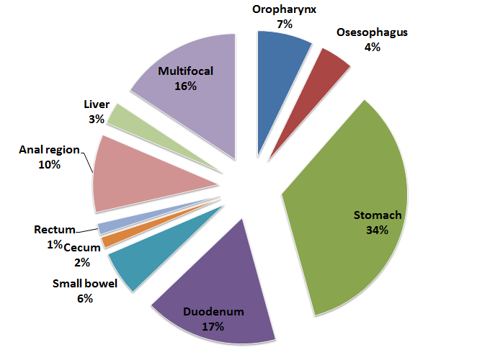
Figure 12 Frequency of the involved gastro-intestinal tract in human immunodeficiency virus-related gastro-intestinal lymphomas. Adapted from Heise^{[206]}, 2010.

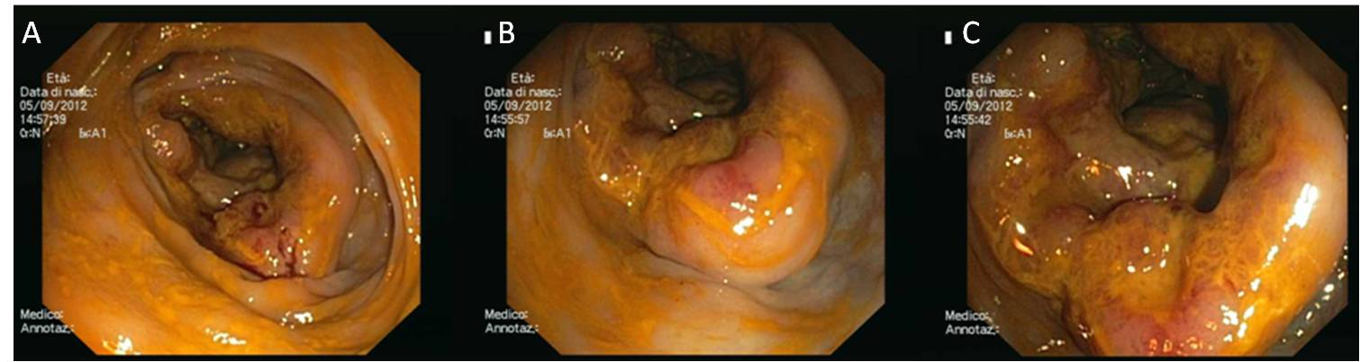
Figure 13 Exophytic erythematous cyrcumpherantial non-ulcerated mass determining a stenosis of the ileo-caecal region. The mass arises from the deep layer and the mucosa presents reddish areas suggestive for lymphomatous infiltration of the caecum.

Table 1 Endoscopic features of rare gastro-intestinal lymphomas according to two classification systems
Author | Wang et al^{[18]} |  | Myung et al^{[17]}
Number of patients | 13 |  | 32
Endoscopic pattern | Mucosal – ulcerative | 30.7% | Fungating | 39%
 | Mucosal – erosive | 15.3% | Ulcerative | 6%
 | Polypoid | 23% | Infiltrative | 14%
 | Massive | 31% | Ulcerofungating | 31%
 |  |  | Ulceroinfiltrative | 11%

Table 2 Listing gastro-intestinal lymphoma with main gastro-intestinal organ involvement, typical presenting characteristics, typical immunophenotype and genotype and prognosis

Lymphoma histotype |  |  | Presenting characteristics | Main GI involvement | Main endoscopic pattern | Typical immunophenotype |  | Typical genotype | prognosis
T and NK lymphomas | EATL |  | Celiac patients with abdominal pain and small intestine obstruction/perforation | Duodenum and jejunum | multiple erosions and ulcers | CD3+, CD4-, CD8+/-, CD7+, CD5-, CD2+, TIA+, GrBPer+, CD30-/+, CD25-/+, CD56-/+, CD16-, CD57-, BCL6-, CD10-, EBV-, EMA-/+ |  | TRB and TRG clonally rearranged  +9q31.3  -16q12.1  +1q32.2-q41  +5q34-q35.2  +8q24(MYC) | Poor
 | PTCL |  | Poor performance status | Stomach and Duodenum | Ulcerative | CD3+, CD4+, CD8-, CD7+, CD5+, CD2+, TIA-, GrBPer-, CD30-/+, CD25-, CD56-, CD16-, CD57-, BCL6-, CD10-, EBV-, EMA- |  | ¹TCR clonally rearranged  +7q/+8q/+17q/+22q/-4q  -5q/-6q/-9p/-10q/-12q/-13q | 54% survival at five year  Poor in case of high IPI score and stage III-IV disease
 | Extranodal NK/T-cell lymphoma |  | Gastrointestinal bleeding and B symptoms | Small Intestine | multiple erosions and ulcers | cyCD3+, CD4-, CD8-/+, CD7-, CD5-, CD2+, TIA+, GrBPer+, CD30-, CD25-, CD56+, CD16-, CD57-, BCL6-, CD10-, EBV+, EMA- |  | TCR in germinal configuration  No specific cytogenetic studies on this specific subtype | Poor especially if perforation occurs
 | Adult T-Cell Leukemia/Lymphoma |  | abdominal pain, diarrhea, general  fatigue, weight loss | No site preferences | Ulcers | CD3+, CD4+, CD8-, CD7-, CD5+, CD2+, TIA-, GrBPer-, CD30-/+, CD25++, CD56-, CD16-, CD57-, BCL6-, CD10-, EBV-, EMA- |  | TCR clonally rearranged  Monoclonal integration of HTLV-1 | Poor²  Good³
 | Indolent lympho-prolipherative diseases of GI tract | T-LPD | dyspepsia and mild diarrhea | Small intestine and colon | Unremarkable/friable or erythematous mucosa | CD3+, CD4-, CD8+, CD7+/-, CD5+/-, CD2+, TIA+/-, GrBPer-/+, CD30-, CD56-, EBV- | TCR- monoclonal |  | Indolent course
 |  | NK-cell enteropathy | Vague symptoms (dyspepsia) | Stomach and small intestine | lesions exhibit superficial ulceration, flat elevations with central depression and are associated with edema and local hemorrhage | cCD3+, CD4-, CD8-, CD7+, CD5-, TIA+, GrBPer+, CD56+, EBV- | TRC polyclonal or oligoclonal |  | Indolent course
Mantle Cell lymphoma |  |  | Vague symptoms (dyspepsia) | Colon | Multiple polyposis, seldom with ulcerations | CD19+, CD20+, CD5+, CD10-, CD43+, sIg+, BCL6-, IRF4/MUM1-, Cyclin D1+ |  | BCR rearranged  t(11;14)(q13;q32) | Negative impact on prognosis
Follicular lymphoma |  |  | Vague symptoms (dyspepsia) | Second part of duodenum | Whitish polyps | CD19+, CD20+, CD5-, CD10+, CD43-, sIg+, BCL6+, IRF4/MUM1-/+, Cyclin D1-, 47+ |  | BCR rearranged  t( 14:18)(q32 :q2 1) | Good
Extramedullary Plasmacytoma |  |  | Alarm symptoms and obstruction | Stomach | Infiltrating mass | Plasmacells expressing CD79a+, CD38+, CD19-, CD138+, CD56+, usually CD20- |  | BCR rearranged  t(11;14)(q32;q13) | Poor
PTLD |  |  | Alarm symptoms | Colon | rubbery erythematous or ulcerated | Similar to DLBCL  and Burkitt’s lymphoma  CD19+, CD20+, CD5-/+, CD10-/+, CD43-/+, sIg+/-, BCL6-/+, IRF4/MUM1-/+, Cyclin D1- |  | Monoclonal BCR | Poor median survival 6 mo
Plasmablastic lymphoma |  |  | Alarm symptoms | Stomach | Large masses and exophitic processes | CD79a+, CD138+, CD38+, IRF4/MUM1, CD45-, CD20, PAX5-, CD56- |  | Clonal IgH chain gene rearranqement | Poor
Hodgkin’s Lymphoma |  |  | obstruction | Colon | Protruding mass | CD30+, CD15+, CD45-, CD20-, CD79a-, PAX5+, Ig-, OCT2-, BOB1-, CD3-, CD2-, CD5-, ALK- |  | clonal immunoglobulin  (IG) gene rearrangeme nts | Prognostic impact not known
¹estrapolated from nodal counterpart but not explored in Primary GI lymphoma; ²ATLL acute and lymphoma types; ³ATLL chronic and smoldering types. TCR: T-cell receptor; BCR: B-cell receptor; EATL: Entheropathy–associated T-cell lymphoma; PTCL: Perypheral T-cell lymphoma; T-LPD: T-cell lymph-prolipferative disease; NK: Natural killer; DLBCL: Diffuse large B-cell lymphoma; PTLD: Post-transplantation lymph-proliferative disease; GI: gastro-intestinal.

Table 3 Prevalence of gastro-intestinal lymphomas among transplant receipts according to transplanted organ
Transplant | Prevalence
Bone Marrow | 0.5%
Liver | 1%-2%
Kidney | 0.7-4%
Heart | 2%-10%
Small bowel | up to 30%
The data extracted from Heise^{[206]}, 2010.

Table 4 Reports of gastro-intestinal plasmablastic lymphoma from 1998
Manuscript | Year | localization | Endoscopic appearance | HIV
Pruneri et al^{[230]} | 1998 | Stomach | Large polypoid mass | -
Colomo et al^{[231]} | 2004 | Anal region | Mass | +
Dong et al^{[232]} | 2005 | GI tract | Not reported | +
 |  | Small Intestine | Not reported | +
Tavora et al^{[228]} | 2006 | Anal region | Not reported | +
 |  | Anal region | Exophytic mass | +
Taddesse-Heath et al^{[233]} | 2010 | Small Intestine/Colon  (2 cases) | Not reported | +
Brahmania et al^{[234]} | 2011 | ano-rectal junction | Hypervascular cauliflower-like mass | -
Mihaljevic et al^{[235]} | 2012 | Stomach | Not reported | -
Hashimoto et al^{[236]} | 2012 | Stomach | Not reported | -
Chapman-Fredricks et al^{[229]} | 2012 | Stomach | Not reported | +
Luria et al^{[237]} | 2014 | Anal region | Mass | +
 |  | Sigma | Mass | -
 |  | Small bowel | Not reported | -
 |  | Ileum | Not reported | -
HIV: Human immunodeficiency virus; GI: gastro-intestinal.

