Name of Journal: World Journal of Clinical Cases
Manuscript NO: 77389
Manuscript Type: CASE REPORT

Infant with reverse-transcription polymerase chain reaction confirmed COVID-19 and normal chest computed tomography: A case report

Ji GH et al. A case of COVID-19 infection in the infant

Guang-Hai Ji, Bo Li, Zu-Chuang Wu, Wei Wang, Hao Xiong

Guang-Hai Ji, Bo Li, Hao Xiong, Department of Radiology, The First Affiliated Hospital of Yangtze University, The First People’s Hospital of Jingzhou, Jingzhou 434000, Hubei Province, China

Zu-Chuang Wu, Department of Pediatric, The First Affiliated Hospital of Yangtze University, Jingzhou 434000, Hubei Province, China

Wei Wang, Department of Clinical Laboratory, The First Affiliated Hospital of Yangtze University, Jingzhou 434000, Hubei Province, China

Author contributions: Ji GH and Li B contributed equally to this work. Ji GH, Li B and Wang W collected the patient’s data and images and wrote the original manuscript; Wu ZC took part in the diagnosis and treatment of the patient; Xiong H was responsible for revising the draft; all authors read and approved the final manuscript.

Corresponding author: Hao Xiong, MS, Professor, Department of Radiology, The First Affiliated Hospital of Yangtze University, No. 55 North Jianghan Road, Shashi District, Jingzhou 434000, Hubei Province, China. xh671201@163.com

Received: April 27, 2022
Revised: June 27, 2022
Accepted: August 21, 2022
Published online: September 26, 2022

Abstract
BACKGROUND
Coronavirus disease-2019 (COVID-19) is a highly pathogenic respiratory disease that mainly affects adults and elderly patients. Yet, over the past three years, there were an increasing number of infected children; however, only a few cases of infants with reverse-transcription polymerase chain reaction (RT-PCR)-confirmed COVID-19 and chest computed tomography (CT) normal have been reported. Herein, we reported a single case of a patient (a 3-mo-old girl) with COVID-19, including her clinical and imaging findings.

CASE SUMMARY
The patient with fever, diarrhea came to fever clinic. Her chest CT was normal. The patient was treated accordingly, the fever disappeared while diarrhea persisted, what’s more, RT-PCR testing of nasopharyngeal swab showed positive results; thus, the patient was admitted to the pediatric department on the 5th day of onset. The child was given systematic treatment, and all her symptoms significantly improved. Consecutive RT-PCR tests were negative after examining the pharyngeal swabs but positive after analyzing anal swabs. She was discharged on the 31st day of hospitalization.

CONCLUSION
This report provides useful references for treating infantile COVID-19 cases with diarrhea or other non-respiratory symptoms and normal chest CT scan. Given the persistent positive RT-PCR results of anal swabs, the possibility of fecal-oral transmission of COVID-19 should be considered.

Key Words: Infant; COVID-19; SARS-CoV-2; Tomography; Case report

©The Author(s) 2022. Published by Baishideng Publishing Group Inc. All rights reserved.

Citation: Ji GH, Li B, Wu ZC, Wang W, Xiong H. Infant with reverse-transcription polymerase chain reaction confirmed COVID-19 and normal chest computed tomography: A case report. World J Clin Cases 2022; 10(27): 9845-9850
URL: https://www.wjgnet.com/2307-8960/full/v10/i27/9845.htm
DOI: https://dx.doi.org/10.12998/wjcc.v10.i27.9845

Core Tip: This study reports an atypical infantile case of coronavirus disease-2019 accompanied by diarrhea or other non-respiratory symptoms. We presented the medical history and the whole process of diagnosis and management of the case and did a literature review. In this paper, we share our experience, which might provide a useful reference for pediatricians and radiologists.

INTRODUCTION
Coronavirus disease-2019 (COVID-19) is an infectious disease caused by the severe acute respiratory syndrome coronavirus 2 (SARS-CoV-2) that originated in China in 2019 and rapidly spread worldwide^{[1]}. Although the disease is mainly affecting adults and the elderly, children of all ages can also get infected and experience serious complications. Moreover, while CT features and clinical characteristics of adult COVID-19 patients have been well investigated^{[2-3]}, data regarding pediatric patients are still lacking. Clinical reports have suggested that children with COVID-19 usually have mild clinical manifestations, most of which are transient fever or mild respiratory symptoms. Some children may present with diarrhea. Also, non-respiratory symptoms with negative or mild lung imaging findings have also been found in some cases ^{[4]}. The coincidence of the outbreak of COVID-19 and the winter-spring flu season was also challenging for establishment of early accurate diagnosis and intervention of pediatric pneumonia. Consequently, a better understanding of clinical and imaging features related to COVID-19 in infants, especially the atypical cases, is urgently needed.
Herein, we reported a single case of a 3-mo old female patient with COVID-19, including her clinical and imaging findings.

CASE PRESENTATION
Chief complaints
A 3 mo and 14 d old female infant visited our department on January 26, 2020 due to a fever that lasted one day and diarrhea that persisted for four days.

History of present illness
Her parents were Wuhan city residents who returned to Jingzhou city on January 18, 2020. Her father had fever and cough on January 25, 2020; the same symptoms were found in the infant one day later.

History of past illness
Patients did not report a history of any underlying disease. The laboratory testing of the infant was: Elevated peripheral white blood cells and lymphocytes, reduced neutrophils, normal C-reactive protein (CRP), elevated lactic dehydrogenase (LDH), alanine aminotransferase (ALT), and aspartate aminotransferase (AST), elevated creatine kinase-MB, and negative influenza virus A and B tests (Table 1). At the same time, the chest CT scan was normal.

Personal and family history
The infant’s father and mother were diagnosed with COVID-19 on January 26 and January 29, 2020, respectively.

Physical examination
Physical examination suggested: Body temperature, 36.5ºC; blood pressure, 85/46 mmHg; heart rate, 119 beats per min; respiratory rate, 34 breaths per min. Her breathing was stable, without a nasal fan and three concave signs. The breath sounded thick, no obvious dry-wet rale was heard, heart rate was rhythmic, and no pathological murmur was detected.

Laboratory examinations
The relevant blood tests in the outpatient department and after admission are shown in Table 1.

Imaging examinations
The patient presented with fever and diarrhea. We performed a routine chest CT scan (Figure 1A). After experiential and systematic treatment, fever and diarrhea disappeared on the 6th hospitalization day. However, the RT-PCR result in the nasopharyngeal swab was still positive. For safety, we routinely performed the second chest CT scan (Figure 1B).

FINAL DIAGNOSIS
Combined with the patient’s medical history and RT-PCR results, the final diagnosis was COVID-19.

TREATMENT
After giving cefixime (25 mg/bid, po) and oseltamivir (0.75 mg/bid, po), the infant's body temperature returned to normal; yet, the diarrhea was not still improved on January 28.
After being hospitalized in the pediatric department, the infant was given systematic treatment, including budesonide (1 mg/bid, inh), interferon alfa-2b (140 units/bid, inh), vitamin C (1g/qd, ivdrp), inosine tablets (0.1g/qd, ivdrp), reduced glutathione (0.6g/qd, ivdrp) and probiotics (1g/qd, po). To exclude the possibility of virus transmission by breastfeeding, the breast milk was analyzed by RT-PCR on the 4th hospitalization day, and the results were negative. After systematic treatment, diarrhea disappeared (on the 6th hospitalization day). On the 10th hospitalization day, liver function testing was still abnormal; thus, the attending doctor decided to prescribe hepatoprotective drugs Gantaile tablets (0.1 g/bid, po) and inosine tablets (0.1 g/bid, po). The main symptom, treatment plan, RT-PCR results, and chest CT results of the infant were presented (Figure 2).
On the 31st hospitalization day, all symptoms of the infant were improved significantly (follow-up performed according to the guidelines for the diagnosis and treatment of COVID-19^{[1])}, and the infant was discharged from the hospital.

OUTCOME AND FOLLOW-UP
In view of the fact that the infant was diagnosed with COVID-19 and discharged from the hospital, it is recommended to isolate at home for 14 d and pay attention to personal hygiene and avoid getting cold. The child was required to re-examine the RT-PCR of SARS-CoV-2 in nasopharyngeal and anal swabs after one week, and the liver function after two weeks.

DISCUSSION
SARS-CoV-2 is primarily transmitted between people via respiratory droplets and contact routes^{[5]}. Lymphopenia occurs in 35%-82.1% of adult patients^{[3,6]}. In this case, lymphocyte count was increased, which was different from the laboratory findings in adult patients. Moreover, ALT, AST, and LDH can be elevated in adult patients, and the proportion of LDH elevation is larger (76%)^{[6]}. The proportion of LDH elevation, in this case, was 45%. Also, according to reports, 86% of adult patients with COVID-19 have elevated CRP, which is a marker of inflammation^{[6]}. Yet, our patient showed normal CRP. The above results show that the clinical manifestations of COVID-19 in infants and young children are different from those seen in adults, which may be related to the fact that children are mostly infected by the second or third-generation virus (the virus virulence is weakened) and due to their lower immune function^{[7]}.
The clinical manifestations of children patients are similar to those of adults and mainly include fever and cough. Diarrhea and runny nose have been observed in a few infected children^{[8]}. A recent study^{[7]} suggested that the relatively low reaction of angiotensin-converting enzyme 2 (ACE2), which induces intracellular response in pediatric patients, might be the reason why children present less severe symptoms compared to adults. In this case, the child had a fever and occasional cough lasting for one day. The chest CT examinations were negative in the outpatient department and after admission. Her parents were confirmed with COVID-19; the father had fever and cough; the mother had no respiratory symptoms such as cough, nasal discharge, or shortness of breath. It is important to note that respiratory symptoms may not be a prerequisite for diagnosing COVID-19^{[9]}.
SARS-CoV-2 may also cause damage to the heart, liver, kidney, and other organs^{[2,3]}. Mechanistically, SARS-CoV-2 invades human host cells expressing the ACE2 receptor. Although this case tested negative after examining pharyngeal swab on RT-PCR four times (February 19, 22, 24, and 26), the results of anal swab RT-PCR analysis on February 22, 24, and 26 were still positive, which suggested that the virus may invade the digestive system through the ACE2 receptor of the gastrointestinal tract and be transmitted via feces. The current clinical diagnosis and treatment plan suggest that the criteria for discharge from isolation should be a normal temperature for more than 3 days, improved respiratory symptoms, and two consecutively pharyngeal swabs of RT-PCR test negative separated by at least 1 d^{[1]}. Yet, given the persistent positive RT-PCR results of anal swabs (as seen in this case), the possibility of fecal-oral transmission of COVID-19 should also be considered.

CONCLUSION
Based on the diagnosis and treatment of this case, people of all ages are susceptible to COVID-19, and the degree of susceptibility may be different. In addition, COVID-19 patients may have few or no clinical symptoms, normal chest CT, and even false-negative PR-PCT results. Thus, early chest CT screening, timely follow-up, corresponding pathogen detection, and epidemiological and clinical features analysis should be included in the screening protocol for children with COVID-19. Early diagnosis, isolation, and treatment of COVID-19 are critical for controlling this pandemic.

ACKNOWLEDGEMENTS
We would like to thank the patient and our colleagues for participating in this study.

REFERENCES
1 National Health Commission of the People's Republic of China. The guidlines for the diagnosis and treatment of 2019-nCoV pneumonia (the 7th edition) [cited 3 Mar 2020]. Available from: http://www.nhc.gov.cn/yzygj/s7653p/202003/46c9294a7dfe4cef80dc7f5912eb1989/files/ce3e6945832a438eaae415350a8ce964.pdf.
2 Wang D, Hu B, Hu C, Zhu F, Liu X, Zhang J, Wang B, Xiang H, Cheng Z, Xiong Y, Zhao Y, Li Y, Wang X, Peng Z. Clinical Characteristics of 138 Hospitalized Patients With 2019 Novel Coronavirus-Infected Pneumonia in Wuhan, China. JAMA 2020; 323: 1061-1069 [PMID: 32031570 DOI: 10.1001/jama.2020.1585]
3 Huang C, Wang Y, Li X, Ren L, Zhao J, Hu Y, Zhang L, Fan G, Xu J, Gu X, Cheng Z, Yu T, Xia J, Wei Y, Wu W, Xie X, Yin W, Li H, Liu M, Xiao Y, Gao H, Guo L, Xie J, Wang G, Jiang R, Gao Z, Jin Q, Wang J, Cao B. Clinical features of patients infected with 2019 novel coronavirus in Wuhan, China. Lancet 2020; 395: 497-506 [PMID: 31986264 DOI: 10.1016/S0140-6736(20)30183-5]
4 Jiehao C, Jin X, Daojiong L, Zhi Y, Lei X, Zhenghai Q, Yuehua Z, Hua Z, Ran J, Pengcheng L, Xiangshi W, Yanling G, Aimei X, He T, Hailing C, Chuning W, Jingjing L, Jianshe W, Mei Z. A Case Series of Children With 2019 Novel Coronavirus Infection: Clinical and Epidemiological Features. Clin Infect Dis 2020; 71: 1547-1551 [PMID: 32112072 DOI: 10.1093/cid/ciaa198]
5 Li Q, Guan X, Wu P, Wang X, Zhou L, Tong Y, Ren R, Leung KSM, Lau EHY, Wong JY, Xing X, Xiang N, Wu Y, Li C, Chen Q, Li D, Liu T, Zhao J, Liu M, Tu W, Chen C, Jin L, Yang R, Wang Q, Zhou S, Wang R, Liu H, Luo Y, Liu Y, Shao G, Li H, Tao Z, Yang Y, Deng Z, Liu B, Ma Z, Zhang Y, Shi G, Lam TTY, Wu JT, Gao GF, Cowling BJ, Yang B, Leung GM, Feng Z. Early Transmission Dynamics in Wuhan, China, of Novel Coronavirus-Infected Pneumonia. N Engl J Med 2020; 382: 1199-1207 [PMID: 31995857 DOI: 10.1056/NEJMoa2001316]
6 Chen N, Zhou M, Dong X, Qu J, Gong F, Han Y, Qiu Y, Wang J, Liu Y, Wei Y, Xia J, Yu T, Zhang X, Zhang L. Epidemiological and clinical characteristics of 99 cases of 2019 novel coronavirus pneumonia in Wuhan, China: a descriptive study. Lancet 2020; 395: 507-513 [PMID: 32007143 DOI: 10.1016/S0140-6736(20)30211-7]
7 Fang F, Luo XP. Facing the pandemic of 2019 novel coronavirus infections: the pediatric perspectives. Zhonghua Er Ke Za Zhi 2020; 58: 81-85 [PMID: 32102140 DOI: 10.3760/cma.j.issn.0578-1310.2020.02.001]
8 Xia W, Shao J, Guo Y, Peng X, Li Z, Hu D. Clinical and CT features in pediatric patients with COVID-19 infection: Different points from adults. Pediatr Pulmonol 2020; 55: 1169-1174 [PMID: 32134205 DOI: 10.1002/ppul.24718]
9 Del Rio C, Malani PN. 2019 Novel Coronavirus-Important Information for Clinicians. JAMA 2020; 323: 1039-1040 [PMID: 32022836 DOI: 10.1001/jama.2020.1490]

Footnotes
Informed consent statement: Informed written consent was obtained from the patient.

Conflict-of-interest statement: All authors report no relevant conflict of interest for this article.

CARE Checklist (2016) statement: The authors have read the CARE Checklist (2016), and the manuscript was prepared and revised according to the CARE Checklist (2016).

Open-Access: This article is an open-access article that was selected by an in-house editor and fully peer-reviewed by external reviewers. It is distributed in accordance with the Creative Commons Attribution NonCommercial (CC BY-NC 4.0) license, which permits others to distribute, remix, adapt, build upon this work non-commercially, and license their derivative works on different terms, provided the original work is properly cited and the use is non-commercial. See: https://creativecommons.org/Licenses/by-nc/4.0/

Provenance and peer review: Unsolicited article; Externally peer reviewed.
Peer-review model: Single blind

Peer-review started: April 27, 2022
First decision: June 8, 2022
Article in press: August 21, 2022

Specialty type: Infectious diseases
Country/Territory of origin: China
Peer-review report’s scientific quality classification
Grade A (Excellent): 0
Grade B (Very good): B
Grade C (Good): C
Grade D (Fair): 0
Grade E (Poor): 0

P-Reviewer: Emran TB, Bangladesh; Hueda-Zavaleta M, Peru S-Editor: Wu YXJ L-Editor: A P-Editor: Wu YXJ

Figure Legends
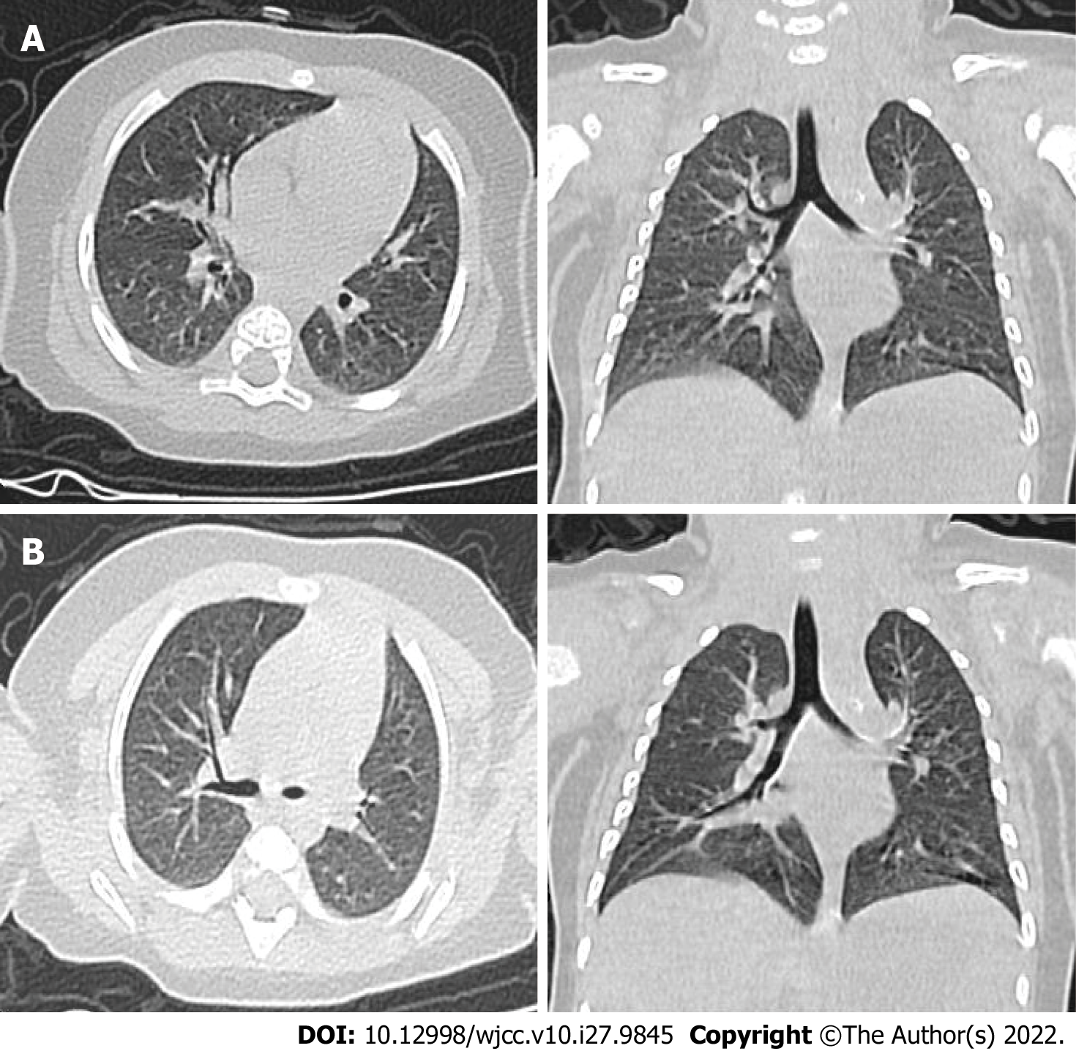
Figure 1 Imaging examinations. A: The chest computed tomography (CT) of the infant while in the outpatient department: The result was normal; B: The chest CT on the 8th hospitalization day: The result was normal.

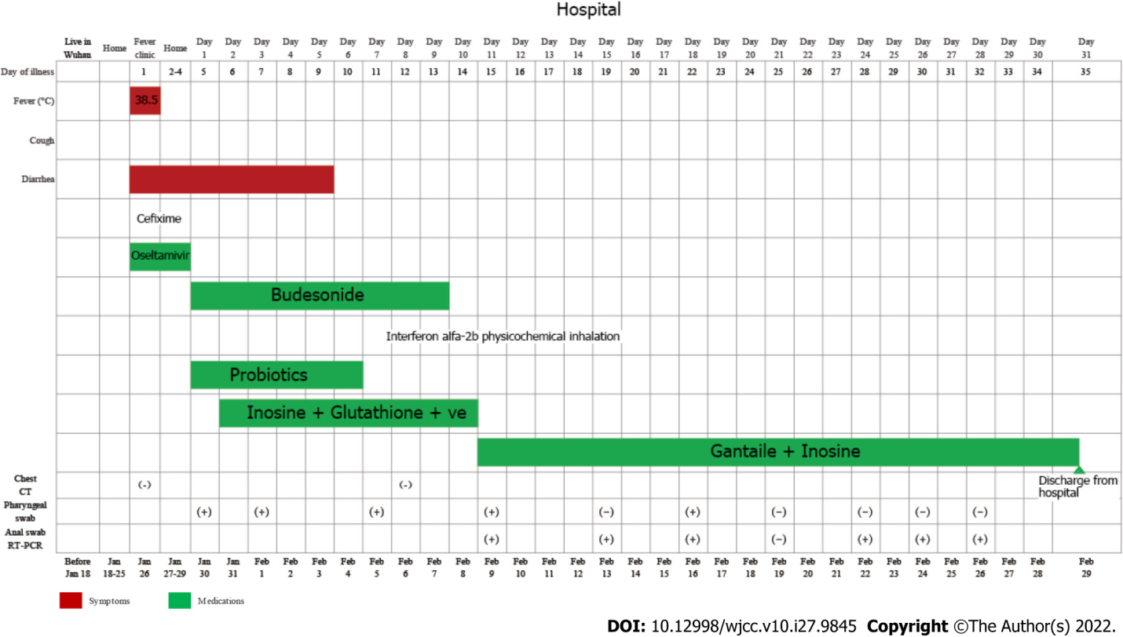
Figure 2 The Gantt chart showing the main symptom, treatment plan, reverse-transcription polymerase chain reaction results, and chest computed tomography results of the infant.

Table 1 Some blood test of the patient
Time | Jan 26, 2021 | Jan 31, 2021 | Feb 6, 2021 | Feb 23, 2021 | Feb 28, 2021
WBC | 10.39 × 10⁹/L (5-12) | 13.21 × 10⁹/L (5-12) | 12.90 × 10⁹/L (5-12) | 15.4 × 10⁹/L (5-12) | 8.5 × 10⁹/L (5-12)
RBC | 4.03×10¹²/L (4.3-5.8) | 4.38 × 10¹²/L (4.3-5.8) | 4.09 × 10¹²/L (4.3-5.8) | 3.99 × 10¹²/L (4.3-5.8) | 3.63 × 10¹²/L (4.3-5.8)
Hemoglobin | 114 g/L (130-175) | 128 g/L (130-175) | 116.1 g/L (130-175) | 109.9 g/L (130-175) | 109.8 g/L (130-175)
Thrombocyte | 196 × 10⁹/L (100-300) | 527 × 10⁹/L (100-300) | 534 × 10⁹/L (100-300) | 418 × 10⁹/L (100-300) | 359 × 10⁹/L (100-300)
Neutrophils | 6.62 × 10⁹/L (1.8-6.3) | 0.93 × 10⁹/L (1.8-6.3) | 3.61 × 10⁹/L (1.8-6.3) | 2.33 × 10⁹/L (1.8-6.3) | 1.86 × 10⁹/L (1.8-6.3)
Lymphocytes | 2.84 × 10⁹/L (1.1-3.2) | 11.39 × 10⁹/L (1.1-3.2) | 64.6 × 10⁹/L (1.1-3.2) | 11.6 × 10⁹/L (1.1-3.2) | 5.97 × 10⁹/L (1.1-3.2)
Influenza A virus | -
Influenza B virus | -
CRP |  | 0.47 mg/L (0-8) | 0.11 mg/L (0-8) | 0.49 mg/L (0-8) | 0.35 mg/L (0-8)
Albumin |  | 44.6 g/L (35-55) | 44.5 g/L (35-55) | 43.9 g/L (35-55) | 43.7 g/L (35-55)
Globulin |  | 17.0 g/L (20-35) | 16.3 g/L (20-35) | 16.3 g/L (20-35) | 13.8 g/L (20-35)
Albumin/Globulin |  | 2.62 (1.2-2.5) | 2.73 (1.2-2.5) | 2.69 (1.2-2.5) | 3.17 (1.2-2.5)
ALT |  | 143 U/L (1-40) | 78 U/L (1-40) | 66 U/L (1-40) | 59 U/L (1-40)
AST |  | 185 U/L (2-42) | 72 U/L (2-42) | 66 U/L (2-42) | 71 U/L (2-42)
ALP |  | 212 U/L (35-128) | 217 U/L (35-128)
LDH |  | 348 U/L (100-240) | 289 U/L (100-240) | 298 U/L (100-240) | 228 U/L (100-240)
TBA |  | 12.99 μmol/L (0-10) | 5.16 μmol/L (0-10) | 7.9 μmol/L (0-10) | 4.8 μmol/L (0-10)
CK-MB |  | 51 U/L (0-20) | 48U/L (0-20) | 63 U/L (0-20) | 34 U/L (0-20)
WBC: White blood cell; RBC: Red blood cell; ALT: Alanine aminotransferase; CRP: C-reactive protein; ALT: Alanine aminotransferase; AST: Aspertate aminotransferase; ALP: Alkaline phosphatase; LDH: Lactic dehydrogenase; TBA: Total bile acid; CK-MB: Creatine kinase-MB; -: Negative.

Published by Baishideng Publishing Group Inc
7041 Koll Center Parkway, Suite 160, Pleasanton, CA 94566, USA
Telephone: +1-925-3991568
E-mail: bpgoffice@wjgnet.com
Help Desk: https://www.f6publishing.com/helpdesk
https://www.wjgnet.com

© 2022 Baishideng Publishing Group Inc. All rights reserved.

