Name of Journal: World Journal of Gastrointestinal Oncology
Manuscript NO: 63592
Manuscript Type: MINIREVIEWS

Targeting of elevated cell surface phosphatidylserine with saposin C-dioleoylphosphatidylserine nanodrug as individual or combination therapy for pancreatic cancer

Davis HW et al. Phosphatidylserine-selective therapies for pancreatic cancer

Harold W Davis, Ahmet Kaynak, Subrahmanya D Vallabhapurapu, Xiaoyang Qi

Harold W Davis, Ahmet Kaynak, Subrahmanya D Vallabhapurapu, Xiaoyang Qi, Division of Hematology/Oncology, Department of Internal Medicine, University of Cincinnati College of Medicine, Brain Tumor Center at UC Neuroscience Institute, Cincinnati, OH 45267, United States

Ahmet Kaynak, Xiaoyang Qi, Department of Biomedical Engineering, College of Engineering and Applied Science, University of Cincinnati, Cincinnati, OH 45221, United States

Author contributions: Davis HW and Qi X conceptualized the review; Kaynak A helped generate the figures; all authors made major contributions to the review’s literature search and contributed to drafting the manuscript; all authors contributed to some or all of our laboratory’s original studies discussed in this review; all authors provided critical review and approved the final manuscript before submission.

Supported by Pancreatic Cancer Action Network Translational Research Grant, No. 20-65-QIXI; Give Hope Foundation, National Institutes of Health, No. R01CA158372 and No. R21NS095047; and CCTST Pilot Collaborative Studies, Bearcats Against Cancer, and Hematology-Oncology Programmatic Support from University of Cincinnati College of Medicine (to Qi X).

Corresponding author: Xiaoyang Qi, PhD, Professor, Division of Hematology/Oncology, Department of Internal Medicine, University of Cincinnati College of Medicine, Brain Tumor Center at UC Neuroscience Institute, 3512 Eden Avenue, Cincinnati, OH 45267, United States. xiaoyang.qi@uc.edu

Received: January 29, 2021
Revised: April 13, 2021
Accepted: May 10, 2021
Published online:

Abstract
Pancreatic cancer is one of the deadliest of cancers with a five-year survival of roughly 8%. Current therapies are: surgery, radiation and chemotherapy. Surgery is curative only if the cancer is caught very early, which is rare, and the latter two modalities are only marginally effective and have significant side effects. We have developed a nanosome comprised of the lysosomal protein, saposin C (SapC) and the acidic phospholipid, dioleoylphosphatidylserine (DOPS). In the acidic tumor microenvironment, this molecule, SapC-DOPS, targets the phosphatidylserine cancer-biomarker which is predominantly elevated on the surface of cancer cells. Importantly, SapC-DOPS can selectively target pancreatic tumors and metastases. Furthermore, SapC-DOPS has exhibited an impressive safety profile with only a few minor side effects in both preclinical experiments and in phase I clinical trials. With the dismal outcomes for pancreatic cancer there is an urgent need for better treatments and SapC-DOPS is a good candidate for addition to the oncologist’s toolbox.

Key Words: Pancreatic cancer; Saposin C; Dioleoylphosphatidylserine; Phosphatidylserine-targeted therapy; Chemotherapy; Radiation

Davis HW, Kaynak A, Vallabhapurapu SD, Qi X. Targeting of elevated cell surface phosphatidylserine with saposin C-dioleoylphosphatidylserine nanodrug as individual or combination therapy for pancreatic cancer. World J Gastrointest Oncol 2021; In press

Core Tip: This review presents the mechanisms and efficacy of saposin C-dioleoylphosphatidylserine (SapC-DOPS), a novel phosphatidylserine (PS) biomarker-targeted nanodrug, alone and in combination with other treatment modalities for the treatment of pancreatic ductal adenocarcinoma (PDAC) tumors. Our results indicate that SapC-DOPS preferentially targets cells with high surface PS which are primarily in the G2/M phase of the cell cycle. Other treatment modalities such as Gemcitabine, Abraxane and radiation target G1 phase cells that have low surface PS. Combination of SapC-DOPS and Gemcitabine/Abraxane or radiation significantly inhibits tumor growth of orthotopic PDAC tumors in vivo and increases survival compared to individual treatments.
INTRODUCTION
On March 6, 2019, Alex Trebek, the beloved host of the quiz show Jeopardy announced that he had Stage IV pancreatic cancer. While discovering that one has cancer is unsettling, a diagnosis of pancreatic cancer is particularly terrifying due to the dismal prognosis. In the United States pancreatic cancer is the 9th or 10th most commonly diagnosed cancer but is the fourth leading cause of cancer-associated death^{[1]}. Pancreatic ductal adenocarcinoma (PDAC) which accounts for 85% of all forms of pancreatic cancer is also the deadliest gastrointestinal cancer^{[2]}. Longevity from the time of diagnosis until death is the worst of any of the major cancers; the median survival for untreated advanced pancreatic cancer is about 3 1/2 mo but with surgery, radiation and chemotherapy this increases to about 8 mo. In contrast to the steady increase in survival observed for most cancer types, advances have been slow for pancreatic cancer and the 5-year survival rate is only about 8%, however patients who are diagnosed at an advanced stage the 5-year survival rate is a discouraging 3%. While over the past 20 years there have been incremental increases in survival due to improving treatments, the incidence of pancreatic cancer is increasing by approximately 0.3%/year leading to the expectation that it will be the second leading cause of cancer deaths by 2030^{[3]}. Pancreatic neuroendocrine tumors or islet cell tumors, are less common and tend to have a better outcome so our emphasis in this review will be on PDAC.
The vast majority of pancreatic tumors are located in the head of the pancreas (65%) which are usually found relatively early due to symptoms of obstructive jaundice and pancreatitis. Pancreatic tumors are also located in the body (15%), in the tail (10%), or present as multifocal lesions (2%). These tumors tend to present late and are associated with a worse prognosis^{[4]}. Unfortunately, PDAC is rarely diagnosed early and the tumor is generally between 2-4 cm when found (but can be even larger if located in the body or tail) and has already infiltrated surrounding structures (i.e., peri-pancreatic adipose tissue, stomach, duodenum, portal vein). The histology of PDAC specimens is critical for assessing a PDAC case, with the three main aspects being the size of the primary tumor, the incidence and number of lymph node metastases and the presence or absence of tumor cells at the resection margins^{[1]}. The tumor is generally a solid, firm white to pale yellow, poorly-defined mass. Regional lymph node metastases are also commonly present at diagnosis^{[5]}. Often as little as 10% of the whole tumor volume is occupied by tumor cells, while the remainder is a network of nonmalignant cells, called the stroma, which acts as a protective barrier. In addition, the tumor usually contains a buildup of matrix proteins that cause blood vessels to collapse, preventing chemotherapeutic drugs from reaching the cancer cells in sufficient amounts.
Pancreatic cancer is staged according to the American Joint Committee on Cancer tumor-node-metastasis classification (Table 1).

Current Therapy
For earlier stage pancreatic cancers, surgery is the best option and is potentially curative. Unfortunately, only approximately 20% of patients are candidates for surgery and Stage III or IV cancers are unresectable. Even then in only about 15% of cases are all cancer cells removed^{[5]}. Recently, neoadjuvant therapy (chemo- or radiation therapy prior to surgery) is used to shrink the tumor. The most common type of surgery is the Whipple procedure, also known as pancreaticoduodenectomy, which involves removal of the head of the pancreas next to the duodenum, the duodenum, a portion of the common bile duct, gallbladder, and occasionally part of the stomach. Afterward, the remaining intestine is reconnected to itself and to the bile duct and pancreas. Although this surgery can improve 5-year survival to approximately 25% it is only available for a small percentage of patients where the tumor has not metastasized^{[6]}. After resection, both gross and microscopic evaluation of the tumor extent is challenging in PDAC, due to dispersed growth, which is more prominent following neoadjuvant therapy, as regression and therefore tumor-induced fibrosis may be patchy. Furthermore, PDAC (even untreated) is characterized by significant inflammation and accumulation of matrix proteins in the normal surrounding stromal cells, making the extent of therapy-induced fibrosis unsatisfactory for determining efficacy^{[1]}.

Chemotherapy
Gemcitabine (GEM, Gemzar) is a first line drug for advanced pancreatic cancer. It can be used alone or combined with other drugs such as albumin-bound paclitaxel (Abraxane), capecitabine (Xeloda), or the targeted drug erlotinib (Tarceva). GEM is hydrophilic and must be transported into cells via molecular transporters for nucleosides. After addition of three phosphates, GEM can mimic deoxycytidine triphosphate so it is incorporated into newly synthesized DNA and creates an irreparable error that leads to inhibition of further DNA synthesis, thereby leading to cell death^{[7]}. However, cancer cells often become resistant to GEM after several months of treatment. Abraxane is a form of the anti-cancer drug, paclitaxel that has fewer side effects. It is an anti-microtubule agent that inhibits mitosis thus preventing cancer cells from growing and dividing, consequently killing them^{[8]}. In a Phase III study of patients with previously untreated metastatic pancreatic cancer there was a statistically significant median overall survival benefit of 8.5 mo vs 6.7 mo in the GEM/Abraxane group compared to the GEM arm^{[9]}.
Capecitabine is metabolized to 5-fluorouracil (5-FU) which inhibits the synthesis of thymidine monophosphate, the active form of thymidine required for de novo synthesis of DNA^{[10]}. Erlotinib specifically targets the epidermal growth factor receptor tyrosine kinase, which is overexpressed and often mutated (to generate an overactive form) in most pancreatic cancers^{[11]}. Interestingly, many PDAC cell lines of the classical subtype seem to be resistant to GEM therapy, but sensitive to erlotinib, while PDAC cell lines of the quasi-mesenchymal subtype seem GEM-sensitive, but erlotinib-resistant^{[12]}. Therapeutic strategies targeting angiogenesis with bevacizumab plus GEM were evaluated in a Phase III study but showed no additional benefit^{[13]}. A combination of chemotherapeutic drugs called FOLFIRINOX consisting of 4 drugs: 5-FU, leucovorin, irinotecan (Camptosar), and oxaliplatin (Eloxatin) improves lifespan compared to GEM alone, but it can also have more severe side effects^{[14,15]}. For otherwise healthy patients, FOLFIRINOX is now considered a category 1 recommendation for advanced pancreatic cancer. In a recent study, adjuvant therapy with a modified FOLFIRINOX protocol led to significantly longer disease-free survival than with GEM among patients with resected PDAC (21.6 mo vs 12.8 mo), but had a higher incidence of adverse events of grade 3 or 4 (75.9% vs 52.9%)^{[16]}. In addition, a retrospective study, Perri et al^{[17]} showed that patients with localized PDAC who received FOLFIRINOX or GEM/Abraxane as their first line of therapy, FOLFIRINOX was associated with a higher rate of RECIST partial response, allowing subsequent pancreatectomy, than GEM/Abraxane but the overall survival rates were similar (21 mo vs 20 mo). However, the patients treated with FOLFIRINOX were significantly younger (61 years vs 71 years). As indicated, none of these treatments are especially effective and Alex Trebek died on November 8, 2020, 19 mo after his announcement.

A Novel Therapy
Phosphatidylserine (PS), an anionic phospholipid, is primarily located on the inner leaflet of the cell membrane^{[18-20]} due to the activity of ATP-dependent phospholipid translocases (flippases)^{[21,22]}. However, in many viable cancer cells flippase activity is depressed and PS accumulates on the outer leaflet of the membrane^{[22]}. In normal cells the increased surface PS would represent apoptosis and the cell would be engulfed by macrophages^{[23,24]} but cancer cells express CD47 which prevents phagocytosis by macrophages^{[25]}. While most cancer cells express higher levels of PS on the extracellular cell membrane than normal cells there is a wide variation of surface PS, even in cell lines from the same type of cancer^{[22]}. We have previously demonstrated this is extant in a panel of pancreatic cancer cell lines^{[26]}.
Exploiting the increased surface PS on cancer cells our lab has developed a therapeutic agent that consists of the membrane fusogenic protein, saposin C (SapC) which is embedded in dioleoylphosphatidylserine (DOPS) vesicles. These nanovesicles selectively target a variety of cancer cells^{[27-30]} including pancreatic tumors, due to high affinity of SapC for cancer cell PS^{[26,31]}. SapC is a stable 80-amino acid lysosomal protein ubiquitous in all cells that has high affinity and exceptional specificity for PS and catabolizes glycosphingolipids in membranes^{[32-34]}.
When SapC is coupled with DOPS durable nanovesicles are formed and selectively fuse with the PS on the surface of cancer cells^{[27,28]}. This targeting correlates with the expression of surface PS on the cells and can be blocked by specific PS-binding proteins, such as lactadherin or β2-glycoprotein^{[26,35]}. The specificity of SapC-DOPS binding to cancer cells is further enhanced by the tumor microenvironment which is acidic due to the Warburg effect^{[36,37]}. In cancer cells, lysosomal acid sphingomyelinase (ASMase) leaks out from lysosomes and migrates to the plasma membrane. When SapC-DOPS nanovesicles fuse with surface PS of cancer cell membranes, SapC stimulates ASMase which elevates ceramide levels and consequently activates caspases that induce apoptotic cell death^{[26,27,38]}. In untransformed cells, asymmetric acidic phospholipid distribution results in low PS exposure on the membrane surface. This coupled with the neutral pH environment leads to weak SapC-DOPS interaction with these cells. Thus, SapC-DOPS selectively kills pancreatic tumor cells, without apparent off-target toxicity to normal cells and tissues^{[26-31]}. Indeed, SapC-DOPS (clinical name: BXQ-350) has shown an exemplary safety profile both preclinically^{[26]} and in Phase I clinical trials^{[39,40]}. In mice there were no noticeable side effects and SapC-DOPS appeared to attenuate cancer-associated cachexia^{[31,41]}. In the clinical trials, no severe adverse events were observed and most subjects showed no drug linked problems at all. Importantly, SapC-DOPS has shown strong cytotoxicity on pancreatic cancer cells regardless of their genetic modifications so it should be effective in all patients.
PS also has potential as a diagnostic biomarker as our data indicate that pancreatic tumors have elevated surface PS compared to relatively normal pancreatic tissue from PDAC patients with no previous therapeutic exposure (Figure 1). This increased PS serves as a molecular target for SapC-DOPS and allows SapC-DOPS to invade the PDAC tumor (Figure 2A) and specifically target tumor blood vessels (Figure 2B) and PDAC cells (Figure 2C) in murine tumor models.
Chu et al^{[26]} have determined that the optimal molar ratio of SapC to DOPS is 1:3-1:10 for maximal cytotoxic effects against human cancer cells and for most studies we use 1:7. This formulation of SapC-DOPS is cytotoxic to a variety of pancreatic cancer cells but harmless to normal human pancreatic ductal epithelial cells (HPDE)^{[26]}. As anticipated, there was a correlation between surface PS and the killing effect of SapC-DOPS. Microscopic inspection of SapC-DOPS-treated cells revealed that tumor cells had morphologies consistent with apoptotic cell death, while HPDE cells appeared unchanged^{[26]}.
To advance these studies, human PANC-1 or MiaPaCa-2 cells were implanted subcutaneously in nude mice then the mice were treated every 2 d to 3 d with various doses of SapC-DOPS. Our results demonstrated a dose-dependent inhibition of pancreatic tumor growth by SapC-DOPS. To investigate a more pathologically important model, mice were implanted with cfPac-1 cells orthotopically into the pancreata. In these mice, SapC-DOPS dramatically prolonged survival; tumor-bearing control mice all died within 170 d but 67% of SapC-DOPS-treated mice survived until they were euthanized at day 260 and none of the surviving mice harbored any detectable tumor. Notably, a metastatic tumor appeared in the lung of one mouse (Figure 2A) and this lesion was targeted by SapC-DOPS^{[26]}.
As mentioned, GEM provides only marginal benefit to patients so we assessed the therapeutic benefits of combining GEM with SapC-DOPS. For these studies^{[31]} we first, treated MiaPaCa-2 cells with SapC-DOPS (48 h) and GEM (24 h) alone as well as a combination of SapC-DOPS with GEM. These data demonstrated that the combination of SapC-DOPS and GEM had a significantly greater anti-tumor effect than either treatment alone. Interestingly, low dose GEM treatment elevates surface PS on cancer cells lines within 48 h without killing the cells, although this may be an early, aborted apoptotic response. We then implanted the pancreatic cancer cell line, p53.2.1.1, subcutaneously into c57Bl/6J mice^{[31]}. We used suboptimal concentrations of both GEM and SapC-DOPS and only treated on days 1 and 4 post implantation to examine the combination effects. Both GEM and SapC-DOPS alone reduced tumor sizes by about 50% but the combination reached 90%. A similar experiment was conducted using subcutaneous mouse 4580P cells in c57Bl/6J mice with GEM/Abraxane and SapC-DOPS with similar results. To ascertain whether the combination could improve survival, we injected mice orthotopically with p53.2.1.1 cells and then administered saline, GEM, SapC-DOPS or the combination. All the control mice died within 29 d. The mice receiving the combination treatment lived substantially longer with one mouse being euthanized tumor-free on day 50. The mice receiving suboptimal concentrations of either GEM or SapC-DOPS alone lived for an intermediate duration. In all of these experiments SapC-DOPS was introduced shortly after the injection of the GEM or GEM/Abraxane. We had previously shown that another chemotherapeutic drug, temozolomide, also had synergistic effects with SapC-DOPS in brain cancer models^{[35]}.
Radiation, another therapy for PDAC, also increases surface PS on viable cancer cells. Pancreatic cell lines with initially low to moderate surface PS exhibited dose-dependent increases in surface PS by 12 h with a maximum increase by 24 h. In addition, subcutaneous tumors generated in nude mice from the human pancreatic cancer cell line, cfPac-1, nearly doubled their surface PS 48 h following focused exposure to 10 Gy of radiation^{[42]}. Incidentally, we have recently demonstrated that we can incorporate the therapeutic radioisotope, ¹³¹I into SapC-DOPS nanovesicles and that this radiation enhances the effects of SapC-DOPS to prolong survival in mice bearing glioblastoma multiforme, a type of brain cancer^{[41]}. In this scenario, the radiation from ¹³¹I, while directly killing the tumor cells may also increase surface PS.
It is tempting to speculate that increasing surface PS with GEM or radiation would augment the cytotoxicity of SapC-DOPS. Thus, we investigated whether sequential treatment order of SapC-DOPS and GEM altered the treatment efficacy. Treating the cells with GEM long enough to increase cell surface PS followed by SapC-DOPS was no more efficacious than SapC-DOPS followed by GEM treatment (Figure 3). These data and results from Davis et al^{[42]} suggest that GEM and radiation do not sensitize cells to SapC-DOPS treatment but rather selectively kill the low surface PS cells, leaving high PS cancer cells intact which can then be targeted by SapC-DOPS.
Even within a specific pancreatic cancer cell line there is heterogeneous surface PS expression. As discussed above, SapC-DOPS targets cancer cells with higher surface PS. Indeed, when we treated a heterogeneous cell population with SapC-DOPS the high surface PS population was killed, leaving behind cells with lower surface PS^{[31]}. Interestingly, the opposite effect was observed when pancreatic cancer cell lines were treated with GEM^{[31]} or radiation^{[42]}, that is GEM and radiation tend to kill low surface PS cells. Additionally, when cells were sorted into low and high surface PS fractions by flow cytometry then treated with GEM, cytotoxicity was more pronounced in the low surface PS population^{[31,42]}.
GEM preferentially kills cells in the G1 phase of the cell cycle by binding to DNA to prevent the cells from entering S phase of the cycle where DNA is duplicated^{[31,43]}. Of note, we have demonstrated that G1 cancer cells have relatively low surface PS and as the cells proceed through the cell cycle surface PS increases even when the expansion of the cell surface area is accounted for^{[31]}. Interestingly, PTDSS1, the gene for the enzyme that converts phosphatidylcholine to PS, is elevated in G2/M compared to G1 phase in cfPac-1 cells but not in a non-cancerous pancreatic epithelial cell line (HPDE). PTDSS2 (the enzyme that catalyzes phosphatidylethanolamine transition to PS) is unchanged in either cell line throughout the cell cycle. On the other hand, when we sorted cells by surface PS, we found that a higher percentage of low surface PS cells were in G1 and a higher percentage of high surface PS cells were in G2/M (Qi and colleagues unpublished data). Consequently, more cells in G1 are killed by GEM than SapC-DOPS while the opposite is true for cells in G2/M^{[31]}. When these experiments were repeated in HPDE surface PS was unaltered throughout the cell cycle.
While GEM and SapC-DOPS kill cells through different mechanisms, by preventing DNA synthesis and activating caspases, respectively, we have shown that cells in tumors are segregated into low PS, high G1 and high PS, high G2/M populations which allows the drugs to work on divergent cells and to collaborate to enhance tumor destruction (Figure 4). Thus, tumor cell surface PS may serve as a significant biomarker to assign the most effective treatment for the patient. Importantly, SapC-DOPS is a nanovesicle, and unlike many chemotherapeutic drugs, can penetrate the fibrosis and stroma of pancreatic tumors (see Figure 2). This makes it available for use as a carrier of therapeutic modalities such as the ¹³¹I mentioned above but also as an imaging and detection agent. In fact, we have demonstrated that fluorescently labeled SapC-DOPS nanovesicles allow selective visualization of primary and metastatic pancreatic tumors in vivo^{[26]}. The nanovesicles can also carry contrast agents (iron or gadolinium) for computed tomography or magnetic resonance imaging of tumors^{[44]}. Thus, SapC-DOPS can be used for both diagnosis and treatment.

CONCLUSION
Phase I clinical trials are designed to evaluate the safety of a candidate drug. In these preliminary trials, SapC-DOPS (BXQ-350) has demonstrated an excellent safety record but impressively, has also shown remarkable efficacy in some patients that have failed all other modalities^{[39,40]}. Our data establish that SapC-DOPS alone or in combination with GEM (GEM/Abraxane) or radiation can reduce tumor growth and enhance survival in mouse models of PDAC. We are hopeful that one day soon SapC-DOPS will be part of the cancer treatment arsenal and alleviate the dread that comes with this diagnosis.

ACKNOWLEDGEMENTS
We thank Chu Z and Blanco V for technical assistance with experiments mentioned within.

REFERENCES
1 Haeberle L, Esposito I. Pathology of pancreatic cancer. Transl Gastroenterol Hepatol 2019; 4: 50 [PMID: 31304427 DOI: 10.21037/tgh.2019.06.02]
2 Siegel RL, Miller KD, Jemal A. Cancer statistics, 2020. CA Cancer J Clin 2020; 70: 7-30 [PMID: 31912902 DOI: 10.3322/caac.21590]
3 Siegel RL, Miller KD, Jemal A. Cancer statistics, 2018. CA Cancer J Clin 2018; 68: 7-30 [PMID: 29313949 DOI: 10.3322/caac.21442]
4 Ghaneh P, Costello E, Neoptolemos JP. Biology and management of pancreatic cancer. Gut 2007; 56: 1134-1152 [PMID: 17625148 DOI: 10.1136/gut.2006.103333]
5 Peixoto RD, Speers C, McGahan CE, Renouf DJ, Schaeffer DF, Kennecke HF. Prognostic factors and sites of metastasis in unresectable locally advanced pancreatic cancer. Cancer Med 2015; 4: 1171-1177 [PMID: 25891650 DOI: 10.1002/cam4.459]
6 Neoptolemos JP, Kleeff J, Michl P, Costello E, Greenhalf W, Palmer DH. Therapeutic developments in pancreatic cancer: current and future perspectives. Nat Rev Gastroenterol Hepatol 2018; 15: 333-348 [PMID: 29717230 DOI: 10.1038/s41575-018-0005-x]
7 Ciccolini J, Serdjebi C, Peters GJ, Giovannetti E. Pharmacokinetics and pharmacogenetics of Gemcitabine as a mainstay in adult and pediatric oncology: an EORTC-PAMM perspective. Cancer Chemother Pharmacol 2016; 78: 1-12 [PMID: 27007129 DOI: 10.1007/s00280-016-3003-0]
8 Gradishar WJ. Albumin-bound paclitaxel: a next-generation taxane. Expert Opin Pharmacother 2006; 7: 1041-1053 [PMID: 16722814 DOI: 10.1517/14656566.7.8.1041]
9 Von Hoff DD, Ervin T, Arena FP, Chiorean EG, Infante J, Moore M, Seay T, Tjulandin SA, Ma WW, Saleh MN, Harris M, Reni M, Dowden S, Laheru D, Bahary N, Ramanathan RK, Tabernero J, Hidalgo M, Goldstein D, Van Cutsem E, Wei X, Iglesias J, Renschler MF. Increased survival in pancreatic cancer with nab-paclitaxel plus gemcitabine. N Engl J Med 2013; 369: 1691-1703 [PMID: 24131140 DOI: 10.1056/NEJMoa1304369]
10 Reigner B, Verweij J, Dirix L, Cassidy J, Twelves C, Allman D, Weidekamm E, Roos B, Banken L, Utoh M, Osterwalder B. Effect of food on the pharmacokinetics of capecitabine and its metabolites following oral administration in cancer patients. Clin Cancer Res 1998; 4: 941-948 [PMID: 9563888]
11 Moore MJ, Goldstein D, Hamm J, Figer A, Hecht JR, Gallinger S, Au HJ, Murawa P, Walde D, Wolff RA, Campos D, Lim R, Ding K, Clark G, Voskoglou-Nomikos T, Ptasynski M, Parulekar W; National Cancer Institute of Canada Clinical Trials Group. Erlotinib plus gemcitabine compared with gemcitabine alone in patients with advanced pancreatic cancer: a phase III trial of the National Cancer Institute of Canada Clinical Trials Group. J Clin Oncol 2007; 25: 1960-1966 [PMID: 17452677 DOI: 10.1200/JCO.2006.07.9525]
12 Collisson EA, Sadanandam A, Olson P, Gibb WJ, Truitt M, Gu S, Cooc J, Weinkle J, Kim GE, Jakkula L, Feiler HS, Ko AH, Olshen AB, Danenberg KL, Tempero MA, Spellman PT, Hanahan D, Gray JW. Subtypes of pancreatic ductal adenocarcinoma and their differing responses to therapy. Nat Med 2011; 17: 500-503 [PMID: 21460848 DOI: 10.1038/nm.2344]
13 Kindler HL, Niedzwiecki D, Hollis D, Sutherland S, Schrag D, Hurwitz H, Innocenti F, Mulcahy MF, O'Reilly E, Wozniak TF, Picus J, Bhargava P, Mayer RJ, Schilsky RL, Goldberg RM. Gemcitabine plus bevacizumab compared with gemcitabine plus placebo in patients with advanced pancreatic cancer: phase III trial of the Cancer and Leukemia Group B (CALGB 80303). J Clin Oncol 2010; 28: 3617-3622 [PMID: 20606091 DOI: 10.1200/JCO.2010.28.1386]
14 Conroy T, Gavoille C, Samalin E, Ychou M, Ducreux M. The role of the FOLFIRINOX regimen for advanced pancreatic cancer. Curr Oncol Rep 2013; 15: 182-189 [PMID: 23341367 DOI: 10.1007/s11912-012-0290-4]
15 Conroy T, Desseigne F, Ychou M, Bouché O, Guimbaud R, Bécouarn Y, Adenis A, Raoul JL, Gourgou-Bourgade S, de la Fouchardière C, Bennouna J, Bachet JB, Khemissa-Akouz F, Péré-Vergé D, Delbaldo C, Assenat E, Chauffert B, Michel P, Montoto-Grillot C, Ducreux M; Groupe Tumeurs Digestives of Unicancer; PRODIGE Intergroup. FOLFIRINOX vs gemcitabine for metastatic pancreatic cancer. N Engl J Med 2011; 364: 1817-1825 [PMID: 21561347 DOI: 10.1056/NEJMoa1011923]
16 Conroy T, Hammel P, Hebbar M, Ben Abdelghani M, Wei AC, Raoul JL, Choné L, Francois E, Artru P, Biagi JJ, Lecomte T, Assenat E, Faroux R, Ychou M, Volet J, Sauvanet A, Breysacher G, Di Fiore F, Cripps C, Kavan P, Texereau P, Bouhier-Leporrier K, Khemissa-Akouz F, Legoux JL, Juzyna B, Gourgou S, O'Callaghan CJ, Jouffroy-Zeller C, Rat P, Malka D, Castan F, Bachet JB; Canadian Cancer Trials Group and the Unicancer-GI–PRODIGE Group. FOLFIRINOX or Gemcitabine as Adjuvant Therapy for Pancreatic Cancer. N Engl J Med 2018; 379: 2395-2406 [PMID: 30575490 DOI: 10.1056/NEJMoa1809775]
17 Perri G, Prakash L, Qiao W, Varadhachary GR, Wolff R, Fogelman D, Overman M, Pant S, Javle M, Koay EJ, Herman J, Kim M, Ikoma N, Tzeng CW, Lee JE, Katz MHG. Response and Survival Associated With First-line FOLFIRINOX vs Gemcitabine and nab-Paclitaxel Chemotherapy for Localized Pancreatic Ductal Adenocarcinoma. JAMA Surg 2020; 155: 832-839 [PMID: 32667641 DOI: 10.1001/jamasurg.2020.2286]
18 Bevers EM, Williamson PL. Getting to the Outer Leaflet: Physiology of Phosphatidylserine Exposure at the Plasma Membrane. Physiol Rev 2016; 96: 605-645 [PMID: 26936867 DOI: 10.1152/physrev.00020.2015]
19 Connor J, Bucana C, Fidler IJ, Schroit AJ. Differentiation-dependent expression of phosphatidylserine in mammalian plasma membranes: quantitative assessment of outer-leaflet lipid by prothrombinase complex formation. Proc Natl Acad Sci U S A 1989; 86: 3184-3188 [PMID: 2717615 DOI: 10.1073/pnas.86.9.3184]
20 Riedl S, Rinner B, Asslaber M, Schaider H, Walzer S, Novak A, Lohner K, Zweytick D. In search of a novel target - phosphatidylserine exposed by non-apoptotic tumor cells and metastases of malignancies with poor treatment efficacy. Biochim Biophys Acta 2011; 1808: 2638-2645 [PMID: 21810406 DOI: 10.1016/j.bbamem.2011.07.026]
21 Soupene E, Kemaladewi DU, Kuypers FA. ATP8A1 activity and phosphatidylserine transbilayer movement. J Receptor Ligand Channel Res 2008; 1: 1-10 [PMID: 20224745 DOI: 10.2147/jrlcr.s3773]
22 Vallabhapurapu SD, Blanco VM, Sulaiman MK, Vallabhapurapu SL, Chu Z, Franco RS, Qi X. Variation in human cancer cell external phosphatidylserine is regulated by flippase activity and intracellular calcium. Oncotarget 2015; 6: 34375-34388 [PMID: 26462157 DOI: 10.18632/oncotarget.6045]
23 Huynh ML, Fadok VA, Henson PM. Phosphatidylserine-dependent ingestion of apoptotic cells promotes TGF-beta1 secretion and the resolution of inflammation. J Clin Invest 2002; 109: 41-50 [PMID: 11781349 DOI: 10.1172/JCI11638]
24 Poon IK, Lucas CD, Rossi AG, Ravichandran KS. Apoptotic cell clearance: basic biology and therapeutic potential. Nat Rev Immunol 2014; 14: 166-180 [PMID: 24481336 DOI: 10.1038/nri3607]
25 Jaiswal S, Jamieson CH, Pang WW, Park CY, Chao MP, Majeti R, Traver D, van Rooijen N, Weissman IL. CD47 is upregulated on circulating hematopoietic stem cells and leukemia cells to avoid phagocytosis. Cell 2009; 138: 271-285 [PMID: 19632178 DOI: 10.1016/j.cell.2009.05.046]
26 Chu Z, Abu-Baker S, Palascak MB, Ahmad SA, Franco RS, Qi X. Targeting and cytotoxicity of SapC-DOPS nanovesicles in pancreatic cancer. PLoS One 2013; 8: e75507 [PMID: 24124494 DOI: 10.1371/journal.pone.0075507]
27 Qi X, Chu Z, Mahller YY, Stringer KF, Witte DP, Cripe TP. Cancer-selective targeting and cytotoxicity by liposomal-coupled lysosomal saposin C protein. Clin Cancer Res 2009; 15: 5840-5851 [PMID: 19737950 DOI: 10.1158/1078-0432.CCR-08-3285]
28 Abu-Baker S, Chu Z, Stevens AM, Li J, Qi X. Cytotoxicity and Selectivity in Skin Cancer by SapC-DOPS Nanovesicles. J Cancer Ther 2012; 3: 321-326 [PMID: 25485166 DOI: 10.4236/jct.2012.34041]
29 Zhao S, Chu Z, Blanco VM, Nie Y, Hou Y, Qi X. SapC-DOPS nanovesicles as targeted therapy for lung cancer. Mol Cancer Ther 2015; 14: 491-498 [PMID: 25670331 DOI: 10.1158/1535-7163.MCT-14-0661]
30 Blanco VM, Curry R, Qi X. SapC-DOPS nanovesicles: a novel targeted agent for the imaging and treatment of glioblastoma. Oncoscience 2015; 2: 102-110 [PMID: 25859553 DOI: 10.18632/oncoscience.122]
31 N'Guessan KF, Davis HW, Chu Z, Vallabhapurapu SD, Lewis CS, Franco RS, Olowokure O, Ahmad SA, Yeh JJ, Bogdanov VY, Qi X. Enhanced Efficacy of Combination of Gemcitabine and Phosphatidylserine-Targeted Nanovesicles against Pancreatic Cancer. Mol Ther 2020; 28: 1876-1886 [PMID: 32516572 DOI: 10.1016/j.ymthe.2020.05.013]
32 Qi X, Leonova T, Grabowski GA. Functional human saposins expressed in Escherichia coli. Evidence for binding and activation properties of saposins C with acid beta-glucosidase. J Biol Chem 1994; 269: 16746-16753 [PMID: 8206997]
33 Wang Y, Grabowski GA, Qi X. Phospholipid vesicle fusion induced by saposin C. Arch Biochem Biophys 2003; 415: 43-53 [PMID: 12801511 DOI: 10.1016/s0003-9861(03)00219-4]
34 Qi X, Chu Z. Fusogenic domain and lysines in saposin C. Arch Biochem Biophys 2004; 424: 210-218 [PMID: 15047193 DOI: 10.1016/j.abb.2004.02.023]
35 Wojton J, Meisen WH, Jacob NK, Thorne AH, Hardcastle J, Denton N, Chu Z, Dmitrieva N, Marsh R, Van Meir EG, Kwon CH, Chakravarti A, Qi X, Kaur B. SapC-DOPS-induced lysosomal cell death synergizes with TMZ in glioblastoma. Oncotarget 2014; 5: 9703-9709 [PMID: 25210852 DOI: 10.18632/oncotarget.2232]
36 Hsu PP, Sabatini DM. Cancer cell metabolism: Warburg and beyond. Cell 2008; 134: 703-707 [PMID: 18775299 DOI: 10.1016/j.cell.2008.08.021]
37 Webb BA, Chimenti M, Jacobson MP, Barber DL. Dysregulated pH: a perfect storm for cancer progression. Nat Rev Cancer 2011; 11: 671-677 [PMID: 21833026 DOI: 10.1038/nrc3110]
38 Sulaiman MK, Chu Z, Blanco VM, Vallabhapurapu SD, Franco RS, Qi X. SapC-DOPS nanovesicles induce Smac- and Bax-dependent apoptosis through mitochondrial activation in neuroblastomas. Mol Cancer 2015; 14: 78 [PMID: 25889084 DOI: 10.1186/s12943-015-0336-y]
39 Rixe O, Morris JC, Puduvalli VK, Villano JL, Wise-Draper TM, Muller C, Johnson AN, Wesolowski R, Qi X. First-in-human, first-in-class phase 1a study of BXQ-350 for solid tumors and gliomas. J Clin Oncol 2018; 36: 2517-17 [DOI: 10.1200/JCO.2018.36.15_suppl.2517]
40 Abdelbaki M, Setty B, DeWire MD, Cripe TP, Curry R. A pediatric and young adult phase I dose escalation study of BXQ-350 for solid and central nervous system tumors. J Clin Oncol 2020; 38: 2541-41 [DOI: 10.1200/JCO.2020.38.15_suppl.2541]
41 Davis HW, Vallabhapurapu SD, Chu Z, Wyder MA, Greis KD, Fannin V, Sun Y, Desai PB, Pak KY, Gray BD, Qi X. Biotherapy of Brain Tumors with Phosphatidylserine-Targeted Radioiodinated SapC-DOPS Nanovesicles. Cells 2020; 9 [PMID: 32854321 DOI: 10.3390/cells9091960]
42 Davis HW, Vallabhapurapu SD, Chu Z, Vallabhapurapu SL, Franco RS, Mierzwa M, Kassing W, Barrett WL, Qi X. Enhanced phosphatidylserine-selective cancer therapy with irradiation and SapC-DOPS nanovesicles. Oncotarget 2019; 10: 856-868 [PMID: 30783515 DOI: 10.18632/oncotarget.26615]
43 Park SH, Sung JH, Kim EJ, Chung N. Berberine induces apoptosis via ROS generation in PANC-1 and MIA-PaCa2 pancreatic cell lines. Braz J Med Biol Res 2015; 48: 111-119 [PMID: 25517919 DOI: 10.1590/1414-431X20144293]
44 Blanco VM, Latif T, Chu Z, Qi X. Imaging and Therapy of Pancreatic Cancer with Phosphatidylserine-Targeted Nanovesicles. Transl Oncol 2015; 8: 196-203 [PMID: 26055177 DOI: 10.1016/j.tranon.2015.03.011]
45 Amin MB, Edge S, Greene F, Byrd DR, Brookland RK, Washington MK, Gershenwald JE, Compton CC, Hess KR, Sullivan DC, Jessup JM, Brierley JD, Gaspar LE, Schilsky RL, Balch CM. AJCC Cancer Staging Manual. 8th ed. Springer International Publishing: American Joint Commission on Cancer, 2017

Footnotes
Conflict-of-interest statement: Qi X is listed as an inventor on the patent for SapC-DOPS technology that is the subject of this review. Consistent with current Cincinnati Children’s Hospital Medical Center policies, the development and commercialization of this technology has been licensed to Bexion Pharmaceuticals, LLC, in which Qi X, holds a minor (< 3%) equity interest.

Open-Access: This article is an open-access article that was selected by an in-house editor and fully peer-reviewed by external reviewers. It is distributed in accordance with the Creative Commons Attribution NonCommercial (CC BY-NC 4.0) license, which permits others to distribute, remix, adapt, build upon this work non-commercially, and license their derivative works on different terms, provided the original work is properly cited and the use is non-commercial. See: http://creativecommons.org/Licenses/by-nc/4.0/

Manuscript source: Invited manuscript

Peer-review started: January 29, 2021
First decision: April 6, 2021
Article in press:

Specialty type: Oncology
Country/Territory of origin: United States
Peer-review report’s scientific quality classification
Grade A (Excellent): 0
Grade B (Very good): B, B, B
Grade C (Good): C
Grade D (Fair): 0
Grade E (Poor): 0

P-Reviewer: Tenreiro N, Wang XB, Zhou J S-Editor: Gao CC L-Editor: P-Editor:
Figure Legends
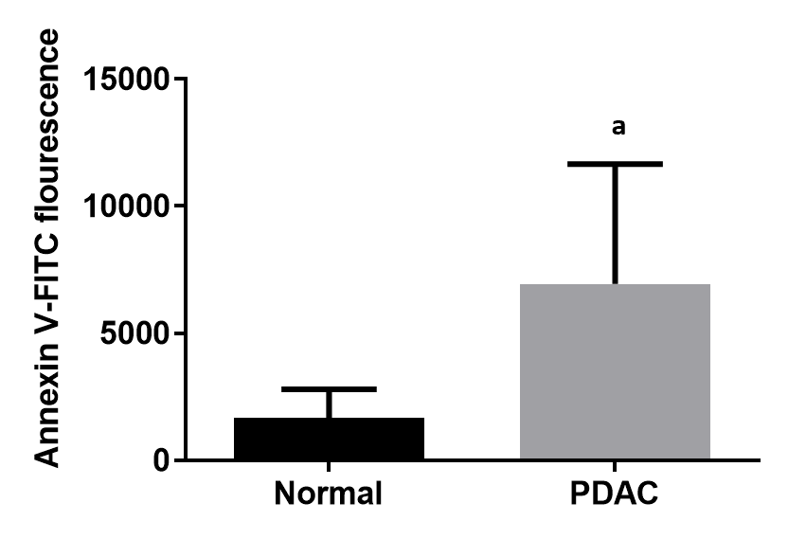
Figure 1 Surface phosphatidylserine on normal pancreata and pancreatic ductal adenocarcinoma tumors. Pancreatic tumors and neighboring more normal tissue excised from treatment naïve pancreatic ductal adenocarcinoma (PDAC) patients were digested with collagenase IV or a Tumor Dissociation kit (Miltenyi). PDAC cells were co-stained with MUC-4-APC, a marker for epithelial cells and Annexin V-FITC, which binds cell surface phosphatidylserine (PS) and surface PS was quantified on MUC-4⁺ cells by flow cytometry (n = 5 for each). Data are presented as the mean ± SE of the mean, and were compared between two groups using t-test. ªP < 0.05 vs normal group. PDAC: Pancreatic ductal adenocarcinoma.
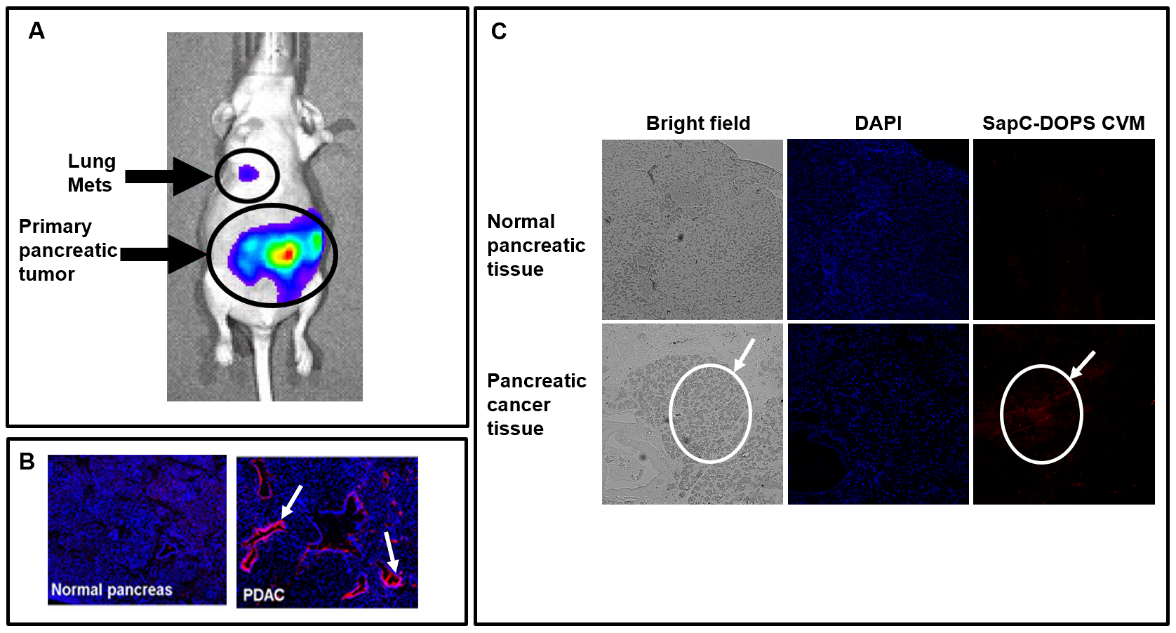
Figure 2 Saposin C-dioleoylphosphatidylserine targets pancreatic tumors. Saposin C-dioleoylphosphatidylserine (SapC-DOPS) was fluorescently labeled with CellVue Maroon (CVM, a far red fluorescent probe) and injected into mice after pancreatic tumors were established from human cancer cells (cfPac-1-Luc3) (see details in reference 24)^{[24]}. A: SapC-DOPS-CVM localized to the primary and lung metastatic tumors detected with intravascular ultrasound live animal imaging; B: Tumors, established from human MiaPaCa-2 cells, and normal pancreata of SapC-DOPS-CVM-injected mice were isolated and prepared for fluorescent microscopy. The slides, after staining with DAPI (blue) to detect nuclei, show accumulation of SapC-DOPS-CVM in the tumors. Note preferential SapC-DOPS labeling of ductal structures in pancreatic ductal adenocarcinoma (PDAC), and minimal binding to normal pancreas (arrows). SapC-DOPS is binding phosphatidylserine (PS) on the cancer cell surfaces as prior treatment with lactadherin, a PS binding protein, eliminates subsequent binding of SapC-DOPS; C: Frozen, unfixed sections from murine PDAC and matched normal pancreas tissues were incubated with SapC-DOPS-CVM nanovesicles for 20 min, counterstained with DAPI and mounted. The ovals localize the PDAC tumor. SapC-DOPS: Saposin C-dioleoylphosphatidylserine; CVM: CellVue Maroon; Mets: Metastatic tumors; PDAC: Pancreatic ductal adenocarcinoma.
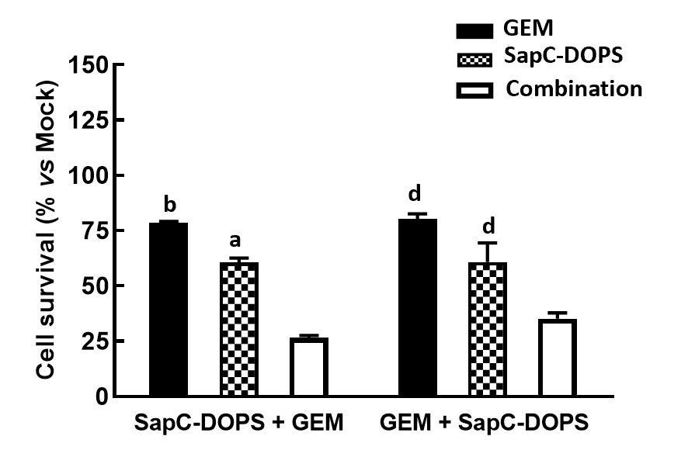
Figure 3 Sequential treatment of pancreatic ductal adenocarcinoma cells with saposin C-dioleoylphosphatidylserine nanodrug and gemcitabine. MiaPaCa-2 cells were treated with saposin C-dioleoylphosphatidylserine (SapC-DOPS) (25 µmol/L) alone, gemcitabine (GEM) (50 nmol/L) alone or in combination. Cells were seeded onto 96 well plates and the next day were exposed to drugs. In the left grouping SapC-DOPS was added for 48 h, the cells were washed twice then incubated with GEM for 24 h. In the right grouping the cells were treated with GEM for 24 h, washed twice and SapC-DOPS was added for 48 h. Untreated cells remained in the media for 72 h. After the 72 h incubation, the MTT cell viability assay was performed. Data are presented as the mean ± SE of the mean, and were compared between two groups using t-test. ªP < 0.05 and ^{b}P < 0.01 vs combination group; ^{d}P < 0.01 vs combination group. GEM: Gemcitabine; SapC-DOPS: Saposin C-dioleoylphosphatidylserine.
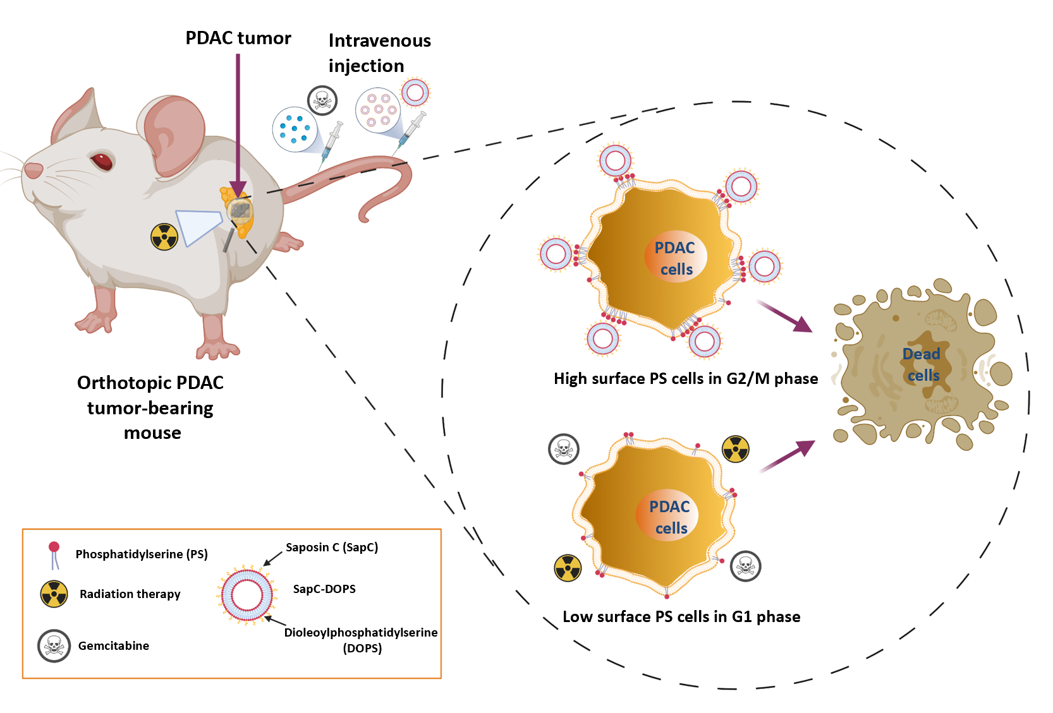
Figure 4 Variable surface phosphatidylserine on pancreatic ductal adenocarcinoma tumor cells are sensitive to phosphatidylserine-selective treatments. Chemotherapy and radiation target primarily low surface phosphatidylserine (PS) cells and may increase PS. Saposin C-dioleoylphosphatidylserine (SapC-DOPS) hones in on high surface PS cells in the acidic tumor microenvironment. Thus, a combination of chemotherapy and/or radiation therapy and SapC-DOPS has the potential to eliminate the preponderance of tumor cells. PDAC: Pancreatic ductal adenocarcinoma.
Table 1 Staging of pancreatic cancer (from the American Joint Committee on Cancer Staging Manual, 8th edition^{[45]})
Stage | Tumor
IA | Limited to pancreas, greatest dimension: ≤ 2 cm
IB | Limited to pancreas, greatest dimension: ≥ 2 cm
IIA | The greatest dimension is > 4 cm but there is no metastasis or lymph node involvement
IIB | The greatest dimension is ≤ 2 cm to > 4 cm but the cancer has spread to 1-3 regional lymph nodes
III | The greatest dimension is > 4 cm and there are 4 or more lymph nodes involved or the tumor has invaded the celiac axis, superior mesenteric artery, and/or common hepatic artery, regardless of tumor size or lymph nodes involved. The tumor is unresectable
IV | Metastasis to distant sites, regardless of size or number of lymph nodes involved. Metastasis of pancreatic cancer occurs mainly in the liver, peritoneum, and lungs

