Name of Journal: World Journal of Clinical Cases
Manuscript NO: 68632
Manuscript Type: META-ANALYSIS

Outcome of the efficacy of Chinese herbal medicine for functional constipation: A systematic review and meta-analysis

Lyu Z et al. Chinese herbal medicine for functional constipation

Zipan Lyu, Yibo Fan, Yang Bai, Tao Liu, Linda LD Zhong, Hui-Feng Liang

Zipan Lyu, Yibo Fan, Teaching and Research Division, School of Chinese Medicine, Hong Kong Baptist University, Hong Kong SAR 99977, China

Yang Bai, Department of Cardiology, Xiyuan Hospital of China Academy of Chinese Medical Sciences, Beijing 100091, China

Tao Liu, Department of Digestive Endoscope Center, Longhua Hospital, Shanghai University of Traditional Chinese Medicine, Shanghai 200032, China

Linda LD Zhong, School of Chinese Medicine, Hong Kong Baptist University, Hong Kong 999077, China

Hui-Feng Liang, The Institute for Science, Technology and Humanities, Shanghai University of Traditional Chinese Medicine, Shanghai 201203, China

Author contributions: Lyu Z and Bai Y contributed toward the concept and data analysis; Lyu Z and Fan Y contributed toward manuscript writing; Zhong LL, Liu T, and Liang HF contributed toward concept and manuscript review; In addition, Lyu Z, Fan Y and Bai Y made equal contributions; Zhong LL and Liang HF should be considered as co corresponding authors.

Supported by the Hong Kong Chinese Medicine Development Fund (19B2/057A). The fund agency has no role in conducting the research.

Corresponding author: Hui-Feng Liang, MD, PhD, Shanghai University of Traditional Chinese Medicine, No. 1200 Cai Lun Road, Shanghai 201203, China. lianghuifeng5418@shutcm.edu.cn

Received: May 31, 2021
Revised: July 14, 2021
Accepted: April 2, 2022
Published online: May 26, 2022

Abstract
BACKGROUND
Functional constipation (FC) is a common and chronic gastrointestinal disease and its treatment remains challenging.

AIM
To evaluate the efficacy and safety of Chinese herbal medicine (CHM) on efficacy rate, global symptoms, bowel movements and the Bristol Stool Scale score in patients with FC by summarizing current available randomized controlled trials (RCTs).

METHODS
RCTs with CHM to treat FC were identified by a systematic search of six databases from inception to October 20, 2020. Two independent reviewers assessed the quality of the included articles and extracted data. Meta-analyses were performed to odds ratio (OR), mean differences (MD) and 95% confidence interval (CI) using random-effects models. Subgroup analyses and sensitivity analyses were used to explore and interpret the sources of heterogeneity. The funnel plot, Begg’s test and Egger’s test were used to detect publication bias.

RESULTS
Ninety-seven studies involving 8693 patients were included in this work. CHM was significantly associated with a higher efficacy rate (OR: 3.62, 95%CI: 3.19-4.11, P < 0.00001) less severe global symptoms (OR: 4.03, 95%CI: 3.49-4.65, P < 0.00001) compared with control treatment, with the low heterogeneity between studies (I² = 0%, P = 0.76). CHM was also associated with more frequent bowel movements (MD 0.83, 95%CI: 0.67-0.98, P < 0.00001), a lower score on the Bristol Stool Scale (OR: 1.63, 95%CI: 1.15-2.32, P < 0.006), and a not significant recurrence rate (OR: 0.47, 95%CI: 0.22-0.99, P = 0.05). No serious adverse effects of CHM were reported.

CONCLUSION
In this meta-analysis, we found that CHM may have potential benefits in increasing the number of bowel movements, improving stool characteristics and alleviating global symptoms in FC patients. However, a firm conclusion could not be reached because of the poor quality of the included trials. Further trials with higher quality are required.

Key Words: Functional constipation; Chinese herbal medicine; Efficacy; Systematic review; Meta-analysis

©The Author(s) 2022. Published by Baishideng Publishing Group Inc. All rights reserved.

Citation: Lyu Z, Fan Y, Bai Y, Liu T, Zhong LL, Liang HF. Outcome of the efficacy of Chinese herbal medicine for functional constipation: A systematic review and meta-analysis. World J Clin Cases 2022; 10(15): 4856-4877
URL: https://www.wjgnet.com/2307-8960/full/v10/i15/4856.htm
DOI: https://dx.doi.org/10.12998/wjcc.v10.i15.4856

Core Tip: In this meta-analysis, we found that Chinese herbal medicine may have potential benefits in increasing the number of bowel movements, improving stool characteristics and alleviating global symptoms in functional constipation patients. However, a firm conclusion could not be reached because of the poor quality of the included trials. Further trials with higher quality are required.

INTRODUCTION
Functional constipation (FC) is a common and chronic gastrointestinal disease. It has a prevalence of 14% in the population in Asia^{[1]} and 15.6% of the population in Hong Kong^{[2]}, representing a huge care burden. It is estimated that about 3.2 million FC patients in the United States visited medical centers in 2012 and the direct cost per patient for chronic constipation ranged from $1912 to $7522 per year^{[3]}. In addition, functional constipation greatly affects the quality of life of patients creating an important mental and physical burden^{[4]}.
The treatment of functional constipation remains challenging. Osmotic laxatives, irritant laxatives and stool softeners are commonly used to treat FC^{[5]}. However, up to 47% of patients were not completely satisfied with such treatment mainly due to concerns about treatment efficacy, safety, adverse reactions and cost^{[6]}. Therefore, patients with FC usually take a self-management approach and try to seek complementary and alternative therapy and Chinese herbal medicine is their usual choice.
Through a randomized controlled trial (RCT), McRorie et al^{[7]} found that Psyllium, an herb, was superior to docusate sodium, a laxative, for the treatment of chronic constipation. Two systematic reviews reported that Chinese herbal medicine (CHM) was effective in treating constipation^{[8-9]}. But they were not clear whether herbs improve bowel movement, increase the frequency of voluntary defecation or alleviate symptoms of constipation. Some people even have concerns about the safety of Chinese herbs. Therefore, the purpose of this review was to evaluate the efficacy and safety of CHM on efficacy rate, global symptoms, bowel movements and the Bristol Stool Scale score in patients with FC by summarizing current available RCTs.

MATERIALS AND METHODS
This systematic review was conducted following the guideline of Preferred reporting items for systematic review and Meta-analysis (PRISMA) statement^{[10]}.

Eligibility criteria
Studies meeting the following criteria will be included: (1) Participants: patients met established diagnostic criteria of FC, including Rome I, II, III, IV criteria, without restrictions for age, sex, ethnicity or setting type; (2) Type of studies: only randomized controlled trials were eligible; (3) Type of intervention: studies compared any CHM with Western medicine (WM) or placebo. For studies using other agents as the third arm, only the two arms using CHM would be included for analysis; and (4) Type of outcome measurements: the efficacy rate (ER); the frequency of bowel movement (BM); the assessments of the global symptom (GS); the score of the Bristol Stool Scale (BSS); the recurrence rate (RR) within follow-up, and reported adverse effects (AEs).

Exclusion criteria
Trials were excluded: (1) Did not meet the criteria above; (2) Involved animal studies or in vitro studies; (3) Case series or reviews and conference abstracts; (4) Valid original data were unable to obtain even when contacting the author; and (5) Similar studies were reported without additional data to analyze and extract.

Search strategy and study selection
MEDLINE, Embase, SinoMed, China National Knowledge Infrastructure (CNKI), Wanfang Database and China Science and Technology Journal Database (VIP) were searched. An electronic search of the databases was performed from 1994, the year of the establishment of Rome criteria, up to June 2020, using the following search terms: (functional constipation) AND (Chinese herbal medicine OR Chinese traditional medicine OR Oriental medicine OR complementary medicine). We also hand-searched conference abstracts. Reference lists of all retrieved articles and reviews were screened as well. We limited the literature search to RCTs on human subjects. No language restrictions were used. Search strategies used for the Medline database were as Supplementary material 1. Two reviewers (Lyu Z and Bai Y) independently read the title and abstract to initially select the studies that meet the eligibility criteria. Further reading of the full text was used to determine the included studies. If the reviewers had different opinions, the third researcher (Zhong LL) made the final decision.

Data extraction
Two reviewers (Lyu Z and Bai Y) independently extracted data on participant characteristics from the selected studies in a standardized data extraction form. We extracted the following information from each included article: first author, year of publication, publication language, number of participants, participant characteristics, duration of intervention and follow-up period, number of dropouts, controlled intervention and outcome data. Authors of trials were contacted for missing data and additional information. Any disparities between the two reviewers were discussed and resolved by consensus.

Definition of outcomes
The ER was considered a primary outcome. The frequency of BM, the assessments of the GS, the score of the BSS, the RR within follow-up and reported AEs were considered to be secondary outcomes.

ER: To access the efficacy of CHM on the number of participants with any self-assessed relief of constipation symptoms.

BM: To determine the efficacy of CHM on the frequency of BM per week, e.g., 4 times/ week.

GS: To assess the efficacy of CHM on the number of participants with any self-assessed relief of global symptoms (including symptoms other than constipation).

BSS: To assess the efficacy of CHM on the number of participants with normal stool evaluated by Bristol Stool Scale ("soft sausage shape, soft lumps, muddy and watery stools" as normal stools).

RR: Recurrence means aggravation of constipation symptoms or reduction of BM to an untreated condition or less within the period of followed-up.

AEs: Including adverse events and clinical laboratory evaluations.

Risk of bias assessment
Two review authors (Lyu Z and Bai Y) assessed potential risks of bias for all included studies using Cochrane’s tool for assessing the risk of bias. The tool assesses bias in six different domains: Sequence generation; allocation concealment; blinding of participants, personnel and outcome assessors; incomplete outcome data; selective outcome reporting; and other sources of bias. Each domain receives a score of high, low or unclear depending on each review author’s judgment. A third review author (Zhong LL) acted as an adjudicator in the event of a disagreement. Where doubt existed as to a potential risk of bias, we contacted the study authors for clarification. Results were tabulated into a "risk of bias graph" and a "risk of bias summary table".

Data synthesis
In this meta-analysis, odds ratio (OR) and 95% confidence interval (CI) was considered as the effect size for dichotomous outcomes; mean differences (MD) with 95%CI were calculated as the effect size for continuous outcomes. Forest plots were produced to visually assess the effect size and corresponding 95%CI using random-effects models. Heterogeneity between studies was assessed via the forest plot, while I² values described the total variation between studies. When I² values > 50%, it indicates high heterogeneity^{[11]}. Subgroup analyses were used to explore and interpret the sources of heterogeneity; to evaluate whether the effects were modified by treatment characteristics and study quality, we specified it based on CHM ingredients, western medicine treatment and high-quality study. We used sensitivity analyses to explore the sources of high heterogeneity. Funnel plots, Begg’s test, and Egger’s test would be adopted to detect publication bias only when at least 10 studies were reporting the primary outcomes^{[12]}. Statistical analysis was performed with RevMan software (version 5.4; The NordicCochrane Centre, The Cochrane Collaboration), and STATA software, version 13.0 (StataCorp, College Station, TX).

RESULTS
The meta-analysis outcomes of each outcome and subgroup are reported in Table 1.

Studies selection
There were 1764 studies via electronic databases and 12 trials by supplementary retrieval of reference lists of relevant literature. After the deletion of duplicate records, 1232 trials were screened, and 1078 trials were excluded by reviewing titles and abstracts. The remaining 154 trials were reviewed by full text. Ultimately, 97 trials involving 8693 FC patients were included in this work. The selection process of research was detailed by the PRISMA flow diagram as shown in Figure 1.

Description of trials identified
Ninety-seven studies were included based on the eligibility criteria in this work. The characteristics of the included studies are summarized in Table 1. As shown in Table 2, five studies^{[13,26,35,40,108]} were published in English, the others in Chinese. Five studies^{[17,50,68,72,77]} included patients using the Rome II criteria, 15 studies[16,25,36,38,42,44,49,58,62,63,67,82,83,90,95] using the Rome IV criteria, whereas the other 70 studies using Rome III criteria. The intervention of the treatment group was reported as CHM, and the ingredients were shown in Supplementary material 2. Besides, 6 types of intervention of the control group included PEG, mosapride, lactulose, phenolphthalein, probiotics and placebo. Duration in the retrieved studies ranged from 1 to 8 wk. Efficacy rate was reported in 97 studies and the global symptom was available in 69 studies. Bowel movement was reported in 15 studies. The recurrence rate within the follow-up period was reported in 5 studies. Bristol Stool Scale was available in 7 studies while adverse effects of CHM were reported in 26 studies. Characteristics of the included trials are listed in Table 2 and quality evaluations of the included trials are shown in Table 2 and Figure 2.

Risk of bias
Among the 97 studies included, 3 trials^{[13,26,108]} were found to be of high methodological quality. Thirteen trials[18,27,43,46,50,57,60,79,87,98,99,103,107] were deemed to have a high risk of bias. All trials mentioned “random” in terms of allocation, but 12 trials[18,43,46,50,57,60,79,87,98,99,103,107] didn’t describe the specific method of randomization. Five trials^{[13,26,53,61,108]} described allocation concealment and used blinding of participants, personnel or outcome assessors. Drop-outs and withdrawals were reported in 5 trials^{[13,19,24,26,108]} which just left out the cases without qualified result data. We considered 8 trials^{[18,50,57,60,79,98,103,107]} to be of selective reporting bias as these trials failed to report all the prespecified outcomes mentioned in their method section. Other potential sources of bias considered in all included studies were unclear. Therefore, study methodologies were incompletely described in majorities. The result of the assessment was showed in Figure 2, and the detail was showed in Supplementary material 3.

Efficacy rate
Ninety-seven studies measured ER (89.9%; 4007/4455) patients in the Chinese herbal medicine treatment group and 72.7% (3079/4238) patients with western medicine were measured. Results from 97 studies showed the treatment for FC was significantly in favor of CHM (OR: 3.62, 95%CI: 3.19-4.11, P < 0.00001) (Table 1 and Figure 3). There was no significant heterogeneity between studies (I² = 0%, P = 0.76).
In the subgroup analysis, CHM had a significant effect compared with PEG (OR: 2.42, 95%CI: 1.91-3.08, P < 0.00001), mosapride (OR: 3.49, 95%CI: 2.67-4.56, P < 0.00001), lactulose (OR: 3.71, 95%CI: 2.86-4.82, P < 0.00001), phenolphthalein (OR: 4.59, 95%CI: 2.71-7.76, P < 0.00001), probiotics (OR: 4.95, 95%CI: 3.21-7.65, P < 0.00001), and specifically compared with placebo (OR: 7.09, 95%CI: 4.83-10.43, P < 0.00001). There was no significant heterogeneity between studies in each subgroup (Table 1 and Figure 3).

Global symptom
Seventy-eight studies measured GS, and the results showed the treatment for FC was significantly in favor of CHM (OR: 4.03, 95%CI: 3.49-4.65, P < 0.00001) (Table 1 and Supplementary material 4). There was no significant heterogeneity between studies (I² = 0%, P = 0.68). In the subgroup analysis, CHM had a significant effect compared with PEG (OR: 2.69, 95%CI: 2.06-3.51, P < 0.00001), mosapride (OR: 3.98, 95%CI: 2.93-5.41, P < 0.00001), lactulose (OR: 3.89, 95%CI: 2.97-5.09, P < 0.00001), probiotics (OR: 6.21, 95%CI: 3.60-10.70, P < 0.00001), and specifically compared with placebo (OR: 8.40, 95%CI: 5.64-12.52, P < 0.00001). There was no significant heterogeneity between studies in each subgroup (Table 1 and Supplementary material 4). However, there was only one study that compared the global symptom between CHM and phenolphthalein (OR: 5.85, 95%CI: 1.22-28.05).

Bowel movement
Fifteen studies measured BM. Results from 15 studies showed the treatment for FC was significantly in favor of CHM (MD 0.83, 95%CI: 0.67-0.98, P < 0.00001) (Table 1 and Figure 4). There was significant heterogeneity between studies (I² = 80%, P < 0.00001).
In the subgroup analysis, CHM had a significant effect compared with PEG (MD 0.83, 95%CI: 0.67-0.98, P < 0.0006), mosapride (MD 0.65, 95%CI: 0.28-1.02, P < 0.00001), and specifically compared with placebo (MD 0.99, 95%CI: 0.87-1.11, P < 0.00001). There was no significant heterogeneity between studies in the placebo subgroup (Table 1 and Figure 4). However, there was only one study that compared CHM with lactulose (MD 0.98, 95%CI: 0.81-1.15, P < 0.00001), and probiotics (MD 0.61, 95%CI: 0.39-0.83, P < 0.00001). No study in the phenolphthalein subgroup.

Bristol stool scale
A total of 7 studies compared CHM with western medicine and reported the Bristol Stool Scale. The results showed the treatment for FC was significantly in favor of CHM (OR: 1.63, 95%CI: 1.15-2.32, P < 0.006) (Table 1 and Supplementary material 5). There was no significant heterogeneity between studies (I² = 0%, P = 0.94).
In the subgroup analysis, CHM had no significant effect compared with PEG (OR: 1.48, 95%CI: 0.96-2.28, P = 0.15) and mosapride (OR: 1.88, 95%CI: 0.79-4.44, P = 0.15). There was no significant heterogeneity between studies in the two subgroups (Table 1 and Supplementary material 5). However, there was only one study that compared CHM with probiotics (OR: 2.07, 95%CI: 0.90-4.74, P = 0.09).

Recurrence rate
Five studies compared CHM with western medicine and reported the RR. The results showed CHM was not superior to western medicine in controlling the recurrence rate of FC (OR: 0.47, 95%CI: 0.22-0.99, P = 0.05) (Table 1 and Figure 5). There was no significant heterogeneity between studies (I² = 9%, P = 0.35).
In the subgroup analysis, CHM had no significant effect compared with placebo (OR: 0.5, 95%CI: 0.08-3.19, P = 0.46). There was no significant heterogeneity between studies in this subgroup (Table 1 and Figure 5). However, there was only one study that compared CHM with PEG (OR: 0.66, 95%CI: 0.20-2.13, P = 0.49), and lactulose (OR: 0.31, 95% CI 0.10-0.91, P = 0.03) (Table 1 and Figure 5).

Adverse events
Ten trials[13,17,19,26,33,38,46,79,81,90] reported digestive symptoms when using CHM, including abdominal pain or bloating, nausea, stomach discomfort, diarrhea and passing of gas. There were also other adverse effects recorded in CHM groups, such as headache^{[17,81]}, transient hypertension^{[35]} and insomnia^{[81]}. While 21 studies[13,15,19,25,26,29,33,35,38-39,46,54,55,68,70,79,81,85,86,94,107] had digestive symptoms in Western medicine group and these mainly occurred when using mosapride and lactulose.

Subgroup analysis
Three studies were evaluated as high quality with a low risk of bias in their methodology. Their compared CHM with western medicine and reported ER. Results showed the treatment for FC was significantly in favor of CHM (OR: 2.89, 95%CI: 1.29-6.46, P < 0.01) (Table 1 and Figure 6). There was no significant heterogeneity between studies (I² = 0%, P = 0.94).
Two CHM ingredients commonly used in the treatment of functional constipation, Cannabis Fructus and Cistanche, were analyzed in a subgroup by measuring ER. In the Cannabis Fructus subgroup, the results showed Cannabis Fructus had no significant effect compared with western medicine (OR: 1.88, 95%CI: 0.97-3.65, P = 0.06). There was significant heterogeneity between studies (I² = 61%, P = 0.08) (Supplementary material 1 and Figure 7). In the Cistanche subgroup, the results showed Cistanche had a significant effect compared with western medicine (OR: 3.49, 95%CI: 2.76-4.41, P < 0.0001). There was significant heterogeneity between studies (I² = 0%, P = 0.71) (Supplementary material 1 and Figure 8).

Publication bias and sensitivity analyses
Visual inspection of funnel plots (Figure 9), Begg’s test (P = 0.31), and Egger’s test (P = 0.26) revealed no evidence of publication bias for the examined primary outcomes. We did sensitivity analyses by excluding seven trials^{[17,19,64,76,87,96,103]} using the decoction; the outcome showed that the results did not change.

DISCUSSION
A total of 97 RCTs involving 8693 patients with FC were recruited in the review. Pooled data showed a tendency for improvement of clinical efficacy in the CHM group, compared with most Western medicine, such as PEG, mosapride, lactulose, phenolphthalein, probiotics and placebo. The results showed that CHM was significantly superior to western medicines in improving efficacy rate, the frequency of bowel movement, global symptom assessment, and Bristol Stool Scale score of FC. However, there was significant heterogeneity between the 7 studies that reported the frequency of bowel movement (I² = 80%, P < 0.00001). Besides, five studies compared CHM with western medicine and reported the recurrence rate showed the treatment for functional constipation was not significantly in favor of CHM.
Our study found that CHM treatment of FC significantly improved physical symptoms, including constipation-related symptoms (abdominal distension, reduced bowel frequency, difficulty defecating) and systemic symptoms (dry mouth, insomnia, and dyspepsia), compared to Western medicine or placebo. Similar findings have been found in related studies^{[110,111]}: They found that herbal medicine can produce synergistic therapeutic effects, such as spasmolytic, tonifying, wind-repelling, anti-inflammatory and local analgesia. We believe that TCM can effectively address the challenge of simultaneously addressing multiple symptoms other than constipation faced by Western medicine in the treatment of FC. However, how to evaluate and quantify the improvement of functional constipation symptoms from the perspective of TCM. Huang et al^{[112,113]} proposed the use of Multidimensional Item Response Theory to solve the problem of standardized results of TCM symptoms.
The normal frequency of defecation is 3 to 21 times per week^{[114,115]}. A recent meta-analysis showed that osmotic and irritant laxatives increased stool frequency by 2.5 times per week in patients with FC^{[116]}. Our study found that CHM had a significant effect compared with PEG (MD 0.83, 95%CI: 0.67-0.98, P < 0.0006). However, six studies were included in this meta-analysis, and significant heterogeneity between studies (I² = 87%, P < 0.00001). The strong conclusion that CHM improves defecation frequency needs to be validated by more high-quality studies. At the same time, we found that many current RCTs recorded stool frequency, but translated into effective results at the time of reporting. This leads to a lack of detailed data on stool frequency. Our study, therefore, suggests that similar future studies should report detailed stool frequency and compare them to baseline, such as Zhong et al’s study^{[108]}.
Despite beneficial findings from meta-analyses, the results of these trials should be interpreted with caution due to the generally low methodological quality of the included studies. Although only RCTs were included, with insufficient information on how the random allocation was generated and/or concealed in most studies, it was uncertain about selection bias. Secondly, considering clinical efficacy was a subjective index and it could introduce performance bias and detection bias without blinding participants, healthcare providers and assessors. Thirdly, missing data due to attrition or exclusions was found in some studies but only a few handled it appropriately. Finally, protocols were not available to confirm free of selective reporting. For all these reasons, further validation of the findings is necessary. Besides, longer follow-up (> 12 wk) is necessary taking the placebo effect into account^{[117]}.
For the safety of CHM, adverse effects were reported, such as abdominal pain or bloating, nausea, stomach discomfort, diarrhea and passing of gas. But there were only 12.4% (12/97) of studies mentioned the safety of interventions or the AEs investigated as one of the main outcome indicators. In addition, many traditional Chinese medicines have been widely used by Chinese traditional medicine practitioners for nearly two millennia. This supports their security. Therefore, more attention should be paid to recording and reporting the harmful effects of these interventions.

Limitation
We searched main English and Chinese databases under well-designed searching strategies and made the comparison between CHM and different WM therapies clearer. There are several limitations to this systematic review. Firstly, missing articles that might be relevant. Although we searched through databases and did not limit the language of the article, we may still miss relevant articles in regional journals. Because the articles published in these regional magazines are not included in the database we searched. Secondly, most of the studies we included were published only in Chinese, which limited readers' review of the original research. This situation may be improved with the worldwide promotion of CHM. Thirdly, the studies we included were all conducted in the Asian region so the extrapolation of these results is limited by geography.

CONCLUSION
In conclusion, in this meta-analysis, we found that CHM may have potential benefits in increasing the number of bowel movements, improving stool characteristics, and alleviating global symptoms in FC patients. However, a firm conclusion could not be reached because of the poor quality of the included trials. Well-designed and high-quality reported RCTs are needed to confirm more definitive conclusions in the future.

ARTICLE HIGHLIGHTS
Research background
Well-designed and high-quality reported randomized controlled trials (RCTs) are needed to confirm more definitive conclusions in the future.

Research motivation
A firm conclusion could not be reached because of the poor quality of the included trials.

Research objectives
Chinese herbal medicine (CHM) may have potential benefits in increasing the number of bowel movements, improving stool characteristics and alleviating global symptoms in functional constipation (FC) patients.

Research methods
To evaluate the efficacy and safety of CHM on efficacy rate, global symptoms, bowel movements, and the Bristol Stool Scale score in patients with FC by summarizing current available RCTs.

Research results
This review aimed to evaluate the efficacy and safety of CHM in patients with FC.

Research conclusions
To evaluate the efficacy and safety of CHM in patients with FC.

Research perspectives
FC is a common and chronic gastrointestinal disease.

REFERENCES
1 Cheng C, Chan AO, Hui WM, Lam SK. Coping strategies, illness perception, anxiety and depression of patients with idiopathic constipation: a population-based study. Aliment Pharmacol Ther 2003; 18: 319-326 [PMID: 12895216 DOI: 10.1046/j.1365-2036.2003.01663.x]
2 Huang R, Ho SY, Lo WS, Lam TH. Physical activity and constipation in Hong Kong adolescents. PLoS One 2014; 9: e90193 [PMID: 24587274 DOI: 10.1371/journal.pone.0090193]
3 Nellesen D, Yee K, Chawla A, Lewis BE, Carson RT. A systematic review of the economic and humanistic burden of illness in irritable bowel syndrome and chronic constipation. J Manag Care Pharm 2013; 19: 755-764 [PMID: 24156644 DOI: 10.18553/jmcp.2013.19.9.755]
4 Belsey J, Greenfield S, Candy D, Geraint M. Systematic review: impact of constipation on quality of life in adults and children. Aliment Pharmacol Ther 2010; 31: 938-949 [PMID: 20180788 DOI: 10.1111/j.1365-2036.2010.04273.x]
5 Basilisco G, Coletta M. Chronic constipation: a critical review. Dig Liver Dis 2013; 45: 886-893 [PMID: 23639342 DOI: 10.1016/j.dld.2013.03.016]
6 Johanson JF, Kralstein J. Chronic constipation: a survey of the patient perspective. Aliment Pharmacol Ther 2007; 25: 599-608 [PMID: 17305761 DOI: 10.1111/j.1365-2036.2006.03238.x]
7 McRorie JW, Daggy BP, Morel JG, Diersing PS, Miner PB, Robinson M. Psyllium is superior to docusate sodium for treatment of chronic constipation. Aliment Pharmacol Ther 1998; 12: 491-497 [PMID: 9663731 DOI: 10.1046/j.1365-2036.1998.00336.x]
8 Lin LW, Fu YT, Dunning T, Zhang AL, Ho TH, Duke M, Lo SK. Efficacy of traditional Chinese medicine for the management of constipation: a systematic review. J Altern Complement Med 2009; 15: 1335-1346 [PMID: 19958146 DOI: 10.1089/acm.2008.0373]
9 Tan N, Gwee KA, Tack J, Zhang M, Li Y, Chen M, Xiao Y. Herbal medicine in the treatment of functional gastrointestinal disorders: A systematic review with meta-analysis. J Gastroenterol Hepatol 2020; 35: 544-556 [PMID: 31674057 DOI: 10.1111/jgh.14905]
10 Liberati A, Altman DG, Tetzlaff J, Mulrow C, Gøtzsche PC, Ioannidis JP, Clarke M, Devereaux PJ, Kleijnen J, Moher D. The PRISMA statement for reporting systematic reviews and meta-analyses of studies that evaluate healthcare interventions: explanation and elaboration. BMJ 2009; 339: b2700 [PMID: 19622552 DOI: 10.1136/bmj.b2700]
11 Higgins JP, Thompson SG. Quantifying heterogeneity in a meta-analysis. Stat Med 2002; 21: 1539-1558 [PMID: 12111919 DOI: 10.1002/sim.1186]
12 Irwig L, Macaskill P, Berry G, Glasziou P. Bias in meta-analysis detected by a simple, graphical test. Graphical test is itself biased. BMJ 1998; 316: 470; author reply 470-470; author reply 471 [PMID: 9492687 DOI: 10.1136/bmj.315.7109.629]
13 Bian ZX, Cheng CW, Zhu LZ. Chinese herbal medicine for functional constipation: a randomised controlled trial. Hong Kong Med J 2013; 19 Suppl 9: 44-46 [PMID: 24473591]
14 Bin DH, Wang AH. Clinical observation of Yiqi Ziyin Decoction for the treatment of senile slow transit constipation. Zhongyiyao Daobao 2011; 17: 31-33 [DOI: 10.13862/j.cnki.cn43-1446/r.2011.02.012]
15 Bu F, Li MY, Gu YF. Effect of Jichuan Decoction combined with Zhizhu Pill on chronic functional constipation in middle-aged and elder lypatients. Xiandai ZhongxiyiJiehe Zazhi 2019; 28: 15-18 [DOI: 10.1142/S0192415X8700031X]
16 Cai XL. Effect of Jichuan decoction on functional constipation in middle-aged and elderly. Shiyong ZhongxiyiJiehe Linchuang Zazhi 2020; 20: 17-18 [DOI: 10.13638/j.issn.1671-4040.2020.11.007]
17 Cao YL. An efficacy observation of Tong Bian Capsule for the treatment of senile functional constipation. Changchun University of Chinese Medicine, 2012. Available from: http://cdmd.cnki.com.cn/Article/CDMD-10199-1012420467.htm
18 Chen H, Fan KH, Yu BT, Zhao T. Clinical controlled observation of treatment of senile chronic functional constipation with polyethylene glycol 4000 and Maren pill. Xibu Yixue Zazhi 2011; 23: 2168-2169 [DOI: 10.3969/j.issn.1672-3511.2011.11.041]
19 Chen M. Stomach medicine on the treatment of functional constipation clinical observation. Hubei University of Chinese Medicine, 2012. Available from: http://cdmd.cnki.com.cn/Article/CDMD-10507-1012488078.htm
20 Chen H, Zhu HP, Li XL, Lin W.G. An efficacy observation of Run Chang Wan for the treatment of functional constipation with the elderly in 60 cases. Zhongyi Yanjiu Zazhi 2014; 27: 13-15 [DOI: 10.3969/j.issn.1001-6910.2014.03.06]
21 Chen P, Liu ZR, Lu JM. Clinical observation of Wenshen Shugan Decoction for the treatment of slow transit constipation in 44 cases. Henan Zhongyi Zazhi 2014; 34: 1351-1352
22 Chen D, Guan XM. Jinkui Shenqi Decoction in the treatment of 55 cases of functional constipation of spleen and kidney Yang deficiency. Sichuan Zhongyiyao Zazhi 2016; 34: 92-94
23 Chen YW, Zhang Q. Clinical study on 60 cases of chronic functional constipation treated with Shenqi Marong Decoction. Linchuang YiyaoWenxian Dianzi Zazhi 2018; 5: 120-122 [DOI: 10.3877/j.issn.2095-8242.2018.47.104]
24 Chen FR. Clinical Observation on the Therapeutic Effect of "Fu-Disease viscera-Viscera treatment" on functional constipation in the elderly with deficiency of Qi and Yin. Fujian University of Traditional Chinese Medicine, 2020. Available from: https://kns.cnki.net/kcms/detail/detail.aspx?FileName=1020633792.nh&DbName=CMFD2020
25 Chen L, Zhang Y. Curative Effect observation of 80 cases of functional constipation with modified Atractylode Decoction. Zhejiang Zhongyi Zazhi 2020; 55: 578-579 [DOI: 10.3969/j.issn.0411-8421.2020.08.017]
26 Cheng CW, Bian ZX, Zhu LX, Wu JC, Sung JJ. Efficacy of a Chinese herbal proprietary medicine (Hemp Seed Pill) for functional constipation. Am J Gastroenterol 2011; 106: 120-129 [PMID: 21045817 DOI: 10.1038/ajg.2010.305]
27 Cheng SP, Zheng QJ, Li YQ. Clinical research on Zhizhu Decoction in the treatment of chronic functional constipation. Zhongyi Xuebao 2012; 27: 1023-1025
28 Chi YH, Jiang MH. Clinical research on functional constipation treated by Mixture Linggu. Liaoning Zhongyiyao Daxue Xuebao 2010; 12: 99-101
29 Deng YX. Clinical observation on the treatment of functional constipation in the elderly by warming Yang and guiding stagnation. Shijie KexueJishu Zhongyiyao Xiandaihua Zazhi 2018; 20: 994-996
30 Dou J, Guo J, Li RW. Clinical observation of the method of Tongyun Wuzang for the treatment of senile functional constipation. Jilin Zhongyiyao Zazhi 2014; 34: 262-264 [DOI: 10.13463/j.cnki.jlzyy.2014.03.016]
31 Fu K. Clinical observation on Zengye Yuanchang decoction in treating syndrome of deficiency of both qi and yin of slow transit constipation. Hunan University of Chinese Medicine, 2012. Available from: https://xueshu.baidu.com/usercenter/paper/show?paperid=163c4b9a8adbada36c2b5a048bd8149c&site=xueshu_se&hitarticle=1
32 Gao CY. The clinical experiment trails on modified Huang QI Jian Zhong Decoction in treating functional constipation with the weak syndrome of the stomach and spleen. Chengdu University of Traditional Chinese Medicine, 2013. Available from: https://xueshu.baidu.com/usercenter/paper/show?paperid=18b01e7746f395c65509de5f070e35aa&site=xueshu_se&hitarticle=1
33 Gao M, Wang W. Clinical observation on Jiawei Sanxiang Decoction in the treatment of Intestinal Qi stagnation and spleen deficiency type of functional constipation. Shijie Zhongyiyao Zazhi 2015; 10: 732-735 [DOI: 10.3969/j.issn.1673-7202.2015.05.025]
34 Gu JY. Clinical observation of Sanren Runchang Formula in the treatment of slow transit functional constipation. Beijing University of Chinese Medicine, 2013. Available from: https://xueshu.baidu.com/usercenter/paper/show?paperid=8e8776587839ede7f3de1fe413195a83&site=xueshu_se&hitarticle=1
35 Jia G, Meng MB, Huang ZW, Qing X, Lei W, Yang XN, Liu SS, Diao JC, Hu SY, Lin BH, Zhang RM. Treatment of functional constipation with the Yun-chang capsule: a double-blind, randomized, placebo-controlled, dose-escalation trial. J Gastroenterol Hepatol 2010; 25: 487-493 [PMID: 20370727 DOI: 10.1111/j.1440-1746.2009.06189.x]
36 Guo HY. Clinical study on Huangyun Tongbian Decoction in functional therapy of Spleen-Lung-Qi Deficiency Constipation. Anhui University of Traditional Chinese Medicine, 2018. Available from: https://xueshu.baidu.com/usercenter/paper/show?paperid=157v0t00dt2502m0sy4m0jb08j372262&site=xueshu_se&hitarticle=1
37 He FH, Liu YZ, Wu Y, Gan YT. Clinical study of Huangqi Decoction in the treatment of senile functional constipation of Qi Deficiency Type. Zhongyaocai Zazhi 2015; 38: 410-412 [DOI: 10.13863/j.issn1001-4454.2015.02.050]
38 He FH, Liu YZ, Wu Y, Gan YT. Clinical effect of Modified Shenqi Dihuang Decoction on chronic functional constipation in elderly with deficiency of Qi and Yin. Zhongguodangdai Yiyao Zazhi 2019; 26: 173-177 [DOI: 10.3969/j.issn.1674-4721.2019.36.050]
39 Hu SY, Zhong CL, Wang YX, Pan SQ. A multi-center clinical trial: Evaluation of Xiao'er Huashi Oral Liquid in treatment of functional constipation children (syndrome of internal heat stagnated from accumulated food). Zhongyi Erke Zazhi 2018; 41: 2155-2159
40 Huang CH, Lin JS, Li TC, Lee SC, Wang HP, Lue HC & Su YC. Comparison of a Chinese Herbal Medicine (CCH1) and Lactulose as First-Line Treatment of Constipation in Long-Term Care: A Randomized, Double-Blind, Double-Dummy, and Placebo-Controlled Trial. Evid Based Complement Alternat Med 2012; 2012: 923190 [DOI: 10.1155/2012/923190]
41 Hui YN. Clinical observation on the treatment of functional constipation in the elderly with the method of benefiting temperature and warming Yang. Guangming Zhongyiyao Zazhi 2018; 33: 678-780
42 Jiang TY, Zhang QY. Clinical study of 36 cases of functional constipation by Strengthening the Spleen and Regulating the Lungs. Jiangsu Zhongyiyao Zazhi 2020; 52: 29-31 [DOI: 10.3969/j.issn.1672-397X.2020.03.011]
43 Jiao CL, Zhang M, Gao YF. Clinical study of Danggui Aloe Capsule in the treatment of senile functional constipation. Xiandai Zhongyiyao Zazhi 2018; 38: 72-75
44 Kong XR, Zhang HX. Self-designed Zhu-Yang Tongfu-tang in the treatment of 49 cases of senile functional constipation. Liaoning Zhongyiyao Zazhi 2020; 47: 105-107 [DOI: 10.13192/j.issn.1000-1719.2020.01.035]
45 Lai YL, Liu Y, Shi HX, Zhang XH. An efficacy observation of Qi Zhu Jiang Ni Decoction for the treatment of senile functional constipation in 60 cases. Huanqiu Zhongyiyao Zazhi 2012; 5: 58-59 [DOI: 10.3969/j.issn.1674-1749.2012.01.019]
46 Li JM. The old doctor of traditional Chinese medicine academic thought summarizing and using modified Buzhong Yiqi Decoction in treating qi deficiency and constipation clinical research. Changchun University of Chinese Medicine, 2012. Available from: https://xueshu.baidu.com/usercenter/paper/show?paperid=56e5e812dfd206edb644ba2181553965&site=xueshu_se
47 Li JJ, Ma Q, Liu BL, Liu MJ. Clinical observation on the treatment of functional constipation with Strengthening Pi and Nourishing Shen in 87 cases. Hebei Zhongyiyao Zazhi 2015; 37: 195-196 [DOI: 10.3969/j.issn.1002-2619.2015. 02.012]
48 Li W, Li QG, Wang S, Wang HB. Efficacy observation of Strengthening Pi and Smooth Bowel method for the treatment of senile functional constipation in 80 cases. Beijing Zhongyiyao Zazhi 2016; 35: 784-786
49 Li Q, Rao WJ, Zeng SL. Clinical observation of Runchang Detoxification Ointment in the treatment of 60 cases of functional constipation. Hunan Zhongyiyao Zazhi 2019; 35: 16-18 [DOI: 10.16808/j.cnki.issn1003-7705.2019.09.006]
50 Lin ME, Liu YJ. Liuwei Anxiao Capsule treats senile functional constipation in 60 cases. Zhejiang ZhongyiyaoDaxue Xuebao 2009; 33: 232-233 [DOI: 10.3969/j.issn.1005-5509.2009.02.048]
51 Lin RJ. Multicenter clinical study of Baizhu Qiwu Granule in the treatment of slow transit constipation of colon. Hunan University of Traditional Chinese Medicine, 2012. Available from: https://xueshu.baidu.com/usercenter/paper/show?paperid=3e20922f37623b2167f3cb27849edb33&site=xueshu_se
52 Liu DB. Research on the treatment of chronic functional constipation of intestinal-qi-stagnation by the soothing liver and descending Qi. Nanjing University of Traditional Chinese Medicine, 2013. Available from: https://xueshu.baidu.com/usercenter/paper/show?paperid=ea2e63429ae52fed1679be3aa7db7f24&site=xueshu_se&hitarticle=1
53 Liu LF, Study of the clinical observation and empirical on treating Qixu and Qizhi type Chronic Functional Constipation with Chaishao Sijun Jiawei Decoction. Guangzhou University of Chinese Medicine, 2017. Available from: https://xueshu.baidu.com/usercenter/paper/show?paperid=f3c3f8a3c928b9925b4818f2189808a8&site=xueshu_se
54 Liu YL, Cao YQ, Guo XT, Zhao XB. The clinical research into functional constipation treated with Qi-Boosting and Yin-Nourishing Decoction. Henan Zhongyi Zazhi 2017; 37: 318-319 [DOI: 10.16367/j.issn.1003-5028.2017.02.0110]
55 Liu ZM, Chen AM, Zhong RH. Clinical observation of Jianpi Qingrun decoction in treating 146 Cases of infantile functional constipation with internal heat. Zhongyi Erke Zazhi 2018; 14: 44-45
56 Lv LY, He XW, Xu H, Wu PS. Clinical observation on 140 cases of functional constipation who were treated by modifying Jichuan Decoction. Sichuan Zhongyiyao Zazhi 2012; 30: 87-88
57 LV N, Zhao YL, Wang M. Clinical study on Erhuang Decoction in the treatment of functional constipation. Anmo Yu Kangfuyixue Zazhi 2018; 9: 51-52
58 Mu Y, Chen Y, Cui H. Clinical Effect observation of Sini Decoction in the treatment of senile Functional constipation with Yang deficiency. Zhongyi LinchuangYanjiu Zazhi 2019; 11: 112-113
59 Qian HH, Shu TS, Zeng L, He WY. Study of Tongbian Granules in the treatment of chronic functional constipation. Nanjing ZhongyiyaoDaxue Xuebao 2014; 30: 587-589
60 Que RY, Fang HQ, Shen YT, Li Y. Study of clinical effect of Qilang decoction on functional constipation of qi and yin deficiency. Tianjin ZhongyiyaoDaxue Xuebao 2018; 35: 182-185
61 Ren AM. Clinical research on the lack of fluid and blood treatment with Runchang Pill disease of functional constipation. Nanjing University of Traditional Chinese Medicine, 2014. Available from: https://xueshu.baidu.com/usercenter/paper/show?paperid=a49bf586e3718aea1d64859b4789f9fd&site=xueshu_se
62 Shao YF, Jiang XM. Self-designed Wenyang Xuanfei Prescription for the treatment of 50 cases of senile functional constipation with Yang deficiency. Fujian Zhongyiyao Zazhi 2019; 50: 79-81 [DOI: 10.3969/j.issn.1000-338X.2019.06.030]
63 Su YS. Clinical Curative Effect observation on Functional constipation with Deficiency of Qi. Guangzhou University of Chinese Medicine, 2019. Available from: https://kns.cnki.net/kcms/detail/detail.aspx?FileName=1020021871.nh&DbName=CMFD2020
64 Sui N, Tian ZG. Observation of the colon delivers the function of treating chronic functional constipation by Zhu Yang Tong Bian Decoction. Liaoning Zhongyiyao Daxue Xuebao 2012; 14: 174-176
65 Sun SN, Wang CJ. Effect observation on patients with senile constipation treated by a decoction of increasing fluid promoting Qi adding or subtracting. Liaoning Zhongyiyao Daxue Xuebao 2011; 13: 165-167
66 Tao YY, Chen FL. Clinical observation of Jichuan Decoction and Buzhong Yiqi decoction in the treatment of kidney deficiency constipation. Jiating Yixue Zazhi 2018; 17: 7 [DOI: 10.3969/j.issn.1671-4954.2018.06.007]
67 Wang TT. Clinical Observation of Wenyang Tongfu Decoction in the treatment of functional constipation with spleen-kidney Yang Deficiency in the elderly. Shanxi University of Traditional Chinese Medicine, 2020. Available from: https://kns.cnki.net/KCMS/detail/detail.aspx?FileName=1020038553.nh&DbName=CMFD2020
68 Wang QC. Er Bai decoction for the treatment of senile functional constipation in 46 cases. Shandong Zhongyiyao Zazhi 2004; 23: 696 [DOI: 10.16295/j.cnki.0257-358x.2004.11.039]
69 Wang HB, Zhang SS, Chen M, Wang ZM. Study on the advantages of regulating qi-flowing and strengthening Pi in treating functional constipation in the elderly. Beijing Zhongyiyao Zazhi 2011; 30: 770-773 [DOI: 10.16025/j.1674-1307.2011.10.009]
70 Wang XY, Qu LC. Lactulose for the treatment of functional constipation in senile adults. Anhui Yiyao Zazhi 2013; 17: 485-486 [DOI: 10.3969/j.issn.1009-6469.2013.03.056]
71 Wang Y, Luo JJ, Qiu JC, Chang K. The clinical curative effect of Tongbian Decoction in the treatment of children functional constipation in 60 cases (Shiji syndrome). Liaoning Zhongyi Zazhi 2014; 41: 507-509 [DOI: 10.13192/j.issn.1000-1719.2014.03.053]
72 Wang BC, Kang P. Clinical study on tongue particles treatment of chronic functional constipation with Yin deficiency and intestinal dryness syndrome. Zhongyiyao Daobao 2015; 30: 1354-1356 [DOI: 10.16368/j.issn.1674-8999.2015.09.468]
73 Wu SL, Zhou JB. Clinical observation of Nourishing Qi and Yin formulation for the treatment of senile functional constipation. Jiangsu Zhongyiyao Zazhi 2008; 53: 54-55 [DOI: 10.3969/j.issn.1672-397X.2008.10.029]
74 Wu H. An efficacy observation of Zengye LunchangDecoction for the treatment of functional constipation in the Elderly (deficiency of Qi and Yin). Changchun University of Chinese Medicine, 2009. Available from: http://cdmd.cnki.com.cn/Article/CDMD-10199-2009208995.htm
75 Wu GL. Clinical effect observation of the Yiqi Runchang Daozhi Decoction treating Qi and Yin Deficiency type constipation (slow transit). Shandong University of Traditional Chinese Medicine, 2013. Available from: https://kns.cnki.net/kcms/detail/detail.aspx?dbcode=CMFD&dbname=CMFD201401&filename=1014116202.nh&uniplatform=NZKPT&v=95TEeoDIai8xJfasACAZf7rhnwAfIQRQ6Gbac2XmUH2fcDqOpqjZyWmtMHLO28WQ
76 Wu JY, Wang QM, Zhang WX, Gao M. Clinical Observation of Modified Buzhong Yiqi Decoction in the Treatment of Functional Constipation. Zhongyiyao Daobao 2013; 41: 114-115 [DOI: 10.19664/j.cnki.1002-2392.2013.05.043]
77 Xin H, Zhang JQ. Efficacy observation of modified ZengYi Chengqi decoction for the treatment of senile functional constipation. Sichuan Zhongyiyao Zazhi 2008; 27: 58-59 [DOI: 10.3969/j.issn.1000-3649.2008.03.035]
78 Xin H, Wang XP. Runchang Tongbian Decoctionfor the treatment of senile functional constipation. Shanghai Zhongyiyao Zazhi 2014; 48(02): 43-44 [DOI: 10.16305/j.1007-1334.2014.02.015]
79 Xu GL, Miao CH, Xie XZ, Xie ZN. Exploration on effect of Sini decoction on 82 functional constipation patients. Shijie Zhongyiyao Zazhi 2013; 8(09): 1025-1027[DOI: 10.3969/j.issn.1673-7202.2013.09.010]
80 Xu L. The clinical study of Modified San Zi Chen Ping decoction treating functional constipation of phlegm dampness stagnation. Shandong University of Traditional Chinese Medicine, 2016. Available from: https://kns.cnki.net/kcms/detail/detail.aspx?dbcode=CMFD&dbname=CMFD201701&filename=1016321605.nh&uniplatform=NZKPT&v=k1KwQUW2VuzO_MoxFcB3Pz5ACODPvUsX4aiN2TV-m566qr4iEciBInzV0zDl9rfv
81 Xu YL, Yin HS, Liu LF,Wu L. Clinical observation on 40 Cases of chronic functional constipation in young and middle-aged women treated with Wenjing Decoction. Zhongguo ZhongxiyiJiehe Xiaohua Zazhi 2018; 26: 794-796 [DOI: 10.3969/j.issn.1671-038X.2018.09.19]
82 Xu PC. Clinical Effect observation of Yiqi Tongbian Prescription on functional constipation with deficiency of Qi. Fujian University of Chinese Medicine 2019. Available from: http://kns.cnki.net/KCMS/detail/detail.aspx?FileName=1019866771.nh&DbName=CMFD2019
83 Yan GL, Li L, Pu YP, Yang XD. Therapeutic Effect of Xuanshen Decoction on chronic functional constipation with deficiency of Qi and Yin. Sichuan Zhongyiyao Zazhi 2020; 38: 129-132
84 Yan XY, Li Z, Yu Q, Lu Y. Cost-effectiveness analysis of three drugs in the treatment of chronic functional constipation in aged patients. Zhongguo XinyaoyuLinchuang Zazhi 2013; 32: 154-157
85 Yan LH. Clinical observation of Tongbian decoction in the treatment of Yin deficiency and intestinal dryness syndrome of slow transit constipation. Hunan University of Traditional Chinese Medicine, 2016. Available from: http://cdm d .cnki.com.cn/Article/CDMD-10541-1016127057.htm
86 Yang TZ. Clinical observation of the method of Zeng Shui Xing Zhou for the treatment of senile functional constipation in 64 cases. Zhongguo Laonianbingxue Zazhi 2008; 18: 1025-1026 [DOI: 10.3969/j.issn.1005-9202.2008.10.045]
87 Yang JM, Liu FD. Efficacy observation of Si Jun Zi Decoction for the treatment of functional constipation in the elderly. Shangxi Zhongyiyao Zazhi 2012; 33: 535-536 [DOI: 10.3969/j.issn.1000-7369.2012.05.014]
88 Yang L, Yuan XX. Clinical observation of Jiu Long Capulase for the treatment of Functional Constipation. Zhongguo ZhongxiyiJiehe Xiaohua Zazhi 2015; 23: 359-361 [DOI: 10.3969/j.issn.1671-038X.2015.05.16]
89 Yao J, Sun XD, Yao H. Clinical observation of Ziyin Yangxue Decoction for the treatment of senile functional constipation (Jinkui Xueshao Syndrome). Beijing Zhongyiyao Zazhi 2016; 35: 689-691
90 Ye ZZ, Lei X. Clinical observation of constipation prescription in treating chronic functional constipation. Beifang Yaoxue Zazhi 2020; 17: 9-10 [DOI: 10.3969/j.is sn.1672-8351.2020.03.006]
91 Ye J, Shui DK, Liang QM, Liu Y. Clinical observation of modified Tongyou formulation for the treatment of senile functional constipation in different syndromes. Zhongguo ZhongxiyiJiehe Xiaohua Zazhi 2016; 24: 387-389
92 Yuan JY. Clinical observation on the treatment of functional constipation (deficiency of both qi and blood type) with Xumi Mixture. Changchun University of Chinese Medicine, 2016. Available from: https://xueshu.baidu.com/usercenter/paper/show?paperid=4b58d0e77e5f6e2c60b470a052348fc7&site=xueshu_se&hitarticle=1
93 Zeng WT. The clinical curative effect of Runtong decoction in the treatment of functional constipation with yin defiency. Fujian University of Traditional Chinese Medicine, 2017. Available from: https://xueshu.baidu.com/usercenter/paper/show?paperid=11090dc6b8f89db1e650df313640e010&site=xueshu_se
94 Zhan SS. Clinical study on Tongfukuanzhongtang combined with auricular point sticking treatment of functional constipation of spleen-qi stagnation. Shandong University of Traditional Chinese Medicine, 2016. Available from: https://xueshu.baidu.com/usercenter/paper/show?paperid=26677bc2f05b8737248cc264291daad8&site=xueshu_se
95 Zhang ZS. Clinical Observation on the Therapeutic Effect of Zhishui Shuanxiang Decoction on functional constipation with spleen-deficiency. Shanxi University of Traditional Chinese Medicine, 2020. Available from: http://kns.cnki.net/KCMS/detail/detail.aspx?FileName=1020038394.nh&DbName=CMFD2020
96 Zhang B. The clinical study and mechanism discussion of Yiqi Wenyang Huayu method in the treatment of slow transit constipation. Shandong University of Traditional Chinese Medicine, 2014. Available from: https://xueshu.baidu.com/usercenter/paper/show?paperid=d95fc14232785a1bdc20071a165ead81&site=xueshu_se&hitarticle=1
97 Zhang Y, Fu R, Zhu LM, Zheng JG. Evaluation of treating senile functional constipation by Yishen Zengye Decoction adopting traditional Chinese medicine pattern effect study. Zhonghua Zhongyiyao Xuekan 2014; 32: 2743-2746
98 Zhang RZ, Yang G, Qian HH. Controlled clinical observation of Tongbian decoction in the treatment of constipation. Hubei Zhongyiyao Daxue Xuebao 2014; 16: 80-82 [DOI: 10.3969/j.issn.1008-987x.2014.04.29]
99 Zhang HL, Li ZB, Zhang HX, Guo YP. Therapeutic effect of Huazhuo Jiedu Tongbian decoction on senile functional constipation. Neimenggu Zhongyiyao Zazhi 2018; 37: 29-30
100 Zhang YH, Yang JH. Clinical observation on regulating Qi-flowing to promote constipation method in the treatment of functional constipation. Guangming Zhongyiyao Zazhi 2018; 33: 501-503
101 Zhang AM. Observation on the therapeutic effect of Shugan Lipi Runchang Decoction on functional constipation with the stagnation of liver and spleen. Shiyong Zhongyiyao Zazhi 2019; 35: 145
102 Zhao JY, L Xuan. Clinical observation of Qinlong campuses for the treatment of constipation (Shire Syndrome). Zhongyaocai Zazhi 2009; 31: 7-8 [DOI: 10.3969/j.issn.1001-1528.2009.12.060]
103 Zhao J, Liu SG. Efficacy observation of Liu Mo Decoction for the treatment of functional constipation in 43 cases. Henan Zhongyiyao Zazhi 2014; 34: 900-901[DOI: 10.16367/j.issn.1003-5028.2014.05.043]
104 Zhao TX. Clinical observation in treating spleen-deficiency syndrome functional constipation with Yunchangruntong decoction. Gansu University of traditional Chinese medicine, 2015. Available from: http://cdmd.cnki.com.cn/Article/CDMD-10735-1015973469.htm
105 Zhao JF. The curative effect observation of Jianertongbian power in treating spleen deficiency with hysteresis children constipation. Heilongjiang University of Traditional Chinese Medicine, 2015. Available from: http://cdmd.cnki.com.cn/Article/CDMD-10228-1015412758.htm
106 Zhao ZY, Zhang N, Li AY. Effect of Xiaochaihu decoction on functional constipation complicated with depression. J Mod Med Health 2018; 34: 2213-2215 [DOI: 10.3969/j.issn.1672-2779.2018.03.050]
107 Zhao CP, Wang MQ. Clinical study of Spleen-Invigorating and Kidney-tonifying Decoction in the Treatment of senile functional constipation. Hebei Zhongyiyao Zazhi 2019; 34: 33-35, 57 [DOI: 10.16370/j.cnki.13-1214/r.2019.05.009]
108 Zhong LLD, Cheng CW, Kun W, Dai L, Hu DD, Ning ZW, Xiao HT, Lin CY, Zhao L, Huang T, Tian K, Chan KH, Lam TW, Chen XR, Wong CT, Li M, Lu AP, Wu J, & Bian ZX. Efficacy of MaZiRenWan, a Chinese Herbal Medicine, in Patients With Functional Constipation in a Randomized Controlled Trial. Clin Gastroenterol Hepatol 2019; 17: 1303-1310. e18 [DOI:10.1016/j.cgh.2018.04.005]
109 Zhou F, Zhang Q, Zhang YA, Zhang AZ. Clinical effect of qi-tonifying and yin-nourishing prescription in the treatment of chronic functional constipation with deficiency of both Qi and Yin: an analysis of 40 cases. Hunan Zhongyiyao Zazhi 2018; 34: 5-7
110 Cremonini F. Standardized herbal treatments on functional bowel disorders: moving from putative mechanisms of action to controlled clinical trials. Neurogastroenterol Motil 2014; 26: 893-900 [PMID: 24965903 DOI: 10.1111/nmo.12384]
111 Xiao HT, Zhong L, Tsang SW, Lin ZS, Bian ZX. Traditional Chinese medicine formulas for irritable bowel syndrome: from ancient wisdoms to scientific understandings. Am J Chin Med 2015; 43: 1-23 [PMID: 25579759 DOI: 10.1142/S0192415X15500019]
112 Huang Z, Yang Y, Liu F, Li L. Development of a Computerized Adaptive Test for Quantifying Chinese Medicine Syndrome of Myasthenia Gravis on Basis of Multidimensional Item Response Theory. Evid Based Complement Alternat Med 2021; 2021: 9915503 [PMID: 34122609 DOI: 10.1155/2021/]
113 Huang Z, Hou Z, Liu X, Liu F, Wu Y. Quantifying Liver Stagnation Spleen Deficiency Pattern for Diarrhea Predominate Irritable Bowel Syndromes Using Multidimensional Analysis Methods. Evid Based Complement Alternat Med 2018; 2018: 6467135 [PMID: 29619071 DOI: 10.1155/2018/6467135]
114 Heaton KW, Radvan J, Cripps H, Mountford RA, Braddon FE, Hughes AO. Defecation frequency and timing, and stool form in the general population: a prospective study. Gut 1992; 33: 818-824 [PMID: 1624166 DOI: 10.1136/gut.33.6.818]
115 Saad RJ, Rao SS, Koch KL, Kuo B, Parkman HP, McCallum RW, Sitrin MD, Wilding GE, Semler JR, Chey WD. Do stool form and frequency correlate with whole-gut and colonic transit? Results from a multicenter study in constipated individuals and healthy controls. Am J Gastroenterol 2010; 105: 403-411 [PMID: 19888202 DOI: 10.1038/ajg.2009.612]
116 Nelson AD, Camilleri M, Chirapongsathorn S, Vijayvargiya P, Valentin N, Shin A, Erwin PJ, Wang Z, Murad MH. Comparison of efficacy of pharmacological treatments for chronic idiopathic constipation: a systematic review and network meta-analysis. Gut 2017; 66: 1611-1622 [PMID: 27287486 DOI: 10.1136/gutjnl-2016-311835]
117 Hu PJ, Liu XG. Gastroenterology. People's Medical Publishing House, Beijing, 2008: 115

Footnotes
Conflict-of-interest statement: The authors deny any conflict of interest.

PRISMA 2009 Checklist statement: The authors have read the PRISMA 2009 Checklist, and the manuscript was prepared and revised according to the PRISMA 2009 Checklist.

Open-Access: This article is an open-access article that was selected by an in-house editor and fully peer-reviewed by external reviewers. It is distributed in accordance with the Creative Commons Attribution NonCommercial (CC BY-NC 4.0) license, which permits others to distribute, remix, adapt, build upon this work non-commercially, and license their derivative works on different terms, provided the original work is properly cited and the use is non-commercial. See: https://creativecommons.org/Licenses/by-nc/4.0/

Provenance and peer review: Unsolicited article; Externally peer reviewed.
Peer-review model: Single blind

Peer-review started: May 31, 2021
First decision: June 25, 2021
Article in press: April 2, 2022

Specialty type: Gastroenterology and hepatology
Country/Territory of origin: China
Peer-review report’s scientific quality classification
Grade A (Excellent): 0
Grade B (Very good): B, B
Grade C (Good): 0
Grade D (Fair): 0
Grade E (Poor): 0

P-Reviewer: Davis J, United States; Sánchez JIA, Colombia S-Editor: Wu YXJ L-Editor: Filipodia P-Editor: Wu YXJ

Figure Legends
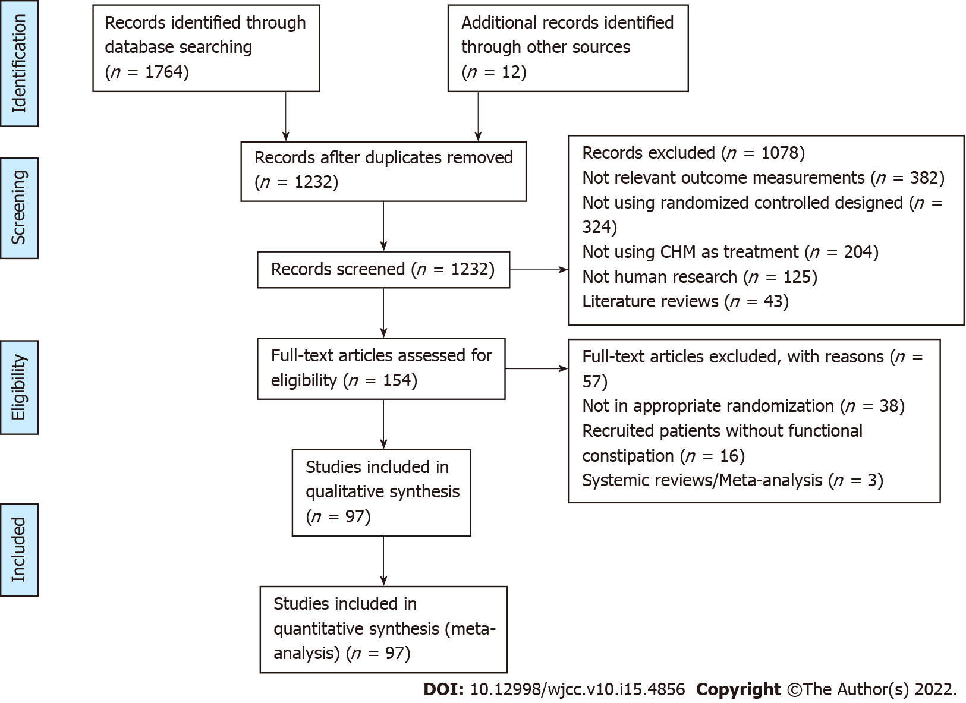
Figure 1 Flow diagram of study selection.

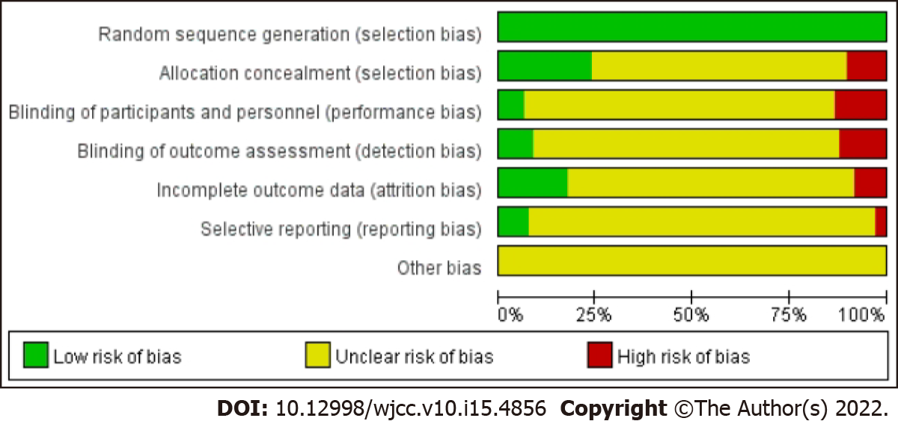
Figure 2 Risk of bias graph with the studies comparing Chinese herbal medicine with PEG/mosapride/lactulose/phenolphthalein/probiotics/placebo for the treatment of FC.

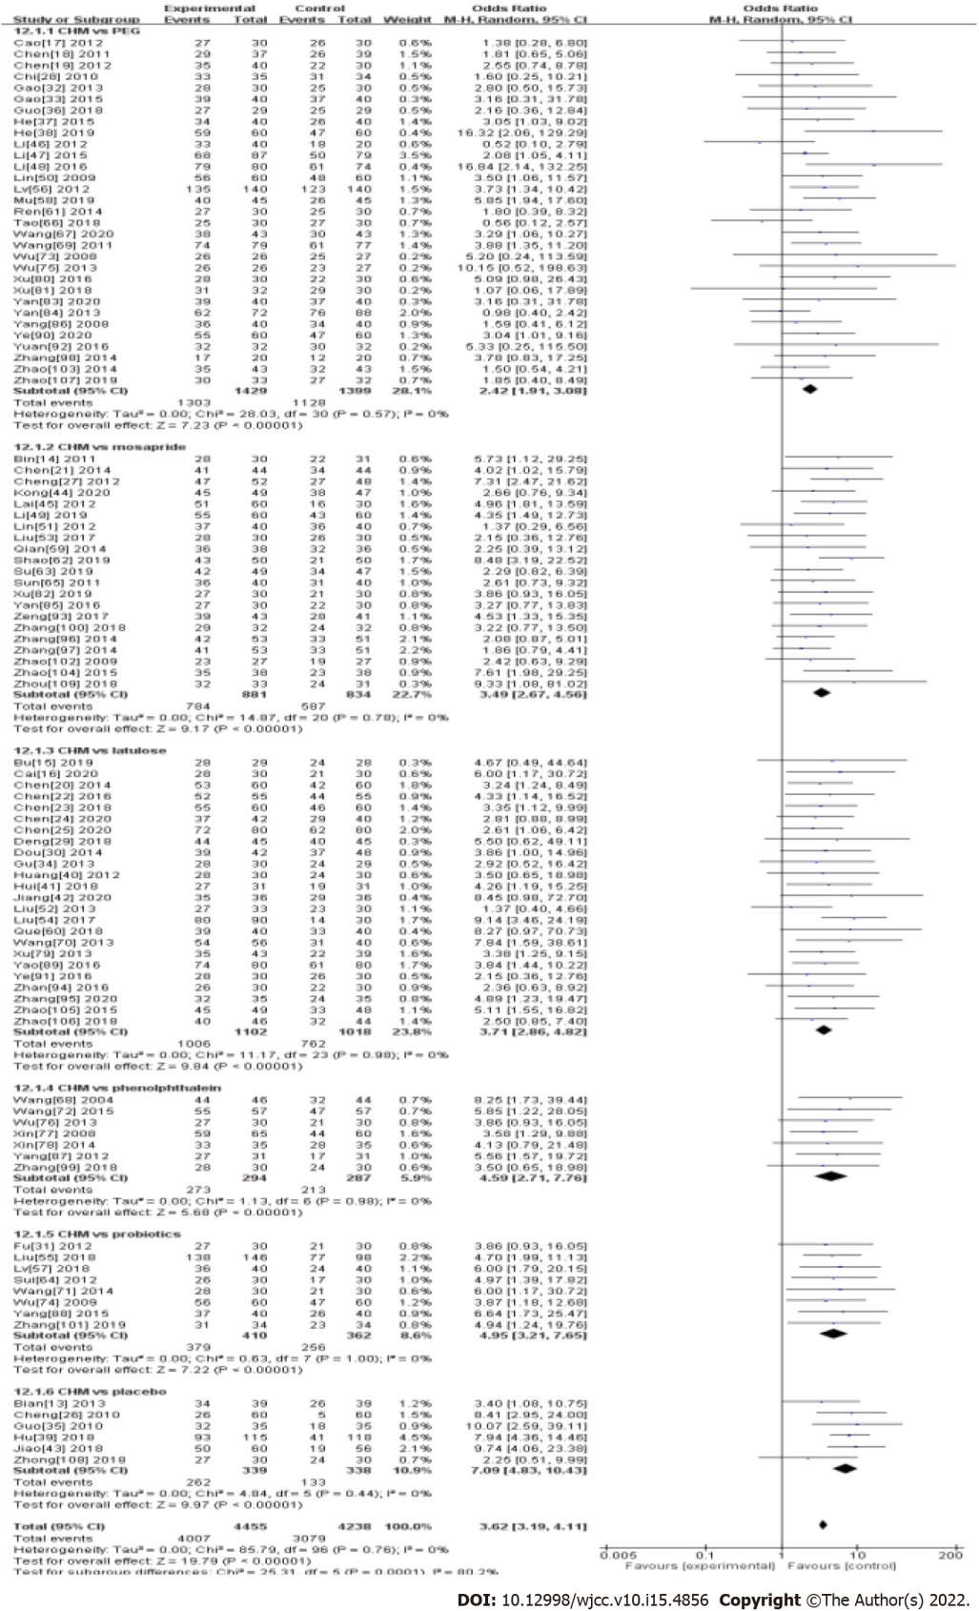
Figure 3 Forest plot of randomized controlled trials in patients with functional constipation comparing Chinese herbal medicine with PEG/mosapride/lactulose/ phenolphthalein/ probiotics/ placebo. Odds ratio (95%CIs) for effective rate are shown.

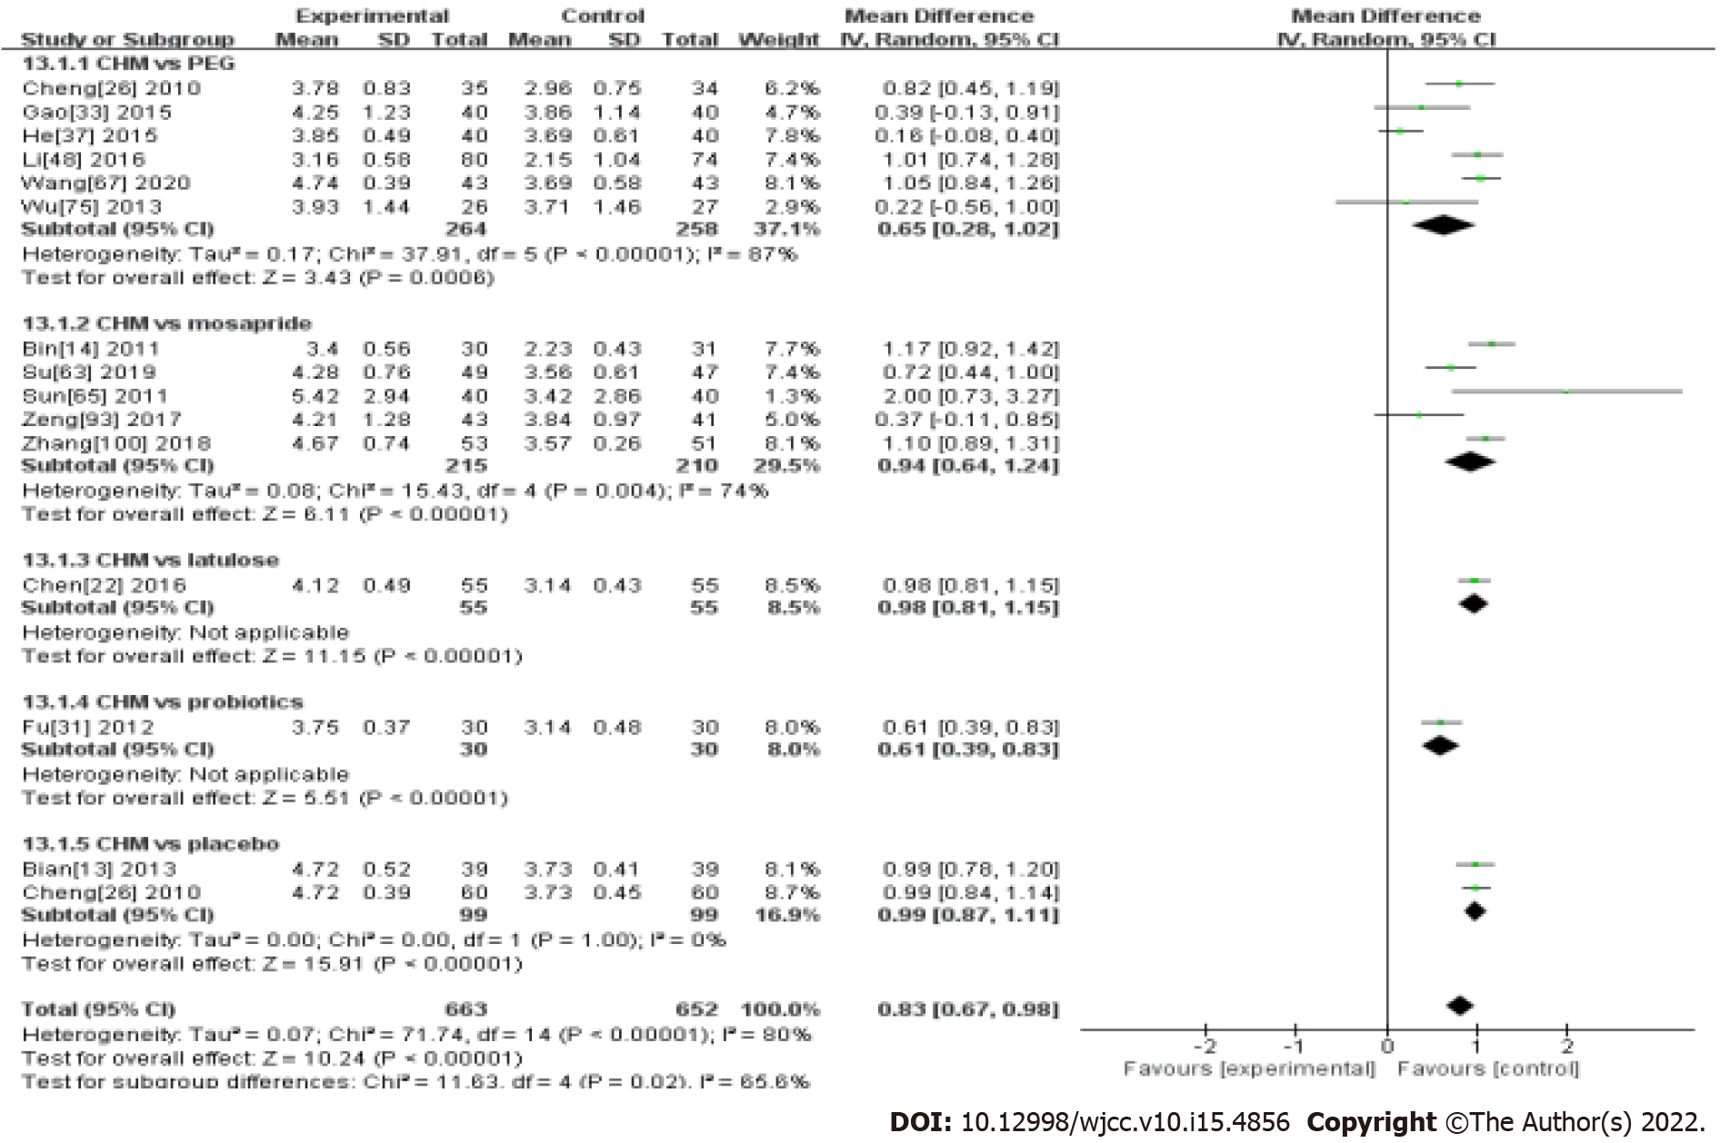
Figure 4 Forest plot of randomized controlled trials in patients with functional constipation comparing Chinese herbal medicine with PEG/mosapride/lactulose/probiotics/placebo. Mean differences (95%CIs) for bowel movement are shown.

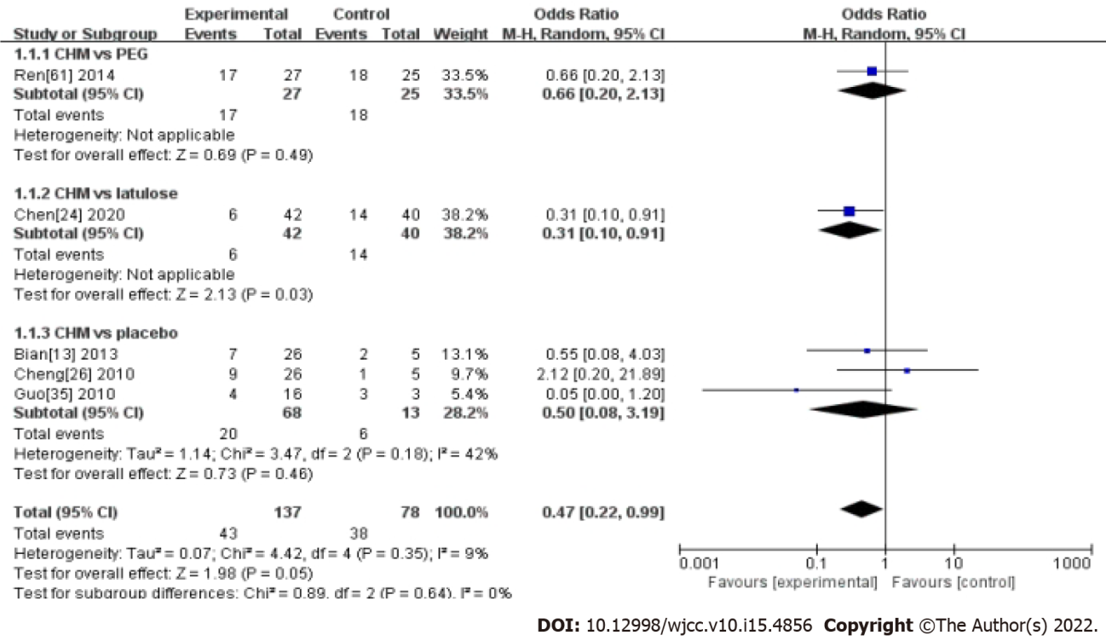
Figure 5 Comparison of Chinese herbal medicine vs Chinese herbal medicine with PEG/ lactulose/ placebo. Odds ratio (95%CIs) for recurrence rate are shown.

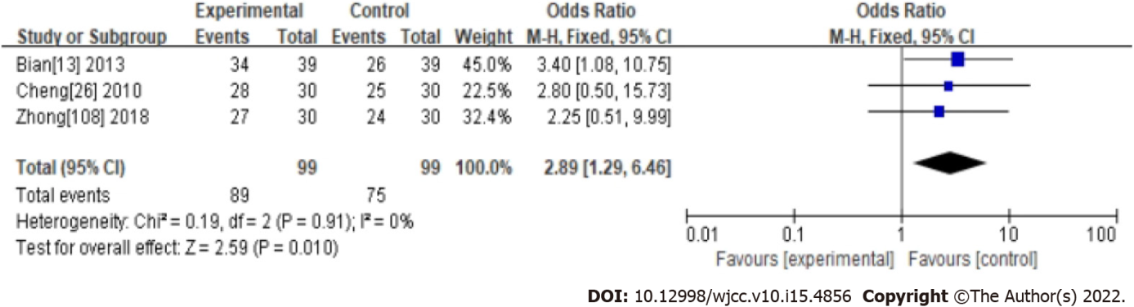
Figure 6 Forest plot of high-quality randomized controlled trials in patients with functional constipation. Odds ratio (95%CIs) for effective rate are shown.

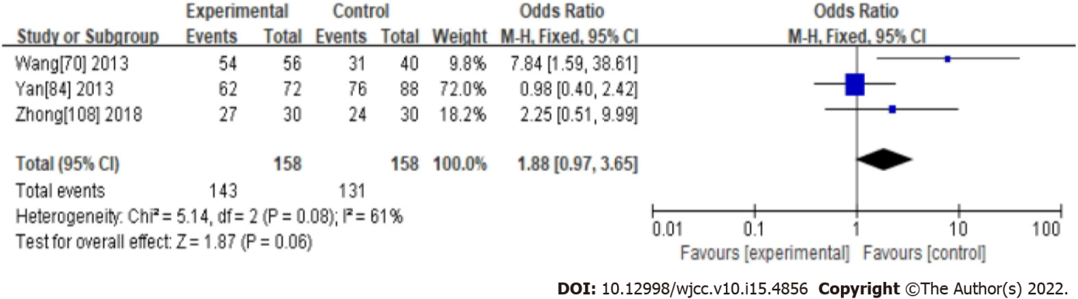
Figure 7 Comparison of Cannabis Fructus vs western medicine. Odds ratio (95%CIs) for effective rate are shown.

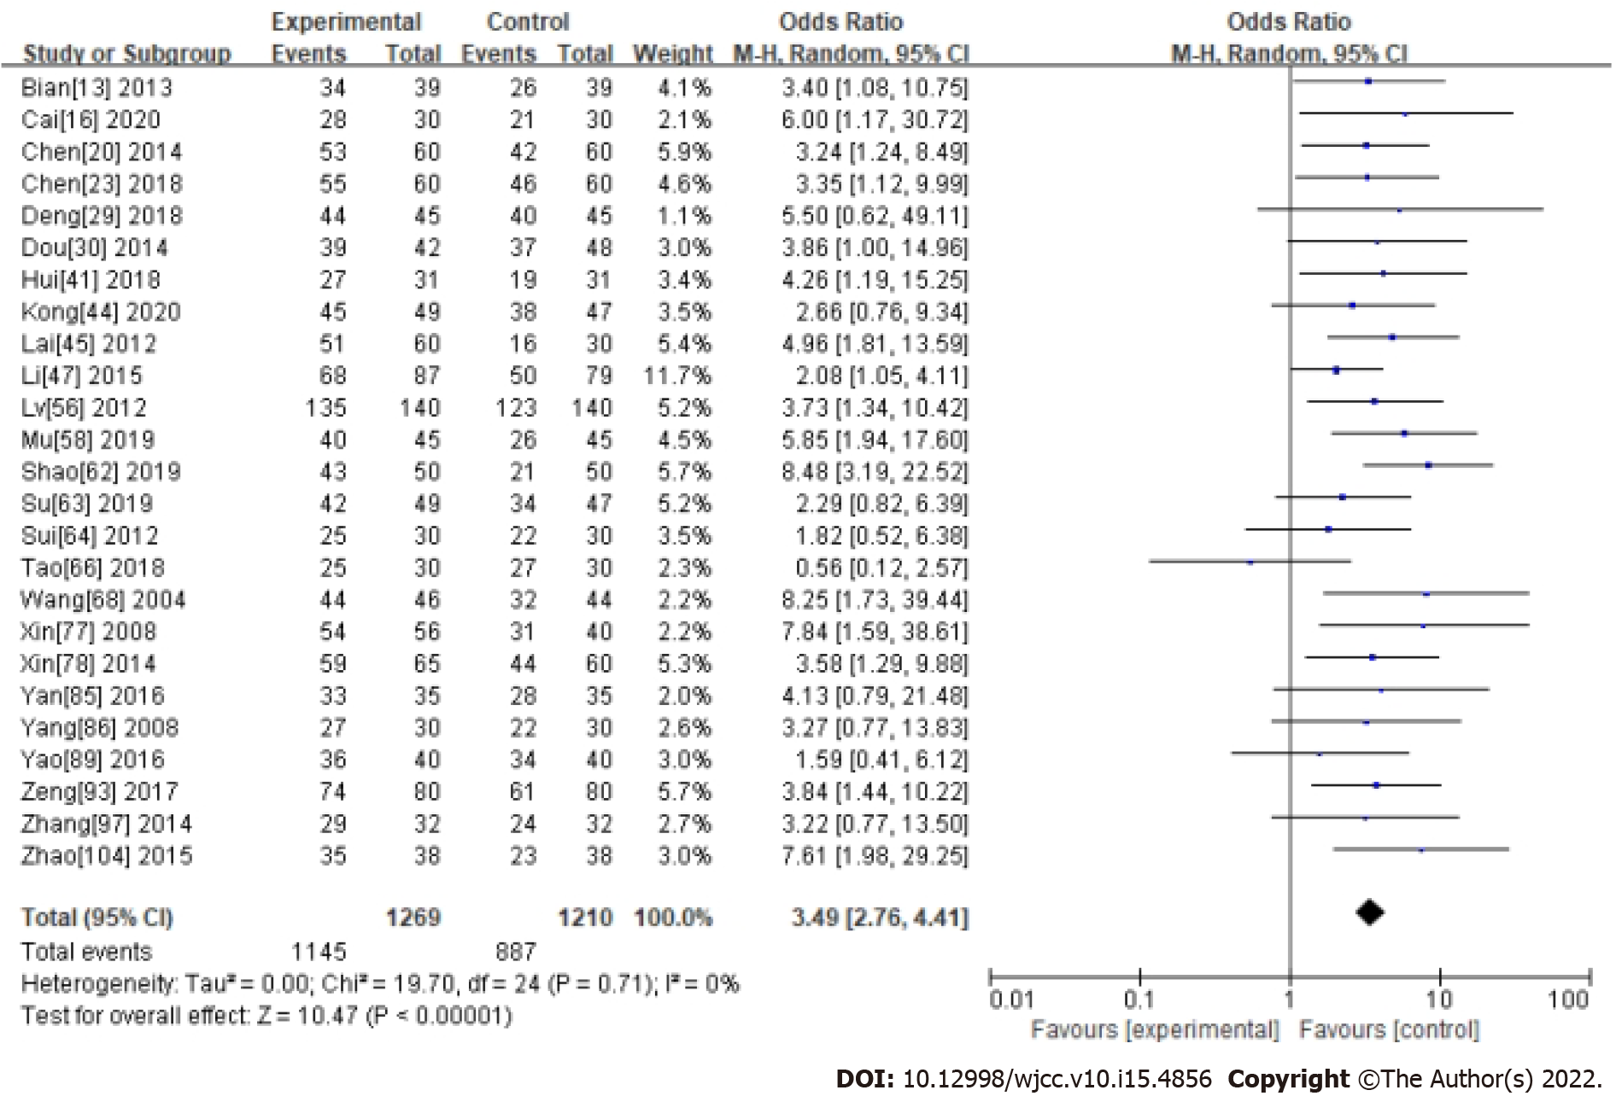
Figure 8 Comparison of cistanche vs western medicine. Odds ratio (95%CIs) for effective rate are shown.

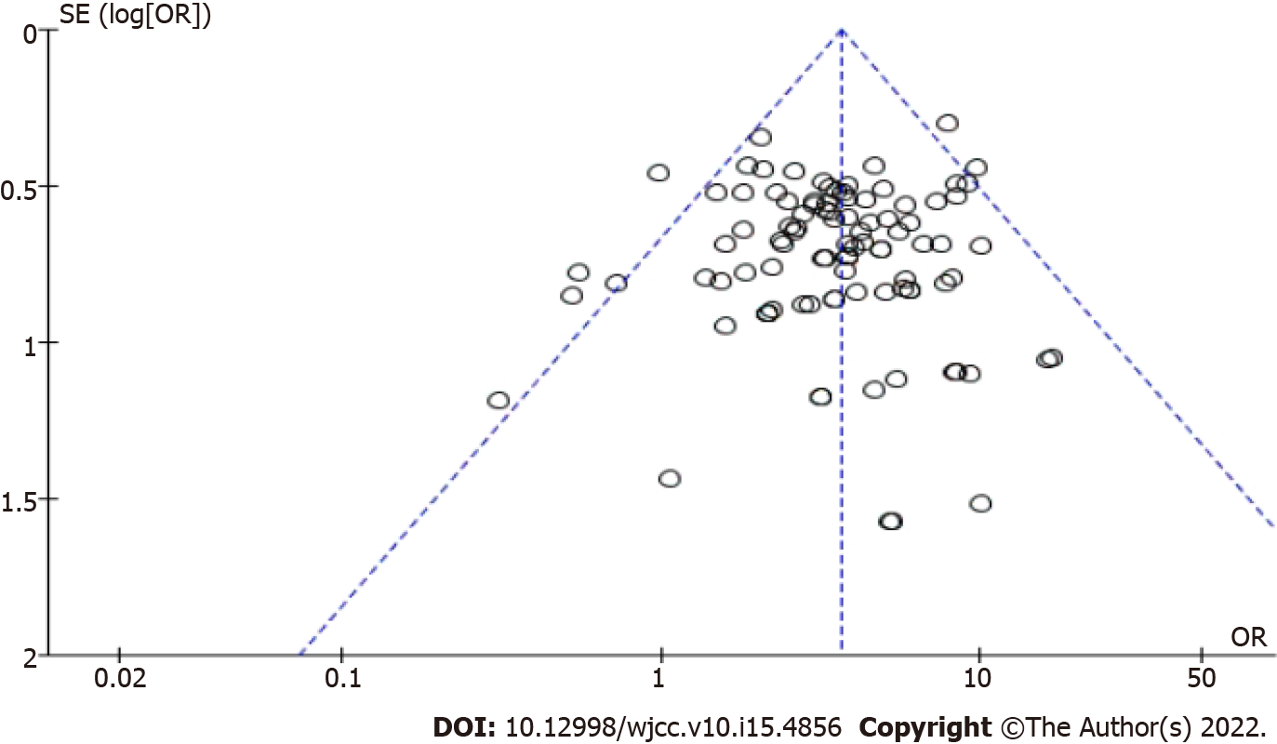
Figure 9 Funnel plots of comparison between Chinese herbal medicine and western medicine.

Table 1 Summary of meta-analysis results
Outcomes | No. of studies in meta-analysis | No. of participants |  | Results |  |  | Heterogeneity
 |  | T | C | OR/MD | 95%CI | P value | Chi- square test | I² | P value
ER | 97 | 4455 | 4238 | 3.62 | (3.19, 4.11) | < 0.00001 | 85.79 | 0% | 0.76
PEG | 31 | 1429 | 1399 | 2.42 | (1.91, 3.08) | < 0.00001 | 28.03 | 0% | 0.57
Mosapride | 21 | 881 | 834 | 3.49 | (2.67, 4.56) | < 0.00001 | 14.87 | 0% | 0.78
Lactulose | 24 | 1102 | 1018 | 3.71 | (2.86, 4.82) | < 0.00001 | 11.17 | 0% | 0.98
Phenolphthalein | 7 | 294 | 287 | 4.59 | (2.71, 7.76) | < 0.00001 | 1.13 | 0% | 0.98
Probiotics | 8 | 410 | 362 | 4.95 | (3.21, 7.65) | < 0.00001 | 0.63 | 0% | 1
Placebo | 6 | 339 | 338 | 7.09 | (4.83, 10.43) | < 0.00001 | 4.84 | 0% | 0.44
GS | 78 | 3438 | 3288 | 4.03 | (3.49, 4.65) | < 0.00001 | 70.74 | 0% | 0.68
PEG | 26 | 1078 | 1038 | 2.69 | (2.06, 3.51) | < 0.00001 | 21.54 | 0% | 0.66
Mosapride | 17 | 714 | 673 | 3.98 | (2.93, 5.41) | < 0.00001 | 10.92 | 0% | 0.81
Lactulose | 23 | 1046 | 978 | 3.89 | (2.97, 5.09) | < 0.00001 | 8.08 | 0% | 1
Phenolphthalein | 1 | 57 | 57 | 5.85 | (1.22, 28.05) | 0.03 | - | - | -
Probiotics | 6 | 234 | 234 | 6.21 | (3.60, 10.70) | < 0.00001 | 1.83 | 0% | 0.87
Placebo | 5 | 309 | 308 | 8.4 | (5.64, 12.52) | < 0.00001 | 3.87 | 0% | 0.42
BM | 15 | 663 | 652 | 0.83 | (0.67, 0.98) | < 0.00001 | 71.74 | 80% | < 0.00001
PEG | 6 | 264 | 258 | 0.65 | (0.28, 1.02) | 0.0006 | 37.91 | 87% | < 0.00001
Mosapride | 5 | 215 | 210 | 0.94 | (0.64, 1.24) | < 0.00001 | 15.43 | 74% | 0.004
Lactulose | 1 | 55 | 55 | 0.98 | (0.81, 1.15) | < 0.00001 | - | - | -
Phenolphthalein | - | - | - | - | - | - | - | - | -
Probiotics | 1 | 30 | 30 | 0.61 | (0.39, 0.83) | - | - | - | -
Placebo | 2 | 99 | 99 | 0.99 | (0.87, 1.11) | < 0.00001 | 0 | 0% | 1
BSS | 7 | 303 | 284 | 1.63 | (1.15, 2.32) | 0.006 | 1.77 | 0% | 0.94
PEG | 4 | 187 | 183 | 1.48 | (0.96, 2.28) | 0.15 | 1.16 | 0% | 0.76
Mosapride | 2 | 60 | 61 | 1.88 | (0.79, 4.44) | 0.15 | 0.01 | 0% | 0.92
Lactulose | - | - | - | - | - | - | - | - | -
Phenolphthalein | - | - | - | - | - | - | - | - | -
Probiotics | 1 | 56 | 40 | 2.07 | (0.90, 4.74) | 0.09 | - | - | -
Placebo | - | - | - | - | - | - | - | - | -
Recurrence | 5 | 137 | 78 | 0.47 | (0.22, 0.99) | 0.05 | 4.42 | 9% | 0.35
PEG | 1 | 27 | 25 | 0.66 | (0.20, 2.13) | 0.49 | - | - | -
Mosapride | - | - | - | - | - | - | - | - | -
Lactulose | 1 | 42 | 40 | 0.31 | (0.10, 0.91) | 0.03 | - | - | -
Phenolphthalein | - | - | - | - | - | - | - | - | -
Probiotics | - | - | - | - | - | - | - | - | -
Placebo | 3 | 68 | 13 | 0.5 | (0.08, 3.19) | 0.46 | 3.47 | 42% | 0.18
Ps: Data were meta-analyzed by using a random-effects model and are presented as OR or MD as appropriate. Statistical heterogeneity was assessed by using the chi-square test and quantified by using the I² statistic. ER: Efficacy rate; PEG: Polyethylene glycol; GS: Global symptom; BM: Bowel movement; BSS: Bristol Stool Scale; RR: Recurrence rate; AEs: Adverse effects.

Table 2 Characteristics of the included studies
Study | Language | Inclusion criteria | No. of participants | Age median (range) | Intervention of treatment group | Intervention of control group | Duration in wk | Assessment of outcomes | Follow-up in mo | Dropout (T/C) | Cochrane
Bian et al^{[13]}, 2014 | English | Rome III | 120 | 55.6 (18-75) | CHM | Placebo | 8 | ER, BM, GS, ARs, RR | 2 | 1/1 | A
Bin et al^{[14]}, 2011 | Chinese | Rome III | 61 | 67.4 (60-85) | CHM | Mosapride | 2 | ER, BM, BSS, GS | NA | NA | B
Bu et al^{[15]}, 2019 | Chinese | Rome III | 57 | 57.9 (40-85) | CHM | Lactulose | 4 | ER, GS, ARs | NA | NA | B
Cai et al^{[16]}, 2020 | Chinese | Rome IV | 60 | 48.2 (45-78) | CHM | Lactulose | 4 | ER, GS | NA | NA | B
Cao et al^{[17]}, 2012 | Chinese | Rome II | 60 | 36.7 (18-65) | CHM | Peg | 4 | ER, GS | NA | NA | B
Chen et al^{[18]}, 2011 | Chinese | Rome III | 76 | 74.3 (60-92) | CHM | Peg | 4 | ER, GS | NA | NA | C
Chen et al^{[19]}, 2012 | Chinese | Rome III | 70 | 31.9 (28-75) | CHM | Peg | 4 | ER, GS | NA | NA | B
Chen et al^{[20]}, 2014 | Chinese | Rome III | 120 | 69.3 (60-75) | CHM | Lactulose | 4 | ER, GS, ARs | NA | NA | B
Chen et al^{[21]}, 2014 | Chinese | Rome III | 88 | 25.1 (17-55) | CHM | Mosapride | 3 | ER, GS | 2 | NA | B
Chen et al^{[22]}, 2016 | Chinese | Rome III | 112 | 62.5 (51-70) | CHM | Lactulose | 4 | ER, BM, GS | NA | 1/1 | B
Chen et al^{[23]}, 2018 | Chinese | Rome III | 120 | 49.2 (25-77) | CHM | Lactulose | 4 | ER, GS | 1 | NA | B
Chen et al^{[24]}, 2020 | Chinese | Rome III | 88 | 66.9 (60-75) | CHM | Lactulose | 4 | ER, GS, RR | 1 | 2/4 | B
Chen et al^{[25]}, 2020 | Chinese | Rome IV | 160 | 48.3 (37-52) | CHM | Lactulose | 4 | ER, GS | NA | NA | B
Cheng et al^{[26]}, 2010 | English | Rome III | 120 | 33.5 (18-65) | CHM | Placebo | 8 | ER, BM, GS, ARs, RR | 2 | 9/8 | A
Cheng et al^{[27]}, 2012 | Chinese | Rome III | 100 | 52.6 (23-67) | CHM | Mosapride | 4 | ER,GS | 3 | NA | C
Chi et al^{[28]}, 2010 | Chinese | Rome III | 70 | NA | CHM | Peg | 4 | ER, BM, GS | NA | 0/1 | B
Deng et al^{[29]}, 2018 | Chinese | Rome III | 96 | 70.2 (50-85) | CHM | Lactulose | 4 | ER, GS | 1 | 3/3 | B
Dou et al^{[30]}, 2014 | Chinese | Rome III | 90 | 58.7 (45-72) | CHM | Lactulose | 3 | ER, GS | NA | NA | B
Fu et al^{[31]}, 2012 | Chinese | Rome III | 60 | 42.8 (18-65) | CHM | Probiotics | 4 | ER, BM, GS | NA | NA | B
Gao et al^{[32]}, 2013 | Chinese | Rome III | 60 | 55.7 (18-70) | CHM | Peg | 8 | ER, GS | NA | NA | B
Gao et al^{[33]}, 2015 | Chinese | Rome III | 80 | 58.3 (20-70) | CHM | Peg | 2 | ER, BM, GS | NA | NA | B
Gu et al^{[34]}, 2013 | Chinese | Rome III | 60 | 45.1 (21-60) | CHM | Lactulose | 4 | ER, GS, BSS, ARs | NA | 0/1 | B
Guo et al^{[35]}, 2010 | English | Rome II | 70 | 64.7 (21-79) | CHM | Placebo | 4 | ER, GS, RR, RR | NA | NA | B
Guo et al^{[36]}, 2018 | Chinese | Rome IV | 60 | 61.8 (18-80) | CHM | Peg | 4 | ER, GS | NA | 1/1 | B
He et al^{[37]}, 2015 | Chinese | Rome III | 80 | 71.4 (60-79) | CHM | Peg | 2 | ER, BM, GS | 2 | NA | B
He et al^{[38]}, 2019 | Chinese | Rome IV | 120 | 72.5 (65-80) | CHM | Peg | 2 | ER, GS, ARs | 2 | NA | B
Hu et al^{[39]}, 2018 | Chinese | Rome III | 238 | 3.84 (1-14) | CHM | Placebo | 1 | ER, GS | NA | NA | B
Huang et al^{[40]}, 2012 | English | Rome III | 60 | 71.8 (60-85) | CHM | Lactulose | 4 | ER, GS, ARs | NA | NA | B
Hui et al^{[41]}, 2018 | Chinese | Rome III | 62 | 68.1 (55-90) | CHM | Lactulose |  | ER, GS, ARs | NA | NA | NA
Jiang et al^{[42]}, 2020 | Chinese | Rome IV | 72 | 51.6 (22-73) | CHM | Lactulose | 4 | ER, GS | NA | NA | B
Jiao et al^{[43]}, 2018 | Chinese | Rome III | 120 | 58.7 (50-70) | CHM | Placebo | 1 | ER, GS | NA | 0/4 | C
Kong et al^{[44]}, 2020 | Chinese | Rome IV | 100 | 69.4 (60-83) | CHM | Mosapride | 2 | ER, GS | 1 | 1/3 | B
Lai et al^{[45]}, 2012 | Chinese | Rome III | 90 | NA | CHM | Mosapride | 4 | ER, GS | NA | NA | B
Li et al^{[46]}, 2012 | Chinese | Rome III | 60 | 49.7 (18-65) | CHM | Peg | 4 | ER, GS | NA | NA | C
Li et al^{[47]}, 2015 | Chinese | Rome III | 166 | 51.9 (18-65) | CHM | Peg | 4 | ER, ARs | 2 | NA | B
Li et al^{[48]}, 2016 | Chinese | Rome III | 160 | 47.2 (23-68) | CHM | Peg | 4 | ER, BM | NA | 0/6 | B
Li et al^{[49]}, 2019 | Chinese | Rome IV | 120 | 55.1 (49-63) | CHM | Mosapride | 2 | ER, GS, ARs | NA | NA | B
Lin et al^{[50]}, 2009 | Chinese | Rome II | 120 | 68.5 (65-80) | CHM | Peg | 4 | ER, ARs | NA | NA | C
Lin et al^{[51]}, 2012 | Chinese | Rome III | 80 | 47.1 (20-60) | CHM | Mosapride | 6 | ER, GS, ARs | NA | NA | B
Liu et al^{[52]}, 2013 | Chinese | Rome III | 66 | 49.6 (18-75) | CHM | Lactulose | 4 | ER, GS | NA | 0/3 | B
Liu et al^{[53]}, 2017 | Chinese | Rome III | 60 | 51.9 (18-65) | CHM | Mosapride | 4 | ER, GS, ARs | NA | NA | B
Liu et al^{[54]}, 2017 | Chinese | Rome III | 120 | 53.7 (45-64) | CHM | Lactulose | 2.1 | ER, GS | NA | NA | B
Liu et al^{[55]}, 2018 | Chinese | Rome III | 244 | 2.6 (1-14) | CHM | Probiotics | 4 | ER | NA | NA | B
Lv et al^{[56]}, 2012 | Chinese | Rome III | 280 | 67.1 (19-82) | CHM | Peg | 3 | ER | 6 | NA | B
Lv et al^{[57]}, 2018 | Chinese | Rome III | 80 | 54.9 (20-71) | CHM | Probiotics | 1 | ER, GS | NA | NA | C
Mu et al^{[58]}, 2019 | Chinese | Rome IV | 90 | 68.7 (62-81) | CHM | Peg | 2 | ER, GS, BSS | NA | NA | B
Qian et al^{[59]}, 2014 | Chinese | Rome III | 80 | 46.3 (18-65) | CHM | Mosapride | 8 | ER, GS, ARs | NA | 2/4 | B
Que et al^{[60]}, 2018 | Chinese | Rome III | 80 | 45.8 (16-70) | CHM | Lactulose | 8 | ER, GS | NA | NA | C
Ren et al^{[61]}, 2014 | Chinese | Rome III | 60 | 47.6 (18-65) | CHM | Peg | 8 | ER, GS, RR | 1 | NA | B
Shao et al^{[62]}, 2019 | Chinese | Rome IV | 100 | 67.9 (65-80) | CHM | Mosapride | 2 | ER, GS | NA | NA | B
Su et al^{[63]}, 2019 | Chinese | Rome IV | 96 | 71.5 (64-78) | CHM | Mosapride | 2 | ER, BM | 1 | NA | B
Sui et al^{[64]}, 2012 | Chinese | Rome III | 120 | 54.9 (18-79) | CHM | Probiotics | 2 | ER, GS | NA | NA | B
Sun et al^{[65]}, 2011 | Chinese | Rome III | 80 | 68.3 (60-80) | CHM | Mosapride | 1 | ER, BM, GS | NA | NA | B
Tao et al^{[66]}, 2018 | Chinese | Rome III | 60 | NA | CHM | Peg | 4 | ER | NA | NA | B
Wang et al^{[67]}, 2020 | Chinese | Rome IV | 94 | 69.3 (66-85) | CHM | Peg | 4 | ER, BM, GS | 2 | 5/5 | B
Wang et al^{[68]}, 2004 | Chinese | Rome II | 90 | 64.5 (56-75) | CHM | Phenolphthalein | 4 | ER | NA | NA | B
Wang et al^{[69]}, 2011 | Chinese | Rome III | 156 | 60.7 (NA) | CHM | Peg | 2 | ER, GS, BSS | NA | NA | B
Wang et al^{[70]}, 2013 | Chinese | Rome III | 112 | 73.6 (65-82) | CHM | Lactulose | 3 | ER, ARs | NA | 0/12 | B
Wang et al^{[71]}, 2014 | Chinese | Rome III | 60 | 1.9 (1-7) | CHM | Probiotics | 8 | ER | 3 | NA | B
Wang et al^{[72]}, 2015 | Chinese | Rome II | 116 | 66.7 (55-75) | CHM | Phenolphthalein | 4 | ER, GS | NA | 1/1 | B
Wu et al^{[73]}, 2008 | Chinese | Rome III | 54 | 76.4 (60-84) | CHM | Peg | 4 | ER, GS | NA | 1/0 | B
Wu et al^{[74]}, 2009 | Chinese | Rome III | 60 | 55.9 (50-75) | CHM | Probiotics | 4 | ER, GS, ARs | 6 | NA | B
Wu et al^{[75]}, 2013 | Chinese | Rome III | 60 | 56.3 (45-75) | CHM | Peg | 4 | ER, BM, ARs | NA | 4/3 | B
Wu et al^{[76]}, 2013 | Chinese | Rome III | 60 | 49.4 (NA) | CHM | Phenolphthalein | 2 | ER | NA | NA | B
Xin et al^{[77]}, 2008 | Chinese | Rome II | 130 | 66.8 (60-88) | CHM | Phenolphthalein | 4 | ER | NA | 0/5 | B
Xin et al^{[78]}, 2014 | Chinese | Rome III | 70 | 69.7 (60-85) | CHM | Phenolphthalein | 4 | ER | NA | NA | B
Xu et al^{[79]}, 2013 | Chinese | Rome III | 82 | 70.3 (NA) | CHM | Lactulose | 4 | ER, GS | NA | NA | C
Xu et al^{[80]}, 2016 | Chinese | Rome III | 70 | 47.2 (18-75) | CHM | Peg | 8 | ER, GS | NA | 5/5 | B
Xu et al^{[81]}, 2018 | Chinese | Rome III | 80 | 41.8 (18-54) | CHM | Peg | 4 | ER, GS | 1 | 8/10 | B
Xu et al^{[82]}, 2019 | Chinese | Rome IV | 60 | 42.3 (25-64) | CHM | Mosapride | 4 | ER, GS | 3 | NA | B
Yan et al^{[83]}, 2020 | Chinese | Rome IV | 80 | 46.7 (16-70) | CHM | Peg | 4 | ER, GS | 2 | NA | B
Yan et al^{[84]}, 2013 | Chinese | Rome II | 258 | 82.2 (80-93) | CHM | Peg | 4 | ER | NA | NA | B
Yan et al^{[85]}, 2016 | Chinese | Rome III | 60 | 43.1 (32-62) | CHM | Mosapride | 4 | ER, GS, BSS | 1 | NA | B
Yang et al^{[86]}, 2008 | Chinese | Rome III | 80 | 67.4 (60-82) | CHM | Peg | 4 | ER, GS | NA | NA | B
Yang et al^{[87]}, 2012 | Chinese | Rome III | 66 | 71.5 (NA) | CHM | Phenolphthalein | 2 | ER | NA | 2/2 | C
Yang et al^{[88]}, 2015 | Chinese | Rome III | 80 | 54.9 (NA) | CHM | Probiotics | 4 | ER, GS, BSS, ARs | NA | NA | B
Yao et al^{[89]}, 2016 | Chinese | Rome III | 160 | 66.1 (60-80) | CHM | Lactulose | 4 | ER, GS | NA | NA | B
Ye et al^{[90]}, 2020 | Chinese | Rome IV | 120 | 57.8 (18-78) | CHM | Peg | 4 | ER, GS | NA | NA | B
Ye et al^{[91]}, 2016 | Chinese | Rome III | 60 | 68.4 (60-85) | CHM | Lactulose | 4 | ER, GS | NA | NA | B
Yuan et al^{[92]}, 2016 | Chinese | Rome III | 64 | 47.4 (30-75) | CHM | Peg | 4 | ER, GS, ARs | 1 | NA | B
Zeng et al^{[93]}, 2017 | Chinese | Rome III | 88 | 47.2 (18-65) | CHM | Mosapride | 4 | ER, BM, GS | 3 | 1/3 | B
Zhan et al^{[94]}, 2016 | Chinese | Rome III | 60 | 56.3 (18-75) | CHM | Lactulose | 4 | ER, GS, ARs | NA | NA | B
Zhang et al^{[95]}, 2020 | Chinese | Rome IV | 80 | 44.5 (18-65) | CHM | Lactulose | 4 | ER, GS, ARs | 3 | 5/5 | B
Zhang et al^{[96]}, 2014 | Chinese | Rome III | 64 | 56.7 (18-75) | CHM | Mosapride | 4 | ER, ARs | NA | NA | B
Zhang et al^{[97]}, 2014 | Chinese | Rome III | 104 | 68.2 (60-80) | CHM | Mosapride | 4 | ER, GS, ARs | 1 | NA | B
Zhang et al^{[98]}, 2014 | Chinese | Rome III | 90 | 65.3 (NA) | CHM | Peg | 4 | ER, GS | NA | NA | C
Zhang et al^{[99]}, 2018 | Chinese | Rome III | 60 | 72.4 (60-85) | CHM | Phenolphthalein | 4 | ER | NA | NA | C
Zhang et al^{[100]}, 2018 | Chinese | Rome III | 106 | 33.5 (24-58) | CHM | Mosapride | 8 | ER, BM | 1 | 0/2 | B
Zhang et al^{[101]}, 2019 | Chinese | Rome III | 68 | 41.7 (19-69) | CHM | Probiotics | 4 | ER, GS | 3 | NA | B
Zhao et al^{[102]}, 2009 | Chinese | Rome III | 76 | 42.4 (NA) | CHM | Mosapride | 2 | ER, GS | 1 | 11/11 | B
Zhao et al^{[103]}, 2014 | Chinese | Rome III | 76 | 56.7 (15-80) | CHM | Peg | 4 | ER, GS | NA | NA | C
Zhao et al^{[104]}, 2015 | Chinese | Rome III | 68 | 51.4 (18-70) | CHM | Mosapride | 4 | ER, GS, ARs | NA | NA | B
Zhao et al^{[105]}, 2015 | Chinese | Rome III | 100 | 4.2 (1-14) | CHM | Lactulose | 8 | ER, GS | 14 | 1/2 | B
Zhao et al^{[106]}, 2018 | Chinese | Rome III | 90 | 53.7 (23-67) | CHM | Lactulose | 8 | ER, GS | NA | NA | B
Zhao et al^{[107]}, 2019 | Chinese | Rome III | 66 | 68.4 (65-84) | CHM | Peg | 3 | ER, BSS | 3 | 0/1 | C
Zhong et al^{[108]}, 2018 | English | Rome III | 194 | 44.6 (18-70) | CHM | Placebo | 8 | ER, BM, GS, ARs | 2 | 3/7 | A
Zhou et al^{[109]}, 2018 | Chinese | Rome III | 80 | 51.3 (30-70) | CHM | Mosapride | 4 | ER, GS, ARs | NA | 7/9 | B
CHM: Chinese herbal medicine; PEG: Polyethylene glycol; ER: Efficacy rate; BM: Bowel movement; GS: Global symptom; BSS: Bristol Stool Scale; RR: Recurrence rate; AEs: Adverse effects; A: Methodology with a low risk of bias; B: Methodology with an unclear risk of bias; C: Methodology with a high risk of bias.

Published by Baishideng Publishing Group Inc
7041 Koll Center Parkway, Suite 160, Pleasanton, CA 94566, USA
Telephone: +1-925-3991568
E-mail: bpgoffice@wjgnet.com
Help Desk: https://www.f6publishing.com/helpdesk
https://www.wjgnet.com

© 2022 Baishideng Publishing Group Inc. All rights reserved.

