Name of Journal: World Journal of Clinical Cases
Manuscript NO: 56488
Manuscript Type: CASE REPORT

Neoadjuvant targeted therapy for apocrine carcinoma of the breast: A case report

Yang P et al. Neoadjuvant targeted therapy for apocrine carcinoma

Ping Yang, Shu-Jia Peng, Yan-Ming Dong, Lin Yang, Zhen-Yu Yang, Xi-E Hu, Guo-Qiang Bao

Ping Yang, Shu-Jia Peng, Yan-Ming Dong, Lin Yang, Zhen-Yu Yang, Xi-E Hu, Guo-Qiang Bao, Department of general surgery, Tangdu hospital, Air Force military medical university, Xi’an 710032, Shaanxi Province, China

Author contributions: Bao GQ conceived the study; Bao GQ and Yang P performed the treatment; Bao GQ and Peng SJ performed the imaging; Yang P and Dong YM collected the data; Yang L, Yang ZY and Hu X drafted the manuscript; Bao GQ reviewed and revised the manuscript.

Corresponding author: Guo-Qiang Bao, MD, Assistant Professor, Associate Chief Physician, Doctor, Surgeon, Department of General Surgery, Tangdu Hospital, Air Force military medical university, No. 569 Xinsi Road, Xi’an 710032, Shaanxi Province, China. guoqiang@fmmu.edu.cn

Received: June 16, 2020
Revised: August 18, 2020
Accepted: October 26, 2020
Published online:

Abstract
BACKGROUND
Apocrine carcinoma of the breast is a special type of invasive ductal carcinoma of the breast that is rare in clinical practice. Neoadjuvant therapy, especially neoadjuvant targeted therapy, has rarely been reported for apocrine carcinoma of the breast.

CASE SUMMARY
A 63-year-old woman presented with apocrine carcinoma of the left breast underwent core needle biopsy. The patient was diagnosed with apocrine carcinoma by immunohistochemical staining and negative hormone status (estrogen receptor and progesterone receptor) but showed overexpression of human epidermal factor receptor 2 (HER-2). Moreover, positive expression of androgen receptor (approximately 60%) and gross cystic disease fluid protein 15 was observed. The patient was treated with neoadjuvant targeted therapy consisting of the TCH regimen (docetaxel, carboplatin area under curve 6 and trastuzumab) every 21 d. The mass in the left breast was significantly reduced, and pain in the breast and left upper arm also improved.

CONCLUSION
HER-2 positive apocrine carcinoma of the breast can be improved by neoadjuvant chemotherapy combined with targeted therapy.

Key Words: Breast neoplasm; ErbB-2 receptor; Targeted therapy; Case report; Apocrine gland; Neoadjuvant therapies

Yang P, Peng SJ, Dong YM, Yang L, Yang ZY, Hu XE, Bao GQ. Neoadjuvant targeted therapy for apocrine carcinoma of the breast: A case report. World J Clin Cases 2020; In press

Core Tip: A woman with apocrine carcinoma of the left breast underwent core needle biopsy. The patient was diagnosed with apocrine carcinoma by immunohistochemical staining and negative hormone status (estrogen receptor and progesterone receptor) but showed overexpression of human epidermal factor receptor 2. Moreover, positive expression of androgen receptor (approximately 60%) and gross cystic disease fluid protein 15 was observed. The patient was treated with neoadjuvant targeted therapy consisting of the TCH regimen (docetaxel, carboplatin area under curve 6 and trastuzumab) every 21 d. The mass in the left breast was significantly reduced, and pain in the breast and left upper arm also improved.
INTRODUCTION
Breast cancer is the most common malignant tumor in women worldwide and has become a major threat to women's health^{[1]}. Invasive ductal carcinoma of no-special-type is the most common type of breast cancer and constitutes up to 75% of all breast carcinomas. The remaining 25% are special histologic types including invasive apocrine carcinoma of the breast, which accounts for 0.4%-4.0% of all breast cancers in women^{[2-4]}. Apocrine carcinoma of the breast is a rare invasive malignant tumor that is mainly composed of apocrine cells, which is defined by the World Health Organization as an invasive carcinoma with cytological features of apocrine cells^{[5]}. More strictly, it is characterized by abundant eosinophilic and granular cytoplasm, centrally/eccentrically located nuclei with prominent nucleoli and distinct cell borders, and a distinct steroid receptor profile: Hormone receptor (HR)-negative and androgen receptor (AR)-positive cells^{[6]}. ‘Pure’ apocrine carcinoma is defined by apocrine morphology in > 90% of tumor cells and immunohistochemical criteria, and it appears to have a worse disease-free survival rate^{[3]}. So far, the precise significance of AR expression is not completely clear. Ni et al^{[7]} showed that androgen stimulated the human epidermal factor receptor 2 (HER2) signaling pathway in estrogen receptor (ER)-negative and HER2-positive breast cancer, and AR blockade in these tumors impaired cell growth. Naderi et al^{[8]} reported similar observations and demonstrated a functional ‘cross-talk’ between androgen and HER2. Unfortunately, it is rarely used clinically at present. Anti-HER2 therapy is still the cornerstone for HR-negative and HER2-positive apocrine carcinoma of the breast. Neoadjuvant therapy is preferred for locally advanced breast cancer, especially HR-negative and HER2-amplified breast cancer. However, there are few reports on the efficacy of neoadjuvant targeted therapy for apocrine carcinoma. Informed content was obtained from the patient.

CASE PRESENTATION
Chief complaints
A 63-year-old woman found a mass in the superior lateral quadrant of the left breast, with no obvious discomfort, and she paid no attention to it.

History of present illness
During the next 2 years, the left breast mass gradually increased in size and was painful. She developed discomfort in the left upper limb and visited a local hospital many times (without an examination report). Surgical treatment was suggested, but the patient refused.

History of past illness
The patient had a free previous medical history.

Personal and family history
The patient has a history of good health, and there is no similar patient in the family members.

Physical examination
Physical examination showed that the skin in the outer upper quadrant of the left mammary gland was obviously sunken, and a hard mass about 5 cm × 6 cm, with an unclear boundary, irregular shape, and poor activity was found on palpation. No obvious enlarged lymph nodes were found in the axilla.

Laboratory examinations
No abnormalities were found in the patient's laboratory examinations.

Imaging examinations
Ultrasound showed a solid hypoechoic mass approximately 3.5 cm × 5.3 cm × 4.5 cm in size at the margin of the gland at 12-3 o'clock in the superior lateral quadrant of the left breast, and several hypoechoic lymph nodes of different sizes were detected in the left axilla. The largest lymph node was about 0.6 cm × 0.6 cm, and the lymphatic hilum structure had disappeared. No abnormalities were found in the right breast. Therefore, chest computed tomography (CT) scanning was performed, and the left breast mass was diagnosed as breast cancer, with no abnormalities in the lungs. Other results, including abdominal ultrasound, bone scan, and laboratory examinations, showed no abnormalities. There was no family history in genetic disorders.

Further diagnostic work-up
The patient underwent core needle biopsy of the left breast mass under ultrasound guidance, and the histopathological diagnosis was apocrine carcinoma. Immunohistochemical analysis showed negative expression of ER and progesterone receptor (PR), but positive expression of HER2 and AR (approximately 60%); gross cystic disease fluid protein 15 (GCDFP-15) was also positive (Figure 1).

FINAL DIAGNOSIS
The final diagnosis of the presented case is apocrine carcinoma of the breast. The clinical stage was T4N1M0 (IIIB).

TREATMENT
Considering that the patient had small breast volume, large breast lesion, late clinical stage, and local advanced breast cancer and her molecular type, neoadjuvant therapy seemed an effective choice. Therefore, after informed consent was obtained from her family members and the patient, neoadjuvant chemotherapy using the TCH regimen [docetaxel, carboplatin area under curve 6 and trastuzumab 8 mg/kg followed by 6 mg/kg every 21 d] and targeted therapy were administered. No significant side effects were observed during the treatment.

OUTCOME AND FOLLOW-UP
After 5 cycles of treatment, the left breast lesion was significantly reduced on CT examination (Figure 2). In November 2019, the patient underwent modified radical mastectomy. During the operation, mild edema and thickening of the left breast skin, unclear boundary of the breast lesions, and irregular morphology were observed, and no capsule or obvious calcified lesions were found in the specimen. The specimen was soaked in formalin solution and sent to the pathology department. Apocrine carcinoma of the breast was confirmed by pathology. The immunohistochemical results were as previously determined, but Ki-67 was reduced to 50%.

DISCUSSION
Apocrine carcinoma of the breast remains largely unknown as studies have recruited a small number of patients and did not use well-defined criteria for apocrine carcinoma. “Molecular apocrine” carcinomas exhibit a prognostically poor gene signature with a high-risk recurrence score and a poor 70-gene prognosis signature^{[9]}. Zhang et al^{[10]} analyzed data from the SEER Program and suggested that compared with other invasive carcinomas, overall survival and disease-specific survival (DSS) were both worse in invasive apocrine adenocarcinoma patients than in invasive ductal carcinoma patients. Based on the Kaplan-Meier analysis, the prognosis of apocrine carcinoma is poor. Further study on the risk factors influencing the overall survival and disease-specific survival by multifactor analysis confirmed that histological grade II/III, tumor size > 2 cm, and positive lymph nodes were associated with poor prognosis and that ER/PR positive breast conserving surgery, and radiotherapy were protective factors in DSS^{[10]}. Nevertheless, Japaze et al^{[11]} suggested that ‘pure’ invasive apocrine carcinoma may be a distinct clinicopathological entity with less aggressive behavior than high-grade no-special-type cancer. In addition, Wu et al^{[12]} identified 366 patients with triple-negative apocrine carcinoma of the breast and 30996 patients with triple-negative breast cancer and invasive ductal carcinoma from the SEER database. Patients with triple-negative apocrine carcinoma had a better prognosis than patients with triple-negative breast cancer, and chemotherapy was associated with survival advantages in patients with triple-negative apocrine carcinoma.
There are some contradictions in the prognostic study of apocrine carcinoma of the breast, which may be related to its unclear definition. In addition, the latest classification of breast tumors by the World Health Organization is equally inaccurate^{[13]}. At present, most experts agree that the definition of pure apocrine carcinoma should be based on typical cell morphology and unique immunohistochemical characteristics^{[14,15]}, as this profile matches closely the normal apocrine epithelium. Our patient was characterized by typical morphological manifestations and immune combinations.
Mammary apocrine cells have abundant eosinophilic and granular cytoplasm, centrally to eccentrically located nuclei with prominent nucleoli and distinctive cell borders, or less common apocrine cells with a foamy and vacuolated cytoplasm^{[16]}. AR activation and signaling is a hallmark of apocrine differentiation in breast pathology; moreover, AR has been associated with HER2 signaling in apocrine carcinoma^{[17]}. HER2 protein is overexpressed in approximately 15% of all breast carcinomas^{[18]}, but the rate of HER2 overexpression is approximately 50% in apocrine carcinoma^{[19]}. GCDFP-15, identified by Haagensen et al^{[20]} in 1977, is a 15-kDa protein mapped to chromosome 7, and its expression has been associated with apocrine differentiation, including apocrine carcinoma, although its positivity has been confirmed in other breast carcinoma subtypes^{[20-22]}. GCDFP-15 positive patients are associated with local recurrence and distant metastases^{[23]}.
At present, clinical and radiological presentations of apocrine carcinoma do not differ from those seen in invasive ductal carcinomas^{[24]}. Clinically, apocrine carcinoma usually presents with a palpable tumor mass, rarely with a bloody discharge from the nipple or as a cyst^{[25,26]}. However, some studies have indicated a higher rate of apocrine carcinoma (and AR expression) in the elderly^{[26]}.
With regard to treatment, some studies have indicated a poor response to chemotherapy in patients with apocrine carcinoma^{[27]}, although HER2 enriched breast carcinomas tend to have the highest rate of complete response to neoadjuvant chemotherapy. Iizuka et al^{[28]} described a case of triple-negative apocrine carcinoma treated with docetaxel/cyclophosphamide (four courses) and epirubicin/ cyclophosphamide (4four courses), with a complete pathologic response to neoadjuvant chemotherapy. However, neoadjuvant targeted therapy for apocrine carcinoma of breast has rarely been reported. The breast mass in our patient was initially up to 5.3 cm in diameter and was locally advanced; thus, she received the neoadjuvant TCH regimen and then underwent surgery after five cycles of treatment, which resulted in partial remission. Therefore, we believe that HER2 positive apocrine carcinoma of the breast can be treated with neoadjuvant targeted therapy.

CONCLUSION
As a rare invasive carcinoma, there is no special treatment at present for apocrine carcinoma of the breast. Appropriate treatment can be given based on immunohistochemical results. For HER2 positive locally advanced apocrine carcinomas of the breast, according to our experience, neoadjuvant targeted therapy is appropriate and can yield desirable results. The predictive role of AR expression and the efficacy of anti-AR therapy in the treatment of breast cancer have not been determined. More clinical evidence is needed.

ACKNOWLEDGEMENTS
The authors thank the patient for agreeing to publish this report.

REFERENCES
1 Lee H, Lee DE, Park S, Kim TS, Jung SY, Lee S, Kang HS, Lee ES, Sim SH, Park IH, Lee KS, Kwon YM, Kong SY, Joo J, Jeong HJ, Kim SK. Predicting Response to Neoadjuvant Chemotherapy in Patients With Breast Cancer: Combined Statistical Modeling Using Clinicopathological Factors and FDG PET/CT Texture Parameters. Clin Nucl Med 2019; 44: 21-29 [PMID: 30394924 DOI: 10.1097/RLU.0000000000002348]
2 Tan PH, Ellis IO. Myoepithelial and epithelial-myoepithelial, mesenchymal and fibroepithelial breast lesions: updates from the WHO Classification of Tumours of the Breast 2012. J Clin Pathol 2013; 66: 465-470 [PMID: 23533258 DOI: 10.1136/jclinpath-2012-201078]
3 Dellapasqua S, Maisonneuve P, Viale G, Pruneri G, Mazzarol G, Ghisini R, Mazza M, Iorfida M, Rotmensz N, Veronesi P, Luini A, Goldhirsch A, Colleoni M. Immunohistochemically defined subtypes and outcome of apocrine breast cancer. Clin Breast Cancer 2013; 13: 95-102 [PMID: 23245877 DOI: 10.1016/j.clbc.2012.11.004]
4 Choi J, Jung WH, Koo JS. Clinicopathologic features of molecular subtypes of triple negative breast cancer based on immunohistochemical markers. Histol Histopathol 2012; 27: 1481-1493 [PMID: 23018247 DOI: 10.14670/HH-27.1481]
5 Cserni G. Histological type and typing of breast carcinomas and the WHO classification changes over time. Pathologica 2020; 112: 25-41 [PMID: 32202537 DOI: 10.32074/1591-951X-1-20]
6 Vranic S, Schmitt F, Sapino A, Costa JL, Reddy S, Castro M, Gatalica Z. Apocrine carcinoma of the breast: a comprehensive review. Histol Histopathol 2013; 28: 1393-1409 [PMID: 23771415 DOI: 10.14670/HH-28.1393]
7 Ni M, Chen Y, Lim E, Wimberly H, Bailey ST, Imai Y, Rimm DL, Liu XS, Brown M. Targeting androgen receptor in estrogen receptor-negative breast cancer. Cancer Cell 2011; 20: 119-131 [PMID: 21741601 DOI: 10.1016/j.ccr.2011.05.026]
8 Naderi A, Hughes-Davies L. A functionally significant cross-talk between androgen receptor and ErbB2 pathways in estrogen receptor negative breast cancer. Neoplasia 2008; 10: 542-548 [PMID: 18516291 DOI: 10.1593/neo.08274]
9 Weigelt B, Horlings HM, Kreike B, Hayes MM, Hauptmann M, Wessels LF, de Jong D, Van de Vijver MJ, Van't Veer LJ, Peterse JL. Refinement of breast cancer classification by molecular characterization of histological special types. J Pathol 2008; 216: 141-150 [PMID: 18720457 DOI: 10.1002/path.2407]
10 Zhang N, Zhang H, Chen T, Yang Q. Dose invasive apocrine adenocarcinoma has worse prognosis than invasive ductal carcinoma of breast: evidence from SEER database. Oncotarget 2017; 8: 24579-24592 [PMID: 28445946 DOI: 10.18632/oncotarget.15597]
11 Japaze H, Emina J, Diaz C, Schwam RJ, Gercovich N, Demonty G, Morgenfeld E, Rivarola E, Gil Deza E, Gercovich FG. 'Pure' invasive apocrine carcinoma of the breast: a new clinicopathological entity? Breast 2005; 14: 3-10 [PMID: 15695074 DOI: 10.1016/j.breast.2004.06.003]
12 Wu W, Wu M, Peng G, Shi D, Zhang J. Prognosis in triple-negative apocrine carcinomas of the breast: A population-based study. Cancer Med 2019; 8: 7523-7531 [PMID: 31642210 DOI: 10.1002/cam4.2634]
13 Yang WT, Zhu XZ. [The introduction of 2012 WHO classification of tumours of the breast]. Zhonghua Bing Li Xue Za Zhi 2013; 42: 78-80 [PMID: 23710911 DOI: 10.3760/cma.j.issn.0529-5807.2013.02.002]
14 Kolečková M, Kolář Z, Ehrmann J, Kořínková G, Zlámalová N, Melichar B, Trojanec R. Tumor-Infiltrating Lymphocytes/Plasmocytes in Chemotherapeutically Non-Influenced Triple-Negative Breast Cancers - Correlation with Morphological and Clinico-Pathological Parameters. Klin Onkol 2019; 32: 380-387 [PMID: 31610672 DOI: 10.14735/amko2019380]
15 Provenzano E, Gatalica Z, Vranic S. Carcinoma with apocrine differentiation. 5th ed. In: WHO lassification of Tumours 5th Edition-Tumours of the Breast Lyon, France: IARC. 2019. Available from: https://qspace.qu.edu.qa/handle/10576/12569
16 Page DL. Apocrine carcinomas of the breast. Breast 2005; 14: 1-2 [PMID: 15695073 DOI: 10.1016/j.breast.2004.06.002]
17 Niemeier LA, Dabbs DJ, Beriwal S, Striebel JM, Bhargava R. Androgen receptor in breast cancer: expression in estrogen receptor-positive tumors and in estrogen receptor-negative tumors with apocrine differentiation. Mod Pathol 2010; 23: 205-212 [PMID: 19898421 DOI: 10.1038/modpathol.2009.159]
18 Baehner FL, Achacoso N, Maddala T, Shak S, Quesenberry CP Jr, Goldstein LC, Gown AM, Habel LA. Human epidermal growth factor receptor 2 assessment in a case-control study: comparison of fluorescence in situ hybridization and quantitative reverse transcription polymerase chain reaction performed by central laboratories. J Clin Oncol 2010; 28: 4300-4306 [PMID: 20697093 DOI: 10.1200/JCO.2009.24.8211]
19 Vranic S, Gatalica Z, Deng H, Frkovic-Grazio S, Lee LM, Gurjeva O, Wang ZY. ER-α36, a novel isoform of ER-α66, is commonly over-expressed in apocrine and adenoid cystic carcinomas of the breast. J Clin Pathol 2011; 64: 54-57 [PMID: 21045236 DOI: 10.1136/jcp.2010.082776]
20 Haagensen DE Jr, Dilley WG, Mazoujian G, Wells SA Jr. Review of GCDFP-15. An apocrine marker protein. Ann N Y Acad Sci 1990; 586: 161-173 [PMID: 2192632 DOI: 10.1111/j.1749-6632.1990.tb17804.x]
21 Naderi A, Meyer M. Prolactin-induced protein mediates cell invasion and regulates integrin signaling in estrogen receptor-negative breast cancer. Breast Cancer Res 2012; 14: R111 [PMID: 22817771 DOI: 10.1186/bcr3232]
22 Lewis GH, Subhawong AP, Nassar H, Vang R, Illei PB, Park BH, Argani P. Relationship between molecular subtype of invasive breast carcinoma and expression of gross cystic disease fluid protein 15 and mammaglobin. Am J Clin Pathol 2011; 135: 587-591 [PMID: 21411781 DOI: 10.1309/AJCPMFR6OA8ICHNH]
23 Ilhan B, Emiroğlu S, Türkay R, Ilhan R. The role of histopathologic testing on apocrine carcinoma of the breast. Curr Probl Cancer 2020; 44: 100501 [PMID: 31521370 DOI: 10.1016/j.currproblcancer.2019.100501]
24 O'Malley FP, Bane AL. The spectrum of apocrine lesions of the breast. Adv Anat Pathol 2004; 11: 1-9 [PMID: 14676636 DOI: 10.1097/00125480-200401000-00001]
25 Mardi K, Sharma J, Sharma N. Apocrine carcinoma of the breast presenting as a solitary cyst: cytological and histopathological study of a case. Indian J Pathol Microbiol 2004; 47: 268-270 [PMID: 16295496]
26 Agoff SN, Swanson PE, Linden H, Hawes SE, Lawton TJ. Androgen receptor expression in estrogen receptor-negative breast cancer. Immunohistochemical, clinical, and prognostic associations. Am J Clin Pathol 2003; 120: 725-731 [PMID: 14608899 DOI: 10.1309/42F0-0D0D-JD0J-5EDT]
27 Nagao T, Kinoshita T, Hojo T, Tsuda H, Tamura K, Fujiwara Y. The differences in the histological types of breast cancer and the response to neoadjuvant chemotherapy: the relationship between the outcome and the clinicopathological characteristics. Breast 2012; 21: 289-295 [PMID: 22277312 DOI: 10.1016/j.breast.2011.12.011]
28 Iizuka M, Enomoto K, Sakurai K. [A case of breast cancer treated with neoadjuvant chemotherapy and segmentectomy]. Gan To Kagaku Ryoho 2012; 39: 2027-2029 [PMID: 23267965]

Footnotes
Informed consent statement: Informed written consent was obtained from the patient for publication of this report and any accompanying images.

Conflict-of-interest statement: The authors declare no conflict of interest.

CARE Checklist (2016) statement: The authors have read the CARE Checklist (2016), and the manuscript was prepared and revised according to the CARE Checklist (2016).

Open-Access: This article is an open-access article that was selected by an in-house editor and fully peer-reviewed by external reviewers. It is distributed in accordance with the Creative Commons Attribution NonCommercial (CC BY-NC 4.0) license, which permits others to distribute, remix, adapt, build upon this work non-commercially, and license their derivative works on different terms, provided the original work is properly cited and the use is non-commercial. See: http://creativecommons.org/Licenses/by-nc/4.0/

Manuscript source: Unsolicited manuscript

Peer-review started: May 15, 2020
First decision: August 8, 2020
Article in press:

Specialty type: Surgery
Country/Territory of origin: China
Peer-review report’s scientific quality classification
Grade A (Excellent): 0
Grade B (Very good): 0
Grade C (Good): C
Grade D (Fair): 0
Grade E (Poor): 0

P-Reviewer: Rim CH S-Editor: Liu M L-Editor: Filipodia P-Editor:
Figure Legends
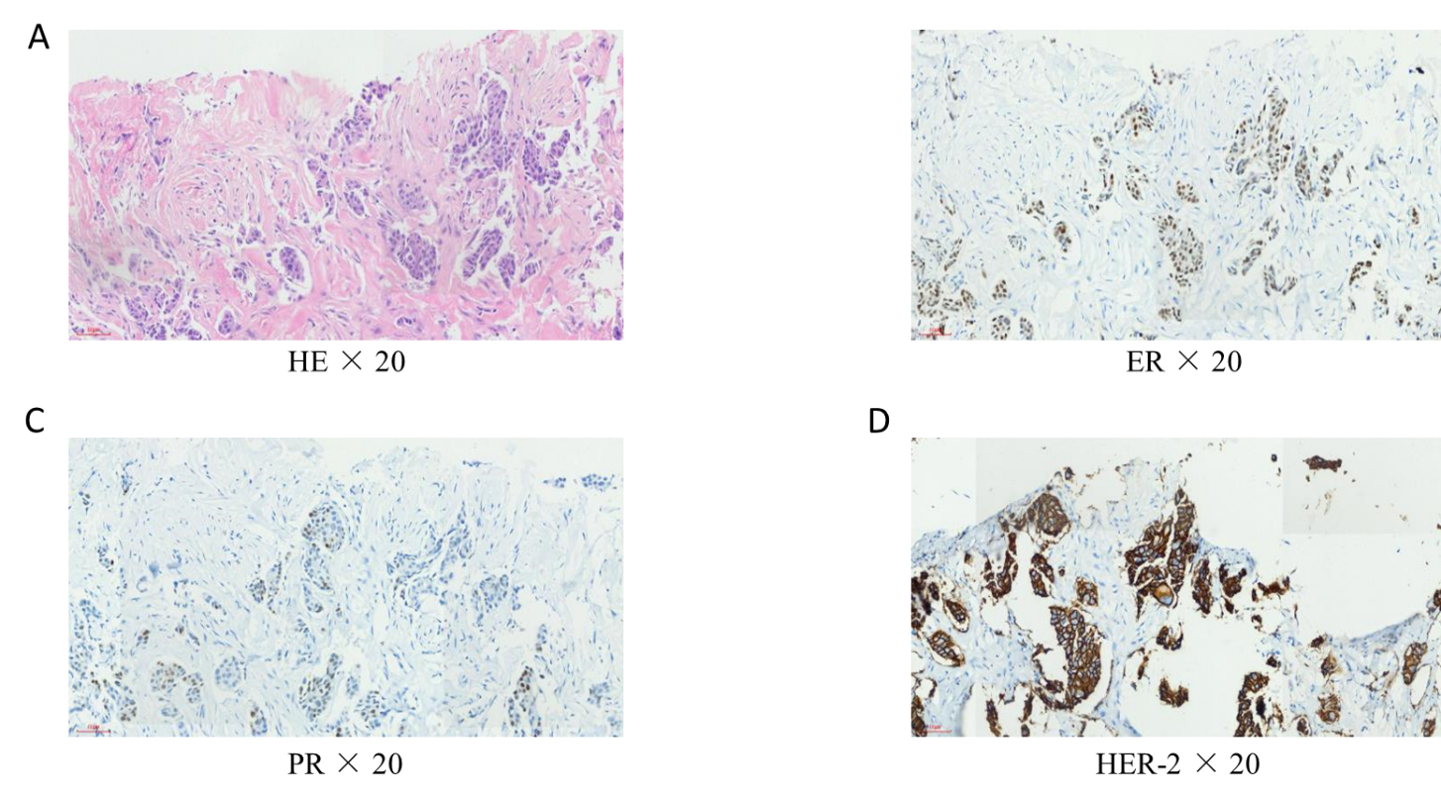
Figure 1 Immunohistochemical examination of the left breast mass. A: Hematoxylin-eosin staining, 20 ×; B: Estrogen receptor, 20 ×; C: Progesterone receptor, 20 ×; D: Human epidermal factor receptor 2, 20 ×. HE: Hematoxylin-eosin; ER: Estrogen receptor; PR: Progesterone receptor; HER2: Human epidermal factor receptor 2.

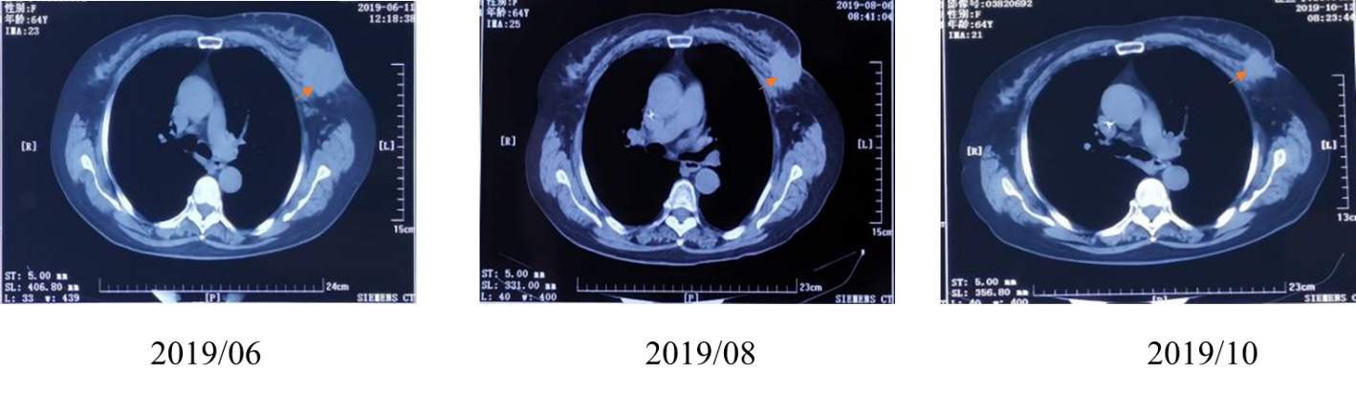
Figure 2 Left breast mass before and after neoadjuvant therapy on computed tomography examination.

