Name of Journal: World Journal of Clinical Cases
Manuscript NO: 77086
Manuscript Type: CASE REPORT

Chondrosarcoma of the toe: a case report and literature review

Zhou LB et al. Chondrosarcoma of the toe

Li-Bo Zhou, He-Cheng Zhang, Zai-Gang Dong, Chao-Chao Wang

Li-Bo Zhou, He-Cheng Zhang, Zai-Gang Dong, Graduate School, Qinghai University, Xining 810016, Qinghai Province, China

Chao-Chao Wang, Department of Bone and Joint Surgery, the Affiliated Hospital of Qinghai University, Xining 810012, Qinghai Province, China

Author contributions: Zhou LB and Wang CC designed the study; Zhang HC collected the data; Zhou LB drafted the manuscript; Wang CC analyzed and interpreted the imaging and pathology results; Dong ZG performed patient follow-up; and All authors have read and approved the manuscript.

Corresponding author: Chao-Chao Wang, md, Attending Doctor, Department of Bone and Joint Surgery, the Affiliated Hospital of Qinghai University, No. 29 Tongren Road, Chengxi District, Xining 810012, Qinghai Province, China. 490209397@qq.com

Received: April 26, 2022
Revised: June 25, 2022
Accepted: July 22, 2022
Published online:

Abstract
BACKGROUND
Chondrosarcoma of the foot is a rare malignant bone tumour, and it is even rarer when it originates in a toe bone. Surgical excision is the only effective treatment. The osteolytic destruction of the tumour severely affects limb function and carries the risk of distant metastasis. Most such tumours are removed surgically to minimize local recurrence and distant metastases, maximize limb function, and prolong the patient's tumour-free survival time. The main objective of this article is to present the case of a chondrosarcoma that invaded the first phalanx of the left foot and formed a large phalangeal mass with osteolytic destruction of the distal bone.

CASE SUMMARY
A 74-year-old man suffered from swelling of his left toe for six months, with pain and swelling for two months. Computed tomography and magnetic resonance imaging showed that the tumour on the first phalanx of the left foot was approximately 54.9 mm × 44.6 mm, surrounded by a significant soft tissue signal mass, with osteolytic destruction of the distal phalanx and a speckled bone-like high-density shadow within it.

CONCLUSION
Chondrosarcoma occurring in a toe bone is extremely rare. In this case, extensive surgical resection of the large low-grade chondrosarcoma, which showed osteolytic destruction and invaded the distal metatarsal bone, was safe and effective.

Key Words: Chondrosarcoma; Phalanges tumour; Diagnosis; Surgery; Case report

Zhou LB, Zhang HC, Dong ZG, Wang CC. Chondrosarcoma of the toe: a case report and a literature review. World J Clin Cases 2022; In press

Core Tip: The main objective of this article is to present a case of chondrosarcoma that invaded the first phalanx of the left foot and formed a sizeable phalangeal mass with osteolytic destruction of the distal bone. Chondrosarcoma originating in a toe bone has only been sporadically reported, and this case report will help clinicians better understand this rare lesion.

INTRODUCTION
Chondrosarcoma is the second most common primary malignant tumour of bone, accounting for approximately 25% of all primary bone tumours. It has an annual incidence of approximately 6.63 per 1 million people and is characterized by the production of tumourigenic cartilage^{[1-3]}. Chondrosarcoma can occur at any age, with a mean age of 50 years, and it affects slightly more men than women (55%: 45%)^{[4]}. The anatomical sites most commonly involved in chondrosarcoma include the long tubular bone (40%), pelvis (25%), and scapula^{[3,5]}.
Chondrosarcoma of the foot is a rare malignant bone tumour. One study found that the prevalence of chondrosarcoma of the foot is approximately 3.0%, with the highest prevalence in the metatarsal bone, and the overall survival of chondrosarcoma of the foot is better than that of chondrosarcoma of other anatomical sites^{[6]}. It is even rarer when it arises in phalanges, the incidence of which has not been clearly established and has rarely been reported in the literature. Chondrosarcoma is insensitive to radiation and chemotherapy; thus, surgery remains the preferred treatment modality. This case report expands the literature on chondrosarcoma of the toe and will help clinicians better understand this rare lesion.

CASE PRESENTATION
Chief complaints
A 74-year-old man suffered from swelling of his left toe for six months, with pain and swelling for two months.

History of present illness
A painless left calcaneal mass observed over six months presented with a rapidly enlarging mass, a significant increase in size, and localized symptoms of pain and swelling for two months.

History of past illness
He reported that he had noticed a mass on the lesser toe of his left foot that had gradually increased in size over the past six months and was not taken seriously.

Personal and family history
He had no family history of chondrosarcoma disease or any other disease.

Physical examination
Physical examination showed swelling of the left calcaneus and a palpable round mass of approximately 60.0 mm x 50.0 mm in size with a mallet-like appearance. The mass was soft, with tenderness on palpation and indistinct borders. The movement of the interphalangeal joint and the metatarsophalangeal joint was limited. Other physical examination findings were normal.

Laboratory examinations
The results of routine blood tests and biochemical tests were normal.

Imaging examinations
computed tomography (CT) and magnetic resonance imaging (MRI) showed a large tumour in the first phalanx of the left foot. A CT scan showed osteolytic destruction of the distal bone of the first phalanx of the left foot, with a local soft tissue density mass of approximately 54.9 mm × 44.6 mm, a local CT value of approximately 21 HU, and a speckled bone-like high-density shadow within it (Figure 1). MRI + enhancement showed that the typical shape of the first phalanx of the left foot had disappeared, and a large soft tissue signal mass with equal length T1 Weighted Image (T1WI) signals was seen around it (Figure 2).

FINAL DIAGNOSIS
The final diagnosis was chondrosarcoma.

TREATMENT
The preoperative imaging findings were suggestive of malignant occupancy of the first phalanx of the left foot with the possible distal invasion of the adjacent metatarsals. All routine blood tests, biochemical tests, and chest radiographs were within normal limits, and parallel CT examinations of the head, chest, abdomen, and pelvis revealed no metastatic lesions or other tumourigenic lesions.
The patient and his family were informed of his condition based on the imaging findings and clinical symptoms. Due to the possibility of invasion of the adjacent distal metatarsal bone, the patient was advised to undergo extensive resection, and the patient and his family agreed. A joint surgeon performed the surgical treatment. The surgeon performed an osteotomy of the first phalanx of the left foot and distal bone removal of the adjacent metatarsal. The tumour tissue was excised and sent for histopathological examination.

OUTCOME AND FOLLOW-UP
The pathological result was reported as highly differentiated cartilaginous sarcoma (low-grade malignancy) (Figure 3). The patient was followed up for 30 mo after surgery, and the patient was in good condition with no tumour recurrence or distant metastasis (Figure 4).

DISCUSSION
Clinical manifestations
Chondrosarcoma is a malignant tumour of mesenchymal cell origin that can be primary or secondary to benign cartilage tumours^{[7]}. A common clinical symptom of chondrosarcoma is localized pain with or without a significant mass. Local pain is an essential feature for distinguishing chondrosarcoma from benign cartilage tumours. This pain is thought to be caused by invasive growth of the chondrosarcoma, and the pain increases with increasing malignancy. At first, the pain is often intermittent and mild, and then it gradually develops into persistent severe pain, nocturnal pain, and tenderness. When the tumours is located close to the joint, the movement of the joint can be limited, and the surrounding soft tissue mass can be easily palpated.

Imaging and pathology
Early diagnosis facilitates effective treatment and improves the prognosis of patients with chondrosarcoma. In addition to the above nonspecific symptoms and signs, the diagnosis of chondrosarcoma mainly relies on imaging evaluation and histopathological characterization. Compared with X-rays, CT is more reliable and sensitive for diagnosing chondrosarcoma, especially with small tumours or tumours that have complex anatomical locations. CT is superior to X-rays for the detection of calcifications^{[8]}. The most common manifestations of chondrosarcoma on X-ray or CT are "ring", "arc," or "popcorn" calcifications and invasive growth; osteolytic changes are also common^{[9]}. The specific imaging signs depend on the type and grade of the chondrosarcoma. Calcification of high-grade chondrosarcoma is rare.
For example, intramedullary chondrosarcoma often presents with osteolytic changes and osteosclerosis, often accompanied by calcification. In clear cell chondrosarcoma, calcification occurs in only 30% of cases. Dedifferentiated chondrosarcoma shows a "biphasic sign" on X-ray or CT. Its imaging manifestations are closely related to the two pathological components in the tumour and depends on the proportion of low-grade and high-grade areas of the lesion^{[8,10]}. MRI is superior to the other techniques in terms of soft-tissue contrast. In typical cases, the edges of the lesion may show lobulated changes with a low or medium signal on T1WI and a high signal on T2 Weighted Image. The combination of MRI diffusion-weighted imaging and enhancement also allows for accurate staging of the lesion. Low-grade lesions tend to show interval and peripheral enhancement, whereas high-grade lesions tend to show diffuse enhancement of the solid component of the lesion, mostly accompanied by a large nonenhancing necrotic shadow^{[11]}.
Pathological classification of chondrosarcoma, according to the WHO classification of bone and soft tissue tumours in 2020, is divided into conventional, periosteal, and clear cell mesenchymal and dedifferentiated chondrosarcoma. Conventional chondrosarcoma is divided into grades I, II, and III^{[12]}. Eighty-five percent of chondrosarcomas are primary and of the conventional type^{[1]}. Chondrosarcomas are central (intramedullary), periosteal, or peripheral according to their location in the bone. Chondrosarcomas are classified into primary and secondary chondrosarcomas by the source^{[13]}. Since the recurrence rate and prognosis of tumours after surgery for intermediate (locally invasive) atypical cartilaginous tumour/chondrosarcoma grade I (atypical cartilaginous tumour, ACT/chondrosarcoma grade I, CS1) differ significantly from site to site, mainly because the location of the tumour determines the prognosis, the new version of the guidelines split atypical cartilaginous tumour/chondrosarcoma grade I into ACT and CS1 based on the anatomical location, with the former retained in the intermediate type and the latter upgraded to malignant disease. The diagnosis of ACT occurring in the tubular bones of the extremities and the diagnosis of CS1 occurring in the mesial bones, such as the skull base, pelvis, and scapula, suggest the need for complete surgical resection^{[14]}.
Chondrosarcoma histological grade (Evans grade) is categorized as grade I (low grade), grade II (intermediate grade), or grade III (high grade). Grade I and II chondrosarcoma have a good prognosis, while grade III chondrosarcoma has a high recurrence and metastasis rate^{[15]}. Grossly, the growth is lobulated, the cut surface is translucent or white with hyaline brittle tissue or even gel-like mucus, and cystic changes can be seen. It can be sandy due to calcification and can be rigid or soft. Microscopically, the density of grade I chondrocytes is low, the nucleus is fat and deeply stained, binucleate cells are occasionally seen, and there are no mitotic images. The density of grade II chondrocytes is increased, the nucleus is increased, the chromatin is thickened, heteromorphism and binucleate cells appear, and mitotic images can be seen. Grade III has a high cell density, with prominent atypia, pleomorphism, and mitotic images. Spindle cells around the leaflets are immature. Mutations of isocitrate dehydrogenase type 1 (IDH1) or isocitrate dehydrogenase type 2 (IDH2) may exist in primary central chondrosarcoma and periosteal chondrosarcoma^{[16]}.

Secondary chondrosarcoma
Secondary chondrosarcoma originates from osteochondroma or endogenous chondrosarcoma. Clinically, they present as new painful episodes of existing lesions, and their histological presentation is indistinguishable from that of primary conventional chondrosarcoma. Osteochondroma is one of the most common benign tumors of bone. Multiple cases often have a family history called hereditary multiple osteochondromas (HMOs), also known as hereditary multiple exostoses. HMO is an autosomal dominant inherited abnormality of skeletal development^{[17]}. Osteochondromas account for approximately 80% or more of secondary chondrosarcomas. The average age at diagnosis is 35 years, which is much younger than that for primary chondrosarcoma.
For patients with isolated exophytic warts, the lifetime risk of malignant transformation is approximately 0.4%-2%, compared to 5%-25% for patients with HMO^{[18]}. The cartilage cap indicates tumour malignancy, and MRI can show this structure. A larger cartilage cap can indicate malignancy, but there is no significant correlation between the thickness of the cartilage cap and the malignancy rate in young patients^{[19]}. One study showed that for cartilage caps of approximately 2 cm, the sensitivity and specificity of MRI and CT were 100% and 98% and 100% and 95%, respectively^{[20]}. However, imaging and clinical aspects are vital because marginal cartilage caps with stable clinical and imaging presentation are unlikely to be cancerous, whereas rapid enlargement may indicate malignant changes.
Chondroma is a common benign tumour of bone. Cases that occur in the bone marrow cavity are called endogenous chondroma, and those that occur on the bone surface are called periosteal chondroma. This disease can have single or multiple lesions, and cases with multiple lesions are called endogenous chondromatosis. Endogenous chondromatosis combined with skeletal deformities is called Ollier's disease, whereas endogenous chondromatosis combined with soft tissue (and occasionally visceral) haemangiomas of the limbs is called Maffucci syndrome^{[21]}.
Both diseases are nonhereditary benign diseases and are related to gene mutations of IDH1 or IDH2^{[22]}. Solitary endophytic chondroma has a 1-9% risk of malignant transformation. Approximately 40% of Ollier's disease cases and more than 50% of Maffucci syndrome cases can be secondary to chondrosarcoma^{[23]}. Almost all patients with Maffucci syndrome will develop malignant transformation. In addition to secondary skeletal system tumours, pancreatic cancer or biliary tract cancer can also occur^{[24]}.
Özmanevra et al^{[25]} reported a patient initially diagnosed with endogenous chondroma who received curettage and bone grafting. The tumour recurred locally seven months after the operation and was then diagnosed as grade 2 chondrosarcoma, followed by resection of the proximal phalanx of the third toe. At the one-year follow-up, the patient survived tumour-free. Therefore, lifelong monitoring is required for patients with endogenous chondromatosis.

Prognosis
It remains controversial which factors affect the prognosis of chondrosarcoma, but tumour grading has clear prognostic significance. The survival and metastatic potential of chondrosarcoma are closely related to histological grade. Evans et al^{[15]} found 10-year survival rates of 83%, 64%, and 29% for grade I, II, and III chondrosarcomas, respectively. There were 40%, 60%, and 47% local recurrence rates for low, medium, and high grades, respectively. The metastasis rate is low for low-grade chondrosarcomas, 10% for intermediate-grade metastases, and 71% for high-grade metastases. Patients undergoing margin-negative surgery have a reduced risk of local tumour recurrence and improved survival. However, even if they undergo margin-negative surgery, patients with grade III chondrosarcoma will eventually die from recurrence and metastasis^{[26]}.
The current case is a 74-year-old male patient with a disease course of 8 mo. Although most of the tumour cells were well differentiated (mildly heterogeneous chondrocytes) and mitotic images were rare, cortical destruction and soft tissue expansion were apparent. Therefore, the patient underwent extensive surgical resection. The patient was free of tumor tumour recurrence and distant metastasis at the 30 mo postoperative follow-up. The most current version of the guideline diagnoses ACT/CS1 occurring in tubular bones of the extremities as ACT because of its relatively short anatomy, relatively easy surgical resection, maximum negative margins, and significantly lower tumour recurrence rate. Hence, patients have a longer tumour-free survival time.

Treatment modality
Surgical resection remains the treatment of choice for primary or secondary chondrosarcoma. According to the Enneking staging^{[27]}, surgical resection is classified as local, extensive, or radical resection. Local resection includes intracapsular curettage and marginal resection, intracapsular curettage is used for central tumours, and marginal resection is used for peripheral tumours. Local excision is used when the tumour is distant from the joint when cortical destruction and soft tissue invasion are not severe. Extensive resection is used when the tumour is close to the joint, has cortical destruction, or has severe soft tissue invasion. When anatomically permitted, the critical treatment for chondrosarcoma is a radical operation; that is, the margin of the resected malignant tumour is negative under the microscope. According to Laitinen et al^{[28]}, complete surgical resection reduces the risk of local recurrence of the tumour.
Chondrosarcoma originating in the toe bone is usually of low grade (grade I), but controversy still exists regarding the surgical approach to grade I chondrosarcoma. According to the latest guidelines, some surgeons suggest that intrathecal curettage and local adjuvant treatment should be adopted for treating the tubular bones of limbs, such as electric knife cauterization, bone cement, high-speed grinding, drilling, ethanol, phenol, and liquid nitrogen^{[2,29]}.
We searched the following 8 databases: four English medical databases [MEDLINE (PubMed), EMBASE, The Cochrane Central Register of Controlled Trials (Cochrane Library)], Web of Science Database, and four Chinese medical databases [the China National Knowledge Database (CNKI), Journal Integration Platform (VIP), WanFang Database and SinoMed (CBM]). We also manually searched the additional relevant studies using the references of the systematic reviews that were published previously. All of the searches were performed from inception to April 2022 and did not impose restrictions on language, population or country. The following search strategy was used for PubMed and was modified to suit other databases.
#1 (chondrosarcoma[Title/Abstract])
#2 (Toe [Title/Abstract])
#1 AND #2
Literature inclusion and exclusion criteria were as follows: (1) The site of the disease was in the toe; (2) Pathologically diagnosed as chondrosarcoma; (3) Chondrosarcoma was the main lesion; and (4) Not combined with other malignant diseases. Figure 5 illustrates the study selection process.
Searching the relevant database, there were 5 cases of chondrosarcoma of the phalanx. Two of the patients had grade 1 chondrosarcoma. The patients underwent resection of the first phalanx of the right foot or resection of the mass on the first phalanx of the left foot with scraping of the proximal phalanx. At the 1-year postoperative follow-up, none of the patients had local recurrence or distant metastases^{[30,31]}. Masuda et al^{[32]} reported a case of primary grade 2 chondrosarcoma in which the patient underwent resection of the distal half of the second proximal phalanx of the right foot. There was no evidence of recurrence or metastasis at two years of follow-up. Özmanevra et al^{[25]} reported a secondary grade 2 chondrosarcoma case with proximal phalangeal resection of the lesser toe. At the one-year follow-up, the patient was tumour-free. We found that patients with grade 2 chondrosarcoma of the toe bone had a better prognosis than those with chondrosarcoma of other sites. In addition, studies have shown that the prognosis of secondary chondrosarcoma is similar to that of primary chondrosarcoma, and the 5-year survival rate is approximately 90%^{[19]}. It has been suggested that the flexor and extensor tendon sheaths are natural barriers that limit the spread of toe tumours; thus, metastases are uncommon^{[24]}. The recurrence rate and metastasis rate of grade 3 chondrosarcoma are relatively high. Rafi et al^{[33]} reported that a patient with grade 3 chondrosarcoma of the right foot and toe underwent amputation treatment. Left orbital and left infratemporal metastasis occurred, causing swelling and pain and gradual vision loss in the left eye.
A literature review showed that the local recurrence rate was only 0%-7.7% when intracapsular curettage was used for the resection of central low-grade chondrosarcoma of the limbs^{[34]}. Chen et al^{[3]} showed that intracapsular curettage was a safe and functional method for treating central primary grade I chondrosarcoma. Lesenský et al^{[35]} concluded that curettage is the treatment of choice for ACT/Grade I tumours; however, surgeons should be aware of the potentially high local recurrence and recurrence rates. Resection is recommended for Grade II and Grade III chondrosarcomas. However, the Dierselhuis et al^{[36]} meta-score noted that the current level of evidence does not yet adequately support local excision as a treatment modality for low-grade chondrosarcoma of the extremities. For grade II and III chondrosarcomas, extensive resection with negative margins should be performed^{[37]}. Although chondrosarcoma of the foot has a low risk of recurrence and metastasis, all patients require long-term follow-up. The previously reported cases are listed in Table 1.
Chondrosarcomas are considered radiation-resistant tumours. However, the exact mechanism has not been clarified. Several ideas have been proposed, such as the ability to inhibit reactive oxygen species and the high expression of antiapoptotic genes^{[38,39]}. Goda et al^{[40]} showed that preoperative or postoperative radiotherapy as an adjuvant treatment could reduce local tumour recurrence. Therefore, radiotherapy can be administered to patients with inoperable or incomplete resection and tumour recurrence, but its therapeutic significance is not yet supported by high-level clinical evidence. Chemotherapy is usually ineffective for chondrosarcoma, especially for conventional and dedifferentiated types. In the future, protein inhibitors targeting altered molecular pathways and mutated genes may become a focus for targeted therapies.

CONCLUSION
Chondrosarcoma is a rare malignant bone tumour, and it is even rarer when it occurs in a toe. Local excision is feasible for low-grade chondrosarcoma of the phalanx, which can minimize surgical trauma while preserving the function and aesthetics of the limb. However, considering the risk of tumour recurrence and metastasis, clinicians should carefully select cases that are not obviously aggressive on imaging, and for patients with chondrosarcoma of grades I (aggressive), II, and III, extensive excision with negative margins is the preferred initial treatment.

ACKNOWLEDGEMENTS
First, we would like to thank the patients and their families for their participation and the faculty members who provided imaging and pathology information for writing this article.

REFERENCES
1 Laitinen MK, Evans S, Stevenson J, Sumathi V, Kask G, Jeys LM, Parry MC. Clinical differences between central and peripheral chondrosarcomas. Bone Joint J 2021; 103-B: 984-990 [PMID: 33934657 DOI: 10.1302/0301-620X.103B5.BJJ-2020-1082.R2]
2 Weinschenk RC, Wang WL, Lewis VO. Chondrosarcoma. J Am Acad Orthop Surg 2021; 29: 553-562 [PMID: 33595238 DOI: 10.5435/JAAOS-D-20-01188]
3 Chen X, Yu LJ, Peng HM, Jiang C, Ye CH, Zhu SB, Qian WW. Is intralesional resection suitable for central grade 1 chondrosarcoma: A systematic review and updated meta-analysis. Eur J Surg Oncol 2017; 43: 1718-1726 [PMID: 28666625 DOI: 10.1016/j.ejso.2017.05.022]
4 Hua KC, Hu YC. Treatment method and prognostic factors of chondrosarcoma: based on Surveillance, Epidemiology, and End Results (SEER) database. Transl Cancer Res 2020; 9: 4250-4266 [PMID: 35117792 DOI: 10.21037/tcr-20-357]
5 Wellings EP, Mallett KE, Parkes CW, Labott JR, Rose PS, Houdek MT. Impact of tumour stage on the surgical outcomes of scapular chondrosarcoma. Int Orthop 2022; 46: 1175-1180 [PMID: 35165786 DOI: 10.1007/s00264-022-05321-4]
6 Tsuda Y, Fujiwara T, Stevenson JD, Abudu A. Surgical outcomes of bone sarcoma of the foot. Jpn J Clin Oncol 2021; 51: 1541-1546 [PMID: 34345896 DOI: 10.1093/jjco/hyab118]
7 Leddy LR, Holmes RE. Chondrosarcoma of bone. Cancer Treat Res 2014; 162: 117-130 [PMID: 25070233 DOI: 10.1007/978-3-319-07323-1_6]
8 Soldatos T, McCarthy EF, Attar S, Carrino JA, Fayad LM. Imaging features of chondrosarcoma. J Comput Assist Tomogr 2011; 35: 504-511 [PMID: 21765311 DOI: 10.1097/RCT.0b013e31822048ff]
9 Herget GW, Uhl M, Opitz OG, Adler CP, Südkamp NP, Knöller S. The many faces of chondrosarcoma of bone, own cases and review of the literature with an emphasis on radiology, pathology and treatment. Acta Chir Orthop Traumatol Cech 2011; 78: 501-509 [PMID: 22217402]
10 Littrell LA, Wenger DE, Wold LE, Bertoni F, Unni KK, White LM, Kandel R, Sundaram M. Radiographic, CT, and MR imaging features of dedifferentiated chondrosarcomas: a retrospective review of 174 de novo cases. Radiographics 2004; 24: 1397-1409 [PMID: 15371616 DOI: 10.1148/rg.245045009]
11 Ollivier L, Vanel D, Leclère J. Imaging of chondrosarcomas. Cancer Imaging 2003; 4: 36-38 [PMID: 18211859 DOI: 10.1102/1470-7330.2003.0022]
12 Anderson WJ, Doyle LA. Updates from the 2020 World Health Organization Classification of Soft Tissue and Bone Tumours. Histopathology 2021; 78: 644-657 [PMID: 33438273 DOI: 10.1111/his.14265]
13 Gelderblom H, Hogendoorn PC, Dijkstra SD, van Rijswijk CS, Krol AD, Taminiau AH, Bovée JV. The clinical approach towards chondrosarcoma. Oncologist 2008; 13: 320-329 [PMID: 18378543 DOI: 10.1634/theoncologist.2007-0237]
14 Zhang HZ, Ding Y, Yang TT, Liu ZY, Jiang ZM. [Advances in molecular pathological diagnosis of bone tumors and changes in WHO classification in the 2020 edition]. Zhonghua Bing Li Xue Za Zhi 2020; 49: 1221-1226 [PMID: 33287504 DOI: 10.3760/cma.j.cn112151-20200415-00317]
15 Evans HL, Ayala AG, Romsdahl MM. Prognostic factors in chondrosarcoma of bone: a clinicopathologic analysis with emphasis on histologic grading. Cancer 1977; 40: 818-831 [PMID: 890662 DOI: 10.1002/1097-0142(197708)40:2<818::aid-cncr2820400234>3.0.co;2-b]
16 Amary MF, Bacsi K, Maggiani F, Damato S, Halai D, Berisha F, Pollock R, O'Donnell P, Grigoriadis A, Diss T, Eskandarpour M, Presneau N, Hogendoorn PC, Futreal A, Tirabosco R, Flanagan AM. IDH1 and IDH2 mutations are frequent events in central chondrosarcoma and central and periosteal chondromas but not in other mesenchymal tumours. J Pathol 2011; 224: 334-343 [PMID: 21598255 DOI: 10.1002/path.2913]
17 Pacifici M. Hereditary Multiple Exostoses: New Insights into Pathogenesis, Clinical Complications, and Potential Treatments. Curr Osteoporos Rep 2017; 15: 142-152 [PMID: 28466453 DOI: 10.1007/s11914-017-0355-2]
18 Ahmed AR, Tan TS, Unni KK, Collins MS, Wenger DE, Sim FH. Secondary chondrosarcoma in osteochondroma: report of 107 patients. Clin Orthop Relat Res 2003: 193-206 [PMID: 12782876 DOI: 10.1097/01.blo.0000069888.31220.2b]
19 Lin PP, Moussallem CD, Deavers MT. Secondary chondrosarcoma. J Am Acad Orthop Surg 2010; 18: 608-615 [PMID: 20889950 DOI: 10.5435/00124635-201010000-00004]
20 Bernard SA, Murphey MD, Flemming DJ, Kransdorf MJ. Improved differentiation of benign osteochondromas from secondary chondrosarcomas with standardized measurement of cartilage cap at CT and MR imaging. Radiology 2010; 255: 857-865 [PMID: 20392983 DOI: 10.1148/radiol.10082120]
21 Jurik AG. Multiple hereditary exostoses and enchondromatosis. Best Pract Res Clin Rheumatol 2020; 34: 101505 [PMID: 32253147 DOI: 10.1016/j.berh.2020.101505]
22 Cheng P, Chen K, Zhang S, Mu KT, Liang S, Zhang Y. IDH1 R132C and ERC2 L309I Mutations Contribute to the Development of Maffucci's Syndrome. Front Endocrinol (Lausanne) 2021; 12: 763349 [PMID: 34790172 DOI: 10.3389/fendo.2021.763349]
23 Verdegaal SH, Bovée JV, Pansuriya TC, Grimer RJ, Ozger H, Jutte PC, San Julian M, Biau DJ, van der Geest IC, Leithner A, Streitbürger A, Klenke FM, Gouin FG, Campanacci DA, Marec-Berard P, Hogendoorn PC, Brand R, Taminiau AH. Incidence, predictive factors, and prognosis of chondrosarcoma in patients with Ollier disease and Maffucci syndrome: an international multicenter study of 161 patients. Oncologist 2011; 16: 1771-1779 [PMID: 22147000 DOI: 10.1634/theoncologist.2011-0200]
24 Schwartz HS, Zimmerman NB, Simon MA, Wroble RR, Millar EA, Bonfiglio M. The malignant potential of enchondromatosis. J Bone Joint Surg Am 1987; 69: 269-274 [PMID: 3805090]
25 Özmanevra R, Calikoglu E, Mocan G, Erler K. Grade 2 Chondrosarcoma of the Great Toe: An Unusual Location. J Am Podiatr Med Assoc 2019; 109: 393-396 [PMID: 31599673 DOI: 10.7547/18-097]
26 Roitman PD, Farfalli GL, Ayerza MA, Múscolo DL, Milano FE, Aponte-Tinao LA. Is Needle Biopsy Clinically Useful in Preoperative Grading of Central Chondrosarcoma of the Pelvis and Long Bones? Clin Orthop Relat Res 2017; 475: 808-814 [PMID: 26883651 DOI: 10.1007/s11999-016-4738-y]
27 Andreou D, Ruppin S, Fehlberg S, Pink D, Werner M, Tunn PU. Survival and prognostic factors in chondrosarcoma: results in 115 patients with long-term follow-up. Acta Orthop 2011; 82: 749-755 [PMID: 22066552 DOI: 10.3109/17453674.2011.636668]
28 Laitinen MK, Parry MC, Le Nail LR, Wigley CH, Stevenson JD, Jeys LM. Locally recurrent chondrosarcoma of the pelvis and limbs can only be controlled by wide local excision. Bone Joint J 2019; 101-B: 266-271 [PMID: 30813783 DOI: 10.1302/0301-620X.101B3.BJJ-2018-0881.R1]
29 Bickels J, Campanacci DA. Local Adjuvant Substances Following Curettage of Bone Tumors. J Bone Joint Surg Am 2020; 102: 164-174 [PMID: 31613863 DOI: 10.2106/JBJS.19.00470]
30 Mondal SK. Chondrosarcoma of the distal phalanx of the right great toe: report of a rare malignancy and review of literature. J Cancer Res Ther 2012; 8: 123-125 [PMID: 22531530 DOI: 10.4103/0973-1482.95191]
31 Haliloglu N, Sahin G, Ekinci C. Periosteal chondrosarcoma of the foot: a case report. J Foot Ankle Surg 2010; 49: 488.e1-488.e4 [PMID: 20576447 DOI: 10.1053/j.jfas.2010.04.017]
32 Masuda T, Otuka T, Yonezawa M, Kamiyama F, Shibata Y, Tada T, Matsui N. Chondrosarcoma of the distal phalanx of the second toe: a case report. J Foot Ankle Surg 2004; 43: 110-112 [PMID: 15057858 DOI: 10.1053/j.jfas.2004.01.002]
33 Rafi M, Abbas S, Intakhab B, Shehzad A, Sultan G, Ahmed S, Maqbool A, Mohsin R, Bhutto K, Mubarak M, Hashmi A, Rizvi AUH. Chondrosarcoma of right big toe with metastases to left orbital and left infra temporal region. J Pak Med Assoc 2019; 69: 896-898 [PMID: 31201400]
34 Funovics PT, Panotopoulos J, Sabeti-Aschraf M, Abdolvahab F, Funovics JM, Lang S, Kotz RI, Dominkus M. Low-grade chondrosarcoma of bone: experiences from the Vienna Bone and Soft Tissue Tumour Registry. Int Orthop 2011; 35: 1049-1056 [PMID: 20803012 DOI: 10.1007/s00264-010-1065-x]
35 Lesenský J, Matejovsky ZJ, Vcelak J, Ostadal M, Hosova M, Bavelou C, Sioutis S, Bekos A, Mavrogenis AF. Chondrosarcomas of the small bones: analysis of 44 patients. Eur J Orthop Surg Traumatol 2021; 31: 1597-1602 [PMID: 33811526 DOI: 10.1007/s00590-021-02964-8]
36 Dierselhuis EF, Goulding KA, Stevens M, Jutte PC. Intralesional treatment versus wide resection for central low-grade chondrosarcoma of the long bones. Cochrane Database Syst Rev 2019; 3: CD010778 [PMID: 30845364 DOI: 10.1002/14651858.CD010778.pub2]
37 Fiorenza F, Abudu A, Grimer RJ, Carter SR, Tillman RM, Ayoub K, Mangham DC, Davies AM. Risk factors for survival and local control in chondrosarcoma of bone. J Bone Joint Surg Br 2002; 84: 93-99 [PMID: 11837841 DOI: 10.1302/0301-620x.84b1.11942]
38 Lechler P, Renkawitz T, Campean V, Balakrishnan S, Tingart M, Grifka J, Schaumburger J. The antiapoptotic gene survivin is highly expressed in human chondrosarcoma and promotes drug resistance in chondrosarcoma cells in vitro. BMC Cancer 2011; 11: 120 [PMID: 21457573 DOI: 10.1186/1471-2407-11-120]
39 de Jong Y, Ingola M, Briaire-de Bruijn IH, Kruisselbrink AB, Venneker S, Palubeckaite I, Heijs BPAM, Cleton-Jansen AM, Haas RLM, Bovée JVMG. Radiotherapy resistance in chondrosarcoma cells; a possible correlation with alterations in cell cycle related genes. Clin Sarcoma Res 2019; 9: 9 [PMID: 31160965 DOI: 10.1186/s13569-019-0119-0]
40 Goda JS, Ferguson PC, O'Sullivan B, Catton CN, Griffin AM, Wunder JS, Bell RS, Kandel RA, Chung PW. High-risk extracranial chondrosarcoma: long-term results of surgery and radiation therapy. Cancer 2011; 117: 2513-2519 [PMID: 21246520 DOI: 10.1002/cncr.25806]

Footnotes
Informed consent statement: The patient agreed to publish her medical records and images. Written informed consent was obtained from the patient.

Conflict-of-interest statement: All authors report no relevant conflicts of interest for this article.

CARE Checklist (2016) statement: The authors read the CARE Checklist (2016), and the manuscript was prepared and revised according to the CARE Checklist (2016).

Open-Access: This article is an open-access article that was selected by an in-house editor and fully peer-reviewed by external reviewers. It is distributed in accordance with the Creative Commons Attribution NonCommercial (CC BY-NC 4.0) license, which permits others to distribute, remix, adapt, build upon this work non-commercially, and license their derivative works on different terms, provided the original work is properly cited and the use is non-commercial. See: https://creativecommons.org/Licenses/by-nc/4.0/

Provenance and peer review: Unsolicited article; Externally peer reviewed.
Peer-review model: Single blind

Peer-review started: April 26, 2022
First decision: June 16, 2022
Article in press:

Specialty type: Orthopedics
Country/Territory of origin: China
Peer-review report’s scientific quality classification
Grade A (Excellent): 0
Grade B (Very good): B
Grade C (Good): C
Grade D (Fair): 0
Grade E (Poor): 0

P-Reviewer: Di Meglio L, Italy; Vahedi M, Iran S-Editor: Ma YJ L-Editor: A P-Editor: Ma YJ
Figure Legends
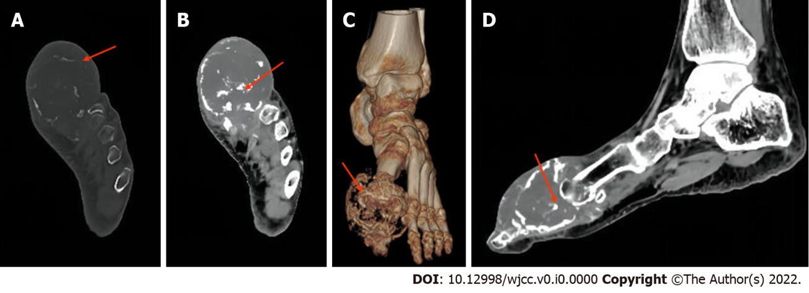
Figure 1 Computed tomography imaging of chondrosarcoma of the toe. A: Osteochondrosarcoma of the first phalanx of the left foot (arrow) [computed tomography (CT) axial bone window] shows osteolytic destruction of the distal bone of this phalanx; B: Osteochondrosarcoma of the first phalanx of the left foot (arrow) (CT axial soft tissue window) shows the longest diameter of the local soft tissue mass with speckled bony hyperintensity; C: Osteochondrosarcoma of the first phalanx of the left foot (arrow) (CT 3D view) showing osteolytic destruction of the distal bone of this phalanx; D: Osteochondrosarcoma of the first phalanx of the left foot (arrow) (CT sagittal soft tissue window) shows the widest diameter of the local soft tissue mass and the relationship of the lesion to the adjacent phalanx with a speckled bony hyperdense shadow.
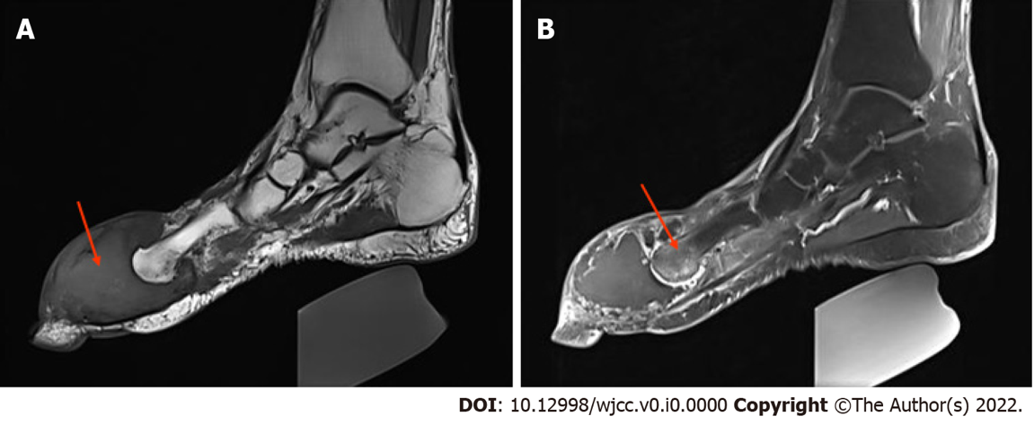
Figure 2 Magnetic resonance imaging of chondrosarcoma of the toe. A: T1 weighted imaging shows a low-signal shadow of the mass (arrow); B: The mass enhances heterogeneously and is seen to strengthen with intracompartmental separation-like enhancement and a high-signal shadow distal to the metatarsal bone (arrow).
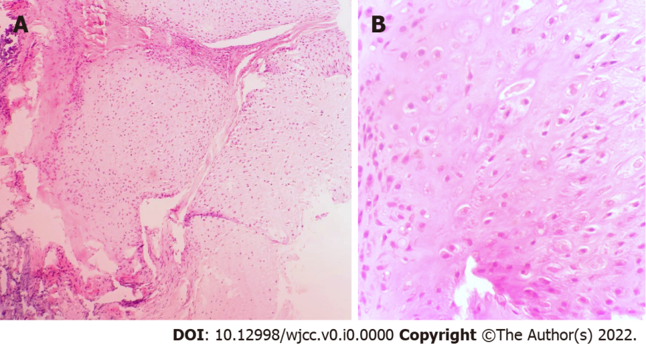
Figure 3 Pathology of chondrosarcoma of the toe. A: Haematoxylin and eosin-stained section of the tumour (× 20 magnification). Microscopically, there are many slightly heterotopic chondrocytes with large cell densities and binucleated and multinucleated types; B: Haematoxylin and eosin-stained section of the tumour (× 40 magnification). Most of the tumour cells are well differentiated, and some hypertrophic nuclear, large, binucleated cells can be seen in the background of the tumour cartilage tissue, with differing degrees of cell heterogeneity and rare nuclear schizophrenia.
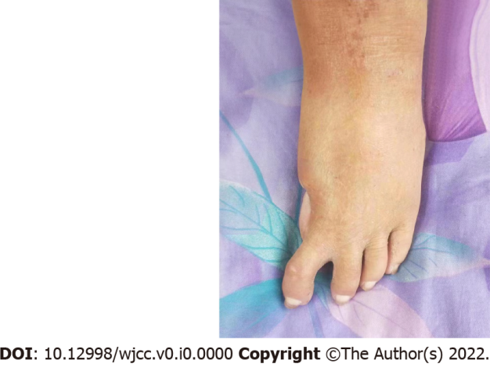
Figure 4 Postoperative photos of the patient. The patient underwent resection of the first phalanx of the left foot + distal bone tumour of the adjacent metatarsal and was followed up for 30 mo after surgery.
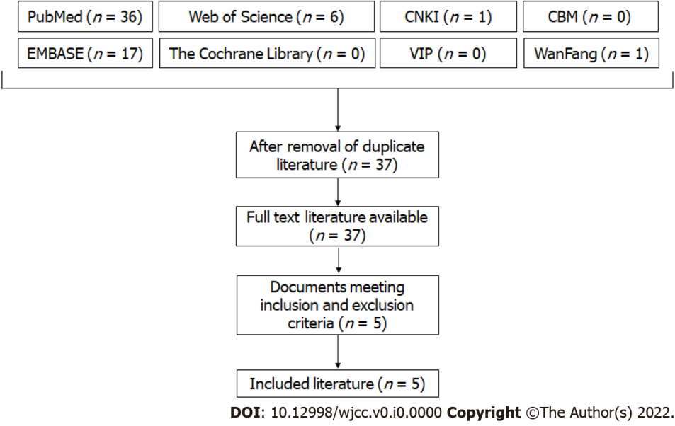
Figure 5 Flow diagram of the search process.
Table 1 Review of the literature of cases of chondrosarcoma of the toe bone
Ref. | Gender | Age, yr | Symptoms | Tumor Location | Histological grading | Treatment | Follow-up
Mondal^{[30]} | Male | 37 | The right big toe was gradually swollen and painful for nearly two years | Distal end of the first phalange of the right foot | Grade I | Excision of the big toe at the metatarsophalangeal joint | Followed up for 1 yr, there was no tumor recurrence or metastasis
Haliloglu et al^{[31]} | Female | 19 | Painless swelling of the left big toe for 6 yr | First phalanx of the left foot | Grade I | The mass was completely removed and the proximal phalanx was scraped | Followed up for 1 yr, there was no tumor recurrence or metastasis
Özmanevra et al^{[25]} | Female | 52 | Swelling of the left big toe | First phalanx of the left foot | Grade II | Excision of the proximal phalanx | Followed up for 1 yr, there was no tumor recurrence or metastasis
Masuda et al^{[32]} | Female | 32 | Pain, swelling and nail deformity of the second toe of the right foot for 6 mo | Second phalangeal bone of the right foot | Grade II | Resection of the distal part of the second proximal phalanx | Followed up for 2 yr, there was no tumor recurrence or metastasis
Rafi et al^{[33]} | Male | 56 | Pain, swelling and ill defined mass on the right toe | First phalangeal bone of the right foot | Grade III | Amputation (specific location unknown) | Left orbital and left infratemporal metastasis

