Name of Journal: World Journal of Clinical Cases
Manuscript NO: 48123
Manuscript Type: CASE REPORT

Pulmonary Langerhans cell histiocytosis in adults: A case report

Wang FF et al. A case of PLCH

Feng-Feng Wang, Ya-Shuang Liu, Wei-Bo Zhu, Yan-Dong Liu, Yao Chen

Feng-Feng Wang, Ya-Shuang Liu, Wei-Bo Zhu, Yan-Dong Liu, Yao Chen, Department of Respiration, People’s Hospital of Jingjiang, YangZhou University Medical Academy, Jingjiang 214500, Jiangsu Province, China

ORCID number: Feng-Feng Wang (0000-0003-1090-3679); Ya-Shuang Liu (0000-0002-9380-7895); Wei-Bo Zhu (0000-0002-8182-2238); Yan-Dong Liu (0000-0001-8064-6642); Yao Chen (0000-0001-7263-1168).

Author contributions: Wang FF designed the report; Zhu WB and Liu YD collected the patient’s clinical data and performed the tracheoscopy procedure; Liu YS analysed the imaging report; Chen Y revised the manuscript for intellectual content; Wang FF was a major contributor in writing of the manuscript; all the authors approved the final version of the article to be published.

Informed consent statement: Consent was obtained from the patient for publication of this report and accompanying images.

Conflict-of-interest statement: The authors have no conflict of interests to declare.

CARE Checklist (2016) statement: The authors have read the CARE Checklist (2016), and the manuscript was prepared and revised according to the CARE Checklist (2016).

Open-Access: This article is an open-access article that was selected by an in-house editor and fully peer-reviewed by external reviewers. It is distributed in accordance with the Creative Commons Attribution Non Commercial (CC BY-NC 4.0) license, which permits others to distribute, remix, adapt, build upon this work non-commercially, and license their derivative works on different terms, provided the original work is properly cited and the use is non-commercial. See: http://creativecommons.org/licenses/by-nc/4.0/

Manuscript source: Unsolicited manuscript

Corresponding author: Yao Chen, MD, Doctor, Department of Respiration, People’s Hospital of Jingjiang, YangZhou University Medical Academy, No. 28, Zhongzhou Road, Jingjiang 214500, Jiangsu Province, China. chenyao760@outlook.com
Telephone: +86-523-84996381
Fax: +86-523-84996381

Received: April 8, 2019
Peer-review started: April 8, 2019
First decision: June 12, 2019
Revised: June 16, 2019
Accepted: June 20, 2019
Article in press:
Published online:

Abstract
BACKGROUND
Langerhans cell histiocytosis (LCH) is a rare disease of unknown aetiology. While it may affect any organ of the body, few cases of solitary lung involvement are published in the literature. Here, we report a rare case of pulmonary LCH (PLCH) in an adult.

CASE SUMMARY
A 52-year-old man presented to hospital in July 2018 with complaints of progressively worsening cough with sputum, breathlessness, easy fatigability, and loss of appetite since 2016, and a 32-year history of heavy cigarette smoking (average 30 cigarettes/d). Physical examination showed only weakened breathing sounds and wheezing during lung auscultation. Chest computed tomography (CT) showed irregular micronodules and multiple thin-walled small holes. Respiratory function tests showed a slight decrease. Ultrasonic cardiogram showed mild tricuspid regurgitation and no pulmonary hypertension. Fibreoptic bronchoscopy was performed with transbronchial biopsies from the basal segment of right lower lobe. LCH was confirmed by immunohistochemistry. The final diagnosis was PLCH without extra-pulmonary involvement. We suggested smoking cessation treatment. A chest CT scan at 3-mo follow-up showed clear absorption of the nodule and thin-walled small holes. The symptoms of cough and phlegm had improved markedly and appetite had improved. There was no obvious dyspnoea.

CONCLUSION
Imaging manifestations of nodules, cavitating nodules, and thick-walled or thin-walled cysts prompt suspicion of PLCH and lung biopsy for diagnosis.

Key words: Pulmonary Langerhans cell histiocytosis; Adult; Smoking cessation; Imaging; Nodules; Case report

© The Author(s) 2019. Published by Baishideng Publishing Group Inc. All rights reserved.

Core tip: Langerhans cell histiocytosis (LCH) is a rare disorder of unknown aetiology and may affect any organ of the body. Local LCH that only affects the lungs is known as pulmonary LCH (PLCH). Reports of PLCH cases are relatively rare in the literature. This report describes the presentation, clinical investigation, and diagnosis of a PLCH case involving a 52-year-old man with a 1-year history of progressively worsening cough with sputum, breathlessness, easy fatigability, and loss of appetite, and a 32-yr history of heavy cigarette smoking. We also discuss the clinical presentation and signs, diagnosis, treatment, and outcome of such rare cases.

Wang FF, Liu YS, Zhu WB, Liu YD, Chen Y. Pulmonary Langerhans cell histiocytosis in adults: A case report. World J Clin Cases 2019; In press

INTRODUCTION
Langerhans cell histiocytosis (LCH) is a rare disorder of unknown aetiology that is characterised by the infiltration of involved tissues by dendritic cells sharing phenotypic similarities to Langerhans cells, which are often organized into granulomas^{[1]}. LCH lesions are comprised of cells with abundant eosinophilic cytoplasm and irregular nuclei with prominent folds and grooves. The characteristic immunophenotype includes expression of CD1A, S100, and langerin (CD207). The disease may affect patients of all ages, ranging from neonates to the elderly^{[2,3]}.
While LCH may affect any organ of the body, cases in children most frequently involve the bones (80% of cases), skin (33%), and pituitary gland (25%), followed by the liver, spleen, hematopoietic system or lungs (15% each), lymph nodes (5%-10%), or the central nervous system (2%-4%, excluding the pituitary)^{[1]}. Involvement of the so-called “risk organs” (i.e., the liver, spleen, and haematopoietic system) is a well-established unfavourable prognosticator. The different clinical forms of LCH have been categorised into systemic and localised forms. Localised LCH often affects the bone, skin, and lung, and is characterised by a good prognosis, with occasional spontaneous resolution^{[4]}.
Pulmonary LCH (PLCH) belongs to a group of rare pulmonary diseases. The prevalence of PLCH is unknown but may account for about 3%–5% of all adult diffuse lung diseases^{[5]}. The precise prevalence of PLCH may be higher than estimated in earlier studies because it may be asymptomatic, remit spontaneously, and be difficult to identify in very advanced forms. In this article, we present a patient who underwent bronchoscopic biopsy to confirm PLCH.

CASE PRESENTATION
Chief complaints
A 52-year-old man was admitted to our department with a year-long history of cough with sputum and breathlessness.

History of present illness
The patient reported progressively worsening cough with sputum, breathlessness, easy fatigability, and loss of appetite since 2016.

History of past illness
The patient denied any other medical conditions.

Personal and family history
The patient denied any family history of related diseases. He did, however, report heaving smoking for 32 years (30 cigarettes per day) and drinking liquor for 30 years (100 mL per day).

Physical examination upon admission
Physical examination showed stable vital signs, including blood pressure of 128/88 mmHg (normal range: 90-140/60-90 mmHg), pulse rate of 84/min (normal range: 60/min to 100/min), respiratory rate of 18/min (normal range: 16/min to 20/min), and temperature of 36.6 °C (normal range: 36.1-37 °C). Weakened breathing sounds and wheezing were detected during lung auscultation.

Laboratory examination
Arterial blood gas findings included: FiO₂, 21%; pH, 7.42; PCO₂, 43 mmHg; PO₂, 82 mmHg; SaO₂, 96%; HCO₃, 27.9 mmol/L; and buffer excess, 2.9 mmol/L. Full blood count showed haemoglobin of 166 g/L (normal range: 130-175 g/L), white blood cell count of 11.8 × 10⁹/L (normal range: 3.5 × 10⁹/L to 9.5 × 10⁹/L), neutrophil percentage of 70.9% (normal range: 40%-75%), lymphocyte count of 2.7 × 10⁹/L (normal range: 1.1 × 10⁹/L to 3.2 × 10⁹/L), eosinophil count of 0.14 × 10⁹/L (normal range: 0.02 × 10⁹/L to 0.52 × 10⁹/L), and platelet count of 395 × 10⁹/L (normal range: 125 × 10⁹/L to 350 × 10⁹/L). The C-reactive protein content was 10.23 mg/L (normal range: 0 mg/L to 8 mg/L). Liver function, renal function, electrolytes, and thyroid function were normal.

Imaging examination
Chest computed tomography (CT) at admission showed the texture to be increased and disordered, thickened bronchial wall, and diffuse patchy ground glass opacity, irregular micronodules, and multiple thin-walled small holes in both lungs (Figure 1A and 1B). There were no abnormalities in the skin or skeleton of the patient, and no pituitary dysfunction or other related clinical manifestations were found. No abnormalities were found in head, neck, and whole abdomen CT examinations.

Pathology examination
A fibreoptic bronchoscopy was performed to obtain transbronchial biopsies from the basal segment of right lower lobe. Haematoxylin-eosin staining showed a large number of typical Langerhans cells in the lung tissue, with abundant eosinophilic cytoplasm, irregular nuclei, and prominent folds and grooves. Immunohistochemical analysis revealed positivity for CD1a, S100, and CD68 (Figure 2).

FINAL DIAGNOSIS
Based on the clinical manifestations and imaging and pathology findings, the final diagnosis was PLCH without extra-pulmonary involvement.

TREATMENT
After comprehensively evaluating the patient's overall condition, we only recommended the patient to stop smoking, attend follow-up observation, and not to take other drugs during this time.

OUTCOME AND FOLLOW-UP
After smoking cessation, the symptoms of cough and phlegm improved markedly, there was no obvious dyspnoea, and the appetite had improved. Chest CT at 3 mo from the initial CT showed clear absorption of the nodules and thin-walled small holes (Figure 1C and 1D). The patient is still being followed as of the writing of this report.

DISCUSSION
PLCH can occur at any age, but the majority of cases reported involve adults (aged between 20 years and 40 years) and particularly cigarette smokers^{[6,7]}. The disorder is now considered a form of smoking-related overreactive immune response in the lung tissue, complicated by chronic inflammation and ultimately resulting in depositing of Langerhans cells into the interstitial area of the small airway^{[8-10]}.
Adult PLCH is generally diagnosed according to the presence of three main clinical manifestations^{[11-13]}. The respiratory symptoms, usually cough and dyspnoea, occur in about two-thirds of cases; the constitutional symptoms of fever, malaise, sweats, and weight loss have been described in 15%–20% of cases. A second manifestation is the acute development of a spontaneous pneumothorax, seen in about 15%–20% of cases; the spontaneous pneumothorax can occur at any time during the course of disease. The third manifestation is an incidental finding on routine chest radiography, reported in 5%–25% of cases. Symptoms generally arise 6–12 mo prior to recognition of the disorder, but in some individuals the diagnosis is established after many years of observation. At late stages of the condition, PLCH patients may develop pulmonary hypertension, characterized by dyspnoea at rest and the features of right-ventricular circulatory failure. However, chest physical examination often does not detect significant pathological signs. The most common auscultations are weakened breathing sounds, wheezes, rales, and drum sounds in the pneumothorax. The first symptoms of our patient were cough and dyspnoea, and physical examination findings were non-specific, with only weakened breathing sounds and wheezing during lung auscultation.
PLCH has a very typical radiological pattern, which may be diagnostic if clinically consistent. Chest high-resolution (HR) CT demonstrates a combination of nodules, cavitating nodules measuring 1–10 mm in diameter, and thick-walled or thin-walled cysts^{[14,15]}. Nodules and vacuolar nodules are common in the early disease state, while the appearance of advanced diseases is often cystic, or even honeycomb lung^{[14]}. Imaging pulmonary lesions are mainly located in the upper and middle lung fields, with fewer in the base of the lung. In our case, chest CT showed diffuse patchy ground glass opacity, irregular micronodules, and multiple thin-walled small holes in both lungs.
The characteristics of PLCH include the accumulation of a large number of CD1a⁺/CD207⁺ cells in loosely formed bronchiolocentric granulomas^{[16,17]}. This results in airspace invasion, cavitation, and consequent destruction of lung parenchyma. However, the underlying molecular mechanism is still unclear. The CD1a⁺/CD207⁺ cells can be obtained by bronchoalveolar lavage, bronchoscopic lung biopsy, and video-assisted thoracoscopic surgery biopsy. Although transbronchial lung biopsies may show LCH granulomas, a definitive diagnosis of PLCH is most commonly obtained through video-assisted thoracoscopic surgical biopsy guided by HRCT findings^{[18]}. Our patient was hospitalized for cough and dyspnoea and had abnormal chest CT examination. Immunohistochemical analysis of bronchoscopic lung biopsy detected CD1a⁺ cells and confirmed the diagnosis of PLCH.
At present, there is no definite therapeutic plan for PLCH. The first therapeutic approach recommended for patients affected by PLCH is smoking cessation^{[19,20]}. Corticosteroids are the second method, applied after smoking cessation. Cytotoxic drugs (e.g., inblastine, methotrexate, cyclophosphamide, and etoposide) are also used to treat progressive PLCH. Cladribine (2-chlorodeoxyadenosine), a purine nucleoside analogue, has been reported to induce remission or improve lung disease in several PLCH cases^{[21,22]}. Recently, a series of studies have confirmed that BRAF and MAP2K1 mutations occur in PLCH and that mutation-specific targeting therapy is effective^{[4]}. For patients with recurrent pneumothorax, pleural fixation can be used to improve life treatment. Lung transplantation may be considered in patients with end-stage or severe pulmonary hypertension. Our patient had no underlying disease and had isolated lung involvement, mild clinical symptoms, and slight decline in lung function. Therefore, after comprehensive assessment of the condition, the treatment recommended was only smoking cessation and close follow-up. After 3 mo, the patient's symptoms had improved significantly, and chest CT showed that nodules were obviously absorbed. The effect of smoking cessation was, thus, good.
The natural history of the disease is variable and difficult to predict in a single patient. In some patients, HRCT abnormalities may disappear partially or completely without treatment, especially after smoking cessation. In the first 2 years after diagnosis, up to 40% of patients may have a significant decrease in FEV1 or DLCO measurements^{[23]}. Five years later, 50% of the patients will experience impaired lung function over time, and some patients will develop obstructive pulmonary disease^{[24]}. In 10%-20% of patients, the first diagnosis is accompanied by severe clinical symptoms, which rapidly evolve into chronic or progressive respiratory failure^{[11,25]}.
Follow-up with a physical examination, chest radiography, and lung function tests should be performed periodically for PLCH. It is recommended that all patients undergo follow-up every 3–6 mo for the first year after diagnosis. Long-term follow-up is recommended and may detect respiratory dysfunction or a rare relapse with recurrent nodule formation^{[26]}. After 3 mo of smoking cessation, our patient was re-examined and his condition had improved significantly. However, close follow-up was still needed to track any changes in the condition over time. Other interventions should be given as early as possible to improve the prognosis of the disease.

CONCLUSION
PLCH is a rare pulmonary cystic disease, and its pathogenic mechanisms are not yet fully understood. Diagnosis of PLCH depends on the pathological manifestations of CD1a⁺ cell aggregation. At present, there is no definite treatment plan for PLCH. The primary treatment is quitting smoking, although cladribine and BRAF inhibitors are the most promising methods for the treatment of aggressive PLCH. Individualized treatment strategies based on each patient's condition are needed and will improve outcomes. It is still necessary to carry out long-term follow-up and observation of PLCH cases.

REFERENCES
1 Emile JF, Abla O, Fraitag S, Horne A, Haroche J, Donadieu J, Requena-Caballero L, Jordan MB, Abdel-Wahab O, Allen CE, Charlotte F, Diamond EL, Egeler RM, Fischer A, Herrera JG, Henter JI, Janku F, Merad M, Picarsic J, Rodriguez-Galindo C, Rollins BJ, Tazi A, Vassallo R, Weiss LM; Histiocyte Society. Revised classification of histiocytoses and neoplasms of the macrophage-dendritic cell lineages. Blood 2016; 127: 2672-2681 [PMID: 26966089 DOI: 10.1182/blood-2016-01-690636]
2 Aricò M, Girschikofsky M, Généreau T, Klersy C, McClain K, Grois N, Emile JF, Lukina E, De Juli E, Danesino C. Langerhans cell histiocytosis in adults. Report from the International Registry of the Histiocyte Society. Eur J Cancer 2003; 39: 2341-2348 [PMID: 14556926]
3 Weitzman S, Egeler RM. Langerhans cell histiocytosis: update for the pediatrician. Curr Opin Pediatr 2008; 20: 23-29 [PMID: 18197035 DOI: 10.1097/MOP.0b013e3282f45ba4]
4 Torre O, Elia D, Caminati A, Harari S. New insights in lymphangioleiomyomatosis and pulmonary Langerhans cell histiocytosis. Eur Respir Rev 2017; 26: [PMID: 28954765 DOI: 10.1183/16000617.0042-2017]
5 Vassallo R, Harari S, Tazi A. Current understanding and management of pulmonary Langerhans cell histiocytosis. Thorax 2017; 72: 937-945 [PMID: 28689173 DOI: 10.1136/thoraxjnl-2017-210125]
6 Vassallo R, Ryu JH, Colby TV, Hartman T, Limper AH. Pulmonary Langerhans'-cell histiocytosis. N Engl J Med 2000; 342: 1969-1978 [PMID: 10877650 DOI: 10.1056/nejm200006293422607]
7 Tazi A. Adult pulmonary Langerhans' cell histiocytosis. Eur Respir J 2006; 27: 1272-1285 [PMID: 16772390 DOI: 10.1183/09031936.06.00024004]
8 Bratke K, Klug M, Bier A, Julius P, Kuepper M, Virchow JC, Lommatzsch M. Function-associated surface molecules on airway dendritic cells in cigarette smokers. Am J Respir Cell Mol Biol 2008; 38: 655-660 [PMID: 18203971 DOI: 10.1165/rcmb.2007-0400OC]
9 Merad M, Ginhoux F, Collin M. Origin, homeostasis and function of Langerhans cells and other langerin-expressing dendritic cells. Nat Rev Immunol 2008; 8: 935-947 [PMID: 19029989 DOI: 10.1038/nri2455]
10 Vassallo R, Walters PR, Lamont J, Kottom TJ, Yi ES, Limper AH. Cigarette smoke promotes dendritic cell accumulation in COPD; a Lung Tissue Research Consortium study. Respir Res 2010; 11: 45 [PMID: 20420706 DOI: 10.1186/1465-9921-11-45]
11 Vassallo R, Ryu JH, Schroeder DR, Decker PA, Limper AH. Clinical outcomes of pulmonary Langerhans'-cell histiocytosis in adults. N Engl J Med 2002; 346: 484-490 [PMID: 11844849 DOI: 10.1056/NEJMoa012087]
12 Wei P, Lu HW, Jiang S, Fan LC, Li HP, Xu JF. Pulmonary langerhans cell histiocytosis: case series and literature review. Medicine (Baltimore) 2014; 93: e141 [PMID: 25415669 DOI: 10.1097/md.0000000000000141]
13 Mendez JL, Nadrous HF, Vassallo R, Decker PA, Ryu JH. Pneumothorax in pulmonary Langerhans cell histiocytosis. Chest 2004; 125: 1028-1032 [PMID: 15006964]
14 Brauner MW, Grenier P, Mouelhi MM, Mompoint D, Lenoir S. Pulmonary histiocytosis X: evaluation with high-resolution CT. Radiology 1989; 172: 255-258 [PMID: 2787036 DOI: 10.1148/radiology.172.1.2787036]
15 Brauner MW, Grenier P, Tijani K, Battesti JP, Valeyre D. Pulmonary Langerhans cell histiocytosis: evolution of lesions on CT scans. Radiology 1997; 204: 497-502 [PMID: 9240543 DOI: 10.1148/radiology.204.2.9240543]
16 Roden AC, Yi ES. Pulmonary Langerhans Cell Histiocytosis: An Update From the Pathologists' Perspective. Arch Pathol Lab Med 2016; 140: 230-240 [PMID: 26927717 DOI: 10.5858/arpa.2015-0246-RA]
17 Kambouchner M, Basset F, Marchal J, Uhl JF, Hance AJ, Soler P. Three-dimensional characterization of pathologic lesions in pulmonary langerhans cell histiocytosis. Am J Respir Crit Care Med 2002; 166: 1483-1490 [PMID: 12450935 DOI: 10.1164/rccm.2201050]
18 Lorillon G, Tazi A. How I manage pulmonary Langerhans cell histiocytosis. Eur Respir Rev 2017; 26 [PMID: 28877978 DOI: 10.1183/16000617.0070-2017]
19 Ninaber M, Dik H, Peters E. Complete pathological resolution of pulmonary Langerhans cell histiocytosis. Respirol Case Rep 2014; 2: 76-78 [PMID: 25473573 DOI: 10.1002/rcr2.54]
20 Wolters PJ, Elicker BM. Subacute onset of pulmonary langerhans cell histiocytosis with resolution after smoking cessation. Am J Respir Crit Care Med 2014; 190: e64 [PMID: 25436789 DOI: 10.1164/rccm.201405-0974IM]
21 Lazor R, Etienne-Mastroianni B, Khouatra C, Tazi A, Cottin V, Cordier JF. Progressive diffuse pulmonary Langerhans cell histiocytosis improved by cladribine chemotherapy. Thorax 2009; 64: 274-275 [PMID: 19252036 DOI: 10.1136/thx.2008.108944]
22 Grobost V, Khouatra C, Lazor R, Cordier JF, Cottin V. Effectiveness of cladribine therapy in patients with pulmonary Langerhans cell histiocytosis. Orphanet J Rare Dis 2014; 9: 191 [PMID: 25433492 DOI: 10.1186/s13023-014-0191-8]
23 Tazi A, de Margerie C, Naccache JM, Fry S, Dominique S, Jouneau S, Lorillon G, Bugnet E, Chiron R, Wallaert B, Valeyre D, Chevret S. The natural history of adult pulmonary Langerhans cell histiocytosis: a prospective multicentre study. Orphanet J Rare Dis 2015; 10: 30 [PMID: 25887097 DOI: 10.1186/s13023-015-0249-2]
24 Tazi A, Marc K, Dominique S, de Bazelaire C, Crestani B, Chinet T, Israel-Biet D, Cadranel J, Frija J, Lorillon G, Valeyre D, Chevret S. Serial computed tomography and lung function testing in pulmonary Langerhans' cell histiocytosis. Eur Respir J 2012; 40: 905-912 [PMID: 22441752 DOI: 10.1183/09031936.00210711]
25 Delobbe A, Durieu J, Duhamel A, Wallaert B. Determinants of survival in pulmonary Langerhans' cell granulomatosis (histiocytosis X). Groupe d'Etude en Pathologie Interstitielle de la Société de Pathologie Thoracique du Nord. Eur Respir J 1996; 9: 2002-2006 [PMID: 8902457]
26 Tazi A, Montcelly L, Bergeron A, Valeyre D, Battesti JP, Hance AJ. Relapsing nodular lesions in the course of adult pulmonary Langerhans cell histiocytosis. Am J Respir Crit Care Med 1998; 157: 2007-2010 [PMID: 9620939 DOI: 10.1164/ajrccm.157.6.9709026]

P-Reviewer: Turner AM S-Editor: Cui LJ L-Editor: Wang TQ E-Editor:

Specialty type: Medicine, research and experimental
Country of origin: China
Peer-review report classification
Grade A (Excellent): 0
Grade B (Very good): 0
Grade C (Good): C
Grade D (Fair): 0
Grade E (Poor): 0

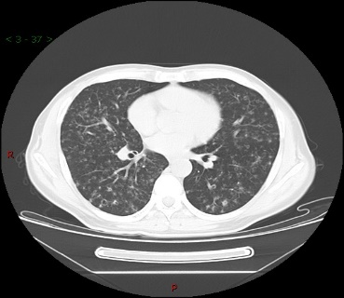
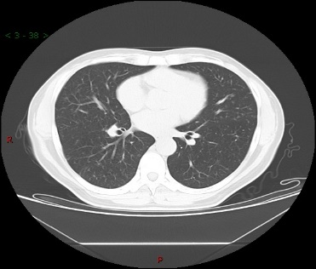
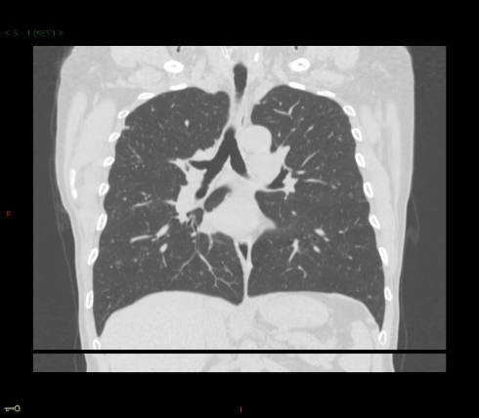

A B

C D

Figure 1 Findings from chest computed tomography scans at the lung window level from our patient. The characteristic nodulocystic pattern was detected at the time of pulmonary Langerhans cell histiocytosis diagnosis. A: Coronal scanning; B Cross-sectional scanning; C: Coronal scanning at 3 mo after smoking cessation. The lung nodulocystic lesions had disappeared significantly; and D: Cross-sectional scanning at 3 mo after smoking cessation. The lung nodulocystic lesions had disappeared significantly.

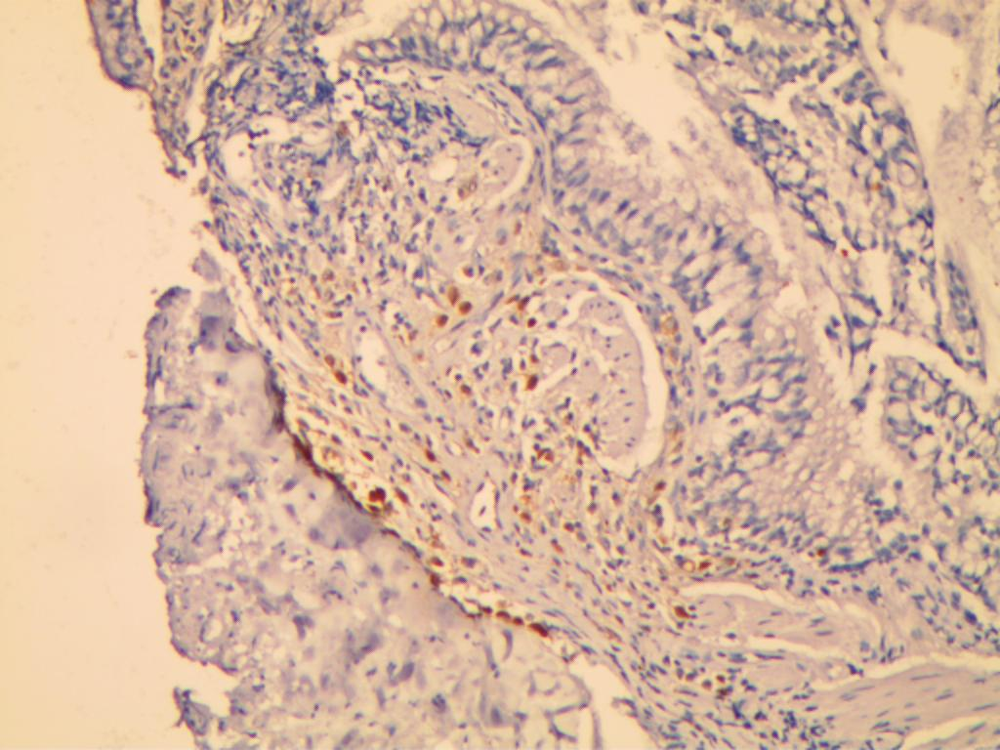
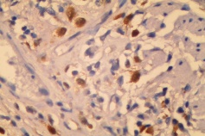
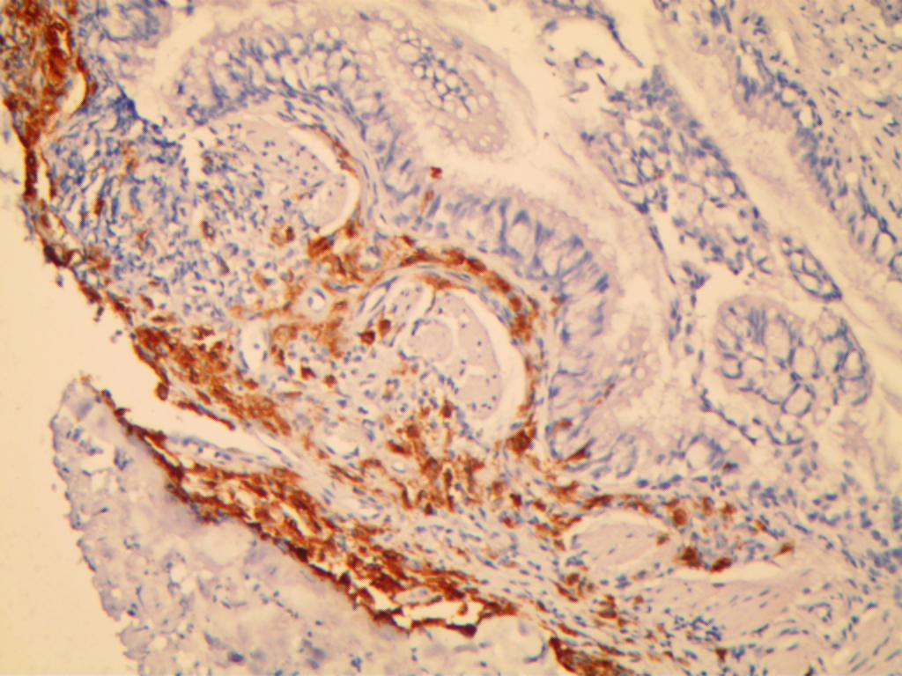
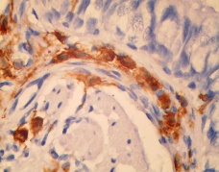
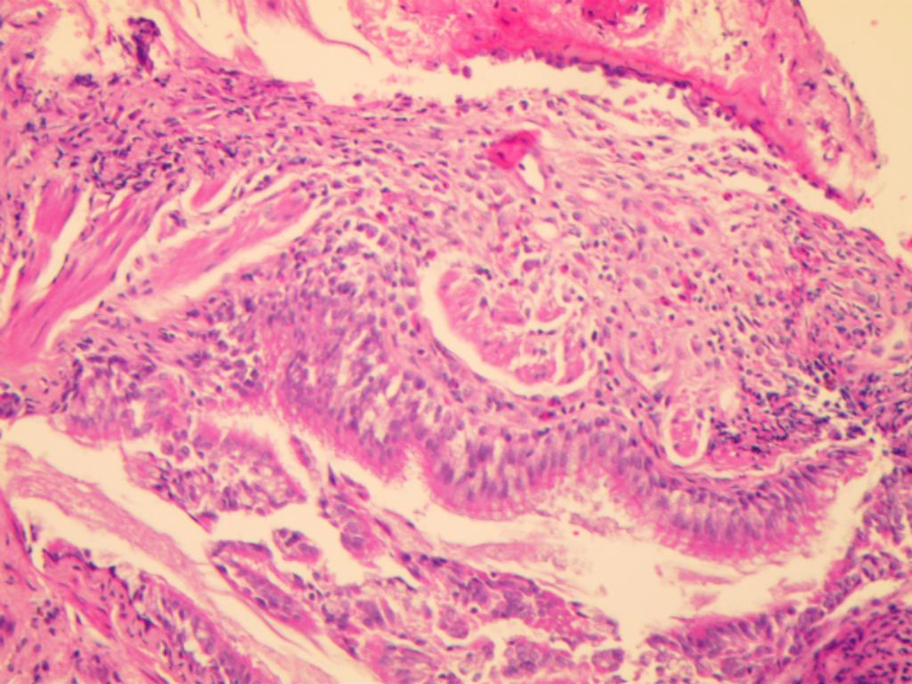
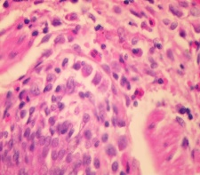

A B
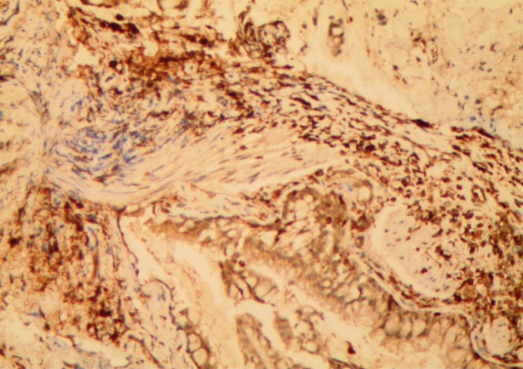
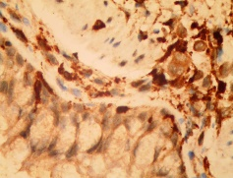

C D

Figure 2 Findings from pathological analyses of lung biopsy from our patient. A: Haematoxylin-eosin staining showed a large number of typical Langerhans cells in the lung tissue, with abundant eosinophilic cytoplasm, irregular nuclei, and prominent folds and grooves; B: Langerhans cells showed positive staining for CD1a; C: Langerhans cells showed positive staining for S-100; D: Langerhans cells showed positive staining for CD68.

