Name of Journal: World Journal of Clinical Cases
Manuscript NO: 71868
Manuscript Type: CASE REPORT

Extranasopharyngeal angiofibroma in children: A case report

Yan et al. Angiofibroma in Children

Yang-Yan Yan, Can Lai, Lei Wu, Yong Fu

Yang-Yan Yan, Yong Fu, Department of Otorhinolaryngology, Head and Neck Surgery, the Children's Hospital, Zhejiang University School of Medicine, National Clinical Research Center for Child Health, Hangzhou 310052, Zhejiang Province, China

Can Lai, Department of Radiology, the Children's Hospital, Zhejiang University School of Medicine, National Clinical Research Center for Child Health, Hangzhou 310052, Zhejiang Province, China

Lei Wu, Department of Endoscopy Center, the Children's Hospital, Zhejiang University School of Medicine, National Clinical Research Center for Child Health, Hangzhou 310052, Zhejiang Province, China

Author contributions: Yan YY and Fu Y contributed equally to this work; Yan YY, Lai C, Wu L and Fu Y participated the treatment of disease. Yan YY and Fu Y analyzed the case and wrote the manuscript; all authors have read and approve the final manuscript.

Corresponding author: Yong Fu, Doctor, PhD, Chief Doctor, Professor, Surgeon, Department of Otorhinolaryngology, Head and Neck Surgery, the Children's Hospital, Zhejiang University School of Medicine, National Clinical Research Center for Child Health, No. Binsheng Road 3333, Hangzhou 310052, Zhejiang Province, China. 1307022@zju.edu.cn

Received: September 24, 2021
Revised: December 11, 2021
Accepted: June 3, 2022
Published online: July 26, 2022

Abstract
BACKGROUND
Sporadic cases of extranasopharyngeal angiofibroma in children, especially preschool children, have been reported in the literature.

CASE SUMMARY
We present a case of extranasopharyngeal angiofibroma in a 4-year-old boy. The presenting symptoms, imaging findings, treatment, histological appearance, and follow-up data are described in detail. For this patient, we performed embolization on two occasions, and then, resected the tumor completely. During the treatment, the patient developed a soft-palate perforation due to aseptic necrosis. However, the healing ability was good, and the perforation healed spontaneously. We additionally reviewed all pediatric cases of extranasopharyngeal angiofibroma published up to 30 June 2020 in the PubMed, Baidu Scholar, Scopus, and Web of Science databases. We identified 45 pediatric patients [average (10.98 ± 4.86), boys 39 (86.7%)]. The highest proportion of cases occurred in adolescence [22 (48.9%)]. The top three sites of occurrence of extranasopharyngeal angiofibroma in children were the maxillary sinus, nasal septum, and inferior turbinate.

CONCLUSION
Extranasopharyngeal angiofibromas can occur throughout childhood, and predominantly present with nasal obstruction and spontaneous rhinorrhagia.

Key Words: Extranasopharyngeal angiofibroma; Inferior turbinate; Children; Embolization; Perforation; Case report

©The Author(s) 2022. Published by Baishideng Publishing Group Inc. All rights reserved.

Citation: Yan YY, Lai C, Wu L, Fu Y. Extranasopharyngeal angiofibroma in children: A case report. World J Clin Cases 2022; 10(21): 7429-7437
URL: https://www.wjgnet.com/2307-8960/full/v10/i21/7429.htm
DOI: https://dx.doi.org/10.12998/wjcc.v10.i21.7429

Core Tip: Extranasopharyngeal angiofibromas can occur throughout childhood, but predominantly occur during adolescence. They present with similar symptoms. In our case, the clinical presentation was unusual due to the patient’s young age, the large tumor size, and the requirement of two embolization treatments. Soft palate perforation developed as a complication, but healed spontaneously during follow-up. Additionally, we performed a literature review to summarize the clinical characteristics of this rare tumor.

INTRODUCTION
Angiofibromas are nasopharyngeal tumors that predominantly occur in adolescent boys. These tumors almost always originate in the region of the sphenopalatine foramen and enlarge to fill the postnasal space^{[1,2]}. Angiofibromas that do not originate in this region are rare, and referred to as extranasopharyngeal angiofibromas^{[3]}. Sporadic cases of extranasopharyngeal angiofibromas have been reported in the literature^{[2]}. These types of angiofibromas most commonly originate from the maxillary sinus. Here, we describe a rare case of an extranasopharyngeal angiofibroma arising from the inferior turbinate and lateral wall of the nasopharynx in a child. The clinical presentation was unusual due to the patient’s young age, the large tumor size, and the requirement of two embolization treatments. Soft palate perforation developed as a complication, but healed spontaneously during follow-up. Additionally, we performed a literature review to summarize the clinical characteristics of this rare tumor.

CASE PRESENTATION
Chief complaints
A 10-d history of epistaxis and nasal obstruction in the left nasal cavity.

History of present illness
A 4-year-old male reported to the ENT outpatient department of our institution with the chief complaints of epistaxis and nasal obstruction in the left nasal cavity for 10 d. The child had a sudden left nasal hemorrhage during sleep 10 days before, which was too large to stop by itself. He went to a local hospital for emergency treatment and stopped bleeding after filling the left nasal cavity with an inflated sponge. The next day, the child removed the expansive sponge by himself without obvious bleeding.Since then, the left nasal obstruction was persistent, accompanied by white purulent nasal discharge, which was difficult to blow out due to a large amount. Blood was sometimes seen in the nose, along with sleep snoring, accompanied by open mouth breathing and suffocation during sleep. Therefore, the patient was admitted to our hospital.

History of past illness
The child was previously healthy.

Physical examination
A pinkish lesion was seen in the total nasal passages of Bilateral nasal cavity

Imaging examinations
A Computed Tomography Scan of the paranasal sinuses was done which showed bilateral posterior nasal passage obstructiona, a 2.5 cm × 2.7 cm size Soft tissue density shadow in the nasopharyngeal,and there was no bony erosion.Enhanced Magnetic Resonance Imaging (MRI) of paranasal sinus presented abnormal signal of nasopharynx with obvious enhancement, consideration of adolescent nasopharyngeal fibroangioma (Figure 1).

FINAL DIAGNOSIS
Nasopharyngealangiofibroma.

TREATMENT
After two embolization treatments, we use a plasma knife to remove the tumor (Figure 2).

OUTCOME AND FOLLOW-UP
The tumor tissues were completely removed. A follow-up nasal endoscopy at 3 mo after the endoscopic excision showed smooth mucosa at the posterior end of the left inferior turbinate and on the lateral wall of the nasopharynx, with no obvious new lesions.

DISCUSSION
Nasopharyngeal angiofibroma is a benign tumor of the nasopharynx. These tumors mostly occur in adolescent boys, and appear to be more common in the Middle East and Indian subcontinent^{[4]}. Although the etiology and pathogenesis of nasopharyngeal angiofibroma are not yet clear, juvenile nasopharyngeal angiofibroma is believed to be caused by insufficient estrogen or relatively excessive androgen, which leads to hyperplasia of the vascular and fibrous tissues^{[5]}.
Due to the locally invasive nature of this tumor, it can widely involve the nasopharynx, paranasal sinuses, the orbital, pterygopalatine, and inferior temporal fossae, and even invade the skull base and cavernous sinus. Angiofibroma of extranasopharyngeal origin is rare. Extranasopharyngeal tumors most commonly originate in the maxillary sinus, but have also been reported to originate in the ethmoid sinus, sphenoid sinus, frontal sinus^{[7]}, middle turbinate^{[8]}, inferior turbinate^{[9]}, septum^{[10]}, cheek^{[11]}, and conjunctiva^{[6]}. We searched the PubMed, Baidu Scholar, Scopus, and Web of Science databases for the search term “extranasopharyngeal angiofibroma.” A review of the retrieved literature revealed that a total of 45 cases, including ours, of this tumor have been reported in children^{[1,2,12,13]}. We have also formulated a table that was first compiled by Ali and Jones in 1982 and updated it with recent cases of extranasopharyngeal angiofibroma in children (age < 18 years), including the present case (Table 1)^{[1]}. The main features of these cases have been summarized in Table 2.
Of the 45 patients with extranasopharyngeal angiofibroma, 39 (86.7%) were boys, and 6 (13.3%) were girls, yielding a male-to-female ratio of 13:2. The highest proportion of cases occurred in adolescence (48.9%), which is consistent with the reported prevalence of the disease in adolescents^{[2]}. The second most affected age group was children aged 7-12 years, who accounted for 35.6% of cases. Infants accounted for the smallest proportion of cases (15.5%). Thus, we found that extranasopharyngeal angiofibromas can occur throughout childhood, with non-adolescent children accounting for half of the total number of cases. The top three sites of occurrence of extranasopharyngeal angiofibroma in children were the maxillary sinus, nasal septum, and inferior turbinate, which accounted for 31.1%, 20%, and 13.3% of cases, respectively. Other sites were less frequently involved, and included the ethmoid sinus (6.7%), sphenoid sinus (4.4%), and middle turbinate (4.4%).
The main clinical manifestations of extranasopharyngeal angiofibroma were nasal obstruction (80%) and spontaneous rhinorrhagia (60%). Other manifestations included secondary headache; sinusitis symptoms; tumor invasion of the pharyngeal opening of the eustachian tube, leading to conductive hearing loss; and tumor enlargement causing cheek swelling^{[14]}. In our patient, the main symptoms were nasal obstruction and nosebleed, which is consistent with the reported findings.
Preoperative examinations for extranasopharyngeal angiofibroma include nasal endoscopy, CT, MRI, and angiography, which are required to fully evaluate the tumor extent, blood supply, and main blood vessels. Prior to the clinical diagnosis, intraoperative hemorrhage can be avoided by performing preoperative angiography and feeding-vessel embolization^{[15]}. However, none of the children in the previous cases underwent preoperative embolization. This shows that extranasopharyngeal angiofibroma is less vascular, and thus, the chances of massive hemorrhage are low. For our patient, we chose to perform a second embolization 28 d after the first embolization, and then, remove the tumor. This is because the tumor had an abundant blood supply, was large, and its boundaries could not be clearly determined. Moreover, angiography showed early arteriovenous enhancement and abundant arteriovenous malformation, so we could not rule out the possibility of arteriovenous fistula (Figure 3A). Therefore, considering the high risk of intraoperative bleeding and the difficulty in achieving complete tumor resection, we planned to perform a second embolization after tumor necrosis and shrinkage had set in (Figure 3B).
After the first embolization, the patient developed soft palate necrosis as a complication, which has not been previously reported (Figure 4A). The patient experienced reflux of food through the perforation in the soft palate and into the nasal cavity. As the perforation gradually narrowed, this symptom lessened and then disappeared. It is possible that the arteries supplying the soft palate were simultaneously embolized during the first embolization of the pterygoid segment of the internal maxillary artery, resulting in ischemic necrosis of the soft palate. However, because the perforation was caused by aseptic necrosis, it healed well, and had completely closed by the time of the reexamination 3 mo after the operation (Figure 4B).
The main treatment for extranasopharyngeal angiofibroma is surgical resection, which is usually performed via the transnasal endoscopic, lateral rhinotomy incision, or transoral approaches, depending on the site and size of the tumor. We reviewed the surgical procedures performed for extrapharyngeal angiofibromas in children over the last 30 years, and found that tumors in the septum, inferior turbinate, and middle turbinate were mostly commonly removed using nasal endoscopic resection (e.g., Ganguly et al^{[16]} and Singh et al^{[17]}). Gaffney et al^{[18]} and Huang et al^{[8]} performed lateral rhinotomy to remove tumors originating from the inferior and middle turbinates, respectively. Handa et al^{[12]} used an external approach incision in the left alar crease to resect a nasal septum tumor, which was found to be firmly adhered to the nasal septum at the junction of the quadrangular cartilage and the bony septum. Endoscopic and KTP laser-assisted surgery has also been used^{[19]}. Panesar et al^{[2]} used the endoscopic approach for the first time to resect a tumor located in the maxillary sinus; however, their patient developed tumor recurrence after the operation, and another midfacial degloving procedure was used for the complete removal of the recurrent tumor. In the present study, we used a nasal endoscopic approach. During the surgery, the tumor was completely excised along with the tissues in a 0.5-cm margin around the tumor to minimize intraoperative hemorrhage. We used a plasma knife to remove the tumor, which helped to clear the operative field and reduced the probability of intraoperative bleeding and complications. There was little intraoperative bleeding in our patient, and nasal packing was not performed after tumor removal, which helped to minimize postoperative pain.

CONCLUSION
Extranasopharyngeal angiofibromas can occur throughout childhood, but predominantly occur during adolescence. They present with similar symptoms such as nasal obstruction and spontaneous rhinorrhagia. When post-embolization complications occur, like in our case, they can be a challenge to manage and treat. However, aseptic necrosis due to embolism is associated with good healing ability and spontaneous repair.

ACKNOWLEDGEMENTS
The authors express their appreciation for Dr. Liu Yang’s assistance with the pathology micrographs.

REFERENCES
1 Pathak PN. Extranasopharyngeal juvenile angiofibroma--a case report. J Laryngol Otol 1970; 84: 449-451 [PMID: 4314888 DOI: 10.1017/s0022215100072066]
2 Panesar J, Vadgama B, Rogers G, Ramsay AD, Hartley BJ.Juvenile angiofibroma of the maxillary sinus. Rhinology 2004; 42:171-174 [DOI: 10.1177/000348944105000222]
3 Sarpa JR, Novelly NJ. Extranasopharyngeal angiofibroma. Otolaryngol Head Neck Surg 1989; 101: 693-697 [PMID: 2556678 DOI: 10.1177/019459988910100613]
4 Gullane PJ, Davidson J, O'Dwyer T, Forte V. Juvenile angiofibroma: a review of the literature and a case series report. Laryngoscope 1992; 102: 928-933 [PMID: 1323003 DOI: 10.1288/00005537-199208000-00014]
5 Dwight AL, Ramanath Rao, John Smeyer. Hormonal receptor determination in juvenile nasopharyngeal angiofibmmas. Cancer 1980; 46: 547-551
6 Schick V, Kind M, Draf W, Weber R, Lackmann GM.Extranasopharyngeal angiofibroma in a 15-month-old child. Int J Pediatr Otorhinolaryngol 1997; 42: 135–140 [DOI: 10.1016/s0165-5876(97)00127-4]
7 Kim JS, Kwon SH, Kim JS, Jung JY, Heo SJ. Extranasopharyngeal Angiofibroma of the Frontal Sinus. J Craniofac Surg 2019; 30: e432-e433 [PMID: 31299804 DOI: 10.1097/SCS.0000000000005464]
8 Huang RY, Damrose EJ, Blackwell KE, Cohen AN, Calcaterra TC. Extranasopharyngeal angiofibroma. Int J Pediatr Otorhinolaryngol 2000; 56: 59-64 [PMID: 11074117 DOI: 10.1016/s0165-5876(00)00404-3]
9 Singh GB, Agarwal S, Arora R, Doloi P, Kumar D. A Rare Case of Angiofibroma Arising from Inferior Turbinate in a Female. J Clin Diagn Res 2016; 10: MD07-MD08 [PMID: 27190846 DOI: 10.7860/JCDR/2016/18548.7621]
10 Hamdan AL, Moukarbel RV, Kattan M, Natout M. Angiofibroma of the nasal septum. Middle East J Anaesthesiol 2012; 21: 653-655 [PMID: 23327044]
11 Dere H, Ozcan KM, Ergul G, Bahar S, Ozcan I, Kulacoglu S. Extranasopharyngeal angiofibroma of the cheek. J Laryngol Otol 2006; 120: 141-144 [PMID: 16359575 DOI: 10.1017/s0022215105004573]
12 Handa KK, Kumar A, Singh MK, Chhabra AH. Extranasopharyngeal angiofibroma arising from the nasal septum. International Journal of Pediatric Otorhinolaryngology 2001; 58: 163–166 [DOI: 10.1016/s0165-5876(00)00460-2]
13 Kim HD, Choi IS. Extranasopharyngeal angiofibroma mimicking choanal polyp in patients with chronic paranasal sinusitis. Auris Nasus Larynx 2019; 46: 302-305 [PMID: 29954635 DOI: 10.1016/j.anl.2018.05.015]
14 López F, Triantafyllou A, Snyderman CH, Hunt JL, Suárez C, Lund VJ, Strojan P, Saba NF, Nixon IJ, Devaney KO, Alobid I, Bernal-Sprekelsen M, Hanna EY, Rinaldo A, Ferlito A. Nasal juvenile angiofibroma: Current perspectives with emphasis on management. Head Neck 2017; 39: 1033-1045 [PMID: 28199045 DOI: 10.1002/hed.24696]
15 Katsiotis P, Tzortzis G, Karaminis C. Transcatheter arterial embolisation in nasopharyngeal angiofibroma. Acta Radiol 1979; 20: 433-438
16 Ganguly S, Gawarle SH, Keche PN. Extra-Nasopharyngeal Angiofibroma in a Pre-Pubertal Child. Journal of Clinical and Diagnostic Research 2017; 11: XD01-XD02 [DOI: 10.7860/jcdr/2017/27897.10771]
17 Singh GB, Shukla S, Kumari P, Shukla I. A rare case of extra-nasopharyngeal angiofibroma of the septum in a female child. J Laryngol Otol 2018; 132: 184-187 [PMID: 29143693 DOI: 10.1017/S0022215117002122]
18 Gaffney R, Hui Yau, Vojvodich S, Forte V. Extranasopharyngeal angiofibromas of the inferior turbinate. Intl J Ped Otorhinolaryngol 1997; 40: 177-180 [DOI: 10.1016/s0165-5876(97)00030-x]
19 Hazarika P, Nayak DR, Balakrishnan R, Raj G, Pillai S. Endoscopic and KTP laser-assisted surgery for juvenile nasopharyngeal angiofibroma. Am J Otolaryngol 2002; 23: 282-286 [PMID: 12239693 DOI: 10.1053/ajot.2002.126324]
20 Kim HD, Choi IS. Extranasopharyngeal angiofibroma mimicking choanal polyp in patients with chronic paranasal sinusitis. Auris Nasus Larynx 2019; 46: 302-305
21 Munson FT. Angiofibroma of the maxilly sinus.Annals of otology. Rhinology and Laryngology 1941; 50: 561-569
22 Radcliffe A. Ethmoidal Fibroangioma. Journal of Laryngology and Otology 1951; 65: 786-787
23 Whitlock RIH. Angiofibroma of Cheek. British Dental Journal 1961; 111: 372-374
24 Szczepanski J, Perlowski H. Vascular tumours of the ethmoid sinus. Polski Tygdnik Lekarski 1967; 22: 1503-1504
25 Isherwood I, Dogra TS, Farrington WT. Extranasopharyngeal juvenile angiofibroma. Journal of Laryngology and Otology 1975; 89: 535-544
26 Ali S, Jones WI. Extranasopharyngeal Angiofibromas. Journal of Laryngology and Otology 1982; 96: 559-565
27 Hiraide F, Matsubara H. Juvenile nasal angiofibroma: a case report. Arch Otorhinolaryngol 1984; 239: 235–41
28 Sarpa JR, Novelly NJ. Extranasopharyngeal angiofibroma. Otolaryngol Head Neck Surg 1989; 101: 693–697
29 Castillo MP, Timmons CF, McClay JE. Autoamputation of an extranasopharyngeal angiofibroma of the nasal septum. Int J Pediatr Otorhinolaryngol Extra 2006; 1: 267–70
30 Krutchkoff DJ, Matteson SR, Mark H, Hasson J. Juvenile nasopharyngeal angiofibroma：an unusual p source arch otolaryngol. Arch Otolaryngol 1977; 103: 553-556
31 Obiako MN, Jacobs A. An isolated case of juvenile angiofibroma in the nasal cavity. Ear nose & throat journal 1983; 62: 70
32 Kitano M, Landini G, Mimura T. Juvenile angiofibroma of the maxillary sinus-A case report. International journal of oral and maxillofacial surgery 1992; 21: 230-232
33 Manjalay G, Hoare TJ, Pearman K, Green NJ. A case of congenital angiofibroma. Intl J Ped Otorhinolaryngol 1992; 24: 275-278
34 Gupta M, Motwani G, Gupta P. Extranasopharyngeal angiofibroma arising from the infratemporal region. Indian J Otolaryngol Head Neck Surg 2006; 58: 312-315 [PMID: 23120330 DOI: 10.1007/BF03050857]
35 Ifeacho SN, Caulfield HM. A rare cause of paediatric epistaxis: lobular capillary haemangioma of the nasal cavity. BMJ Case Rep 2011; 2011 [PMID: 22707545 DOI: 10.1136/bcr.07.2010.3199]

Footnotes
Informed consent statement: Written informed consent was obtained from individual participants.

Conflict-of-interest statement: This paper has not been published elsewhere in whole or in part. All authors have read and approved the content, and agree to submit it for consideration for publication in your journal. There are no conflict of interest related to the manuscript.

CARE Checklist (2016) statement: The authors have read the CARE Checklist (2016), and the manuscript was prepared and revised according to the CARE Checklist (2016).

Open-Access: This article is an open-access article that was selected by an in-house editor and fully peer-reviewed by external reviewers. It is distributed in accordance with the Creative Commons Attribution NonCommercial (CC BY-NC 4.0) license, which permits others to distribute, remix, adapt, build upon this work non-commercially, and license their derivative works on different terms, provided the original work is properly cited and the use is non-commercial. See: https://creativecommons.org/Licenses/by-nc/4.0/

Provenance and peer review: Unsolicited article; Externally peer reviewed.
Peer-review model: Single blind

Peer-review started: September 24, 2021
First decision: December 2, 2021
Article in press: June 3, 2022

Specialty type: Surgery
Country/Territory of origin: China
Peer-review report’s scientific quality classification
Grade A (Excellent): 0
Grade B (Very good): B
Grade C (Good): C
Grade D (Fair): 0
Grade E (Poor): 0

P-Reviewer: Noh CK, South Korea; Saad K, Egypt A-Editor: Valencia GA S-Editor: Ma YJ L-Editor: A P-Editor: Ma YJ
Figure Legends
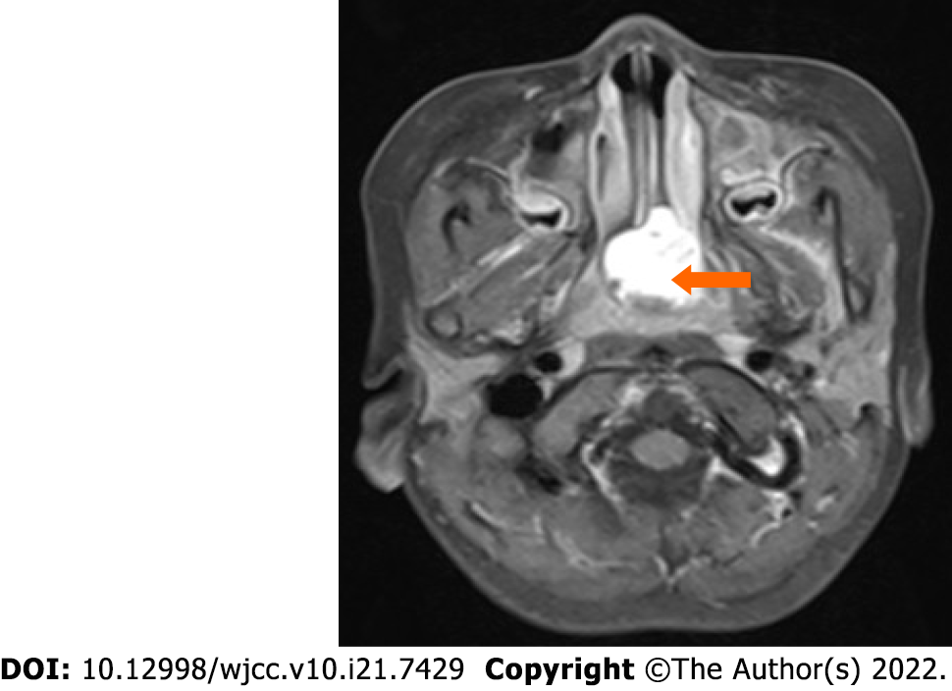
Figure 1 Enhanced magnetic resonance imaging showing an abnormal signal in the nasopharynx with obvious enhancement.

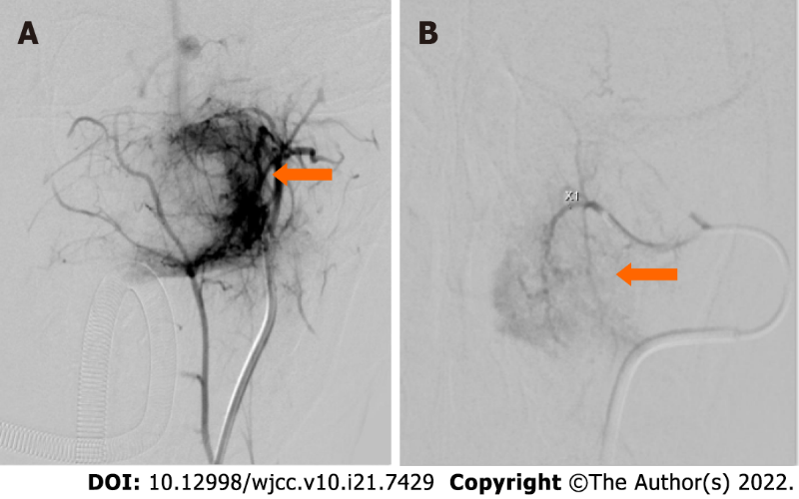
Figure 2 Before and after embolization. A: Pre-embolization angiography reveals that the tumor (arrow) is supplied by the left internal maxillary artery; B: After the second embolization, the arteriovenous fistula in the tumor in the nasopharynx has almost disappeared.

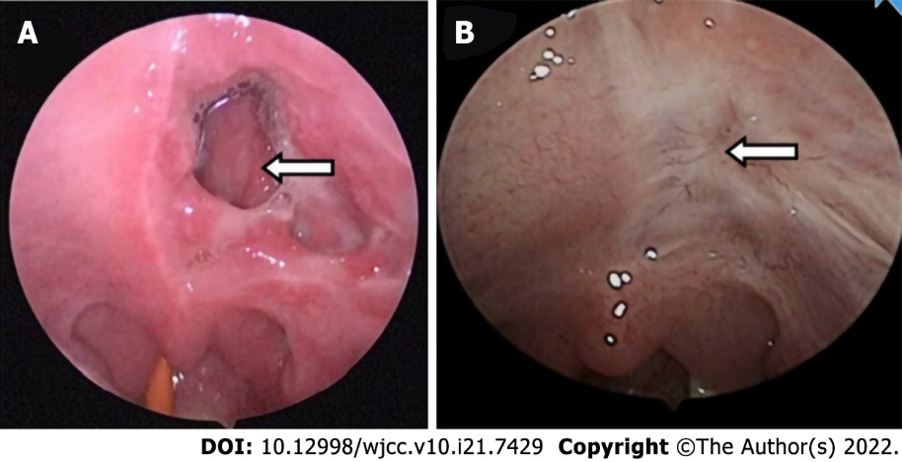

Figure 3 Transformation of soft palate perforation. A: After the first embolization, an irregular perforation is seen in the left soft palate; B: At 3 mo after the endoscopic excision, the necrotic area in the left soft palate has completely healed.

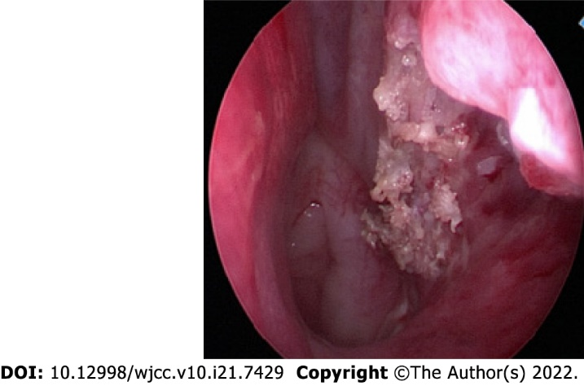
Figure 4 The posterior end of the inferior turbinate and lateral wall of the nasopharynx after resection of the tumor mass.

Table 1 Characteristics of extranasopharyngeal angiofibromas in children
No | Ref. | Site of origin | Age | Sex
1 | Munson^{[21]}, 1941 | Maxillary sinus | 15 yr | M
2 | Radcliffe^{[22]}, 1951 | Ethmoid sinus | 16 yr | M
3 | Alajmo and Fini-Storchi^{[26]}, 1962 | Maxillary sinus | 9 yr | M
4 | Whitlock et al^{[23]}, 1961 | Cheek | 16 yr | M
5 | Alajmo and Fini-Storchi^{[26]}, 1962 | Maxillary sinus | 6 yr | M
6 | Hora and Brown^{[26]}, 1962 | Maxillary sinus | 13 yr | M
7 | Furstenborg and Boles^{[26]}, 1963 | Ethmoid sinus | 1 mo | M
8 | Minicone^{[26]}, 1964 | Conjunctiva | 17 yr | M
9 | Ogura^{[26]} 1965 | Maxillary sinus | 16 yr | M
10 | Chaikovskii^{[26]}, 1967 | External nose | 14 yr | F
11 | Szczepanski et al^{[24]}, 1967 | Ethmoid sinus | 13 yr | F
12 | Manigla^{[26]}, 1969 | Maxillary sinus | 15 yr | M
13 | Pathak^{[26]}, 1970 | Maxillary sinus | 18 yr | M
14 | Beeden and Alexander^{[26]}, 1971 | Oropharynx and hypopharynx | 1 yr | M
15 | Charkabti^{[26]},1973 | Maxillary sinus | 17 yr | M
16 | Rye^{[26]},1973 | Maxillary sinus | 17 yr | M
17 | Stewart and O’Brien^{[26]}, 1973 | Molar and retromolar | 10 yr | M
18 | Ramajaneyulu^{[26]}, 1974 | Maxillary sinus | 17 yr | M
19 | Yamagiwa^{[26]}, 1974 | Sphenoid sinus | 14 yr | M
20 | Isherwood et al^{[25]}, 1975 | Pterygomaxillary fissure, infratemporal region | 13 yr | M
21 | Krutchkoff^{[30]}, 1977 | Maxillary sinus | 12 yr | M
22 | Reddy^{[26]}, 1979 | Molar and retromolar area | 14 yr | F
23 | Obiako et al^{[31]}, 1983 | Roof of nasal cavity | 12 years | M
24 | Hiraide and Matsubara^{[27]}, 1984 | Nasal septum | 13 years | M
25 | Sarpa and Novelly^{[28]}, 1989 | Nasal septum | 9 years | M
26 | Kitano et al^{[32]}, 1992 | Maxillary sinus | 13 years | M
27 | Manjalay et al^{[33]}, 1992 | Maxillary sinus | Newborn | M
28 | Gaffney et al^{[18]}, 1997 | Inferior turbinate | 9 years | M
29 | Schick et al^{[6]}, 1997 | Lacrimal sac | 15 months | M
30 | Schick et al^{[6]}, 1997 | Paranasal sinus | 9 years | M
31 | Schick et al^{[6]}, 1997 | Sphenoid sinus | 6 years | M
32 | Huang et al^{[8]}, 2000 | Middle turbinate | 14 years | M
33 | Handa et al^{[12]}, 2001 | Nasal septum | 8 yr | M
34 | Panesar et al^{[2]}, 2003 | Maxillary sinus | 1 yr | M
35 | Gupta et al^{[34]}, 2006 | Infratemporal region | 13 yr | M
36 | Castillo et al^{[29]}, 2006 | Nasal septum | 9 yr | M
37 | Ifeacho and Caulfield^{[35]}, 2011 | Middle turbinate | 14 years | M
38 | Singhal et al^{[17]}, 2014 | Nasal septum | 12 years | M
39 | Ganguly et al^{[16]}, 2017 | Nasal septum | 7 years | M
40 | Singh et al^{[17]}, 2018 | Nasal septum | 9 years | F
41 | Kim et al^{[20]}, 2019 | Inferior turbinate | 9 years | M
42 | Kim et al^{[20]}, 2019 | Inferior turbinate | 16 years | M
43 | Kim et al^{[20]}, 2019 | Inferior turbinate | 8 years | F
44 | Kim et al^{[20]}, 2019 | Inferior turbinate | 12 years | F
45 | Our case | Inferior turbinate and lateral wall of nasopharynx | 4 years | M
Table 2 Reported cases of extranasopharyngeal angiofibroma in children (n = 45)
Variable | N (%)
Gender
Male | 39 (86.7%)
Female | 6 (13.3%)
Age at the time of surgery
≤ 6 years | 8 (17.8%)
7-12 years | 15 (33.3%)
13-18 years | 22 (48.9%)
Site
Maxillary sinus | 15 (33.3%)
Ethmoid sinus | 3 (6.7%)
Sphenoid sinus | 2 (4.4%)
Nasal septum | 7 (15.6%)
Inferior turbinate | 6 (13.3%)
Middle turbinate | 2 (4.4%)
Roof of nasal cavity | 1 (2.2%)
Lacrimal sac | 1 (2.2%)
Cheek | 1 (2.2%)
Conjunctiva | 1 (2.2%)
External nose | 1 (2.2%)
Molar and retromolar area | 2 (4.4%)
Oropharynx and hypopharynx | 1 (2.2%)
Infratemporal region | 2 (4.4%)

Published by Baishideng Publishing Group Inc
7041 Koll Center Parkway, Suite 160, Pleasanton, CA 94566, USA
Telephone: +1-925-3991568
E-mail: bpgoffice@wjgnet.com
Help Desk: https://www.f6publishing.com/helpdesk
https://www.wjgnet.com

© 2022 Baishideng Publishing Group Inc. All rights reserved.

