Name of Journal: World Journal of Critical Care Medicine
Manuscript NO: 47146
Manuscript Type: REVIEW

One approach to circulation and blood flow in the critical care unit

Pena-Hernandez C et al. One approach to circulatory failure

Camilo Pena-Hernandez, Kenneth Nugent

Camilo Pena-Hernandez, Department of Internal Medicine, Division of Nephrology and Hypertension, Texas Tech University Health Sciences Center, Lubbock, TX 79430, United States

Kenneth Nugent, Department of Internal Medicine, Division of Pulmonary and Critical Care Medicine, Texas Tech University Health Sciences Center, Lubbock, TX 79430, United States

ORCID number: Camilo Pena-Hernandez (0000-0002-5149-0930); Kenneth Nugent (0000-0003-2781-4816).

Author contributions: Pena-Hernandez C and Nugent K contributed equally to this work.

Conflict-of-interest statement: Authors declare no conflict of interest for this article.

Open-Access: This article is an open-access article which was selected by an in-house editor and fully peer-reviewed by external reviewers. It is distributed in accordance with the Creative Commons Attribution Non-Commercial (CC BY-NC 4.0) license, which permits others to distribute, remix, adapt, build upon this work non-commercially, and license their derivative works on different terms, provided the original work is properly cited and the use is non-commercial. See: http://creativecommons.org/licenses/by-nc/4.0/

Manuscript source: Unsolicited manuscript

Corresponding author: Camilo Pena-Hernandez, MD, Assistant Professor, Department of Internal Medicine, Division of Nephrology and Hypertension, Texas Tech University Health Sciences Center, 3601 4th Street STOP 9410, Lubbock, TX 79430, United States. camilo.pena@ttushc.edu
Telephone: +1-210-5511524
Fax: +1-806-7433143

Received: March 7, 2019
Peer-review started: March 11, 2019
First decision: April 16, 2019
Revised: May 14, 2019
Accepted: June 12, 2019
Article in press:
Published online:

Abstract
Evaluating and managing circulatory failure is one of the most challenging tasks for medical practitioners involved in critical care medicine. Understanding the applicability of some of the basic but, at the same time, complex physiological processes occurring during a state of illness is sometimes neglected and/or presented to the practitioners as point-of-care protocols to follow. Furthermore, managing hemodynamic shock has shown us that the human body is designed to fight to sustain life and that the compensatory mechanisms within organ systems are extraordinary. In this review article, we have created a minimalistic guide to the clinical information relevant when assessing critically ill patients with failing circulation. Measures such as organ blood flow, circulating volume, and hemodynamic biomarkers of shock are described. In addition, we will describe historical scientific events that led to some of our current medical practices and its validation for clinical decision making, and we present clinical advice for patient care and medical training.

Key words: Shock; Volume status; Fluid; Vasopressors; Mean systemic pressure; Pulse pressure; Plethysmography variability index

© The Author(s) 2019. Published by Baishideng Publishing Group Inc. All rights reserved.

Core tip: In this review, we depict the historical understanding of circulation and blood flow physiology. Also, by characterizing the different approaches to circulatory failure, we attempt to provide a simplified tool for education and one summarized clinical guideline for management in the critical care unit.

Pena-Hernandez C, Nugent K. One approach to circulation and blood flow in the critical care unit. World J Crit Care Med 2019; In press

INTRODUCTION
In the era of evidence-based medicine and quality measures, shock has become a synonym for critically ill patients. Shock has a significant effect on morbidity, mortality, and costs; septic shock has been associated with 40%-80% of all sepsis-related deaths in the hospital and has increased hospital costs to more than $3000 per day for these patients^{[1]}. The management of patients with shock remains a challenge for clinicians and subspecialists involved in their care. Not only is circulatory failure common in the hospital and intensive care unit (ICU) setting (to the point that administrative efforts by the hospitals are now made to protocolize management), but it is also such a common problem that physicians sometimes focus more on symptomatic stepwise approaches than on understanding the disease process to determine the best treatment.
In this review we will discuss the pathophysiology of shock, the assessment of volume status, and approaches to management.

DEFINITIONS AND PATHOPHYSIOLOGY
Shock
For the medical practitioner in charge of the ICU, shock is the clinical manifestation of inadequate blood flow and circulatory failure^{[2]}. Some define it as insufficient oxygen delivery; the problem with this definition is that there are overlapping diseases of the respiratory tract associated with hypoxemia, which cause inadequate tissue oxygenation but not necessarily a state of shock.

Hypotension
Blood pressure determines the blood flow distribution but does not define the state of shock or the adequacy of circulation. Manual blood pressure readings are an appropriate way to determine blood pressure, but an arterial line continues to be the best practice when more accurate readings are needed, even though arterial lines are invasive, painful, and difficult in patients with vascular disease and have a variety of complications.
To understand circulatory failure, it is paramount to recognize that blood pressure and flow are uncoupled physiological processes. From basic physiology, we know that in the range of acceptable blood pressures and normal circulation, all vital organs (including the brain and kidneys) have a wide array of blood flow patterns that are completely disengaged from blood pressure; thus, clinicians will be incapable of making any assumptions about organ flow and cardiac output based on blood pressure alone (Figures 1 and 2, Table 1)^{[3,4]}.

Regulation of blood flow
In basic science classes, we learn about the physiology of cardiovascular circulation based on the idea that organ blood flow is similar to electric voltage and currents; consequently, we have adapted Ohm’s principle of conduction for a better understanding of the cardiovascular system: voltage (V) = electric current (I) x resistance (R). Replacement with hemodynamic parameters results in mean arterial pressure (MAP) – right atrial pressure (PRA) = cardiac output (CO) x systemic vascular resistance (SVR): MAP – PRA = CO x SVR.
For explaining the theoretical bases of hemodynamics and flow, this equation is adequate. The clinical application of this equation fails since it neglects the fact that humans have baroreceptors and reflex responses to changes in pressure. Therefore, when CO decreases, there is an instantaneous vasoconstrictor response to maintain equilibrium within the system, thereby maintaining a normal blood pressure. Understanding this concept is imperative, since patients may become overtly hypertensive with low cardiac output or uncalibrated/dysfunctional baroreceptors^{[5,6]}.
The sicker the patients become, the more difficult it is for the cardiovascular system to increase the SVR to maintain balance; when the ability to increase the SVR is exhausted, patients develop hypotension. Conversely, when patients present with a vasodilated state (e.g., septic shock), they will attempt to increase the CO to preserve an adequate MAP, and as the blood pressure continues to drop, they may reach a point at which the ability to increase the CO is surpassed, following which they become overtly hypotensive. These ideas indicate that low blood pressure is a late and insensitive indicator of inadequate circulation^{[7]}. Furthermore, this concept applies when you are describing cardiogenic shock^{[8]}, sepsis^{[9]}, cardiac tamponade^{[10]}, or traumatic shock^{[11]}. For example, an ICU patient with class 3 hypovolemic shock (Table 2) exemplifies the fact that 40% of the blood volume needs to be lost before the blood pressure decreases.
Understanding this concept will afford a clinical advantage when assessing the patient as one will know that hypoperfusion may be the result of a low SVR, a low CO, or a high SVR in the setting of a critically depressed CO. As a result, planning medical care and prognosis based solely on blood pressure may not work. In 2013, Lehman et al^{[12]} reported interesting data related to the clinical applications of these concepts and observed that only when the MAP dropped below 70 mmHg did the risk for acute kidney injury and/or mortality increase.

Adequacy of circulation and venous oxygenation
For more than 20 years, critical care medicine has been trying to assess the adequacy of circulation. There are overwhelming data and information on mixed venous oxygen saturation (SvO₂), lactic acid, and clinical signs and symptoms, such as mental status and urine output.
We should start with an understanding of adequate oxygen (O₂) delivery and consumption to assess SvO₂. A healthy individual deliver approximately 1,000 ml/min of oxygen to peripheral tissues, and the tissues extract nearly 25% of the oxygen [extraction ratio (ER)]. In low-oxygen delivery states, such as low CO, anemia, or hypoxia, there is an increase in the extraction of oxygen that continues until the low O₂ state is either corrected or surpasses the capacities of the tissues to extract O₂ (approximately 60%–70% ER). At this point, any further decline in O₂ delivery will cause an abrupt decline in O₂ consumption, with deterioration of the clinical condition (Figure 3, Table 3). As a result, assessing SvO₂ provides a quantitative method of assuring that patients do not encounter the critical points of O₂ consumption and extraction. With a better understanding of oxygen physiology in ICU patients, the concepts of venous oxygen saturation in central venous catheters (ScvO₂) vs mixed venous oxygen saturation in pulmonary artery catheters (SvO₂) were developed. The conclusion from regression analysis and determination coefficients (R²) was that there is no significant difference between the two assessment tools with R = 0.945, SvO₂ = 1.16 (ScvO₂)^{0.96[9,13]}. In clinical practice, this translates to two different procedures with different risks, costs, and complications but with similar medical utility.

Early goal-directed therapy
Because of the similar findings and the lesser risk associated with the insertion of a central venous catheter compared to a pulmonary artery catheter, ScvO₂ became an important measurement in the original “early goal-directed therapy (EGDT) in the treatment of sepsis and septic shock”^{[9]} (Figure 4). With the implementation of the EGDT across the board as a standard of care for sepsis and septic shock, it was found that the clinical validity for ScvO₂ vs SvO₂ performed well for sepsis and septic shock (R = 0.88 – R = 0.89, P < 0.001)^{[14,15]}, but not as well for cardiac surgery patients (R = 0.72, P < 0.001 – ScvO₂ most reliable > 70%)^{[16]}. Therefore, for patients with significant cardiac disease/cardiac surgery, ScvO₂ and SvO₂ are not interchangeable for medical decision making.
A series of clinical trials concerning EGDT and clinical outcomes have been performed through the years. The ProCESS trial published in 2014 compared the EGDT vs an alternative protocol vs usual care. There was no difference in 60-d (P = 0.52) or 1-year mortality (P = 0.92)^{[17]}. Similar findings were published in 2015 in a trial by Mouncey et al^{[18]}, in which 1200 patients were randomized to EGDT vs usual care, with no difference in mortality outcomes (P = 0.63).

Lactate
Lactic acid measurement has become an important method for the assessment of critically ill patients while avoiding the cumbersome process of obtaining central venous oxygen saturation. Some of the initial algorithms for the use of lactate measurements in the ICU involved combining the measurements with ScvO₂, to provide a stepwise approach for guiding the resuscitation of patients with circulatory failure: if lactate > 3.0 meq/L, then the ScvO₂ should be checked, and if it is not more than 3.0 meq/L, then there is no need to check the ScvO₂^{[19]}. However, when serum lactic acid was compared to ScvO₂ as the goal for resuscitation of patients with sepsis and septic shock, there was no difference in outcome^{[20]}. Considering these outcomes, there has been a shift in clinical practice from using central venous oxygen saturation to lactate in patients with sepsis and septic shock (i.e., for patients without major cardiovascular disease).

Circulating volume/volume status
What is the volume status in the ICU patient? We do not know. A more definite answer is “nobody knows”. However, to better understand, assess, and manage volume in critically ill patients, we need to first recognize what we do know about circulating volume and the fact that physical examination, regardless of many years of training and experience, is neither sensitive nor specific^{[21]}.
In the 1950s, Guyton et al^{[22]}’s experiments with the Frank and Starling models of cardiac physiology gave rise to some interesting concepts regarding circulation and blood flow. One of his conclusions regarding venous return (VR) physiology is that when the PRA and the mean systemic filling pressure (PMS) are equal, there will be no return of blood to the heart: VR = (PMS – PRA)/resistance to the venous return (RVR).
Furthermore, Guyton et al^{[23]}’s model established that PRA is not an indicator of circulating volume but a marker of pressure exerted by the venous system for the return of blood to the heart; thus, the lower the PRA, the higher the venous return^{[23]} (Figure 5). With his description, we understood the importance of the PMS as the driving force for the return of blood volume back to the heart and one of the most useful parameters for assessing the actual circulating volume status^{[24]}.

Central venous pressure and capillary wedge pressure
With the understanding of the mechanistic aspect of circulatory physiology described with the Starling curve (Figure 6) and the notion of venous return by Guyton’s model, it is possible to extrapolate the central venous pressure (CVP) as a product of the interaction between the venous system and cardiac function. Under those circumstances, the clinical inference from the CVP measured in patients is that, regardless of the number, it is lower than the mean systemic venous pressure (Figure 7).
Although the bedside utility of CVP alone for predicting volume responsiveness and medical decision making is not ideal, it is, however, a measurement available for the evaluation of critically ill patients with circulatory failure. The CVP alone in the ICU does not correlate with either the circulating volume status (R = 0.27)^{[25]} or the clinical response to volume/fluid administration^{[26]}. Similarly, the estimated left atrial pressure by pulmonary capillary wedge pressure (PCWP) via the more invasive pulmonary artery catheterization (Swan-Ganz catheter) was once considered to be one of the most reliable methods to assess the ventricular preload and circulating volume. This method was one of the characteristic features of critical care medicine, but has been shown to underperform in the clinical setting in predicting responsiveness to intravascular volume administration^{[27]}.

Peripheral vs central venous pressure
As an available tool, the CVP continues to be widely used alone or in combination with other parameters to enable an educated guess about the venous system volume status. An alternative and less invasive method, which provides an equivalent physiological estimation of the volume status, is the peripheral venous pressure (PVP). The PVP is a tool that is inadequately and seldom used, is less invasive, requires the same transducer/equipment as the CVP, and has similar results. Any patent peripheral intravenous access (for flushing and drawing) may be used for measuring PVP. One does need to adjust the value of PVP by subtracting 2 mmHg. Thus, PVP = CVP + 2 or PVP – 2 = CVP^{[28]}. The PVP not only is useful but also has been validated in many clinical scenarios in humans and animals (R = 0.97)^{[29,30]}; its validity has been tested and proven in surgical patients (for surgical scenarios such as brain, abdominal, and cardiac surgery), in ICU patients, and in pediatric patients^{[28,31,32]}.

ASSESSMENT OF THE PATIENT WITH CIRCULATORY FAILURE
Once the basic concepts of blood flow and circulating volume are understood for a critically ill patient with circulatory failure, the next step is to determine if the patient responds to volume expansion. The most physiologically correct method to determine this is by measuring the mean systemic pressure (PMS). Currently, we do not have a validated clinical tool to measure the PMS in the hospital. However, there is research in the Netherlands with noninvasive devices to quantify the PMS and predict volume responsiveness, which may entirely change our methods of approaching and managing shock and volume administration^{[33]}.

Mean systemic pressure, systolic pressure variation, and pulse pressure variation
Since we do not currently have a way to measure PMS in our patients, what has been done through the years for assessing the circulating volume status and volume administration is to measure indices, such as the systolic pressure variation (SPV) and pulse pressure variation (PPV) in mechanically ventilated patients with circulatory failure^{[34]} (Figure 8). The idea behind using these volumetric indicators (SPV and PPV) comes from the expected fluctuation of the Frank-Starling curve with mechanical ventilation and the minimal variability in the systolic and pulse pressures on the flat portion of the Starling curve. However, as volume depletion develops, the venous return decreases, and the system shifts towards the steep portion of the Starling curve, resulting in an increase in the variability in systolic pressure and pulse pressure. The implication is that the higher the PPV and SPV, the greater the expected response to volume administration, and this provides a guide for volume resuscitation^{[35]}.
The correlation between PPV/SPV and respiratory changes has been widely validated as a means to predict volume responsiveness in different scenarios, with sensitivities and specificities of 94% and 96%, respectively. For septic shock, the correlation (R = 0.85) is higher than the PCWP and PRA (R = 0.5 for both RAP and PCWP)^{[35]}. It also performs well after cardiac surgery compared with the CVP and PCWP (PPV/SPV: R = 0.8, CVP/PCWP: R = 0.5)^{[36,37]}. The two most important clinical scenarios in which PPV/SPV are known to fail are right ventricular failure (e.g., right ventricular infarction, cardiomyopathy, and pulmonary hypertension) and obstructive shock (e.g., tension pneumothorax, abdominal compartment syndrome, and cardiac tamponade)^{[35,38]}.
However, what if the patient is not mechanically ventilated, is spontaneously breathing, does not have a regular heart rate or on adequate tidal volume—can PPV and SPV still be used? The answer is yes, they can. The requirement for specific ventilatory parameters has been challenged, and both PPV and SPV tests work well in patients breathing spontaneously, with an AUC (area under the curve) of more than 0.8 for both. However, it is important to be cautious when using PPV/SPV with spontaneously breathing patients due to the varying reliability and results with changes in breathing patterns^{[39,40]}. Similarly, the need for arterial catheter insertion to measure the changes in PPV/SPV has been questioned, and plethysmographic waveform changes by pulse oximetry make it possible to calculate the plethysmography variability index (PVI). Subsequently, validated with comparable results as the more invasive PPV/SPV, the PVI can detect circulatory volume changes as low as 4%. Measurements with blood pressure require > 30% reduction in circulatory volume for hypotension to be present. A PVI of more than 17% will correlate with volume responsiveness. Furthermore, the PPV will change in parallel to the PVI (R = 0.85, P < 0.001), making it an excellent tool for evaluating patients with circulatory failure^{[41,42]}.

Cardiac output
Interestingly, in the acute care setting when the patient has developed circulatory failure, knowing and calculating the current blood flow is not as essential as understanding and assessing the consequences of appropriate blood flow, such as mental status, urine output, lactic acid level, and even central venous oxygen saturation. Moreover, pulse pressure (PP) is one of the more reliable correlates of low cardiac output (Table 4) since the aorta functions as a left ventricular counterpulsation balloon pump, stretching during systole and contracting during diastole while maintaining the mean arterial pressure with changes in flow, but the PP will vary with the amount of volume per stroke. This translates to a scenario in which the more that the stroke volume decreases, the more that the PP will decrease, giving enough information for medical decision making in the ICU. However, if the need is to know and quantify the cardiac output, then there are numerous devices available in hospitals to do so.
In summary, before adding more accessories to measure cardiac output, we recommend going back to your previous answers when assessing the patient. If your biological markers (e.g., urine output, mental status) and your surrogates of blood flow (e.g., lactate, central venous saturation) are within normal limits, then the cardiac output should not be the major concern. On the other hand, if the available bedside tools fail to support your clinical assessment about the cardiac output, we recommend more physiological substitutes for blood flow and stroke volume, such as the PP to make inferences and medical decisions.

VOLUME MANAGEMENT IN A NUTSHELL
The “silver lining” of restoring adequate circulation is the balance between reestablishing tissue perfusion with the appropriate/physiological distribution of blood flow by improving circulatory volume and avoiding iatrogenic volume excess. In the event of hypovolemic failure (regardless of the state of shock), the treatment is to replace the volume. Needless to say, hemorrhagic shock necessitates blood transfusion.
The classic example of the most common type of shock seen in the ICU is a septic shock patient who has not felt well before admission, not eating or drinking, and who developed a low volume state from lack of water (dehydration) and solutes (nutrition). This is in addition to the associated loss of fluid from increased capillary permeability, which is part of the septic process, and this loss of extra volume from the intravascular space into the interstitium leads to a state of relative hypovolemia superimposed on actual hypovolemia. Additionally, septic shock also induces maladaptive venous vasodilation, which decreases the circulatory blood flow return to the heart even after adequate fluid replacement^{[43]}. It may also cause cardiac dysfunction and vasomotor paralysis to the point that patients need inotropes and sometimes corticosteroids^{[2]}.
Protocols for optimal preload optimization and volume administration have been used in the clinical setting to improve outcomes (as previously discussed in the section: “Definitions and Pathophysiology”), but no benefit in survival or prevention of developing new organ failure has been achieved using protocolized fluid therapies. If anything, when comparing the fluid administration for patients receiving a lower total amount of fluid per usual care against the protocols, there may, in fact, be an association with renal dysfunction and the need for dialysis (P = 0.04) with the protocolized fluid therapies^{[17,44]}.

Type of fluid
The type and composition of fluid given do seem to matter. Recently published, the Isotonic Solutions and Major Adverse Renal Events Trial concluded that the use of balanced crystalloid solutions is overall better than the use of saline solutions, with less adverse kidney events (P = 0.04) and lower 30-d mortality (P = 0.02)^{[45]}. Normal saline (0.9% NaCl) is the most commonly administered solution in our hospital and around the world^{[46]}. Some of the problems associated with chloride-rich solutions include the development of hyperchloremic acidosis with an increase in morbidity and mortality outcomes^{[47-50]}. On the other hand, the Saline vs Plasma-Lyte for ICU fluid Therapy trial did not show any difference in outcomes between the two solutions studied (P = 0.85), although it is important to mention that these patients received, on average, a total of less than 2 liters of either solution throughout the whole study. Additionally, this amount of fluid may not be enough compared with the fluid quantities used for resuscitation and maintenance for ICU patients with circulatory failure^{[51]}. One clinical scenario in which normal saline should be the principal solution to use is in patients with intravascular volume depletion, metabolic alkalosis, and hypochloremic hyponatremia (e.g., over diuresis).
Hydroxyethyl starch is known to be nephrotoxic and is not used currently in the United States for fluid resuscitation (it was never used that much before either)^{[52]}. Other colloids, such as albumin and gelatins, remain valuable tools when used appropriately (Table 5). However, no significant clinical benefit from using colloids instead of crystalloids for volume resuscitation has been demonstrated^{[53,54]}.

Vasopressors and corticosteroids
Several different classes of vasopressors, including inotropic agents, are widely available and used in the treatment of shock for primarily inducing vasoconstriction, increasing mean arterial pressures, and optimizing blood flow and tissue perfusion. The three main categories that divide vasopressors are catecholamines (e.g., epinephrine, norepinephrine, dopamine), non-adrenergic drugs (e.g., vasopressin, angiotensin II), and other adrenergic agonists (e.g., phenylephrine, midodrine, dobutamine).
Despite the fact that there is no difference in survival between norepinephrine and dopamine as the first-line agent for the treatment of shock (P = 0.07), there are significantly more adverse events related to arrhythmias (atrial fibrillation, ventricular tachycardia, ventricular fibrillation) with dopamine, and for this reason, its use has declined significantly over the years^{[55]}. Although phenylephrine has not been tested against norepinephrine and continues to be widely available, there have been observational data reported after the 2011 shortage of norepinephrine in the United States which showed increased in-hospital mortality when phenylephrine is used as first line agent^{[56]}.
Vasopressin performs as well as norepinephrine and is a useful medication for second-line therapy if needed^{[57]}. The new vasopressor being used more frequently in the ICU is angiotensin II. The Angiotensin II for the Treatment of Vasodilatory Shock (ATHOS-3) trial demonstrated that it works well for vasodilatory/high output shock, has a great safety profile, and has minimal side effects. It is an excellent second-line therapy currently and will be so the near future, with appropriate concerns about price and availability^{[58]}. Corticosteroid use in septic shock has been debated throughout the years and is recommended for refractory shock per Surviving Sepsis guidelines. These drugs do not have any other proven benefit in this clinical setting^{[59,60]}.
In summary, we recommend avoiding dopamine as a first line drug due to the severity of side effects and possibility of harm. We continue to use norepinephrine as the first line agent, but vasopressin is also an option for either first or second drug choice. If available, angiotensin II will work well as second line vasopressor; it is possible that phenylephrine may lead to worse outcomes if used as first line therapy.

CONCLUSION
Accuracy in diagnosis with selection of the right tool for assessment and not simply symptomatic treatment must be a strategic element in the care provided to patients with circulatory failure. Understanding physiological concepts is vital. More importantly, learning and practicing medicine based only on protocols and flowcharts will always exclude an important portion of the science. The careful understanding and management of circulation must be part of daily clinical practice. Changing dogmas in medicine generates apprehension as the illusion of knowledge and expertise becomes vulnerable, but we as health care providers should continue evolving for the benefit of our patients.
Intravenous fluid solutions are more similar to drugs than is acknowledged and therefore need to be used with care and precision. The composition of the fluid does matter, but only if the patient is alive. When administering intravascular fluids, targets such as the restoration of intravascular volume should have more impact on medical decisions than urine output or blood pressure. Extravasation of water and solutes can occur, and for this reason, we need to be mindful that not every patient in a hospital bed needs a fluid bolus.

REFERENCES
1 Paoli CJ, Reynolds MA, Sinha M, Gitlin M, Crouser E. Epidemiology and Costs of Sepsis in the United States-An Analysis Based on Timing of Diagnosis and Severity Level. Crit Care Med 2018; 46: 1889-1897 [PMID: 30048332 DOI: 10.1097/CCM.0000000000003342]
2 Vincent JL, De Backer D. Circulatory shock. N Engl J Med 2013; 369: 1726-1734 [PMID: 24171518 DOI: 10.1056/NEJMra1208943]
3 Navar LG, Inscho EW, Majid SA, Imig JD, Harrison-Bernard LM, Mitchell KD. Paracrine regulation of the renal microcirculation. Physiol Rev 1996; 76: 425-536 [PMID: 8618962 DOI: 10.1152/physrev.1996.76.2.425]
4 Fantini S, Sassaroli A, Tgavalekos KT, Kornbluth J. Cerebral blood flow and autoregulation: current measurement techniques and prospects for noninvasive optical methods. Neurophotonics 2016; 3: 031411 [PMID: 27403447 DOI: 10.1117/1.NPh.3.3.031411]
5 Wallbach M, Zürbig P, Dihazi H, Müller GA, Wachter R, Beige J, Koziolek MJ, Mischak H. Kidney protective effects of baroreflex activation therapy in patients with resistant hypertension. J Clin Hypertens (Greenwich) 2018; 20: 1519-1526 [PMID: 30203514 DOI: 10.1111/jch.13365]
6 Wallbach M, Koziolek MJ. Baroreceptors in the carotid and hypertension-systematic review and meta-analysis of the effects of baroreflex activation therapy on blood pressure. Nephrol Dial Transplant 2018; 33: 1485-1493 [PMID: 29136223 DOI: 10.1093/ndt/gfx279]
7 Graham CA, Parke TR. Critical care in the emergency department: shock and circulatory support. Emerg Med J 2005; 22: 17-21 [PMID: 15611535 DOI: 10.1136/emj.2003.012450]
8 Ander DS, Jaggi M, Rivers E, Rady MY, Levine TB, Levine AB, Masura J, Gryzbowski M. Undetected cardiogenic shock in patients with congestive heart failure presenting to the emergency department. Am J Cardiol 1998; 82: 888-891 [PMID: 9781972 DOI: 10.1016/S0002-9149(98)00497-4]
9 Rivers E, Nguyen B, Havstad S, Ressler J, Muzzin A, Knoblich B, Peterson E, Tomlanovich M; Early Goal-Directed Therapy Collaborative Group. Early goal-directed therapy in the treatment of severe sepsis and septic shock. N Engl J Med 2001; 345: 1368-1377 [PMID: 11794169 DOI: 10.1056/NEJMoa010307]
10 Reddy PS, Curtiss EI, O'Toole JD, Shaver JA. Cardiac tamponade: hemodynamic observations in man. Circulation 1978; 58: 265-272 [PMID: 668074 DOI: 10.1161/01.CIR.58.2.265]
11 Wo CC, Shoemaker WC, Appel PL, Bishop MH, Kram HB, Hardin E. Unreliability of blood pressure and heart rate to evaluate cardiac output in emergency resuscitation and critical illness. Crit Care Med 1993; 21: 218-223 [PMID: 8428472 DOI: 10.1097/00003246-199302000-00012]
12 Lehman LW, Saeed M, Talmor D, Mark R, Malhotra A. Methods of blood pressure measurement in the ICU. Crit Care Med 2013; 41: 34-40 [PMID: 23269127 DOI: 10.1097/CCM.0b013e318265ea46]
13 Ladakis C, Myrianthefs P, Karabinis A, Karatzas G, Dosios T, Fildissis G, Gogas J, Baltopoulos G. Central venous and mixed venous oxygen saturation in critically ill patients. Respiration 2001; 68: 279-285 [PMID: 11416249 DOI: 10.1159/000050511]
14 Chawla LS, Zia H, Gutierrez G, Katz NM, Seneff MG, Shah M. Lack of equivalence between central and mixed venous oxygen saturation. Chest 2004; 126: 1891-1896 [PMID: 15596689 DOI: 10.1378/chest.126.6.1891]
15 Varpula M, Karlsson S, Ruokonen E, Pettilä V. Mixed venous oxygen saturation cannot be estimated by central venous oxygen saturation in septic shock. Intensive Care Med 2006; 32: 1336-1343 [PMID: 16826387 DOI: 10.1007/s00134-006-0270-y]
16 Sander M, Spies CD, Foer A, Weymann L, Braun J, Volk T, Grubitzsch H, von Heymann C. Agreement of central venous saturation and mixed venous saturation in cardiac surgery patients. Intensive Care Med 2007; 33: 1719-1725 [PMID: 17525841 DOI: 10.1007/s00134-007-0684-1]
17 ProCESS Investigators, Yealy DM, Kellum JA, Huang DT, Barnato AE, Weissfeld LA, Pike F, Terndrup T, Wang HE, Hou PC, LoVecchio F, Filbin MR, Shapiro NI, Angus DC. A randomized trial of protocol-based care for early septic shock. N Engl J Med 2014; 370: 1683-1693 [PMID: 24635773 DOI: 10.1056/NEJMoa1401602]
18 Mouncey PR, Osborn TM, Power GS, Harrison DA, Sadique MZ, Grieve RD, Jahan R, Harvey SE, Bell D, Bion JF, Coats TJ, Singer M, Young JD, Rowan KM; ProMISe Trial Investigators. Trial of early, goal-directed resuscitation for septic shock. N Engl J Med 2015; 372: 1301-1311 [PMID: 25776532 DOI: 10.1056/NEJMoa1500896]
19 Jansen TC, van Bommel J, Schoonderbeek FJ, Sleeswijk Visser SJ, van der Klooster JM, Lima AP, Willemsen SP, Bakker J; LACTATE study group. Early lactate-guided therapy in intensive care unit patients: a multicenter, open-label, randomized controlled trial. Am J Respir Crit Care Med 2010; 182: 752-761 [PMID: 20463176 DOI: 10.1164/rccm.200912-1918OC]
20 Jones AE, Shapiro NI, Trzeciak S, Arnold RC, Claremont HA, Kline JA; Emergency Medicine Shock Research Network (EMShockNet) Investigators. Lactate clearance vs central venous oxygen saturation as goals of early sepsis therapy: a randomized clinical trial. JAMA 2010; 303: 739-746 [PMID: 20179283 DOI: 10.1001/jama.2010.158]
21 Hiemstra B, Eck RJ, Keus F, van der Horst ICC. Clinical examination for diagnosing circulatory shock. Curr Opin Crit Care 2017; 23: 293-301 [PMID: 28570301 DOI: 10.1097/MCC.0000000000000420]
22 Guyton AC, Lindsey AW, Kaufmann BN. Effect of mean circulatory filling pressure and other peripheral circulatory factors on cardiac output. Am J Physiol 1955; 180: 463-468 [PMID: 14376522 DOI: 10.1152/ajplegacy.1955.180.3.463]
23 Guyton AC, Lindsey AW, Abernathy B, Richardson T. Venous return at various right atrial pressures and the normal venous return curve. Am J Physiol 1957; 189: 609-615 [PMID: 13458395 DOI: 10.1152/ajplegacy.1957.189.3.609]
24 Maas JJ, Geerts BF, van den Berg PC, Pinsky MR, Jansen JR. Assessment of venous return curve and mean systemic filling pressure in postoperative cardiac surgery patients. Crit Care Med 2009; 37: 912-918 [PMID: 19237896 DOI: 10.1097/CCM.0b013e3181961481]
25 Marik PE, Baram M, Vahid B. Does central venous pressure predict fluid responsiveness? A systematic review of the literature and the tale of seven mares. Chest 2008; 134: 172-178 [PMID: 18628220 DOI: 10.1378/chest.07-2331]
26 Osman D, Ridel C, Ray P, Monnet X, Anguel N, Richard C, Teboul JL. Cardiac filling pressures are not appropriate to predict hemodynamic response to volume challenge. Crit Care Med 2007; 35: 64-68 [PMID: 17080001 DOI: 10.1097/01.CCM.0000249851.94101.4F]
27 Kumar A, Anel R, Bunnell E, Habet K, Zanotti S, Marshall S, Neumann A, Ali A, Cheang M, Kavinsky C, Parrillo JE. Pulmonary artery occlusion pressure and central venous pressure fail to predict ventricular filling volume, cardiac performance, or the response to volume infusion in normal subjects. Crit Care Med 2004; 32: 691-699 [PMID: 15090949]
28 Munis JR, Bhatia S, Lozada LJ. Peripheral venous pressure as a hemodynamic variable in neurosurgical patients. Anesth Analg 2001; 92: 172-179 [PMID: 11133622 DOI: 10.1097/00000539-200101000-00033]
29 Hadimioglu N, Ertug Z, Yegin A, Sanli S, Gurkan A, Demirbas A. Correlation of peripheral venous pressure and central venous pressure in kidney recipients. Transplant Proc 2006; 38: 440-442 [PMID: 16549142 DOI: 10.1016/j.transproceed.2005.12.057]
30 Chow RS, Kass PH, Haskins SC. Evaluation of peripheral and central venous pressure in awake dogs and cats. Am J Vet Res 2006; 67: 1987-1991 [PMID: 17144798 DOI: 10.2460/ajvr.67.12.1987]
31 Baty L, Russo P, Tobias JD. Measurement of central venous pressure from a peripheral intravenous catheter following cardiopulmonary bypass in infants and children with congenital heart disease. J Intensive Care Med 2008; 23: 136-142 [PMID: 18372352 DOI: 10.1177/0885066607305861]
32 Choi SJ, Gwak MS, Ko JS, Kim GS, Kim TH, Ahn H, Kim JA, Yang M, Lee S, Kim M. Can peripheral venous pressure be an alternative to central venous pressure during right hepatectomy in living donors? Liver Transpl 2007; 13: 1414-1421 [PMID: 17902127 DOI: 10.1002/lt.21255]
33 Maas JJ, Pinsky MR, Aarts LP, Jansen JR. Bedside assessment of total systemic vascular compliance, stressed volume, and cardiac function curves in intensive care unit patients. Anesth Analg 2012; 115: 880-887 [PMID: 22763909 DOI: 10.1213/ANE.0b013e31825fb01d]
34 Michard F. Changes in arterial pressure during mechanical ventilation. Anesthesiology 2005; 103: 419-28; quiz 449-5 [PMID: 16052125 DOI: 10.1097/00000542-200508000-00026]
35 Magder S. Clinical usefulness of respiratory variations in arterial pressure. Am J Respir Crit Care Med 2004; 169: 151-155 [PMID: 14718237 DOI: 10.1164/rccm.200211-1360CC]
36 Hofer CK, Müller SM, Furrer L, Klaghofer R, Genoni M, Zollinger A. Stroke volume and pulse pressure variation for prediction of fluid responsiveness in patients undergoing off-pump coronary artery bypass grafting. Chest 2005; 128: 848-854 [PMID: 16100177 DOI: 10.1378/chest.128.2.848]
37 Preisman S, Kogan S, Berkenstadt H, Perel A. Predicting fluid responsiveness in patients undergoing cardiac surgery: functional haemodynamic parameters including the Respiratory Systolic Variation Test and static preload indicators. Br J Anaesth 2005; 95: 746-755 [PMID: 16286349 DOI: 10.1093/bja/aei262]
38 Wyler von Ballmoos M, Takala J, Roeck M, Porta F, Tueller D, Ganter CC, Schröder R, Bracht H, Baenziger B, Jakob SM. Pulse-pressure variation and hemodynamic response in patients with elevated pulmonary artery pressure: a clinical study. Crit Care 2010; 14: R111 [PMID: 20540730 DOI: 10.1186/cc9060]
39 Zöllei E, Bertalan V, Németh A, Csábi P, László I, Kaszaki J, Rudas L. Non-invasive detection of hypovolemia or fluid responsiveness in spontaneously breathing subjects. BMC Anesthesiol 2013; 13: 40 [PMID: 24188480 DOI: 10.1186/1471-2253-13-40]
40 Hong DM, Lee JM, Seo JH, Min JJ, Jeon Y, Bahk JH. Pulse pressure variation to predict fluid responsiveness in spontaneously breathing patients: tidal vs. forced inspiratory breathing. Anaesthesia 2014; 69: 717-722 [PMID: 24773446 DOI: 10.1111/anae.12678]
41 Pizov R, Eden A, Bystritski D, Kalina E, Tamir A, Gelman S. Arterial and plethysmographic waveform analysis in anesthetized patients with hypovolemia. Anesthesiology 2010; 113: 83-91 [PMID: 20526193 DOI: 10.1097/ALN.0b013e3181da839f]
42 Loupec T, Nanadoumgar H, Frasca D, Petitpas F, Laksiri L, Baudouin D, Debaene B, Dahyot-Fizelier C, Mimoz O. Pleth variability index predicts fluid responsiveness in critically ill patients. Crit Care Med 2011; 39: 294-299 [PMID: 21057311 DOI: 10.1097/CCM.0b013e3181ffde1c]
43 Siddall E, Khatri M, Radhakrishnan J. Capillary leak syndrome: etiologies, pathophysiology, and management. Kidney Int 2017; 92: 37-46 [PMID: 28318633 DOI: 10.1016/j.kint.2016.11.029]
44 Kellum JA, Chawla LS, Keener C, Singbartl K, Palevsky PM, Pike FL, Yealy DM, Huang DT, Angus DC; ProCESS and ProGReSS-AKI Investigators. The Effects of Alternative Resuscitation Strategies on Acute Kidney Injury in Patients with Septic Shock. Am J Respir Crit Care Med 2016; 193: 281-287 [PMID: 26398704 DOI: 10.1164/rccm.201505-0995OC]
45 Semler MW, Self WH, Rice TW. Balanced Crystalloids versus Saline in Critically Ill Adults. N Engl J Med 2018; 378: 1951 [PMID: 29768150 DOI: 10.1056/NEJMc1804294]
46 Finfer S, Liu B, Taylor C, Bellomo R, Billot L, Cook D, Du B, McArthur C, Myburgh J; SAFE TRIPS Investigators. Resuscitation fluid use in critically ill adults: an international cross-sectional study in 391 intensive care units. Crit Care 2010; 14: R185 [PMID: 20950434 DOI: 10.1186/cc9293]
47 Yunos NM, Kim IB, Bellomo R, Bailey M, Ho L, Story D, Gutteridge GA, Hart GK. The biochemical effects of restricting chloride-rich fluids in intensive care. Crit Care Med 2011; 39: 2419-2424 [PMID: 21705897 DOI: 10.1097/CCM.0b013e31822571e5]
48 Kellum JA, Song M, Almasri E. Hyperchloremic acidosis increases circulating inflammatory molecules in experimental sepsis. Chest 2006; 130: 962-967 [PMID: 17035425 DOI: 10.1378/chest.130.4.962]
49 Shaw AD, Bagshaw SM, Goldstein SL, Scherer LA, Duan M, Schermer CR, Kellum JA. Major complications, mortality, and resource utilization after open abdominal surgery: 0.9% saline compared to Plasma-Lyte. Ann Surg 2012; 255: 821-829 [PMID: 22470070 DOI: 10.1097/SLA.0b013e31825074f5]
50 Raghunathan K, Shaw A, Nathanson B, Stürmer T, Brookhart A, Stefan MS, Setoguchi S, Beadles C, Lindenauer PK. Association between the choice of IV crystalloid and in-hospital mortality among critically ill adults with sepsis*. Crit Care Med 2014; 42: 1585-1591 [PMID: 24674927 DOI: 10.1097/CCM.0000000000000305]
51 Young P, Bailey M, Beasley R, Henderson S, Mackle D, McArthur C, McGuinness S, Mehrtens J, Myburgh J, Psirides A, Reddy S, Bellomo R; SPLIT Investigators; ANZICS CTG. Effect of a Buffered Crystalloid Solution vs Saline on Acute Kidney Injury Among Patients in the Intensive Care Unit: The SPLIT Randomized Clinical Trial. JAMA 2015; 314: 1701-1710 [PMID: 26444692 DOI: 10.1001/jama.2015.12334]
52 Perner A, Haase N, Guttormsen AB, Tenhunen J, Klemenzson G, Åneman A, Madsen KR, Møller MH, Elkjær JM, Poulsen LM, Bendtsen A, Winding R, Steensen M, Berezowicz P, Søe-Jensen P, Bestle M, Strand K, Wiis J, White JO, Thornberg KJ, Quist L, Nielsen J, Andersen LH, Holst LB, Thormar K, Kjældgaard AL, Fabritius ML, Mondrup F, Pott FC, Møller TP, Winkel P, Wetterslev J; 6S Trial Group; Scandinavian Critical Care Trials Group. Hydroxyethyl starch 130/0.42 versus Ringer's acetate in severe sepsis. N Engl J Med 2012; 367: 124-134 [PMID: 22738085 DOI: 10.1056/NEJMoa1204242]
53 Finfer S, Bellomo R, Boyce N, French J, Myburgh J, Norton R; SAFE Study Investigators. A comparison of albumin and saline for fluid resuscitation in the intensive care unit. N Engl J Med 2004; 350: 2247-2256 [PMID: 15163774 DOI: 10.1056/NEJMoa040232]
54 Annane D, Siami S, Jaber S, Martin C, Elatrous S, Declère AD, Preiser JC, Outin H, Troché G, Charpentier C, Trouillet JL, Kimmoun A, Forceville X, Darmon M, Lesur O, Reignier J, Abroug F, Berger P, Clec'h C, Cousson J, Thibault L, Chevret S; CRISTAL Investigators. Effects of fluid resuscitation with colloids vs crystalloids on mortality in critically ill patients presenting with hypovolemic shock: the CRISTAL randomized trial. JAMA 2013; 310: 1809-1817 [PMID: 24108515 DOI: 10.1001/jama.2013.280502]
55 De Backer D, Biston P, Devriendt J, Madl C, Chochrad D, Aldecoa C, Brasseur A, Defrance P, Gottignies P, Vincent JL; SOAP II Investigators. Comparison of dopamine and norepinephrine in the treatment of shock. N Engl J Med 2010; 362: 779-789 [PMID: 20200382 DOI: 10.1056/NEJMoa0907118]
56 Vail E, Gershengorn HB, Hua M, Walkey AJ, Rubenfeld G, Wunsch H. Association Between US Norepinephrine Shortage and Mortality Among Patients With Septic Shock. JAMA 2017; 317: 1433-1442 [PMID: 28322415 DOI: 10.1001/jama.2017.2841]
57 Russell JA, Walley KR, Singer J, Gordon AC, Hébert PC, Cooper DJ, Holmes CL, Mehta S, Granton JT, Storms MM, Cook DJ, Presneill JJ, Ayers D; VASST Investigators. Vasopressin versus norepinephrine infusion in patients with septic shock. N Engl J Med 2008; 358: 877-887 [PMID: 18305265 DOI: 10.1056/NEJMoa067373]
58 Khanna A, English SW, Wang XS, Ham K, Tumlin J, Szerlip H, Busse LW, Altaweel L, Albertson TE, Mackey C, McCurdy MT, Boldt DW, Chock S, Young PJ, Krell K, Wunderink RG, Ostermann M, Murugan R, Gong MN, Panwar R, Hästbacka J, Favory R, Venkatesh B, Thompson BT, Bellomo R, Jensen J, Kroll S, Chawla LS, Tidmarsh GF, Deane AM; ATHOS-3 Investigators. Angiotensin II for the Treatment of Vasodilatory Shock. N Engl J Med 2017; 377: 419-430 [PMID: 28528561 DOI: 10.1056/NEJMoa1704154]
59 Rhodes A, Evans LE, Alhazzani W, Levy MM, Antonelli M, Ferrer R, Kumar A, Sevransky JE, Sprung CL, Nunnally ME, Rochwerg B, Rubenfeld GD, Angus DC, Annane D, Beale RJ, Bellinghan GJ, Bernard GR, Chiche JD, Coopersmith C, De Backer DP, French CJ, Fujishima S, Gerlach H, Hidalgo JL, Hollenberg SM, Jones AE, Karnad DR, Kleinpell RM, Koh Y, Lisboa TC, Machado FR, Marini JJ, Marshall JC, Mazuski JE, McIntyre LA, McLean AS, Mehta S, Moreno RP, Myburgh J, Navalesi P, Nishida O, Osborn TM, Perner A, Plunkett CM, Ranieri M, Schorr CA, Seckel MA, Seymour CW, Shieh L, Shukri KA, Simpson SQ, Singer M, Thompson BT, Townsend SR, Van der Poll T, Vincent JL, Wiersinga WJ, Zimmerman JL, Dellinger RP. Surviving Sepsis Campaign: International Guidelines for Management of Sepsis and Septic Shock: 2016. Intensive Care Med 2017; 43: 304-377 [PMID: 28101605 DOI: 10.1007/s00134-017-4683-6]
60 Sprung CL, Annane D, Keh D, Moreno R, Singer M, Freivogel K, Weiss YG, Benbenishty J, Kalenka A, Forst H, Laterre PF, Reinhart K, Cuthbertson BH, Payen D, Briegel J; CORTICUS Study Group. Hydrocortisone therapy for patients with septic shock. N Engl J Med 2008; 358: 111-124 [PMID: 18184957 DOI: 10.1056/NEJMoa071366]
61 Mattson DL, Lu S, Roman RJ, Cowley AW. Relationship between renal perfusion pressure and blood flow in different regions of the kidney. Am J Physiol 1993; 264(3 Pt 2): R578-583 [PMID: 8457011 DOI: 10.1152/ajpregu.1993.264.3.R578]
62 Guyton AC. Determination of cardiac output by equating venous return curves with cardiac response curves. Physiol Rev 1955; 35: 123-129 [PMID: 14356924 DOI: 10.1152/physrev.1955.35.1.123]
63 Koeppen BM, Stanton BA. Integrated Control of The Cardiovascular System. In: Koeppen BM, Stanton BA, editors. Berne and Levy Physiology. Amsterdam: Elsevier, 2017
P-Reviewer: Aurilio C, Willms DC, Yeh YC S-Editor: Wang JL L-Editor: E-Editor:

Specialty type: Critical care medicine
Country of origin: United States
Peer-review report classification
Grade A (Excellent): A
Grade B (Very good): B
Grade C (Good): C
Grade D (Fair): 0
Grade E (Poor): 0

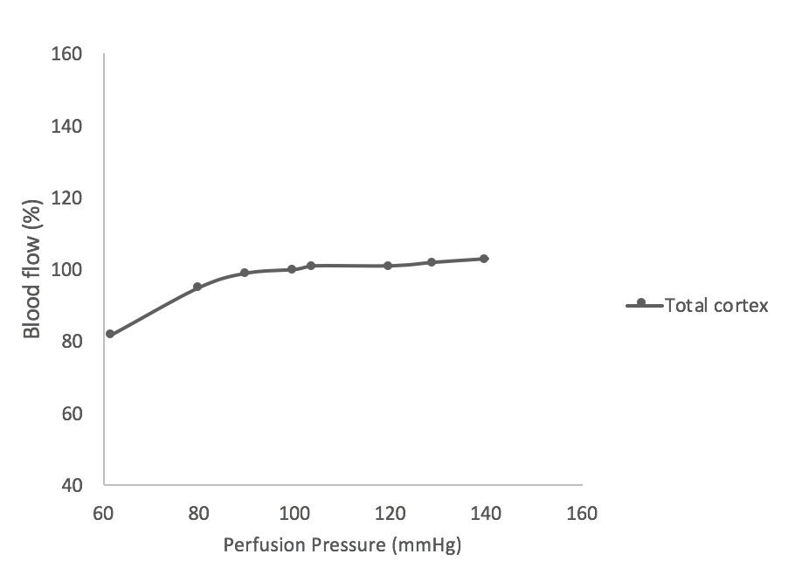
Figure 1 Renal autoregulation. Total renal blood flow over a range of perfusion pressure. Adapted from^{[61]}.
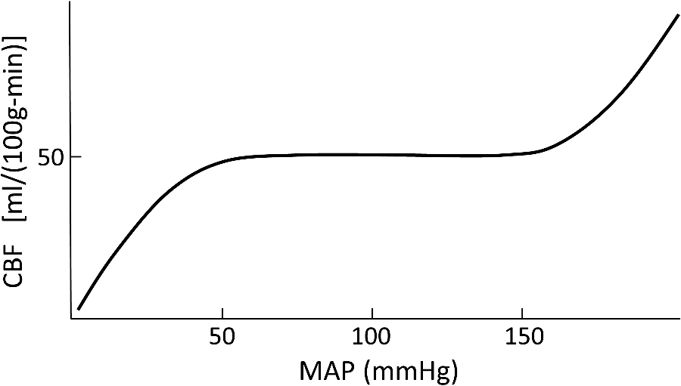

Figure 2 Cerebral autoregulation. Blood flow over a range of perfusion pressures. Reproduced from^{[4]} with permission of the Society of Photo Optical Instrumentation Engineers (SPIE)

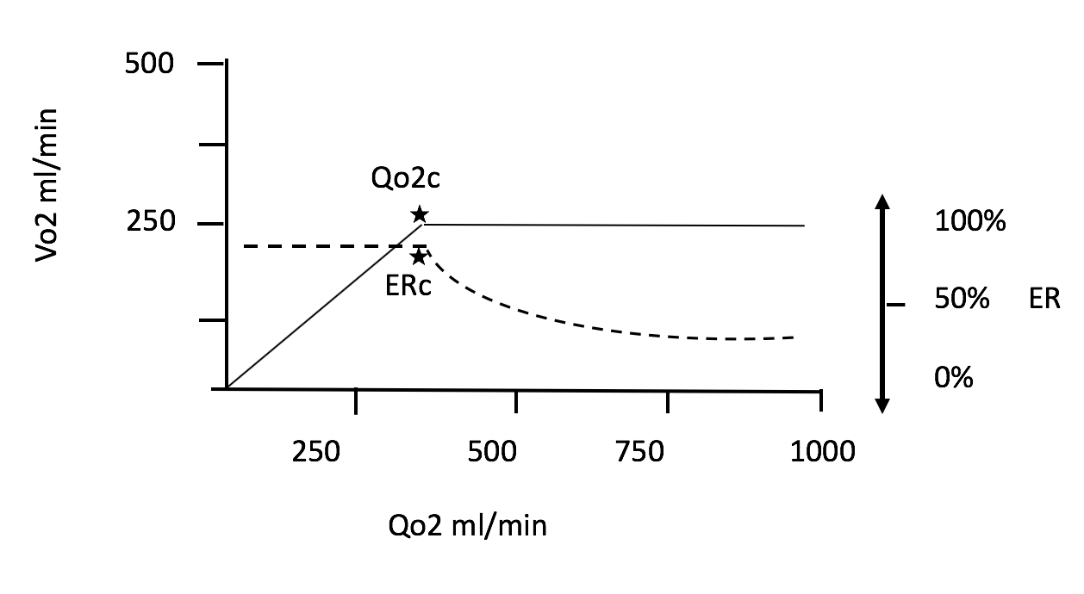 Figure 3 Relationship between oxygen delivery and venous oxygenation/oxygen consumption. VO₂: Oxygen consumption; QO₂: Oxygen flow delivery; ER: Extraction ratio; ERc: Critical point of extraction; QO₂c: Critical point of delivery.

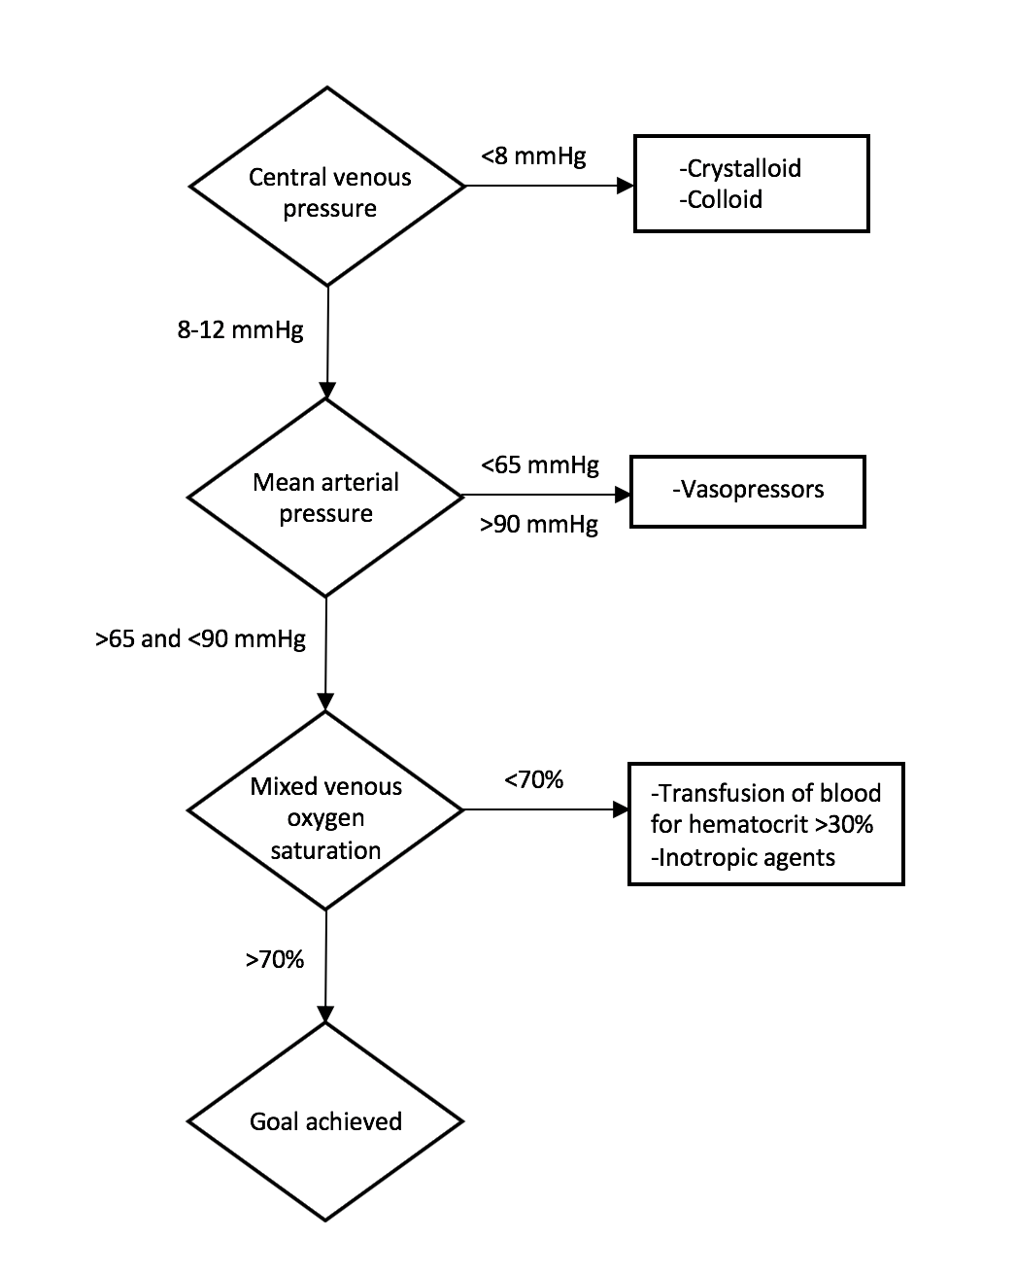
Figure 4 Protocol for early goal-directed therapy. Adapted from^{[9]}.

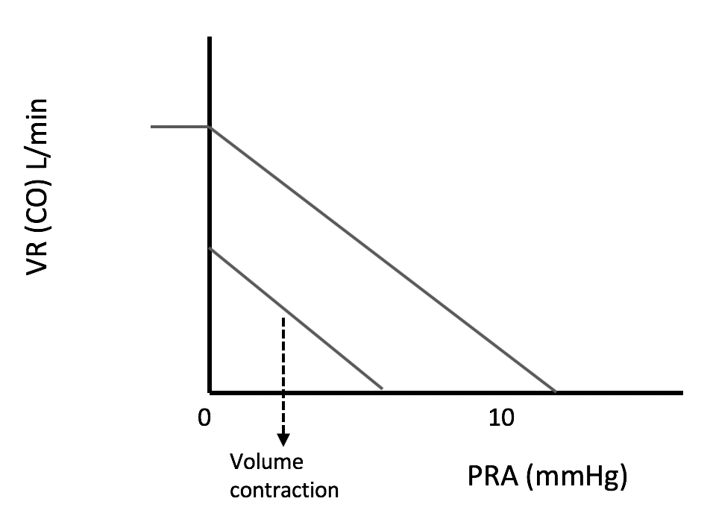
Figure 5 Guyton’s model of venous return and cardiac output in relation to the right atrial pressure. Adapted from^{[62]}.

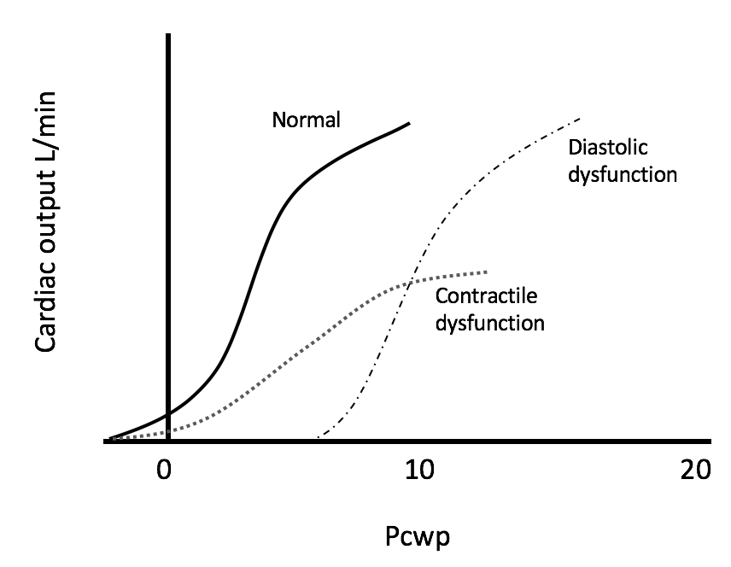
Figure 6 Frank-Starling curves representing normal contractility, diastolic dysfunction, and contractile dysfunction. Pcwp: Pulmonary capillary wedge pressure. Adapted from^{[63]}.

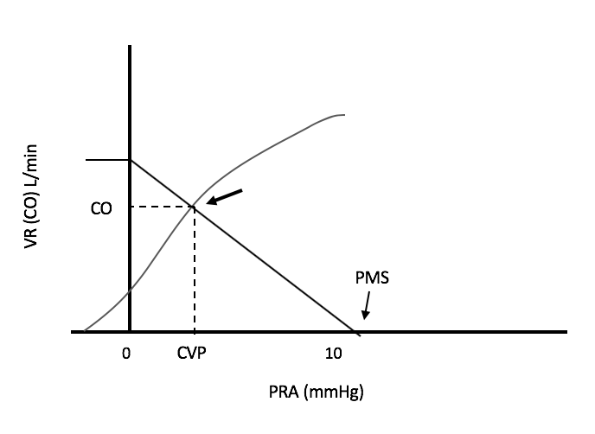
Figure 7 Modified cardiac function curve representing the central venous pressure measured in the clinical setting by superimposing Guyton’s model of venous return and Frank-Starling contractility curve. CO: Cardiac output; CVP: Central venous pressure; PRA: Right atrial pressure; VR: Venous return; PMS: Mean systemic filling pressure. Adapted from^{[62]}.

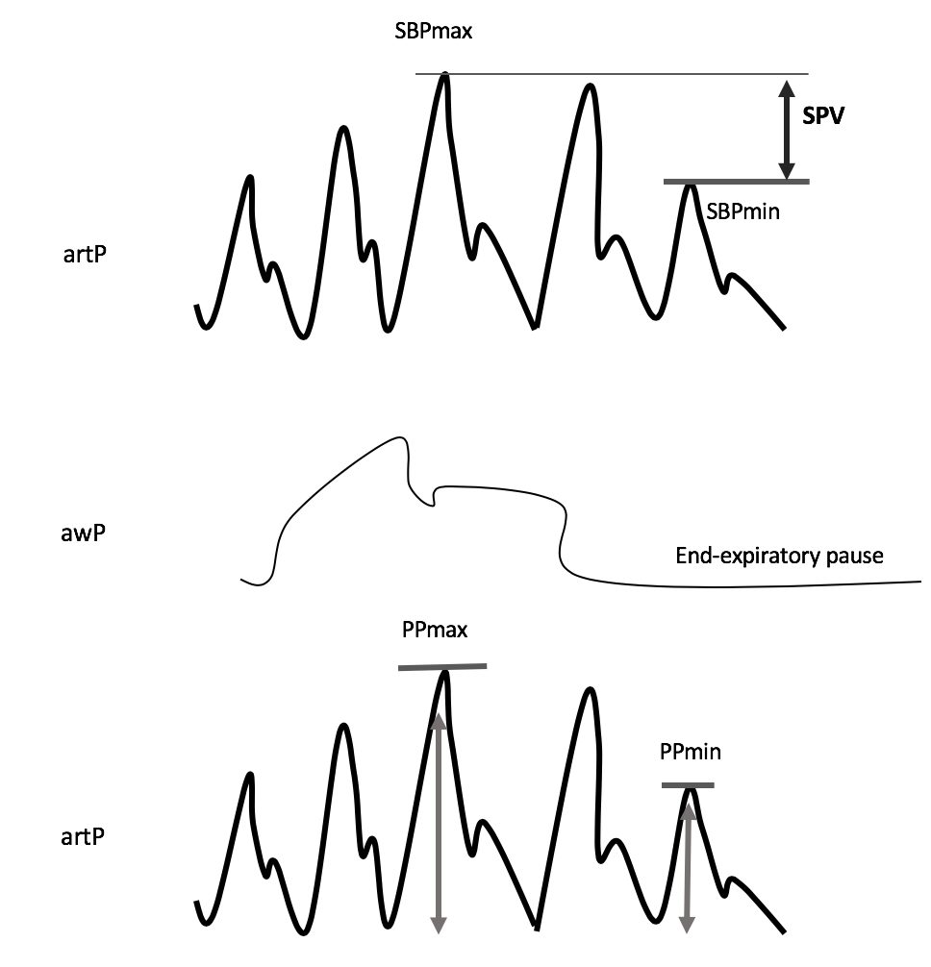
Figure 8 Description of the systolic pressure variation and pulse pressure variation during mechanical ventilation. SPV: Systolic pressure variation; PPV: Pulse pressure variation; artP: Arterial pressure; awP: Airway pressure; SBP: Systolic pressure. PP = 100 x (PPmax – PPmin) / [(PPmax + PPmin)/2].

Table 1 Types of shock and relationship with blood pressure and cardiac output

 | Blood pressure | Cardiac output
Hypovolemic | ? | ↓
Cardiogenic | ? | ↓
Obstructive | ? | ↓
Distributive | ↓ (Most of the time) | ?
?: May be high, normal, or low.

Table 2 Hypovolemic shock categories
 | I | II | III | IV
Blood loss (mL) | Up to 750 | 750-1500 | 1500-2000 | > 2000
% of blood loss | Up to 15 | 15-30 | 30-40 | > 40
Blood pressure | Normal | Normal | Decreased | Decreased
Mentation | Preserved | Anxious | Confused | Lethargic
Summary as described by the American College of Surgeons in The Advanced Trauma Life Support training program.

Table 3 Conditions that affect the venous oxygen saturation measurement

Condition | SvO₂ change
Anemia (Hemoglobin < 8) | ↓
Low cardiac output | ↓
Agitation | ↓
Sepsis | ↑
States of hypoxia | ↓
Anesthesia (↓O₂ utilization) | ↑
Normal SvO₂: 60%-80%.

Table 4 Correlates of low cardiac output

 | Low CO | High CO
Blood pressure | ↓ | ↓
Heart rate | ↑ | ↑
Systemic vascular resistance | ↑ | ↓
CO | ↓ | ↑
Pulse pressure | ↓ | ↑
CO: Cardiac output.

Table 5 Crystalloid vs colloid solutions

Crystalloid | Colloid
Lower price | Expensive
Believed to be safer | Some toxic (hydroxyethyl starch)
Higher amount needed for resuscitation | Less required
Slower action | Faster action
Moves out the intravascular space faster | Remains in circulation longer

