Name of Journal: World Journal of Clinical Cases
Manuscript NO: 89954
Manuscript Type: CASE REPORT

Primary anaplastic lymphoma kinase-positive large B-cell lymphoma of the left bulbar conjunctiva: A case report

Guo XH et al. Follow-up of ALK-positive LBCL

Xiao-Hong Guo, Chu-Bin Li, Hui-Hui Cao, Gen-Yuan Yang

Xiao-Hong Guo, Chu-Bin Li, Hui-Hui Cao, Department of Pathology, Zhuhai People's Hospital (Zhuhai Hospital Affiliated with Jinan University), Zhuhai 519000, Guangdong Province, China

Gen-Yuan Yang, Endoscopy Center, Zhuhai People's Hospital (Zhuhai Hospital Affiliated with Jinan University), Zhuhai 519000, Guangdong Province, China

Author contributions: Guo XH contributed to monitoring and drafted the original manuscript, collected the data and wrote the manuscript; Li CB contributed to patient follow-up and clinical data collection; Cao HH contributed to the diagnosis and data analysis; Yang GY contributed to conceptualization and supervision; All authors have read and approved the final manuscript.

Corresponding author: Gen-Yuan Yang, MD, Associate Chief Physician, Doctor, Endoscopy Center, Zhuhai People's Hospital (Zhuhai Hospital Affiliated with Jinan University), No. 79 Kangning Road, Zhuhai 519000, Guangdong Province, China. ygy19811104@163.com

Received: November 18, 2023
Revised: December 17, 2023
Accepted: January 2, 2024
Published online: January 26, 2024

Abstract
BACKGROUND
Anaplastic lymphoma kinase (ALK)-positive large B-cell lymphoma (LBCL) is an aggressive and rare variant of diffuse LBCL. Herein, we report an uncommon case of stage IE extranodal ALK-positive LBCL initially originating in the bulbar conjunctiva.

CASE SUMMARY
A 63-year-old woman presented with a mass in the left bulbar conjunctiva that had persisted for six months, accompanied by swelling and pain that had persisted for 3 d. Eye examination revealed an 8 mm slightly elevated pink mass in the lower conjunctival sac of the left eye. Microscopically, the tumor was composed of large immunoblastic and plasmablastic large lymphoid cells with scattered anaplastic or multinucleated large cells. Immunophenotypically, the neoplastic cells were positive for ALK, CD10, CD138, Kappa, MUM1, BOB.1, OCT-2, CD4, CD45, EMA, CD79a, CD38, and AE1/AE3, and negative for CD20, PAX5, Lambda, BCL6, CD30 and all other T-cell antigens. The results of gene rearrangement tests showed monoclonal IGH/IGK/IGL and TCRD rearrangements. Fluorescence in situ hybridization studies did not reveal any BCL2, BCL6 or MYC rearrangements. Furthermore, Epstein-Barr virus was not detected by in situ hybridization in the lesions. Based on the histopathological and imaging examinations, the neoplasm was classified as stage IE ALK-positive LBCL. No further treatments were administered. At the 6, 15, and 21 mo postoperative follow-up visits, the patient was in good condition, without obvious discomfort. This case represents the first example of primary extranodal ALK-positive LBCL presenting as a bulbar conjunctival mass, which is extremely rare and shares morphological and immunohistochemical features with a variety of other neoplasms that can result in misdiagnosis.

CONCLUSION
Awareness of the condition presented in this case report is necessary for early and accurate diagnosis and appropriate treatment.

Key Words: Anaplastic lymphoma kinase; Large B-cell lymphoma; Conjunctiva; Immunoglobulin/T-cell receptor gene; Immunohistochemistry; Case report

©The Author(s) 2024. Published by Baishideng Publishing Group Inc. All rights reserved.

Citation: Guo XH, Li CB, Cao HH, Yang GY. Primary anaplastic lymphoma kinase-positive large B-cell lymphoma of the left bulbar conjunctiva: A case report. World J Clin Cases 2024; 12(3): 657-664
URL: https://www.wjgnet.com/2307-8960/full/v12/i3/657.htm
DOI: https://dx.doi.org/10.12998/wjcc.v12.i3.657

Core Tip: Anaplastic lymphoma kinase (ALK)-positive large B-cell lymphoma (LBCL) is an aggressive and rare variant of diffuse LBCL. Herein, we report an uncommon case of stage IE extranodal ALK-positive LBCL initially originating in the bulbar conjunctiva. This case represents the first example of primary extranodal ALK-positive LBCL presenting as a bulbar conjunctival mass, which is extremely rare and shares morphological and immunohistochemical features with a variety of other neoplasms that can result in misdiagnosis. Awareness of the condition presented in this case report is necessary for early and accurate diagnosis and appropriate treatment.
INTRODUCTION
Anaplastic lymphoma kinase (ALK)-positive large B-cell lymphoma (LBCL) is an aggressive B-cell non-Hodgkin’s lymphoma, a rare variant that accounts for < 1 % of diffuse LBCL (DLBCL). This condition shows distinctive immunoblastic and/or plasmablastic morphology, consistent absence or focal and weak expression of pan-B-cell markers while acquiring plasma cell-associated markers, abnormal ALK expression resulting from a chromosomal translocation t(2;17)(p23;q23) which fuses Clathrin and ALK genes, and originates from post-germinal center B cells^{[1]} . However, primary extranodal site involvement is extremely rare, such as in the nasopharynx, tonsil, tongue, digestive tract, ovary, soft tissue, breast, pancreas, and skin^{[2-5]}.
Herein, we present the first uncommon case of primary extranodal ALK-positive LBCL manifesting as a bulbar conjunctival mass with aberrant T-cell receptor (TCR) rearrangement, which is unfamiliar to most pathologists and shares morphological and immunohistochemical (IHC) features with other neoplasms that can result in misdiagnosis. Awareness of this condition is necessary for early and accurate diagnosis and appropriate treatment.

CASE PRESENTATION
Chief complaints
A 63-year-old woman presented with a mass in the left bulbar conjunctiva that had persisted for six months, accompanied by swelling and pain that had persisted for 3 d.

History of present illness
The mass had not significantly increased in size since its discovery. It was not taken seriously at the time and was not treated. However, swelling and pain appeared 3 d ago.

History of past illness
The patient had undergone aortic valve replacement surgery 8 years ago.

Personal and family history
The personal history had no abnormalities. There was no immunodeficiency, particularly human immunodeficiency virus (HIV) infection. The patient had no family history of lymphoid hematopoietic system tumors and hereditary diseases.

Physical examination
Eye examination revealed an 8 mm slightly elevated, sessile, pink-colored sub-epithelial mass described as a “salmon patch” in the conjunctival sac of the left eye (Figure 1, anterior segment image), which could move with eyeball rotation, accompanied by congestion and edema of the surrounding conjunctiva.

Laboratory examinations
No abnormalities were found in routine blood, biochemical tests and lactose dehydrogenase levels.

Imaging examinations
For in-depth diagnosis and treatment of this patient, positron emission tomography/computed tomography examination was performed after conjunctival mass resection, and revealed no other positive signs in the body.

Histopathology
Macroscopically, the surface of the specimen was smooth and the cross section was solid, grayish-white, and focally darkish red, and it measured 1.3 cm × 0.9 cm × 0.6 cm.
Microscopically, the tumor was well-demarcated in low-power fields and showed diffuse infiltration of monomorphic lymphoid cells in the stroma of the conjunctival subepithelium (Figure 2A) and focal involvement of the accessory lacrimal gland (Figure 2B). Most of the superficial epithelium was exfoliated and absent. The neoplasm comprised uniformly moderate to large immunoblastic and plasmablastic cells. In tumor cells with an immunoblastic appearance, the cytoplasm was abundant and pale eosinophilic, basophilic, or amphophilic. The nuclei were large and round with vesicular chromatin; a clear nuclear membrane; and a single prominent, centrally located eosinophilic nucleolus (Figure 2C). Plasmablastic cells were slightly smaller with basophilic or amphophilic cytoplasm and had a large, round, centrally or eccentrically placed nucleus with clumped chromatin and a conspicuous nucleolus or several small peripherally located nucleoli (Figure 2D). Pleomorphic neoplastic giant cells with multinucleation or binucleation were observed focally (Figure 2E). In addition, mitotic activity was brisk and easily observable, with up to 16 cells per high-power field. Furthermore, focal necrosis, abundant apoptotic debris, and hemorrhage were observed (Figure 2F).

Molecular analysis findings
A polymerase chain reaction-based clonality study was performed for immunoglobulins (Ig) and TCR according to BIOMED-2 protocols. The results showed monoclonal IGH/IGK/IGL and TCRD rearrangements; however, monoclonal TCRB and TCRG rearrangements were not detected. Fluorescence in situ hybridization (FISH) studies did not reveal any BCL2, BCL6, and MYC rearrangements. Furthermore, in situ hybridization did not detect an Epstein-Barr virus (EBV) infection in the lesions.

IHC results
Given that the first IHC only showed CD79a patchily weak positive, an extensive IHC panel was performed using a streptavidin-peroxidase assay in batches to further confirm the nature of the neoplasm with appropriate reactive controls.
Immunophenotypically, the neoplastic cells were diffusely positive for ALK (cytoplasmic with perinuclear intensification) (Figure 3A), CD10 (Figure 3B), CD138 (Figure 3C), Kappa, MUM1, BOB.1 (Figure 3D), OCT-2 (Figure 3E), CD4 (Figure 3F), CD45, EMA (Figure 3G), and Vimentin. Furthermore, they were focally weak positive for CD79a (Figure 3H), CD38, IgA (Figure 3I), CK (AE1/AE3), and CD99 (plasmalemma staining) and negative for CD20 (Figure 3J), PAX5, Lambda, IgG, IgM, BCL6, CD30, CD21, CyclinD1, c-MYC, BCL2, CD3, CD5, CD43, CD8, TIA-1, CD56, CD117, MPO, TDT, S-100, HMB45, Desmin, INI-1, and BRG1. The proliferation index (Ki67) was approximately 70%. ALK showed a cytoplasmic distribution and a perinuclear pattern, reflecting Golgi localization.

FINAL DIAGNOSIS
Based on the above observations, a final diagnosis of primary ALK-positive LBCL of the left bulbar conjunctiva was made, and the neoplasm was subsequently classified as stage IE using the Ann Arbor staging system, and the International Prognostic Index score was 0.

TREATMENT
Surgical resection was performed with no complications. No further treatments were administered for any indication.

OUTCOME AND FOLLOW-UP
During the return visit and four weeks postoperative follow-up, a scar was present in the conjunctiva; however, the patient had no clinical symptoms and blood counts, biochemical tests, and lactose dehydrogenase levels were within normal ranges. At 6, 15, and 21 mo postoperative follow-up visits, the patient was in good condition without obvious discomfort and remained in regular follow-up.

DISCUSSION
Based on the best of our knowledge and extensive literature search, we believe that ALK-positive LBCL is a rare variant of DLBCL that has not been previously reported in the conjunctiva. Its identification in routine pathological examinations remains challenging; however, recognition of this condition is important, as it possesses an aggressive clinical course and the conventional therapy used for typical DLBCL has limited efficacy. Therefore, pathologists should be aware of this lymphoma to make an accurate diagnosis.
Clinically, ALK-positive LBCL can occur in all age groups (range: 9–90 years old). It affects men more than women (male/female: 5:1), and usually presents as a mediastinal mass or diffuse lymphadenopathy. Approximately half of the patients present with B symptoms^{[1-3,6]}, whereas a male patient had spontaneous tumor lysis syndrome^{[7]}. Most cases have no association with immunosuppression, whereas one case was comorbid with an HIV infection^{[8]}. Notably, one case was treated with azathioprine for ulcerative colitis^{[9]}. At present, there are no reports of human herpesvirus-8 infection; however, two cases of EBV infection have been reported^{[10,11]}.
Histopathologically, ALK-positive LBCL features a monomorphic immunoblastic and/or plasmablastic appearance, diffuse or sinusoidal infiltrative patterns in the lymph nodes, and diffuse or sheet-like growth patterns in extranodal sites. Small lymphocytes and mature plasma cells are present in the background, whereas in a rare case, this condition was accompanied by prominent neutrophilic infiltration^{[12]}.
The immunophenotype of ALK-positive LBCL is consistent with plasmablastic differentiation; therefore, the neoplastic cells are diffusely positive for plasma cell markers and CD45 and B-cell-specific transcriptional factors (including BOB.1 and OCT-2), whereas the mature pan-B cell markers are downregulated and present as mostly negative or focally weakly positive occasionally. Neoplastic cells are usually negative for T-cell and cytotoxic markers; however, the T helper marker CD4 is abnormally positive in half of the cases. The EMA is generally positive, whereas cytokeratin AE1/AE3 is patchy and weakly positive (perinuclear dots or cytoplasm), which may raise the hypothesis of a poorly differentiated carcinoma. CD30 is usually negative; however, 12% of the cases are focal and weakly positive. ALK expression was detected by immunohistochemistry in 99% of the cases, most of which appeared as cytoplasmic granular staining, whereas in two ALK-negative cases, ALK translocation was detected by FISH^{[2,3,13]}. Moreover, ALK translocation is a key event in the oncogenesis of this tumor, which activates the STAT3 signaling pathway and further upregulates downstream PRDM1/BLIMP1 (a master regulator of plasma cell differentiation) and the overexpression of c-MYC without MYC translocations^{[14]}. The aberrant expression of CD3^{[15]}, CD33^{[16]}, and CyclinD1^{[11]} has recently been reported.
Furthermore, germinal center-associated antigens, comprising CD10 and BCL6, are either expressed by themselves or together in some cases, similar to the reported case here. ALK-positive LBCL is postulated to originate from post-germinal center B cells with plasmablastic differentiation. This raises the following possibilities that some subpopulations may: (1) Be derived from germinal center B cells; (2) be influenced by the germinal center microenvironment; or (3) acquire CD10 expression through somatic mutations. Coexpression of CD10 and BCL6 has also been reported, supporting the hypothesis that at least a subset of ALK-positive LBCL may be derived from germinal center B cells (germinal center plasmablasts)^{[5]}. However, in this case, the patient was CD10-positive, BCL6-negative, and MUM-1-positive. Considering that BCL-6 expression is predominantly restricted to germinal center B cells, the absence of BCL-6 in the present case may indicate that these cells did not originate from germinal center B cells.
Cytogenetically, ALK-positive LBCL shows characteristic ALK gene rearrangements, all of which lead to overexpression and oncogenic activation of the ALK protein. Clonal gene rearrangement tests for Ig/TCR clonality assays in B-NHL showed that the sensitivity of IgH and IgK gene rearrangement detection was 91.18%, and the rate of TCR gene rearrangement detection was 3.68%^{[17]}. ALK-positive LBCL usually shows Ig rearrangements and the absence of TCR gene rearrangements. However, monoclonal Ig rearrangements are absent in some cases^{[2,18]}, which may be the result of a lack of consensus on target sequences or target site alterations as a result of somatic hypermutation. Moreover, TCR rearrangements are detected in some reported cases^{[19]}, as well as in our case showing Ig/TCR rearrangements, which may be formed from the earliest stages of B- and T-cell development. Otherwise, only a few reactive T cells within a high load of B-cell lymphoma are not sufficient to produce a polyclonal background^{[20]}. Traditionally, TCRG and TCRB are the gold standard targets, whereas TCRD (generally combined with TCRG) should only be used as a target for well-defined clinical requests, and the paucity of TCRD templates may easily give rise to preferential amplification and pseudoclonality. Moreover, authentic clonal TCRD rearrangements may not be associated with malignant lymphoid proliferation^{[20]}. This case can be explained from this viewpoint.
As the condition presented in this case originated in the conjunctiva, the main differential diagnoses may have included poorly differentiated carcinoma, small round cell tumors such as rhabdomyosarcoma and amelanotic melanoma, ALK-positive anaplastic large cell lymphoma, myeloid sarcomas, EBV-positive LBCL, DLBCL, and NOS. However, the integration of clinicopathological data, including clinical history, site, histomorphology, a panel of immunophenotypes, and molecular genetic characteristics, is necessary for the accurate diagnosis of lymphomas, and multiparametric marker evaluation is of critical value.

CONCLUSION
Herein, we report an extremely rare case of ALK-positive LBCL that presented as a bulbar conjunctival mass and shared morphological and IHC features with a variety of other neoplasms, which could result in misdiagnosis. Our experience suggests that awareness of this condition is necessary for an early and accurate diagnosis and appropriate treatment. For any subtype of conjunctival lymphoma, long-term follow-up is necessary because systemic disease may develop months or years after the initial diagnosis.

ACKNOWLEDGEMENTS
We wish to thank the timely help given by Hao Tang in figure editing.

REFERENCES
1 Campo E, Gascoyne RD. ALK-positive large B-cell lymphoma. In: Swerdlow SH, Campo E, Harris NL, Jaffe ES, Pileri SA, Stein H, Thiele J. WHO Classification of Tumors of Haematopoietic and Lymphoid Tissues. 4th ed. Lyon: International Agency for Research on Cancer, 2017: 319–320
2 Pan Z, Hu S, Li M, Zhou Y, Kim YS, Reddy V, Sanmann JN, Smith LM, Chen M, Gao Z, Wang HY, Yuan J. ALK-positive Large B-cell Lymphoma: A Clinicopathologic Study of 26 Cases With Review of Additional 108 Cases in the Literature. Am J Surg Pathol 2017; 41: 25-38 [PMID: 27740969 DOI: 10.1097/PAS.0000000000000753]
3 Jiang XN, Yu BH, Wang WG, Zhou XY, Li XQ. Anaplastic lymphoma kinase-positive large B-cell lymphoma: Clinico-pathological study of 17 cases with review of literature. PLoS One 2017; 12: e0178416 [PMID: 28665943 DOI: 10.1371/journal.pone.0178416]
4 Kushwaha P, Singh M, Vindal A, Verma N, Jain S. Primary ALK-Positive Large B Cell Lymphoma of Pancreas. J Gastrointest Cancer 2022; 53: 830-833 [PMID: 34374890 DOI: 10.1007/s12029-021-00662-6]
5 Yan M, Khattab R, Meyerson H. ALK-positive Large B-Cell Lymphoma Presenting as a Circumscribed Breast Mass with Germinal Center Immunophenotype. Int J Surg Pathol 2023; 31: 233-238 [PMID: 35521914 DOI: 10.1177/10668969221099627]
6 Xiong H, Liu SY, Yang YX, Tan XX, Luo QP, Peng J, Xiong ZT, Chen H, Chen J, Li Z, Jiang QP. An unusual case of anaplastic lymphoma kinase-positive large B-cell lymphoma in an elderly patient: A case report and discussion. Exp Ther Med 2016; 11: 1799-1802 [PMID: 27168806 DOI: 10.3892/etm.2016.3129]
7 Chapman-Fredricks J, Blieden C, Sandoval JD, Ernani V, Ikpatt OF. Acute spontaneous tumor lysis syndrome as the initial presentation of ALK-positive diffuse large B-cell lymphoma. Appl Immunohistochem Mol Morphol 2014; 22: 317-321 [PMID: 24717232 DOI: 10.1097/PAI.0b013e3182275c02]
8 Shi M, Miron PM, Hutchinson L, Woda BA, Nath R, Cerny J, Yu H. Anaplastic lymphoma kinase-positive large B-cell lymphoma with complex karyotype and novel ALK gene rearrangements. Hum Pathol 2011; 42: 1562-1567 [PMID: 21497367 DOI: 10.1016/j.humpath.2011.01.012]
9 Quesada AE, Huh YO, Wang W, Medeiros LJ, Thakral B. Anaplastic lymphoma kinase (ALK)-positive large B-cell lymphoma in a patient treated with azathioprine for ulcerative colitis. Pathology 2016; 48: 513-515 [PMID: 27311871 DOI: 10.1016/j.pathol.2016.03.017]
10 Liu H, Hu S. EBV+ ALK+ large B-cell lymphoma. Blood 2021; 138: 2741 [PMID: 34940813 DOI: 10.1182/blood.2021013595]
11 Wu WN, Xiang CX, Ma DS, Liu GZ, Liu H. [ALK-positive large B-cell lymphoma with EBV infection or cyclin D1 expression: a clinicopathological analysis of 3 cases]. Zhonghua Bing Li Xue Za Zhi 2022; 51: 506-511 [PMID: 35673721 DOI: 10.3760/cma.j.cn112151-20211117-00836]
12 Lin SY, Chuang SS, Jhuang JY, Sakamoto K, Takeuchi K, Bahrami A, Tsai CC. ALK positive large B-cell lymphoma with a massive neutrophilic infiltrate: report of a case mimicking epithelioid inflammatory myofibroblastic tumour. J Clin Pathol 2015; 68: 496-498 [PMID: 25720769 DOI: 10.1136/jclinpath-2014-202847]
13 Castillo JJ, Beltran BE, Malpica L, Marques-Piubelli ML, Miranda RN. Anaplastic lymphoma kinase-positive large B-cell lymphoma (ALK + LBCL): a systematic review of clinicopathological features and management. Leuk Lymphoma 2021; 62: 2845-2853 [PMID: 34151703 DOI: 10.1080/10428194.2021.1941929]
14 Valera A, Colomo L, Martínez A, de Jong D, Balagué O, Matheu G, Martínez M, Taddesse-Heath L, Jaffe ES, Bacchi CE, Campo E. ALK-positive large B-cell lymphomas express a terminal B-cell differentiation program and activated STAT3 but lack MYC rearrangements. Mod Pathol 2013; 26: 1329-1337 [PMID: 23599149 DOI: 10.1038/modpathol.2013.73]
15 Khanlari M, Medeiros LJ. ALK+ large B-cell lymphoma with aberrant expression of CD3. Blood 2020; 136: 3086 [PMID: 33367551 DOI: 10.1182/blood.2020008882]
16 Corean J, Li KD. A Rare Case of ALK-Positive Large B-Cell Lymphoma with CD33 Expression. Case Rep Hematol 2018; 2018: 5320590 [PMID: 29992063 DOI: 10.1155/2018/5320590]
17 Liu X, He H, Li Y, Huang Y, Li G, Yu Q, Li W, Li D. The application of antigen receptor gene rearrangement of BIOMED-2 in the pathologic diagnosis of 348 cases with non-Hodgkin lymphoma in a single institution in Southwest of China. Pathol Res Pract 2019; 215: 152615 [PMID: 31562020 DOI: 10.1016/j.prp.2019.152615]
18 Van Roosbroeck K, Cools J, Dierickx D, Thomas J, Vandenberghe P, Stul M, Delabie J, De Wolf-Peeters C, Marynen P, Wlodarska I. ALK-positive large B-cell lymphomas with cryptic SEC31A-ALK and NPM1-ALK fusions. Haematologica 2010; 95: 509-513 [PMID: 20207848 DOI: 10.3324/haematol.2009.014761]
19 De Paepe P, Baens M, van Krieken H, Verhasselt B, Stul M, Simons A, Poppe B, Laureys G, Brons P, Vandenberghe P, Speleman F, Praet M, De Wolf-Peeters C, Marynen P, Wlodarska I. ALK activation by the CLTC-ALK fusion is a recurrent event in large B-cell lymphoma. Blood 2003; 102: 2638-2641 [PMID: 12750159 DOI: 10.1182/blood-2003-04-1050]
20 Langerak AW, Groenen PJ, Brüggemann M, Beldjord K, Bellan C, Bonello L, Boone E, Carter GI, Catherwood M, Davi F, Delfau-Larue MH, Diss T, Evans PA, Gameiro P, Garcia Sanz R, Gonzalez D, Grand D, Håkansson A, Hummel M, Liu H, Lombardia L, Macintyre EA, Milner BJ, Montes-Moreno S, Schuuring E, Spaargaren M, Hodges E, van Dongen JJ. EuroClonality/BIOMED-2 guidelines for interpretation and reporting of Ig/TCR clonality testing in suspected lymphoproliferations. Leukemia 2012; 26: 2159-2171 [PMID: 22918122 DOI: 10.1038/leu.2012.246]

Footnotes
Informed consent statement: Informed written consent was obtained from the patient for publication of this report and any accompanying images.

Conflict-of-interest statement: The authors declare that they have no conflict of interest to disclose.

CARE Checklist (2016) statement: The authors have read the CARE Checklist (2016), and the manuscript was prepared and revised according to the CARE
Checklist (2016).

Open-Access: This article is an open-access article that was selected by an in-house editor and fully peer-reviewed by external reviewers. It is distributed in accordance with the Creative Commons Attribution NonCommercial (CC BY-NC 4.0) license, which permits others to distribute, remix, adapt, build upon this work non-commercially, and license their derivative works on different terms, provided the original work is properly cited and the use is non-commercial. See: https://creativecommons.org/Licenses/by-nc/4.0/

Provenance and peer review: Unsolicited article; Externally peer reviewed.
Peer-review model: Single blind

Peer-review started: November 18, 2023
First decision: December 5, 2023
Article in press: January 2, 2024

Specialty type: Pathology
Country/Territory of origin: China
Peer-review report’s scientific quality classification
Grade A (Excellent): 0
Grade B (Very good): B
Grade C (Good): 0
Grade D (Fair): 0
Grade E (Poor): 0

P-Reviewer: Chuang SS, Taiwan S-Editor: Zhang H L-Editor: A P-Editor: Xu ZH

Figure Legends
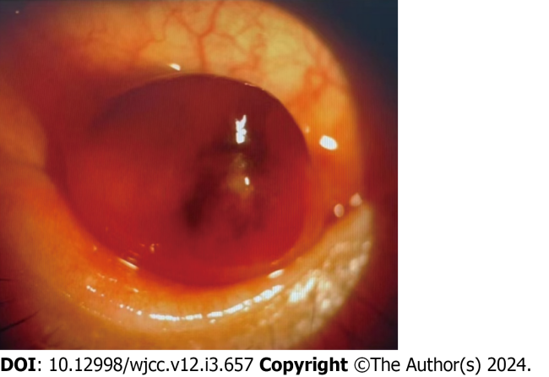
Figure 1 Anterior segment image showed an 8 mm slightly elevated, sessile, pink-colored sub-epithelial mass described as a “salmon patch” in the conjunctival sac of the left eye.
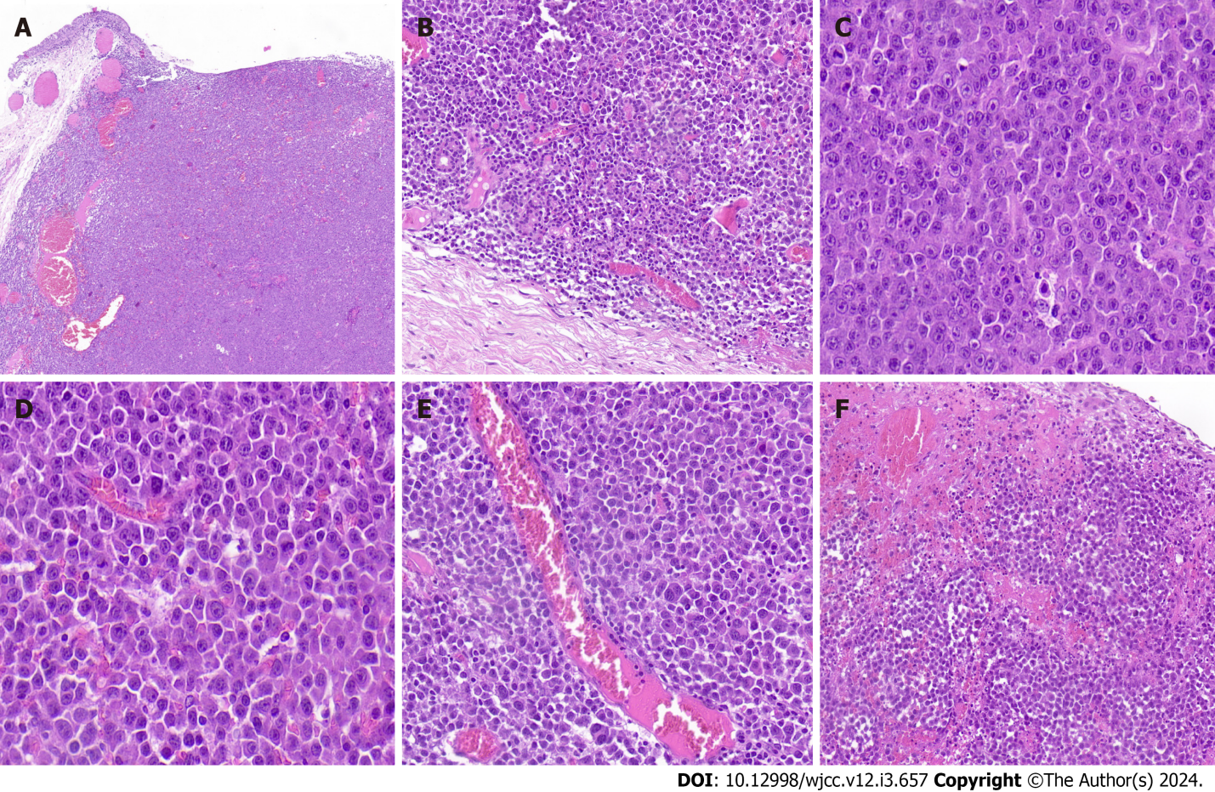
Figure 2 Anaplastic lymphoma kinase-positive large B-cell lymphoma. A: The tumor was well-demarcated and showed a diffusely infiltrate of monomorphicatypical lymphoid cells in the stroma of the conjunctival subepithelial [hematoxylin and eosin (HE) ×100]; B: The accessory lacrimal glands were involved (HE × 400); C: The lymphoid cells displayed immunoblastic morphology (HE × 1000); D: The lymphoid cells with plasmablastic morphology (HE × 1000); E: the pleomorphic neoplastic giant cells were present focally (HE × 400); F: Necrosis, abundant apoptotic debris and haemorrhage were observed (HE × 400).
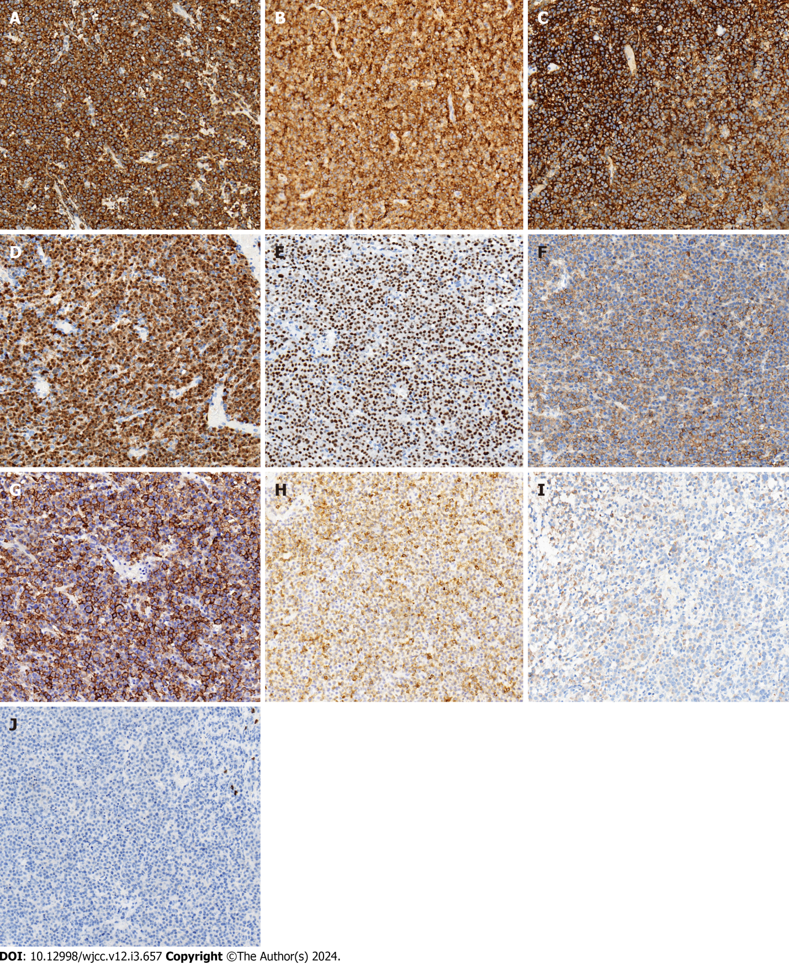
Figure 3 Immunohistochemical stains of anaplastic lymphoma kinase-positive large B-cell lymphoma (× 400). A-G: The large atypical cells were diffusely positive for anaplastic lymphoma kinase with a characteristic cytoplasmic granular staining pattern (A), CD10 (B), CD138 (C), BOB.1 (D), OCT-2 (E), CD4 (F) and EMA (G); H-J: Focally positive for CD79a (H) and IgA (I); negative for CD20 (J).

Published by Baishideng Publishing Group Inc
7041 Koll Center Parkway, Suite 160, Pleasanton, CA 94566, USA
Telephone: +1-925-3991568
E-mail: office@baishideng.com
Help Desk: https://www.f6publishing.com/helpdesk
https://www.wjgnet.com

© 2024 Baishideng Publishing Group Inc. All rights reserved.

