Name of Journal: World Journal of Psychiatry
Manuscript NO: 54331
Manuscript Type: ORIGINAL ARTICLE

Basic Study
Identification of key genes involved in post-traumatic stress disorder: Evidence from bioinformatics analysis

Bian YY et al. Identification of key genes in post-traumatic stress disorder

Yao-Yao Bian, Li-Li Yang, Bin Zhang, Wen Li, Zheng-Jun Li, Wen-Lin Li, Li Zeng

Yao-Yao Bian, School of Nursing, Nanjing University of Chinese Medicine, Nanjing 210023, Jiangsu Province, China

Li-Li Yang, Li Zeng, School of First Clinical Medicine, Nanjing University of Chinese Medicine, Nanjing 210023, Jiangsu Province, China

Li-Li Yang, Wen-Lin Li, Li Zeng, Jingwen Library, Nanjing University of Chinese Medicine, Nanjing 210023, Jiangsu Province, China

Bin Zhang, Digestive Department, Ningbo Hospital of Traditional Chinese Medicine, Ningbo 315200, Zhejiang Province, China

Wen Li, School of Preclinical Medicine, Guizhou University of Traditional Chinese Medicine, Guiyang 550025, Guizhou Province, China

Zheng-Jun Li, Management School, University of St Andrews, St Andrews KY16 9AJ, United Kingdom

Zheng-Jun Li, College of Health Economics Management, Nanjing University of Chinese Medicine, Nanjing 210023, Jiangsu Province, China

Author contributions: Bian YY, Yang LL, and Zhang B contributed equally to this study; Bian YY and Yang LL designed the study and wrote the manuscript; Zhang B, Li W, and Li ZJ conducted data analysis; Yang LL and Zhang B performed the statistical analysis; Li WL and Zeng L provided several suggestions for manuscript revision.

Supported by the National Natural Science Foundation of China, No. 81603529, 81673982, and 81704084; the Natural Science Foundation of the Jiangsu Higher Education Institutions, No. 16KJB360002; the Advantages of the Nursing Discipline Project of Jiangsu Province, No. 2019YSHL005; China Scholarship Council, No. 201908320373; the Jiangsu Government Scholarship for Overseas Studies; and the Qing Lan Project, No. 014000773/2018-00376.

Corresponding author: Li Zeng, MD, PhD, Academic Research, School of First Clinical Medicine, Nanjing University of Chinese Medicine, No. 138 Xianlin Avenue, Qixia District, Nanjing 210023, Jiangsu Province, China. zengbingli@njucm.edu.cn

Received: February 20, 2020
Revised: October 6, 2020
Accepted: November 4, 2020
Published online:

Abstract
BACKGROUND
Post-traumatic stress disorder (PTSD) is a serious stress-related disorder.

AIM
To identify the key genes and pathways to uncover the potential mechanisms of PTSD using bioinformatics methods.

METHODS
Gene expression profiles were obtained from the Gene Expression Omnibus database. The differentially expressed genes (DEGs) were identified by using GEO2R. Gene functional annotation and pathway enrichment were then conducted. The gene-pathway network was constructed with Cytoscape software. Quantitative real-time polymerase chain reaction (qRT-PCR) analysis was applied for validation, and text mining by Coremine Medical was used to confirm the connections among genes and pathways.

RESULTS
We identified 973 DEGs including 358 upregulated genes and 615 downregulated genes in PTSD. A group of centrality hub genes and significantly enriched pathways (MAPK, Ras, and ErbB signaling pathways) were identified by using gene functional assignment and enrichment analyses. Six genes (KRAS, EGFR, NFKB1, FGF12, PRKCA, and RAF1) were selected to validate using qRT-PCR. The results of text mining further confirmed the correlation among hub genes and the enriched pathways. It indicated that these altered genes displayed functional roles in PTSD via these pathways, which might serve as key signatures in the pathogenesis of PTSD.

CONCLUSION
The current study identified a panel of candidate genes and important pathways, which might help us deepen our understanding of the underlying mechanism of PTSD at the molecular level. However, further studies are warranted to discover the critical regulatory mechanism of these genes via relevant pathways in PTSD.

Key Words: Post-traumatic stress disorder; Differentially expressed genes; Key pathway; Gene-pathway co-expression; Bioinformatics analysis; Microarray

Bian YY, Yang LL, Zhang B, Li W, Li ZJ, Li WL, Zeng L. Identification of key genes involved in post-traumatic stress disorder: Evidence from bioinformatics analysis. World J Psychiatr 2020; In press

Core Tip: Post-traumatic stress disorder (PTSD) is an affective disorder after exposure to trauma or stress directly or indirectly. The pathogenesis of PTSD is not entirely understood. The purpose of this study was to uncover the critical signatures and key pathways to elucidate the underlying mechanisms of PTSD at the molecular level. To address this issue, the closely related genes and the most enriched pathways were identified by using bioinformatics analysis, which was then validated by using basic study in an exploratory approach. Our results showed that a series of significantly expressed genes and relevant pathways might serve as potential biomarkers involved in the pathogenesis of PTSD.

INTRODUCTION
Post-traumatic stress disorder (PTSD), a serious stress-related disorder, is characterized as hypervigilance or hyperarousal, which is caused by traumatic exposure or stressful event directly or indirectly^{[1]}. It presents with a wide range of significant symptoms, e.g., disturbing when reminding the flashbacks, avoidance following re-experiencing the traumatic events, and negative changes in mood and cognitive^{[2]}. It is diagnosed when these symptoms last for at least 1 mo after traumatic or stressor-related exposure^{[3]}.
It is estimated that the prevalence of PTSD ranges from 3.1% to 61.6% among 6648 participants in six countries by the International Consortium to Predict PTSD project^{[4]}. In a recent meta-analysis of 96 studies representing 34 countries, a 15.3% prevalence rate of PTSD was found^{[5]}. The lifetime rate of PTSD in the United States population is about 6.8%^{[6]}. A recent cross-sectional study performed in France showed that 35.3% of adults were diagnosed with PTSD^{[7]}. Additionally, about 89.7% of United States adults have exposed at least one traumatic event^{[8]}. Even though PTSD afflicts millions of people throughout the world, it remains largely undiagnosed, particularly in developing countries like China. It is not only comorbid with a wide range of psychological disorders (i.e., depression, anxiety, and substance abuse), which may further cause suicidal ideation or aggressive/addictive behaviors, but also associated with multiple negative psychosocial outcomes such as marital difficulties and unemployment. PTSD has brought a significant burden on individuals, families, and countries. It is reported that the United States spent more than 45 billion dollars annually on the treatment of mental disorders like PTSD^{[9]}. At present, the understanding of the underlying mechanisms of PTSD is not entirely clear, but it is likely related to the hypothalamic-pituitary-adrenal axis, neural circuits, autonomic nervous system, as well as the immune system. Taken together, these facts highlight an urgent need to uncover the molecular mechanisms of PTSD.
To date, with the advances of genomic and transcriptomic study, increasing genes and pathways have been screened out and reported to be related to the occurrence and development of PTSD. For instance, previous studies^{[10,11]} showed that FK506 binding protein 51 was associated with PTSD by deregulating the hypothalamic-pituitary-adrenal axis, indicating a key modulator of PTSD risk. In another instance, a gene-based study^{[12]} found that beta 2 adrenergic receptor gene was related to childhood trauma exposure in predicting PTSD symptoms in adults. Additionally, a variety of signaling pathways were reported to be involved in the developmental progression of PTSD, i.e., NF-κB pathway^{[13]}, BDNF-TrkB pathway^{[14]}, and JAK/STAT pathway^{[15]}, etc. Hence, it is necessary to identify candidate genes and relevant pathways involved in the onset and development of PTSD.
In this study, we screened out a group of candidate signatures and key pathways associated with PTSD from the National Center for Biotechnology Information (NCBI) Gene Expression Omnibus (GEO) database by using bioinformatics analysis. Furthermore, the results were verified by using the experimental methods. Our results may provide a significant step forward in understanding the pathogenesis of PTSD at the molecular level.

MATERIALS AND METHODS
Data resources and data processing
The gene expression profile of GSE68077 submitted by Muhie et al^{[16]} was obtained for our analysis. In this study, the microarray data of hemibrain samples were collected for analysis. GEO2R (http://www.ncbi.nlm.nih.gov/geo/geo2r) is an online tool based on the GEO query and Limma R packages. It was conducted to screen differentially expressed genes (DEGs) from different groups of different GEO series^{[17]}. The significant DEGs were obtained by meeting both |logFC| > 1 and P < 0.05. The Venny online tool (available online: http://bioinfogp.cnb.csic.es/tools/venny) was used to identify overlapping DEGs across two groups. The common genes were preserved for further bioinformatics analysis.

Functional enrichment analysis
Gene ontology (GO) enrichment analysis was used for gene annotation and function description. It consisted of three regulated functions, that is, biological processes (BP), cellular component (CC), and molecular function (MF). The GO terms were identified using the Database for Annotation, Visualization, and Integrated Discovery (DAVID, available online: http://david.abcc.ncifcrf.gov/)^{[18]} to identify the biological significance of genes when P < 0.05 was considered statistically significant. The Kyoto Encyclopedia of Genes and Genomes (KEGG) enrichment analysis was conducted using DAVID^{[18]} to identify pathway enrichment when P < 0.05 was set as the threshold value.

Gene–pathway network construction and prediction
The identified genes and significantly enriched pathways mapped with Cytoscape (http://www.cytoscape.org) software^{[19]} was used to visualize the integrated regulatory networks. Text mining conducted by Coremine Medical (http://www.coremine.com/medical/)^{[20]} was used to visualize the connections among genes and pathways.

Experimental animals and model preparation
Six male SJL albino mice (weighing 30 ± 2 g) provided by the Beijing Vital River Laboratory Animal Technology Co., Ltd (Beijing, China) were trained as aggressor mice according to the study^{[21]}. The mice were housed in home cages that were made of plexiglass material with plenty of water and food. Twelve male C57BL/6N mice (weighing 18 ± 2 g) were purchased from Changzhou Cavens Laboratory Animal Co., Ltd (Changzhou, China). They were randomly assigned to a control or an aggressed-exposed (Agg-E) group. All mice were housed under a standard condition on a 12-h light/darkness cycle in a temperature-controlled room (23 ± 2 ℃). As described previously^{[22]}, we used a modified “cage-within-cage resident-intruder” protocol^{[23]} to prepare the social stressed models. Briefly, Agg-E mice were housed in a wire mesh cage (17 cm × 14 cm × 8 cm), which were put inside the aggressor’s larger home cage (50 cm × 30 cm × 20 cm) for 6 h per day. The control mice were treated without aggressor exposure in the same condition. During the exposure time, the experimental mice were given no water and food, while the aggressor mice had free access to them. The direct or indirect exposure lasted for 10 successive days. After 6 wk of recovery, all experimental mice were sacrificed to harvest hemibrain tissues.

Depression-like behavior tests
All mice underwent three depression-like behavior tests, that is, forced swim test (FST), tail suspension test (TST), and open-field test (OFT). These tests were described previously^{[23,24]}. In brief, the mice were put in a transparent, glass cylindrical tank (2500 mL total volume) filled with 20 cm water (25 ± 1℃) and swam for 6 min. The time when they remained floating passively, stopped struggle, or swimming was regarded as the immobility time. The last 4 min of the immobility time was recorded with a video camera in the FST test. For TST, the mice were suspended by the tail and the last 4 min of the immobility time were measured. While the OFT test was conducted to assess locomotor activity. The mice were allowed to move freely in a specific device for 5 min. The movements of each mouse were measured with a video camera.

Quantitative real-time polymerase chain reaction analysis
Total RNA of hemibrain tissues was isolated according to the instructions of the kit. Polymerase chain reaction was conducted using the SYBR Green Master Mix (ThermoFisher, United States). The gene expression was calculated by 2^{−ΔΔCT} method and normalized against the reference gene, GAPDH. The primers are presented in Supplementary Table 1.

Data analysis and statistics
The experimental results are all shown as the mean ± SD. Intergroup differences were analyzed by the t-test by using the SPSS 19.0 software. A P value less than 0.05 was regarded as statistically significant.

RESULTS
Identification of DEGs
First, we retrieved DEGs at two-time points (24 h post 10 d and 42 d post 10 d) by using GEO2R, separately. A total of 1432 DEGs (577 upregulated DEGs and 855 downregulated DEGs) at the time point of 24 h (24 h) post 10 d, and 1374 DEGs (569 upregulated DEGs and 805 downregulated DEGs) at the time point of 42 d (42 d) post 10 d were obtained. Based on Venny online tool, a total of 358 overlapping upregulated DEGs and 615 overlapping downregulated DEGs of the two-time points were identified in the social-stress group compared with the control group. The Venny diagram of upregulated and downregulated DEGs was shown in Figure 1.

Functional annotations
The 973 DEGs (358 upregulated DEGs and 615 downregulated DEGs) were assessed using the DAVID database for functional assignment and pathway enrichment with a P value < 0.05. We identified the most enriched GOs (top 20) ranked by P value, including protein binding (GO: 0005515), cell junction (GO: 0030054), and neuron projection (GO: 0043005) (Figure 2A). Functional enrichment analysis based on GO terms showed that these altered genes significantly participated in PTSD-related pathways (top 20, Figure 2B), i.e., MAPK, Ras, and ErbB signaling pathways.
The above 358 upregulated DEGs and 615 downregulated DEGs were analyzed using DAVID, respectively. Based on P value, the upregulated genes in BP terms were markedly enriched in nervous system development, cell differentiation, and positive regulation of neuron projection development. The upregulated genes enriched in CC terms were mainly associated with cell junction, and the upregulated genes in MF terms were markedly enriched in cell adhesion molecule binding and protein domain specific binding. Meanwhile, the downregulated genes in BP terms were markedly enriched in protein transport, cell cycle, and vesicle-mediated transport. The downregulated genes in MF terms were markedly enriched in protein binding, nucleic acid binding, and nucleocytoplasmic transporter activity (Table 1). Furthermore, KEGG enrichment analysis results showed that the upregulated genes were enriched in neuroactive ligand-receptor interaction, calcium signaling pathway, and MAPK signaling pathway, while the downregulated genes were enriched in the ErbB signaling pathway and Toll-like receptor signaling pathway (Table 2). Combined with the results in Figure 2, MAPK, Ras, and ErbB signaling pathways were the main PTSD-related pathways. These markedly enriched pathways with their DEGs are presented in Table 3. Finally, these genetic pathways with their genes were uploaded to Cytoscape to construct the co-expression pattern of the most significantly enriched pathways of DEGs involved in PTSD, as shown in Figure 3.

Verification and text mining of hub genes and pathways
The genes in the central roles connected to the three enriched pathways were considered as hub genes. In our study, we tried to uncover the closely enriched genes related to the most significant pathways in an exploratory approach. Six hub genes were selected based on the literature due to their neurobiology assumption to be related to PTSD. The hub genes were listed as follows, that is, nuclear factor kappa B subunit 1 (NFKB1), KRAS proto-oncogene, GTPase (KRAS), epidermal growth factor receptor (EGFR), fibroblast growth factor 12 (FGF12), protein kinase C alpha (PRKCA), and Raf-1 proto-oncogene, serine/threonine kinase (RAF1). Quantitative real-time polymerase chain reaction (qRT-PCR) was used for validation. The above genes in hemibrain tissues were differently expressed between the two groups (Figure 4), which was in line with the results of the microarray datasets. It indicated that these genes played crucial roles in the occurrence and development of PTSD. To further visualize the linear connections between the hub genes and the associated pathways, text mining was performed with Coremine Medical online tool. The above six gene symbols and three pathways were used as search terms, and the co-expressed network is shown in Figure 5. We found that KRAS and EGFR were correlated with the Ras pathway, while four genes (KRAS, EGFR, PRKCA, and RAF1) were related to the ErbB pathway. The genes except FGF12 were associated with the MAPK pathway. More importantly, EGFR and KRAS were connected with three pathways, which further demonstrated that these genes have important biological functions in the signaling pathway.

Depression-like behavior analysis
The results of FST, TST, and OFT are presented in Figure 6. We found that the immobility time in the Agg-E group was significantly increased than that of the control group. However, the path length of OFT showed no significant difference between the Agg-E group and control group.

DISCUSSION
PTSD as a trauma-related or stressor-related disorder is the consequence of direct or indirect stress. It can lead to subsequent response patterns such as avoidance, negative emotion, and hyperarousal^{[2]}. PTSD is diagnosed when the above symptoms last for at least 1 mo after the onset of the event^{[25]}. The genesis and progression of PTSD are complicated and the pathogenesis is not entirely understood. Thus, it is needed to uncover the key targets to elucidate the underlying mechanisms associated with PTSD.
In this study, the gene expression microarrays of GSE68077 were downloaded from the GEO database. A total of 973 DEGs including 358 upregulated genes and 615 downregulated genes were identified. The functional enrichment analysis of DEGs based on GO terms demonstrated that the most functional and molecular work might focus on MAPK, Ras, and ErbB signaling pathways. Based on functional enrichment, we found that the upregulated genes displayed functionalities, such as cell differentiation and positive regulation of neuron projection development, while the downregulated genes had other functionalities, such as protein transport, cell cycle, and DNA repair. The upregulated genes were markedly concentrated in neuroactive ligand-receptor interaction, calcium, and MAPK signaling pathways, and the downregulated genes were markedly enriched in the ErbB and Toll-like receptor signaling pathways. Taken together, we speculated that MAPK, Ras, and ErbB pathways played regulatory roles in the occurrence and progression of PTSD. Consistent with our hypothesis, the MAPK pathway as a kind of stress response signaling cascade, is involved in synaptic plasticity and is connected with depressive-like symptoms or severity of the depression^{[26]}. In line with our findings, a previous study^{[27]} based on bioinformatics analysis showed that the MARK signaling pathway was one of the mainly enriched signaling pathways involved in major depressive disorder. Another study suggested that the ErbB signaling pathway might be associated with cognitive deficiencies after early social isolation^{[28]}, and Ras pathway acted as a critical role in the pathogenesis of depression^{[29]}.
Currently, we identified the closely related genes involved in the most significant pathways above, as shown in Table 3. Among these genes, we found that a panel of hub genes was closely related to the significantly expressed pathways. In an exploratory approach, several hub genes were selected based on the literature due to their neurobiology assumption to be related to PTSD. To validate our hypothesis, we further performed qRT-PCR to verify our findings. The results were consistent with the microarray analysis. Besides, several genes were reported in previous studies. For example, NFKB1, a transcription regulator, was found to be overexpressed in depressive disorders patients^{[30]}. PRKCA has been implicated in PTSD pathogenesis, and the single nucleotide polymorphism of PRKCA was considered to be significantly associated with traumatic experiences and PTSD symptoms, which can further increase the rate of PTSD^{[31]}. EGFR plays a vital role in cellular growth, differentiation, and apoptosis. Several studies indicated that EGFR genotype is closely correlated to depression or major depressive disorder^{[32-34]}. Its main downstream pathway is MAPK that plays a dominant role in signal transduction in many biological activities such as cell proliferation and inflammatory responses. It has been known that the MAPK pathway is activated by neuropeptide oxytocin in the paraventricular nucleus of the hypothalamus by transactivation of EGFR to regulate anxiety^{[35]}. Interestingly, the connections among hub genes and relevant pathways were supported by the results of the co-occurrence analysis of test mining. We found that the above genes were correlated with the enriched signaling pathways. It indicated that these altered hub genes played functional roles in PTSD via these pathways. Based on the evidence above, we argued that these genes may serve as important contributors to PTSD. Besides, the depression-like behavioral data (FST and TST) indicated a marked increase in immobility time in the Agg-E group. It showed that stress exposure could induce depressive-behavior that may co-occur with PTSD.

CONCLUSION
In conclusion, the present study identified a series of significantly expressed genes and relevant pathways, which may serve as potential biomarkers involved in the pathogenesis of PTSD. The results were confirmed using experimental verification. We further surmised that the identified genes may be key contributors associated with PTSD. However, future studies on the precise mechanism are warranted.

ARTICLE HIGHLIGHTS
Research background
Post-traumatic stress disorder (PTSD) is a common trauma-related or stressor-related disorder characterized by a wide range of significant symptoms, e.g., avoidance, negative emotion, and hyperarousal. A variety of targeted genes and pathways may be associated with the occurrence and progression of PTSD.

Research motivation
The underlying mechanisms of PTSD are complicated and not entirely clear. We sought to uncover the key targets for the potential mechanisms associated with PTSD at the molecular level.

Research objectives
The main objective was to identify critical genes and key pathways associated with PTSD.

Research methods
Our study was conducted based on the NCBI Gene Expression Omnibus database by using bioinformatics analysis. The differentially expressed genes were identified by using GEO2R. Gene functional annotation and pathway enrichment were performed using the Database for Annotation, Visualization, and Integrated Discovery. The gene-pathway network was mapped with Cytoscape software. Quantitative real-time polymerase chain reaction (qRT-PCR) analysis was applied for validation, and text mining by Coremine Medical was used to confirm the connections among genes and pathways.

Research results
A total of 358 upregulated genes and 615 downregulated genes were obtained. These altered genes were significantly enriched in PTSD-related pathways, such as MAPK, Ras, and ErbB signaling pathways. The co-expression pattern of these enriched pathways with their genes was constructed. And a group of hub genes was obtained from the gene-pathway network. qRT-PCR indicated that the hub genes were differentially expressed. Besides, text mining showed that these genes were linearly connected with the associated pathways, which suggested that these genes might play crucial roles in the signal pathway conduction in the onset and development of PTSD.

Research conclusions
The results of this study have contributed to the identification of a panel of candidate genes and important pathways, which may serve as potential biomarkers involved in the pathogenesis of PTSD.

Research perspectives
Our findings may provide a significant step forward in understanding the pathogenesis of PTSD at the molecular level.

REFERENCES
1 Watkins LE, Sprang KR, Rothbaum BO. Treating PTSD: A Review of Evidence-Based Psychotherapy Interventions. Front Behav Neurosci 2018; 12: 258 [PMID: 30450043 DOI: 10.3389/fnbeh.2018.00258]
2 Dennis PA, Weinberg JB, Calhoun PS, Watkins LL, Sherwood A, Dennis MF, Beckham JC. An investigation of vago-regulatory and health-behavior accounts for increased inflammation in posttraumatic stress disorder. J Psychosom Res 2016; 83: 33-39 [PMID: 27020074 DOI: 10.1016/j.jpsychores.2016.02.008]
3 Paredes Molina CS, Berry S, Nielsen A, Winfield R. PTSD in civilian populations after hospitalization following traumatic injury: A comprehensive review. Am J Surg 2018; 216: 745-753 [PMID: 30103902 DOI: 10.1016/j.amjsurg.2018.07.035]
4 Qi W, Ratanatharathorn A, Gevonden M, Bryant R, Delahanty D, Matsuoka Y, Olff M, deRoon-Cassini T, Schnyder U, Seedat S, Laska E, Kessler RC, Koenen K, Shalev A on behalf of the ICPP. Application of data pooling to longitudinal studies of early post-traumatic stress disorder (PTSD): the International Consortium to Predict PTSD (ICPP) project. Eur J Psychotraumatol 2018; 9: 1476442 [PMID: 29938009 DOI: 10.1080/20008198.2018.1476442]
5 Charlson F, van Ommeren M, Flaxman A, Cornett J, Whiteford H, Saxena S. New WHO prevalence estimates of mental disorders in conflict settings: a systematic review and meta-analysis. Lancet 2019; 394: 240-248 [PMID: 31200992 DOI: 10.1016/S0140-6736(19)30934-1]
6 Kessler RC, Chiu WT, Demler O, Merikangas KR, Walters EE. Prevalence, severity, and comorbidity of 12-month DSM-IV disorders in the National Comorbidity Survey Replication. Arch Gen Psychiatry 2005; 62: 617-627 [PMID: 15939839 DOI: 10.1001/archpsyc.62.6.617]
7 Husky MM, Mazure CM, Kovess-Masfety V. Gender differences in psychiatric and medical comorbidity with post-traumatic stress disorder. Compr Psychiatry 2018; 84: 75-81 [PMID: 29723769 DOI: 10.1016/j.comppsych.2018.04.007]
8 Kilpatrick DG, Resnick HS, Milanak ME, Miller MW, Keyes KM, Friedman MJ. National estimates of exposure to traumatic events and PTSD prevalence using DSM-IV and DSM-5 criteria. J Trauma Stress 2013; 26: 537-547 [PMID: 24151000 DOI: 10.1002/jts.21848]
9 Kheirbek MA, Klemenhagen KC, Sahay A, Hen R. Neurogenesis and generalization: a new approach to stratify and treat anxiety disorders. Nat Neurosci 2012; 15: 1613-1620 [PMID: 23187693 DOI: 10.1038/nn.3262]
10 Young DA, Inslicht SS, Metzler TJ, Neylan TC, Ross JA. The effects of early trauma and the FKBP5 gene on PTSD and the HPA axis in a clinical sample of Gulf War veterans. Psychiatry Res 2018; 270: 961-966 [PMID: 29576410 DOI: 10.1016/j.psychres.2018.03.037]
11 Hawn SE, Sheerin CM, Lind MJ, Hicks TA, Marraccini ME, Bountress K, Bacanu SA, Nugent NR, Amstadter AB. GxE effects of FKBP5 and traumatic life events on PTSD: A meta-analysis. J Affect Disord 2019; 243: 455-462 [PMID: 30273884 DOI: 10.1016/j.jad.2018.09.058]
12 Hauser MA, Garrett ME, Liu Y, Dennis MF, Kimbrel NA, Veterans Affairs Mid-Atlantic Mental Illness Research Education And Clinical Center Workgroup, Beckham JC, Ashley-Koch AE. Further evidence for a role of the ADRB2 gene in risk for posttraumatic stress disorder. J Psychiatr Res 2017; 84: 59-61 [PMID: 27701011 DOI: 10.1016/j.jpsychires.2016.09.013]
13 Guardado P, Olivera A, Rusch HL, Roy M, Martin C, Lejbman N, Lee H, Gill JM. Altered gene expression of the innate immune, neuroendocrine, and nuclear factor-kappa B (NF-κB) systems is associated with posttraumatic stress disorder in military personnel. J Anxiety Disord 2016; 38: 9-20 [PMID: 26751122 DOI: 10.1016/j.janxdis.2015.12.004]
14 Green CR, Corsi-Travali S, Neumeister A. The Role of BDNF-TrkB Signaling in the Pathogenesis of PTSD. J Depress Anxiety 2013; 2013: 006 [PMID: 25226879 DOI: 10.4172/2167-1044.S4-006]
15 Feng D, Guo B, Liu G, Wang B, Wang W, Gao G, Qin H, Wu S. FGF2 alleviates PTSD symptoms in rats by restoring GLAST function in astrocytes via the JAK/STAT pathway. Eur Neuropsychopharmacol 2015; 25: 1287-1299 [PMID: 25979764 DOI: 10.1016/j.euroneuro.2015.04.020]
16 Muhie S, Gautam A, Meyerhoff J, Chakraborty N, Hammamieh R, Jett M. Brain transcriptome profiles in mouse model simulating features of post-traumatic stress disorder. Mol Brain 2015; 8: 14 [PMID: 25888136 DOI: 10.1186/s13041-015-0104-3]
17 Barrett T, Wilhite SE, Ledoux P, Evangelista C, Kim IF, Tomashevsky M, Marshall KA, Phillippy KH, Sherman PM, Holko M, Yefanov A, Lee H, Zhang N, Robertson CL, Serova N, Davis S, Soboleva A. NCBI GEO: archive for functional genomics data sets--update. Nucleic Acids Res 2013; 41: D991-D995 [PMID: 23193258 DOI: 10.1093/nar/gks1193]
18 Huang DW, Sherman BT, Tan Q, Collins JR, Alvord WG, Roayaei J, Stephens R, Baseler MW, Lane HC, Lempicki RA. The DAVID Gene Functional Classification Tool: a novel biological module-centric algorithm to functionally analyze large gene lists. Genome Biol 2007; 8: R183 [PMID: 17784955 DOI: 10.1186/gb-2007-8-9-r183]
19 Shannon P, Markiel A, Ozier O, Baliga NS, Wang JT, Ramage D, Amin N, Schwikowski B, Ideker T. Cytoscape: a software environment for integrated models of biomolecular interaction networks. Genome Res 2003; 13: 2498-2504 [PMID: 14597658 DOI: 10.1101/gr.1239303]
20 de Leeuw N, Dijkhuizen T, Hehir-Kwa JY, Carter NP, Feuk L, Firth HV, Kuhn RM, Ledbetter DH, Martin CL, van Ravenswaaij-Arts CM, Scherer SW, Shams S, Van Vooren S, Sijmons R, Swertz M, Hastings R. Diagnostic interpretation of array data using public databases and internet sources. Hum Mutat 2012; 33: 930-940 [PMID: 26285306 DOI: 10.1002/humu.22049]
21 Hammamieh R, Chakraborty N, De Lima TC, Meyerhoff J, Gautam A, Muhie S, D'Arpa P, Lumley L, Carroll E, Jett M. Murine model of repeated exposures to conspecific trained aggressors simulates features of post-traumatic stress disorder. Behav Brain Res 2012; 235: 55-66 [PMID: 22824590 DOI: 10.1016/j.bbr.2012.07.022]
22 Bian Y, Yang L, Zhao M, Li Z, Xu Y, Zhou G, Li W, Zeng L. Identification of Key Genes and Pathways in Post-traumatic Stress Disorder Using Microarray Analysis. Front Psychol 2019; 10: 302 [PMID: 30873067 DOI: 10.3389/fpsyg.2019.00302]
23 Steru L, Chermat R, Thierry B, Simon P. The tail suspension test: a new method for screening antidepressants in mice. Psychopharmacology (Berl) 1985; 85: 367-370 [PMID: 3923523 DOI: 10.1007/BF00428203]
24 Porsolt RD, Le Pichon M, Jalfre M. Depression: a new animal model sensitive to antidepressant treatments. Nature 1977; 266: 730-732 [PMID: 559941 DOI: 10.1038/266730a0]
25 Lisieski MJ, Eagle AL, Conti AC, Liberzon I, Perrine SA. Single-Prolonged Stress: A Review of Two Decades of Progress in a Rodent Model of Post-traumatic Stress Disorder. Front Psychiatry 2018; 9: 196 [PMID: 29867615 DOI: 10.3389/fpsyt.2018.00196]
26 Duric V, Banasr M, Licznerski P, Schmidt HD, Stockmeier CA, Simen AA, Newton SS, Duman RS. A negative regulator of MAP kinase causes depressive behavior. Nat Med 2010; 16: 1328-1332 [PMID: 20953200 DOI: 10.1038/nm.2219]
27 Ji HF, Zhuang QS, Shen L. Genetic overlap between type 2 diabetes and major depressive disorder identified by bioinformatics analysis. Oncotarget 2016; 7: 17410-17414 [PMID: 27007159 DOI: 10.18632/oncotarget.8202]
28 Makinodan M, Rosen KM, Ito S, Corfas G. A critical period for social experience-dependent oligodendrocyte maturation and myelination. Science 2012; 337: 1357-1360 [PMID: 22984073 DOI: 10.1126/science.1220845]
29 Li H, Linjuan-Li, Wang Y. G-CSF improves CUMS-induced depressive behaviors through downregulating Ras/ERK/MAPK signaling pathway. Biochem Biophys Res Commun 2016; 479: 827-832 [PMID: 27680311 DOI: 10.1016/j.bbrc.2016.09.123]
30 Iacob E, Light KC, Tadler SC, Weeks HR, White AT, Hughen RW, Vanhaitsma TA, Bushnell L, Light AR. Dysregulation of leukocyte gene expression in women with medication-refractory depression versus healthy non-depressed controls. BMC Psychiatry 2013; 13: 273 [PMID: 24143878 DOI: 10.1186/1471-244X-13-273]
31 de Quervain DJ, Kolassa IT, Ackermann S, Aerni A, Boesiger P, Demougin P, Elbert T, Ertl V, Gschwind L, Hadziselimovic N, Hanser E, Heck A, Hieber P, Huynh KD, Klarhöfer M, Luechinger R, Rasch B, Scheffler K, Spalek K, Stippich C, Vogler C, Vukojevic V, Stetak A, Papassotiropoulos A. PKCα is genetically linked to memory capacity in healthy subjects and to risk for posttraumatic stress disorder in genocide survivors. Proc Natl Acad Sci USA 2012; 109: 8746-8751 [PMID: 22586106 DOI: 10.1073/pnas.1200857109]
32 Pirl WF, Traeger L, Greer JA, Bemis H, Gallagher E, Lennes I, Sequist L, Heist R, Temel JS. Tumor epidermal growth factor receptor genotype and depression in stage IV non-small cell lung cancer. Oncologist 2011; 16: 1299-1306 [PMID: 21807767 DOI: 10.1634/theoncologist.2011-0116]
33 Pirl WF, Traeger L, Greer JA, Jackson V, Lennes IT, Gallagher E, Sequist L, Temel JS. Depression, survival, and epidermal growth factor receptor genotypes in patients with metastatic non-small cell lung cancer. Palliat Support Care 2013; 11: 223-229 [PMID: 23399428 DOI: 10.1017/S1478951512001071]
34 Jacobs JM, Traeger L, Eusebio J, Simon NM, Sequist LV, Greer JA, Temel JS, Pirl WF. Depression, inflammation, and epidermal growth factor receptor (EGFR) status in metastatic non-small cell lung cancer: A pilot study. J Psychosom Res 2017; 99: 28-33 [PMID: 28712427 DOI: 10.1016/j.jpsychores.2017.05.009]
35 Blume A, Bosch OJ, Miklos S, Torner L, Wales L, Waldherr M, Neumann ID. Oxytocin reduces anxiety via ERK1/2 activation: local effect within the rat hypothalamic paraventricular nucleus. Eur J Neurosci 2008; 27: 1947-1956 [PMID: 18412615 DOI: 10.1111/j.1460-9568.2008.06184.x]

Footnotes
Institutional review board statement: This study was reviewed and approved by the Animal Experiment Ethics Committee of Nanjing University of Chinese Medicine.

Institutional animal care and use committee statement: All experimental procedures followed the protocols approved by the Institutional Animal Care and Use Committee of Nanjing University of Chinese Medicine.

Conflict-of-interest statement: The authors declare no conflicts of interest.

Data sharing statement: Data of the studies are not publicly available but might be shared upon request from the corresponding author.

ARRIVE guidelines statement: The authors have read the ARRIVE guideline, and the manuscript was prepared and revised according to the ARRIVE guidelines.

Open-Access: This article is an open-access article that was selected by an in-house editor and fully peer-reviewed by external reviewers. It is distributed in accordance with the Creative Commons Attribution NonCommercial (CC BY-NC 4.0) license, which permits others to distribute, remix, adapt, build upon this work non-commercially, and license their derivative works on different terms, provided the original work is properly cited and the use is non-commercial. See: http://creativecommons.org/Licenses/by-nc/4.0/

Manuscript source: Unsolicited manuscript

Peer-review started: February 20, 2020
First decision: September 21, 2020
Article in press:

Specialty type: Psychiatry
Country/Territory of origin: China
Peer-review report’s scientific quality classification
Grade A (Excellent): 0
Grade B (Very good): 0
Grade C (Good): C, C
Grade D (Fair): 0
Grade E (Poor): 0

P-Reviewer: Ahboucha S, Vyshka G S-Editor: Chen XF L-Editor: Wang TQ P-Editor:
Figure Legends
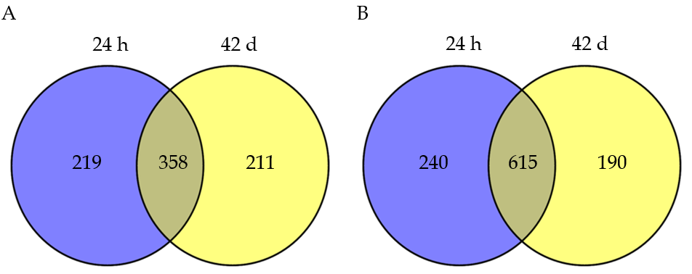
Figure 1 Venny diagrams of differentially expressed genes at the time point of 24 h post 10 d compared with 42 d post 10 d after aggressor exposure sessions. A: Overlapping upregulated differentially expressed genes; B: Overlapping downregulated differentially expressed genes.

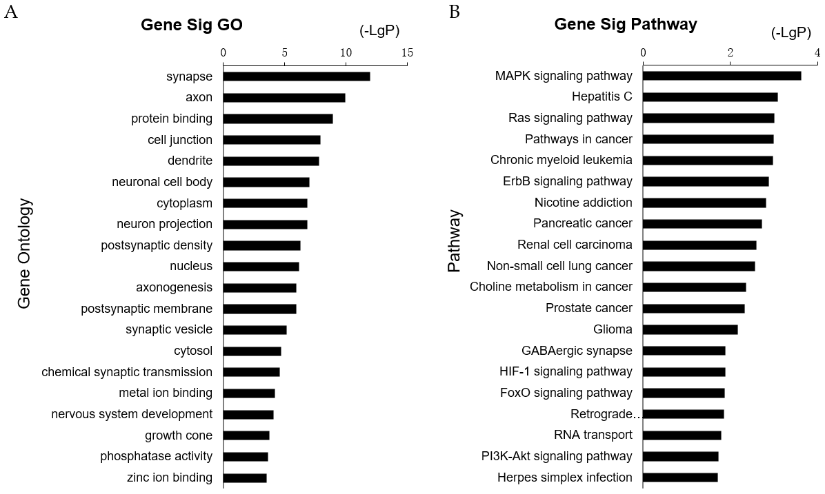
Figure 2 Gene ontology annotation and pathway enrichment of differentially expressed genes associated with post-traumatic stress disorder. A: Gene ontology analysis of differentially expressed genes (top 20); B: The Kyoto Encyclopedia of Genes and Genomes enrichment analysis of differentially expressed genes (top 20) with enriched score values setting as –log10 (P values). GO: Gene ontology.

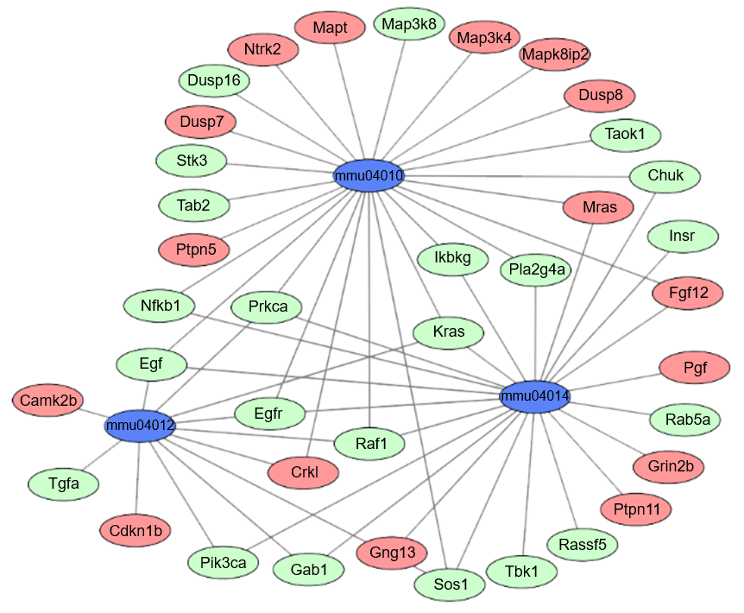
Figure 3 Co-expression pattern of the most significantly enriched pathways of differentially expressed genes involved in post-traumatic stress disorder. In the graphic, red cycles as the upregulated genes, green cycles as the downregulated genes, and blue cycles as the signaling pathway.

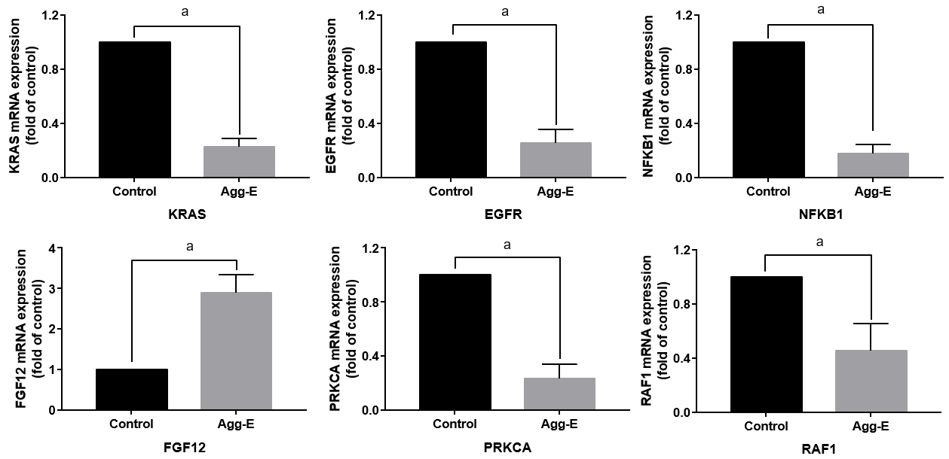
Figure 4 The mRNA expression of hub genes in control and aggressed-exposed groups. The results are shown as the mean ± SD, ªP < 0.05. Agg-E: Aggressed-exposed; KRAS: KRAS proto-oncogene, GTPase; EGFR: Epidermal growth factor receptor; NFKB1: Nuclear factor kappa B subunit 1; FGF12: Fibroblast growth factor 12; PRKCA: Protein kinase C alpha; RAF1: Raf-1 proto-oncogene, serine/threonine kinase.

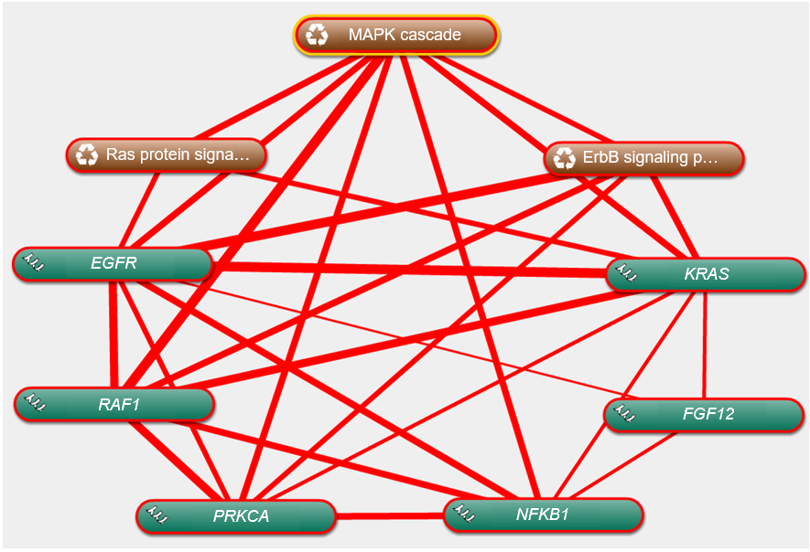
Figure 5 Linear association among the hub genes and co-expressed pathways using Coremine Medical online tool. The thicker the line, the closer the relationship. KRAS: KRAS proto-oncogene, GTPase; EGFR: Epidermal growth factor receptor; NFKB1: Nuclear factor kappa B subunit 1; FGF12: Fibroblast growth factor 12; PRKCA: Protein kinase C alpha; RAF1: Raf-1 proto-oncogene, serine/threonine kinase.

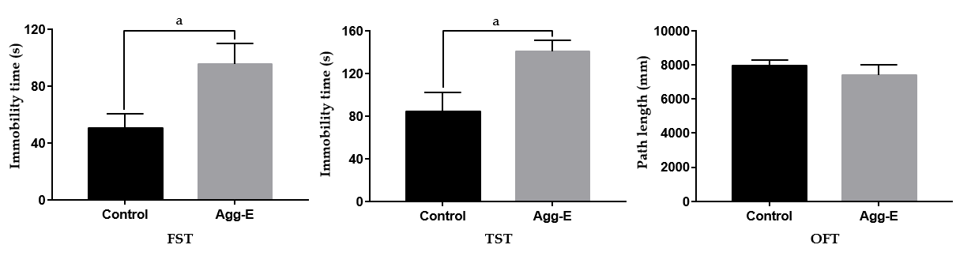
Figure 6 The immobility time in forced swim test and tail suspension test, and the path length of open-field test. Data are presented as the mean ± SD, ªP < 0.05. Agg-E: Aggressed-exposed; FST: Forced swim test; TST: Tail suspension test; OFT: Open-field test.

Table 1 Gene ontology annotations of differentially expressed genes associated with post-traumatic stress disorder (top 5)
Expression | Category | Term | Function | Count | P value
Up-regulated | BP | GO: 0007399 | Nervous system development | 25 | 1.21E–08
 | BP | GO: 0007409 | Axonogenesis | 14 | 1.82E–08
 | BP | GO: 0007268 | Chemical synaptic transmission | 16 | 1.33E–07
 | BP | GO: 0030154 | Cell differentiation | 32 | 3.75E–06
 | BP | GO: 0010976 | Positive regulation of neuron projection development | 12 | 1.51E–05
 | CC | GO: 0045202 | Synapse | 43 | 1.25E–18
 | CC | GO: 0043025 | Neuronal cell body | 39 | 1.18E–14
 | CC | GO: 0030425 | Dendrite | 37 | 2.35E–14
 | CC | GO: 0030054 | Cell junction | 44 | 7.70E–14
 | CC | GO: 0030424 | Axon | 31 | 3.10E–13
 | MF | GO: 0005515 | Protein binding | 99 | 3.15E–05
 | MF | GO: 0050839 | Cell adhesion molecule binding | 8 | 1.71E–04
 | MF | GO: 0019904 | Protein domain specific binding | 15 | 3.48E–04
 | MF | GO: 0005216 | Ion channel activity | 11 | 5.51E–04
 | MF | GO: 0008144 | Drug binding | 8 | 0.002625
Down-regulated | BP | GO: 0015031 | Protein transport | 38 | 7.01E–06
 | BP | GO: 0007049 | Cell cycle | 38 | 1.59E–05
 | BP | GO: 0016192 | Vesicle-mediated transport | 17 | 4.14E–04
 | BP | GO: 0007040 | Lysosome organization | 7 | 7.61E–04
 | BP | GO: 0006281 | DNA repair | 21 | 8.39E–04
 | CC | GO: 0005737 | Cytoplasm | 243 | 1.19E–08
 | CC | GO: 0005634 | Nucleus | 219 | 2.55E–07
 | CC | GO: 0005829 | Cytosol | 77 | 5.42E–05
 | CC | GO: 0005768 | Endosome | 30 | 4.60E–04
 | CC | GO: 0005794 | Golgi apparatus | 53 | 4.91E–04
 | MF | GO: 0046872 | Metal ion binding | 135 | 4.24E–06
 | MF | GO: 0005515 | Protein binding | 156 | 1.17E–05
 | MF | GO: 0003676 | Nucleic acid binding | 61 | 1.93E–05
 | MF | GO: 0005487 | Nucleocytoplasmic transporter activity | 5 | 0.001069
 | MF | GO: 0016874 | Ligase activity | 22 | 0.001335
BP: Biological processes; CC: Cellular component; MF: Molecular function; GO: Gene ontology.

Table 2 Kyoto Encyclopedia of Genes and Genomes analysis of differentially expressed genes associated with post-traumatic stress disorder (top 10)
Expression | Term | Definition | Count | P value
Upregulated | mmu04080 | Neuroactive ligand-receptor interaction | 16 | 2.02E–05
 | mmu05014 | ALS | 6 | 1.08E–04
 | mmu04530 | Tight junction | 8 | 1.23E–03
 | mmu00430 | Taurine and hypotaurine metabolism | 2 | 1.30E–03
 | mmu04020 | Calcium signaling pathway | 9 | 2.08E–03
 | mmu00650 | Butanoate metabolism | 3 | 3.77E–03
 | mmu04512 | ECM-receptor interaction | 5 | 6.91E–03
 | mmu05322 | Systemic lupus erythematosus | 7 | 8.98E–03
 | mmu04720 | Long-term potentiation | 4 | 1.25E–02
 | mmu04010 | MAPK signaling pathway | 10 | 1.31E–02
Downregulated | mmu05223 | Non-small cell lung cancer | 9 | 1.48E–05
 | mmu05212 | Pancreatic cancer | 10 | 2.35E–05
 | mmu05160 | Hepatitis C | 14 | 4.31E–05
 | mmu05211 | Renal cell carcinoma | 8 | 6.64E–04
 | mmu05221 | Acute myeloid leukemia | 7 | 6.55E–04
 | mmu04012 | ErbB signaling pathway | 9 | 6.19E–04
 | mmu04620 | Toll-like receptor signaling pathway | 10 | 5.05E–04
 | mmu03013 | RNA transport | 14 | 3.89E–04
 | mmu05214 | Glioma | 8 | 3.55E–04
 | mmu05215 | Prostate cancer | 10 | 1.91E–04
ALS: Amyotrophic lateral sclerosis; ECM: Extracellular matrix.

Table 3 The most significantly enriched pathways of differentially expressed genes associated with post-traumatic stress disorder
Term | pathway | P value | Genes
 |  |  | Upregulated | Downregulated
mmu04010 | MAPK signaling pathway | 1.51E–08 | Crkl, Fgf12, Mras, Mapt, Ntrk2, Dusp8, Ptpn5, Map3k4, Mapk8ip2, Dusp7 | Chuk, Egf, Egfr, Ikbkg, Kras, Nfkb1, Prkca, Pla2g4a, Sos1, Map3k8, Stk3, Tab2, Dusp16, Raf1, Taok1
mmu04014 | Ras signaling pathway | 1.84E–07 | Fgf12, Grin2b, Mras, Pgf, Ptpn11, Gng13 | Chuk, Egf, Egfr, Gab1, Ikbkg, Insr, Kras, Nfkb1, Pik3ca, Prkca, Pla2g4a, Sos1, Rassf5, Tbk1, Raf1, Rab5a
mmu04012 | ErbB signaling pathway | 3.85E–06 | Camk2b, Cdkn1b, Crkl | Egf, Egfr, Gab1, Kras, Pik3ca, Prkca, Sos1, Tgfa, Raf1

