Name of Journal: World Journal of Gastroenterology
Manuscript NO: 54554
Manuscript Type: ORIGINAL ARTICLE

Basic Study

Rno_circ_0005139 regulates apoptosis by targeting Wnt5a in rat anorectal malformations

Liu D et al. Circ_0005139 plays roles in ARM

Dan Liu, Yuan Qu, Zheng-Nong Cao, Hui-Min Jia

Dan Liu, Yuan Qu, Zheng-Nong Cao, Hui-Min Jia, Department of Pediatric Surgery, Shengjing Hospital of China Medical University, Shenyang 110004, Liaoning Province, China

Author contributions: Liu D and Qu Y performed the experiments, and analyzed the results; Liu D drafted the manuscript; Cao ZN and Jia HM reviewed manuscript; Cao ZN supervised the manuscript; Jia HM revised the final manuscript; all authors revised and approved the final manuscript.

Supported by the National Natural Science Foundation of China, No. 81671503.

Corresponding author: Hui-Min Jia, PhD, Chief Doctor, Professor, Department of Pediatric Surgery, Shengjing Hospital of China Medical University, No. 36 Sanhao Street, Heping District, Shenyang 110004, Liaoning Province, China. jiahm@sj-hospital.org

Received: February 7, 2020
Revised: May 9, 2020
Accepted: May 26, 2020
Published online: August 7, 2020
Abstract
BACKGROUND
The molecular mechanisms underlying anorectal malformations (ARM) are not fully established. Circular RNAs (circRNAs) are new born non-coding RNAs, and their role in ARM is unclear. We assumed that rno_circ_0005139 influences apoptosis and proliferation by acting as a miR-324-3p sponge, and downregulating Wnt5a in ARM.

AIM
To identify the differential expression of circRNAs and mRNAs in a rat ARM model.

METHODS
Sixty-six pregnant Wistar rats were randomly divided into two groups: ARM group (2-imidazolidinethione-induced) and control groups. Embryos were harvested by cesarean delivery, and anorectal tissue was taken on embryonic days 16 (E16), 17 (E17), 19 (E19), and 21 (E21). RNA sequencing and gene microarray analysis was used to identify differentially expressed circRNAs and mRNAs in the ARM in a rat model. We selected 6 circRNAs and 3 mRNAs in the Wnt signal pathway from the result of the RNA sequencing and gene microarray analysis, and quantitative reverse transcription polymerase chain reaction was performed to evaluate their tissue expression. According to bioinformatics prediction, rno_circ_0005139 acted as a miR-324-3p sponge to regulate the expression of Wnt5a. We chose rno_circ_0005139 and Wnt5a as the final candidates. We tested the function of rno_circ_0005139 and the binding sites between rno_circ_0005139 and miR-324-3p, miR-324-3p and Wnt5a by luciferase assays. Co-transfection of rno_circ_0005139 and miR-324-3p was to verify their functional consistency.

RESULTS
We identified 38 upregulated and 42 downregulated circRNAs on E17 (P < 0.05), and 301 mRNAs were upregulated and 256 downregulated in the ARM on E17 (P < 0.05, fold-change > 2.0). We found that rno_circ_0006880 and rno_circ_0011386 were upregulated, whereas rno_circ_0000436, rno_circ_0005139, rno_circ_0009285, rno_circ_0014367, Wnt5a, Wnt10b, and Wnt2b were downregulated in ARM tissues. According to bioinformatics prediction, rno_circ_0005139 acted as a miR-324-3p sponge to regulate the expression of Wnt5a. We chose rno_circ_0005139 and Wnt5a as the final candidates. Because the role and molecular mechanism of rno_circ_0005139 are poorly understood, its effect on apoptosis and proliferation was investigated by in vitro plasmid transfection. A luciferase experiment showed that rno_circ_0005139 could bind with miR-324-3p, which negatively regulated Wnt5a expression. The expression of miR-324-3p was significantly higher in ARM anorectal tissues than that in control group on E17 and E19; Wnt5a expression showed the opposite trend. In addition, a miR-324-3p inhibitor attenuated the effects of rno_circ_0005139 knockdown on ARM development.

CONCLUSION
Rno_circ_0005139 influences cell proliferation and apoptosis by acting as a miR-324-3p sponge, thereby downregulating Wnt5a in ARM. Accordingly, rno_circ_0005139, miR-324-3p, and Wnt5a could be targeted therapeutic factors for ARM.

Key words: Anorectal malformation; Circular RNA; MicroRNA; Wnt5a; Rno_circ_0005139

Citation: Liu D, Qu Y, Cao ZN, Jia HM. Rno_circ_0005139 regulates apoptosis by targeting Wnt5a in rat anorectal malformations. World J Gastroenterol 2020; 26(29): 4272-4287

URL: https://www.wjgnet.com/1007-9327/full/v26/i29/4272.htm

DOI: https://dx.doi.org/10.3748/wjg.v26.i29.4272

Core tip: Rno_circ_0005139, miR-324-3p, and Wnt5a play regulatory roles in the pathogenesis of anorectal malformations (ARM). Rno_circ_0005139 is a potential biomarker or therapeutic target in the ARM. In general, this study provides an important basis for further studies on the diagnosis, treatment, and prevention of ARM.

INTRODUCTION
Anorectal malformations (ARM) are the most common gastrointestinal malformations in pediatric surgery, with an incidence of 1/5000-1/1500 live births^{[1,2]}. More than half of patients have genitourinary, cardiovascular, skeletal, and gastrointestinal malformations^{[3,4]}. Wnt signaling pathway, SHH signaling pathway, BMP pathway, FGF signaling pathway, and Hox family are all associated with ARM^{[5-10]}. Wnt5a is located on chromosome 3p14–p21, and Wnt5a plays a pivotal role in the development of anorectum, deformity, terminal rectal intestinal neuromuscular, and pelvic floor neuromuscular development in both human and rats^{[11]}. In addition, ARM in Wnt5a^{-/-}mice shows anal atresia with rectal urethral fistula^{[12]}. However, the regulatory factors upstream of Wnt5a remain unknown.
Circular RNAs (circRNAs) were originally thought to be transcriptional mismatches or transcriptional byproducts; the first evidence for the existence of circRNAs was reported in 1976^{[13]}. Unlike linear RNA molecules, circRNAs represent a class of single-stranded, unusually conserved, and stable RNAs with a covalently closed loop structure lacking 5’-3’ polarity or a polyadenylated tail^{[14]}. The functions of circRNAs have been gradually revealed, and they mainly act as microRNA (miRNA) sponges to regulate gene expression in neurological diseases, cardiovascular diseases, and various types of cancers^{[15,16]}. However, the role of circRNAs in ARM has not been widely examined. RNA sequencing was used to identify differentially expressed circRNAs in congenital ARM, and validated a novel circRNA, rno_circ_0005139. Bioinformatics analysis revealed that miR-324-3p was a potential target of rno_circ_0005139, and Wnt5a was the target gene of miR-324-3p. There have been no reports on the function of rno_circ_0005139 and its relationship with miR-324-3p.
In the present study, downregulation of rno_circ_0005139 and upregulation of miR-324-3p resulted in decreased Wnt5a expression in the anorectal tissues of ARM and intestinal epithelial cells (IECs) and promoted apoptosis. Overexpression of rno_circ_0005139 and miR-324-3p mimic inhibited apoptosis by blocking the interaction of miR-324-3p and the 3'-untranslated region (UTR) of Wnt5a. Rno_circ_0005139/miR-324-3p/Wnt5a pathway may have the crucial effect on cell apoptosis and proliferation in ARM, and circ_0005139 may thus be a targeted therapeutic factor for ARM.

MATERIALS AND METHODS
Preparation of tissues
Prior to the study, approval was obtained from the Medical Research and New Technology Ethics Committee of Shengjing Hospital, affiliated with China Medical University (2016PS045K). Female (250-280 g) and male (280-300 g) Wistar rats were provided by the Chang Sheng Biotechnology Co., Ltd. (Changchun, China). The Wistar rats were in the specific pathogen free grade (12 h light-dark cycle, 37 °C, get water and feed anytime) animal litter. Wistar rats were mated overnight in a cage (a ratio of female: male, 4:1). Pregnant rats were identified by sperm in vaginal smears in the morning, and the day was defined E0. A total of 66 pregnant Wistar rats were randomly divided into 2-imidazolidinethione (ETU)-induced ARM group [a single dose of ETU (Aldrich Chemical, Penzberg, Germany)] and control group (an equal dose of saline without ETU) on E10. The concentration of ETU was 0.01 g/L and the dose was 0.125 g/kg given via oral gavage. Embryos were harvested by cesarean delivery on embryonic days 16 (E16), 17 (E17), 19 (E19), and 21 (E21). The embryos in ARM group were short or no tail, and in control group were long tail. The hindgut tissues were removed under a microscope and immediately frozen in liquid nitrogen.

Library preparation, RNA sequencing, and data analysis
Six cDNA libraries were constructed, i.e., three for E17 rats with ARM and three for E17 normal control rats. Three micrograms of RNA per sample was used as the input material for sample preparation with TRIzol (Invitrogen, Carlsbad, CA, United States) according to the manufacturer's instructions, followed by DNase I treatment to remove DNA contamination. The total RNA level was assessed on a denaturing agarose gel and quantified by the NanoDrop spectrophotometer (NanoDrop, Wilmington, DE, United States). First, total RNA was treated with an Epicentre Ribo-Zero kit (Epicentre Technologies, Madison, WI, United States) to remove all rRNAs. The remaining RNAs were processed using a TruSeq RNA Sample Prep Kit according to the Illumina protocol (San Diego, CA, United States). Quantitative reverse transcription polymerase chain reaction (qRT-PCR) was performed with Phusion High-Fidelity DNA polymerase (Agilent Technologies, United States), Index (X) Primer (Agilent Technologies, United States), and universal qRT-PCR primers (Agilent Technologies, United States). Finally, the products were purified using the AMPure XP system (Beckman, Brea, CA, United States), and library quality was evaluated on an Agilent Bioanalyzer 2100 system (Santa Clara, CA, United States). The RNA library was sequenced on an Illumina Hiseq 2500 platform and find_circ^{[17]} was used to identify circRNA. The expression of known and predicted circRNAs were normalized by transcripts per million, and differential expression analysis was performed using DEGseq. CircRNAs with Q < 0.01 and |log2 fold-change| > 1 were considered as differentially expressed.
Another six samples (three for E17 rats with ARMs and three for E17 normal rats) were used for gene microarray analysis. Total RNA was quantified using Nano Drop ND-1000, and RNA integrity was assessed by standard denaturing agarose gel electrophoresis. According to manufacturer’s protocols, the following steps were taken: preparing samples, hybridizing microarray, amplifying and transcribing into fluorescent complementary (c) RNA. The labeled cRNAs were hybridized onto a Whole Genome Oligo Array (444K, Agilent Technologies). The Whole Rat Genome Oligo Microarray Kit is a tool for modeling human biology in the rat model organism. The arrays were scanned to analyze the acquired array images by Agilent Scanner G2505C and Agilent Feature Extraction software (version 11.0.1.1). A Gene Spring GX v11.5.1 software package (Agilent Technologies) was used to perform the quantile normalization and subsequent data procession.

IECs culture and processing
Rat IECs were acquired from the BeNa Culture Collection (Beijing, China) and were cultured in α-minimum Eagle,s medium containing 10% fetal bovine serum and 1% penicillin/streptomycin (Gibco, Grand Island, NY, United States) at 37 °C and 5% CO₂ (Gibco).

RNA extraction and qRT–PCR analysis
Total RNA was isolated from IECs and anorectal tissues using TRIzol reagent (Invitrogen), the synthesis of complementary (c)DNA was completed using RNA PCR Kit from TaKaRa (Dalian, China) and gene amplification was carried out using a SYBR Premix Ex Taq Kit from Takara the according to the manufacturer’s instructions. qRT–PCR was performed with the 7500 Fast PCR System (Applied Biosystems, Foster City, CA, United States). Primers for β-actin (for circRNA and mRNA) and U6 (for miRNA) were used as endogenous controls. Each experiment was performed in triplicate. The Ct values were recorded and melting curve was analyzed. Comparative Ct (2^{-ΔΔCt}) method was used to calculate the expression of the genes^{[18]}.
Primers for rno_circ_0005139, rno_circ_0006880, rno_circ_0011386, rno_circ_0000436, rno_circ_0005139, rno_circ_0009285, and rno_circ_0014367 were synthesized by Geneseed (Guangzhou, China). Primers for miR-324-3p and U6 were designed and synthesized by RiboBio (Guangzhou, China). U6 was the normalization control for miRNAs. Primers for Wnt5a, Wnt2b, Wnt10b and β-actin were designed by Takara (Table 1).

Western blotting
Chopped tissues and cells were placed in radioimmunoprecipitation assay lysis buffer containing 1% phenylmethylsulfonyl fluoride (Beyotime, Jiangsu, China). Supernatant was collected after 12 000 r/min for 15 min. Protein lysates were separated by gel electrophoresis and transferred onto polyvinylidene difluoride membranes. The membranes were exposed to anti-Wnt5a (Invitrogen) or anti-glyceraldehyde-3-phosphate dehydrogenase (GAPDH) antibodies at 4 °C overnight. The membrane was incubated in the anti-rabbit IgG secondary antibody (1:5000; Proteintech, Rosemont, IL, United States) for 2 h at room temperature. A ProtoBlot II AP System (Promega, Madison, WI, United States) was used to test the signals. The protein expression was compared with the expression of GAPDH. Densitometry quantified the protein relative expression with ImageJ software (National Institutes of Health, Bethesda, MD, United States).

Luciferase assays
Rno_circ_0005139 wild-type, mutant sequences, the 3'-UTR of Wnt5a wild-type and the 3'-UTR of Wnt5a mutant-type were inserted into a pMIR-REPORT Vector (RiboBio). pMIR-REPORT with rno_circ_0005139 wild-type and mutant sequences were co-transfected with miR-324-3p and pMIR-REPORT with Wnt5a wild-type and mutant-type were co-transfected with miR-324-3p into HEK293T cells using Lipofectamine 3000 (Invitrogen) following the manufacturer's protocol. After 48 h, the luciferase activity was detected using the Dual-Luciferase Reporter Assay System (Promega). Relative firefly luciferase activity (firefly luciferase activity/Renilla luciferase activity) was the final criterion.

Apoptosis of IECs
IECs in the logarithmic phase were collected and seeded into 6-well plates at a density of 4 × 10⁵ cells per well. After 48 h transfection, 10 µL annexin V-fluorescein isothiocyanate and 5 µL propidium iodide were added to each sample well. After incubation for 15 min at room temperature in the dark, the samples were diluted with another 300 µL binding buffer, followed by filtration through a 300-µmol/L mesh cell strainer. The apoptotic rate for each sample was measured by flow cytometry (BD Biosciences, San Jose, CA, United States).

Proliferation assays
Cell Counting Kit (CCK)-8 assay (KeyGEN, Jiangsu, China) was used to assess the cell proliferation. IECs (1 × 10⁴) were added to each well of a 96-well plate. Next, 10 μL CCK-8 solution was added to each well at four time points. After 2 h incubation at 37 °C in 5% CO₂, absorbance at 450 nmol/L was measured using an automatic microplate reader (Synergy4, BioTek, Winooski, VT, United States). Each experiment was repeated three times.

Statistical analysis
SPSS 21.0 (SPSS, Inc., Chicago, IL, United States) and Prism 7.0 (GraphPad Software, San Diego, CA, United States) were used for statistical analysis using the Student’s t test and one-way analysis of variance. Data were obtained from at least three biological replicates and the results are presented as the means ± SD. P < 0.05 or P < 0.01 indicated that the difference between the contrast groups was statistically significant.
RESULTS
Analysis of circRNAs in ARM tissues and control tissues on E17
We obtained a total of 652 fetal rats, including 310 in the ARM group and 342 in the control group. And 218 embryos had ARM (218/310, 70.32%) in the ARM group. And we randomly selected the same number of embryos at the same day. We sequenced RNA in rat ARM tissues and control fetuses on E17. The results of a cluster analysis of differentially expressed circRNAs on E17 are summarized in Figure 1A. We identified 38 circRNAs that were up-regulated in anorectal tissues compared to the control tissues (P < 0.05) and 42 circRNAs that were down-regulated (P < 0.05) on E17 (Figure 1B). To further explore the function of circRNAs which were differentially expressed on E17. Kyoto Encyclopedia of Genes and Genomes (KEGG) analysis revealed that the top 5 pathways of dysregulated genes were “VEGF signaling pathway”, “B cell receptor signaling pathway”, “Prostate cancer”, “Estrogen signaling pathway”, and “cGMP-PKG signaling pathway”, which are known to be closely associated with proliferation, apoptosis, migration, and survival (Figure 1C). We randomly selected rno_circ_0006880, rno_circ_0011386, rno_circ_0000436, rno_circ_0005139, rno_circ_0009285, and rno_circ_0014367 as targets (Figure 1D). Based on the qRT–PCR results, rno_circ_0005139 was the final candidate. Additionally, we identified the cyclization site of rno_circ_0005139. We found that from E16 to E21, rno_circ_0005139 levels were decreased in the anorectal tissues of the ARM group compared to control tissues. Rno_circ_0005139 was significantly dysregulated on E16 and E17.

Rno_circ_0005139 modulates apoptosis and proliferation in IECs
It was reported that IECs were used in cell proliferation and apoptosis during rat anorectal development experiments and were therefore used for subsequent functional experiments. . The relative rno_circ_0005139 expression levels after silencing and over-expression in IECs are shown in Figure 2A. Based on the results of the CCK-8 assay, rno_circ_0005139 silencing markedly inhibited cell proliferation and overexpression promoted cell proliferation (Figure 2B). Flow cytometry analysis showed that rno_circ_0005139 silencing increased the rate of apoptosis, whereas rno_circ_0005139 overexpression decreased the rate of apoptosis (Figure 2C and D).

Sequencing analysis of mRNAs in ARM and control tissues on E17
To examine the expression of mRNAs, we used tissues from a rat ARM model and normal anorectal tissues collected on E17. Using an Agilent RNA Microarray Scanner, cluster analysis of differentially expressed mRNAs is shown in a heatmap scatter plot (Figure 3A). A total of 301 mRNAs were up-regulated and 256 mRNAs down-regulated in the ARM on E17 (P < 0.05, fold-change > 2.0) (Figure 3B). According to the KEGG analysis, 38 signaling pathways were enriched, with the top 10 listed in Figure 3C. Of these pathways, “Pathways in cancer” showed the greatest enrichment, followed by “Neuroactive ligand-receptor interaction”. The enriched pathways included “MAPK signal pathway” and “Ras signal pathway”, which are known to be closely associated with the process of embryonic development and ARM. RNA microarray scanner and the KEGG pathway analyses identified 3 mRNAs in ARM tissues that consistently responded to treatment: Wnt5a, Wnt2b, and Wnt10b. qRT–PCR analysis further showed that from E16 to E21, the expression levels of Wnt5a, Wnt2b, and Wnt10b were down-regulated in the anorectal tissues of the ARM group relative to normal tissues (Figure 3D). Wnt5a was selected as the final candidate.

Rno_circ_0005139 acts as a sponge for miR-324-3p, which interacts with Wnt5a
We used TargetScan prediction software to predict the binding sites of six pairs of circRNAs (rno_circ_0000436, rno_circ_0005139, rno_circ_0006880, rno_circ_0009285, rno_circ_0011386, and rno_circ_0014367) and their target miRNAs, and miRNAs pairs and their three target Wnt genes (Wnt5a, Wnt2b, and Wnt10b). The results showed that rno_circ_0005139 shared a potential binding site with miR-324-3p, and the seed region of miR-324-3p was predicted to recognize the 3'-UTR of Wnt5a. qRT–PCR analysis showed that from E16 to E21, miR-324-3p was up-regulated in the anorectal tissues of the ARM group relative to normal control tissues (Figure 4A), in contrast with the expression changes in rno_circ_0005139 and Wnt5a. Furthermore, a luciferase assay revealed that co-transfection of cells with miR-324-3p mimic decreased the luciferase activity of wild-type rno_circ_0005139, but not of the mutant rno_circ_0005139 (Figure 4B). The results indicated that rno_circ_0005139 acted as a sponge for miR-324-3p. Moreover, we found that miR-324-3p was up-regulated after silencing of rno_circ_0005139 (Figure 4C). The prediction results showed that the miR-324-3p could bind with Wnt5a 3’-UTR; this prediction was confirmed by a luciferase reporter assay (Figure 4D). The ratios of miR-324-3p inhibitor and mimic in IECs are shown in Figure 4E. The expression of Wnt5a was negatively regulated by miR-324-3p, as shown by qRT–PCR and western blotting results (Figure 4F and G). These findings indicate that Wnt5a is a direct downstream target of miR-324-3p.

Rno_circ_0005139 regulates apoptosis and proliferation via the miR-324-3p/Wnt5a pathway
Wnt5a expression was lower in ARM anorectal tissues than in control tissues. Previous studies demonstrated negative regulatory relationships between rno_circ_0005139 and miR-324-3p, miR-324-3p, and Wnt5a. Therefore, the rno_circ_0005139/miR-324-3p/Wnt5a pathway may be a key regulator during the development of ARM. Silencing of rno_circ_0005139 decreased Wnt5a expression, whereas overexpression of rno_circ_0005139 increased the expression of Wnt5a (Figure 5A). These results suggest that rno_circ_0005139 influences the expression of Wnt5a. We further found that overexpression of rno_circ_0005139 partially up-regulated Wnt5a expression after co-transfection with a miR-324-3p mimic (Figure 5B). rno_circ_0005139 overexpression partially rescued the suppressive effects of an miR-324-3p mimic on cell proliferation (Figure 5C and D). rno_circ_0005139 overexpression also partially reversed the promotion of apoptosis by an miR-324-3p mimic (Figure 5E and F). These findings indicate that rno_circ_0005139 exerts its effects by targeting the miR-324-3p/Wnt5a pathway.

DISCUSSION
Previous studies have indicated that the Wnt signaling pathway is involved in the formation of ARM. However, the roles of circRNAs associated competing endogenous RNAs in Wnt signaling are not well understood. In this study, we validated rno_circ_0005139 and predicted miR-324-3p as its target miRNA. We found that miR-324-3p was up-regulated, whereas rno_circ_0005139 and Wnt5a were down-regulated in ARM. The rno_circ_0005139-miR-324-3p-Wnt5a axis was validated by luciferase assays in rat ARM, and modulated cell proliferation and apoptosis in IECs. Our findings revealed a novel regulatory mechanism by which rno_circ_0005139 acts as a sponge for miR-324-3p to regulate the expression of Wnt5a. This provides a new therapeutic target for ARM diseases.
As a member of non-coding RNAs, circRNAs can bind with miRNAs to regulate the target genes expression, indicating that circRNAs regulate the occurrence and the function of diseases^{[19]}. We identified differentially expressed circRNAs on E17, and KEGG pathway analysis showed that both the vascular endothelial growth factor and cyclic guanosine monophosphate-dependent protein kinase signaling pathways, which are involved in the process of apoptosis and migration, are related to ARM development. In our study, transfection of IECs with si-rno_circ_0005139 increased apoptosis and decreased proliferation, and our results are consistent with ARM being associated with high rates of apoptosis during anorectal development^{[20]}. The results indicate that rno_circ_0005139 had a significant influence on IECs. We used the interference of rno_circ_0005139 in IECs to simulate decreased rno_circ_0005139 expression in ARM, which showed a crucial role of rno_circ_0005139 in ARM.
The circRNAs may act as miRNAs “sponges”, which combine miRNAs to regulate the expression and function of targeting functional genes^{[21]}. At the same time, circRNAs have been shown to regulate many diseases by interacting with mRNAs^{[22]}. Luciferase reporter assays confirmed that down-regulated rno_circ_0005139 targets miR-324-3p, which is upregulated in ARM. And Wnt5a is a predicted target of up-regulated miR-324-3p. This suggests that rno_circ_0005139 acts via miR-324-3p to regulate Wnt5a function in ARM.
The Wnt signaling pathway is highly conserved, regulates numerous processes in tissue development, cellular metabolism, and apoptosis, and is associated with processes of urogenital and anorectal embryogenesis^{[23]}. As an important member in Wnt family, Wnt5a has demonstrated its decreased expression in ARM group compared with the control group^{[24]}. And the ARM is closely related to high levels of apoptosis in anorectal tissue development^{[25]}. Thus, it is reasonable that the rno_circ_0005139/miR-324-3p/Wnt axis contributes to ARM. Transfected with si-rno_circ_0005139 in IECs, higher levels of apoptosis and lower proliferation rates similar to those in ARM abnormalities were observed. However, co-transfection with the rno_circ_0005139 over-expression vector and miR-324-3p mimic attenuated these effects. Therefore, rno_circ_0005139 positively regulated the expression and function of Wnt5a by acting as a sponge for miR-324-3p. Additionally, E16 and E17 appear to be a critical period for the development of ARM, and rno_circ_0005139 may regulate miR-324-3p/Wnt5a mainly in the middle and late stages of anorectal development.
We further found that rno_circ_0005139 positively regulated the expression and function of Wnt5a by acting as a sponge for miR-324-3p. More broadly, clarifying the crosstalk between circRNA associated competing endogenous RNAs networks in Wnt signaling will provide insight into ARM development as well as new therapeutic targets.
However, our study had several potential limitations. Particularly, the corresponding time of the rat IECs transfection moment in ARM model was unclear. Therefore, gene expression and function deviations were possible.
In conclusion, our findings improve our understanding of the regulatory roles of rno_circ_0005139, miR-324-3p, and Wnt5a in the pathogenesis of ARM. Rno_circ_0005139 is a potential biomarker or therapeutic target in ARM. In general, this study provides an important basis for further studies of the diagnosis, treatment, and prevention of ARM.

ARTICLE HIGHLIGHTS
Research background
Anorectal malformations (ARM) are common in pediatric surgery. During normal embryonic development of the anus and rectum, the Wnt signaling pathway is one of the most mature and important pathways in ARM, but its upstream regulatory mechanism is not clear. Due to its strong stability and high conservation, circular RNA (circRNA) is considered to be the most competitive microRNA (miRNA) "sponge", which competitively binds to the 3'-non-coding region of the common target gene and regulates the expression process of the target gene. circRNA is rarely reported in the research of ARM, and circRNA acts on miRNA, and then regulates the expression of Wnt signaling pathway in ARM, and affects cell proliferation and apoptosis, which are of research significance.

Research motivation
ARM is often combined with multiple system malformations. Although they can be treated surgically, children with multiple system malformations often require long-term multidisciplinary treatment, and some children even need psychological treatment. The quality of life is poor, and the prognosis is not ideal. The mechanism of ARM is still unclear. Therefore, an in-depth study of circRNA and the upstream of the Wnt genes in ARM will provide a new research direction for ARM and a new approach to prenatal intervention therapy to improve the children’ quality of life.

Research objectives
To investigate differentially expressed circRNAs and mRNAs in a rat ARM model and identify the mechanism of rno_circ_0005139 targeting Wnt5a in proliferation and apoptosis.

Research methods
We chose 66 pregnant Wistar rats and randomly divided them into two groups: ethylenethiourea-induced ARM group and control group. A total of 652 embryos was harvested by cesarean delivery and anorectal tissue was taken on embryonic day 16 (E16), 17 (E17), 19 (E19) and 21 (E21). RNA sequencing and gene microarray analysis were used to identify differentially expressed circRNAs and mRNAs in ARM in a rat model. We selected 6 circRNAs and 3 mRNAs in the Wnt signal pathway from the result of the RNA sequencing and gene microarray analysis, and quantitative reverse transcription polymerase chain reaction was performed to evaluate their tissue expression. We tested the function of rno_circ_0005139 and the binding sites between rno_circ_0005139 and miR-324-3p, miR-324-3p and Wnt5a by luciferase assays. Co-transfection of rno_circ_0005139 and miR-324-3p was performed to verify their functional consistency.

Research results
We found 38 upregulated and 42 downregulated circRNAs on E17, and 301 mRNAs were upregulated and 256 downregulated in the ARM on E17. We also observed that rno_circ_0006880 and rno_circ_0011386 were upregulated, whereas rno_circ_0000436, rno_circ_0005139, rno_circ_ 0009285, rno_circ_0014367, Wnt5a, Wnt10b, and Wnt2b were downregulated in ARM tissues. A luciferase experiment showed that rno_circ_0005139 was a sponge for miR-324-3p, which negatively regulated Wnt5a expression. MiR-324-3p expression was significantly higher in ARM group anorectal tissues than in normal control tissues on E17 and E19; Wnt5a expression showed the opposite trend. The knockdown of rno_circ_0005139 promoted cell apoptosis. In addition, a miR-324-3p inhibitor attenuated the effects of rno_circ_0005139 knockdown on ARM development and cell apoptosis.

Research conclusions
Rno_circ_0005139 influences cell proliferation and apoptosis by acting as a miR-324-3p sponge, thereby downregulating Wnt5a in ARM. Accordingly, rno_ circ_0005139, miR-324-3p, and Wnt5a are potential therapeutic targets for ARM.

Research perspectives
There are a large number of circRNAs in ARM, and in terms of the mechanism of rno_circ_0005139/miR-324-3p/Wnt5a, the specific regulatory mechanism of circRNAs is the focus of future research. In line with this, future directions should include studies exploring the diagnostic and therapeutic potential of circRNAs.

ACKNOWLEDGEMENTS
We would like to thank Luo K, biostatistician at the MOE-Shanghai Key Laboratory of Children‘s Environmental Health in Shanghai Jiao Tong University School of Medicine, for reviewing the content of our manuscript to confirm appropriateness of biostatistical methods for study design.

REFERENCES
1 van der Putte SC. Normal and abnormal development of the anorectum. J Pediatr Surg 1986; 21: 434-440 [PMID: 3712197 DOI: 10.1016/s0022-3468(86)80515-2]
2 Tsuda T, Iwai N, Deguchi E, Kimura O, Ono S, Furukawa T, Sasaki Y, Fumino S, Kubota Y. PCSK5 and GDF11 expression in the hindgut region of mouse embryos with anorectal malformations. Eur J Pediatr Surg 2011; 21: 238-241 [PMID: 21480163 DOI: 10.1055/s-0031-1273691]
3 Stoll C, Alembik Y, Dott B, Roth MP. Associated malformations in patients with anorectal anomalies. Eur J Med Genet 2007; 50: 281-290 [PMID: 17572165 DOI: 10.1016/j.ejmg.2007.04.002]
4 Nah SA, Ong CC, Lakshmi NK, Yap TL, Jacobsen AS, Low Y. Anomalies associated with anorectal malformations according to the Krickenbeck anatomic classification. J Pediatr Surg 2012; 47: 2273-2278 [PMID: 23217888 DOI: 10.1016/j.jpedsurg.2012.09.017]
5 Kaemmerer E, Gassler N. Wnt Lipidation and Modifiers in Intestinal Carcinogenesis and Cancer. Cancers (Basel) 2016; 8: 69 [PMID: 27438855 DOI: 10.3390/cancers8070069]
6 Wong EH, Cui L, Ng CL, Tang CS, Liu XL, So MT, Yip BH, Cheng G, Zhang R, Tang WK, Yang W, Lau YL, Baum L, Kwan P, Sun LD, Zuo XB, Ren YQ, Yin XY, Miao XP, Liu J, Lui VC, Ngan ES, Yuan ZW, Zhang SW, Xia J, Wang H, Sun XB, Wang R, Chang T, Chan IH, Chung PH, Zhang XJ, Wong KK, Cherny SS, Sham PC, Tam PK, Garcia-Barcelo MM. Genome-wide copy number variation study in anorectal malformations. Hum Mol Genet 2013; 22: 621-631 [PMID: 23108157 DOI: 10.1093/hmg/dds451]
7 Biau S, Jin S, Fan CM. Gastrointestinal defects of the Gas1 mutant involve dysregulated Hedgehog and Ret signaling. Biol Open 2013; 2: 144-155 [PMID: 23429478 DOI: 10.1242/bio.20123186]
8 Mandhan P, Quan QB, Beasley S, Sullivan M. Sonic hedgehog, BMP4, and Hox genes in the development of anorectal malformations in Ethylenethiourea-exposed fetal rats. J Pediatr Surg 2006; 41: 2041-2045 [PMID: 17161201 DOI: 10.1016/j.jpedsurg.2006.08.035]
9 Wu X, Ferrara C, Shapiro E, Grishina I. Bmp7 expression and null phenotype in the urogenital system suggest a role in re-organization of the urethral epithelium. Gene Expr Patterns 2009; 9: 224-230 [PMID: 19159697 DOI: 10.1016/j.gep.2008.12.005]
10 Suzuki K, Haraguchi R, Ogata T, Barbieri O, Alegria O, Vieux-Rochas M, Nakagata N, Ito M, Mills AA, Kurita T, Levi G, Yamada G. Abnormal urethra formation in mouse models of split-hand/split-foot malformation type 1 and type 4. Eur J Hum Genet 2008; 16: 36-44 [PMID: 17878916 DOI: 10.1038/sj.ejhg.5201925]
11 Jia H, Chen Q, Zhang T, Bai Y, Yuan Z, Wang W. Wnt5a expression in the hindgut of fetal rats with chemically induced anorectal malformations--studies in the ETU rat model. Int J Colorectal Dis 2011; 26: 493-499 [PMID: 21212964 DOI: 10.1007/s00384-010-1125-0]
12 Tai CC, Sala FG, Ford HR, Wang KS, Li C, Minoo P, Grikscheit TC, Bellusci S. Wnt5a knock-out mouse as a new model of anorectal malformation. J Surg Res 2009; 156: 278-282 [PMID: 19577771 DOI: 10.1016/j.jss.2009.03.087]
13 Warner JR. The economics of ribosome biosynthesis in yeast. Trends Biochem Sci 1999; 24: 437-440 [PMID: 10542411 DOI: 10.1016/s0968-0004(99)01460-7]
14 Sanger HL, Klotz G, Riesner D, Gross HJ, Kleinschmidt AK. Viroids are single-stranded covalently closed circular RNA molecules existing as highly base-paired rod-like structures. Proc Natl Acad Sci U S A 1976; 73: 3852-3856 [PMID: 1069269 DOI: 10.1073/pnas.73.11.3852]
15 Huang G, Zhu H, Shi Y, Wu W, Cai H, Chen X. cir-ITCH plays an inhibitory role in colorectal cancer by regulating the Wnt/β-catenin pathway. PLoS One 2015; 10: e0131225 [PMID: 26110611 DOI: 10.1371/journal.pone.0131225]
16 Li F, Zhang L, Li W, Deng J, Zheng J, An M, Lu J, Zhou Y. Circular RNA ITCH has inhibitory effect on ESCC by suppressing the Wnt/β-catenin pathway. Oncotarget 2015; 6: 6001-6013 [PMID: 25749389 DOI: 10.18632/oncotarget.3469]
17 Memczak S, Jens M, Elefsinioti A, Torti F, Krueger J, Rybak A, Maier L, Mackowiak SD, Gregersen LH, Munschauer M, Loewer A, Ziebold U, Landthaler M, Kocks C, le Noble F, Rajewsky N. Circular RNAs are a large class of animal RNAs with regulatory potency. Nature 2013; 495: 333-338 [PMID: 23446348 DOI: 10.1038/nature11928]
18 Livak KJ, Schmittgen TD. Analysis of relative gene expression data using real-time quantitative PCR and the 2(-Delta Delta C(T)) Method. Methods 2001; 25: 402-408 [PMID: 11846609 DOI: 10.1006/meth.2001.1262]
19 Jin S, Wang J, Chen H, Xiang B. Differential miRNA expression analysis during late stage terminal hindgut development in fetal rats. J Pediatr Surg 2017; 52: 1516-1519 [PMID: 28320521 DOI: 10.1016/j.jpedsurg.2017.02.015]
20 Chen QJ, Jia HM, Zhang SW, Zhang SC, Bai YZ, Yuan ZW, Wang WL. Apoptosis during the development of pelvic floor muscle in anorectal malformation rats. J Pediatr Surg 2009; 44: 1884-1891 [PMID: 19853742 DOI: 10.1016/j.jpedsurg.2009.02.004]
21 Liu T, Song Z, Gai Y. Circular RNA circ_0001649 acts as a prognostic biomarker and inhibits NSCLC progression via sponging miR-331-3p and miR-338-5p. Biochem Biophys Res Commun 2018; 503: 1503-1509 [PMID: 30029881 DOI: 10.1016/j.bbrc.2018.07.070]
22 Liu H, Xue L, Song C, Liu F, Jiang T, Yang X. Overexpression of circular RNA circ_001569 indicates poor prognosis in hepatocellular carcinoma and promotes cell growth and metastasis by sponging miR-411-5p and miR-432-5p. Biochem Biophys Res Commun 2018; 503: 2659-2665 [PMID: 30086881 DOI: 10.1016/j.bbrc.2018.08.020]
23 Draaken M, Prins W, Zeidler C, Hilger A, Mughal SS, Latus J, Boemers TM, Schmidt D, Schmiedeke E, Spychalski N, Bartels E, Nöthen MM, Reutter H, Ludwig M. Involvement of the WNT and FGF signaling pathways in non-isolated anorectal malformations: sequencing analysis of WNT3A, WNT5A, WNT11, DACT1, FGF10, FGFR2 and the T gene. Int J Mol Med 2012; 30: 1459-1464 [PMID: 22961180 DOI: 10.3892/ijmm.2012.1124]
24 Ren X, Mi J, Jia H, Gao H, Bai Y, Wang W. Reduced Wnt3a expression correlates with poor development of the hindgut in rats with anorectal malformations. Exp Mol Pathol 2015; 99: 81-85 [PMID: 26024594 DOI: 10.1016/j.yexmp.2015.05.008]
25 Qu Y, Liang X, Liu D, Jia H, Wang W. MSX2 and BCL2 expressions in the development of anorectal malformations in ethylenethiourea-induced rat embryos. Exp Mol Pathol 2018; 105: 311-321 [PMID: 30268882 DOI: 10.1016/j.yexmp.2018.09.005]
Footnotes
Institutional review board statement: The study was reviewed and approved by Medical Research and New Technology Ethics Committee of Shengjing Hospital, affiliated with China Medical University.

Institutional animal care and use committee statement: All animal experiments conformed to the internationally accepted principles for the care and use of laboratory animals (licence No. 2016PS045K).

Conflict-of-interest statement: All other authors have nothing to disclose.

ARRIVE guidelines statement: The authors have read the ARRIVE guidelines, and the manuscript was prepared and revised according to the ARRIVE guidelines.

Open-Access: This article is an open-access article that was selected by an in-house editor and fully peer-reviewed by external reviewers. It is distributed in accordance with the Creative Commons Attribution NonCommercial (CC BY-NC 4.0) license, which permits others to distribute, remix, adapt, build upon this work non-commercially, and license their derivative works on different terms, provided the original work is properly cited and the use is non-commercial. See: http://creativecommons.org/licenses/by-nc/4.0/

Manuscript source: Unsolicited manuscript

Peer-review started: February 7, 2020
First decision: April 22, 2020
Article in press: May 26, 2020

Specialty type: Gastroenterology and hepatology
Country/Territory of origin: China
Peer-review report’s scientific quality classification
Grade A (Excellent): 0
Grade B (Very good): B
Grade C (Good): 0
Grade D (Fair): 0
Grade E (Poor): 0

P-Reviewer: Liang Y S-Editor: Yan JP L-Editor: MedE-Ma JY E-Editor: Zhang YL

Figure Legends

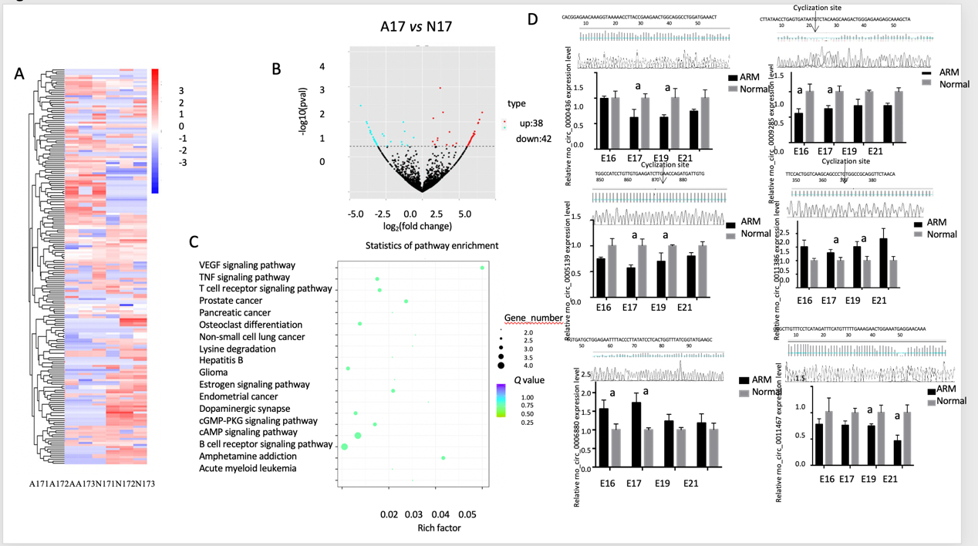
Figure 1 Identification of differentially expressed circular RNAs between anorectal malformations anorectal tissues and control anorectal tissues. A: Cluster analysis of differentially expressed circular RNAs (circRNAs) presented as a heatmap. Red indicates high expression and blue indicates low expression [red to blue represent high to low log10 (transcripts per million + 1) values]; B: Volcano plot of 38 up-regulated (red) and 42 down-regulated (green) circRNAs on embryonic day 17 (E17) in anorectal malformations (ARM) anorectal tissues compared with control tissues showing a two-fold change; C: Vertical axis represents the pathway name, and horizontal axis represents the enrichment factor. The size of the dots indicates the number of parent genes in this pathway, and the color of the dots indicates different q-value ranges; D: circRNA rno_circ_0000436, rno_circ_0005139, rno_circ_0006880, rno_circ_0009285, rno_circ_0011386, and rno_circ_0014367 were evaluated using quantitative reverse transcription polymerase chain reaction in ARM and control anorectal tissues. ªP < 0.05 vs normal. A: Anorectal malformations; ARM: Anorectal malformations; E: Embryonic day; N: Normal control.
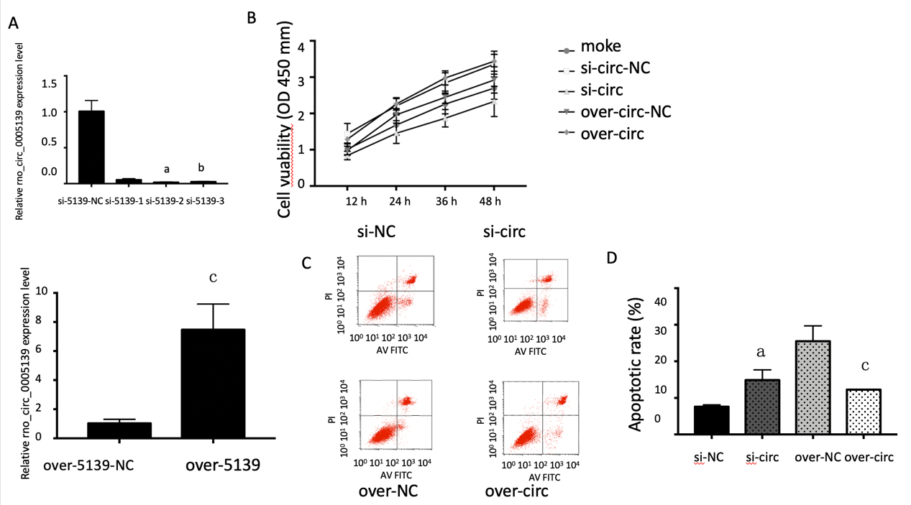

Figure 2 Knockdown and overexpression of rno_circ_0005139 affected proliferation and apoptosis of intestinal epithelial cells. A: Expression of rno_circ_0005139 was detected after transfection with si-rno_circ_0005139 (si-circ), pLO5-rno_circ_0005139 (over-circ), or a negative control (si-NC/vector) in intestinal epithelial cells (IECs), as determined by quantitative reverse transcription polymerase chain reaction; B: Cell Counting Kit-8 assays were used to measure the viability of IECs after transfection (rno_circ_0005139); C and D: Apoptosis detection using flow cytometry was conducted to measure apoptosis in IECs after transfection (rno_circ_0005139). ªP < 0.01 vs si-5139-NC, ^{b}P < 0.05 vs si-5139-NC, ^{c}P < 0.05 vs over-5139-NC.
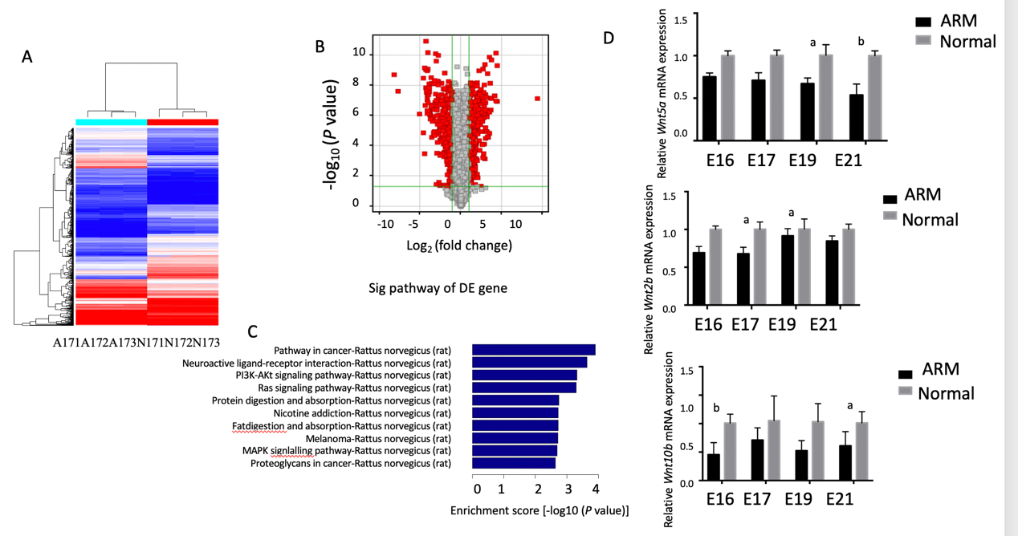
Figure 3 Identification of mRNAs in ARM and normal anorectal tissues. A: Cluster analysis of differentially expressed mRNAs was conducted with a heatmap on E17. In the heatmap, red and blue indicate high and low expression, respectively. The color ranges from red to blue, indicating that log10 (transcripts per million + 1) expression ranges from large to small; B: Volcano plot showing 301 up-regulated (red) and 256 down-regulated (green) circular RNAs profiled on E17 in anorectal malformations (ARM) anorectal tissues compared to normal tissues showing a two-fold change (P < 0.05); C: Pathway analysis was performed using Kyoto Encyclopedia of Genes and Genomes pathways. The top 10 pathways in mRNA analysis are shown; D: Three mRNAs were evaluated by quantitative reverse transcription polymerase chain reaction in ARM and normal anorectal tissues. ªP < 0.05 vs normal, ^{b}P < 0.01 vs normal. A: Anorectal malformations; ARM: Anorectal malformations; E: Embryonic day; N: Normal; DE: Differentially expression.
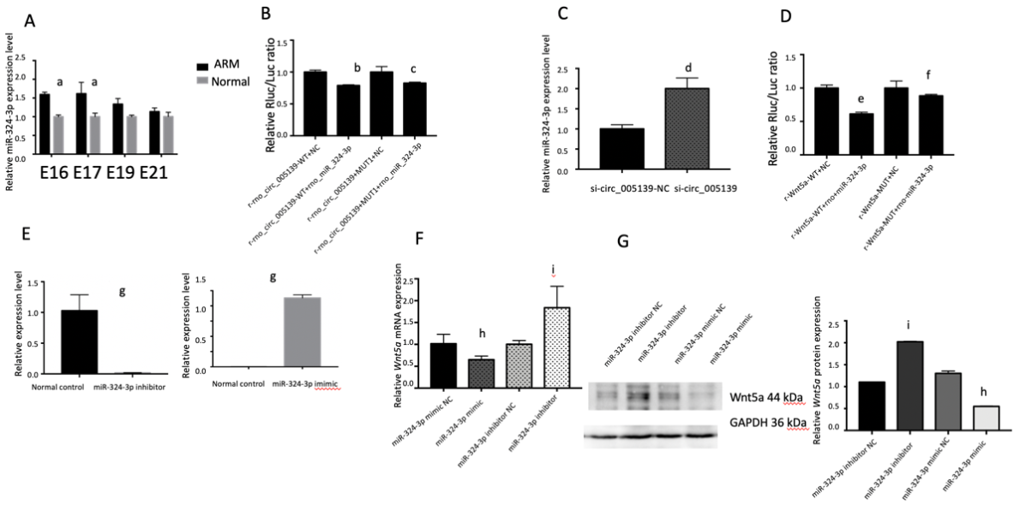
Figure 4 Rno_circ_0005139 directly binds to miR-324-3p, a direct upstream target of Wnt5a. A: Relative expression of microRNA (miR)-324-3p in anorectal malformations and normal control anorectal tissues was detected by quantitative reverse transcription polymerase chain reaction (qRT–PCR); B: Luciferase reporter assays were conducted to explore the correlation between rno_circ_0005139 and miR-324-3p; C: Expression of miR-324-3p was detected after transfection with si-rno_circ_0005139 (si-circ) and a negative control (si-NC) in IECs by qRT–PCR; D: Luciferase reporter assays were conducted to explore the correlation between miR-324-3p and Wnt5a; E: Expression of miR-324-3p was detected after transfection with miR-324-3p mimic, miR-324-3p inhibitor, or a negative control (mimic-NC/inhibitor-NC) by qRT–PCR. Expression of Wnt5a was detected after transfection with miR-324-3p mimic, miR-324-3p inhibitor, or negative control (mimic-NC/inhibitor-NC) by qRT–PCR; F and G: mRNA and protein expression levels of Wnt5a were detected after transfection with miR-324-3p mimic, miR-324-3p inhibitor, or negative control (mimic-NC/inhibitor-NC) by qRT–PCR and western blotting. ªP < 0.05 vs normal, ^{b}P < 0.01 vs r-rno_circ_0005139-WT+NC, ^{c}P < 0.05 vs vs r-rno_circ_0005139-MUT1+NC, ^{d}P < 0.05 vs si-circ_0005139-NC; ^{e}P < 0.05 vs r-Wnt5a-WT+NC, ^{f}P < 0.05 vs r-Wnt5a-MUT+NC, ^{g}P < 0.05 vs Normal control, ^{h}P < 0.05 vs miR-324-3p mimic NC and ^{i}P < 0.05 vs miR-324-3p inhibitor NC. ARM: Anorectal malformations; miR: microRNA.
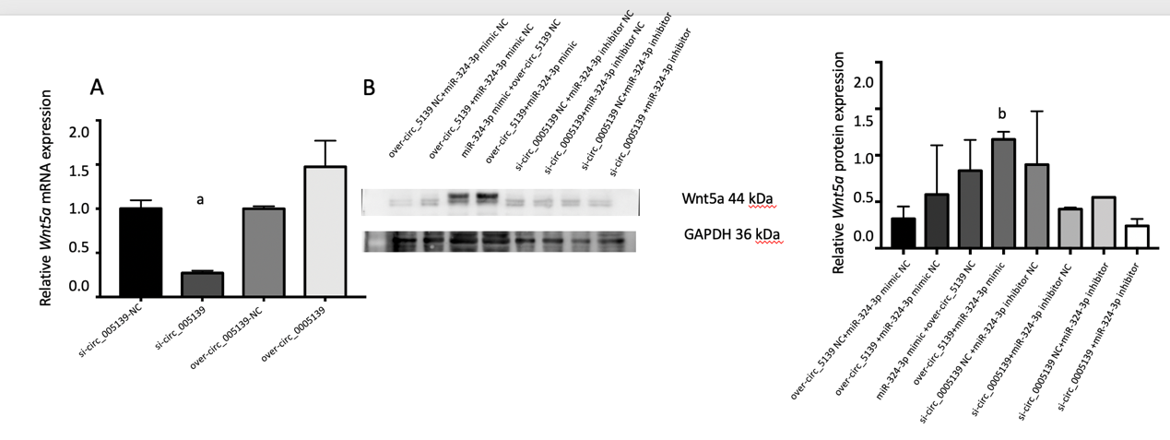
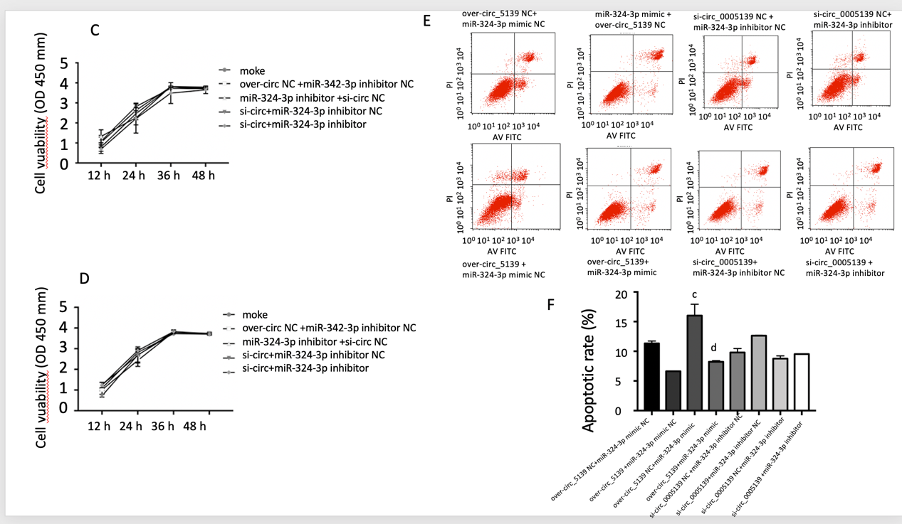
Figure 5 Rno_circ_0005139 regulated cell proliferation and apoptosis via miR-324-3p/Wnt5a. A: Relative expression of Wnt5a was measured by quantitative reverse transcription polymerase chain reaction with si-rno_circ_0005139 (si-circ), pLO5-rno_circ_0005139 (over-circ), or a negative control (si-NC/vector); B: Wnt5a expression was measured by western blotting after co-transfection with si-rno_circ_0005139 (si-circ), miR-324-3p inhibitor, or a negative control (si-NC/inhibitor-NC), and co-transfection with pLO5-rno_circ_0005139 (over-circ), miR-324-3p mimic, or a negative control (over-NC/mimic-NC); C and D: A Cell Counting Kit-8 assay was used to measure viability in intestinal epithelial cells (IECs) after co-transfection (rno_circ_0005139 and miR-324-3p); E and F: An apoptosis assay with detection by flow cytometry was used to measure apoptosis in IECs after co-transfection (rno_circ_0005139 and miR-324-3p). ªP < 0.05 vs si-circ_0005139-NC, ^{b}P < 0.05 vs over-circ_0005139-NC+miR-324-3p mimic NC, ^{c}P < 0.01 vs over-circ_0005139-NC+miR-324-3p mimic NC and ^{d}P < 0.01 vs over-circ_0005139-NC+miR-324-3p mimic.
Table 1 Circular RNA and mRNA primer sequences
 | Forward | Reverse
Rno_circ_0000436 | 5′-CCACGGAGAACAAGGTAAAA-3′ | 5′-ATTGACCTTGTCTTCCTCAG-3′
Rno_circ_0005139 | 5′-CATCCTGTTGTGAAGATCTTG-3′ | 5′-TGTGGTAAGCCAAGTGATGAA-3′
Rno_circ_0006880 | 5′-ACTGTTTACTTCTCCCAGGAAG-3′ | 5′-GCTTCATACCGATAAACCAGTG-3′
Rno_circ_0009285 | 5′-CTTATAACCTGAGTGATAATGTC-3′ | 5′-TGGCATTCTTGCTGTTGGCT-3′
Rno_circ_0011386 | 5′-CCACTGGTCAAGCAGCCTGT-3′ | 5′-GATGATCCTTCTCGGTCAGAG-3′
Rno_circ_0014367 | 5′-GCGCTTGTTTCCTCATAGATTTC-3′ | 5′-CTTTGATTCCTTGATCTCCTC-3′
Wnt5a | 5′-AGACGGGCATCAAAGAGT-3′ | 5′-AAGCGGTAGCCATAGTC-3′
Wnt2b | 5′-CGGGCCCTCATGAACTTACATAAC-3′ | 5′-CAGGGTACAGGAGCCACTCACA-3′
Wnt10b | 5'-AGTCACAGAGTGGGTCAACG-3′ | 5'-CGAAATCCGAGCAAAGAGC-3′
β-actin | 5′-GGAGATTACTGCCCTGGCTCCTA-3′ | 5′-GACTCATCGTACTCCTGCTTGCTG-3′

