Name of Journal: World Journal of Clinical Cases
Manuscript NO: 69886
Manuscript Type: CASE REPORT

Uncommon complication of nasoenteral feeding tube: A case report

Jiang YP et al. Complication of nasoenteral feeding tube

Yong-Po Jiang, Sheng Zhang, Rong-Hai Lin

Yong-Po Jiang, Sheng Zhang, Rong-Hai Lin, Department of Critical care medicine, Taizhou Hospital of Zhejiang Province affiliated to Wenzhou Medical University, Taizhou 317000, Zhejiang Province, China

Author contributions: Lin RH helped to design the manuscript; Jiang YP helped to write the manuscript; Zhang S helped to revise the manuscript; all authors issued final approval for the version to be submitted.

Supported by The Science and Technology Project of Taizhou, No.1902KY02.

Corresponding author: Rong-Hai Lin, MD, Chief Doctor, Depertment of Critical care medicine, Taizhou Hospital of Zhejiang Province Affiliated to Wenzhou Medical University, Taizhou Hospital of Zhejiang Province Affiliated to Wenzhou Medical University, No. 150, Ximen Street, Taizhou, China, Taizhou 317000, Zhejiang Province, China. tylinrh@163.com

Received: July 15, 2021
Revised: October 19, 2021
Accepted: January 11, 2022
Published online: February 16, 2022

Abstract
BACKGROUND
The jejunal nutrition tube has increasingly been used in clinical practice, and the results in frequent complications.

CASE SUMMARY
We present the case of a 74-year-old male patient who had been admitted to the intensive care unit for aspiration pneumonia and respiratory failure. When confirming the position of the jejunal tube by X-ray, we found that the feeding tube had been placed into the chest. The complications was a disaster, though the misplacement of jejunal feeding tube are uncommon.

CONCLUSION
We introduced a way of ultrasound-guided jejunum feeding tube placement to avert the disaster, which was convenient and economical.

Key Words: Nasoenteral feeding tube; Nutritional support; Complication; Ultrasound-guided; Feeding tube placement; Case report

©The Author(s) 2022. Published by Baishideng Publishing Group Inc. All rights reserved.

Citation: Jiang YP, Zhang S, Lin RH. Uncommon complication of nasoenteral feeding tube: A case report. World J Clin Cases 2022; 10(5): 1598-1601
URL: https://www.wjgnet.com/2307-8960/full/v10/i5/1598.htm
DOI: https://dx.doi.org/10.12998/wjcc.v10.i5.1598

Core Tip: We report a case of a patient who has a serious complication during the catheterization of the jejunal tube and introduce a way of using of bedside ultrasound to guide the placement of the jejunal tube to avert the disaster, which was convenient and economical.

INTRODUCTION
Early enteral nutrition in critically ill patients who cannot eat by mouth is widely recommended by the clinical practice guidelines of nutrition^{[1]}. For patients at high risk of aspiration and who were intolerant of oral or gastric feeding the advice is to place a post-pyloric feeding tube^{[2,3]}. Complication of jejunal feeding tubes are rare. A recent report revealed that a jejunal tube caused gastrointestinal perforation^{[4]}. In this case report, we will present a case where a jejunal feeding tube was placed into the chest and provide a brief overview of a method to avoid the complication of placing a jejunal feeding tube. Written informed consent was obtained from the patient’s family for publication of this manuscript and any accompanying images.

CASE PRESENTATION
Chief complaints
A 74-year-old male patient who with a history of chronic obstructive pulmonary disease (COPD) was admitted to the intensive care unit (ICU) for aspiration pneumonia and respiratory failure.

History of present illness
He had a prolonged course of treatment and a nasoduodenal feeding tube blind placed at the bedside.

Imaging examinations
A chest X-ray revealed that the position of the nasoduodenal feeding tube was in the chest (Figure 1A). An abdominal X-ray also made it clear that the nasoduodenal feeding tube was not placed in the abdomen (Figure 1B). Visual laryngoscopy revealed that the tube entered the airway together with the windpipe (Figure 2).

FINAL DIAGNOSIS
The patient suffered from pneumothorax due to tracheal pleura leakage, which occurred when the feeding tube was immediately removed.

TREATMENT
We administered chest drainage in the middle of the clavicle and second ribs.

OUTCOME AND FOLLOW-UP
However, the patient died as a result of the aggravation of the lung infection.

DISCUSSION
The most commonly used non-invasive method of enteral nutrition is a nasogastrojejunal tube. The jejunal nutrition tube has increasingly been used in clinical practice, and the results in frequent complications^{[4,5]}. The traditional method of intubation depends on the operator experience, X-ray, and gastroscope. Nasogastrojejunal tube insertion based on a minimally invasive catheterization procedure, combined with ultrasound guidance, is becoming more prevalent^{[6]}. The use of bedside ultrasound to guide the placement of the jejunal tube is safe, convenient and economical. One of the common complications of indwelling jejunal tubes is the misplaced airway as reported in this case. How can we avoid it? When the cannula is about 30 cm, we need to observe the patient's response and ventilator condition. Even neck ultrasound determines access to the esophagus. If the patient has a severe cough response or a leak and a high pressure alarm, it may suggest that the tube has entered the airway. When the tube is placed around 50 cm, we need to complete a test of pumping. If you can hear the gas over water (bubble sound), then the catheter head has entered the stomach. If not, the patient should be reintubated.

CONCLUSION
The complication of blind bedside jejunal feeding tube placement was a disaster. Ultrasound guidance under visualization can avoid serious complications. Practitioners need to pay attention to patient response and the ventilator during catheterization.

REFERENCES
1 Reintam Blaser A, Starkopf J, Alhazzani W, Berger MM, Casaer MP, Deane AM, Fruhwald S, Hiesmayr M, Ichai C, Jakob SM, Loudet CI, Malbrain ML, Montejo González JC, Paugam-Burtz C, Poeze M, Preiser JC, Singer P, van Zanten AR, De Waele J, Wendon J, Wernerman J, Whitehouse T, Wilmer A, Oudemans-van Straaten HM; ESICM Working Group on Gastrointestinal Function. Early enteral nutrition in critically ill patients: ESICM clinical practice guidelines. Intensive Care Med 2017; 43: 380-398 [PMID: 28168570 DOI: 10.1007/s00134-016-4665-0]
2 Rhodes A, Evans LE, Alhazzani W, Levy MM, Antonelli M, Ferrer R, Kumar A, Sevransky JE, Sprung CL, Nunnally ME, Rochwerg B, Rubenfeld GD, Angus DC, Annane D, Beale RJ, Bellinghan GJ, Bernard GR, Chiche JD, Coopersmith C, De Backer DP, French CJ, Fujishima S, Gerlach H, Hidalgo JL, Hollenberg SM, Jones AE, Karnad DR, Kleinpell RM, Koh Y, Lisboa TC, Machado FR, Marini JJ, Marshall JC, Mazuski JE, McIntyre LA, McLean AS, Mehta S, Moreno RP, Myburgh J, Navalesi P, Nishida O, Osborn TM, Perner A, Plunkett CM, Ranieri M, Schorr CA, Seckel MA, Seymour CW, Shieh L, Shukri KA, Simpson SQ, Singer M, Thompson BT, Townsend SR, Van der Poll T, Vincent JL, Wiersinga WJ, Zimmerman JL, Dellinger RP. Surviving Sepsis Campaign: International Guidelines for Management of Sepsis and Septic Shock: 2016. Intensive Care Med 2017; 43: 304-377 [PMID: 28101605 DOI: 10.1007/s00134-017-4683-6]
3 Taylor BE, McClave SA, Martindale RG, Warren MM, Johnson DR, Braunschweig C, McCarthy MS, Davanos E, Rice TW, Cresci GA, Gervasio JM, Sacks GS, Roberts PR, Compher C; Society of Critical Care Medicine; American Society of Parenteral and Enteral Nutrition. Guidelines for the Provision and Assessment of Nutrition Support Therapy in the Adult Critically Ill Patient: Society of Critical Care Medicine (SCCM) and American Society for Parenteral and Enteral Nutrition (A.S.P.E.N.). Crit Care Med 2016; 44: 390-438 [PMID: 26771786 DOI: 10.1097/CCM.0000000000001525]
4 Fakih HAM, Daouk S, Runnstrom M, Ataya A. A nasoenteral feeding tube barking up the wrong tree. Intensive Care Med 2017; 43: 930-931 [PMID: 28124087 DOI: 10.1007/s00134-017-4686-3]
5 Stefani A, Ruggiero C, Aramini B, Scamporlino A. An unusual drain in the pleural cavity: iatrogenic pneumothorax due to pulmonary misplacement of a nasogastric tube. Intensive Care Med 2018; 44: 2290-2291 [PMID: 29974170 DOI: 10.1007/s00134-018-5280-z]
6 Li Y, Ye Y, Mei Y, Ruan H, Yu Y. Semi-automated ultrasound guidance applied to nasogastrojejunal tube replacement for enteral nutrition in critically ill adults. Biomed Eng Online 2018; 17: 21 [PMID: 29415733 DOI: 10.1186/s12938-018-0452-1]

Footnotes
Informed consent statement: Informed written consent was obtained from the patient for publication of this report and any accompanying images.

Conflict-of-interest statement: The authors declare that they have no conflict of interest.

CARE Checklist (2016) statement: The authors have read the CARE Checklist (2016), and the manuscript was prepared and revised according to the CARE Checklist (2016).

Open-Access: This article is an open-access article that was selected by an in-house editor and fully peer-reviewed by external reviewers. It is distributed in accordance with the Creative Commons Attribution NonCommercial (CC BY-NC 4.0) license, which permits others to distribute, remix, adapt, build upon this work non-commercially, and license their derivative works on different terms, provided the original work is properly cited and the use is non-commercial. See: https://creativecommons.org/Licenses/by-nc/4.0/

Provenance and peer review: Unsolicited article; Externally peer reviewed.
Peer-review model: Single blind

Peer-review started: July 15, 2021
First decision: October 18, 2021
Article in press: January 11, 2022

Specialty type: Critical Care Medicine
Country/Territory of origin: China
Peer-review report’s scientific quality classification
Grade A (Excellent): 0
Grade B (Very good): B
Grade C (Good): 0
Grade D (Fair): 0
Grade E (Poor): 0

P-Reviewer: Soares RLS S-Editor: Li JH L-Editor: A P-Editor: Li JH

Figure Legends
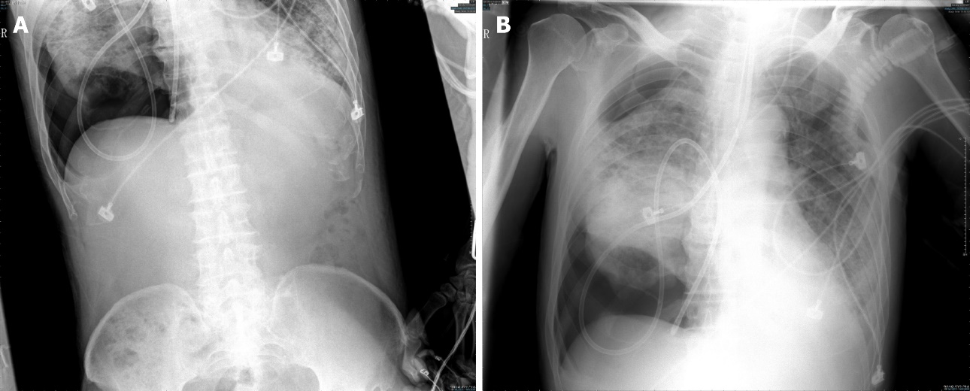
Figure 1 X-ray after placement of the feeding tube. A: Abdominal X-ray shows there is no jejunal tube in the abdomen, and the jejunal tube is on the diaphragm; B: Chest X-ray shows the jejunal tube is in the chest.
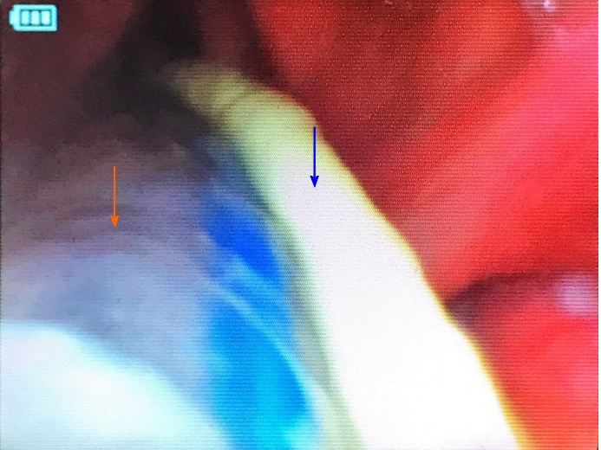
Figure 2 Visual laryngoscopy after placement of the feeding tube. The blue arrow is feeding tube and the orange arrow is windpipe.

Published by Baishideng Publishing Group Inc
7041 Koll Center Parkway, Suite 160, Pleasanton, CA 94566, USA
Telephone: +1-925-3991568
E-mail: bpgoffice@wjgnet.com
Help Desk: https://www.f6publishing.com/helpdesk
https://www.wjgnet.com

© 2022 Baishideng Publishing Group Inc. All rights reserved.

