Name of Journal: World Journal of Gastroenterology
Manuscript NO: 61631
Manuscript Type: REVIEW

Environmental perspectives of COVID-19 outbreaks: A review

Samanta P et al. Environmental aspects of COVID-19 outbreaks

Palas Samanta, Apurba Ratan Ghosh

Palas Samanta, department of Environmental Science, Sukanta Mahavidyalaya, University of North Bengal, Dhupguri 735210, West Bengal, India

Apurba Ratan Ghosh, department of Environmental Science, The University of Burdwan, Burdwan 713104, West Bengal, India

Author contributions: Samanta P contributed to the conceptualization, writing- original draft preparation, software running; Ghosh AR contributed to the conceptualization, supervision, writing- reviewing and editing.

Corresponding author: Palas Samanta, PhD, Assistant Professor, department of Environmental Science, Sukanta Mahavidyalaya, University of North Bengal, Dhupguri, Jalpaiguri, Dhupguri 735210, West Bengal, India. samanta.palas2010@gmail.com

Received: December 14, 2020
Revised: January 10, 2021
Accepted: August 12, 2021
Published online:

Abstract
The coronavirus disease 2019 (COVID-19) pandemic, caused by the novel virus severe acute respiratory syndrome coronavirus 2 (SARS-CoV-2), began in December 2019 in China and has led to a global public health emergency. Previously, it was known as 2019-nCoV and caused disease mainly through respiratory pathways. The COVID-19 outbreak is ranked third globally as the most highly pathogenic disease of the twenty-first century, after the outbreak of SARS-CoV and Middle East respiratory syndrome in 2002 and 2012, respectively. Clinical, laboratory, and diagnostic methodology have been demonstrated in some observational studies. No systematic reviews on COVID-19 have been published regarding the integration of COVID-19 outbreaks (monitoring, fate and treatment) with environmental and human health perspectives. Accordingly, this review systematically addresses environmental aspects of COVID-19 outbreak such as the origin of SARS-CoV-2, epidemiological characteristics, diagnostic methodology, treatment options and technological advancement for the prevention of COVID-19 outbreaks. Finally, we integrate COVID-19 outbreaks (monitoring, fate and treatment) with environmental and human health perspectives. We believe that this review will help to understand the SARS-CoV-2 outbreak as a multipurpose document, not only for the scientific community but also for global citizens. Countries should adopt emergency preparedness such as prepare human resources, infrastructure and facilities to treat severe COVID-19 as the virus spreads rapidly globally.

Key Words: COVID-19; SARS-CoV-2 virus; Environmental perspectives; Epidemiological characteristics; Public health; Emergency preparedness

Samanta P, Ghosh AR. Environmental perspectives of COVID-19 outbreaks: A review. World J Gastroenterol 2021; In press

Core Tip: This review is the first attempt to integrate coronavirus disease 2019 (COVID-19) outbreaks (monitoring, fate and treatment) with respect to environmental and human health perspectives. Briefly, the paper systematically addresses the environmental aspects of the COVID-19 outbreak such as the origin of severe acute respiratory syndrome coronavirus 2, epidemiological characteristics, diagnostic methodology, treatment options and technological advancement for the prevention of COVID-19 outbreaks.

INTRODUCTION
A series of patients with unidentified pneumonia, caused by β-coronavirus, was reported in late December 2019 in Wuhan (Hubei Province), China. coronavirus disease 2019 (COVID-19) outbreaks are clinically very similar to viral pneumonia. A number of experts from the PRC Centers for Disease Control declared that this respiratory disorder (alternatively known as novel coronavirus pneumonia, NCP) was caused by a novel coronavirus^{[1]}. The World Health Organization (WHO) initially named the disease as 2019-nCoV (2019-novel coronavirus) on January 12, 2020. It was officially later named COVID-19 on February 11, 2020 by the WHO. On the same date, the International Committee on Taxonomy of Viruses named the virus as severe acute respiratory syndrome coronavirus 2 (SARS-CoV-2) after developing the genome sequence from a COVID-19 patient in Wuhan on January 7, 2020. The virus belongs to the β-coronavirus family, which is very prevalent in nature among other families. Similar to other viruses, the SARS-CoV-2 also has many natural hosts including different intermediate and final hosts, which makes it challenging for scientific communities to treat and prevent COVID-19 outbreaks. It has higher transmission and infection potential but causes a lower mortality rate compared with SARS-CoV and Middle East respiratory syndrome (MERS-CoV)^{[2]}. The genomic sequence of SARS-CoV-2 revealed that it has 79.5% and 96% similarity with SARS-CoV and bat coronavirus, respectively^{[1]}, which implies that bats might be the source of SARS-CoV-2. Although the COVID-19 outbreak started in China, the virus has spread to over 213 countries with the highest rate of infection in the United States, Italy, France, and Spain among others as per data published by the WHO on December 13, 2020 (Figure 1). There are approximately 202608306 confirmed SARS-CoV-2 cases and 4293591 deaths worldwide. Consequently, COVID-19 has emerged as a global threat to public health and is steadily growing due to human-to-human transmission. Moreover, this transmission also spreads in different environmental sectors such as water, air, soil, sewage and fecal matter^{[3]}. Additionally, this process is accelerated by a number of meteorological factors namely temperature, weather, humidity and air quality parameters including particulate matter, SOx, NOx and carbon, etc. Therefore, a better understanding of the global consequences of COVID-19 is required with regard to environmental perspectives. Accordingly, this review will address the origin of SARS-CoV-2, route of transmission, pathogenesis, epidemiological characteristics, diagnostic methodology, treatment options and technological advancement for the prevention of COVID-19 outbreaks with regard to environmental perspectives in order to acquire the latest understanding of this new infectious disease of which certain immediate as well as long-term remedial measures can be explored.

EPIDEMIOLOGY OF THE COVID-19 OUTBREAK
Origin of the COVID-19 outbreak
SARS-CoV-2 is a β-coronavirus and is enveloped with non-segmented Orthocoronavirinae subfamily RNA^{[4]}. Among the four genera, γ- and δ-CoV infect birds while α- and β-CoV infect mammals including humans (Table 1). The α- and β-CoV have six variants. Among them α-CoVs variants (HCoV-229E and HCoV-NL63), and β-CoVs variants (HCoV-HKU1 and HCoV-OC43) have lower pathogenic capability in humans and cause mild respiratory symptoms similar to the common cold. Only β-CoVs variants (SARS-CoV and MERS-CoV) have severe pathogenic capability in humans. This pandemic started in Wuhan specifically in a seafood wet market, on December 12, 2019. Several studies have demonstrated that bats are natural hosts of SARS-CoV-2 and animals such as snakes, turtles and pangolins are intermediate hosts of SARS-CoV-2.
Previously, snakes were thought to be involved in COVID-19 outbreaks by Ji et al^{[5]} but this hypothesis was rejected by Zhang et al^{[6]} who did not find any similarity in genome sequence between snakes and COVID-19 patients. In another study, researchers found an approximately 96.2% genome sequence similarity between SARS-CoV-2 and bat coronavirus (CoV RaTG13)^{[7]}. In addition, the genomic sequence of SARS-CoV-2 matched with 79.5% of the genome sequence of SARS-CoV^{[8]}. These findings implied that bats were the suspected source of COVID-19 outbreaks as well as the natural host of this virus. The virus was finally transmitted to humans via unknown intermediate hosts from bats. However, few bats are sold in the Wuhan seafood market^{[9]}. Accordingly, scientists are trying to determine the intermediate sources such as snakes, turtles and pangolins. Xu et al^{[10]} found approximately 99% genomic similarity between SARS-CoV-2 and pangolins. Furthermore, they revealed that pangolins are the potential intermediate host of SARS-CoV-2. Apart from these studies, to date there is no adequate evidence on the virus origin regarding potential intermediate hosts and the natural host of SARS-CoV-2. Therefore, SARS-CoV-2 could use angiotensin-converting enzyme 2 (ACE2), similar to SARS-CoV receptor for human infection^{[7]}. However, there is controversy regarding the infectious potential of COVID-19 patients to transmit the disease during the incubation period. Recently, the WHO reported that cats may be the carrier of this virus, whereas other domestic animals like ducks, hens and dogs may not be carriers of this deadly virus.

Transmission of COVID-19
The animal-human interface is not a new concept. Zoonotic diseases with a wildlife reservoir have long been recognized as significant public health problems. Indeed, up to three-quarters of infectious diseases that cause human infections are known to be zoonotic^{[11]}. Apart from this, the complexity of animal, human, and environmental factors is thought to play a critical role in its emergence^{[12]}. On the other hand, contact with infected patients and droplets are considered to be major transmission routes of COVID-19. Aerosol transmission is another important route of SARS-CoV-2 infection. By contrast, SARS-CoV and MERS-CoV transmission are mainly reported through nosocomial transmission. However, human-to-human SARS-CoV-2 transmission occurs mainly through close contact between COVID-19 patients or friends or carriers and between family members including relatives. It can be spread rapidly in healthcare workers (up to 50%) and patients (62–79%) similar to SARS-CoV and MERS-CoV and is considered the most common route of infection^{[13]}. It is also assumed that consumption of wild animals who are the hosts of SARS-CoV-2 and humans in close contact with these animals are suspected to be the route of entry of SARS-CoV-2 and its mode of transmission. However, this route of SARS-CoV-2 transmission remains controversial and requires further study.
To date, 1 million people around the world have tested positive for this virus, but only 4 cases have so far been reported in which pets showed positive for SARS-CoV-2. These involved 2 dogs and 2 cats, the owners had COVID-19 and are believed to be the most likely source of transmission to their pets. The dogs showed clinical signs, but one of the cats did not have signs of illness. In late March 2020, health officials in Belgium reported that a cat from Liège province had also tested positive for SARS-CoV-2. Nevertheless, the US Centers for Disease Control and Prevention (CDC), WHO, and key animal health organizations have all issued statements aiming to calm people’s fears about their pets being a source of the novel virus^{[14-16]}. In this regard, the World Organization for Animal Health has emphasized that “there is no justification in taking measures against companion animals which may compromise their welfare”. Furthermore, given the speculation that wild live animal species may be linked to this pandemic, this collaborative approach will also require the expertise of wildlife forensic specialists.
SARS-CoV-2 has also been detected in saliva, the gastrointestinal tract, urine and stool. In particular, the gastrointestinal tract or digestive tract has been recognized as another route of SARS-CoV-2 infection based on a bioinformatics study^{[17]}. SARS-CoV-2 has been detected in gastrointestinal mucosal tissue of COVID-19 patients^{[18]}. In addition, it has also been detected in tears and conjunctival secretions of COVID-19 patients^{[19]}. Intrauterine vertical transmission from pregnant women to the newborn is temporarily excluded due to a lack of adequate data on pregnant women infected with SARS-CoV-2^{[20]}.

Prevalence of COVID-19
A number of researchers estimated the basic reproduction number (R₀) to calculate the number of people affected by secondary infections. Generally, it represents the number of people with COVID-19 but in a completely susceptible population without intervention^{[21]}. Using the SEIR model, Wu et al^{[22]} recorded an R₀ value for SARS-CoV-2 in the range of 2.47-2.86, while Majumder and Kenneth^{[23]} estimated the R₀ value to be 2.0–3.3 based on the IDEA model. By contrast, other β-CoV viruses namely SARS-CoV and MERS-CoV showed an R₀ value in the range of 2.2–3.6 and 2.0–6.7, respectively^{[24,25]}, which indicated that SARS-CoV-2 has higher transmissibility than SARS-CoV and MERS-CoV. In China, 87% of cases were in the age group 30 to 79 years and 3% cases were noted to be aged ≥ 80 years, while female cases were only 41.9%^{[26,27]}. Additionally, 81% of cases were classified as mild, 14% cases were severe and 5% cases were very critical. In another study, it was reported that the overall case-fatality rate (CFR) was 2.3%; however, in the age groups 70-79 and ≥80 years, the CFRs were 8.0% and 14.8%, respectively^{[22]}. These findings clearly indicated that elderly males are more susceptible to SARS-CoV-2 compared with other groups. In addition, the virus affected those elderly males with chronic diseases such as diabetes, hypertension, heart disease, etc.^{[20]}. In summary, the prevalence of COVID-19 is very high, and it can spread very rapidly within countries and outside countries.

Virus susceptibility and incubation period
Generally, elderly people aged between 55 and 75 years are more susceptible to SARS-CoV-2 infection. Currently, it has been found that the virus is also infecting middle-aged people aged between 25 and 50 years. The average age of patients across 18 studies was 51.97 years (95%CI: 46.06%-57.89%), 55.9% were male (95%CI: 51.6%–60.1%). Additionally, 36.8% cases showed comorbidities (95%CI: 24.7%-48.9%), the most significant being hypertension (18.6%; 95%CI, 8.1–29.0%), cardiovascular disease (14.4%; 95%CI: 5.7%–23.1%), and diabetes (11.9%; 95%CI: 9.1%-14.6%), among others^{[28]}. Children account for 1% to 3% of COVID-19 cases across countries and likely experience an asymptomatic infection (mild or no symptoms on infection) compared with adults. Zhong et al^{[29]} demonstrated that the virus has an average median incubation period of about 3 d but it can range between 0 and 24 d, and the average median time from symptomatic onset to death is 14 d. They also found that mortality rises in patients with comorbidities or a surgical history before virus infection. Generally, the average median latency period for SARS-CoV-2 infection was 4 d, the average interval to hospital admission after onset of symptoms was 3.8 d, and the average time to death after admission to hospital was 17.4 d^{[30]}. Another study reported that the time to appearance of COVID-19 symptoms to death ranged between 6 and 41 d with a median period 14 d^{[22]}. They also showed that this period was age-dependent and related to the patient’s immune system status. The prevalence was greater in patients aged over 70 years compared with those less than 70 years. According to the WHO, the incubation period for COVID-19 ranged from 2 to 10 d. By contrast, for MERS-CoV infection the average median latency was 7 d^{[31]}. However, in COVID-19, the maximum latency was observed to be 24 d, which was high compared with SARS and MERS. This indicated that SARS-CoV-2 has a higher risk of transmission. Accordingly, in comparison with SARS and MERS, SARS-CoV-2 has a shorter median incubation period. Recent data showed that elderly people (aged above 75 years) have a shorter median interval, i.e., 11.5 d from symptom onset to death in comparison to COVID-19 patients (20 d). This finding indicated that disease progression is more rapid in elderly people compared to younger people^{[1]}.

GENOMIC STRUCTURE AND PATHOPHYSIOLOGY
Genomic structure
SARS-CoV-2, a β-coronavirus, is a single-stranded RNA virus with a diameter ranging between 80 nm and 120 nm. Currently, four types of coronavirus are present in nature: α-, β-, δ- and γ- coronavirus. The γ- and δ-CoV infect birds, while α- and β-CoV infect mammals. Details of these coronaviruses are presented in Table 1. There are six coronaviruses causing human infection including SARS-CoV and MERS-CoV. The complete genome sequence of SARS-CoV-2 is closest to SARS-like bat CoV (MG772933). There is approximately 79% homology in genome sequence between SARS-CoV-2 and SARS^{[9]}. In addition, the complete genomic sequence of SARS-CoV-2 is approximately 29.9 kb, while SARS-CoV and MERS-CoV have a genome length of 27.9 kb and 30.1 kb, respectively^{[8,32]}. The SARS-CoV-2 genome contains a variable number of open reading frames (ORFs) ranging between 6 and 11^{[33]}. Two-thirds are located mainly in the first ORF (ORF1a/b) which encodes 16 non-structural proteins (NSP) and translates polyproteins (pp1a and pp1ab), while the remaining ORFs encode accessory and structural proteins. The remainder of the RNA virus encodes four essential structural proteins, including the spike (S) glycoprotein, small envelope (E) protein, matrix (M) protein, and nucleocapsid (N) protein, and several accessory proteins, that interfere with the host innate immune response^{[34]}. Frameshift mutation between ORF1a and ORF1b is mainly responsible for the production of pp1a and pp1ab polypeptides that are regulated by chymotrypsin-like protease (3CLpro) or main protease (Mpro), and this process produces 16 non-structural proteins (NSPs) with the help of papain-like proteases^{[35]}. Therefore, SARS-CoV-2 pathophysiology and virulence are thought to be linked with NSPs and structural protein functions.

Pathophysiology
The pathophysiology of COVID-19 produces pneumonia which seems to be very complex. The pathological mechanism is presented in Figure 2. A group of researchers claimed that viral infection is caused by an immune reaction through the “cytokine storm”^{[36,37]}. The main protagonist of this “cytokine storm” is interleukin 6 (IL-6). Generally, activated leukocytes are primarily responsible for IL-6 production and IL-6 acts on a number of cells and tissues. It stimulates acute phase protein production and regulates thermoregulation, bone structure and central nervous system functions^{[36,37]}. However, its main role is pro-inflammatory actions. COVID-19 enhances IL-6 level, which is implicated in the pathogenesis of the cytokine release syndrome (CRS), which is an acute systemic inflammatory syndrome characterized by fever and multiple organ dysfunction^{[36,37]}.
Another group of researchers demonstrated that SARS-CoV-2 uses angiotensin converting enzyme 2 (ACE2) receptor for both cross-species and human-to-human transmission^{[1,38]}. The virion S-glycoprotein present on the virus surface interacts with ACE2 receptors on human cells to spread the infection^{[39]}. S-glycoprotein contains two subunits, S1 and S2. The S1 determines the virus-host range and cellular tropism in the key function domain – RBD (receptor-binding domain), while S2 is responsible for cell membrane-virus fusion by two tandem domains, heptad repeats 1 (HR1) and HR2^{[40,41]}. Following membrane fusion, viral RNA is released into the cytoplasm, and the uncoated RNA is induced to produce pp1a and pp1ab polypeptides with the help of either chymotrypsin-like protease (3CLpro) or main protease (Mpro), which encode 16 non-structural proteins (NSPs) in the presence of papain-like proteases, and finally form a replication-transcription complex (RTC) in double-membrane vesicles^{[8]}. Subsequently, the RTC replicates continuously and synthesizes sub-genomic RNAs^{[42]} to encode accessory proteins and structural proteins. This newly formed genomic RNA, envelopes glycoproteins and nucleocapsid proteins mediated through the endoplasmic reticulum (ER) and Golgi^{[43]} are assembled together to form viral buds. Finally, these newly formed virion-containing vesicles are fused with plasma membrane to release the virus and cause infection through mucous membranes, especially nasal and larynx mucosa, and then enter the lungs through the respiratory tract.
These ACE2 receptors are very important in the spread of COVID-19. They are mainly found in the lower respiratory tract of humans. After entry through mucous membranes, especially nasal and larynx mucosa, the virus enters directly into the lungs through the respiratory tract. In the next step, the virus attacks other target organs which contain ACE2 receptors, such as the lungs, heart, renal system and gastrointestinal tract^{[36,37]}. Accordingly, the binding affinity of this virus-receptor has been intensively studied using different approaches. Systematic detection analysis showed that SARS-CoV-2 S-glycoprotein binding capacity with ACE2 was 10-fold higher than SARS-CoV as shown under cryo-electron microscopy of the SARS-CoV-2 S protein in pre-fusion conformation^{[39]}. Recently, Wu et al^{[9]} demonstrated moderate genomic and phylogenetic similarity with SARS-CoV but higher similarity with bat CoV genome sequence, particularly in the S-glycoprotein and RBD. They also found that there were no amino acid substitutions occurring in the NSP7, NSP13, envelope, matrix, or accessory proteins p6 and 8b at the protein level, except in NSP2, NSP3, spike protein, underpinning the subdomain, i.e., RBD. Another recent study demonstrated that mutation of NSP2 and NSP3 plays an important role in infection and SARS-CoV-2 differentiation. However, this mechanism of SARS-CoV-2 infection in humans via S-protein binding with ACE2 is unclear, as is the interaction strength for risk transmission. Accordingly, the WHO was also unable to clarify the mechanism of COVID-19. This has led to further investigations regarding potential human-to-human transmission and the pathophysiological mechanisms of COVID-19 outbreaks.

CLINICAL CHARACTERISTICS OF COVID-19 INFECTION
Being an acute respiratory infection, COVID-19 is initiated in the respiratory tract, primarily by droplets, respiratory secretions, and direct contact. After entry, the virus affects a number of organs or systems (Figure 3). The clinical symptoms of COVID-19 vary from asymptomatic or paucisymptomatic forms to clinical conditions. In particular, all patients are divided into general, severe, and critical patient groups. The most common clinical symptoms of COVID-19 are fever (87.9%), cough (67.7%), fatigue (38.1%), sputum production (33.4%), shortness of breath (18.6%), sore throat (13.9%), and headache (13.6%)^{[27,44]}. The development of these symptoms may occur within 3 d of viral infection. On the other hand, other symptoms may occur 9 d after virus infection. Of these, fever and cough are the dominant COVID-19 symptoms. The incidence of diarrhea (3.7%) and vomiting (5.0%) is very rare^{[27,44]}. However, it is very difficult to accurately distinguish COVID-19 from other viral respiratory infections. The CDC included loss of taste or smell, pink eye, muscle pain, intense chills, headache and sore throat as COVID symptoms. In severe cases, symptoms such as acute respiratory distress syndrome, rhinorrhea, dyspnea, gastrointestinal disorders, septic shock, mental stress, acute heart injury, sepsis, multiple organ dysfunction syndrome (MODS), secondary infection and even death may occur^{[8,34]}. Critical COVID-19 patients with severe respiratory failure require an intensive care unit (ICU) or ventilation support. However, the occurrence of upper respiratory symptoms and gastrointestinal symptoms are very rare compared with other symptoms. In addition to this, the elderly and those who have underlying diseases (i.e., chronic obstructive pulmonary disease, hypertension, diabetes, cardiovascular disease) are very prone to COVID-19 and develop symptoms such as metabolic acidosis, acute respiratory distress syndrome, coagulation dysfunction and even death^{[8,45]}. Sometimes, COVID-19 patients experience acute heart injury, arrhythmia, impaired renal function and abnormal liver function such as the formation of micro-vesicular steatosis (50.7%) at the time of admission^{[1,45,46]}.
Hematological assays revealed that most patients had decreased white blood cell counts, and lymphocytopenia^{[27]}. In the case of critical patients, neutrophil count, D-dimer, blood urea, creatinine and lymphocyte levels decreased markedly. In another study, a reduction in albumin level (75.8%; 95%CI, 30.5%-100.0%), higher C-reactive protein (58.3%; 95%CI: 21.8%-94.7%) and lactate dehydrogenase (LDH) levels (57.0%; 95%CI: 38.0%-76.0%), higher lymphopenia level (43.1%; 95%CI, 18.9%-67.3%), and higher erythrocyte sedimentation rate (ESR) (41.8%; 95%CI: 0.0-92.8%) and other clinical manifestations were recorded^{[28]}. Additionally, inflammatory factors, which indicated the immune status of patients, namely IL-6, IL-10, and tumor necrosis factor-α (TNF-α) are also markedly increased. In critical patients (admitted to the ICU), higher IL-2, IL-7, IL-10, granulocyte colony-stimulating factor (GCSF), 10 kD interferon gamma-induced protein (IP-10), monocyte chemoattractant protein-1 (MCP-1), macrophage inflammatory protein 1-α (MIP-1α), and TNF-α levels in plasma were observed^{[8,45]}. In patients with severe COVID-19 [admitted to the ICU; 20.3% cases (95%CI, 10.0–30.6%)], 32.8% of patients experienced ARDS (95%CI: 13.7%–51.8%), 13.0% patients had acute cardiac injury (95%CI: 4.1%-21.9%), 7.9% patients experienced acute kidney injury (95%CI: 1.8-14.0%), 6.2% cases (95%CI: 3.1%-9.3%) developed shock and 13.9% cases (95%CI 6.2%-21.5%) experienced fatal outcomes^{[28]}. Furthermore, 96.8% of all patients (95%CI: 94.9%-98.7%) had RNAemia in blood and nasopharyngeal aspirates (NPA)^{[28]}.

IMMUNOPATHOLOGICAL RESPONSES
Immunological symptoms are generally caused due to binding of virus S proteins with ACE2 at the receptor, usually in the endosome Toll-like receptor (TLR) 3, TLR7, TLR8, and TLR9^{[8,47]}. Retinoic-acid inducible gene I (RIG-I) of the virus, melanoma differentiation-associated gene 5 (MDA5) of the cytosol and nucleotidyltransferase cyclic GMP-AMP synthase (cGAS) are generally responsible for the spread of COVID-19^{[8,48,49]}. Viral infection activates nuclear factor-κB (NF-κB) and interferon regulatory factor 3 (IRF3) to produce type I interferons (IFN-α/β) and pro-inflammatory cytokines as immune mediators (i.e., innate immunity) to prevent infection^{[8,50]}. As a result, the plasma levels of some cytokines and chemokines are elevated in COVID-19 patients such as IL-1, IL-2, IL-4, IL-7, IL-10, IL-12, IL-13, IL-17, GCSF, macrophage colony-stimulating factor (MCSF), IP-10, MCP-1, MIP-1α, hepatocyte growth factor (HGF), IFN-γ and TNF-α^{[20,45,51]}. Generally, these inflammatory responses were noted in the lower airway and lung^{[52]}. Consequently, these trigger immune signaling and produce the “cytokine storm’ within the body leading to a very critical condition in COVID-19 patients.

DIAGNOSIS OF COVID-19
Since the outbreak of COVID-19, a number of diagnostic tools have been used to detect the infection. The classical Koch’s postulates method was used to detect the infection in Wuhan^{[22]}. This method is very expensive and time-consuming as it uses electron microscopy. In some countries, radiography was used to detect the viral infection such as a chest computed tomography (CT) scan. CT scan is an important tool in diagnosing COVID-19 pneumonia. Typical COVID-19 pneumonia features were observed by CT. and CT imaging showed ground-glass opacities (56.4%-65%), an air bronchogram (47%), bilateral patchy shadowing (51.8%), consolidations (50%), smooth or irregular interlobular septal thickening (35%), thickening of adjacent pleura (32%), sometimes rounded morphology, peripheral and lower lobe involvement and a peripheral lung distribution in COVID patients^{[27,53,54]}. A very recent study recorded bilateral chest CT findings in 90% patients, and proved its sensitivity (97%) in detecting COVID-19^{[55]}. However, in another study clinical scientists found that some patients with confirmed COVID-19 had normal CT scans^{[53]}. Therefore, the diagnosis of COVID-19 is very confusing. Moreover, this technique mainly determines pneumonia. Accordingly, scientists are looking for an alternative method which is more reliable and confirmative. The detection of viral nucleic acid from nasal and throat swab samples, cough, sputum or other respiratory tract samples is the golden diagnostic method for COVID-19 detection. This method uses RT-PCR technology to detect viral infection. Although, this method has high specificity, false-negative results may occur due to low sensitivity and the testing time is too long. In the case of false-positive tests, the WHO recommends resampling and further testing. In this regard, serologic testing is an important diagnostic tool to detect patients who have either current or previous infection but have a negative PCR test^{[56,57]}. In this technique, basic parameters are tested to detect the COVID-19, namely white blood cell count, neutrophil and lymphocyte count, D-dimer, blood urea, and creatinine estimation to identify the appearance of leukopenia, leukocytosis, and lymphopenia as COVID-19 symptoms^{[58,59]}. In another study, it was demonstrated that 82.1% of COVID patients are lymphopenic, 33.7% patients are leukopenic and 36.2% patients are thrombocytopenic^{[1]}. In addition, another group of researchers recommended elevated plasma levels of C-reactive protein, lactate dehydrogenase, creatinine kinase, transaminase, abnormal myocardial enzyme spectrum or creatinine as COVID-19 indicators^{[27,45]}. They also showed that cytokine release syndrome is an important vital indicator of disease progression. On the other hand, Wan et al^{[60]} demonstrated higher IL-6 and IL-10 levels, and lower CD4+T and CD8+T levels as indicators of COVID-19.
Currently, a number of technological inventions are ongoing to detect COVID-19 in a simplistic pathway. Different technological inventions such as the more organized sequencing library (SHERRY) in China, SHERLOCK technology in China, FELUDA in India etc., have been developed as testing tools for rapid detection of COVID-19^{[6,61]}. However, clinical verification of these technological inventions has not been undertaken to date, and once approved, they will be a major breakthrough in technology to diagnose COVID-19 rapidly and economically.

GLOBAL SCENARIOS OF COVID-19 OUTBREAKS
Since its outbreak in Wuhan, China in late December 2019, SARS-CoV-2 infection is spreading very rapidly across the globe. COVID-19 has affected 202608306 people and caused around 4293591 deaths (Table 2). The inter-continental spread is described in Table 2. Figure 4 shows COVID-19 outbreaks in different countries. In the beginning, the Asian countries namely China and South Korea were the epicenter of COVID-19 until the first week of February. Up to August 10, 2021, there have been 93,826 confirmed cases and 4636 deaths in China (WHO). In Korea the first COVID case was recorded on January 20, 2020. Since then, about 212448 cases have been confirmed and 2125 deaths recorded in Korea. The epicenter then moved from Asian countries to European countries mainly Italy and Spain. COVID-19 was recorded in Italy on January 30, 2020, and was found in France and Spain on January 24, 2020 and January 31, 2020, respectively. In particular, in Italy, the United Kingdom, France, Germany and Spain it affected people more seriously; approximately 4400617, 6094243, 6310933, 3800048, and 4627770 confirmed cases and 128242, 130357, 112288, 92291, and 82125 deaths were recorded in these countries, respectively, up to August 10, 2021. Among the European countries, mortality rate was highest in Italy due to its travel connection with China. In the middle of March, the virus epicenter moved to the United States and other American countries. The United States and Canada were the most affected countries during this phase. Although the first COVID-19 patient was recorded in late January, 2020 the first death was confirmed in February. In the USA, the first COVID-19 patient died in the middle of March. On August 10, 2021, the USA had recorded the greatest number of confirmed cases and deaths worldwide. The death rate is 206 per million people, which is the tenth highest rate globally. The first COVID-19 patient in Canada was reported on January 27, 2020. On August 10, 2021 there have been 36780480 and 1442087 confirmed cases in the USA and Canada, respectively, and 633799 and 26678 deaths, respectively. In the middle of April, the virus epicenter moved to Russia and India. As of August 10, 2021, there have been 6469910 and 31997017 confirmed cases in Russia and India, respectively, and the number of deaths is 165650 and 428715, respectively. However, the first confirmed COVID-19 case was recorded on January 30, 2020 in Kerala state and January 31, 2020 in Russia. The virus infection in these countries took a very long time to spread due to the implementation of different control measures. The details of COVID-19 cases in India are presented in Table 3. However, according to fatality rate data, Belgium (15% fatality) is highest, followed by the United Kingdom (15%), France (14.7%), Italy (13.6%) and the Netherlands (12.3%) (John Hopkins Bulletin).

TREATMENT OF COVID-19
Antiviral drug treatment
Presently, COVID-19 treatment is based on symptomatic findings. To date, there is no precise treatment method, but currently the WHO, CDC and Food and Drug Administration have recommended certain drugs for COVID-19 treatment. The effectiveness and limitations of each drug are summarized in Table 4^{[62]}. The existing drugs for treating COVID-19 patients are remdesivir, chloroquine, hydroxychloroquine, tocilizumab, lopinavir-ritonavir, azithromycin, baloxavir, favipiravir, etc.^{[63]}. Remdesivir, is most prominent for treating COVID-19 patients^{[64]}. The efficacy of remdesivir in treating patients has been reported globally^{[63-65]}. Recently, the ChAdOx1 vaccine developed by the University of Oxford’s Jenner Institute and the Oxford Vaccine Group has proved effective in combatting COVID-19. More recently, Russia has reportedly developed a coronavirus vaccine named Sputnik V.

Chinese medicine treatment
A number of Chinese medicines have been used to treat COVID-19 patients. According to the Academy of Sciences, Shuanghuanglian oral liquid is most prominent and inhibits SARS-CoV-2. Several studies reported that baicalin, chlorogenic acid and forsythin present in Shuanghuanglian oral liquid have certain inhibitory effects on various viruses and bacteria including SARS-CoV-2^{[66]}; however, the detailed mechanism is not yet known. Lianhuaqingwen capsules have also been used to treat SARS-CoV-2 infected people as well as other diseases such as influenza viruses, including H7N9 by reducing inflammatory factors^{[1,17]}.

Unani medicine treatment
These are plant-based treatments, called Ayurvedic treatments, and these treatments are nontoxic and have no side effects. Different plant parts are used to treat anti-viral activities^{[67]}. The most important plants are Glycyrrhiza glabra, Allium cepa, Allium sativum, Ocimum sanctum, Ocimum tenuiflorum, Piper nigrum, Cinnamomum verum, Daucus maritimus, Curcuma longa, etc. Administration of the aqueous extracts of these plants along with lemon juice and honey is very effective for flu and the common cold^{[68]}. According to Fiore et al^{[69]} Glycyrrhiza glabra plant extract is effective in treating viruses such as SARS related coronavirus, HIV-1, respiratory syncytial virus, varicella zoster, hepatitis A, B, C, and cytomegalovirus herpes. Similarly, Wang et al^{[70]} indicated that Glycyrrhiza glabra also has antiviral and antimicrobial activities. Therefore, Glycyrrhiza glabra plant extract along with other plants may be useful in controlling COVID-19. Accordingly, the Government of India has recommended Ayurveda treatment methods to improve immunity (Table 5).

Homeopathic treatment
Arsenic album-30 is considered beneficial for viral infections. Recently, the Directorate of AYUSH, New Delhi, India has issued an order on January 30, 2020 to take prophylactic medicine to avoid coronavirus infection. Dr Rajan Sankaran has recommended Camphor 1M as a potential medicine for COVID-19 (https://www.boomlive.in/coronavirus-outbreak/homoeopathy-can-be-used-as-adjuvant-to-covid-19-treatment-dr-anil-khurana-7997). They recommended 4 pills of Arsenic album-30 medicine once daily on an empty stomach for 3 d. It is highly diluted arsenic trioxide and works as a homeopathic prophylaxis. Accordingly, the Homeopathy Department of Kerala Government is administering Arsenicum Album 30C as a preventive medicine to boost immunity in COVID-19 patients and it was approved by the department of AYUSH, GoI (https://gulfnews.com/world/asia/india/covid-19-kerala-government-distributes-homeopathy-medicine-to-boost-immunity-1.1588091249686). However, to date, there is no clinical evidence that Arsenic album-30 is an effective medicine. As a result, the use of these medicines to manage COVID-19 has been criticized globally. Mathie et al^{[71]} reported that Arsenicum album medicine is effective in reducing fever, runny nose, headache, and sore throat in patients with swine flu. Therefore, the use of homeopathy in COVID-19 management is debatable and requires further scientific study.

Immuno-booster treatment
Boosting the body’s immunity is a potential individual protocol as COVID-19 pathogenesis is caused by a disproportionate immune response. Therefore, it is important to take supplements to boost both innate and adaptive immune response. Interferon is reported to inhibit viral infection and in particular, recombinant interferon α is effective for SARS-like viruses. Additionally, interferon was reported to be an effective inhibitor of MERS-CoV replication^{[72]}. These findings indicated that interferon could be used to treat COVID-19 infection. Intravenous immunoglobulin might be the safest immune modulator for all age groups, and could help to inhibit pro-inflammatory cytokine production and to increase anti-inflammatory mediators^{[1,73]}. Moreover, thymosin alpha-1 (Ta1) is used as an immune booster for SARS patients to effective control the disease^{[74]}. Accordingly, intravenous immunoglobulin and Ta1 may also be used for the treatment of COVID-19. Recently, different immune-booster drugs have been used to treat COVID-19 such as neuraminidase inhibitors (e.g., oseltamivir used to treat influenza). Apart from these, citrus fruits, dry fruits (almonds, walnuts, and dates) are very effective in improving the immune system. Vitamin A, C, D and E, and zinc supplements are effective in older patients. Additionally, adequate sleep, regular exercise and stress avoidance is essential to boost the immune system^{[68]}.

Plasma therapy
Due to lack of appropriate vaccines and specific drugs, plasma therapy could be an effective way to treat COVID-19. Previously, convalescent plasma therapy was proved to be an effective treatment option for SARS patients and those with H1N1 influenza^{[75,76]}. From an immunological perspective, it was observed that recovered COVID-19 patients produced specific antibodies against SARS-CoV-2, and therefore their serum could be used to prevent re-infection. Additionally, these antibodies can limit the production of virus in the acute phase and help to clear the virus if injected during the first week of the viremia peak. Therefore, plasma globulin specific to SARS-CoV-2 has to be prepared from recovered COVID-19 patients. Recently, the Delhi Government successfully applied plasma therapy to treat COVID-19 patients.
In summary, in addition to the abovementioned treatments for COVID-19, auxiliary blood purification treatment (mainly used for severe NCP patients) could be used as an alternative therapy. According to Zarbock et al^{[77]} the ACE2 receptor, the key receptor of SARS-CoV-2, is highly expressed in human kidney (100 times higher than in the lung). Kidney is one of the target organs for SARS-CoV-2; therefore, continuous blood purification could reduce renal recovery during COVID-19. Additionally, the kidney suffers from cytokine storms under severe COVID-19 infection. Therefore, blood purification technology could be an alternative method for removing inflammatory factors, eliminating cytokine storms, correcting electrolyte imbalances and maintaining acid–base status^{[1]}. In addition, randomized double-blind clinical trials should be used as standard methodology for large sample sizes to determine antiviral drug efficacy in clinical practice. Currently, in India the discharge policy for COVID-19 recovered patients is based on 3 tier COVID-19 facilities and the categorization of patients is based on clinical severity. The revised discharge policy is indicated in Figure 5.

PREVENTION OF COVID-19 OUTBREAKS
COVID-19 has affected all sectors of society. Therefore, prevention is the best practice to reduce the impact of COVID-19 considering the lack of effective treatments. This can be achieved through a variety of means as follows:

Individual measures
Individual measures are essential in reducing the spread of COVID-19 at the community level. Community level spread is mainly caused when an infected person is in close contact with other healthy individuals. According to the WHO, the following individual measures should be taken to reduce the contamination level such as the use of face masks; respiratory hygiene by covering the mouth and nose with a bent elbow or tissue during coughing or sneezing; washing hands regularly with soap or disinfectant (containing at least 60% alcohol); avoiding contact with infected people, maintaining an appropriate distance (at least 2 m) from coughing or sneezing people; refraining from touching eyes, nose, and mouth with unwashed hands and finally, following advice from the healthcare provider.

Community level measures, social lockdown
Social lockdown is the restriction of inter-individual physical contact. Generally, it is a community level measure. The prime objective of social lockdown is to avoid two people from different families or nearby inhabitants coming in close contact with each other^{[78]}. However, minimal and emergency movement of the general public is allowed under this condition. The emergency services (medical care, food security, general security and medicine supply) vary in different countries. However, in severe situations, emergency services such as the food and medical supply chain can also be closed as external or internal body fluid discharges such as coughs, sneezes, saliva etc. from COVID-19 patients infect healthy persons due to its easy transmissibility. Another objective of social lockdown is to allow the community to develop mild or full resistance to a mutated virus^{[78]}. Moreover, it provides researchers more time to work on medicine or vaccines production. Considering the advantages of social lockdown, many nations across the globe have started different degrees of social lockdown to prevent SARS-CoV-2 infection.

International social lockdown progress
Some of the international social lockdown campaigns have been addressed here to understand COVID-19 preventive measures. Since the outbreak of COVID-19, China was the first country to implement social lockdown, which occurred in the last week of January 2020 in Wuhan city, the epicenter of the COVID-19 outbreak. During lockdown, buses and cars were allowed to run but domestic flights and trains were cancelled in various cities, and around 760 million people were under lockdown^{[29]}. Accordingly, the WHO praised China as they had taken “perhaps the most ambitious, agile and aggressive disease containment effort in history”^{[79-81]}. After China, Italy was the second country to adopt social lockdown. In Italy, social lockdown was declared on February 21, 2020 in northern Italy covering only 50,000 people. Considering the disease incidence, the Federal government of Italy declared whole country lockdown on March 9, 2020. Only public transport was partially allowed, and a public pass system was initiated to ride buses or board flights on an emergency basis^{[82]}.
COVID-19 in the USA was spreading very rapidly with a high death rate since its first official COVID-19 case. Higher infection was mainly due to either higher migrant movement or a higher rate of clinical diagnosis^{[83]}. Hence, following the high death and infection rate in the USA, the Trump government implemented the first lockdown on March 19, 2020 but to achieve total control of COVID-19, the American government extended the lockdown period to April 30, 2020 on March 30, 2020. The Trump government explained the second lockdown as follows “The better you do, the faster this whole nightmare will end. Therefore, we will be extending our guidelines to April 30th to slow the spread.” Accordingly, the Director of NIH recommended the people of the USA to adapt to the lockdown voluntarily and stringently^{[84]}. Most of the African countries had started to implement social distancing in the middle of March and ended it between May 10 and May 20, 2020. The same window was also used by most European countries. Social distancing in Bangladesh was implemented by Prime Minister Sheikh Hasina very late on March 25, 2020 and ended on May 16, 2020. Other countries such as Pakistan and Sri Lanka started to implement social distancing on March 24, 2020 which ended on May 9, 2020. Additionally, Sri Lanka declared a curfew to maintain strict social distancing.

Social lockdown status in India
Being a populous country, a large portion of the population lives in places of high density and their unhygienic lifestyle results in frequent infectious and epidemic diseases^{[85]}. Therefore, as World Bank data have indicated India is still struggling to improve its health care system and is unable to provide sufficient hospital beds for its citizens. India can only afford 0.7 hospital beds per 1000 people, the doctor: population ratio is 1:1800 (standard is 1:1000), and the total number of ventilators available is 48000^{[86]}. Considering this, the Government of India under Prime Minister Narendra Modi declared a Janata Curfew for 14-h (from 7 a.m. to 9 p.m.) on March 22, 2020 prior to total lockdown. Except for 'essential services' (police, medical services, media and home delivery) everyone took part in the curfew. According to Swiss firm IQAir, at least 75 Indian districts took part and helped to control the spread of SARS-CoV-2, which had an immediate positive effect, especially in Delhi, which is known as one of the world’s most polluted capital cities. This resulted in a massive change in New Delhi’s Air Quality Index (AQI). This was mainly due to a huge reduction in vehicular traffic; during lockdown there was a 70% reduction in the demand for petroleum oil. India is the third largest user of oil, after the USA and China. After that a nationwide lockdown for 21 days (except emergency services) was declared on March 24, 2020. The government implemented the following restrictions: (1) ban on people from stepping out of their homes; (2) closed all services and shops except pharmacies, hospitals, banks, grocery shops and other essential services; (3) closed all commercial and private establishments (only work-from-home allowed); (4) suspended all educational, training, and research institutions; (5) closed all places of worship; (6) suspended all non-essential public and private transport; (7) prohibited all social, political, sports, entertainment, academic, cultural, and religious activities; and (8) suspended entry of all international commercial flights from March 22. During the first phase of lockdown, the infection rate was not as high as that in the USA, Spain and Italy. It was previously reported that temperature may adversely affect virus infection^{[87]}. Considering the influence of the upcoming Indian hot and humid summer, the health experts urged the Government to extend the lockdown. Many international news agencies described this strict lockdown by the Indian government as harsh, intensive and mismanaged^{[88,89]}. However, the WHO declared that “the measures taken by India to break the community spread of COVID-19 by the lockdown was a very early, scientific and timely decision”^{[90]}. In the words of Dr. David Nabarro, special envoy on the disease, WHO “The lockdown in India was quite early on, when there was relatively a small number of cases detected. This was really a far-sighted decision because it gave the whole country the opportunity to come to terms with the reality of this enemy. People understood that there is a virus in our midst. It gave time to develop capacities at the local level for interrupting transmission and sorting out hospitals. Of course, there is a lot of debate and criticism, and inevitably with a lot of frustration and anger that life is being disturbed in this way. It is very, very upsetting. I think it is courageous of the government, honestly, to take this step and provoke this enormous public debate and let the frustration come out, to accept that there will be hundreds of millions of people whose lives are being disrupted. For poor people on daily wages, this is a massive sacrifice they are making. And to do it now at an early stage as opposed to waiting three or four weeks later when the virus is much more widespread was very courageous^{[91]}.”
In the second phase, PM Modi extended the nationwide lockdown on April 14, 2002 until May 3, with a conditional relaxation after April 20. On April 16, lockdown areas were classified as "red, orange and green zones", indicating the presence of infection hotspots, some infection, no infections, respectively. On April 20, the government announced relaxations in different sectors such as agriculture including dairy, aquaculture and plantations, selling of farming products, cargo transportation including trucks, trains and planes following social distancing norms^{[92]}. On April 25, the government allowed the opening of small retail shops with half-staff following social distancing norms. On April 29, the Ministry of Home Affairs allowed inter-state movement of migrant people following the guidelines laid down by the government. An additional extension (May 4 – May 17) was granted by Government of India on May 1, 2020 with additional relaxation to curb the infection.
In this phase, the whole country was categorized into three zones namely red zones (130 districts), orange zones (284 districts) and green zones (319 districts). Red zones were areas with high infection and a high doubling rate, orange zones had comparatively fewer cases and green zones had no cases in the past 21 days. Normal movement was allowed in green zones with buses (50% capacity). In orange zones, only private and hired vehicles but no public transportation was allowed, while red zones were under complete lockdown. The government then implemented a fourth phase of lockdown to prevent COVID-19 between May 18 and May 31, 2020. On May 30, the government extended the ongoing lockdown until June 30 for only containment zones with services resumed in a phased-manner from 8 June. This was termed "Unlock 1.0". The second phase of unlock, called Unlock 2.0, was announced for the period of 1 to 31 July, followed by the easing of restrictions. Currently, Unlock 3.0 has been announced for August.

ENVIRONMENTAL PERSPECTIVES: INFLUENCE AND IMPACTS
The lockdown period has greatly helped the environment to rejuvenate, simply due to a reduction in pollution level to a large extent.

Longevity of SARS-CoV-2 in the environment
SARS-CoV-2 can remain suspended for approximately 30 min as an aerosol (< 5 μm). SARS-CoV-2 remained viable in aerosols for up to 3 h, with a reduction in infectious titer from 10^{3.5} to 10^{2.7} TCID₅₀ per L of air. SARS-CoV-2 is more stable on plastic and stainless steel than on copper and cardboard^{[78]}. The virus has the longest life on plastic and steel, surviving up to 72 h but the total number of virus particles decreases sharply over this time (10^{3.7} to 10^{0.6} TCID₅₀ per mL of medium after 72 h on plastic and 10^{3.7} to 10^{0.6} TCID₅₀ per mL after 48 h on stainless steel). On copper, it survives up to 4 h^{[78]}. On cardboard, it survives up to 24 h, which suggests packages that arrived in the mail should have only low levels of the virus. On copper and cardboard, the virus is undetectable by 8 and 48 h, respectively^{[78]}. The half-life of SARS-CoV-2 is similar to SARS-CoV-1 in aerosols, with a median of approximately 1.1 to 1.2 h and 95% credible intervals of 0.64 to 2.64 for SARS-CoV-2 and 0.78 to 2.43 for SARS-CoV-1^{[78]}. The half-life of these two viruses is also similar on copper. On cardboard, the half-life of SARS-CoV-2 is longer than SARS-CoV-1. The longest viability was detected on stainless steel and plastic; the estimated median half-life of SARS-CoV-2 is 5.6 h on stainless steel and 6.8 h on plastic^{[78]}.

Meteorological influence
The COVID-19 pandemic is spreading globally irrespective of meteorological influence. Meteorological factors such as temperature, weather conditions and humidity are thought to play a vital role in COVID-19 transmission. At the beginning of the outbreak, it was speculated that COVID-19 may decrease with increasing air temperature as the outbreak occurred in the winter months^{[93]}. Additionally, air temperature was relatively low in those months in comparison with Spring and/or Summer months. Accordingly, Zhou and Xie^{[94]} demonstrated there is no concrete evidence of a decrease in COVID-19 when ambient temperature increases. Recently, Ma et al^{[95]} indicated the positive influence of temperature and humidity on COVID-19 i.e., increase in temperature and humidity decreases the number of COVID-19 deaths. This study was also conducted in same time period (January-February) as the study by Zhou and Xie^{[94]}. A similar positive influence of meteorological factors on COVID-19 in various countries^{[96,97]} was demonstrated. In addition to meteorological factors, Ramadhan^{[96]} highlighted very high mobility and high density of people resulted in fast transmission of COVID-19 in Jakarta.

Influence on air quality
COVID-19 transmission has a direct impact on air quality namely particulate matter, SOx, NOx and carbon, etc. Standard air quality is essential in maintaining human health. However, almost 91% of the world’s population lives in very poor air quality that exceeds the permissible limits^{[98]}, resulting in approximately 8% of deaths globally mainly in Asia, Africa and parts of Europe^{[98]}. Coccia^{[99]} demonstrated that cities (North Italy) with poor air quality (PM₁₀ or ozone) increased the probability of COVID-19, mainly due to air pollution-to-human rather than human-to-human transmission. Another study from the same city indicated that prolonged exposure to poor air quality (PM₁₀, PM_{2.5}, O₃, SOx and NO₂) boosts COVID-19 incidence and even death in elderly people who have severe respiratory and cardiovascular disorders^{[97]}.
On the other hand, COVID-19 has significantly improved the air quality globally, particularly during lockdown periods due to the cessation of social activity, industrial activity, institutional activity, etc. Columbia University reported that the amount of carbon monoxide and carbon dioxide in New York City was reduced by 5% and 10%, respectively. During February 2020, carbon emission was decreased by 25% in China, which was last recorded during the economic crisis of 2008-2009. NASA’s OMI instrument measured a 36% reduction in NO₂ concentration in China as well as in Italy, Spain, and France during February 2020 (these countries declared lockdown before other European nations). The level of particulate matter (PM_{2.5}) in London, Cardiff, and Bristol was less following the implementation of lockdown. PM induces inflammation in lung cells and exposure to PM increases the susceptibility and severity of COVID-19 symptoms.
In China, there was a profound decline in air pollution (greenhouse gases) during January and February as recorded by NASA using satellite images due to the decrease in industrial, business and transportation activity. Accordingly, the China’s Ministry of Ecology and Environment declared that it is ‘good quality, air days’.
An approximately 43%, 31%, 10%, and 18% decrease in PM_{2.5}, PM₁₀, CO, and NO₂ levels, respectively, were observed in India during COVID-19 lockdown compared to previous years^{[100]}. The AQI was reduced by 44%, 33%, 29%, 15% and 32% in north, south, east, central and western India, respectively. In New Delhi, the AQI was reduced to as low as 93, and in Mumbai it decreased to 90 from 161 and 153, respectively.
Due to quarantine, NO₂ level was reduced by 22.8 μg/m³ and 12.9 μg/m³ in Wuhan and China, respectively. PM_{2.5} level dropped by 1.4 μg/m³ in Wuhan but in another 367 cities it was decreased by 18.9 μg/m^{3[101]}. After two weeks of lockdown in Spain, the black carbon and NO₂ level decreased markedly (-45 to -51%)^{[102]}. However, O₃ level increased (+33 to +57%, 8 h daily), probably due to lower titration of O₃ by NO due to lower NOx level^{[102]}. Additionally, the Copernicus Atmosphere Monitoring Service (CAMS) of the European Union observed a drop in PM_{2.5} level during February 2020 in comparison with the previous three years. In China, according to CAMS^{[103]}, an approximately 20%–30% decrease in PM_{2.5} was recorded in different parts of China during February 2020 compared with monthly averages in February 2017, 2018 and 2019. It is likely that the improvement in air quality around the globe was recorded due to COVID-19 control measures mainly by lockdown and quarantine^{[104-108]}. During this period the demand for petroleum oil was reduced by 20% worldwide.
Furthermore, different national and international media on 10th February reported increased SO₂ concentration of approximately 1,350 µg/m³ in Wuhan and Chongqing cities due to mass cremation of COVID-19 victims based on a screenshot image from windy.com. These were the results of the GEOS-5 Model. On the other hand, The Sun showed that this was not certain but mainly due to the cremation of virus-infected victims. Accordingly, The Sun (https://archive.is/ShAfz), WION (https://archive.is/Cdz4d) and IndiaTimes (https://timesofindia.indiatimes.com/times-fact-check/news/fact-check-satellite-images-showing-high-levels-of-sulphur-dioxide-indicate-mass-cremations-in-china/articleshow/74130633.cms) demonstrated that the mass cremations in Wuhan and Chongqing cities could be the prime reason for increased SO₂ concentration. Dr Arlindo M da Silva, from the Global Modeling and Assimilation Office, stated that GEOS-5 sulfur dioxide models do not “assimilate real satellite data” to confirm the image of windy.com. The China National Environmental Monitoring Center and the Center for Satellite Application on Environment and Ecology and the Chinese Academy of Sciences explained that the SO₂ data fluctuated between 4 and 8 µg/m³, which was over 200 times less than the data shown on the website.

Influence on noise level and water quality
Environmental noise produced mainly by industrial or commercial operations, transit vehicles, and many other sources cause serious health problems in the population^{[109]}. The implementation of quarantine and lockdown due to COVID-19 preventive measures by most governments around the globe has compelled people to stay at home. The use of private and public transportation including trains and planes decreased significantly. Additionally, all commercial activities, shopping complexes and industrial operations stopped almost entirely. Accordingly, it is thought that noise level should have reduced; however, there are currently no studies on this issue. Most studies are confined to air quality assessment. Therefore, more attention should be focused on this environmental aspect.
Water quality in freshwater and marine ecosystems is also expected to improve globally. The lack of tourists, as a result of social distancing, has caused a significant change in beaches around the world. Coastal areas are important natural assets, which provide recreation and tourism, and fishing activities. These services are crucial for the nutrition and survival of coastal animals and human communities, and impart intrinsic values^{[110]}. The lack of tourists has resulted in less pollution, especially plastics and wastes as well as reduced drainage volume into water bodies. A lower pollution level in aquatic ecosystems improves the health of the ecosystem by improving the health of aquatic organisms. In undisturbed habitats, olive ridley turtles were able to lay their eggs in Odisha’s Gahirmatha beach and Rushikulya roockery. A number of dolphins were observed jumping in the water at the Marine Drive of Mumbai in the Arabian Sea, and the Canals of Venice are now full of fish and dolphins, as the water has sufficient time for sediments to settle to the bottom. According to Sunita Narain, the environmental activist, also the Director General of the Centre for Science and Environment (CSE), explained that, “Right after this health crisis subsides, it is imperative to get the economy back in shape. People need to get back to work and continue leading their lives. This is just a phase. People can learn from it. However, we require long-term solutions like that of the utilization of clean energy, conservation of forests, and efficient waste management systems in order to see real impact.” According to R. Ramamurthy, COVID-19 is an eye-opener. For example, beaches such as those of Acapulco (Mexico), Barcelona (Spain), or Salinas (Ecuador) are now cleaner with crystal clear waters^{[101]}. This aspect also needs further study to understand the impact of COVID-19.

Influence on waste generation and waste recycling
A number of environmental issues such as air and water pollution, soil erosion, and deforestation are responsible for direct or indirect generation of organic and inorganic waste^{[111]}. Home quarantine measures, established across most countries as COVID-19 measures, have expanded online shopping dramatically. Accordingly, online procurement systems enhanced the generation of inorganic waste due to packaging, in addition to enhanced organic waste generation by households. Furthermore, medical waste generation is also high. In Wuhan, around 240 metric tons of medical waste is generated per day since the COVID-19 outbreak, which is too high compared with previous years (average 50 tons)^{[45]}. Calma^{[112]} reported that in countries like the USA garbage generation due to personal protective equipment such as masks and gloves have increased significantly compared with previous years.
Waste recycling is a common and effective way to prevent pollution, save energy, and conserve natural resources; simultaneously, it is a major environmental problem across the globe^{[113,114]}. Although wastes are generated in high volume globally, at present it is impossible for all countries to recycle these wastes due to the further spread of SARS-CoV-2 infection. Accordingly, the USA has closed waste recycling totally due to COVID-19. Affected European countries have also restricted waste management during this outbreak^{[101]}. For example, Italy totally prohibited infected residents from sorting their waste. Industry also seized the use of reusable bags, as single-use plastic can harbor viruses^{[115]}. China has implemented the use of additional disinfectant in wastewater treatment plants to strengthen their disinfection process to prevent the new coronavirus spreading via wastewater. However, to date, there is no evidence of the survival of SARS-CoV-2 in drinking water or wastewater^{[116]}.

Other indirect influences on the environment
Wildlife is also affected by SARS-CoV-2. In a USA sanctuary, one tiger was reported to be coronavirus positive. In a Chinese sanctuary, two pangolins died due to the virus infection. It also affected the movement of migratory birds. Different migratory birds are now visiting places where they never visited before due to high pollution levels. It has also forced the UN organization to postpone the Annual Climate Change Conference, i.e., COP-26, which was scheduled to be held at Glasgow in the UK in November 2020.

SOCIAL IMPACTS
COVID-19 outbreaks have adversely affected different sectors of society with big losses globally in terms of both monetary and personal loss, which cannot be accurately estimated. However, some aspects can be addressed here. Globalization is a chain process; therefore, it will collapse if a single chain stops working. In particular, the economy of countries is adversely affected. Functions, especially business meetings, sports events, scientific conferences, running educational institutes, fashion shows, and wedding parties are to be avoided, which has a big social impact on society. In the educational sector, many countries banned the running of schools, colleges and universities as well as students attending classes, which has deprived the students of a good quality education. This loss poses a large problem not only in monetary matters but also a big disadvantage to the students and their families mainly due to psychological stress. Apart from this, the tourism sector and industrial sectors are facing a major problem due to lack of labor. Prices of commodities are increasing, which has had a negative impact on poor people worldwide. Implementation of lockdown has had an enormous negative impact on poor people especially their daily wage as they are unable to earn. According to the ILO, half of permanent employees will be deprived of work, particularly in the Asia and Pacific regions. In India, 90% of workers from unorganized sectors were highly affected. In addition, production in eight major sectors was reduced by 6.5%, which obviously affected the industrial production index. According to an estimate by the IATA there was a loss of about $113 billion during the lockdown period so far. However, the positive effect of social lockdown is spending more time with family members as well as friends but without physical meetings. It has positive effects on health and accordingly improves immunity.
This pandemic has had a serious impact on major festivals around the world, which may lead to secondary epidemic burnout and stress-related absenteeism. The Public Health Department of England has mentioned 14 ways to protect mental health during the pandemic. The WHO has recommended two most effective protocols, the R-TEP (Recent Traumatic Episode Protocol) and G-TEP (Group Traumatic Episode Protocol) to treat the invisible and psychological wounds of trauma in these situations. ‘The Lancet’ documented the psychological impact of quarantine in people which included low mood, insomnia, stress, anxiety, anger, irritability, emotional exhaustion, depression and post-traumatic stress symptoms. Some people have a higher risk because of long-term absenteeism from work due to illness and burnout, which has led to a loss of productivity of approximately 35% in these workers (America’s State of Mind Report). In the case of patients who are in quarantine with their children they are facing major mental disorders such as trauma-related health disorder.
It is obvious that this pandemic has both long- and short-term implications on public mental health. Poor mental health may be the result of social isolation and loneliness. It is reported that 47% cases showed negative mental health effects due to worry or stress related to coronavirus, in particular, the situation is very pronounced among older adults and households with adolescents. Research has shown that older adults are at higher risk of poor mental health due to loneliness and bereavement. It also showed that job loss enhances depression, anxiety, distress, and low self-esteem and a higher rate of disorders. In the USA, 30 million students and subsequently their families face physical, social, and mental health impairment. During this pandemic, mental health illness among adolescents has been exacerbated, and over 12% of adolescents aged between 12 and 17 years have depression and/or anxiety. Closures of non-essential businesses and disruption to livelihood have a negative impact on mental health. It has been observed that people with low incomes (about 26%) experience major negative mental health impacts (worry, 17% and stress, 14%) compared with high income groups. Presently, the Coronavirus Aid, Relief, and Economic Security Act (CARES Act) endorsed the need for emergency services to improve the mental health conditions of remote people. According to the CDC, people who suffer from chronic illness such as chronic lung disease, asthma, chronic cardiovascular disease, and diabetes are at high risk of severe illness due to COVID-19.

RECURRENCE OF COVID-19
Although a large number of individuals recover from COVID-19, the incidence of SARS-CoV-2 RNA recurrence has been recorded in various countries. To date, the incidence of recurrent SARS-CoV-2 in recovered individuals ranges from 7.35 to 21.4%^{[117]}. Bonifácio et al^{[118]} reported the recurrence of COVID-19 in a female nurse from Brazil. Following her recovery, two family members developed flu-like symptoms and tested positive for COVID-19 by RT-PCR. The next day, the nurse experienced malaise, myalgia, severe headache, fatigue, weakness, feverish sensation, sore throat, anosmia and dysgeusia. Hoang^{[119]} estimated that 15% (95%CI, 12% to 19%) of patients (among 3,644 patients, recovering from COVID-19) tested positive for SARS-CoV-2. In addition, Hoang^{[119]} documented that the proportion was 14% (95%CI, 11% to 17%) in China and 31% (95%CI: 26%-37%) in Korea. Furthermore, he demonstrated that among recurrent cases, 39% (95%CI: 31%-48%) experienced at least one comorbidity. The estimates for times from disease onset to admission, from admission to discharge, and from discharge to RNA positive conversion were 4.8, 16.4, and 10.4 d, respectively^{[119]}. Loconsole et al^{[120]} reported the recurrence of Covid-19 in a 48-year-old man from Italy who developed dyspnea and chest pain. The recurrence of COVID-19 has been reported around the world, and raises questions about the durability and quality of immune protection from SARS-CoV-2 as well as the quality of treatment options.

FUTURE PERSPECTIVES
COVID-19 has been an unprecedented disaster around the globe in every aspect, especially environmental health, social and economic aspects. This pandemic originated from bats. People worldwide are consuming different animals including bats, cats, snakes, mice, rats, pigs, dogs, etc., as food stuff. Accordingly, our future generation must be provided with substantial knowledge before consuming these animals as food. Furthermore, people should be informed about the negative impact of these foods as they may harbor dangerous microbes. Emphasis should be given to providing adequate health care facilities to all people across countries including a greater number of health care systems, health insurance etc. This pandemic has highlighted the lack of health care facilities across the globe. Therefore, investment is needed in science and technology to establish specialized research centers to fight against such disasters in the future. In addition, more scientific studies are needed especially on viral diseases, mosquito-and insect-based diseases, bacterial infections, cancer, etc., to combat any future pandemics. Currently, no medicine or vaccines have been identified to treat or eradicate COVID-19. Therefore, efforts should be focused on developing effective medicine or vaccines to treat COVID-19 through technological advancements.

CONCLUSION
This review provides an insight into the current status of COVID-19 (to date) from an environmental perspective. COVID-19 is a zoonotic disease, which originated from bats in Wuhan, China and was declared a pandemic by the WHO. The main symptoms are high fever, cough, shortness of breath and fatigue, which are similar to those of SARS. COVID-19 is highly infectious and transmissible through either aerosol droplets or close contact. The virus has spread to 213 countries/territories with approximately 202608306 confirmed cases and 4293591 deaths up to August 10, 2021. SARS-CoV-2 binds to human ACE2 and infects humans. Elderly people are more prone to SARS-CoV-2 compared to other age groups. To date, there is no specific medicine or vaccines for COVID-19. Currently, drugs such as remdesivir, chloroquine, hydroxychloroquine, tocilizumab, lopinavir-ritonavir, azithromycin, etc., are used to treat SARS-CoV-2 infection. However, no drug is able to induce full recovery in COVID-19 patients. Remdesivir is effective in treating the virus. Recently, the ChAdOx1 vaccine was developed by the University of Oxford’s Jenner Institute and the Oxford Vaccine Group. More recently, Russia has developed a coronavirus vaccine, named Sputnik V but these are still in the testing phase. Therefore, boosting the immune response could be an effective way to improve viral resistance. Accordingly, prevention and management are currently the best solution to control COVID-19. Therefore, it is essential that we follow the preventive measures, management and quarantine strictly laid down by the concerned government (Figure 6). Source reduction as an individual protective measure is the best way to control the infection. Lockdown as a social strategy is considered an indirect, but effective alternative tool to control spread of the virus. Additionally, the pandemic has had a direct impact on the environment, society and economy. Therefore, we should promote science and technology to develop vaccines or specific drugs to combat COVID-19.

ACKNOWLEDGEMENTS
The authors would like to thank the department of Environmental Science of Sukanta Mahavidyalaya and The University of Burdwan for allowing working from home during the lockdown period.

REFERENCES
1 Wang L, Wang Y, Ye D, Liu Q. Review of the 2019 novel coronavirus (SARS-CoV-2) based on current evidence. Int J Antimicrob Agents 2020; 55: 105948 [PMID: 32201353 DOI: 10.1016/j.ijantimicag.2020.105948]
2 Liu Y, Gayle AA, Wilder-Smith A, Rocklöv J. The reproductive number of COVID-19 is higher compared to SARS coronavirus. J Travel Med 2020; 27 [PMID: 32052846 DOI: 10.1093/jtm/taaa021]
3 Núñez-Delgado A. What do we know about the SARS-CoV-2 coronavirus in the environment? Sci Total Environ 2020; 727: 138647 [PMID: 32315907 DOI: 10.1016/j.scitotenv.2020.138647]
4 Zhu N, Zhang D, Wang W, Li X, Yang B, Song J, Zhao X, Huang B, Shi W, Lu R, Niu P, Zhan F, Ma X, Wang D, Xu W, Wu G, Gao GF, Tan W; China Novel Coronavirus Investigating and Research Team. A Novel Coronavirus from Patients with Pneumonia in China, 2019. N Engl J Med 2020; 382: 727-733 [PMID: 31978945 DOI: 10.1056/NEJMoa2001017]
5 Ji W, Wang W, Zhao X, Zai J, Li X. Cross-species transmission of the newly identified coronavirus 2019-nCoV. J Med Virol 2020; 92: 433-440 [PMID: 31967321 DOI: 10.1002/jmv.25682]
6 Zhang C, Zheng W, Huang X, Bell EW, Zhou X, Zhang Y. Protein Structure and Sequence Reanalysis of 2019-nCoV Genome Refutes Snakes as Its Intermediate Host and the Unique Similarity between Its Spike Protein Insertions and HIV-1. J Proteome Res 2020; 19: 1351-1360 [PMID: 32200634 DOI: 10.1021/acs.jproteome.0c00129]
7 Zhou P, Yang XL, Wang XG, Hu B, Zhang L, Zhang W, Si HR, Zhu Y, Li B, Huang CL, Chen HD, Chen J, Luo Y, Guo H, Jiang RD, Liu MQ, Chen Y, Shen XR, Wang X, Zheng XS, Zhao K, Chen QJ, Deng F, Liu LL, Yan B, Zhan FX, Wang YY, Xiao GF, Shi ZL. A pneumonia outbreak associated with a new coronavirus of probable bat origin. Nature 2020; 579: 270-273 [PMID: 32015507 DOI: 10.1038/s41586-020-2012-7]
8 Guo YR, Cao QD, Hong ZS, Tan YY, Chen SD, Jin HJ, Tan KS, Wang DY, Yan Y. The origin, transmission and clinical therapies on coronavirus disease 2019 (COVID-19) outbreak - an update on the status. Mil Med Res 2020; 7: 11 [PMID: 32169119 DOI: 10.1186/s40779-020-00240-0]
9 Wu A, Peng Y, Huang B, Ding X, Wang X, Niu P, Meng J, Zhu Z, Zhang Z, Wang J, Sheng J, Quan L, Xia Z, Tan W, Cheng G, Jiang T. Genome Composition and Divergence of the Novel Coronavirus (2019-nCoV) Originating in China. Cell Host Microbe 2020; 27: 325-328 [PMID: 32035028 DOI: 10.1016/j.chom.2020.02.001]
10 Xu X, Chen P, Wang J, Feng J, Zhou H, Li X, Zhong W, Hao P. Evolution of the novel coronavirus from the ongoing Wuhan outbreak and modeling of its spike protein for risk of human transmission. Sci China Life Sci 2020; 63: 457-460 [PMID: 32009228 DOI: 10.1007/s11427-020-1637-5]
11 Kruse H, kirkemo AM, Handeland K. Wildlife as source of zoonotic infections. Emerg Infect Dis 2004; 10: 2067-2072 [PMID: 15663840 DOI: 10.3201/eid1012.040707]
12 Parry NMA. COVID-19 and pets: When pandemic meets panic. Forensic Sci Int Rep 2020; 2: 100090 [DOI: 10.1016/j.fsir.2020.100090]
13 Chowell G, Abdirizak F, Lee S, Lee J, Jung E, Nishiura H, Viboud C. Transmission characteristics of MERS and SARS in the healthcare setting: a comparative study. BMC Med 2015; 13: 210 [PMID: 26336062 DOI: 10.1186/s12916-015-0450-0]
14 British Veterinary Association. Coronavirus and animals. [cited 3 April 2020]. Available from: https://www.bva.co.uk/news-and-blog/news-article/coronavirus-disease-covid-19-updates-for-the-veterinary-profession/
15 Centers for Disease Control and Prevention. Coronavirus Disease 2019 (COVID-19). If You Have Animals, (2020). [cited 6 April 2020]. Available from: https://www.cdc.gov/coronavirus/2019-ncov/daily-life-coping/animals.html
16 World Organisation for Animal Health (OIE). Questions and Answers on the 2019 Coronavirus Disease (COVID-19), (2020). [cited 3 April 2020]. Available from: https://www.oie.int/en/scientific-expertise/specific-information-and-recommendations/questions-andanswers-on-2019novel-coronavirus/
17 Wang W, Tang J, Wei F. Updated understanding of the outbreak of 2019 novel coronavirus (2019-nCoV) in Wuhan, China. J Med Virol 2020; 92: 441-447 [PMID: 31994742 DOI: 10.1002/jmv.25689]
18 Xiao F, Tang M, Zheng X, Liu Y, Li X, Shan H. Evidence for Gastrointestinal Infection of SARS-CoV-2. Gastroenterology 2020; 158: 1831-1833.e3 [PMID: 32142773 DOI: 10.1053/j.gastro.2020.02.055]
19 Xia J, Tong J, Liu M, Shen Y, Guo D. Evaluation of coronavirus in tears and conjunctival secretions of patients with SARS-CoV-2 infection. J Med Virol 2020; 92: 589-594 [PMID: 32100876 DOI: 10.1002/jmv.25725]
20 Chen N, Zhou M, Dong X, Qu J, Gong F, Han Y, Qiu Y, Wang J, Liu Y, Wei Y, Xia J, Yu T, Zhang X, Zhang L. Epidemiological and clinical characteristics of 99 cases of 2019 novel coronavirus pneumonia in Wuhan, China: a descriptive study. Lancet 2020; 395: 507-513 [PMID: 32007143 DOI: 10.1016/S0140-6736(20)30211-7]
21 Remais J. Modelling environmentally-mediated infectious diseases of humans: transmission dynamics of schistosomiasis in China. Adv Exp Med Biol 2010; 673: 79-98 [PMID: 20632531 DOI: 10.1007/978-1-4419-6064-1_6]
22 Wu JT, Leung K, Leung GM. Nowcasting and forecasting the potential domestic and international spread of the 2019-nCoV outbreak originating in Wuhan, China: a modelling study. Lancet 2020; 395: 689-697 [PMID: 32014114 DOI: 10.1016/S0140-6736(20)30260-9]
23 Majumder MS, Mandl KD. Early Transmissibility Assessment of a Novel Coronavirus in Wuhan, China. SSRN 2020: 3524675 [PMID: 32714102 DOI: 10.2139/ssrn.3524675]
24 Lipsitch M, Cohen T, Cooper B, Robins JM, Ma S, James L, Gopalakrishna G, Chew SK, Tan CC, Samore MH, Fisman D, Murray M. Transmission dynamics and control of severe acute respiratory syndrome. Science 2003; 300: 1966-1970 [PMID: 12766207 DOI: 10.1126/science.1086616]
25 Majumder MS, Rivers C, Lofgren E, Fisman D. Estimation of MERS-Coronavirus Reproductive Number and Case Fatality Rate for the Spring 2014 Saudi Arabia Outbreak: Insights from Publicly Available Data. PLoS Curr 2014; 6 [PMID: 25685622 DOI: 10.1371/currents.outbreaks.98d2f8f3382d84f390736cd5f5fe133c]
26 Wu Z, McGoogan JM. Characteristics of and Important Lessons From the Coronavirus Disease 2019 (COVID-19) Outbreak in China: Summary of a Report of 72 314 Cases From the Chinese Center for Disease Control and Prevention. JAMA 2020; 323: 1239-1242 [PMID: 32091533 DOI: 10.1001/jama.2020.2648]
27 Guan WJ, Ni ZY, Hu Y, Liang WH, Ou CQ, He JX, Liu L, Shan H, Lei CL, Hui DSC, Du B, Li LJ, Zeng G, Yuen KY, Chen RC, Tang CL, Wang T, Chen PY, Xiang J, Li SY, Wang JL, Liang ZJ, Peng YX, Wei L, Liu Y, Hu YH, Peng P, Wang JM, Liu JY, Chen Z, Li G, Zheng ZJ, Qiu SQ, Luo J, Ye CJ, Zhu SY, Zhong NS; China Medical Treatment Expert Group for Covid-19. Clinical Characteristics of Coronavirus Disease 2019 in China. N Engl J Med 2020; 382: 1708-1720 [PMID: 32109013 DOI: 10.1056/NEJMoa2002032]
28 Rodriguez-Morales AJ, Cardona-Ospina JA, Gutiérrez-Ocampo E, Villamizar-Peña R, Holguin-Rivera Y, Escalera-Antezana JP, Alvarado-Arnez LE, Bonilla-Aldana DK, Franco-Paredes C, Henao-Martinez AF, Paniz-Mondolfi A, Lagos-Grisales GJ, Ramírez-Vallejo E, Suárez JA, Zambrano LI, Villamil-Gómez WE, Balbin-Ramon GJ, Rabaan AA, Harapan H, Dhama K, Nishiura H, Kataoka H, Ahmad T, Sah R; Latin American Network of Coronavirus Disease 2019-COVID-19 Research (LANCOVID-19). Electronic address: https://www.lancovid.org. Clinical, laboratory and imaging features of COVID-19: A systematic review and meta-analysis. Travel Med Infect Dis 2020; 34: 101623 [PMID: 32179124 DOI: 10.1016/j.tmaid.2020.101623]
29 Zhong R, Mozur P, Tame TYT. Coronavirus, mao-style social control blankets china. The New Yorks Times. [cited 10 April 2020]. Available from: https://www.nytimes.com/2020/02/15/business/china-coronavirus-lockdown.html
30 Lessler J, Reich NG, Brookmeyer R, Perl TM, Nelson KE, Cummings DA. Incubation periods of acute respiratory viral infections: a systematic review. Lancet Infect Dis 2009; 9: 291-300 [PMID: 19393959 DOI: 10.1016/S1473-3099(09)70069-6]
31 Cho SY, Kang JM, Ha YE, Park GE, Lee JY, Ko JH, Lee JY, Kim JM, Kang CI, Jo IJ, Ryu JG, Choi JR, Kim S, Huh HJ, Ki CS, Kang ES, Peck KR, Dhong HJ, Song JH, Chung DR, Kim YJ. MERS-CoV outbreak following a single patient exposure in an emergency room in South Korea: an epidemiological outbreak study. Lancet 2016; 388: 994-1001 [PMID: 27402381 DOI: 10.1016/S0140-6736(16)30623-7]
32 de Wit E, van Doremalen N, Falzarano D, Munster VJ. SARS and MERS: recent insights into emerging coronaviruses. Nat Rev Microbiol 2016; 14: 523-534 [PMID: 27344959 DOI: 10.1038/nrmicro.2016.81]
33 Belouzard S, Millet JK, Licitra BN, Whittaker GR. Mechanisms of coronavirus cell entry mediated by the viral spike protein. Viruses 2012; 4: 1011-1033 [PMID: 22816037 DOI: 10.3390/v4061011]
34 Lupia T, Scabini S, Mornese Pinna S, Di Perri G, De Rosa FG, Corcione S. 2019 novel coronavirus (2019-nCoV) outbreak: A new challenge. J Glob Antimicrob Resist 2020; 21: 22-27 [PMID: 32156648 DOI: 10.1016/j.jgar.2020.02.021]
35 Letko M, Marzi A, Munster V. Functional assessment of cell entry and receptor usage for SARS-CoV-2 and other lineage B betacoronaviruses. Nat Microbiol 2020; 5: 562-569 [PMID: 32094589 DOI: 10.1038/s41564-020-0688-y]
36 Bennardo F, Buffone C, Giudice A. New therapeutic opportunities for COVID-19 patients with Tocilizumab: Possible correlation of interleukin-6 receptor inhibitors with osteonecrosis of the jaws. Oral Oncol 2020; 106: 104659 [PMID: 32209313 DOI: 10.1016/j.oraloncology.2020.104659]
37 Chen C, Zhang XR, Ju ZY, He WF. [Advances in the research of mechanism and related immunotherapy on the cytokine storm induced by coronavirus disease 2019]. Zhonghua Shao Shang Za Zhi 2020; 36: 471-475 [PMID: 32114747 DOI: 10.3760/cma.j.cn501120-20200224-00088]
38 Hoffmann M, Kleine-Weber H, Krüger N, Müller M, Drosten C, Pöhlmann S. The novel coronavirus 2019 (2019-nCoV) uses the SARS-coronavirus receptor ACE2 and the cellular protease TMPRSS2 for entry into target cells. 2020 preprint. Available from: bioRxiv [DOI: 10.1101/2020.01.31.929042]
39 Wrapp D, Wang N, Corbett KS, Goldsmith JA, Hsieh CL, Abiona O, Graham BS, McLellan JS. Cryo-EM structure of the 2019-nCoV spike in the prefusion conformation. Science 2020; 367: 1260-1263 [PMID: 32075877 DOI: 10.1126/science.abb2507]
40 Xia S, Zhu Y, Liu M, Lan Q, Xu W, Wu Y, Ying T, Liu S, Shi Z, Jiang S, Lu L. Fusion mechanism of 2019-nCoV and fusion inhibitors targeting HR1 domain in spike protein. Cell Mol Immunol 2020; 17: 765-767 [PMID: 32047258 DOI: 10.1038/s41423-020-0374-2]
41 Yu F, Du L, Ojcius DM, Pan C, Jiang S. Measures for diagnosing and treating infections by a novel coronavirus responsible for a pneumonia outbreak originating in Wuhan, China. Microbes Infect 2020; 22: 74-79 [PMID: 32017984 DOI: 10.1016/j.micinf.2020.01.003]
42 de Wilde AH, Snijder EJ, Kikkert M, van Hemert MJ. Host Factors in Coronavirus Replication. Curr Top Microbiol Immunol 2018; 419: 1-42 [PMID: 28643204 DOI: 10.1007/82_2017_25]
43 Perrier A, Bonnin A, Desmarets L, Danneels A, Goffard A, Rouillé Y, Dubuisson J, Belouzard S. The C-terminal domain of the MERS coronavirus M protein contains a trans-Golgi network localization signal. J Biol Chem 2019; 294: 14406-14421 [PMID: 31399512 DOI: 10.1074/jbc.RA119.008964]
44 Yang Y, Lu Q, Liu M, Wang Y, Zhang A, Jalali N, Dean NE, Longini I, Halloran ME, Xu B, Zhang XA, Wang LP, Liu W, Fang LQ. Epidemiological and clinical features of the 2019 novel coronavirus outbreak in China. 2020 preprint. Available from: medRxiv [DOI: 10.1101/2020.02.10.20021675]
45 Huang C, Wang Y, Li X, Ren L, Zhao J, Hu Y, Zhang L, Fan G, Xu J, Gu X, Cheng Z, Yu T, Xia J, Wei Y, Wu W, Xie X, Yin W, Li H, Liu M, Xiao Y, Gao H, Guo L, Xie J, Wang G, Jiang R, Gao Z, Jin Q, Wang J, Cao B. Clinical features of patients infected with 2019 novel coronavirus in Wuhan, China. Lancet 2020; 395: 497-506 [PMID: 31986264 DOI: 10.1016/S0140-6736(20)30183-5]
46 Li Z, Wu M, Guo J, Yao J, Liao X, Song S, et al Caution on kidney dysfunctions of 2019-nCoV patients. 2020 preprint. Available from: medRxiv [DOI: 10.1101/2020.02.08.20021212]
47 Wu J, Chen ZJ. Innate immune sensing and signaling of cytosolic nucleic acids. Annu Rev Immunol 2014; 32: 461-488 [PMID: 24655297 DOI: 10.1146/annurev-immunol-032713-120156]
48 Wu J, Sun L, Chen X, Du F, Shi H, Chen C, Chen ZJ. Cyclic GMP-AMP is an endogenous second messenger in innate immune signaling by cytosolic DNA. Science 2013; 339: 826-830 [PMID: 23258412 DOI: 10.1126/science.1229963]
49 Yoo JS, Kato H, Fujita T. Sensing viral invasion by RIG-I like receptors. Curr Opin Microbiol 2014; 20: 131-138 [PMID: 24968321 DOI: 10.1016/j.mib.2014.05.011]
50 Kawai T, Akira S. The role of pattern-recognition receptors in innate immunity: update on Toll-like receptors. Nat Immunol 2010; 11: 373-384 [PMID: 20404851 DOI: 10.1038/ni.1863]
51 Liu Y, Zhang C, Huang F, Yang Y, Wang F, Yuan J, Zhang Z, Qin Y, Li X, Zhao D, Li S, Tan S, Wang Z, Li J, Shen C, Li J, Peng L, Wu W, Cao M, Xing L, Xu Z, Chen L, Zhou C, Liu WJ, Liu L, Jiang C. 2019-novel coronavirus (2019-nCoV) infections trigger an exaggerated cytokine response aggravating lung injury. 2020 preprint. Available from: chinaXiv
52 Liu Q, Wang R, Qu G, Wang Y, Liu P, Zhu Y. General anatomy report of novel coronavirus pneumonia death corpse. J Forensic Med 2020; 36: 19-21
53 Chung M, Bernheim A, Mei X, Zhang N, Huang M, Zeng X, Cui J, Xu W, Yang Y, Fayad ZA, Jacobi A, Li K, Li S, Shan H. CT Imaging Features of 2019 Novel Coronavirus (2019-nCoV). Radiology 2020; 295: 202-207 [PMID: 32017661 DOI: 10.1148/radiol.2020200230]
54 Shi H, Han X, Jiang N, Cao Y, Alwalid O, Gu J, Fan Y, Zheng C. Radiological findings from 81 patients with COVID-19 pneumonia in Wuhan, China: a descriptive study. Lancet Infect Dis 2020; 20: 425-434 [PMID: 32105637 DOI: 10.1016/S1473-3099(20)30086-4]
55 Ai T, Yang Z, Hou H, Zhan C, Chen C, Lv W, Tao Q, Sun Z, Xia L. Correlation of Chest CT and RT-PCR Testing for Coronavirus Disease 2019 (COVID-19) in China: A Report of 1014 Cases. Radiology 2020; 296: E32-E40 [PMID: 32101510 DOI: 10.1148/radiol.2020200642]
56 Lim CC, Tan CS, Kaushik M, Tan HK. Initiating acute dialysis at earlier Acute Kidney Injury Network stage in critically ill patients without traditional indications does not improve outcome: a prospective cohort study. Nephrology (Carlton) 2015; 20: 148-154 [PMID: 25395245 DOI: 10.1111/nep.12364]
57 Liang W, Guan W, Chen R, Wang W, Li J, Xu K, Li C, Ai Q, Lu W, Liang H, Li S, He J. Cancer patients in SARS-CoV-2 infection: a nationwide analysis in China. Lancet Oncol 2020; 21: 335-337 [PMID: 32066541 DOI: 10.1016/S1470-2045(20)30096-6]
58 Lagier JC, Colson P, Tissot Dupont H, Salomon J, Doudier B, Aubry C, Gouriet F, Baron S, Dudouet P, Flores R, Ailhaud L, Gautret P, Parola P, La Scola B, Raoult D, Brouqui P. Testing the repatriated for SARS-Cov2: Should laboratory-based quarantine replace traditional quarantine? Travel Med Infect Dis 2020; 34: 101624 [PMID: 32179125 DOI: 10.1016/j.tmaid.2020.101624]
59 Lippi G, Simundic AM, Plebani M. Potential preanalytical and analytical vulnerabilities in the laboratory diagnosis of coronavirus disease 2019 (COVID-19). Clin Chem Lab Med 2020; 58: 1070-1076 [PMID: 32172228 DOI: 10.1515/cclm-2020-0285]
60 Wan S, Yi Q, Fan S, Lv J, Zhang X, Guo L, Lang C, Xiao Q, Xiao K, Yi Z, Qiang M, Xiang J, Zhang B, Chen Y. Characteristics of lymphocyte subsets and cytokines in peripheral blood of 123 hospitalized patients with 2019 novel coronavirus pneumonia (NCP). 2020 Preprint. Available from: medRxiv [DOI: 10.1101/2020.02.10.20021832]
61 Di L, Fu Y, Sun Y, Li J, Liu L, Yao J, Wang G, Wu Y, Lao K, Lee RW, Zheng G, Xu J, Oh J, Wang D, Xie XS, Huang Y, Wang J. RNA sequencing by direct tagmentation of RNA/DNA hybrids. Proc Natl Acad Sci USA 2020; 117: 2886-2893 [PMID: 31988135 DOI: 10.1073/pnas.1919800117]
62 Smith T, Bushek J, LeClaire A, Prosser T. COVID-19 Drug Therapy. Available from: https://www.elsevier.com/__data/assets/pdf_file/0007/988648/COVID-19-Drug-Therapy_2020-8-28.pdf
63 Di Gennaro F, Pizzol D, Marotta C, Antunes M, Racalbuto V, Veronese N, Smith L. Coronavirus Diseases (COVID-19) Current Status and Future Perspectives: A Narrative Review. Int J Environ Res Public Health 2020; 17 [PMID: 32295188 DOI: 10.3390/ijerph17082690]
64 Wang M, Cao R, Zhang L, Yang X, Liu J, Xu M, Shi Z, Hu Z, Zhong W, Xiao G. Remdesivir and chloroquine effectively inhibit the recently emerged novel coronavirus (2019-nCoV) in vitro. Cell Res 2020; 30: 269-271 [PMID: 32020029 DOI: 10.1038/s41422-020-0282-0]
65 Holshue ML, DeBolt C, Lindquist S, Lofy KH, Wiesman J, Bruce H, Spitters C, Ericson K, Wilkerson S, Tural A, Diaz G, Cohn A, Fox L, Patel A, Gerber SI, Kim L, Tong S, Lu X, Lindstrom S, Pallansch MA, Weldon WC, Biggs HM, Uyeki TM, Pillai SK; Washington State 2019-nCoV Case Investigation Team. First Case of 2019 Novel Coronavirus in the United States. N Engl J Med 2020; 382: 929-936 [PMID: 32004427 DOI: 10.1056/NEJMoa2001191]
66 Lu HT, Yang JC, Yuan ZC, Sheng WH, Yan WH. [Effect of combined treatment of Shuanghuanglian and recombinant interferon alpha 2a on coxsackievirus B3 replication in vitro]. Zhongguo Zhong Yao Za Zhi 2000; 25: 682-684 [PMID: 12525074]
67 Kim HY, Eo EY, Park H, Kim YC, Park S, Shin HJ, Kim K. Medicinal herbal extracts of Sophorae radix, Acanthopanacis cortex, Sanguisorbae radix and Torilis fructus inhibit coronavirus replication in vitro. Antivir Ther 2010; 15: 697-709 [PMID: 20710051 DOI: 10.3851/IMP1615]
68 Ali I, Alharbi OML. COVID-19: Disease, management, treatment, and social impact. Sci Total Environ 2020; 728: 138861 [PMID: 32344226 DOI: 10.1016/j.scitotenv.2020.138861]
69 Fiore C, Eisenhut M, Krausse R, Ragazzi E, Pellati D, Armanini D, Bielenberg J. Antiviral effects of Glycyrrhiza species. Phytother Res 2008; 22: 141-148 [PMID: 17886224 DOI: 10.1002/ptr.2295]
70 Wang L, Yang R, Yuan B, Liu Y, Liu C. The antiviral and antimicrobial activities of licorice, a widely-used Chinese herb. Acta Pharm Sin B 2015; 5: 310-315 [PMID: 26579460 DOI: 10.1016/j.apsb.2015.05.005]
71 Mathie RT, Baitson ES, Frye J, Nayak C, Manchanda RK, Fisher P. Homeopathic treatment of patients with influenza-like illness during the 2009 A/H1N1 influenza pandemic in India. Homeopathy 2013; 102: 187-192 [PMID: 23870378 DOI: 10.1016/j.homp.2013.04.001]
72 Mustafa S, Balkhy H, Gabere MN. Current treatment options and the role of peptides as potential therapeutic components for Middle East Respiratory Syndrome (MERS): A review. J Infect Public Health 2018; 11: 9-17 [PMID: 28864360 DOI: 10.1016/j.jiph.2017.08.009]
73 Gilardin L, Bayry J, Kaveri SV. Intravenous immunoglobulin as clinical immune-modulating therapy. CMAJ 2015; 187: 257-264 [PMID: 25667260 DOI: 10.1503/cmaj.130375]
74 Kumar V, Jung YS, Liang PH. Anti-SARS coronavirus agents: a patent review (2008 - present). Expert Opin Ther Pat 2013; 23: 1337-1348 [PMID: 23905913 DOI: 10.1517/13543776.2013.823159]
75 Soo YO, Cheng Y, Wong R, Hui DS, Lee CK, Tsang KK, Ng MH, Chan P, Cheng G, Sung JJ. Retrospective comparison of convalescent plasma with continuing high-dose methylprednisolone treatment in SARS patients. Clin Microbiol Infect 2004; 10: 676-678 [PMID: 15214887 DOI: 10.1111/j.1469-0691.2004.00956.x]
76 Hung IF, To KK, Lee CK, Lee KL, Chan K, Yan WW, Liu R, Watt CL, Chan WM, Lai KY, Koo CK, Buckley T, Chow FL, Wong KK, Chan HS, Ching CK, Tang BS, Lau CC, Li IW, Liu SH, Chan KH, Lin CK, Yuen KY. Convalescent plasma treatment reduced mortality in patients with severe pandemic influenza A (H1N1) 2009 virus infection. Clin Infect Dis 2011; 52: 447-456 [PMID: 21248066 DOI: 10.1093/cid/ciq106]
77 Zarbock A, Kellum JA, Schmidt C, Van Aken H, Wempe C, Pavenstädt H, Boanta A, Gerß J, Meersch M. Effect of Early vs Delayed Initiation of Renal Replacement Therapy on Mortality in Critically Ill Patients With Acute Kidney Injury: The ELAIN Randomized Clinical Trial. JAMA 2016; 315: 2190-2199 [PMID: 27209269 DOI: 10.1001/jama.2016.5828]
78 van Doremalen N, Bushmaker T, Morris DH, Holbrook MG, Gamble A, Williamson BN, Tamin A, Harcourt JL, Thornburg NJ, Gerber SI, Lloyd-Smith JO, de Wit E, Munster VJ. Aerosol and Surface Stability of SARS-CoV-2 as Compared with SARS-CoV-1. N Engl J Med 2020; 382: 1564-1567 [PMID: 32182409 DOI: 10.1056/NEJMc2004973]
79 World Health Organization. Clinical Management of Severe Acute Respiratory Infection (SARI) When COVID-19 Disease Is Suspected. Interim Guidance. 2020 [DOI: 10.15557/PiMR.2020.0003]
80 WHO. Report of the WHO-China joint mission on coronavirus disease 2019 (COVID-19). Available from: https://www.who.int/docs/default-source/coronaviruse/who-chinajoint-mission-on-COVID-19-final-report.pdf. 2020b
81 WHO. Rolling updates on coronavirus disease (COVID-19). [Accessed April 10, 2020] Available from: https://www.who.int/emergencies/diseases/novel-coronavirus-2019/events-as-they-happen
82 BBC. Coronavirus: Venice carnival closes as Italy imposes lockdown. Available from: https://www.bbc.com/news/world-europe-51602007,2020a
83 Rasheed Z, Allahoum R, Siddiqui U. Trump extends US social distancing until April 30: live updates. 2020. Available from: https://www.aljazeera.com/news/2020/03/trump-weighs-coronavirus-lockdown-york-live-updates-200328234401911.html
84 Collins F. To beat COVID-19, social distancing is a must. 2020. Available from: https://directorsblog.nih.gov/2020/03/19/to-beat-COVID-19-social-distancing-is-a-must/
85 Naidoo D, Schembri A, Cohen M. The health impact of residential retreats: a systematic review. BMC Complement Altern Med 2018; 18: 8 [PMID: 29316909 DOI: 10.1186/s12906-017-2078-4]
86 World Bank. Hospital beds (per 1,000 people). [cited 10 April 2020]. Available from: https://data.worldbank.org/indicator/sh.med.beds.zs
87 Chin AWH, Chu JTS, Perera MRA, Hui KPY, Yen HL, Chan MCW, Peiris M, Poon LLM. Stability of SARS-CoV-2 in different environmental conditions. Lancet Microbe 2020; 1: e10 [PMID: 32835322 DOI: 10.1016/S2666-5247(20)30003-3]
88 Daniyal S. India is enforcing the harshest and most extensive COVID-19 Lockdown in the world. [cited 11 April 2020]. Available from: https://qz.com/india/1828915/indias-coronavirus-lockdown-harsherthan-china-italy pakistan/
89 Abidi A, Jacinto L. Lack of compassion, more than resources, marks india’s deadly lockdown mismanagement. [cited 11 April 2020]. Available from: https://www.france24.com/en/20200401-lack-of-compassion-more-than-resources-marks-india-s-deadly-lockdown-mismanagement
90 Kumar A. Coronavirus: WHO lauds Modi government's social outreach during lockdown. [cited 11 April 2020]. Available from: https://www.indiatoday.in/india/story/who-coronavirus-lockdownindia-economic-stimulus-package-1662392-2020-04-02
91 Sharma S. Lockdown in India was early, far-sighted and courageous': WHO envoy. [cited 25 October 2020]. Available from: https://www.hindustantimes.com/india-news/Lockdown-in-india-was-early-thiswas-far-sighted courageous-move-who-special-envoy-on-COVID-19/storywNdCkNVOqV5gCN8Du9jJ3N.html
92 BBC. Coronavirus deaths exceed SARS fatalities in 2003. [cited 11 April 2020]. Available from: https://www.bbc.com/news/world-asia-china-51431087
93 Barcelo D. An environmental and health perspective for COVID-19 outbreak: Meteorology and air quality influence, sewage epidemiology indicator, hospitals disinfection, drug therapies and recommendations. J Environ Chem Eng 2020; 8: 104006 [PMID: 32373461 DOI: 10.1016/j.jece.2020.104006]
94 Xie J, Zhu Y. Association between ambient temperature and COVID-19 infection in 122 cities from China. Sci Total Environ 2020; 724: 138201 [PMID: 32408450 DOI: 10.1016/j.scitotenv.2020.138201]
95 Ma Y, Zhao Y, Liu J, He X, Wang B, Fu S, Yan J, Niu J, Zhou J, Luo B. Effects of temperature variation and humidity on the death of COVID-19 in Wuhan, China. Sci Total Environ 2020; 724: 138226 [PMID: 32408453 DOI: 10.1016/j.scitotenv.2020.138226]
96 Tosepu R, Gunawan J, Effendy DS, Ahmad OAI, Lestari H, Bahar H, Asfian P. Correlation between weather and Covid-19 pandemic in Jakarta, Indonesia. Sci Total Environ 2020; 725: 138436 [PMID: 32298883 DOI: 10.1016/j.scitotenv.2020.138436]
97 Conticini E, Frediani B, Caro D. Can atmospheric pollution be considered a co-factor in extremely high level of SARS-CoV-2 lethality in Northern Italy? Environ Pollut 2020; 261: 114465 [PMID: 32268945 DOI: 10.1016/j.envpol.2020.114465]
98 WHO. Air pollution. [cited 5 April 2020]. Available from: https://www.who.int/health-topics/air-pollution#tab=tab_1
99 Coccia M. Factors determining the diffusion of COVID-19 and suggested strategy to prevent future accelerated viral infectivity similar to COVID. Sci Total Environ 2020; 729: 138474 [PMID: 32498152 DOI: 10.1016/j.scitotenv.2020.138474]
100 Sharma S, Zhang M, Anshika, Gao J, Zhang H, Kota SH. Effect of restricted emissions during COVID-19 on air quality in India. Sci Total Environ 2020; 728: 138878 [PMID: 32335409 DOI: 10.1016/j.scitotenv.2020.138878]
101 Zambrano-Monserrate MA, Ruano MA, Sanchez-Alcalde L. Indirect effects of COVID-19 on the environment. Sci Total Environ 2020; 728: 138813 [PMID: 32334159 DOI: 10.1016/j.scitotenv.2020.138813]
102 Tobías A, Carnerero C, Reche C, Massagué J, Via M, Minguillón MC, Alastuey A, Querol X. Changes in air quality during the lockdown in Barcelona (Spain) one month into the SARS-CoV-2 epidemic. Sci Total Environ 2020; 726: 138540 [PMID: 32302810 DOI: 10.1016/j.scitotenv.2020.138540]
103 CAMS. [cited 5 April 2020]. Available from: https://atmosphere.copernicus.eu/amid-coronavirus-outbreak-copernicusmonitors-reduction-particulate-matter-pm25-over-china
104 Ceylan Z. Estimation of COVID-19 prevalence in Italy, Spain, and France. Sci Total Environ 2020; 729: 138817 [PMID: 32360907 DOI: 10.1016/j.scitotenv.2020.138817]
105 Ibarra-Vega D. Lockdown, one, two, none, or smart. Modeling containing covid-19 infection. A conceptual model. Sci Total Environ 2020; 730: 138917 [PMID: 32387821 DOI: 10.1016/j.scitotenv.2020.138917]
106 Mahato S, Pal S, Ghosh KG. Effect of lockdown amid COVID-19 pandemic on air quality of the megacity Delhi, India. Sci Total Environ 2020; 730: 139086 [PMID: 32375105 DOI: 10.1016/j.scitotenv.2020.139086]
107 Ogen Y. Assessing nitrogen dioxide (NO₂) levels as a contributing factor to coronavirus (COVID-19) fatality. Sci Total Environ 2020; 726: 138605 [PMID: 32302812 DOI: 10.1016/j.scitotenv.2020.138605]
108 Prata DN, Rodrigues W, Bermejo PH. Temperature significantly changes COVID-19 transmission in (sub)tropical cities of Brazil. Sci Total Environ 2020; 729: 138862 [PMID: 32361443 DOI: 10.1016/j.scitotenv.2020.138862]
109 Zambrano-Monserrate MA, Ruano MA. Does environmental noise affect housing rental prices in developing countries? Evidence from Ecuador. Land Use Policy 2019; 87: 104059 [DOI: 10.1016/j.landusepol.2019.104059]
110 Zambrano-Monserrate MA, Silva-Zambrano CA, Ruano MA. The economic value of natural protected areas in Ecuador: a case of Villamil Beach National Recreation Area. Ocean Coast Manage 2018; 157: 193-202 [DOI: 10.1016/j.ocecoaman.2018.02.020]
111 Schanes K, Dobernig K, Gözet B. Food waste matters-a systematic review of household food waste practices and their policy implications. J Clean Prod 2018; 182: 978-991 [DOI: 10.1016/j.jclepro.2018.02.030]
112 Calma J. The COVID-19 pandemic is generating tons of medical waste. [cited 5 April 2020]. Available from: https://www.theverge.com/2020/3/26/21194647/the-covid-19-pandemic-is-generating-tons-of-medical-waste
113 Liu M, Tan S, Zhang M, He G, Chen Z, Fu Z, Luan C. Waste paper recycling decision system based on material flow analysis and life cycle assessment: A case study of waste paper recycling from China. J Environ Manage 2020; 255: 109859 [PMID: 32063319 DOI: 10.1016/j.jenvman.2019.109859]
114 Ma B, Li X, Jiang Z, Jiang J. Recycle more, waste more? When recycling efforts increase resource consumption. J Clean Prod 2019; 206: 870-877 [DOI: 10.1016/j.jclepro.2018.09.063]
115 Bir B. Single-use items not safest option amid COVID-19. [cited 5 April 2020]. Available from: https://www.aa.com.tr/en/health/single-use-items-not-safest-option-amidcovid-19/1787067
116 WHO. Water, sanitation, hygiene, and waste management for COVID-19. [cited 5 April 2020]. Available from: https://www.who.int/publications-detail/water-sanitation-hygiene-andwaste management-for-covid-19
117 Xiao AT, Tong YX, Zhang S. False negative of RT-PCR and prolonged nucleic acid conversion in COVID-19: Rather than recurrence. J Med Virol 2020; 92: 1755-1756 [PMID: 32270882 DOI: 10.1002/jmv.25855]
118 Bonifácio LP, Pereira APS, Araújo DCAE, Balbão VDMP, Fonseca BALD, Passos ADC, Bellissimo-Rodrigues F. Are SARS-CoV-2 reinfection and Covid-19 recurrence possible? a case report from Brazil. Rev Soc Bras Med Trop 2020; 53: e20200619 [PMID: 32965458 DOI: 10.1590/0037-8682-0619-2020]
119 Hoang T. Characteristics of COVID-19 recurrence: a systematic review and meta-analysis. 2020 Preprint. Available from: medRxiv [DOI: 10.1101/2020.09.05.20189134]
120 Loconsole D, Passerini F, Palmieri VO, Centrone F, Sallustio A, Pugliese S, Grimaldi LD, Portincasa P, Chironna M. Recurrence of COVID-19 after recovery: a case report from Italy. Infection 2020; 48: 965-967 [PMID: 32415334 DOI: 10.1007/s15010-020-01444-1]

Footnotes
Conflict-of-interest statement: The authors have no conflicts of interest to declare.

Open-Access: This article is an open-access article that was selected by an in-house editor and fully peer-reviewed by external reviewers. It is distributed in accordance with the Creative Commons Attribution NonCommercial (CC BY-NC 4.0) license, which permits others to distribute, remix, adapt, build upon this work non-commercially, and license their derivative works on different terms, provided the original work is properly cited and the use is non-commercial. See: http://creativecommons.org/Licenses/by-nc/4.0/

Manuscript source: Invited manuscript

Corresponding Author's Membership in Professional Societies: Electron Microscopy Society of India, No. LM-1738; and The Biotech Research Society, India, No. BRSI LM 2410.

Peer-review started: December 14, 2020
First decision: January 7, 2021
Article in press:

Specialty type: Public, environmental and occupational health
Country/Territory of origin: India
Peer-review report’s scientific quality classification
Grade A (Excellent): 0
Grade B (Very good): B, B
Grade C (Good): 0
Grade D (Fair): 0
Grade E (Poor): 0

P-Reviewer: Jiang T, Pan H S-Editor: Gong ZM L-Editor: Webster JR P-Editor:

Figure Legends
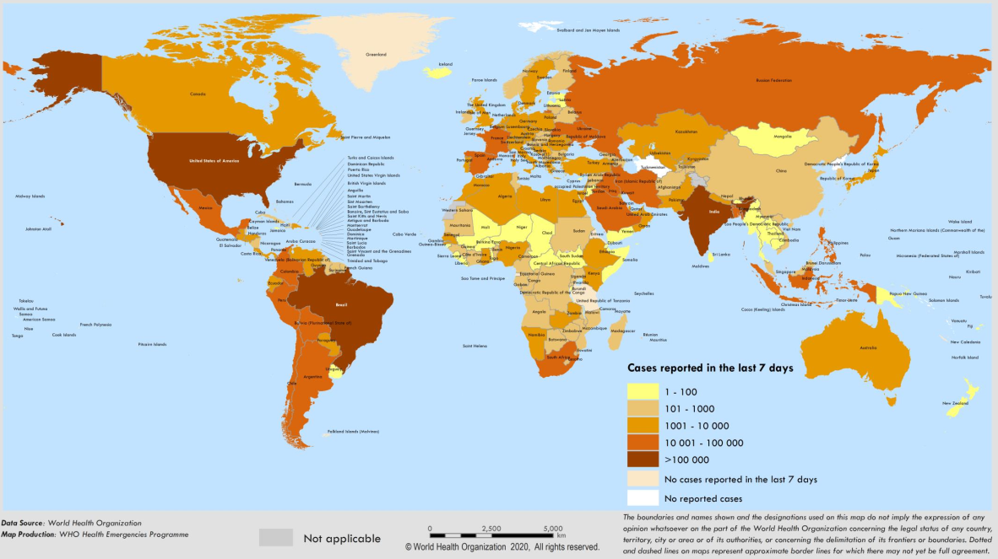
Figure 1 Geographical distribution of coronavirus disease 2019 outbreaks. Source: https://www.who.int/publications/m/item/weekly-epidemiological-update-8-december-2020 (data as reported at 4:58 pm CET on December 8, 2020).
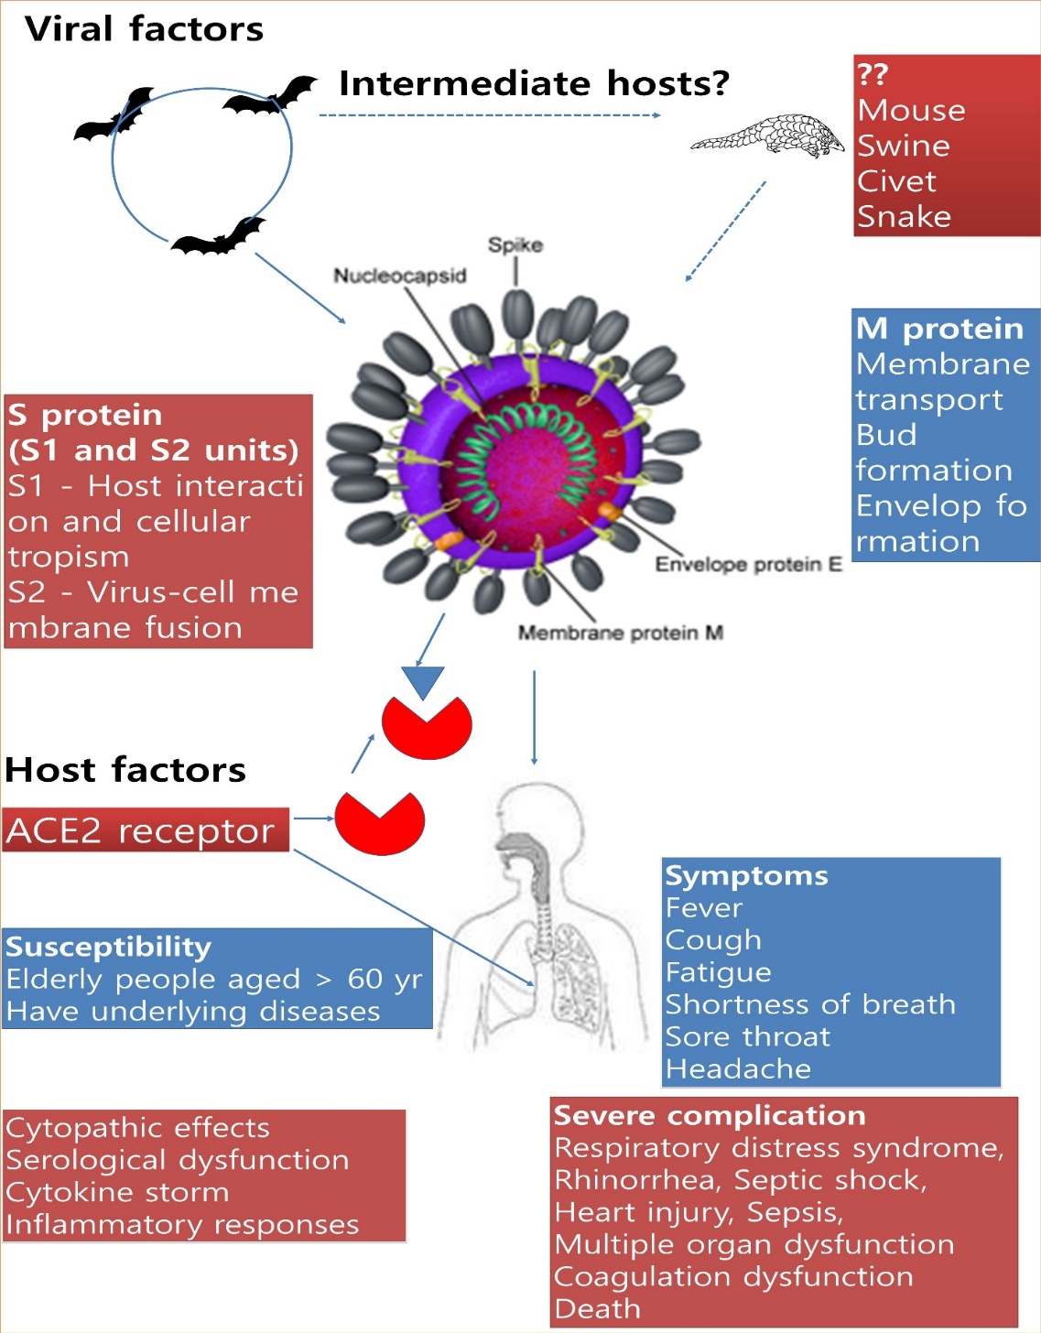
Figure 2 Pathogenesis of severe acute respiratory syndrome coronavirus 2 (viral and host factors). ACE2: angiotensin-converting enzyme 2.
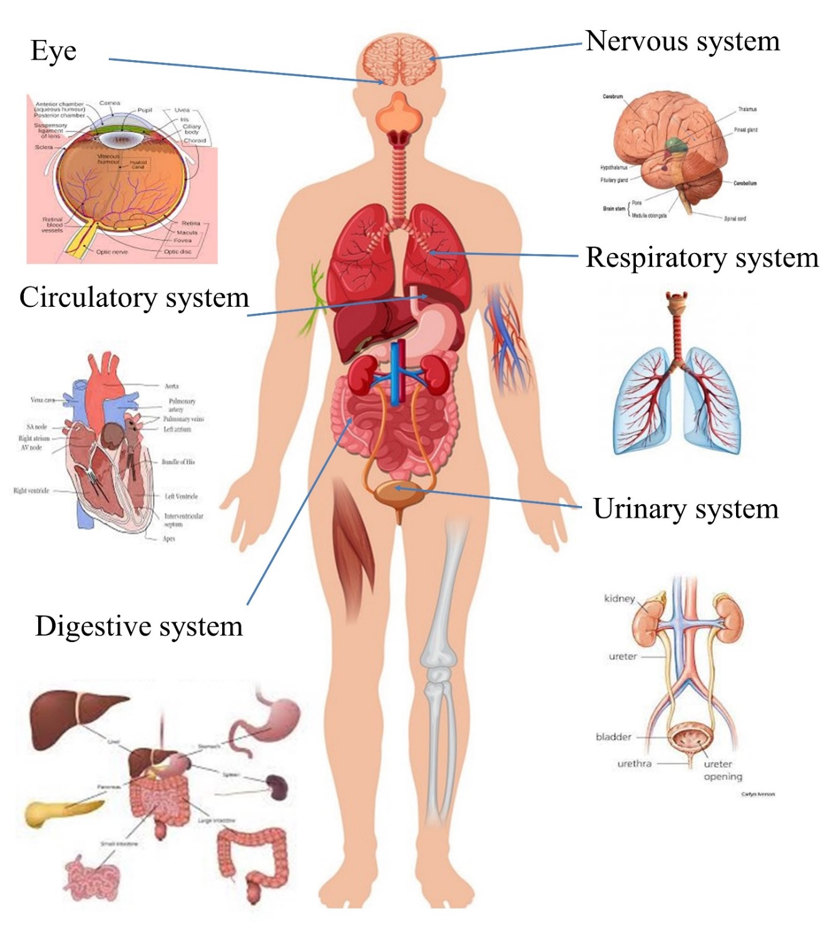
Figure 3 coronavirus disease 2019 in organs or systems (Images were taken www.google.com).
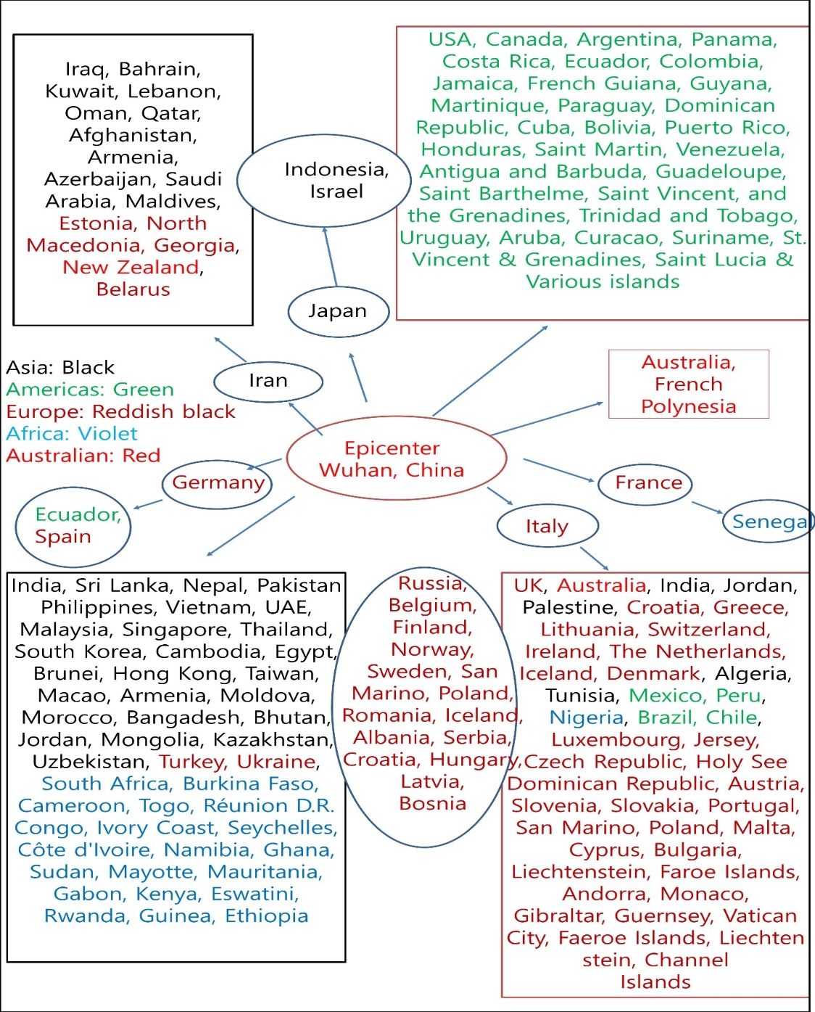
Figure 4 coronavirus disease 2019 routes of transmission across countries. Figure modified after Ali and Alharbi (2020)^{[68]}, an Elsevier journal.
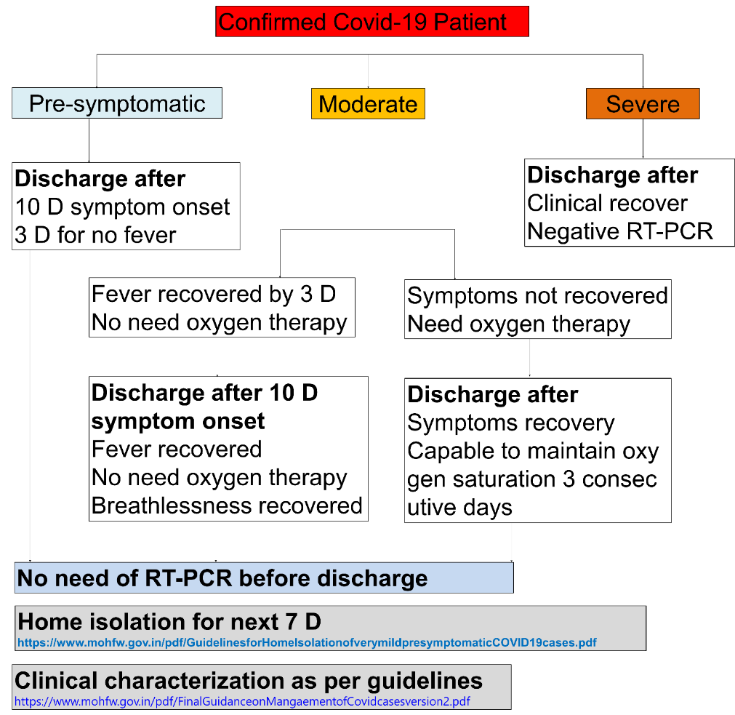
Figure 5 Discharge policies adopted by the Indian government. COVID-19: coronavirus disease 2019.
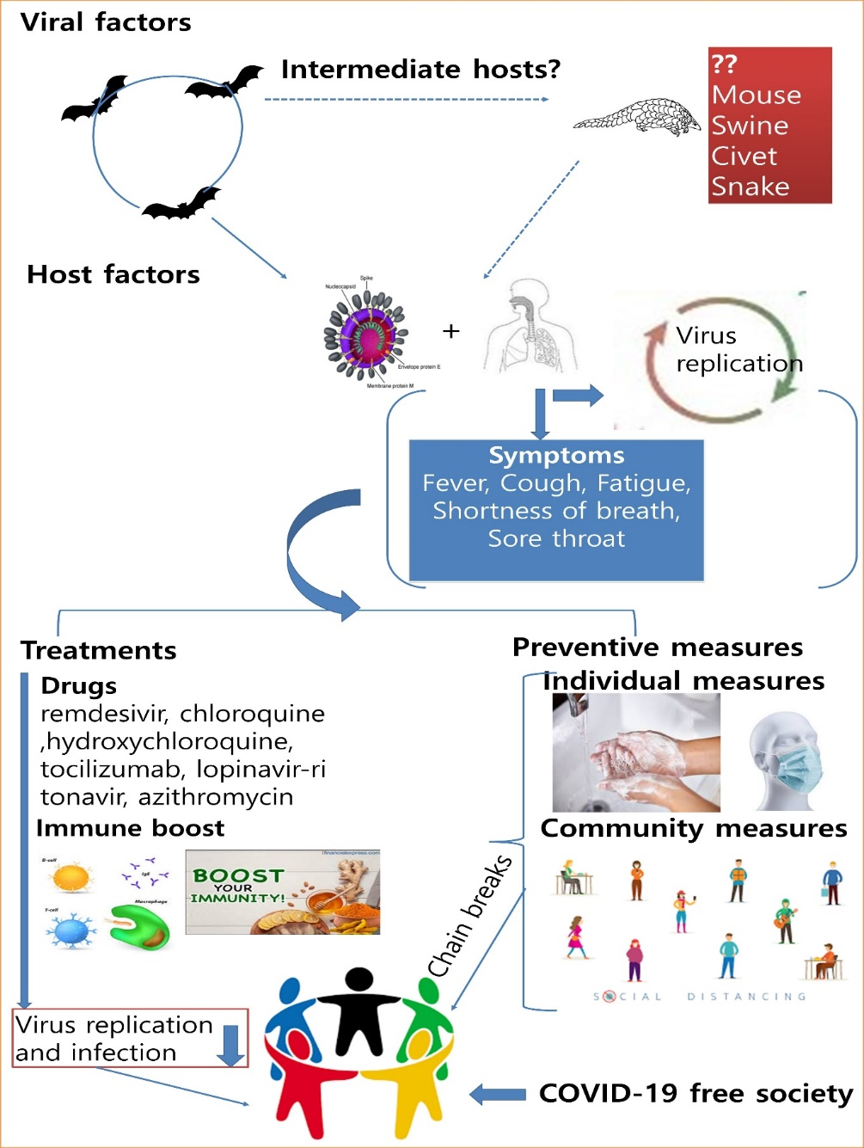
Figure 6 Schematic presentation of the management of coronavirus disease 2019 outbreaks. COVID-19: coronavirus disease 2019.

Table 1 Details of coronavirus (genus, species and receptor)
Genus | Species | Targets | Receptor
α-CoV | Alphacoronavirus 1:  Feline coronavirus serotype 2  Canine coronavirus serotype 2  Transmissible gastroenteritis virus  Human coronavirus 229E  Human coronavirus NL63 | Mammals | Aminopeptidase N  Aminopeptidase N  Aminopeptidase N  Aminopeptidase N  ACE2
 | Porcine epidemic diarrhea coronavirus  Rhinolophus bat coronavirus HKU2  Scotophilus bat coronavirus 512/05  Miniopterus bat coronavirus 1  Miniopterus bat coronavirus HKU8 |  | Aminopeptidase N
β-CoV | Betacoronavirus 1:  Bovine coronavirus  Human coronavirus OC43  Equine coronavirus  Human enteric coronavirus  Porcine haemagglutinating encephalomyelitis virus  Canine respiratory coronavirus  Murine coronavirus:  Mouse hepatitis virus  Rat coronavirus  Puffinosis virus  Hedgehog coronavirus 1,  Human coronavirus HKU1,  Middle East respiratory syndrome-related coronavirus,  Pipistrellus bat coronavirus HKU5,  Rousettus bat coronavirus HKU9,  Severe acute respiratory syndrome-related coronavirus  SARS-CoV  SARS-CoV-2  Rhinolophus bat viruses  Tylonycteris bat coronavirus HKU4 | Mammals | Neu 5,9 Ac2  Neu 5,9 Ac2  CEACAM1  ACE2
γ-CoV | Avian coronavirus:  IBV (turkey, pheasant, duck, goose and pigeon)  Beluga Whale coronavirus SW1 | Birds
δ-CoV | Bulbul coronavirus HKU11  Thrush coronavirus HKU12  Munia coronavirus HKU13  Porcine coronavirus HKU15 | Birds
ACE2: angiotensin-converting enzyme 2; SARS-CoV-2: severe acute respiratory syndrome coronavirus 2.

Table 2 Coronavirus disease 2019 outbreaks based on the World Health Organization (data as reported at 7.07 PM CEST on August 10, 2021)
Items | Confirmed cases | Deaths
Globally | 202608306 | 4293591
Africa | 5156790 | 122537
Americas | 78718104 | 2032256
Eastern Mediterranean | 13169171 | 243217
Europe | 61333662 | 1231439
South-East Asia | 39271048 | 593565
Western Pacific | 4958767 | 70564

Table 3 coronavirus disease 2019 state-wise status in India (as on August 10, 2021; Ministry of Home Affairs, GoI)
No. | Name of State / UT | Total confirmed cases* | Cured/discharged/migrated | Deaths**
1 | Andaman and Nicobar Islands | 7546 | 7412 | 129
2 | Andhra Pradesh | 1983721 | 1950623 | 13549
3 | Arunachal Pradesh | 50372 | 47520 | 246
4 | Assam | 575220 | 558720 | 5404
5 | Bihar | 725235 | 715303 | 9646
6 | Chandigarh | 61984 | 61,146 | 811
7 | Chhattisgarh | 1003244 | 988004 | 13540
8 | Dadar Nagar Haveli | 10656 | 10612 | 4
9 | Delhi | 1436800 | 1411235 | 25067
10 | Goa | 171944 | 167884 | 3164
11 | Gujarat | 825064 | 814778 | 10077
12 | Haryana | 770091 | 759769 | 9650
13 | Himachal Pradesh | 208197 | 202569 | 3,519
14 | Jammu and Kashmir | 322658 | 316957 | 4390
15 | Jharkhand | 347406 | 342074 | 5,130
16 | Karnataka | 2919711 | 28,59,552 | 36,817
17 | Kerala | 3565574 | 3377691 | 17852
18 | Ladakh | 20393 | 20117 | 207
19 | Madhya Pradesh | 791970 | 781307 | 10514
20 | Maharashtra | 6357833 | 61,51,956 | 134,064
21 | Manipur | 104791 | 96128 | 1657
22 | Meghalaya | 69358 | 63450 | 1174
23 | Mizoram | 44520 | 32854 | 168
24 | Odisha | 987956 | 971391 | 6554
25 | Puducherry | 121665 | 119031 | 1800
26 | Punjab | 599514 | 582753 | 16320
27 | Rajasthan | 953840 | 944670 | 8954
28 | Tamil Nadu | 2577237 | 2522470 | 34340
29 | Telengana | 649859 | 637789 | 3828
30 | Tripura | 80208 | 77230 | 767
31 | Uttarakhand | 342423 | 328569 | 7368
32 | Uttar Pradesh | 1708793 | 1685449 | 22774
33 | West Bengal | 1534360 | 1505808 | 18240
34 | Nagaland | 28709 | 25906 | 585
35 | Sikkim | 27908 | 24544 | 355
36 | Lakshadweep | 10257 | 10112 | 51

Table 4 Recommended drugs for coronavirus disease 2019 treatments (Food and Drug Administration and World Health Organization)
Common drugs | Dose | Mechanism
Chloroquine  Antimalarial | 50% for GFR < 10 mL/min | In vitro activity and has immunomodulating properties.
 |  | Inhibits viral enzymes or processes such as viral DNA and RNA polymerase, viral protein glycosylation, virus assembly, new virus particle transport, and virus release.
 |  | ACE2 inhibition due to acidification at cell membrane surface, inhibits fusion of virus, and cytokine release.
Hydroxychloroquine  Antimalarial | 800 mg orally on day one, followed by 400 mg/d orally for four to seven days | Same as chloroquine
Chloroquine phosphate  Antimalarial | 1 g orally on day one, followed by 500 mg/d orally for four to seven days | Same as chloroquine
Remdesivir  Nucleoside Analogue | 200 mg IV on day 1 followed by 100 mg IV daily on days two to five or 200 mg IV on day 1 followed by 100 mg IV daily on days two to ten | In vitro activity; Inhibitor of RNA-dependent RNA polymerases (RdRps).
 |  | Remdesivir-TP competes with adenosine-triphosphate for incorporation into nascent viral RNA chains.
 |  | Once incorporated into the viral RNA at position i, RDV-TP terminates RNA synthesis at position i+3.
 |  | Because RDV-TP does not cause immediate chain termination (i.e., 3 additional nucleotides are incorporated after RDV-TP), the drug appears to evade proofreading by viral exoribonuclease (an enzyme thought to excise nucleotide analogue inhibitors).
Azithromycin  Macrolide Antibacterial | 500 mg on day one, followed by 250 mg daily for four days | Prevents bacterial superinfection, has immunomodulatory action on pulmonary inflammatory disorders.
 |  | Downregulates inflammatory responses and reduces excessive cytokine production associated with respiratory viral infections; however, its direct effects on viral clearance are uncertain.
 |  | Immunomodulatory mechanisms include reducing chemotaxis of neutrophils (PMNs) to lungs by inhibiting cytokines (i.e., IL-8), inhibition of mucus hypersecretion, decreased production of ROS, accelerating neutrophil apoptosis, blocking activation of nuclear transcription factors.
Lopinavir; Ritonavir  HIV protease inhibitor | 400 mg/ritonavir 100 mg orally twice daily for up to 21 d | In vitro animal model studies show potential activity for other coronaviruses (SARS-CoV and MERS-CoV).
 |  | Lopinavir and ritonavir may bind to Mpro, a key enzyme for virus replication and suppress virus activity.
Tocilizumab  Interleukin-6 (IL-6) Receptor-Inhibiting  Monoclonal Antibody | 4-8 mg/kg infused over more than 60 min (additional dose after 12 h) | Cytokine release syndrome; Inhibits IL-6-mediated signaling by competitively binding to both soluble and membrane-bound IL-6 receptors. IL-6 involved in T-cell activation, immunoglobulin secretion induction, hepatic acute-phase protein synthesis initiation, and hematopoietic precursor cell proliferation and differentiation stimulation.
Baloxavir  Antiviral | 80 mg orally on day 1 and on day 4, and another dose of 80 mg on day 7 (as needed); not to exceed 3 total doses. | Active against influenza viruses; In vitro antiviral activity against SARS-CoV-2 demonstrated in one trial
Favipiravir  Antiviral | 1600 mg twice daily on day 1, then 600 mg twice daily for 7-10 d  Severe: 1600 mg every 12 h on day 1, then 600 mg every 12 h days 2-10 | In vitro activity against Vero E6 cells
SARS-CoV-2: severe acute respiratory syndrome coronavirus 2.
Table 5 Unani drugs for coronavirus disease 2019 treatment (Source: department of AYUSH, Government of India)
Unani drugs | Doses
Symptomatic treatments
SharbatUnnab | 10-20 mL twice a day
TiryaqArba | 3-5 g twice a day
TiryaqNazla | 5 g twice a day
KhamiraMarwareed | 3-5 g once a day
ArqAjeeb | 4-8 drops in fresh water and four times a day
Habb e IkseerBukhar (fever) | 2 pills with lukewarm water twice daily
SharbatNazla | 10 mL mixed in 100 mL of lukewarm water twice daily
Qurs e Suaal | 2 tablets to be chewed twice daily
Decoction
Behidana | 3 g
Unnab | 7 nos
Sapistan | 7 nos
Darchini | 3 g
Banafsha | 5 g
Berg-e-Gaozabaan | 7 g
Sore throat
Khashkhash; Bazrulbanj; Post Khashkhash; Barg e Moard (Habbulaas); Tukhm e kahuMukashar; GuleSurkh | Any of them @12 g (each)

