Name of Journal: World Journal of Clinical Cases
Manuscript NO: 67735
Manuscript Type: CASE REPORT

Acute lower extremity arterial thrombosis after intraocular foreign body removal under general anesthesia: A case report and review of literature

Jeon S et al. Arterial thrombosis during ophthalmic surgery

Soeun Jeon, Jeong-Min Hong, Hyeon Jeong Lee, Eunsoo Kim, Hyunju Lee, Yesul Kim, Hyun-Su Ri, Jae Jung Lee

Soeun Jeon, Jeong-Min Hong, Hyeon Jeong Lee, Eunsoo Kim, Hyunju Lee, Yesul Kim, Department of Anesthesia and Pain Medicine, Pusan National University, School of Medicine, Busan 49241, South Korea

Soeun Jeon, Jeong-Min Hong, Hyeon Jeong Lee, Eunsoo Kim, Jae Jung Lee, Biomedical Research Institute, Pusan National University Hospital, Busan 49241, South Korea

Hyun-Su Ri, Department of Anesthesia and Pain Medicine, Kyungpook National University, School of Medicine, Daegu 41944, South Korea

Jae Jung Lee, Department of Ophthalmology, College of Medicine, Pusan National University, School of Medicine, Yangsan 50612, South Korea

Author contributions: Jeon S and Hong JM designed the study; Jeon S, Hong JM and Ri HS drafted the manuscript; Lee H, Kim Y and Lee JJ collected data and pictures; Jeon S, Hong JM, Lee HJ, Kim E and Ri HS reviewed the literature and edited the manuscript; all authors agreed to be accountable for all aspects of the work; all authors issued final approval for the version to be submitted.

Corresponding author: Jeong-Min Hong, MD, PhD, Assistant Professor, Doctor, Department of Anesthesia and Pain Medicine, Pusan National University, School of Medicine, 179 Gudeok-ro, Seo-gu, Busan 49241, South Korea. ccarrot@pusan.ac.kr

Received: May 4, 2021
Revised: July 8, 2021
Accepted: August 11, 2021
Published online: September 26, 2021

Abstract
BACKGROUND
Surgery, which is a major risk factor for venous thrombosis, has rarely been considered a risk factor for arterial thrombosis. Recent studies have suggested that venous and arterial thromboses share common risk factors and have a bidirectional relationship. Accordingly, there is a growing interest in the risk of arterial thrombosis after surgery. We report a case of acute bilateral lower extremity arterial thromboses that developed after a prolonged surgery.

CASE SUMMARY
A 59-year-old man was hospitalized for intraocular foreign body removal surgery. He was a heavy-drinking smoker and had untreated hypertension and varicose veins in both legs. The operation was unexpectedly prolonged, lasting 4 h and 45 min. Immediately after emergence from general anesthesia, the patient complained of extreme pain in both legs. After the surgical drape was removed, cyanosis was evident in both feet of the patient. The pulse was not palpable, and continuous-wave Doppler signals were inaudible in the bilateral dorsalis pedis and posterior tibial arteries. Computed tomography angiography confirmed acute bilateral thrombotic occlusion of the popliteal arteries, proximal anterior tibial arteries, and tibioperoneal trunks. Arterial pulse returned in both lower limbs after 6 h of heparin initiation. The patient was discharged on postoperative day 26 without any sequelae.

CONCLUSION
Acute lower extremity arterial thrombosis can occur after surgery. Anesthesiologists should pay particular attention to patients with risk factors for thrombosis.

Key Words: Thromboembolism; Thrombosis; Arterial thrombosis; Arterial occlusive diseases; Peripheral occlusive artery disease; Case report

©The Author(s) 2021. Published by Baishideng Publishing Group Inc. All rights reserved.

Citation: Jeon S, Hong JM, Lee HJ, Kim E, Lee H, Kim Y, Ri HS, Lee JJ. Acute lower extremity arterial thrombosis after intraocular foreign body removal under general anesthesia: A case report and review of literature. World J Clin Cases 2021; 9(27): 8232-8241
URL: https://www.wjgnet.com/2307-8960/full/v9/i27/8232.htm
DOI: https://dx.doi.org/10.12998/wjcc.v9.i27.8232

Core Tip: The conventional literature emphasizes that surgery is a major risk factor for venous thrombosis rather than arterial thrombosis. However, recent studies have suggested that these two types of thromboses are closely related and share common risk factors. Accordingly, there has been a growing interest in the increased postoperative risk of arterial thrombosis. We report the case of a patient with multiple risk factors, who developed acute bilateral arterial thromboses of the lower limbs after an unexpectedly prolonged surgery. Although postoperative arterial thrombosis of the lower extremity is rare, anesthesiologists should pay particular attention to patients with risk factors for thrombosis.
INTRODUCTION
Thrombosis refers to the formation of a blood clot, which partially or fully blocks the blood flow, in a blood vessel^{[1]}. The complications of thrombosis vary depending on the type and anatomical location of the blood vessel in which the clot is located. While venous thrombosis causes congestion in the upstream area, arterial thrombosis causes ischemia in the downstream area^{[2,3]}. Traditionally, arterial thrombosis and venous thrombosis have been considered as distinct diseases, with different risk factors, underlying mechanisms, and treatments^{[4,5]}. The well-established risk factors for venous thrombosis include trauma, surgery, and cancer, while the factors leading to arterial thrombosis include smoking, hypertension, and dyslipidemia^{[4]}.
Due to immobility and systemic hypercoagulability, surgery is a risk factor for venous thrombosis^{[4]}. To reduce this preventable complication during surgery, patients scheduled for high-risk surgical procedures, such as major orthopedic, general, gynecological, urological, vascular, and neurological surgeries, are recommended to undergo thromboprophylaxis after a risk and benefit assessment^{[6,7]}. In contrast, until recently, surgery has rarely been considered a risk factor for arterial thrombosis^{[4]}. Recent studies have suggested that venous and arterial thromboses share many common risk factors and have a bidirectional relationship^{[4,5]}. Therefore, there is a growing interest in the risk of arterial thrombosis after surgery. Herein, we report a case of acute bilateral lower extremity arterial thromboses that developed after intraocular foreign body removal under general anesthesia. A relevant literature review was also conducted.

CASE PRESENTATION
Chief complaints
A 59-year-old male patient (163 cm, 70 kg) complained of severe pain in both legs immediately after intraocular foreign body removal under general anesthesia.

History of present illness
After an accident at a construction site, in which a 3 mm iron particle entered the patient’s left eye, the patient was hospitalized for foreign body removal surgery. Physical examination immediately after admission revealed no abnormal findings, except for the left eye injury. The patient did not complain of any discomfort in either leg. Preoperative electrocardiogram (ECG), chest radiography, and laboratory findings were unremarkable (Table 1). In the operating room, standard monitoring (ECG, pulse oximetry, noninvasive blood pressure, end-tidal CO₂ (EtCO₂), and esophageal stethoscope temperature measurement) was performed; the patient’s initial (pre-induction) heart rate (HR), oxygen saturation (SpO₂), systolic blood pressure (SBP), diastolic blood pressure (DBP), EtCO₂, and respiratory rate (RR) were 60 beats/min, 100%, 179 mmHg, 78 mmHg, 30 mmHg, and 20 breaths/min, respectively. The vital signs and drugs used during the surgery are shown in Figure 1. The surgery lasted 4 h and 45 min and included phacoemulsification, vitrectomy, intraocular foreign body removal, endolaser photocoagulation, and fluid-air exchange. During surgery, the patient was in a supine position without restraints, and graduated compression stockings or intermittent pneumatic compression devices were not used. Immediately after emergence from general anesthesia, the patient complained of extreme pain in both legs.

History of past illness
Although the patient was diagnosed with hypertension > 10 years earlier (baseline SBP/DBP, 160-180/100-78 mmHg), he had voluntarily not taken antihypertensive medication for years. He also had varicose veins in both legs.

Personal and family history
The patient was a heavy-drinking smoker^{[8]}; he would drink more than 50 g of alcohol and smoke 18 cigarettes per day. The patient had no family history of hypercoagulable disorders.

Physical examination
After the surgical drape was removed, cyanosis was evident in both feet of the patient. The pulse was not palpable in the bilateral dorsalis pedis and posterior tibial arteries. For further evaluation and treatment, the patient was referred for a consultation to the vascular surgery department of our hospital. A hand-held continuous-wave Doppler examination revealed that Doppler signals of the bilateral dorsalis pedis and posterior tibial arteries were absent (i.e., inaudible).

Laboratory examinations
Immediately after the surgery, a series of laboratory tests were performed. Routine postoperative laboratory test findings are presented in Table 1. Except for a decrease in protein S activity [22% (reference range^{[9]}, 65-160)] and an increase in fibrinogen degradation products [146.3 µg/mL (0.0-5.0)] and the D-dimer level [35.2 µg/mL (0.0-0.5)], the results of the hypercoagulability work-up were not specific [protein C activity, 102.6% (73.0-142.0); fibrinogen, 277.2% (170.0-380.0); and antithrombin III activity, 91.7% (80.0-120.0)]; factor V Leiden, lupus anticoagulant, anti-cardiolipin immunoglobulin (Ig) M, anti-cardiolipin IgG, anti-cardiolipin IgA, anti-phospholipid IgG, and prothrombin G20210A mutation findings were all negative. Blood cultures were also negative. Lipid profile was as follows: Low-density lipoprotein cholesterol level, 108 mg/dL (< 160); high-density lipoprotein cholesterol level, 69.0 mg/dL (35.0-72.0); and triglyceride level, 64 mg/dL (58-250 mg/dL). Cardiac markers were as follows: myoglobin level, 1192.8 ng/mL (15.2-91.2); creatine kinase (CK) level, 7081 U/L (5-217); CK-myocardial band level, 89.06 ng/mL (0.5-5.0); troponin I level, 0.02 ng/mL (0-0.05); and brain natriuretic peptide level, 28 pg/mL (0-100). Urinalysis results were as follows: color, yellow; clarity, clear; pH, 7.0 (5.0-6.5); urine occult blood, trace; urine RBC, 11-15/high power field (HPF; 0-2); urine WBC, 0-2 (0-2); urine glucose, negative. HbA1c and blood glucose levels were 5.9% and 99 mg/dL, respectively.

Imaging examinations
On computed tomography (CT) angiography, filling defects in the bilateral popliteal arteries, bilateral proximal anterior tibial artery, and bilateral tibioperoneal trunk were visible, which confirmed the Doppler findings (Figure 2). Concomitant venous thrombosis was not observed.

Further diagnostic work-up
Transesophageal echocardiography revealed no structural or functional abnormalities, and there was no evidence of a cardiac embolic source. Postoperative ECG showed a normal sinus rhythm.

FINAL DIAGNOSIS
The patient was diagnosed with acute thrombotic occlusion of the bilateral popliteal arteries, proximal anterior tibial arteries, and tibioperoneal trunk.

TREATMENT
After surgery, the patient was administered oxygen at the rate of 5 L/min using a nasal cannula, and the patient’s vital signs were stable, except for tachycardia caused by pain (HR, 119-125 beats/min; SpO₂, 97%-100%; SBP, 110-120 mmHg; DBP, 55-80 mmHg; and RR, 15-20 breaths/min). For pain control, intravenous fentanyl 100 mcg and pethidine 25 mcg were administered immediately and 30 min after surgery, respectively. Immediately after the diagnosis was confirmed, intravenous unfractionated heparin (UFH) was administered for anticoagulation, with a bolus loading dose of 5000 units, followed by a maintenance dose of 800 units/h. After 2 h, heparin infusion was stopped, and surgical thrombectomy was planned. However, upon arrival in the operating room, that is 4 h after heparin cessation, the arterial pulse had returned in both lower limbs. Therefore, the surgery was canceled, and heparin therapy was reinitiated. Lipo-prostaglandin E1, a potent vasodilator and platelet aggregation inhibitor, was administered as an adjuvant treatment^{[10]}. After 10 h of heparin reinitiation, the patient had hematochezia with a total volume of approximately 500 mL. Heparin infusion was immediately stopped, and the patient was closely monitored. The patient’s vital signs remained stable (HR: 74-92 beats/min; SpO₂: 97%-99%; SBP: 120-140 mmHg; DBP: 80-82 mmHg; and RR: 20-21 breaths/min). Due to the repeated heparin infusion and discontinuation, activated partial thromboplastin time (aPTT) monitoring was not performed. Emergency sigmoidoscopy and esophagogastroduodenoscopy revealed no ischemic lesions or obvious sources of bleeding. Eight hours after the discontinuation of heparin, the aPTT level normalized, and hematochezia disappeared. The results of the laboratory tests after hematochezia are summarized in Table 1. No definite bleeding focus was noted on follow-up abdominal CT, gastroduodenoscopy, and sigmoidoscopy performed on postoperative days (PODs) 3, 5, and 7, respectively.
Although myoglobinuria was absent, the patient’s history, symptoms, and markedly elevated myoglobin and CK levels strongly suggested rhabdomyolysis. Hydration was performed for kidney protection, and serial ECG monitoring and laboratory tests were performed. No specific ECG abnormalities were found immediately after surgery and on PODs 1-3. The serial laboratory results are summarized in Table 1. Myoglobin and CK levels normalized at POD 3 and 11 (37.3 ng/mL and 159 U/L), respectively, and the patient recovered completely from rhabdomyolysis without any sequelae.

OUTCOME AND FOLLOW-UP
Immediately after surgery, the patient complained of motor weakness in both lower extremities, and the muscle strength parameters according to the expanded Medical Research Council of Great Britain grading scale^{[11]} were as follows, right/Left: hip flexion (2/5-), hip extension (2/5-), hip abduction (2/5-), hip adduction (2/5-), knee flexion (2/5-), knee extension (2/5-), ankle dorsiflexion (3/5-), ankle plantar flexion (3/5-), great toe extension (3/5-), and great toe flexion (3/5-). To evaluate the cause of motor weakness, the ankle brachial index (ABI) was measured; the right and left ABIs were within the normal range (1.26 and 1.21, respectively). Electromyogram and nerve conduction examinations showed non-specific findings. On POD 12, lipo-prostaglandin E1 was discontinued, and beraprost (0.12 mg/d), aspirin (100 mg/d), and physical therapy were initiated. The motor function of both lower extremities gradually improved and returned to normal, and the patient was discharged on POD 26 without any sequelae. The timeline of this case is shown in Figure 3. This study was approved by the Institutional Review Board of Pusan National University Hospital, Republic of Korea (ID 2104-014-101).

DISCUSSION
The conventional literature emphasizes the difference between arterial and venous thromboses^{[4]}. The pathophysiology of venous thrombosis has been described as Virchow’s triad, that is, stasis, hypercoagulability, and alterations in the endothelium^{[1,3,4]}. In contrast, the pathophysiology of acute arterial thrombosis includes rupture of an atherosclerotic plaque associated with high shear rates and disruption of the endothelium^{[1,3,4]}. Moreover, it is still recommended to treat arterial thrombosis with drugs that target platelets and venous thrombosis with drugs that target proteins of the coagulation cascade^{[1,4]}.
However, recent epidemiological studies have suggested that venous thrombosis and arterial thrombosis are closely related^{[4,5]}. The most probable biological explanation for the link between these two types of thrombosis is that they share common cardiovascular risk factors, such as advanced age, immobility, obesity, smoking, hypertension, cancer, hormone replacement therapy, infection, major trauma, thrombophilia, and surgery^{[4,12,13]}.
In the present case, the patient had multiple risk factors (advanced age, smoking, hypertension, varicose veins, and protein S deficiency) and developed acute arterial thromboses in the lower limbs during an unexpectedly prolonged operation.
The aging process involves degeneration of vessel walls, activation of the coagulation system, and a decrease in physical activity^{[3,4]}, which exponentially increase the incidence of venous and arterial thromboses^{[4,14]}. Specifically, compared with young adults, patients aged > 40 and > 50 years are at a significantly higher risk of venous and arterial thrombosis, respectively^{[15,16]}.
Cigarette smoking generates a prothrombotic environment by increasing the arterial intima-media thickness, promoting endothelial dysfunction, and increasing platelet activation and prothrombic biomarkers^{[17,18]}. Smoking is a particularly strong risk factor for arterial thrombosis^{[17,18]}. However, evidence on the effect of smoking on venous thrombosis remains controversial^{[13]}. According to a recent large-scale, population-based survey, smoking is a potential risk factor for venous thrombosis if additional risk factors are present^{[19]}.
In patients with hypertension, despite the continuous exposure of the vessel wall to high pressure, complications of hypertension are paradoxically more strongly associated with thrombosis than with hemorrhage^{[20,21]}. In this context, hypertension has been considered the classical leading cause of arterial diseases of the heart, brain, and leg^{[4,22,23]}. In addition, a recent meta-analysis reported that patients with hypertension are at a high risk of venous thromboembolism [odds ratio, 1.51; 95% confidence interval (CI): 1.23-1.85]^{[13]}.
For venous thrombosis, varicose vein and protein S deficiency are well-documented risk factors; however, with regard to arterial thrombosis, the effects of varicose veins and protein S deficiency remain unclear^{[24,25]}. In a retrospective cohort study using national health insurance data, Chang et al^{[24]} found that varicose veins were significantly associated with peripheral arterial disease (adjusted hazard ratio, 1.76; 95%CI: 1.72-1.79). However, this study did not fully consider the possible confounding factors due to the inherent limitation of claims data, which necessitates further evaluation of associations between varicose veins and arterial thrombosis^{[24]}.
Protein S, a cofactor of protein C, inactivates coagulation factors Va and VIIIa and inhibits thrombin generation^{[25]}. In a retrospective family cohort study, Mahmoodi et al^{[26]} reported that protein S deficiency increases arterial thromboembolic risk in patients below 55 years of age (adjusted hazard ratio, 4.6; 95%CI: 1.1-18.3). Furthermore, Cho et al^{[27]} suggested that protein S deficiency could be an independent risk factor for peripheral arterial occlusion. The authors also reported that patients with arterial occlusion with protein S deficiency demonstrated characteristic angiographic findings, such as long segment thrombotic occlusion of a main peripheral artery without atherosclerosis. Moreover, in the present case, protein S deficiency could be considered a possible trigger for arterial thrombosis. Therefore, further well-designed research is needed to investigate the effect of protein S deficiency on the development of arterial thrombosis.
Surgery is an independent risk factor for venous thrombosis^{[28]}. Surgery itself induces blood stasis, release of tissue factors, and a generalized hypercoagulable environment^{[3,29]}. With prolonged surgical time, patients are more likely to be exposed to a prothrombic state. In a large retrospective cohort study, Kim et al^{[28]} demonstrated that in all types of surgery, surgical duration is directly correlated with an increased likelihood of the development of venous thromboembolism. Specifically, in Kim et al^{[28]}’s study, the longest operation duration demonstrated a 1.27-fold increase in the odds of developing venous thromboembolism (95%CI: 1.21-1.34) as compared with the average operation duration; similarly, the shortest operation showed an odds ratio of 0.86 (95%CI: 0.83-0.88). Surgical procedures could also lead to arterial thrombosis-related complications, such as stroke and myocardial infarction^{[3,30,31]}, and there has been a growing interest in the increased risk of postoperative arterial thrombotic disease^{[4]}.
Prevention is the most effective strategy for limiting the adverse consequences of thromboembolism in surgical patients^{[29,32]}. Thromboprophylaxis includes mechanical methods, such as the use of graded compression stockings, intermittent pneumatic compression devices, and pharmacologic methods using UFH and low-molecular-weight heparin^{[29,32]}. These thromboprophylaxis strategies were designed for venous thromboembolism; however, recent studies have demonstrated that some of these strategies, including the use of intermittent pneumatic compression devices, UFH, and low-molecular-weight heparin, are also effective against arterial thrombotic diseases^{[33,34]}.
As ophthalmic surgery is considered as a low-risk procedure, routine thromboprophylaxis is often overlooked, and relevant guidelines for thromboprophylaxis during ophthalmic surgery are scarce^{[35,36]}. In a previous survey-based study of anesthesiologists involved in the management of ophthalmic surgeries, 45% of respondents reported experiencing thromboembolism after ophthalmic surgery; however, only 40% stated that there were routine assessments for indications and contraindications of thromboprophylaxis in preanesthetic clinics^{[36]}. In this case too, the preoperative thromboembolism risk assessment was overlooked. Moreover, while it was planned for < 2 h, the surgery was unexpectedly prolonged. As prevention is the best policy, this case highlights the importance of preoperative thromboembolic risk assessment, intraoperative communication between the surgeon and anesthesiologist (particularly in the context of unexpectedly prolonged surgery), and the need for consensus guidelines for the prevention of thromboembolism during ophthalmic surgery.

CONCLUSION
In summary, acute bilateral lower extremity arterial thromboses can occur unexpectedly after surgery. Our results suggest that anesthesiologists should pay particular attention to patients with multiple risk factors for thrombosis, especially those undergoing lengthy or high-risk surgical procedures. Although acute arterial thrombosis of the lower limb following surgery is rare, in cases with suggestive manifestations, additional evaluation for accurate diagnosis should be performed as soon as possible to prevent complications and improve outcomes.

REFERENCES
1 Mackman N. Triggers, targets and treatments for thrombosis. Nature 2008; 451: 914-918 [PMID: 18288180 DOI: 10.1038/nature06797]
2 Tsai FY, Kostanian V, Rivera M, Lee KW, Chen CC, Nguyen TH. Cerebral venous congestion as indication for thrombolytic treatment. Cardiovasc Intervent Radiol 2007; 30: 675-687 [PMID: 17573553 DOI: 10.1007/s00270-007-9046-1]
3 Previtali E, Bucciarelli P, Passamonti SM, Martinelli I. Risk factors for venous and arterial thrombosis. Blood Transfus 2011; 9: 120-138 [PMID: 21084000 DOI: 10.2450/2010.0066-10]
4 Lowe GD. Common risk factors for both arterial and venous thrombosis. Br J Haematol 2008; 140: 488-495 [PMID: 18275426 DOI: 10.1111/j.1365-2141.2007.06973.x]
5 Jerjes-Sanchez C. Venous and arterial thrombosis: a continuous spectrum of the same disease? Eur Heart J 2005; 26: 3-4 [PMID: 15615791 DOI: 10.1093/eurheartj/ehi041]
6 Autar R. NICE guidelines on reducing the risk of venous thromboembolism (deep vein thrombosis and pulmonary embolism) in patients undergoing surgery. J Orthop Nurs 2007; 11: 169-176 [DOI: 10.1016/j.joon.2007.07.003]
7 Agnelli G. Prevention of venous thromboembolism in surgical patients. Circulation 2004; 110: IV4-I12 [PMID: 15598646 DOI: 10.1161/01.CIR.0000150639.98514.6c]
8 Mirbaba M. Heavy-Drinking Smokers: Pathophysiology and Pharmacologic Treatment Options. Am J Psychiatry Resid J 2016; 11: 8-11 [DOI: 10.1176/appi.ajp-rj.2016.110603]
9 Myo Clinic Laboratories. Protein S Activity, Plasma. [cited 25 April 2021]. In: Myo Clinic Laboratories. [Internet]. Available from: https://hematology.testcatalog.org/show/S_FX
10 Li J, Wang B, Wang Y, Wu F, Li P, Li Y, Zhao L, Cui W, Ding Y, An Q, Si J. Therapeutic effect of liposomal prostaglandin E₁ in acute lower limb ischemia as an adjuvant to hybrid procedures. Exp Ther Med 2013; 5: 1760-1764 [PMID: 23837069 DOI: 10.3892/etm.2013.1061]
11 Barohn RJ, Dimachkie MM, Jackson CE. A pattern recognition approach to patients with a suspected myopathy. Neurol Clin 2014; 32: 569-593, vii [PMID: 25037080 DOI: 10.1016/j.ncl.2014.04.008]
12 Violi F, Loffredo L. Association between venous and arterial thrombosis. Lancet 2008; 371: 809; author reply 809-809; author reply 810 [PMID: 18328920 DOI: 10.1016/S0140-6736(08)60370-0]
13 Ageno W, Becattini C, Brighton T, Selby R, Kamphuisen PW. Cardiovascular risk factors and venous thromboembolism: a meta-analysis. Circulation 2008; 117: 93-102 [PMID: 18086925 DOI: 10.1161/CIRCULATIONAHA.107.709204]
14 Lowe GD. Venous and arterial thrombosis: epidemiology and risk factors at various ages. Maturitas 2004; 47: 259-263 [PMID: 15063477 DOI: 10.1016/j.maturitas.2003.12.009]
15 Anderson FA Jr, Spencer FA. Risk factors for venous thromboembolism. Circulation 2003; 107: I9-16 [PMID: 12814980 DOI: 10.1161/01.CIR.0000078469.07362.E6]
16 Savji N, Rockman CB, Skolnick AH, Guo Y, Adelman MA, Riles T, Berger JS. Association between advanced age and vascular disease in different arterial territories: a population database of over 3.6 million subjects. J Am Coll Cardiol 2013; 61: 1736-1743 [PMID: 23500290 DOI: 10.1016/j.jacc.2013.01.054]
17 Campbell RA, Machlus KR, Wolberg AS. Smoking out the cause of thrombosis. Arterioscler Thromb Vasc Biol 2010; 30: 7-8 [PMID: 20018940 DOI: 10.1161/ATVBAHA.109.198051]
18 Tsiara S, Elisaf M, Mikhailidis DP. Influence of smoking on predictors of vascular disease. Angiology 2003; 54: 507-530 [PMID: 14565627 DOI: 10.1177/000331970305400501]
19 Enga KF, Braekkan SK, Hansen-Krone IJ, le Cessie S, Rosendaal FR, Hansen JB. Cigarette smoking and the risk of venous thromboembolism: the Tromsø Study. J Thromb Haemost 2012; 10: 2068-2074 [PMID: 22882779 DOI: 10.1111/j.1538-7836.2012.04880.x]
20 Lip GY. Hypertension and the prothrombotic state. J Hum Hypertens 2000; 14: 687-690 [PMID: 11095159 DOI: 10.1038/sj.jhh.1001051]
21 Yameogo AR, Mandi G, Millogo G, Samadoulougou A, Zabsonre P. Assessing causes of death in the Cardiology Department of Yalgado Ouédraogo University Hospital. Pan Afr Med J 2014; 19: 155 [PMID: 25767673 DOI: 10.11604/pamj.2014.19.155.5286]
22 Dorobantu M, Onciul S, Tautu OF, Cenko E. Hypertension and Ischemic Heart Disease in Women. Curr Pharm Des 2016; 22: 3885-3892 [PMID: 27075582 DOI: 10.2174/1381612822666160414142426]
23 Gordon T, Kannel WB. Predisposition to atherosclerosis in the head, heart, and legs. The Framingham study. JAMA 1972; 221: 661-666 [PMID: 4261853 DOI: 10.1001/jama.221.7.661]
24 Chang SL, Huang YL, Lee MC, Hu S, Hsiao YC, Chang SW, Chang CJ, Chen PC. Association of Varicose Veins With Incident Venous Thromboembolism and Peripheral Artery Disease. JAMA 2018; 319: 807-817 [PMID: 29486040 DOI: 10.1001/jama.2018.0246]
25 Fearon A, Pearcy P, Venkataraman S, Shah P. Protein S Deficiency and Arterial Thromboembolism: A Case Report and Review of the Literature. J Hematol 2019; 8: 37-39 [PMID: 32300440 DOI: 10.14740/jh478]
26 Mahmoodi BK, Brouwer JL, Veeger NJ, van der Meer J. Hereditary deficiency of protein C or protein S confers increased risk of arterial thromboembolic events at a young age: results from a large family cohort study. Circulation 2008; 118: 1659-1667 [PMID: 18824642 DOI: 10.1161/CIRCULATIONAHA.108.780759]
27 Cho YP, Kwon TW, Ahn JH, Kang GH, Han MS, Kim YH, Kwak JH, Lee SG. Protein C and/or S deficiency presenting as peripheral arterial insufficiency. Br J Radiol 2005; 78: 601-605 [PMID: 15961841 DOI: 10.1259/bjr/65615343]
28 Kim JY, Khavanin N, Rambachan A, McCarthy RJ, Mlodinow AS, De Oliveria GS Jr, Stock MC, Gust MJ, Mahvi DM. Surgical duration and risk of venous thromboembolism. JAMA Surg 2015; 150: 110-117 [PMID: 25472485 DOI: 10.1001/jamasurg.2014.1841]
29 Marino PL. The ICU book. 4th ed. Lippincott Williams & Wilkins, 2013: 59-69
30 Tuman KJ. Perioperative myocardial infarction. Semin Thorac Cardiovasc Surg 1991; 3: 47-52 [PMID: 2015318]
31 Ng JL, Chan MT, Gelb AW. Perioperative stroke in noncardiac, nonneurosurgical surgery. Anesthesiology 2011; 115: 879-890 [PMID: 21862923 DOI: 10.1097/ALN.0b013e31822e9499]
32 O'Donnell M, Weitz JI. Thromboprophylaxis in surgical patients. Can J Surg 2003; 46: 129-135 [PMID: 12691354]
33 Moran PS, Teljeur C, Harrington P, Ryan M. A systematic review of intermittent pneumatic compression for critical limb ischaemia. Vasc Med 2015; 20: 41-50 [PMID: 25270409 DOI: 10.1177/1358863X14552096]
34 Nenci GG, Minciotti A. Low molecular weight heparins for arterial thrombosis. Vasc Med 2000; 5: 251-258 [PMID: 11213238 DOI: 10.1191/135886300701568559]
35 Yang V, Romeo P. Review: Ophthalmic Surgery as a cause of Pulmonary Emboli. J Cardiol Clin Res 2020; 8: 1156 [DOI: 10.47739/Cardiology.1156]
36 Kumar CM, Macachor J, Seet E. Venous thromboembolism prophylaxis during vitreoretinal surgery – a snapshot survey of international ophthalmic anaesthetists. Br J Anaesth 2015; 115: 320-321 [PMID: 26170356 DOI: 10.1093/bja/aev241]

Footnotes
Informed consent statement: Informed written consent was obtained from the patient for publication of this report and any accompanying images.

Conflict-of-interest statement: The authors declare that they have no conflicts of interest.

CARE Checklist (2016) statement: The authors have read the CARE Checklist (2016), and the manuscript was prepared and revised according to the CARE Checklist (2016).

Open-Access: This article is an open-access article that was selected by an in-house editor and fully peer-reviewed by external reviewers. It is distributed in accordance with the Creative Commons Attribution NonCommercial (CC BY-NC 4.0) license, which permits others to distribute, remix, adapt, build upon this work non-commercially, and license their derivative works on different terms, provided the original work is properly cited and the use is non-commercial. See: http://creativecommons.org/Licenses/by-nc/4.0/

Manuscript source: Unsolicited manuscript

Peer-review started: May 4, 2021
First decision: June 24, 2021
Article in press: August 11, 2021

Specialty type: Medicine, research and experimental
Country/Territory of origin: South Korea
Peer-review report’s scientific quality classification
Grade A (Excellent): 0
Grade B (Very good): B
Grade C (Good): C
Grade D (Fair): 0
Grade E (Poor): 0

P-Reviewer: Chauhan S, Chilimuri S S-Editor: Gao CC L-Editor: A P-Editor: Yuan YY

Figure Legends
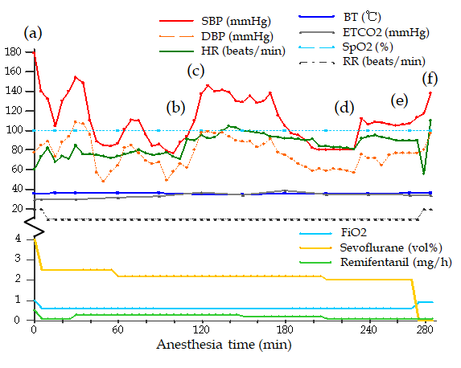
Figure 1 The vital signs and drugs used during the operation. Intravenous drugs: (a) Propofol 70 mg and rocuronium 50 mg; (b) Ephedrine 10 mg; (c) Rocuronium 10 mg; (d) Ephedrine 5 mg; (e) Ramosetron 0.3 mg and ketorolac 30 mg; and (f) Pyridostigmine 10 mg and glycopyrrolate 0.4 mg. SBP: Systolic blood pressure; DBP: Diastolic blood pressure; HR: Heart rate; BT: Body temperature; ETCO2: End-tidal CO2; SpO2: Oxygen saturation; RR: Respiratory rate; FiO2: Fraction of inspired oxygen.
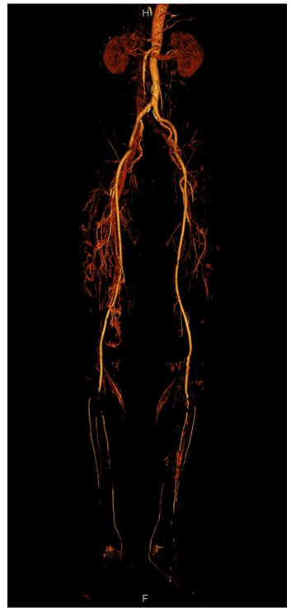
Figure 2 Computed tomography angiography findings. Filling defects are seen in the bilateral popliteal arteries, bilateral proximal anterior tibial arteries, and bilateral tibioperoneal trunks.
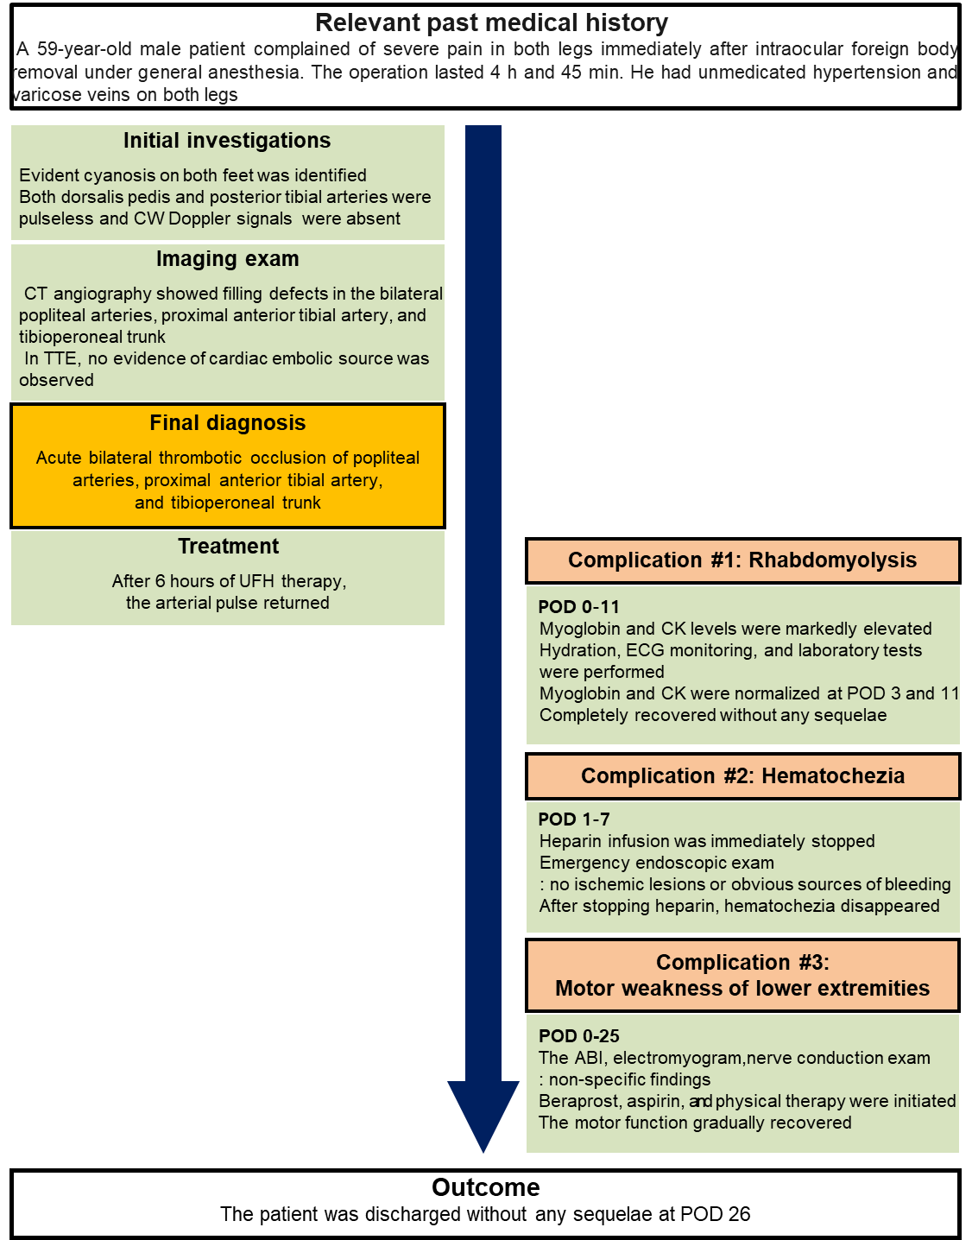
Figure 3 Case report timeline. CW: Continuous wave; TTE: Transthoracic echocardiogram; UFH: Unfractionated heparin; ABI: Ankle brachial index; POD: Postoperative day.
Table 1 Laboratory data
 | Preoperative | After surgery (POD 0) | After hematochezia (POD 1) | POD 2 | Reference range
Complete blood count
WBC (10³/µL) | 6.80 | 13.11 | 10.00 | 8.4 | 4.0-11.0
RBC (10⁶/µL) | 4.44 | 4.6 | 3.89 | 3.25 | 4.5-6.0
Hb (g/dL) | 14.7 | 15.1 | 12.6 | 10.4 | 14.0-17.0
Hct (%) | 42.3 | 44.0 | 36.6 | 31.3 | 42.0-52.0
Plt (10³/µL) | 205 | 176 | 160 | 109 | 140-400
PCT (%) | 0.2 | 0.18 | 0.16 | 0.11
MPV (fL) | 9.6 | 10.0 | 9.8 | 9.9 | 7-11
PDW (fL) | 10.9 | 110. | 10.2 | 10.3 | 11-16
Coagulation profile
PT-INR | 1.07 |  | 1.03 | 1.03 | 0.88-1.12
aPTT (s) | 33.2 |  | 24.7 | 32.1 | 27-42
Liver and kidney function tests
AST (U/L) | 20 |  | 136 | 114 | 10-40
ALT (U/L) | 18 |  | 62 | 59 | 6-40
ALP (U/L) | 107 |  | 75 | 64 | 40-129
T bil (mg/dL) | 0.75 |  | 0.51 | 0.88 | 0.1-1.2
Albumin (g/dL) | 4.9 |  | 3.7 | 3.7 | 3.3-5.2
T chol (mg/dL) | 213 |  | 169 | 156 | 175-210
BUN (mg/dL) | 12.5 |  | 32.9 | 20.1 | 6-26
Creatinine (mg/dL) | 0.76 |  | 0.98 | 0.77 | 0.4-1.2
GFR (mL/min/1.73 m²) | 105 |  | 78.3 | 103.4
Uric acid (mg/dL) | 4.1 |  | 6.1 | 3.3 | 2.5-8.0
Electrolyte
Sodium (mmol/L) | 142.2 | 144.2 | 139.4 | 139.7 | 138-148
Potassium (mmol/L) | 4.08 | 3.70 | 4.25 | 4.01 | 3.5-5.3
Calcium (mg/dL) | 9.2 |  | 7.7 | 7.8 | 8.5-10.3
Phosphorus (mg/dL) | 3.4 |  | 3.2 | 2.3 | 2.0-4.6
Anion gap | 11.7 | 20.4 | 14.3 | 10.4
myoglobin and muscle enzyme
Myoglobin (ng/mL) |  | 1192.8 | 295.0 | 96.7 | 15.2-91.2
Creatine kinase (U/L) |  | 7081.0 | 6198.6 | 4697 | 5-217
CK-MB (ng/mL) |  | 89.06 | 55.02 |  | 0.5-5.0
POD: Postoperative day; WBC: White blood cell; RBC: Red blood cell; Hb: Hemoglobin; Hct: Hematocrit; Plt: Platelet; PCT: Plateletcrit; MPV: Mean platelet volume; PDW: Platelet distribution width; PT-INR: Prothrombin time international normalized ratio; aPTT: Activated partial thromboplastin time; AST: Aspartate aminotransferase; ALT: Alanine aminotransferase; ALP: Alkaline phosphatase; T bil: Total bilirubin; T chol: Total cholesterol; BUN: Blood urea nitrogen; GFR: Glomerular filtration rate; CK-MB: Creatine kinase myocardial band.

Published by Baishideng Publishing Group Inc
7041 Koll Center Parkway, Suite 160, Pleasanton, CA 94566, USA
Telephone: +1-925-3991568
E-mail: bpgoffice@wjgnet.com
Help Desk: https://www.f6publishing.com/helpdesk
https://www.wjgnet.com

© 2021 Baishideng Publishing Group Inc. All rights reserved.

