Name of Journal: World Journal of Gastroenterology
Manuscript NO: 65240
Manuscript Type: ORIGINAL ARTICLE

Basic Study
Increased systemic RNA oxidative damage and diagnostic value of RNA oxidative metabolites during Shigella flexneri-induced intestinal infection

Nie JJ et al. RNA oxidative damage in infection

Jing-Jing Nie, Ya-Ya Pian, Ji-Hong Hu, Guo-Qing Fan, Lv-Tao Zeng, Qiu-Geng Ouyang, Zhen-Xiang Gao, Zhen Liu, Chen-Chen Wang, Qian Liu, Jian-Ping Cai

Jing-Jing Nie, Ya-Ya Pian, Ji-Hong Hu, Zhen-Xiang Gao, Department of Microbiology, National Center for Clinical Laboratories, Beijing Hospital, National Center of Gerontology, Institute of Geriatric Medicine, Chinese Academy of Medical Sciences, Beijing 100730, China

Guo-Qing Fan, Lv-Tao Zeng, Zhen Liu, Qian Liu, Jian-Ping Cai, The Key Laboratory of Geriatrics, Beijing Institute of Geriatrics, Beijing Hospital, National Center of Gerontology, National Health Commission, Institute of Geriatric Medicine, Chinese Academy of Medical Sciences, Beijing 100730, China

Qiu-Geng Ouyang, Chen-Chen Wang, Department of Pharmacy, Wenzhou Medical University, Wenzhou 325035, Zhejiang Province, China

Author contributions: Cai JP provided the research concept; Cai JP, Hu JH, and Nie JJ designed the study; Nie JJ and Pian YY performed the majority of the experiments; Fan GQ, Zeng LT, Ouyang QG, Wang CC, Liu Q, Liu Z, and Gao ZX helped to perform part of the experiments; Nie JJ performed the statistical analysis; Nie JJ and Cai JP wrote the manuscript; all authors approved the final version of the article; Nie JJ and Pian YY contributed equally to this work.

Supported by the National Key R&D Program of China, No. 2018YFC2000300; and CAMS Innovation Fund for Medical Sciences, No. 2018-I2M-1-002.

Corresponding author: Jian-Ping Cai, PhD, Professor, The Key Laboratory of Geriatrics, Beijing Institute of Geriatrics, Beijing Hospital, National Center of Gerontology, National Health Commission, Institute of Geriatric Medicine, Chinese Academy of Medical Sciences, No. 1 Dahua Road, Dongcheng District, Beijing 100730, China. caijp61@vip.sina.com

Received: March 2, 2021
Revised: April 29, 2021
Accepted: August 9, 2021
Published online: October 7, 2021

Abstract
BACKGROUND
Shigella flexneri (S. flexneri) is a major pathogen causing acute intestinal infection, but the systematic oxidative damage incurred during the course of infection has not been investigated.

AIM
To investigate the incurred systemic RNA oxidative damage and the diagnostic value of RNA oxidative metabolites during S. flexneri-induced intestinal infection.

METHODS
In this study, a Sprague-Dawley rat model of acute intestinal infection was established by oral gavage with S. flexneri strains. The changes in white blood cells (WBCs) and cytokine levels in blood and the inflammatory response in the colon were investigated. We also detected the RNA and DNA oxidation in urine and tissues.

RESULTS
S. flexneri infection induced an increase in WBCs, C-reactive protein, interleukin (IL)-6, IL-10, IL-1β, IL-4, IL-17a, IL-10, and tumor necrosis factor α (TNF-α) in blood. Of note, a significant increase in urinary 8-oxo-7,8-dihydroguanosine (8-oxo-Gsn), an important marker of total RNA oxidation, was detected after intestinal infection (P = 0.03). The urinary 8-oxo-Gsn level returned to the baseline level after recovery from infection. In addition, the results of a correlation analysis showed that urinary 8-oxo-Gsn was positively correlated with the WBC count and the cytokines IL-6, TNF-α, IL-10, IL-1β, and IL-17α. Further detection of the oxidation in different tissues showed that S. flexneri infection induced RNA oxidative damage in the colon, ileum, liver, spleen, and brain.

CONCLUSION
Acute infection induced by S. flexneri causes increased RNA oxidative damage in various tissues (liver, spleen, and brain) and an increase of 8-oxo-Gsn, a urinary metabolite. Urinary 8-oxo-Gsn may be useful as a biomarker for evaluating the severity and prognosis of infection.

Key Words: 8-oxo-7,8-dihydroguanosine; Shigella flexneri; Infection; Oxidative damage

©The Author(s) 2021. Published by Baishideng Publishing Group Inc. All rights reserved.

Citation: Nie JJ, Pian YY, Hu JH, Fan GQ, Zeng LT, Ouyang QG, Gao ZX, Liu Z, Wang CC, Liu Q, Cai JP. Increased systemic RNA oxidative damage and diagnostic value of RNA oxidative metabolites during Shigella flexneri-induced intestinal infection. World J Gastroenterol 2021; 27(37): 6248-6261
URL: https://www.wjgnet.com/1007-9327/full/v27/i37/6248.htm
DOI: https://dx.doi.org/10.3748/wjg.v27.i37.6248

Core Tip: Shigella flexneri (S. flexneri) is a major pathogen causing acute intestinal infection, but the systematic oxidative damage incurred during the course of infection has not been investigated. By establishing a Sprague-Dawley rat model with S. flexneri infection in the intestine, we found that 8-oxo-7,8-dihydroguanosine (8-oxo-Gsn) levels were markedly increased in the colon, ileum, liver, spleen, and brain after infection, showing that S. flexneri can exacerbate systemic RNA oxidation. The changing trend in levels of urinary 8-oxo-Gsn (as the RNA oxidative metabolites) was consistent with the changes in the white blood cell count, C-reactive protein level, and cytokine levels during infection. Urinary 8-oxo-Gsn may be useful as a biomarker for evaluating the severity and prognosis of infection.
INTRODUCTION
Shigella infection is a major public health concern around the world, causing acute diarrhea, known as shigellosis or bacillary dysentery. There are almost 165 million cases of diarrhea caused by Shigella each year, of which 163 million occur in developing countries^{[1]}. People of all ages can be infected by Shigella, but children under five years old are most susceptible^{[2]}.
Shigella flexneri (S. flexneri) is the most frequently isolated Shigella species worldwide^{[2]}. The pathogenesis of S. flexneri involves invasion of the mucosa by bacteria, which replicate within and spread between the mucosal epithelial cells, resulting in a subsequent severe inflammatory response and epithelial destruction in the colon tissue. However, the oxidative damage in the colon during S. flexneri-induced infection has not been investigated. In the present study, the oxidative stress changes in the intestine during S. flexneri-induced acute intestinal infection were investigated.
Shigella infection can cause inflammatory responses in the intestine, which is also a potential source of inflammation-related cytokines^{[3]}. Researchers have established cell models/animal models and observed the infected patients to investigate the inflammation-related cytokine production. In cell models, S. flexneri was able to cause an increase in interleukin (IL)-1, IL-10, and tumor necrosis factor α (TNF-α) in macrophage-like cells^{[4]}. Outer membrane protein A of S. flexneri can trigger B cells to secret the cytokines IL-6 and IL-10^{[5]}. The production of the cytokines IL-4, IL-6, and IL-8 is increased in HeLa cells with S. flexneri infection^{[6]}. Researchers also found that the TNFα and IL-1β production is reduced in mouse macrophages with an S. ﬂexneri msbB gene mutation^{[7]}. In mouse models, S. flexneri infection can cause an increase in the IL-1β production^{[8]}. In S. flexneri-infected patients, the TNF-α, IL-1, IL-4, IL-6, and interferon-γ levels increased significantly after infection^{[3]}.
In the present study, we established an S. flexneri-infected rat model to explore the changes in the levels of the above-mentioned cytokines (IL-1, IL-6, IL-10, and TNF-α) as well as IL-17α, which plays important roles in host immunity against intracellular pathogens.
Urinary 8-oxo-7,8-dihydroguanosine (8-oxo-Gsn) and 8-oxo-7,8-dihydro-2-deoxyguanosine (8-oxo-dGsn) are oxidative stress by-products of RNA and DNA, respectively, which are widely used as markers of oxidative stress^{[9,10]}. Previous studies have reported their utility as biomarkers for predicting aging-related diseases^{[11]} and neurodegenerative diseases^{[12]}. Our lab found that 8-oxo-Gsn may have potential utility as a marker for evaluating the severity of Salmonella-related infection^{[13]}. The present study investigated the diagnostic value of 8-oxo-Gsn and 8-oxo-dGsn in intestinal infection induced by S. flexneri. In addition, we investigated the correlation between cytokine levels and oxidative production of 8-oxo-Gsn.
Accumulating evidence suggests that intestinal infection caused by Gram-negative bacteria may also influence other organs. For example, the Gram-negative bacterium Escherichia coli can form extracellular amyloid, which may play a role in causing sporadic Alzheimer’s disease^{[14]}. S. dysenteriae, a causative agent of bloody diarrhea, may cause diarrhea-associated hemolytic uremic syndrome and neurological disorders^{[15]}. Acute intestinal infection induced by Salmonella can cause oxidative damage to the intestine, liver, and spleen^{[13]}. However, the effects of Shigella-induced intestinal infection on other tissues have not been reported.
We hope that the rat infection model established in the present study will help improve our understanding of how vertebrates regulate their response to S. flexneri infection. We further intended to explore whether or not S. flexneri infection in the intestine can cause oxidative damage to other organs, such as the liver, spleen, and brain.

MATERIALS AND METHODS
Bacterial strains
The S. flexneri strain used in this study (CICC 21534) was purchased from the China Center of Industrial Culture Collection (CICC; Beijing, China). The source of the CICC 21534 strain was Guizhou Health and Epidemic Prevention Station, China. The serotype of CICC 21534 was F1a.
S. flexneri strain CICC 21534 was stored at -80 °C. The isolate was subcultured on blood agar plates twice and then suspended in Trypticase Soy Broth (bioMérieux SA, 69280 Marcy I’Etoile, France). The bacterial concentration was measured spectrophotometrically and confirmed by serial dilution on blood agar.

Animal experimental design
Twenty-four 4-wk-old healthy male Sprague-Dawley (SD) rats were purchased from Vital River (Beijing, China). All appropriate measures were taken to minimize the pain or discomfort of the rats. The rats were housed in a temperature-controlled room (24 ± 2 °C). Drinking water and food were provided ad libitum. There were three rats in each cage. The rats were not pretreated with any antibiotics and were all healthy before treatment, with normal white blood cell (WBC) counts and a normal flora in the feces.
The rats were divided randomly into either an infection group or a control group. In the infection group (n = 12), rats were infected by gavage with 1 dose of 1 × 10⁹ colony-forming units (CFU) of the S. flexneri strain. In the control group (n = 12), rat gavage was performed with phosphate-buffered saline (PBS). On days 1, 5, 9, and 18, three rats per group were euthanized by intraperitoneal injection of pentobarbital sodium (200 mg/kg), and tissues were obtained.
For the establishment of the infection model, before infection, the rats were starved overnight. To neutralize the gastric acid, 400 μL of 3% NaHCO₃ was administered orally 15 min before infection. The rats in the infection group were then orally administered with 1 × 10⁹ CFU of S. flexneri in a volume of 1 mL. The establishment of infection was verified by the continuous detection of S. flexneri in feces, an increased WBC count, and obvious lymphocyte infiltration in the colon. In the control group, rats were also starved overnight and administered with 3% NaHCO₃ orally 15 min before PBS administration.
We took care of and sacrificed the animals strictly according to animal welfare laws and regulations. This study was approved by the Ethical Committee of the Institute of Medical Biotechnology, Chinese Academy of Medical Sciences (approval number: IMB-201803140206).

Body temperature and body weight of rats
The body temperature (rectal temperature) and body weight of the rats were measured every morning.

Microbiological detection
For the qualitative detection, conventional bacterial culture methods were used to detect S. flexneri in feces. Samples were collected and inoculated onto blood agar, China blue agar plates (Jinzhang Science and Technology Development Co. Ltd, Tianjin 300190, China), and Salmonella-Shigella (bioMérieux SA, 69280 Marcy I’Etoile, France) agar plates within 2 h of collection. S. flexneri was identified using morphologic observation on the selective medium, combined with triple-iron slants and Vitek 2 (bioMérieux, Inc., NC, United States) detection.
For the quantitative detection of S. flexneri, the feces and tissues were weighed after collection and then diluted in 1 mL of PBS and homogenized with a tissue homogenizer (PRO Scientific Inc., CT, United States). After centrifugation, the supernatant was diluted and inoculated onto Salmonella-Shigella (bioMérieux SA, Marcy I’Etoile, France) agar plates. The plates were incubated at 37 °C overnight. The number of Shigella colonies was counted on each plate. Shigella was quantitatively detected in the infection and control groups at fixed time points on days 1, 3, 5, 7, 9, 13, 15, and 18.

White blood cell count
WBCs in blood samples were counted manually. A 20-μL blood sample was added to 380 μL of 2% ethanoic acid solution. Then, WBCs were counted in a hemacytometer using a conventional light microscope.

C-reactive protein and cytokine detection
Blood samples were collected by the tail vein sampling method. Serum C-reactive protein (CRP) levels were detected with a Rat CRP ELISA kit (Immunology Consultants Laboratory, Inc., OR, United States). The CRP test kit is a highly sensitive two-site ELISA for measuring CRP in rat biological samples. The assay for quantification of CRP in samples requires that each test sample be diluted before use. For the serum samples of the rats in our study, 1/12000 dilution was appropriate for detection. The dilution ratio was determined based on the data provided by the kit and the data of the preliminary experiment.
The cytokines TNF-α, IL-6, IL-10, IL-1β, IL-4, and IL-17α were measured using a commercially available MILLIPLEX MAP Kit (Rat Cytokine/Chemokine Magnetic Bead Panel, 96-Well Plate Assay, Cat. #RECYTMAG-65K, RECYMAG65K27PMX, RECYMAG-65PMX27BK; Millipore Corporation, MA, United States) according to the manufacturer’s protocol. In this study, 1/2 dilution of serum was appropriate for detection. A Luminex 200 System (Luminex Corporation, TX, United States) was used for quantification.

Detection of urinary 8-oxo-dGsn and 8-oxo-Gsn levels
The manual bladder expression method was used to collect the urine samples of rats. Urine samples were stored at -80 °C. Urinary 8-oxo-dGsn and 8-oxo-Gsn were detected by the liquid chromatography with tandem mass spectrometry method as reported^{[13]}. In brief, all urine samples were analyzed using an Agilent 1290 Infinity UHPLC instrument equipped with an Agilent 6490 triple-quadrupole mass spectrometer with a Jet Stream ESI source and iFunnel (Agilent, United States; parameters are shown in Supplementary Tables 1-3). The concentrations of 8-oxo-dGsn and 8-oxo-Gsn were then normalized by urinary creatinine to correct for the impact of water intake/excretion on urine. The results are presented as the ratio of the concentrations of nucleosides (8-oxo-dGsn and 8-oxo-Gsn) and creatinine.

Hematoxylin and eosin staining of tissues
Histopathological tests were performed using standard laboratory procedures. Tissue samples were fixed in 10% neutral-buffered formalin and embedded in paraffin. The paraffin-embedded tissue was then sliced into 4-μm-thick sections with a microtome and placed onto glass slides for further experiments. The tissue sections were deparaffinized with xylene, hydrated through an alcohol series, and then stained with hematoxylin and eosin (H&E). After dehydration and clearing, the mounting tissue sections were observed under a light microscope. H&E Stain kit was purchased from ZSGB-BIO (Beijing, China).

Immunohistochemical detection of 8-oxo-Gsn and 8-oxo-dGsn
Immunohistochemical staining was performed to detect the expression of 8-oxo-Gsn in the ileum, colon, liver, spleen, and brain. In brief, paraffin-embedded tissue sections were deparaffinized in xylene and rehydrated through a series of graded alcohols. Antigen retrieval was performed in citric acid buffer at 95 °C for 40 min. DNase I (TaKaRa Biotechnology Co., Ltd., Dalian, China) was added to slides to remove genomic DNA from samples. The slides were washed with 1 × PBS, and 3% hydrogen peroxide was added to eliminate endogenous peroxidases. Slides were then blocked with goat serum working solution. Primary monoclonal 15A3 antibody (ab62623; Abcam, Cambridge, United Kingdom) was added, and slides were incubated at 37 °C for 2 h (antibody dilutions: Colon, 1:700; ileum, 1:2000; liver, 1:700; spleen, 1:700; brain, 1:2000). The sections were incubated with HRP-conjugated secondary antibody (PV-6002; ZSGB-BIO) for 20 min. Coloration was performed with DAB (ZSGB-BIO), and the sections were observed under a microscope^{[16]}.
To detect the expression of 8-oxo-dGsn in tissue, tissue sections were treated with RNase A (TaKaRa Biotechnology Co., Ltd.) to remove RNA from samples. The primary monoclonal antibody was N45.1 (ab48508; Abcam). The dilutions of primary antibody were 1:2000 for the colon, 1:3000 for the ileum, 1:3000 for the liver, 1:500 for the spleen, and 1:2000 for the brain.

Statistical analysis
The SPSS 16.0 software program was used for the statistical analyses. Quantitative data are expressed as the mean ± SD and were analyzed by a t-test or one-way analysis of variance (ANOVA) after the normality test. Pearson's correlation coefficient (r) was used when comparing the linear relationship between the variables with a normal distribution. An area under the receiver operating characteristic (ROC) curve was created to assess the predictive value of urinary 8-oxo-Gsn and cytokines for the presence of infection. The results were considered significant only when P < 0.05.

RESULTS
Orally administered S. flexneri can provoke pathogen colonization and intestinal inflammation in rats
The body temperature showed no significant changes during the infection progression. Furthermore, the body weight increase of the rats was not significantly different between the infection and control groups.
After the intragastric administration of S. flexneri, serial fecal cultures were performed at fixed time points (days 1, 3, 5, 7, 9, 13, 15, and 18) in the two groups. In the control group, S. flexneri was undetectable during the experiment. In the infection group, S. flexneri was detectable in the feces of all infected rats after infection (day 1) and remained until day 7, whereas it was undetectable on day 9 (Figure 1A). In the intestine, liver, and spleen, S. flexneri was detectable on days 1 and/or 5. S. flexneri was undetectable in the brain at all time points.
Shigella can invade the colonic epithelial cells and provoke an intense inflammatory response. Compared with the control group (Figure 1B), obvious leukocyte infiltration was observed in the colonic mucosa on day 1 (P < 0.001 vs control; Figure 1C and G) and day 5 (P < 0.001 vs control; Figure 1D and G) after infection with S. flexneri, as detected by H&E staining. Intestinal inflammation was decreased on day 9 (Figure 1E), which was accompanied by pathogen elimination. By day 18, the colonic mucosa had returned to normal (Figure 1F).

Changes in WBC count and CRP levels during the course of infection
The WBC count is often used to assess bacterial infections. The changes in the WBC count after the establishment of intestinal infection are shown in Figure 1H. The WBC count increased after oral exposure to S. flexneri and peaked on day 5 (P < 0.0001, WBC_{day5} = 27.42 ± 3.77 × 10⁹ cells/L). The WBC count then decreased and returned to baseline after day 13. In the control group, there were no significant changes in the WBC count during the experiment.
Furthermore, it was shown that the level of CRP, an acute-phase response protein commonly used as a marker of inflammation, was significantly increased after exposure to S. flexneri on day 1 (CRP = 4.87 ± 1.59 × 10³ mg/L, P = 0.005), and the level remained high when it was detected on day 5 (CRP = 4.85 ± 1.41 × 10³ mg/L, P = 0.002). The CRP level then decreased and returned to baseline on day 18 (Figure 1I).

Induction of inflammatory cytokine production
The expression of IL-6, an important mediator of the acute-phase response, was significantly increased in the infection group on day 1 (207.26 ± 19.93 pg/mL, P = 0.02) and remained high when detected on day 5 (207.99 ± 21.49 pg/mL, P = 0.01; Figure 2A). After pathogen clearance on day 9, the levels of IL-6 decreased and returned to baseline.
The expression of TNF-α, a cell-signaling protein involved in systemic inflammation and one of the cytokines that make up the acute phase reaction, was also significantly increased after infection (day 1: 96.07 ± 8.29 pg/mL, P < 0.001) and peaked on day 5 (119.11 ± 9.69 pg/mL, P < 0.001). The TNF-α level then decreased and returned to the baseline at the end of the experiment (Figure 2B).
Consistent with this trend, increased levels of proinflammatory IL-1β (Figure 2C) and IL-17α (Figure 2D) were observed after infection and peaked on day 5. IL-10, a cytokine with multiple, pleiotropic effects in immunoregulation and inflammation, was also significantly produced after bacterial infection (Figure 2E).

High levels of oxidized guanosine in urine after Shigella infection
8-oxo-Gsn levels were increased after oral exposure to S. flexneri. Compared with the control group, significantly increased levels of 8-oxo-Gsn were observed from day 1 to day 9 (P < 0.05), with the level peaking on day 5 (P = 0.017). After day 5, the level of 8-oxo-Gsn began to decrease and returned to baseline on day 15 (Figure 3A). The trends in the changes in the urinary 8-oxo-Gsn level were consistent with the changes in colonic tissue inflammation, the WBC count, and the CRP level, suggesting that urinary 8-oxo-Gsn may serve as a biomarker for assessing the severity of the infection.
In the control group, no significant changes in the 8-oxo-Gsn level were observed at any time point. For 8-oxo-dGsn, no significant changes were observed at any time point (Figure 3B).

Shigella infection leads to RNA oxidative damage in tissues
Immunohistochemical staining showed that the 8-oxo-Gsn staining intensity in the infected colon tissue was significantly altered compared with normal colon tissue (P < 0.05; Figure 4A). In infected colon tissues, antibodies directed against the RNA damage marker 8-oxo-Gsn produced more intense staining than uninfected colon tissues, thereby indicating a general increase in oxidative stress and RNA damage. Although 8-oxo-Gsn was more highly expressed on day 1 than on day 5, the difference between the two time points was not statistically significant. In the ileum (Figure 4B), liver (Figure 4C), spleen (Figure 4D), and brain tissues (Figure 4E), the expression of 8-oxo-Gsn was significantly higher on days 1 and day 5 than that in uninfected tissues.
The levels of the DNA damage marker 8-oxo-dGsn were significantly increased in the colon and brain tissues after infection (Figure 5A and E). In the infection group, there was no significant change in the 8-oxo-dGsn expression in the ileum, liver, or spleen (Figure 5B-D).

Correlation of 8-oxo-Gsn with WBC, CRP, and inflammatory cytokines
The 8-oxo-Gsn concentration in the urine of the infection group was positively correlated with the WBC count (r = 0.652, P < 0.001) and levels of IL-6 (r = 0.461, P = 0.005), TNF-α (r = 0.541, P = 0.001), IL-10 (r = 0.359, P = 0.032), IL-1β (r = 0.402, P = 0.017), and IL-17α (r = 0.431, P = 0.009). No significant correlation was found between 8-oxo-Gsn and CRP (r = 0.289, P = 0.203).
HE staining and fecal discharge are the gold standards for diagnosing the presence of infection. The predictive value of 8-oxo-Gsn in identifying the presence of intestinal infection was assessed using a ROC curve. The area under the ROC curve of urinary 8-oxo-Gsn was 0.750 (95%CI, 0.615–0.885, P = 0.001) (Figure 6A).
The predictive value of the WBC count and CRP for identifying intestinal infection was also assessed using a ROC curve. The area under the ROC of the WBC count was 0.792 (95%CI, 0.674–0.911, P < 0.001) (Figure 6B), and that for CRP was 0.733 (95%CI, 0.544–0.923, P = 0.014) (Figure 6C).
For inflammatory cytokines, the area under the ROC of IL-6 (Figure 6D), TNF-α (Figure 6E), IL-1β (Figure 6F), IL-17α (Figure 6G), and IL-10 (Figure 6H) was 0.838 (95%CI, 0.698–0.978, P = 0.003), 0.980 (95%CI, 0.948–1.012, P < 0.001), 0.948 (95%CI, 0.882–1.014, P < 0.001), 0.964 (95%CI, 0.917–1.012, P < 0.001), and 0.864 (95%CI, 0.752–0.977, P < 0.001), respectively.

DISCUSSION
The present findings suggested that urinary 8-oxo-Gsn can be used to identify the presence of infection and to assess the severity of infection. In this study, Shigella infection in the gastrointestinal tract induced significant increases in the 8-oxo-Gsn concentration, the WBC count, and the CRP level. The WBC count is widely used to evaluate the severity of bacterial infections. CRP, an acute-phase protein of hepatic origin, is a non-specific marker of inflammation and one of the most sensitive acute-phase reactants.
The levels of 8-oxo-Gsn, a marker of oxidative stress, as well as the WBC count and the CRP level, which are markers of inflammation, were all increased significantly on day 1 and peaked on day 5. Following the clearance of the pathogen, the values for these biomarkers returned to the baseline level.
The correlation analysis showed that 8-oxo-Gsn was positively correlated with the WBC count. Although no significant correlation was found between 8-oxo-Gsn and CRP, the trend of the urinary 8-oxo-Gsn concentration was consistent with the changes of the WBC count and CRP level. The sharp increase in the CRP level on day 1 (20 times higher than that on day 0) may be the reason for the absence of a significant correlation. The predictive value of the 8-oxo-Gsn concentration, WBC count, and CRP level for differentiating between infection and non-infection was assessed using the ROC curve. The results showed that 8-oxo-Gsn achieved a fair accuracy in classifying subjects as infected or uninfected. When the area under the ROC curve for the 8-oxo-Gsn concentration was compared to those of the WBC count and CRP level, all values ranged from 0.70 to 0.80, indicating that these diagnostic markers have a similar discrimination ability for the infection status^{[17]}. Furthermore, urinary 8-oxo-Gsn is a noninvasive biomarker and can be measured more frequently than blood biomarkers, such as the WBC and CRP.
The immunohistochemistry results showed that in addition to intestinal tract tissue, 8-oxo-Gsn (RNA oxidative product) levels were increased in the liver, spleen, and brain tissues. Previous studies have shown that Shigella has a predilection to infect and colonize the large bowel^{[2,18]}. The increased oxidative stress in other tissues might be induced by endo- or exotoxin produced by Shigella strains, according to previous studies^{[14,15,19]}. Our study suggested that diarrhea caused by Shigella bacteria could induce a transient elevation in systemic oxidative stress.
The levels of the DNA oxidative product 8-oxo-dGsn showed no significant changes in urine, ileum, liver, or spleen tissues. The increase was only detected in the colon and brain. The results suggested that DNA oxidative damage occurred less frequently than RNA oxidative damage in the course of acute infection. This might be because DNA molecules have a double-stranded structure, which is protected by histones and the cell nucleus^{[11]}. All of these protections reduce the DNA oxidative damage during acute infection. Previous studies have shown that, in the course of chronic infection, DNA oxidative damage occurred more frequently, which helps promote inflammation-mediated carcinogenesis^{[20,21]}.
The present study showed that the levels of the cytokines IL-6, TNF-α, IL-1β, IL-17α and IL-10 were significantly increased after infection. Previous studies also showed that S. flexneri induced the release of both inflammatory (IL6, IL-8, and IL1β) and anti-inflammatory cytokines (IL-10)^{[22-24]}. However, changes in the levels of IL-17α in S. flexneri-related infection have not been investigated. IL-17 has emerged as a central player in the mammalian immune system^{[25]}. To promote inflammation, IL-17 acts in concert with IL-1β and TNF-α^{[26]}, with IL-1β being required to mediate inflammation in S. flexneri infection^{[8]}. The present results suggested that S. flexneri infection activates inflammatory cytokines. Our findings also showed that the cytokine levels were positively correlated with the concentration of 8-oxo-Gsn, a marker of RNA oxidation, which proved again that 8-oxo-Gsn was useful as a diagnostic biomarker in infection.

CONCLUSION
In summary, during the early stage of Shigella infection, tissue inflammation occurs at the site of pathogen colonization, accompanied by an increase in reactive oxygen species (ROS) and the release of inflammatory cytokines. With the clearance of Shigella, the levels of oxidative stress markers and inflammatory cytokines decline, and the tissue inflammation recovers. The results suggested that although an increase in ROS can induce RNA oxidative damage in the colon and various tissues, this is temporary and differs from DNA oxidative damage, which occurs more frequently under conditions of chronic infection^{[20]}. Thus, the combination of oxidative stress and inflammatory cytokines promotes infection recovery. A previous study showed that the RNA oxidative nucleic acid 8-oxoGTP increased protein variation^{[27]}. The influence of various mutated proteins in infection, especially in the course of chronic infection, should be investigated in future studies.

ARTICLE HIGHLIGHTS
Research background
Shigella infection is a major public health concern around the world. Shigella flexneri (S. flexneri) is a major pathogen causing acute intestinal infection and is more frequently fatal than other Shigella species. The white blood cell (WBC) count and levels of C-reactive protein (CRP) and cytokines have always been used to evaluate the severity of Shigella-induced infection. Because RNA oxidation plays a substantial role in the progression of multiple diseases, the RNA oxidative product 8-oxo-7,8-dihydroguanosine (8-oxo-Gsn) may be useful as a biomarker for predicting infectious disease progression and severity.

Research motivation
There is no information regarding the diagnostic value of urinary 8-oxo-Gsn and 8-oxo-7,8-dihydro-2-deoxyguanosine (8-oxo-dGsn) in intestinal infection induced by S. flexneri. In addition, the correlation of blood inflammatory-related cytokines with RNA oxidative metabolites is unclear. Furthermore, the systematic tissue oxidative damage during Shigella-induced intestinal infection has not been investigated.

Research objectives
To determine the systemic RNA oxidative damage incurred in S. flexneri-induced intestinal infection and to evaluate the diagnostic value of the RNA oxidative metabolites 8-oxo-Gsn in urine.

Research methods
Sprague-Dawley rats were used to establish an acute intestinal infection model by oral gavage of S. flexneri strains. The CRP level was measured by ELISA, and cytokines were detected using the MILLIPLEX MAP Kit according to the manufacturer's protocol. Hematoxylin and eosin staining was performed to detect tissue inflammation. Liquid chromatography with tandem mass spectrometry was used to determine the 8-oxo-dGsn and 8-oxo-Gsn levels in urine. Immunohistochemical staining was performed to detect the expression of 8-oxo-Gsn and 8-oxo-dGsn in the ileum, colon, liver, spleen, and brain.

Research results
Intestinal infection induced by S. flexneri caused an increase in inflammation-related markers in the blood [WBCs, CRP, tumor necrosis factor α (TNF-α), interleukin (IL)-6, IL-10, IL-1β, IL-4, and IL-17a] and RNA oxidative damage-related markers in the urine (8-oxo-Gsn). The urinary 8-oxo-Gsn level increased after infection and returned to the baseline level after recovery from infection. A correlation analysis showed that urinary 8-oxo-Gsn was positively correlated with the WBC count and the cytokines IL-6, TNF-α, IL-10, IL-1β, and IL-17α. The evaluation of oxidation in different tissues showed that intestinal infection caused by S. flexneri induced an increase in RNA oxidative damage in various tissues, including the intestine, liver, spleen, and brain.

Research conclusions
This study demonstrated that acute intestinal infection induced by S. flexneri not only causes RNA oxidative damage in the intestine but also other tissues as well (liver, spleen, and brain). Furthermore, the urinary metabolite of RNA oxidation 8-oxo-Gsn was shown to be useful as a diagnostic index to evaluate the infection status.

Research perspectives
Urinary 8-oxo-Gsn can be used as a noninvasive diagnostic biomarker to evaluate the severity and prognosis of infection in clinical practice.

ACKNOWLEDGEMENTS
We are grateful to the members of the Institute of Geriatrics of the Ministry of Health for advice and assistance.

REFERENCES
1 Sheikh AF, Moosavian M, Abdi M, Heidary M, Shahi F, Jomehzadeh N, Seyed-Mohammadi S, Saki M, Khoshnood S. Prevalence and antimicrobial resistance of Shigella species isolated from diarrheal patients in Ahvaz, southwest Iran. Infect Drug Resist 2019; 12: 249-253 [PMID: 30774392 DOI: 10.2147/IDR.S187861]
2 Jennison AV, Verma NK. Shigellaflexneri infection: pathogenesis and vaccine development. FEMS Microbiol Rev 2004; 28: 43-58 [PMID: 14975529 DOI: 10.1016/j.femsre.2003.07.002]
3 Raqib R, Lindberg AA, Wretlind B, Bardhan PK, Andersson U, Andersson J. Persistence of local cytokine production in shigellosis in acute and convalescent stages. Infect Immun 1995; 63: 289-296 [PMID: 7806368 DOI: 10.1128/IAI.63.1.289-296.1995]
4 Bando SY, Moreno AC, Albuquerque JA, Amhaz JM, Moreira-Filho CA, Martinez MB. Expression of bacterial virulence factors and cytokines during in vitro macrophage infection by enteroinvasive Escherichia coli and Shigella flexneri: a comparative study. Mem Inst Oswaldo Cruz 2010; 105: 786-791 [PMID: 20944993 DOI: 10.1590/s0074-02762010000600009]
5 Bhowmick R, Pore D, Chakrabarti MK. Outer membrane protein A (OmpA) of Shigella flexneri 2a induces TLR2-mediated activation of B cells: involvement of protein tyrosine kinase, ERK and NF-κB. PLoS One 2014; 9: e109107 [PMID: 25286253 DOI: 10.1371/journal.pone.0109107]
6 García-Weber D, Dangeard AS, Cornil J, Thai L, Rytter H, Zamyatina A, Mulard LA, Arrieumerlou C. ADP-heptose is a newly identified pathogen-associated molecular pattern of Shigella flexneri. EMBO Rep 2018; 19 [PMID: 30455202 DOI: 10.15252/embr.201846943]
7 Ranallo RT, Kaminski RW, George T, Kordis AA, Chen Q, Szabo K, Venkatesan MM. Virulence, inflammatory potential, and adaptive immunity induced by Shigella flexneri msbB mutants. Infect Immun 2010; 78: 400-412 [PMID: 19884336 DOI: 10.1128/IAI.00533-09]
8 Sansonetti PJ, Phalipon A, Arondel J, Thirumalai K, Banerjee S, Akira S, Takeda K, Zychlinsky A. Caspase-1 activation of IL-1beta and IL-18 are essential for Shigella flexneri-induced inflammation. Immunity 2000; 12: 581-590 [PMID: 10843390 DOI: 10.1016/s1074-7613(00)80209-5]
9 Halliwell B. Why and how should we measure oxidative DNA damage in nutritional studies? How far have we come? Am J Clin Nutr 2000; 72: 1082-1087 [PMID: 11063432 DOI: 10.1093/ajcn/72.5.1082]
10 Poulsen HE, Specht E, Broedbaek K, Henriksen T, Ellervik C, Mandrup-Poulsen T, Tonnesen M, Nielsen PE, Andersen HU, Weimann A. RNA modifications by oxidation: a novel disease mechanism? Free Radic Biol Med 2012; 52: 1353-1361 [PMID: 22306201 DOI: 10.1016/j.freeradbiomed.2012.01.009]
11 Nie B, Gan W, Shi F, Hu GX, Chen LG, Hayakawa H, Sekiguchi M, Cai JP. Age-dependent accumulation of 8-oxoguanine in the DNA and RNA in various rat tissues. Oxid Med Cell Longev 2013; 2013: 303181 [PMID: 23738036 DOI: 10.1155/2013/303181]
12 Isobe C, Abe T, Terayama Y. Homocysteine may contribute to pathogenesis of RNA damage in brains with Alzheimer's disease. Neurodegener Dis 2009; 6: 252-257 [PMID: 19940460 DOI: 10.1159/000262443]
13 Hu JH, Nie JJ, Gao ZX, Weng QH, Wang ZH, Li CB, Pian YY, Zhang R, Jiang ZL, Xia MM, Cai JP. Oxidative DNA and RNA damage and their prognostic values during Salmonella enteritidis-induced intestinal infection in rats. Free Radic Res 2018; 52: 961-969 [PMID: 30422023 DOI: 10.1080/10715762.2018.1500022]
14 Zhan X, Stamova B, Sharp FR. Lipopolysaccharide Associates with Amyloid Plaques, Neurons and Oligodendrocytes in Alzheimer's Disease Brain: A Review. Front Aging Neurosci 2018; 10: 42 [PMID: 29520228 DOI: 10.3389/fnagi.2018.00042]
15 Lee MS, Tesh VL. Roles of Shiga Toxins in Immunopathology. Toxins (Basel) 2019; 11 [PMID: 30970547 DOI: 10.3390/toxins11040212]
16 Zheng JD, Hei AL, Zuo PP, Dong YL, Song XN, Takagi Y, Sekiguchi M, Cai JP. Age-related alterations in the expression of MTH2 in the hippocampus of the SAMP8 mouse with learning and memory deterioration. J Neurol Sci 2009; 287: 188-196 [PMID: 19735921 DOI: 10.1016/j.jns.2009.07.027]
17 Li F, He H. Assessing the Accuracy of Diagnostic Tests. Shanghai Arch Psychiatry 2018; 30: 207-212 [PMID: 30858674 DOI: 10.11919/j.issn.1002-0829.218052]
18 Schroeder GN, Hilbi H. Molecular pathogenesis of Shigella spp.: controlling host cell signaling, invasion, and death by type III secretion. Clin Microbiol Rev 2008; 21: 134-156 [PMID: 18202440 DOI: 10.1128/CMR.00032-07]
19 Obata F, Tohyama K, Bonev AD, Kolling GL, Keepers TR, Gross LK, Nelson MT, Sato S, Obrig TG. Shiga toxin 2 affects the central nervous system through receptor globotriaosylceramide localized to neurons. J Infect Dis 2008; 198: 1398-1406 [PMID: 18754742 DOI: 10.1086/591911]
20 Ohnishi S, Ma N, Thanan R, Pinlaor S, Hammam O, Murata M, Kawanishi S. DNA damage in inflammation-related carcinogenesis and cancer stem cells. Oxid Med Cell Longev 2013; 2013: 387014 [PMID: 24382987 DOI: 10.1155/2013/387014]
21 Tsukiyama-Kohara K. Role of oxidative stress in hepatocarcinogenesis induced by hepatitis C virus. Int J Mol Sci 2012; 13: 15271-15278 [PMID: 23203124 DOI: 10.3390/ijms131115271]
22 Marteyn B, Gazi A, Sansonetti P. Shigella: a model of virulence regulation in vivo. Gut Microbes 2012; 3: 104-120 [PMID: 22356862 DOI: 10.4161/gmic.19325]
23 Liu G, Pilla G, Tang CM. Shigella host: Pathogen interactions: Keeping bacteria in the loop. Cell Microbiol 2019; 21: e13062 [PMID: 31134722 DOI: 10.1111/cmi.13062]
24 Samandari T, Kotloff KL, Losonsky GA, Picking WD, Sansonetti PJ, Levine MM, Sztein MB. Production of IFN-gamma and IL-10 to Shigella invasins by mononuclear cells from volunteers orally inoculated with a Shiga toxin-deleted Shigella dysenteriae type 1 strain. J Immunol 2000; 164: 2221-2232 [PMID: 10657678 DOI: 10.4049/jimmunol.164.4.2221]
25 Onishi RM, Gaffen SL. Interleukin-17 and its target genes: mechanisms of interleukin-17 function in disease. Immunology 2010; 129: 311-321 [PMID: 20409152 DOI: 10.1111/j.1365-2567.2009.03240.x]
26 Gaffen SL. An overview of IL-17 function and signaling. Cytokine 2008; 43: 402-407 [PMID: 18701318 DOI: 10.1016/j.cyto.2008.07.017]
27 Dai DP, Gan W, Hayakawa H, Zhu JL, Zhang XQ, Hu GX, Xu T, Jiang ZL, Zhang LQ, Hu XD, Nie B, Zhou Y, Li J, Zhou XY, Li J, Zhang TM, He Q, Liu DG, Chen HB, Yang N, Zuo PP, Zhang ZX, Yang HM, Wang Y, Wilson SH, Zeng YX, Wang JY, Sekiguchi M, Cai JP. Transcriptional mutagenesis mediated by 8-oxoG induces translational errors in mammalian cells. Proc Natl Acad Sci USA 2018; 115: 4218-4222 [PMID: 29610342 DOI: 10.1073/pnas.1718363115]

Footnotes
Institutional animal care and use committee statement: This study was approved by the Ethical Committee of the Institute of Medical Biotechnology, Chinese Academy of Medical Sciences (approval number: IMB-201803140206).

Conflict-of-interest statement: The authors declare no conflicts of interest in association with the present study.

Data sharing statement: No additional data are available.

ARRIVE guidelines statement: The authors have read the ARRIVE guidelines, and the manuscript was prepared and revised according to the ARRIVE guidelines.

Open-Access: This article is an open-access article that was selected by an in-house editor and fully peer-reviewed by external reviewers. It is distributed in accordance with the Creative Commons Attribution NonCommercial (CC BY-NC 4.0) license, which permits others to distribute, remix, adapt, build upon this work non-commercially, and license their derivative works on different terms, provided the original work is properly cited and the use is non-commercial. See: http://creativecommons.org/Licenses/by-nc/4.0/

Manuscript source: Invited manuscript

Peer-review started: March 2, 2021
First decision: April 17, 2021
Article in press: August 9, 2021

Specialty type: Gastroenterology and hepatology
Country/Territory of origin: China
Peer-review report’s scientific quality classification
Grade A (Excellent): 0
Grade B (Very good): B, B
Grade C (Good): 0
Grade D (Fair): 0
Grade E (Poor): 0

P-Reviewer: Kashyap MK, Scarfì S S-Editor: Zhang H L-Editor: Wang TQ P-Editor: Li JH
Figure Legends
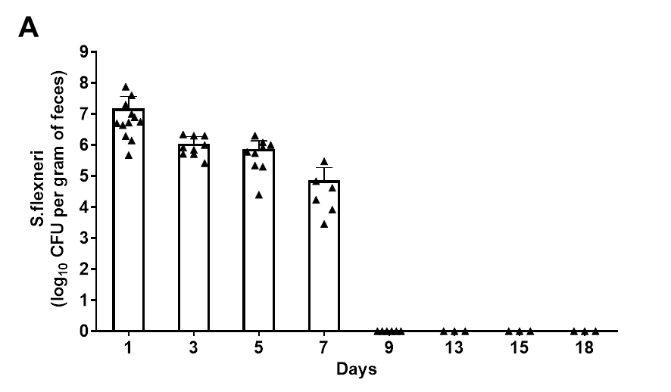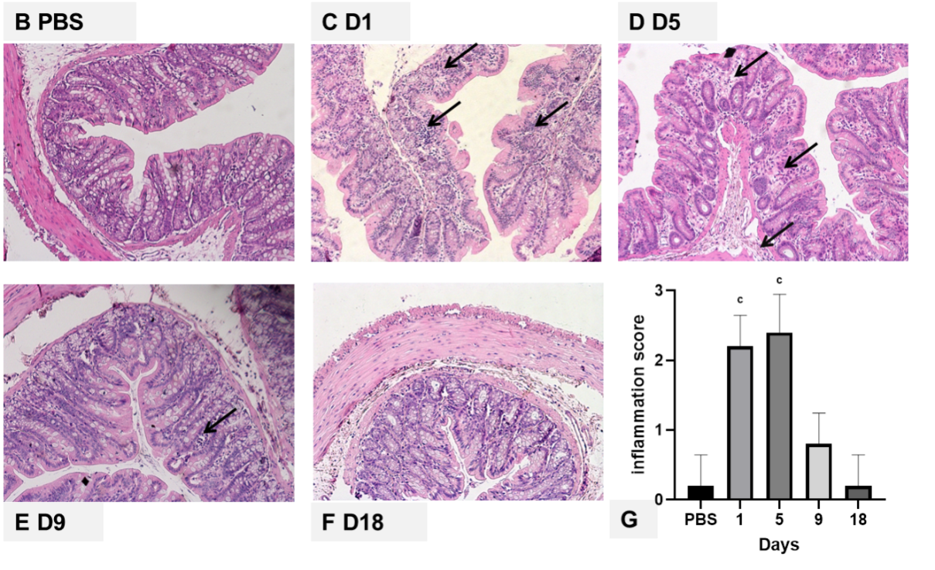
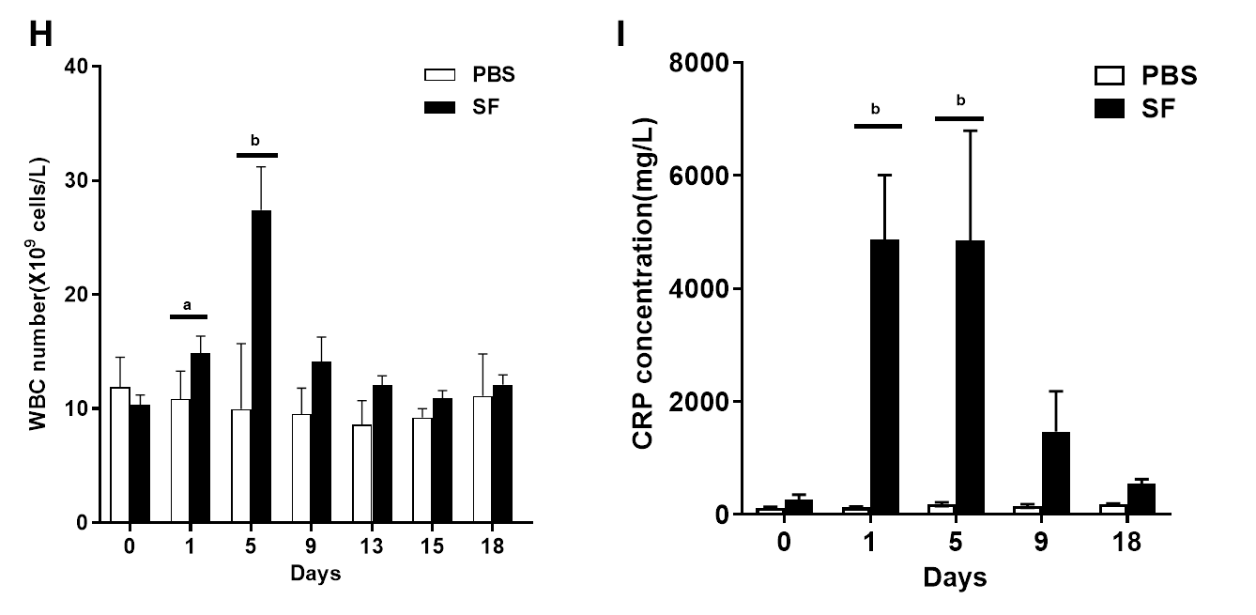
Figure 1 Pathogen colonization, intestinal inflammation, and changes in the white blood cell count and C-reactive protein level after Shigella flexneri infection in rats. A: Quantitative detection of Shigella flexneri (S. flexneri) in feces of Sprague-Dawley rats after infection; B-G: Representative hematoxylin & eosin (H&E) staining (100 × magnification) of colon tissue from control and S. flexneri-infected groups; B: H&E staining of normal colon tissue in the control group; C: H&E staining of colon tissue after S. flexneri infection at day 1; D: H&E staining of colon tissue on day 5; E: H&E staining of colon tissue on day 9; F: H&E staining of colon tissue on day 18; G: Inflammation scores of the control and infection groups at different time points; H: White blood cells counts in the S. flexneri infection and control groups; I: C-reactive protein in the S. flexneri infection and control groups. ªP < 0.05; ^{b}P < 0.01; and ^{c}P < 0.001. Scale bar, 100 μm. Black arrows indicate inflammatory cell infiltration. PBS: Phosphate-buffered saline; WBC: White blood cell; CRP: C-reactive protein; CFU: Colony-forming units; S. flexneri: Shigella flexneri.
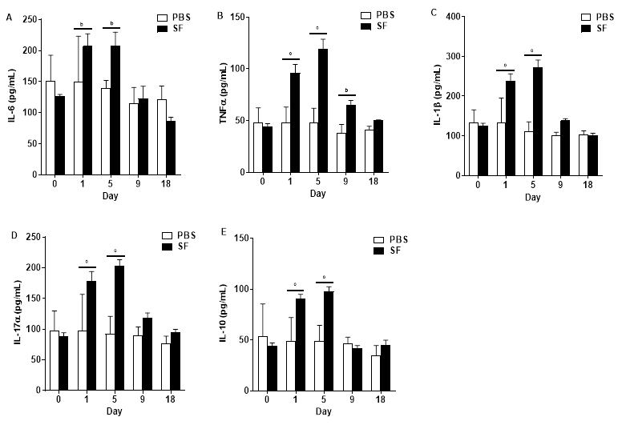
Figure 2 Inflammatory cytokines interleukin-6, tumor necrosis factor-α, interleukin-1β, interleukin-17α, and interleukin-10 detected in serum samples of Shigella flexneri infected rats. A: Interleukin (IL)-6; B: Tumor necrosis factor-α; C: IL-1β; D: IL-17α; E: IL-10. 0: Before infection. 1-18: The number of days after the establishment of the Shigella flexneri infection model. n = 12 per group on day 0 and day 1; n = 9 per group on day 5; n = 6 per group on day 9; n = 3 per group on day 18. Data are presented as the mean ± SEM. ªP < 0.05; ^{b}P < 0.01; and ^{c}P < 0.001 (two-tailed unpaired Student’s t-test). PBS: Phosphate-buffered saline; IL: Interleukin; TNF: Tumor necrosis factor.
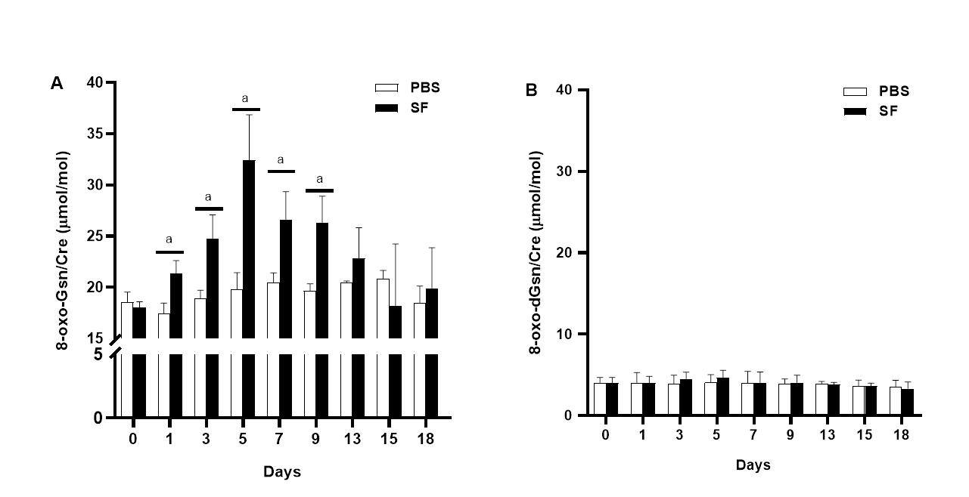
Figure 3 Liquid chromatography-tandem mass spectrometry measurement of 8-oxo-7,8-dihydroguanosine and 8-oxo-7,8-dihydro-2-deoxyguanosine in the urine of Sprague-Dawley rats. A: Urinary 8-oxo-7,8-dihydroguanosine; B: Urinary 8-oxo-7,8-dihydro-2-deoxyguanosine. n = 12 per group on day 0 and day 1; n = 9 per group on day 3 and day 5; n = 6 per group on day 9; n = 3 per group on day 13, day 15, and day 18. 0: Before infection. 1-18: The number of days after the establishment of the Shigella flexneri infection model. ªP < 0.05. 8-oxo-Gsn: 8-oxo-7,8-dihydroguanosine; 8-oxo-dGsn: 8-oxo-7,8-dihydro-2-deoxyguanosine.
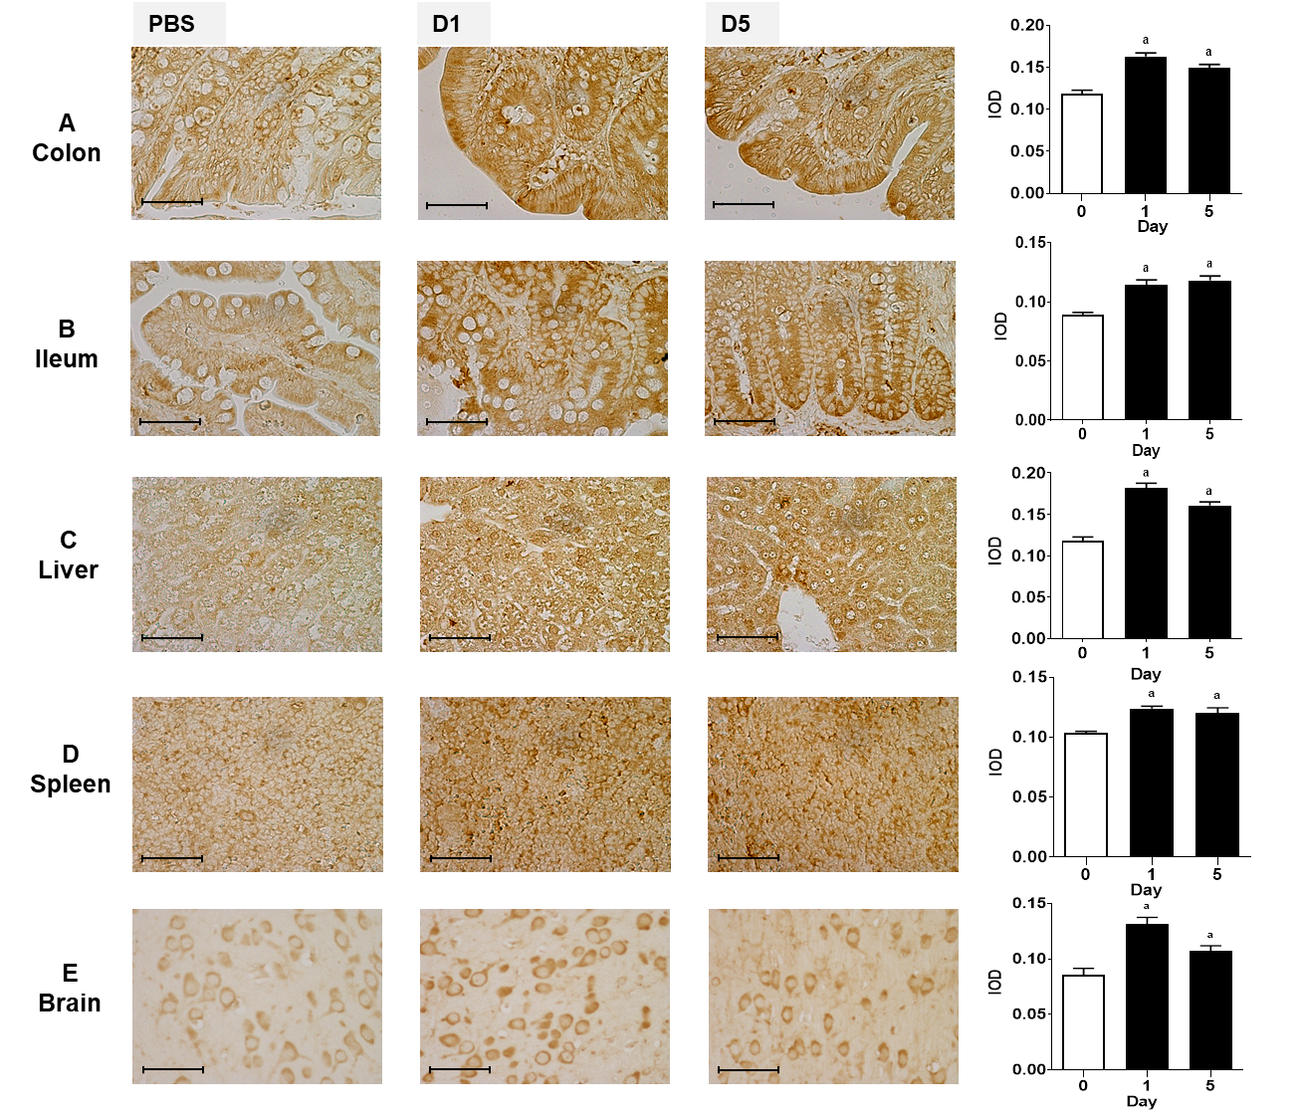
Figure 4 Immunohistochemical staining for 8-oxo-7,8-dihydroguanosine in tissues. A: Representative images showing immunohistochemical staining (400 × magnification) of 8-oxo-7,8-dihydroguanosine (8-oxo-Gsn) in paraffin-embedded colon sections from rats. Left panel images (PBS) indicate the results of the control group. Middle panel images (D1) indicate the results one day after Shigella flexneri (S. flexneri) infection. Right panel images (D5) indicate the results five days after S. flexneri infection; B: Immunohistochemical staining for 8-oxo-Gsn in ileum sections; C: Immunohistochemical staining for 8-oxo-Gsn in liver sections; D: Immunohistochemical staining for 8-oxo-Gsn in spleen sections; E: Immunohistochemical staining for 8-oxo-Gsn in brain sections. Histogram: The quantitative analysis of immunohistochemical staining of 8-oxo-Gsn in tissues of the infection and control groups. Scale bar, 50 μm. ªP < 0.05. The immunohistochemical images were analyzed using the Image Pro-Plus (IPP) software. The integrated optical density (IOD) is a representative parameter for assessing the immunostaining quantiﬁcation in the IPP analyses, and it indicates the total amount of staining material in that area. IOD: Integrated optical density.
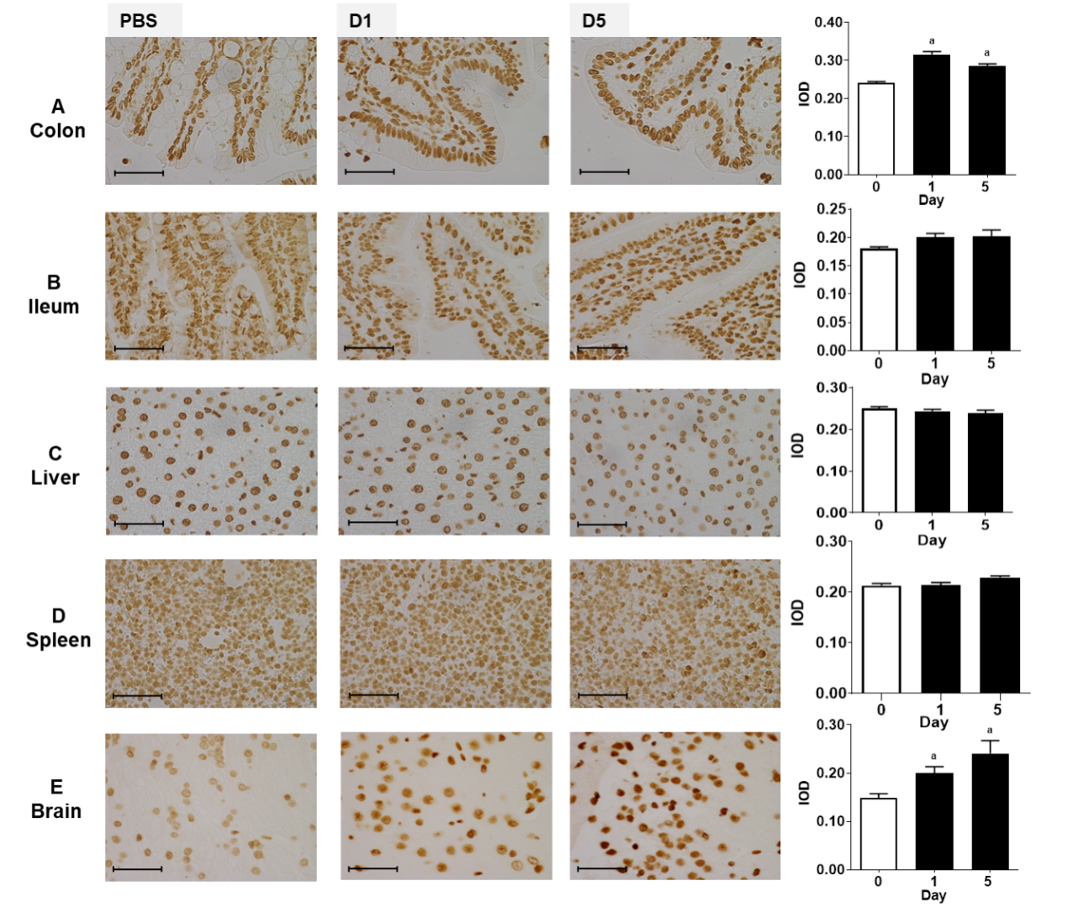
Figure 5 Immunohistochemical staining for 8-oxo-7,8-dihydro-2-deoxyguanosine in tissues. A: Representative images showing immunohistochemical staining (400 × magnification) of 8-oxo-7,8-dihydro-2-deoxyguanosine (8-oxo-dGsn; a DNA oxidative damage marker) in colon sections of rats. Left panel images (PBS) indicate the results of the control group. Middle panel images (D1) indicate the results one day after Shigella flexneri (S. flexneri) infection. Right panel images (D5) indicate the results five days after S. flexneri infection; B: Immunohistochemical staining for 8-oxo-dGsn in ileum sections; C: Immunohistochemical staining for 8-oxo-dGsn in liver sections; D: Immunohistochemical staining for 8-oxo-dGsn in spleen sections; E: Immunohistochemical staining for 8-oxo-dGsn in brain sections. Histogram: The quantitative analysis of immunohistochemical staining of 8-oxo-dGsn in tissues from the infection and control groups. Scale bar, 50 μm. ªP < 0.05. IOD: Integrated optical density.
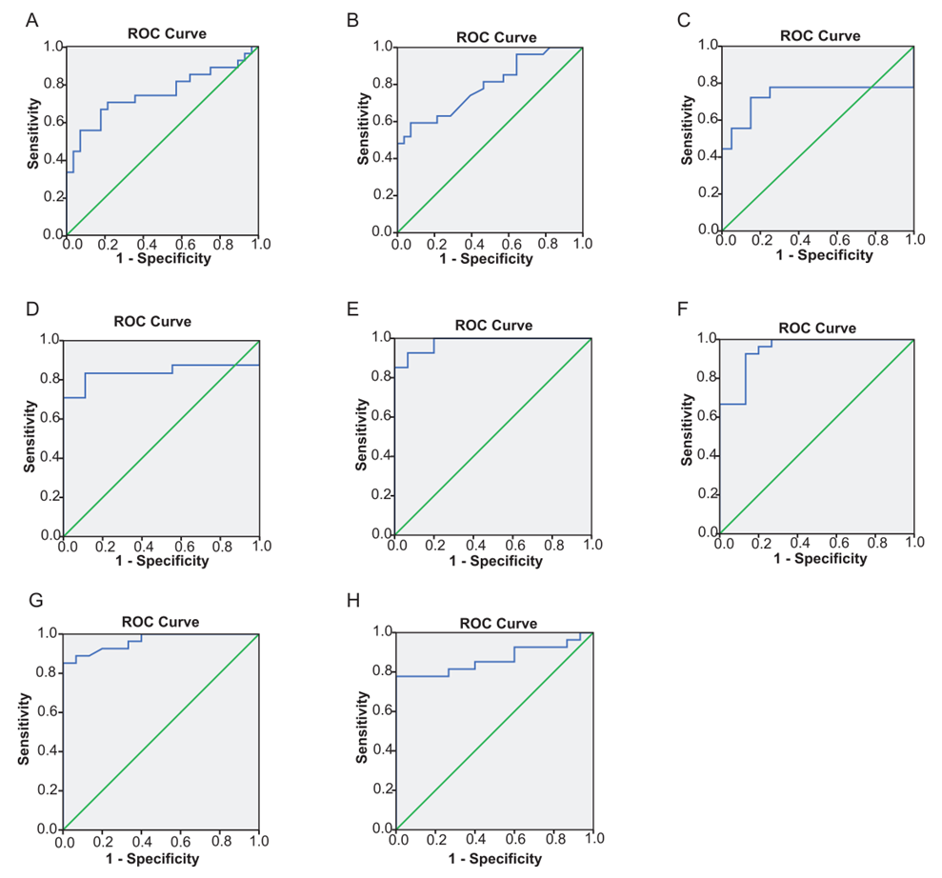
Figure 6 Receiver operator characteristic curves of 8-oxo-7,8-dihydroguanosine, white blood cell count, C-reactive protein, interleukin-6, tumor necrosis factor α, interleukin-1β, interleukin-17α, and interleukin-10 for assessing the infection status. A: Receiver operator characteristic (ROC) curve of urinary 8-oxo-7,8-dihydroguanosine; B: ROC curve of white blood cell count; C: ROC curve of C-reactive protein; D: ROC curve of interleukin (IL)-6; E: ROC curve of tumor necrosis factor α; F: ROC curve of IL-1β; G: ROC curve of IL-17α; H: ROC curve of IL-10. ROC: Receiver operator characteristic.

Published by Baishideng Publishing Group Inc
7041 Koll Center Parkway, Suite 160, Pleasanton, CA 94566, USA
Telephone: +1-925-3991568
E-mail: bpgoffice@wjgnet.com
Help Desk: https://www.f6publishing.com/helpdesk
https://www.wjgnet.com

© 2021 Baishideng Publishing Group Inc. All rights reserved.

