Name of journal: World Journal of Gastroenterology
ESPS Manuscript NO: 1599
Columns: CASE REPORT

Aggressive juvenile polyposis in children with chromosome 10q23 deletion

Septer S et al. Juvenile polyposis with chromosome deletion

Seth Septer, Lei Zhang, Caitlin E Lawson, Jose Cocjin, Thomas Attard, Holly H Ardinger

Seth Septer, Jose Cocjin, Thomas Attard, Department of Gastroenterology and Hepatology, Children’s Mercy Hospital and Clinics, Kansas City, MO 64108, United States

Lei Zhang, Division of Cytogenetics, Department of Pathology, Children’s Mercy Hospital and Clinics, Kansas City, MO 64108, United States

Caitlin E Lawson, Holly H Ardinger, Division of Clinical Genetics, Department of Pediatrics, Children’s Mercy Hospitals and Clinics and University of Missouri, Kansas City School of Medicine, Kansas City, MO 64108, United States

Author contributions: Septer S, Cocjin J, Attard T and Ardinger H designed the research; Septer S, Zhang L, Lawson C, Attard T and Ardinger H wrote the paper.

Correspondence to: Dr. Seth Septer, Department of Gastroenterology and Hepatology, Children’s Mercy Hospital and Clinics, 2401 Gillham Road, Kansas City, MO 64108, United States. ssepter@cmh.edu

Telephone: +1-816-2343016 Fax: +1-816-2341553
Received: December 22, 2012 Revised: February 1, 2013
Accepted: February 7, 2013
Published online:

Abstract
Abstract: Juvenile polyps are relatively common findings in children, while juvenile polyposis syndrome (JPS) is a rare hereditary syndrome entailing an increased risk of colorectal cancer. Mutations in BMPR1A or SMAD4 are found in roughly half of patients diagnosed with JPS. Mutations in PTEN gene are also found in patients with juvenile polyps and in Bannayan-Riley-Ruvalcaba syndrome and Cowden syndrome. Several previous reports have described microdeletions in chromosome 10q23 encompassing both PTEN and BMPR1A causing aggressive polyposis and malignancy in childhood. These reports have also described extra-intestinal findings in most cases including cardiac anomalies, developmental delay and macrocephaly. In this report we describe a boy with a 5.75 Mb deletion of chromosome 10q23 and a 1.03 Mb deletion within chromosome band 1p31.3 who displayed aggressive juvenile polyposis and multiple extra-intestinal anomalies including macrocephaly, developmental delay, short stature, hypothyroidism, atrial septal defect, ventricular septal defect and hypospadias. He required colectomy at six years of age, and early colectomy was a common outcome in other children with similar deletions. Due to the aggressive polyposis and reports of dysplasia and even malignancy at a young age, we propose aggressive gastrointestinal surveillance in children with 10q23 microdeletions encompassing the BMPR1A and PTEN genes to include both the upper and lower gastrointestinal tracts, and also include a flowchart for an effective genetic testing strategy in children with juvenile polyposis.

© 2013 Baishideng. All rights reserved.

Key words: Polyposis; Genetics; Cancer; Endoscopy pediatric

Core tip: Children with aggressive juvenile polyposis related to microdeletions of chromosome 10q23 and involving PTEN and BMPR1A are rare, however this deletion conveys significant gastrointestinal and extraintestinal risks. Children with this gene mutation are at significant risk for extensive polyposis, early colectomy and gastrointestinal malignancy. This work describes the clinical manifestations associated with these deletions. We also suggest genetic testing strategies for those with juvenile polyps and also propose gastrointestinal surveillance for patients with chromosome 10q23 deletions encompassing PTEN and BMPR1A.

Septer S, Zhang L, Lawson CE, Cocjin J, Attard T, Ardinger HH. Aggressive juvenile polyposis in children with chromosome 10q23 deletion.

Available from:
DOI:

INTRODUCTION
Classification of polyps in children and subsequent attempts to diagnose hereditary polyposis syndromes begin with histologic sub-typing. The juvenile polyp was first described by Diamond^{[1]} and is characterized histologically by an edematous lamina propria with inflammatory cells and cystically dilated glands which are lined by cuboidal to columnar epithelium^{[2]}. While sporadic juvenile polyps are fairly common in the first decade of life and may be found in up to 2% of the pediatric population^{[3,4]}, juvenile polyposis syndrome (JPS) is a rare hereditary polyposis syndrome occurring in 1:100 000^{[5]} and entails an increased risk of colorectal cancer and to a lesser degree gastric cancer. Juvenile polyposis syndrome is defined (Jass Criteria) by the presence of five or more juvenile polyps in the colorectum, any number of juvenile polyps proximal to the colorectum or any number of juvenile polyps with a positive family history of juvenile polyposis^{[3,4,6]}. JPS typically presents in adolescence or adulthood. Treatment consists of surveillance endoscopy with polypectomy. Endoscopy is typically performed on a regular basis after polyps are found. Prophylactic surgery is indicated if polyp burden is unmanageable endoscopically, when juvenile polyps display dysplasia or in the case of severe gastrointestinal bleeding. A severe form of JPS called juvenile polyposis of infancy (JPI) has also been described and is characterized by its early manifestations of generalized polyposis, diarrhea, gastrointestinal bleeding and protein losing enteropathy in the first 2 years of life resulting in death in infancy in some patients^{[7]}.
Three genes have been associated with juvenile polyps. In 45%-60% of patients with typical JPS a mutation can be found in either the SMAD4 or BMPR1A genes^{[8-12]}. SMAD4 is a tumor suppressor gene located on chromosome 18q21 and is associated with hereditary hemorrhagic telangiectasia in some individuals in addition to JPS. BMPR1A is located on chromosome 10q22-23^{[12]} and encodes for a receptor important in the BMP/growth factor signaling pathways. Additionally, a third gene, PTEN, also located on chromosome 10q22-23, has been associated with juvenile polyps, in association with the Cowden syndrome, a familial cancer syndrome, and the lesser known Bannayan-Riley-Ruvalcaba syndrome^{[13]} associated with macrocephaly, developmental delay and some minor dysmorphia. These conditions, now grouped together as the “PTEN-hamartoma syndrome” (PHTS)^{[14]}, may present with juvenile or hamartomatous polyps. In addition to an increased risk for breast, thyroid, colorectal and endometrial cancers in adulthood, skin lesions such as lipomas, trichelommomas and papillomatous lesions, and penile macules are common findings.
Of considerable interest are a small group of patients who have been reported to have a chromosome 10q23 deletion involving both the BMPR1A and PTEN genes and also developed juvenile polyposis. Less than twenty patients have been described with these mutations^{[8,15-26]}. Many of these patients were originally tested by chromosome analysis or more recently by chromosome microarray due to congenital anomalies, macrocephaly and/or developmental delay. Many of them also developed aggressive juvenile polyposis and in some cases required colectomy. The most common physical finding in these children was macrocephaly and the majority also had developmental delay. Other findings seen in multiple patients were atrial septal defect and/or ventricular septal defect, hemangioma, club foot, hypotonia and speckling of the penis.
Herein, we describe a patient who presented with a microdeletion of chromosome 10q23 which resulted in the deletion of both BMPR1A and PTEN genes and an additional microdeletion involving chromosome 1p31.3 of uncertain significance. His polyposis history is compared to that of others with similar 10q23 deletions and contrasted with those with mutations in either BMPR1A, PTEN or SMAD4 alone. We have developed an algorithm for genetic testing for patients presenting with juvenile polyposis since those with microdeletions are subject to significant health risks, including malignancy. We will also focus on the optimal long term gastrointestinal surveillance for these patients.

CASE REPORT
The patient was delivered at 37 wk gestation by Caesarean delivery due to macrocephaly and weighed 9 lbs, 12 oz. Head circumference at birth was 38.7 cm (90th percentile), and at 11 mo of age he was significantly macrocephalic (+4 SD). At a few days of age, a heart murmur was noted and echocardiogram revealed a large ventricular septal defect (VSD), atrial septal defects (ASD) and several smaller VSDs. Repair was performed at 10 d of age. His postoperative course was complicated by ectopic atrial tachycardia which required short term amiodarone therapy. Tracheostomy was performed at 11 mo of age due to multiple episodes of respiratory distress, multiple pneumonias and a diagnosis of tracheobronchomalacia. Other phenotypic characteristics in this child were hypospadias requiring repair, sagittal craniosynostosis requiring surgical correction, exotropia, midface hypoplasia with large cheeks, a prominent Cupid’s bow of the upper lip, and deep palmar creases. Additionally, his medical history included adenoidal hypertrophy necessitating adenoidectomy and fundoplication for medically refractory gastroesophageal reflux exacerbating respiratory compromise. Developmental delay was also present with delayed speech and gross motor delays. Endocrine issues included short stature (< 3rd percentile), obesity (body mass index, BMI > 97 percentile), growth hormone deficiency and primary hypothyroidism. The patient was treated with growth hormone and L-thyroxine and his height eventually reached the 10th percentile.
Due to the multiple anomalies found in this patient, genetic consultation had been obtained at 4 years of age. He was reported to have had a normal 46, XY karyotype on previous testing. Microarray comparative genomic hybridization (aCGH) analysis was performed (Agilent 244k platform) and two genomic deletions were found in this patient. One is a 1.03 Mb deletion within chromosome band 1p31.3 involving seven annotated genes and transcripts: CACHD1, RAVER2, JAK1, AK3L1, DNAJC6, LEPR, LEPROT [chr1:64870449-65897852 (hg18)]. The other one is a 5.75 Mb deletion of chromosome 10q23.1q23.31 involving 26 annotated genes and transcripts including BMPR1A and PTEN [chr10: 84311235-90064565 (hg18)]. Parental analyses of these two deletions showed normal results indicating these deletions are de novo in origin.
At 4 years of age the patient was seen in our Pediatric Gastroenterology Clinic for consultation due to the concern regarding polyposis with the 10q23 deletion and also for his symptoms of abdominal distension of uncertain etiology. At age 5 years he underwent esophagogastroduodenoscopy (EGD) and colonoscopy with significant findings of five small (4-5 mm) duodenal polyps and approximately 30 polyps in the colon, from rectum to cecum. Histopathology revealed juvenile polyps in all cases, without any adenomatous transformation. Growth hormone was stopped at this point due to a concern for increased polyp growth.
Four months later blood was noted in the stool and repeat endoscopy was performed. The polyp burden had increased to approximately 50 small polyps (4-6 mm) in the duodenum and 75-100 polyps in the colon. The majority of these colonic polyps were less than 6 mm, however there were five to six larger polyps 1-2 cm in size. Histology of all polyps was consistent with juvenile polyps.
A third endoscopy was performed six months later and again 50 polyps were noted in the duodenum, with several of them increased in size to 8 mm. Colonoscopy revealed 50-100 polyps from sigmoid to cecum (Figure 1). Approximately half of these polyps were now > 1.5 cm with several larger than 3cm in diameter. Subsequently, as a result of the polyp burden which precluded endoscopic removal, the child was referred for laparoscopic subtotal colectomy with ileorectal anastamosis. The resected colon contained greater than 50 polyps, ranging in size from 0.6-3.1 cm in diameter. The polyps were juvenile in all cases and there was no dysplasia found. Post-operatively the patient struggled with frequent stooling and skin breakdown but is improved with use of fiber and loperamide.

DISCUSSION
The 10q23 deletion encompassing both PTEN and BMPR1A is rare, but conveys significant multisystem health problems and is known to have a variable phenotype with many individuals harboring juvenile polyps. Some individuals with this deletion fit the description of JPI with aggressive and early onset gastrointestinal polyposis. Our patient did not meet the criteria for JPI, as there was not diarrhea, bloody stools or hypoalbuminemia in the first two years of life. However, he did have extensive juvenile polyposis at a young age which led to colectomy. This aggressive gastrointestinal phenotype is not expected in generalized JPS, which is typically diagnosed in adolescence or adulthood. Additional clinical features in our patient included cardiac defects, macrocephaly, developmental delay, tracheobronchomalacia necessitating tracheostomy, medically refractory gastroesophageal reflux requiring fundoplication, thyroid and growth hormone deficiency and hypospadias. Whether these additional features represent the variability of the 10q23 deletion syndrome or whether they are associated with the additional 1p31.3 deletion is unknown at this time.
This is the first report of co-existing deletions of 10q23 and 1p31.3. The 1.03 Mb deletion of 1p31.3 has not been reported before. There are no known benign copy number variants in the region (http://projects.tcag.ca/variation/). Petti et al^{[27]} reported a 15-year-old boy who carried a heterozygous 3.2 Mb deletion, which covers and extends beyond the deletion in our patient and had obesity, behavioral problems, mild intellectual impairment and facial dysmorphism. Vauthier et al^{[28]} reported a three-year-old boy with an 80 kb homozygous deletion of 1p31.3 which included part of DNAJC6 and LEPR genes. This patient showed early onset obesity, mild dysmorphic features, intellectual disability, and epilepsy. Eight additional family members were heterozygous for the 80 kb 1p31.3 deletion. Seven of the eight were either overweight or obese and none had intellectual impairment. Our current patient has a heterozygous deletion of the DANJC6 and LEPR genes. Since age 2 years, his weight has tracked above the 75th percentile and height at or below the 10th percentile with a BMI at the 99th percentile for age which may reflect the effect of the deleted LEPR gene as high BMI is not typically associated with the 10q23 deletion phenotype. Heterozygous loss of the DNAJC6 gene in the current patient is of unknown significance. A literature review did not reveal any significant clinical associations of other genes deleted in the region within 1p31.3. Therefore, it is unclear how the 1p31.3 deletion may have impacted the phenotype of 10q23 deletion in our patient other than contributing to his elevated BMI.
This patient’s most significant medical issues, including polyposis and subsequent colectomy, pertain to his chromosome 10q23 deletion and its disruption of the function of BMPR1A and PTEN. PTEN is an important tumor suppressor gene. Mutations (including sequence changes or deletions) of the PTEN gene are associated with PHTS as previously described. Both hamartomatous and juvenile polyps are seen in PHTS. Sequence changes or partial deletions of the BMPR1A gene result in loss-of-function of that gene and typically result in juvenile polyposis syndrome. Interestingly, among patients reported to have a deletion of chromosome 10q23 which includes BMPR1A but does not include PTEN^{[17,29]}, none have been reported to have polyposis thus far^{[30]}. A combined and synergistic effect of the deletion of both BMPR1A and PTEN in 10q23 microdeletion may be involved in this aggressive polyposis. The functions of the PTEN protein include phosphatase activity down-regulating the PI3K/Akt pathway, which helps regulate cell growth, proliferation, and apoptosis^{[31]}. The BMPR1A gene encodes a receptor for the BMP pathway binding proteins and this pathway inhibits cell proliferation, especially of the gastrointestinal tract^{[32,33]}. Therefore, the deletion of both of these genes may lead to increased proliferation of gastrointestinal cells predisposing to polyps and potential gastrointestinal malignancies.
Gastrointestinal management of patients with 10q23 microdeletions is determined on an individual basis due to the variability in onset of polyps and severity of progression. In many patients with this deletion, including the patient described in this report, there is an accelerated rate of polyp development that occurs at a very early age and is more aggressive than that seen in PHTS or in BMPR1A-associated JPS. In fact, nearly half of the reported patients have been referred for colectomy^{[16-18,20,23,25,26]} in childhood, with several requiring surgery before 2 years of age. When contemplating colectomy, the number of polyps, size of polyps, associated symptoms and level of concern for malignancy are all considered. Although there is an increased risk of colorectal cancer in adults with PHTS^{[34]} and JPS^{[35]}, children are rarely diagnosed with gastrointestinal cancer and do not routinely undergo colectomy. However, in those with 10q23 microdeletions there are reports of early colorectal dysplasia and malignancy. Dysplastic polyps or colonic epithelial dysplasia were noted in the colon in three children^{[22,23,25]} and the duodenum in one^{[20]}. An additional patient developed rectal cancer at age 24 years^{[23]} and is now deceased. These observations suggest children with 10q23 deletions require frequent endoscopic surveillance of not only the lower but also the upper gastrointestinal tracts. We propose yearly EGD and colonoscopy after diagnosis of these mutations. Some patients, such as the one described in this paper, may require more frequent endoscopy if polyps are rapidly increasing in size or number and all polyps cannot be removed during one endoscopy. Small bowel surveillance with capsule endoscopy should also be considered. As in our patient, this risk for early gastrointestinal malignancy should prompt consideration for colectomy when the polyp burden becomes too great to manage through serial polypectomy or when dysplasia develops. Additionally, post-colectomy endoscopic surveillance is also warranted by the presence of upper intestinal polyps in a majority of reported cases, the high recurrence rates of polyps in the remnant rectum and the pouch and the fact that even after colectomy there is continued risk for duodenal or rectal cancer.
Extra-intestinal workup should also be considered due to the frequent non-gastrointestinal manifestations. In the patients’ reported, common findings include cardiac (ASD, VSD), developmental delay, hypotonia, lipoma and hemangioma. Extraintestinal malignancies reported in 10q23 microdeletions include thyroid cancer^{[8]} and mucinous cystadenoma of the ovaries^{[26]}. These observations suggest neurodevelopmental assessment, close monitoring of growth parameters, careful dermatologic exam, thyroid exam and/or ultrasound and echocardiography should all be considered in these patients both at time of diagnosis and throughout life.
Genetic testing plays a critical role in establishing the correct diagnosis for patients who have features of JPS, PHTS, or both since this will have an impact on the surveillance and management of the patient. We propose the following algorithm to achieve a genetic diagnosis in the most timely and cost-effective manner (Figure 2). Macrocephaly of greater than 2.5 SD is a common feature seen in PHTS and is not commonly associated with JPS so it is a reasonable starting point in making a diagnosis. Additionally, in patients with JPS, a mutation in SMAD4 is more likely when there is family history of polyps when compared to BMPR1A. A SMAD4 mutation is also more likely when there is a positive family history of nosebleeds and/or telangiectasias, as SMAD4 mutations are also associated with hereditary hemorrhagic telangiectasia syndrome, along with features of JPS. Immunohistochemistry for SMAD4 may also be done in some centers, and if positive, guide genetic testing^{[36]}. BMPR1A is located more proximal to the centromere on chromosome 10 than PTEN and there are several genes located between these two. Therefore, if a deletion is detected in either BMPR1A or PTEN, it is important to assess the precise location of this deletion in the event it could represent a larger 10q23 microdeletion. For this reason, we recommend a microarray analysis (if one has not already been completed) if a deletion is detected in either BMPR1A or PTEN. Both PHTS and JPS are inherited in an autosomal dominant pattern and both can either be inherited from a parent or occur as a de novo event. Once a genetic diagnosis is established in a presenting patient, parental studies may be critical to assess if either parent is at risk for medical complications that are associated with these conditions.
Our report highlights the phenotypic diversity of deletions including chromosome 10q23 and involving PTEN and BMPR1A. These patients are at risk for cardiac, endocrine, gastrointestinal and neurodevelopmental abnormalities. They have a heightened risk of accelerated polyposis, in some cases conforming to the traditional definition of JPI and, in addition harboring an increased risk of gastrointestinal malignancy that appears greater than if there is a mutation or deletion in either gene alone. Multidisciplinary assessment of these patients is an early prerequisite for care.

ACKNOWLEDGEMENTS
The authors would like to thank Holly Welsh for her help designing the genetic testing flowchart (Figure 2).

REFERENCES
1 Diamond M. Adenoma of the rectum in children report of a case in a thirty month old girl. Am J Dis Child 1939; 57: 360–367
2 Brosens LA, Langeveld D, van Hattem WA, Giardiello FM, Offerhaus GJ. Juvenile polyposis syndrome. World J Gastroenterol 2011; 17: 4839-4844 [PMID: 22171123 DOI: 10.3748/wjg.v17.i44.4839]
3 Giardiello FM, Hamilton SR, Kern SE, Offerhaus GJ, Green PA, Celano P, Krush AJ, Booker SV. Colorectal neoplasia in juvenile polyposis or juvenile polyps. Arch Dis Child 1991; 66: 971-975 [PMID: 1656892 DOI: 10.1136/adc.66.8.971]
4 Nugent KP, Talbot IC, Hodgson SV, Phillips RK. Solitary juvenile polyps: not a marker for subsequent malignancy. Gastroenterology 1993; 105: 698-700 [PMID: 8395444]
5 Merg A, Howe JR. Genetic conditions associated with intestinal juvenile polyps. Am J Med Genet C Semin Med Genet 2004; 129C: 44-55 [PMID: 15264272 DOI: 10.1002/ajmg.c.30020]
6 Jass JR, Williams CB, Bussey HJ, Morson BC. Juvenile polyposis--a precancerous condition. Histopathology 1988; 13: 619-630 [PMID: 2853131 DOI: 10.1111/j.1365-2559.1988.tb02093.x]
7 Sachatello CR, Griffen WO. Hereditary polypoid diseases of the gastrointestinal tract: a working classification. Am J Surg 1975; 129: 198-203 [PMID: 1091175]
8 van Hattem WA, Brosens LA, de Leng WW, Morsink FH, Lens S, Carvalho R, Giardiello FM, Offerhaus GJ. Large genomic deletions of SMAD4, BMPR1A and PTEN in juvenile polyposis. Gut 2008; 57: 623-627 [PMID: 18178612 DOI: 10.1136/gut.2007.142927]
9 Calva-Cerqueira D, Chinnathambi S, Pechman B, Bair J, Larsen-Haidle J, Howe JR. The rate of germline mutations and large deletions of SMAD4 and BMPR1A in juvenile polyposis. Clin Genet 2009; 75: 79-85 [PMID: 18823382 DOI: 10.1111/j.1399-0004.2008.01091.x]
10 Aretz S, Stienen D, Uhlhaas S, Stolte M, Entius MM, Loff S, Back W, Kaufmann A, Keller KM, Blaas SH, Siebert R, Vogt S, Spranger S, Holinski-Feder E, Sunde L, Propping P, Friedl W. High proportion of large genomic deletions and a genotype phenotype update in 80 unrelated families with juvenile polyposis syndrome. J Med Genet 2007; 44: 702-709 [PMID: 17873119 DOI: 10.1136/jmg.2007.052506]
11 Howe JR, Roth S, Ringold JC, Summers RW, Järvinen HJ, Sistonen P, Tomlinson IP, Houlston RS, Bevan S, Mitros FA, Stone EM, Aaltonen LA. Mutations in the SMAD4/DPC4 gene in juvenile polyposis. Science 1998; 280: 1086-1088 [PMID: 9582123 DOI: 10.1126/science.280.5366.1086]
12 Howe JR, Bair JL, Sayed MG, Anderson ME, Mitros FA, Petersen GM, Velculescu VE, Traverso G, Vogelstein B. Germline mutations of the gene encoding bone morphogenetic protein receptor 1A in juvenile polyposis. Nat Genet 2001; 28: 184-187 [PMID: 11381269]
13 Pilarski R, Eng C. Will the real Cowden syndrome please stand up (again)? Expanding mutational and clinical spectra of the PTEN hamartoma tumour syndrome. J Med Genet 2004; 41: 323-326 [PMID: 15121767 DOI: 10.1136/jmg.2004.018036]
14 Eng C. PTEN: one gene, many syndromes. Hum Mutat 2003; 22: 183-198 [PMID: 12938083 DOI: 10.1002/humu.10257]
15 Jacoby RF, Schlack S, Sekhon G, Laxova R. Del(10)(q22.3q24.1) associated with juvenile polyposis. Am J Med Genet 1997; 70: 361-364 [PMID: 9182775 DOI: 10.1002/(SICI)1096-8628(19970627)70: 4<361: : AID-AJMG6>3.0.CO; 2-W]
16 Arch EM, Goodman BK, Van Wesep RA, Liaw D, Clarke K, Parsons R, McKusick VA, Geraghty MT. Deletion of PTEN in a patient with Bannayan-Riley-Ruvalcaba syndrome suggests allelism with Cowden disease. Am J Med Genet 1997; 71: 489-493 [PMID: 9286463 DOI: 10.1002/(SICI)1096-8628(19970905)71: 4<489: : AID-AJMG24>3.0.CO; 2-B]
17 Balciuniene J, Feng N, Iyadurai K, Hirsch B, Charnas L, Bill BR, Easterday MC, Staaf J, Oseth L, Czapansky-Beilman D, Avramopoulos D, Thomas GH, Borg A, Valle D, Schimmenti LA, Selleck SB. Recurrent 10q22-q23 deletions: a genomic disorder on 10q associated with cognitive and behavioral abnormalities. Am J Hum Genet 2007; 80: 938-947 [PMID: 17436248 DOI: 10.1086/513607]
18 Zigman AF, Lavine JE, Jones MC, Boland CR, Carethers JM. Localization of the Bannayan-Riley-Ruvalcaba syndrome gene to chromosome 10q23. Gastroenterology 1997; 113: 1433-1437 [PMID: 9352843 DOI: 10.1053/gast.1997.v113.pm9352843]
19 Tsuchiya KD, Wiesner G, Cassidy SB, Limwongse C, Boyle JT, Schwartz S. Deletion 10q23.2-q23.33 in a patient with gastrointestinal juvenile polyposis and other features of a Cowden-like syndrome. Genes Chromosomes Cancer 1998; 21: 113-118 [PMID: 9491322 DOI: 10.1002/(SICI)1098]
20 Delnatte C, Sanlaville D, Mougenot JF, Vermeesch JR, Houdayer C, Blois MC, Genevieve D, Goulet O, Fryns JP, Jaubert F, Vekemans M, Lyonnet S, Romana S, Eng C, Stoppa-Lyonnet D. Contiguous gene deletion within chromosome arm 10q is associated with juvenile polyposis of infancy, reflecting cooperation between the BMPR1A and PTEN tumor-suppressor genes. Am J Hum Genet 2006; 78: 1066-1074 [PMID: 16685657 DOI: 10.1086/504301]
21 Sweet K, Willis J, Zhou XP, Gallione C, Sawada T, Alhopuro P, Khoo SK, Patocs A, Martin C, Bridgeman S, Heinz J, Pilarski R, Lehtonen R, Prior TW, Frebourg T, Teh BT, Marchuk DA, Aaltonen LA, Eng C. Molecular classification of patients with unexplained hamartomatous and hyperplastic polyposis. JAMA 2005; 294: 2465-2473 [PMID: 16287957 DOI: 10.1001/jama.294.19.2465]
22 Salviati L, Patricelli M, Guariso G, Sturniolo GC, Alaggio R, Bernardi F, Zuffardi O, Tenconi R. Deletion of PTEN and BMPR1A on chromosome 10q23 is not always associated with juvenile polyposis of infancy. Am J Hum Genet 2006; 79: 593-56; author reply 593-56; [PMID: 16909400 DOI: 10.1086/507151]
23 Menko FH, Kneepkens CM, de Leeuw N, Peeters EA, Van Maldergem L, Kamsteeg EJ, Davidson R, Rozendaal L, Lasham CA, Peeters-Scholte CM, Jansweijer MC, Hilhorst-Hofstee Y, Gille JJ, Heins YM, Nieuwint AW, Sistermans EA. Variable phenotypes associated with 10q23 microdeletions involving the PTEN and BMPR1A genes. Clin Genet 2008; 74: 145-154 [PMID: 18510548 DOI: 10.1111/j.1399-0004.2008.01026.x]
24 Marsh DJ, Kum JB, Lunetta KL, Bennett MJ, Gorlin RJ, Ahmed SF, Bodurtha J, Crowe C, Curtis MA, Dasouki M, Dunn T, Feit H, Geraghty MT, Graham JM, Hodgson SV, Hunter A, Korf BR, Manchester D, Miesfeldt S, Murday VA, Nathanson KL, Parisi M, Pober B, Romano C, Eng C. PTEN mutation spectrum and genotype-phenotype correlations in Bannayan-Riley-Ruvalcaba syndrome suggest a single entity with Cowden syndrome. Hum Mol Genet 1999; 8: 1461-1472 [PMID: 10400993 DOI: 10.1093/hmg/8.8.1461]
25 Hiljadnikova Bajro M, Sukarova-Angelovska E, Adélaïde J, Chaffanet M, Dimovski AJ. A new case with 10q23 interstitial deletion encompassing both PTEN and BMPR1A narrows the genetic region deleted in juvenile polyposis syndrome. J Appl Genet 2013; 54: 43-47 [PMID: 22993021 DOI: 10.1007/s13353-012-0115]
26 Babovic N, Simmons PS, Moir C, Thorland EC, Scheithauer B, Gliem TJ, Babovic-Vuksanovic D. Mucinous cystadenoma of ovary in a patient with juvenile polyposis due to 10q23 microdeletion: expansion of phenotype. Am J Med Genet A 2010; 152A: 2623-2627 [PMID: 20815035 DOI: 10.1002/ajmg.a.33637]
27 Petti M, Samanich J, Pan Q, Huang CK, Reinmund J, Farooqi S, Morrow B, Babcock M. Molecular characterization of an interstitial deletion of 1p31.3 in a patient with obesity and psychiatric illness and a review of the literature. Am J Med Genet A 2011; 155A: 825-832 [PMID: 21416589 DOI: 10.1002/ajmg.a.33869]
28 Vauthier V, Jaillard S, Journel H, Dubourg C, Jockers R, Dam J. Homozygous deletion of an 80 kb region comprising part of DNAJC6 and LEPR genes on chromosome 1P31.3 is associated with early onset obesity, mental retardation and epilepsy. Mol Genet Metab 2012; 106: 345-350 [PMID: 22647716]
29 Alliman S, Coppinger J, Marcadier J, Thiese H, Brock P, Shafer S, Weaver C, Asamoah A, Leppig K, Dyack S, Morash B, Schultz R, Torchia BS, Lamb AN, Bejjani BA. Clinical and molecular characterization of individuals with recurrent genomic disorder at 10q22.3q23.2. Clin Genet 2010; 78: 162-168 [PMID: 20345475 DOI: 10.1111/j.1399-0004.2010.01373.x]
30 Dahdaleh FS, Carr JC, Calva D, Howe JR. Juvenile polyposis and other intestinal polyposis syndromes with microdeletions of chromosome 10q22-23. Clin Genet 2012; 81: 110-116 [PMID: 21834858 DOI: 10.1111/j.1399-0004.2011.01763.x]
31 Waite KA, Eng C. Protean PTEN: form and function. Am J Hum Genet 2002; 70: 829-844 [PMID: 11875759 DOI: 10.1086/340026]
32 Waite KA, Eng C. BMP2 exposure results in decreased PTEN protein degradation and increased PTEN levels. Hum Mol Genet 2003; 12: 679-684 [PMID: 12620973 DOI: 10.1093/hmg/12.6.679]
33 He XC, Zhang J, Tong WG, Tawfik O, Ross J, Scoville DH, Tian Q, Zeng X, He X, Wiedemann LM, Mishina Y, Li L. BMP signaling inhibits intestinal stem cell self-renewal through suppression of Wnt-beta-catenin signaling. Nat Genet 2004; 36: 1117-1121 [PMID: 15378062 DOI: 10.1038/ng1430]
34 Heald B, Mester J, Rybicki L, Orloff MS, Burke CA, Eng C. Frequent gastrointestinal polyps and colorectal adenocarcinomas in a prospective series of PTEN mutation carriers. Gastroenterology 2010; 139: 1927-1933 [PMID: 20600018 DOI: 10.1053/j.gastro.2010.06.061]
35 Brosens LA, van Hattem A, Hylind LM, Iacobuzio-Donahue C, Romans KE, Axilbund J, Cruz-Correa M, Tersmette AC, Offerhaus GJ, Giardiello FM. Risk of colorectal cancer in juvenile polyposis. Gut 2007; 56: 965-967 [PMID: 17303595 DOI: 10.1136/gut.2006.116913]
36 Langeveld D, van Hattem WA, de Leng WW, Morsink FH, Ten Kate FJ, Giardiello FM, Offerhaus GJ, Brosens LA. SMAD4 immunohistochemistry reflects genetic status in juvenile polyposis syndrome. Clin Cancer Res 2010; 16: 4126-4134 [PMID: 20682711 DOI: 10.1158/1078-0432.CCR-10-0168]

P-Reviewers Brosens LAA, Howe JR, Vergara-Fernandez O S-Editor Gou SX
L-Editor E-Editor

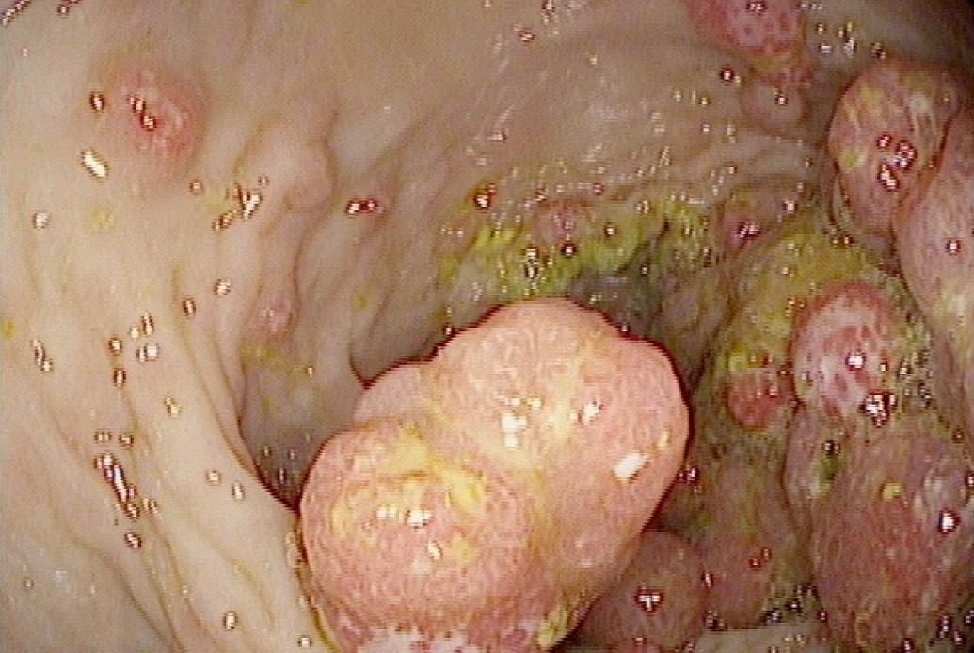
A
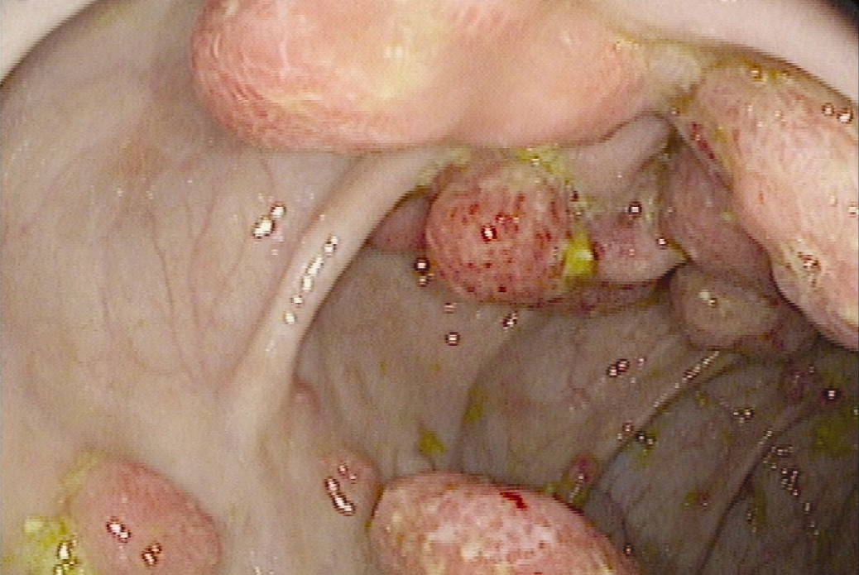
B
Figure 1 Endoscopic view. A: Polyps noted during colonoscopy, prior to colectomy; B: Endoscopic view of colonic polyps in the patient described.

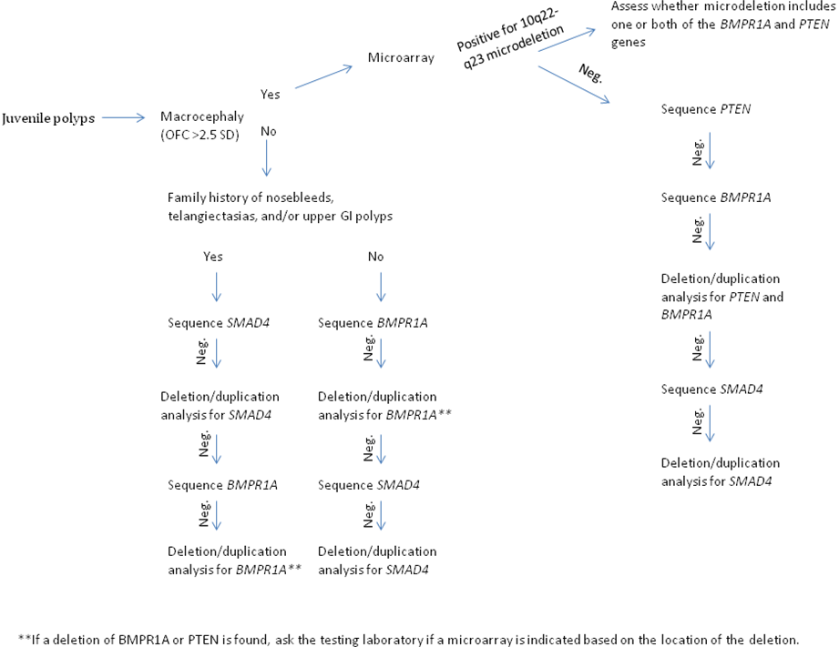
Figure 2 Algorithm for genetic testing and diagnosis of individuals with juvenile polyps. OFC: Occipital-frontal circumference.

