Name of journal: World Journal of Gastroenterology
ESPS Manuscript NO: 28669
Manuscript Type: ORIGINAL ARTICLE

Basic study
Non-invasive evaluation of liver stiffness after splenectomy on CCl₄-induced liver fibrosis in rabbits

Wang MJ et al. Liver stiffness measured by ElastPQ

Ming-Jun Wang, Wen-Wu Ling, Hong Wang, Ling-Wei Meng, He Cai, Bing Peng

Ming-Jun Wang, Ling-Wei Meng, He Cai, Bing Peng, Department of Pancreatic Surgery, West China Hospital, Chengdu 610041, Sichuan Province, China

Wen-Wu Ling, Hong Wang, Department of Ultrasound, West China Hospital, Chengdu 610041, Sichuan Province, China

Author contributions: Wang MJ designed the research; Wang MJ, Wang H and Ling WW performed the research; Meng LW and Cai H analyzed the data; Wang MJ wrote the paper; and Peng B approved the manuscript.

Institutional review board statement: The study protocol was approved by the Ethics Committees of the West China Hospital, Sichuan University, Chengdu, Sichuan, China.

Institutional animal care and use committee statement: The experimental procedures were approved by the Institutional Animal Ethical Committee of Sichuan University (Chengdu, China), and all animals received humane care according to the Guide for the Care and Use of Laboratory Animals published by the US National Institutes of Health (NIH Publication No. 85-23, revised 1996).

Conflict-of-interest statement: The authors declare that they have no conflicts of interest to report.

Data sharing statement: No additional data are available in this study.

Open-Access: This article is an open-access article which was selected by an in-house editor and fully peer-reviewed by external reviewers. It is distributed in accordance with the Creative Commons Attribution Non Commercial (CC BY-NC 4.0) license, which permits others to distribute, remix, adapt, build upon this work non-commercially, and license their derivative works on different terms, provided the original work is properly cited and the use is non-commercial. See: http://creativecommons.org/licenses/by-nc/4.0/

Manuscript source: Invited manuscript

Correspondence to: Bing Peng, MD, PhD, Department of Pancreatic Surgery, West China Hospital, No. 37, Guoxue Alley, Chengdu 610041, Sichuan Province, China. wmjjmw01pb@126.com
Telephone: +86-28-85433477
Fax: +86-28-85433474

Received: July 9, 2016
Peer-review started: July 13, 2016
First decision: August 29, 2016
Revised: September 3, 2016
Accepted: September 28, 2016

Article in press:
Published online:

Abstract
AIM
To investigate the diagnostic performance of the liver stiffness measurement (LSM) by elastography point quantification (ElastPQ) in animal models and assay the longitudinal changes of liver stiffness by ElastPQ after splenectomy at different fibrosis stages.

METHODS
The liver stiffness was measured in sixty-eight rabbits with CCl₄-induced different liver fibrosis stages and eight healthy control rabbits by ElastPQ. Liver biopsies and blood samples were obtained at scheduled time points for liver function and fibrosis degree analyses. Afterwards, thirty-one rabbits with complete data that underwent splenectomy at different liver fibrosis stages were included for dynamic monitoring of changes in the liver stiffness by ElastPQ and liver function according to blood tests.

RESULTS
LSM by ElastPQ significantly correlated with the histologic fibrosis stage (r = 0.85, P < 0.001). The optimal cutoff values by ElastPQ were 11.27, 14.89, and 18.21 kpa for predicting minimal fibrosis, moderate fibrosis, and cirrhosis, respectively. Longitudinal monitoring of the changes of liver stiffness by ElastPQ showed that early splenectomy (especially F1) might delay liver fibrosis progression.

CONCLUSION
ElastPQ is an available, convenient, objective and non-invasive technique for assessing the liver stiffness on CCl₄-induced liver fibrosis in rabbits. Additionally, liver stiffness measurements with ElastPQ could dynamically monitor the changes of the liver stiffness in rabbit models, or even patients, after splenectomy.

Key words: fibrosis stages splenectomy; elastography point quantification; liver stiffness no-invasive technique

© The Author(s) 2016. Published by Baishideng Publishing Group Inc. All rights reserved.

Core tip: elastography point quantification (ElastPQ) is a non-invasive technique for assessing the tissue stiffness, which we used in this study. Splenectomy is a surgical intervention for liver cirrhosis patients with hypersplenism. The aim of the current study is to evaluate the diagnostic accuracy of the liver stiffness measurement by ElastPQ in animal models and assay the longitudinal changes of liver stiffness by ElastPQ after splenectomy at different fibrosis stages. We concluded that liver stiffness measurements with ElastPQ could be used to dynamically monitor the changes in the liver stiffness in rabbit models, or patients, after splenectomy.

Wang MJ, Ling WW, Wang H, Meng LW, Cai H, Peng B. Non-invasive evaluation of liver stiffness after splenectomy on CCl₄-induced liver fibrosis in rabbits. World J Gastroenterol 2016; In press

Introduction
Liver fibrosis, which is characterized by encapsulation or replacement of injured tissue by a collagenous scar^{[1]}, represents a common pathological process for chronic liver injury of varying etiologies. Cirrhosis, which is morphologically described as an abnormal liver architecture encompassing fibrous bands surrounding regenerative nodules, is the end stage of liver fibrosis and has clinical complications, including liver failure, portal hypertension, and, ultimately, hepatocellular carcinoma. A growing body of clinical evidence has indicated that liver fibrosis could reverse and possibly return to normal condition following the development of effective treatments for chronic hepatitis infection (B and C)^{[2-6]}, autoimmune hepatitis^{[7]}, and primary biliary cirrhosis^{[8]}.
Additionally, improving results on the molecular mechanisms associated with the pathogenesis of hepatic fibrosis has led to growing acceptance of liver fibrosis as a potentially reversible process^{[9,10]}. Hepatic stellate cells (HSCs) are a worldwide research focus based on their activation and transdifferentiation to myofibroblasts, which ultimately results in liver fibrosis in response to a variety of injuries; more interestingly, previous studies indicated that macrophages could influence the process of liver fibrosis via different mechanisms^{[11,12]}. Circulating macrophages arise from monocytes in the bone marrow (BM)^{[13]}, and Swirski et al^{[14]} and other researchers have indicated that numerous monocytes in the spleen could be mobilized in the pathological state such that the spleen can be considered a monocyte reservoir^{[14-16]}. Bone marrow cell infusion can improve liver function^{[17]} and decrease liver fibrosis^{[18]}, while splenectomy can result in liver function improvements for liver cirrhotic patients^{[19-21]}. Furthermore, a previous study indicated that splenectomy attenuated murine liver fibrosis when accompanied by hypersplenism^{[22]}.
On the other hand, liver biopsy is traditionally regarded as the golden standard for staging fibrosis. Nevertheless, as an invasive procedure, liver biopsy is unwelcome for patients who need repeated examination to monitor fibrosis progression. Furthermore, liver biopsy is limited by serious complications^{[23,24]}, sample errors^{[25]}, and interpathologist and intrapathologist variabilities^{[26]}. Shear wave elastography, a reliable, rapid and non-invasive technique, has been used to evaluate tissue stiffness for many years and is increasingly important for liver fibrosis diagnoses^{[27-29]}. Furthermore, an acoustic radiation force impulse (ARFI) technique, elastography point quantification (ElastPQ)^{[30]}, has been developed to measure the tissue^{[31-34]}. However, no data are available on the evidence of changes in the fibrotic liver stiffness after splenectomy at different pathological stages from ElastPQ.
We took advantage of a CCl₄-induced liver fibrosis model in rabbits, from which liver biopsy could be obtained at scheduled time points and ElastPQ could be easily performed, to evaluate the correlation between liver fibrosis histological staging and liver stiffness measured by ElastPQ before splenectomy (Experiment 1). Additionally, we assayed the longitudinal changes of liver stiffness by ElastPQ after splenectomy at different pathological stages (Experiment 2).

Materials and Methods
Animals
One hundred and eight male New Zealand White rabbits weighing 2000-2500 g on arrival at the laboratory were purchased from the Experimental Animal Center of West China Medical Center, Sichuan University (Chengdu, China). All rabbits were acclimatized for one week to adapt to the new environment. Daily evaluation of the rabbit health status was performed for one week to make sure they were clinically healthy prior to the experiments. The animals were individually housed in cages under a set temperature (22 ± 1 ℃) and relative humidity (45% ± 10%) with a 12-h light/12-h dark cycle. Each animal was allowed free access to a standard diet for rabbits and fresh water. The experimental procedures were approved by the Institutional Animal Ethical Committee of Sichuan University (Chengdu, China), and all animals received humane care according to the Guide for the Care and Use of Laboratory Animals published by the United States National Institutes of Health (NIH Publication No. 85-23, revised 1996).

CCl₄-induced live fibrosis
Liver fibrosis was induced by CCl₄ intraperitoneal injection, as previously described^{[35]}. Unfortunately, in a pilot experiment (10 rabbits), using the regimen reported by Zhang et al^{[35]}, a mortality of 60% (6 out of 10 rabbits) was observed. The pilot study was stopped, and a modified method for liver fibrosis induction was explored and eventually adopted. The injection started with 50% CCl₄, which was diluted in olive oil, in doses of 0.10 mL/kg body weight twice per week for the first two weeks, which gave rabbits a period of time to gradually adapt to the toxic agent. Afterwards, 50% CCl₄ was intraperitoneally given in doses of 0.20 mL/kg body weight twice a week for another 18 wk in Experiment 1, and the liver injury induced by 50% CCl₄ lasted for ten weeks from the first operation in Experiment 2. This method was sufficient to produce all stages of liver fibrosis. Humane endpoints were established in the modeling process according to the guidelines for assessing discomfort in experiment animals^{[36]}. No animals died in Experiment 1.

Ultrasound-based examinations
On the same day, just before operation and blood collection, eight rabbits were chosen at random for preoperative examinations after at least four hours of fasting. The rabbits were anesthetized with a 40 mg/kg dose of pentobarbital via ear border vein injection and were then placed in the supine position with whole abdominal skin preparation. Afterwards, liver stiffness measurement was performed in or close to the subxiphoid region by two experienced examiners via ElastPQ with a 4-cm depth and a 0.5 cm × 1.5 cm region of interest (ROI) on vessel-free areas at the end-inspiration phase with an iU22 ultrasound system (Royal Philips Electronics, the Netherlands) that was equipped with an ElastPQ feature and two transducers, C5-1 (1-5 MHz) [used in this study] and L9-3 (3-9 MHz) [not used in this study]. Both examiners were blinded to the clinical, serological, and histological data. The results are expressed in kilopascals. ElastPQ results were obtained with 10 valid measurements from each operator; a success rate of at least 60% and an interquartile range of all successful measurements (IQR/M) less than 30% of the median values were considered reliable. The successful measurements obtained by each operator were used for inter-examiner agreement analysis, while the median measurement obtained by both operators for each rabbit were used for other analyses in the current study.

Serum parameters test
After ultrasound-based examinations, peripheral blood was collected via ear border vein. The levels of the following parameters were determined: (1) Class I biomarkers of liver fibrogenesis, including type IV collagen, and hyaluronic acid^{[37]}, were quantified using a standardized and optimized commercial radioimmunoassay kit (Haiyan Biotechnology Center, Shanghai, China) and (2) conventional liver function tests, including the total bilirubin (TB), albumin, alanine aminotransferase (ALT), and aspartate aminotransferase (AST) levels (Leadman Biochemistry Co., Ltd, Beijing, China).

Surgical procedure
For Experiment 1, after 4-wk modeling, the eight rabbits were randomly divided into two equal groups following preoperative examinations (ultrasound-based examinations and blood test mentioned above). After disinfection, the operation began with a midline abdominal incision. For one group (Group S, splenectomy group), total splenectomy was performed by ligature of the splenic vascular pedicle with 4-0 chromic catgut; then, a 1-cm × 1-cm piece of hepatic tissue from the subxiphoid region of the liver was cut for biopsy. For another group (Group L, liver biopsy group or named sham group), the same process was performed with the exception of total splenectomy. The abdominal cavity was closed after checking that there was no active hemorrhage for all rabbits. To obtain different stages of liver fibrosis at different time intervals, the same surgical process was repeated for the remaining rabbits every two weeks until the 20th week. Specifically, because of humane endpoints and failed liver stiffness measurements, only seven rabbits remained for operation at the 8th, 14th, 18th, and 20th weeks (Table 1). In this case, four rabbits randomly underwent splenectomy plus liver biopsy, while the remaining three underwent liver biopsy alone.
For Experiment 2, after the first operation for each rabbit, a 1 × 1-cm piece of hepatic tissue was cut to dynamically monitor the changes in histological features according to the aforementioned ultrasound-based examinations and blood tests every two weeks for 10 wk. To avoid adhesion, chitosan (0.5 mL/surgery) was used. Even so, along with the increase in the operation times, it was difficult to acquire liver tissue along the original midline incision. In this case, a left or right subcostal incision was needed. For Experiments 1 and 2, all animals were intramuscularly given penicillin in doses of 40 U/rabbit to prevent infection during the operation, which was repeated once daily for another two days. To reduce bias, only the hepatic tissue obtained in or very close to the subxiphoid region was included for analysis. Additionally, by the same token (humane endpoints) and because of failed LSM and death during the surgical procedure, only thirty-one rabbits with complete experimental data were available for analysis after the 10-wk surveillance period (Table 1).

Liver histological assessment
Liver biopsy samples taken at the time of the operation were fixed in formalin and embedded in paraffin. Sections (4 μm) were stained with hematoxylin and eosin (HE) and Masson trichrome. A biopsy sample with a minimum of 5 portal tracts was required for diagnosis. Two doctors with significant experience, who were blinded to all animal characteristics, were responsible for evaluating liver fibrosis, which was staged on a scale of 0-4 according to METAVIR^{[38]} (F0, no fibrosis; F1, portal fibrosis without septa; F2, portal fibrosis and a few septa; F3, numerous septa without cirrhosis; and F4, cirrhosis). The fibrosis stage was independently assessed on each histological section by both doctors. In case of discrepancies, histological sections were simultaneously reviewed again by the two doctors to reach a final consensus. Typical liver fibrosis stages (F1-F4) are illustrated in Figure 1.

Statistical analysis
The quadratic-weighted k coefficient of Cohen was used to assess the consistency of the two doctors who were in charge of the pathological examinations, while the ICC (interclass correlation coefficient) was used to evaluate the agreement between the two examiners who performed the liver stiffness measurement via ElastPQ.
The median LSM obtained by both operators for each rabbit ElastPQ was calculated and used for further analyses. Because the LSM values were not normally distributed, the Kruskal-Wallis nonparametric analysis of variance test was used to compare these values with the categories of the consensus fibrosis stage. Correlations between the LSM and histologic fibrosis stage were further analyzed using Spearman correlation coefficients. The diagnostic performance of ElastPQ and serum fibrosis markers, including type IV collagen and hyaluronic acid, was assessed using receiver operating characteristics curves (ROC). The optimal cutoff values for predicting different fibrosis stages were chosen to maximize the sum of the sensitivity and specificity, and the corresponding positive predictive values (PPV), negative predictive values (NPV) were computed. The AUC (area under ROC) values for the different diagnostic criteria for the same data were compared using the nonparametric DeLong test.
Quantitative data were presented as the mean ± SD (standard deviation) or median (quartile), while categorical data were expressed as the number of cases with/without percentage. Statistical analyses also included the nonparametric Mann-Whitney U and Student’s t tests.
All statistical analyses were performed using SPSS 19.0 (SPSS, Chicago, IL, United States) for windows and with significance set at a P value < 0.05.

Results
Experimental details
The experimental details are presented in Table 1. In addition to eight blank controls, ninety rabbits were planned for inclusion. As mentioned in the materials and methods section because of humane termination (n = 19) and failed LSM (n = 3) during Experiment 1, sixty-eight rabbits with available information remained for analysis. Similarly, over the 10 wk after splenectomy or sham operation, only thirty-one rabbits with complete data remained for comparable analyses.

Agreement between observers
The two doctors responsible for pathological diagnosis were initially in agreement for 197 (85.3%) of the 231 liver samples (231 = 7 + 5×31) (k coefficient = 0.792, P < 0.01), and the agreement reached 100% after the final reviews. The ElastPQ results identified by the two examiners were strongly correlated with an ICC value of 0.888, which is illustrated in Figure 2.

Basic characteristics of the included rabbits
After 20 wk of medication, all fibrosis stages confirmed by pathological examinations were obtained. As is shown in Table 2, F1 was diagnosed in 11 cases (14.5%), F2 in 16 (21.1%), F3 in 16 (21.1%), and F4 in 25 (32.9%), and eight healthy rabbits (F0, n = 8, 10.4%) were included as blank controls. Table 3 includes the basic information of rabbits with different fibrosis stages. Except for the body weight and total bilirubin, AST, ALT, and albumin levels, a trend of stepwise increase with liver fibrosis progression was found in the parameters, including type IV collagen (F0: 200.8 ± 131.5, F1: 427.1 ± 226.2, F2: 683.4 ± 332.5, F3: 1161.4 ± 482.5, and F4: 1292.0 ± 689.7), hyaluronic acid (F0: 225.6 ± 117.1, F1: 475.7 ± 296.4, F2: 676.2 ± 274.8, F3: 724.0 ± 264.5, and F4: 1182.3 ± 1091.3), and LSM [F0: 7.88 (6.60-8.46), F1: 8.46 (6.22-10.35), F2: 10.89 (8.09-14.46), F3: 18.62 (16.03-21.16), and F4: 25.10 (20.28-30.95)].

Relationship between histological findings and LSM by ElastPQ
The median liver stiffness measured with ElastPQ in the eight controls was 7.88 (6.60-8.46). The liver stiffness measured in the fibrosis rabbits ranged from 5.86 to 39.12. Based on the different fibrosis stages, the median liver stiffness values in the fibrosis candidates with F1 to F4 were 8.46 (6.22-10.35), 10.89 (8.09-14.46), 18.62 (16.03-21.16), and 25.10 (20.28-30.95), respectively, indicating a gradual increase with fibrosis progression, which is shown in Figure 3, with a Spearman correlation coefficient of 0.85 (P < 0.001). Given that the distributions of ElastPQ results for F0 and F1 were comparable and only eight F0 rabbits were included, F0 and F1 rabbits were combined as a single group for further analyses. Significant differences in the LSM by ElastPQ between each fibrosis stage were observed (F0-1 vs F2, P < 0.01; F2 vs F3, P < 0.01; and F3 vs F4, P < 0.01).

Relationship between the LSM by ElastPQ and fibrosis blood tests
ROC curves of ElastPQ, hyaluronic acid, and type IV collagen for predicting minimal fibrosis (F0-F1 vs F2-F4), moderate fibrosis (F0-F2 vs F3-F4), and cirrhosis (F0-F3 vs F4) were drawn in Figure 4 A-C. The AUROC (area under ROC) of ElastPQ for predicting minimal fibrosis (0.931, 95%CI: 0.849-0.977) was comparable to those of hyaluronic acid (0.807, 95%CI: 0.700-0.889) and type IV collagen (0.919, 95%CI: 0.833-0.969), while the ElastPQ for predicting moderate fibrosis and cirrhosis (0.969, 95%CI: 0.901-0.995; 0.925, 95%CI: 0.841-0.973) was significantly superior to hyaluronic acid (0.677, 95%CI: 0.560-0.780; 0.670, 95%CI: 0.553-0.774) and type IV collagen (0.861, 95%CI: 0.762-0.930; 0.695, 95%CI: 0.578-0.795), which is summarized in Table 4. Afterwards, the ElastPQ critical values for differentiating fibrosis stages were confirmed according to the ROC, and the corresponding specificities, sensitivities, positive predictive values (PPVs), and negative predictive values (NPVs) are listed in Table 5.

Longitudinal change trends in the LSM by ElastPQ and liver function following splenectomy
The longitudinal ElastPQ and laboratory data for the included rabbits with different fibrosis stages after splenectomy and sham operation in Experiment 2 are shown in Tables 6 and 7. For the nine rabbits with F1 liver fibrosis (five in the splenectomy group vs. four in the sham group), the increase in the ElastPQ values was delayed in the splenectomy group compared with that in the sham group during a period of 10 weeks following the operations (Figure 5A), while the change trend of other laboratory parameters, including the AST, ALT, albumin, and TB levels, indicated otherwise (Figure 6, Table 7). For the rabbits with F2, F3, and F4 liver fibrosis, no favorable change trend in the parameters, including the ElastPQ, AST, ALT, albumin, and TB levels, was detected in the splenectomy group compared with the sham group over the ten weeks after the operations (Figure 5B-D, Figure 6 and Table 7).

Discussion
In the current study, after four to twenty weeks of fibrosis induction, the LSM increased from 7.88 kpa to 5.86-39.12 kpa in all rabbits that had different proven fibrosis stages. Two specific serum markers of liver fibrogenesis (type IV collagen and hyaluronic acid) were selected to reflect the progression of CCl₄-induced liver fibrosis, and both had a step-wise correlation with the liver fibrosis stages compared to the LSM via ElastPQ, reinforcing that ElastPQ could reflect the severity of liver fibrosis. However, the compatibility of the baseline values for the liver stiffness in different studies is unavailable, which is mainly attributed to variations in the modeling methods and species.
Although there was a significant increase in the LSM via ElastPQ, alongside the increase in the fibrosis stage, there was a degree of overlap between consecutive stages. In this study, for F0-F2 liver fibrosis categories, the LSM was 7.88 (6.60-8.46), 8.46 (6.22-10.35), and 10.89 (8.09-14.46), respectively, which could be due to insufficient number of included candidates with F0-F2. Additionally, a similar concern was reported in a previous study on the ARFI for assessing liver fibrosis^{[39]}. The ElastPQ cutoff values for minimal fibrosis (F0-F1 vs F2-F4), moderate fibrosis (F0-F2 vs F3-F4), and cirrhosis (F0-F3 vs F4) were defined. As is shown in Table 5, the ElastPQ cutoff values for predicting different fibrosis stages can be clearly distinguished, which may be due to the relatively uniform distribution of rabbits with different fibrosis stages.
The areas under the ROC curves were compared in ElastPQ, hyaluronic acid and type IV collagen. The ElastPQ prediction of minimal fibrosis was comparable to that for hyaluronic acid and type IV collagen, while the ElastPQ prediction of moderate fibrosis and cirrhosis was significantly superior to hyaluronic acid. This outcome supports that this non-invasive technique could have clinical utility.
As basic research continues, the concept of liver fibrosis has changed from static and progressive to dynamic and bidirectional, especially when the causes of liver damage have been removed. Additionally, because there is a significant correlation between the ElastPQ values and liver fibrosis stages, it is theoretically possible to use ElastPQ to non-invasively assess the effect of anti-fibrosis treatments. Indeed, previous studies have reported on the clinical application of TE for dynamically monitoring fibrosis regression during antiviral treatment in chronic hepatitis B and C patients, indicating that the TE values seem to decrease during antiviral therapy^{[40,41]}.
Although splenectomy was performed for patients with hypersplenism in some institutions^{[21,42]}, hypersplenism in most patients should be considered as a laboratory abnormality that does not require treatment or further consideration^{[43]}. However, a previous well-designed study indicated that splenectomy attenuated murine liver fibrosis^{[22]}. Therefore, splenectomy remains controversial for patients with hypersplenism. In the present study, splenectomy was only used for grouping rabbits and then exploring whether splenectomy at different liver fibrosis stages will delay or reverse the progression of liver fibrosis. A previous study indicated that the spleen plays an important regulatory role in rat liver cirrhosis induced by a choline-deficient L-amino acid-defined diet^{[44]}. In this study, a trend that splenectomy can delay the progression of early liver fibrosis (especially F1) was detected. A previous study using a rat liver fibrosis model indicated that spleen-derived TGF-β1 is involved in the development of liver fibrosis such that decreasing the TGF-β1 level by splenectomy could inhibit hepatic stellate cell activation and then improve liver fibrosis^{[45]}. However, in the present study, splenectomy did not seem to improve late liver fibrosis (especially types F3 and F4); therefore, there may be another potential mechanism for improving early liver fibrosis following splenectomy.
Although activated hepatic stellate cells have a great impact on liver fibrogenesis, recent studies have suggested that monocytes and their progeny macrophages are additionally responsible for liver fibrosis^{[46,47]}. Based on a study of monocytes derived from bone marrow (BM)^{[13]} as well as studies by Swirski FK and other researchers, there are numerous monocytes in the spleen that could be mobilized in pathological states. As a result, the spleen can be considered a monocyte reservoir^{[14-16]}. An interesting previous study demonstrated that the spleen a site for storing and rapidly deploying monocytes that are involved in inflammation regulation^{[14]}. Therefore, performing splenectomy in the early stages of liver fibrosis would block the rapid deployment of monocytes to the liver, which may alleviate the inflammation reaction and delay liver fibrosis. By contrast, performing splenectomy in the late stage would not help to postpone liver fibrosis, which may be explained by the hypothesis that during the late stage, monocytes from bone marrow play a predominate role in liver fibrosis. However, it should be further determined whether the diversity of monocyte origin influences the different stages of liver fibrosis.
In summary, ElastPQ is an available, convenient, objective and non-invasive technique for assessing the liver stiffness in CCl₄-induced rabbits with liver fibrosis, which paves the way for its clinical application. Additionally, liver stiffness measurements with ElastPQ could dynamically monitor the changes in liver stiffness in rabbit models, or patients, after splenectomy. However, the underlying mechanism by which early splenectomy could decelerate liver fibrosis should be further studied.

COMMENTS
Background
elastography point quantification (ElastPQ) is a non-invasive technique for assessing the tissue stiffness, and it was used in this study. Splenectomy is a surgical intervention for liver cirrhosis patients with hypersplenism. However, no data about the evidence of changes in fibrotic liver stiffness after splenectomy at different pathological stages from ElastPQ have previously been available.

Research frontiers
Liver biopsy is the reference standard for staging fibrosis. Nevertheless, because of its invasive nature, liver biopsy is difficult to perform in patients who require repeated examination to monitor liver fibrosis progression. An acoustic radiation force impulse (ARFI) technique, ElastPQ, has been developed for measuring tissue stiffness. In this study, the author used a liver fibrosis animal model to demonstrate that ElastPQ is an available, convenient, objective and non-invasive technique for assessing the liver stiffness in rabbits with CCl₄-induced liver fibrosis. Additionally, the changes in the liver stiffness in rabbit models, or patients, after splenectomy can be dynamically monitored by ElastPQ.

Innovations and breakthrough
This is the first animal experiment that confirmed that liver stiffness measurements with ElastPQ could be used to dynamically monitor the changes in liver stiffness. The results provide good news for liver fibrosis patients who are in need of long-term follow-up.

Applications
Based on this study, ElastPQ could dynamically monitor the changes in liver stiffness after interventions.

Terminology
ElastPQ is an ARFI technique that can non-invasively measure tissue stiffness.

Peer-review
This is a well-supported paper presenting a study on utilizing CCl₄-induced liver fibrosis to evaluate liver stiffness measurement approaches.

References
1 Schuppan D, Afdhal NH. Liver cirrhosis. Lancet 2008; 371: 838-851 [PMID: 18328931 DOI: 10.1016/S0140-6736(08)60383-9]
2 Papatheodoridis GV, Petraki K, Cholongitas E, Kanta E, Ketikoglou I, Manesis EK. Impact of interferon-alpha therapy on liver fibrosis progression in patients with HBeAg-negative chronic hepatitis B. J Viral Hepat 2005; 12: 199-206 [PMID: 15720536 DOI: 10.1111/j.1365-2893.2005.00582.x]
3 Dienstag JL, Goldin RD, Heathcote EJ, Hann HW, Woessner M, Stephenson SL, Gardner S, Gray DF, Schiff ER. Histological outcome during long-term lamivudine therapy. Gastroenterology 2003; 124: 105-117 [PMID: 12512035 DOI: 10.1053/gast.2003.50013]
4 Poynard T, McHutchison J, Manns M, Trepo C, Lindsay K, Goodman Z, Ling MH, Albrecht J. Impact of pegylated interferon alfa-2b and ribavirin on liver fibrosis in patients with chronic hepatitis C. Gastroenterology 2002; 122: 1303-1313 [PMID: 11984517]
5 George SL, Bacon BR, Brunt EM, Mihindukulasuriya KL, Hoffmann J, Di Bisceglie AM. Clinical, virologic, histologic, and biochemical outcomes after successful HCV therapy: a 5-year follow-up of 150 patients. Hepatology 2009; 49: 729-738 [PMID: 19072828 DOI: 10.1002/hep.22694]
6 Mallet V, Gilgenkrantz H, Serpaggi J, Verkarre V, Vallet-Pichard A, Fontaine H, Pol S. Brief communication: the relationship of regression of cirrhosis to outcome in chronic hepatitis C. Ann Intern Med 2008; 149: 399-403 [PMID: 18794559]
7 Czaja AJ, Carpenter HA. Decreased fibrosis during corticosteroid therapy of autoimmune hepatitis. J Hepatol 2004; 40: 646-652 [PMID: 15030981 DOI: 10.1016/j.jhep.2004.01.009]
8 Kaplan MM, DeLellis RA, Wolfe HJ. Sustained biochemical and histologic remission of primary biliary cirrhosis in response to medical treatment. Ann Intern Med 1997; 126: 682-688 [PMID: 9139553]
9 Sun M, Kisseleva T. Reversibility of liver fibrosis. Clin Res Hepatol Gastroenterol 2015; 39 Suppl 1: S60-S63 [PMID: 26206574 DOI: 10.1016/j.clinre.2015.06.015]
10 Atta HM. Reversibility and heritability of liver fibrosis: Implications for research and therapy. World J Gastroenterol 2015; 21: 5138-5148 [PMID: 25954087 DOI: 10.3748/wjg.v21.i17.5138]
11 Rantakari P, Patten DA, Valtonen J, Karikoski M, Gerke H, Dawes H, Laurila J, Ohlmeier S, Elima K, Hübscher SG, Weston CJ, Jalkanen S, Adams DH, Salmi M, Shetty S. Stabilin-1 expression defines a subset of macrophages that mediate tissue homeostasis and prevent fibrosis in chronic liver injury. Proc Natl Acad Sci USA 2016; 113: 9298-9303 [PMID: 27474165 DOI: 10.1073/pnas.1604780113]
12 Chu PS, Nakamoto N, Ebinuma H, Usui S, Saeki K, Matsumoto A, Mikami Y, Sugiyama K, Tomita K, Kanai T, Saito H, Hibi T. C-C motif chemokine receptor 9 positive macrophages activate hepatic stellate cells and promote liver fibrosis in mice. Hepatology 2013; 58: 337-350 [PMID: 23460364 DOI: 10.1002/hep.26351]
13 Geissmann F, Manz MG, Jung S, Sieweke MH, Merad M, Ley K. Development of monocytes, macrophages, and dendritic cells. Science 2010; 327: 656-661 [PMID: 20133564 DOI: 10.1126/science.1178331]
14 Swirski FK, Nahrendorf M, Etzrodt M, Wildgruber M, Cortez-Retamozo V, Panizzi P, Figueiredo JL, Kohler RH, Chudnovskiy A, Waterman P, Aikawa E, Mempel TR, Libby P, Weissleder R, Pittet MJ. Identification of splenic reservoir monocytes and their deployment to inflammatory sites. Science 2009; 325: 612-616 [PMID: 19644120 DOI: 10.1126/science.1175202]
15 Venosa A, Malaviya R, Gow AJ, Hall L, Laskin JD, Laskin DL. Protective role of spleen-derived macrophages in lung inflammation, injury, and fibrosis induced by nitrogen mustard. Am J Physiol Lung Cell Mol Physiol 2015; 309: L1487-L1498 [PMID: 26475734 DOI: 10.1152/ajplung.00276.2015]
16 Kim E, Yang J, Beltran CD, Cho S. Role of spleen-derived monocytes/macrophages in acute ischemic brain injury. J Cereb Blood Flow Metab 2014; 34: 1411-1419 [PMID: 24865998 DOI: 10.1038/jcbfm.2014.101]
17 Terai S, Ishikawa T, Omori K, Aoyama K, Marumoto Y, Urata Y, Yokoyama Y, Uchida K, Yamasaki T, Fujii Y, Okita K, Sakaida I. Improved liver function in patients with liver cirrhosis after autologous bone marrow cell infusion therapy. Stem Cells 2006; 24: 2292-2298 [PMID: 16778155 DOI: 10.1634/stemcells.2005-0542]
18 Kisseleva T, Brenner DA. The phenotypic fate and functional role for bone marrow-derived stem cells in liver fibrosis. J Hepatol 2012; 56: 965-972 [PMID: 22173163 DOI: 10.1016/j.jhep.2011.09.021]
19 Shimada M, Hashizume M, Shirabe K, Takenaka K, Sugimachi K. A new surgical strategy for cirrhotic patients with hepatocellular carcinoma and hypersplenism. Performing a hepatectomy after a laparoscopic splenectomy. Surg Endosc 2000; 14: 127-130 [PMID: 10656943]
20 Ushitora Y, Tashiro H, Takahashi S, Amano H, Oshita A, Kobayashi T, Chayama K, Ohdan H. Splenectomy in chronic hepatic disorders: portal vein thrombosis and improvement of liver function. Dig Surg 2011; 28: 9-14 [PMID: 21293126 DOI: 10.1159/000321886]
21 Yamamoto N, Okano K, Oshima M, Akamoto S, Fujiwara M, Tani J, Miyoshi H, Yoneyama H, Masaki T, Suzuki Y. Laparoscopic splenectomy for patients with liver cirrhosis: Improvement of liver function in patients with Child-Pugh class B. Surgery 2015; 158: 1538-1544 [PMID: 26070848 DOI: 10.1016/j.surg.2015.05.008]
22 Yada A, Iimuro Y, Uyama N, Uda Y, Okada T, Fujimoto J. Splenectomy attenuates murine liver fibrosis with hypersplenism stimulating hepatic accumulation of Ly-6C(lo) macrophages. J Hepatol 2015; 63: 905-916 [PMID: 26022691 DOI: 10.1016/j.jhep.2015.05.010]
23 Procopet B, Bureau C, Métivier S, Selves J, Robic MA, Christol C, Grigorescu M, Vinel JP, Péron JM. Tolerance of liver biopsy in a tertiary care center: comparison of the percutaneous and the transvenous route in 143 prospectively followed patients. Eur J Gastroenterol Hepatol 2012; 24: 1209-1213 [PMID: 22668874 DOI: 10.1097/MEG.0b013e328355e2ba]
24 Cadranel JF, Rufat P, Degos F. Practices of liver biopsy in France: results of a prospective nationwide survey. For the Group of Epidemiology of the French Association for the Study of the Liver (AFEF). Hepatology 2000; 32: 477-481 [PMID: 10960438 DOI: 10.1053/jhep.2000.16602]
25 Bedossa P, Dargère D, Paradis V. Sampling variability of liver fibrosis in chronic hepatitis C. Hepatology 2003; 38: 1449-1457 [PMID: 14647056 DOI: 10.1016/j.hep.2003.09.022]
26 Rousselet MC, Michalak S, Dupré F, Croué A, Bedossa P, Saint-André JP, Calès P. Sources of variability in histological scoring of chronic viral hepatitis. Hepatology 2005; 41: 257-264 [PMID: 15660389 DOI: 10.1002/hep.20535]
27 Ozturker C, Karagoz E, Mutlu H. Noninvasive Evaluation of Liver Fibrosis by Using Two-dimensional Shear-Wave Elastography. Radiology 2016; 280: 323-324 [PMID: 27322979 DOI: 10.1148/radiol.2016152531]
28 Kazemirad S, Zhang E, Nguyen BN, Bodson-Clermont P, Destrempes F, Trudel D, Cloutier G, Tang A. Detection of Steatohepatitis in a Rat Model by Using Spectroscopic Shear-Wave US Elastography. Radiology 2016; Epub ahead of print [PMID: 27513850 DOI: 10.1148/radiol.2016160308]
29 Jansen C, Bogs C, Verlinden W, Thiele M, Moller P, Gortzen J, Lehmann J, Vanwolleghem T, Vonghia L, Praktiknjo M, Chang J, Krag A, Strassburg CP, Francque S, Trebicka J. Shear-wave Elastography of the liver and spleen identifies clinically significant portal hypertension: a prospective multi-center study. Liver Int 2016; Epub ahead of print [PMID: 27569696 DOI: 10.1111/liv.13243]
30 Xie H, Shamdasani V, Fernandez AT, Peterson R, Lachman M, Shi Y, Robert J-L, Urban M, Chen S, Greenleaf J. Shear wave Dispersion Ultrasound Vibrometry (SDUV) on an ultrasound system: In vivo measurement of liver viscoelasticity in healthy animals. in Ultrasonics Symposium (IUS), 2010 IEEE. 2010.
31 Barr RG, Ferraioli G, Palmeri ML, Goodman ZD, Garcia-Tsao G, Rubin J, Garra B, Myers RP, Wilson SR, Rubens D, Levine D. Elastography Assessment of Liver Fibrosis: Society of Radiologists in Ultrasound Consensus Conference Statement. Radiology 2015; 276: 845-861 [PMID: 26079489 DOI: 10.1148/radiol.2015150619]
32 Ma JJ, Ding H, Mao F, Sun HC, Xu C, Wang WP. Assessment of liver fibrosis with elastography point quantification technique in chronic hepatitis B virus patients: a comparison with liver pathological results. J Gastroenterol Hepatol 2014; 29: 814-819 [PMID: 24325607 DOI: 10.1111/jgh.12479]
33 Ferraioli G, Tinelli C, Lissandrin R, Zicchetti M, Dal Bello B, Filice G, Filice C. Point shear wave elastography method for assessing liver stiffness. World J Gastroenterol 2014; 20: 4787-4796 [PMID: 24782633 DOI: 10.3748/wjg.v20.i16.4787]
34 Ferraioli G, Filice C, Castera L, Choi BI, Sporea I, Wilson SR, Cosgrove D, Dietrich CF, Amy D, Bamber JC, Barr R, Chou YH, Ding H, Farrokh A, Friedrich-Rust M, Hall TJ, Nakashima K, Nightingale KR, Palmeri ML, Schafer F, Shiina T, Suzuki S, Kudo M. WFUMB guidelines and recommendations for clinical use of ultrasound elastography: Part 3: liver. Ultrasound Med Biol 2015; 41: 1161-1179 [PMID: 25800942 DOI: 10.1016/j.ultrasmedbio.2015.03.007]
35 Zhang L, Duan YY, Yin JK, Cui JH, Zhang Y, Cao TS. Grey scale enhancement by a new self-made contrast agent in early cirrhotic stage of rabbit liver. BMC Gastroenterol 2007; 7: 32 [PMID: 17686161 DOI: 10.1186/1471-230x-7-32]
36 Morton DB, Griffiths PH. Guidelines on the recognition of pain, distress and discomfort in experimental animals and an hypothesis for assessment. Vet Rec 1985; 116: 431-436 [PMID: 3923690]
37 Gressner OA, Weiskirchen R, Gressner AM. Biomarkers of hepatic fibrosis, fibrogenesis and genetic pre-disposition pending between fiction and reality. J Cell Mol Med 2007; 11: 1031-1051 [PMID: 17979881 DOI: 10.1111/j.1582-4934.2007.00092.x]
38 Bedossa P, Poynard T. An algorithm for the grading of activity in chronic hepatitis C. The METAVIR Cooperative Study Group. Hepatology 1996; 24: 289-293 [PMID: 8690394 DOI: 10.1002/hep.510240201]
39 Lupsor M, Badea R, Stefanescu H, Sparchez Z, Branda H, Serban A, Maniu A. Performance of a new elastographic method (ARFI technology) compared to unidimensional transient elastography in the noninvasive assessment of chronic hepatitis C. Preliminary results. J Gastrointestin Liver Dis 2009; 18: 303-310 [PMID: 19795024]
40 Enomoto M, Mori M, Ogawa T, Fujii H, Kobayashi S, Iwai S, Morikawa H, Tamori A, Sakaguchi H, Sawada A, Takeda S, Habu D, Shiomi S, Kawada N. Usefulness of transient elastography for assessment of liver fibrosis in chronic hepatitis B: Regression of liver stiffness during entecavir therapy. Hepatol Res 2010; 40: 853-861 [PMID: 20887589 DOI: 10.1111/j.1872-034X.2010.00687.x]
41 Arima Y, Kawabe N, Hashimoto S, Harata M, Nitta Y, Murao M, Nakano T, Shimazaki H, Kobayashi K, Ichino N, Osakabe K, Nishikawa T, Okumura A, Ishikawa T, Yoshioka K. Reduction of liver stiffness by interferon treatment in the patients with chronic hepatitis C. Hepatol Res 2010; 40: 383-392 [PMID: 20236358 DOI: 10.1111/j.1872-034X.2009.00618.x]
42 Yu H, Guo S, Wang L, Dong Y, Tian G, Mu S, Zhang H, Li D, Zhao S. Laparoscopic Splenectomy and Esophagogastric Devascularization for Liver Cirrhosis and Portal Hypertension Is a Safe, Effective, and Minimally Invasive Operation. J Laparoendosc Adv Surg Tech A 2016; 26: 524-530 [PMID: 27064936 DOI: 10.1089/lap.2016.0032]
43 Boyer TD, Habib S. Big spleens and hypersplenism: fix it or forget it? Liver Int 2015; 35: 1492-1498 [PMID: 25312770 DOI: 10.1111/liv.12702]
44 Oishi T, Terai S, Iwamoto T, Takami T, Yamamoto N, Sakaida I. Splenectomy reduces fibrosis and preneoplastic lesions with increased triglycerides and essential fatty acids in rat liver cirrhosis induced by a choline-deficient L-amino acid-defined diet. Hepatol Res 2011; 41: 463-474 [PMID: 21435125 DOI: 10.1111/j.1872-034X.2011.00784.x]
45 Akahoshi T, Hashizume M, Tanoue K, Shimabukuro R, Gotoh N, Tomikawa M, Sugimachi K. Role of the spleen in liver fibrosis in rats may be mediated by transforming growth factor beta-1. J Gastroenterol Hepatol 2002; 17: 59-65 [PMID: 11895554 DOI: 10.1046/j.1440-1746.2002.02667.x]
46 Tacke F, Zimmermann HW. Macrophage heterogeneity in liver injury and fibrosis. J Hepatol 2014; 60: 1090-1096 [PMID: 24412603 DOI: 10.1016/j.jhep.2013.12.025]
47 Baeck C, Wei X, Bartneck M, Fech V, Heymann F, Gassler N, Hittatiya K, Eulberg D, Luedde T, Trautwein C, Tacke F. Pharmacological inhibition of the chemokine C-C motif chemokine ligand 2 (monocyte chemoattractant protein 1) accelerates liver fibrosis regression by suppressing Ly-6C(+) macrophage infiltration in mice. Hepatology 2014; 59: 1060-1072 [PMID: 24481979 DOI: 10.1002/hep.26783]
P-Reviewer: Bubnov RV, Ferraioli G, Gorrell MD S-Editor: Gong ZM
L-Editor: E-Editor:
Specialty type: Gastroenterology and hepatology
Country of origin: China
Peer-review report classification
Grade A (Excellent): A
Grade B (Very good): 0
Grade C (Good): C, C
Grade D (Fair): 0
Grade E (Poor): 0

A1 A2
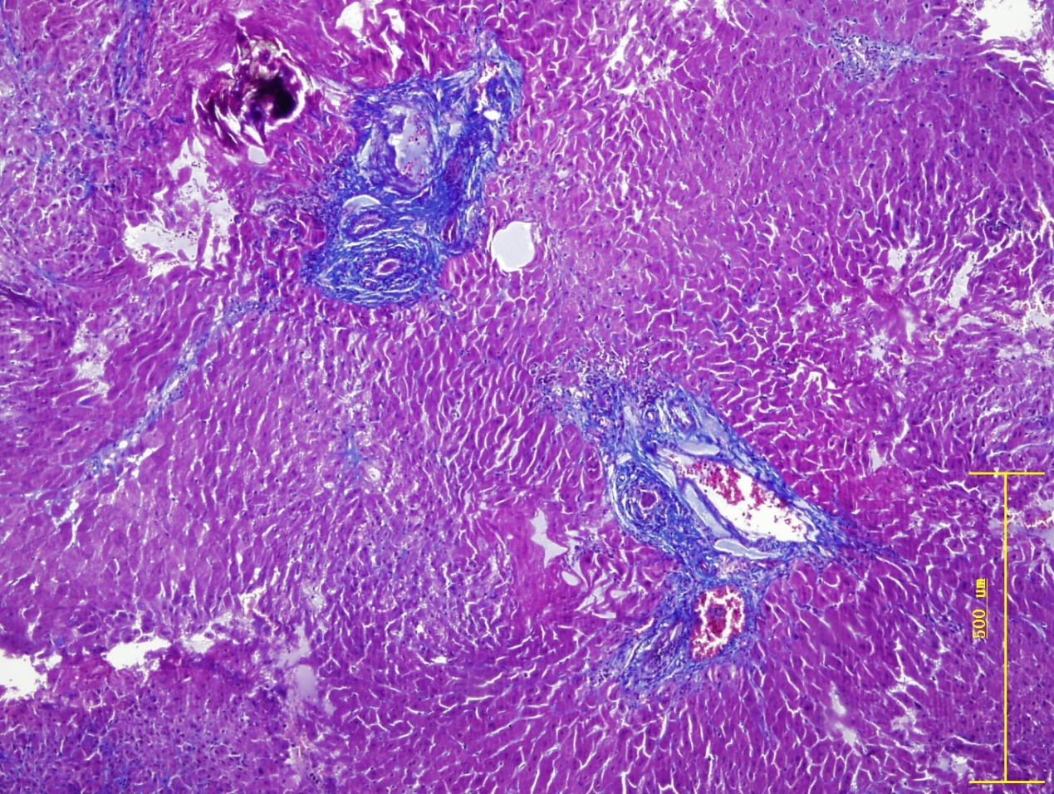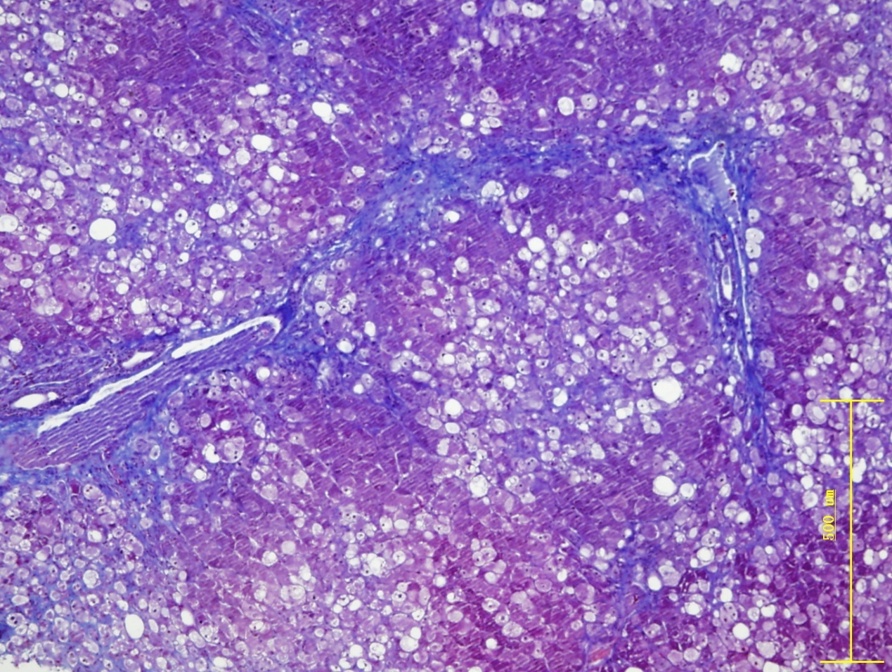
A3 A4
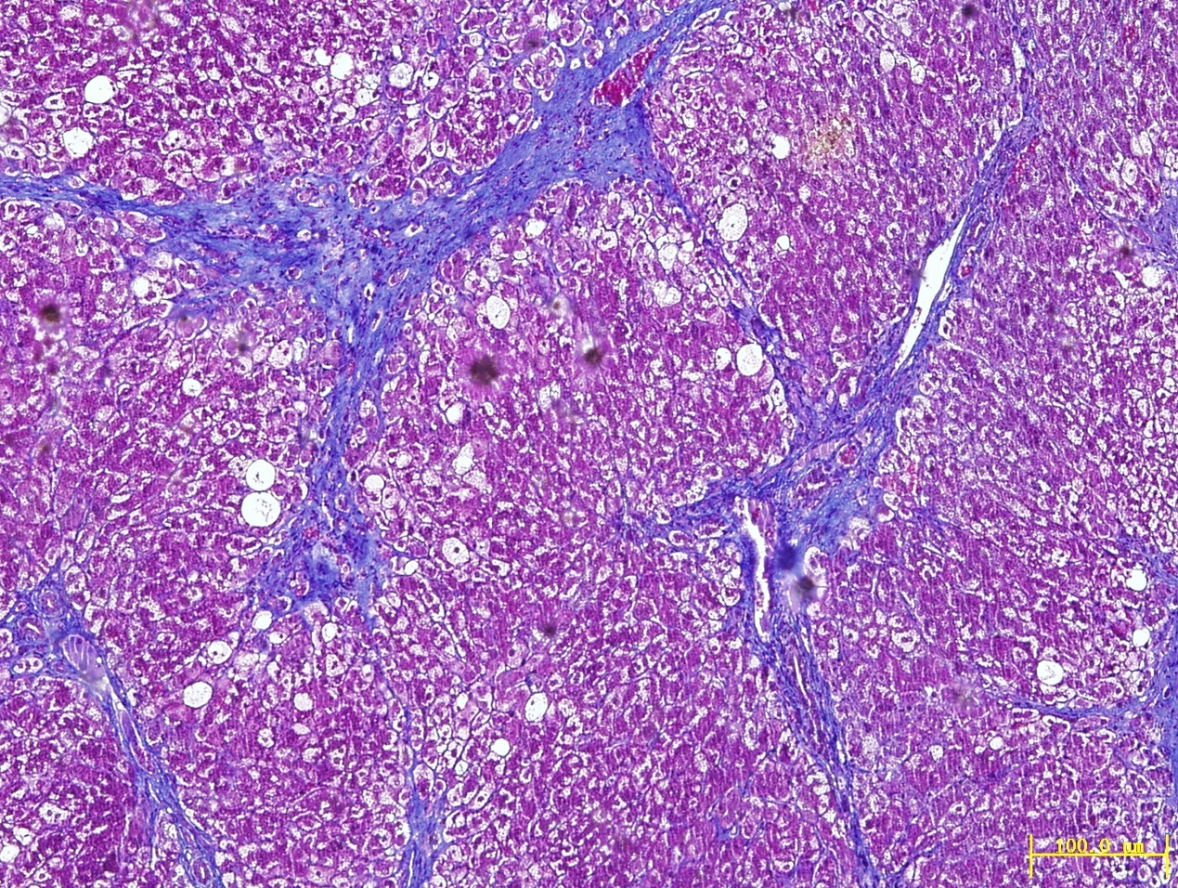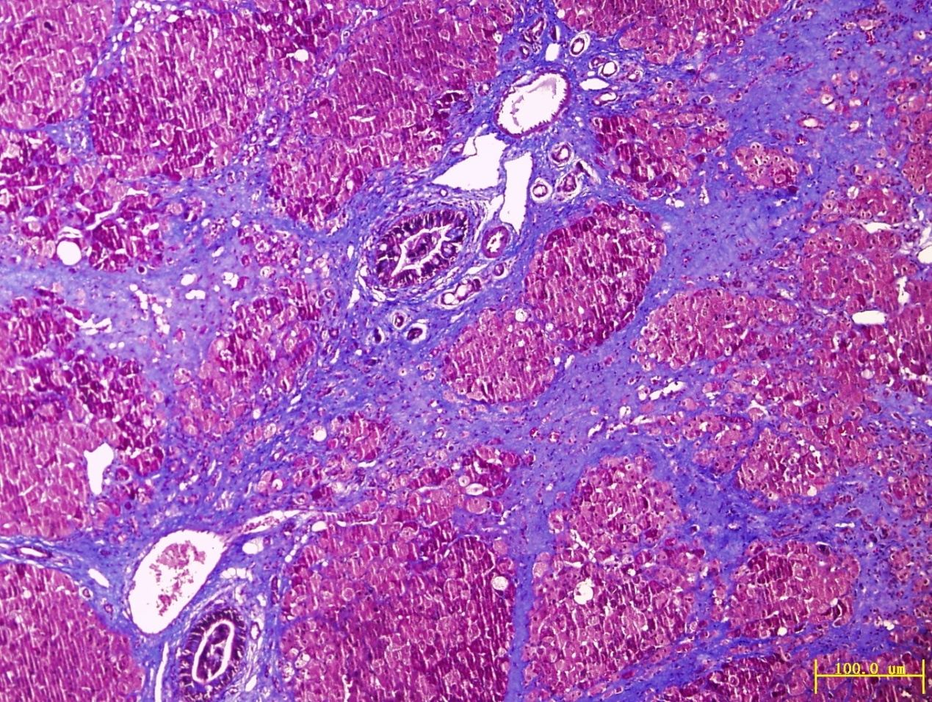
B1 B2
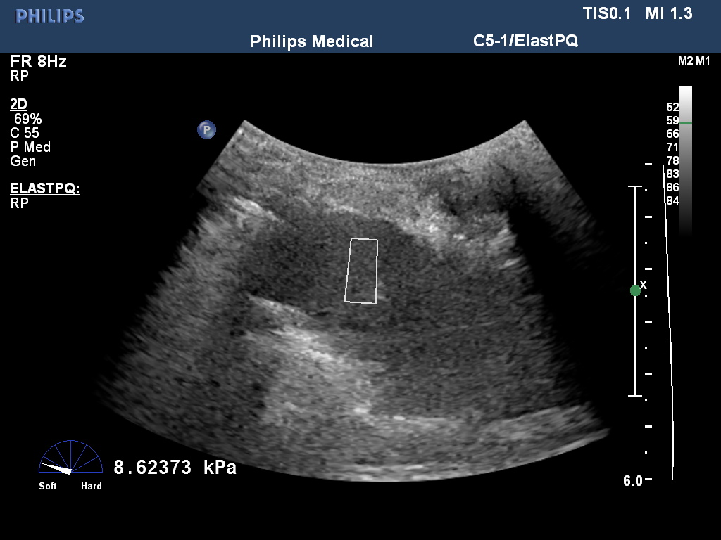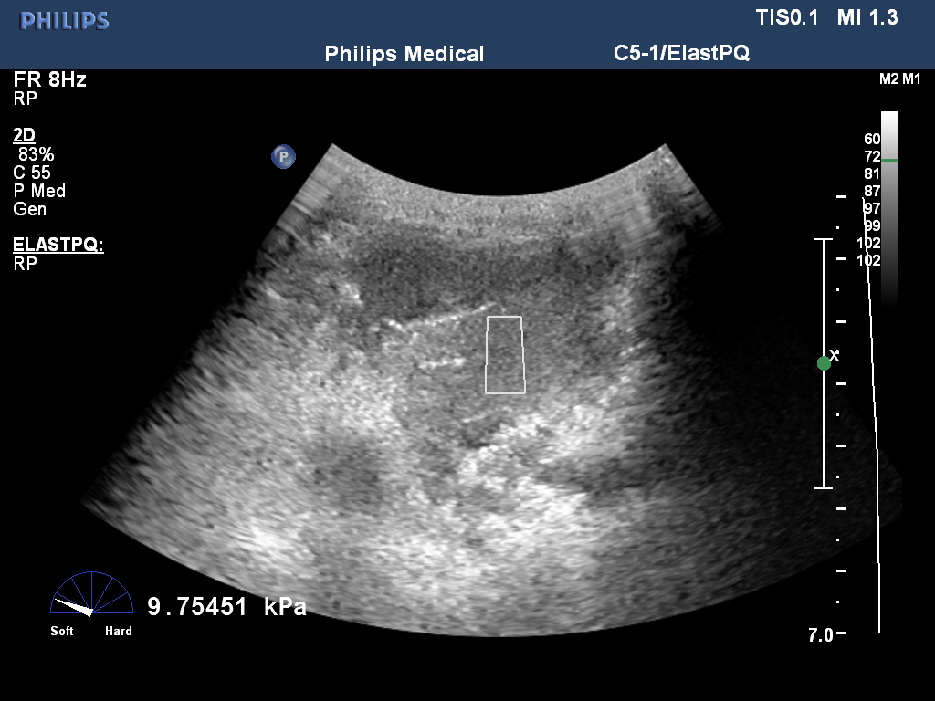
B3 B4
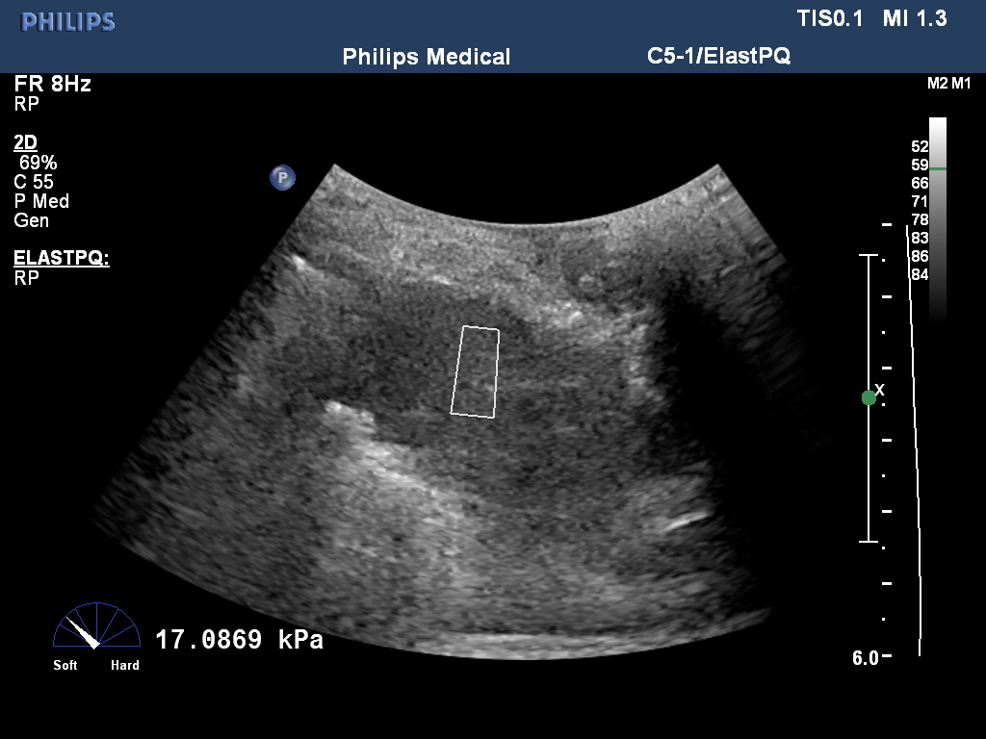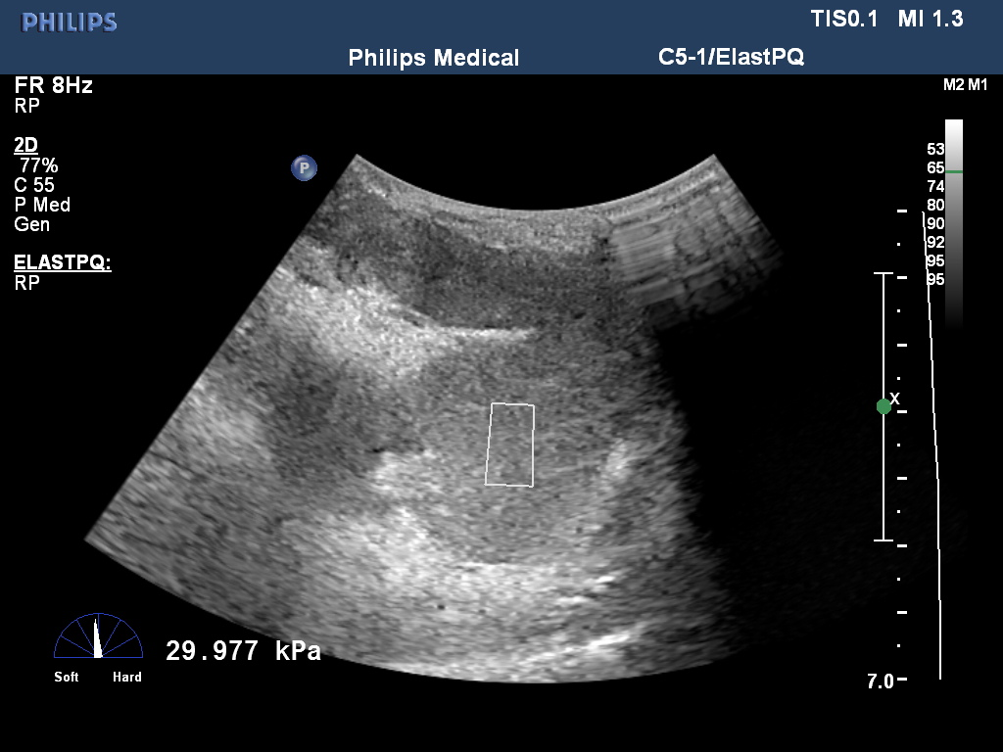
Figure 1 Masson trichrome staining for assessment of liver fibrosis stages according to METAVIR (A1: F1, A2: F2, A3: F3, and A4: F4; 100 ×) and the corresponding ElastPQ images (B1: F1; B2: F2; B3: F3; and B4: F4)

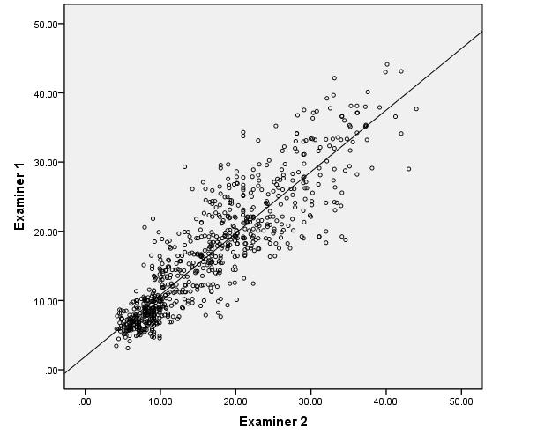
Figure 2 Graph shows correlation of elastography point quantification results between two examiners (ICC value of 0.888, r² = 0.788, P < 0.05).

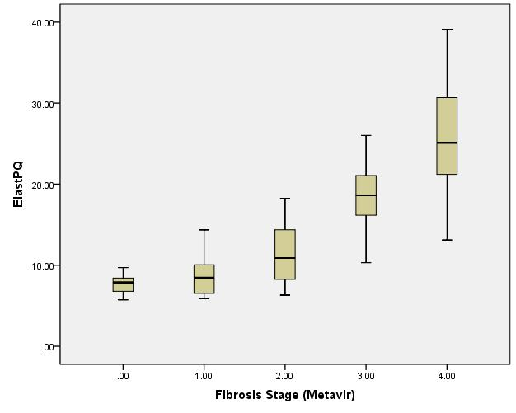
Figure 3 Boxplot shows the elastography point quantification results for each fibrosis stage. The top and bottom of the boxes are the first and third quartiles, respectively. Accordingly, the length of box plot represents the interquartile range within which 50% of the values were located. The lines through the middle of boxes indicate the median values. ElastPQ: elastography point quantification.

A B
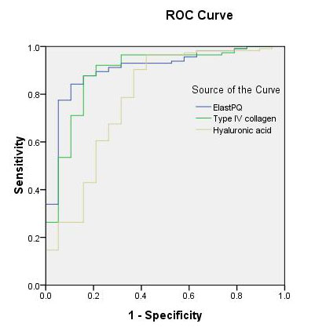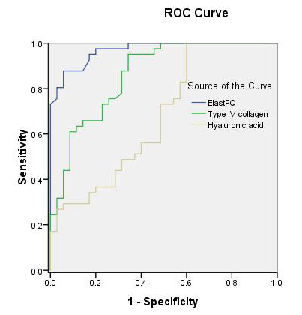
C
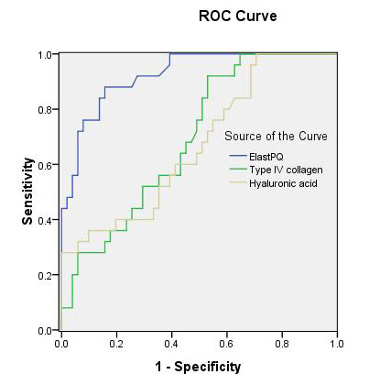
Figure 4 Receiver operating characteristic curves of elastography point quantification and serum fibrosis markers for diagnosis of (A) minimal fibrosis (F0-F1 vs F2-F4), (B) moderate fibrosis (F0-F2 vs F3-F4), and (C) cirrhosis (F0-F3 vs F4). ElastPQ: elastography point quantification.

A B
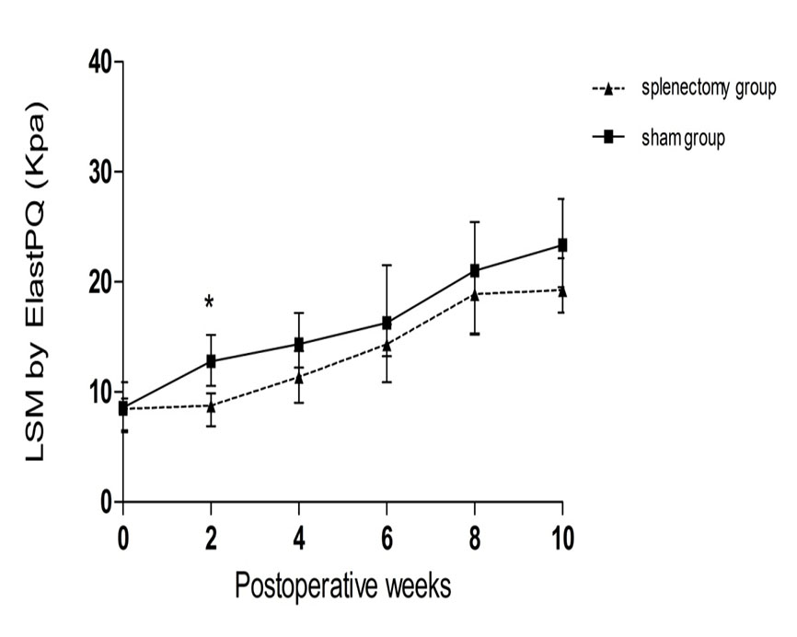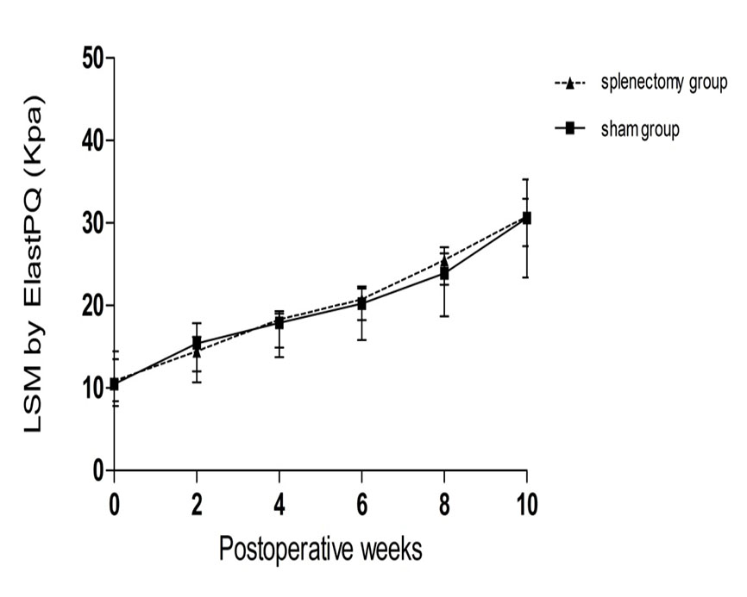
C D
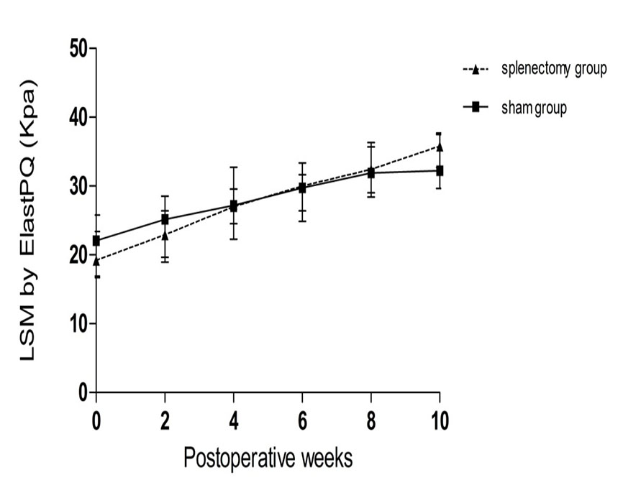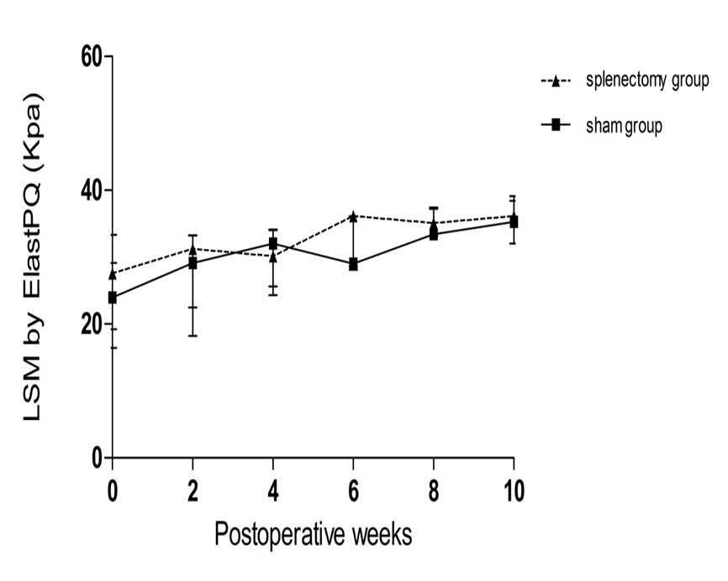
Figure 5 Dynamic changes of liver stiffness measurement by elastography point quantification after surgeries for rabbits with F1 (A), F2 (B), F3 (C), and F4 (D) liver fibrosis (sham group vs splenectomy group). LSM: liver stiffness measurement; ElastPQ: elastography point quantification.

A
F1 F2 F3 F4
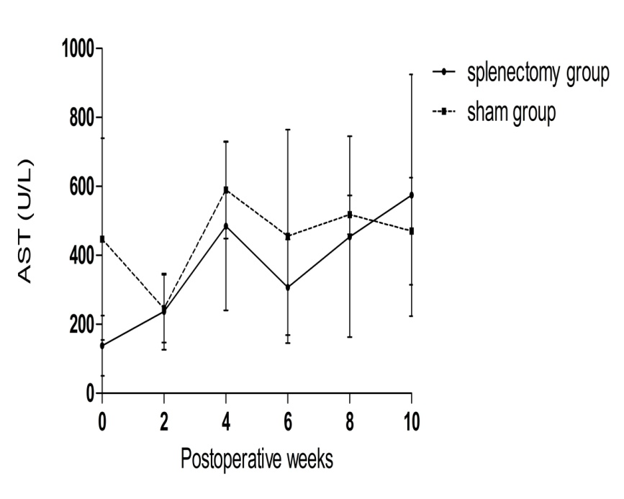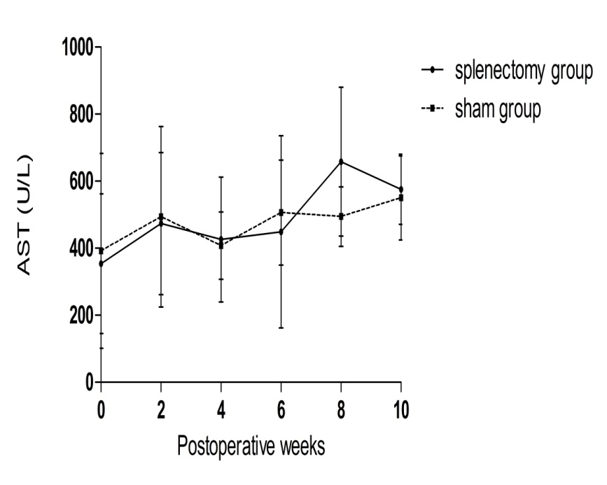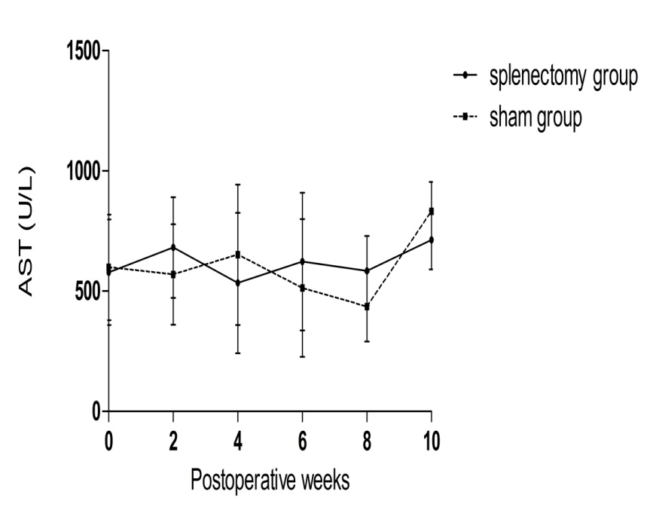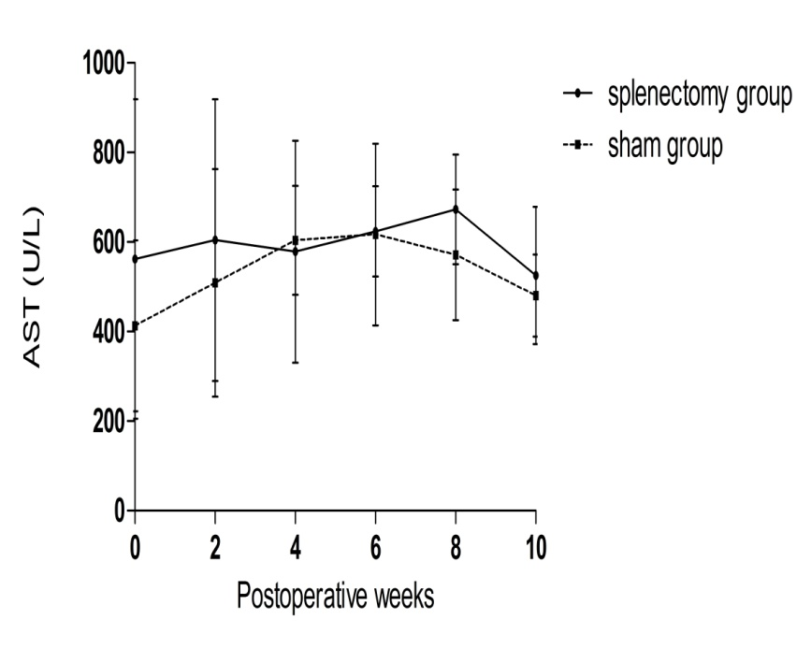
B
F1 F2 F3 F4
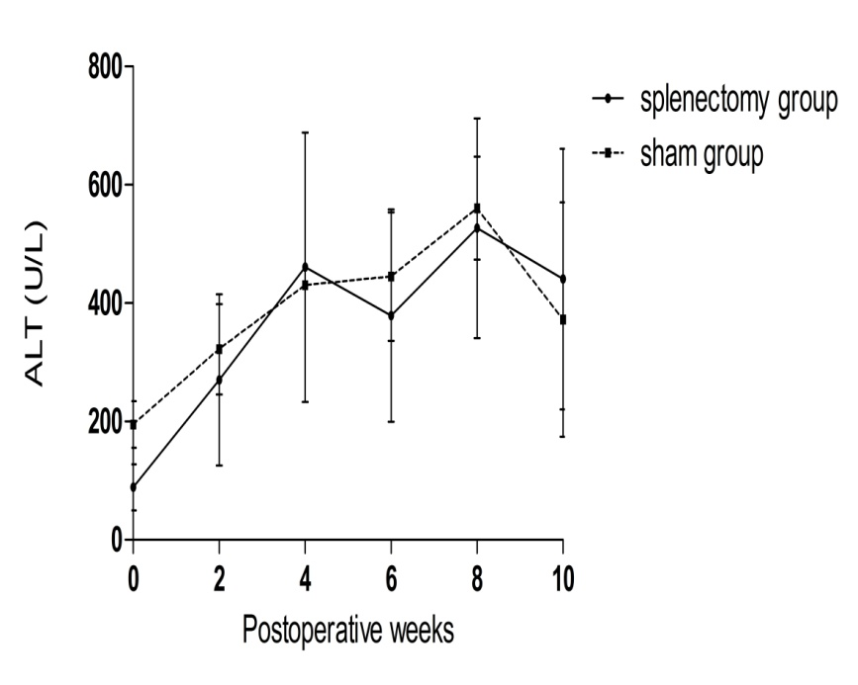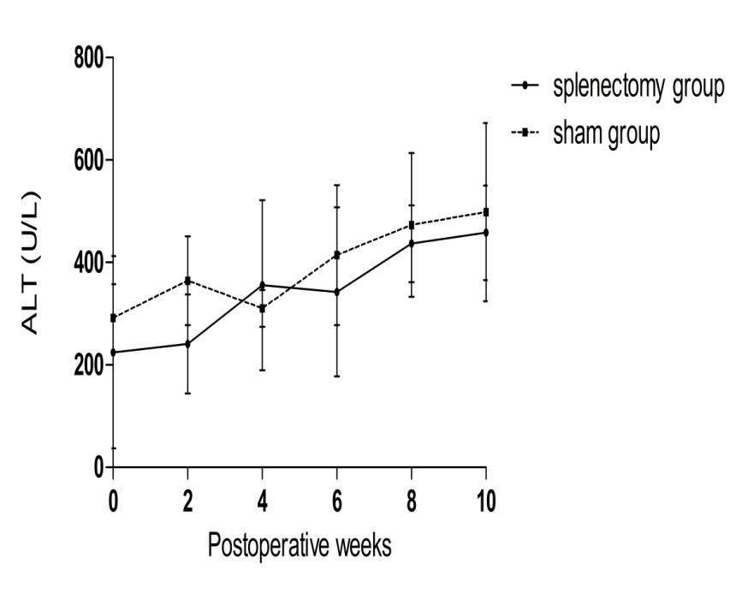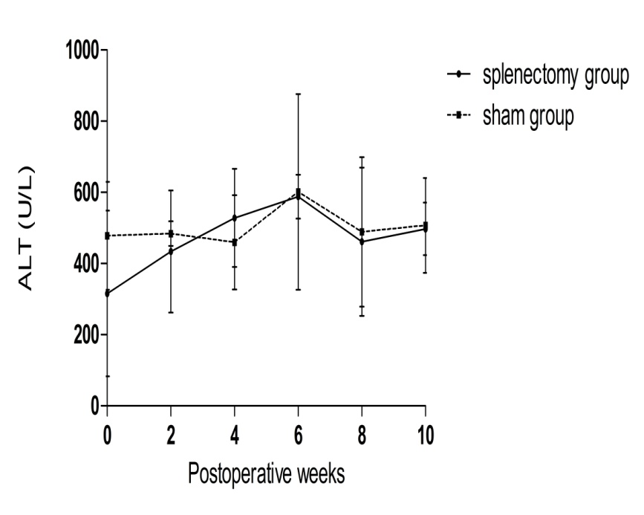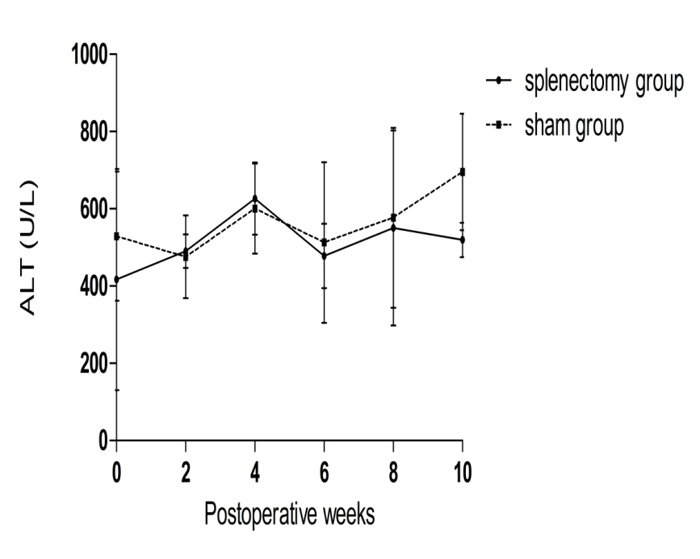
C
F1 F2 F3 F4
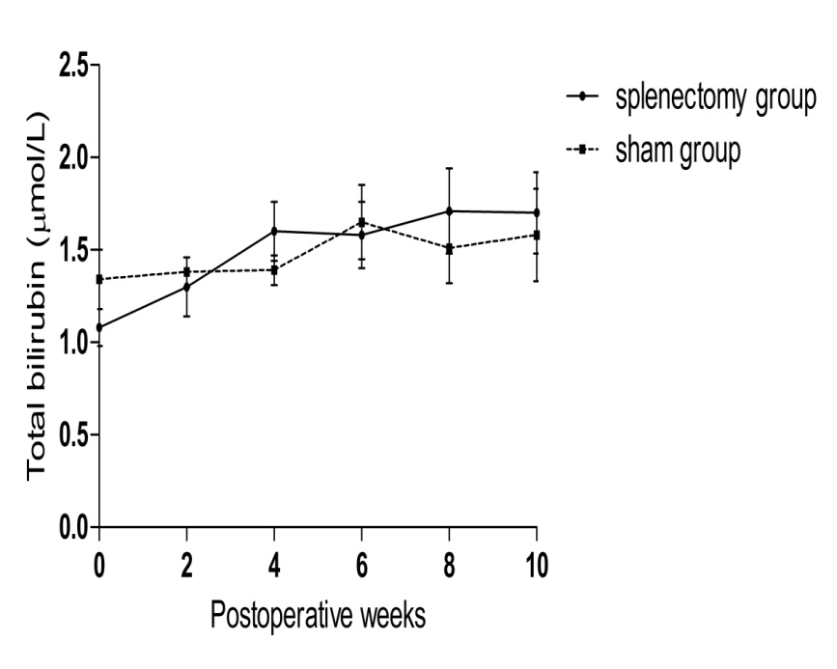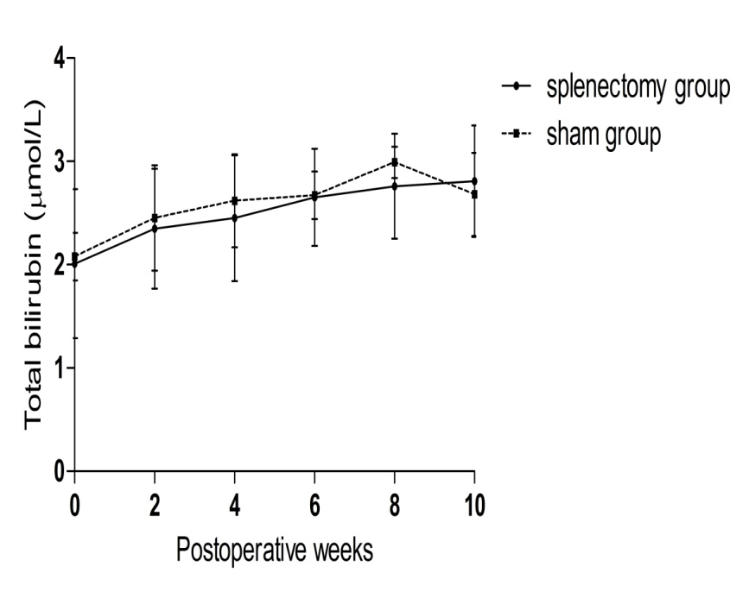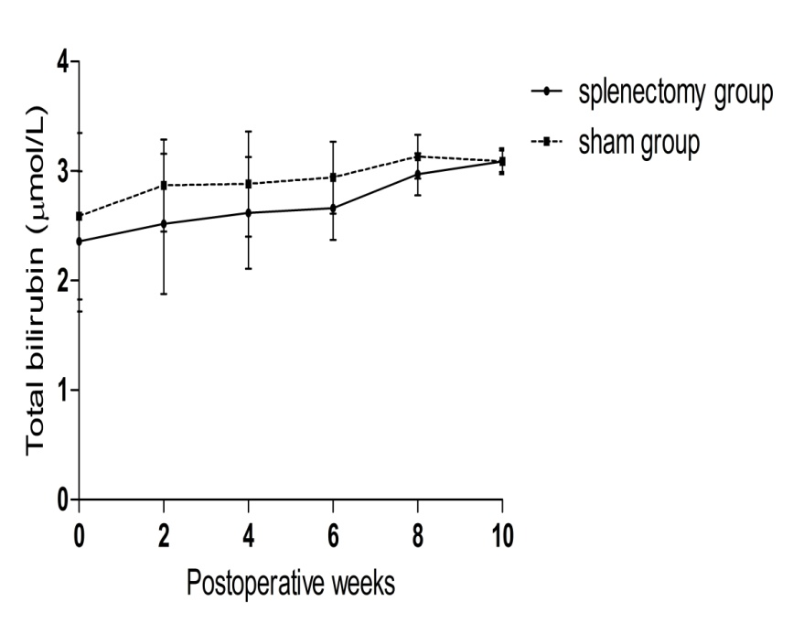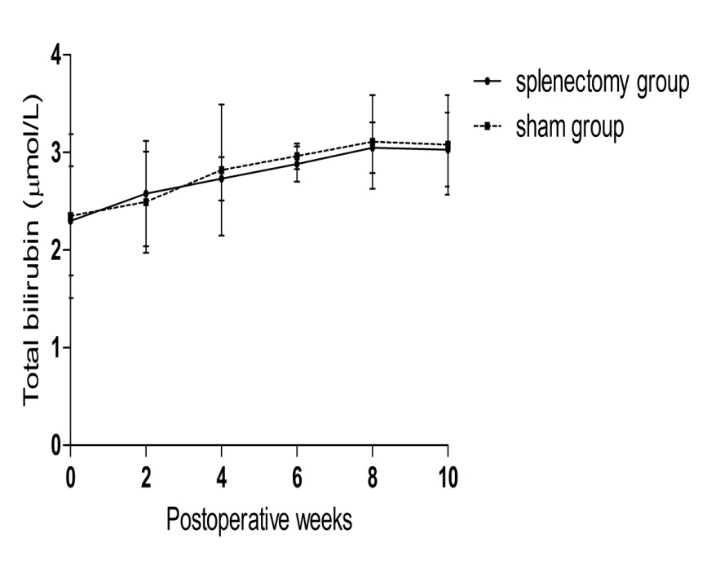
D
F1 F2 F3 F4
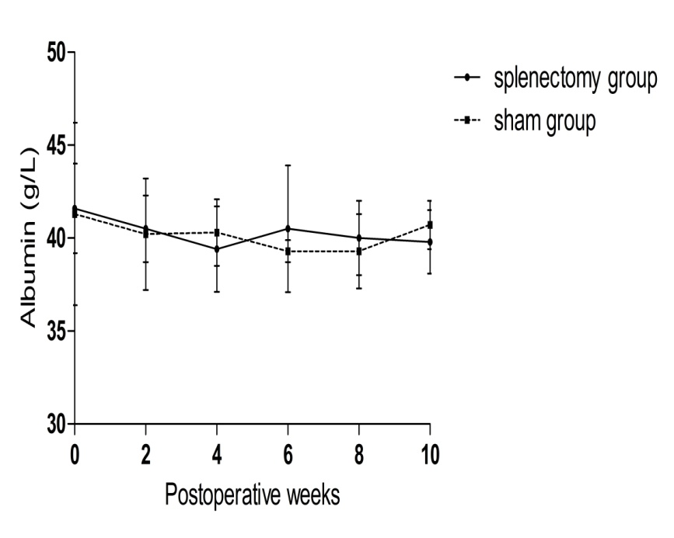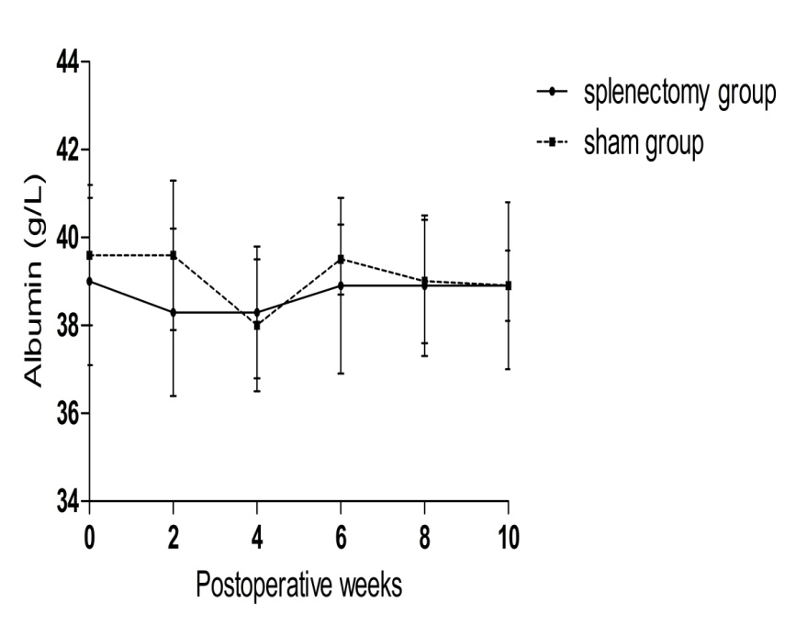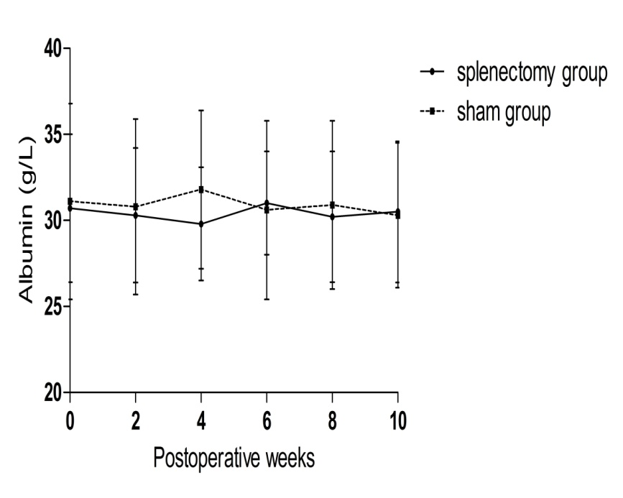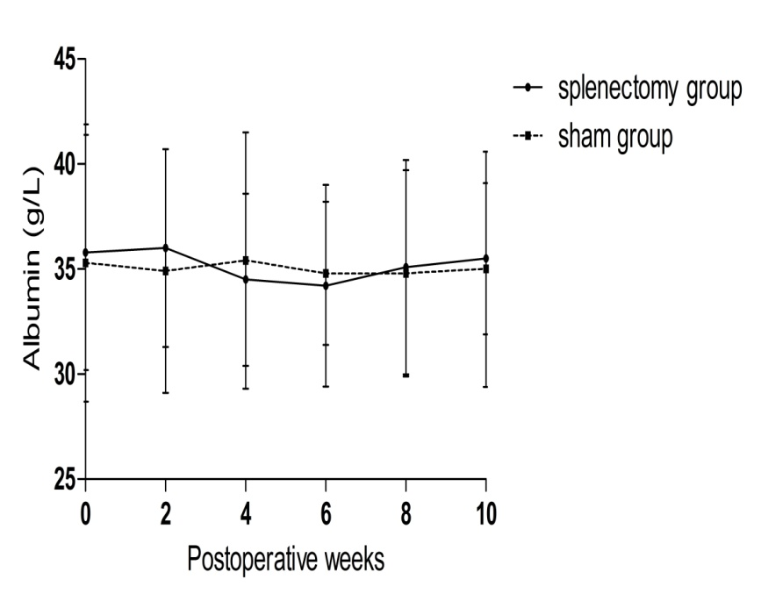
Figure 6 Longitudinal changes of liver function following splenectomy vs sham operation at different liver fibrosis stages. A: changes of AST for rabbits with F1-F4 liver fibrosis; B: changes of ALT for rabbits with F1-F4 liver fibrosis; C: changes of total bilirubin for rabbits with F1-F4 liver fibrosis; and D: changes of albumin for rabbits with F1-F4 liver fibrosis. AST: aspartate aminotransferase; ALT: alanine aminotransferase.

Table 1 Detailed information associated with the experimental process
Modeling time | Distribution of operation | Humane  Termination¹ | Rabbits  left ² | POW 2 | POW 4 | POW 6 | POW 8 | POW 10 | Humane  Termination³ | Exclusion | Death | Rabbits  left ⁴
0W | / | 0 | 90 | / | / | / | / | / | / | / | / | /
2W | / | 0 | 90 | / | / | / | / | / | / |  | / | /
4W | ●●●● | 0 | 82 | ●●●● | ●●●● | ●●● | ●● | ●● | 1 | 1 | 1 | 5
 | ◤◤◤◤ |  |  | ◤◤◤ | ◤◤◤ | ◤◤◤ | ◤◤◤ | ◤◤◤
6W | ●●●● | 0 | 74 | ●●● | ●●● | ●●● | ●● | ●● | 2 | 0 | 2 | 4
 | ◤◤◤◤ |  |  | ◤◤◤◤ | ◤◤◤ | ◤◤◤ | ◤◤ | ◤◤
8W | ●●●● | 2 | 64 | ●●● | ●● | ●● | ●● | ●● | 2 | 0 | 1 | 4
 | ◤◤◤◤ |  |  | ◤◤◤ | ◤◤◤ | ◤◤ | ◤◤ | ◤◤
10W | ●●●● | 3 | 53 | ●●● | ●●● | ●● | ●● | ●● | 2 | 1 | 1 | 4
 | ◤◤◤◤ |  |  | ◤◤◤◤ | ◤◤◤ | ◤◤◤ | ◤◤ | ◤◤
12W | ●●●● | 3 | 42 | ●●● | ●●● | ●● | ●● | ●● | 3 | 0 | 1 | 4
 | ◤◤◤◤ |  |  | ◤◤◤ | ◤◤ | ◤◤ | ◤◤ | ◤◤
14W | ●●●● | 2 | 32 | ●●● | ●● | ●● | ●● | ● | 5 | 0 | 0 | 2
 | ◤◤◤◤ |  |  | ◤◤◤ | ◤◤◤ | ◤◤ | ◤ | ◤
16W | ●●●● | 4 | 20 | ●●●● | ●●● | ●●● | ●● | ●● | 4 | 0 | 1 | 3
 | ◤◤◤◤ |  |  | ◤◤◤ | ◤◤ | ◤◤ | ◤◤ | ◤
18W | ●●●● | 3 | 9 | ●●● | ●●● | ●●● | ●● | ●● | 4 | 0 | 0 | 3
 | ◤◤◤◤ |  |  | ◤◤◤ | ◤◤ | ◤◤ | ◤ | ◤
20W | ●●●● | 2 | 0 | ●● | ●● | ●● | ●● | ● | 4 | 1 | 0 | 2
 | ◤◤◤ |  |  | ◤◤◤ | ◤◤◤ | ◤◤ | ◤◤ | ◤
Total | 68 | 19 | / | / | / | / | / | / | 27 | 3 | 7 | 31
¹number of rabbits with humane termination during Experiment 1; ²number of rabbits left excluding the rabbits with humane termination and failed liver stiffness measurement via ElastPQ during Experiment 1; ³number of rabbits with humane termination during Experiment 2; ⁴number of rabbits left excluding the rabbits with humane termination, failed liver stiffness measurement via ElastPQ, and death during Experiment 2. Red color symbols indicate rabbits with failed LSM via ElastPQ. POW: postoperative weeks; LSM: liver stiffness measurement; ElastPQ: elastography point quantification; ●: rabbits receiving splenectomy and liver biopsy; ◤: rabbits receiving only liver biopsy.

Table 2 Distribution of liver fibrosis stages at different time intervals in Experiment 1
 | F0 | F1 | F2 | F3 | F4
0w | 98 | / | / | / | /
2w |  | / | / | / | /
4w |  | 5 | 3 | 0 | 0
6w |  | 3 | 4 | 1 | 0
8w |  | 2 | 4 | 1 | 0
10w |  | 1 | 2 | 3 | 2
12w |  | 0 | 2 | 1 | 5
14w |  | 0 | 1 | 2 | 4
16w |  | 0 | 0 | 4 | 4
18w |  | 0 | 0 | 3 | 4
20w |  | 0 | 0 | 1 | 6
Total | 8 | 11 | 16 | 16 | 25

Table 3 Basic characteristics of rabbits with different liver fibrosis stages in Experiment 1
Parameters | F0 (n = 8) | F1 (n = 11) | F2 (n = 16) | F3 (n = 16) | F4 (n = 25)
Body weight (kg) | 2.34 ± 0.24 | 2.28 ± 0.27 | 2.39 ± 0.14 | 2.30 ± 0.38 | 2.24 ± 0.33
Type IV collagen  (μg/L) | 200.8 ± 131.5 | 427.1 ± 226.2 | 683.4 ± 332.5 | 1161.4 ± 482.5 | 1292.0 ± 689.7
Hyaluronic acid (μg/L) | 225.6 ± 117.1 | 475.7 ± 296.4 | 676.2 ± 274.8 | 724.0 ± 264.5 | 1182.3 ± 1091.3
TB (μmol/L) | 0.98 ± 0.53 | 1.91 ± 0.63 | 2.20 ± 0.85 | 1.81 ± 0.82 | 1.64 ± 0.91
AST (IU/L) | 26.8 ± 14.7 | 345.0 ± 295.9 | 449.2 ± 304.7 | 666.4 ± 428.3 | 616.1 ± 609.2
ALT (IU/L) | 14.0 ± 3.7 | 254.7 ± 194.0 | 301.5 ± 210.7 | 456.3 ± 316.0 | 486.5 ± 295.8
Albumin (g/L) | 42.7 ± 4.9 | 40.4 ± 4.6 | 36.5 ± 4.3 | 32.3 ± 6.4 | 35.3 ± 5.9
LSM (kpa) | 7.88 (6.60-8.46) | 8.46 (6.22-10.35) | 10.89 (8.09-14.46) | 18.62 (16.03-21.16) | 25.10 (20.28-30.95)
ALT: alanine aminotransferase; AST: aspartate aminotransferase; LSM: liver stiffness measurement; TB: total bilirubin.

Table 4 Comparison between elastography point quantification and fibrosis blood tests
AUROC | F0-F1 vs F2-F4 | F0-F2 vs F3-F4 | F0-F3 vs F4
ElastPQ | 0.931 (0.849-0.977) | 0.969 (0.901-0.995) | 0.925 (0.841-0.973)
Hyaluronic acid | 0.807 (0.700-0.889) | 0.677 (0.560-0.780)ª | 0.670 (0.553-0.774)ª
Type IV collagen | 0.919 (0.833-0.969) | 0.861 (0.762-0.930)ª | 0.695 (0.578-0.795)ª
comparison of AUROC between ElastPQ and hyaluronic acid or type IV collagen, ªP < 0.05. ElastPQ: elastography point quantification.

Table 5 Cutoff and performance values of elastography point quantification for diagnosis of liver fibrosis stages
Parameter | F0-F1 vs F2-F4 | F0-F2 vs F3-F4 | F0-F3 vs F4
AUROC | 0.931 (0.849-0.977) | 0.969 (0.901-0.995) | 0.925 (0.841-0.973)
Optimal cutoff value | 11.27 | 14.89 | 18.21
Sensitivity (%) | 82.5 (70.1-91.3) | 87.8 (73.8-95.9) | 88.0 (68.8-97.5)
Specificity (%) | 94.7 (74.0-99.9) | 94.3 (80.8-99.3) | 84.3 (71.4-93.0)
PPV (%) | 97.9 (88.9-99.9) | 94.7 (82.3-99.4) | 73.3 (54.1-87.7)
NPV (%) | 64.3 (44.1-81.4) | 86.8 (71.9-95.6) | 93.5 (82.1-98.6)
PPV: positive predictive values; NPV: negative predictive value.

Table 6 Longitudinal changes of liver stiffness measurement (kPa) via elastography point quantification between splenectomy and sham groups
 |  | POW 0 | POW 2 | POW 4 | POW 6 | POW 8 | POW 10
F1 | Group S (n = 5) | 8.46 (6.63-8.50) | 8.74 (6.97-8.91) | 11.34 (9.13-12.89) | 14.32 (11.45-15.45) | 18.89 (16.43-19.23) | 19.24 (17.78-21.09)
 | Group L (n = 4) | 8.59 (7.12-10.13) | 12.79 (11.01-14.62) | 14.35 (12.24-16.70) | 16.30 (13.25-20.07) | 21.01 (16.11-25.45) | 23.34 (20.66-26.15)
F2 | Group S (n = 4) | 10.81 (8.34-13.48) | 14.45 (12.53-15.70) | 18.28 (16.72-18.56) | 20.73 (18.09-22.26) | 25.50 (23.10-25.89) | 30.79 (27.29-33.31)
 | Group L (n = 4) | 10.50 (9.31-11.96) | 15.39 (13.55-16.92) | 17.90 (16.01-19.27) | 20.25 (18.92-21.51) | 23.89 (23.15-25.24) | 30.60 (28.54-32.29)
F3 | Group S (n = 4) | 19.19 (17.77-21.25) | 22.90 (20.70-25.17) | 26.99 (25.13-28.88) | 29.98 (26.14-33.23) | 32.38 (29.06-35.89) | 35.79 (33.79-37.31)
 | Group L (n = 4) | 22.08 (18.24-25.35) | 25.17 (21.79-27.59) | 27.21 (24.38-30.23) | 29.72 (28.27-30.70) | 31.89 (29.91-33.98) | 32.22 (30.70-34.71)
F4 | Group S (n = 3) | 27.56 (23.4028.34) | 31.23 (26.84-32.22) | 30.12 (27.89-32.12) | 36.12 (32.39-36.34) | 35.10 (34.12-36.27) | 36.12 (34.06-37.28)
 | Group L (n = 3) | 23.98 (20.21-28.66) | 29.12 (23.68-31.19) | 32.00 (28.17-33.00) | 29.00 (28.56-32.56) | 33.43 (33.32-35.32) | 35.30 (35.25-37.21)
POW: postoperative weeks; Group S: rabbits received splenectomy plus liver biopsy; Group L: rabbits received liver biopsy only.

Table 7 Longitudinal changes of liver function between splenectomy and sham groups
 |  | POW 0 | POW 2 | POW 4 | POW 6 | POW 8 | POW 10
AST (IU/L)
F1 | Group S (n = 5) | 138.0 ± 87.3 | 236.7 ± 110.6 | 484.3 ± 244.2 | 307.3 ± 138.9 | 454.0 ± 291.3 | 574.3 ± 350.6
 | Group L (n = 4) | 447.0 ± 292.7 | 245.5 ± 98.3 | 589.5 ± 140.7 | 455.0 ± 309.7 | 517.5 ± 55.9 | 470.0 ± 155.6
F2 | Group S (n = 4) | 353.6 ± 208.4 | 473.4 ± 212.1 | 426.0 ± 186.4 | 448.6 ± 286.4 | 658.2 ± 221.9 | 575.6 ± 104.4
 | Group L (n = 4) | 392.0 ± 290.5 | 493.5 ± 269.0 | 407.5 ± 100.4 | 506.3 ± 156.8 | 494.5 ± 88.8 | 550.0 ± 125.6
F3 | Group S (n = 4) | 578.3 ± 219.5 | 681.3 ± 208.9 | 534.0 ± 292.2 | 622.7 ± 286.2 | 584.7 ± 144.5 | 713.3 ± 122.8
 | Group L (n = 4) | 598.8 ± 219.5 | 569.8 ± 208.9 | 651.5 ± 292.2 | 513.0 ± 286.2 | 435.5 ± 144.5 | 831.8 ± 122.8
F4 | Group S (n = 3) | 562.2 ± 356.6 | 604.2 ± 314.3 | 578.4 ± 247.7 | 623.8 ± 101.1 | 672.6 ± 122.6 | 525.6 ± 153.2
 | Group L (n = 3) | 412.6 ± 190.9 | 508.7 ± 253.8 | 604.0 ± 121.8 | 616.7 ± 203.1 | 571.0 ± 145.7 | 480.3 ± 91.4
ALT(IU/L)
F1 | Group S (n = 5) | 88.7 ± 39.2 | 270.3 ± 144.9 | 460.7 ± 227.5 | 379.0 ± 179.2 | 526.7 ± 185.8 | 440.7 ± 220.4
 | Group L (n = 4) | 195.0 ± 39.6 | 322.0 ± 76.4 | 430.5 ± 2.1 | 445.0 ± 108.9 | 560.5 ± 87.0 | 372.0 ± 198.0
F2 | Group S (n = 4) | 224.6 ± 187.8 | 240.8 ± 96.7 | 355.8 ± 165.8 | 342.6 ± 165.1 | 436.8 ± 74.9 | 458.0 ± 92.4
 | Group L (n = 4) | 291.8 ± 65.9 | 364.3 ± 86.5 | 310.3 ± 35.8 | 414.5 ± 136.8 | 473.3 ± 140.5 | 498.3 ± 174.0
F3 | Group S (n = 4) | 315.7 ± 232.7 | 434.0 ± 171.8 | 528.3 ± 137.7 | 588.0 ± 61.6 | 461.3 ± 208.2 | 497.3 ± 73.6
 | Group L (n = 4) | 477.8 ± 151.7 | 484.0 ± 34.4 | 459.3 ± 132.5 | 601.0 ± 274.9 | 488.8 ± 210.2 | 507.0 ± 133.2
F4 | Group S (n = 3) | 416.8 ± 286.2 | 490.6 ± 43.3 | 626.2 ± 93.0 | 478.0 ± 83.3 | 550.6 ± 252.5 | 519.2 ± 44.9
 | Group L (n = 3) | 529.0 ± 167.0 | 475.8 ± 106.7 | 600.4 ± 116.3 | 512.6 ± 207.8 | 576.8 ± 233.1 | 695.4 ± 150.6
Albumin (g/L)
F1 | Group S (n = 5) | 41.6 ± 2.4 | 40.5 ± 1.8 | 39.4 ± 2.3 | 40.5 ± 3.4 | 40.0 ± 2.0 | 39.8 ± 1.7
 | Group L (n = 4) | 41.3 ± 4.9 | 40.2 ± 3.0 | 40.3 ± 1.8 | 39.3 ± 0.6 | 39.3 ± 2.0 | 40.7 ± 1.3
F2 | Group S (n = 4) | 39.0 ± 1.9 | 38.3 ± 1.9 | 38.3 ± 1.5 | 38.9 ± 2.0 | 38.9 ± 1.6 | 38.9 ± 0.8
 | Group L (n = 4) | 39.6 ± 1.6 | 39.6 ± 1.7 | 38.0 ± 1.5 | 39.5 ± 0.8 | 39.0 ± 1.4 | 38.9 ± 1.9
F3 | Group S (n = 4) | 30.7 ± 4.3 | 30.3 ± 3.9 | 29.8 ± 3.3 | 31.0 ± 3.0 | 30.2 ± 3.8 | 30.5 ± 4.1
 | Group L (n = 4) | 31.1 ± 5.7 | 30.8 ± 5.1 | 31.8 ± 4.6 | 30.6 ± 5.2 | 30.9 ± 4.9 | 30.3 ± 4.2
F4 | Group S (n = 3) | 35.8 ± 5.6 | 36.0 ± 4.7 | 34.5 ± 4.1 | 34.2 ± 4.8 | 35.1 ± 5.1 | 35.5 ± 3.6
 | Group L (n = 3) | 35.3 ± 6.6 | 34.9 ± 5.8 | 35.4 ± 6.1 | 34.8 ± 3.4 | 34.8 ± 4.9 | 35.0 ± 5.6
TB (μmol/L)
F1 | Group S (n = 5) | 1.08 ± 0.10 | 1.30 ± 0.16 | 1.60 ± 0.16 | 1.58 ± 0.18 | 1.71 ± 0.23 | 1.70 ± 0.22
 | Group L (n = 4) | 1.34 ± 0.16 | 1.38 ± 0.08 | 1.39 ± 0.08 | 1.65 ± 0.20 | 1.51 ± 0.19 | 1.58 ± 0.25
F2 | Group S (n = 4) | 2.01 ± 0.72 | 2.35 ± 0.58 | 2.45 ± 0.61 | 2.65 ± 0.47 | 2.76 ± 0.51 | 2.81 ± 0.54
 | Group L (n = 4) | 2.08 ± 0.23 | 2.45 ± 0.51 | 2.62 ± 0.45 | 2.67 ± 0.23 | 2.99 ± 0.15 | 2.68 ± 0.40
F3 | Group S (n = 4) | 2.36 ± 0.64 | 2.52 ± 0.64 | 2.62 ± 0.51 | 2.66 ± 0.29 | 2.97 ± 0.19 | 3.09 ± 0.10
 | Group L (n = 4) | 2.59 ± 0.76 | 2.87 ± 0.42 | 2.88 ± 0.48 | 2.94 ± 0.33 | 3.13 ± 0.20 | 3.09 ± 0.12
F4 | Group S (n = 3) | 2.30 ± 0.56 | 2.58 ± 0.54 | 2.73 ± 0.22 | 2.88 ± 0.18 | 3.05 ± 0.26 | 3.03 ± 0.38
 | Group L (n = 3) | 2.35 ± 0.84 | 2.49 ± 0.52 | 2.82 ± 0.67 | 2.96 ± 0.13 | 3.11 ± 0.48 | 3.08 ± 0.51
POW: postoperative weeks; Group S: rabbits received splenectomy plus liver biopsy; Group L: rabbits received liver biopsy only.

