Name of Journal: World Journal of Radiology
Manuscript NO: 72410
Manuscript Type: MINIREVIEWS

Acute coronary syndrome on non-electrocardiogram-gated contrast-enhanced computed tomography

Yoshihara S. ACS on Non-ECG-Gated CECT

Shu Yoshihara

Shu Yoshihara, Department of Diagnostic Radiology, Iwata City Hospital, Iwata 438-8550, Japan

Author contributions: Yoshihara S designed and performed all of this study and wrote the all of the revised manuscript.

Corresponding author: Shu Yoshihara, MD, PhD, Doctor, Department of Diagnostic Radiology, Iwata City Hospital, 512-3 Ookubo, Iwata 438-8550, Japan. shuy@hospital.iwata.shizuoka.jp

Received: October 18, 2021
Revised: December 14, 2021
Accepted: February 15, 2022
Published online: February 28, 2022

Abstract
It is not rare for acute coronary syndrome (ACS) patients to present with symptoms that are atypical, rather than chest pain. It is sometimes difficult to achieve a definitive diagnosis of ACS for such patients who present with atypical symptoms, normal initial biomarkers of myocardial necrosis, and normal or nondiagnostic electrocardiograms (ECGs). Although cardiac CT allows for assessments of coronary artery stenosis as well as myocardial perfusion defect in patients with suspected ACS, it requires ECG gating and is usually performed with high-performance multislice CT for highly probable ACS patients. However, several recent reports have stated that ACS is detectable by myocardial perfusion defects even on routine non-ECG-gated contrast-enhanced CT. A growing number of contrast-enhanced CT scans are now being performed in emergency departments in search of pathologies responsible for a patient’s presenting symptoms. In order to avoid inappropriate management for this life-threatening event, clinicians should be aware that myocardial perfusion defect is more commonly detectable even on routine non-ECG-gated contrast-enhanced CT performed in search of other pathologies.

Key Words: Acute coronary syndrome; Non-ECG-gated CT; Computed tomography; Myocardial perfusion defect; Emergency department

©The Author(s) 2022. Published by Baishideng Publishing Group Inc. All rights reserved.

Citation: Yoshihara S. Acute coronary syndrome on non-electrocardiogram-gated contrast-enhanced computed tomography. World J Radiol 2022; 14(2): 30-46
URL: https://www.wjgnet.com/1949-8470/full/v14/i2/30.htm
DOI: https://dx.doi.org/10.4329/wjr.v14.i2.30

Core Tip: Definitive diagnosis of acute coronary syndrome (ACS) is sometimes difficult to achieve, especially in patients who present with atypical symptoms, normal initial biomarkers of myocardial necrosis, and normal or nondiagnostic electrocardiograms (ECGs). In order to avoid inappropriate management for this life-threatening event, clinicians should be aware that myocardial perfusion defect is more commonly detectable even on routine non-ECG-gated contrast-enhanced computed tomography performed in search of other pathologies. In this review, several essential points of image interpretation in diagnosing ACS on non-ECG-gated contrast-enhanced computed tomography has been described.

INTRODUCTION
Acute coronary syndrome (ACS) is a term used to refer to a range of conditions associated with acute myocardial ischemia and/or infarction, which are usually due to an abrupt reduction in the coronary blood flow^{[1]}. Chest pain characteristics, specific associated symptoms, electrocardiogram (ECG) abnormalities, and the levels of serum biomarkers of myocardial necrosis are essential for a diagnosis of ACS^{[1]}. However, rather than chest pain, some ACS patients present with atypical symptoms^{[2-4]}. A review of over 430,000 patients from the National Registry of Myocardial Infarction II with confirmed acute myocardial infarction (AMI) showed that one-third presented at the hospital with no chest pain^{[2]}. Patients such as these often present with symptoms including dyspnea alone, weakness, nausea and/or vomiting, palpitations, syncope, or cardiac arrest. The implications of absence of chest pain are important in terms of therapy and prognosis. The Registry report revealed that patients without chest pain were less likely to receive a diagnosis of a confirmed MI on admission, and were also less likely to receive thrombolytic therapy or primary percutaneous coronary intervention, and to undergo treatment with appropriate medical therapy. It is unsurprising that these differences were associated with increased in-hospital mortality^{[2]}. Therefore, it is sometimes difficult to achieve a definitive diagnosis of ACS, especially for patients who present with atypical symptoms, normal initial biomarkers of myocardial necrosis, and normal or nondiagnostic ECGs. Even in the presence of acute coronary ischemia, women, diabetics, and the elderly are more likely to present with atypical symptoms, and caution is required in evaluating possible ACS^{[2,3]}. The use of computed tomography (CT) in the emergency department (ED) has increased at a consistent exponential rate^{[5]}. Due to their greater temporal and spatial resolution, current multi-slice computed tomography (MSCT) systems are capable of rapid scanning that renders non-ECG-gated images with fewer cardiac motion artifacts. Although imaging of various cardiac diseases is superior with ECG-gated MSCT images, typically there is sufficient information provided in non-ECG-gated MSCT images of the thorax or abdomen to identify a number of incidental cardiac abnormalities like myocardial perfusion defect (MPD) of the left ventricle which may be related to the patient’s presenting symptoms^{[6]}. Consequently, clinically unrecognized ACS cases identified on CT performed for the indication of other diseases are increasing, especially in the ED. In this article, we present clinically unrecognized several ACS cases detected on routine non-ECG-gated contrast-enhanced CT performed in the ED for discriminating other pathologies. Non-ECG-gated contrast-enhanced CT was performed using an 80-row MSCT scanner (Aquilion Prime, Toshiba Medical Systems, Tochigi, Japan). The scanning parameters were as follows: tube voltage, 120 kV; tube current, mA modulation technique with a noise index of 12 (maximum 500 mA); gantry rotation time, 350 ms; reconstruction slice thickness, 1mm. An intravenous bolus of nonionic contrast medium (55 kg < body weight; iopamidol 300 mg iodine/mL, 55 kg ≥ body weight; iopamidol 370 mg iodine/ml) was delivered through a vein in the arm with a flow rate of 3.3 mL/s. The dose of contrast medium was appropriately 600 mg I/kg of body weight, to a maximum of 100 mL. The scanning delay was calculated by monitoring the contrast values that increased to 150 Hounsfield units in the descending aorta as the region of interest (25-30 s after injection). A second scan was performed 120 s after injection. When focal decrease of the left ventricular myocardial enhancement was visually found, a region of interest was manually set to measure CT attenuation values of the normal and hypoperfused myocardium. MPD was defined as a decrease of 20 or more Hounsfield units compared with the adjacent normal enhanced myocardium.

CARDIAC COMPUTED TOMOGRAPHY AND ACS
Progress in the technical development of cardiac CT enables rapid, accurate imaging of the cardiovascular system. With cardiac CT, it is necessary to use either prospective or retrospective ECG gating to synchronize the CT image with the ECG. In both methods, the waveform of the ECG is used to coordinate image reconstruction with the heart’s position in the chest^{[7]}. Recently, a large body of evidence has been published supporting early assessment of coronary artery stenosis by cardiac CT as an accurate, safe, and efficient rapid diagnostic strategy for ED patients with low-intermediate risk acute chest pain^{[8-11]}. As a result, the appropriate use criteria for cardiac CT designated detection of coronary artery stenosis by cardiac CT as appropriate for use in acute chest pain patients for whom the likelihood of ACS is low or intermediate^{[12]}. Moreover, identification of regional subendocardial or transmural hypoattenuation of the myocardium in cardiac CT provides incremental diagnostic value to detect ACS^{[13]}. Based on this novel evidence, the updated SCCT guidelines for the interpretation and reporting of coronary CT angiography have newly designated that myocardial CT enhancement patterns should be assessed during performance of cardiac CT^{[14]}.

NON-ELECTROCARDIOGRAM-GATED CONTRAST-ENHANCED CT AND ACS
Recently, several reports have been published that suggest non-ECG-gated contrast-enhanced CT can detect ACS with high diagnostic accuracy (Table 1)^{[15-19]}. Mano et al^{[17]} evaluated the frequency of MPD on non-ECG-gated contrast-enhanced CT performed with a 64-slice CT scanner, which was done to assess aortic dissection or pulmonary embolism in 154 patients who had been admitted to the ED with acute chest pain and/or back pain. MPD was detected in 43 patients, 26 (60%) of whom were ultimately diagnosed with AMI. In the remaining 111 patients without MPD, only 2 (2%) were ultimately diagnosed with AMI. They showed good diagnostic performance for MPD on non-ECG-gated contrast-enhanced CT in predicting AMI with a sensitivity of 93% and a specificity of 87%. Watanabe et al^{[18]} evaluated the presence of MPD on non-ECG-gated contrast-enhanced CT using a 64-slice CT scanner in 23 patients who had been admitted to the ED with acute-onset chest pain and underwent emergent invasive coronary angiography. Of the 23 patients, 13 were diagnosed with ACS and the remaining 10 were diagnosed with other conditions. MPD was detected in 11 (85%) of the 13 ACS patients. They showed good diagnostic performance for MPD on non-ECG-gated contrast-enhanced CT in predicting ACS with a sensitivity of 85% and a specificity of 90%. In comparison with the other studies using non-ECG-gated contrast-enhanced arterial phase CT imaging for detecting ACS, Yamazaki et al^{[19]} evaluated the ACS detection capability of using non-ECG-gated contrast-enhanced parenchymal phase CT imaging acquired with a 100-s scan delay. They showed good diagnostic performance for MPD visualized on non-ECG-gated contrast-enhanced CT during the parenchymal phase in predicting ACS with a sensitivity of 91% and a specificity of 93%. In non-ECG-gated contrast-enhanced CT, the normal myocardium is usually blurry because reconstructed images are a mixture of the systolic and diastolic phases. Indeed, cardiac motion artifacts are recognized to be the most important factor to degrade diagnostic performance on non-ECG-gated contrast-enhanced CT^{[19]}. However, the frequency of false positive cases who were misjudged to have MPD without myocardial ischemia mainly due to cardiac motion artifacts was only 15%-20% in the previous reports^{[17,18]}. In cases with ACS, decreased regional myocardial wall motion due to acute myocardial ischemia will contribute to reduced motion artifacts and sharp visualization of the myocardial border.

IMPORTANT POINTS OF IMAGE INTERPRETATION IN DETECTING ACS ON NON-ELECTROCARDIOGRAM-GATED CONTRAST-ENHANCED CT
Vascular territories of the coronary artery
CT images are usually oriented and displayed using transaxial views, but these images do not cleanly transect the ventricle, atria, or myocardial regions supplied by the major coronary arteries. The American Heart Association (AHA) showed the cardiac plane definition and display for tomographic image modalities^{[20]}. Essentially, it has been suggested that, using any noninvasive method, the displays for evaluation of cardiac structures are presented in three orthogonal cardiac planes: Horizontal long axis, vertical long axis, and short axis (Figure 1). Therefore, it is important to evaluate a suspicious findings of MPD detected in transaxial images by multiplanar reformatted cardiac plane images. To identify a culprit coronary artery and likely location of flow-limiting coronary stenosis, knowledge of the distribution of coronary blood flow in the AHA 17-segment model of the left ventricle is also important. Figure 2 shows the general assignment of the 17 myocardial segments to one of the three major coronary arteries^{[20]}. The apex, segment 17, which can be supplied by any of the three arterie, is where the greatest variability in myocardial blood supply occurs. Segments 1, 2, 7, 8, 13, 14, and 17 are assigned to the left anterior descending artery (LAD) distribution, and segments 3, 4, 9, 10, and 15 to the right coronary artery (RCA) when it is dominant. Generally, segments 5, 6, 11, 12, and 16 are assigned to the left circumflex coronary artery (LCX). However, it should be noted that the coronary artery blood supply to the myocardial segments is variable. Coronary dominance is determined by the artery supplying the posterior descending artery (Figure 3). Among the general population, approximately 70%-80% is right-dominant (supplied by the RCA), 5%-10% is left-dominant (supplied by the LCX), and 10%-20% is co-dominant (supplied by both the RCA and LCX)^{[21]}. In our experience, MPD territories demonstrated on non-ECG-gated contrast-enhanced CT agree with the results of invasive coronary angiography, radionuclide myocardial perfusion imaging, and cardiac magnetic resonance imaging with high accuracy (LAD: Figures 4 and 5, LCX: Figures 6 and 7, RCA: Figures 8 and 9).

Global myocardial ischemia
In a study that evaluated the presence of MPD on non-ECG-gated contrast-enhanced CT, Watanabe et al^{[18]} described a patient with AMI of the left main trunk who did not show MPD. In our experience, broad MPD induced by the occlusion of the left main trunk highlights the normally perfused myocardial enhancement in the RCA territory (Figures 10 and 11). Balanced ischemia is a well-known limitation of stress radionuclide myocardial perfusion imaging^{[22]}. MPD seen in radionuclide myocardial perfusion imaging results from the relative difference in radiotracer uptake of the left ventricular myocardium normalized to the most normal area with the highest radiotracer uptake. Therefore, in patients with ischemia that is relatively balanced among the three major vascular territories, this potentially results in a homogeneous radiotracer distribution in the myocardium, thus underestimating the severity of ischemia or even indicating a falsely normal result. MPD demonstrated on contrast-enhanced CT also reflects the relative difference in left ventricular myocardial contrast enhancement. Hence, it may be difficult to detect global myocardial ischemia as focal MPD on non-ECG-gated contrast-enhanced CT even in a rest condition.

Hemopericardium
Common causes of pericardial effusion include heart failure, renal failure, neoplasm, infection, and injury, including trauma and myocardial infarction^{[23]}. Pericardial fluid characteristics are reflected in the CT attenuation value. It is likely that a value closer to the value of water (0 Hounsfield units) is a simple effusion. A value greater than that of water density can be observed in conditions including malignancy, purulent exudate, and hemopericardium^{[23]}. Hemopericardium is induced by cardiac rupture, ruptured ascending aortic dissection, trauma, neoplasm, and as a consequence of cardiac surgery (iatrogenic)^{[24,25]}. Left ventricular free wall rupture is one of the complications of AMI that is often fatal. Acute rupture is usually fatal, but some patients with a small ventricular tear, which may be sealed temporarily by a clot or fibrinous pericardial adhesions, may progress to a subacute form allowing late survival. In cases with hemopericardium, the presence of MPD on contrast-enhanced CT is a finding highly suspicious of left ventricular free wall rupture and should be carefully checked. Accompanying myocardial defects are also detected even in non-ECG-gated contrast-enhanced CT (Figures 12 and 13).

Papillary muscle
The papillary muscles are one of the components of the mitral valve apparatus^{[26]}. Two papillary muscles arise from the area between the apical and middle thirds of the left ventricular wall. Both the anterior and posterior mitral valve leaflets are attached via primary, secondary, and tertiary chordae to both anterolateral and posteromedial papillary muscles. The anterolateral papillary muscle is often composed of a single major muscle group, whereas the posteromedial papillary muscle usually comprises two or three major muscle groups (Figure 14). Left ventricular papillary muscles are particularly vulnerable to ischemia because they are perfused by the terminal portion of the coronary vascular bed. The anterolateral papillary muscle is supplied by the diagonal branches of the LAD and often by marginal branches from the LCX. In contrast, the supply to the posteromedial papillary muscle is via the posterior descending branch of the LCX or RCA (depending on dominance)^{[27]}. Necrosis of a papillary muscle is a frequent complication of MI and it should be recognized because it may lead to papillary muscle rupture, which is a rare but often-fatal mechanical complication. The posteromedial papillary muscle is particularly vulnerable to myocardial ischemia because of its single system of blood supply (Figure 15). The presence of MPD of the papillary muscle on contrast-enhanced CT is a finding suspicious of papillary muscle ischemia or necrosis, and detectable even in non-ECG-gated contrast-enhanced CT (Figure 16).

Myocardial fat
CT attenuation values are quantitative, and they can be used to define a structure’s density or the iodine content after administration of iodinated contrast media. In a cardiac CT study, Nieman et al^{[28]} showed that CT attenuation values found in patients with long-standing (over 1 year) MI (-13 ± 37 HU) were significantly lower than in patients with acute (within 1 week) MI (26 ± 26 HU) and normal hearts (73 ± 14 HU). Histologic analyses showed that myocardial fat at the site of a healed MI is common with a prevalence of 68%-84%^{[29,30]}. The presence of myocardial fat can be identified at the macroscopic level by CT, although a small amount of microscopic myocardial fat may be undetectable^{[31]}. Myocardial fat at the site of a MI is frequently observed as a subendocardial low attenuation in the distribution of the culprit coronary artery on both non-contrast and contrast-enhanced CT even in non-ECG-gated CT (Figure 17). Concomitant regional myocardial wall motion reduction in areas of old MI may support the clear visualization of the myocardial fat. The prevalence of left ventricular myocardial fat detected by CT increases as the infarct age becomes higher^{[32]}. Because it is important to differentiate ACS from OMI, in cases who present MPD on contrast-enhanced CT, CT-detectable myocardial fat associated with old MI should be excluded by comparison with non-contrast CT. In our experience, AMI of the RCA complicated with old MI of the diagonal branch was successfully distinguished by comparison with non-contrast CT in a non-ECG-gated CT examination (Figures 17-19). However, because OMI does not always show myocardial fat, it is difficult to differentiate ACS from OMI without CT-detectable myocardial fat only with usual contrast-enhanced computed tomography.

CONCLUSION
Definitive diagnosis of ACS is sometimes difficult to achieve, especially in patients who present with atypical symptoms, normal initial biomarkers of myocardial necrosis, and normal or nondiagnostic ECGs. In order to avoid inappropriate management for this life-threatening event, clinicians should be aware that MPD is more commonly detectable even on routine non-ECG-gated contrast-enhanced CT performed in search of other pathologies.

REFERENCES
1 Amsterdam EA, Wenger NK, Brindis RG, Casey DE Jr, Ganiats TG, Holmes DR Jr, Jaffe AS, Jneid H, Kelly RF, Kontos MC, Levine GN, Liebson PR, Mukherjee D, Peterson ED, Sabatine MS, Smalling RW, Zieman SJ; ACC/AHA Task Force Members. 2014 AHA/ACC guideline for the management of patients with non-ST-elevation acute coronary syndromes: a report of the American College of Cardiology/American Heart Association Task Force on Practice Guidelines. Circulation 2014; 130: e344-e426 [PMID: 25249585 DOI: 10.1161/CIR.0000000000000134]
2 Canto JG, Shlipak MG, Rogers WJ, Malmgren JA, Frederick PD, Lambrew CT, Ornato JP, Barron HV, Kiefe CI. Prevalence, clinical characteristics, and mortality among patients with myocardial infarction presenting without chest pain. JAMA 2000; 283: 3223-3229 [PMID: 10866870 DOI: 10.1001/jama.283.24.3223]
3 Kosuge M, Kimura K, Ishikawa T, Ebina T, Hibi K, Tsukahara K, Kanna M, Iwahashi N, Okuda J, Nozawa N, Ozaki H, Yano H, Nakati T, Kusama I, Umemura S. Differences between men and women in terms of clinical features of ST-segment elevation acute myocardial infarction. Circ J 2006; 70: 222-226 [PMID: 16501283 DOI: 10.1253/circj.70.222]
4 Body R, Carley S, Wibberley C, McDowell G, Ferguson J, Mackway-Jones K. The value of symptoms and signs in the emergent diagnosis of acute coronary syndromes. Resuscitation 2010; 81: 281-286 [PMID: 20036454 DOI: 10.1016/j.resuscitation.2009.11.014]
5 Larson DB, Johnson LW, Schnell BM, Salisbury SR, Forman HP. National trends in CT use in the emergency department: 1995-2007. Radiology 2011; 258: 164-173 [PMID: 21115875 DOI: 10.1148/radiol.10100640]
6 Shriki JE, Shinbane J, Lee C, Khan AR, Burns N, Hindoyan A, Wilcox A. Incidental myocardial infarct on conventional nongated CT: a review of the spectrum of findings with gated CT and cardiac MRI correlation. AJR Am J Roentgenol 2012; 198: 496-504 [PMID: 22357988 DOI: 10.2214/AJR.11.7683]
7 American College of Cardiology Foundation Task Force on Expert Consensus Documents, Mark DB, Berman DS, Budoff MJ, Carr JJ, Gerber TC, Hecht HS, Hlatky MA, Hodgson JM, Lauer MS, Miller JM, Morin RL, Mukherjee D, Poon M, Rubin GD, Schwartz RS. ACCF/ACR/AHA/NASCI/SAIP/SCAI/SCCT 2010 expert consensus document on coronary computed tomographic angiography: a report of the American College of Cardiology Foundation Task Force on Expert Consensus Documents. J Am Coll Cardiol 2010; 55: 2663-2699 [PMID: 20513611 DOI: 10.1016/j.jacc.2009.11.013]
8 Goldstein JA, Chinnaiyan KM, Abidov A, Achenbach S, Berman DS, Hayes SW, Hoffmann U, Lesser JR, Mikati IA, O'Neil BJ, Shaw LJ, Shen MY, Valeti US, Raff GL; CT-STAT Investigators. The CT-STAT (Coronary Computed Tomographic Angiography for Systematic Triage of Acute Chest Pain Patients to Treatment) trial. J Am Coll Cardiol 2011; 58: 1414-1422 [PMID: 21939822 DOI: 10.1016/j.jacc.2011.03.068]
9 Hoffmann U, Truong QA, Schoenfeld DA, Chou ET, Woodard PK, Nagurney JT, Pope JH, Hauser TH, White CS, Weiner SG, Kalanjian S, Mullins ME, Mikati I, Peacock WF, Zakroysky P, Hayden D, Goehler A, Lee H, Gazelle GS, Wiviott SD, Fleg JL, Udelson JE; ROMICAT-II Investigators. Coronary CT angiography vs standard evaluation in acute chest pain. N Engl J Med 2012; 367: 299-308 [PMID: 22830462 DOI: 10.1056/NEJMoa1201161]
10 Litt HI, Gatsonis C, Snyder B, Singh H, Miller CD, Entrikin DW, Leaming JM, Gavin LJ, Pacella CB, Hollander JE. CT angiography for safe discharge of patients with possible acute coronary syndromes. N Engl J Med 2012; 366: 1393-1403 [PMID: 22449295 DOI: 10.1056/NEJMoa1201163]
11 Cury RC, Feuchtner GM, Batlle JC, Peña CS, Janowitz W, Katzen BT, Ziffer JA. Triage of patients presenting with chest pain to the emergency department: implementation of coronary CT angiography in a large urban health care system. AJR Am J Roentgenol 2013; 200: 57-65 [PMID: 23255742 DOI: 10.2214/AJR.12.8808]
12 Taylor AJ, Cerqueira M, Hodgson JM, Mark D, Min J, O'Gara P, Rubin GD; American College of Cardiology Foundation Appropriate Use Criteria Task Force; Society of Cardiovascular Computed Tomography; American College of Radiology; American Heart Association; American Society of Echocardiography; American Society of Nuclear Cardiology; North American Society for Cardiovascular Imaging; Society for Cardiovascular Angiography and Interventions; Society for Cardiovascular Magnetic Resonance, Kramer CM, Berman D, Brown A, Chaudhry FA, Cury RC, Desai MY, Einstein AJ, Gomes AS, Harrington R, Hoffmann U, Khare R, Lesser J, McGann C, Rosenberg A, Schwartz R, Shelton M, Smetana GW, Smith SC Jr. ACCF/SCCT/ACR/AHA/ASE/ASNC/NASCI/SCAI/SCMR 2010 appropriate use criteria for cardiac computed tomography. A report of the American College of Cardiology Foundation Appropriate Use Criteria Task Force, the Society of Cardiovascular Computed Tomography, the American College of Radiology, the American Heart Association, the American Society of Echocardiography, the American Society of Nuclear Cardiology, the North American Society for Cardiovascular Imaging, the Society for Cardiovascular Angiography and Interventions, and the Society for Cardiovascular Magnetic Resonance. J Am Coll Cardiol 2010; 56: 1864-1894 [PMID: 21087721 DOI: 10.1016/j.jacc.2010.07.005]
13 Pursnani A, Lee AM, Mayrhofer T, Ahmed W, Uthamalingam S, Ferencik M, Puchner SB, Bamberg F, Schlett CL, Udelson J, Hoffmann U, Ghoshhajra BB. Early resting myocardial computed tomography perfusion for the detection of acute coronary syndrome in patients with coronary artery disease. Circ Cardiovasc Imaging 2015; 8: e002404 [PMID: 25752898 DOI: 10.1161/CIRCIMAGING.114.002404]
14 Leipsic J, Abbara S, Achenbach S, Cury R, Earls JP, Mancini GJ, Nieman K, Pontone G, Raff GL. SCCT guidelines for the interpretation and reporting of coronary CT angiography: a report of the Society of Cardiovascular Computed Tomography Guidelines Committee. J Cardiovasc Comput Tomogr 2014; 8: 342-358 [PMID: 25301040 DOI: 10.1016/j.jcct.2014.07.003]
15 Gosalia A, Haramati LB, Sheth MP, Spindola-Franco H. CT detection of acute myocardial infarction. AJR Am J Roentgenol 2004; 182: 1563-1566 [PMID: 15150010 DOI: 10.2214/ajr.182.6.1821563]
16 Moore W, Fields J, Mieczkowski B. Multidetector computed tomography pulmonary angiogram in the assessment of myocardial infarction. J Comput Assist Tomogr 2006; 30: 800-803 [PMID: 16954933 DOI: 10.1097/01.rct.0000230001.15650.05]
17 Mano Y, Anzai T, Yoshizawa A, Itabashi Y, Ohki T. Role of non-electrocardiogram-gated contrast-enhanced computed tomography in the diagnosis of acute coronary syndrome. Heart Vessels 2015; 30: 1-8 [PMID: 24221182 DOI: 10.1007/s00380-013-0437-8]
18 Watanabe T, Furuse Y, Ohta Y, Kato M, Ogawa T, Yamamoto K. The Effectiveness of Non-ECG-Gated Contrast-Enhanced Computed Tomography for the Diagnosis of Non-ST Segment Elevation Acute Coronary Syndrome. Int Heart J 2016; 57: 558-564 [PMID: 27593539 DOI: 10.1536/ihj.16-072]
19 Yamazaki M, Higuchi T, Shimokoshi T, Kiguchi T, Horii Y, Yoshimura N, Aoyama H. Acute coronary syndrome: evaluation of detection capability using non-electrocardiogram-gated parenchymal phase CT imaging. Jpn J Radiol 2016; 34: 331-338 [PMID: 26883335 DOI: 10.1007/s11604-016-0527-5]
20 Cerqueira MD, Weissman NJ, Dilsizian V, Jacobs AK, Kaul S, Laskey WK, Pennell DJ, Rumberger JA, Ryan T, Verani MS; American Heart Association Writing Group on Myocardial Segmentation and Registration for Cardiac Imaging. Standardized myocardial segmentation and nomenclature for tomographic imaging of the heart. A statement for healthcare professionals from the Cardiac Imaging Committee of the Council on Clinical Cardiology of the American Heart Association. Circulation 2002; 105: 539-542 [PMID: 11815441 DOI: 10.1161/hc0402.102975]
21 Angelini P. Coronary artery anomalies--current clinical issues: definitions, classification, incidence, clinical relevance, and treatment guidelines. Tex Heart Inst J 2002; 29: 271-278 [PMID: 12484611]
22 Berman DS, Kang X, Slomka PJ, Gerlach J, de Yang L, Hayes SW, Friedman JD, Thomson LE, Germano G. Underestimation of extent of ischemia by gated SPECT myocardial perfusion imaging in patients with left main coronary artery disease. J Nucl Cardiol 2007; 14: 521-528 [PMID: 17679060 DOI: 10.1016/j.nuclcard.2007.05.008]
23 Wang ZJ, Reddy GP, Gotway MB, Yeh BM, Hetts SW, Higgins CB. CT and MR imaging of pericardial disease. Radiographics 2003; 23 Spec No: S167-S180 [PMID: 14557510 DOI: 10.1148/rg.23si035504]
24 Haddadin S, Milano AD, Faggian G, Morjan M, Patelli F, Golia G, Franchi P, Mazzucco A. Surgical treatment of postinfarction left ventricular free wall rupture. J Card Surg 2009; 24: 624-631 [PMID: 20078707 DOI: 10.1111/j.1540-8191.2009.00896.x]
25 Restrepo CS, Gutierrez FR, Marmol-Velez JA, Ocazionez D, Martinez-Jimenez S. Imaging patients with cardiac trauma. Radiographics 2012; 32: 633-649 [PMID: 22582351 DOI: 10.1148/rg.323115123]
26 Otto CM. Clinical practice. Evaluation and management of chronic mitral regurgitation. N Engl J Med 2001; 345: 740-746 [PMID: 11547744 DOI: 10.1056/NEJMcp003331]
27 Voci P, Bilotta F, Caretta Q, Mercanti C, Marino B. Papillary muscle perfusion pattern. A hypothesis for ischemic papillary muscle dysfunction. Circulation 1995; 91: 1714-1718 [PMID: 7882478 DOI: 10.1161/01.cir.91.6.1714]
28 Nieman K, Cury RC, Ferencik M, Nomura CH, Abbara S, Hoffmann U, Gold HK, Jang IK, Brady TJ. Differentiation of recent and chronic myocardial infarction by cardiac computed tomography. Am J Cardiol 2006; 98: 303-308 [PMID: 16860013 DOI: 10.1016/j.amjcard.2006.01.101]
29 Baroldi G, Silver MD, De Maria R, Parodi O, Pellegrini A. Lipomatous metaplasia in left ventricular scar. Can J Cardiol 1997; 13: 65-71 [PMID: 9039067]
30 Su L, Siegel JE, Fishbein MC. Adipose tissue in myocardial infarction. Cardiovasc Pathol 2004; 13: 98-102 [PMID: 15033159 DOI: 10.1016/S1054-8807(03)00134-0]
31 Kimura F, Matsuo Y, Nakajima T, Nishikawa T, Kawamura S, Sannohe S, Hagiwara N, Sakai F. Myocardial fat at cardiac imaging: how can we differentiate pathologic from physiologic fatty infiltration? Radiographics 2010; 30: 1587-1602 [PMID: 21071377 DOI: 10.1148/rg.306105519]
32 Ichikawa Y, Kitagawa K, Chino S, Ishida M, Matsuoka K, Tanigawa T, Nakamura T, Hirano T, Takeda K, Sakuma H. Adipose tissue detected by multislice computed tomography in patients after myocardial infarction. JACC Cardiovasc Imaging 2009; 2: 548-555 [PMID: 19442939 DOI: 10.1016/j.jcmg.2009.01.010]

Footnotes
Conflict-of-interest statement: The authors declare that they have no conflicts of interest.

Open-Access: This article is an open-access article that was selected by an in-house editor and fully peer-reviewed by external reviewers. It is distributed in accordance with the Creative Commons Attribution NonCommercial (CC BY-NC 4.0) license, which permits others to distribute, remix, adapt, build upon this work non-commercially, and license their derivative works on different terms, provided the original work is properly cited and the use is non-commercial. See: https://creativecommons.org/Licenses/by-nc/4.0/

Provenance and peer review: Invited article; externally peer reviewed.
Peer-review model: Single blind

Peer-review started: October 18, 2021
First decision: December 10, 2021
Article in press: February 15, 2022

Specialty type: Radiology, Nuclear Medicine and Medical Imaging
Country/Territory of origin: Japan
Peer-review report’s scientific quality classification
Grade A (Excellent): 0
Grade B (Very good): B
Grade C (Good): 0
Grade D (Fair): 0
Grade E (Poor): 0

P-Reviewer: Apiratwarakul K S-Editor: Liu JH L-Editor: A P-Editor: Liu JH
Figure Legends
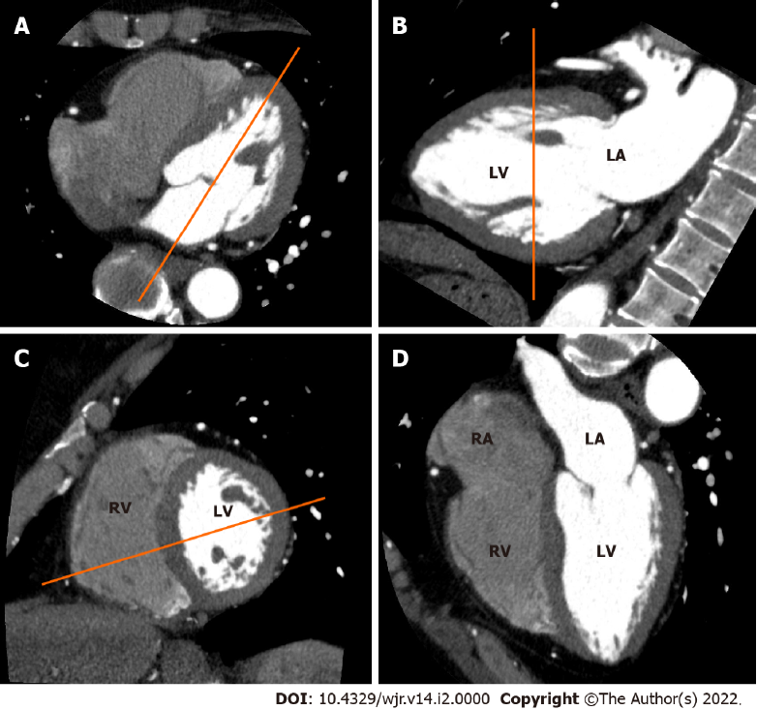
Figure 1 Electrocardiogram-gated cardiac computed tomography (CT)-based sequential approach to CT imaging of cardiac planes. A: From an axial CT data set at the level of the mitral valve, a longitudinal plane bisecting the mitral valve and the left ventricular apex is used to create a vertical long axis view; B: From the vertical long axis view, a slice parallel to the mitral annulus at the mid ventricular level is used to obtain a short axis view; C: From the short axis view, a slice bisecting the center of the left ventricle (LV) and the intersection between the junction of the free wall and diaphragmatic wall of the right ventricle (RV) are used to obtain a horizontal long axis view. (D) Horizontal long axis view showing the left atrium, LV, right atrium and RV.
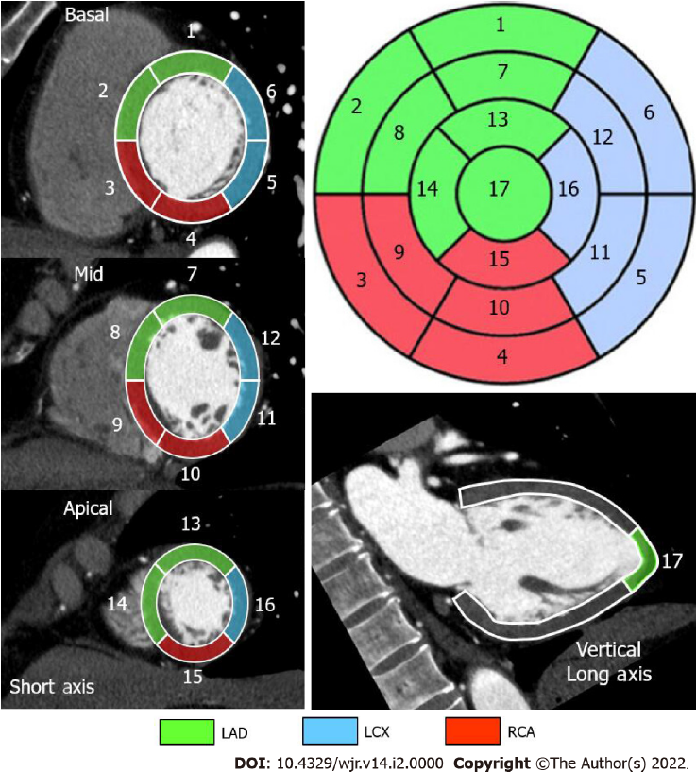
Figure 2 Standard segmental myocardial display in a 17-segment model. Electrocardiogram-gated cardiac computed tomography-based individual assignment of left ventricular segmentation following the American Heart Association 17-segment model with corresponding color-coded coronary artery perfusion territories for a right-dominant coronary system. LAD: Left anterior descending artery in green; LCX: Left circumflex coronary artery in blue; RCA: Right coronary artery in red.
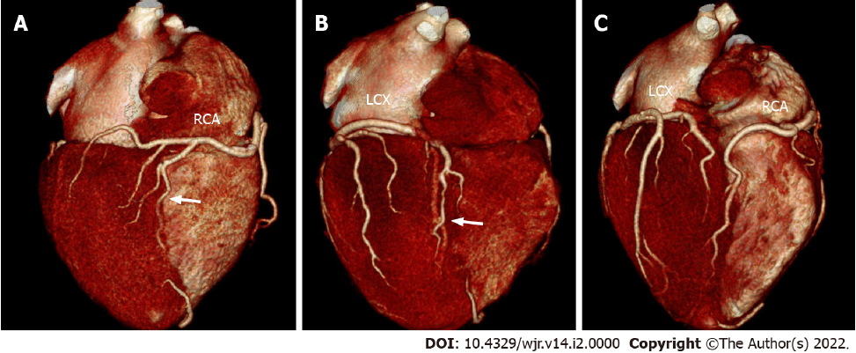
Figure 3 Variability in the coronary artery blood supply to the myocardium. Three-dimensional volume-rendered electrocardiogram-gated cardiac computed tomography images showing the inferior surface of the heart representing different coronary anatomy variants; A: Standard, right-dominant circulation. Right coronary artery (RCA) supplies posterior descending branch (arrow). Left circumflex coronary artery (LCX) supplies only inferolateral left ventricular myocardium; B: Left-dominant circulation. LCX supplies posterior descending branch (arrow). RCA supplies only right ventricular myocardium; C: Codominant circulation. Inferior myocardium is supplied both RCA and LCX.
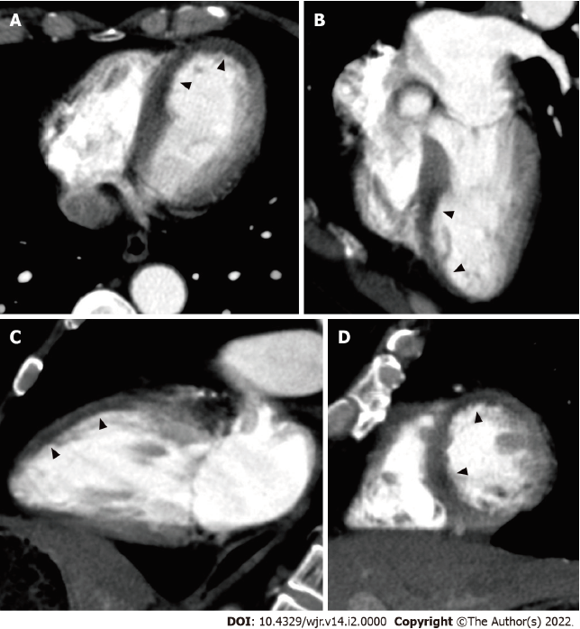
Figure 4 Non-electrocardiogram-gated contrast-enhanced computed tomography images in acute coronary syndrome of left anterior descending artery. A 64-year-old man with chest pain underwent non-electrocardiogram (ECG)-gated contrast-enhanced computed tomography (CECT) in search of aortic dissection. Axial (A), horizontal long axis (B), vertical long axis (C), and short axis (D) reformatted non-ECG-gated CECT images acquired 29 s after contrast injection showed decreased myocardial enhancement in the mid to apical anterior wall to the septum and apex of the left ventricle (arrowheads).
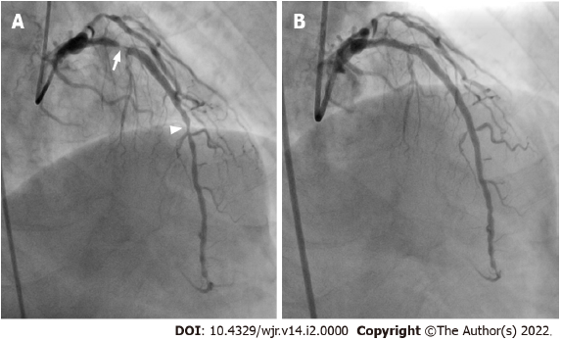
Figure 5 Corresponding invasive coronary angiography in acute coronary syndrome of left anterior descending artery. A: Same patient as Figure 4. Invasive coronary angiography showed 90% and 75% stenosis in the proximal (arrow) and mid (arrowhead) site of the left anterior descending artery; B: Subsequent percutaneous coronary intervention was performed by balloon angioplasty and stent implantation. His laboratory examination showed no elevation of cardiac biomarkers.
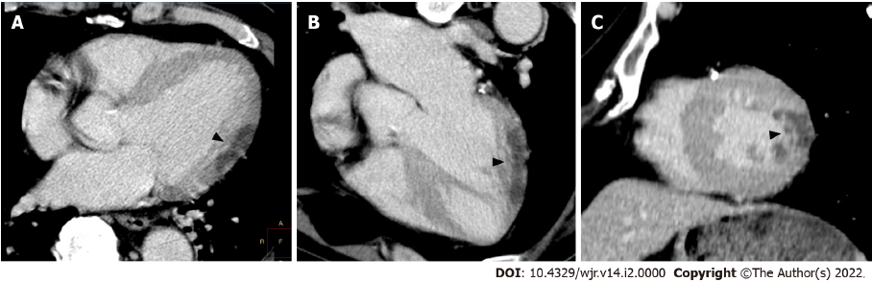
Figure 6 Non-electrocardiogram-gated contrast-enhanced computed tomography images in acute coronary syndrome of left circumflex coronary artery. A 65-year-old man with epigastralgia underwent non-electrocardiogram (ECG)-gated contrast-enhanced computed tomography (CECT) in search of aortic dissection. Axial (A), horizontal long axis (B), and short axis (C) reformatted non-ECG-gated CECT images acquired 120 s after contrast injection showed decreased myocardial enhancement in the mid lateral wall of the left ventricle (arrowheads).
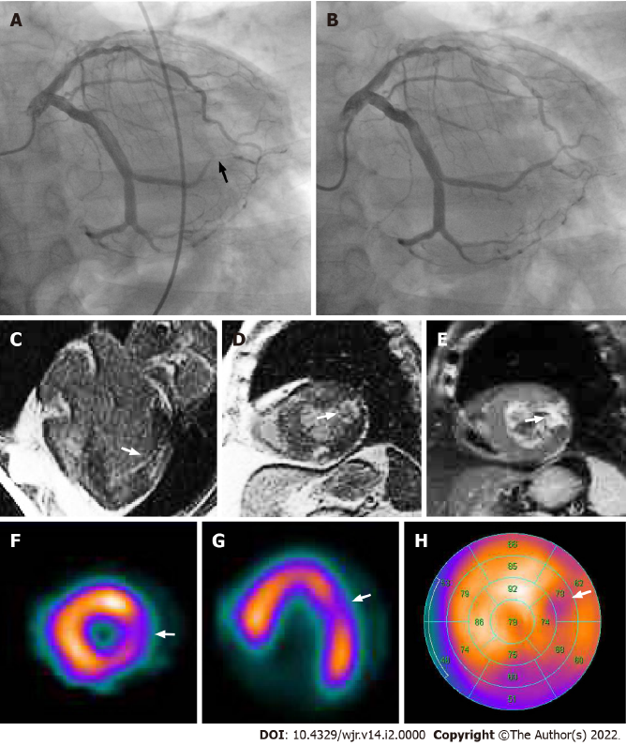
Figure 7 Corresponding invasive coronary angiography, cardiac magnetic resonance imaging and tetrofosmin single-photon emission computed tomography in acute coronary syndrome of left circumflex coronary artery. Same patient as Figure 6. A: Invasive coronary angiography showed 99% stenosis in the posterolateral branch of the left circumflex coronary artery (arrow). B: Subsequent percutaneous coronary intervention was performed by balloon angioplasty and stent implantation. His laboratory data showed elevation of cardiac biomarkers (creatine kinase 1620 IU/L, creatine kinase MB 120 IU/L). Horizontal long axis (C) and short axis (D) views of the contrast-enhanced cardiac magnetic resonance imaging (MRI) showed late gadolinium enhancement in the mid lateral wall of the left ventricle (arrow). A short axis view of the T2-weighted cardiac MRI showed high signal intensity in the mid lateral wall of the left ventricle (E, arrow). Short axis (F) and horizontal long axis (G) views and a bull’s eye polar plot (H) of rest technetium-99m tetrofosmin single-photon emission computed tomography myocardial perfusion imaging showed hypoperfusion in the mid lateral wall of the left ventricle (arrows).
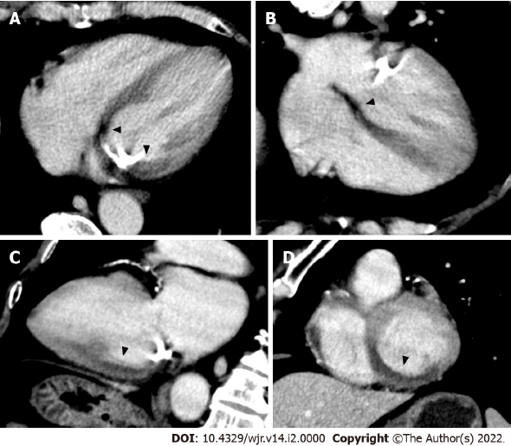
Figure 8 Non-electrocardiogram-gated contrast-enhanced computed tomography images in acute coronary syndrome of right coronary artery. A 67-year-old man with chest pain underwent non-electrocardiogram (ECG)-gated contrast-enhanced computed tomography (CECT) in search of aortic dissection. Axial (A), horizontal long axis (B), vertical long axis (C), and short axis (D) reformatted non-ECG-gated CECT images acquired 120 s after contrast injection showed decreased myocardial enhancement in the basal to mid inferior, inferolateral, and inferoseptal wall of the left ventricle (arrowheads).
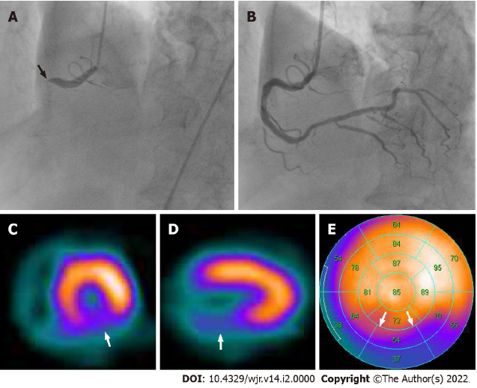
Figure 9 Corresponding invasive coronary angiography and sestamibi single-photon emission computed tomography in acute coronary syndrome of right coronary artery. Same patient as Figure 8. A: Invasive coronary angiography showed total occlusion in the proximal site of the right coronary artery (arrow); B: Subsequent percutaneous coronary intervention was performed by balloon angioplasty and stent implantation. His laboratory data showed elevation of cardiac biomarkers (creatine kinase 1620 IU/L, creatine kinase MB 239 IU/L). Short axis (C) and vertical long axis (D) views and a bull’s eye polar plot (E) of rest technetium-99m sestamibi single-photon emission computed tomography myocardial perfusion imaging showed perfusion defect in the basal to mid inferior, inferolateral and inferoseptal wall of the left ventricle (arrows).
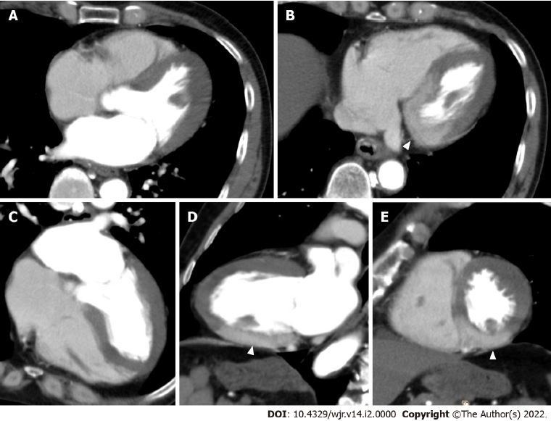
Figure 10 Non-electrocardiogram-gated contrast-enhanced computed tomography images in acute coronary syndrome of left main trunk. A 70-year-old man with severe dyspnea underwent non-electrocardiogram (ECG)-gated contrast-enhanced computed tomography (CECT) for discriminating acute pulmonary thromboembolism. Axial (A, B), horizontal long axis (C), vertical long axis (D), and short axis (E) reformatted non-ECG-gated CECT images acquired 120 s after contrast injection showed localized myocardial enhancement only in the basal to mid inferior wall of the left ventricle (arrowheads).
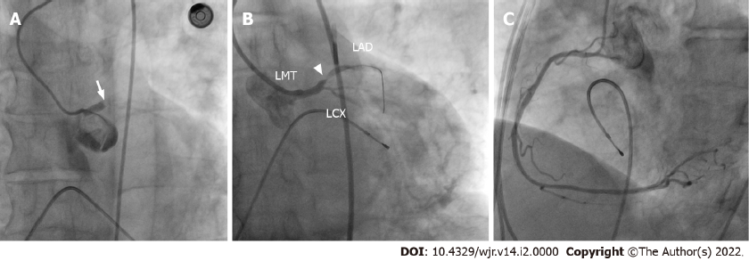
Figure 11 Corresponding invasive coronary angiography in acute coronary syndrome of left main trunk. Same patient as Figure 10. A: Invasive coronary angiography showed thrombotic occlusion in the left main trunk (arrow). Subsequent percutaneous coronary intervention (PCI) was tried. B: After guidewire was crossed to the left anterior descending artery, there was minimal improvement in flow and 99% stenosis in the proximal site of the left anterior descending artery appeared (arrowhead); C: The right coronary artery showed no significant stenosis. The patient died during PCI because of uncontrollable ventricular fibrillation. LMT: Left main trunk; LAD: Left anterior descending artery; LCX: Left circumflex coronary artery.
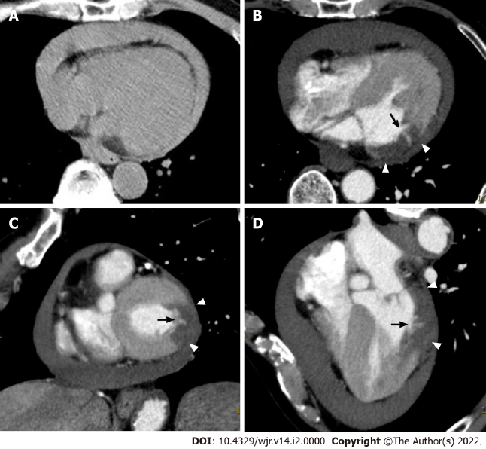
Figure 12 Non-electrocardiogram-gated contrast-enhanced computed tomography images in postinfarct cardiac free wall rupture. A: An 81-year-old man with syncope first underwent non-electrocardiogram (ECG)-gated non-contrast whole body computed tomography (CT), and moderate pericardial effusion was found. The attenuation value of the pericardial effusion was about 50 Hounsfield units. Subsequently, non-ECG-gated contrast-enhanced CT (CECT) was performed in search of ascending aortic dissection. Axial (B), short axis (C), and horizontal long axis (D) reformatted non-ECG-gated CECT images acquired 120 s after contrast injection showed decreased myocardial enhancement in the basal to mid lateral wall of the left ventricle (arrowheads) and a small myocardial defect (arrow).
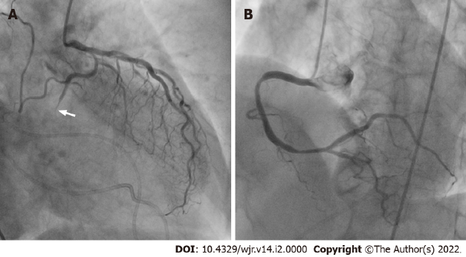
Figure 13 Corresponding invasive coronary angiography in postinfarct cardiac free wall rupture. Same patient as Figure 12. A: Invasive coronary angiography showed total occlusion in the distal site of the left circumflex coronary artery (arrow); B: The right coronary artery showed no significant stenosis. The patient subsequently underwent a surgical operation. After removal of the large clot within the pericardium, a small perforation was found in the lateral wall of the left ventricle, confirming a definitive diagnosis of left ventricular free wall rupture.
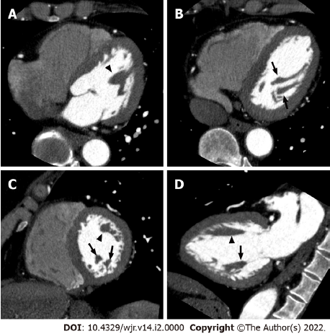
Figure 14 Left ventricular papillary muscles. Axial (A, B), short axis (C), and vertical long axis (D) reformatted electrocardiogram-gated cardiac CT images showing the anatomy of the left ventricular chamber of the normal heart. The anterolateral (arrowheads) and posteromedial (arrows) papillary muscles manifest as filling defects within the contrast-filled left ventricular lumen.
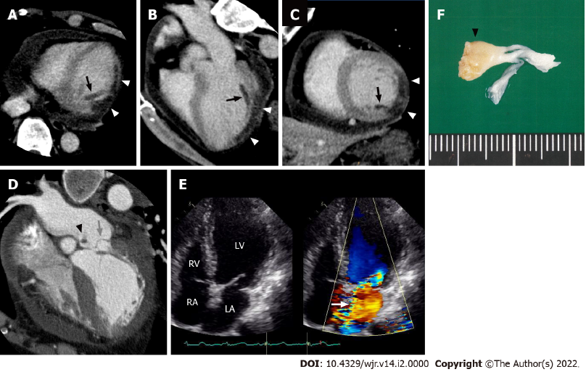
Figure 15 Postinfarct left ventricular papillary muscle rupture. Electrocardiogram-gated cardiac CT images from a 61-year-old man with posteromedial papillary muscle rupture complicated by acute ST elevation myocardial infarction due to total occlusion of the left circumflex coronary artery. Axial (A), three-chamber (B), and short axis (C) reformatted cardiac CT images showed decreased myocardial enhancement in the inferolateral wall (white arrowheads) and posteromedial papillary muscle (black arrows) of the left ventricle. A horizontal long axis image (D) showed severe prolapse of the posterior mitral valve leaflet into the left atrium (grey arrow) with discernible papillary muscle attachment (black arrowhead). An apical four-chamber color Doppler image of the transthoracic echocardiogram showed severe mitral regurgitation during ventricular systole extending to the posterior left atrial wall (E, white arrow). The patient subsequently underwent a mitral valve replacement. Surgical specimen showed posteromedial papillary muscle attached to the resected posterior mitral leaflet (F, black arrowhead). LV: Left ventricle; LA: Left atrium; RV: Right ventricle; RA: Right atrium.
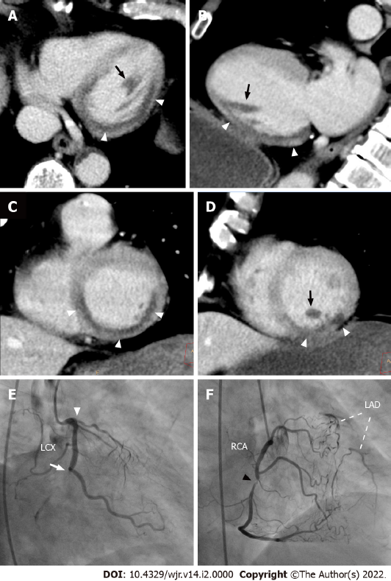
Figure 16 Myocardial perfusion defect of the posteromedial papillary muscle on non-electrocardiogram-gated contrast-enhanced computed tomography. A 68-year-old man with right anterior chest pain underwent non-electrocardiogram (ECG)-gated contrast-enhanced computed tomography (CECT) in search of aortic dissection. Axial (A), vertical long axis (B), and short axis (C, D) reformatted non-ECG-gated CECT images acquired 120 s after contrast injection showed decreased myocardial enhancement in the basal to mid inferior, inferolateral, and inferoseptal walls of the left ventricle (arrowheads). Decreased myocardial enhancement was also recognized in the posteromedial papillary muscle (arrows). Invasive coronary angiography showed total occlusion in the distal site of the left circumflex coronary artery (E, arrow), total occlusion in the proximal site of the left anterior descending artery (E, arrowhead), and 90% stenosis in the mid site of the right coronary artery (F, arrowhead), which provides abundant collateral flow to the left anterior descending artery. The patient subsequently underwent an emergent coronary artery bypass grafting. LAD: Left anterior descending artery; LCX: Left circumflex coronary artery; RCA: Right coronary artery.
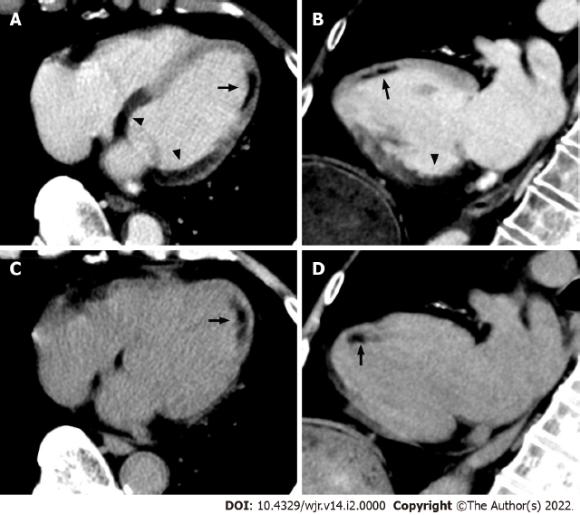
Figure 17 Non-electrocardiogram-gated contrast-enhanced computed tomography images in acute coronary syndrome of right coronary artery complicated with anterior old myocardial infarction. An 82-year-old man with back pain underwent non-electrocardiogram (ECG)-gated contrast-enhanced computed tomography (CECT) in search of aortic dissection. Axial (A) and vertical long axis (B) reformatted non-ECG-gated CECT images acquired 120 s after contrast injection showed decreased myocardial enhancement in the basal to mid inferior, inferolateral, and inferoseptal walls of the left ventricle (arrowheads). Non-ECG-gated CECT images also showed decreased myocardial enhancement in the mid anterior wall of the left ventricle apart from the above-mentioned area (arrow). Axial (C) and vertical long axis (D) reformatted non-ECG-gated non-contrast CT images showed subendocardial low attenuation less than 0 Hounsfield units only in the mid anterior wall of the left ventricle, which is consistent with myocardial fatty degeneration associated with the old myocardial infarction (arrow).
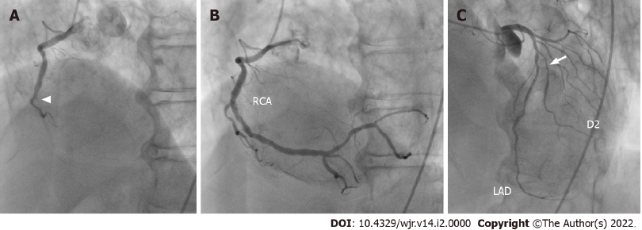
Figure 18 Corresponding invasive coronary angiography in acute coronary syndrome of right coronary artery complicated with anterior old myocardial infarction. Same patient as Figure 17. A: Invasive coronary angiography showed total occlusion in the mid site of the right coronary artery (arrowhead); B: Subsequent percutaneous coronary intervention was performed by balloon angioplasty and stent implantation. C: Invasive coronary angiography also showed 75% stenosis in the proximal site of the second diagonal branch (arrow). RCA: Right coronary artery; LAD: Left anterior descending artery; D2: Second diagonal branch.
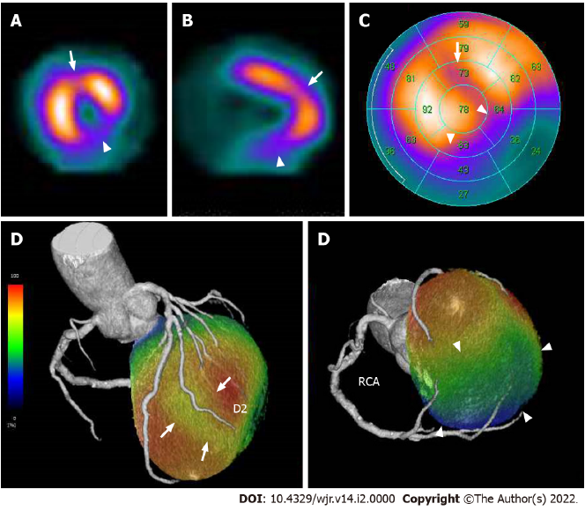
Figure 19 Corresponding sestamibi single-photon emission computed tomography in acute coronary syndrome of right coronary artery complicated with anterior old myocardial infarction. Same patient as Figures 17 and 18. Rest technetium-99m sestamibi single-photon emission computed tomography (SPECT) myocardial perfusion imaging (MPI) are shown. Short axis (A) and vertical long axis (B) views and a bull’s eye polar plot (C) of rest technetium-99m sestamibi SPECT MPI showed perfusion defects in the basal to mid inferior, inferolateral, and inferoseptal walls of the left ventricle (arrowheads). In addition, SPECT MPI also showed hypoperfusion in the mid anterior wall of the left ventricle (arrows). The volume-rendered, coregistered SPECT MPI, and cardiac CT images demonstrated that hypoperfusion in the mid anterior wall of the left ventricle seen on the SPECT MPI corresponded with the territory of the second diagonal branch (D, arrows), whereas the perfusion defects in the basal to mid inferior, inferolateral, and inferoseptal walls of the left ventricle seen on the SPECT MPI corresponded with the territory of the right coronary artery (D, arrowheads). LAD: Left anterior descending artery, D2: Second diagonal branch; RCA: Right coronary artery.
Table 1 Studies investigating the ability of non-ECG-gated contrast-enhanced computed tomography to detect acute coronary syndrome
Ref. | Type of CT | CT phase | No. of Patients | No. of ACS | No. of positive MPD | True Positive | False Positive | True Negative | False Negative | Sensitivity (%) | Specificity (%) | PPV (%) | NPV (%)
Gosalia et al^{[15]}, 2004 | SD | Arterial | 37 | 18 | 16 | 15 | 1 | 18 | 3 | 83 | 95 | 94 | 86
Moore et al^{[16]}, 2006 | 16-slice | Arterial | 87 | 11 | 10 | 6 | 4 | 72 | 5 | 55 | 95 | 60 | 94
Mano et al^{[17]}, 2015 | 64-slice | Arterial | 154 | 28 | 43 | 26 | 17 | 109 | 2 | 93 | 87 | 60 | 98
Watanabe et al^{[18]}, 2016 | 64-slice | Arterial | 23 | 13 | 12 | 11 | 1 | 9 | 2 | 85 | 90 | 92 | 82
Yamazaki et al^{[19]}, 2016 | 16/64-slice | Parenchymal | 47 | 32 | 30 | 29 | 1 | 14 | 3 | 91 | 93 | 97 | 82
ACS: Acute coronary syndrome, MPD: Myocardial perfusion defect, PPV: Positive predictive value, NPV: Negative predictive value, SD: Single detector.

Published by Baishideng Publishing Group Inc
7041 Koll Center Parkway, Suite 160, Pleasanton, CA 94566, USA
Telephone: +1-925-3991568
E-mail: bpgoffice@wjgnet.com
Help Desk: https://www.f6publishing.com/helpdesk
https://www.wjgnet.com

© 2022 Baishideng Publishing Group Inc. All rights reserved.

